Supplemental material

Kaplan Meier Curve divided by IGF-1 strata

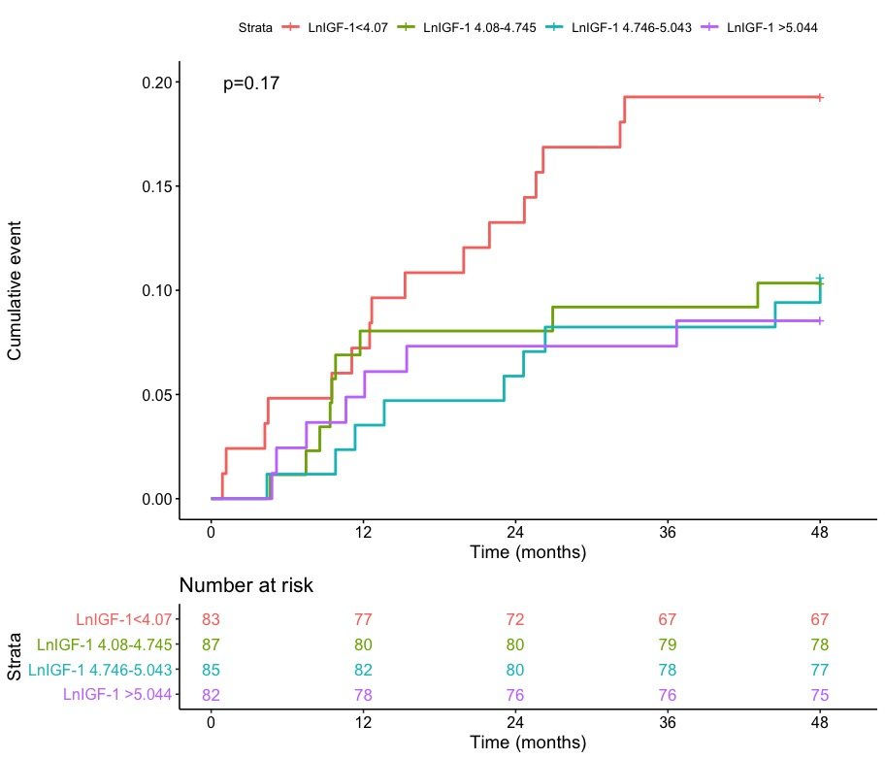

AUC plot
