Supplemental Table 1. Baseline characteristics stratified by survival within 30 days
 | Survivor  (n = 112) |  | Non-survivor  (n = 126) |  | p value
Age (median, (IQR)) | 72 | (62-79) | 74 | (64-81) | 0.354
Male sex, n (%) | 66 | (58.9) | 76 | (60.3) | 0.827
Body mass index, kg/m² (median, (IQR)) | 26.0 | (23.9-28.0) | 26.6 | (24.5-30.5) | 0.132
Clinical parameters, (median, (IQR))
Body temperature (°C) | 36.1 | (35.2-36.6) | 35.8 | (34.5-36.5) | 0.046
Heart rate (bpm) | 85 | (69-106) | 95 | (74-112) | 0.032
Systolic blood pressure (mmHg) | 110 | (94-130) | 105 | (93-127) | 0.281
Respiratory rate (breaths/min) | 20 | (16-22) | 20 | (17-25) | 0.180
Cardiovascular risk factors, n (%)
Arterial hypertension | 82 | (73.2) | 90 | (71.4) | 0.759
Diabetes mellitus | 38 | (33.9) | 50 | (39.7) | 0.359
Hyperlipidemia | 58 | (51.8) | 64 | (50.8) | 0.879
Smoking | 41 | (36.6) | 46 | (36.5) | 0.987
Prior medical history, n (%)
Coronary artery disease: | 39 | (34.8) | 46 | (36.5) | 0.786
1-vessel disease | 9 | (8.0) | 14 | (11.1) | 0.560
2-vessel disease | 6 | (5.4) | 3 | (2.4) | 0.560
3-vessel disease | 24 | (21.4) | 29 | (23.0) | 0.560
Congestive heart failure | 39 | (34.8) | 47 | (37.3) | 0.691
Atrial fibrillation | 35 | (31.3) | 40 | (31.7) | 0.934
Chronic kidney disease | 39 | (34.8) | 43 | (34.1) | 0.910
Stroke | 18 | (16.1) | 15 | (11.9) | 0.353
COPD | 19 | (17.0) | 29 | (23.0) | 0.246
Liver cirrhosis | 6 | (5.4) | 2 | (1.6) | 0.152
Medication on admission, n (%)
ACE-inhibitor | 40 | (35.7) | 39 | (31.0) | 0.436
ARB | 20 | (17.9) | 22 | (17.5) | 0.936
Beta-blocker | 58 | (51.8) | 61 | (48.5) | 0.603
ARNI | 5 | (4.5) | 3 | (2.4) | 0.482
Mineralocorticoid antagonist | 18 | (16.1) | 18 | (14.3) | 0.701
SGLT-2 inhibitor | 4 | (3.6) | 4 | (3.2) | 1.000
Diuretics | 47 | (42.0) | 58 | (46.0) | 0.528
ASA | 31 | (27.7) | 35 | (27.8) | 0.986
P2Y12-inhibitor | 10 | (8.9) | 12 | (9.5) | 0.874
Statin | 55 | (49.1) | 49 | (38.9) | 0.113
ACE, angiotensin-converting-enzyme; ARB, angiotensin receptor blocker; ARNI, angiotensin receptor neprilysin inhibitor; ASA, acetylsalicylic acid; bpm, beats per
minute; COPD, chronic obstructive pulmonary disease; DP, driving pressure; IQR, interquartile range; Level of significance p<0.05. Bold type indicates statistical significance.

Supplemental Table 2 Correlations of PaCO₂ with laboratory and clinical parameters in ventilated CS-patients.
 | PaCO₂
 | r | p value
Age | -0.190 | 0.017
Body mass index (kg/m²) | 0.054 | 0.502
Heart rate (bpm) | 0.174 | 0.029
Lactate (mmol/L) | -0.051 | 0.525
Norepinephrine dose (µg/kg/min) | -0.064 | 0.428
pH | -0.485 | 0.001
PaO₂/FiO₂ ratio | -0.297 | 0.001
PEEP (cmH₂O) | 0.107 | 0.198
Driving pressure (cmH₂O) | 0.296 | 0.001
Peak inspiratory pressure (cmH₂O) | 0.305 | 0.001
Tidal volume (ml) | -0.097 | 0.245
Respiratory rate (breaths/min) | 0.039 | 0.634
Lung compliance (ml/cmH₂O) | -0.235 | 0.005
Pneumonia (ICU acquired) | 0.047 | 0.555
Bpm, beats per minute; FiO2, fraction of inspired oxygen; ICU, intensive care unit; PaO2, partial pressure of oxygen; PaCO2, partial pressure of carbon dioxide; PEEP, positive end expiratory pressure;
Level of significance p<0.05. Bold type indicates statistical significance.

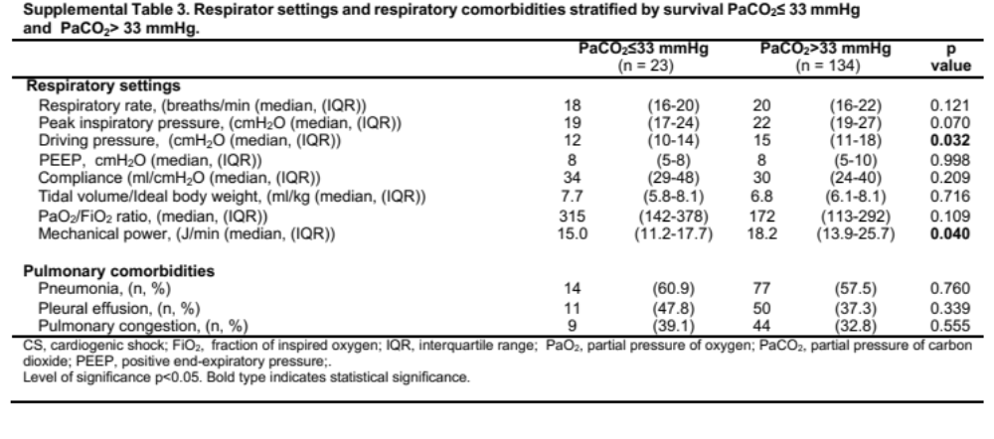

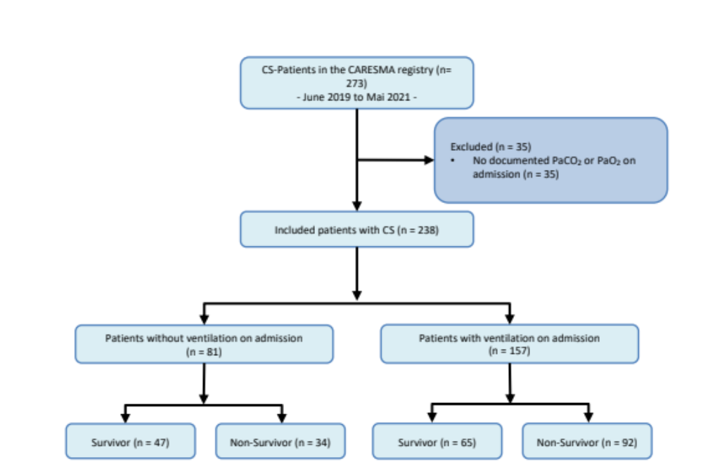
Supplemental Figure 1 In- and exclusion process

