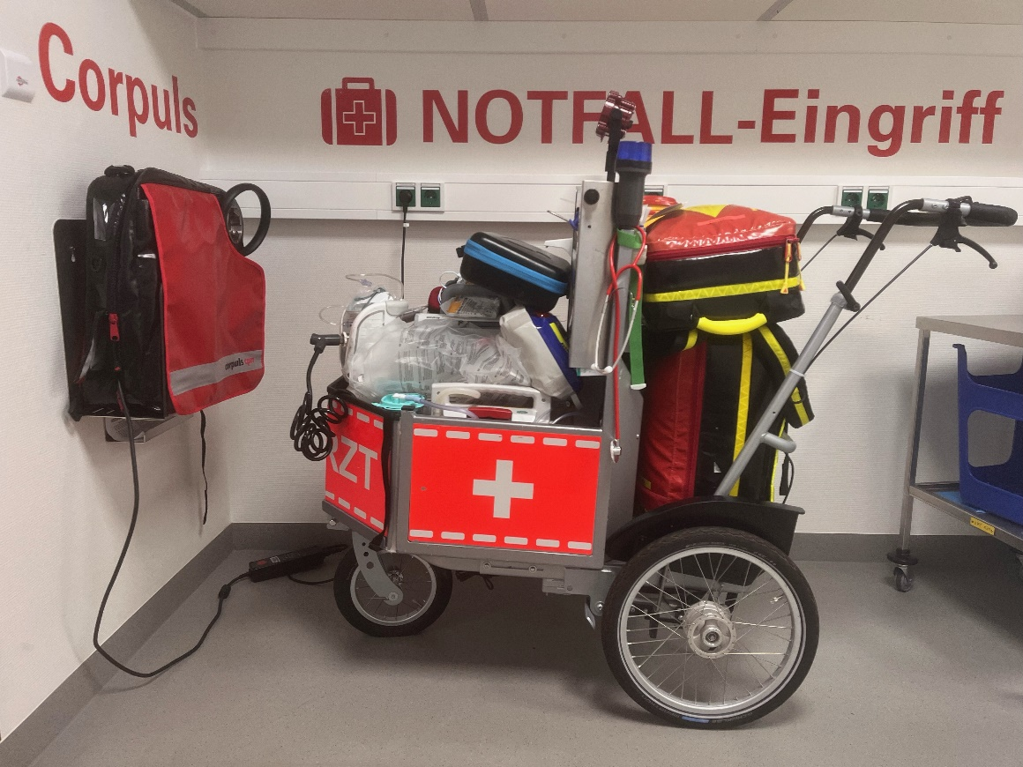
Supl. Picture 1: Emergency Cart with Equipment

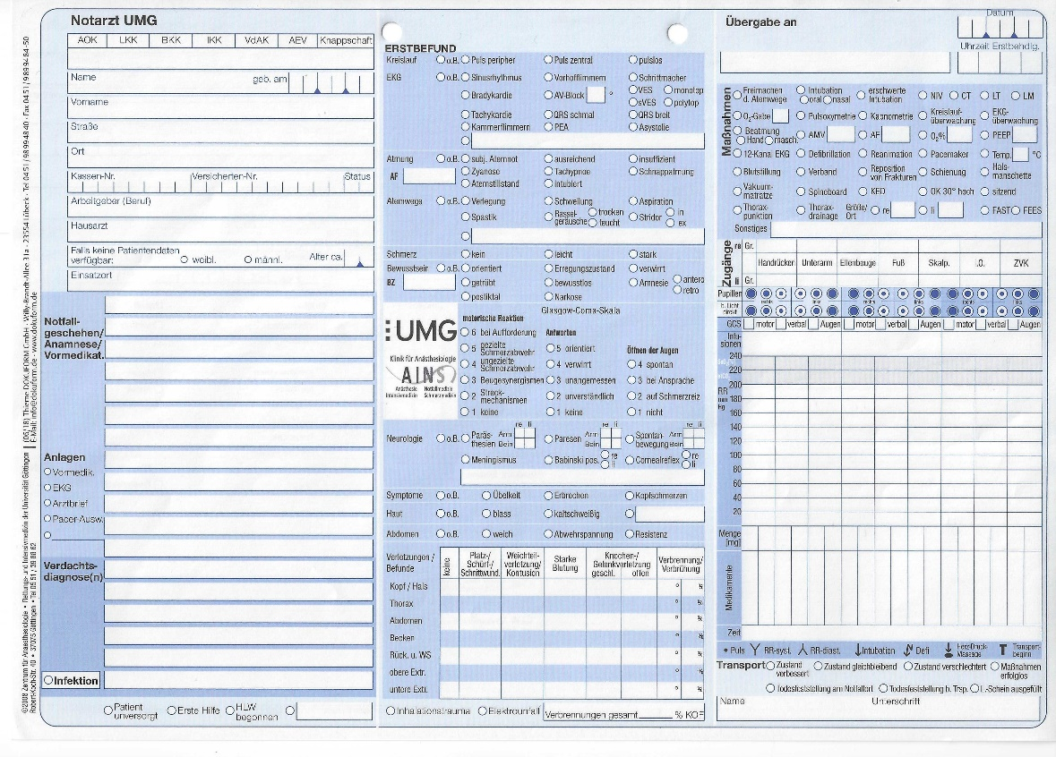
Supl. Picture 2: Emergency Protocol

Supl. Table 1: NACA-Score and Definition

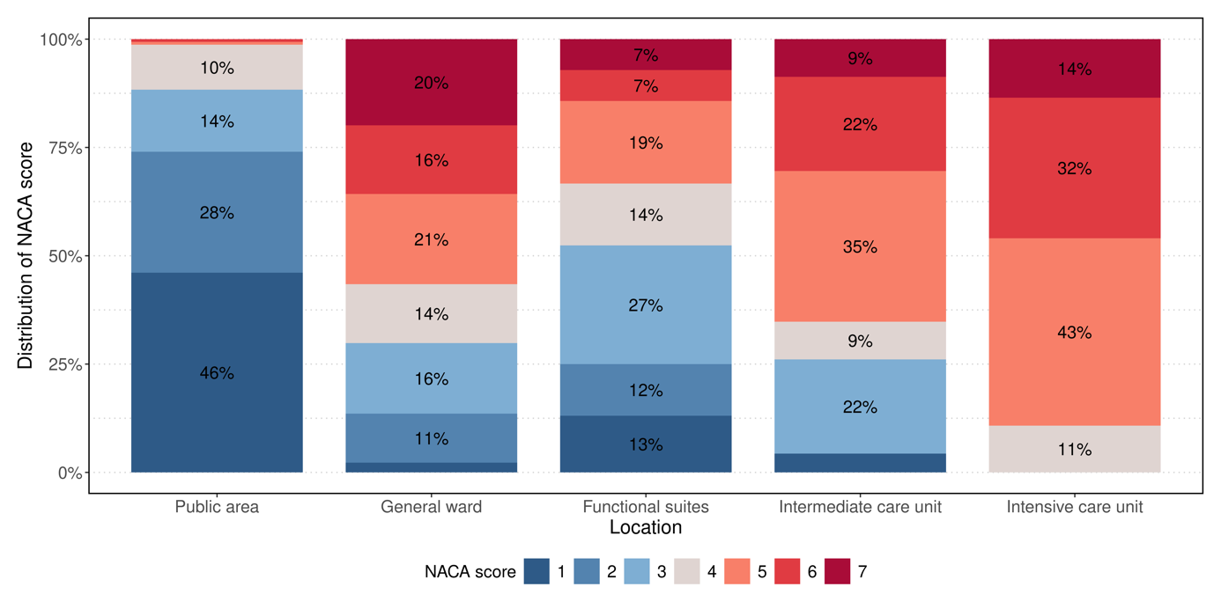
Supl. Figure 1: NACA-Score Distribution by Location

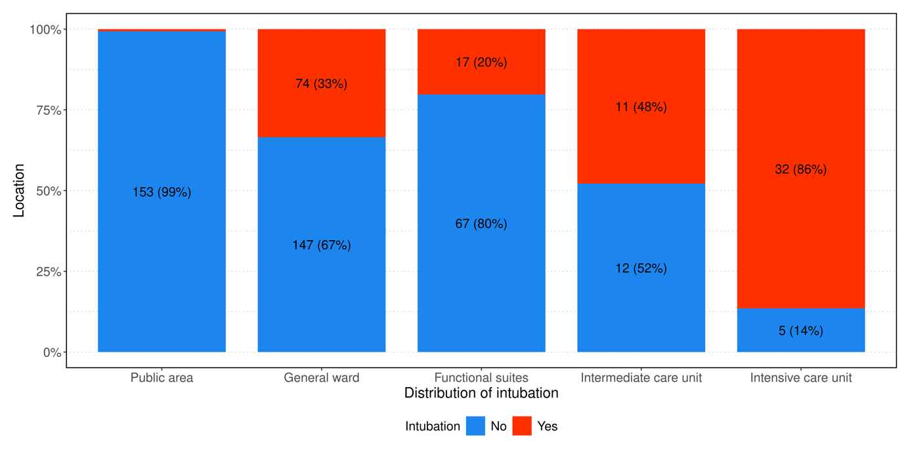
Supl. Figure 2: Intubation by location

