SUPPLEMENTARY MATERIAL

Supplementary Figure 1: Flowchart demonstrating patients presenting with UGIH to the ED enrolled into the study
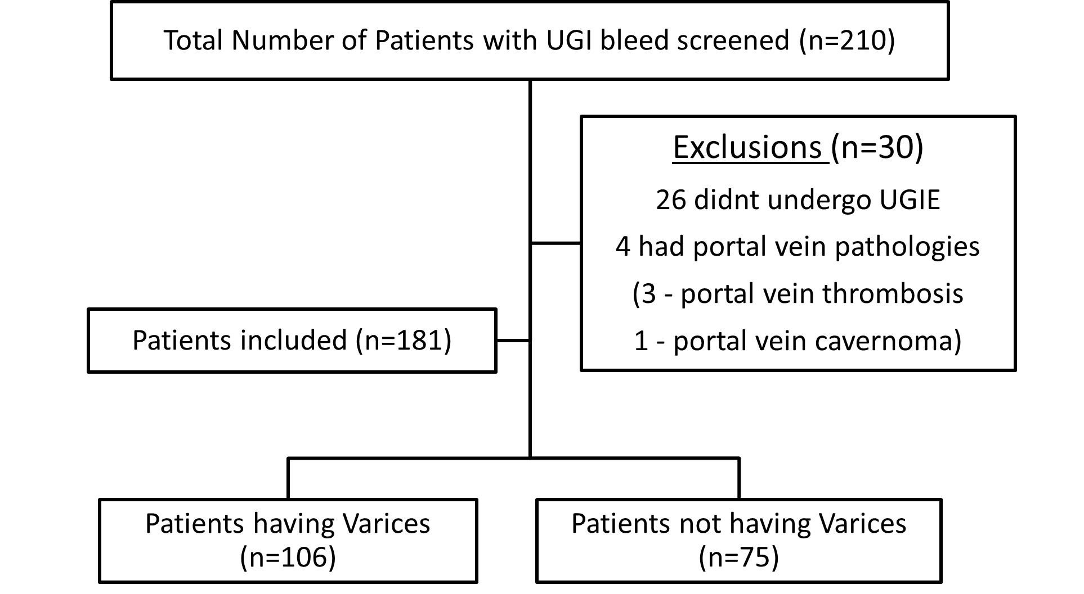

Supplementary Table 1: Diagnostic accuracy of SCoPE score and Fibrosis scores for predicting varices in UGIH
Variables | AUC | OR  (95% C.I) | Cut-offs | Sensitivity (%) | Specificity (%) | PPV  (%) | NPV  (%) | Diagnostic accuracy (%) | LR  (+) | LR  (-)
SCoPE | 0.843* | 1.633  (1.417-1.883) | >/=3 | 79.2 | 77 | 83.2 | 71.8 | 78.2 | 3.4 | 0.27
AAR | 0.663* | 1.400  (1.079-1.816) | >1.94 | 61.3 | 68 | 73 | 55.4 | 64.1 | 1.92 | 0.57
APRI | 0.742* | 1.253  (1.051-1.494) | >0.86 | 75 | 65.3 | 75.2 | 65 | 71 | 2.15 | 0.39
Fib-4 | 0.699* | 1.143  (1.054-1.239) | >3.59 | 68 | 68 | 75 | 60 | 68 | 2.12 | 0.472
King | 0.738* | 1.006  (1.001-1.011) | >20.34 | 79.2 | 63.5 | 75.7 | 68.1 | 72.8 | 2.17 | 0.327
Lok | 0.775* | 103.64  (23.29-461.06) | >0.65 | 91.5 | 67 | 74 | 81.5 | 76.1 | 1.99 | 0.16
*P<0.005

Supplementary Table 2: Comparison of POCUS and laboratory parameters between Patients with Varices and Patients without Varices on UGIE in all patients with CLD (n=122)
Parameter | Varices absent (n=17) | Varices present (n=105) | p-value
Portal vein diameter (mm) | 9.59 ± 1.95 | 9.86 ± 2.72 | 0.693*
Spleen diameter (cm) | 10.73 ± 2.03 | 12.46 ± 2.30 | 0.004*
Portal vein velocity (cm/s) | 14.20 (11.75-17.65) | 11.5 (8.90- 14) | 0.035#
Portal vein CSA (cm²) | 0.79 (0.58-0.94) | 0.74 (0.52-1.09) | 0.897#
Portal vein congestion index | 0.05 (0.04-0.08) | 0.06 (0.04-0.09) | 0.223#
Platelet (cu mm)/  Spleen diameter(mm) | 1128 (851-1744) | 1050 (726-1537) | 0.174#
Ascites present | 5 (29.4%) | 47 (44.8%) | 0.235^
Blood Flow pattern  Hepatopetal-1  Hepatofugal-2  Mixed-3 | 76.5%  11.8%  11.8% | 56.2%  21.9%  21.9% | 0.288^
Hematocrit | 25.0 (15.5- 31.00) | 26 (20-30.5) | 0.597#
WBC | 10.2 (7.05-14.85) | 10 (7.1-13.95) | 0.994#
Platelets | 129 (106.5 -193) | 134 (86-186) | 0.478#
Creatinine | 1.41 (0.77-1.70) | 0.98 (0.72-1.36) | 0.175#
Urea | 55 (30.5-122.5) | 41.00 (31-64.50) | 0.132#
Total bilirubin | 1.54 (0.9-3.4) | 2.08 (1.08-5.63) | 0.292#
Direct bilirubin | 0.78 (0.54-2.53) | 1.2 (0.55-2.46) | 0.688#
AST | 60 (36-111.5) | 72 (49.5-116.50) | 0.387#
ALT | 36 (18.85-51.5) | 30 (21.65-50.9) | 0.900#
ALP | 87 (64-133) | 102 (82.50-132.5) | 0.146#
Albumin | 2.81± 0.82 | 2.84±0.58 | 0.901*
PT | 16.64±5.14 | 16.81±5.18 | 0.900*
aPTT | 30.95±10.81 | 30.79±8.51 | 0.945*
*Independent Student t-test, #Mann-Whitney U test, ^Chi-Square test

Supplementary Figure 2
2 (a): ROC curve analysis of spleen diameter for predicting the presence of varices in UGIH in all CLD patients (AUC=0.713)
2 (b) ROC curve analysis of PVFV for predicting the absence of varices in UGIH in all CLD patients (AUC=0.66)
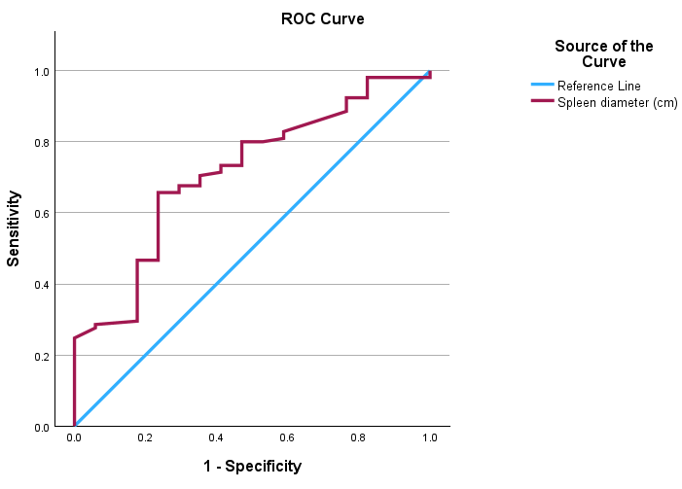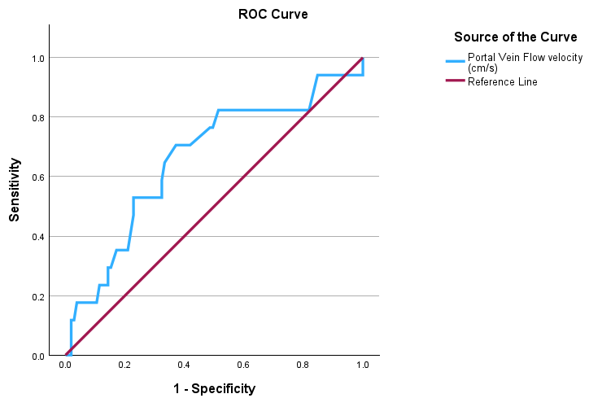
2 (a) 2 (b)

Supplementary Table 3: Child–Pugh–wise comparison of spleen diameter and PVFV between patients with and without varices on UGIE among those with CLD (n = 122)
 | No varices (n= 17) | Varices (n= 105) | P value
PVFV (cm/s)
Child Pugh A (n=23) | 14.20 (12-16.7) | 10.45 (8.94-11.95) | 0.015#
Child Pugh B (n=40) | 17.65 (15.57-23.10) | 11.25 (9.65-13.55) | 0.002#
Child Pugh C (n=59) | 10.5 (7.2-15.8) | 12 (8.15-16.15) | 0.651#
Spleen diameter (cm)
Child Pugh A (n=23) | 9.79 ± 1.51 | 11.99 ± 2.77 | 0.024*
Child Pugh B (n=40) | 11.16 ± 2.04 | 12.01 ± 2.53 | 0.524*
Child Pugh C(n=59) | 11.53 ± 2.43 | 12.91 ± 1.92 | 0.109*
*Independent Student t-test, #Mann-Whitney U test

Supplementary Figure 3:

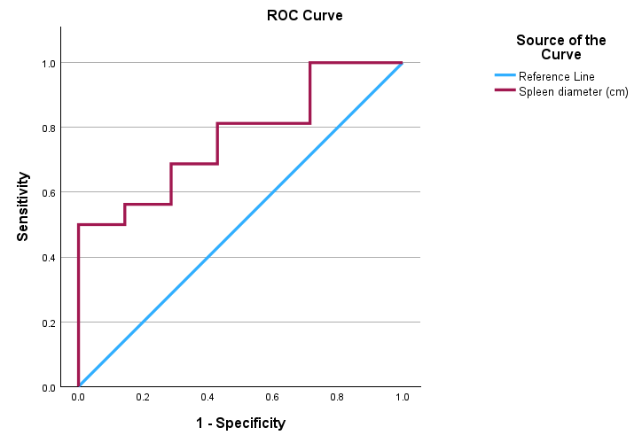
3 (a): ROC curve analysis of spleen diameter for predicting the presence of varices in UGIH among Child–Pugh A CLD patients(AUC=0.768)

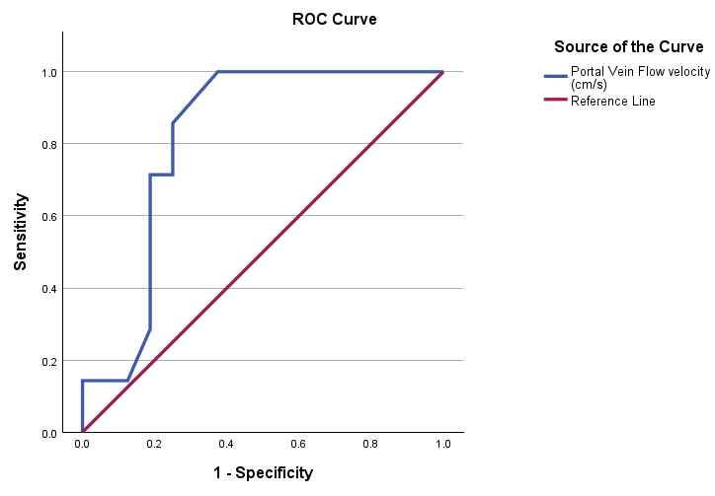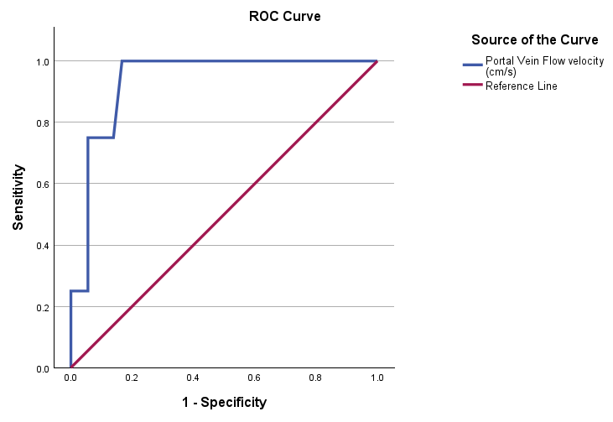
3(b) 3(c)
3 (b) ROC curve analysis of PVFV for predicting the absence of varices in UGIH among Child Pugh A CLD patients (AUC=0.817)
3 (c) ROC curve analysis of PVFV for predicting the absence of varices in UGIH among Child Pugh B CLD patients (AUC=0.934)

Supplementary table 4:
Comparison of POCUS parameters between Patients with Varices and Patients without Varices on UGIE in newly diagnosed CLD (n=32)

Parameter | Varices absent (n=7) | Varices present (n=25) | p-value
Portal vein diameter (mm) | 9.08 ± 1.63 | 9.74 ± 2.93 | 0.579*
Spleen diameter (cm) | 10.33 ± 2.00 | 12.02 ± 1.98 | 0.058*
Portal vein velocity (cm/s) | 15 (12.70-18.00) | 9.8 (7.20- 11.65) | 0.001#
Portal vein CSA (cm²) | 0.68 (0.57-0.85) | 0.80 (0.51-1.10) | 0.721#
Portal vein congestion index | 0.045 (0.035-0.052) | 0.073 (0.05-0.119) | 0.018#
Platelet (cu mm)/Spleen diameter(mm) | 1460 (9682-1723) | 1030 (796-1632) | 0.261#
Ascites present | 1 (14.3%) | 11 (44%) | 0.151^
Blood Flow pattern  Hepatopetal-1  Hepatofugal-2  Mixed-3 | 85.7%  14.3%  0% | 48%  24%  28% | 0.167^
*Independent Student t-test, #Mann-Whitney U test, ^Chi-Square test

Supplementary table 5:
Comparison of POCUS and laboratory parameters between Patients with Varices and Patients without Varices on UGIE among study participants without prior diagnosis of CLD (n=91)
Parameter | Varices absent (n=65) | Varices present (n=26) | p-value
Portal vein diameter (mm) | 8.88 ± 2.67 | 9.78 ± 2.88 | 0.163*
Spleen diameter (cm) | 9.56 ± 2.09 | 12.08 ± 1.97 | <0.001*
Portal vein velocity (cm/s) | 15.00 (11.25-19.00) | 9.80 (7.30-11.85) | <0.001#
Portal vein CSA (cm²) | 0.63 (0.50-0.80) | 0.80 (0.51-1.08) | 0.076#
Portal vein congestion index | 0.04 (0.03-0.05) | 0.07 (0.05-0.11) | <0.001#
Platelet (cu mm)/Spleen diameter(mm) | 2195 (1333-3236) | 1040 (800-1669) | <0.001#
Ascites present | 6 (9.2%) | 11 (42.3%) | <0.001^
Blood Flow pattern  Hepatopetal-1  Hepatofugal-2  Mixed-3 | 61.5%  9.2%  29.2% | 46.2%  23.1%  30.8% | 0.175^
Hematocrit | 29.0 (20.20- 36.00) | 26 (21-32.5) | 0.266#
WBC | 10.2 (6.95-14.30) | 10.15 (8.05-14.20) | 0.765#
Platelets | 210 (142 -260.5) | 130.5 (98.75-193.5) | <0.001#
Creatinine | 1.03 (0.8-1.43) | 0.93 (0.71-1.24) | 0.232#
Urea | 47 (24-77.5) | 38.00 (31.50-64.00) | 0.527#
Total bilirubin | 0.68 (0.35-1.15) | 1.72 (0.72-3.22) | <0.001#
Direct bilirubin | 0.31 (0.14-0.55) | 0.61 (0.35-1.41) | <0.001#
AST | 35 (20.5-70) | 70 (40.25-101.50) | 0.002#
ALT | 21 (14.15-38) | 27.5 (23.60-55.45) | 0.010#
ALP | 72 (57.5-98) | 96.0 (76.50-117.0) | 0.005#
Albumin | 3.41±0.74 | 3.06±0.56 | 0.038*
PT | 12.41±2.62 | 15.42±3.97 | <0.001*
aPTT | 26.67±10.33 | 28.21±5.47 | 0.498*
*Independent Student t-test, #Mann-Whitney U test, ^Chi-Square test

Supplementary Figure 4:
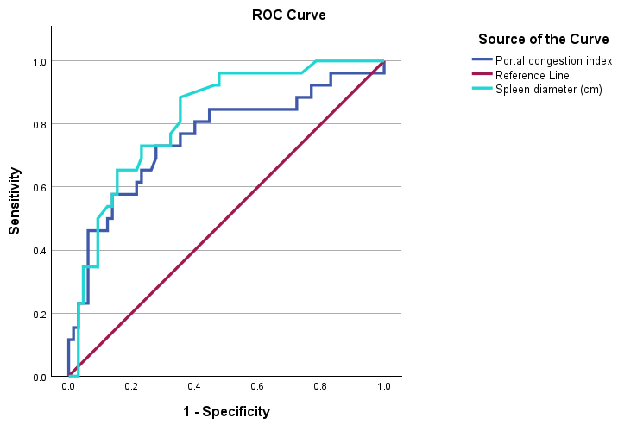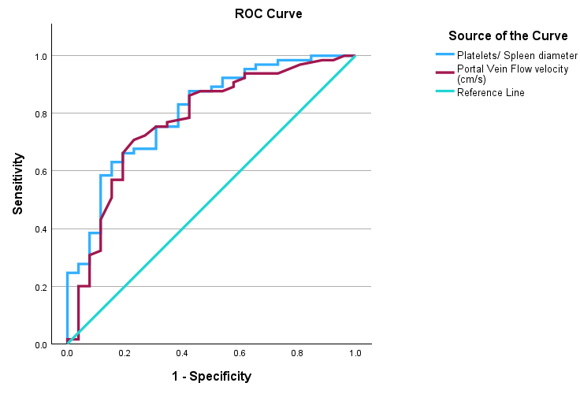
4 (a) 4 (b)
4 (a): ROC curve analysis of spleen diameter (AUC= 0.819) and PCI (AUC=0.755) for predicting the presence of varices in UGIH among patients without prior history of CLD
4 (b): ROC curve analysis of PVFV (AUC= 0.773) and PC/SD (AUC=0.801) for predicting the absence of varices in UGIH among patients without prior history of CLD
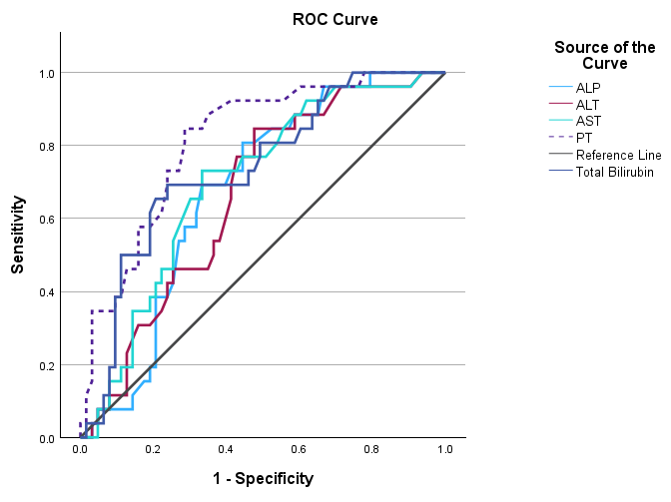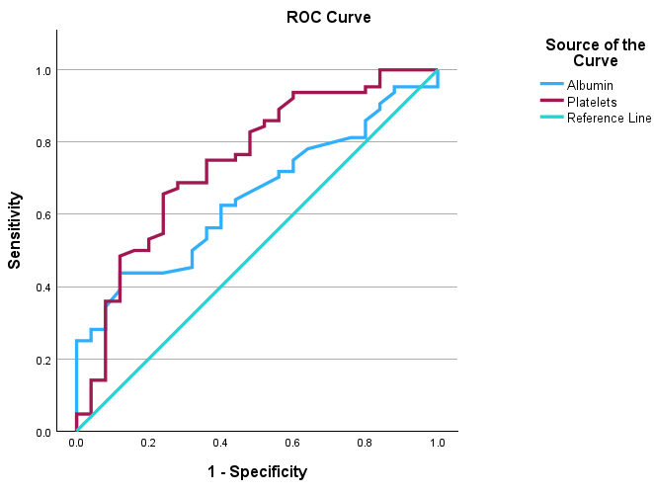
4 (c) 4 (d)
4 (c): ROC curve analysis of ALP (AUC=0.678 ), ALT (AUC=0.673), AST (AUC= 0.698), PT (AUC=0.814) and total bilirubin (AUC= 0.737) for predicting the presence of varices in UGIH among patients without prior history of CLD
4 (d): ROC curve analysis of albumin (AUC= 0.647) and Platelets (AUC=0.745) for predicting the absence of varices in UGIH among patients without prior history of CLD

Supplementary table 6:
Comparison of POCUS parameters between Patients with Varices and Patients without Varices on UGIE among study participants not on non-selective beta blockers (n=129)

Supplementary figure 5:
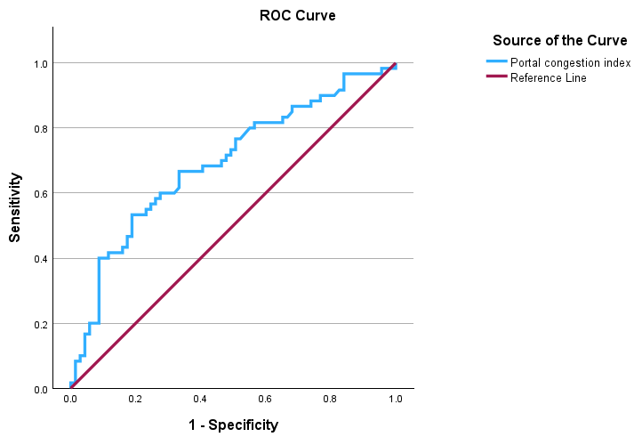
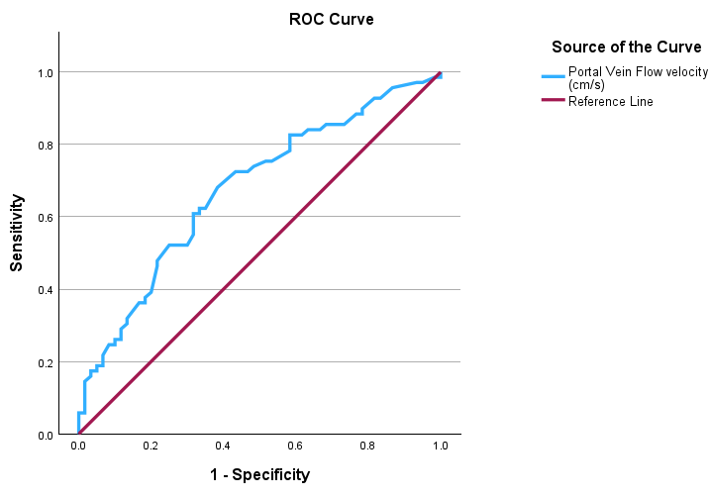
Parameter | Varices absent (n=69) | Varices present (n=60) | p-value
Portal vein diameter (mm) | 9.02 ± 2.70 | 9.94 ± 2.79 | 0.058*
Portal vein velocity (cm/s) | 14 (10.55- 18.45) | 10.7 (8.54- 13.95) | <0.001#
Portal vein CSA (cm²) | 0.64 (0.50-0.83) | 0.75 (0.53-0.95) | 0.074#
Portal vein congestion index | 0.04 (0.03-0.06) | 0.07 (0.04-0.09) | <0.001#
5 (a) 5 (b)
5 (a): ROC curve analysis of PVFV (AUC= 0.676) for predicting the absence of varices in UGIH among patients not on non-selective beta blockers
5 (b): ROC curve analysis of PCI (AUC=0.693) for predicting the presence of varices in UGIH among patients not on non-selective beta blockers

Supplementary Figure 6: Correlation of systolic blood pressure with portal vein flow velocity (6 a) and portal vein diameter (6 b)
6(a)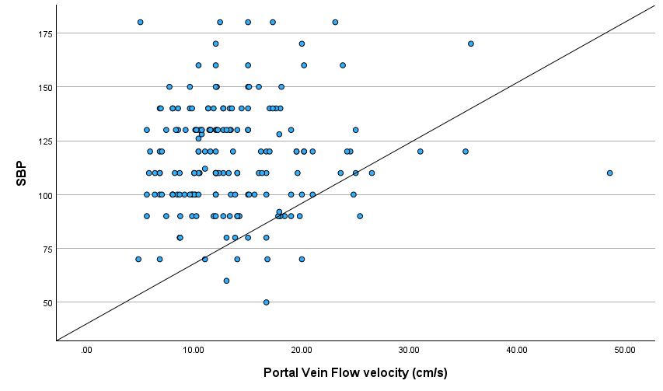

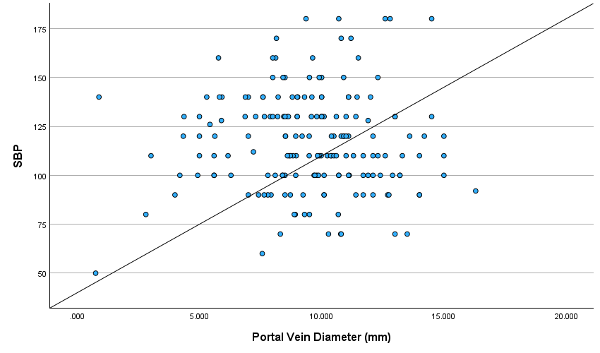
6 (b)

Supplementary table 7: Summary of cut-off values for POCUS parameters from previous studies predicting varices
Studies | Place of Study | Study Population | PVD (mm) | PVFV (cm/s) | PCI | SD (cm) | PC (per mm3)/SD  (mm) | Platelet counts (10³/µL)
Naik, et al | Karnataka, India | UGIH |  | < 14 |  | ≥ 12 | < 1741 | < 155
Nouh et al (20) | Egypt | CLD | 10.4 | 15.2 | 0.1 |  | 604
Bhattarai et al (17) | Nepal | CLD | 12.25 |  |  | 13.9
Elkenawy et al (6) | Egypt | CLD |  | 19 |  |  |  | 1,40,000/µL
Katwal et al (7) | Nepal | CLD | 13 | 19 | 0.1
Shanker et al (15) | Jaipur, India | CLD | 12.2 |  |  | 13.5
Wasif Khan et al (10) | Lahore | CLD |  | 18
Zhang et al (16) | China | CLD | 14.3 | 19.6 |  | 16.2
Shastri et al (23) | Vadodara, India | CLD | 13 | 16 | 0.1
Zironi et al (24) | Italy | CLD |  | 15 |  |  |  | 40,000/µL
Cherian et al (8) | Chennai, India | CLD | 13 |  |  | 15 | 666
Patil et al (21) | Bhubaneshwar, India | CLD |  |  |  |  | 1400
Baig et al (22) | Karnataka, India | CLD |  |  |  |  | 1014

Studies | Study Population | APRI | AAR | FIB-4 | King | Lok
Naik, et al | UGIH | 0.86 | 1.94 | 3.59 | 20.34 | 0.65
Pandey et al (9) | CLD | 1.4 | 1.7 | 6.4 | 46.5 | 0.97
Civan et al (5) | UGIH | 1.4
Liu et al (26) | CLD | 1.33 |  | 3.83 | 19.38 | 1.62
Zhang et al (25) | CLD | 1.4 | 1.3
Tarar et al (27) | CLD |  |  |  |  | 0.335
Hassan et al (28) | HCV- related CLD | 0.85 | 0.67 | 2.8 | 24.7

Supplementary Table 8 : Summary of Fibrosis Score Cut-off Values from Previous Studies for Variceal Prediction

