Supplementary materials

Test interpretation band (band number) | Infection status by Clinical adjudication |  | Sensitivity | Specificity | Likelihood ratio (LR)
Very high (5) | yes ($y_{5}$) | no ($x_{5}$) | $$\frac{y_{5}}{\sum_{n=1}^{5}{y_{n}}}$$ | $$\frac{x_{4}+x_{3}+x_{2}+x_{1}}{\sum_{n=1}^{5}{x_{n}}}$$ | $$\frac{sensitivity}{1-specificity}$$
High (4) | yes ($y_{4}$) | no ($x_{4}$) | $$\frac{y_{4}}{\sum_{n=1}^{5}{y_{n}}}$$ | $$\frac{x_{5}+x_{3}+x_{2}+x_{1}}{\sum_{n=1}^{5}{x_{n}}}$$ | $$\frac{sensitivity}{1-specificity}$$
Moderate (3) | yes ($y_{3}$) | no ($x_{3}$) | $$\frac{y_{3}}{\sum_{n=1}^{5}{y_{n}}}$$ | $$\frac{x_{1}+x_{2}+x_{4}+x_{5}}{\sum_{n=1}^{5}{x_{n}}}$$ | $$\frac{sensitivity}{1-specificity}$$
Low (2) | yes ($y_{1}$) | no ($x_{1}$) | $$\frac{y_{5}+y_{4}+y_{3}+y_{1}}{\sum_{n=1}^{5}{y_{n}}}$$ | $$\frac{x_{2}}{\sum_{n=1}^{5}{x_{n}}}$$ | $$\frac{1-sensitivity}{specificity}$$
Very low (1) | yes ($y_{1}$) | no ($x_{1}$) | $$\frac{y_{5}+y_{4}+y_{3}+y_{2}}{\sum_{n=1}^{5}{y_{n}}}$$ | $$\frac{x_{1}}{\sum_{n=1}^{5}{x_{n}}}$$ | $$\frac{1-sensitivity}{specificity}$$
Table S1. Calculation of accuracy for bacterial and viral interpretation bands (Same calculation for severity with the respective endpoint).

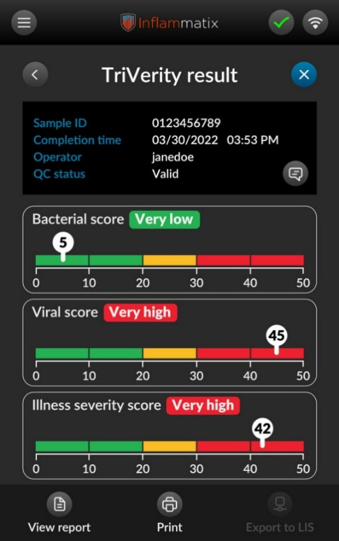

Figure S1. Example output of the TriVerity Test on the Inflammatix Myrna instrument.
The TriVerity Test reports three independent scores: likelihood of bacterial infection, likelihood of viral infection, and illness severity. Each score is categorized into one of five predefined interpretation bands: Very High, High, Moderate, Low, and Very Low. Bands classified as Very High or High indicate a rule-in result; bands classified as Low or Very Low indicate a rule-out result. The Moderate band is considered non-actionable. Results are generated from whole blood collected in PAXGene RNA tubes, with a turnaround time of approximately 30 minutes.

1 | Ruled Out: [Bacterial/Viral] infection ruled out by clinical assessment, with another definitive diagnosis established.
2 | Unlikely: [Bacterial/Viral] infection unlikely based on clinical assessment, but no other definitive diagnosis established, or a microorganism detected but interpreted as colonization rather than a cause of infection.
3 | Probable: [Bacterial/Viral] infection probable based on clinical assessment, but not confirmed by microbiological, PCR, or other laboratory results.
4 | Rule In: [Bacterial/Viral] infection proven by clinical assessment, supported by microbiological or other laboratory test results.
Table S2. Definitions for adjudication of infection status. Adjudication was performed independently by two physicians blinded to TriVerity results. Discordant cases were resolved by a third adjudicator. For consensus adjudication (CA), only ruled-in and ruled-out categories were used; probably and unlikely were classified as inconclusive and excluded. For forced adjudication (FA), probably was classified as ruled-in and unlikely as ruled-out, retaining all patients for analysis.

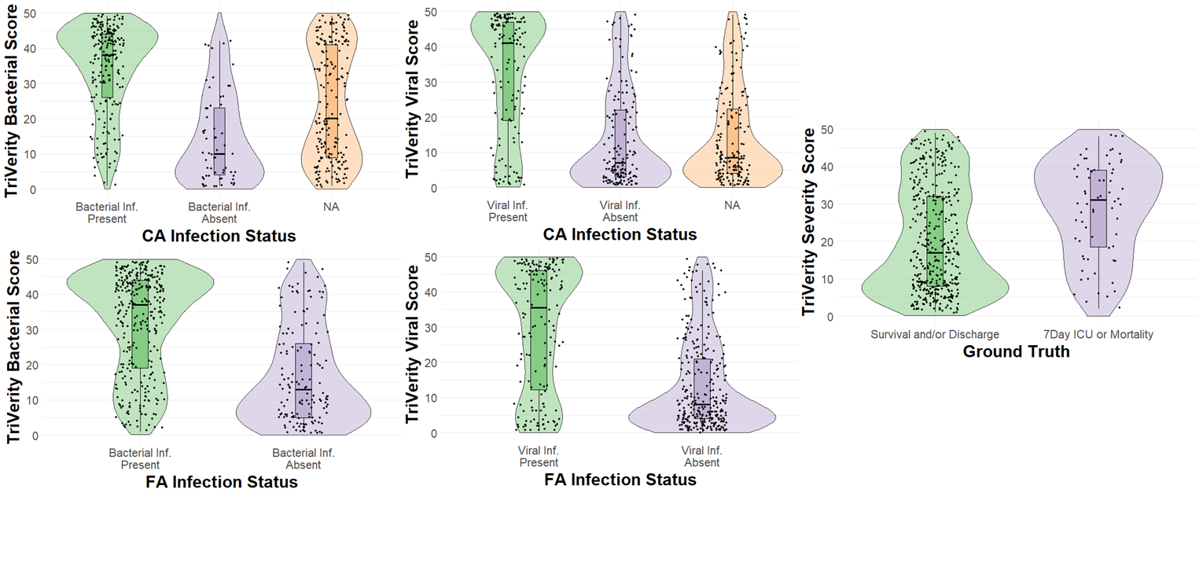Figure S2. TriVerity Interpretation score Distributions for Infection and Severity Outcomes. Distribution of TriVerity scores across interpretation bands for bacterial infection, viral infection, and illness severity. Violin/box plots represent the proportion of patients classified into each of the five predefined bands (very low, low, moderate, high, and very high), stratified by the reference standard (clinical adjudication for bacterial/viral infection and 7-day medium care unit/ICU admission or mortality for severity). CA = consensus adjudication, FA = forced adjudication. NA = patients excluded by CA adjudication (ruled-in and ruled-out cases were considered positive or negative for (bacterial or viral) infection, while probably and unlikely were deemed inconclusive and excluded from analysis).

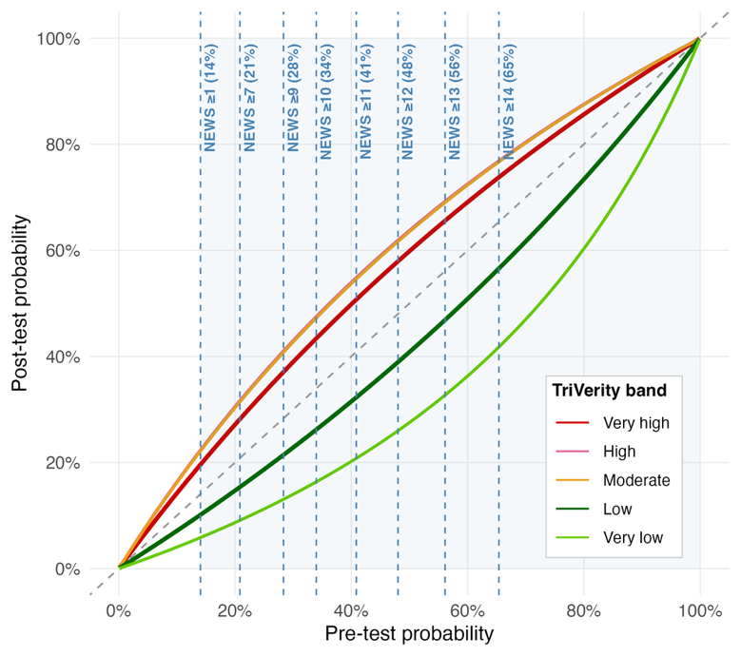
Figure S3. Results of integrated analysis of NEWS and TriVerity severity prediction. Pre-test probability was based on the observed incidence in this cohort (14%; odds 0.163). Likelihood ratios for NEWS score categories were derived from Churpek et al. (n=30,677) [39]. Each curve represents a TriVerity severity band; post-test probability was calculated by sequential multiplication of NEWS and TriVerity likelihood ratios. LR = likelihood ratio.

