WEB APPENDIX

Table of Contents

A. Survey questions 2
A.1. Understanding score 2
A.2. Cognitive ability score 5
A.3. Financial literacy score 5
A.4. Risk preference score 6
A.5. Notice correlation 7
A.6. Tendency to form separate mental accounts 10
A.7. Satisfaction with the outcome distribution 12
B. Regression analysis results on the inefficiency of investors’ decisions 13
B.1. Robust linear regressions on loss in returns and excessive risk in Experiment 1 13
B.2. Robust linear regressions on loss in returns and excessive risk in Experiment 2 14
B.3. Robust linear regressions on loss in returns and excessive risk in Experiment 3 15

Survey questions
All questions in the appendix were translated from Dutch into English. We italicized the correct answers for questions if feasible. Some questions were adapted for each experiment and presented in the appendix individually.

Understanding score
We would like to know whether you understand the information presented in the tool clearly. Please answer the following questions about the investment simulator.

[Experiment 1]
Imagine that your investment of €20,000 on the funds will give you a return following the distribution in the figure below. Please note that this is the identical funds to those you made investment decisions [earlier in the tool], but possibly with a different choice on the risk.
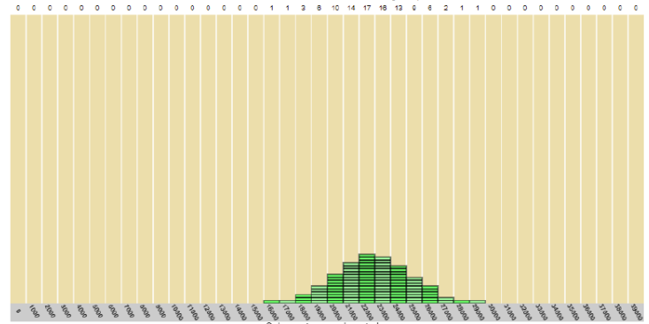

Q1. What is the probability that you will receive €25,000 or more?
- The chance is less than 5% (5 per 100 cases)
- The chance is between 5% and 25% (between 5 and 25 per 100 cases)
- The chance is higher than 25% (25 per 100 cases)

Q2. When the risk level of the investment is reduced, what would the probability that you will receive €25,000 or more be?
- The chance will increase
- The chance will decrease
- The chance will stay the same

[Experiment 2 and 3]
Imagine that your investment of €200 on the funds will give you a return following the distribution in the figure below. Please note that this is the identical funds to those you made investment decisions [earlier in the tool], but possibly with a different choice on the risk.
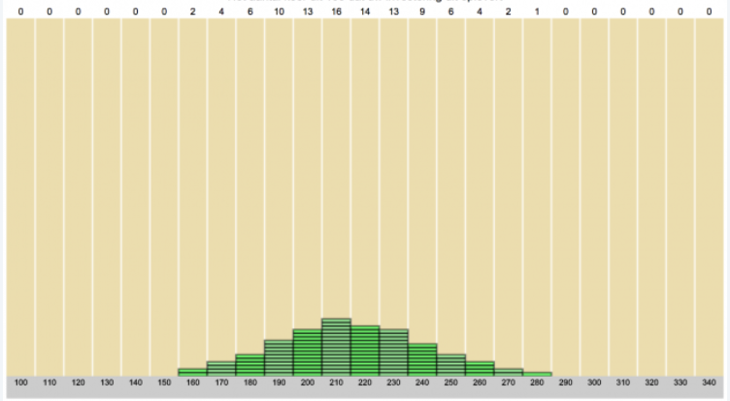

Q1. What is the probability that you will receive €250 or more?
- The chance is less than 5% (5 per 100 cases)
- The chance is between 5% and 25% (between 5 and 25 per 100 cases)
- The chance is higher than 25% (25 per 100 cases)

Q2. When the risk level of the investment is reduced, what would the probability that you will receive €250 or more be?
- The chance will increase
- The chance will decrease
- The chance will stay the same

[Common to all experiments]
Please note that different investment decisions lead the different investment incomes. In the figure below, you will see the return distribution of two different investments.
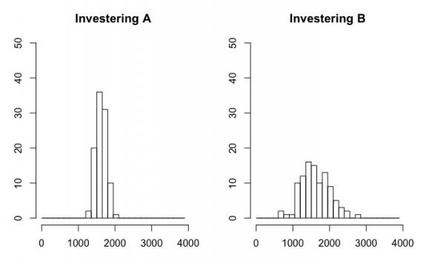
Q3. Which investments will give you the most uncertain income?
- Investment A
- Investment B
- No difference between both investments

Please note again that different investment decisions lead the different investment incomes. In the figure below, you will see the return distribution of two different investments.
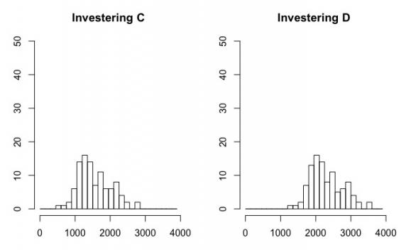
Q4. Which investments will give you the highest income?
- Investment C
- Investment D
- No difference between both investments

Cognitive ability score
[Common to all experiments]
We would like to know your analytical skills. Please answer the following questions.

Q5. A racket and a ball cost €1.10 in total. The racket costs €1.00 more than the ball. How much does the ball cost?
A: The ball costs __ cents. (5 cents)

Q6. If it takes 5 machines 5 minutes to make 5 widgets, how long would it take 100 machines to make 100 widgets?
A: It takes __ minutes. (5 minutes)

Q7. In a lake, there is a patch of lily pads. Every day, the patch doubles in size. If it takes 48 days for the patch to cover the entire lake, how long would it take for the patch to cover half of the lake?
A: It takes __ days. (47 days)

[Only for Experiment 3]
Q8. How familiar are you with above three questions?
- Not at all familiar (1)
- Slightly familiar (2)
- Somewhat familiar (3)
- Moderately familiar (4)
- Extremely familiar (5)

Financial literacy score
[Common to all experiments]
We would like to know your financial knowledge. Please answer the following questions.

Q9. If someone buys the stock of firm B in the stock market, which of the following statements is correct?
- He owns part of form B
- He has lent money to firm B
- He is liable for B’s debts
- None of above statements are correct

Q10. Considering a long-time period (e.g. 10 or 20 years), which asset normally gives the highest return?
- Saving accounts
- Bonds
- Stocks
- Don’t know

Q11. Normally, which asset displays the highest fluctuations over time?
- Savings accounts
- Bonds
- Stock
- Don’t know

Q12. When an investor spreads his money across different assets, the risk of losing money:
- Increases
- Decreases
- Stays the same
- Don’t know

Risk preference score
[Common to all experiments]
Q13. Please indicate how much risk you would like to take with your investments.
- 1 (not willing to take any risk)
- 2
- 3
- 4
- 5
- 6
- 7 (willing to accept substantial risk to potentially earn a greater return)

Q14. Please choose the one sentence that best characterizes your risk preferences.
- I am not at all willing to take a high risk even if I get a high expected return for it (1)
- I am unwilling to take a high risk even if I get a high expected return for it (2)
- I am willing to take a high risk if I get a high expected return for it (3)
- I am very willing to take a high risk if I get a high expected return for it (4)

Notice correlation
[Experiment 1]
Imagine that your investment decision on two funds will give you returns following the distributions in the figure below. Suppose that the outcome of your investment (of €10,000) for the fund on the left is positive (i.e., the outcome is more than €10,000).

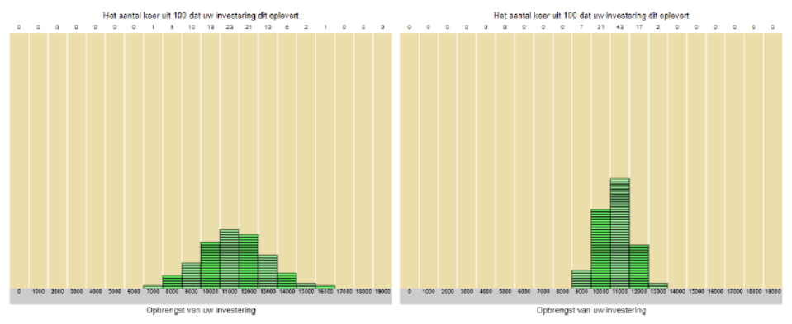

Q15. What do you think how much you will receive from the fund on the right?
- €10,000 or less
- €11,000 or more

[Experiment 2]
Imagine that your investment decision on two funds will give you returns following the distributions in the figure below. Suppose that you receive €70 from the fund on the left.

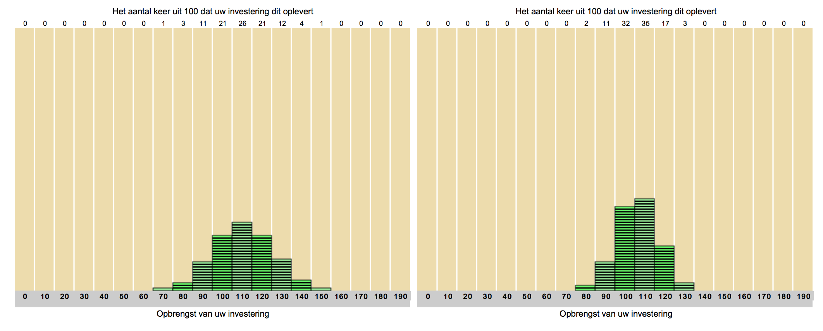

Q15. What do you think how much you will receive from the fund on the right?
- Less than €110
- More than €100
- Anything possible

[Experiment 3]
Imagine that your investment decision on two funds will give you returns following the distributions in the figure below. Suppose that the outcome of your investment (of €10,000) for the fund on the left is positive (i.e., the outcome is more than €10,000).

Q15. What do you think how much you will receive from the fund on the right?
- €10,000 or less
- €11,000 or more
- Anything possible

Imagine that your investment on two accounts will give outputs, as shown in the figure below, respectively.
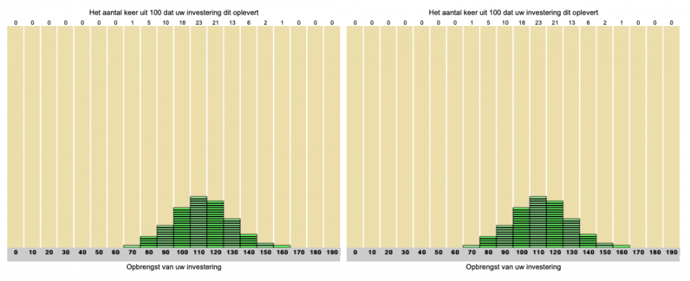

Q16. What would the probability of the joint outcome being equal to or below than 180 be?
- Less than 3%
- Between 3% and 8%
- Between 9% and 13%
- More than 13%

Q17. What would the probability of the joint outcome being equal to or above than 280 be?
- Less than 1%
- Between 1% and 3%
- Between 4% and 7%
- More than 7%

Tendency to form separate mental accounts
[Experiment 1]
Imagine that you want to buy a car for €15,000 and renovate a kitchen for €10,000. You have saved money for both purchases in separate accounts, which currently have €15,000 for the car and €8,000 for the kitchen, respectively.

Suppose that you decide to buy the car. However, the car has become more expensive and costs €16,000 now, so you are still €1,000 short.

Q18. How likely would you transfer money from the account for the kitchen to purchase the car?
- 0 (Very unlikely)
- 1
- 2
- 3
- 4
- 5
- 6
- 7
- 8
- 9
- 10 (Very likely)

[Experiment 3]
Imagine that you invest in two investment funds, where you have a different investment goal in each investment fund. In one fund account, you have invested €10,000 to renovate your kitchen. In another account, you have invested €10,000 to repay a loan of €9,500.

Q18. Imagine now that you want to start with the kitchen renovation. You have not yet repaid the loan. However, it turns out that the costs of renovation you had in mind have risen sharply. The total costs for this are now €11,000. How likely would you transfer money from the other account to pay for the more expensive kitchen?
- 0 (Very unlikely)
- 1
- 2
- 3
- 4
- 5
- 6
- 7
- 8
- 9
- 10 (Very likely)

Q19. Now imagine the opposite situation. You plan to repay the loan now. The kitchen renovation is not yet planned. However, you also owe €1,500 on your credit card. Therefore, your total debt amounts to €11,000. How likely would you transfer money from the other account to pay off your debts in full?
- 0 (Very unlikely)
- 1
- 2
- 3
- 4
- 5
- 6
- 7
- 8
- 9
- 10 (Very likely)

Satisfaction with the outcome distribution
[Only for Experiment 3]
How satisfied are you with the distribution of possible outcomes?
- 1 (Very dissatisfied)
- 2
- 3
- 4
- 5
- 6
- 7 (Very satisfied)

Regression analysis results on the inefficiency of investors’ decisions

Robust linear regressions on loss in returns and excessive risk in Experiment 1
 | (1) Dep.: Loss in returns |  | (2) Dep.: Excessive risks
 | Coeff. | Std. Err. | Coeff. | Std. Err.
Constant | 0.003 | 0.003 | 0.006 | 0.005
Investment goal condition: Carª | 0.000 | 0.001 | 0.001 | 0.002
Investment goal condition: Kitchenª | 0.002 | 0.001 | 0.003 | 0.002
Male | 0.000 | 0.001 | 0.000 | 0.002
Age | -0.000 | 0.000 | -0.000 | 0.000
Schooling | -0.000 | 0.000 | -0.000 | 0.001
Income | 0.001* | 0.000 | 0.002* | 0.001
Financial literacy | -0.000 | 0.000 | -0.000 | 0.001
Understanding | 0.000 | 0.000 | 0.001 | 0.001
Cognitive ability | -0.001 | 0.000 | -0.001 | 0.001
Risk preference | 0.000 | 0.000 | 0.001 | 0.001
Awareness of correlation | -0.000 | 0.001 | -0.001 | 0.002
Tendency to form mental accounts | -0.000 | 0.000 | -0.000 | 0.000
Adj R-squared | 0.01 |  | 0.01
Note: N=598. *p<0.05. Estimates over all three investment goal conditions. Coeff. and Std. Err. stand for the coefficients and corresponding standard errors, respectively.
ª Baseline goal condition is the combined car and kitchen goal

Robust linear regressions on loss in returns and excessive risk in Experiment 2
 | (1) Dep.: Loss in returns |  | (2) Dep.: Excessive risks
 | Coeff. | Std. Err. | Coeff. | Std. Err.
Constant | -0.008 | 0.056 | -0.024 | 0.107
Positive correlation condition  (vs. no correlation condition) | 0.160* | 0.080 | 0.328* | 0.015
Male | -0.005 | 0.009 | -0.009 | 0.016
Age | -0.001 | 0.000 | -0.001 | 0.001
Schooling | -0.009* | 0.004 | -0.017* | 0.008
Log(income) | 0.005 | 0.006 | 0.010 | 0.011
Financial literacy | 0.003 | 0.004 | 0.006 | 0.008
Understanding | -0.001 | 0.004 | -0.003 | 0.008
Cognitive ability | 0.004 | 0.004 | 0.007 | 0.008
Risk preference | 0.011* | 0.004 | 0.021* | 0.008
Adj R-squared | 0.46 |  | 0.49
Note: N=310. * p<0.05. Coeff. and Std. Err. stand for the coefficients and corresponding standard errors, respectively.

Robust linear regressions on loss in returns and excessive risk in Experiment 3
 | (1) Dep.: Loss in returns |  | (2) Dep.: Excessive risks
 | Coeff. | Std. Err | Coeff. | Std. Err
Constant | 0.052* | 0.024 | 0.080* | 0.025
Investment goal condition: Kitchenª | -0.001 | 0.008 | -0.003 | 0.009
Investment goal condition: Loanª | -0.003 | 0.008 | -0.002 | 0.009
Correlation condition: Negative^{b} | 0.060* | 0.007 | 0.041* | 0.007
Male | 0.012 | 0.007 | 0.013 | 0.008
Age | -0.000 | 0.000 | -0.000 | 0.000
Schooling | 0.001 | 0.003 | -0.002 | 0.004
Income | -0.004 | 0.003 | -0.006 | 0.003
Financial literacy | 0.003 | 0.003 | 0.005 | 0.003
Understanding | -0.003 | 0.003 | -0.001 | 0.004
Cognitive ability | 0.000 | 0.003 | 0.000 | 0.004
Risk preference | 0.006 | 0.004 | 0.006 | 0.004
Awareness of correlation | 0.008 | 0.008 | 0.010 | 0.009
Tendency to form combined mental accounts for renovating a kitchen | 0.003 | 0.001 | 0.003 | 0.002
Tendency to form combined mental accounts for repaying a loan | 0.000 | 0.001 | 0.000 | 0.001
Adj R-squared | 0.02 |  | 0.01
Note: N=1468. *p<0.05. Estimates over all six between-subject conditions.
ª Baseline goal condition is the combined kitchen and loan goal
^{b} Baseline correlation condition is no correlation

