Web Appendix: Revisiting Gaussian copulas to handle endogenous regressors

Table of Contents
Web Appendix 1: Literature Review |  | Page(s)
 | Figure WA.1.1. Use of the Gaussian copula approach in publications over time | 2
 | Figure WA.1.2. Inclusion of an intercept in Gaussian copula applications | 2
 | References of all included studies | 3-7
Web Appendix 2: Additional Results of Simulation Study 1
 | Table WA.2.1. Parameter bias of the endogenous regressor | 8
 | Table WA.2.2. Parameter bias of the copula term | 9
 | Table WA.2.3. Percentage of statistically significant parameters (power) | 10
Web Appendix 3: Additional Results of Simulation Study 3
 | Table WA.3.1. Bias and power of selected total sample sizes in the multilevel model | 11
Web Appendix 4: Additional Results of Simulation Study 4
 | Design of the simulation study | 12-14
 | Figure WA.4.1. Power differences of the maximum likelihood and the control function approach for different distribution parameters, sample sizes, and endogeneity levels | 15-16
 | Figure WA.4.2. Power of Gaussian copula approach for different distributions parameters, sample sizes, and endogeneity levels | 17
 | Figure WA.4.3. Power of the copula term for different levels of nonnormality and sample sizes | 18
 | Figure WA.4.4. Decision tree for predicting an 80% power of the copula term | 19
 | Figure WA.4.5. Additional decision trees predicting an 80% power of the copula term | 20
 | Table WA.4.1. Expectations regarding the simulation factors’ effects | 21-22
 | Table WA.4.2. Effects of key simulation factors on the Gaussian copula maximum likelihood approach’s performance | 23
 | Table WA.4.3. p-values from regressing performance criteria on simulation factors | 24
 | Table WA.4.4. Correspondence analysis of nonnormality tests and the copula term’s significance | 25-26
 | Table WA.4.5. Skewness and kurtosis of the distributions in the simulation | 27
 | Table WA.4.6. Average R² value per simulation design condition | 27
Web Appendix 5: Additional Results of Simulation Study 5
 | Design of the simulation study | 28-29
 | Figure WA.5.1. Power of the copula term for different error term distributions in the copula model with intercept | 30
 | Figure WA.5.2. Power of the endogenous regressor for different error term distributions in the copula model with intercept | 30
 | Figure WA.5.3. Bias of the endogenous regressor for the different copulas with and without intercept | 31
 | Figure WA.5.4. Power of the copula term for the different copula models | 32
 | Figure WA.5.5. Power of the endogenous regressor for the different copula models | 33
 | Table WA.5.1. Nonnormality statistics of the regression residual for different error term distributions | 34
Web Appendix 6: Software used for simulation
 | Software used for simulation | 35
 | Table WA.6.1. R packages used for simulation | 35

Web Appendix 1: Literature review
Figure WA.1.1. Use of the Gaussian copula approach in publications over time
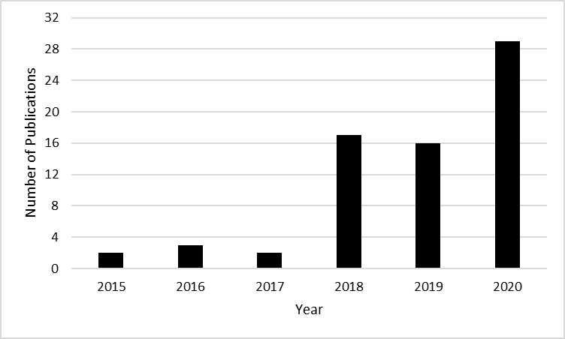

Figure WA.1.2. Inclusion of an intercept in Gaussian copula applications
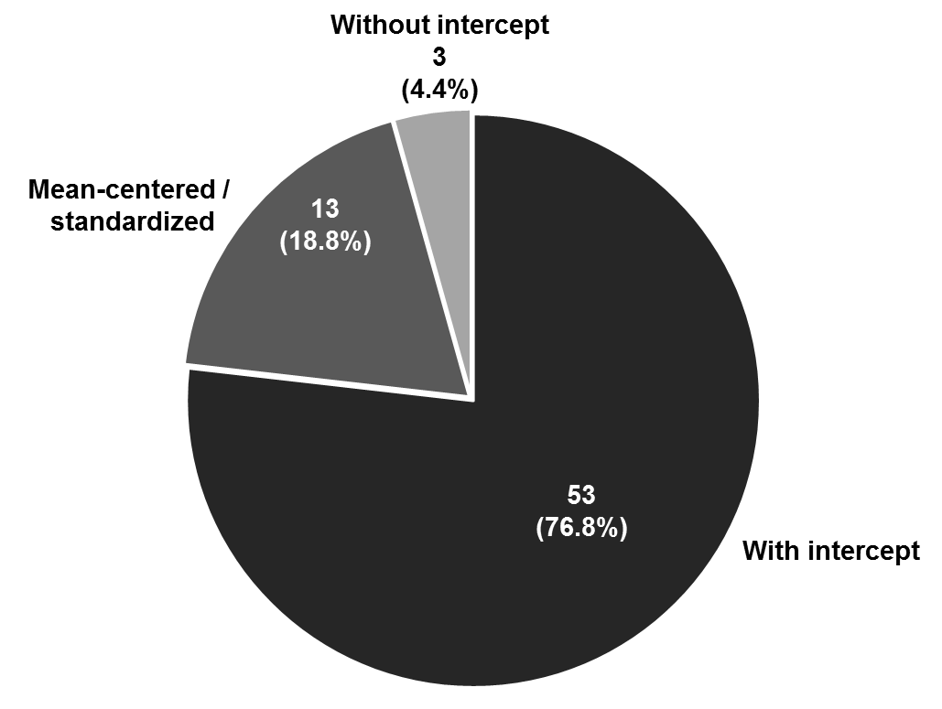

References of all included studies
Please note that we last updated our literature review in December 2020. We included articles that are in press with their online publication year. After publication in a regular issue, the year of these articles might have changed.

Atefi, Y., Ahearne, M., Maxham III, J. G., Donavan, D. T., & Carlson, B. D. (2018). Does selective sales force training work? Journal of Marketing Research, 55, 722–737.
Aydinli, A., Lamey, L., Millet, K., ter Braak, A., & Vuegen, M. (2020). How do customers alter their basket composition when they perceive the retail store to be crowded? An empirical study. Journal of Retailing, in press.
Bandyopadhyay, S., & Green, E. (2018). Urbanization and mortality decline. Journal of Regional Science, 58, 483–503.
Bhattacharya, A., Good, V., Sardashti, H., & Peloza, J. (2020). Beyond warm glow: The Risk-mitigating effect of Corporate Social Responsibility (CSR). Journal of Business Ethics, in press.
Blauw, S., & Franses, P. H. (2016). Off the hook: Measuring the impact of mobile telephone use on economic development of households in Uganda using copulas. The Journal of Development Studies, 52, 315–330.
Bombaij, N. J. F., & Dekimpe, M. G. (2020). When do loyalty programs work? The moderating role of design, retailer-strategy, and country characteristics. International Journal of Research in Marketing, 37, 175–195.
Bornemann, T., Hattula, C., & Hattula, S. (2020). Successive product generations: Financial implications of industry release rhythm alignment. Journal of the Academy of Marketing Science, 48, 1174–1191.
Burmester, A. B., Becker, J. U., van Heerde, H. J., & Clement, M. (2015). The impact of pre-and post-launch publicity and advertising on new product sales. International Journal of Research in Marketing, 32, 408–417.
Campo, K., Lamey, L., Breugelmans, E., & Melis, K. (2020). Going online for groceries: Drivers of category-level share of wallet expansion. Journal of Retailing, in press.
Carson, S. J., & Ghosh, M. (2019). An integrated power and efficiency model of contractual channel governance: Theory and empirical evidence. Journal of Marketing, 83, 101–120.
Cottle, G. W., & Anderson, B. S. (2020). The temptation of exaggeration: Exploring the line between preparedness and misrepresentation in entrepreneurial pitches. Journal of Business Venturing Insights, 14, 1–8.
Datta, H., Ailawadi, K. L., & van Heerde, H. J. (2017). How well does consumer-based brand equity align with sales-based brand equity and marketing-mix response? Journal of Marketing, 81, 1–20.
Datta, H., Foubert, B., & van Heerde, H. J. (2015). The challenge of retaining customers acquired with free trials. Journal of Marketing Research, 52, 217–234.
De Almeida, M. I. S., Coelho, R. L. F., de Oliveira, D. S., Camarqo, A., & Savion, P. (2020). Sales-based brand equity as a performance driver in ‘the country of soccer’. Revista de Administração Contemporânea, 24, 134–150.
De Jong, A., Zacharias, N. A., & Nijssen, E. J. (2020). How young companies can effectively manage their slack resources over time to ensure sales growth: the contingent role of value-based selling. Journal of the Academy of Marketing Science, in press.
Elshiewy, O., & Boztug, Y. (2018). When back of pack meets front of pack: How salient and simplified nutrition labels affect food sales in supermarkets. Journal of Public Policy & Marketing, 37, 55–67.
Garrido-Morgado, Á., González-Benito, Ó., Martos-Partal, M., & Campo, K. (2020). Which Products are More Responsive to In-Store Displays: Utilitarian or Hedonic? Journal of Retailing, in press.
Gielens, K., Geyskens, I., Deleersnyder, B., & Nohe, M. (2018). The new regulator in town: The effect of Walmart’s sustainability mandate on supplier shareholder value. Journal of Marketing, 82, 124–141.
Gijsbrechts, E., Campo, K., & Vroegrijk, M. (2018). Save or (over-) spend? The impact of hard-discounter shopping on consumers’ grocery outlay. International Journal of Research in Marketing, 35, 270–288.
Gill, T., Ma, Z., Zhao, P., & Chen, Y. K. (2020). How accessories add value to a platform: the role of innovativeness and nonalignability. European Journal of Marketing, in press.
Gim, G. C., & Cheahb, W. S. (2020). Pay satisfaction and organizational trust: an importance-performance map analysis, Journal of Applied Structural Equation Modeling, 4,1–16.
Gruner, R. L., Vomberg, A., Homburg, C., & Lukas, B. A. (2019). Supporting new product launches with social media communication and online advertising: Sales volume and profit implications. Journal of Product Innovation Management, 36, 172–195.
Guitart, I. A., Gonzalez, J., & Stremersch, S. (2018). Advertising non-premium products as if they were premium: The impact of advertising up on advertising elasticity and brand equity. International Journal of Research in Marketing, 35, 471–489.
Guitart, I. A., Hervet, G., & Gelper, S. (2020). Competitive advertising strategies for programmatic television. Journal of the Academy of Marketing Science, 48, 753–775.
Guitart, I. A., & Stremersch, S. (2020). The Impact of Informational and Emotional Television Ad Content on Online Search and Sales. Journal of Marketing Research, in press.
Heitmann, M., Landwehr, J. R., Schreiner, T. F., & van Heerde, H. J. (2020). Leveraging brand equity for effective visual product design. Journal of Marketing Research, 57, 257–277.
Hult, G. T. M., Hair, J. F., Proksch, D., Sarstedt, M., Pinkwart, A., & Ringle, C. M. (2018). Addressing endogeneity in international marketing applications of partial least squares structural equation modeling. Journal of International Marketing, 26, 1–21.
Jaeger, L., Eckhardt, A., & Kroenung, J. (2020). The role of deterrability for the effect of multi-level sanctions on information security policy compliance: Results of a multigroup analysis. Information & Management, in press.
Kabir, M. R. (2020). Behavioural intention to adopt blockchain for a transparent and effective taxing system. Journal of Global Operations and Strategic Sourcing, in press.
Keller, W. I. Y., Deleersnyder, B., & Gedenk, K. (2019). Price promotions and popular events. Journal of Marketing, 83, 73–88.
Kim, N., & Kim, W. (2018). Do your social media lead you to make social deal purchases? Consumer-generated social referrals for sales via social commerce. International Journal of Information Management, 39, 38–48.
Kostov, P., Davidova, S., Bailey, A., Gjokaj, E., & Halimi, K. (2020). Can direct payments facilitate agricultural ommercialization: Evidence from a transition country. Journal of Agricultural Economics, 72, 72–96.
Kowalczuk, P., Siepmann, C., & Adler, J. (2020). Cognitive, affective, and behavioral consumer responses to augmented reality in e-commerce: A comparative study. Journal of Business Research, 124, 357–373.
Lamey, L., Deleersnyder, B., Steenkamp, J.-B. E. M., & Dekimpe, M. G. (2018). New product success in the consumer packaged goods industry: A shopper marketing approach. International Journal of Research in Marketing, 35, 432–452.
Lenz, I., Wetzel, H. A., & Hammerschmidt, M. (2017). Can doing good lead to doing poorly? Firm value implications of CSR in the face of CSI. Journal of the Academy of Marketing Science, 45, 677–697.
Lim, L. G., Tuli, K. R., & Dekimpe, M. G. (2018). Investors’ evaluations of price-increase preannouncements. International Journal of Research in Marketing, 35, 359–377.
Liu, H., Lobschat, L., Verhoef, P. C., & Zhao, H. (2020). The effect of permanent product discounts and order coupons on purchase incidence, purchase quantity, and spending. Journal of Retailing, in press.
Magnotta, S., Murtha, B., & Challagalla, G. (2020). The joint and multilevel effects of training and incentives from upstream manufacturers on downstream salespeople’s efforts. Journal of Marketing Research, 57, 695–716.
Maier, E., & Wieringa, J. (2020). Acquiring customers through online marketplaces? The effect of marketplace sales on sales in a retailer’s own channels. International Journal of Research in Marketing, in press.
Mathys, J., Burmester, A. B., & Clement, M. (2016). What drives the market popularity of celebrities? A longitudinal analysis of consumer interest in film stars. International Journal of Research in Marketing, 33, 428–448.
Nath, P., Kirca, A. H., Kim, S., & Andras, T. L. (2019). The effects of retail banner standardization on the performance of global retailers. Journal of Retailing, 95, 30–46.
Otten, C., Clement, M., & Stehr, D. (2019). Sales estimations in the book industry–comparing management predictions with market response models in the children’s book market. Journal of Media Business Studies, 16, 249–274.
Park, S. & Nicolau, J. L. (2019). Image effect on customer-centric measures of performance. Annals of Tourism Research, 76, 226-238.
Raza-Ullah, T. (2018). Experiencing the paradox of coopetition: A moderated mediation framework explaining the paradoxical tension–performance relationship. Long Range Planning, 53, 1–17.
Risselada, H., Verhoef P. C., & Bijmolt, T. H. (2016). Indicators of opinion leadership in customer networks: self-reports and degree centrality. Marketing Letters, 27, 449–460.
Roy, D., Mishra, A., & Sinha, K. K. (2020). Taxing the taxpayers: An empirical investigation of the drivers of baseline changes in US federal government technology programs. Manufacturing & Service Operations Management, in press.
Saleem, M. A., Li, J., & Afzal, H. (2020). Protect for affinity? The role of destination brand engagement in forming environmentally responsible tourist behaviours. Journal of Sustainable Tourism, in press.
Sarker, M., Mohd-Any, A. A., & Kamarulzaman, Y. (2020). Validating a consumer-based service brand equity (CBSBE) model in the airline industry. Journal of Retailing and Consumer Services, 59, 1–14.
Sarstedt, M., Ringle, C. M., Cheah, J. H., Ting, H., Moisescu, O. I., & Radomir, L. (2019). Structural model robustness checks in PLS-SEM. Tourism Economics, 26, 531–554.
Schlaegel, C., Engle, R. L., & Lang, G. (2020). The unique and common effects of emotional intelligence dimensions on job satisfaction and facets of job performance: An exploratory study in three countries. The International Journal of Human Resource Management, in press.
Schulz, P., Shehu, E., & Clement, M. (2019). When consumers can return digital products: Influence of firm-and consumer-induced communication on the returns and profitability of news articles. International Journal of Research in Marketing, 36, 454–470.
Schwipper, S., Peche, S., & Schmitz, G. (2020). Mobile location-based services’ value-in-use in inner cities: Do a customer’s shopping patterns, prior user experience, and Sales Promotions Matter? Schmalenbach Business Review, 72, 511–564.
Shehu, E., Papies, D., & Neslin, S. A. (2020). Free shipping promotions and product returns. Journal of Marketing Research, in press.
Svensson, G., Ferro, C., Høgevold, N., Padin, C., Varela, J. C. S., & Sarstedt, M. (2018), Framing the triple bottom line approach: Direct and mediation effects between economic, social and environmental elements. Journal of Cleaner Production, 197, 972–991.
Swani, K. (2020). To app or not to app: A business-to-business seller’s decision. Industrial Marketing Management, in press.
Tan, X., Lu, Y., & Tan, Y. (2019). The impact of subscription reciprocity on charitable content creation and sharing: Evidence from Twitter on Giving Tuesday. Management Information Systems Quarterly, in press.
Ter Braak, A. & Deleersnyder, B. (2018). Innovation cloning: The introduction and performance of private label innovation copycats. Journal of Retailing, 94, 312–327.
Vaid, S. S., Ahearne, M., & Krause, R. (2020). Joint marketing and sales appointment: Uncertainty from intertwining of marketing and sales in one position. Industrial Marketing Management, 85, 221–239.
Van Ewijk, B. J., Stubbe, A., Gijsbrechts, E., & Dekimpe, M. G. (2020). Online display advertising for CPG brands: (When) does it work? International Journal of Research in Marketing, in press.
Velu, S. R., Al Mamun, A., Kanesan, T., Hayat, N., & Gopinathan, S. (2019). Effect of information system artifacts on organizational resilience: A study among Malaysian SMEs. Sustainability, 11, 3177.
Vieira, V.A., de Almeida, M.I.S., Agnihotri, R., & Arunachalam S. (2019). In pursuit of an effective B2B digital marketing strategy in an emerging market. Journal of the Academy of Marketing Science, 47, 1085–1108.
Villena, V. H., Choi, T. Y., & Revilla, E. (2020). Mitigating mechanisms for the dark side of collaborative buyer–supplier relationships: A mixed‐method study. Journal of Supply Chain Management, in press.
Vomberg, A., Homburg, C., & Gwinner, O. (2020). Tolerating and managing failure: An organizational perspective on customer reacquisition management. Journal of Marketing, in press.
Wang X., Xu W., & Zhong Z. (2019). Economic policy uncertainty, CDS spreads, and CDS liquidity provision. Journal of Future Markets, 39, 461–480.
Wetzel, H. A., Hattula, S., Hammerschmidt, M., & van Heerde, H. J. (2018). Building and leveraging sports brands: Evidence from 50 years of German professional soccer. Journal of the Academy of Marketing Science, 46, 591–611.
Wlömert, N. & Papies, D. (2019). International heterogeneity in the associations of new business models and broadband Internet with music revenue and piracy. International Journal of Research in Marketing, 36, 400–419.
Yoon, H. D., Kim, N., Buisson, B., & Phillips, F. (2018). A cross-national study of knowledge, government intervention, and innovative nascent entrepreneurship. Journal of Business Research, 84, 243–252.
Zhang, R., Wang, J., & Hao, J. X. (2020). How does knowledge heterogeneity affect transactive memory system in innovation? Evidence from a field study. Journal of Knowledge Management, 24, 1965–1985.
Zhao, Y., Zhang, Y., Wang, J. F., Schrock, W. A., & Calantone, R. J. (2020). Brand relevance and the effects of product proliferation across product categories. Journal of the Academy of Marketing Science, 48, 1192–1210.

Web Appendix 2: Additional Results of Simulation Study 1

Table WA.2.1. Parameter bias of the endogenous regressor
Sample size | Model without a copula term |  |  |  | Copula model (control function) |  |  |  | Copula model (maximum likelihood)
Sample size | Without intercept | With intercept | Mean centered |  | Without intercept | With intercept | Mean centered |  | Without intercept | With intercept | Mean centered
100 | 0.416 | 1.687 | 1.687 |  | -0.010 | 1.023 | 1.034 |  | -0.010 | 1.023 | 1.034
200 | 0.420 | 1.684 | 1.684 |  | -0.003 | 0.758 | 0.764 |  | -0.003 | 0.757 | 0.764
400 | 0.421 | 1.700 | 1.700 |  | -0.007 | 0.502 | 0.505 |  | -0.007 | 0.502 | 0.504
600 | 0.426 | 1.699 | 1.699 |  | 0.001 | 0.386 | 0.388 |  | 0.001 | 0.386 | 0.387
800 | 0.424 | 1.692 | 1.692 |  | 0.000 | 0.285 | 0.286 |  | 0.000 | 0.285 | 0.286
1,000 | 0.425 | 1.694 | 1.694 |  | 0.000 | 0.235 | 0.236 |  | 0.000 | 0.234 | 0.235
2,000 | 0.425 | 1.693 | 1.693 |  | 0.002 | 0.117 | 0.117 |  | 0.002 | 0.116 | 0.116
4,000 | 0.423 | 1.691 | 1.691 |  | 0.000 | 0.043 | 0.043 |  | 0.000 | 0.042 | 0.042
6,000 | 0.422 | 1.692 | 1.692 |  | -0.001 | 0.045 | 0.045 |  | -0.001 | 0.043 | 0.044
8,000 | 0.422 | 1.692 | 1.692 |  | -0.002 | 0.022 | 0.022 |  | -0.002 | 0.020 | 0.020
10,000 | 0.423 | 1.690 | 1.690 |  | 0.000 | 0.015 | 0.015 |  | 0.000 | 0.014 | 0.014
20,000 | 0.424 | 1.694 | 1.694 |  | 0.000 | 0.011 | 0.011 |  | 0.000 | 0.010 | 0.010
40,000 | 0.423 | 1.692 | 1.692 |  | 0.000 | 0.003 | 0.003 |  | 0.000 | 0.002 | 0.002
60,000 | 0.423 | 1.692 | 1.692 |  | 0.000 | 0.001 | 0.001 |  | 0.000 | 0.000 | 0.000
Note: Bias = parameter estimate – true parameter

Table WA.2.2. Parameter bias of the copula term
Sample size | Copula model (control function) |  |  |  | Copula model (maximum likelihood)
Sample size | Without intercept | With intercept | Mean centered |  | Without intercept | With intercept | Mean centered
100 | -0.058 | -0.311 | -0.315 |  | -0.050 | -0.299 | -0.302
200 | -0.031 | -0.231 | -0.233 |  | -0.026 | -0.219 | -0.221
400 | -0.010 | -0.149 | -0.150 |  | -0.009 | -0.136 | -0.137
600 | -0.007 | -0.114 | -0.114 |  | -0.006 | -0.104 | -0.104
800 | -0.007 | -0.087 | -0.087 |  | -0.006 | -0.079 | -0.079
1,000 | -0.005 | -0.070 | -0.070 |  | -0.004 | -0.064 | -0.064
2,000 | -0.003 | -0.035 | -0.035 |  | -0.002 | -0.032 | -0.032
4,000 | -0.002 | -0.014 | -0.014 |  | -0.001 | -0.013 | -0.013
6,000 | -0.001 | -0.014 | -0.014 |  | 0.000 | -0.011 | -0.011
8,000 | 0.000 | -0.007 | -0.007 |  | 0.000 | -0.006 | -0.006
10,000 | -0.001 | -0.005 | -0.005 |  | -0.001 | -0.005 | -0.005
20,000 | 0.000 | -0.003 | -0.003 |  | 0.000 | -0.002 | -0.002
40,000 | 0.000 | -0.001 | -0.001 |  | 0.000 | -0.001 | -0.001
60,000 | 0.000 | -0.001 | -0.001 |  | 0.000 | 0.000 | 0.000
Note: Bias = parameter estimate – true parameter

Table WA.2.3. Percentage of statistically significant parameters (power)
Sample size | Model without a copula term |  |  |  | Copula model (control function) |  |  |  |  |  |  | Copula model (maximum likelihood)
Sample size | Without intercept | With intercept | Mean centered |  | Without intercept |  | With intercept |  | Mean centered |  |  | Without intercept |  | With intercept |  | Mean centered
Sample size | Regressor | Regressor | Regressor |  | Regressor | Copula term | Regressor | Copula term | Regressor | Copula term |  | Regressor | Copula term | Regressor | Copula term | Regressor | Copula term
100 | 96% | 62% | 62% |  | 100% | 98% | 1% | 3% | 1% | 3% |  | 100% | 99% | 8% | 30% | 8% | 31%
200 | 100% | 89% | 89% |  | 100% | 100% | 2% | 14% | 3% | 14% |  | 100% | 100% | 10% | 46% | 10% | 46%
400 | 100% | 99% | 99% |  | 100% | 100% | 8% | 42% | 8% | 42% |  | 100% | 100% | 17% | 71% | 17% | 72%
600 | 100% | 100% | 100% |  | 100% | 100% | 21% | 68% | 21% | 68% |  | 100% | 100% | 29% | 83% | 30% | 83%
800 | 100% | 100% | 100% |  | 100% | 100% | 31% | 83% | 31% | 84% |  | 100% | 100% | 39% | 92% | 40% | 92%
1,000 | 100% | 100% | 100% |  | 100% | 100% | 41% | 91% | 41% | 91% |  | 100% | 100% | 48% | 96% | 48% | 97%
2,000 | 100% | 100% | 100% |  | 100% | 100% | 80% | 100% | 79% | 100% |  | 100% | 100% | 81% | 100% | 81% | 100%
4,000 | 100% | 100% | 100% |  | 100% | 100% | 99% | 100% | 99% | 100% |  | 100% | 100% | 99% | 100% | 99% | 100%
6,000 | 100% | 100% | 100% |  | 100% | 100% | 100% | 100% | 100% | 100% |  | 100% | 100% | 100% | 100% | 100% | 100%
8,000 | 100% | 100% | 100% |  | 100% | 100% | 100% | 100% | 100% | 100% |  | 100% | 100% | 100% | 100% | 100% | 100%
10,000 | 100% | 100% | 100% |  | 100% | 100% | 100% | 100% | 100% | 100% |  | 100% | 100% | 100% | 100% | 100% | 100%
20,000 | 100% | 100% | 100% |  | 100% | 100% | 100% | 100% | 100% | 100% |  | 100% | 100% | 100% | 100% | 100% | 100%
40,000 | 100% | 100% | 100% |  | 100% | 100% | 100% | 100% | 100% | 100% |  | 100% | 100% | 100% | 100% | 100% | 100%
60,000 | 100% | 100% | 100% |  | 100% | 100% | 100% | 100% | 100% | 100% |  | 100% | 100% | 100% | 100% | 100% | 100%
Note: Statistical significance is calculated using bootstrapped standard errors with 500 resamples and p < 0.05; the given percentages represent the method’s statistical power or sensitivity.

Web Appendix 3: Additional Results of Simulation Study 3
Table WA.3.1. Bias and power of selected total sample sizes in the multilevel model
Total sample  size | Level 2 (cluster) sample size | Level 1 (within) sample size | Random intercept  multilevel model |  | Fixed-effects  panel model
Total sample  size | Level 2 (cluster) sample size | Level 1 (within) sample size | Bias | Power | Bias | Power
100 | 5 | 20 | 1.06 | 7.9% | 1.06 | 2.7%
100 | 10 | 10 | 1.04 | 5.8% | 1.04 | 2.8%
100 | 20 | 5 | 0.99 | 2.9% | 1.00 | 0.8%
200 | 5 | 40 | 0.76 | 24.4% | 0.76 | 15.0%
200 | 10 | 20 | 0.74 | 17.4% | 0.74 | 12.8%
200 | 20 | 10 | 0.75 | 16.1% | 0.75 | 12.4%
200 | 40 | 5 | 0.78 | 13.9% | 0.78 | 9.1%
400 | 5 | 80 | 0.50 | 51.6% | 0.50 | 41.5%
400 | 10 | 40 | 0.47 | 49.9% | 0.47 | 44.6%
400 | 20 | 20 | 0.49 | 47.1% | 0.49 | 44.2%
400 | 40 | 10 | 0.51 | 40.9% | 0.51 | 37.5%
400 | 80 | 5 | 0.48 | 38.9% | 0.48 | 30.3%
500 | 5 | 100 | 0.41 | 64.2% | 0.41 | 58.2%
500 | 100 | 5 | 0.41 | 50.9% | 0.41 | 44.0%
600 | 10 | 60 | 0.37 | 69.7% | 0.37 | 65.7%
600 | 60 | 10 | 0.36 | 64.4% | 0.36 | 62.2%
800 | 10 | 80 | 0.28 | 84.4% | 0.28 | 82.8%
800 | 20 | 40 | 0.31 | 80.1% | 0.31 | 80.3%
800 | 40 | 20 | 0.25 | 84.4% | 0.25 | 83.7%
800 | 80 | 10 | 0.28 | 81.9% | 0.28 | 79.8%
1,000 | 5 | 200 | 0.24 | 94.9% | 0.24 | 92.0%
1,000 | 10 | 100 | 0.23 | 92.0% | 0.23 | 90.9%
1,000 | 100 | 10 | 0.23 | 90.5% | 0.23 | 90.4%
1,000 | 200 | 5 | 0.24 | 86.4% | 0.23 | 82.3%
1,200 | 20 | 60 | 0.18 | 96.8% | 0.18 | 96.7%
1,200 | 60 | 20 | 0.20 | 95.9% | 0.20 | 96.3%
1,600 | 20 | 80 | 0.13 | 99.4% | 0.13 | 99.2%
1,600 | 40 | 40 | 0.13 | 99.6% | 0.13 | 99.4%
1,600 | 80 | 20 | 0.14 | 99.4% | 0.14 | 99.3%
2,000 | 5 | 400 | 0.12 | 99.8% | 0.12 | 99.9%
2,000 | 10 | 200 | 0.11 | 99.9% | 0.11 | 100.0%
2,000 | 20 | 100 | 0.12 | 100.0% | 0.12 | 100.0%
2,000 | 100 | 20 | 0.12 | 99.9% | 0.12 | 99.7%
2,000 | 200 | 10 | 0.11 | 99.6% | 0.11 | 99.5%
2,000 | 400 | 5 | 0.11 | 99.9% | 0.11 | 99.6%
2,400 | 40 | 60 | 0.10 | 100.0% | 0.10 | 100.0%
2,400 | 60 | 40 | 0.08 | 100.0% | 0.08 | 100.0%
3,000 | 5 | 600 | 0.07 | 100.0% | 0.07 | 100.0%
3,000 | 600 | 5 | 0.08 | 100.0% | 0.08 | 100.0%
3,200 | 40 | 80 | 0.07 | 100.0% | 0.07 | 100.0%
3,200 | 80 | 40 | 0.07 | 100.0% | 0.07 | 100.0%
3,600 | 60 | 60 | 0.07 | 100.0% | 0.07 | 100.0%
4,000 | 5 | 800 | 0.05 | 100.0% | 0.05 | 100.0%
4,000 | 10 | 400 | 0.05 | 100.0% | 0.05 | 100.0%
4,000 | 20 | 200 | 0.05 | 100.0% | 0.05 | 100.0%
4,000 | 40 | 100 | 0.05 | 100.0% | 0.05 | 100.0%
4,000 | 100 | 40 | 0.06 | 100.0% | 0.06 | 100.0%
4,000 | 200 | 20 | 0.05 | 100.0% | 0.05 | 100.0%
4,000 | 400 | 10 | 0.05 | 100.0% | 0.05 | 100.0%
4,000 | 800 | 5 | 0.06 | 100.0% | 0.06 | 100.0%
Note: The table shows the bias of the endogenous regressor and power of the copula term

Web Appendix 4: Additional Results of Simulation Study 4

Design of the simulation study
In Study 4, we extend Study 1 by varying (1) the endogeneity level, (2) the distributional form of P_{t}, and (3) the ratio of explained to unexplained variance (i.e., the R²). Specifically, instead of using Equation 1, which specifies a correlation of 0.50 between the error term and the endogenous regressor, we use Equation WA.4.1, which specifies an error correlation of $ρ ϵ${0.10, 0.20, 0.30, 0.40, 0.50, 0.60, 0.70, 0.80}:
$\left(\begin{matrix}ξ_{t}^{*} \\ P_{t}^{*}\end{matrix}\right)=N\left(\left[\begin{matrix}0 \\ 0\end{matrix}\right], \left[\begin{matrix}1 & ρ \\ ρ & 1\end{matrix}\right]\right)$ (WA.4.1)
In addition, instead of using Equation 3, in which P_{t} is uniformly distributed resulting from the cumulative distribution function of the normal distribution , we use Equation WA.4.2, in which $Θ^{-1}$ is the inverse cumulative distribution function of one of the following distributions:
- Gamma | $\left(\text{α, β}\right)\text{ ϵ \{(1, }\text{0}\text{.50), (1, 2), (2, 4), (4, 2)\} }$
- Chi² |$\text{ df ϵ \{2, 8, 14, 20\}}$
- Student t |$\text{df ϵ \{3, 4, 5, 6\}}$
- Beta | $\text{(p, q) ϵ \{(}\text{0}\text{.50, }\text{0}\text{.50), (1, 1) (2, 2) (4, 4)\}}$
- Log-normal | $\text{(}\text{μ}\text{, }\text{σ}\text{) }\text{ϵ}\text{ \{(0, 1), (0, }\text{0}\text{.75) (0, }\text{0}\text{.50) (0, }\text{0}\text{.25)\}}$
$P_{t}=Θ^{-1}(\left(P_{t}^{*}\right))$ (WA.4.2)
We therefore capture a wide variety of nonnormal distributions, including different levels of skewness and kurtosis, ranging from a low to a high level of nonnormality (for an overview of the expected and average skewness and kurtosis, see the Table WA.4.5.).
Finally, we vary the ratio of explained to unexplained variance (i.e., the R²) by scaling the variance of the error term ξ_{t} in the regression model in Equation WA.4.3 by means of a factor f, which is dependent on: (1) the level of error correlation $ρ$, (2) the variance of P_{t}, and (3) the desired ratio of explained to unexplained variance.
$Y_{t}=1-1P_{t}+f*ξ_{t}$ (WA.4.3)
More specifically, we vary the R² from 10% to 70% in steps of 10% (i.e., 0.10, 0.20, 0.30, 0.40, 0.50, 0.60, and 0.70).
We do so by using a factor f in Equation WA.4.3 to scale the variance of the error term ξ_{t} in the regression model so that it corresponds to the pre-defined level of the R² values that we vary in our simulation (i.e., a specific ratio of explained to unexplained variance).
Our calculation of f extends the specification by Mason and Perreault (1991) incorporating the endogeneity problem (i.e., the correlation between the endogenous regressor and the error term), which effects the explained variance: the higher the error correlation the higher the explained variance. More specifically, the factor f depends on: (1) the level of error correlation ρ, (2) the variance of the endogenous regressor P_{t}, and (3) the desired ratio of explained to unexplained variance. All three elements vary in our simulations: We vary the error correlation ρ (Equation WA.4.4) and the given level of R² (Equation WA.4.5) directly as our primary design factors. In addition, the endogenous regressor’s variance varies with the distribution of P_{t} (Equation WA.4.6), which is another design factor. It is therefore important to incorporate all these aspects into specifying the correct R² level.
The total variance of the dependent variable Y is given as:
$var\left(Y\right)=var\left(P\right)+var\left(ξ\right)+2*cov\left(P,ξ\right)$ (WA.4.4)
$var\left(Y\right)=var\left(P\right)+f^{2}+2*cor\left(P,ξ\right)*\sqrt{var(P)}*f$ (WA.4.5)
with$var\left(ξ\right)=f^{2}$
and $cov\left(P,ξ\right)$ = $cor\left(P,ξ\right)*\sqrt{var\left(P\right)*var\left(ξ\right)}=cor\left(P,ξ\right)*\sqrt{var\left(P\right)}*f$
The variance of the error term $var\left(ξ\right)$can be further decomposed into the variance that is shared with P_{t} and the variance not shared with P_{t}, using the squared correlation:
$var\left(ξ\right)={ cor}^{2}\left(P,ξ\right)*f^{2}+\left(1-{cor}^{2}\left(P,ξ\right)\right)*f^{2}$ (WA.4.6)
This allows for determining the unexplained variance in Y:
${\sqrt{1-{cor}^{2}\left(P,ξ\right)}}^{2}*f^{2}=\left(1-{cor}^{2}\left(P,ξ\right)\right)*f^{2}$ (WA.4.7)
and the explained variance in Y:
$var\left(P\right)+{cor}^{2}\left(P,ξ\right)*f^{2}+2*cor\left(P,ξ\right)*\sqrt{var(P)}*f$ (WA.4.8)
Given the unexplained variance in Equation WA.4.7 and the total variance in Equation WA.4.5, we can determine the R² value as
$R^{2}=1-\frac{unexplained variance}{total variance}$
$=1-\frac{\left(1 – {cor}^{2}\left(P,ξ\right)\right) * f^{2}}{var\left(P\right) + f^{2} + 2*cor\left(P,ξ\right) * \sqrt{var\left(P\right)} * f}$ (WA.4.9)
and then solve Equation WA.4.9 for f:
$f=\frac{\left(cor\left(P,ξ\right) * R^{2} * \sqrt{var\left(P\right)} – cor\left(P,ξ\right) * \sqrt{var\left(P\right)} +/- \sqrt{var\left(P\right) * R^{2} * \left({cor}^{2}\left(P,ξ\right) * R^{2} – R^{2} +1-{cor}^{2}\left(P,ξ\right)\right)}\right)}{\left({R^{2}-cor}^{2}\left(P,ξ\right)\right)}$ (WA.4.10)
Equation WA.4.10 shows that, as expected, f depends on (1) the error correlation $cor\left(P,ξ\right)$, (2) the variance of the endogenous regressor var(P), and (3) the specified R² level. The results of our simulation study in Table WA.4.6. show that we simulated datasets successfully with the pre-specified R² level.

Reference
Mason, C. H., & Perreault, W. D. (1991). Collinearity, power, and interpretation of multiple regression analysis. Journal of Marketing Research, 28, 268–280.

Figure WA.4.1. Power differences of the maximum likelihood and the control function approach for different distribution parameters, sample sizes, and endogeneity levels
Note: Higher values denote higher power for the maximum likelihood approach. Colors for distribution parameters:
Beta distribution (p, q): red (0.50, 0.50), green (1, 1), blue (2, 2), purple (4, 4); Chi² distribution (df): red (2), green (8), blue (14), purple (20); Gamma distribution (α, β): red (1, 0.50), green (1, 2), blue (2, 4), purple (4, 2); Log-normal distribution (μ, σ): red (0, 1), green (0, 0.75), blue (0, 0.50), purple (0, 0.25); Student t distribution (df): red (3), green (4), blue (5), purple (6)
Differences of maximum likelihood estimation
Overall, the results of the maximum-likelihood estimation are very similar to the control function approach. We reveal only two noticeable exceptions. First, in terms of bias, we find that when the error correlation is small (i.e., 0.10), the maximum likelihood approach shows a (much) larger relative bias than the control function approach, particularly regarding chi-square distributed endogenous regressors. Second, in terms of power, we uncover that the maximum-likelihood approach’s copula parameter has higher power for smaller sample sizes when the error correlation is high, particularly regarding beta distributions. The last finding also results in kurtosis having a slightly increased importance in respect of the copula parameter’s power compared to the control function approach. Nevertheless, increases in power are again relatively small. In respect of, for example, sample sizes of 100, the increase in power is on average about 10% compared to the control function approach.

Figure WA.4.2. Power of the Gaussian copula approach for different distributions parameters, sample sizes, and endogeneity levels
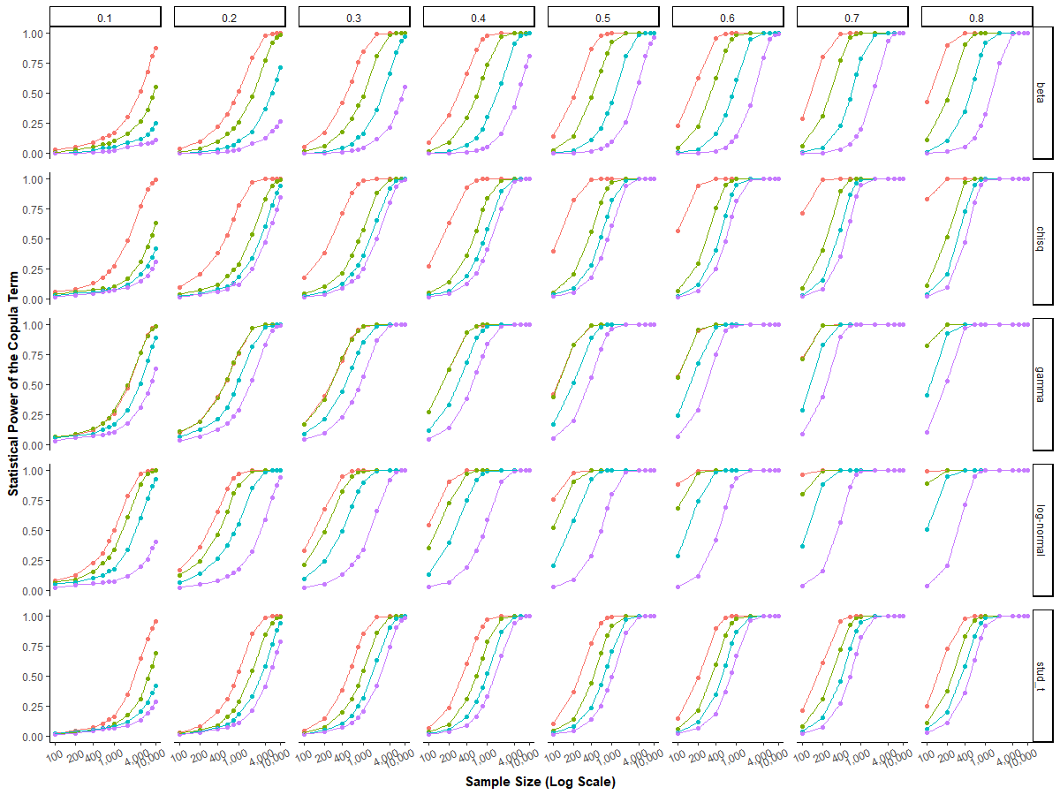
Note: Different colors represent different distribution parameters (see Figure WA.4.1 for more details).
Figure WA.4.3. Power of the copula term for different levels of nonnormality and sample sizes
A: Absolute skewness  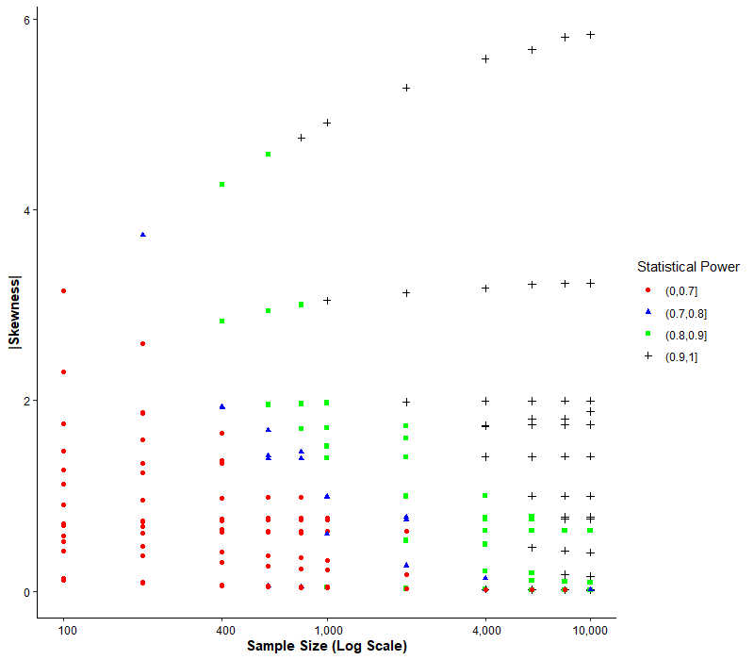 | B: Kurtosis  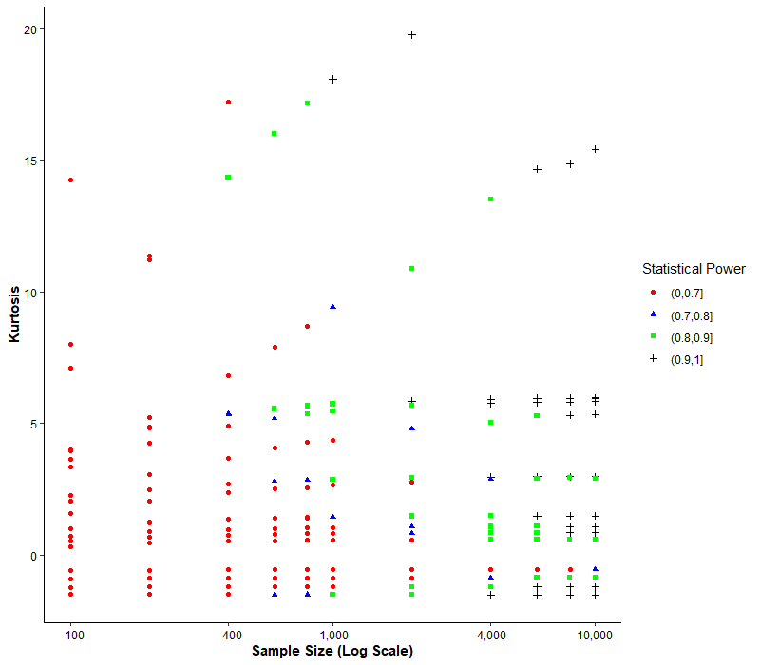
C: Cramer-von Mises  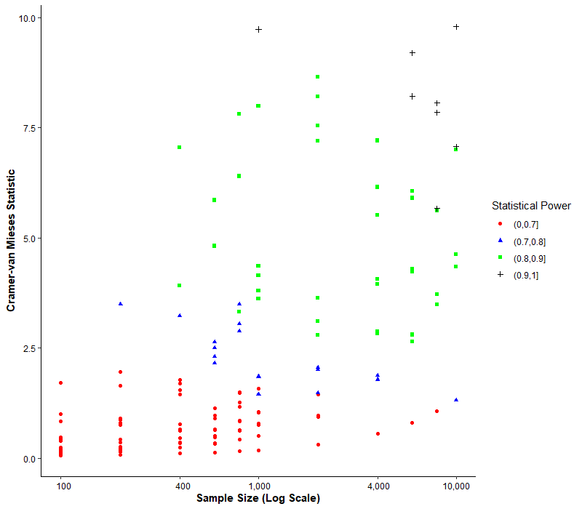 | D: Anderson-Darling  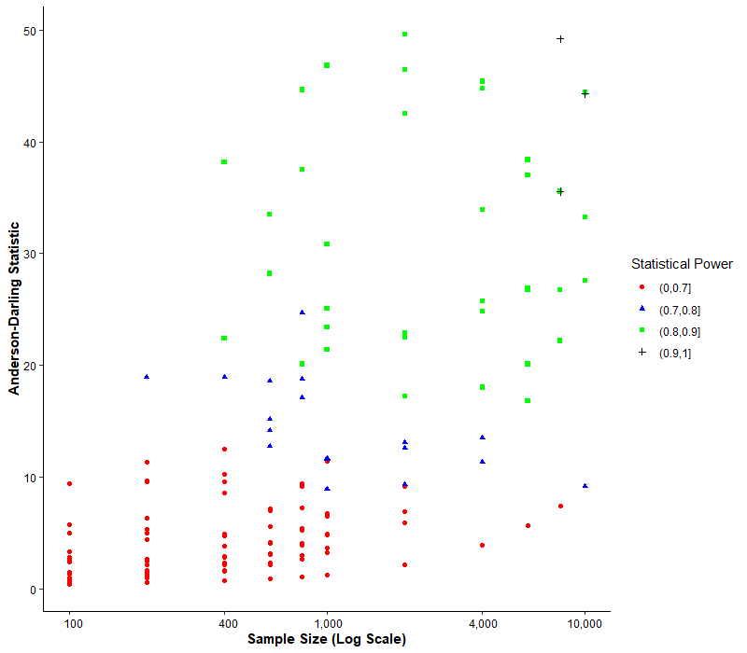

Figure WA.4.4. Decision tree for predicting an 80% power of the copula term
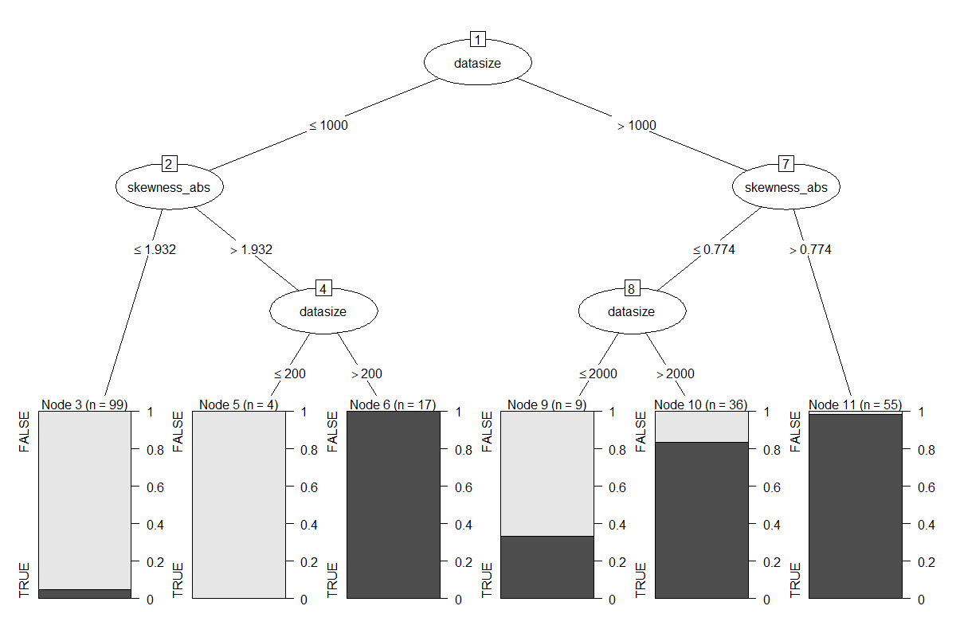

Figure WA.4.5. Additional decision trees predicting an 80% power of the copula term
A: Tree model including sample size, Cramer-van Mises test statistic, absolute skewness*, kurtosis*, and R²*
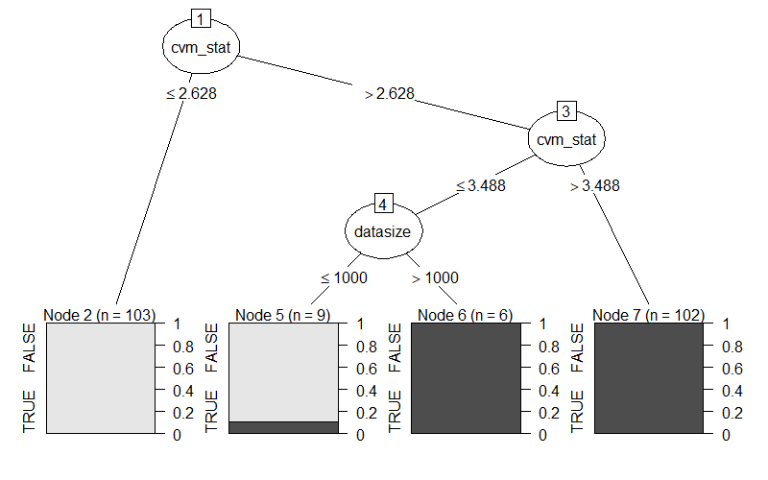
Classification error: 0.50 % with 1 false negative in 220 design conditions
B: Tree model including sample size, Anderson-Darling test statistic, absolute skewness*, kurtosis*, and R²*
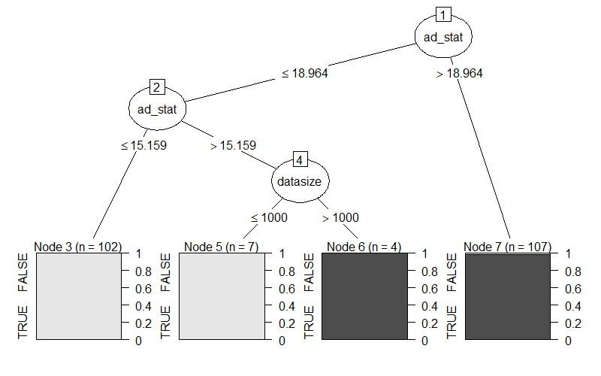
Classification error: 0.50 % with 1 false positive in 220 design conditions
Note: Variables indicated by an asterisk were not important in the prediction when considering the other variables, and therefore do not appear in the figures.

Table WA.4.1. Expectations and considerations regarding the simulation factors’ effects
 | Mean Bias | Relative Bias | Power Copula | Power Regressor
Sample Size | Based on the results of Studies 1 to 3, we expect both the mean and relative bias to decrease with larger sample sizes. However, we expect that the two metrics are similarly affected, because the sample size does not influence the original endogeneity bias.  (supported) |  | Based on the results of Studies 1 to 3 and on general considerations about statistical power, we expect that larger sample sizes increase the statistical power of both the endogenous regressor and the copula term.  (supported)
R² | We expect that the endogenous regressor’s bias to increase with decreasing R², because with more unexplained variance relative to the explained variance (i.e., lower levels of R²), the error term’s importance increases, and consequently the endogeneity bias (i.e., the bias in the regression without copula increases). Owing to the increased endogeneity bias, the copula approach needs to correct more bias, thus potentially leaving more bias uncorrected.  (supported) | While the R² impacts the endogeneity bias and therefore also the remaining bias in the copula regression, we do not have a clear prediction for the relative bias. On the one hand, the larger error variance increases the uncertainty in the model and complicates the model parameters’ identification. This could potentially result in additional remaining endogeneity bias. On the other hand, the Gaussian copula approach should account for the error variance in the estimation (the maximum likelihood approach directly and the control function approach indirectly; Eq. 10 in P&G) so that the performance might not be influenced.  (no expectations) | We expect the copula term’s statistical power to decrease with decreasing R². First, the standard regression literature maintains that, in a regression analysis, more unexplained variance relative to explained variance (i.e., lower levels of R²) increases the estimated parameters’ standard errors (i.e., their uncertainty). Second, larger error variances are factored into the copula parameter’s estimate in the control function approach (Eq. 10 in P&G), therefore increasing the estimate’s uncertainty.  (not supported) | We expect the endogenous regressor’s statistical power to decrease with decreasing R², because the standard regression literature maintains that, in a regression analysis, more unexplained variance relative to explained variance (i.e., lower levels of R²) increases the estimated parameters’ standard errors (i.e., their uncertainty).  (supported)
Endogeneity Level | We expect the endogenous regressor’s bias to increase with increasing endogeneity levels, because the original endogeneity bias increases with higher error term correlations, requiring the copula approach to correct more bias. Under stable relative performance, this would lead to larger remaining biases for increased levels of endogeneity.  (supported) | We expect no or only weak influence of the endogeneity level on the relative bias, because there are two opposing mechanisms that may cancel each other. On the one hand, the original endogeneity bias increases with higher error term correlations, requiring the copula approach to correct more bias. On the other hand, the Gaussian copula model should be easier to identify if the endogeneity (i.e., error term correlation) is large.  (supported) | We expect the copula term to have a higher statistical power if the correlation between the endogenous regressor and the error term is higher. The higher the error term correlation, the easier it should be to identify a significant copula term parameter with the same sample size, because the parameter estimate is larger.  (supported) | We have no clear expectations regarding the endogenous regressor’s power. On the one hand, higher endogeneity levels entail higher endogeneity bias, which, in our case, biases the coefficient toward zero, inducing lower power. On the other hand, the copula is better identifiable with larger error correlations, and the correction might therefore work better.  (no expectations)
Table WA.4.1. (continued)
 | Mean Bias | Relative Bias | Power Copula | Power Regressor
Distribution of the regressor | P&G suggest that the endogenous regressor’s nonnormality is essential to identify the Gaussian copula. We therefore expect distributions that deviate more from a normal distribution (e.g., in terms of kurtosis or skewness), reducing the endogeneity bias (both the mean bias and the relative bias) and increasing the copula term’s statistical power.  (supported) |  |  | The endogenous regressor’s remaining bias will also affect its statistical power. When the parameter is biased toward zero the power is reduced, however, when the coefficient is biased away from zero the power is artificially increased.  In addition, weak identification could possibly also affect the endogenous regressor’s standard errors by introducing a collinearity problem between the copula term and the endogenous regressor, therefore decreasing its statistical power.  Thus, we expect more nonnormal distributions to have a larger power for the endogenous regressor in our model.  (supported)

Table WA.4.2. Effects of key simulation factors on the Gaussian copula maximum likelihood approach’s performance
 |  |  | Statistical power |  | Bias | Relative bias
 |  |  | Copula  term | Endogenous regressor | Endogenous regressor | Endogenous regressor
Sample  size | 100 |  | 26% | 75% | 0.186 | 51%
Sample  size | 200 |  | 40% | 87% | 0.119 | 32%
Sample  size | 400 |  | 55% | 94% | 0.066 | 18%
Sample  size | 600 |  | 64% | 96% | 0.044 | 12%
Sample  size | 800 |  | 69% | 98% | 0.033 | 9%
Sample  size | 1,000 |  | 73% | 98% | 0.025 | 7%
Sample  size | 2,000 |  | 81% | 99% | 0.013 | 3%
Sample  size | 4,000 |  | 88% | 100% | 0.007 | 2%
Sample  size | 6,000 |  | 90% | 100% | 0.005 | 1%
Sample  size | 8,000 |  | 92% | 100% | 0.004 | 1%
Sample  size | 10,000 |  | 93% | 100% | 0.004 | 1%
R² | 10% |  | 70% | 86% | 0.069 | 13%
R² | 20% |  | 70% | 91% | 0.057 | 12%
R² | 30% |  | 70% | 95% | 0.050 | 12%
R² | 40% |  | 70% | 97% | 0.044 | 12%
R² | 50% |  | 70% | 98% | 0.039 | 12%
R² | 60% |  | 70% | 99% | 0.034 | 12%
R² | 70% |  | 70% | 100% | 0.030 | 12%
Endogeneity  level  (error term correlation) | 0.10 |  | 29% | 91% | 0.019 | 16%
Endogeneity  level  (error term correlation) | 0.20 |  | 51% | 93% | 0.027 | 13%
Endogeneity  level  (error term correlation) | 0.30 |  | 64% | 94% | 0.036 | 13%
Endogeneity  level  (error term correlation) | 0.40 |  | 74% | 95% | 0.043 | 12%
Endogeneity  level  (error term correlation) | 0.50 |  | 80% | 96% | 0.050 | 12%
Endogeneity  level  (error term correlation) | 0.60 |  | 84% | 97% | 0.057 | 12%
Endogeneity  level  (error term correlation) | 0.70 |  | 88% | 97% | 0.064 | 12%
Endogeneity  level  (error term correlation) | 0.80 |  | 91% | 98% | 0.073 | 12%

Table WA.4.3. p-values from regressing performance criteria on simulation factors
 |  | Statistical power |  | Mean bias | Relative bias
Design factor |  | Copula  term | Endogenous regressor | Endogenous regressor | Endogenous regressor
Sample size |  | p < 0.001 | p < 0.001 | p < 0.001 | p < 0.001
Level of endogeneity |  | p < 0.001 | p < 0.001 | p < 0.001 | p < 0.001
R² |  | p = 0.616 | p < 0.001 | p < 0.001 | p = 0.597
Distribution function |  | p < 0.001 | p < 0.001 | p < 0.001 | p < 0.001
Function parameter |  | p < 0.001 | p < 0.001 | p < 0.001 | p < 0.001
Note: Significant results at p < 0.05 are highlighted in bold. For the statistical power, we estimated logistic regressions and assessed the significance of each design factor, using likelihood ratio tests (i.e., including vs. excluding each factor from the model). For the bias, we estimated a normal regression and assessed the significance of each design factor, using ANOVA’s F-test.

Table WA.4.4. Correspondence analysis of nonnormality tests and the copula term’s significance
Shapiro-Wilk |  | Copula term |  |  | Copula term
 |  | p ≥ 0.05 | p < 0.05 |  | p ≥ 0.05 | p < 0.05
Nonnormality test | p ≥ 0.05 | 3.9% | 0.0% | p ≥ 0.01 | 6.2% | 0.1%
Nonnormality test | p < 0.05 | 38.8% | 57.3% | p < 0.01 | 36.5% | 57.2%
 | Correspondence rate: 61.2% |  |  | Correspondence rate: 63.4

Kolmogorov-Smirnov |  | Copula term |  |  | Copula term
 |  | p ≥ 0.05 | p < 0.05 |  | p ≥ 0.05 | p < 0.05
Nonnormality test | p ≥ 0.05 | 5.3% | 2.1% | p ≥ 0.01 | 6.4% | 3.4%
Nonnormality test | p < 0.05 | 27.7% | 65.0% | p < 0.01 | 26.5% | 63.7%
 | Correspondence rate: 70.3 |  |  | Correspondence rate: 70.1%

Kolmogorov-Smirnov with Lilliefors correction |  | Copula term |  |  | Copula term
 |  | p ≥ 0.05 | p < 0.05 |  | p ≥ 0.05 | p < 0.05
Nonnormality test | p ≥ 0.05 | 6.6% | 0.3% | p ≥ 0.01 | 10.1% | 0.8%
Nonnormality test | p < 0.05 | 26.3% | 66.8% | p < 0.01 | 22.9% | 66.2%
 | Correspondence rate: 73.4% |  |  | Correspondence rate: 76.3%

Anderson-Darling |  | Copula term |  |  | Copula term
 |  | p ≥ 0.05 | p < 0.05 |  | p ≥ 0.05 | p < 0.05
Nonnormality test | p ≥ 0.05 | 3.9% | 0.1% | p ≥ 0.01 | 6.2% | 0.2%
Nonnormality test | p < 0.05 | 29.0% | 67.0% | p < 0.01 | 26.8% | 66.9%
 | Correspondence rate: 70.9% |  |  | Correspondence rate: 73.1%

Cramer-von Mises |  | Copula term |  |  | Copula term
 |  | p ≥ 0.05 | p < 0.05 |  | p ≥ 0.05 | p < 0.05
Nonnormality test | p ≥ 0.05 | 4.8% | 0.1% | p ≥ 0.01 | 7.3% | 0.3%
Nonnormality test | p < 0.05 | 28.2% | 66.9% | p < 0.01 | 25.7% | 66.8%
 | Correspondence rate: 71.7% |  |  | Correspondence rate: 74.1%

Shapiro-Francia |  | Copula term |  |  | Copula term
 |  | p ≥ 0.05 | p < 0.05 |  | p ≥ 0.05 | p < 0.05
Nonnormality test | p ≥ 0.05 | 4.4% | 0.0% | p ≥ 0.01 | 7.0% | 0.1%
Nonnormality test | p < 0.05 | 38.3% | 57.3% | p < 0.01 | 35.7% | 57.2%
 | Correspondence rate: 61.7% |  |  | Correspondence rate: 64.2%

Jarque-Bera |  | Copula term |  |  | Copula term
 |  | p ≥ 0.05 | p < 0.05 |  | p ≥ 0.05 | p < 0.05
Nonnormality test | p ≥ 0.05 | 0.5% | 0.4% | p ≥ 0.01 | 0.9% | 0.5%
Nonnormality test | p < 0.05 | 32.4% | 66.7% | p < 0.01 | 32.1% | 66.5%
 | Correspondence rate: 67.2% |  |  | Correspondence rate: 67.4%

Table WA.4.4. (continued)
D’Agostino |  | Copula term |  |  | Copula term
 |  | p ≥ 0.05 | p < 0.05 |  | p ≥ 0.05 | p < 0.05
Nonnormality test | p ≥ 0.05 | 13.3% | 13.4% | p ≥ 0.01 | 14.8% | 14.2%
Nonnormality test | p < 0.05 | 19.6% | 53.6% | p < 0.01 | 18.2% | 52.8%
 | Correspondence rate: 67% |  |  | Correspondence rate: 67.6%

Bonett-Seier |  | Copula term |  |  | Copula term
 |  | p ≥ 0.05 | p < 0.05 |  | p ≥ 0.05 | p < 0.05
Nonnormality test | p ≥ 0.05 | 10.6% | 5.1% | p ≥ 0.01 | 13.3% | 7.2%
Nonnormality test | p < 0.05 | 22.4% | 61.9% | p < 0.01 | 19.7% | 59.9%
 | Correspondence rate: 72.5% |  |  | Correspondence rate: 73.2%

Table WA.4.5. Skewness and kurtosis of the distributions in the simulation
Distribution | Distribution parameters and corresponding skewness and kurtosis
Log-Normal | µ = 0; σ = 1  Skewness: 6.18  Kurtosis: 11.94 | µ = 0; σ = 0.75  Skewness: 3.26  Kurtosis: 23.54 | µ = 0; σ = 0.50  Skewness: 1.75  Kurtosis: 5.90 | µ = 0; σ = 0.25  Skewness: 0.78  Kurtosis: 1.10
Beta | p = 0.50; q = 0.50  Skewness: 0  Kurtosis: -1.5 | p = 1; q = 1  Skewness: 0  Kurtosis: -1.2 | p = 2; q = 2  Skewness: 0  Kurtosis: -0.86 | p = 4; q = 4  Skewness: 0  Kurtosis: -0.55
Student t | df = 3  Skewness: 0  Kurtosis: – | df = 4  Skewness: 0  Kurtosis: – | df = 5  Skewness: 0  Kurtosis: 6 | df = 6  Skewness: 0  Kurtosis: 3
Gamma | α = 1; β = 0.50  Skewness: 2  Kurtosis: 6 | α = 1; β = 2  Skewness: 2  Kurtosis: 6 | α = 2; β = 4  Skewness: 1.41  Kurtosis: 3 | α = 4; β = 2  Skewness: 1  Kurtosis: 1.5
Chi² | df = 2  Skewness: 2  Kurtosis: 6 | df = 8  Skewness: 1  Kurtosis: 1.5 | df = 14  Skewness: 0.76  Kurtosis: 0.86 | df = 20  Skewness: 0.63  Kurtosis: 0.6
Note: µ: expected value of natural logarithm, σ: standard variation of natural logarithm, p: shape 1, q: shape 2, df: degree of freedom, α: shape, β: rate

Table WA.4.6. Average R² value per simulation design condition
Specified  R² | R² in the  model without a copula term | R² in the  copula model
0.10 | 0.101 | 0.137
0.10 | (0.016) | (0.060)
0.20 | 0.201 | 0.233
0.20 | (0.023) | (0.056)
0.30 | 0.301 | 0.328
0.30 | (0.026) | (0.051)
0.40 | 0.401 | 0.424
0.40 | (0.026) | (0.046)
0.50 | 0.500 | 0.520
0.50 | (0.025) | (0.040)
0.60 | 0.600 | 0.616
0.60 | (0.023) | (0.033)
0.70 | 0.700 | 0.712
0.70 | (0.019) | (0.026)
Note: Standard deviation in parenthesis

Web Appendix 5: Additional Results for Simulation Study 5

Design of the simulation study
In this study we utilize two separate simulations. Study 5a assesses the effect of error term misspecification on the performance of the Gaussian copula approach with intercept. Study 5b assesses the effect of copula misspecification on the performance of the Gaussian copula approach with intercept. Both studies build on the same DGP as in Study 1, but with modifications to meet each simulation’s specific objectives.
In particular, in respect of Study 5a (error term misspecification), instead of using Equation 2 from Study 1, in which $ξ_{t}$ is normally distributed with a zero mean and a variance of one resulting from the inverse cumulative distribution function of the standard normal distribution ${}^{-1}$, we use Equation WA.5.1, in which $Θ^{-1}$ is the inverse cumulative distribution function of the Beta distribution with $\text{(p, q) ϵ \{(}\text{0}\text{.50,}\text{ 0.}\text{50), (1, 1) (2, 2) (4, 4)\}}$:
$ξ_{t}=\left(Θ^{-1}\left(\left(ξ_{t}^{*}\right)\right)-0.50\right)*f$ (WA.5.1)
Here, $f$ is a multiplicator based on the distribution’s expected variance, so that the resulting variance of the error term is scaled to one for comparability with Study 1. In addition, we also use Equation WA.5.2, in which $Θ^{-1}$ is the inverse cumulative distribution function of the Student-t distribution with$\text{df ϵ \{3, 4, 5, 6}\text{,}\text{ 10, 20\}}$:
$ξ_{t}=\left(Θ^{-1}\left(\left(ξ_{t}^{*}\right)\right)\right)*f$ (WA.5.2)
While the beta distribution has a mean of 0.50, the student t distribution has a mean of zero. Consequently, there is no need to subtract something to obtain a zero-centered error term for the t-distribution.
In Study 5b (copula misspecification), instead of using Equation 1 from Study 1, which defines the generator for $ξ_{t}^{*}$ and $P_{t}^{*}$ as a bivariate normal distribution with a zero mean and a covariance matrix of $\left[\begin{matrix}1 & 0.50 \\ 0.50 & 1\end{matrix}\right]$, we use the generators for the copulas with the same parameters as in P&G’s simulation study (i.e., Ali-Mikhail-Haq distribution with θ = 1, Plackett distribution with θ = 20, Farlie-Gumbel-Morgenstern distribution with θ = 1, Clayton copula with θ = 2, and Frank copula with θ = 2). These copula generators return the marginals directly (i.e., two uniformly distributed random variables with specified correlation structure). Consequently, Equations 2 and 3 change into Equations WA.5.3 and WA.5.4, because there is no need to transform the normally distributed variables into marginals by using the cumulative distribution function.
$ξ_{t}={}^{-1}(ξ_{t}^{*})$ (WA.5.3)
$P_{t}=P_{t}^{*}$ (WA.5.4)
Note that these simulations are conceptual replications of the DGP’s from P&G. Our simulations have two notable differences: First, as noted earlier, we rescale the error variance in Study 5a to one for all distributions of the error term in order to facilitate comparability. P&G do not use this rescaling and therefore use an error with a smaller error variance than in other studies (i.e., the variance of the uniform distribution is only 1/12). The error variance affects the original endogeneity bias and, therefore, the remaining bias’s location, but does not affect the relative bias (i.e., the pattern of the bias) as our Study 4 showed. Consequently, the rescaling makes the results better comparable to those of Study 1, and also across different distributions that naturally have a different variance, but does not affect our conclusions. Second, the endogenous regressor in our simulations (both Study 5a and 5b) has a uniform distribution as in Study 1. In contrast, P&G use a normal distribution with a mean and variance of one. Such a model can only be estimated without intercept because copula models with intercept would not be identified, since they would not fulfill the assumption of nonnormal regressors. We therefore use the same nonnormal endogenous regressor as in Study 1 to allow for a comparison and to assess only one misspecification at a time.
Finally, we again vary the sample size, as in Study 1, and generate 1,000 datasets for each factor-level combination, as well as estimate a model with and without intercept. In addition, we also generate a dataset with one million observations for Study 5a to show that the bias that the error term misspecification causes does no vanish when increasing the sample size toward infinity. We do not estimate the power for these datasets because the statistical power already reaches its maximum for much smaller sample sizes and is therefore not relevant anymore.
Figure WA.5.1. to WA.5.5. as well as Table WA.5.1. show the detailed results for the simulation study.

Figure WA.5.1. Power of the copula term for different error term distributions in the copula model with intercept
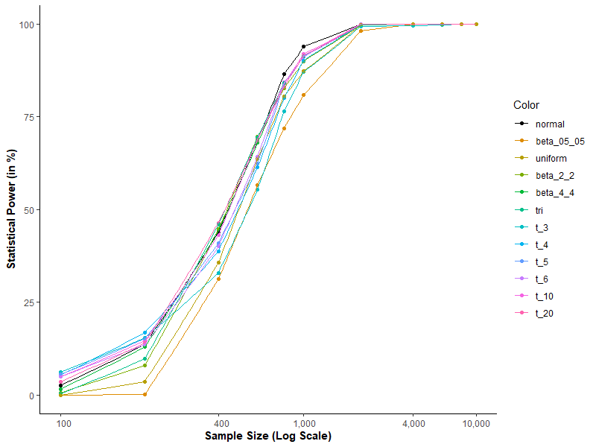
Figure WA.5.2. Power of the endogenous regressor for different error term distributions in the copula model with intercept
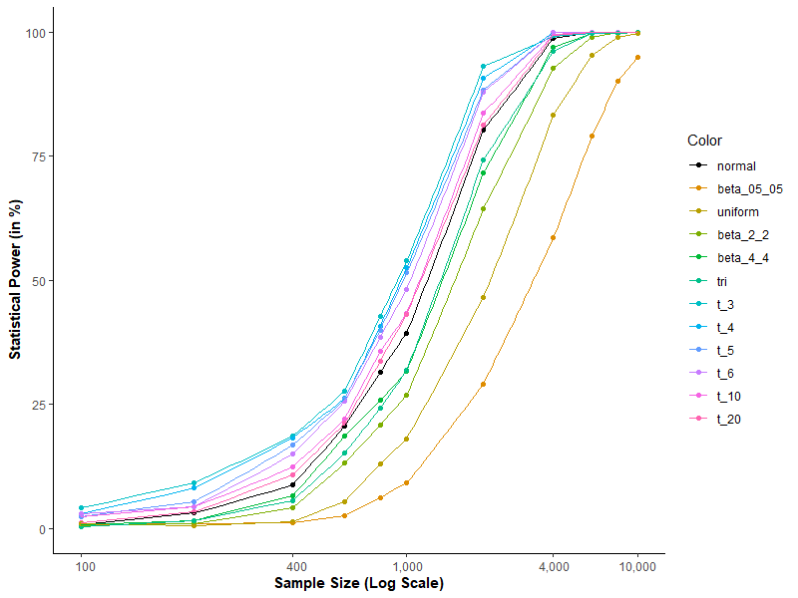
Figure WA.5.3. Bias of the endogenous regressor for the different copulas with and without intercept
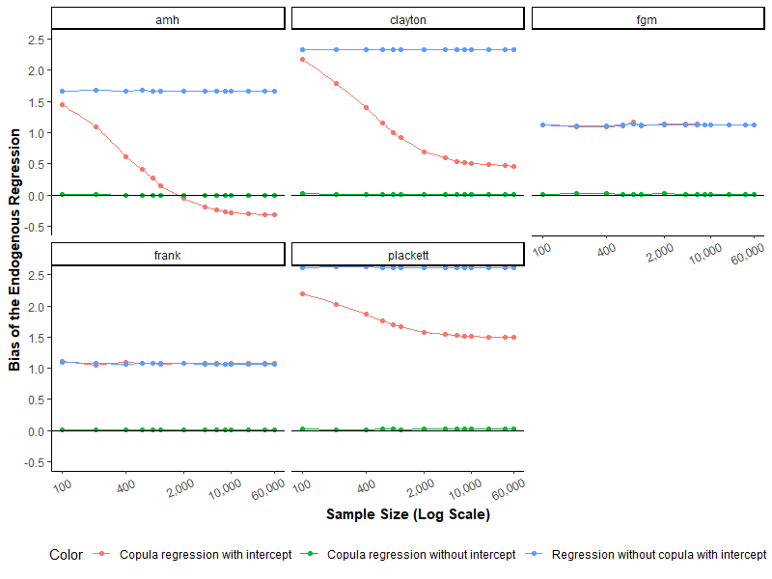
Note: amh = Ali-Mikhail-Haq distribution, clayton = Clayton copula, fgm = Farlie-Gumbel-Morgenstern distribution, frank = Frank copula, plackett = Plackett distribution

Figure WA.5.4. Power of the copula term for the different copula models
A: Model with Intercept
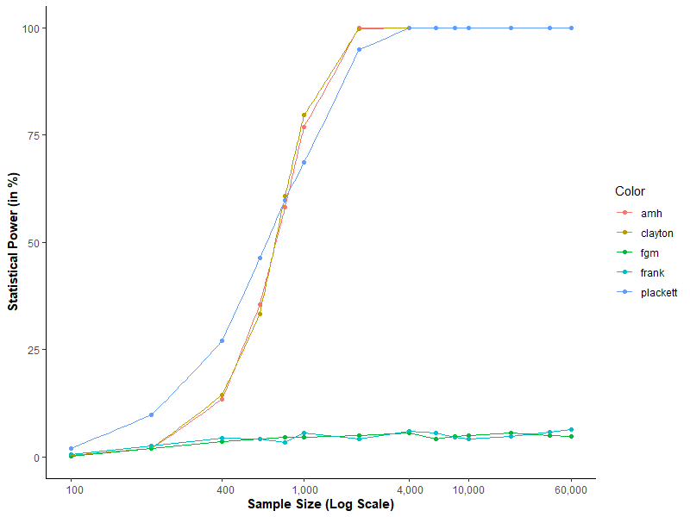
B: Model without Intercept
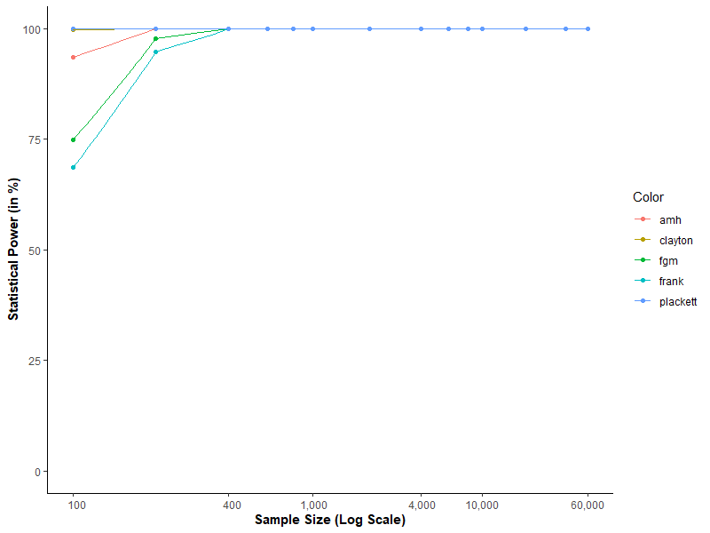

Figure WA.5.5. Power of the endogenous regressor for the different copula models
A: Model with Intercept
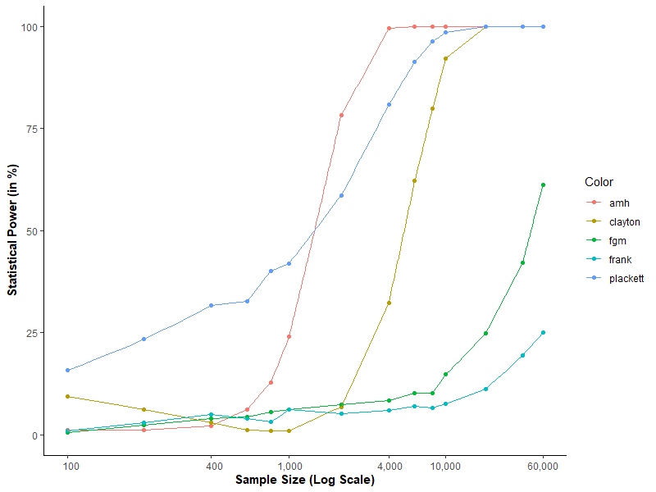
B: Model without Intercept
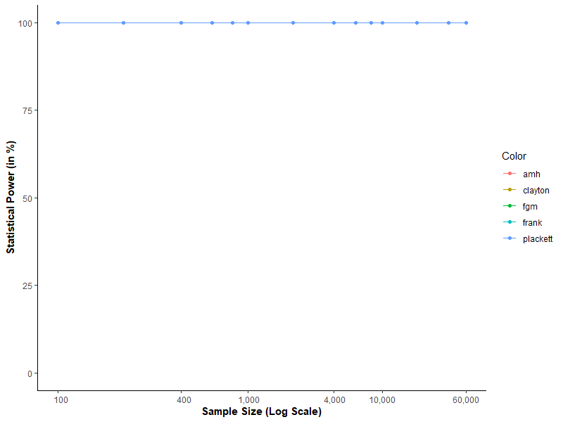

Table WA.5.1. Nonnormality statistics of the regression residual for different error term distributions
Distribution | SW | KS | Lili | AD | CVM | SF | JB | DAG | Bonett | Kurtosis | Skewness
beta_05_05 | 94% | 67% | 96% | 97% | 97% | 91% | 100% | 0% | 98% | -0.920 | 0.000
uniform | 88% | 50% | 88% | 92% | 92% | 83% | 100% | 1% | 95% | -0.764 | 0.001
beta_2_2 | 73% | 47% | 70% | 80% | 78% | 67% | 100% | 1% | 85% | -0.583 | 0.000
beta_4_4 | 47% | 46% | 48% | 59% | 56% | 40% | 100% | 1% | 66% | -0.399 | 0.000
tri | 53% | 46% | 49% | 61% | 57% | 44% | 100% | 1% | 68% | -0.428 | 0.001
normal | 5% | 57% | 4% | 5% | 5% | 5% | 100% | 5% | 5% | -0.025 | 0.002
t_3 | 97% | 96% | 95% | 97% | 96% | 98% | 97% | 86% | 98% | 51.178 | 0.071
t_4 | 94% | 88% | 89% | 94% | 92% | 95% | 96% | 74% | 96% | 11.356 | 0.009
t_5 | 89% | 83% | 82% | 89% | 87% | 91% | 95% | 62% | 92% | 4.493 | 0.009
t_6 | 85% | 80% | 74% | 84% | 81% | 87% | 97% | 52% | 88% | 2.522 | 0.002
t_10 | 64% | 71% | 51% | 63% | 59% | 68% | 100% | 26% | 71% | 0.806 | 0.000
t_20 | 31% | 64% | 21% | 36% | 32% | 36% | 100% | 12% | 45% | 0.271 | 0.001
Note: SW = Shapiro-Wilk, KS = Kolmogorov-Smirnov, Lili = KS with Lilliefors correction, AD = Anderson-Darling, CVM = Cramer-von Mises, SF = Shapiro-Francia, JB = Jarque-Bera, DAG = D’Agostino, Bonett: Bonett-Seier

Assessment of tests to identify the nonnormality of the residual
In Study 5a, we also evaluate whether it is possible to assess the error term’s nonnormality by testing the regression residual from the estimated regression models. Table WA.5.1 shows the percentage of significant test results (i.e., p-values below 5%) of different nonnormality tests on the regression with an untreated endogeneity problem (without a copula term). In addition, it also reports the estimated skewness and kurtosis of the regression residual. The results do not differ much when we use the residual from the copula regression, but are slightly worse (i.e., for most of the nonnormality tests the statistical power is, on average, 1-3 percentage points lower, but never higher).
Overall, our results show that several nonnormality tests are suitable for identifying the error term’s nonnormality by testing the regression residual. In particular, the Anderson-Darling test and the Cramer-von Mises test led to good results (i.e., relatively high power for nonnormal distributions, while maintaining the defined error level of 5% for the normal distribution). These tests are also the ones we recommend for assessing the nonnormality of the endogenous regressor in Study 4. In addition, the Shapiro-Wilk and Shapiro-Francia tests perform well. However, they are only defined for sample sizes of less than 5,000 observations. The Jarque-Bera and Kolmogorov-Smirnov test are not suitable, because they do not maintain the given error level of 5% when the error term is indeed a nonnormal distribution. Likewise, the D’Agostino test is not suitable, because it does not detect nonnormality caused by distributions with a negative kurtosis (i.e., the Beta distribution). We therefore advise against using these three tests.

Web Appendix 6: Software used for simulation
We used the statistical software R (R Core Team 2020) to generate the data and estimate the models. We conducted our analysis on a parallel computing cluster, using the snowfall package (Knaus 2015). Table WA.6.1 details the R packages we used for each study.
Table WA.6.1. R packages used for the simulations
 | Study 1 | Study 2 | Study 3 | Study 4 | Study 5
snowfall parallelization package (Knaus 2015) | X | X | X | X | X
boot package (Canty and Ripley 2019) | X | X | X | X | X
lme4 (Bates et al. 2015) |  |  | X
plm pakages (Croissant and Millo 2008) |  |  | X
nortest package (Gross and Ligges 2015) |  |  |  | X | X
moments package (Komsta and Novomestky 2015) |  |  |  | X | X
c50 package (Kuhn et al. 2020) |  |  |  | X
copula package (Hofert et al. 2020) |  |  |  |  | X
EnvStats package (Millard 2013) |  |  |  |  | X

References
Bates, D., Mächler, M., Bolker, B., & Walker, S. (2015). Fitting linear mixed-effects models using lme4, Journal of Statistical Software, 67, 1–48.
Canty, A., & Ripley, B. (2019). R package boot: Bootstrap functions (version 1.3-24): https://cran.r-project.org/web/packages/boot/.
Croissant, Y., & Millo, G. (2008). Panel data econometrics in R: The plm package. Journal of Statistical Software, 27, 1–43.
Gross, J., & Ligges, U. (2015). R package nortest: Tests for normality (version 1.0-4): https://CRAN.R-project.org/package=nortest.
Hofert, M., Kojadinovic, I., Maechler, M., & Yan, J. (2020). copula: Multivariate Dependence with Copulas. R package version 1.0-1, https://cran.r-project.org/web/packages/copula/.
Knaus, J. (2015). R package snowfall: Easier cluster computing (based on snow; version: 1.84-6.1): cran.r-project.org/web/packages/snowfall/.
Komsta, L., & Novomestky, F. (2015). R package moments: Moments, cumulants, skewness, kurtosis and related tests (version 0.14): https://CRAN.R-project.org/package=moments.
Kuhn, M., Weston, S., Culp, M., Coulter, N., & Quinlan, R. (2020). R package C50: C5.0 decision trees and rule-based models (version 1.3.1): https://cran.r-project.org/web/packages/C50/.
Millard, S.P. (2013). EnvStats: An R Package for Environmental Statistics (version 2.4.1): https://cran.r-project.org/web/packages/EnvStats/.
R Core Team. (2020). R: A language and environment for statistical computing. Vienna, Austria: R Foundation for Statistical Computing (https://www.R-project.org).

The beta distribution with parameter (1,1) is the uniform distribution utilized in P&G.

