Methodological Details Appendix
"Collect them all! Increasing product category cross-selling using the incompleteness effect"

Note: All studies were conducted in German. All variables and instructions have been translated to English.
Study 1
Introduction to Situation
You want to celebrate your birthday and have 10 friends invited to an evening meal/ dinner to your home. You and your friends are Italy fans. You have become besotted with Tuscany in particular. Therefore, you want to buy drinks for dinner at one of the most renowned vineyards of Tuscany. You have already had good experiences with this vineyard in the past. The vineyard is also well known by many of your friends. The online store of the vineyard you want to use for your order has been (anonymously) activated for you. Please fictitiously order drinks there for your birthday dinner. Please assume that you have the required glasses for each respective drink or that you can borrow them from a good neighbor. By clicking on save and send in the shopping cart you complete this test purchase. At the end we briefly ask you about your test purchase.

Condition Manipulations
Condition A – Individually Presented Product Categories
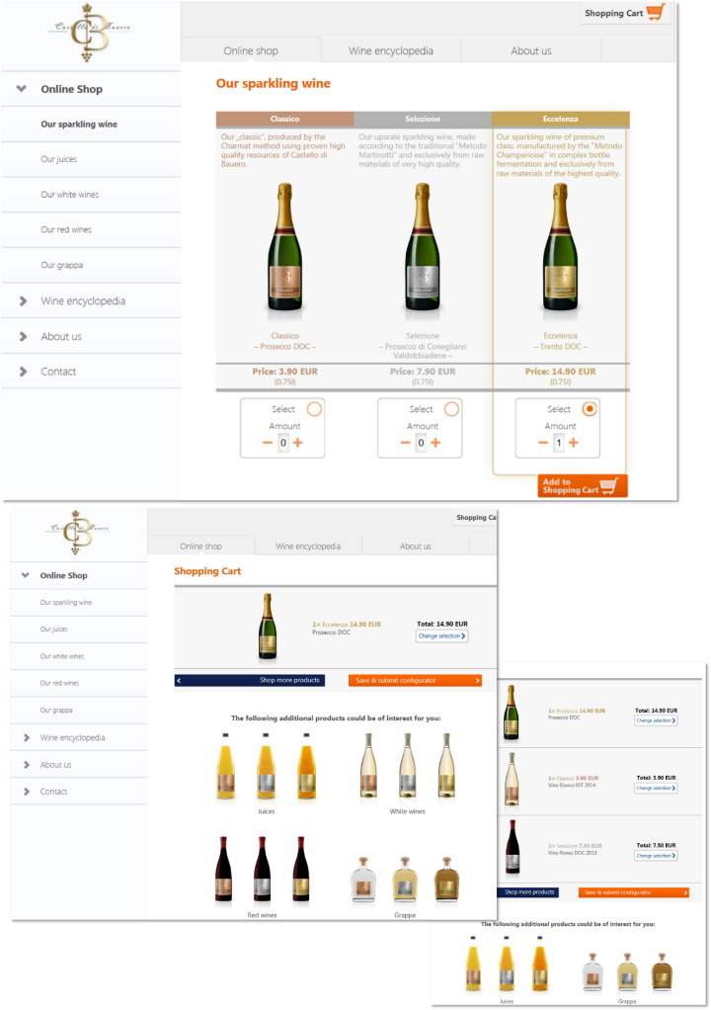

Condition B – Basic Configurator
- Selected products were represented via text under the category name in the configurator
- Product categories where no decision was made were labeled “No [product category]”

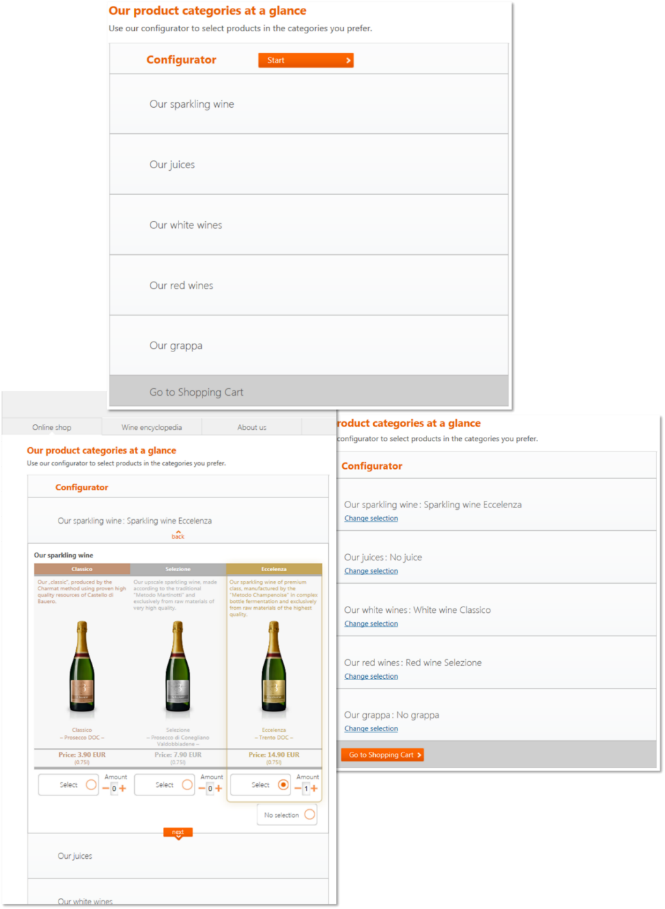

Condition C – Configurator with products as part of an interrelated set
- Page and product names were changed to encapsulate the products in a larger whole (i.e., a complete beverage set for a dinner party)

 | Condition B | Condition C
Page Title | Our product categories at a glance | Our dinner product program: Everything for your dinner
Sparkling Wine | Our sparkling wine | A welcoming sparkling wine
Juice | Our juices | It is the mix that counts – juices
White Wine | Our white wines | For a starter and friends of white wine
Red Wine | Our red wines | For main course and friends of red wine
Grappa | Our grappa | For digestion and friends of grappa

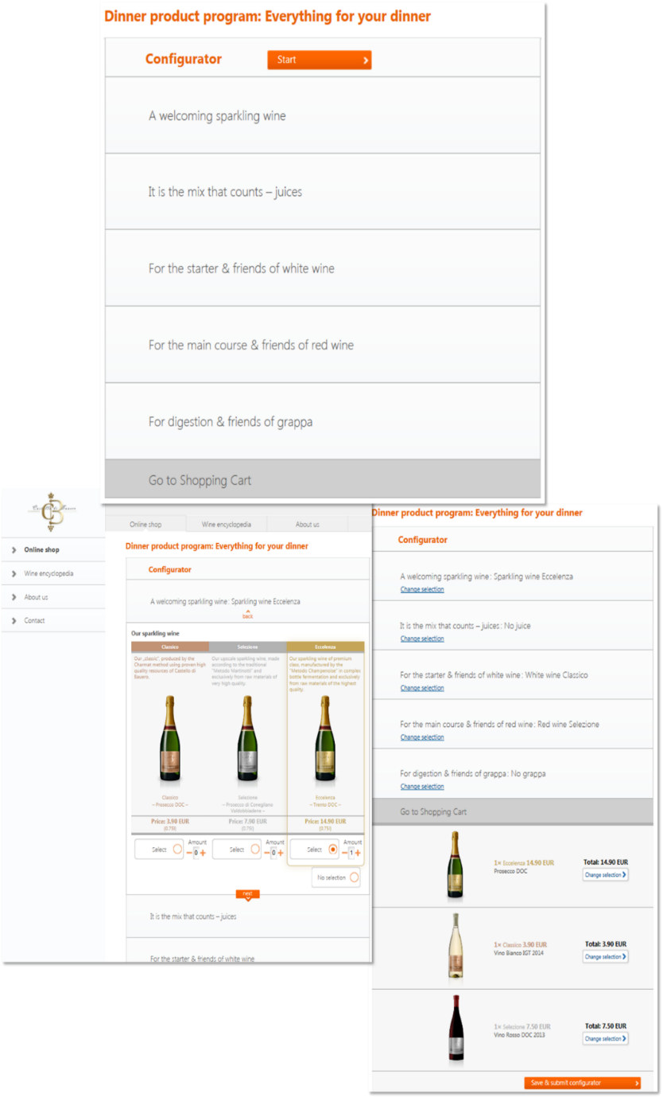

Condition D – Configurator with products presented as an interrelated set and increased visual salience
- Added a “Panini column” on the right side of the configurator. Picture placeholders are filled upon selection in a category and remain empty with non-selection
- Progress bar to indicate how complete one’s program is

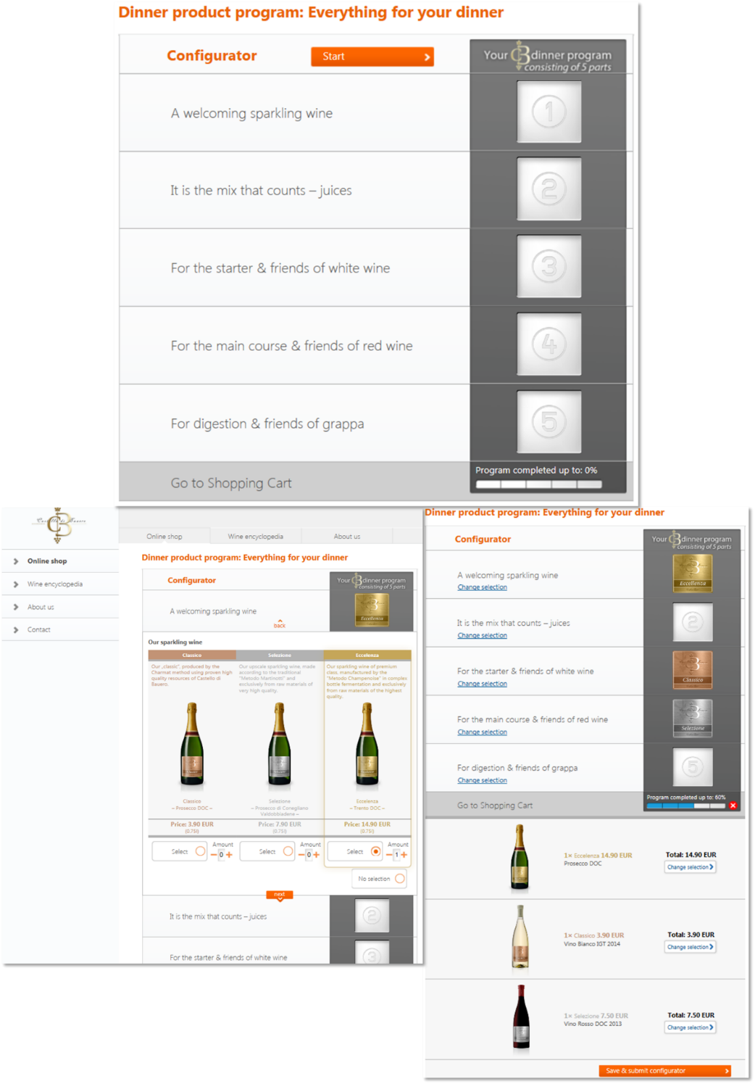

Table 2. Study 1 – Measures

 | Measures | Anchors
Condition A vs. B
Mediator
# of Categories Considered | Number of category pages browsed (max. 5)
Condition B vs. C
Manipulation Check
Product Program  Perception | To what extent do you perceive the products as part of a product program that is designed to be fully utilized? | 1 = Not at all  10 = Very much
Mediators
Completion Impulse | To what extent did you experience the impulse to buy a product in all five categories? | 1 = Not at all  10 = Very much
# of Categories considered | Number of category pages browsed (max. 5)
Condition C vs. D
Manipulation Check
Visual Emphasis of  Incompletion | You have [not] completed the dinner program: How noticeable was the completeness [incompleteness] of the program based on the visual presentation in the product configurator? | 1 = Not noticeable at all  10 = Very noticeable
Mediators
Perception of Incompleteness | To what extent did the non-selection of products leave the impression of an incomplete product program? | 1 = Not at all  10 = Very much
Completion Impulse | To what extent did you experience the impulse to buy a product in all five categories? | 1 = Not at all  10 = Very much
# of Categories Considered | Number of category pages browsed (max. 5)
Product Evaluations
 | How attractive was the juice you viewed? | 1 = Not attractive at all  7 = Very attractive  *Participants could select “not sure”
 | How attractive was the grappa you viewed?
Potential Confounds (α = .94)
Fairness | How do you evaluate the product configuration regarding FAIRNESS? | 1 = Very bad  7 = Very good
Complexity | How do you evaluate the product configuration regarding SIMPLICITY?  How do you evaluate the product configuration regarding CLARITY? | 1 = Very bad  7 = Very good
User Friendliness | How do you evaluate the product configuration regarding USABILITY?  How do you evaluate the product configuration regarding LAYOUT? | 1 = Very bad  7 = Very good
Satisfaction & Quality
Quality | How did the online store you viewed compare to other online stores known to you? | 1 = Much worse  7 = Much better
Satisfaction | How satisfied were you with the configured solution? | 1 = Very dissatisfied  7 = Very satisfied
Note: All variables were translated to English from original participant questionnaire in German.

Study 2
Introduction to Situation

You decided to accept a new job offer in Austria and to move there. On recommendation of your new employer, you want to open a salary account at the BANK (anonymized, prestigious Austrian banking institution). The following website shows the respective product category ‘Account & Cards. ‘Please choose an account plus possible complementary products from this category. Click on ‘Save & Submit’ in the Shopping Cart to finalize the online purchase. You will then be forwarded to a questionnaire. There we ask you about your selection.

Condition Manipulations
Condition A – Individually presented product categories

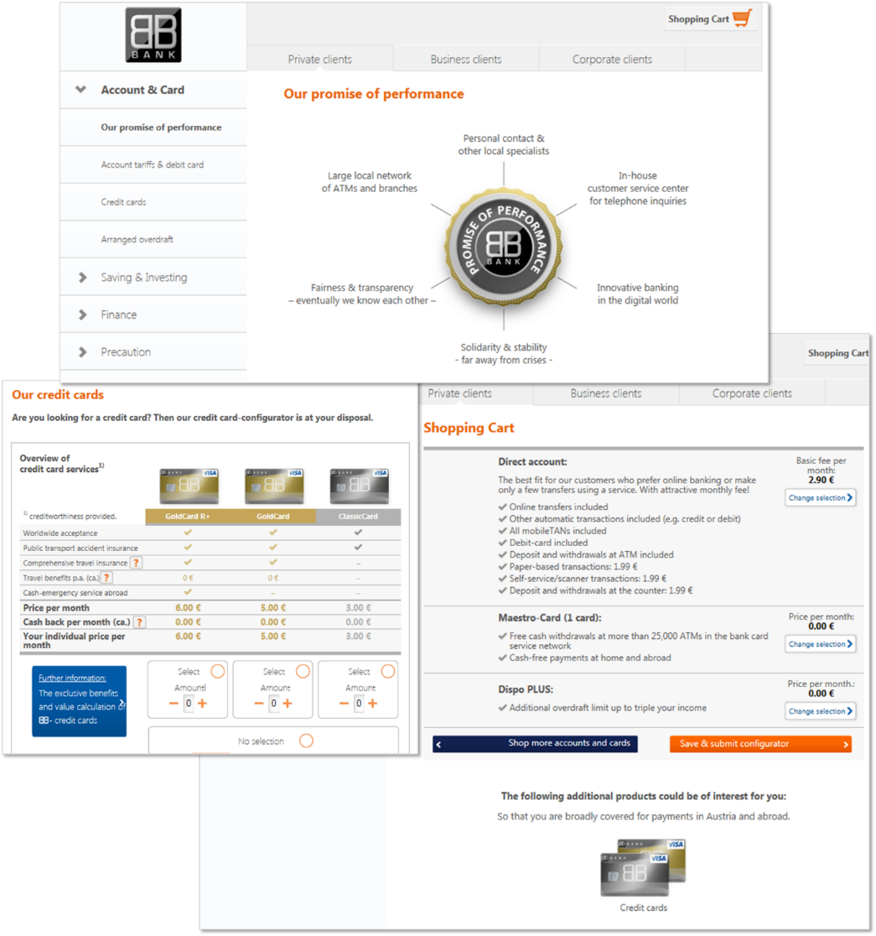

Condition C – Configurator with products as part of an interrelated set
- Page title was changed from “Our account and card solution – All about numbers and transfers”

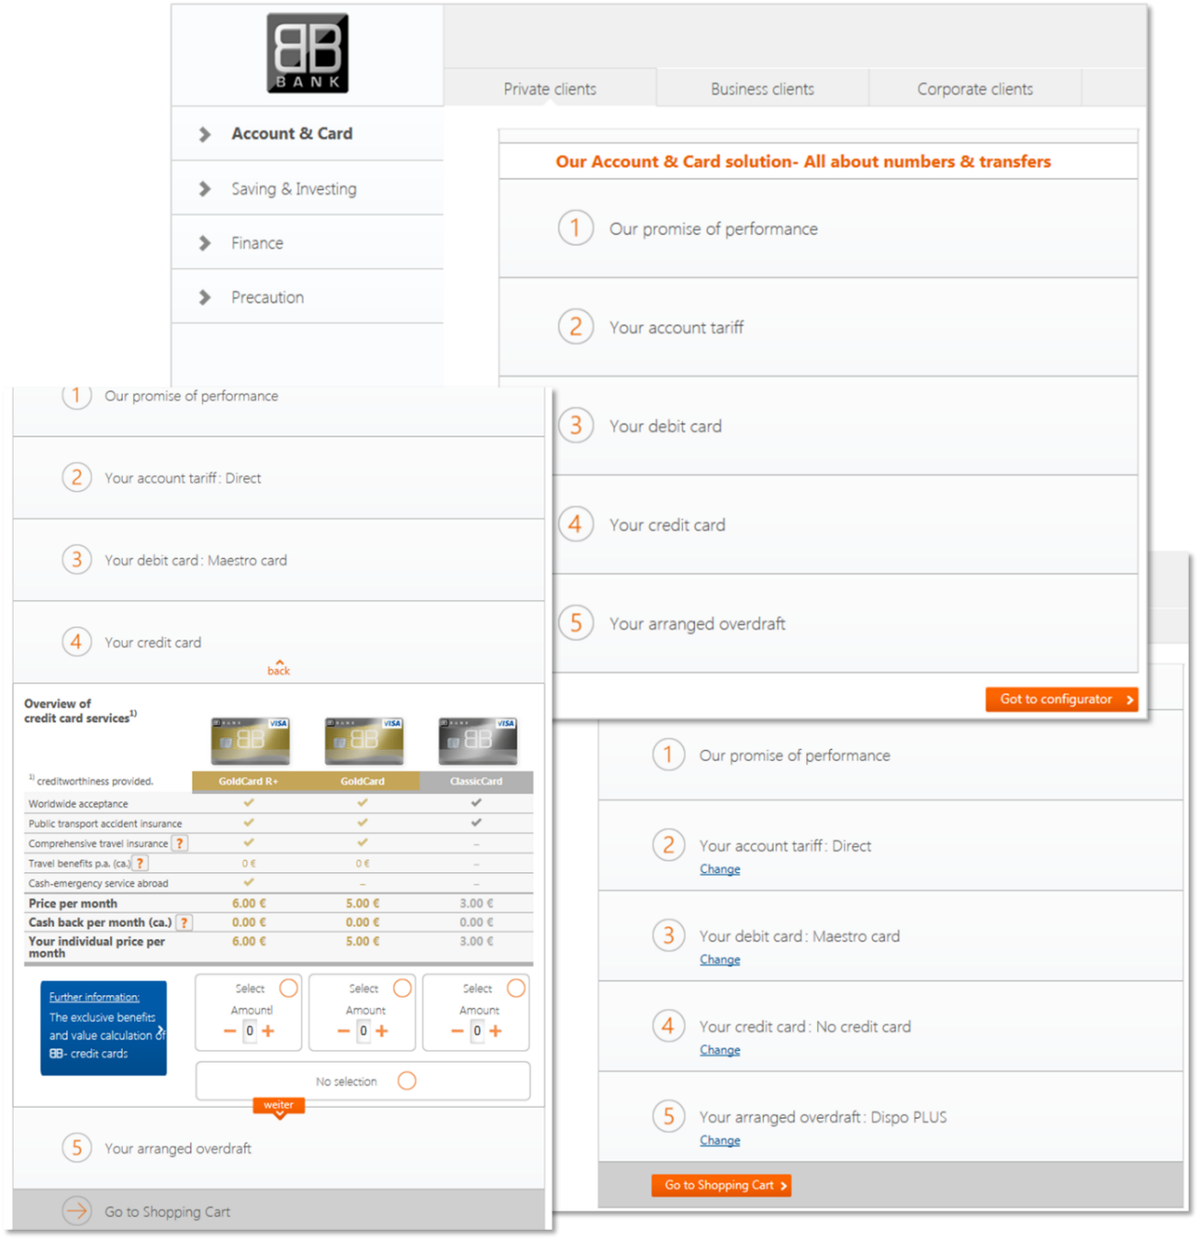

Condition D – Configurator with products presented as an interrelated set and increased visual salience
- Added a “Panini column” on the right side of the configurator. Picture placeholders are filled upon selection in a category and remain empty with non-selection
- Progress bar to indicate how complete one’s program is
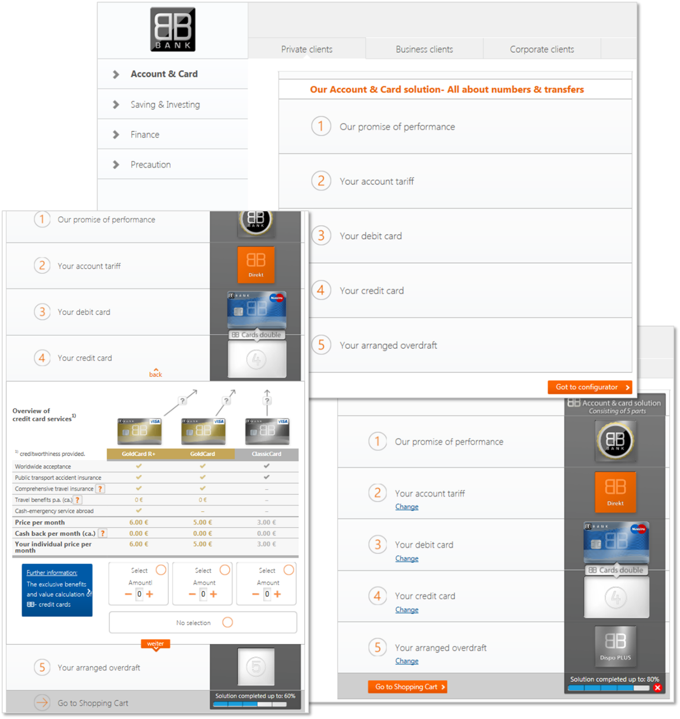

Study 2 Measures

Condition A (individually presented categories) versus C (configurator with interrelated products)

Product Program Perception
To what extent did you perceive the offerings as part of a product program designed to be completely utilized?
- 1 = Not at all, 10 = Very much

Condition C (configurator with interrelated products) versus D (visual salience)

Visual Emphasis of Incompleteness
You have [not] completed the basic banking program: How noticeable was the completeness [incompleteness] of the program based on the visual presentation in the product configurator?
- 1 = Not noticeable at all, 10 = Very noticeable
Study 3

Study 3 Manipulations

Visualization Manipulations

Condition A – Conventional Bank Login/Homepage
Condition B – Selected and non-selected products represented with text
Condition C – Visual representation of selected and non-selected products (Jigsaw puzzle)

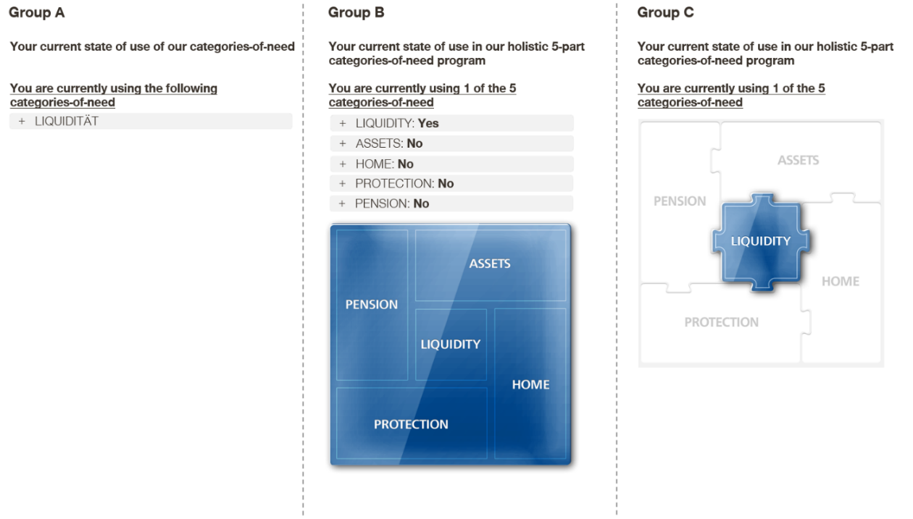

Study 3 – Stimuli providing information regarding unused categories-of-need

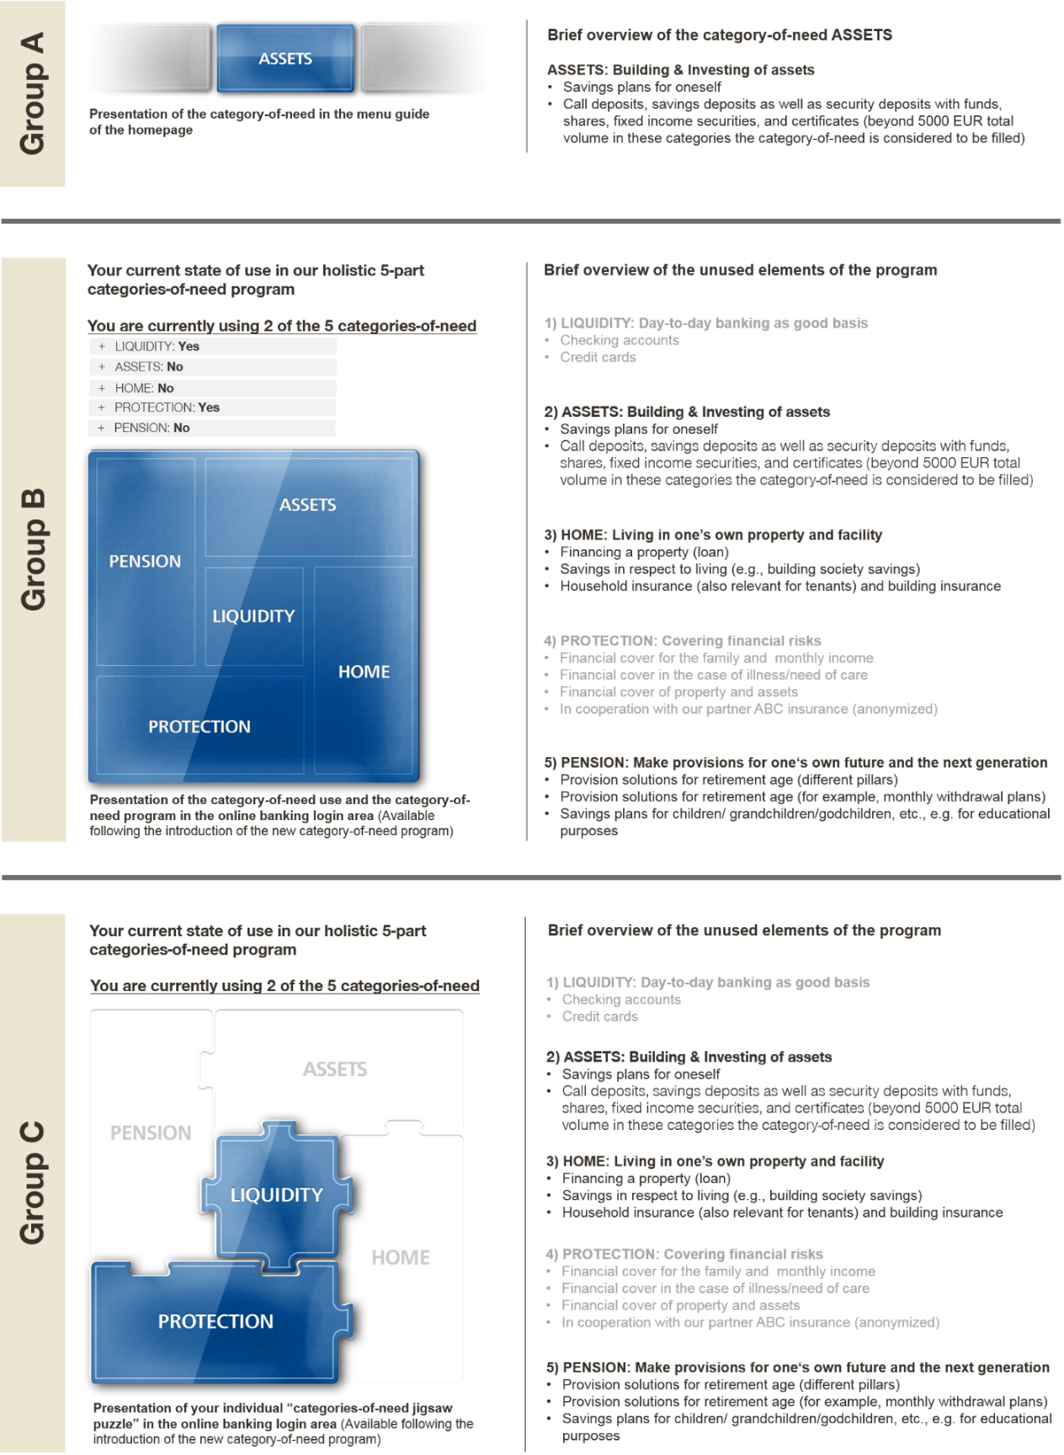

Note: In Condition A, each category was shown on a separate page

Study 3 Measures

Dependent Variable
How likely are you to seek more information about each unused category-of-need?
Asked for each category not currently in use
- 1 = Very unlikely, 7 = Very likely

Manipulation Check
To what extent are the not-yet-used categories-of-need perceived as missing parts of a holistic program designed to be fully utilized?
- 1 = Not at all, 7 = Very much

Moderator – Feasibility
For each category-of-need, respondents could report that they needed no products in the category and would therefore never buy this product (from the bank or other providers).

Moderator – Rationalization (α = .80)
- How important was it to have taken all relevant financial categories into account?
- How attractive is it to be able to access all banking and insurance products from a single source?
- How attractive is it to have all banking and insurance products available at a single glance?
- 1 = Not at all, 7 = Very much

