Web Appendix

Voice Bots on the Frontline: Voice-Based Interfaces Enhance Flow-Like Consumer Experiences & Boost Service Outcomes

A. SUPPLEMENTARY METHODS 3
A1. Technical Details Interface Implementation 3
A1.1 System Architecture Voice Interface 3
A1.2 Details on Voice Interface Configuration 3
A1.3 Screenshot Voice Interface 5
A1.4 Hardware Precheck Voice Interface 5
A1.5 Exemplary User Journey Voice Interface 6
A1.6 Exemplary Text-Based Interface 8
A2. Insurance Claim Filing Task 9
A2.1 Main Task 9
A2.2 Variations for Study 2 9
A2.3 Variations for Study 3 10
A3. List of Scales & Formulas 11
A3.1 Interface Flow (Study 1, Study 2, Study 3, Study 4) 11
A3.2 Experiential Service Delivery (Study 1, Study 2, Study 3, Study 4) 11
A3.3 Service Firm Evaluation (Study 2, Study 3, Study 4) 11
A3.4 Insurance Familiarity Questionnaire (Study 1, Study 2, Study 3, Study 4) 11
A3.5 Experience with Voice-Based Interfaces (Study 1, Study 2, Study 3, Study 4) 12
A3.6 Readability Scores (Study 2) 13
A3.7 Perceived Care of the Interface (Study 3) 13
A3.8 Challenge (Study 4) 13
A4. Advertising Stimuli (Study 4) 14
A4.1 Voice Based Interface Advertising Stimuli 14
A4.2 Text Based Interface Advertising Stimuli 14
B. SUPPLEMENTARY ANALYSES 15
B1. Demographics Across Studies 15
B2. Study 1: Additional Analyses 16
B3. Discriminant Validity Tests Interface Flow vs. Experiential Service Experience 17
C. REFERENCES 18

SUPPLEMENTARY METHODS

A1. Technical Details Interface Implementation

A1.1 System Architecture Voice Interface
The voice assistant application was built using the open-source Python framework "Flask" for the backend and the open-source JavaScript framework "VueJS" for the frontend. They act as separate components with the frontend running in the user’s browser and interacting with the backend API via JSON.
A custom JSON schema was devised to configure the user journeys which enables simple branching and looping algorithms based on configurable regex checks. Thus, we can create adaptive user journeys based on user’s verbally issued intents. The frontend is voice-based and requires a user to give the permission to access the microphone. Voice input is transcribed via the Google Speech API. All data is stored in an SQLite database. If desired, the voice files can be stored in the server’s file system.

A1.2 Details on Voice Interface Configuration
In order to illustrate the functionalities of our interface in more detail, we discuss here our JSON File that defines how a user journey is configured. Each journey configures the id, title, and description, based on which different journeys can be called in parallel. Note that the description can contain HTML parts, which can be used to individualize the frontend of the interface.

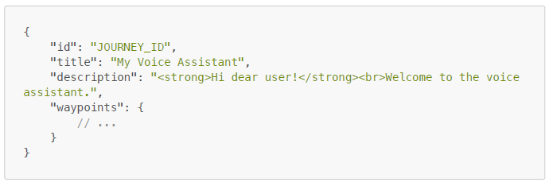

To illustrate the operational functionality of our interface, we showcase two types of journeys that can be built with our interface. The first is a simple linear user journey. The actual journey is defined with the waypoints key. The different steps are connected with simple links: each link has a specific type (in this case a GO_TO) that defines a link_to value that points to the key of the waypoint that the user should continue with after the given step. Each step contains a predefined text and/or audio file. As a result, simple linear user journeys can be modelled as follows:
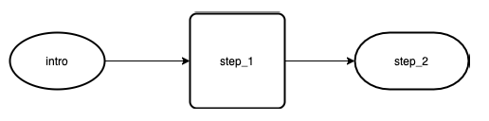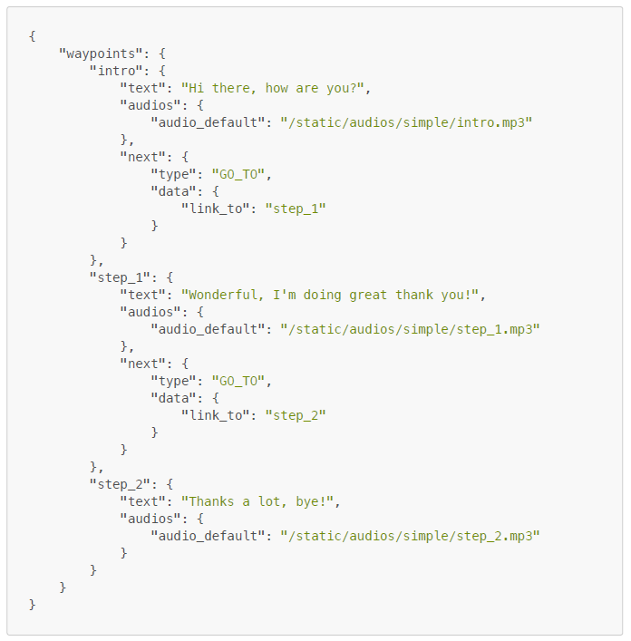
Second, in order to create adaptive user journeys, we can use a so-called Simple_Branch. As we kept the conversation flow steady in the current study, we did not use this link type. However, to demonstrate the potential of our interface for modelling more complex, adaptive conversation flows, the below illustration highlights the option to include additional branching (if needed for future research implementations for instance):

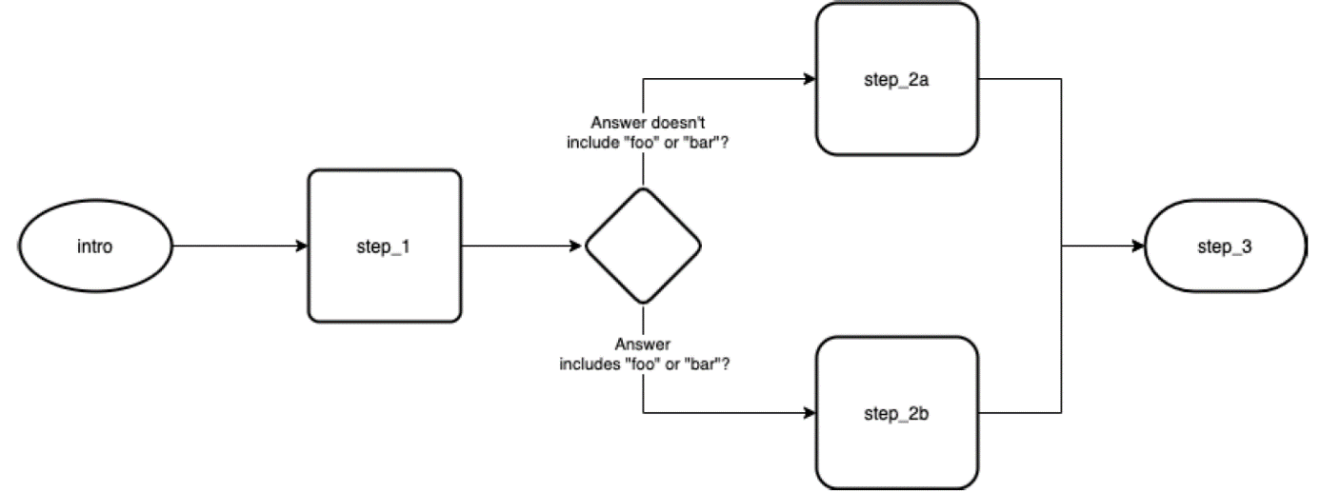
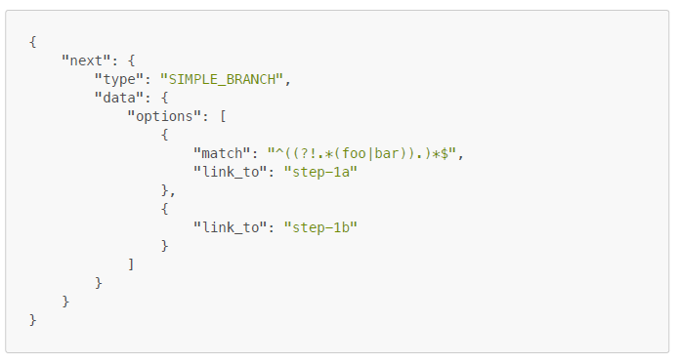

A1.3 Screenshot Voice Interface

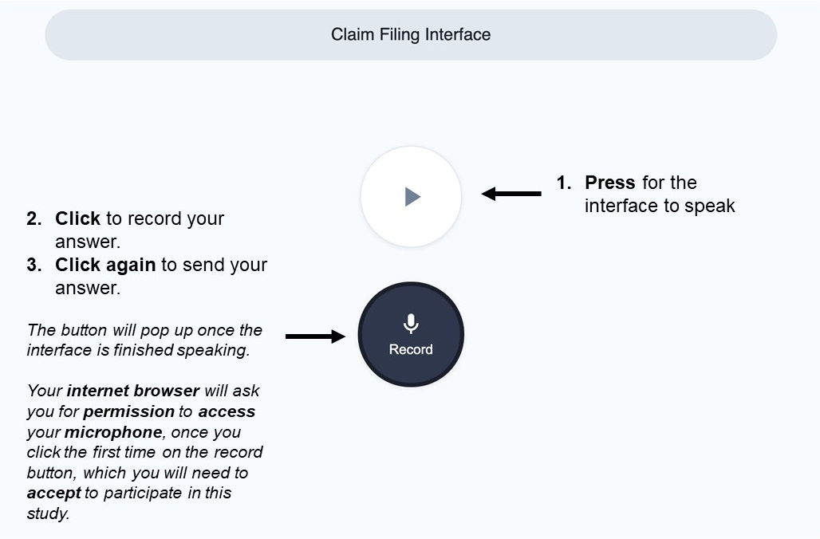

A1.4 Hardware Precheck Voice Interface
Prior to initiating our experiment, we presented participants in the voice conditions with a microphone check. Participants were instructed to provide access to their microphone input and test it. Only participants for whom the interface detected a voice input were allowed to proceed with the study.

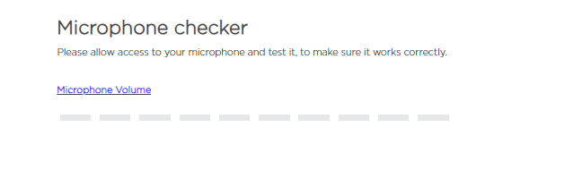

A1.5 Exemplary User Journey Voice Interface
The user interaction with the voice-interface follows a simple conversational path, as illustrated below:

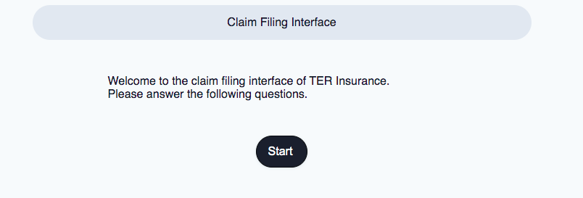

- “Start”-screen: This is the first screen the user interacts with. The conversation flow is initialized by clicking on the “start”-button.

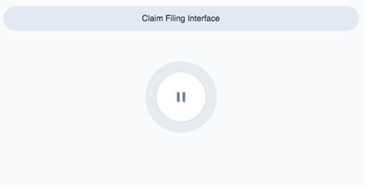

- “Listening”-screen: The conversational interface plays its message. Concentric vibrating circles graphically underline the audio message.

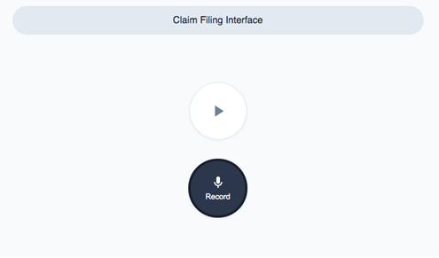

- “Interaction”-screen: The user can either play the audio message again by clicking on the “play”-button (based on which the “listening-screen” will arise) or to record a message by clicking on the “record” button.

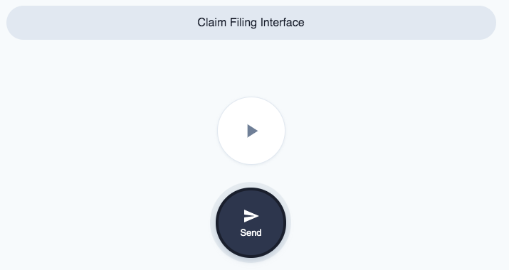

- “Record”-screen: Once the user clicks the “record”-button, the following screen appears. The user can now record a message by speaking into the microphone. When the user has finished the recording, the message can be sent by clicking on the “Send”-button. Either the user is linked to the next step of the predefined interaction journey (“interaction”- screen) or directly transferred to the survey platform once the interaction is finished.

A1.6 Exemplary Text-Based Interface
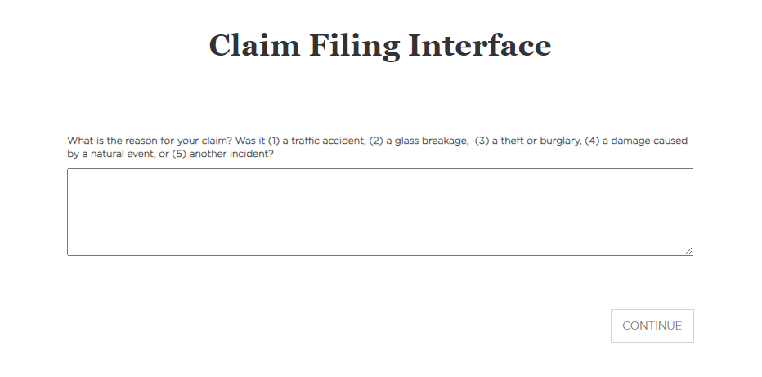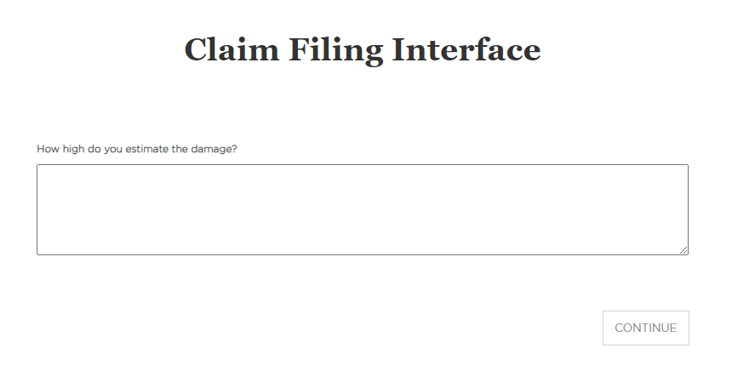
Sample screenshots from the insurance claim filing task with the text-based interface.

A2. Insurance Claim Filing Task

A2.1 Main Task
Instructions:
Please imagine the following scenario:
- Five days ago, you drove to the city centre, parking your car in a public parking garage. On the way out of your parking spot, you accidentally hit a pole, leaving a long scratch on the left side of your car. Eventually, you visited the car repair yesterday and you were told that the paintwork must be completely redone. The damage is estimated to be around $1250.
- You now want to file a claim concerning your car damage with your car insurance company TER Insurance.
- On the following page(s), you are asked to complete your claim via a web interface, which is automatically sent to your insurance company. After responding to all questions, please continue with the rest of the survey.

Follow-up questions as part of the Claim Filing Process:
- “What happened? Was it a (1) traffic accident, (2) glass breakage, (3) theft or burglary, (4) damage caused by natural event, (5) another incident?”
- “How did the damage occur? Please describe the course of events as accurate as possible.”
- “What damage occurred?”
- “How high do you estimate the damage?”
- “When did you notice the damage?”
- “Would you like to notify us about something else?”
Each follow-up question was presented on a separate page, and responses were given in open text fields for the text-based interface conditions.
Participants in the voice-based interface conditions were provided with exactly the same questions, the same wording, and the same sequence. They had to click a button to listen to each follow-up question and another button to record their voice input for their responses to each question (see voice interface screenshots in section A1).

A2.2 Variations for Study 2
- Added additional follow-up questions to the claim filing process:
  - “What repairs and maintenance do you think are needed to fix the damage?”
  - “Next, please tell us about any other parties that might be involved in this case by addressing the following questions. Were there any other directly or indirectly involved parties in the accident and if so which?”
  - “Additionally, please notify us if you already consulted a technical expert on the damage?”
  - “Finally, please indicate if you have been already in touch with another insurance about this damage.”
- Added another interaction task (“follow up customer questionnaire”), where we asked participants to indicate where they want to continue their policy:
  - “We just saw that your insurance policy is about to end. Would you like us to send you an email so that you can renew your policy: yes or no?” (low semantic fluency)
  - “It has been determined that your insurance policy is due to expire shortly. Please indicate if you would like to receive an email to prolong your policy: yes or no?” (high semantic fluency)

A2.3 Variations for Study 3
We manipulated the number of conversational turns through coupling (decoupling) of the follow-up questions in individual interaction turns. In the low conversational turns conditions, the questions were combined into 4 individual interaction turns. In the high conversational turns condition, each question asked in claim filing process resembles an own interaction turn resulting in a total of 10 interaction turns.

A3. List of Scales & Formulas

A3.1 Interface Flow (Study 1, Study 2, Study 3, Study 4)
“To what extent do you agree with the following statements?” (7-point Likert scale; “Strongly disagree” to “Strongly agree”)
- This interface totally absorbed me.
- This interface really intrigued me.
- This interface drew me in.
Adapted from Unger and Kernan (1983).

A3.2 Experiential Service Delivery (Study 1, Study 2, Study 3, Study 4)
“How do you feel about filing your insurance claims through this interface?” (7-point Likert scale; “Strongly disagree” to “Strongly agree”)
- It offers novel experiences.
- It satisfies my sense of curiosity.
- There is novelty in it.
- I feel like I am exploring new worlds.
Adapted from Unger and Kernan (1983).

A3.3 Service Firm Evaluation (Study 2, Study 3, Study 4)
“To what extent do you agree with the following statements?” (7-point Likert scale; “Strongly disagree” to “Strongly agree”)
- Overall, I am satisfied with the online experience with TER Insurance.
- My overall opinion of the services provided by TER Insurance is very good.
Adapted from Lee and Lin (2005).

A3.4 Insurance Familiarity Questionnaire (Study 1, Study 2, Study 3, Study 4)
In order to better understand or control for participants´ insurance claim filing experience, we asked the following items:
Car Ownership: “Do you own a car, or have you ever owned a car?”
- Yes
- No
Possession of an Insurance: “Do you currently own a car insurance?”
- Yes
- No

Previous Experience with Insurance Claim Filing: “Have you ever filed an insurance claim (in person, via phone, via the insurance company´s website)?”
- Yes
- No
When participants replied with “Yes” to the previous experience question, they were asked the following item:
Last File Claiming Experience: “When have you last filed an insurance claim?”
- Less than a year ago
- Between a year and two years ago
- Between two and three years ago
- More than three years ago

A3.5 Experience with Voice-Based Interfaces (Study 1, Study 2, Study 3, Study 4)
Previous Experience with Voice Assistants: “Have you ever used a voice assistant, such as Siri (Apple), Google Assistant (Google), or Alexa (Amazon)?”
- Yes
- No
- I don´t know

Voice Assistant Use: “How often do you use voice assistants?”
- Never
- Less than once a month
- Once a month
- Once every two to three weeks
- Once a week
- Several times a week
- Once a day
- Several times a day

Level of Comfort with Voice Assistant Use: “How comfortable are you using a voice assistant?”
- Not at all
- Slightly
- Somewhat
- Moderately
- Extremely

A3.6 Readability Scores (Study 2)
Semantic fluency was assessed using three different readability scores: the Flesch reading ease score (FRE), the Automated Readability Index (ARI), and the New Dale-Chall readability formula (NDR). The formulas to the individual scores are presented below:

$$FRE=206.835 - 1.015 x \left(\frac{words}{sentences}\right)- 84.6 x \left(\frac{syllables}{words}\right)$$

$$ARI=4.71 x \left(\frac{characters}{words}\right)+ 0.5 x \left(\frac{words}{sentences}\right)- 21.43$$

$$NDR=0.1579 * \left(Percentag of difficult words\right)+ 0.0496 * Average Sentence Lengh in Words$$

A3.7 Perceived Care of the Interface (Study 3)
“To what extent do you agree with the following statement?” (7-point Likert scale; “Strongly disagree” to “Strongly agree”)
- I feel like the claim filing interface actually cares about me
Adapted from Breivik and Thorbjørnsen (2008).

A3.8 Challenge (Study 4)
“To what extent do you agree with the following statement?” (7-point Likert scale; “Strongly disagree” to “Strongly agree”):
- Using the claim filing interface challenges me.
- Using the claim filing interface challenges me to perform the best of my ability.
- Using the claim filing interface provides a good test of my skills.
- I find that using the claim filing interface stretches my capabilities to my limits.

“Please answer the following questions:” (7-point Likert scale; “Not at all challenged” to “Extremely challenged”):
- How much does using the claim filing interface challenge you, compared to other things you do on the computer?
- How much does using the claim filing interface challenge you, compared to the sport or game you are best at?
Adapted from Novak et al. (2000)

A4. Advertising Stimuli (Study 4)

A4.1 Voice Based Interface Advertising Stimuli

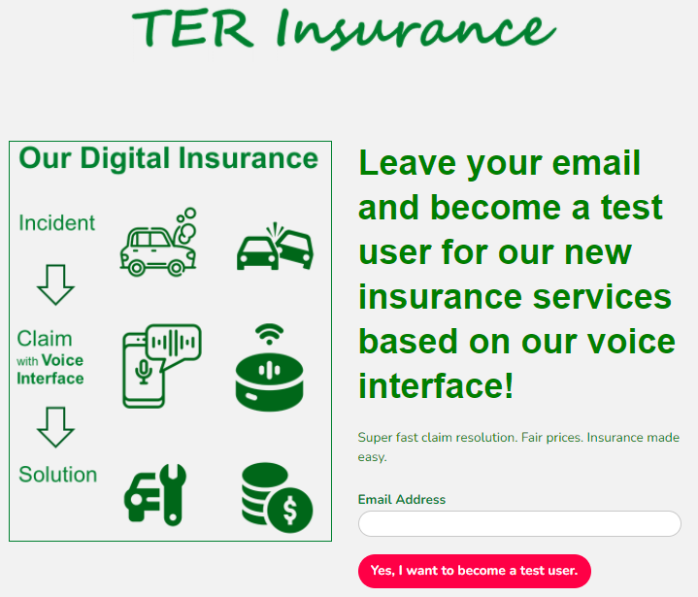

A4.2 Text Based Interface Advertising Stimuli

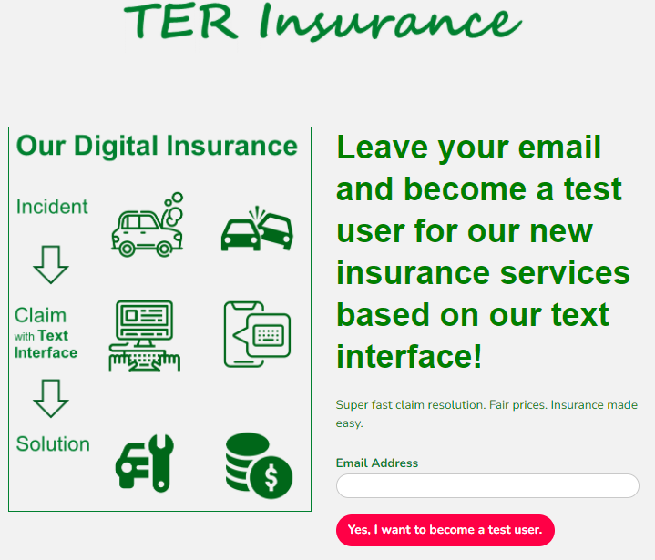

SUPPLEMENTARY ANALYSES

B1. Demographics Across Studies

 | N | N  male | N female | N  other | Mean age | SD  age | % male
Study 1 | 184 | 92 | 90 | 2 | 32.97 | 11.05 | 50.0%
Study 2 | 612 | 278 | 322 | 12 | 37.19 | 13.34 | 45.4%
Study 3 | 610 | 286 | 313 | 11 | 35.59 | 12.70 | 46.9%
Study 4 | 811 | 392 | 413 | 6 | 35.15 | 12.93 | 48.3%

B2. Study 1: Additional Analyses

 | Model 1 |  |  | Model 2 |  |  | Model 3 |  |  | Model 4
 | DV: Flow |  |  | DV: Flow |  |  | DV: Flow |  |  | DV: Flow
Predictors | Est. | CI | p | Est. | CI | p | Est. | CI | p | Est. | CI | p
(Intercept) | 2.31 | 1.95-2.57 | <.001 | 2.10 | 1.66-2.53 | <.001 | 2.08 | 1.58-2.57 | <.001 | 1.68 | 0.58-2.78 | .003
Interface Modality (Voice) | 0.78 | 0.27-1.29 | .003 | 0.77 | 0.26-1.28 | .003 | 0.81 | 0.09-1.53 | .028 | 1.88 | 0.48-3.28 | .009
Gender (Male) |  |  |  | 0.44 | -0.07-0.95 | .089 | 0.48 | -0.23-1.19 | .184 | 0.50 | -0.22-1.21 | .172
Interface Modality x Gender |  |  |  |  |  |  | -0.9 | -1.10-0.93 | .869 | -0,18 | -1.21-0.58 | .735
Experience with VAs (No) |  |  |  |  |  |  |  |  |  | -0.88 | -3.63-1.87 | .529
Experience with VAs (Yes) |  |  |  |  |  |  |  |  |  | -1.14 | -2.43-0.15 | .083
Car Ownership (Yes) |  |  |  |  |  |  |  |  |  | 0.23 | -0.64-1.09 | .607
Domain Experience |  |  |  |  |  |  |  |  |  | 0.10 | -0.48-0.69 | .727
Observations | 184 |  |  | 184 |  |  | 184 |  |  | 184
R2 / R2 adjusted | .047/.042 |  |  | .062/052 |  |  | .062/.047 |  |  | .083/.047

B3. Discriminant Validity Tests Interface Flow vs. Experiential Service Experience
Our theorizing rests on the assumption that interface flow and experiential service experience are two conceptually distinct constructs. To rule out that interface flow and experiential service experience are reflecting the same underlying construct, we conducted a series of discriminant validity tests.
We first estimated and tested a two-factor model for each construct against a single-factor model with all items loading on the same factor to assess the discriminant validity between the constructs (Bagozzi et al. 1991). A significant Chi-Square Difference Test indicates the superiority of the two-factor over the single-factor model across all studies (Study 1: χ²_{Δ}(1) = 231.49, p < .001; Study 2: χ²_{Δ}(1) = 694.32, p < .001; Study 3: χ²_{Δ}(1) = 384.10, p < .001; Study 4: χ²_{Δ}(1) = 379.2, p < .001), and smaller information criteria in favor of the two-factor model across each study (Study 1: BIC_{TwoFactor} = 4108.6 vs. BIC_{SingleFactor} = 4334.9; Study 2: BIC_{TwoFactor} = 16235 vs. BIC_{SingleFactor} = 16923; Study 3: BIC_{TwoFactor} = 17726 vs. BIC_{SingleFactor} = 18103; Study 4: BIC_{TwoFactor} = 17965 vs. BIC_{SingleFactor} = 18337). Second, following Fornell and Larcker (1981), discriminant validity was also supported when comparing the constructs’ average variance extracted (AVE) with the squared correlation of the two constructs across all studies (Study 1: AVE_{Flow}= .85, AVE_{Experiential} = .81; r² = .56; Study 2: AVE_{Flow}= .77, AVE_{Experiential} = .79; r² = .50; Study 3: AVE_{Flow}= .77, AVE_{Experiential} = .75; r² = .60; Study 4: AVE_{Flow}= .78, AVE_{Experiential} = .75; r² = .61). Third, estimating the bootstrapped correlation coefficients between the two constructs (5000 iterations; using the ‘boot’ package in R) across studies confirm that the confidence intervals do not include either 1 or -1 (Study 1: CI_{95%} = [.68; .83]; Study 2: CI_{95%} = [.66; .75]; Study 3: CI_{95%} = [.74; .80], Study 4: CI_{95%} = [.75; .81]). These results further indicate that the two constructs are distinct (Bagozzi, Yi, and Phillips 1991).
Overall, the discriminant validity tests demonstrate that experiential service experience and interface flow are distinct and statistically separable constructs.

REFERENCES

Bagozzi, R. P., Yi, Y., & Phillips, L. W. (1991). Assessing Construct Validity in Organizational Research. Administrative Science Quarterly, 36(3), 421–458. https://doi.org/10.2307/2393203
Breivik, E., & Thorbjørnsen, H. (2008). Consumer brand relationships: An investigation of two alternative models. Journal of the Academy of Marketing Science, 36(4), 443–472. https://doi.org/10.1007/s11747-008-0115-z
Fornell, C., & Larcker, D. F. (1981). Evaluating Structural Equation Models with Unobservable Variables and Measurement Error. Journal of Marketing Research, 18(1), 39–50. https://doi.org/10.2307/3151312
Lee, G. G., & Lin, H. F. (2005). Customer perceptions of e-service quality in online shopping. International Journal of Retail and Distribution Management, 33(2), 161–176. https://doi.org/10.1108/09590550510581485
Novak, T. P., Hoffman, D. L., Yung, Y., Novak, T. P., & Hoffman, D. L. (2000). Measuring the Customer Experience in Online Environments : A Structural Modeling Approach. Marketing Science, 19(1), 22–42.
Unger, L. S., & Kernan, J. B. (1983). On the Meaning of Leisure: An Investigation of Some Determinants of the Subjective Experience. Journal of Consumer Research, 9(4), 381–392. https://doi.org/10.1086/208932

