WEB APPENDICES

Avengers, Assemble! A Network-Based Contingency Analysis of Spillover Effects
in Multi-Brand Alliances

Web Appendix A: Survey 2
Web Appendix B: Marvel Website [Screenshots] 3
Website overview 3
Team-brand list 3
Constituent-brand list 4
Constituent-brand description 5
Appearing characters in comic issue 6
Web Appendix C: Team Brands and Their Constituent Brands 7
Web Appendix D: Deriving the Brand-Association Network of a Team Brand 8
Web Appendix E: Descriptive Statistics 9
Web Appendix F: Robustness Check Using a SUR Model 10
Web Appendix G: Robustness Checks for the Team-Brand Model 11
Web Appendix H: Robustness Checks for the Constituent-Brand Model 14
Web Appendix I: Illustrating the Economic Impact 16
References in the Web Appendices 17

Web Appendix A: Survey

To test Marvel consumers’ awareness of the connections between team brands and constituent brands, we conducted a survey among n = 109 consumers recruited from several Marvel fan forums. We asked participants to assign 30 constituent brands to a set of six team brands from the Marvel universe. We chose team brands that are featured in current Marvel comics, TV shows, and/or movies and respective constituent brands that are part of the team in all formats to prevent ambiguity. Participants had to assign each of the 30 constituent brands in random order to one of the six team brands or chose that the constituent brand belongs to none of the teams (see Table A.1). Afterwards, participants had to indicate whether they ever purchased a TV show, movie, or comic from the respective team brands.

Table A.1 List of brands for assignment task
Team brand | Constituent brands
Avengers | Black Panther, Black Widow, Captain America, Iron Man, Thor
Defenders | Daredevil, Iron Fist, Jessica Jones, Luke Cage, Misty Knight
Fantastic Four | Franklin Richards, Human Torch, Invisible Woman, Mister Fantastic, The Thing
Guardians of the Galaxy | Gamora, Groot, Mantis, Rocket, Star-Lord
X-Men | Storm, Iceman, Wolverine, Phoenix, Rogue
Thunderbolts | Baron Zemo, Fixer, Moonstone, Songbird, Atlas

In total we collected m = 3,270 assignments (n = 109 participants times 30 assignments). Examining the correctness of the answers given, the overall accuracy (i.e., proportion of constituent brands assigned to the correct team brand) is 43% (n = 109; m = 3,270 assignments) versus a 14% baseline accuracy (i.e., randomly answering the assignment task). Accuracy does not correlate with survey duration (Pearson r = .05), so it is unlikely that participants looked up the answers. For participants who watched a movie or TV show in the past, or bought a comic from the respective team in the past, accuracy increases to 61% (n = 109; m = 1,705 assignments). Looking at the participants who purchased a comic from the respective team yields an accuracy of 70% (n = 106; m = 1,055 assignments). Notably, only three participants did never purchase a comic of the six team brands.
These results show that Marvel consumers, particularly those who purchase comics and thus are the focal consumers in our main analysis based on comic sales, have sufficient knowledge to allow sales spillover effects between teams and their constituent brands to occur. Interestingly, we observe heterogeneity in assignment accuracy between team and constituent brands, with team brands having accuracy ranging from 77% (Avengers) to 50% (Defenders) and constituent brands ranging from 87% (Captain America) to 39% (Misty Knight). These differences highlight the need to investigate potential moderators of sales spillover effects.

Web Appendix B: Marvel Website [Screenshots]

Website overview
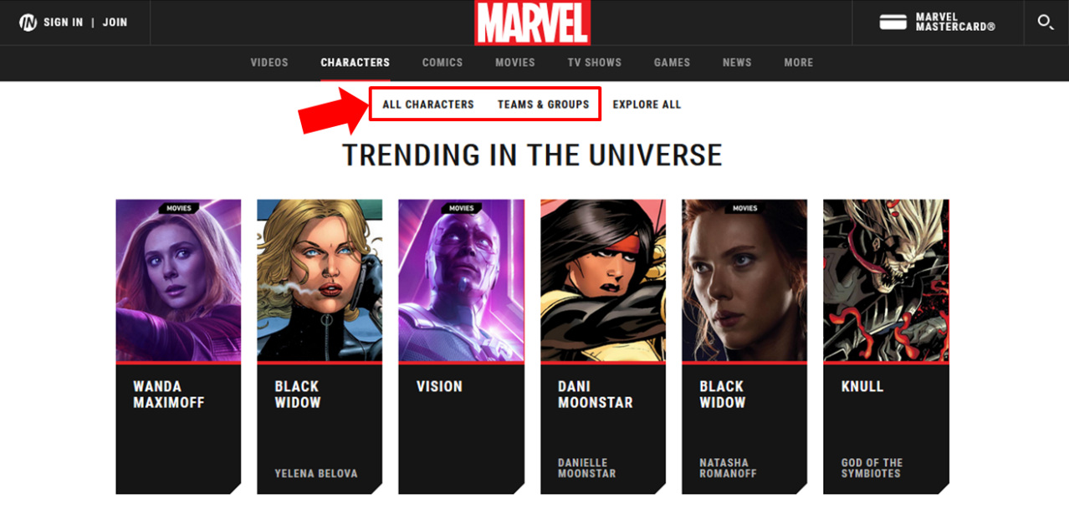Notes: Screenshot of the Marvel website marvel.com. At the top of the website, users can navigate to “Characters” to see all brands in the Marvel brand universe. After clicking on “Characters,” users can choose between “All Characters” representing the constituent brands or “Teams & Groups” representing the team brands in the universe.

Team-brand list
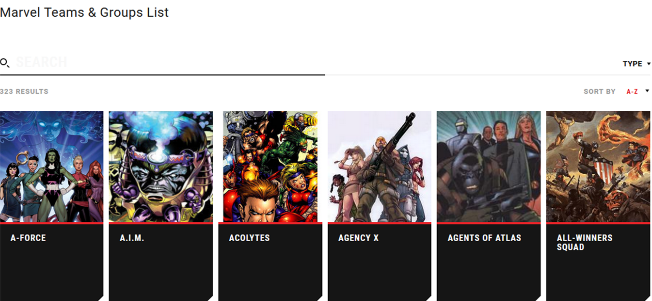
Notes: Screenshot of the Marvel website marvel.com/teams-and-groups illustrating all team brands in the Marvel brand universe.

Constituent-brand list
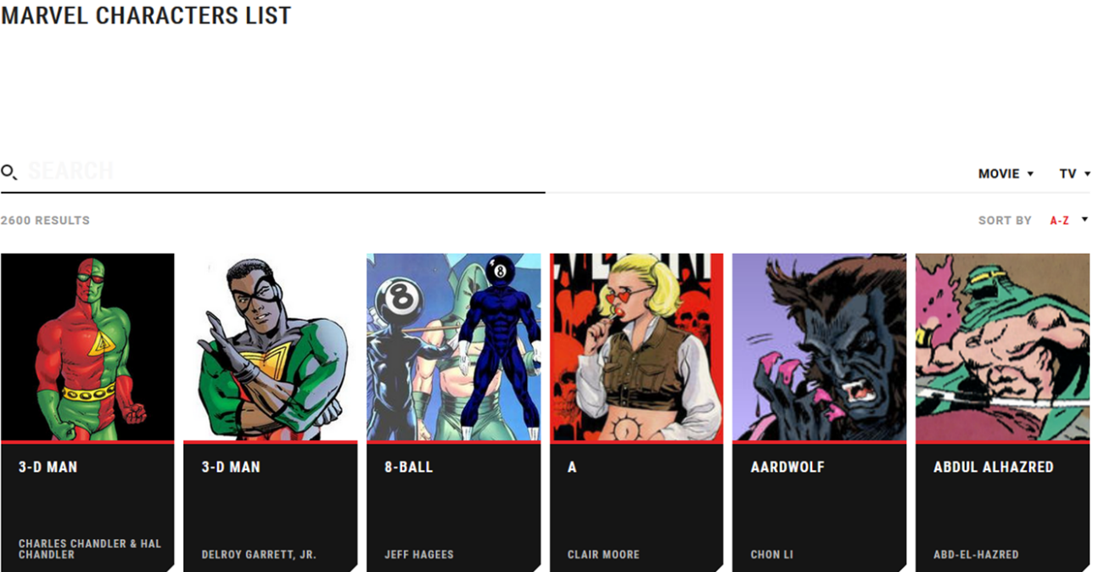
Notes: Screenshot of the Marvel website marvel.com/characters illustrating the character list of all constituent brands in the Marvel brand universe. Users can filter constituent brands by their appearance in the two most important other formats “Movie” and “TV.” Users can also click on each constituent brand to read its description, including the team affiliation.

Constituent-brand description
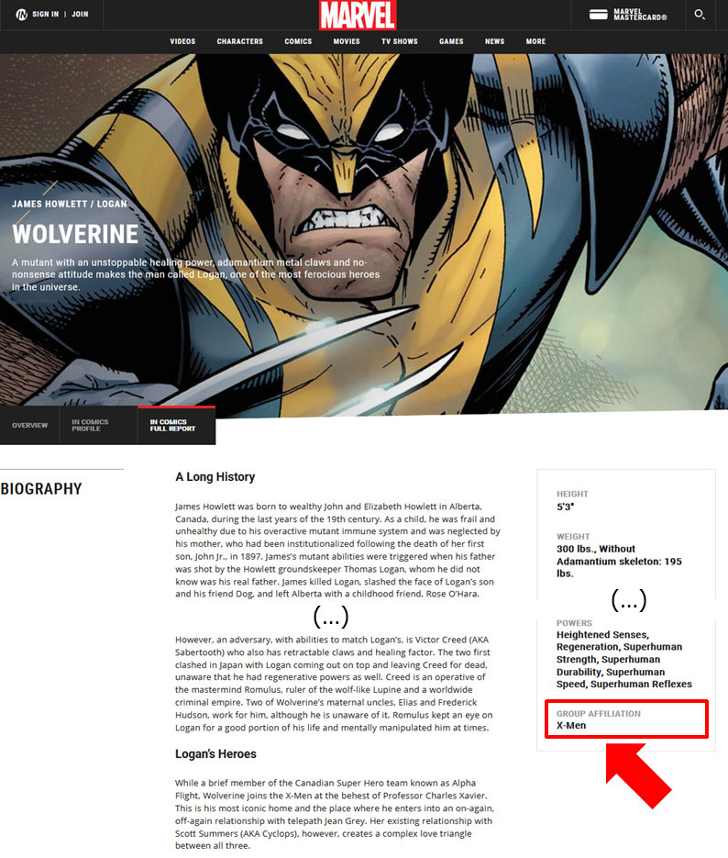
Notes: A typical screenshot of the description of a constituent brand (Wolverine). The description entails various types of information about the constituent brand, including its history, powers, and team affiliation (X-Men).

Appearing characters in comic issue
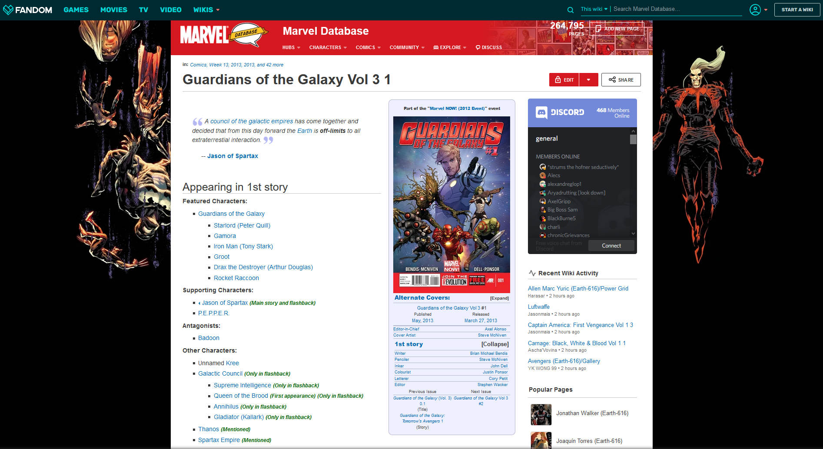
Notes: A typical screenshot of the appearing characters in a comic issue (Guardians of the Galaxy, Vol. 3, Issue 1) from the website marvel.fandom.com. The list entails information about the featured characters, including the members of the team Guardians of the Galaxy, supporting characters, antagonists, and other characters. We use the information of team membership in the comic issues to calculate the independent variable team-brand pent-up sales as well as to build the underlying BBN for the moderating variables BBN size and BBN centrality. We also use the information of antagonists in the Heckman selection model.

Web Appendix C: Team Brands and Their Constituent Brands

Constituent Brands | Team Brands
- Ant-Man | - Avengers
- Black Widow | - Avengers
- Captain America | - Avengers
- Hawkeye | - Avengers
- Hulk | - Avengers
- Iron Man | - Avengers
- Loki* | - Avengers
- Nick Fury | - Avengers
- Spider-Man | - Avengers
- Thor | - Avengers
- Vision | - Avengers
- War Machine | - Avengers
- Silver Surfer* | - Defenders
- Doctor Doom* | - Fantastic Four
- The Thing | - Fantastic Four
- Groot | - Guardians of the Galaxy
- Rocket Raccoon* | - Guardians of the Galaxy
- Star-Lord | - Guardians of the Galaxy
- Winter Soldier* | - Invaders
- Ghost Rider* | - Thunderbolts
- The Punisher | - Thunderbolts
- Venom | - Thunderbolts
- Deadpool* | - X-Force
- Angel | - X-Men
- Cyclops | - X-Men
- Gambit | - X-Men
- Magneto | - X-Men
- Storm* | - X-Men
- Wolverine | - X-Men
Notes: As outlined in the main text, after we consistently applied the selection criteria, the procedure resulted in 29 constituent brands and 8 team brands. Note that if only one constituent brand from a team brand fulfills the specified selection criteria, only this constituent brand is listed here. However, we use all team members to calculate the BBN-size and BBN-centrality variables. *Denotes those constituent brands that appear in the randomized sample of constituent brands included in the team-brand model in the main analysis.

Web Appendix D: Deriving the Brand-Association Network of a Team Brand

We used various forms of online consumer-generated content (CGC), such as product reviews and blog posts, to derive the brand-association networks (BANs) of the team brands in our sample. According to the associative network memory model, consumers’ memories about a brand and its products are structured in the form of a network of associations (e.g., feelings, features, logos, products), which are connected with the brand and one another (e.g., John et al., 2006; Keller, 1993). Consumers articulate these associations when they voice opinions, feelings, and reviews about the brand and its products on the web (Gensler et al., 2016). We used this CGC to derive the underlying time-variant consumer-based association networks (i.e., the BANs) of the team brands in our sample. In these networks, a constituent brand represents a mentioned association of its team brand and thus represents a node in the network.
To derive consumers’ association networks from CGC, we cooperated with Insius, a company specializing in web and social media monitoring that applies text-mining techniques to automatically collect relevant CGC on the web. Relevant CGC is hereby identified by searching for texts about the brands of interest. In our case, we searched the web for texts containing the focal team brand’s name (e.g., Defenders) in combination with the word “Marvel” to avoid unwanted results (Berger et al., 2020). For example, both the team brand we were interested in and activists for human rights or environmental protection are called “Defenders,” so including “Marvel” in the search ensured that we obtained relevant search results. Across all brands, this procedure resulted in 3,137,761 consumer-generated web entries used in the analysis.
To obtain brand associations from the identified texts, a tokenization algorithm cut each text into a set of tokens (e.g., sentences or words) according to preset rules (e.g., using spaces to separate words). In addition, we removed parts of the texts that did not contain associations (e.g., words such as “and”) from the tokens by comparing them with stop-word lists (Berger et al., 2020). This procedure resulted in a set of associations for each team brand in our dataset (e.g., “Hulk,” “mighty,” and “movie” for the team brand the Avengers). Whenever two associations were mentioned jointly (i.e., within one web entry), they were connected by an edge in the focal team-brand network (for a detailed description of how to elicit BANs from CGC, see Gensler et al., 2016).
We included all consumer-generated texts identified in a given month to ensure that the BANs were grounded in a comprehensive and, in terms of CGC, complete (as best possible) set of consumer articulations. As different CGC is generated every month, we constructed a separate BAN for each team brand for each month, representing the current association network for each brand at that point in time.

Web Appendix E: Descriptive Statistics
 |  |  |  |  | Correlations (Pearson)
 | Mean | SD | Min | Max | 1 |  | 2 |  | 3 |  | 4 |  | 5 |  | 6 |  | 7 |  | 8 |  | 9 |  | 10 |  | 11 |  | 12 |  | 13
Dependent Variables
1. Team-brand sales | 220,514 | 18.073 | 0 | 742,102
2. Constituent-brand sales | 35,323 | 73.575 | 0 | 763,043 |  | .163
Independent Variables
3. Constituent-brand pent-up sales | 35,008 | 77.982 | 0 | 967,132 |  | .171 |  | .941
4. Team-brand pent-up sales | 46,883 | 427.768 | 0 | 16,600,000 |  | .063 |  | .069 |  | .067
Moderating Variables
5. BBN size | 24.200 | 2.728 | 0 | 86 |  | .789 |  | .126 |  | .131 |  | .081
6. BAN size | 252.834 | 107.254 | 43 | 562 |  | .401 |  | .177 |  | .169 |  | -.011 |  | .191
7. BBN centrality | 9.094 | 13.377 | 0 | 81 |  | .483 |  | .162 |  | .159 |  | .142 |  | .669 |  | -.009
8. BAN centrality | 11.961 | 5.982 | 0 | 210 |  | .355 |  | .469 |  | .443 |  | .069 |  | .356 |  | .155 |  | .274
Control Variables
9. Team-brand sales lag | 220,514 | 18.073 | 0 | 742,102 |  | .871 |  | .158 |  | .153 |  | .058 |  | .767 |  | .404 |  | .454 |  | .357
1. Team-brand movie viewers | 653,078 | 5,289,294 | 0 | 66,892,460 |  | .022 |  | .016 |  | .016 |  | -.005 |  | .114 |  | -.067 |  | .084 |  | .082 |  | .102
11. Team-brand TV viewers | 1,626,390 | 4,123,903 | 0 | 35,448,000 |  | .142 |  | .065 |  | .099 |  | -.003 |  | .262 |  | -.075 |  | .129 |  | .146 |  | .110 |  | .133
12. Constituent-brand sales lag | 35,323 | 73.575 | 0 | 763,043 |  | .152 |  | .864 |  | .808 |  | .035 |  | .121 |  | .178 |  | .163 |  | .465 |  | .159 |  | .017 |  | .041
13. Constituent-brand movie viewers | 731,231 | 5,958,120 | 0 | 126,019,335 |  | .031 |  | .069 |  | .060 |  | .279 |  | .069 |  | -.036 |  | .063 |  | .076 |  | .062 |  | .355 |  | .048 |  | .039
14. Constituent-brand TV viewers | 1,800,876 | 9,692,881 | 0 | 350,502,000 |  | .037 |  | .151 |  | .134 |  | .342 |  | .064 |  | -.001 |  | .056 |  | .126 |  | .042 |  | .019 |  | .153 |  | .119 |  | .345
Notes: Critical correlation values r for a two-sided test are .033 (α = .05), .044 (α = .01), and .056 (α = .001).

Web Appendix F: Robustness Check Using a SUR Model

The additional analysis using a SUR model supports the robustness of our analysis in the main text, as the results are similar to those in Table 4. Importantly, we again find significant, positive spillover from the constituent brands to their team brands and vice versa.

(M5)
SUR Model
 | b | (SE)
Equation 1 (DV: Team-brand sales)
Intercept | 1.734*** | (.284)
Mean constituent-brand sales | .405*** | (.024)
Team-brand sales lag | .609*** | (.019)
Team-brand movie viewers | -.017 | (.027)
Team-brand TV viewers | .044** | (.015)
IMR | -1.457*** | (.161)
Equation 2 (DV: Mean constituent-brand sales)
Intercept | .146 | .270
Team-brand sales | .199*** | .027
Mean constituent-brand sales lag | .557*** | .022
Mean constituent-brand movie viewers | .183*** | .030
Mean constituent-brand TV viewers | .237*** | .020
Mean IMR | .186 | .151
Fixed-effect team brand | Yes
Fixed-effect year | Yes
R² Equation 1/Equation 2 | .865/.790
N Equation 1/Equation 2 | 952/952
***p < .001, **p < .01. Notes: Standard errors are in parentheses. As the equations in a SUR model need to have the same unit of analysis, we use mean values (at the team level) for the constituent brands’ variables.

Web Appendix G: Robustness Checks for the Team-Brand Model

Table G.1 Team-brand model with Gaussian copulas
To account for potentially endogenous variables, we use a Gaussian copula approach. The copula for an endogenous variable X_{jt} is calculated as Copula (X_{jt}) Φ⁻¹[H_{X}(X_{jt})], where Φ⁻¹ is the inverse of the cumulative distribution function of the standard normal distribution and H_{X} is the empirical distribution function of the focal endogenous variable X_{jt}. Identification in the copula approach requires that the endogenous variables are not normally distributed (e.g., Guitart & Stremersch, 2021). Visual inspections of the histograms and results from Shapiro–Wilk tests confirm that the continuous endogenous variables are not normally distributed (constituent-brand pent-up sales: W = .912, p < .01; BBN size: W = .953, p < .01; BBN centrality: W = .961, p < .01). Including copulas supports the robustness of our initial results. In contrast with M3, the interaction between constituent-brand pent-up sales and BBN centrality becomes significant at p < .01, in further support of H1c.

 | (M6) Including copulas of the potentially endogenous variables
 | b | (SE)
Intercept | -.399 | (.813)
Independent Variable
Constituent-brand pent-up sales | .025 | (.023)
Moderating Variables
BBN size | 2.666*** | (.322)
BAN size | .515 | (.403)
BBN centrality | -.869*** | (.267)
BAN centrality | .114 | (.079)
Interaction Effects
Constituent-brand pent-up sales × BBN size | -.117*** | (.020)
Constituent-brand pent-up sales × BAN size | .053 | (.061)
Constituent-brand pent-up sales × BBN centrality | .032** | (.012)
Constituent-brand pent-up sales × BAN centrality | -.041*** | (.012)
Control Variables
Team-brand sales lag | .458*** | (.045)
Team-brand movie viewers | -.006 | (.017)
Team-brand TV viewers | .059*** | (.015)
IMR | -.797*** | (.184)
Endogeneity Correction
Copula Constituent-brand pent-up sales | 1.135** | (.311)
Copula BBN size | -2.468*** | (.533)
Copula BBN centrality | 1.941* | (.728)
Fixed-effect brand | Yes
Fixed-effect year | Yes
R² | .847
N | 952
*p < .05; **p < .01; ***p < .001. Notes: Standard errors (1000 bootstrap samples) are in parentheses. Dependent variable = team-brand sales.
Table G.2 Team-brand model with Marvel NOW! relaunch dummy
To examine the robustness of our results, we include a variable named Marvel NOW! reflecting the comic branding used for the relaunch of several ongoing comic series in October 2012 (i.e., dummy variable taking the value 1 in the months after the relaunch). Including this additional control variable supports the robustness of our results, as it does not cause notable changes in the effects of our focal variables as reported in Table 4, which leaves the results of our hypothesis testing unchanged.

 | (M7) Including Marvel NOW! as additional control variable
 | b | (SE)
Intercept | .220 | (.794)
Independent Variable
Constituent-brand pent-up sales | .069** | (.025)
Moderating Variables
BBN size | 1.783*** | (.125)
BAN size | .533 | (.413)
BBN centrality | -.396*** | (.109)
BAN centrality | .090 | (.073)
Interaction Effects
Constituent-brand pent-up sales × BBN size | -.117*** | (.018)
Constituent-brand pent-up sales × BAN size | -.063 | (.065)
Constituent-brand pent-up sales × BBN centrality | .028† | (.015)
Constituent-brand pent-up sales × BAN centrality | -.037** | (.011)
Control Variables
Team-brand sales lag | .464*** | (.021)
Team-brand movie viewers | -.003 | (.025)
Team-brand TV viewers | .051*** | (.015)
IMR | -.866*** | (.144)
Additional Control Variable
Marvel NOW! | .422 | (.429)
Fixed-effect brand | Yes
Fixed-effect year | Yes
R² | .892
N | 952
*p < .05; **p < .01; ***p < .001; †p < .10. Notes: Standard errors are in parentheses. Dependent variable = team-brand sales.

Table G.3 Team-brand model with mean sales and network characteristics of other constituent brands of the team
Controlling for mean constituent-brand sales of the team’s other constituent brands in our sample (M8) as well as the mean BBN and BAN centrality of the team’s other constituent brands in our sample (M9) supports the robustness of our analyses.

 | (M8) Controlling for mean constituent-brand sales |  |  | (M9) Controlling for mean constituent-brand sales and mean centrality variables
Intercept | b | (SE) | b |  | (SE)
Intercept | .331 | (.907) | -.431 |  | (1.069)
Independent Variable
Constituent-brand pent-up sales | .070** | (.025) | .062* |  | (.025)
Moderating Variables
BBN size | 1.776*** | (.126) | 1.957*** |  | (.132)
BAN size | .528 | (.413) | .061 |  | (.434)
BBN centrality | -.394*** | (.109) | -.319** |  | (.111)
BAN centrality | .090 | (.073) | .085 |  | (.073)
Interaction Effects
Constituent-brand pent-up sales × BBN size | -.118*** | (.019) | -.121*** |  | (.018)
Constituent-brand pent-up sales × BAN size | -.064 | (.066) | -.045 |  | (.066)
Constituent-brand pent-up sales × BBN centrality | .028† | (.015) | .026† |  | (.015)
Constituent-brand pent-up sales × BAN centrality | -.036** | (.011) | -.036** |  | (.011)
Control Variables
Team-brand sales lag | .464*** | (.021) | .454*** |  | (.021)
Team-brand movie viewers | -.004 | (.025) | -.004 |  | (.025)
Team-brand TV viewers | .052*** | (.015) | .050*** |  | (.015)
IMR | -.862*** | (.144) | -.800*** |  | (.144)
Mean of the Team’s Other Constituent Brands | -.010 | (.036)
Mean constituent-brand sales | .331 | (.907) | -.018 |  | (.036)
Mean BBN centrality |  |  | .397*** |  | (.117)
Mean BAN centrality |  |  | -.456** |  | (.141)
Fixed-effect brand | Yes |  |  | Yes
Fixed-effect year | Yes |  |  | Yes
R² | .892 |  |  | .894
N | 952 |  |  | 952
*p < .05; **p < .01; ***p < .001; †p < .10. Notes: Standard errors are in parentheses. Dependent variable = team-brand sales

Web Appendix H: Robustness Checks for the Constituent-Brand Model

Table H.1 Constituent-brand model with Gaussian copulas
Visual inspection of the histograms and results from Shapiro–Wilk tests confirm that the continuous endogenous variables are not normally distributed (team-brand pent-up sales: W = .941, p < .01; BBN size: W = .854, p < .01; BBN centrality: W = .956, p < .01). Including copulas supports the robustness of our initial results, as the interaction effects remain the same compared with M4.

 | (M10) Including copulas of the potentially endogenous variables
 | b | (SE)
Intercept | -.762 | (1.280)
Independent Variable
Team-brand pent-up sales | .364*** | (.043)
Moderating Variables
BBN size | .138 | (.091)
BAN size | .496* | (.410)
BBN centrality | -.484*** | (.072)
BAN centrality | -.453** | (.149)
Interaction Effects
Team-brand pent-up sales × BBN size | -.005 | (.025)
Team-brand pent-up sales × BAN size | .212** | (.081)
Team-brand pent-up sales × BBN centrality | -.035 | (.020)
Team-brand pent-up sales × BAN centrality | -.197*** | (.054)
Control Variables
Constituent-brand sales lag | .518*** | (.044)
Constituent-brand movie viewers | .087*** | (.020)
Constituent-brand TV viewers | .186*** | (.032)
IMR | .116 | (.158)
Endogeneity Correction
Copula team-brand pent-up sales | 1.106*** | (.231)
Copula BBN size | .148 | (.097)
Copula BBN centrality | .241† | (.129)
Fixed-effect brand | Yes
Fixed-effect year | Yes
R² | .857
N | 3,451
*p < .05; **p < .01; ***p < .001; †p < .10. Notes: Standard errors (1000 bootstrap samples) are in parentheses. Standard errors are clustered at the team-brand level. Dependent variable = constituent-brand sales.

Table H.2 Constituent-brand model with Marvel NOW! relaunch dummy
Including the additional control variable Marvel NOW! in the constituent-brand model also supports the robustness of our analyses presented in the manuscript, as the results remain robust.

 | (M11) Including Marvel NOW! as additional control variable
 | b |  | (SE)
Intercept | .418 | (.366)
Independent Variable
Team-brand pent-up sales | .415*** | (.040)
Moderating Variables
BBN size | .187† | (.096)
BAN size | .418 | (.419)
BBN centrality | -.367*** | (.073)
BAN centrality | -.465** | (.154)
Interaction Effects
Team-brand pent-up sales × BBN size | -.008 | (.024)
Team-brand pent-up sales × BAN size | .213** | (.073)
Team-brand pent-up sales × BBN centrality | -.015 | (.017)
Team-brand pent-up sales × BAN centrality | -.202*** | (.058)
Control Variables
Constituent-brand sales lag | .503*** | (.044)
Constituent-brand movie viewers | .092*** | (.019)
Constituent-brand TV viewers | .193*** | (.030)
IMR | .147 | (.166)
Additional Control Variable
Marvel NOW! | -.403* | (.178)
Fixed-effect brand | Yes
Fixed-effect year | Yes
R² | .857
N | 3451
*p < .05; **p < .01; ***p < .001; †p < .10. Notes: Standard errors (1000 bootstrap samples) are in parentheses. Standard errors are clustered at the team-brand level. Dependent variable = constituent-brand sales.

Web Appendix I: Illustrating the Economic Impact

 | b | (SE)
Constituent Brands (M1 with sub-sample)
Angel | .003 | (.016)
Ant-Man | .164** | (.047)
Black Widow | .214*** | (.045)
Captain America | .141** | (.041)
Cyclops | .027* | (.013)
Deadpool | .434*** | (.047)
Doctor Doom | -.002 | (.066)
Gambit | .009 | (.012)
Ghost Rider | .319*** | (.056)
Groot | .112 | (.104)
Hawkeye | .055* | (.027)
Hulk | .505*** | (.060)
Iron Man | .203*** | (.043)
Loki | .147** | (.051)
Magneto | .004 | (.011)
Nick Fury | .060 | (.046)
Punisher | .635*** | (.045)
Rocket Raccoon | -.108 | (.079)
Silver Surfer | .793*** | (.122)
Spider-Man | .907*** | (.037)
Star-Lord | .050 | (.078)
Storm | .013 | (.012)
Thing | .028 | (.117)
Thor | .132** | (.038)
Venom | .316*** | (.077)
Vision | -.058 | (.060)
War Machine | .062 | (.092)
Winter Soldier | .348*** | (.069)
Wolverine | .066*** | (.016)
Team Brands (M2 with sub-sample)
Avengers | .311*** | (.016)
Defenders | .469* | (.205)
Fantastic Four | .503*** | (.062)
Guardians | .051 | (.040)
Invaders | .704*** | (.141)
Thunderbolts | .311*** | (.054)
X-Force | -.023 | (.105)
X-Men | .420*** | (.018)
*p < .05; **p < .01; ***p < .001. Notes: Standard errors are in parentheses. Brand-specific elasticities are based on models M1 and M2.

References in the Web Appendices
Berger, J., Humphreys, A., Ludwig, S., Moe, W. W., Netzer, O., & Schweidel, D. A. (2020). Uniting the tribes: Using text for marketing insight. Journal of Marketing, 84(1), 1–25.
Gensler, S., Völckner, F., Egger, M., Fischbach, K., & Schoder, D. (2016). Listen to your customers: Insights into brand image using online consumer-generated product reviews. International Journal of Electronic Commerce, 20(1), 112–141.
Guitart, I. A., & Stremersch, S. (2021). The impact of informational and emotional television ad content on online search and sales. Journal of Marketing Research, 58(2), 299–320.
John, D. R., Loken, B., Kim, K., & Monga, A. B. (2006). Brand concept maps: A methodology for identifying brand association networks. Journal of Marketing Research, 43(4), 549–563.
Keller, K. L. (1993). Conceptualizing, measuring, and managing consumer-based brand equity. Journal of Marketing, 57(1), 1–22.

