Web Appendix

How speaking versus writing to conversational agents shapes consumers’ choice and choice satisfaction

Web Appendices | Content
Web Appendix A | Real-world examples
Web Appendix B | Study 1
Web Appendix C | Stimulus material
Web Appendix D | Operationalization of constructs
Web Appendix E | Follow-up study (branded product)
Web Appendix F | Study 2
Web Appendix G | Study 3
Web Appendix H | Study 4
Web Appendix I | Study 5
Web Appendix J | Initial field study in offline context

Web Appendix A: Real-world examples
Company | Interaction |  | Via … | Illustration
Company | Written | Oral | Via … | Illustration
AXA |  |  | Self-service kiosk | https://www.globalbankingandfinance.com/on-the-fly-new-partnership-allows-travellers-to-buy-last-minute-insurance-at-the-airport/
Bank of America |  |  | Company app | 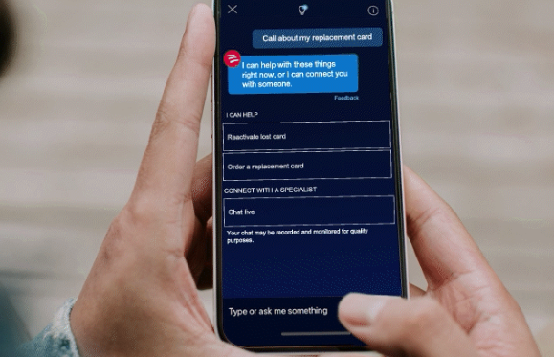  https://promotions.bankofamerica.com/digitalbanking/mobilebanking/erica
Best Buy |  |  | Digital company experts |   https://www.retaildive.com/news/best-buy-pilots-small-format-digital-store/628088/
Decathlon |  |  | WhatsApp | 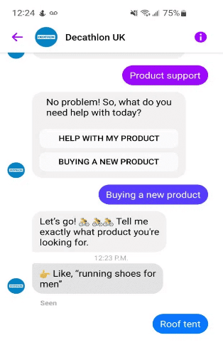  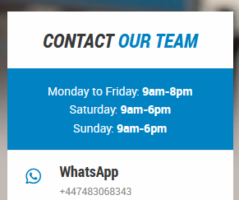  https://www.decathlon.co.uk/help/app/home
Company | Interaction |  | Company | Illustration
Company | Written | Oral | Company | Illustration
Dominos |  |  | WhatsApp, Google Assistant, Amazon’s Alexa | 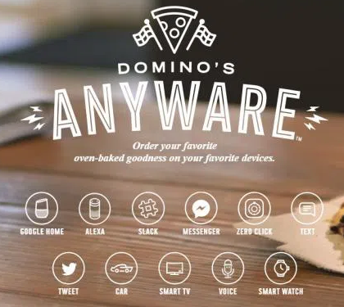  https://www.mastermarketingdigital.com/everriculum/2018/05/25/dominos-pizza-placer-la-experiencia-usuario/
Expedia |  |  | Google Assistant |   https://www.expedia.com/stories/plan-your-next-trip-with-the-google-assistant/
GrubHub |  |  | Amazon’s Alexa | 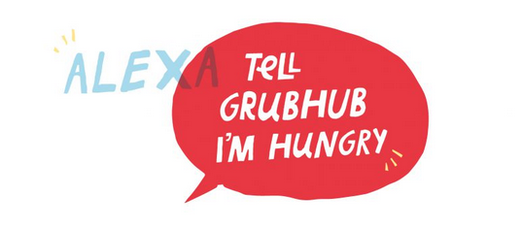  https://blog.grubhub.com/amazon-alexa
Jack & Jones |  |  | Company chatbot | 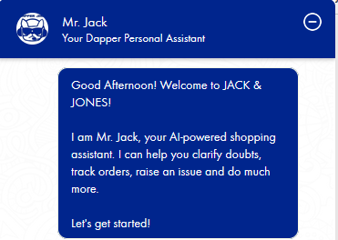  https://www.jackjones.in/
KFC |  |  | Robot | 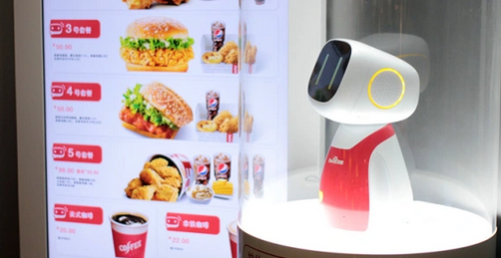  https://adamgood.net/2017/05/03/kfc-dumi-a-chinese-voice-controlled-food-ordering-robot-from-dentsu-isobar-and-baidu/
Company | Interaction |  | Company | Illustration
Company | Written | Oral | Company | Illustration
KLM |  |  | Google Assistant | 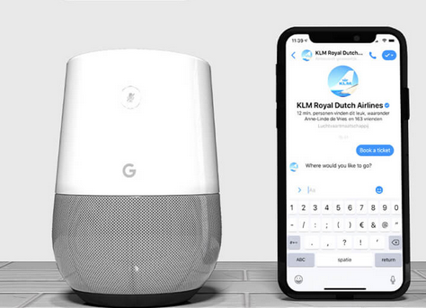  https://social.klm.com/travel-assistant
Newegg |  |  | Company chatbot, phone number | 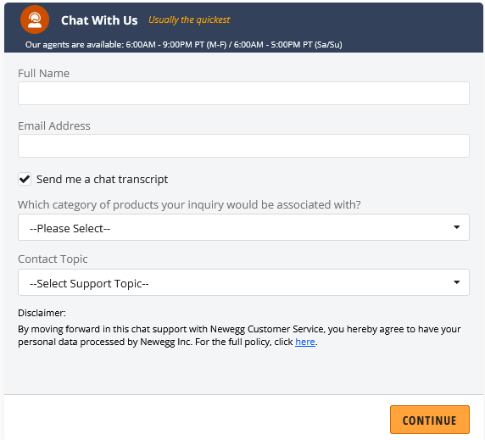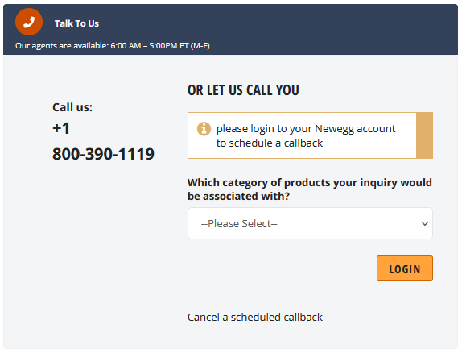  https://kb.newegg.com/
Lehman College |  |  | College  chatbot | 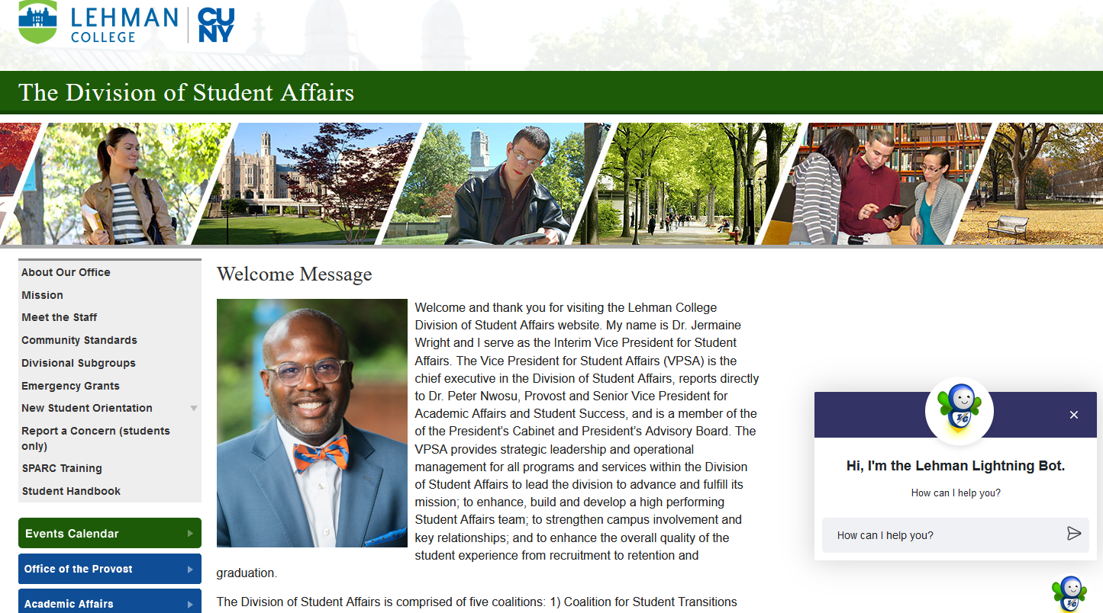  https://www.lehman.edu/student-affairs/
PVR (cinemas) |  |  | WhatsApp |   https://www.facebook.com/moviesatpvr/videos/-yes-we-are-on-whatsapp-your-favourite-movie-destination-is-now-available-just-o/235446524810175/
Walmart |  |  | Company app, SMS | 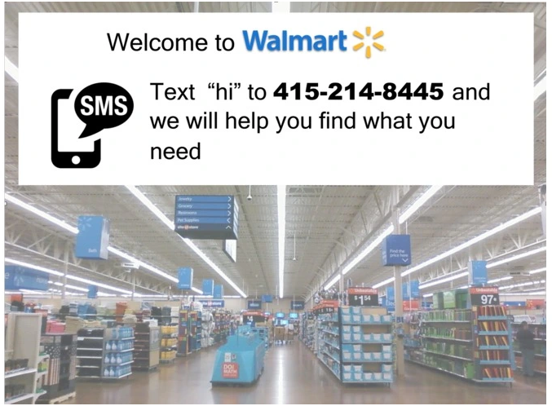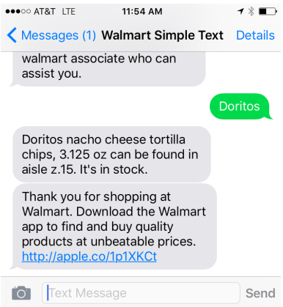  https://techcrunch.com/2015/09/20/walmart-simple-text-could-be-walmarts-version-of-magic/

Web Appendix B: Study 1
Using publications and real offers on tripadvisor.com, we generated a list of 20 hotel attributes. We provided 61 participants (77% female, M_{age} = 20.77, SD = 2.50) with the definitions of utilitarian and hedonic attributes and asked them to classify all hotel attributes as 1= “hedonic” or 7 = “utilitarian” along a seven-point bipolar scale. We defined “hedonic as relating to or characterized by pleasure and…related to aesthetics and emotional response. A hedonic product allows the customer to feel pleasure, fun and enjoyment.” We defined “utilitarian as relating to or characterized by function and…related to purpose and one’s needs. A utilitarian product allows the customer to fulfill a need but may not necessarily bring pleasure” (Roggeveen et al. 2015, pp. 37-38).
The pretest revealed three hedonic attributes (i.e., beautiful view over the city [M = 2.57, t(60) = –7.66, p < .001], extra wide box spring bed [M = 2.43, t(60) = –7.80, p < .001], and wellness and spa offers [M = 1.98, t(60) = –10.91, p < .001]; all were significantly lower than the neutral midpoint [4] of the scale). In addition, we identified three utilitarian attributes (i.e., subway station nearby [M = 6.38, t(60) = 19.51, p < .001], room with soundproof window [M = 4.84, t(60) = 3.97, p < .001], and late checkout available free of charge [M = 5.57, t(60) = 8.81, p < .001]; all were significantly higher than the neutral midpoint [4] of the scale). The sets of hedonic and utilitarian attributes were rated as equally important (p = .699).

Interaction with conversational agent
Instruction
- Imagine the following scenario: You are planning a three-day stay in London and are looking for a hotel that suits your needs. To find a hotel, you go to hotelfinder.com.
- You have the option of communicating with a conversational agent and receiving a suitable offer. You can communicate with the conversational agent by voice or text.
- Please start a conversation with the conversational agent by saying/writing the following sentence: “I am looking for a hotel in London.”

Script of the conversational agent
- What time of year do you want to go to London and why is this the best time of year for you to travel to London?
- What activities would you like to do during your stay in London?
- What price range do you want to choose for your hotel room in London, and why?
- What is particularly important to you in a hotel?
- Thank you very much. Based on your answers, I found the following two offers:
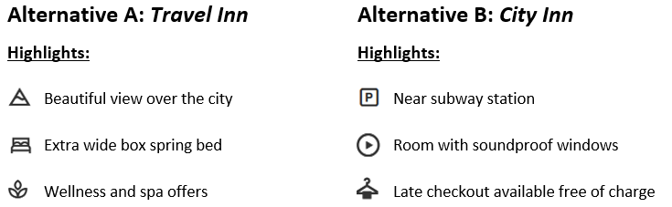

Participants in the writing condition were given open text fields to provide their answers. Each question was presented on a separate page. Participants in the speaking condition were provided with exactly the same questions.

Upon finishing their interaction, consumers in both conditions completed a short questionnaire on a desktop PC in the lab where the experiment was conducted.

Additional analyses
Variable | Speaking condition | Writing condition | F value | p value
Perceived comfort with the interface | 5.91 (1.02) | 5.79 (1.05) | .368 | .545
Challenges with the interface | 1.77 (1.10) | 1.96 (1.27) | .755 | .386
Service evaluation | 5.16 (1.42) | 5.17 (1.14) | .001 | .981
Online experience | 5.24 (1.21) | 5.17 (1.23) | .087 | .768
Privacy concerns | 4.94 (1.14) | 5.11 (1.37) | .532 | .467
Note: Standard deviations appear in parentheses.
Web Appendix C: Stimulus material
Study 1: Choice between two hotels
Hedonic option Utilitarian option


Study 2: Choice between two recently launched movies
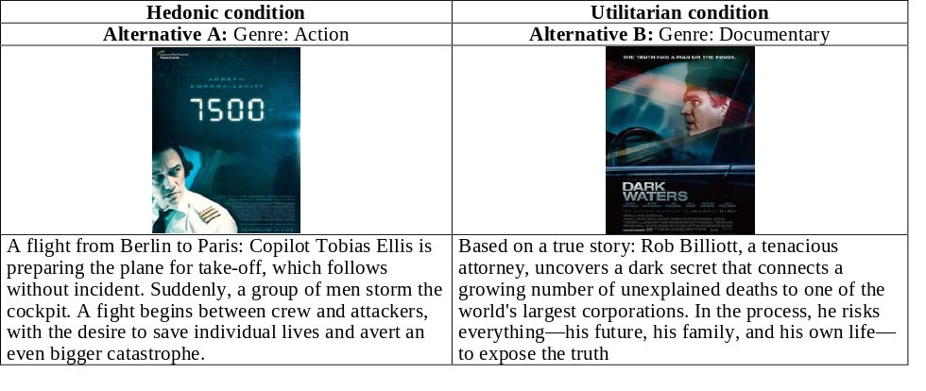
Study 3: Food choice at an online delivery service
Hedonic options  󠇝 Cheesy pizza balls  󠇝 Deep-fried rice balls | Utilitarian options  󠇝 Vegan meatballs  󠇝 Herb cheese balls
Study 4: Choice between two apartments
Hedonic condition |  |  |  | Utilitarian condition
Alternative A | Alternative B | Alternative C |  | Alternative A | Alternative B | Alternative C
 |  | 
Nice view of the green | Lovely view over the city | Beautiful view over the park |  | Bike lane is right outside your door | Subway connection | Bus stop only 2 minutes away
Suburban fashionable neighborhood | Trendy new neighborhood | Old town trendy neighborhood |  | Short distance to Central City | Close to Central City | Only 5 minutes to Central City
Fair-faced concrete | Artistic interior | Old style apartment |  | Modern energy insulation | Good thermal insulation of your home | Energy certificate: B
The closest park is right outside your door | Beautiful green park within 2 minutes walking distance | Close to occasional city park |  | Own spacious basement | Own cellar compartment for your bike | Lockable basement compartment

Note: Participants either saw the hedonic or utilitarian condition.
Study 5: Choice between two tablets
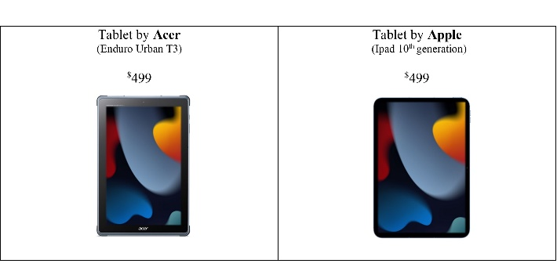
Note: Consumers either evaluated the tablet by Acer or the tablet by Apple.
Web Appendix D: Operationalization of constructs
Choice satisfaction (Zhang and Fitzsimons 1999); α = .82 (Study 4)
“I am satisfied with my choice.”
“I would make the same choice again.”
“I would make the same choice even if other options might be available.”
Intention to choose a product (adapted from Berry et al. 2017; Ding and Zhang 2020; α = .93 (Study 5)
“How likely would you be to purchase the tablet by [brand]?” (1 = “not at all” to 7 = “very much”)
“Assuming you were interested in buying a tablet, to what extent are you interested in buying the tablet from [brand]?” (1 = “not at all” to 7 = “very much”)
“How probable is it that you would consider the purchase of the tablet by [brand], if you were interested in buying a tablet?” (1 = “not at all” to 7 = “very much”)
Verbalizing focus (Pennebaker et al. 2015)
Linguistic inquiry and word count (LIWC) (Studies 1-3, and 5): “analytic thinking” measure (1-100 scale; 50 as the “neutral point”): “a high number reflects formal, logical, and hierarchical thinking,” while “lower numbers reflect more informal, personal, here-and-now, and narrative thinking” (Pennebaker et al. 2015, p. 21)
Food quantity (Biswas et al. 2023; Study 3)
“How many [food] balls would you like to order?”
Preference fluency (Novemsky et al. 2007); α = .86 (Study 4)
“It was easy for me to evaluate the choice alternatives.”
“I quickly realized which alternative was best for me.”
“Forming a preference for an alternative was fairly simple.”
Brand equity (Yoo et al. 2000; Heinberg et al. 2020); all α = .98 (Study 5)
“It makes sense to buy [brand] instead of another brand.”
“Even if another brand has the same features as [brand], I would prefer to buy [brand].”
“If there is another brand as good as [brand], I prefer to buy [brand].”
“If another brand is not different from [brand] in any way, it seems smarter to purchase [brand].”
Hedonism/utilitarism (Sela and Berger 2012); all α = .94 (Study 5)
“not fun vs. fun”
“not pleasurable vs. pleasurable”
“not useful vs. useful” (reverse coded)
“not practical vs. practical” (reverse coded)
Challenge with interface (Zierau et al. 2022; Study 1)
“Using the conversational agent challenges me.”
Comfort with interface (Estes and Streicher 2022); r = .65 (Study 1)
“How comfortable was this interface?” (1 = “not comfortable at all” to 7 = “very comfortable”)
“How comfortable are you using this interface?” (1 = “not at all” to 7 = “extremely”)
Online experience (Henkel and Toporowski 2022); α = .83 (Study 1)
“The platform is exciting.”
“The platform is unique.”
“The platform has a pleasant atmosphere.”
Privacy concerns (Brough et al. 2022; Study 1)
“How comfortable are you with the way your data is collected and managed by this company?” (1 = “not at all” to 7 = “extremely”)
Service evaluation (Zierau et al. 2022); α = .81 (Study 1)
“Overall, I am satisfied with the platform’s online experience.”
“My overall opinion of the services provided by the platform is very good.”
“Overall, the platform offers a meaningful service.”
Note: If not indicated otherwise, items used a scale ranging from 1 = “strongly disagree” to 7 = “strongly agree.”
Web Appendix E: Follow-up study (branded products)
Method
Design and sample This study used a 2 (communication modality: speaking vs. writing) × 2 (brand equity: high-high vs. low-low) between-subjects design. We recruited 302 participants on Prolific (45% female, M_{age} = 40.63, SD = 13.33) in exchange for monetary compensation of $2.50.
Procedure and measures Participants were provided with descriptions and a photo of two earbuds from different brands that differed in terms of four attributes. The product descriptions were shown in random order. Attributes were either all hedonic (e.g., design, comfort) or all utilitarian (e.g., battery life, charging speed). A pretest (N = 53; see below) confirmed that attributes were perceived as expected and that both products were equally attractive. We manipulated brand equity between choice alternatives by presenting two brands that manufacture earbuds. The brands were similar in their brand equity (i.e., either high or low). The brand order was randomized. We pretested a number of brands to identify two that were high in brand equity (Bose, Sony) and two that were low (Beats, JVC; N = 74; see below).
Participants then read that an online electronics retailer wanted them to test a new conversational agent, Aria, which had been recently implemented in its web store. We programmed the agent saying: “Please tell me what you think and how you feel about the two alternatives.” The participants were then randomly assigned to the speaking or the writing condition and asked to respond to the agent’s question by either speaking or writing. Afterward, participants chose either the hedonic or the utilitarian product. Finally, as a manipulation check, participants completed four items regarding the brand equity of the two presented brands. We excluded 19 participants who did not follow our instructions. Our final sample consisted of 283 participants.
Results
We conducted chi-square tests (see Figure below) to examine separately the impact of the communication modality used on consumer choice for two contexts: high-equity brand vs. high-equity brand (Panel 1) and low-equity brand vs. low-equity brand (Panel 2). When both the hedonic and utilitarian products were high in brand equity (Panel 1), consumers in the speaking condition preferred the hedonic product (61.6% [45/73]), whereas those in the writing condition were more likely to choose the utilitarian product (67.1% [49/73]; χ²(1) = 12.12, p < .001). Similarly, when both the hedonic and utilitarian products were low in brand equity (Panel 2), consumers in the speaking condition preferred the hedonic product (60.3% [41/68]), whereas those in the writing condition were more likely to choose the utilitarian alternative (65.2% [45/69]; χ²(1) = 8.94, p = .003).
PANEL 2
PANEL 1

Hedonic product (high-equity brand)  Utilitarian product (high-equity brand)  Match  Match  Mismatch  Mismatch  χ²(1) = 12.12, p < .001 | Hedonic product (low-equity brand)  Utilitarian product (low-equity brand)  Match  Mismatch  Match  Mismatch  χ²(1) = 8.94, p = .003

†< .10, * p < .05, ** p < .01, *** p < .001. Bold boxes highlight key findings in Panels 1 and 2.
Discussion
The follow-up investigation shows that in the context of similar brand equity between choice alternatives, matching the communication modality with the product type leads to favorable consumer decision-making outcomes both for low-equity brands and, importantly, for high-equity brands.

Pretest results (hedonic/utilitarian attributes)
We generated a list of 20 common attributes for earbuds/headphones based on available publications and advertisements. Fifty-three participants (62% female, M_{age} = 24.45, SD = 3.09) were given the definition of utilitarian and hedonic attributes (“Utilitarian [attributes] are primarily instrumental, i.e., useful, practical, functional […], whereas hedonic [attributes] are multisensory and provide for experiential consumption, fun, pleasure, and excitement”; Hsee et al. 2015, p. 140) and asked to classify all attributes from 1 = “purely hedonic” to 7 = ”purely utilitarian” along a seven-point bipolar scale (scale adapted from Chang and Hung 2018). The results revealed four attributes as clearly hedonic (i.e., design [M = 1.94, t(52) = –11.21, p < .001], comfort [M = 2.09, t(52) = –10.18, p < .001], water-/dustproof [M = 2.43, t(52) = –7.02, p < .001], and sound [M = 3.06, t(52) = –3.74, p < .001]; all means were significantly lower than the neutral midpoint [4] of the scale). Moreover, the results indicated four attributes as clearly utilitarian (i.e., battery life [M = 5.87, t(52) = 9.02, p < .001], noise cancelling [M = 5.32, t(52) = 5.96, p < .001], charging time [M = 5.64, t(52) = 7.67, p = .002], and compatibility [M = 5.77, t(52) = 8.75, p < .001]; all means were significantly higher than the neutral midpoint [4] of the scale). The sets of hedonic and utilitarian attributes were equally attractive (p = .415).

Pretest results (brand equity)
We generated a list of eight well-known brands in the earphone category. Seventy-four Prolific workers (64% female, M_{age} = 36.66, SD = 14.09) were presented with and rated all brands on four items related to brand equity (e.g., “It makes sense to buy [brand] instead of another brand”; all α > .95; Yoo et al. 2000, see also Heinberg et al. 2020) along a seven-point bipolar scale. We identified two brands as low-equity brands (i.e., Beats [M = 3.31, t(73) = –4.01, p < .001], JVC [M = 3.15, t(73) = –5.20, p < .001]; both means were significantly lower than the neutral midpoint [4] of the scale) and two brands as high-equity brands (i.e., Sony [M = 4.52, t(73) = 3.01, p = .004], Bose [M = 4.45, t(73) = 2.50, p = .015]; both means were significantly higher than the neutral midpoint [4] of the scale).

Stimulus material
Condition: similar brand equity between choice alternatives (high equity vs. high equity)
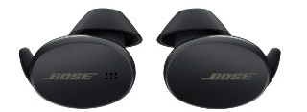 | Earbuds by Bose  $99⁹⁵  About this item  - Fantastic sound  - Outstanding style  - Maximum comfort: Inspired by the natural shape of the ear  - Ideal for outdoor activities |  | Earbuds by Sony  $99⁹⁵  About this item  - Up to 28 hours of listening  - Fast charging (4 hours)  - 2x the speed with new Bluetooth  - Eliminates ambient noise
Note: Illustrative example (brand order was randomized)
Web Appendix F: Study 2
Pretest results
We pretested four movies that were about to be released in theaters soon after the study. Forty-three college students from a large public university (70% female, M_{age} = 23.74, SD = 1.40, online study) were presented with a short description and a poster of each movie. We asked participants to classify the movies as hedonic (i.e., 1 = “focus on entertaining”) or utilitarian (i.e., 7 = “focus on informing”) along a seven-point bipolar scale (adapted from Savary et al. 2015). The results indicated one movie as clearly hedonic/entertaining (“7500”; M = 1.65, lower than the neutral scale midpoint [4], t(42) = –17.18, p < .001) and one as clearly utilitarian/informing (“Dark Waters”; M = 5.51, higher than the scale midpoint [4], t(42) = 12.42, p < .001). Both movies were rated as equally likeable (p = .497).

Different text analysis approaches to capturing consumers’ verbalizing focus
We used the Evaluative Lexicon (Rocklage et al. 2018) as an alternative approach to assess consumers’ verbalizing focus on feelings or reasons. The Evaluative Lexicon consists of more than 1,500 words that have been rated in terms of their emotionality. In contrast to LIWC, which does not include a measure for emotional intensity, the Evaluative Lexicon quantifies individuals’ emotional reaction on a 0 = “not at all emotional” to 9 = “very emotional” scale (see Berger et al. 2022 for a more detailed comparison of LIWC and Evaluative Lexicon). We used the same text data as input as we used for the LIWC approach.
Similar to the initial analysis, a one-factor ANOVA showed that consumers’ verbalizing focus was different for the speaking (M_{speaking} = 5.14, SD = 1.89) and writing conditions (M_{writing} = 3.87, SD = 2.59; F(1, 105) = 8.34, p = .005, η² = .074), providing additional support for H1. Specifically, participants in the speaking condition focused more on feelings (mean significantly higher than the scale midpoint [4.5]; t(52) = 2.45, p = .018), while participants in the writing condition were less likely to focus on feelings (mean marginally lower than the scale midpoint [4.5]; t(53) = –1.79, p = .079). In addition, mediation analysis (PROCESS Model 4) with communication modality (0 = speaking; 1 = writing) as the independent variable, choice (0 = action movie/hedonic, 1 = documentary/utilitarian) as the dependent variable, and emotionality as the mediator demonstrated that writing decreases a focus on feelings (a = –1.267, SE = .439, p = .005), which subsequently decreases consumers’ choice of the utilitarian product (b = –.157, SE = .093, p = .090; ab = .199, SE = .140, 95% CI [–.049; .512], 90% CI [.001; .453]).

Web Appendix G: Study 3
Method
Design and sample Study 3 used a one-factor between-subjects design with two conditions (communication modality: speaking vs. writing). We recruited 152 college students from a large public university (N = 152, 60% female, M_{age} = 23.29, SD = 3.55, lab study).
Procedure and measures Participants were told that they had received a 5€ voucher to order a snack from a delivery service and that the food would be delivered on the date they specified during the ordering process. Next, participants were randomly assigned to either the speaking or writing condition and asked to use a digital assistant to place an order with the new delivery service, either by speaking to the digital assistant or by writing in the digital assistant’s app (similar to GrubHub’s food delivery service skill on Amazon’s Alexa; see Web Appendix A).
Consumers started a conversation with the assistant by asking it for suggestions on the snacks they could order. The digital assistant used a “natural” female voice and prompted consumers to indicate what snacks they typically buy. Consumers were also asked to provide their preferences and their feelings and thoughts about important elements when making a choice. The content and the sequence of all questions from the digital assistant were identical across conditions (see below for the script and further details). The digital assistant then presented four snack alternatives in randomized order. Consumers were asked to choose one option from a set of two hedonic snacks (i.e., cheesy pizza balls and deep-fried rice balls) and two utilitarian snacks (i.e., vegan meatballs, herb cheese balls). A pretest (N = 51; see below) confirmed that the snacks were perceived as expected and that the hedonic and utilitarian alternatives were equally likeable. All alternatives were priced the same (i.e., 50 cents per ball), and consumers could use their entire 5€ voucher to order food or only part of it (i.e., they could order quantities of 1–10 balls). If they used only part of their voucher, they were informed that they could save the rest for a future order. Consumers then indicated which snack they chose and in what quantity.
Upon concluding this interaction, consumers in both conditions completed a short questionnaire on a PC in the lab where the experiment was conducted. We included control variables to measure participants’ mood and hunger using single-item measures. Finally, we informed the participants that the delivery service was fictitious and that they would receive 5€ in cash instead. Eleven participants did not follow the instructions and were dropped from the analysis. Thus, our final sample consisted of 141 participants. We performed all subsequent analyses with and without covariates and obtained similar results. In the following section, we discuss the covariate-free analysis (see below for analyses with covariates).
Results
Verbalizing focus Similar to Studies 1 and 2, two research assistants transcribed the recorded interactions from the speaking condition. Again, we employed LIWC-22 (analytic thinking measure). An ANOVA showed that the verbalizing focus was different between the speaking condition and the writing condition (F(1, 139) = 31.95, p < .001, η² = .187). While consumers in the speaking condition were more likely to focus on feelings (M_{speaking} = 29.06, SD = 30.56; lower than the scale midpoint [50]; t(71) = −5.82, p < .001), those in the writing condition were more likely to focus on reasons (M_{writing} = 56.22, SD = 26.24; marginally higher than the scale midpoint [50]; t(68) = 1.97, p = .053). These results provide further support for H1.
Food choice and quantity A chi-square test revealed that a majority of participants in the speaking condition (65.3% [47/72]) preferred a hedonic snack, while a majority in the writing condition (56.5% [39/69]; χ² (1) = 6.76, p = .009) preferred a utilitarian snack. This result provides support for H2a. An ANOVA on the number of food items ordered indicated a marginally significant difference between the speaking and writing conditions. Participants speaking about choice alternatives ordered greater quantities of food items (M_{speaking} = 6.00, SD = 2.54) than when writing (M_{writing} = 5.25, SD = 2.32; F(1, 139) = 3.38, p = .068; η² = .024).
Mediation analysis We performed two mediation analyses (PROCESS Model 4), one for food choice and one for food quantity. First, a mediation analysis with communication modality (0 = speaking; 1 = writing) as the independent variable, food choice (0 = hedonic foods; 1 = utilitarian foods) as the dependent variable, and verbalizing focus (measured through LIWC’s analytic thinking dimension) as the mediating variable showed that writing fostered a greater focus on reasons, thereby increasing the likelihood that consumers chose a utilitarian snack, while speaking triggered a focus on feelings, thereby increasing the likelihood that consumers chose a hedonic snack (a = 27.165, SE = 4.806, p < .001; b = .017, SE = .006, p = .006; ab = .471, SE = .194, 95% CI [.133; .894]). This result is further evidence for H1 and H2a. Second, a mediation analysis for food quantity showed that the greater reason-based focus when writing increased the likelihood that consumers chose smaller food quantities, while the greater feeling-based focus when speaking increased the likelihood that consumers chose larger food quantities (a = 27.165, SE = 4.806, p < .001; b = –.012, SE = .007, p = .106; ab = –.318, SE = .172, 95% CI [–.701; –.009]).
Discussion
This study generalizes our previous findings by investigating a food delivery context. In particular, the results demonstrate that consumers writing (vs. speaking) about choice alternatives are more likely to choose utilitarian food items. In addition, we show that consumers order lower quantities of food items when writing (vs. speaking). Since utilitarian foods can be generally considered “healthy” (e.g., apples, lettuce, tomatoes) and hedonic foods as “unhealthy” (e.g., bacon, chocolate, lemonade; Vosgerau et al. 2020, p. 182), this study provides important implications for marketers in encouraging healthier choices (Biswas et al. 2019).

Pretest results
Fifty-one college students from a large public university (55% female, M_{age} = 23.37, SD = 3.13, online study) rated four snack alternatives from 1 = “hedonic food” (i.e., offering pleasure or sensory stimulation) to 7 = “utilitarian food” (i.e., offering functional benefits such as nutrition or lower calories) along a seven-point bipolar scale (adapted from Mishra and Mishra 2011). We found two alternatives to be clearly utilitarian (i.e., vegan meatballs [M = 5.12, t(50) = 7.46, p < .001], herb cheese balls [M = 4.78, t(50) = 4.41, p < .001]; both means were significantly higher than the neutral midpoint [4] of the scale) and two alternatives to be clearly hedonic (i.e., cheesy pizza balls [M = 2.43, t(50) = –7.16, p < .001] and deep-fried rice balls [M = 2.84, t(50) = –5.15, p < .001]; both means were significantly lower than the neutral midpoint [4] of the scale). The hedonic and utilitarian alternatives were equally likeable (ps > .151).

Interaction with digital assistant
Instruction
- NowFresh is a new delivery service that lets you order food online and have it delivered. Today, you have the chance to order a meal of your choice with NowFresh and have it delivered. We provide you with a voucher of 5€ for this. Please keep in mind that the voucher can only be used to order food from NowFresh and that the food will be delivered to you tonight (or on another night if needed). If your chosen meal is cheaper than 5€, you can also use the voucher for your next order.
- To order food, we ask you to use the digital assistant Soundy. Soundy will help you make a choice and place your order. Please first explain your intentions to Soundy—Soundy will then guide you through the ordering process.
- Please start a conversation with Soundy by saying/writing the following sentence: Hi Soundy, I would like to order some food. Can you suggest some dishes that I could order?

Script of the digital assistant
- What dishes do you typically like?
- What do you think about a delicious snack? I recommend one of the following four dishes:
- Vegan meatballs
- Herb cheese balls
- Deep-fried rice balls
- Cheesy pizza balls
- What is your choice?
- Please tell me now how many balls you want to order. You have received a voucher for 5€ and can therefore order up to 10 balls.
- When do you want the dish delivered? Please let me know a specific day and time.

Participants in the writing condition were given open text fields to provide their answers. Each question was presented on a separate page. Participants in the speaking condition were provided with exactly the same questions, wording, and sequence.

Upon concluding their interaction, consumers in both conditions completed a short questionnaire on a desktop PC in the lab where the experiment was conducted.

Analysis with covariates
 | Verbalizing focus |  | Food choice |  |  | Food quantity
 | F value | p value | Coefficient | Wald | p value | F value | p value
Modality | 29.79 | < .001 | .953 | 7.26 | .007 | 3.08 | .082
Mood | .02 | .898 | –.031 | .06 | .813 | .01 | .923
Hunger | .70 | .406 | –.113 | .98 | .323 | .15 | .704

Web Appendix H: Study 4
Pretest results
Using publications and real estate ads, we generated a list of 25 common attributes for apartments. We provided 42 participants (69% female, M_{age} = 23.83, SD = 1.27) with the definition of utilitarian and hedonic attributes (“Utilitarian [attributes] are primarily instrumental, i.e., useful, practical, functional […], whereas hedonic [attributes] are multisensory and provide for experiential consumption, fun, pleasure, and excitement”; Hsee et al. 2015, p. 140) and asked them to classify all apartment attributes from 1 = “hedonic” to 7 = “utilitarian” along a seven-point bipolar scale (scale adapted from Chang and Hung 2018). The pretest indicated four clear hedonic attributes (i.e., view from the apartment [M = 2.00, t(41) = –8.95, p < .001], how trendy the neighborhood is [M = 1.81, t(41) = –10.39, p < .001], charm of the apartment [M = 1.64, t(41) = –15.16, p < .001], and distance to the nearest park [M = 3.05, t(41) = –3.34, p = .002], all being significantly lower than the neutral midpoint [4] of the scale). In addition, we identified four clear utilitarian attributes (i.e., distance to central city [M = 5.17, t(41) = 4.95, p < .001], proximity to public transport [M = 5.02, t(41) = 4.66, p < .001], thermal insulation [M = 5.43, t(41) = 5.81, p < .001], and basement compartment [M = 5.36, t(41) = 6.02, p < .001], all being significantly higher than the neutral midpoint [4] of the scale).

Web Appendix I: Study 5
Results: Free choice of the communication modality
Intention to choose A two-way ANOVA showed a significant main effect of brand equity (F(1, 220) = 10.13, p = .002; η² = .044) and a significant interaction between modality and brand equity (F(1, 220) = 4.95, p = .027; η² = .022). For the low-equity brand, consumers expressed a higher intention to choose when speaking (M = 4.35, SD = 2.01) versus writing (M = 3.40, SD = 1.58; F(1, 220) = 7.01, p = .009, η² = .031). In contrast, for the high-equity brand, there was no significant difference between the speaking condition (M = 4.60, SD = 2.17) and the writing condition (M = 4.80, SD = 1.74; F(1, 220) = .279, p = .598, η² = .001).
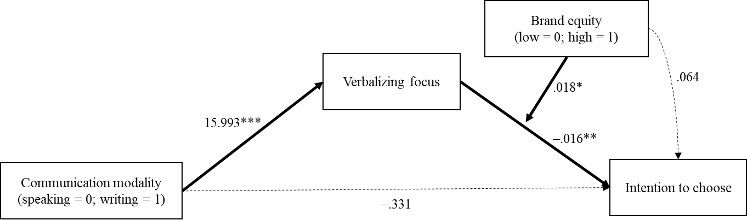
Mediation We conducted mediation analysis (PROCESS Model 14) with modality as the independent variable, verbalizing focus as the mediator, intention to choose as the dependent variable, and brand equity as the moderator influencing the path between verbalizing focus and intention to choose. The analysis provides support for moderated mediation (index = .295, SE = .167, 95% CI [.015; .674]). The indirect effect on intention to choose through verbalizing focus was stronger for the low-equity brand (ab = –.251, SE = .110, 95% CI [–.496; –.063]) than for the high-equity brand (ab = .044, SE = .110, 95% CI [–.165; .285]).

Results: Controlled choice of the communication modality
Intention to choose We found a main effect of brand equity (F(1, 216) = 26.70, p < .001; η² = .110) and an interaction between modality and brand equity (F(1, 216) = 7.26, p = .008; η² = .033). For the low-equity brand, intention to choose was higher when speaking (M = 4.67, SD = 1.38) versus writing (M = 3.81, SD = 1.52; F(1, 216) = 8.18, p = .005, η² = .036). In contrast, for the high-equity brand, we did not find a significant difference between the speaking condition (M = 5.18, SD = 1.58) and the writing condition (M = 5.46, SD = 1.70; F(1, 216) = .870, p = .352, η² = .004).
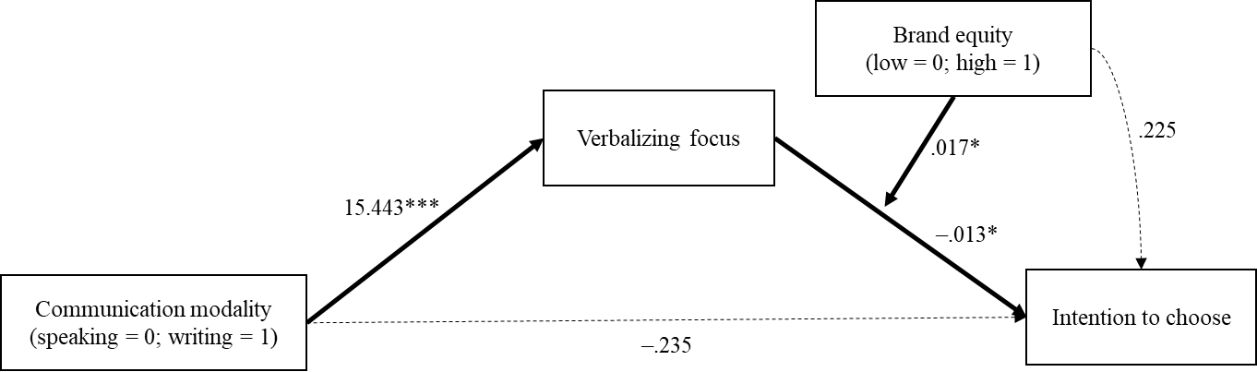
Mediation We found a significant moderated mediation (index = .262, SE = .139, 95% CI [.032; .569]). The indirect effect on intention to choose through verbalizing focus was stronger for the low-equity brand (ab = –.203, SE = .093, 95% CI [–.409; –.048]) than for the high-equity brand (ab = .059, SE = .095, 95% CI [–.112; .265]).

Results: Mediation Model (free- and controlled-modality conditions collapsed)
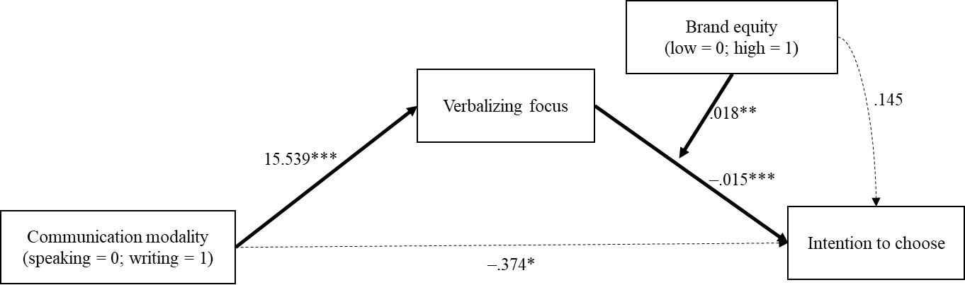
We conducted mediation analysis (PROCESS Model 14, see below) with communication modality as the independent variable, verbalizing focus as the mediator, intention to choose as the dependent variable, and brand equity as the moderator influencing the path between verbalizing focus and intention to choose. The analysis provides support for moderated mediation (index = .279, SE = .107, 95% CI [.098; .518]). The indirect effect on intention to choose through verbalizing focus was stronger for the low-equity brand (ab = –.225, SE = .071, 95% CI [–.386; –.103]) than for the high-equity brand (ab = .054, SE = .073, 95% CI [–.082; .207]). Together, these findings provide additional support for H4.

Web Appendix J: Initial field study in offline context
Pretest results
We presented 29 college students from a large public university (76% female, M_{age} = 24.10, SD = 3.17, online study) with the names of 20 different lunch alternatives from the food court’s total menu and asked them to classify the alternatives from 1 = “vice/hedonic food” (i.e., offering pleasure or sensory stimulation) to 7 = “virtue/utilitarian food” (i.e., offering functional benefits such as nutrition or lower calories) along a seven-point bipolar scale (adapted from Mishra and Mishra 2011). On the day of our study, we coordinated with the food court to offer a double-stack burger with potato wedges (M = 2.14), braised pork loin with potatoes and vegetables (M = 2.69), and currywurst with fries (M = 1.83), which were rated as hedonic foods (all means were significantly lower than the neutral midpoint [4] of the scale, t(28)_{burger} = –7.70, p < .001; t(28)_{pork} = –5.62, p < .001; t(28)_{currywurst} = –10.30, p < .001) as well as a farmer green salad with cheese, mushrooms, and oregano (M = 5.97), vegan tortellini with spinach (M = 5.48), and a quinoa bowl with fresh vegetables (M = 5.55), which were rated as utilitarian foods (all means were significantly higher than the neutral midpoint [4] of the scale, t(28)_{salad} = 6.26, p < .001; t(28)_{tortellini} = 5.23, p < .001; t(28)_{quinoa} = 5.85, p < .001). The hedonic and utilitarian alternatives were equally likeable (ps > .125).

Method
Design and sample We employed a one-factor between-subjects design with two conditions (communication modality: speaking vs. writing). We recruited 196 participants (49% female, M_{age} = 23.26, SD = 6.33) from among the customers who entered the food court.
Procedure and measures We set up a booth at the entrance of the food court where customers received information about the daily offers (six lunch options) on large displays. We coordinated with the food court to offer three options that day that were more likely to be perceived as hedonic foods (i.e., which offer pleasure or sensory stimulation—double-stack burger with potato wedges; braised pork loin with potatoes and vegetables; currywurst with fries) and three options that were more likely to be perceived as utilitarian foods (i.e., which offer functional benefits such as nutrition or lower calories—farmer green salad with cheese, mushrooms, and oregano; vegan tortellini with spinach; quinoa bowl with fresh vegetables; procedure adapted from Mishra and Mishra 2011). Given that it is an actual operating business, the food court determined the order of food alternatives that was not randomized or in any particular order. A pretest (N = 29; see above) demonstrated that all alternatives were perceived as expected.
A trained female confederate approached customers at our booth. She used the slogan “Tell us your opinion and get lunch for free” and introduced herself as a member of a local student marketing organization. She told customers that the organization was performing a market research study to improve the food court’s offers and was therefore tracking opinions about the currently offered lunch alternatives. The participants were then randomly assigned to the speaking or writing condition. For the speaking condition, the confederate asked participants to verbalize their thoughts and feelings regarding the choice alternatives aloud to her. After encouraging the participants to begin speaking, the confederate adopted a passive role and focused on listening. For the writing condition, participants were asked to write down their thoughts and feelings regarding the alternatives (manipulation adapted from Shen and Sengupta 2018). We excluded two participants who did not follow the instructions (i.e., they did not write down their thoughts and feelings). Thus, our final sample consisted of 194 participants. Because the confederate was present in the speaking and writing conditions, we were able to rule out that the effects were influenced by her mere presence.
All participants then completed a short questionnaire. Specifically, they reported the lunch option they had chosen. To assess participants’ verbalizing focus, we asked the participants to indicate the extent to which they focused on feelings or reasons when verbalizing using one item (“I focused on …” 1 = “feelings,” to 7 = “reasons”; adapted from Hong and Chang 2015). Due to the field setting, we included control variables to measure participants’ mood, involvement, visit frequency, and whether they had previously purchased a similar meal using single-item measures. The participants were run individually and were not witnessed by either the confederate or other customers while reporting their choice. They received 5€ as a thank you for their participation. In the following, we report the covariate-free analysis (see below for analyses with covariates).
Results and discussion
Verbalizing focus We found that consumers speaking about the choice alternatives focused more on feelings (M_{speaking} = 3.71, SD = 1.71), while consumers writing about the alternatives had a greater focus on reasons (M_{writing} = 4.33, SD = 1.74; F(1, 192) = 6.23, p = .013, η² = .031). Supplemental analysis revealed that both conditions were marginally significantly different from the scale midpoint ([4]; t(95)_{speaking} = −1.67, p = .098; t(97)_{writing} = 1.86, p = .066).
Choice A chi-square test revealed that a majority of participants in the speaking condition (59.4% [57/96]) preferred a hedonic lunch option, while a majority in the writing condition (60.2% [59/98]; χ²(1) = 7.44, p = .006) preferred a utilitarian option, thereby supporting H2a.
Mediation analysis A mediation analysis (PROCESS Model 4) with communication modality (0 = speaking; 1 = writing) as the independent variable and choice (0 = action movie/hedonic; 1 = documentary/utilitarian) as the dependent variable revealed that writing fostered a greater verbalizing focus on reasons, which, in turn, led consumers to be more likely to choose a utilitarian lunch option, whereas speaking triggered a greater focus on feelings, which led consumers to be more likely to choose a hedonic lunch option (a = .618, SE = .248, p = .013; b = .346, SE = .093, p < .001; ab = .214, SE = .109, 95% CI [.044; .464]).
Discussion
Employing actual behavioral data that included real consumer food choices, this study validated our prediction that matching the communication modality with the product type shapes consumers’ choice (H2a) in a physical environment. However, we acknowledge that encouraging consumers to write down their thoughts in a physical store may appear artificial.

ANCOVA results
 | Verbalizing focus |  | Choice
Effect | F value | p value | Coefficient | Wald | p value
Modality | 5.69 | .018 | .852 | 7.726 | .005
Mood | .009 | .923 | .055 | .183 | .669
Involvement | .086 | .769 | −.002 | .000 | .988
Frequency | .368 | .545 | −.052 | .194 | .659
Experience | .826 | .365 | −.545 | 2.582 | .108
Note: Results for the analysis without covariates appear in parentheses.

References
Berger, J., Rocklage, M. D., & Packard, G. (2022). Expression modalities: How speaking versus writing shapes word of mouth. Journal of Consumer Research, 49(3), 389–408.
Berry, C., Burton, S., & Howlett, E. (2017). It’s only natural: The mediating impact of consumers’ attribute inferences on the relationships between product claims, perceived product healthfulness, and purchase intentions. Journal of the Academy of Marketing Science, 45(5), 698–719.
Biswas, D., Hartmann, P., Eisend, M., Szocs, C., Jochims, B., Apaolaza, V., Hermann, E., López Cristina M., & Borges, A. (2023). Caffeine’s effects on consumer spending. Journal of Marketing, 87(2), 149–167.
Biswas, D., Lund, K., & Szocs, C. (2019). Sounds like a healthy retail atmospheric strategy: Effects of ambient music and background noise on food sales. Journal of the Academy of Marketing Science, 47(1), 37–55.
Brough, A. R., Norton, D. A., Sciarappa, S. L., & John, L. K. (2022). The bulletproof glass effect: Unintended consequences of privacy notices. Journal of Marketing Research, 59(4), 739–754.
Chang, H. H., & Hung, I. W. (2018). Mirror, mirror on the retail wall: Self-focused attention promotes reliance on feelings in consumer decisions. Journal of Marketing Research, 55(4), 586–599.
Ding, Y., & Zhang, Y. (2020). Hiding gifts behind the veil of vouchers: On the effect of gift vouchers versus direct gifts in conditional promotions. Journal of Marketing Research, 57(4), 739–754.
Estes, Z., & Streicher, M. C. (2022). Getting a handle on sales: Shopping carts affect purchasing by activating arm muscles. Journal of Marketing, 86(6), 135–154.
Heinberg, M., Katsikeas, C. S., Ozkaya, H. E., & Taube, M. (2020). How nostalgic brand positioning shapes brand equity: Differences between emerging and developed markets. Journal of the Academy of Marketing Science, 48(5), 869–890.
Henkel, L. & Toporowski (2022). Once they’ve been there, they like to share: Capitalizing on ephemerality and need for uniqueness to drive word of mouth for brands with pop-up stores. Journal of the Academy of Marketing Science, https://doi.org/10.1007/s11747-022-00861-y.
Hong, J., & Chang, H. H. (2015). “I” follow my heart and “we” rely on reasons: The impact of self-construal on reliance on feelings versus reasons in decision making. Journal of Consumer Research, 41(6), 1392–1411.
Hsee, C. K., Yang, Y., Zheng, X., & Wang, H. (2015). Lay rationalism: Individual differences in using reason versus feelings to guide decisions. Journal of Marketing Research, 52(1), 134–146.
Mishra, A., & Mishra, H. (2011). The influence of price discount versus bonus pack on the preference for virtue and vice foods. Journal of Marketing Research, 48(1), 196–216.
Novemsky, N., Dhar, R., Schwarz, N., & Simonson, I. (2007). Preference fluency in choice. Journal of Marketing Research, 44(3), 347–356.
Pennebaker, J. W., Booth, R. J., Boyd, R. L., & Francis, M. E. (2015). Linguistic Inquiry and Word Count: LIWC2015. Austin, TX: Pennebaker Conglomerates.
Rocklage, M. D., Rucker, D. D., & Nordgren, L. F. (2018). The Evaluative Lexicon 2.0: The measurement of emotionality, extremity, and valence in language. Behavior Research Methods, 50(4), 1327–1344.
Roggeveen, A. L., Grewal, D., Townsend, C., & Krishnan, R. (2015). The impact of dynamic presentation format on consumer preferences for hedonic products and services. Journal of Marketing, 79(6), 34–49.
Savary, J., Goldsmith, K., & Dhar, R. (2015). Giving against the odds: When tempting alternatives increase willingness to donate. Journal of Marketing Research, 52(1), 27–38.
Sela, A., & Berger, J. (2012). How attribute quantity influences option choice. Journal of Marketing Research, 49(6), 942–953.
Shen, H., & Sengupta, J. (2018). Word of mouth versus word of mouse: Speaking about a brand connects you to it more than writing does. Journal of Consumer Research, 36(1), 595–614.
Vosgerau, J., Scopelliti, I., & Huh, Y. E. (2020). Exerting self-control ≠ sacrificing pleasure. Journal of Consumer Psychology, 30(1), 181–200.
Yoo, B., Donthu, N., & Lee, S. (2000). An examination of selected marketing mix elements and brand equity. Journal of the Academy of Marketing Science, 28(2), 195–211.
Zhang, S., & Fitzsimons, G. J. (1999). Choice-process satisfaction: The influence of attribute alignability and option limitation. Organizational Behavior and Human Decision Processes, 77(3), 192–214.
Zierau, N., Hildebrand, C., Bergner, A., Busquet, F., Schmitt, A., & Leimeister, J. M. (2023). Voice bots on the frontline: Voice-based interfaces enhance flow-like consumer experiences & boost service outcomes. Journal of the Academy of Marketing Science, 51(4), 823–842.

