Web Appendix

Pairing Up with Anthropomorphized Artificial Agents: Leveraging Employee Creativity in Service Encounters

TABLE OF CONTENTS
Web Appendix A: Definitions of Key Constructs 2
Web Appendix B: Pilot Studies 3
Web Appendix C: Literature Review: Group Stereotyping 7
Web Appendix D: Additional Results and Supplementary Study 1b 8
Web Appendix E: Descriptive Statistics 14
Web Appendix F: Stimuli and Manipulations 17
Web Appendix G: Data Exclusion Criteria 22
Web Appendix H: Full Scales of Measurements, Studies 1–5 23

Web Appendix A: Definitions of Key Constructs
Constructs | Definition | Source
Artificial Agents (AAs) | The physically embodied or virtual, autonomous agents that facilitate service provision by performing physical or nonphysical tasks. | (Blut et al. 2021; Jorling et al. 2019)
Anthropomorphism | To imbue nonhuman agents with human features such as personality, intentions, or minds. | (Epley et al. 2007; van Doorn et al. 2016)
Perceived Entitativity | The degree to which the dyad is perceived as possessing the quality of an entity. | (Campbell 1958; Crawford et al. 2002)
Perceived AA Creativity | Customer perceptions of an AA’s ability to develop novel products, ideas, or solutions that are of value to customers. | (Hennessey and Amabile 2009)
Dyads’ Temporal Stability | The degree to which dyad members have a history of working together in the past and an expectation of working together in the future. | (Hollenbeck et al. 2012)
Customers’ Lay Beliefs of Group Entitativity | Commonsense explanations customers use to understand groups as entities. | (Argyle 2013)
Customers’ Consumption Goals | The main benefits sought by customers when purchasing products or services. | (Garrido-Morgado et al. 2021)

Web Appendix B: Pilot Studies
B1: General Perceptions of AA Traits
In a pilot test, we used a one-factor (target of judgment: human vs. artificial agent [AA]) within-subject design to learn how people perceive humans and artificial intelligence (AI), as representative of AA, on a series of general traits. From 119 participants (M_{age} = 26.5 years, SD = 8.2; 30.3% women) recruited from Prolific Academic in return for monetary compensation, we collected their views on the extent to which an average person and AI could have the following traits (1 = “not at all,” 7 = “very much”): flexible, analytical, creative, artistic, trendy, vigilant, reliable, obedient, fair, loyal, careful, precise, prompt, responsive, helpful, sincere, and able to understand. Compared with an average human (M = 5.24, SD = 1.23), they considered the AI less creative (M = 3.94, SD = 1.68; t(1, 118) = 7.24, p < .001), as Table B1 details.
Table B1 Pilot Test 1 Results
Trait | M_{humans} | SD_{humans} | M_{AIs} | SD_{AIs} | t(1, 118) | p
Flexible | 5.06 | 1.09 | 4.36 | 1.61 | 3.87 | .000
Analytical | 4.58 | 1.17 | 6.41 | 0.88 | -13.66 | .000
Creative | 5.24 | 1.23 | 3.94 | 1.68 | 7.24 | .000
Artistic | 4.88 | 1.33 | 3.63 | 1.63 | 6.63 | .000
Trendy | 5.03 | 1.28 | 4.30 | 1.60 | 4.42 | .000
Vigilant | 4.66 | 1.23 | 4.88 | 1.69 | -1.19 | .238
Reliable | 4.39 | 1.04 | 5.37 | 1.26 | -6.55 | .000
Obedient | 4.51 | 1.06 | 5.92 | 1.32 | -9.46 | .000
Fair | 4.35 | 1.00 | 4.84 | 1.63 | -2.83 | .005
Loyal | 4.56 | 1.18 | 4.71 | 2.04 | -0.67 | .502
Careful | 4.82 | 1.13 | 5.12 | 1.62 | -1.52 | .132
Precise | 4.43 | 1.20 | 6.33 | 0.97 | -12.85 | .000
Prompt | 4.48 | 0.99 | 5.35 | 1.32 | -5.89 | .000
Responsive | 5.00 | 1.01 | 5.37 | 1.56 | -2.23 | .028
Helpful | 5.14 | 1.08 | 5.46 | 1.40 | -1.92 | .057
Sincere | 4.71 | 1.08 | 4.29 | 1.96 | 2.03 | .045
Able to Understand | 5.10 | 1.26 | 3.76 | 1.80 | 6.44 | .000

B2: Effect of Anthropomorphism on Perceived AA Creativity
With a second pilot test, we investigated if anthropomorphism alone could improve perceived AA creativity. For this test, we recruited 352 participants (M_{age} = 43.8 years, SD = 14.9; 50% women) from Prolific Academic and provided them with monetary compensation. To ensure a complete design, we randomly assigned these participants to four conditions: anthropomorphism alone, nonanthropomorphism alone, anthropomorphism in dyad, or nonanthropomorphism in dyad condition.
Participants read a scenario describing how an AA alone or an AA–employee dyad created fabric chairs. We anthropomorphized the AA with visual cues (e.g., head) and verbal cues (first-person language). In the anthropomorphism alone condition, the participants read that the designer Kimo would build a profile based on their preferences, then generate and finalize the designs. In the nonanthropomorphism alone condition, the participants read that a design machine would perform these functions. If the AA was paired with a creative human employee, the description included an introduction of the human employee, who would complete the profile building, leaving the AA (anthropomorphized or not) to generate and finalize the designs. Figure B depicts these conditions.

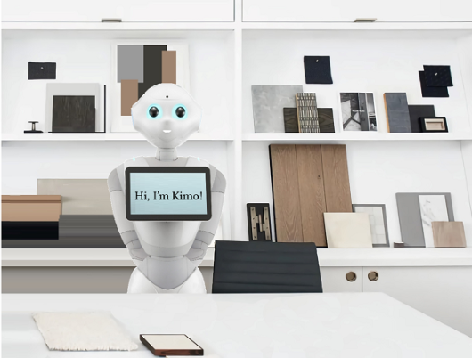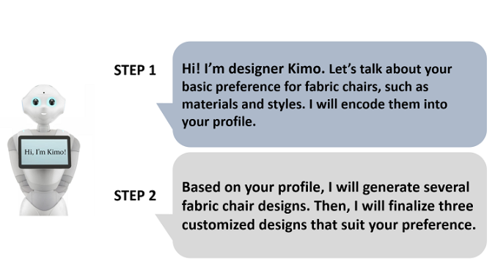
a. Anthropomorphism Alone Condition

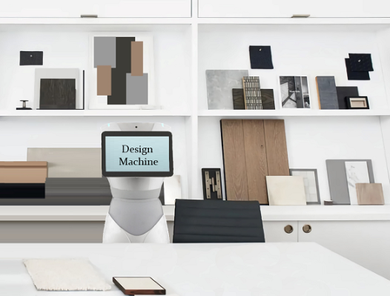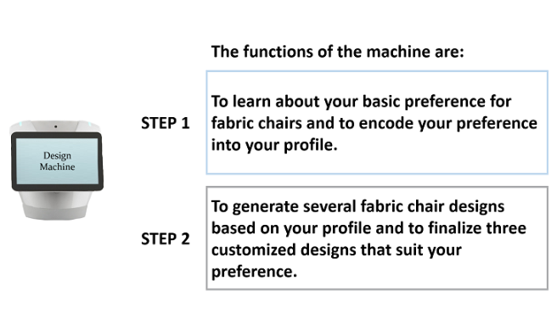
b. Nonanthropomorphism Alone Condition

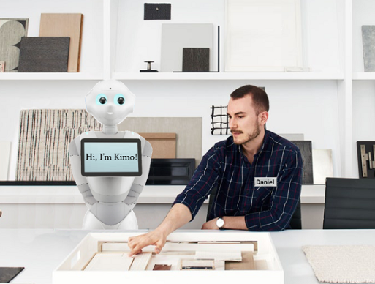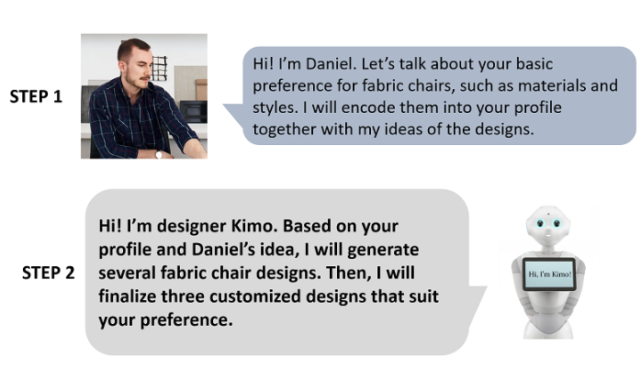
c. Anthropomorphism in Dyad Condition

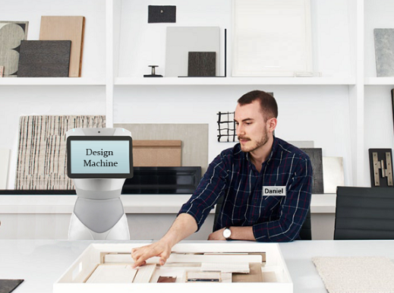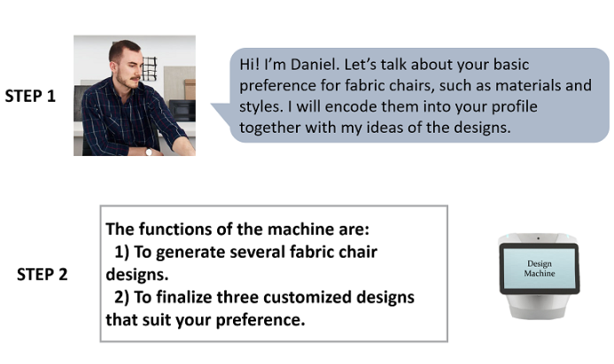
d. Nonanthropomorphism in Dyad Condition
Figure B Manipulation of Anthropomorphism

Next, participants answered a four-item manipulation check, indicating the extent to which they agreed that the AA felt like a person and had a mind of its own, its own intention, and its own personality (α = .88). They also rated how “creative” and “innovative” they perceived the AA to be, as a measure of perceived AA creativity (1 = “not at all,” 7 = “very much”; r = .79).
As predicted, when the AA was not paired with a human designer, participants perceived the anthropomorphized AA (M_{A} = 2.64, SD = 1.16) as more humanlike than the nonanthropomorphized AA (M_{NA} = 1.68, SD = .91; t(1, 348) = 6.12, p < .001, d = .86). The manipulation of anthropomorphism thus was effective. But participants did not perceive the anthropomorphized AA as more creative (M_{A} = 3.86, SD = 1.53) than the nonanthropomorphized AA (M_{NA} = 3.69, SD = 1.66; t(1, 348) = .69, p = .493). When the AA was paired with a human designer, participants perceived the anthropomorphized AA as more human-like (M_{A} = 2.90, SD = 1.34; M_{NA} = 1.80, SD = 1.03; t(1, 348) = 6.14, p < .001, d = .99) and more creative (M_{A} = 4.59, SD = 1.16; M_{NA} = 3.99, SD = 1.49; t(1, 348) = 2.99, p = .003, d = .41). Thus, anthropomorphism alone did not appear sufficient to improve customers’ perceptions of AA creativity, but with the social influence of another human employee improved perceived creativity.

Web Appendix C: Literature Review: Group Stereotyping
Context | Subjects | Trait(s) | Mechanism | Moderator(s) | Findings | Source
Group stereotyping among humans | Group members | Twelve traits (e.g., cruelty) | Mindless associations | / | Participants viewed the communicators as having more of the traits implied by the behavior of others they described. | Carlston et al. (1995)
Group stereotyping among humans | Group members | Aggressiveness, honesty, intelligence, laziness | Perceived entitativity | / | Participants were more likely to transfer traits from one group member to other members in more cohesive groups. | Crawford et al. (2002)
Group stereotyping among humans | Facebook users | Attractiveness | / | / | Participants judged Facebook users with more (vs. less) physically attractive friends as more attractive. | Walther et al. (2008)
Group stereotyping among humans | Group members | Intelligence, popularity, likeability, friendliness, pleasantness | / | Time delay | Immediately, participants generalized traits of the original individuals to new individuals in the same group, implicitly but not explicitly. Days later, they generalized traits of the original individuals to new individuals in the same group, both implicitly and explicitly. | Ranganath and Nosek (2008)
Group stereotyping among humans | Group members | Expected performance | / | Perceived group homogeneity | Participants made inferences about other group members’ performance based on the member appearing in the first position (vs. other positions) in an arbitrary order. This effect was attenuated when the group members were perceived as nonhomogeneous (vs. homogeneous). | Steinmetz et al. (2019)
Group stereotyping among humans | Neighborhood | Athleticism, sociability, political activism, intelligence | Perceived entitativity | / | Participants made quicker and more extreme judgments with greater confidence and transferred more traits to individual members when the neighborhood was high (vs. low) in entitativity. | Bernardo and Palma-Oliveira (2022)
Trait transference in AA–human dyads | AAs as service employees | Creativity | Perceived entitativity | Temporal stability of the dyad; lay beliefs of group entitativity; customer consumption goals | Customers perceived anthropomorphized (vs. nonanthropomorphized) AAs in AA–employee dyads as having greater entitativity and creativity, which drove better service evaluations. This effect was attenuated when the dyad’s temporal stability was low (vs. high), the customer’s lay beliefs about entitativity were weak (vs. strong), or customers’ consumption goals were utilitarian (vs. hedonic). | Current research

Web Appendix D: Additional Results and Supplementary Study 1b
D1: Results for Purchase Intentions, Willingness to Pay (WTP), and Word of Mouth (WOM), Study 1b
The anthropomorphism condition had a significant effect on purchase intentions (F(3, 308) = 4.97, p = .002, η² = .05), such that participants were more likely to purchase the chair designed by the anthropomorphized AA–designer dyad (M_{A} = 3.84, SD = 1.68) than the nonanthropomorphized AA–designer dyad (M_{NA} = 3.28, SD = 1.56; t(308) = 2.09, p = .037) or a human alone (M_{HA} = 3.08, SD = 1.71; t(308) = 2.89, p = .004). An ANOVA indicated a significant main effect of designer condition on WTP (F(3, 308) = 3.83, p = .010, η² = .04). Contrasts revealed that participants were willing to pay more for the chair from the anthropomorphized AA–designer dyad (M_{A} = $231.69, SD = 109.52) than from the nonanthropomorphized AA–designer dyad (M_{NA} = $195.74, SD = 111.76; t(308) = 2.14, p = .033) or human designer alone (M_{HA} = $189.47, SD = 92.59; t(308) = 2.53, p = .012). We found significant impacts on positive WOM too (F(3, 308) = 6.92, p < .000, η² = .06): Participants were more likely to spread positive WOM about the design studio when the AA was anthropomorphized in the AA–designer dyad (M_{A} = 4.57, SD = 1.47) than when it was not (M_{NA} = 3.69, SD = 1.71; t(308) = 3.36, p = .001), as well as compared with a sole designer (M_{HA} = 3.84, SD = 1.62; t(308) = 2.82, p = .005). For all these service evaluations, participants in the anthropomorphism condition did not offer different assessments than those in the human–human condition (purchase intentions: M_{HH} = 3.92, SD = 1.61; t(308) = -.32, p = .749; WTP: M_{HH} = $233.03, SD = 102.50; t(308) = -.08, p = .936; WOM: M_{HH} =4.62, SD = 1.67; t(308) = -.19, p = .851). We again controlled for customers’ age and gender as covariates in the analyses. The results remained significant (ps < .05).

D2: Facebook A/B Test, Supplementary Study 1b
This study establishes the main effect on behavioral outcomes through a social media platform. We again included the human-alone and human–human dyad baseline conditions to examine the incremental impact of an AA–employee dyad.
Method Using Facebook’s A/B test, we designed four advertisements featuring four types of service providers: anthropomorphized AA–human dyad, nonanthropomorphized AA–human dyad, human–human dyad, and a human alone (Orazi and Johnston 2020; see Web Appendix F6). The ads all promoted a fictitious business, J&R Studio, that provides design services, and they all ran for a one-week period in October 2022. They reached 3,746 Facebook users on their newsfeeds, such that these users could click to access the J&R Studio page. Thus, our dependent variable is the click-through rate (CTR), or the ratio of the number of clicks for a particular ad to the total number of impressions (Castelo et al. 2019).
Results and discussion As expected, Facebook users were more likely to click on the ad featuring the anthropomorphized AA–designer dyad (CTR = 2.24%) than the nonanthropomorphized AA–designer dyad (CTR = 1.27%; χ²(1) = 4.00, p = .046, odds ratio = 1.78) or human designer alone (CTR = 1.22%; χ²(1) = 4.10, p = .043, odds ratio = 1.86). With binary logistic regressions (anthropomorphized AA–designer dyad = 1, nonanthropomorphized AA–designer dyad = 0, human-alone = 0), we obtained convergent results, with significant differences in CTR between the anthropomorphized AA–designer dyad and the nonanthropomorphized AA–designer dyad (β = .58, p = .048) or human-alone condition (β = .62, p = .046). Moreover, the CTRs of anthropomorphized AA–designer dyad (2.24%) and human–human dyads (2.45%, χ²(1) = .14, p = .712), along with its binary logistic regression (anthropomorphized AA–designer dyad = 1, human–human dyad = 0), did not reveal significant differences (β = -.09, p = .712).
These empirical results support our predictions and are in line with the results of Study 1b. That is, Facebook users are more likely to click when the design service is provided by an anthropomorphized AA–human dyad rather than a nonanthropomorphized AA–human dyad or a human alone; the likelihood is approximately the same as that for a human–human dyad. We openly acknowledge the limitations of this study design though, because the effect of anthropomorphism on CTR could be driven by factors other than perceived entitativity or creativity of the AA.

D3: Results for Purchase Intentions, WTP, and WOM, Study 2
An ANOVA revealed that anthropomorphism exerted a significant effect on purchase intentions, such that participants were more likely to purchase the service from the anthropomorphized AA–designer dyad (M_{A} = 4.24, SD = 1.48) than from the nonanthropomorphized AA–designer dyad (M_{NA} = 3.48, SD = 1.81; F(1, 160) = 8.59, p = .004, η² = .05). Likewise, participants appeared willing to pay marginally more for a design created by the anthropomorphized AA–designer dyad (M_{A} = $2851.32, SD = 772.01) rather than the nonanthropomorphized version (M_{NA} = $2631.15, SD = 746.93; F(1, 160) = 3.38, p = .068, η² = .02). They also expressed greater willingness to spread positive WOM about the design studio when the AA was anthropomorphized (M_{A} = 4.46, SD = 1.80) than otherwise (M_{NA} = 3.65, SD = 2.01; F(1, 160) = 7.21, p = .008, η² = .04). In serial mediation analyses with PROCESS Model 6 (Hayes 2017), we found a significant serial mediation through perceived entitativity and AA creativity for all these outcomes (purchase intentions; indirect effect = .06, boot SE= .04, 95% confidence interval [CI] [.0044, .1458]; WTP: indirect effect = 25.96, boot SE= 16.95, 95% CI [.2329, 66.0992]; WOM: indirect effect = .07, boot SE= 0.5, 95% CI [.0028, 1787]).

D4: Results for Purchase Intentions, Study 3
A 2 × 2 ANOVA indicated that participants were more willing to buy the painting by an anthropomorphized AA (M_{A} = 2.76, SD = 1.55) than by a nonanthropomorphized one (M_{NA} = 2.29, SD = 1.26; F (1, 327) = 9.42, p = .002, η² = .03) or by a more stable AA–artist dyad (M_{H} = 2.75, SD = 1.53; M_{L} = 2.28, SD = 1.28; F(1, 327) = 9.39, p = .002, η² = .03). We also established a critical two-way interaction between anthropomorphism and temporal stability (F(1, 327) = 4.67, p = .031, η² = .06). Contrasts showed that participants who saw a painting finalized by the anthropomorphized AA (M_{A} = 3.15, SD = 1.69) were more likely to purchase it, compared with people who saw a painting by the nonanthropomorphized AA (M_{NA} = 2.35, SD = 1.23; F (1, 327) = 13.88, p < .001, η² = .04). No differences arose when the dyad indicated low temporal stability (M_{A} = 2.35, SD = 1.28; M_{NA} = 2.21, SD = 1.28; p = .525; Figure D1).
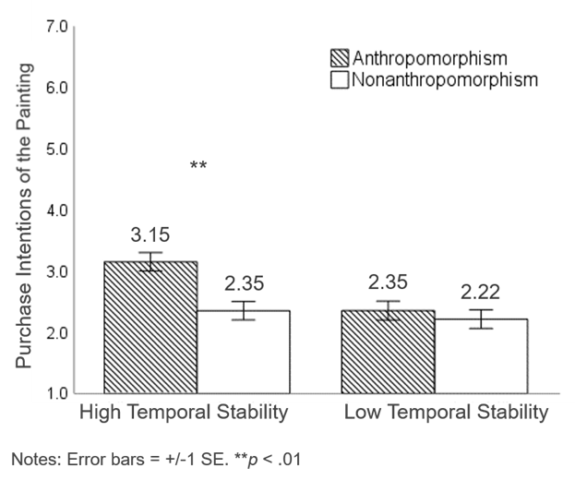
Figure D1 Interaction of anthropomorphism and temporal stability on purchase intentions, Study 3

In a moderated mediation analysis (Hayes 2017; PROCESS Model 83, 5,000 bootstrapped samples), we included temporal stability as a moderator, perceived entitativity and perceived AA creativity as serial mediators, anthropomorphism as the predictor, and purchase intentions as the outcome. The results revealed a significant moderated serial mediation for purchase intentions (index = -.05, boot SE = .03, 95% CI [-.1206, -.0105]). In the high temporal stability conditions, the indirect effect of anthropomorphism on purchase intentions was significant, through perceived entitativity and AA creativity (indirect effect = .04, boot SE = .02, 95% CI [.0098, .0947]); when temporal stability was low, this effect was not significant (indirect effect = -.01, boot SE = .01, 95% CI [-.0400, .0132]).

D5: Results for Purchase Intentions, Study 5
A 2 × 2 ANOVA suggested a significant main effect of anthropomorphism, such that participants were more likely to purchase if the AA in the dyad was anthropomorphized rather than nonanthropomorphized (M_{A} = 4.04, SD = 1.68; M_{NA} = 3.42, SD = 1.62; F(1, 346) = 12.17, p = .001, η² = .03). A critical two-way interaction arose between anthropomorphism and consumption goals too (F(1, 346) = 4.01, p = .046, η² = .01). Participants who saw the interior design created by the anthropomorphized AA–designer dyad (M_{A} = 4.35, SD = 1.65) were more likely to purchase than those assigned to the nonanthropomorphism condition (M_{NA} = 3.38, SD = 1.66; F (1, 346) = 15.17, p < .001, η² = .04) if they were in pursuit of hedonic goals. We found no difference for those with utilitarian goals (M_{A} = 3.73, SD = 1.67; M_{NA} = 3.46, SD = 1.59; p = .296). When the AA was anthropomorphized, customers also were more likely to purchase if they had been primed with hedonic goals (M_{H} = 4.35, SD = 1.65) rather than utilitarian goals (M_{U} = 3.73, SD = 1.67; F(1, 346) = 6.24, p = .013, η² = .02; Figure D2).
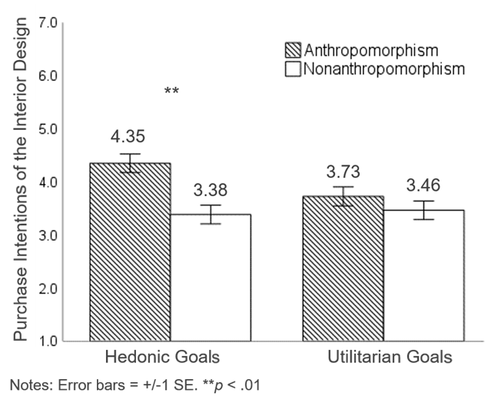
Figure D2 Interaction of anthropomorphism and consumption goals on purchase intentions, Study 5

A moderated mediation analysis (Hayes 2017, PROCESS Model 83, 5,000 bootstrapped samples) included consumption goals as the moderator, perceived entitativity and perceived AA creativity as serial mediators, anthropomorphism as the predictor, and purchase intentions as the outcome. The results affirmed the significant moderated serial mediation (index = -.08, boot SE = .04, 95% CI [-.1786, -.0147]), such that in the hedonic conditions, the indirect effect of anthropomorphism on purchase intentions was significant, through perceived entitativity and AA creativity (indirect effect = .14, boot SE = .05, 95% CI [.0571, .2553]). This effect was attenuated in the utilitarian conditions (indirect effect = .06, boot SE = .03, 95% CI [.0133, .1362]).

Web Appendix E: Descriptive Statistics
Study 1a
Variables | No. of Items |  | M |  | SD |  | α/r |  | CR |  | AVE |  | 1 |  | 2 |  | 3 |  | 4
1. Anthropomorphism  (manipulation check) | 4 |  | 4.69 |  | 1.25 |  | .91 |  | .92 |  | .73 |  | 1
2. Product evaluations | 2 |  | 5.61 |  | 1.33 |  | .69 |  | .81 |  | .69 |  | .423** |  | 1
3. Like (like = 1, dislike = 0) | / |  | .78 |  | .41 |  | / |  | / |  | / |  | .200** |  | .481** |  | 1
4. Actual purchases (US$) | / |  | 10.21 |  | 12.12 |  | / |  | / |  | / |  | .152 |  | .273** |  | .240* |  | 1
Study 1b†
Variables | No. of Items |  | M |  | SD |  | α/r |  | CR |  | AVE |  | 1 |  | 2 |  | 3 |  | 4 |  | 5 |  | 6
1. Anthropomorphism  (manipulation check) | 4 |  | 2.29 |  | 1.36 |  | .90 |  | .90 |  | .70 |  | 1
2. Perceived AA creativity | 2 |  | 4.71 |  | 1.60 |  | .87 |  | .93 |  | .87 |  | .493** |  | 1
3. Product evaluations | 2 |  | 4.79 |  | 1.28 |  | .75 |  | .86 |  | .75 |  | .306** |  | .375** |  | 1
4. Purchase intentions | 3 |  | 3.53 |  | 1.67 |  | .96 |  | .96 |  | .88 |  | .320** |  | .224** |  | .391** |  | 1
5. WTP (US$) | 1 |  | 212.46 |  | 105.70 |  | / |  | / |  | / |  | .187* |  | .159* |  | .245** |  | .402** |  | 1
6. WOM | 2 |  | 4.18 |  | 1.66 |  | .91 |  | .95 |  | .91 |  | .356** |  | .297** |  | .466** |  | .706** |  | .442** |  | 1
Study 2
Variables |  | No. of Items |  | M |  | SD |  | α/r | CR | AVE |  | 1 |  | 2 |  | 3 |  | 4 |  | 5 |  | 6 |  | 7 |  | 8
1. Anthropomorphism  (manipulation check) |  | 4 |  | 2.55 |  | 1.56 |  | .92 | .93 | .76 |  | 1
2. Perceived entitativity |  | 4 |  | 4.66 |  | 1.43 |  | .90 | .90 | .70 |  | .439** |  | 1
3. Perceived AA creativity |  | 2 |  | 4.50 |  | 1.58 |  | .82 | .87 | .76 |  | .534** |  | .446** |  | 1
4. Product evaluations 1 |  | 2 |  | 4.61 |  | 1.42 |  | .79 | .88 | .79 |  | .388** |  | .452** |  | .521** |  | 1
5. Product evaluations 2 |  | 2 |  | 4.71 |  | 1.43 |  | .81 | .90 | .81 |  | .386** |  | .421** |  | .532** |  | .671** |  | 1
6. Purchase intentions |  | 3 |  | 3.87 |  | 1.69 |  | .95 | .95 | .87 |  | .404** |  | .383** |  | .315** |  | .452** |  | .439** |  | 1
7. WTP (US$) |  | 1 |  | 2743.29 |  | 765.44 |  | / | / | / |  | .414** |  | .300** |  | .280** |  | .292** |  | .259** |  | .618** |  | 1
8. WOM |  | 2 |  | 4.07 |  | 1.94 |  | .96 | .98 | .96 |  | .405** |  | .496** |  | .368** |  | .505** |  | .540** |  | .684** |  | .542** |  | 1

Study 3
Variables | No. of Items | M | SD | α/r | CR | AVE | 1 | 2 | 3 |  | 4 |  | 5
1. Anthropomorphism  (manipulation check) | 4 | 2.64 | 1.57 | .92 | .92 | .74 | 1
2. Perceived entitativity | 4 | 4.82 | 1.49 | .91 | .91 | .72 | .361** | 1
3. Perceived AA creativity | 2 | 3.92 | 1.77 | .65 | .79 | .66 | .624** | .431** | 1
4. Lay beliefs (manipulation check) | 4 | 3.92 | 1.77 | .98 | .98 | .93 | .218** | .075 | .142** |  | 1
5. Product evaluations | 2 | 4.18 | 1.68 | .78 | .87 | .78 | .430** | .437** | .535** |  | .161** |  | 1
Study 4
Variables | No. of Items | M | SD | α/r | CR | AVE | 1 | 2 | 3 | 4 | 5 | 6
1. Anthropomorphism  (manipulation check) | 4 | 2.43 | 1.28 | .86 | .86 | .61 | 1
2. Perceived entitativity | 4 | 4.16 | 1.40 | .90 | .91 | .71 | .265** | 1
3. Perceived AA creativity | 2 | 3.99 | 1.45 | .53 | .72 | .57 | .377** | .367** | 1
4. Temporal stability  (manipulation check) | 4 | 4.04 | 1.83 | .94 | .94 | .80 | .135* | .404** | .362** | 1
5. Product evaluations | 2 | 3.74 | 1.58 | .83 | .91 | .81 | .237** | .348** | .287** | .185** | 1
6. Purchase intentions | 3 | 2.52 | 1.43 | .95 | .95 | .87 | .268** | .301** | .231** | .226** | .394** | 1
Study 5
Variables | No. of Items | M | SD | α/r | CR | AVE | 1 | 2 | 3 | 4 | 5 | 6
1. Anthropomorphism  (manipulation check) | 4 | 2.22 | 1.23 | .86 | .82 | .61 | 1
2. Perceived entitativity | 4 | 4.18 | 1.54 | .92 | .92 | .75 | .399** | 1
3. Perceived AA creativity | 2 | 4.14 | 1.45 | .63 | .77 | .63 | .493** | .483** | 1
4. Consumption goals  (manipulation check) | 3 | 3.61 | 1.45 | .89 | .89 | .73 | .131* | .230** | .241** | 1
5. Product evaluations | 2 | 4.04 | 1.42 | .75 | .86 | .75 | .380** | .370** | .416** | .200** | 1
6. Purchase intentions | 3 | 3.73 | 1.68 | .96 | .96 | .89 | .398** | .385** | .350** | .145** | .444** | 1
*p < .05, **p < .01.
†Notes: The Study 1b analyses exclude cases for the non-AA conditions. CTR = click-through rate, WTP = willingness to pay, WOM = word of mouth, CR = composite reliability, AVE = average variance extracted.

Web Appendix F: Stimuli and Manipulations
F1: Online Store, Study 1a
As noted in the main text, real customers of an online store that sells more than 700 creative household products in different categories participated in Study 1a. This store ranks in the top 10% among its competitors on the global e-commerce platform AliExpress. This appendix contains snapshots of some of its offerings.


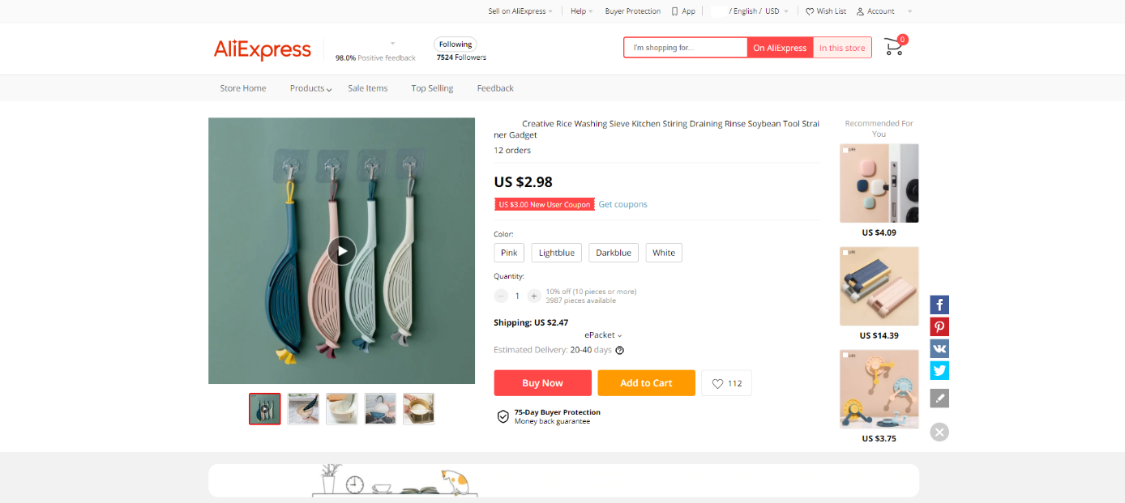
F2: Introductions of Service Procedures, Studies 1a, 1b and 2
Study 1a
Anthropomorphism | Nonanthropomorphism
Dori: “Hi! I am Dori, Jessica’s design assistant throughout the design process. For a certain product, Jessica usually starts by identifying the trend of consumers’ preferences. Then I use deep learning to analyze her inputs and create initial models. Next, Jessica adds her ideas to those models. Lastly, I generate the final product design. That’s how we develop new designs together!” | This design program assists Jessica throughout the design process. For a certain product, Jessica usually starts by identifying the trend of consumers’ preferences. Then the program uses deep learning to analyze her inputs and create initial models. Next, Jessica adds her ideas to those models. Lastly, the program generates the final product design. That’s how they develop new designs together!
Study 1b
Anthropomorphism | Nonanthropomorphism | Human–human | Human-alone
Step 1: Hi! I’m Daniel. Let’s talk about your basic preference for fabric chairs, such as materials and styles. I will encode them into your profile together with my ideas for the designs.
Step 2: Hi! I’m designer Alex. Based on your profile and Daniel’s idea, I will generate several fabric chair designs. Then, I will finalize one customized design that suit your preference. | The functions of the machine are:  1) To generate several fabric chair designs.  2) To finalize one customized design that suit your preference. | Same as anthropomorphized AA–human dyad | Based on your profile, I will generate several fabric chair designs. Then, I will finalize one customized design that suit your preference.
Study 2
Anthropomorphism | Nonanthropomorphism
Step 1: Hi! I’m Daniel. Let’s talk about your basic preference and needs in your living room, such as functions and style. I will encode them into your profile together with my ideas for the design.
Step 2: Hi! I’m designer Alex. Based on your profile and Daniel’s ideas, I will generate several designs that make the most of the space in your living room.  Then, I will finalize two customized options that suit your preference. | Step 2: The functions of the machine are:  1) To generate several designs that make the most of the space of your living room.  2) To finalize two customized options that suit your preference.

F3: Manipulation of Temporal Stability, Study 3
High temporal stability | Low temporal stability
Mozzie is an AI painter that can create decorative paintings solely, and Jenny and Mozzie also have a long history of painting together to serve customers. They’ve already been collaborating for a few years on over one hundred paintings. Jenny will continue painting with Mozzie for years to come. | Mozzie is an AI painter that can create decorative paintings solely, but Jenny and Mozzie have never painted together to serve a customer before. This is their first time collaborating on paintings. Jenny tries to create paintings with Mozzie this time, but she’s not sure whether she will continue painting with Mozzie in the future.
The painting machine can create decorative paintings solely, and Jenny also has a long history of painting with the machine to serve customers. They’ve already been collaborating for a few years on over one hundred paintings. Jenny will continue painting with the machine for years to come. | The painting machine can create decorative paintings solely, but Jenny has never painted with the machine to serve a customer. This is their first time collaborating on paintings. Jenny tried to create paintings with the machine this time, but she’s not sure whether she will continue painting with the machine in the future.

F4: Manipulation of Lay Beliefs about Group Entitativity, Study 4
Strong beliefs | Weak beliefs
"Birds of a feather flock together" is a well-known saying. It means that people who gather in a group often become similar to each other. Is this a reliable way to form impressions?  A recent scientific report shows that such inferences turn out to be accurate judgments most of the time. Due to social influence on identities and team interaction, members often assimilate with each other. Specifically, when it comes to traits that are essential to the team, teammates have a 90% chance of becoming identical after joining the same team. For example, knowing that one member of a team is open-minded, it is a reliable inference that other members of the same team would also be open-minded.  Therefore, based on statistical evidence and theories in social psychology, judging a person by his or her teammates leads to the right inferences most of the time. | "Birds of a feather flock together" is a well-known saying. It means that people who gather in a group often become similar to each other. Is this a reliable way to form impressions?  A recent scientific report shows that such inferences turn out to be inaccurate judgments most of the time. Due to the maintenance of self-identity and team diversity, members often differentiate from one another. Specifically, when it comes to traits that are essential to the team, teammates only have a 9% chance to become identical after joining the team. For example, knowing that one member of a team is open-minded, it is an unreliable inference that other members of the same team would also be open-minded.  Therefore, based on statistical evidence and theories in social psychology, judging a person by his or her teammates leads to wrong inferences most of the time.

F5: Manipulation of Consumption Goals, Study 5
Hedonic consumption goals | Utilitarian consumption goals
Now please imagine you are planning to get your living room a renovation plan for a more enjoyable living experience!  The renovation will bring you a lot of fun: you’ve been living here for a long time, and this renovation is a reward to yourself. It is also a delightful process that can give you the aesthetic pleasure of decoration. So, you found this J&R design studio to customize a plan that will achieve your goal. | Now please imagine you are at a design studio to get your living room a renovation plan for a higher rental fee!  The renovation will bring you a higher income: you are renting this place out, and this renovation can help you raise the rent. It is also a useful process that can help you decide the markup based on the cost. So, you found this J&R design studio to customize a plan that will achieve your goal.

F6: AA–Employee Dyads and Design Outcomes, Studies 1–5
Study | AA–Employee Dyads and Control Conditions |  |  |  | Service Outcomes
Study | Anthropomorphism |  | Nonanthropomorphism |  | Service Outcomes
Study 1a  (Household product design) |  |  |  |  | A set of brass hook  
 | Anthropomorphism | Nonanthropomorphism | Human–human | Human-alone
Study 1b  (Furniture design service) | 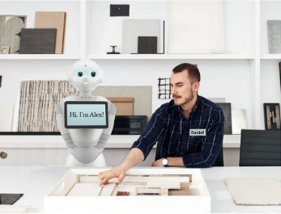 | 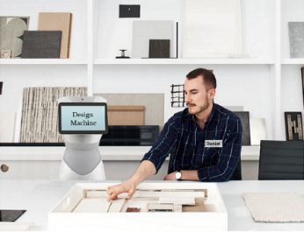 | 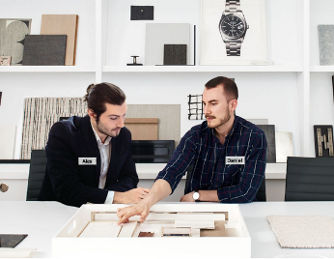 |  | A fabric chair  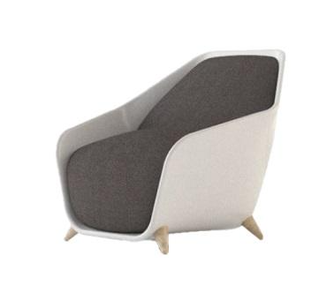
Supplementary Study  (Interior design service) | 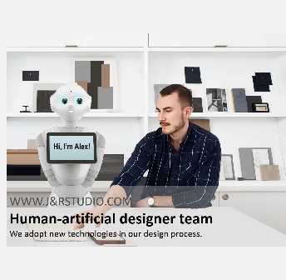 |  |  |  | /

(Continued)
Study | AA–Employee Dyads |  | Service Outcomes
Study | Anthropomorphism | Nonanthropomorphism | Service Outcomes
Study 2  (Interior design service) |  |  | Interior design  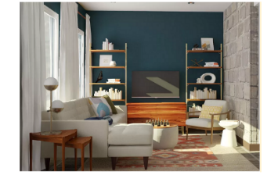  Design 1  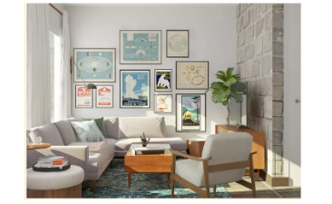  Design 2
Studies 3 & 4  (Painting service) | 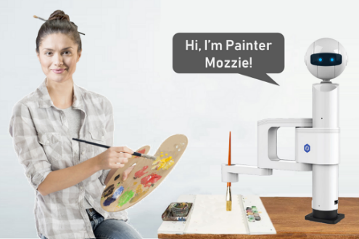 | 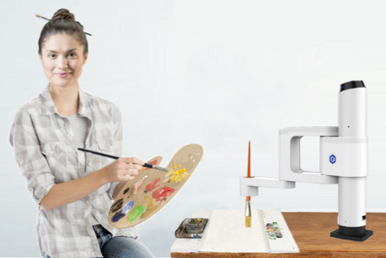 | A painting  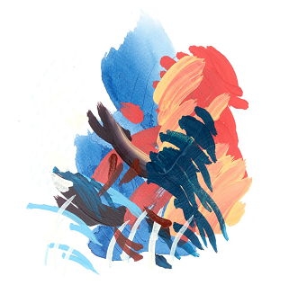
Study 5  (Interior design service) | 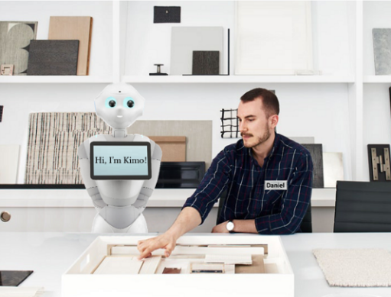 | 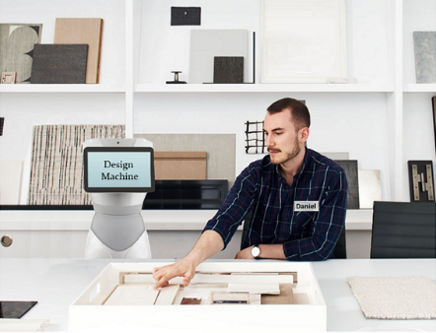 | Interior design

Web Appendix G: Data Exclusion Criteria
In Study 1a, customers of the online store completed an attention check at the end of the experiment that asked them to choose “strongly disagree” in response to the question. Any participants who failed this attention check were excluded from the analyses.
In Studies 1b, 3, and 5, an attention check at the beginning of the experiment asked participants to read a paragraph that contained instructions about which answer to choose. Participants who failed this task were directed to the end of the experiment; their data were not collected.
In Studies 2 and 4, we included two attention checks at the end of the experiment. The first check prompted participants to select a certain number as a response, regardless of the question posed. Data from participants who failed this attention check were excluded. The second attention check asked whether the participant conducted other activities during the experiment, such as listening to music, watching TV, chatting online, messaging with others, other (need to specify), or none. Any participants who acknowledged that they engaged in other activities during the experiment were excluded from the analyses.
In addition to the two attention checks, we administered a manipulation recall in Study 4. Participants summarized the gist of the report they read, which manipulated their beliefs about group entitativity. If participants answered incorrectly or offered nonsense responses to the open question, we excluded their data from the analyses.

Web Appendix H: Full Scales of Measurements, Studies 1–5
Study | Measurements | Full Scales
Study 1a | Anthropomorphism manipulation check | To what extent do you agree with each of the following statements? (1 = Strongly disagree; 7 = Strongly agree)  - I think Dori has a mind of its own.  - I think Dori has its own personality.  - I think Dori feels like a person.  - I think Dori has its own intention.
Study 1a | Product evaluations | I think these hooks are _______: (1 = Not at all; 7 = Very much)  - Creative  - Innovative
Study 1b | Anthropomorphism manipulation check | Same as Study 1a
Study 1b | Product evaluations | Same as Study 1a
Study 1b | Purchase intentions | Please answer the following questions about this furniture design service: (1 = Very low; 7 = Very high)  - My willingness to pay for the interior design service customized is ________.  - The likelihood of purchasing the interior design service customized is ________.  - The probability that I would consider buying the interior design service customized is ________.
Study 1b | Willingness to pay | The average price of a piece of customized furniture ranges from US$50 to US$500. What is the maximum amount you are willing to pay for one designed fabric chair provided by this artificial designer?  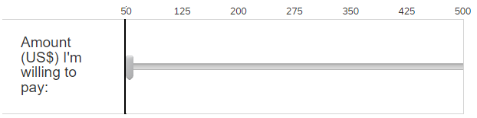
Study 1b | Word of mouth | To what extent do you agree with the following statement about your opinion on the customized furniture design service? (1 = Strongly disagree; 7 = Strongly agree)  - I will recommend this furniture design studio to my relatives or friends.  - I will tell more people about this furniture design studio favorably.
Study 2 | Perceived entitativity | Please answer the following questions about Daniel and the artificial designer Alex: (1 = Not at all; 7 = Very much)  - How much do Daniel and Alex qualify as a “team”?  - Do you think Daniel and Alex are a cohesive group?  - How unified are Daniel and Alex?  Please select the set of circles that best represents Daniel and Alex as a team (The left circle represents Daniel, and the right one represents Alex):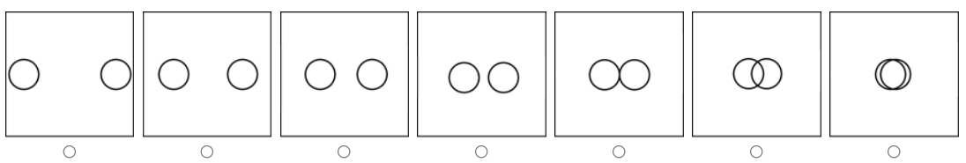
Study 2 | Perceived AA creativity | To what extent do you think the computer assistant Kelly would be ______? (1 = Not at all; 7 = Very much)  - Creative  - Innovative
Study 2 | Willingness to pay | The average price of a piece of customized furniture ranges from US$2,000 to US$5,000. What is the maximum amount you are willing to pay for the interior design service provided by this studio?  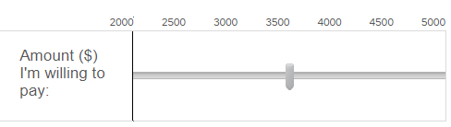
Study 2 | Anthropomorphism manipulation check  Product evaluations  Purchase intentions  Word of mouth | Same as Study 1b
Study 2 | Realism of the scenario* | To what extent do you agree with the following statements? (1 = Strongly disagree; 7 = Strongly agree)  - The service scenario is realistic.  - The service scenario is practical.
Study 2 | Perceived skill complimentary* | To what extent do you agree with the following statement about designers Daniel and Alex? (1 = Strongly disagree; 7 = Strongly agree)  - Alex complements Daniel in things he is not good at.  - Alex and Daniel complement each other.  - Alex and Daniel compensate for their weaknesses.  - Alex and Daniel can do more together than they can separately.
Study 2 | Eeriness of the AA* | To what extent do you think Alex is ______? (1 = Not at all; 7 = Very much)  - Creepy  - Eerie
Study 2 | Perceived employee creativity* | Please recall the earlier description of the designer Daniel. Based on the description, to what extent do you think designer Daniel is ______? (1 = Not at all; 7 = Very much)  - Creative  - Innovative
Study 3 | Temporal stability manipulation check | To what extent do you agree with the following statements about the team of the artist and the painter Mozzie? (1 = Strongly disagree; 7 = Strongly agree)  - This team has been together for a long time in the past.  - This team expects to be together for a long time in the future.  - This is an established team that worked on many projects.  - This is an established team that may work on many projects in the future.
Study 3 | Anthropomorphism manipulation check  Perceived entitativity  Perceived AA creativity  Product evaluations  Purchase intentions  Eeriness of the AA* | Same as in Study 2
Study 3 | Attitude toward AAs in general* | To what extent do you agree with the following statements about your attitude toward artificial agents? (1 = Strongly disagree; 7 = Strongly agree)  - I would feel nervous when interacting with an artificial agent.  - I would feel paranoid interacting with an artificial agent.  - I would feel uneasy if artificial agents really had thoughts and emotions.  - I dislike the idea that artificial agents are in charge of many things.  - I am concerned that artificial agents might develop into living beings.
Study 3 | Experience in using AAs* | How experienced are you in interacting with artificial agents in your daily life? (1 = Not at all; 7 = Very much)
Study 3 | Knowledge of the service output* | How knowledgeable are you about painting artwork in general? (1 = Not at all; 7 = Very much)
Study 4 | Anthropomorphism manipulation check  Perceived entitativity  AA creativity  Product evaluations | Same as Study 3
Study 4 | Lay beliefs manipulation check | After reading the article, I believe that it is ______ to make inferences about a person based on his or her teammates.  - Inaccurate/Accurate  - Unreliable/Reliable  - Illogical/Logical  - Invalid/Valid
Study 5 | Anthropomorphism manipulation check  Perceived entitativity  Perceived AA creativity  Product evaluations  Purchase intentions  Eeriness of the AA*  Attitude toward AAs in general*  Experience in using AAs*  Knowledge of the service output* | Same as Study 3
Study 5 | Consumption goals manipulation check | To what extent do you perceive your goal of this interior design service as ______?  - Function-oriented/Pleasure-oriented  How would you perceive your design service experience at this J&R studio?  - Definitely utilitarian/Definitely hedonic  Please indicate your manner of decision-making to use the design service at J&R studio:  - Decided mainly by utilitarian goal/Decided mainly by hedonic goal.

References
Argyle, M. (2013). Lay theories: Everyday understanding of problems in the social sciences. Elsevier.
Bernardo, F., & Palma-Oliveira, J. M. (2022). Tell me where you live… How the perceived entitativity of neighborhoods determines the formation of impressions about their residents. Frontiers of Psychology, 13, 821786.
Blut, M., Wang, C., Wünderlich, N. V., & Brock, C. (2021). Understanding anthropomorphism in service provision: a meta-analysis of physical robots, chatbots, and other AI. Journal of the Academy of Marketing Science, 49, 632–658.
Campbell, D. T. (1958). Common fate, similarity, and other indices of the status of aggregates of persons as social entities. Behavioral Science, 3(1), 14-25.
Carlston, D. E., Skowronski, J. J., & Sparks, C. (1995). Savings in relearning: II. On the formation of behavior-based trait associations and inferences. Journal of Personality and Social Psychology, 69(3), 420–436.
Castelo, N., Bos, M. W., & Lehmann, D. R. (2019). Task-dependent algorithm aversion. Journal of Marketing Research, 56(5), 809-825.
Crawford, M. T., Sherman, S. J., & Hamilton, D. L. (2002). Perceived entitativity, stereotype formation, and the interchangeability of group members. Journal of Personality and Social Psychology, 83(5), 1076-1094.
Epley, N., Waytz, A., & Cacioppo, J. (2007). On seeing human: A three-factor theory of anthropomorphism. Psychological Review, 114, 864-886.
Garrido-Morgado, Á., González-Benito, Ó., Martos-Partal, M., & Campo, K. (2021). Which products are more responsive to in-store displays: Utilitarian or hedonic? Journal of Retailing, 97(3), 477-491.
Hayes, A. F. (2017). Introduction to mediation, moderation, and conditional process analysis, second edition: A regression-based approach. Guilford Press.
Hennessey, B. A., & Amabile, T. M. (2009). Creativity. Annual Review of Psychology, 61(1), 569-598.
Hollenbeck, J. R., Beersma, B., & Schouten, M. E. (2012). Beyond team types and taxonomies: A dimensional scaling conceptualization for team description. Academy of Management Review, 37(1), 82-106.
Jorling, M., Bohm, R., & Paluch, S. (2019). Service robots: drivers of perceived responsibility for service outcomes. Journal of Service Research, 22(4), 404-420.
Orazi, D. C., & Johnston, A. C. (2020). Running field experiments using Facebook split test. Journal of Business Research, 118, 189–198.
Ranganath, K. A., & Nosek, B. A. (2008). Implicit attitude generalization occurs immediately; Explicit attitude generalization takes time. Psychological Science, 19(3), 249-254.
Steinmetz, J., Touré-Tillery, M., & Fishbach, A. (2019). The first-member heuristic: Group members labeled “first” influence the judgment and treatment of groups. Journal of Personality and Social Psychology, 118(4), 706-719.
Van Doorn, J., Mende, M., Noble, S. M., Hulland, J., Ostrom, A. L., Grewal, D., & Petersen, J. A. (2016). Domo Arigato Mr. Roboto: Emergence of automated social presence in organizational frontlines and customers’ service experiences. Journal of Service Research, 20(1), 43-58.
Walther, J. B., Van Der Heide, B., Kim, S.-Y., Westerman, D., & Tong, S. T. (2008). The role of friends’ appearance and behavior on evaluations of individuals on Facebook: Are we known by the company we keep? Human Communication Research, 34(1), 28-49.

