WEB APPENDIX
Felt Something, Hence It Works: Merely Adding a Sensory Signal to a Product Improves Objective Measures of Product Efficacy and Product Evaluations

Web Appendix 1
Examples of sensory signals and products generated by participants in Study 1

Out of 300 participants (56% females; M_{age} = 39.59 years, SD = 14.52; four participants did not report gender), we found that 180 participants mentioned sensations (sensory signals) in their writing task, whereas 120 participants did not mention any sensation. Among those who mentioned sensation(s), some participants mentioned more than one sensation. Thus, there were a total of 229 sensations generated by the participants. We then classified these sensations into five categories: (1) tingling, (2) burning (also includes heating, warming), (3) fizzing (also includes bubbling, carbonated sensations), (4) cooling (also includes freezing), and others (e.g., soothing, vibration, minty, greasy, and popping, spicy, foaming, acid). The table below presents the number of responses by sensory categories, as well as provides examples of products that correspond to the sensation.

 | Type of sensation generated by participants
 | Tingling | Burning | Fizziness | Cooling | Others
Number of responses | 53 (23%) | 46 (20%) | 12 (5%) | 83 (36%) | 35 (15%)
Examples of topical products applied to the bodily area | Pre-workout cream, muscle rub, pain relief product, itch spray, hydrogen peroxide, nicotine patch, aloe vera gel, shampoo, conditioner, body wash | Muscle rub, pain relief product,  nicotine patch, shampoo, body cream, firm cellulite cream, liquid bandage | Hydrogen peroxide | Muscle rub, pain relief product, cream for Eczema, aloe vera gel, shampoo, body wash, body lotion, suntan spray, sunscreen, insect repellant, liquid bandage | Bug spray repellant, conditioner, sunscreen, pain relief cream, hand lotion, calamine lotion, body wash, soap
Examples of topical products applied to the facial area | Face moisturizer, face cleanser, face mask, face scrub, peeling mask, lip plumper | Face moisturizer, clay mask, serum |  | Eye drops, face lotion, face cream, face scrub, lip balm | Face cream
Examples of non-topical products related to oral hygiene | Toothpaste, mouthwash, mouth pain liquid | Toothpaste, mouthwash, breath strips |  |  | Toothpaste, mouthwash
Examples of products consumed inside the body | Pain reliever pill, energy drink | Hot sauce, muscle relaxer, green tea | Sparkling water, energy drink, sugar free beverage, carbonated soft drink, heartburn tablet | Cough drops, chewing gum, slushy, iced cream, mint candy, coffee | Lozenge, chocolate, energy drink, coffee, powder, nicotine gum
Other product types | Vaginal cream, violet wand | Cuban tobacco oil |  | Vaginal cream, sleeper chair, cooling towel, humidifier, ice packs | Electric toothbrush, laser trimmer, Arcade game, caplet, shoes

Web Appendix 2
Mediation analysis in Study 1

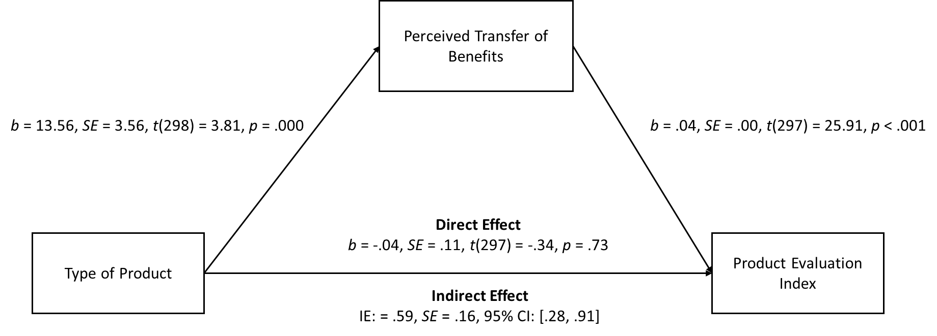

Note. Our independent variable compared sensory signaling product condition (coded 1) with nonsignaling product condition (coded 0).

Web Appendix 3
Stimuli and materials used in Study 2

Stimuli used in Study 2 and Studies 4-5. To increase external validity, we used actual products from the marketplace from the same brand. Participants in all conditions were exposed to an herbal balm with the same novel scent and appearance, and the herbal balm was placed in the same type of container.
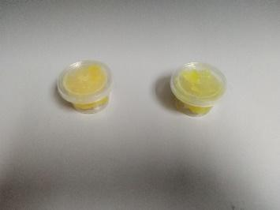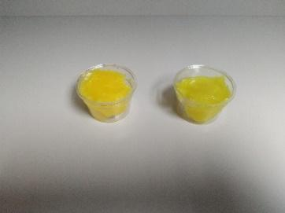

Ingredients. Based on the product labels, the two products have similar main ingredients (i.e., Fresh Zingiber Montanum (Koenig) Link ex. A Dietr) at about 90% and other medicaments at 10%.

Pretest. In the pretest, we performed a manipulation check for the tingling sensation, and controlled for the pleasantness of smell, pleasantness of texture, and strength of smell (i.e., consumers may associate a strong smell with better product performance; Kramer et al. 2012). A pretest with 42 participants (81% females; M_{age} = 40.14 years, SD = 12.37) confirmed that the two stimuli differed on tingling sensation (M_{nonsignaling} = 4.27, SD = 1.88 vs. M_{signaling} = 5.75, SD = 1.55; t(40) = 2.76, p = .009), but not on the pleasantness of smell (M_{nonsignaling} = 5.55, SD = 1.71 vs. M_{signaling} = 5.80, SD = 1.70; t(40) = .48, p = .63), the pleasantness of texture (M_{nonsignaling} = 5.68, SD = 1.43 vs. M_{signaling} = 5.90, SD = 1.41; t(40) = .50, p = .62), nor on the strength of smell (M_{nonsignaling} = 5.86, SD = 1.17 vs. M_{signaling} = 5.65, SD = 1.66; t(40) = .49, p = .63). At the end of the experiment, we asked pretest participants to guess the brand of the product. None of the participants were able to correctly identify the brand.

Verbal claims used in Study 2



Web Appendix 4
Mediation analysis in Study 2

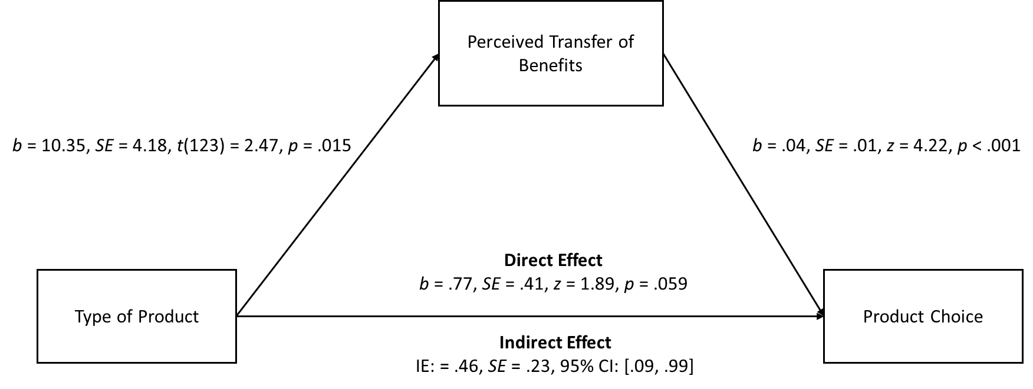

Note. Our independent variable compared sensory signaling product condition (coded 1) with nonsignaling product condition (coded 0).

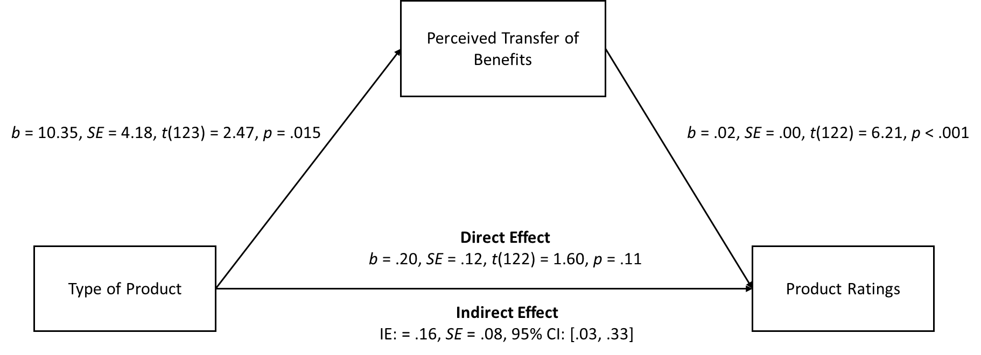

Note. Our independent variable compared sensory signaling product condition (coded 1) with nonsignaling product condition (coded 0).

Web Appendix 5
Web Appendix S1: Consumers like sensory signaling products more after product trial

This study had two goals. First, it aimed to replicate Study 2 using a different product (i.e., headwrap), a different sensory signal (i.e., cooling), and a different measure of product evaluations (i.e., willingness to pay and attitude towards the product). The study employed a two-condition (nonsignaling product vs. sensory signaling product), between-subjects design. We designed a product trial study in which participants tried a new product that would be launched in the U.S. market, and then reported their product evaluations. We predicted that a sensory signaling (vs. nonsignaling) product would elicit higher product evaluations due to higher levels of perceived transfer of product benefits.

Second, this study aimed to explore an individual difference that could provide a managerially meaningful boundary condition. We measured participants’ Protestant Work Ethic (PWE), a belief that exerting unpleasant (hard) work leads to success. PWE is managerially meaningful and actionable because Catholic consumers are typically “low PWE,” whereas Protestant consumers are typically “high PWE.” Additionally, the relative prevalence of Protestants (or Catholics) can be geolocated by marketers according to specific states and countries. We predicted that low PWE participants would be more likely to find that a sensory signaling product is effective. However, this positive effect would be attenuated among high PWE participants who believe that only hard work leads to benefits. Low PWE participants do not look forward to spending unpleasant effort on tasks as a way to salvation (they have been taught that receiving sacraments and holy water will lead to benefits), compared to high PWE consumers (who believe that only doing the unpleasant hard work leads to virtue and benefits). Therefore, low PWE participants would be more likely to believe that the cooling sensation from the headwrap is transferring something good (e.g., energy, focus, relaxation) to them, akin to how receiving a sacrament leads to benefits. In contrast, high PWE participants would be less likely to believe that merely receiving a neutral or pleasant sensation leads to benefits, because high PWE participants believe in the “unpleasant hard work leads to benefits” heuristic (Cheng et al. 2017). Hence, low PWE participants would be more likely to report higher product evaluations for sensory signaling products than nonsignaling products, whereas such difference would be attenuated among high PWE participants.

Stimuli. To increase external validity, we used the same product (i.e., a headwrap) for both conditions but varied the surface temperature of the product. The headwrap is made from a lightweight fleece fabric material in gray color. We then manipulated the two conditions following prior research (Park and Hadi 2020). In the sensory signaling product condition (i.e., with cooling sensation), we placed the headwrap with the gel packs inside the refrigerator for at least 15 minutes before each headwrap was given to the participant, to generate a cooling effect of approximately 50.9°F, as intended by the manufacturer. In the nonsignaling product condition (i.e., no cooling sensation), we placed the same headwrap with the gel packs (to control for the weight) inside a box at a room temperature of approximately 69.8°F.
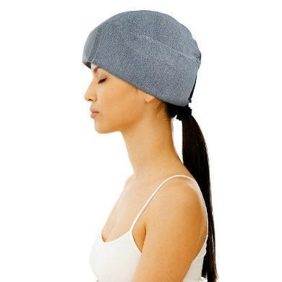

Verbal claims. To increase ecological validity and realism, these verbal claims were modeled after the actual product claims on the manufacturer’s website.
 | 
Note. The ad on the left presents a nonsignaling product, whereas the ad on the right presents a sensory signaling product.

Method
Procedure. Based on our previous sample size of about 25-30 participants per cell and our effect size on product evaluations in the lab study (η_{p}² ≈ .16; Study 5), we aimed to recruit 50 participants. Fifty-eight students participated in our study (60% females; M_{age} = 20.19 years, SD = .76) in exchange for course credit. The study was run one person at a time. Following the consent form signing and random assignment of two conditions (nonsignaling product vs. sensory signaling product; between-subjects), each participant viewed the ad (adapted from an actual ad) of a new headwrap on a computer screen. The ad contained a picture of the product, product benefits (i.e., energy, focus, fresh, active), and a tagline (i.e., “The headwrap can help” in the nonsignaling condition or “The cooling headwrap can help” in the sensory signaling condition). The research assistant then gave each participant either a noncooling headwrap or a cooling headwrap. Next, participants completed a filler task that consisted of answering questions on individual differences for about 4-6 minutes. Following the filler task, participants completed a behavioral measure of PWE (Cheng et al. 2017): “How many hours do you study on each weekend?” Participants entered the number of hours. After that, participants completed a measure of perceived transfer of benefits and a measure of curiosity using the same scales as participants did in Studies 1-2. Next, each participant indicated her willingness to pay: “Suppose that budget is not an issue, how much would you be willing to pay for this product?” Participants used a slider scale from $0 to $100 in US dollars. Participants also completed attitude measures towards the product using the same three items on a 7-point scale as in Study 1. Each participant completed demographic information, was asked to remove the headwrap, debriefed, and thanked for participating.

Results
Product evaluations. We removed one outlier who indicated a willingness to pay greater than 3.5 SD from the mean (Smith et al. 2016), thus leaving 57 participants in the main analysis (N = 29; nonsignaling vs. N = 28; sensory signaling). An ANOVA on the willingness to pay (WTP) measure was significant. Participants in the sensory signaling product condition (M = $20.71, SD = 9.90) were willing to pay more for the product than participants in the nonsignaling product condition (M = $13.03, SD = 9.41; F(1, 55) = 9.01, p = .004, η_{p}² = .141). Furthermore, we found that three participants in the nonsignaling condition responded with $0 on the willingness to pay measure. After removing these participants from the analysis, our results still held (N = 26; nonsignaling vs. N = 28; sensory signaling). Participants in the sensory signaling condition (M = 20.71, SD = 9.90) were willing to pay more for the product than participants in the nonsignaling condition (M = 14.54, SD = 8.75; F(1, 52) = 5.86, p = .019, η_{p}² = .101). Thus, removing those participants did not impact our results. Next, an ANOVA on the attitude index (α = .92) was also significant, with more favorable attitudes for the sensory signaling product (M = 4.56, SD = 1.11) compared to the nonsignaling product (M = 3.57, SD = 1.50; F(1, 55) = 7.92, p = .007, η_{p}² = .126). Thus, H1a was supported.

Perceived transfer of benefits. An ANOVA was significant, and levels of perceived transfer of benefits were higher for the sensory signaling product (M = 51.04, SD = 23.87) compared to the nonsignaling product (M = 26.72, SD = 24.73; F(1, 55) = 14.25, p < .001, η_{p}² = .206). We also further checked our results after removing those who did not indicate WTP. Results showed that participants in the sensory signaling condition (M = 51.04, SD = 23.87) perceived a greater transfer of product benefits than participants in the nonsignaling condition (M = 29.81, SD = 24.28; F(1, 52) = 10.49, p = .002, η_{p}² = .168).

Mediation analysis. The indirect effect of product type (sensory signaling product, coded 1; nonsignaling product, coded 0) on willingness to pay via perceived transfer of benefits was significant (95% CI: [3.11, 11.31]). Participants in the sensory signaling product condition (relative to nonsignaling product condition) indicated a greater transfer of benefits (b = 26.20, SE = 6.28, t(54) = 4.17, p = .001), and were subsequently willing to pay more for the product (b = .26, SE = .04, t(53) = 6.25, p < .001). The direct effect of product type on product evaluations became nonsignificant (b = 1.56, SE = 2.22, t(53) = .71, p = .48) when including perceived transfer of benefits, suggesting a full mediation. Also, the indirect effect of product type on attitude towards the product via perceived transfer of benefits was significant (95% CI: [.59, 1.80]). Participants in the sensory signaling product condition (relative to nonsignaling product condition) indicated a greater transfer of benefits (b = 26.20, SE = 6.28, t(54) = 4.17, p = .001), which in turn led to more favorable attitudes toward the product (b = .04, SE = .00, t(53) = 10.04, p < .001). The direct effect of product type on product evaluations became nonsignificant (b = -.08, SE = .23, t(53) = -.35, p = .73) when including perceived transfer of benefits, suggesting a full mediation. Thus, H1b was supported.

Curiosity. An ANOVA was not significant, with similar levels of curiosity in the sensory signaling product condition (M = 5.36, SD = 1.47) and in the nonsignaling product condition (M = 5.69, SD = 1.58; F(1, 55) = .67, p = .42). Furthermore, curiosity did not mediate the effect of product type on willingness to pay (95% CI: [-2.28, 1.43]) as well as the effect of product type on attitude towards the product (95% CI: [-.42, .25]). Thus, curiosity did not explain our effect.

Additional analyses on moderation by individual’s PWE on willingness to pay. We tested whether the level of PWE of each participant moderated the effect of product type (sensory signaling coded 1; nonsignaling coded 0) on willingness to pay (model 1; 5000 samples). We found a marginally significant interaction (B = -1.70, SE = .88, p = .061). Consistent with our predictions, the analysis showed that the effect of product type on willingness to pay was significant when PWE was low (M_{signaling} = $22.21 vs. M_{nonsignaling} = $9.40; B = 12.81, SE = 3.62, p = .001) but not when PWE was high (M_{signaling} = $18.62 vs. M_{nonsignaling} = $15.67; B = 2.95, SE = 3.62, p = .42). In addition, we used the Johnson-Neyman floodlight approach (Spiller et al. 2013) to identify a region of significance of the effect at different levels of PWE. We found a significant effect of product type on willingness to pay when the PWE score was lower than 6.93 (out of 15) or 68.42% of participants (B_{JN} = 5.63, SE = 2.81, p = .05), but not when the PWE score was higher than 6.93. Next, we tested whether participants with low (but not high) PWE perceived a higher transfer of product benefits, which then increased their willingness to pay (model 7; 5000 samples). The index of moderated mediation was significant (95% CI: [-2.48, -.03]). Consistent with our predictions, the indirect effect of type of product on willingness to pay was significant at low PWE (95% CI: 5.37, 16.38]), but not high PWE (95% CI: [-1.49, 9.15]).

Additional analyses on moderation by individual’s PWE on attitude towards the product. We tested whether the level of PWE of each participant moderated the effect of product type (sensory signaling coded 1; nonsignaling coded 0) on attitude towards the product (model 1; 5000 samples). We found a marginally significant interaction (B = -.23, SE = .12, p = .058). Consistent with our predictions, the analysis showed that the effect of product type on attitude towards the product was significant when PWE was low (M_{signaling} = 4.61 vs. M_{nonsignaling} = 2.87; B = 1.74, SE = .49, p = .001) but not when PWE was high (M_{signaling} = 4.49 vs. M_{nonsignaling} = 4.08; B = .40, SE = .49, p = .41). In addition, we used the Johnson-Neyman floodlight approach (Spiller et al. 2013) to identify a region of significance of the effect at different levels of PWE. We found a significant effect of product type on attitude towards the product when the PWE score was lower than 6.96 (out of 15), corresponding to 68.42% of participants (B_{JN} = .76, SE = .38, p = .05), but not when PWE score was higher than 6.96. Next, we tested whether participants with low (but not high) PWE perceived a higher transfer of product benefits, which then increased attitudes towards the product (model 7; 5000 samples). The index of moderated mediation was significant (95% CI: [-.40, -.01]). Consistent with our predictions, the indirect effect of type of product on attitudes towards the product was significant at low PWE (95% CI: .96, 2.55]), but not at high PWE (95% CI: [-.27, 1.44]).

In a product trial context, the results of this study provided support for H1a and reinforced the findings of Studies 1 and 2 on marketing outcomes (i.e., willingness to pay and attitude towards the product) using a different sensory signal. Moreover, results provided support for H1b in which perceived transfer of benefits mediated the effect of product type on product evaluations. Additionally, the results of this study also revealed a boundary condition with regards to consumer segmentation: when the PWE is low (but not high), consumers are more willing to pay for and form positive attitudes toward a sensory signaling product compared to the nonsignaling product due to perceived transfer of benefits. However, we acknowledge the various limitations of drawing a conclusion on the interaction between the type of product and PWE on product evaluations with a single-item measure and a small sample size. Future research may replicate and extend this study using a multi-item scale (see scales from Mirels and Garrett 1971) to measure this construct or manipulate participants’ level of PWE with passages that associate unpleasantness with benefits, and passages that associate pleasantness with benefits (Cheng et al. 2017). We also acknowledge that the interaction effect we had observed in our study is limited to the cooling sensation. Thus, future research could investigate other types of sensations.

Web Appendix 6
Stimuli used in Study 3

Stimuli. To prevent any a priori associations, we asked a manufacturer to create two novel products for our studies. Participants in all conditions were exposed to a gel with the same novel scent and appearance, and the gel was placed in the same type of container. We asked the manufacturer to use the same citrus fragrance in both conditions to control for the scent.
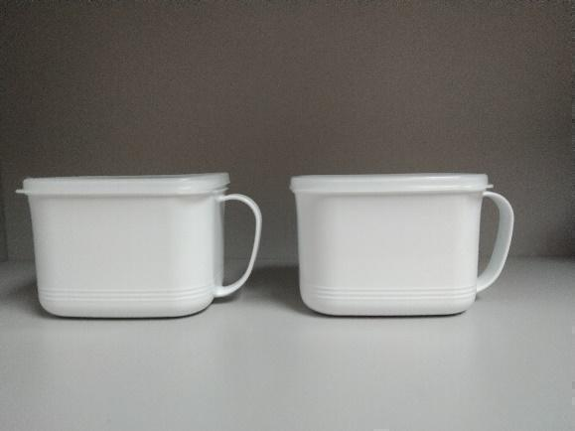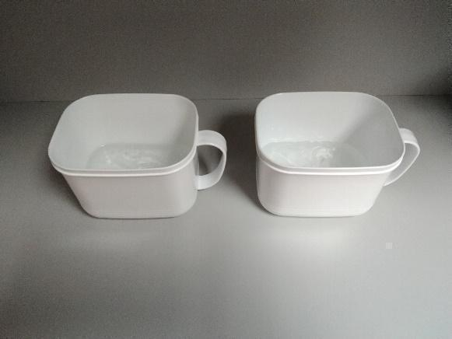

Ingredients. The two stimuli have similar ingredients except for tingling agents, which do not enhance physical performance, whether applied externally on the skin or incidentally inhaled (Köteles et al. 2018). Nevertheless, we ruled out this alternative explanation by manipulating the psychological attribution towards the sensation in the main study (Study 3).
Ingredients | Type of product
Ingredients | Nonsignaling  product | Sensory signaling product
Polyquaternium-37 (an antistatic agent) | 1.13% | 1.13%
Water | 52.63% | 52.63%
Ethyl Alcohol | 45.11% | 40.60%
Menthone Glycerin Acetal | 0.00% | 4.51%
Phenoxyethanol (a preservative) | 0.75% | 0.75%
Fragrance | 0.38% | 0.38%
Total | 100.00% | 100.00%

Pretest. Our separate pretest with 35 participants (34% females; M_{age} = 20.74 years, SD = 2.09) confirmed that the two stimuli that were used differed on tingling sensation (M_{nonsignaling} = 4.00, SD = 2.11 vs. M_{signaling} = 5.53, SD = 1.51; t(33) = 2.45, p = .020), but not on pleasantness of smell (M_{nonsignaling} = 4.61, SD = 1.65 vs. M_{signaling} = 4.47, SD = 1.38; t(33) = .27, p = .79), pleasantness of texture (M_{nonsignaling} = 4.56, SD = 1.82 vs. M_{signaling} = 4.71, SD = 1.57; t(33) = .26, p = .80), nor on strength of smell (M_{nonsignaling} = 4.67, SD = 1.97 vs. M_{signaling} = 4.76, SD = 1.79; t(33) = .15, p = .88).

Web Appendix 7
Other scale items measured in Studies 3-5 and Web Appendix S2

Prior research that measured consumer performance (i.e., physical performance or cognitive performance) as the dependent variable have shown that motivation, attention, anxiety reduction, trait measures of self-efficacy, and task difficulty may, depending on the contextual environment, influence efficacy judgments and task performance (Garvey et al. 2016; Ilyuk et al. 2014; Ilyuk and Block 2016; Shiv et al. 2005). For example, participants using a sensory signaling (vs. nonsignaling) product may pay greater attention to the task or feel less anxious, thus performing better. Alternatively, participants might perform better because of individual differences in strength training (trait self-efficacy). Some participants might perform better because the task was less difficult to them, because they have had experience with a particular exercise or movement for years. Therefore, we collected participants’ responses on these measures.

Variable | Scale
Motivation^{a,b,c} | How motivated were you to perform the weightlifting? (Study 3)  How motivated were you to perform the twists? (Web Appendix S2)  How motivated were you to perform the handgrip task? (Studies 4-5)
Attention^{b,c} | How much attention did you pay to the weightlifting exercise? (Study 3)  How much attention did you pay to the twisting exercise? (Web Appendix S2)  How much attention did you pay to the handgrip task? (Studies 4-5)
Anxietyª | How anxious were you during the weightlifting exercise? (Study 3)  How anxious were you during the twisting exercise? (Web Appendix S2)  How anxious were you during the handgrip task? (Studies 4-5)
Trait self-efficacy^{a,d} | Before you came into the study session, how good were you at weightlifting? (Study 3)  Before you came into the study session, how good were you at twisting? (Web Appendix S2)  Before you came into the study session, how good were you at squeezing a handgrip? (Study 4)
Task Difficulty^{c} | How difficult was the weightlifting task? (Study 3)  How difficult was the Russian Twist exercise? (Web Appendix S2)  How difficult was the handgrip task? (Studies 4-5)
Note. All items were measured on a 7-point scale (1 = not at all, 7 = very much).
ª Adapted from Garvey, Germann, and Bolton (2016).
^{b} Adapted from Ilyuk and Block (2016).
^{c} Adapted from Ilyuk, Block, and Faro (2014).
^{d} Adapted from Shiv, Carmon, and Ariely (2005).

Means of other variables measured in Studies 3-5 and Web Appendix S2
Study | Conditions |  |  |  | p-value
Study 3 | Nonsignaling product  (n = 29) | Sensory signaling product with related signal (n = 27) | Sensory signaling product with unrelated signal (n = 28) |  | p-value
Motivation | 4.41 (1.78) | 5.22 (1.12) | 5.07 (1.49) |  | .103
Attention | 5.48 (1.27) | 5.74 (1.16) | 6.00 (.94) |  | .234
Anxiety | 3.69 (1.67) | 4.52 (1.48) | 4.46 (1.62) |  | .097
Trait self-efficacy | 3.14 (1.71) | 3.48 (2.01) | 3.64 (1.87) |  | .580
Task difficulty | 3.93 (1.83) | 3.41 (1.62) | 4.00 (1.72) |  | .386
Web Appendix S2 | Nonsignaling product  (n = 36) | Sensory signaling product with sensation present (n = 36) | Sensory signaling product with sensation absent (n = 33)
Motivation | 4.64 (1.90) | 5.06 (1.39) | 4.36 (1.75) |  | .235
Attention | 5.44 (1.56) | 5.39 (1.40) | 4.61 (1.95) |  | .068
Anxiety | 4.08 (1.95) | 4.53 (1.91) | 3.42 (1.79) |  | .055
Trait self-efficacy | 3.67 (1.71) | 3.61 (1.84) | 3.88 (1.73) |  | .804
Task difficulty | 3.86 (1.79) | 4.17 (1.91) | 4.12 (1.82) |  | .751
Study 4 | Nonsignaling product  (n = 31) | Sensory signaling product with claims  (n = 34) | Sensory signaling product without claims  (n = 31)
Motivation | 5.19 (1.17) | 4.76 (1.67) | 4.74 (1.21) |  | .348
Attention | 5.48 (1.36) | 5.44 (1.13) | 5.29 (1.10) |  | .801
Anxiety | 3.13 (1.88) | 2.79 (1.59) | 3.58 (1.84) |  | .205
Trait self-efficacy | 3.68 (1.54) | 3.29 (1.92) | 3.55 (1.59) |  | .650
Task difficulty | 3.19 (1.60) | 2.76 (1.63) | 3.03 (1.45) |  | .537
Study 5 | Absence of suspicion prime |  | Presence of suspicion prime
Study 5 | Nonsignaling product  (n = 32) | Sensory signaling product (n = 31) | Nonsignaling product  (n = 28) | Sensory signaling product (n = 34)
Motivation | 5.06 (1.29) | 5.29 (1.35) | 4.57 (1.23) | 5.21 (1.12) | .366
Attention | 5.56 (.88) | 6.06 (.77) | 5.50 (.92) | 5.91 (.90) | .773
Anxiety | 3.97 (1.15) | 3.81 (1.49) | 4.18 (1.25) | 4.29 (1.53) | .573
Task difficulty | 4.59 (1.41) | 4.45 (1.46) | 4.57 (1.29) | 4.88 (1.15) | .344
Note. Means are reported in the table; standard deviations are in parentheses. In Study 5, the p-values demonstrate the significance levels of an interaction.

Web Appendix 8
Means of pre-performance, post-performance, pre-SBP, and post-SBP in Studies 3-5 and Web Appendix S2
Study | Conditions |  |  |  | p-value
Study 3 | Nonsignaling product  (n = 29) | Sensory signaling product with related signal (n = 27) | Sensory signaling product with unrelated signal (n = 28) |  | p-value
Pre-performance | 48.80 (22.53) | 42.85 (22.87) | 47.39 (31.11) |  | .671
Post-performance | 45.31 (20.22) | 49.85 (25.25) | 43.35 (25.16) |  | .580
Objective performance | -3.49 (12.95) | +7.00 (11.62) | -4.04 (12.11) |  | .001
Web Appendix S2 | Nonsignaling product  (n = 36) | Sensory signaling product with sensation present  (n = 36) | Sensory signaling product with sensation absent  (n = 33)
Pre-performance | 36.18 (17.41) | 32.78 (14.02) | 33.32 (16.88) |  | .634
Post-performance | 39.68 (15.54) | 43.41 (20.11) | 37.42 (17.14) |  | .367
Objective performance | +3.50 (13.15) | +10.64 (14.63) | +4.10 (9.24) |  | .034
Study 4 | Nonsignaling product  (n = 31) | Sensory signaling product with claims  (n = 34) | Sensory signaling product without claims (n = 31)
Pre-performance | 66.35 (36.55) | 55.03 (28.53) | 51.06 (26.31) |  | .131
Post-performance | 76.81 (29.23) | 86.26 (32.29) | 84.39 (30.19) |  | .431
Objective performance | +10.45 (35.01) | +31.24 (24.80) | +33.32 (20.79) |  | .002
Pre-SBP | 116.03 (14.77) | 112.88 (14.59) | 113.45 (13.16) |  | .643
Post-SBP | 116.21 (14.57) | 116.78 (14.01) | 117.18 (14.77) |  | .965
Objective bodily energization | +.18 (4.84) | +3.90 (7.43) | +3.73 (6.78) |  | .041
Study 5 | Absence of suspicion prime |  | Presence of suspicion prime
Study 5 | Nonsignaling product  (n = 32) | Sensory signaling product  (n = 31) | Nonsignaling product  (n = 28) | Sensory signaling product  (n = 34)
Pre-performance | 61.97 (25.73) | 55.16 (25.19) | 63.21 (24.33) | 56.18 (27.18) | .980
Performance before measuring post-SBP | 39.09 (18.26) | 41.48 (15.87) | 37.46 (15.07) | 44.18 (22.76) | .515
Post-performance | 72.97 (29.14) | 75.97 (25.47) | 65.89 (24.40) | 81.09 (36.05) | .250
Objective performance | +11.00 (17.68) | +20.81 (21.19) | +2.68 (15.78) | +24.91 (19.02) | .065
Pre-SBP | 111.95 (13.23) | 112.06 (10.51) | 110.64 (8.67) | 108.56 (12.58) | .595
Post-SBP | 111.33 (13.74) | 114.94 (12.05) | 109.84 (9.26) | 111.51 (10.78) | .644
Objective bodily energization | -.63 (7.08) | +2.87 (4.54) | -.80 (5.59) | +2.96 (8.63) | .913
Note. Means are reported in the table; standard deviations are reported in parentheses. Objective performance was measured by subtracting participants’ pre-performance scores from post-performance scores (Studies 3-5 and Web Appendix S2). Objective bodily energization was measured by subtracting participants’ pre-SBP scores from post-SBP scores (Studies 4-5). Study 3 and Web Appendix S2 measured the number of seconds that participants performed the task. Studies 4 and 5 measured the number of handgrip squeezes that participants performed within two minutes. In Study 5, the p-values demonstrate the significance levels of an interaction.

Additional analyses without subtracting the pre-activity measure in Studies 3-5 and Web Appendix S2
Study 3. Consistent with Gray’s (2010) recommendation, we performed an analysis of covariance (ANCOVA) on the post-manipulation lifting (“post-lift”) with condition as the independent variable, and the pre-manipulation lifting (“pre-lift”) as a covariate. The analysis revealed a significant effect (F(2, 80) = 6.84, p = .002, η_{p}² = .146). In support of H2a, participants in the sensory signaling product with related signal condition (M = 49.85 sec, SD = 25.25) lifted the weight longer than did those in the nonsignaling product condition (M = 45.31 sec, SD = 20.22; t(80) = 3.09, p = .003, d = .199) and those in the sensory signaling product with unrelated signal condition (M = 43.35 sec, SD = 25.16; t(80) = 3.34, p = .001, d = .258). Importantly, and also as predicted, participants in the sensory signaling with unrelated signal condition (M = 43.35 sec, SD = 25.16) did not physically outperform those in the nonsignaling condition (M = 45.31 sec, SD = 20.22; t(80) = .28, p = .78).

Web Appendix S2. Similar to Study 3, an ANCOVA on the post-lift (controlling for pre-lift), was significant (F(2, 101) = 3.25, p = .043, η_{p}² = .060). Replicating Study 3 and consistent with H2a, participants in the sensory signaling product with sensation present condition (M = 43.41 sec, SD = 20.11) twisted their torso longer than did those in the nonsignaling product condition (M = 39.68 sec, SD = 15.54; t(101) = 2.22, p = .029, d = .208) and those in the sensory signaling product with sensation absent condition (M = 37.42 sec, SD = 17.14; t(101) = 2.18, p = .032, d = .319). In contrast, participants in the sensory signaling product with sensation absent condition (M = 37.42 sec, SD = 17.14) did not outperform participants in the nonsignaling product condition (M = 39.68 sec, SD = 15.54; t(101) = .01, NS.)

Study 4. An ANCOVA on the post-squeeze, controlling for pre-squeeze, revealed a significant effect (F(2, 92) = 4.50, p = .014, η_{p}² = .089). Replicating results observed in the previous Study 3, participants in the sensory signaling product with claims condition (M = 86.26 times, SD = 32.29) performed better than did participants in the nonsignaling condition (M = 76.81 times, SD = 29.23; t(92) = 2.62, p = .010, d = .306). Also, as predicted, participants in the sensory signaling product without claims condition (M = 84.39 times, SD = 30.19) performed better than did participants in the nonsignaling product condition (M = 76.81 times, SD = 29.23; t(92) = 2.62, p = .010, d = .255). Importantly, participants in the sensory signaling product with claims condition (M = 86.26 times, SD = 32.29) performed equally as well as did those in the sensory signaling product without claims condition (M = 84.39 times, SD = 30.19; t(92) = .08, p = .94).

Study 5. A two-way ANCOVA on the post-squeeze measure (controlling for pre-squeeze measure), revealed a significant main effect of product type on objective performance (F(1, 120) = 20.91, p < .001, η_{p}²= .148), with better performance scores for participants using a sensory signaling product (M = 78.65 times, SD = 31.32) compared to those using a nonsignaling product (M = 69.67 times, SD = 27.04). Results also showed a marginally significant interaction effect (F(1, 120) = 3.51, p = .064, η_{p}²= .028). With regards to those who used a sensory signaling product, participants performed equally well either when suspicion prime was present (M = 81.09 times, SD = 36.05) or absent (M = 75.97 times, SD = 25.47; F(1, 120) = .84, p = .36). In contrast, with regards to those who used a nonsignaling product, participants performed worse when suspicion prime was present (M = 65.89 times, SD = 24.40) compared to absent (M = 72.97 times, SD = 29.14; F(1, 120) = 2.94, p = .089, η_{p}² = .024). Thus, these results provided support for our H3 that sensory signaling products are more resistant to persuasion knowledge than nonsignaling products. The main effect of suspicion prime was not significant (F(1, 120) = .36, p = .55).

Additional analyses on the moderating roles of age and gender in Studies 3-5 and Web Appendix S2
Study 3. The interaction between product type and age on the objective performance index (“post-performance minus pre-performance”) was not significant (F(2, 78) = .66, p = .52), suggesting that the effect was not moderated by age. Similarly, the interaction between product type and gender on the objective performance index was not significant (F(2, 78) = 2.35, p = .10), suggesting that the effect was not moderated by gender.

Web Appendix S2. The interaction between product type and age on the objective performance index (“post-performance minus pre-performance) was not significant (F(2, 99) = .33, p = .72), suggesting that the effect was not moderated by age. Likewise, the interaction between product type and gender on the objective performance index was not significant (F(2, 99) = 1.29, p = .28), suggesting that the effect was not moderated by gender.

Study 4. We excluded two participants who did not provide age, yielding 94 participants in the analysis. The interaction between product type and age on the objective performance index (“post-performance minus pre-performance) was not significant (F(2, 88) = .85, p = .43), suggesting that the effect was not moderated by age. The interaction between product type and gender on the objective performance index was not significant (F(2, 90) = 1.92, p = .15), suggesting that the effect was not moderated by gender.

Study 5. We excluded six participants who did not indicate their age, yielding 119 in the analysis. A 3-way interaction (product type x suspicion prime x age) on the objective performance index (“post-performance minus pre-performance”) was not significant (F(1, 111) = 1.84, p = .18), suggesting the effect was not moderated by age. We excluded two participants who did not indicate gender, yielding 123 in the analysis. We then performed a 3-way interaction (product type x suspicion prime x gender) on the objective performance index. Results did not show a significant 3-way interaction (F(1, 115) = .21, p = .65), suggesting that the effect was not moderated by gender.

Web Appendix 9
Mediation analysis in Study 3

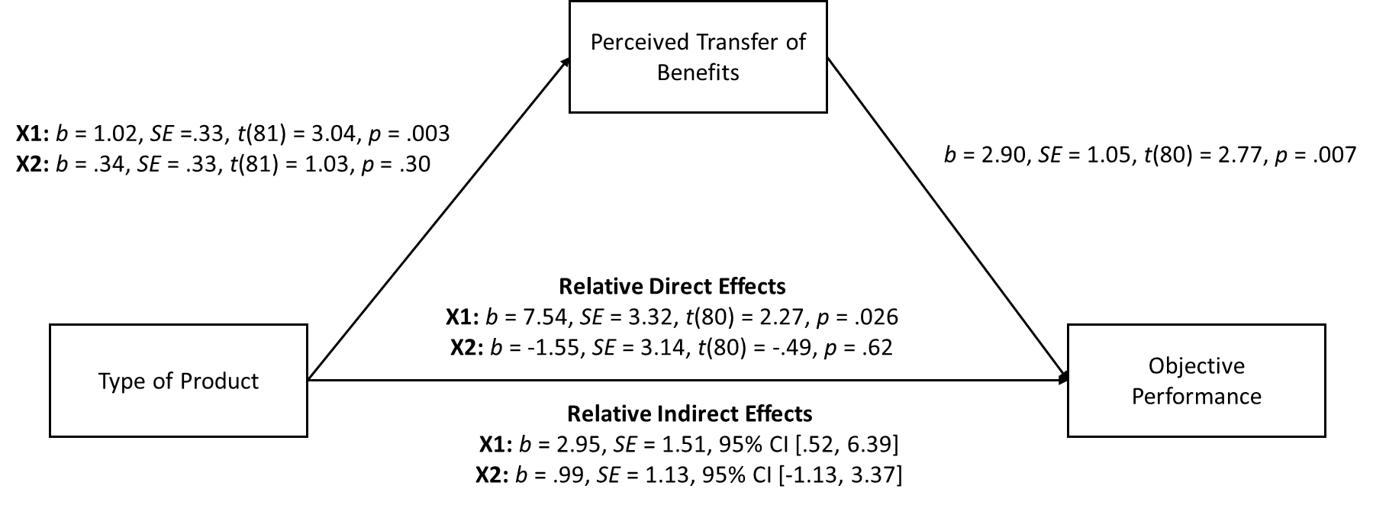

Note. Our independent variable is a multicategorical variable, so we created two dummy variables where X1 compared sensory signaling product with related signal (coded 1) with nonsignaling product (coded 0) and X2 compared sensory signaling product with unrelated signal condition (coded 1) with nonsignaling product condition (coded 0).

Web Appendix 10
Web Appendix S2: Sensory signaling products work when consumers can feel it

This study aimed to replicate Study 3 in the manuscript using a different product (i.e., a spray) and a different objective performance measure (i.e., upper body twisting). The study had a similar design as that of Study 3, in which participants read the same verbal claims but applied different products (nonsignaling product vs. sensory signaling product). In addition, we added a third condition in which participants applied a sensory signaling product, but removed the tingling sensation before performing the task. We predicted that participants using a sensory signaling product with the bodily sensation (e.g., tingle) removed during task performance (hereafter, “sensory signaling product with sensation absent”) would perceive less (or no) transferred benefits, and thus would perform worse than participants using a sensory signaling product with the bodily sensation present during the task performance (hereafter, “sensory signaling product with sensation present”). We also predicted that participants in the sensory signaling product with sensation absent condition would perform equally poorly as those in the nonsignaling product condition. Thus, the study employed a three-condition (nonsignaling product vs. sensory signaling product with sensation present vs. sensory signaling product with sensation absent), between-subjects design.

Stimuli. Like in Study 3, we hired a manufacturer to create two completely novel products in a different product format (i.e., spray) with an equally pleasant fresh scent and controlled for color and texture. We asked the manufacturer to use the same fresh fragrance in both conditions to control for the scent. We then put the products in identical spray bottles. A pretest confirmed that the two stimuli differed on tingling sensation, but not on other attributes.
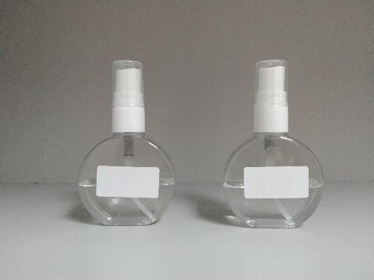

Ingredients. The two stimuli have similar ingredients except for tingling agents, which do not enhance physical performance (Köteles et al. 2018).
Ingredients | Type of product
Ingredients | Nonsignaling  product | Sensory signaling product
Ethyl Alcohol | 97.00% | 67.00%
Menthone Glycerin Acetal | 0.00% | 30.00%
Fragrance | 3.00% | 3.00%
Total | 100.00% | 100.00%

Pretest of the stimuli. A pretest with 30 participants (57% females; M_{age} = 20.77 years, SD = 2.29) confirmed that the two stimuli differed on tingling sensation (M_{nonsignaling} = 3.60, SD = 1.81 vs. M_{signaling} = 5.20, SD = 1.21; t(28) = 2.85, p = .008), but not on the pleasantness of smell (M_{nonsignaling} = 4.87, SD = 1.89 vs. M_{signaling} = 5.27, SD = 1.49; t(28) = .65, p = .52), the pleasantness of texture (M_{nonsignaling} = 5.20, SD = 1.70 vs. M_{signaling} = 5.40, SD = .99; t(28) = .39, p = .70), nor on the strength of smell (M_{nonsignaling} = 4.93, SD = 1.53 vs. M_{signaling} = 5.67, SD = 1.35; t(28) = 1.39, p = .18).

Pretest of the cleansing solvent used to remove the tingling sensation. The cleansing solvent is made of Ethanol 99% (cosmetic grade). It eliminates the tingling sensation from other topical products. We conducted a separate pretest with 21 participants (52% females; M_{age} = 26.05 years, SD = 7.85). In this pretest, participants were randomly assigned to one of the three groups (nonsignaling product; n = 6 vs. sensory signaling product with sensation present; n = 7 vs. sensory signaling product with sensation absent; n = 8) as in the main study. First, participants sprayed the product on their body (i.e., arms and stomach as in the main study) and then waited for three minutes (for the tingling to kick in). After the three minutes of waiting, participants answered the following question: “How tingling is the spray on your arms and body?” (1 = not at all tingling, 7 = very tingling). Then, only participants in the third group (sensory signaling product with sensation absent condition) were asked to remove the sensation using the cleansing solvent. Specifically, participants were handed towelettes soaked with the cleansing solvent to remove the sensation from each arm and abdomen (stomach area). All participants were then asked to wait for another 1 minute before they answered the following choice-based question: “How do you feel now?” (1 = I feel a tingle on my arms and body, 0 = I don’t feel any tingle on my arms and body).
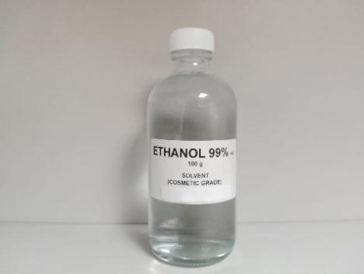

Before removing the sensation. Our analysis revealed that participants using a sensory signaling product with sensation present (M_{signaling-present} = 5.29, SD = .76) reported a higher level of tingling sensation compared to participants using a nonsignaling product (M_{nonsignaling} = 1.67, SD = 1.21; t(18) = 7.21, p < .001). Similarly, participants using a sensory signaling product with sensation absent (not yet removed at the time of reporting the sensation) reported higher levels of tingling sensations (M_{signaling-absent} = 5.63, SD = .74) compared to participants using a nonsignaling product (M_{nonsignaling} = 1.67, SD = 1.21; t(18) = 8.13, p = < .001). As anticipated, participants using a sensory signaling product with sensation present (M_{signaling-present} = 5.29, SD = .76) reported similar levels of tingling sensations as did those who used a sensory signaling product with sensation absent (not yet removed at the time of reporting the sensation; M_{signaling-absent} = 5.63, SD = .74; t(18) = .73, p = .48).

After removing the sensation. After we asked participants in the third group to remove the tingling sensation, our results were consistent with our predictions. A chi-square test (χ² = 17.29, p < .001) indicated that 87.5% of participants (7 out of 8 participants) using a sensory signaling product with sensation absent reported that they did not feel any tingling on their arms and body. In contrast, 100% of the participants (7 out of 7) using the sensory signaling product with sensation present reported that they felt tingling on their arms and body. Finally, 100% of participants (6 out of 6) who used the nonsignaling product reported that they did not feel any tingling sensation. Therefore, our manipulation was successful, and hence we used them in the main study.

Method
Procedure. We recruited 105 students (46% females; M_{age} = 20.67 years, SD = 2.15) who agreed to participate in the study in exchange for small rewards. Upon arrival at the lab, each participant read the consent form where they were invited to participate in a physical exercise study. Next, participants were randomly assigned to one of the three conditions (nonsignaling product vs. sensory signaling product with sensation present vs. sensory signaling product with sensation absent), conducted one person at a time. Each participant watched a short video on how to perform a Russian Twist, a physical exercise that strengthens the core muscles in the upper body. Each participant then performed a Russian Twist (pre-twist measure) where s(he) has to hold her torso and fully twist her upper body clockwise and counterclockwise for as long as s(he) can. To ensure that each participant gave their maximum effort on the pre-twist, s(he) was not told in advance that s(he) would be twisting again, and was not told anything else about the experiment. A research assistant blind to the hypothesis used a stopwatch to measure the twisting duration (sec) from the time that each participant started twisting until s(he) stopped twisting. Results showed that participants in all three conditions twisted equally well in the pre-manipulation twist (“pre-twist”) (F(2, 102) = .46, p = .63).

Following the pre-manipulation twist measure, participants in all conditions read information about the new product (“The Ultra Testosterone Booster” spray), which promised positive outcomes such as increases in muscle mass and strength. After participants read the product claims, they were told that there is a product sample for them to try, and participants applied the spray (i.e., regular spray: nonsignaling product vs. tingling spray: sensory signaling product) on their arms from the wrists to shoulders and stomach (abs) and then waited for three minutes for the product to be absorbed into the skin. After waiting for three minutes (for the tingling to kick in), only participants in the sensory signaling product with sensation absent condition were asked to remove the sensation from their skin using sheets of wet towelettes with a cleansing solvent. A pretest with a separate pool of participants confirmed that participants no longer felt any sensation after the removal procedure. All participants then twisted again (post-manipulation twist measure; “post-twist”).

Following the post-twist measure, each participant completed a similar scale from Study 3, which measured perceptions of the degree to which benefits had been transferred (e.g., “As I was twisting, I can continuously feel that the spray is enhancing my muscles;” α = .96). Later, each participant completed other measures as in Study 3 (see Web Appendix 7). Finally, participants were debriefed and thanked for their participation.

Results
Objective performance. An ANOVA on the index (post-twist measure minus pre-twist measure) was significant (F(2, 102) = 3.49, p = .034, η_{p}² = .064). As predicted, objective performance was higher in the sensory signaling product with sensation present condition (M = +10.64 sec, SD = 14.63) compared to those in the nonsignaling product condition (M = +3.50 sec, SD = 13.15; t(102) = 2.40, p = .018, d = .513) and sensory signaling product with sensation absent condition (M = +4.10 sec, SD = 9.24; t(102) = 2.15, p = .034, d = .529). However, objective performance did not differ between sensory signaling product with sensation absent condition (M = +4.10 sec, SD = 9.24) and nonsignaling product condition (M = +3.50 sec, SD = 13.15; t(102) = .20, p = .85).

Perceived transfer of benefits. An ANOVA was significant (F(2, 102) = 5.20, p = .007, η_{p}² = .092), with higher levels of perceived benefits transfer in the sensory signaling product with sensation present condition (M = 4.97, SD = 1.44) compared to those in the nonsignaling product condition (M = 3.82, SD = 1.76; t(102) = 3.04, p = .003, d = .715) and sensory signaling product with sensation absent condition (M = 4.03, SD = 1.63; t(102) = 2.43, p = .017, d = .613). However, levels of perceived benefits transfer did not differ between sensory signaling product with sensation absent condition (M = 4.03, SD = 1.63) and nonsignaling product condition (M = 3.82, SD = 1.76; t(102) = .54, p = .59).

Mediation analysis. A bootstrapping analysis with 5000 samples based on a multicategorical approach (Hayes and Preacher 2014) with nonsignaling product as a baseline group (coded 0) revealed a significant indirect effect for X1 (sensory signaling product with sensation present coded 1; 95% CI: [.57, 5.75]) but not significant for X2 (sensory signaling product with sensation absent coded 1; 95% CI: [-1.53, 2.72]). Please see figure below for regression coefficients.
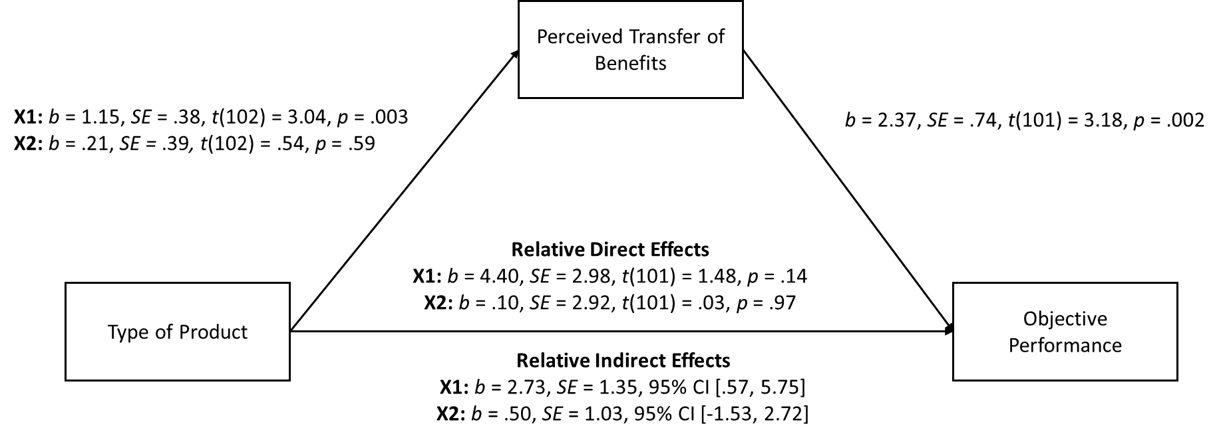

Additional analyses. Results showed marginally significant main effects on attention (F(2, 102) = 2.77, p = .068) and anxiety (F(2, 102) = 2.98, p = .055) but not on other measures (see Web Appendix 7). Of importance to our conceptual interest, the planned contrasts comparing the nonsignaling product condition and the sensory signaling product with sensation present condition were not significant for attention (M_{nonsignaling} = 5.44, SD = 1.56 vs. M_{signaling-present} = 5.39, SD = 1.40; t(102) = .14, p = .89) and for anxiety (M_{nonsignaling} = 4.08, SD = 1.95 vs. M_{signaling-present} = 4.53, SD = 1.91; t(102) = 1.00, p = .32). Therefore, these rival constructs did not explain our results.

Thus, results provided support for the role of sensory signaling in enhancing objective performance through perceived transfer of benefits.

Web Appendix 11
Verbal claims used in Study 4



Web Appendix 12
Mediation analysis in Study 4

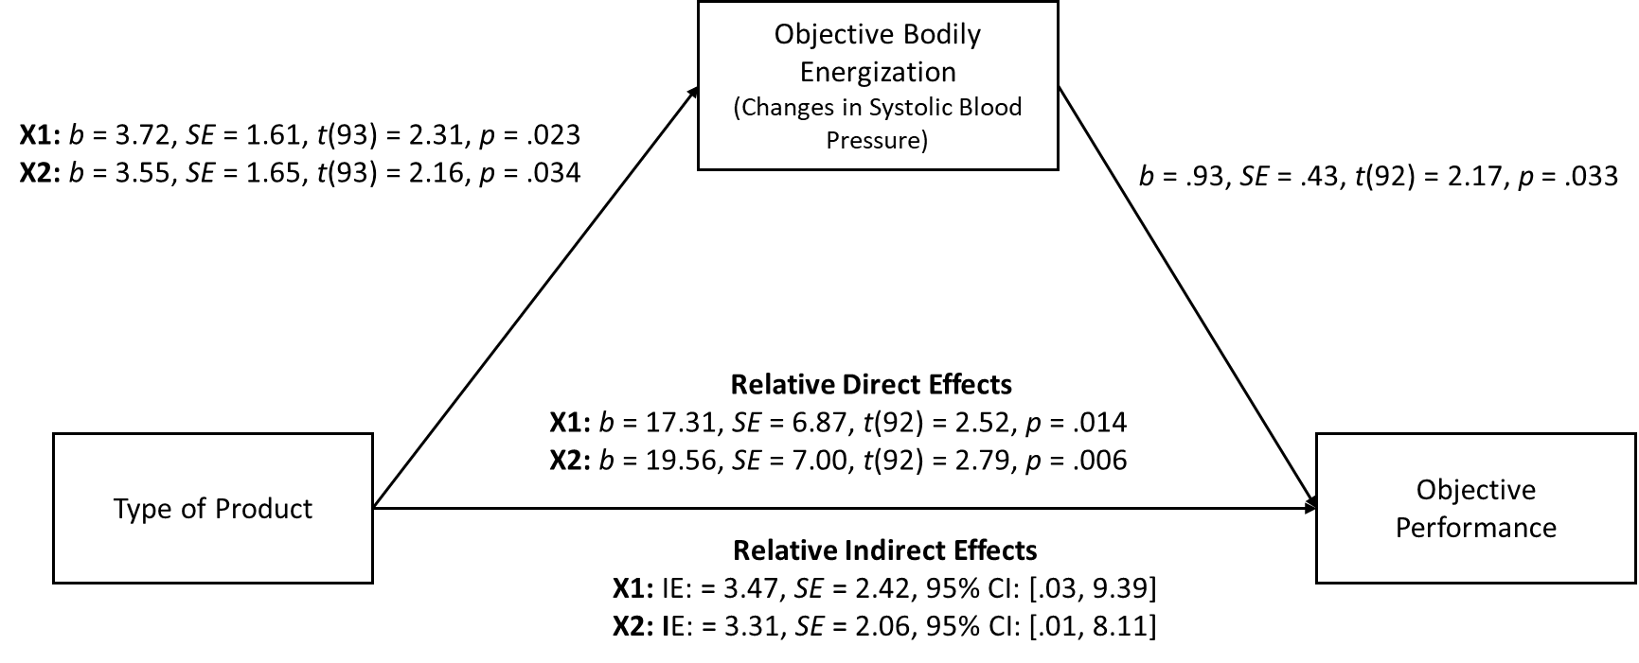

Note. Our independent variable is a multicategorical variable, so we created two dummy variables where X1 compared sensory signaling product with claims condition (coded 1) with nonsignaling product condition (coded 0) and X2 compared sensory signaling product without claims condition (coded 1) with nonsignaling product condition (coded 0).

Web Appendix 13
Verbal claims used in Study 5

 | 
Note. The ad on the left represents the suspicion prime absent condition, whereas the ad on the right represents the suspicion prime present condition.

Pretest. To check our manipulation of suspicion prime, we conducted a separate pretest with 40 participants (53% females; M_{age} = 22.54 years, SD = 3.80; five participants did not report age), in which participants rated one of the two ads on a 7-point scale (1 = unbelievable, 7 = believable; 1 = not truthful, 7 = truthful l; r = .64; Kirmani and Zhu 2007). These items were then reverse coded so that higher numbers indicate greater perceptions of deceptiveness. Confirming our intended manipulation, pretest results confirmed that the ad in the suspicion present condition (M = 4.26, SD = 1.24) was perceived as more deceptive compared to the ad in the suspicion absent condition (M = 2.98, SD = 1.13; t(38) = 3.43, p < .001).

Web Appendix 14
Mediation analysis in Study 5

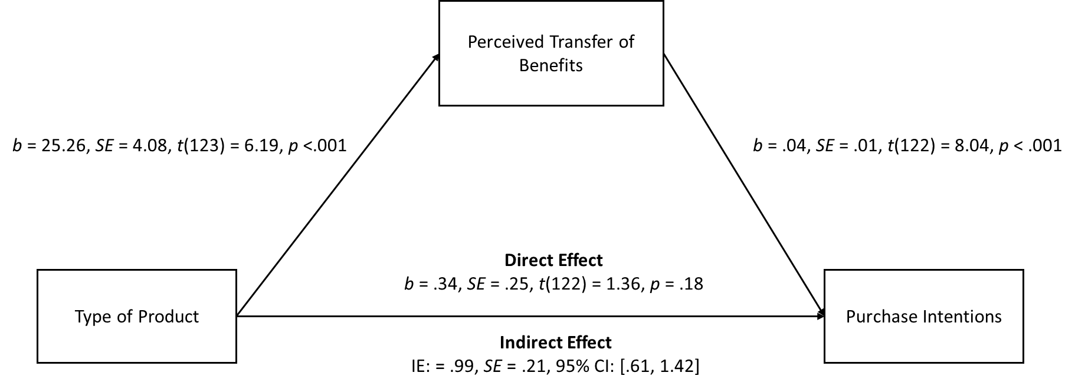

Note. Our independent variable compared sensory signaling product condition (coded 1) with nonsignaling product condition (coded 0).

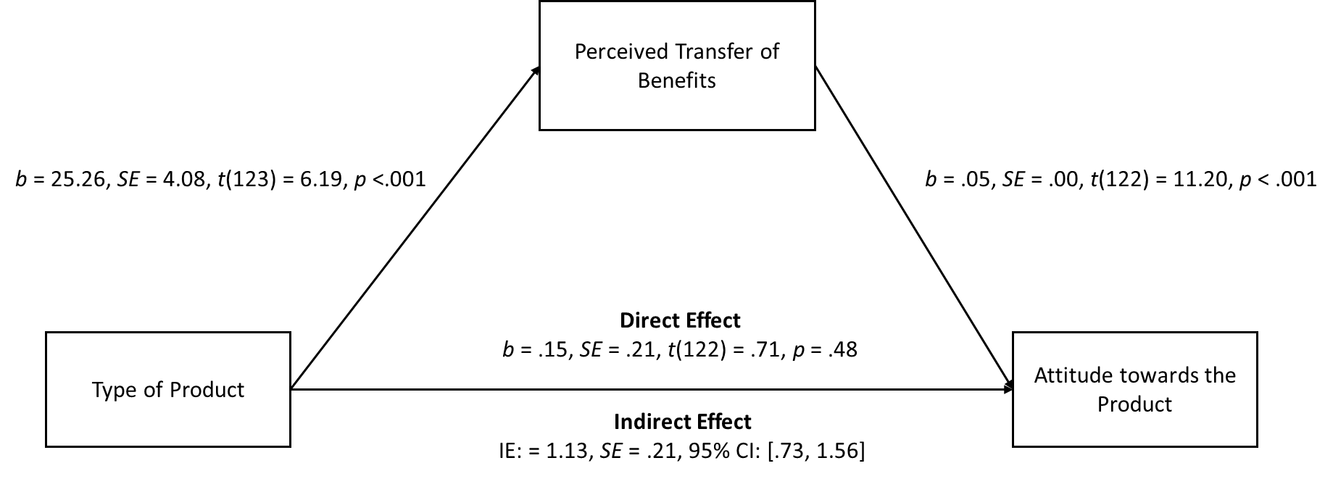

Note. Our independent variable compared sensory signaling product condition (coded 1) with nonsignaling product condition (coded 0).

References
Cheng, Y., Mukhopadhyay, A., & Schrift, R. Y. (2017). Do costly options lead to better outcomes? How the protestant work ethic influences the cost–benefit heuristic in goal pursuit. Journal of Marketing Research, 54(4), 636-649.
Garvey, A. M., Germann, F., & Bolton, L. E. (2016). Performance brand placebos: how brands improve performance and consumers take the credit. Journal of Consumer Research, 42(6), 931-951.
Gray, K. (2010). Moral transformation: Good and evil turn the weak into the mighty. Social Psychological and Personality Science, 1(3), 253-258.
Hayes, A. F., & Preacher, K. J. (2014). Statistical mediation analysis with a multicategorical independent variable. British Journal of Mathematical and Statistical Psychology, 67(3), 451-470.
Ilyuk, V., & Block, L. (2016). The effects of single-serve packaging on consumption closure and judgments of product efficacy. Journal of Consumer Research, 42(6), 858-878.
Ilyuk, V., Block, L., & Faro, D. (2014). Is it still working? Task difficulty promotes a rapid wear-off bias in judgments of pharmacological products. Journal of Consumer Research, 41(3), 775-793.
Kirmani, A., & Zhu, R. (2007). Vigilant against manipulation: the effect of regulatory focus on the use of persuasion knowledge. Journal of Marketing Research, 44(4), 688-701.
Köteles, F., Babulka, P., Szemerszky, R., Dömötör, Z., & Boros, S. (2018). Inhaled peppermint, rosemary and eucalyptus essential oils do not change spirometry in healthy individuals. Physiology & Behavior, 194, 319-323.
Kramer, T., Irmak, C., Block, L. G., & Ilyuk, V. (2012). The effect of a no-pain, no-gain lay theory on product efficacy perceptions. Marketing Letters, 23(3), 517-529.
Mirels, H. L., & Garrett, J. B. (1971). The Protestant Ethic as a personality variable. Journal of Consulting and Clinical Psychology, 36(1), 40–44.
Park, J., & Hadi, R. (2020). Shivering for status: when cold temperatures increase product evaluation. Journal of Consumer Psychology, 30(2), 314-328.
Shiv, B., Carmon, Z., & Ariely, D. (2005). Placebo effects of marketing actions: consumers may get what they pay for. Journal of Marketing Research, 42(4), 383-393.
Spiller, S. A., Fitzsimons, G. J., Lynch Jr, J. G., & McClelland, G. H. (2013). Spotlights, floodlights, and the magic number zero: simple effects tests in moderated regression. Journal of Marketing Research, 50(2), 277-288.
Smith, R. K., Newman, G. E., & Dhar, R. (2016). Closer to the creator: Temporal contagion explains the preference for earlier serial numbers. Journal of Consumer Research, 42(5), 653-668.

