WEB APPENDIX

One size does not fit all: Optimizing size-inclusive model photography mitigates fit risk in online fashion retailing

A. OVERVIEW OF SELECTED ONLINE CLOTHING RETAILERS’ APPROACH TO SIZE INCLUSIVITY MODEL PHOTOGRAPHY 2
B. INTERVIEWS WITH REPRESENTATIVES OF THE FASHION INDUSTRY 3
C. STUDY W1 FIT RISK IS SEPARATE FROM OTHER TYPES OF RISKS 5
D. STUDY W2 THE SIMILARITY-RISK EFFECT, SOCIAL IDENTIFICATION AND PERCEIVED PERSONALIZATION 11
E. STUDY W3 AVAILABILITY OF SIZE-MEASUREMENT INFORMATION 17
F. STIMULI MATERIALS OF STUDIES 1-6 AND STUDIES W2-4 22
G. OVERVIEW OF ATTENTION CHECKS USED IN THE STUDIES 27
H. STUDY 3 PRACTICE BIDDING 28
I. ADDITIONAL RESULTS TABLES 30
J. STUDY 6 PREREGISTERED PREPARATORY ANALYSES 39
K. STUDY 7 PREREGISTERED PREPARATORY ANALYSES 40
L. STUDY 7 PREREGISTERED ANALYSES 42
M. STUDY 2 SURVEY FLOW 45
N. STUDY EXPLORING SIZE-DIVERSITY IN ADVERTISING VS ONLINE SHOPPING 50
O. REFERENCES 56

OVERVIEW OF SELECTED ONLINE CLOTHING RETAILERS’ APPROACH TO SIZE INCLUSIVITY MODEL PHOTOGRAPHY

 | Industry Standard | Size inclusivity approaches¹ |  | Plus sizing
Brand | Thin models only | Models of various sizes mixed across items² | Select model size | Thin + plus size separately³
H&M |  | 🗸 |  | 🗸
Zara | 🗸
Lululemon |  | 🗸  (between-items, but also different colors on the product page worn by models of different sizes)
Good American |  |  | 🗸
Asos |  |  |  | 🗸  (categories curve, petite and tall)
na-kd | 🗸
Calzedonia | 🗸
Hunkemöller |  | 🗸
Puma |  | 🗸
Mango |  |  |  | 🗸
Bershka | 🗸
Burton | 🗸
Dorothy Berkins |  |  |  | 🗸  (plus-size, petite, tall)
New Look |  |  |  | 🗸  (called curves)
Missguided |  |  |  | 🗸  (called plus-size & curve)
ASDA George | 🗸
Pretty Little Thing |  |  |  | 🗸
Zalando |  |  |  | 🗸
Boohoo |  |  |  | 🗸  (called plus-size & curve, tall and petite)
Nasty Gal |  |  |  | 🗸  (possible to “shop by shape” for plus-size or petite)
Free People | 🗸
Nordstrom |  |  |  | 🗸

Notes. The table displays different size inclusivity approaches for a random selection of brands. Data collected in November 2022. 1 While brands and retailers (e.g., Zalando) rely more and more on influencers of different sizes, this practice is out of the scope of our paper. 2 Among the brands showing more size inclusivity, using thin models continues to be the standard approach with non-idealized models mostly still a minority in model photography. 3 For comprehensiveness purposes, we report also whenever a brand showcases the availability of a plus-size collection. As these collections are separate lines, they are at the very opposite of the definition of inclusivity, which is even more surprising given that 2/3 of the women in the US are plus size (Forbes 2022). As the cofounder & creative director of Universal Standard, Alexandra Waldman points out “the only right way to do plus-size, is not to do plus-size at all”

INTERVIEWS WITH REPRESENTATIVES OF THE FASHION INDUSTRY

In the fall of 2022 and spring 2023, we held informal interviews and discussions with representatives of the fashion industry. This included an E-commerce Director from a large fashion brand (selling through both brick-and-mortar and online), a Marketing Analytics Lead from an online fashion retailer, as well as a Co-founder of a company developing AI-tools for model photography. Our main aims for these discussions were to understand the current developments in model photography in the industry especially in relation to diversity, equity and inclusivity, as well as to gain better insight into the reasons why online retailer has seemed slower to adapt to the increasing demand towards more inclusive practices in model photography.
The interviews were conducted virtually on video calls. The duration of the interviews ranged between 30 minutes and an hour. The interviews were adapted to fit the business in question (i.e., focusing on the business itself for the fashion brand and retailer, and on the industry and clients for the AI model photography company), but followed a similar structure. The interviews started with getting to know the daily business of the interviewees and the issues they detected in the industry. Next, we moved to asking about how fashion companies go about creating product images to their websites. Once the interviewees had generally discussed their process of creating product images and model photography, we asked whether the brands had considered using differently sized models and lead the discussion to understand what the key considerations for deciding to use or not use models of varying body sizes. We then presented the idea of using own-size models and asked the companies their thoughts on the expected effectiveness and feasibility of such as approach. Finally, we discussed the role of AI tools in implementing such strategies.
The key conclusions from these interviews are that even though companies are aware of the discussions regarding body positivity and size-inclusivity, they find it difficult to adapt their current model photography strategy. One recurring reason is that they have limited understanding of how any changes in the current (considered to be) well-working strategy would influence consumers. An assumption coming through in all three interviews is that consumers in fact may dislike seeing “themselves” when shopping as this has typically been a setting where photography offers aspiration and inspiration.
A second important finding related to understanding the feasibility of adopting more size-inclusive practices in the field. For brands with frequently changing assortments, taking photographs of each item with multiple models is not realistic given the time and budget this would require, though for more permanent collections this may be possible. In terms of new developments in virtual reality and artificial intelligence to expedite the development of size-inclusive product imagery, retailers also shared constraints with implementation. These systems require higher quality renders of the product images than are needed for production, which are also very time-consuming to create. Even though AI may seem like an ideal solution (from a speed and cost perspective), it seems that for most brands this is more complicated than it seems at first.
Despite the issues and hesitation, all three companies acknowledged the importance of fostering size-inclusivity in the industry. They are actively working to understand how to best approach the necessary changes and take the next steps.

STUDY W1 FIT RISK IS SEPARATE FROM OTHER TYPES OF RISKS

Study W1 builds upon Studies 1A and 1B, investigating the impact of using thin models, a standard in the fashion industry, on the purchase intention of online consumers of different body sizes, and explores how this model size affects the perceived difficulty in evaluating fit risk, as well as examines various types of risks associated with online shopping. Clothing is often used to signal one’s identity and fit into a group (Chan et al. 2012), which creates many types of risks for buying fashion, especially when buying online (Forsythe and Shi 2003). However, while consumers are reliant on product imagery also when judging other types of risk factors, such as social reactions and product quality, we expect that similarity with the model’s body size will only influence perceptions of fit-related risk, even when controlling for other types of risks. Additionally, given that poor fit is the key reason for product returns (e.g., Foresight Factory 2021; industry interviews), we expect that reducing this fit risk is going to have an additional downstream consequence on the likelihood of the product being returned. More specifically, in line with Studies 1A and 1B, we expect that consumers who wear larger sizes than the model showcasing the clothing item in an online store will perceive higher difficulty to assess the clothing's fit based on the product picture, which in turn (a) decreases their purchase intent and (b) increases the likelihood of product return. To show the robustness of the similarity-risk reduction effect, Study W1 measures its effect with an alternative measure, aligned with the measurement of the two other aspects of risk.

Method
In Study W1, we recruited 450 female participants from Prolific (aiming at a sample of 400). We excluded participants when their self-reported gender did not match the female prescreening (n = 0), when they answered “other” in clothing size for jeans (n = 9), or failed the attention check (n = 2). The final sample consisted of 439 participants between 18 and 77 years of age (M = 40.09, SD = 13.46; male: n = 217, between 19 and 77 years of age, M = 44.85, SD = 13.74; female: n = 222, between 18 and 71 years of age, M = 35.43, SD = 11.44). Their frequency of wearing jeans was approximately once a week (M = 4.87, SD = 1.75). On average participants were slightly dissatisfied in their body size and shape (M = 3.74, SD = 1.54). Participants were first asked about the size of jeans they typically wear (from XXS to XXL or ‘other’, M = 4.64, SD = 1.23), age and their body satisfaction. They were then asked to imagine they wanted to buy new jeans and were looking for options online. We told them they came across a pair of jeans on the website of an online retailer. All female participants saw a front and behind picture of a thin female model and all male participants saw a thin male model wearing a pair of jeans.
Next, participants reported their purchase intention (“How likely would you be to buy these jeans in your size?” 1- Not at all likely, 7- Extremely likely; M = 3.70, SD = 1.79) and likelihood of product return (i.e., “How likely is it that you would have to return these jeans?” Not at all likely 1 - Extremely likely 7; M = 4.03, SD = 1.73). Next participants indicated their difficulty to assess risk, for three different aspects (random order). The first was fit risk of the jeans (3 items, “This product's pictures ensure me about the jeans' fit to be satisfactory to my needs”, “This product's pictures help me to assess how the jeans would fit me”, “This product’s pictures make me confident that the jeans’ fit will be as I expect”. Strongly disagree 1 - Strongly agree 7, all risk items were reverse coded; α = .879, M = 3.81, SD = 1.47). The second was quality risk (adapted from the Perceived Quality scale from Dodds, Monroe and Grewal, 1991; 5 items, “This product's pictures make me confident of the jeans' reliability”, “This product’s pictures help me to assess the workmanship of the jeans”, “This product’s pictures allow me to determine the quality of the jeans”, “This product’s pictures allow me to judge the dependability of the jeans”, “This product’s pictures help me to evaluate the durability of the jeans”. α = .908, M = 4.26, SD = 1.73). The third was social risk (adapted from Eisingerich et al., 2015; 3 items, “This product's pictures help me to judge if I may be embarrassed when I wear the jeans in the company of my friends”, “This product’s pictures allow me to evaluate if people would disapprove of me when I wear the jeans”, “This product’s pictures help me to assess the social risk of wearing the jeans in public”, α = .944, M = 4.44, SD = 1.39) and answered an attention check. Participants then indicated their online shopping frequency and frequency of wearing jeans. Because the gender of the participants did not influence the results, we collapsed the data across the gender.

Results
Purchase intention We analyzed the data using PROCESS model 4 for parallel mediation (10,000 bootstraps; Hayes 2018). The clothing size of the participant was the independent variable, difficulty to assess the clothing's (1) fit risk, (2) social risk and (3) quality risk based on the product pictures the parallel mediators, and purchase intention the dependent variable. The results show a positive association between the clothing size of the participant and perceived difficulty assessing fit risk (b = .212, se = .055, p < .001). However, the perceived difficulty assessing quality risk and social risk were not significantly associated with consumers’ clothing size (quality risk: b = -.037 se = .054, p = .490; social risk: b = .060 se = .067, p = .369). Perceived difficulty assessing fit risk and quality risk were both negatively associated with purchase intention (fit risk: b = -.336, se = .065, p < .001; quality risk: b = -.349, se = .064, p < .001), but perceived difficulty assessing social risk was not (b = .082, se = .050, p = .100). The indirect effect of consumers’ clothing size on purchase intention through perceived difficulty assessing fit risk was negative and significant (b = -.072, se = .023, 95%CI [-.121, -.031]). The indirect effect intention through perceived difficulty assessing quality risk (b = .013 se = .019, 95%CI [-.022, .051]) or social risk did not reach significance (b = .005 se = .007, 95%CI [-.007, .022]).
When controlling for body satisfaction, the indirect effect of consumers’ clothing size on purchase intention through perceived difficulty assessing fit risk was reduced to being marginally significant but was consistent in direction (b = -.035 se = .022, 90%CI [-.072, -.003]). The results of perceived difficulty assessing social risk and quality risk did not change in significance or direction when including body satisfaction in the analysis.
Product return To explore downstream consequences of thin models on product returns, we replaced the dependent variable of purchase intention with likelihood of returning the product in a separate analysis with the same independent variable and mediators. The results showed that the indirect effect of consumers’ clothing size on return likelihood through perceived difficulty assessing fit risk was positive and significant (b = .076, se = .024, 95%CI [.034, .128]). As expected, through perceived difficulty assessing social risk (b = -.004, se = .006, 95%CI [-.019, .007]) and quality risk (b = -.008, se = .012, 95%CI [-.035, .014]) the indirect effect did not reach significance. When controlling for body satisfaction, the indirect effect of consumers’ clothing size on product return through perceived difficulty assessing fit risk was marginally significant (b = .036 se = .022, 90%CI [.003, .073]). The results of perceived difficulty assessing social risk and quality risk did not change in significance or direction when including body satisfaction in the analysis.

Discussion Study W1
Study W1 again demonstrates the negative consequences of using only thin models to display clothing, specifically highlighting how this approach hampers consumers' ability to accurately perceive the fit of clothing on models with body types unrepresentative of the average consumer. Here, we acknowledge that online shopping especially for fashion inherently involves various types of risks, relating not only to evaluating the fit of the item, but for example also its quality as well as reactions from one’s social group. Through this study, we show the “Dissimilarity-Risk Deterrence Effect” specifically relates to fit risk. In other words, this effect is distinct and separate from other forms of risk associated with online shopping. Moreover, our study reveals that the inability of consumers to effectively assess fit risk not only deters purchases but also contributes to a higher expectancy of product returns. This showcases a critical inefficiency in the current online retail practice of thin model photography, suggesting that addressing the associated fit risk could not only improve sales but also reduce product returns. Given the significant negative footprint associated with product returns (Tian and Sarkis 2022), this shows that adopting a more inclusive approach to model photography can potentially yield benefits also for the environment. This is an important avenue for future research on model photography and online shopping more generally.

Table C1. Indirect effects and models figures for Study W1
Purchase Intention Serial Mediation PROCESS Model 6 (10000 bootstrap)
Without covariate | b | se | 95%CI
Perceived difficulty assessing fit risk | -.071 | .023 | -.121, -.031
Perceived difficulty assessing social risk | .005 | .007 | -.007, .022
Perceived difficulty assessing quality risk | .013 | .019 | -.023, .051
With covariate (body satisfaction)
Perceived difficulty assessing fit risk | -.035 | .022 | -.071, -.003*
Perceived difficulty assessing social risk | .002 | .007 | -.011, .019
Perceived difficulty assessing quality risk | .034 | .022 | -.007, .079
With covariate (body satisfaction and gender)
Perceived difficulty assessing fit risk | -.0325 | .016 | -.067, -.004
Perceived difficulty assessing social risk | .003 | .005 | -.006, .016
Perceived difficulty assessing quality risk | .017 | .015 | -.012, .048
Product Return Serial Mediation PROCESS Model 6 (10000 bootstrap)
Without covariate | b | se | 95%CI
Perceived difficulty assessing fit risk | .076 | .024 | .034, .128
Perceived difficulty assessing social risk | -.004 | .006 | -.019, .007
Perceived difficulty assessing quality risk | .008 | .012 | -.035, .014
With covariate (body satisfaction)
Perceived difficulty assessing fit risk | .036 | .022 | .002, .073*
Perceived difficulty assessing social risk | -.002 | .006 | -.012, .007
Perceived difficulty assessing quality risk | -.021 | .015 | -.049, .000
With covariate (body satisfaction and gender)
Perceived difficulty assessing fit risk | .046 | .022 | .006, .093
Perceived difficulty assessing social risk | -.003 | .006 | -.019, .008
Perceived difficulty assessing quality risk | -.015 | .014 | -.046, .010
* Confidence intervals 90%

Purchase Intention Serial Mediation PROCESS Model 6
Without covariate |  | With covariate
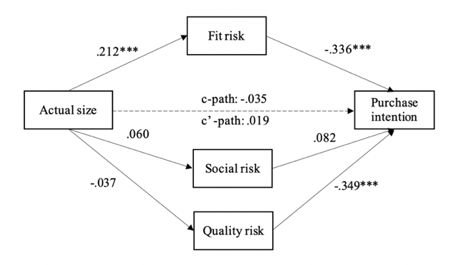 |  | 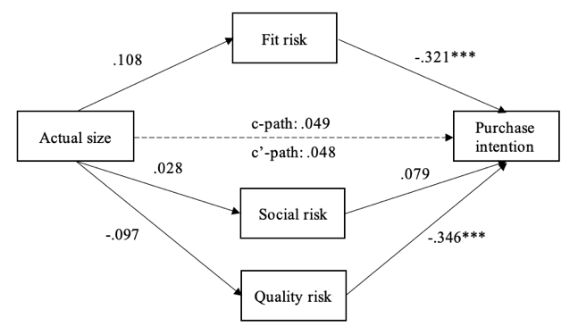
 | Product Return Serial Mediation PROCESS Model 6
Without covariate |  | With covariate
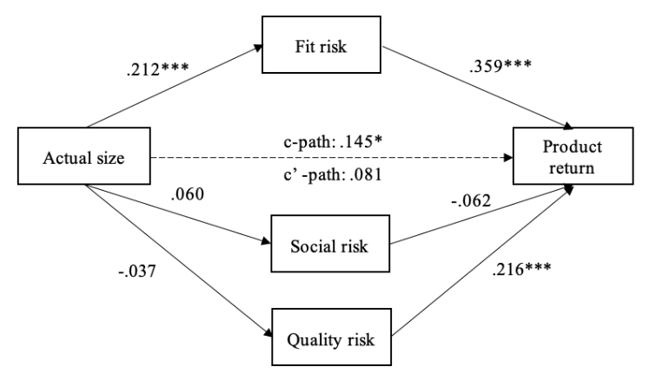 |  | 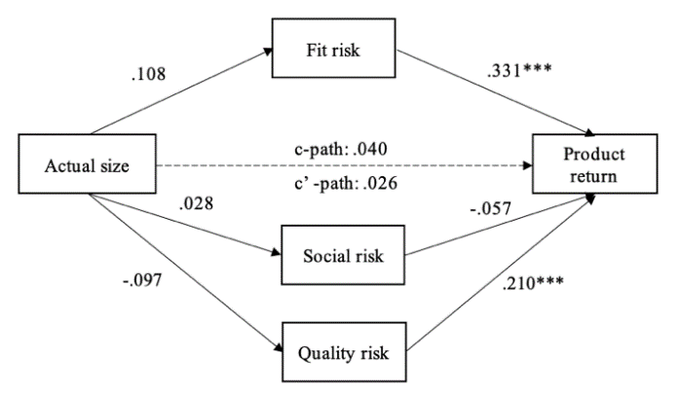
* p < .05, **p < .01, *** p < .001

STUDY W2 THE SIMILARITY-RISK EFFECT, SOCIAL IDENTIFICATION AND PERCEIVED PERSONALIZATION

This study examines how different model photography approaches (model's body size: thin vs. own clothing size vs. larger) influence consumers' purchase intention, while accounting for alternative explanations of personalization and social identification. Our hypothesis suggests that own-sized models trigger a sense of perceived body-size similarity in consumers, which in turn reduces perceived fit risk and, in turn, increases purchase intention. However, given that consumers generally more easily feel a sense of social identification with those more similar to themselves (Chan et al. 2012), and we tend to react positively to products used or created by those in our in-group (White and Dahl 2007; Brown, Schmidt and Collins 1988), it is also possible that own-size models influence purchase by inducing social identification. Additionally, given that consumers generally respond positively to more personalized marketing communications (Chandra et al. 2022), the effect may also be driven by a higher sense of personalization by the retailer. To explore these alternative effects of model size and test the robustness of our findings, we include measures of both social identification and perceived personalization in this study.

Method
We recruited 634 female participants from Prolific (aiming at a sample of 600). We excluded participants when their self-reported gender did not match the female prescreening (n = 0), when they answered “other” in clothing size for jeans (n = 28), or failed the attention check (n = 3). The final sample consisted of 603 female participants from Prolific between 18 and 80 years of age (M = 36.17, SD = 12.38). Their frequency of wearing dresses was approximately once a week (M = 2.47, SD = 1.28). On average participants were slightly dissatisfied in their body size and shape (M = 3.53, SD = 1.61). First, participants reported the gender with which they identified and their clothing size for dresses (from XS to XL, coded as 1 to 5 and “other”), age, online shopping frequency (M = 3.34, SD = .968) and their body satisfaction. Participants were then told they were looking to buy a new dress and were looking for options online. They were randomly assigned to one of three model body-size conditions (thin vs. own size vs. larger model). They saw either a thin model (XS size), a model of their own size (wearing the size reported by participants at the start of the study) or a larger model (XL size) with a text: “This model is wearing size []” according to the condition they were in (see Figure D1). Participants were asked to indicate their purchase intention (α = .933, M = 2.53, SD = 1.52) and reported their perceived fit risk (α = .727, M = 4.45, SD = 1.35) and body-size similarity with the model (M = 3.10, SD = 1.79). We also measured social identification (adapted from Escalas and Bettman 2005 to the context at hand; 3 items, “I consider myself to be this type of person,” “I belong to this model's group” and “I fit in with this model's group of people” Strongly disagree - 1, Strongly agree - 7; α = .950, M = 2.88, SD = 1.54) and perceived personalization (Kalyanaraman and Sundar, 2006 ; 2 items, i.e., “This web environment is personalized according to my interests” and “This web environment targets me as a unique individual;” α = .904, M = 3.19, SD = 1.58). Next, participants answered attention checks and reported their frequency of wearing dresses.

Results
We conducted a path analysis using the lavaan package for R (Rosseel 2012), using the averaged, mean-centered scales and 500 bootstraps with model size as the independent variable (dummy coded; X1: thin vs. own size and X2: larger vs. own size; own size as the reference point), and purchase intention as the dependent variable. We simultaneously examine three parallel mediation paths: (1) serial mediation through perceived similarity and risk (H2), (2) simple mediation through social identification, and (3) simple mediation through perceived personalization.
The results support H1: the own-size model was perceived more similar in body size than the thin-size (b = -1.739, se = .156, p < .001) and larger-size models (b = -1.649, se = .169, p < .001). This similarity was associated with lower perceived fit risk (b = -.174, se = .032, p < .001), which in turn was significantly associated with purchase intention (b = -.260, se = .035, p < .001). The results also support H2: the indirect effect of model size on purchase intention through perceived similarity and risk was significant for both comparisons (X1: b = -.114, se = .029, p < .001, 95%CI [-.177, -.062]; X2: b = -.108, se = .027, p < .001, 95%CI [-.167, -.061]).
The results revealed that participants also identified more with the model in the own-sized condition than in the thin-sized condition and larger-sized condition (X1: b = -.930, se = .143, p < .001; X2: b = -.558, se = .162, p = .001). Social identification was significantly associated with participants’ purchase intention (b = .216, se = .052, p < .001). The indirect effect through social identification was also significant (X1: b = -.200, se = .055, p < .001, 95%CI [-.311, -.092]; X2: b = -.120, se = .048, p = .012, 95%CI [-.230, -.043]).
Lastly, participants also perceived the web environment with the own-size model to be more personalized than in the thin-sized model condition (X1: b = -.577, se = .158, p < .001) and the larger sized model condition (X2: b = -.401, se = .165, p = .015). The feeling of personalization was positively associated with purchase intention (b = .180, se = .039, p < .001). The indirect effect of model size on purchase was significant for both the thin vs. own-size model (X1: b = .104, se = .034, p = .003, 95%CI [-.173, -.039]) and the larger vs. own-size model comparisons (X2: b = -.072, se = .033 p = .031, 95%CI [-.144, -.014]). None of the results reported changes in significance or direction when including body satisfaction in the analysis.

Discussion
This study again replicated our key finding, reinforcing the support for H1 and H2, that own-size models trigger a sense of perceived body-size similarity, which lowers consumers’ perceived fit risk and, in turn, increases purchase. Furthermore, we expanded our investigation to include two alternative mediators: social identification and personalization. Notably, the inclusion of these mediators simultaneously within the same path model did not weaken our focal path; rather, it highlights the importance of fit risk in driving consumers’ decision-making and showed the robustness of our primary pathway through perceived similarity and fit risk. Additionally, the results show additional benefits of own-sized models: consumers identify more strongly with own-sized models compared to thin or larger models and also perceive a higher level of personalization. Both social identification and personalization had a significant positive influence on purchase intention. These findings suggest that the advantages of using own-sized models go beyond reducing the perceived risk of poor fit and that the impact of diverse body sizes of models on consumer perceptions and purchase are multi-faceted and complex. It demonstrates that moving away from the traditional reliance on exclusively thin or only including larger models can have an impact on consumer behavior in a broader sense, but future research should investigate whether these aspects prevent consumers from making bad buys. These findings open paths to more extensive research into the currently underresearched area of body-size inclusivity in marketing practice by shedding light to the many ways the body size of models can have an impact on consumers, businesses and society.

Table D1. Indirect effects and models figures for Study W2
 | Path Model (500 bootstraps)
 | Through perceived similarity and perceived risk
 | Without covariate | b |  | se | 95%CI
 | Thin vs. Own size | -.114 |  | .029 | -.177, -.062
 | Larger vs. Own size | -.108 |  | .027 | -.167, -.061
With covariate (body satisfaction)
 | Thin vs. Own size | -.113 |  | .029 | -.177, -.062
 | Larger vs. Own size | -.107 |  | .027 | -.162, -.059
 | Through social identification
 | Without covariate | b |  | se | 95%CI
 | Thin vs. Own size | -.200 |  | .055 | -.311, -.092
 | Larger vs. Own size | -.120 |  | .048 | -.230, -.043
With covariate (body satisfaction)
 | Thin vs. Own size | -.200 |  | .058 | -.321, -.102
 | Larger vs. Own size | -.120 |  | .045 | -.220, -.047
 | Through perceived personalization
 | Without covariate | b |  | se | 95%CI
 | Thin vs. Own size | -.104 |  | .034 | -.173, -.039
 | Larger vs. Own size | -.072 |  | .033 | -.144, -.014
With covariate (body satisfaction)
 | Thin vs. Own size | -.104 |  | .036 | -.188, -.046
 | Larger vs. Own size | -.073 |  | .033 | -.141, -.018
 | Path Model (500 bootstraps)
 | Without covariate(s) |  | With covariate(s)
 | 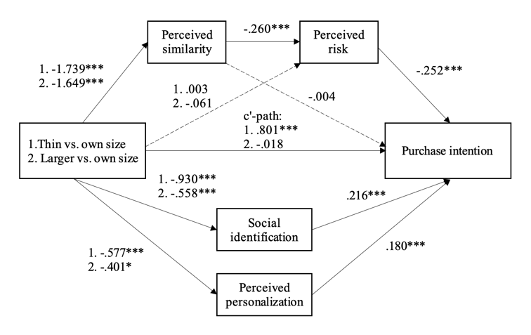 |  | 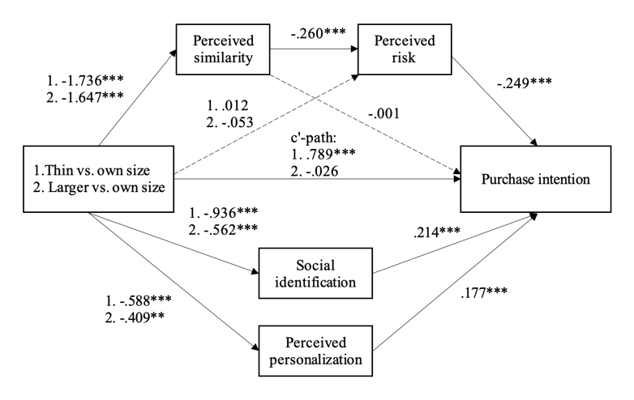

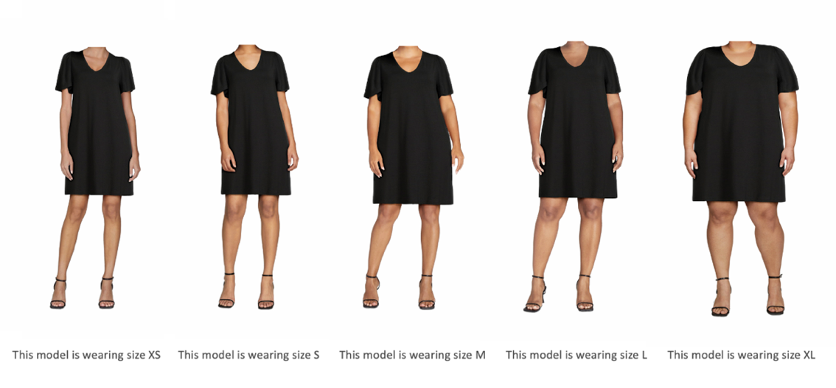
Fig. D1 Stimuli Materials
Actual product imagery and models from an online retailer using a virtual reality tool (Walmart Zeekit)

STUDY W3 AVAILABILITY OF SIZE-MEASUREMENT INFORMATION

This study investigates another potential boundary condition for the positive effect that own-size model photography has on consumers' purchase intention by reducing the perceived fit risk. As shown across the previous studies, when size-measurement information is not readily available, using own-size models helps mitigate the perceived fit risk. However, we expect that when an alternative source of information about the product’s fit is available, for example when retailers inform consumers about the fit based on feedback from other customers, we expect that the importance of model photography for evaluating fit is attenuated. This is because providing consumers with additional, more objectively verifiable, information may reduce the need to rely on more implicit cues. This study again explores the effect of model size on consumers’ perception of the retailer’s size inclusivity.

Method
We recruited 448 female participants from Prolific (aiming at a sample of 400). We excluded participants when their self-reported gender did not match the female prescreening (n = 0), when they answered “other” in clothing size for jeans (n = 11), or failed the attention check (n = 8). The final sample consisted of 429 female participants between 18 and 67 years of age (M = 31.79, SD = 12.11). Their frequency of wearing jeans was approximately once a week (M = 3.83, SD = 1.41). On average participants were slightly dissatisfied in their body size and shape (M = 3.65, SD = 1.65). The study had a 2 (model: thin vs. own size) x 2 (measurement cue: present vs. absent) completely randomized between-subjects design.
Participants first reported the gender with which they identified and their clothing size for pants (from XXS to XXL, coded as 1 to 7 and ’other’; M = 3.30, SD = 1.81). Next, we asked the participants to imagine that their favorite jeans had ripped. To ensure that the participants would be involved in the buying decision, we told them that they usually wore those jeans when going out, meeting friends and at the office, and were now looking for options online to replace the jeans. All participants then saw a pair of jeans. The front and behind pictures of the jeans were of a thin model or a model their own size (matched based on their reported size at the start of the study). Next to the model’s body size, we also manipulated the presence or absence of a measurement cue. When the cue was present, participants saw a ruler from “Runs small” to “Runs large,” marked in the middle and indicating “Perfect fit!” for the jeans (see Figure E1 below). The accompanying message read: “Based on the reviews of customers who previously bought these jeans in size [participants’ reported clothing size], these jeans fit them perfect to size! We recommend you buy them in your regular size.” In other words, the cue highlighted that others of the same size as the participant found the jeans to fit perfectly.

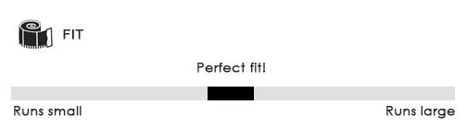
Based on the reviews of customers who previously bought these jeans in size [INSERT SIZE], these jeans fit them perfect to size! We recommend you buy them in your regular size.

Fig. E1 Stimuli Materials
Note. The jeans pictures were the same as in Study 2 (see below).

All participants then indicated their purchase likelihood for the jeans (α = .957, M = 4.26, SD = 1.79), their perceived fit risk (α = .854, M = 4.12, SD = 1.24), and body-size similarity with the model (M = 4.58, SD = 1.39). Subsequently, we measured participants’ perception of the retailer’s size-inclusivity (α = .949, M = 3.66, SD = 1.50). Next, participants answered an attention check (e.g., “In order to show that you are reading the questions and paying attention to all instructions, please choose number 3 below, and then move forward to some demographic questions.”), rated the product’s attractiveness (“I like the style of the jeans;” 1 Completely disagree – 7 Completely agree; M = 4.16, SD = 1.87), their body satisfaction, frequency of wearing jeans and age. As a manipulation check of the measurement cue, we asked participants to express to what extent they agreed that customers who buy the jeans would find that the sizing of the product is accurate, after which we debriefed everyone.

Results
Manipulation check A one-way ANOVA revealed that the manipulation of the measurement cue worked (F(1, 427) = 60.55, p < .001, η_{p}² = .124). When the measurement cue was present (M = 4.70, SD = 1.14) participants reported a significantly higher level of perceived size accuracy than when the measurement cue was absent (M = 3.80, SD = 1.25, p < .001).
Similarity A 2 (measurement cue: cue vs. no cue) × 2 (model size: thin vs. own size) ANOVA showed that perceived similarity significantly differed across the model size conditions (F(1, 428) = 51.88, p < .001, η_{p}² = .109). Participants in the own-size condition (M = 3.89, SD = 1.63) felt more similar to the model than those in the thin-model condition (M = 2.69, SD = 1.78), supporting H1. The main effect of the measurement cue was not significant (F(1, 428) = 1.46, p = .228, η_{p}² = .003; cue absent: M = 3.44, SD = 1.82, cue present: M = 3.15, SD = 1.81). The interaction between model size and measurement cue on perceived similarity was also not significant (F(1, 428) = 2.527, p = .113, η_{p}² = .006).
Moderated mediation To explore whether the measurement cue may moderate any direct effect between model size and risk, we ran a parallel moderated mediation analysis (PROCESS model 7 with 10,000 bootstraps) with model size (-1 thin vs. 1 own size) as the independent variable, measurement cue as moderator (-1 absent vs. 1 present), perceived risk and retailer’s inclusivity as parallel mediators and purchase intention as the dependent variable. The results showed that compared to the thin-size model, the own-size model lowered the perceived risk that the jeans will fit poorly (b = .116, se = .064, p = .070). However, this effect was qualified by a model size x measurement cue interaction (b = -.142, se = .064, p = .027). Perceived risk, in turn, negatively related to purchase intention (b = -.605, se = .056, p < .001). Overall, when there was no measurement cue, we find the model size – perceived risk – purchase intention indirect effect (b = -.156, se = .050, 95% CI [-.256, -.058]). However, when the measurement cue was added, the indirect effect no longer reached significance (b = .016, se = .059, 95% CI [-.101, .132]). The index of moderated mediation was significant (b = .172, se = .078, 95%CI [.023, .328]).
Looking at retailers’ brand image of size inclusivity shows that, compared to the thin-size model, those who saw the own-size model reported significantly higher retailer inclusivity (b = -.999, se = .054, p < .001). However, this heightened size inclusivity did not relate to a higher purchase intention (b = .126, se = .069, p = .070). The model size – retailer inclusivity – purchase intention indirect effect was not significant (measurement cue absent: b = -.135, se = .073, 95% CI [-.281, .010]; measurement cue present: b = -.117, se = .065, 95% CI [-.250, .008]). The index of moderated mediation for this path was also not significant (b = .017, se = .017, 95% CI [-.011, .056]).

Discussion
This study explores how the presence of other, more objective, fit-related information being presented to the consumer at the point of purchase influences the model size effect. In this study, we specifically tested a common strategy used by online retailers: sharing fit-related feedback from other consumers. This provides more support to the importance of retailers finding ways to mitigate perceived fit risk for consumers. However, measurement information is often only shown to consumers in a later stage of the purchase decision; Model photography is generally considered first. Moreover, given the additional cognitive effort required to make use of measurement information and the potentially limited attention such measurement cues receive from consumers, we continue to highlight the importance of size-inclusive model photography not only for societal benefit but risk reduction as well. As in Study 3, we find that using models who are the same size as consumers increases perceived retailer inclusivity. However, again, it did not signicantly (here, marginally) spill over to purchase intention.

Table E1. Indirect effects and models figures for Study W3
Moderated Mediation PROCESS model 7 (10000 bootstrap)
Through perceived risk
Without covariate | b |  | se | 95%CI
Perceived risk cue absent | -.156 |  | .049 | -.256, -.058
Perceived risk cue present | .016 |  | .059 | -.101, .132
Moderated mediation index | .172 |  | .078 | .022, .328
With covariate (body satisfaction)
Perceived risk cue absent | -.169 |  | .049 | -.266, -.074
Perceived risk cue present | .034 |  | .059 | -.084, .152
Moderated mediation index | .203 |  | .078 | .053, .360
Through retailer size inclusivity
Without covariate | b |  | se | 95%CI
Perceived risk cue absent | -.135 |  | .074 | -.281, .010
Perceived risk cue present | -.117 |  | .066 | -.250, .008
Moderated mediation index | .018 |  | .017 | -.011, .056
With covariate (body satisfaction)
Perceived risk cue absent | -.137 |  | .073 | -.276, .009
Perceived risk cue present | -.117 |  | .064 | -.247, .007
Moderated mediation index | .020 |  | .017 | -.010, .059
Moderated Mediation PROCESS model 7 (10000 bootstrap)
Without covariate(s) |  | With covariate(s)
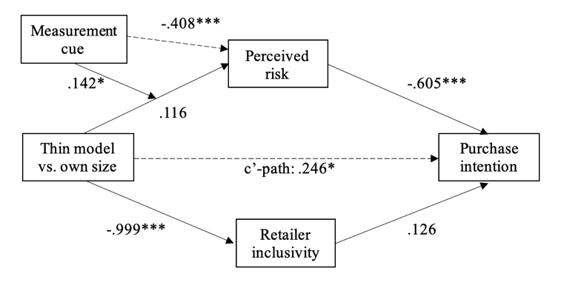 |  | 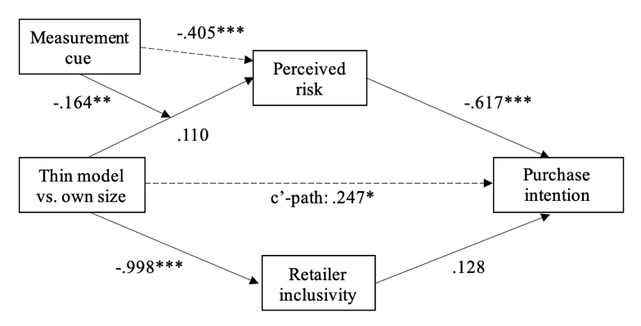
* p < .05, **p < .01, *** p < .001

STIMULI MATERIALS OF STUDIES 1-7 AND STUDIES W2-3

Study 1A

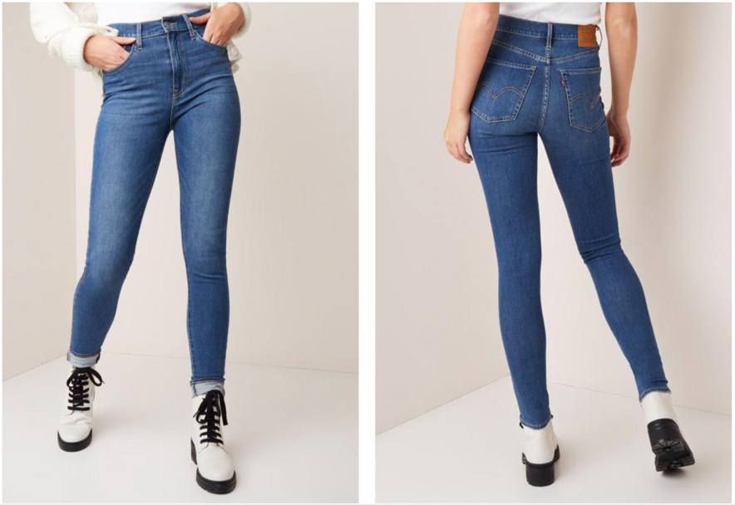
Actual product imagery from an online retailer (De Bijenkorf)

Study 1B

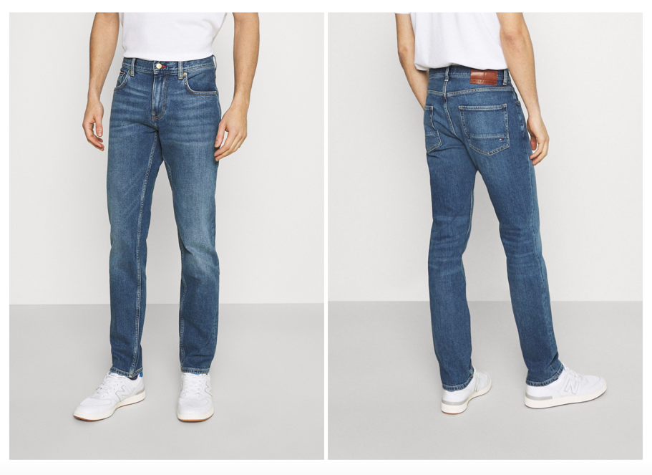
Actual product imagery from an online retailer (Tommy Hilfiger)

Study 2

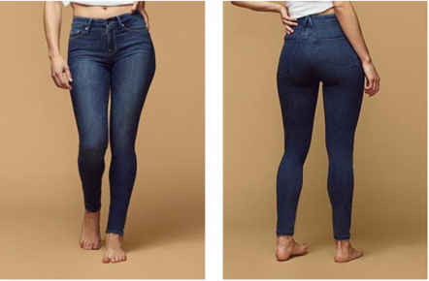 | 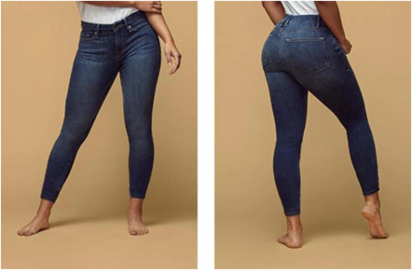 | 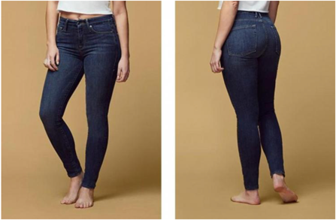
Size 2 | Size 4 | Size 6
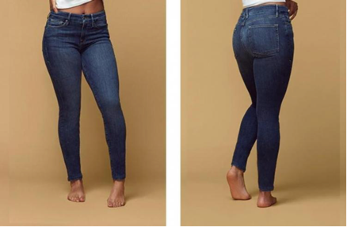 | 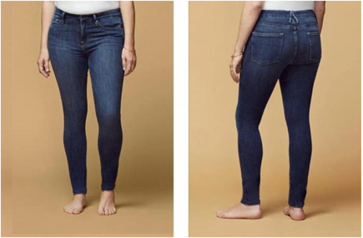 | 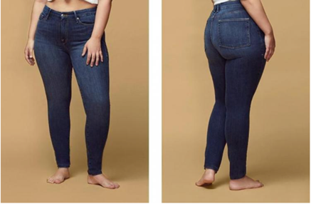
Size 8 | Size 10 | Size 12
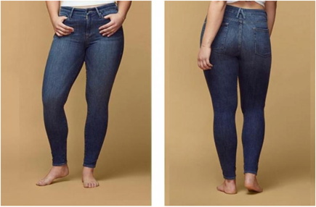 | 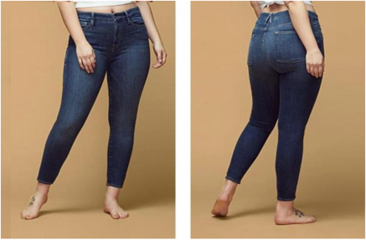 | 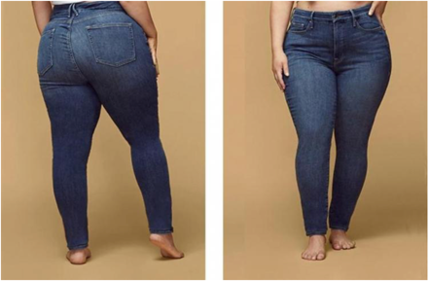
Size 14 | Size 16 | Size 18
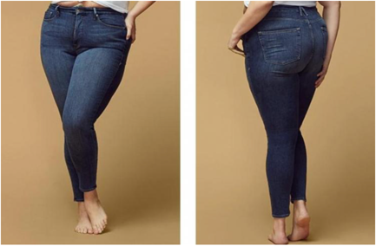 | 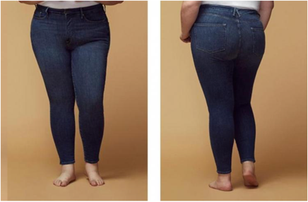 | 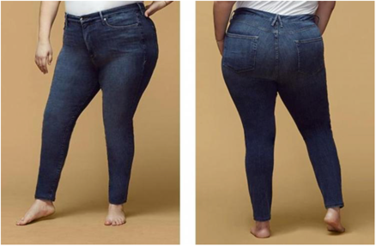
Size 20 | Size 22 | Size 24
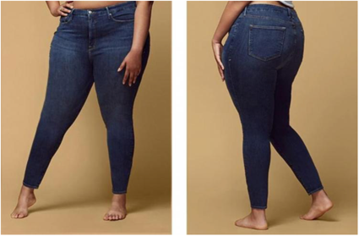
Size 26
Actual product imagery from an online retailer (Good American)

Study 3

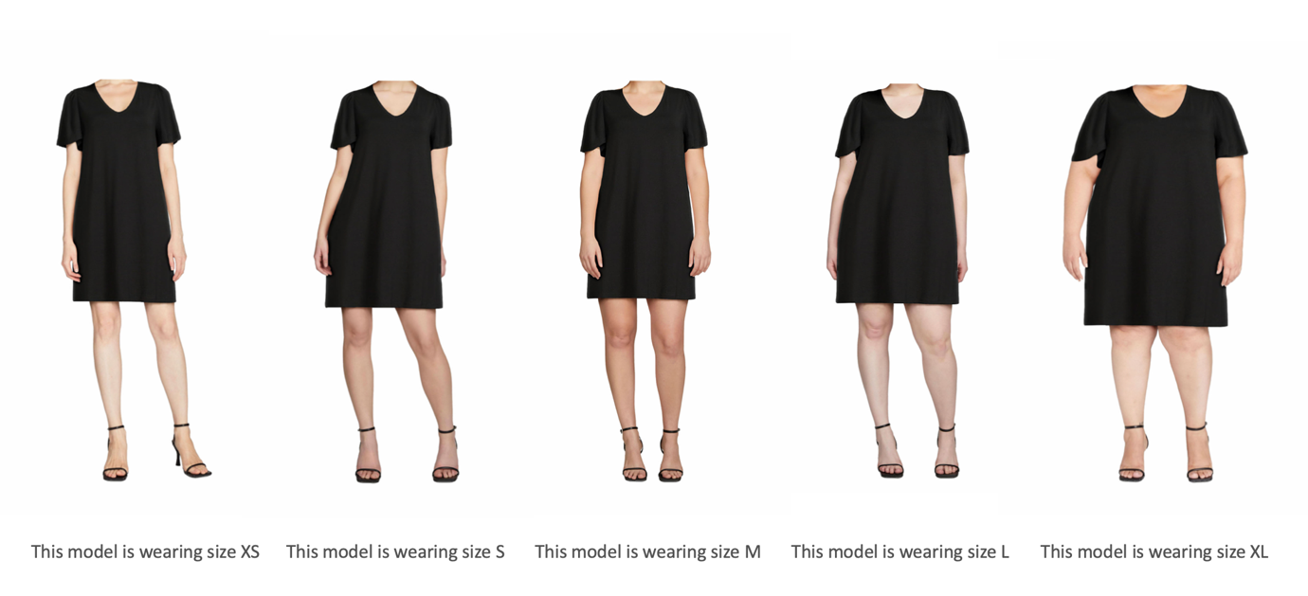
Actual product imagery and models from an online retailer using a virtual reality tool (Walmart Zeekit)

Study 4

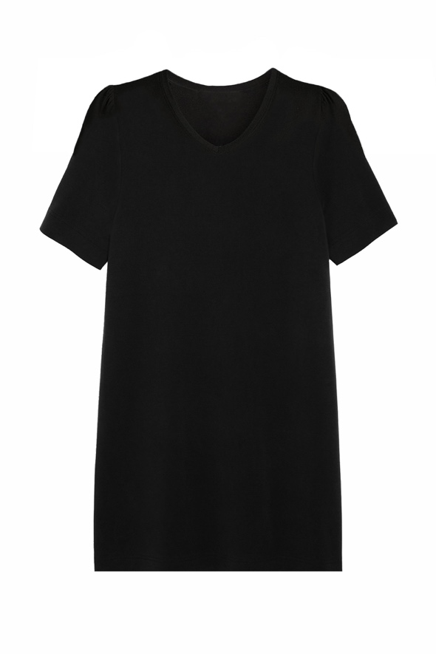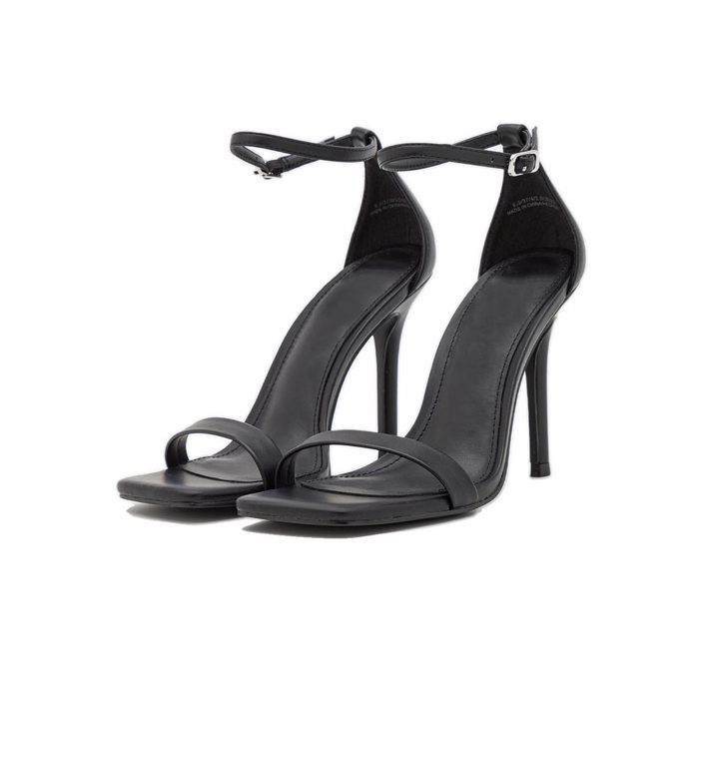
Note. The model pictures were the same as in Study 3.

Study 5


The dress pictures were the same as in Study 3
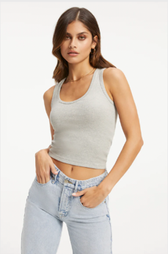
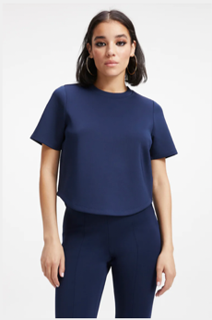
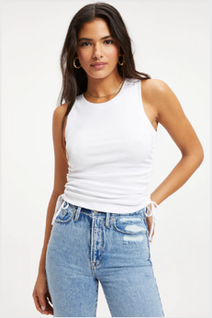
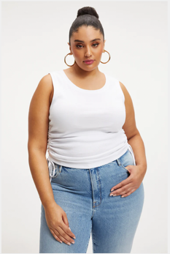
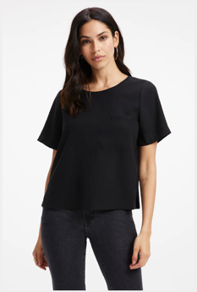
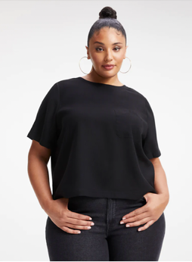
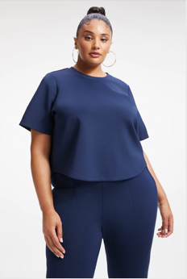
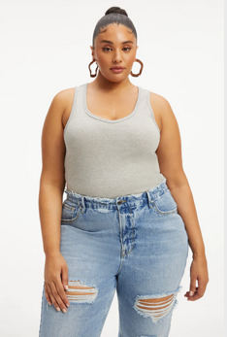
Study 6
Actual product imagery from an online retailer (Good American)

Participants were randomly assigned to seeing the large model with the white, blue, grey or black top (i.e., four top conditions). It automatically follows that the other three tops were presented by the thin models. Within each version however, for each participant the order of the pictures was randomized.

Study 7

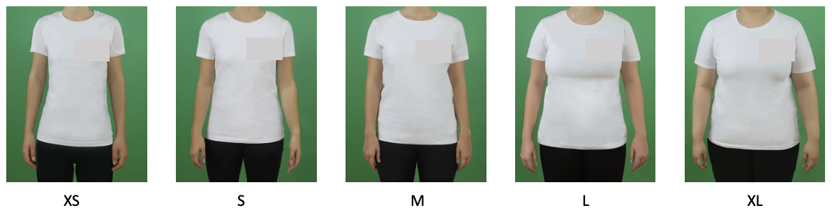
Images self-created with student models. Pictures were lightly edited to remove wrinkles and other imperfections in the T-shirt

In the choose-model condition, participants could select a model from XS to XL
In the thin model condition, participants saw the XS model with a message “this model wears size XS”
In the own-size model condition, participants saw the model their size with a message “this model wears size [insert own size]”

Note. the logo of the shirt is covered to keep anonymity during the review process

Study W2

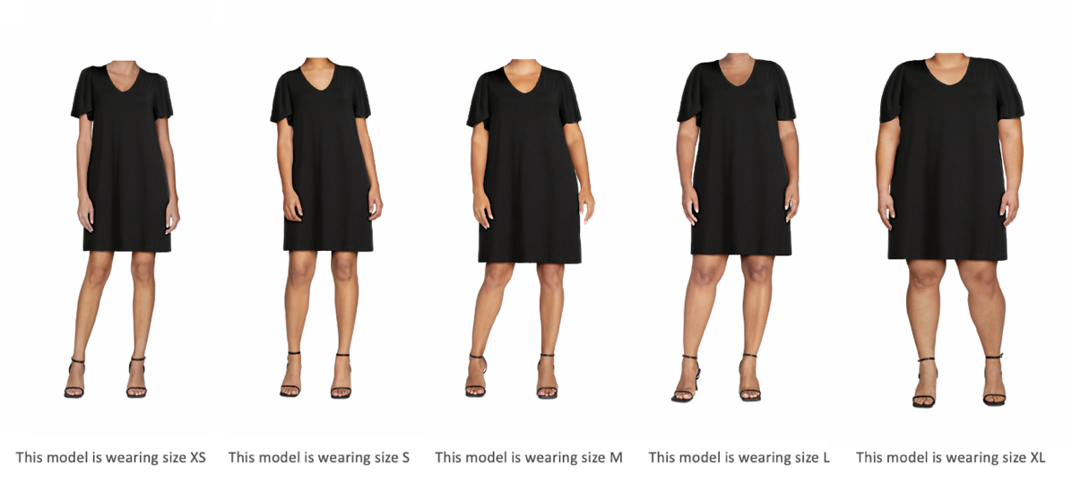
Actual product imagery and models from an online retailer using a virtual reality tool (Walmart Zeekit)

Study W3

Based on the reviews of customers who previously bought these jeans in size [INSERT SIZE], these jeans fit them perfect to size! We recommend you buy them in your regular size.

The jeans pictures were the same as in Study 2.

OVERVIEW OF ATTENTION CHECKS USED IN THE STUDIES
 | Attention checks
 | In order to show that you are reading the questions and paying attention to all instructions, please choose number 2 below, and then move forward to some demographic questions. | Other attention check questions (correct answer bold)
Study 1A & 1B | ✓
Study 2 | ✓
Study 3 | ✓ | 1) What was the product that you were evaluating on the previous pages? (Dress; Pants; T-shirt; Shoes; I don't know)
Study 4 | ✓ | 1) At the start of the study after showing participants the shopping scenario, we ask "According to the scenario, which product type are you interested in buying online? (Dress, Jeans, Shirt, Shoes, I don't know)." If the participant provides an incorrect response, they will be presented with the same scenario again and asked to answer the question once more. If they answer incorrectly the second time, they will be excluded.  2) What was the product that you were evaluating on the previous pages? (Dress; Shoes; Pants; T-shirt; I don't know)
Study 5 | ✓ | At the beginning of the study, we told you: "In this study, you are looking to buy a new dress, and you are searching for options online. You come across the following dress on a website of an online retailer." What else did we mention? (Nothing else; Free Return: When returning items, no fee will be charged; I don't know; correct answer based on the condition participants were in during the study.)
Study 6 | ✓ | 1) What was the product that you were evaluating on the previous pages? (Open answer box)  2) Which of the following best describes the study you just completed? (I chose the top I want to order in my size from 4 different tops; I was asked to choose a model that looked different than the others; I was asked to evaluate multiple clothing items such as tops and jeans; I don’t know)
Study 7 |  | 1) What can you redeem with the voucher you received in this study (shirt, water bottle, key chain, anything you want, I don’t know – first three options randomized)  2) Where can you redeem this voucher? (university webshop, [name supermarket], any shop you want, I don’t know – first two options randomized)
Study W1 | ✓
Study W2 |  | 1) What was the product that you were evaluating on the previous pages? (Dress; Pants; T-shirt; Shoes; I don't know)
Study W3 | ✓ | 1) In order to show that you are reading the questions and paying attention to all instructions, please choose number 3 below, and then move forward to some demographic questions.

STUDY 3 PRACTICE BIDDING

We told all participants:
As part of this research, on top of the standard payment in Prolific, five participants will win the product they evaluate or a monetary value.
Here’s how it goes: The computer will draw
- five winners from all participants AND
- a random monetary value between, for example, 5 and 40 pounds.
For each monetary value, you can choose if you wish to win the product or the bonus payment.

If you are one of five winners, and you win the product, you receive a digital voucher in Prolific to have the product delivered without further costs. If you win the monetary value, you receive a bonus payment.
Below is an example.
Imagine that Catherine has indicated the following choices:
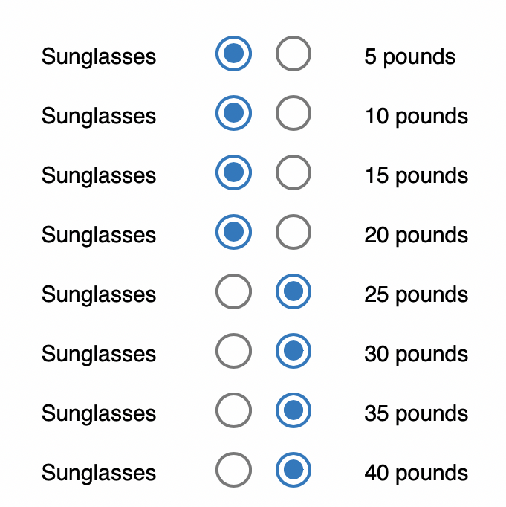

What happens if the computer draws Catherine as one of five winners, and draws a monetary value of 10 pounds?
Catherine will receive the sunglasses, because she prefers the sunglasses over 10 pounds.

What happens if the computer draws Catherine as one of five winners, and draws a monetary value of 30 pounds?
Catherine will receive 30 pounds, because she prefers 30 pounds over the sunglasses.

Then we asked the participants:
Take a look at the choices Catherine made. What happens if the computer draws Catherine as one of five winners and draws a monetary value of 20 pounds?
(Catherine will receive nothing; Catherine will receive the sunglasses (digital voucher in Prolific to have the product delivered without further costs); Catherine will receive 20 pounds (bonus payment in Prolific); I don't know)

If they answered the question incorrectly, we told the participants:
That’s incorrect. Catherine will receive the sunglasses.
She prefers the sunglasses over 20 pounds, as you can tell from her choices.
Please also note that if Catherine is not selected as a winner, she will receive nothing.

Participants with the incorrect answer in the first practice round received another practice round:
What happens if the computer draws Catherine as one of five winners and draws 25 pounds? (Catherine will receive nothing; Catherine will receive the sunglasses (digital voucher in Prolific to have the product delivered without further costs); Catherine will receive 25 pounds (bonus payment in Prolific); I don't know)

We exclude all participants who fail the practice bidding process twice. Participants with an inconsistent preference structure (i.e., multiple switching points) are also excluded from analyses.

ADDITIONAL RESULTS TABLES

Table I1. Indirect effects for all studies
Study 1A Serial Mediation PROCESS Model 6 (10000 bootstrap)
Without covariate | b | se |  | 95%CI
Actual size | -.185 | .044 |  | -.277, -.107
BMI | -.032 | .009 |  | -.051, -.018
Perceived own body image | -.155 | .041 |  | -.243, -.083
With covariate (body satisfaction)
Actual size | -.142 | .037 |  | -.223, -.078
BMI | -.022 | .007 |  | -.038, -.011
Perceived own body image | -.131 | .038 |  | -.215, -.068
Study 1B Serial Mediation PROCESS Model 6 (10000 bootstrap)
Without covariate | b | se |  | 95%CI
Actual size | -.063 | .022 |  | -.111, -.026
BMI | -.022 | .008 |  | -.039, -.009
Perceived own body image | -.078 | .024 |  | -.130, -.037
With covariate (body satisfaction)
Actual size | -.057 | .021 |  | -.104, -.023
BMI | -.019 | .007 |  | -.035, -.008
Perceived own body image | -.064 | .021 |  | -.111, -.029
Study 2 Path Model (500 bootstraps)
Through perceived similarity and perceived risk
Without covariate | b | se |  | 95%CI
Thin vs. Own size | -.097 | .037 |  | -.179, -.034
Larger vs. Own size | -.113 | .042 |  | -.210, -.043
With covariate (body satisfaction)
Thin vs. Own size | -.100 | .035 |  | -.172, -.034
Larger vs. Own size | -.116 | .040 |  | -.207, -.045
Through positive affect
Without covariate | b | se |  | 95%CI
Thin vs. Own size | -.208 | .106 |  | -.432, -.010
Larger vs. Own size | -.110 | .102 |  | -.328, .093
With covariate (body satisfaction)
Thin vs. Own size | -.229 | .101 |  | -.437, -.038
Larger vs. Own size | -.119 | .101 |  | -.310, .065
Through perceived authenticity
Without covariate | b | se |  | 95%CI
Thin vs. Own size | .018 | .071 |  | -.110, .176
Larger vs. Own size | -.002 | .013 |  | -.032, .028
With covariate (body satisfaction)
Thin vs. Own size | .023 | .067 |  | -.107, .159
Larger vs. Own size | -.002 | .013 |  | -.032, .025

Study 3 Path Model (500 bootstraps)
Through perceived similarity and perceived risk
Without covariate | b | se | 95%CI
Thin vs. Own size | -.049 | .016 | -.084 -.021
Larger vs. Own size | -.064 | .021 | -.108, -.029
With covariate (body satisfaction)
Thin vs. Own size | -.052 | .016 | -087, -.024
Larger vs. Own size | -.067 | .021 | -.111, -.032
Through aspiration
Without covariate | b | se | 95%CI
Thin vs. Own size | .090 | .041 | .019 .187
Larger vs. Own size | -.064 | .021 | -.455, -.052
With covariate (body satisfaction)
Thin vs. Own size | .084 | .044 | .010, .181
Larger vs. Own size | -.224 | .047 | -.442, -.022
Through retailer size inclusivity
Without covariate | b | se | 95%CI
Thin vs. Own size | -.073 | .066 | -.206 .063
Larger vs. Own size | .062 | .057 | -.058, .178
With covariate (body satisfaction)
Thin vs. Own size | -.057 | .067 | -186, .078
Larger vs. Own size | .049 | .058 | -.071, .158
Study 4 Path Model (500 bootstraps)
Through perceived similarity and perceived risk
Dress condition without covariate | b | se | 95%CI
Thin vs. Own size | -.211 | .033 | -.280, -.149
Larger vs. Own size | -.234 | .036 | -.305, -.161
Shoes condition without covariate
Thin vs. Own size | -.090 | .025 | -.146, -.044
Larger vs. Own size | -.100 | .028 | -.157, -.049
Wald test indirect effect comparisons
Thin vs. Own size | Wald (1) = 13.827 |  | p < .001
Larger vs. Own size | Wald (1) = 14.104 |  | p < .001
With covariate (body satisfaction) | b | se | 95%CI
Thin vs. Own size | -.210 | .030 | -.274, -.154
Larger vs. Own size | -.231 | .032 | -.303, -.171
With covariate (body satisfaction)
Thin vs. Own size | -.089 | .025 | -.140, -.039
Larger vs. Own size | -.098 | .027 | -.152, -.045
Wald test indirect effect comparisons
Thin vs. Own size | Wald (1) = 14.395 |  | p < .001
Larger vs. Own size | Wald (1) = 14.978 |  | p < .001
Through retailer size inclusivity
Without covariate | b | se | 95%CI
Thin vs. Own size | -.142 | .054 | -.249, -.030
Larger vs. Own size | .095 | .037 | .019, .171
With covariate (body satisfaction)
Thin vs. Own size | -.140 | .054 | -.246, -.037
Larger vs. Own size | .093 | .036 | .025, .165

Study 5 Moderated Mediation PROCESS model 7 (10000 bootstrap)
Through perceived risk
Without covariate |  | b |  |  | se |  | 95%CI
Control condition |  | -.191 |  |  | .037 |  | -.268, -.122
Free return condition |  | .022 |  |  | .036 |  | -.050, .092
Moderated mediation index |  | .213 |  |  | .051 |  | .115, .317
With covariate (body satisfaction)
Control condition |  | -.189 |  |  | .036 |  | -.263, -.121
Free return condition |  | .023 |  |  | .034 |  | -.044, .088
Moderated mediation index |  | .212 |  |  | .049 |  | .118, .310
 | Study 6 Serial Mediation PROCESS Model 6 (10000 bootstrap)
 | With covariates¹ |  | b | se |  | 95%CI
 | Larger model score |  | .111 | .047 |  | .041, .225
 | Relative score |  | .164 | .065 |  | .068, .324
 | Study 7 Serial Mediation PROCESS Model 6 (10000 bootstrap)
 | Redemption likelihood
 | Without covariate |  | b | se |  | 95%CI
 | Thin vs. Own size |  | -.069 | .039 |  | -.155, -.002
 | Choose model vs. Own size |  | .010 | .033 |  | -.053, .084
 | With covariates²
 | Thin vs. Own size |  | -.039 | .025 |  | -.095, -.001
 | Choose model vs. Own size |  | -.006 | .018 |  | -.044, .031
 | Shopping experience
 | Without covariate |  | b | se |  | 95%CI
 | Thin vs. Own size |  | -.038 | .024 |  | -.081, -.004*
 | Choose model vs. Own size |  | .005 | .018 |  | -.030, .043
 | With covariates²
 | Thin vs. Own size |  | -.023 | .017 |  | -.053, -.000*
 | Choose model vs. Own size |  | -.004 | .011 |  | -.028, .017

* Confidence intervals 90%
¹ Covariates: body satisfaction and the top condition participants are in, attractiveness of the large model and attractiveness of the top the large model is wearing (In the relative score model, relative attractiveness score was used)
² Covariates: body satisfaction, pride, attractiveness of the shirt, and attractiveness of the model
Table I2. PROCESS Model figures for all studies (10000 bootstrap)

Study 1A
Without covariate(s) | With covariate(s)
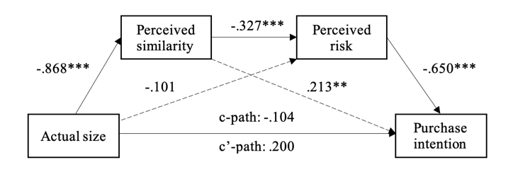 | 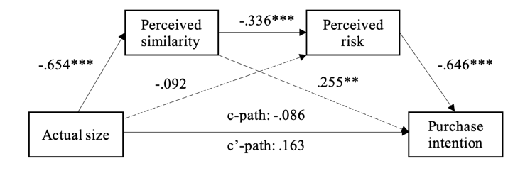
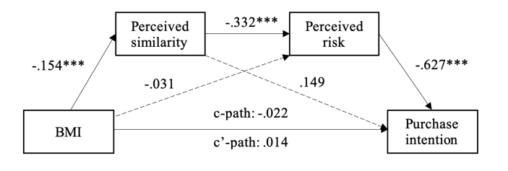 | 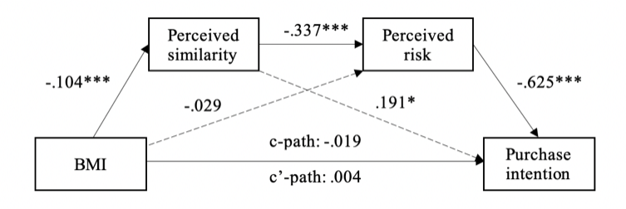
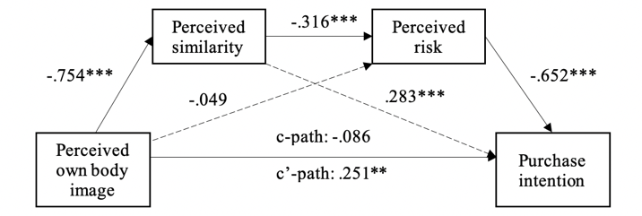 | 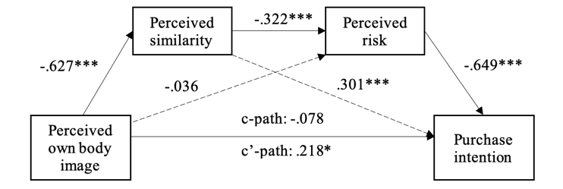
Study 1B
Without covariate(s) | With covariate(s)
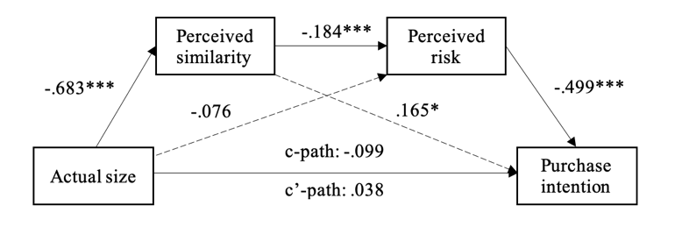 | 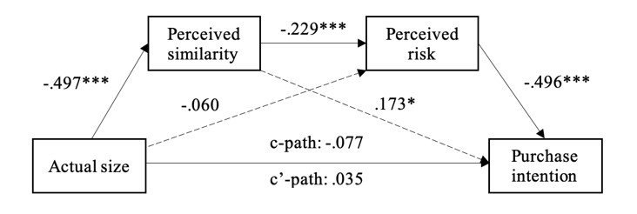
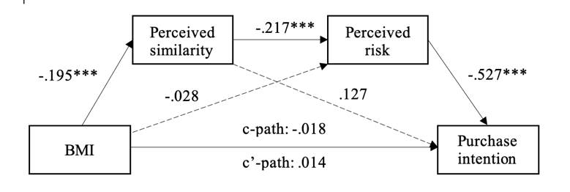 | 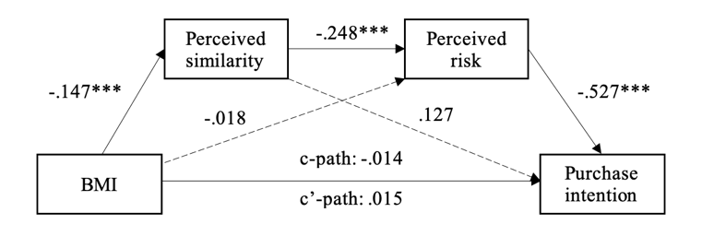
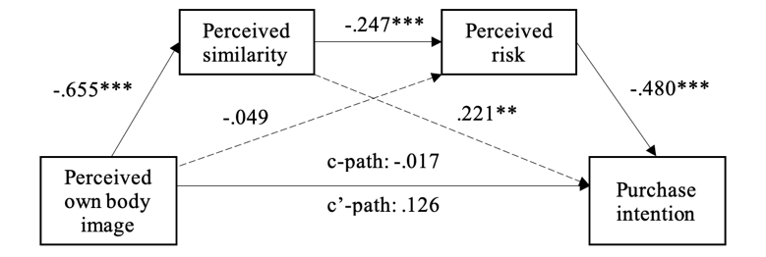 | 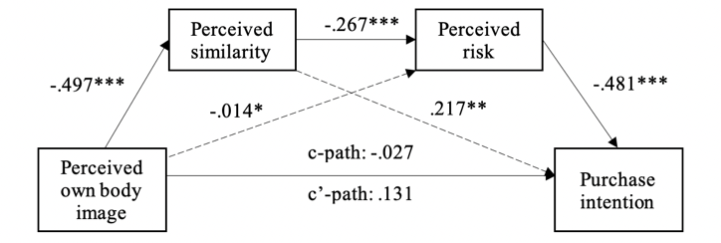

Study 2 (500 bootstraps)
Without covariate(s) | With covariate(s)
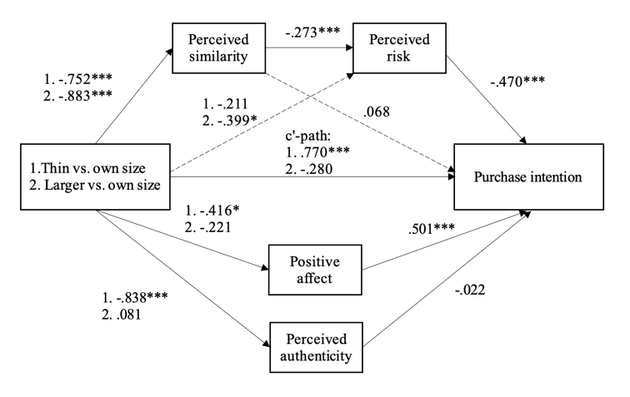 | 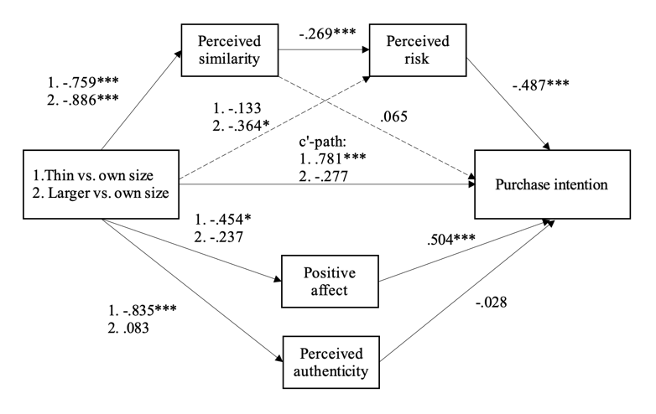
Study 3 (500 bootstraps)
Without covariate(s) | With covariate(s)
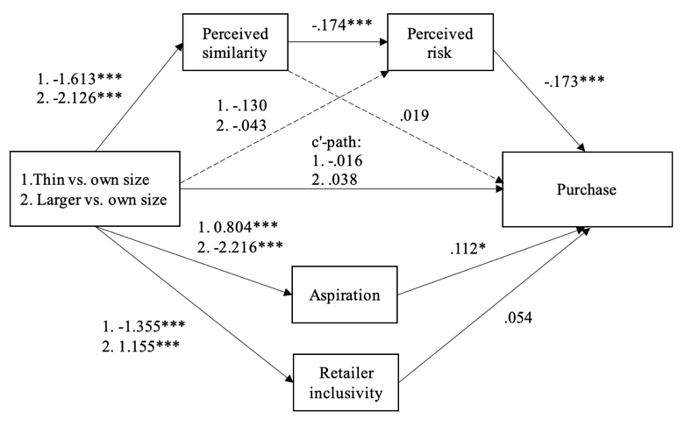 | 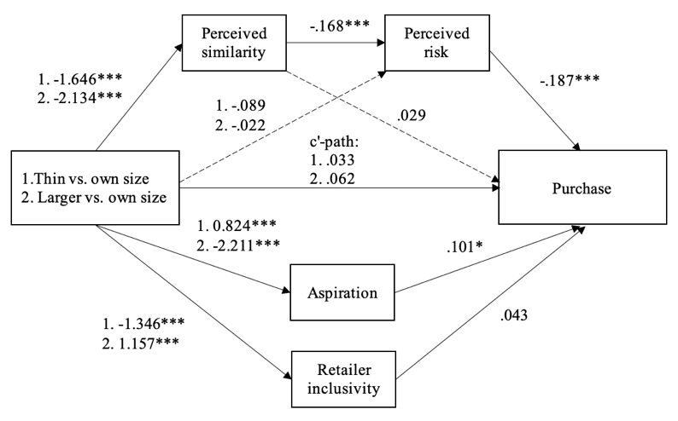
Study 4 (500 bootstraps)
Without covariate(s) | With covariate(s)
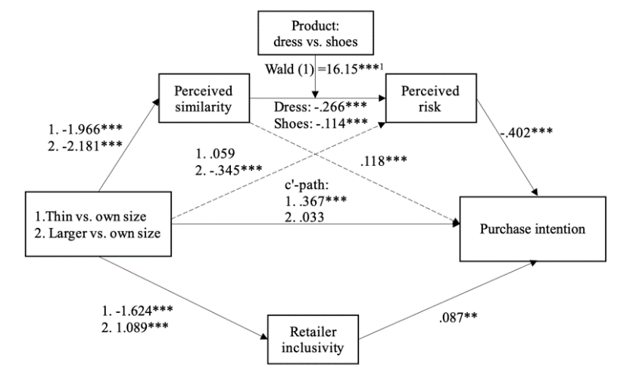 | 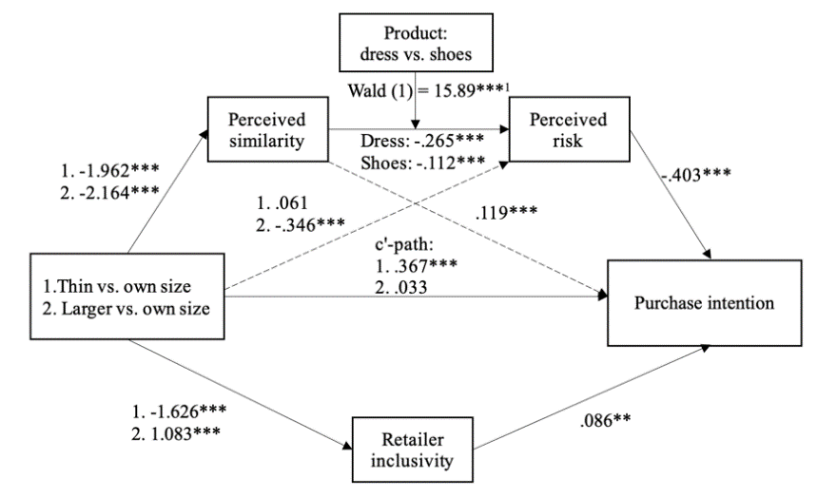

Study 5
Without covariate(s) | With covariate(s)
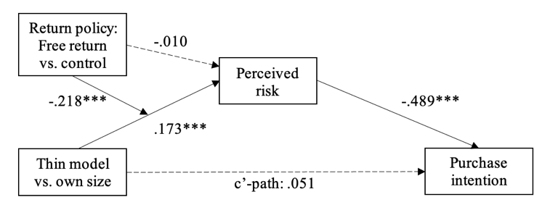 | 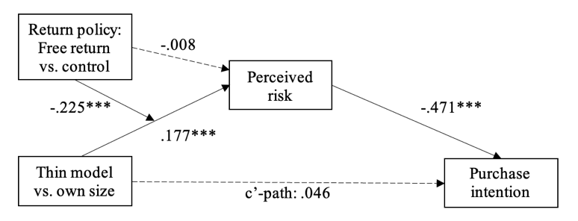
Study 6
Large model scores |  | Relative scores
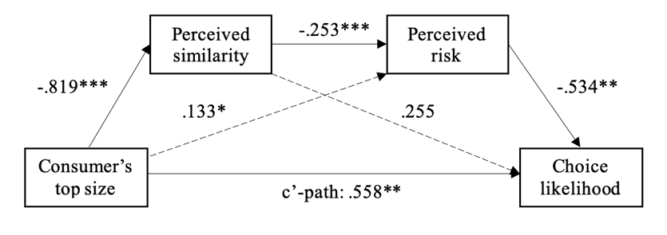 |  | 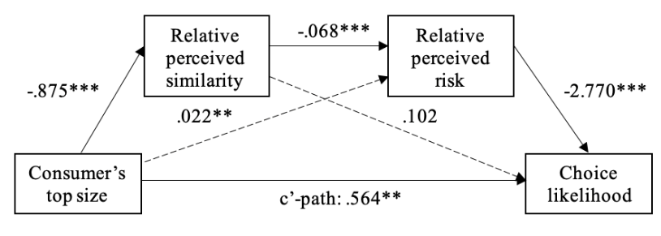
Study 7
Without covariate(s) |  | With covariate(s)
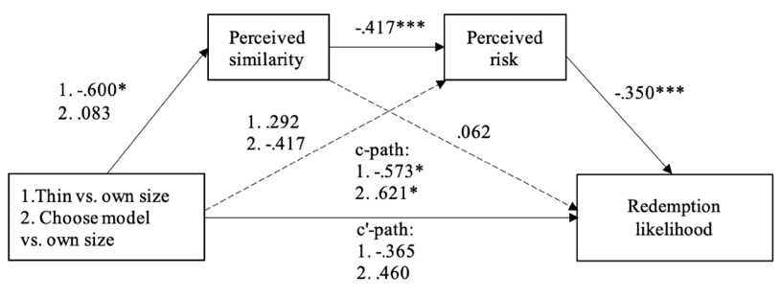 |  | 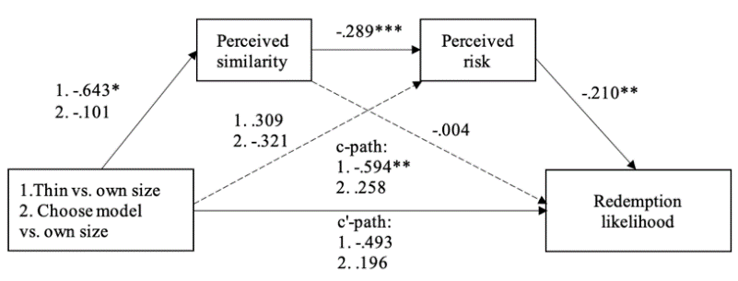
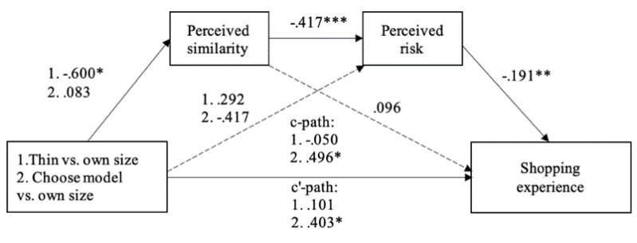 |  | 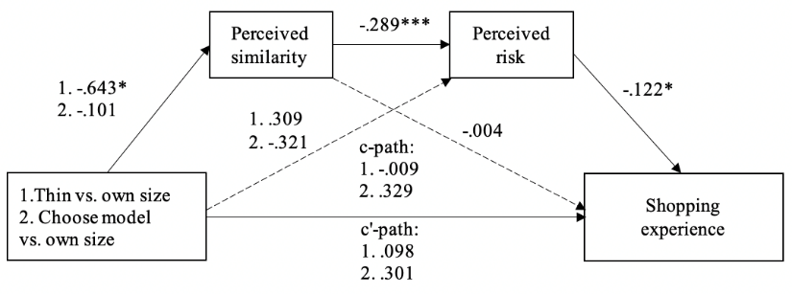

* p < .05, **p < .01, *** p < .001
Note. In study 2, 3 and 4 we ran the path analysis using the lavaan package for R with 500 bootstraps.
¹Wald test statistic testing H₀: b_{similarity-risk_shoes =} b_{similarity-risk_dress}

Table I3. PROCESS Model results for thin-size models condition (10000 bootstrap)
Study 2 Thin Condition
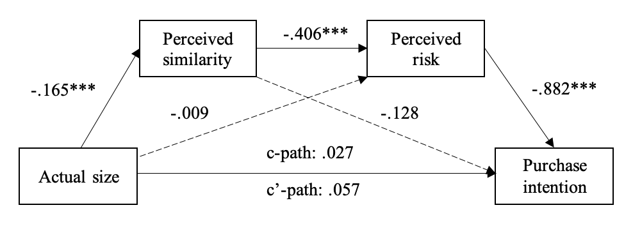
Thin condition: N = 113 | b | se | 95%CI
Actual size | -.059 | .020 | -.103, -.025
Study 3 Thin Condition
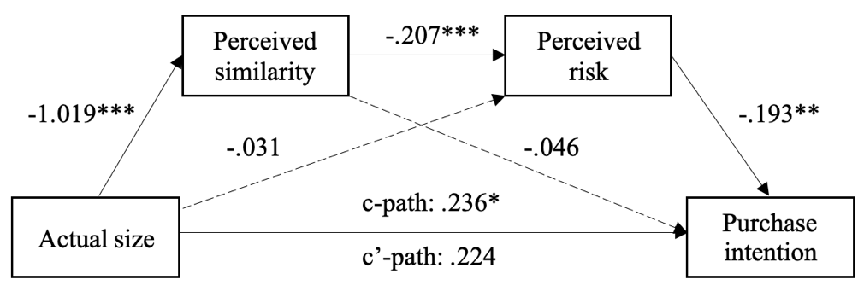
Thin condition: N = 270 | b | se | 95%CI
Actual size | -.041 | .023 | -.094, -.004
Study 4 Thin Dress Condition
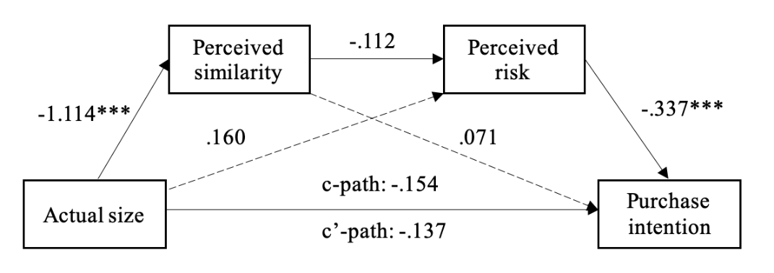
Thin condition: N = 258 | b | se | 90%CI
Actual size | -.042 | .027 | -.089, -.003
Study 5 Thin Control Condition
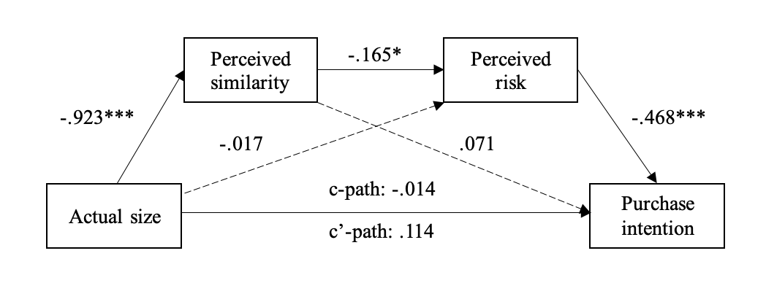
Thin condition: N = 195 | b | se | 95%CI
Actual size | -.071 | .035 | -.149 -.011

Study 7 Thin Condition
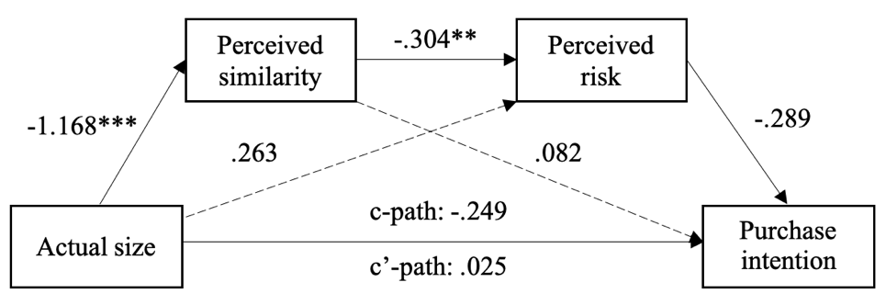
Thin condition: N = 65 | b |  | se |  | 95%CI
Actual size | -.103 |  | .092 |  | -.335, .023
Study W2 Thin Condition
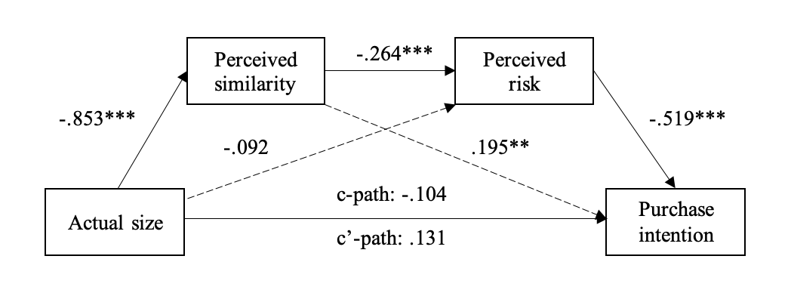
Thin condition: N = 203 |  | b |  | se |  | 95%CI
Actual size |  | -.117 |  | .039 |  | -.203, -.048
Study W3 Thin Measurement Cue Absent Condition
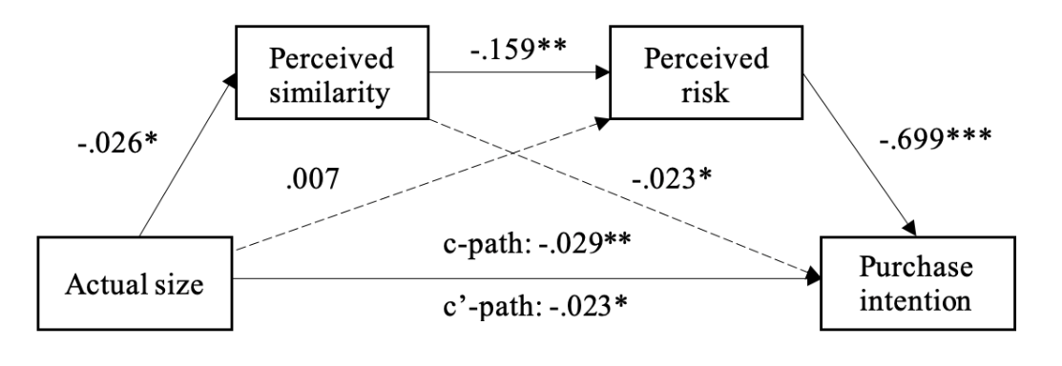

Thin condition: N = 106 |  | b |  | se |  | 95%CI
Actual size |  | -.003 |  | .025 |  | -.089, -.001
* p < .05, **p < .01, *** p < .001

Table I4. Main effects with means and standard deviations for Study 2-6

Variables | Study 2 |  |  | Study 3 |  |  |  |  | Study 4 |  |  |  |  |  | Study 5 |  |  |  |  |  | Study 6
Condition | Thin  model | Own-size model | Larger model | Thin  model | Own-size model |  | Larger model |  | Thin model |  | Own-size model |  | Larger model |  | Thin model |  |  | Own-sized model |  |  | Thin  model | Own size model | Choose your model
 |  |  |  |  |  |  |  |  | Dress | Shoes | Dress | Shoes | Dress | Shoes | Free return | Control |  | Free return |  | Control | Thin  model | Own size model | Choose your model
Purchase intention | F(2, 335) = 6.098, p = .003, ηp² = .035 |  |  | - |  |  |  |  | Condition:  F(2, 1530) = 1.681  p = .186, ηp² = .002 |  | Product:  F(1, 1530) = 12.269  p < .001, ηp² = .008 |  | Interaction:  F(2, 1530) = 5.342,  p = .005, ηp² = .007 |  | Condition:  F(1, 705) = .329  p = .567, ηp² = .000 |  | Return:  F(1, 705) = 1.128  p = .289, ηp² = .002 |  | Interaction:  F(1, 705) = 1.581,  p = .209, ηp² = .002 |  | -
Purchase intention | M = 4.14  SD = 2.03 | M = 3.61  SD = 1.92 | M = 3.23  SD = 1.94 | - |  |  |  |  | M = 2.51  SD = 1.49 | M = 2.78  SD = 1.62 | M = 2.83  SD = 1.82 | M = 2.80  SD = 1.65 | M = 2.35  SD = 1.47 | M = 2.99  SD = 1.71 | M = 2.77  SD = 1.61 | M = 2.75  SD = 1.64 |  | M = 2.68  SD = 1.81 |  | M = 2.98  SD = 1.72 | - | - | -
Purchase | - |  |  | F(2, 805) = 1.564, p = .210, ηp² = .004 |  |  |  |  | - |  | - |  | - |  | - |  |  | - |  |  | -
Purchase | - |  |  | M = 2.13  SD = 1.73 | M = 2.18  SD = 1.81 |  | M = 1.94  SD = 1.50 |  | - |  | - |  | - |  | - |  |  | - |  |  | - | - | -
Voucher redemption | - |  |  | - |  |  |  |  | - |  | - |  | - |  | - |  |  | - |  |  | F(2, 188) = 10.130, p < .001, ηp² = .097
Voucher redemption | - |  |  | - |  |  |  |  | - |  | - |  | - |  | - |  |  | - |  |  | M = 3.73  SD = 1.58 | M = 4.30  SD = 1.60 | M = 4.92  SD = 1.32
Shopping experience | - |  |  | - |  |  |  |  | - |  | - |  | - |  | - |  |  | - |  |  | F(2, 188) = 5.023, p = .007, ηp² = .051
Shopping experience | - |  |  | - |  |  |  |  | - |  | - |  | - |  | - |  |  | - |  |  | M = 4.92  SD = 1.00 | M = 4.97  SD = 1.15 | M = 5.46  SD = 1.08
Perceived body-size similarity | F(2, 335) = 8.125, p < .001, ηp² = .046 |  |  | F(2, 805) = 120.949, p < .001, ηp² = .231 |  |  |  |  | Condition:  F(2, 1530) = 274.642  p < .001, ηp² = .264 |  | Product:  F(1, 1530) = 2.376  p = .123, ηp² = .002 |  | Interaction:  F(2, 1530) = .886,  p = .412, ηp² = .001 |  | Condition:  F(1, 705) = 176.933  p < .001, ηp² = .201 |  | Return:  F(1, 705) = .919  p = .338, ηp² = .001 |  | Interaction:  F(1, 705) = 2.938,  p = .087,ηp² = .004 |  | F(2, 188) = 3.342, p = .037, ηp² = .034
Perceived body-size similarity | M = 3.36  SD = 1.79 | M = 4.12  SD = 1.64 | M = 3.23  SD = 1.89 | M = 2.90  SD = 1.77 | M = 4.52  SD = 1.58 |  | M = 2.39  SD = 1.61 |  | M = 2.59  SD = 1.75 | M = 2.76  SD = 1.78 | M = 4.52  SD = 1.54 | M = 4.76  SD = 1.41 | M = 2.47  SD = 1.68 | M = 2.45  SD = 1.63 | M = 2.66  SD = 1.75 | M = 2.57  SD = 1.65 |  | M = 4.13  SD = 1.71 |  | M = 4.47  SD = 1.61 | M = 3.74  SD = 1.88 | M = 4.34  SD = 1.44 | M = 4.42  SD = 1.55
Perceived fit-risk | F(2, 335) = .457, p = .634, ηp² = .003 |  |  | F(2, 805) = 3.780, p = .023, ηp² = .009 |  |  |  |  | Condition:  F(2, 1530) = 13.902  p < .001, ηp² = .018 |  | Product:  F(1, 1530) = 1.979  p = .160, ηp² = .001 |  | Interaction:  F(2, 1530) = 2.583,  p = .076, ηp² = .003 |  | Condition:  F(1, 705) = 11.93  p < .001, ηp² = .017 |  | Return:  F(1, 705) = .038  p = .845, ηp² = .008 |  | Interaction:  F(1, 705) = 18.872,  p < .001,ηp² = .026 |  | F(2, 188) = 8.218, p < .001, ηp² = .080
Perceived fit-risk | M = 4.67  SD = 1.38 | M = 4.67  SD = 1.40 | M = 4.51  SD = 1.43 | M = 4.78  SD = 1.45 | M = 4.63  SD = 1.35 |  | M = 4.95  SD = 1.34 |  | M = 4.87  SD = 1.30 | M = 4.88  SD = 1.41 | M = 4.28  SD = 1.40 | M = 4.61  SD = 1.45 | M = 4.52  SD = 1.48 | M = 4.48  SD = 1.44 | M = 4.45  SD = 1.33 | M = 4.90  SD = 1.26 |  | M = 4.53  SD = 1.34 |  | M = 4.12  SD = 1.40 | M = 3.70  SD = 1.47 | M = 3.21  SD = 1.26 | M = 2.77  SD = 1.16
Retailer’s size inclusivity | - |  |  | F(2, 805) = 280.663, p < .001, ηp² = .411 |  |  |  |  | Condition:  F(2, 1530) = 571.247  p < .001, ηp² = .428 |  | Product:  F(1, 1530) = 4.051  p = .044, ηp² = .003 |  | Interaction:  F(2, 1530) = .722,  p = .486, ηp² = .001 |  | - |  |  |  |  |  | -
Retailer’s size inclusivity | - |  |  | M = 3.09  SD = 1.19 | M = 4.44  SD = 1.34 |  | M = 5.60  SD = 1.15 |  | M = 2.76  SD = 1.30 | M = 2.80  SD = 1.15 | M = 4.34  SD = 1.37 | M = 4.46  SD = 1.46 | M = 5.37  SD = 1.29 | M = 5.60  SD = 1.18 | - |  |  |  |  |  | -
Aspiration | - |  |  | F(2, 805) = 280.663, p < .001, ηp² = .411 |  |  |  |  | - |  | - |  | - |  | - |  |  |  |  |  | -
Aspiration | - |  |  | M = 4.74  SD = 1.59 | M = 3.93  SD = 1.67 |  | M = 1.72  SD = 1.02 |  | - |  | - |  | - |  |  |  |  |  |  |  | - | - | -
Positive affect | F(2, 335) = 2.302, p = .102, ηp² = .014 |  |  | - |  |  |  |  | - |  | - |  | - |  |  |  |  |  |  |  | -
Positive affect | M = 3.54  SD = 1.55 | M = 3.96  SD = 1.36 | M = 3.73  SD = 1.45 | - |  |  |  |  | - |  | - |  | - |  |  |  |  |  |  |  | - | - | -
Perceived authenticity | F(2, 335) = 21.091, p < .001, ηp² = .112 |  |  | - |  |  |  |  | - |  | - |  | - |  |  |  |  |  |  |  | -
Perceived authenticity | M = 4.92  SD = 1.38 | M = 5.76  SD = 1.08 | M = 5.84  SD = 1.05 | - |  |  |  |  | - |  | - |  | - |  |  |  |  |  |  |  | - | - | -

STUDY 6 PREREGISTERED PREPARATORY ANALYSES

Preparatory analyses To find out if the effects of consumers' body size on choosing the top of the larger model differ based on the top the larger model was wearing (i.e., significant interaction effect), we conducted a Generalized Linear Model analysis (binary logit model) with consumer's binary choice of top (coded 0 if one of the thinner models’ top is selected, coded 1 if larger model’s top is selected) as dependent variable, consumers' top size and top condition (a variable indicating which top the larger model was wearing) as independent variables. Results showed that consumers’ top size significantly influenced the choice likelihood (χ²(1) = 18.94, p < .001; see main analyses for further details). Because the interaction between consumers’ top size and top condition was not significant (χ²(3) = 5.16, p = .159), we merely control for top condition in the main analyses as preregistered.
Multicollinearity was not a concern (attractiveness of the large model: tolerance = .87, VIF = 1.15; attractiveness of the top the large model is wearing: tolerance = .87, VIF = 1.15). Additional measures were calculated to run robustness checks, comparing the larger model relative to the other models: a relative measure of body-size similarity was calculated by dividing the score of body-size similarity with the larger model by the average similarity score of the three thinner models. We followed the same procedure to calculate the relative measures of perceived fit-risk, top attractiveness and model attractiveness.

STUDY 7 PREREGISTERED PREPARATORY ANALYSES

Preparatory data analyses To check whether the data could be pooled across orders of measurement, we analyzed the likelihood for redeeming the voucher using PROCESS model 83 for a moderated mediation model (serial mediation 10,000 bootstraps; order moderating the path from experimental condition to similarity). Retailer's choice of models was the independent variable (dummy coded; X1: own size vs. thin and X2: own size vs. choose model), perceived similarity and perceived risk mediators and redemption likelihood the dependent variable. The moderator is the order of questions (DV first or mediators first). The results showed that the index of moderated mediation was not significant (b = .012, se = .066, 95%CI [-.123; .143]). We then ran the same analysis with shopping experience as the dependent variable, and the results again showed an insignificant index of moderated mediation (b = .006, se = .036, 95%CI [-.069; .081]). Because the order of asking the questions did not influence the results, we collapsed the data across the orders.
Similarity We ran a one-way ANOVA (coded as: -1 - thin vs. 0 - own size vs. 1 - choose-model) to test for the effect of retailers' choice of models on perceived similarity (H1). The results revealed that the perceived similarity significantly differed between the experimental conditions (F(2, 188) = 3.342, p = .037, η_{p}² = 0.03). Participants in the thin model condition reported less perceived similarity with the model’s body than those in the own-size (b = -.600, se = .291, p = .040) and choose-model condition (b = -.683, se = .288, p = .019). Participants in the own-size condition and choose-model condition reported equal levels of perceived similarity to the (chosen) model (b = -.083, se = .292, p = .776). In the choose-model condition, we found a significant correlation between the size of the model participants chose to see and their own reported clothing size (r = .620, p < .001), suggesting that when participants were given the option to choose from differently size models, they indeed chose to look at the model similar in size to themselves. Together, these findings are in line with the first hypothesis that models of one’s own size increase perceived body-size similarity, albeit the choose-model approach did not increase similarity further than the own-size approach.

STUDY 7 PREREGISTERED ANALYSES

Preparatory data analyses To check whether the data could be pooled across orders of measurement, we analyzed the likelihood for redeeming the voucher using PROCESS model 83 for a moderated mediation model (serial mediation 10,000 bootstraps; the order moderated the path from experimental condition to similarity). Retailer's choice of models is the independent variable (coded 0 - thin, 1 - own size, 2 – choose model to capture the predicted linear trend), perceived similarity and perceived risk are mediators and redemption likelihood the dependent variable. The moderator is the order of questions (DV first or mediators first). The results showed that the index of moderated mediation was not significant (b = .006, se = .033, 95%CI [-.058; .083]). We then ran the same analysis with shopping experience as the dependent variable, results again showed that the index of moderated mediation was insignificant (b = .004, se = .032, 95%CI [-.066; .072]). Because the order of asking the questions did not influence the results, we collapsed the data across the orders.
Similarity We ran a linear trend analysis to test for the predicted linear trend of the effect of retailers' choice of models on perceived similarity (H1). The results revealed that the groups differed (F(2, 188) = 3.342, p = .037, η_{p}² = 0.03) and showed the expected linear trend (β = .483, se = .204, p =.019, 95%CI [-.081, .885]). A one-way ANOVA (all ANOVAs are coded as: -1 - thin vs. 0 - own size vs. 1 - choose-model) showed that participants in the thin model condition (M = 3.74, SD = 1.88) reported less perceived similarity with the model’s body than those in the own-size (M = 4.34, SD = 1.44, p = .040) and choose-model condition (M = 4.42, SD = 1.55, p = .019). Even though the trend was significant, participants in the choose-model condition did not perceive higher body-size similarity than in the own-size condition and the choose-model condition reported equal perceived similarity with the model’s body (p = .776). In the choose-model condition however, we did find a correlation between the size participants chose and the participants’ clothing size (r = .620, p < .001), suggesting that when participants were given the option to choose from differently size models, they indeed choose to look at the model similar in size to themselves. Together, these findings are in line with the first hypothesis that models of one’s own size increase perceived body-size similarity.
Mediation To test hypothesis 2, that participants who perceive the model's body size to be more similar to themselves, would report a lower level of risk that the T-shirt would not fit them, which in turn increases participants' likelihood to redeem a voucher to buy the T-shirt and creates a more positive customer experience, we ran a PROCESS model 6 for a serial mediation (10,000 bootstraps). Retailer's choice of models (0 - thin vs. 1 - own size vs. 2 - choose model; linear trend) was the independent variable, perceived similarity and perceived risk the mediators, and voucher redemption likelihood the dependent variable. We ran the analysis with and without simultaneously controlling for body satisfaction, pride, attractiveness of the T-shirt, and attractiveness of the model. The results show that there was a significant linear trend, the perceived similarity was significant increase across conditions (thin-model < own-size model < choose model, b = .342, se = .144, p = .019). Perceived similarity negatively correlated with perceived risk (b = -.325, se = .053, p < .001), which in turn negatively relates to redemption likelihood (b = -.350, se = .087, p < .001). The result revealed that without control variables in the model, the serial indirect effect was significant (b = .039, se = .021, 95%CI [.004; .087]), when controlling for all control variables simultaneously the serial indirect effect was marginally significant (b = .017, se = .013, 90%CI [.000; .040]; see discussion).
We ran the same analysis but with shopping experience as dependent variable. As for voucher redemption, perceived risk was negatively related to shopping experience (b = -.194, se = .063, p = .002). This result showed that when not controlling for control variables, the indirect effect was significant (b = .022, se = .013, 95%CI [.002; .051]). When simultaneously controlling for all control variables, the indirect effect was again marginally significant (b = .009, se = .008, 90%CI [-.001; .024]).

STUDY 2 SURVEY FLOW

Introduction

Dear Participant,
Thank you for agreeing to take part in this survey. The purpose of this short survey is to understand consumers' clothing shopping behavior online. In this survey you will be shown one piece of clothing and asked some questions about your opinion regarding the item. Please pay close attention to the product as well as all the questions. It should not take more than 2 minutes to answer.
The data will be collected anonymously, and only used for research purposes. Note that you can stop your participation at any time should you wish to do so. Please reach out to the researcher through Prolific Academic if you have any questions.
Thank you for your time.

Consent
I have read, understood the above consent form and agree to participate in this study. (If you no longer want to participate, click 'I do not want to participate in this study'. The session will be terminated immediately. You will not receive a payment by Prolific.)
- I want to participate in this study. I understand that my submission will not be approved if I fail to follow instructions correctly or do not pass all attention checks. (1)
- I do not want to participate in this study. I will return my submission on Prolific. (2)

Gender

What is your gender?
Male (1) Female (2) Other / I wish not to disclose (3)

ID

Before we start, please switch off phone / music / e-mail, so you can focus on this study.Thank you!
What is your Prolific ID?
Note that the payment is allocated based on your Prolific ID and it is therefore important you use the correct one here.
________________________________________________________________

Before you proceed to the survey, please complete the captcha below.

The study will start on the next screen. Please take your time to read all information carefully, as the quality of the data is important to us, academic researchers. There will be an attention check at the end of the survey.

Size
What is your typical clothing size (for pants)?
2 4 6 8 10 12 14 16 18 20 22 24 26
Other / my size is not on the list

Other. If you answered "Other / my size is not on the list," please specify your size here
________________________________________________________________

Imagine you are looking to buy new jeans, and you are looking for options online. You come across the following jeans on a website of an online retailer. The product is presented on the website with two pictures, which you can see below.
Stimuli shown based on random assignment to one of three conditions:
- Own size condition
Display if…
Size = 2 | Size = 4 | Size = 6
Size = 8 | Size = 10 OR size = ‘other’*  *Size = ‘other’ excluded from analyses | Size = 12
Size = 14 | Size = 16 | Size = 18
Size = 20 | Size = 22 | Size = 24
Size = 26
- Thin model condition
All participants assigned to this condition see the model wearing size 2
- Larger model condition
All participants assigned to this condition see the model wearing size 26
Purchase intent
PI own size. How likely would you be to buy these jeans in your size?
Not at all likely 1 - Extremely likely 7

Perceived risk
[Stimuli presented again according to assigned condition]

Risk1. How sure are you, if you purchase the jeans online, about the jeans' appearance to be satisfactory to your needs?
Not at all sure 1 - Very sure 7

Risk2. How much risk would you say there would be that, if you purchase the jeans online, the product will not look on you like you expect?
Very little risk 1 - A great deal of risk 7

Risk3. How confident are you, if you purchase the jeans online, that the jeans' appearance will be as you expect?
Not at all confident 1 - Very confident 7

Risk4. How sure are you, if you purchase the jeans online, about the jeans' fit to be satisfactory to your needs?
Not at all sure 1 - Very sure 7

Risk5. How much risk would you say there would be that, if you purchase the jeans online, the product will not fit you like you expect?
Very little risk 1 - A great deal of risk 7

Risk6. How confident are you, if you purchase the jeans online, the jeans' fit will be as you expect?
Not at all confident 1 - Very confident 7

Perceived similarity
[Stimuli presented again according to assigned condition]

Please indicate to what extent you agree to the following statement about the model wearing the jeans: This model’s body looks similar to mine.
Not at all similar 1 - Extremely similar 7

Positive affect
[Stimuli presented again according to assigned condition]

The pictures of this model make me feel:
Good/ Excited/ Enthusiastic
Strongly disagree 1- Strongly agree 7

Perceived Authenticity
[Stimuli presented again according to assigned condition]

The pictures of this model are:
Authentic/ Realistic/ Truthful
Strongly disagree 1- Strongly agree 7

Attention check

In order to show that you are reading the questions and paying attention to all instructions, please choose number 2 below, and then move forward to some demographic questions.
1 2 3 4 5 6 7

Body satisfaction

How (dis-)satisfied are you with your body shape and size in general?
Very dissatisfied Neither dissatisfied Very satisfied
nor satisfied
1 2 3 4 5 6 7

Age
What is your age? Please insert a number (full years)

Usage frequency
How often do you wear jeans?
Daily (1) 4-6 times a week (2) 2-3 times a week (3) Once a week (4) Less than once a week (5) Very rarely / never (6)

Final block
The purpose of this study is to understand how presenting clothing on differently sized models influences consumers' shopping behaviour when they are shopping for clothing online.
Thank you for participating in this study.
Now click ">>" and you will be redirected back to Prolific Academic. Do NOT close the page/tab or you might not be able to receive your payment.

STUDY EXPLORING SIZE-DIVERSITY IN ADVERTISING VS ONLINE SHOPPING

In this study, we explore whether models’ body-size diversity on an online shopping platform adds value beyond its presence in advertising. While advertising research shows that size-inclusive models positively influence brand attitude and purchase intention, showcasing size-inclusivity in advertising might suffice to convey a brand's inclusive image and increase sales. However, if consumers rely on body-size information to make purchase decisions, the models’ body-size diversity on the shopping platform itself becomes crucial.

We manipulate consumers’ exposure to models’ body-size diversity (vs. thin models only) in advertising and on the online shopping platform. To explore the robustness of the body-size diversity effects, the models are of diverse ethnicities. In fact, we measure perceived ethnic diversity, to control for its influences. Because we expect consumers to use size information when shopping for clothing, we anticipate that size diversity on the website’s product pages will increase consumers' interest to buy from the assortment more strongly than size diversity in the retailer's advertising. We also test whether a website that displays models with diverse body sizes (vs. thin models only) will lead consumers to perceive more similarity, reducing fit risk of the clothing and increase their interest in buying one of the products they are exposed to.

Method
We recruited 410 participants on Prolific (female: N = 205; male: N = 205) between 18 and 78 years of age (M = 42.30, SD = 14.96). Their online shopping frequency for clothing was on average about half of their clothing purchases (M = 2.98, SD = 1.09). The majority of the participants were white caucasians (85.4%).
This study made use of a 2 (channel: advertisement vs. webshop’s product page; within-subjects) x 2 (body-size diversity: thin models only vs. diverse models; between-subjects) mixed design. In sum, participants were exposed to one of four possible combinations of body size-diversity in the ad and on the product pages (i.e., thin-thin, thin-diverse, diverse-thin, diverse-diverse).
Participants first reported the gender with which they identified. Next, participants were asked to imagine that they were looking to buy some new shirts and were looking for options online. We told them that they came across a fictional brand called “Horizon,” which had just released an advertisement for their online shop. Participants were randomly assigned to seeing an ad with four thin models or an ad with four models with diverse body sizes (two female models and two male models in both conditions; see Figure N1).
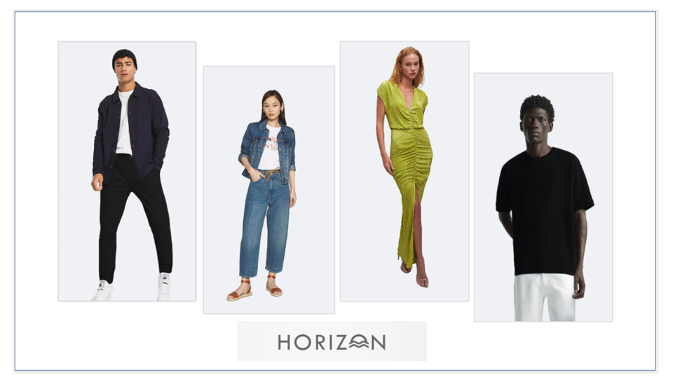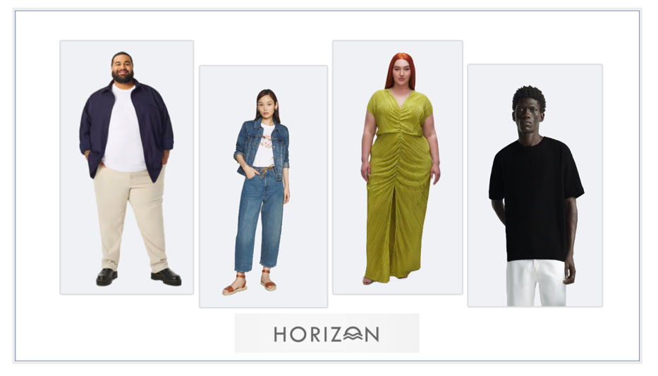
Fig N1. Advertisement with thin models or body-size diverse models

Next, participants imagined browsing Horizon’s website, and saw three product pages of shirts, featuring only thin models or models with diverse body sizes, matching the participants’ gender (see Figure N2). Then they saw the advertisement and product pages they just viewed simultaneously and answered their perception of the retailer’s size inclusivity (i.e, 3 items, such as “To what extent do you feel that this brand is being inclusive of all body sizes?” 1 – Not at all inclusive to 7 – Very inclusive) and ethnicity inclusivity (i.e, 3 items, such as “To what extent do you feel that this brand cares about representing a variety of ethnicities?” 1 – Does not care at all 7 – Cares a lot), in randomized order, while seeing the ad and the product pages side by side.
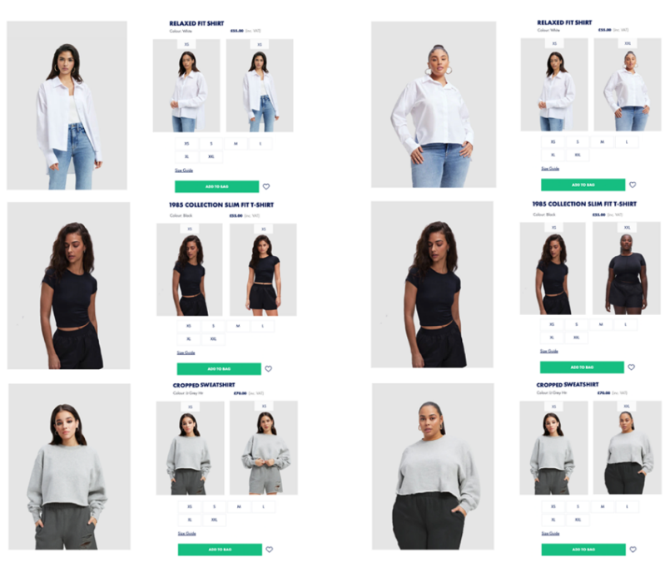
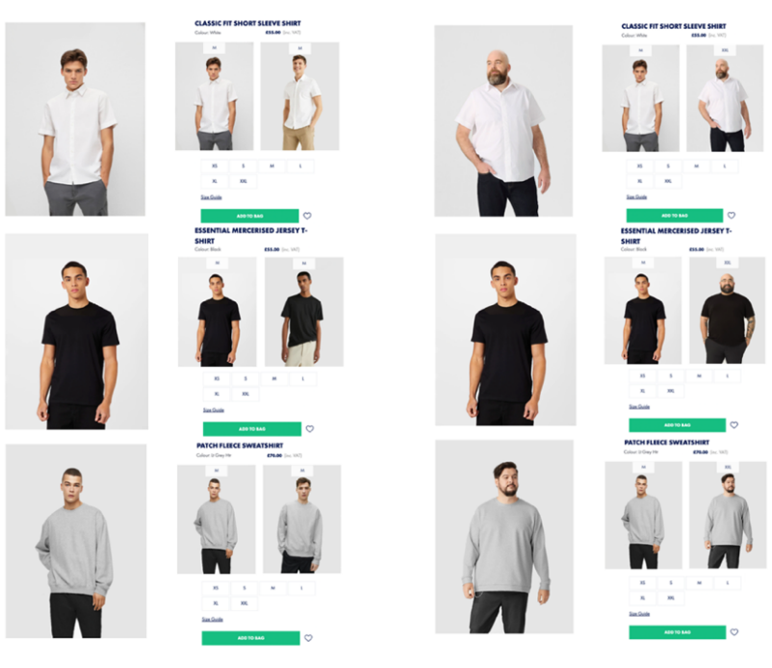
Fig. N2 The study’s product pages with thin models (left) or body-size diverse models (right), matching the participant’s gender.
Participants then reported their willingness to continue shopping with the retailer on a binary measure (“Do you have any interest in continuing to shop with this brand Horizon?,” 0 – No, 1 – Yes). Subsequently, we showed them only the product pages they viewed before and asked them to report their purchase intention for any of the three shirts in their size (“How likely would you be to buy one of these three shirts in your size?,” 1 – Not at all likely; 7 – Extremely likely). Finally, participants reported their perceived risk of purchasing one of the three shirts (i.e, 3 items, such as “How sure are you, if you purchase one of these shirts, about the clothing's fit to be satisfactory to your needs?” 1 – Not at all sure to 7 – Very sure) and their perceived similarity to one of the three models ( “One of these models’ body size looks similar to mine.” 1 – Not at all similar to 7 – Extremely similar). To end with, participants completed an attention check question, their typical clothing size for shirts (“What is your typical clothing size (for shirts)?,” XXS – XXL, ‘Other / my size is not on the list’), reported frequency of online clothing shopping (“How often do you shop for clothing items online?,” 1 – Never, 5 – Always), age, ethnicity and body satisfaction (“How (dis-)satisfied are you with your body shape and size in general?,” 1 – Very dissatisfied, 7– Very satisfied).

Results
Manipulation checks of perception of body-size inclusivity A 2 x 2 ANOVA revealed that the manipulation of model body-size inclusivity in both channels worked as intended (product pages: F(1, 406) = 256.32, p < .001, η_{p}² = .387; advertisement: F(1, 406) = 167.74, p < .001, η_{p}² = .292). Participants perceived significantly lower body-size inclusivity in the thin model-only advertisement compared to the ad with diverse models (b = -1.581, se = .122, p < .001). They also perceived significantly lower body-size inclusivity in the thin models only product pages compared to product pages with diverse models (b = -1.954, se = .122, p < .001). There was a significant interaction between product page and advertisement (F(1, 406) = 88.57, p < .001, η_{p}² = .179). Diverse product pages were considered significantly more size-inclusive when the advertisement featured thin models only (b = 3.103, se = .173, p < .001). Diverse product pages were also considered more size-inclusive than thin-only product pages when the advertisement was more diverse, but the difference was understandably smaller (b = .805, se = .172, p < .001).
Interest in shopping with retailer To find out if size diversity on the advertisement and product pages of a website increased consumers' interest to buy from the assortment, we conducted a moderation analysis process model 1 (10,000 bootstraps) with willingness to continue shopping with the retailer (binary measure: 1- Yes, 0 – No) as dependent variable, product-page condition as independent variable and advertisement condition as moderator, controlling for perception of ethnic diversity and body satisfaction. Results showed that the product-page condition significantly influenced the willingness to continue shopping with the retailer (b = .267, se = .104, p = .010). However, the advertisement condition did not significantly influence willingness to continue shopping (b = .056, se = .103, p = .588). The interaction between advertisement and product-page conditions was not significant (χ²(1) = .307, p = .579; b = -.057, se = .103, p = .579). We also ran a process model 3 (10,000 bootstraps) adding gender as a second moderator. Results revealed that the three-way interaction was not significant (χ²(1) = .658, p = .417), showing that the effect was not influenced by gender.
Similarity-risk effect on product purchase To test if featuring models with diverse body sizes (compared to using only thin models) on the product page of the webshop will increase consumers’ purchase intention through similarity and fit risk perceptions, we ran a PROCESS model 6 for a serial mediation (10,000 bootstraps). The product-page condition (body-size diverse vs. thin models) as independent variable, perceived similarity and perceived fit risk as mediators and purchase intention as dependent variable, controlling for perceived ethnic diversity and body satisfaction. The results showed that having body-size diverse models increased the perceived similarity (b = .648, se = .084, p < .001), which reduced perceived risk (b = -.273, se = .032, p < .001), and in turn increased purchase intention (b = -.418, se = .076, p < .001). The indirect effect of model-size diversity on product-specific purchase intention through perceived similarity and perceived risk was, indeed, significant (b = -.074, se = .020, 95%CI[.039, .116]).

Discussion
This study set out to test the importance of body-size diversity as represented in advertising and on the product pages of online retailers. We find that diversity on product pages was more crucial in driving consumers’ willingness to continue shopping with a specific retailer. Furthermore, when looking specifically at the product page, we again find evidence supporting our proposed mechanism of size-inclusive model photography on consumers' purchase decisions through perceived similarity and perceived risk. When participants felt similar in size to one of the models on the product pages, they were better able to evaluate the fit of the item and more likely to purchase it. Altogether, these findings call for more research about studying product-specific effects of model body-size diversity, and other types of diversity in purchase contexts specifically, given that consumers may respond differently to size-diversity in this context in comparison to diverse advertising.

REFERENCES

Brown, J. D., Schmidt, G. W., & Collins, R. L. (1988). Personal involvement and the evaluation of group products. European Journal of Social Psychology, 18, 177-179.
Chan, C., Berger, J., & Van Boven, L. (2012). Identifiable but not identical: combining social identity and uniqueness motives in choice. Journal of Consumer Research, 39(3), 561–573.
Chandra, S., Verma, S., Lim, W. M., Kumar, S., & Donthu, N. (2022). Personalization in personalized marketing: Trends and ways forward. Psychology & Marketing, 39(8), 1529-1562.
Dodds, W. B., Monroe, K. B., & Grewal, D. (1991). Effects of price, brand, and store information on buyers’ product evaluations. Journal of marketing research, 28(3), 307-319.
Eisingerich, A. B., Chun, H. H., Liu, Y., Jia, H. M., & Bell, S. J. (2015). Why recommend a brand face-to-face but not on Facebook? How word-of-mouth on online social sites differs from traditional word-of-mouth. Journal of Consumer Psychology, 25(1), 120-128.
Escalas, J. E., & Bettman, J. R. (2005). Self-construal, reference groups, and brand meaning. Journal of consumer research, 32(3), 378-389.
Foresight Factory (July 7, 2021). Main reasons for online shoppers worldwide to return clothes purchased online as of 2021 [Graph]. In Statista. Retrieved November 21, 2022, from https://www.statista.com/statistics/1300981/main-reasons-return-clothes-bought-online/
Forsythe, S. M., & Shi, B. (2003). Consumer patronage and risk perceptions in Internet shopping. Journal of Business Research, 56(11), 867-875.
Hayes, A. F. (2018). Introduction to Mediation, Moderation, and Conditional Process Analysis: A Regression-Based Approach (2nd ed.). New York: The Guilford Press.
Kalyanaraman, S., & Sundar, S. S. (2006). The psychological appeal of personalized content in web portals: Does customization affect attitudes and behavior?. Journal of Communication, 56(1), 110-132.
Tian, X., & Sarkis, J. (2022). Emission burden concerns for online shopping returns. Nature Climate Change, 12(1), 2-3.
Rosseel, Y. (2012). Lavaan: an R package for structural equation modelling. Journal of Statistical Software, 48(2), 1-36.
White, K., & Dahl, D. W. (2007). Are all out-groups created equal? Consumer identity and dissociative influence. Journal of Consumer Research, 34(4), 525-536.

We thank an anonymous reviewer for these suggestions.
We report all the pre-registered analyses here. The analyses reported in the paper deviate from the pre-registration, in the preregistration we predicted a linear trend over the three conditions. However, given the ordinal nature of the independent variable, analysing the data as multicategorical was requested by the Review Team and matches the data more accurately. The overall findings and conclusions remain the same across the two ways of analyzing the data.

