“Activating the Sustainable Consumer: The Role of Customer Involvement in Corporate Sustainability”

OVERVIEW OF WEB APPENDICES

OVERVIEW OF WEB APPENDICES
Appendix A. Studies 1 and 2: online shop screenshots
Appendix B. Studies 1 and 2: introduction and instructions to the online shop simulation
Appendix C. Studies 1-3: comparison of outcomes among treatment groups using a non-parametric test
Appendix D. Studies 1-3: results of generalized linear models
Appendix E. Studies 1-3: comparison of number of products bought and shopping cart value
Appendix F. Study 3: opening and klick rate analyses
Appendix G. Study 3: alternative models

Appendix A. Studies 1 and 2: online shop screenshots

Appendix A. Studies 1 and 2: online shop screenshots
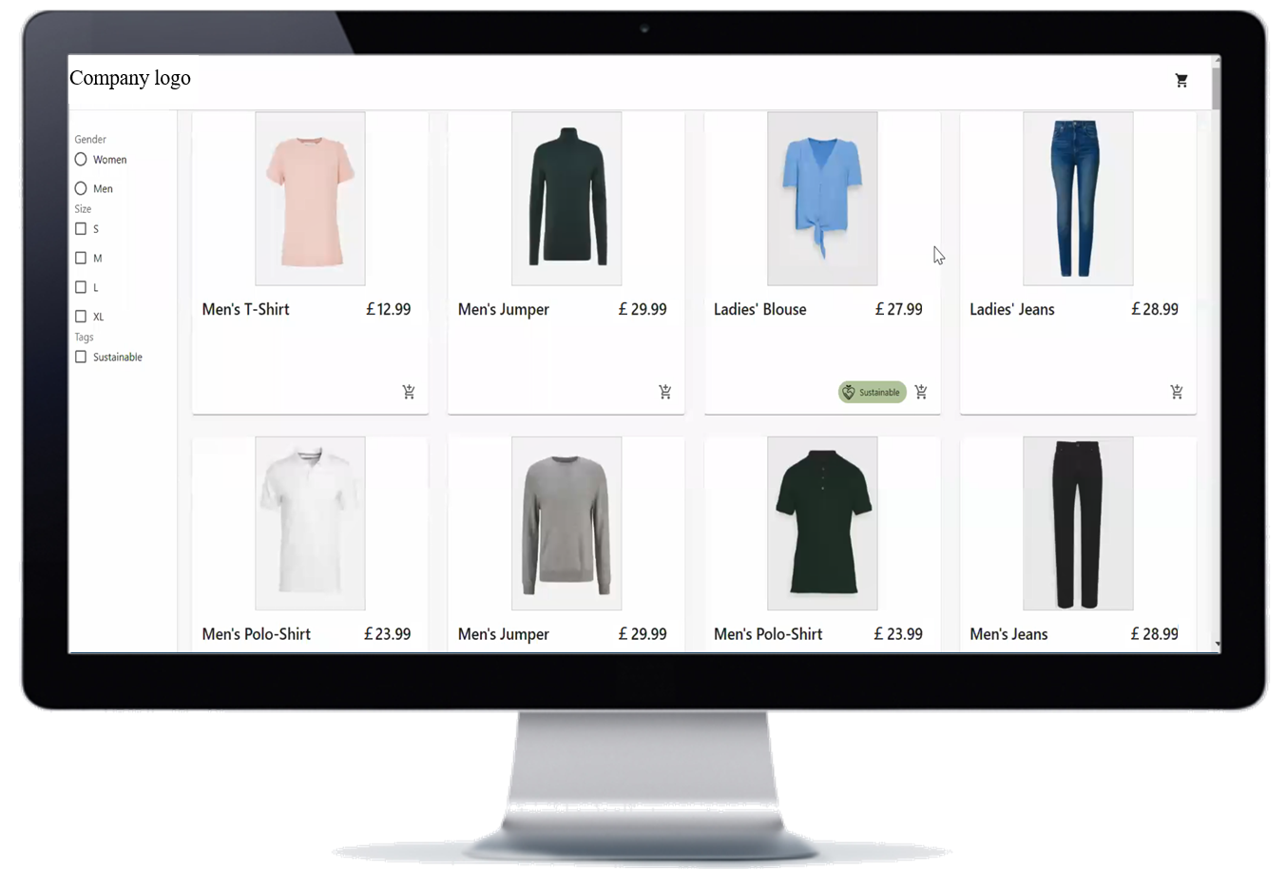
Product selection
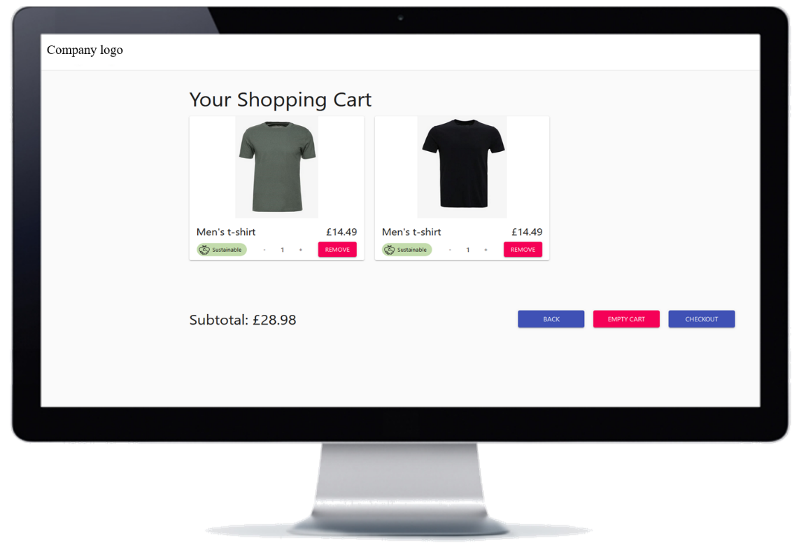
Shopping cart review and checkout

Additional details regarding the online shop simulation:
- Product assortment The product assortment used in our lab studies includes about 75 product pairs. Out of these pairs, one was labeled as sustainable and the other was not (i.e., we presented 150 products in total, 75 labeled as sustainable, and 75 without a sustainability label). The products of the respective product pairs were chosen to look very similar. Half of the products were for men, the other half for women. For both men and women, there were further subgroups according to the type of clothing (men and women: jeans, trousers, shorts, jumper, shirt, t-shirt; women only: blouse, pants, skirt, denim skirt, dress; men only: polo shirt, tank top).
- Product presentation Each time a participant entered the online shop, 100 out of the 150 products were randomly selected and displayed in the online shop. The products appeared in random order next to each other (4 columns x 25 lines).
- Product Pricing The product portfolio and pricing were aligned with those used by the retailer. Sustainable products were offered at a price premium of 10 to 13%.

Appendix B. Studies 1 and 2: introduction and instructions to the online shop simulation

Appendix B. Studies 1 and 2: introduction and instructions to the online shop simulation
Introduction when entering the experiment:
Dear participants,
Thank you very much for participating in our survey. This survey is conducted in collaboration with [company name], a real family-owned textile retailer.
The survey comprises three parts:
1. [company name] will briefly introduce itself and explain the purpose of this study. This is followed by a newsletter from [company name] with information about [company name]’s activities. Please read the information carefully.
2. An online shop visit is simulated by asking you to compile a shopping cart. Important: Please behave as you normally would when shopping online.
3. Finally, we have a few questions for you. Please answer the questions conscientiously.

Extract from the text on the page linking to the online shop simulation:
“Please click on “to the shop” to start the shopping simulation. Your shop visit should not take longer than 2 minutes.“
Please follow the instructions given right at the beginning of the simulation (popup window) to successfully complete the shop visit.
Important:
- Sometimes it takes a few seconds until the products appear in the shop.
- Do not close this window. The online shop will open in a new window. Return to this window after shopping and click on “continue” to complete the survey.

Popup window text at the beginning of the online shop simulation:
During this shopping trip, please shop for yourself (i.e., clothing for you and not for others) and behave as you would do in case of a real shopping trip happening right here and right now. That means, please only checkout with items in your shopping basket you would also buy in the real world. In case none of the offered items are of your interest, feel free to leave the shopping basket empty.
Before starting, please enter your prolific ID here and click on "Go!".
After selecting the products you would like to "buy", click on the shopping cart in the upper right corner. You can then click on "Checkout" to complete the online shop visit.
Appendix C. Studies 1-3: comparison of outcomes among treatment groups using a non-parametric test

Appendix C. Studies 1-3: comparison of outcomes among treatment groups using a non-parametric test
Kruskal-Wallis test comparing mean rank sums (using SPSS)
 |  |  | Study 1 | Study 2 | Study 3
Sustainable consumption
Involvement | 102.69 |  |  | 221.01 | 141.40
No involvement | 86.42 |  |  | 174.99 | 124.85
Test statistics
Kruskal-Wallis H | 5.61 |  |  | 17.89 | 3.15
p-value | .024 |  |  | < .001 | .07
Embedded CS | - |  |  | 208.65 | 136.95
Peripheral CS | - |  |  | 189.49 | 122.26
Test statistics
Kruskal-Wallis H | - |  |  | 3.11 | 2.11
p-value | - |  |  | .08 | .14
Involvement in embedded CS | - |  |  | 225.04 | 146.63
All other groups | - |  |  | 187.53 | 125.67
Test statistics
Kruskal-Wallis H | - |  |  | 10.37 | 4.47
p-value | - |  |  | .001 | .03
Psychological ownership
Involvement | 105,84 |  |  | 210.80 | 135.94
No involvement | 82,45 |  |  | 186.62 | 129.54
Test statistics
Kruskal-Wallis H | 8,50 |  |  | 4.38 | 0.46
p-value | .004 |  |  | .036 | 0.496
Embedded CS | - |  |  | 216.24 | 144.14
Peripheral CS | - |  |  | 181.18 | 105.73
Test statistics
Kruskal-Wallis H | - |  |  | 9.24 | 14.17
p-value | - |  |  | < .01 | < .01
Involvement in embedded CS | - |  |  | 234.77 | 156.60
All other groups | - |  |  | 182.97 | 120.86
Test statistics
Kruskal-Wallis H | - |  |  | 17.56 | 12.76
p-value | - |  |  | < .001 | < .001
N |  | 190 |  | 398 | 264
Note: mean rank sums are displayed.

Appendix D. Studies 1-3: results of generalized linear models

Appendix D. Results of generalized linear models
Poisson regression (using Mplus)
 |  | Study 1 |  | Study 2 | Study 3
Main effects on sustainable consumption
Customer involvement in CS | -1.10 (0.39)*** |  | 0.11 (0.01)*** |  |  | 0.06 (0.02)***
Psychological ownership | 3.53 (0.93)*** |  | 0.04 (0.01)*** |  |  | 0.10 (0.01)***
Main effects on psychological ownership
Customer involvement in CS | 0.38 (0.12)*** |  | -0.39 (0.20)* |  |  | -0.52 (0.24)**
CS embeddedness |  |  | -0.02 (0.20) |  |  | 0.08 (0.20)
Interaction effect on psychological ownership
Customer involvement in CS × CS embeddedness |  |  | 0.84 (0.28)*** |  |  | 0.73 (0.29)**
Conditional indirect effects of customer involvement in CS on sustainable consumption
Type of CS = embedded | 1.32 (0.41) |  | 0.02 (0.01) |  |  | 0.02 (0.02)
CI (95%) | 0.52 to 2.13 |  | 0.00 to 0.03 |  |  | -0.01 to 0.05
Type of CS = peripheral |  |  | -0.02 (0.01) |  |  | -0.05 (0.02)
CI (95%) |  |  | -0.03 to 0.00 |  |  | -0.10 to -0.00
Index of moderated mediation |  |  | 0.03 (0.01) |  |  | 0.07 (0.03)
CI (95%) |  |  | 0.01 to 0.06 |  |  | 0.02 to 0.13
N | 190 |  | 398 |  |  | 264
*p < .10, **p < .05, ***p < .01.
Notes: unstandardized coefficients displayed. Standard errors in parentheses. CI = confidence interval. All models include the control variables gender, age, income or education, and sustainable consumption involvement (SCI). The model in Study 3 additionally includes customer-company identification as a further control variable.
Appendix E. Studies 1-3: comparison of number of products bought and shopping cart value

Appendix E. Study 3: comparison of number of products bought and shopping cart value
Number of products bought across experimental groups

Shopping cart value across experimental groups

Appendix F. Study 3: opening and klick rate analyses

Appendix F. Study 3: opening and klick rate analyses
Figure 1: Receiver-opening rate (Study 3)
Comment Figure 1: We manipulated the email subject of the newsletter based on the CS embeddedness treatment. This involved one version with a subject line informing recipients about the company’s embedded CS activities, while the other highlighted its peripheral CS engagements. These newsletter versions were sent to all customers on the retailer’s mailing list, contingent upon the treatment condition they were assigned to. Figure 1 illustrates the percentages of customers in each condition who opened the newsletter email. 150,814 customers opened the newsletter mail. Notably, the embedded CS condition exhibited a significantly higher opening rate compared to the peripheral group.
Figure 2: Click-rates shopping button (Study 3)
Comment Figure 2: A total of 15,033 customers clicked the shopping button in the newsletter. Receiver-click rate shows the number of participants who clicked on the shopping button in the newsletter in relation to the total number of participants who received the newsletter (476,532; control group excluded). The opening-click rate represents the proportion of the number of clicks on the shopping button in the newsletter against the total number of recipients who opened the newsletter (138,168). We observed higher shopping button click rates (receiver-click rate and opening-click rate) in the embedded than in the peripheral CS conditions. The involvement groups (compared to the non-involvement groups) showed slightly lower shopping button click rates, likely due to the placement of the involvement button before the shopping button in the newsletter (the involvement tasks opened in a new window – some customers did not return to the newsletter). Overall, the embedded CS groups showed more favorable click behavior than the peripheral CS groups.

Figure 3: Click data (“to the shop” button; t0) matched with survey data from t1 (Study 3)
Comment Figure 3: Figure 3 illustrates the proportion of customers who clicked on the shopping button within the sample comprising 6,089 customers’ survey responses (for the data collection procedure see Figure 2 in the paper). The group involved in embedded CS activities demonstrates the highest click-rate, while those who received only the information about the company’s peripheral CS (without involvement) exhibit the lowest click-rate.

Figure 4: Click-rates involvement button (Study 3)
Comment Figure 4: Figure 4 illustrates the proportions of customers who clicked on the shopping involvement button in relation to total number of participants in the involvement condition who received the newsletter (238,276; receiver-click rate) and in relation to the total number of recipients in the involvement condition who opened the newsletter (68,876; opening-click rate). The group involved in embedded CS activities demonstrates higher click-rates (receiver-click rate and opening-click rate) compared to the group involved in peripheral CS activities.

Appendix G. Study 3: alternative models

Appendix G. Study 3: alternative models
Alternative models (AM) to the moderated meditation model displayed in Table 2 (Study 3) in the paper:
AM 1: Consumer-company identification (CCI) as mediator instead of psychological ownership (PO)
AM 2: trust as mediator instead of PO
AM 3: PO as mediator and CCI and trust as control variables

 | AM 1 | AM 2 |  | AM 3
Direct effects
Sustainable consumption (SC)
Customer involvement in CS → SC | 7.19 (3.88)* |  | 8.43 (3.82)** | 8.28 (3.79)**
Mediator → SC | 0.69 (1.35) |  | 6.64 (1.99)*** | 4.03 (1.74)**
CS embeddedness → SC
Mediator
Customer involvement in CS → Mediator | -0.10 (0.32) |  | -0.02 (0.21) | -0.52 (0.24)**
Embedded CS → Mediator | 0.41 (0.26) |  | 0.27 (0.17) | 0.01 (0.19)
Interaction effect
Customer involvement × embedded CS → Mediator | 0.24 (0.38) |  | -0.24 (0.25) | 0.80 (0.29)***
Control effects
Sustainable consumption involvement → SC | 1.40 (1.33) |  | 0.37 (1.34) | -0.54 (1.38)
Customer-company identification → SC |  |  | -1.46 (1.48) | -2.61 (1.54)*
Trust → SC |  |  |  | 5.50 (2.04)***
Sustainable consumption involvement → Mediator | 0.26 (0.06)*** |  | 0.15 (0.04)*** | 0.22 (0.05)***
Customer-company identification → Mediator |  |  | 0.32 (0.04)*** | 0.26 (0.05)***
Trust → Mediator |  |  |  | 0.28 (0.07)***
Indirect effects
Type of sustainability: embedded
Customer involvement → Mediator → SC | 0.09 (0.37) |  | -1.71 (1.03) | 1.12 (0.84)
CI (95%) | -0.57 to 1.02 |  | -3.95 to 0.06 | -0.15 to 3.05
Type of sustainability: peripheral
Customer involvement → Mediator → SC | -0.07 (0.51) |  | -0.12 (1.50) | -2.08 (1.28)
CI (95%) | -1.32 to 0.87 |  | -3.07 to 3.12 | -5.15 to -0.14
Index of moderated mediation | 0.16 (0.67) |  | -1.59 (1.83) | 3.21 (1.78)
CI (95%) | -1.10 to 1.87 |  | -5.52 to 1.68 | 0.41 to 7.33
N | 264 | 264 |  | 264
Notes. Standard errors in parentheses; CI = confidence intervals. Customer-company identification was measured via the single-item “I strongly identify with [company].” based on Korschun et al. (2014). Trust was measured as latent construct consisting of three items based on Homburg et al. (2013) as well as Newell and Goldsmith (2001): “I trust [company]”; “[Company] is honest”; “I believe the information [company] provides me with.”
*p < .10, **p < .05, ***p < .01.

