Marketing inputs and outcome heterogeneity:
Using a quantile regression framework in the entertainment industry

Web Appendix

Web Appendix A: Comparison of the interquantile regression results for box office revenues for total spread (.9–.1) between .5, .1 and .9 as first-stage regression model
 | First-stage  .5 (main model) |  |  |  | First-stage  .1 |  |  |  | First-stage  .9
Variable | Δ Coef. |  | t |  | Δ Coef. |  | t |  | Δ Coef. |  | t
ln_ACTOR | .099 | ** | 2.539 |  | .094 | ** | 2.433 |  | .160 | *** | 2.935
ln_director | .000 |  | .001 |  | .014 |  | .314 |  | .033 |  | .631
LN_CRITIC | –.982 | *** | –5.597 |  | –.984 | *** | –5.166 |  | –1.427 | *** | –4.768
LN_ADVERT | –.221 | *** | –4.612 |  | –.215 | *** | –4.505 |  | –.052 |  | –.516
mpaa_nr | –.469 | ** | –2.511 |  | –.361 | * | –1.771 |  | –.531 | *** | –2.837
mpaa_pg | .251 |  | 1.069 |  | .262 |  | 1.128 |  | .264 |  | 1.072
mpaa_pg13 | .083 |  | .590 |  | .191 |  | 1.256 |  | –.020 |  | –.138
comedy | –.036 |  | –.268 |  | –.063 |  | –.448 |  | .102 |  | .729
documentary | .003 |  | .013 |  | –.029 |  | –.109 |  | –.454 |  | –1.502
action | –.158 |  | –.885 |  | –.164 |  | –.831 |  | –.150 |  | –.846
thriller | –.496 | * | –1.866 |  | –.604 | ** | –2.294 |  | –.521 |  | –1.635
horror | .287 |  | .765 |  | .193 |  | .538 |  | .485 |  | 1.326
Scifi | –.097 |  | –.132 |  | –.169 |  | –.188 |  | –.421 |  | –.809
adventure | .223 |  | .639 |  | –.002 |  | –.005 |  | .404 |  | 1.074
animation | 1.068 | ** | 2.465 |  | .912 | ** | 2.069 |  | .943 | ** | 2.063
biography | –.734 | ** | –2.050 |  | –.777 | ** | –2.294 |  | –.645 | * | –1.707
other | –.103 |  | –.259 |  | –.416 |  | –.949 |  | .096 |  | .251
sequel | –.043 |  | –.250 |  | .053 |  | .298 |  | .101 |  | .560
Us_prod | .468 | *** | 2.997 |  | .462 | *** | 2.937 |  | .939 | *** | 4.446
LN_OPEN_SCRNS* | –.241 | *** | –3.082 |  | –.264 | *** | –3.346 |  | –.776 | *** | –2.964
ln_season | –.179 |  | –.987 |  | –.162 |  | –.867 |  | –.453 | ** | –2.056
ln_compT_BO | .064 |  | .530 |  | .039 |  | .296 |  | –.040 |  | –.314
Constant | 11.964 | *** | 8.573 |  | 11.602 | *** | 8.213 |  | 16.793 | *** | 6.320

Note: * p < .1; ** p < .05; *** p < .01; t–values are computed from 1,000 repetitions of design matrix bootstrap.
Dependent variable: LN_BOX_OFF.

Web Appendix B: First-stage .5-quantile regression results for opening screens
 | .5
Variables | Coef. |  | t
ln_ACTOR | .128 | *** | 5.975
ln_director | .08 | *** | 2.578
LN_CRITIC | –1.126 | *** | –8.135
LN_ADVERT | .14 | *** | 11.55
mpaa_nr | .476 | *** | 3.417
mpaa_pg | .914 | *** | 5.956
mpaa_pg13 | .489 | *** | 4.976
comedy | .104 |  | 1.184
documentary | .103 |  | .892
action | .278 | ** | 2.51
thriller | .329 | * | 1.755
horror | 1.674 | *** | 3.149
Scifi | .475 |  | 1.341
adventure | .213 |  | .971
animation | .463 | ** | 1.965
biography | –.575 |  | –1.644
other | .132 |  | .427
sequel | .189 | * | 1.927
Us_prod | .759 | *** | 6.988
ln_season | –.474 | *** | –4.241
ln_compT_BO | –.096 |  | –1.344
BUDGET | .458 | *** | 7.499
DISTRIB | 2.151 | *** | 7.345
Constant | 1.191 |  | .959
Pseudo–R² | .591

Note: * p < .1; ** p < .05; *** p < .01; t–values are computed from 1,000 repetitions of design matrix bootstrap. Dependent variable: LN_OPEN_SCRNS.

Web Appendix C: Quantile coefficient graphs for all input variables in the motion picture industry
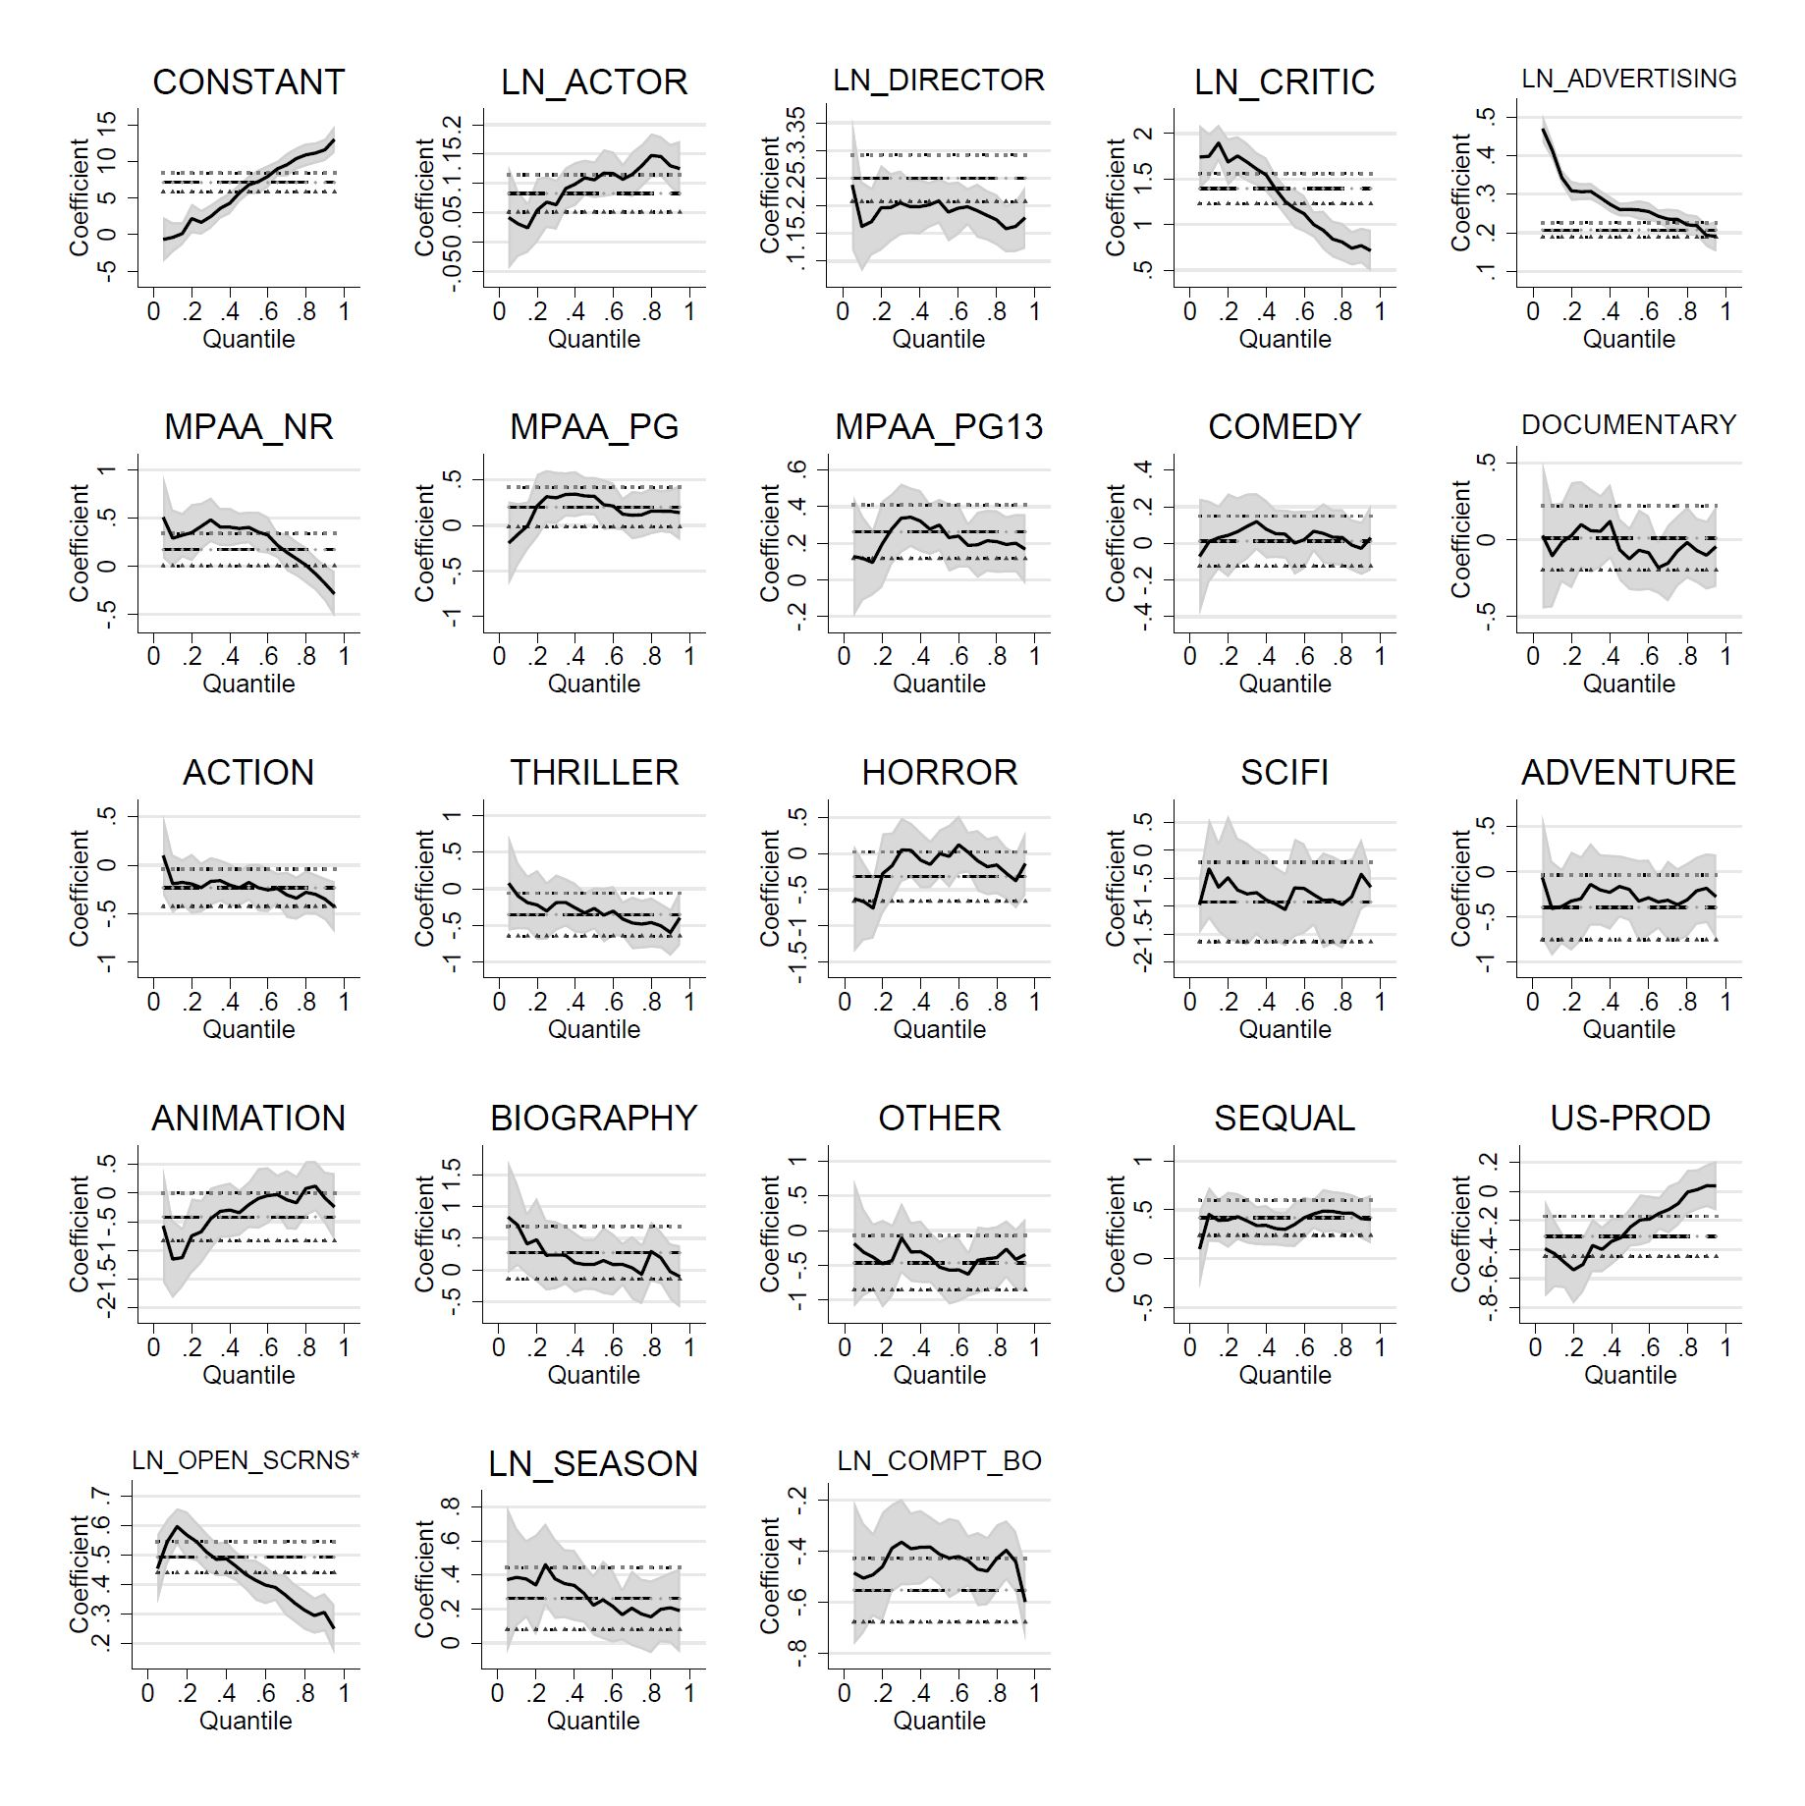
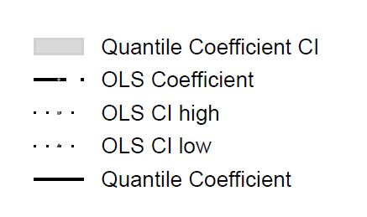

Web Appendix D: Quantile coefficient graphs for all input variables
in the book industry
