The Paradox of Product Scarcity: Catalyzing the Speed of Innovation Diffusion
WEB-APPENDIX C

DESCRIPTION OF THE APP

SPEEDUP OF DIFFUSION WITH COMPETITIVE ENTRY
December 2023

Competitive Entry Diffusion Model

Theoretical Underpinnings: Two-Parameters
The simulation presents a two-parameter competitive entry diffusion model that investigates the ‘Scarcity Paradox’ within the context of market dynamics influenced by word-of-mouth effects alongside the impact of a competitor’s entry into the market. The model juxtaposes the Classical Word-of-Mouth and External Influence of the Standard Bass Model with our CWBW-2-STAGE model to assess the impact of a competitor’s entry on the speed of the diffusion process of a new product category.

CWBM-2-STAGE Model
In the CWBM-2-STAGE model, the demand at any time $t$, $D\left(t\right)$, is given by the following expression:
$$D\left(t\right)=\left(p+\frac{q_{W}}{m}W\left(t-1\right)+\frac{q_{A}}{m}N\left(t-1\right)\right)\left(m-W\left(t-1\right)-N\left(t-1\right)\right)+W\left(t-1\right)$$
Where:
- $p$ is the coefficient of innovation.
- $q_{W}$ and $q_{A}$ are the coefficients for imitation due to word-of-mouth from the two groups, waiting customers, and adopters, respectively.
- $m$ is the market potential. - $W\left(t-1\right)$ is the word-of-mouth effect at time $t-1$.
- $N\left(t-1\right)$ is the cumulative number of adopters up to time $t-1$.
The sales $s\left(t\right)$ at any time $t$ is determined by the minimum of the demand $D\left(t\right)$, the capacity at that time (CL or CE), and the remaining market potential $m-N\left(t-1\right)$. Any excess supply not satiating the demand becomes end inventory. The excess of demand not satisfied by the supply becomes waiting customers, who then feed the word-of-mouth effect in subsequent periods.

Standard Bass Model
For the Standard Bass Model, the number of new adopters $N{\left(t\right)}_{Bass}$ at time $t$ is calculated using the following formula:
$$N{\left(t\right)}_{Bass}=N{\left(t-1\right)}_{Bass}+\left(p_{Bass}+\frac{q_{Bass}}{m}N{\left(t-1\right)}_{Bass}\right)\left(m-N{\left(t-1\right)}_{Bass}\right)$$
Where: - $p_{Bass}$ and $q_{Bass}$ are the coefficients of innovation and imitation, respectively, for the Bass model.

Simulation Outcomes
The simulation tracks the number of adopters over time for both models, highlighting the impact of a competitor’s market entry at time $TL$ and the change in total industry capacity to $CE$. Key metrics such as the time to reach 10% and 90% market saturation are compared between the CWBM-2-STAGE and Bass models, as well as the point in time when the CWBM-2-STAGE adoption curve intersects with the Bass model’s curve.
Please see: https://diffusion-2params.streamlit.app/ for access to the simulation APP.

Model Parameters
The model is parameterized with a set of fixed and user-defined variables:
- p (Innovation coefficient): Fixed at 0.03
- qW (Word-of-mouth imitation coefficient – Waiting Customers): Fixed at 0.9
- qA (Word-of-mouth imitation coefficient - Adopters): Fixed at 0.35
- m (Market potential): Fixed at 40,001
- CL (Initial industry capacity): (set at 1,000)
- p_bass (Innovation coefficient for Bass model): Fixed at 0.03
- q_bass (Imitation coefficient for Bass model): Fixed at 0.35
- User-Defined Parameters: Dynamic variables modifiable
  - TL (Time of competitor entry): The time at which competitors enter the market.
  - CE (New Total Industry Capacity): The updated industry capacity after competitor entry (ranging from 4,000 to 12,000).

Simulation Dynamics
The simulation progresses in discrete time steps, evaluating the diffusion process based on the CWBM-2-STAGE and the standard Bass diffusion model. The models track the number of adopters over time, represented by $N\left(t\right)$, with the following considerations:
- CWBW-2-STAGE Model: Incorporates the effect of market capacity constraints and competitive entry. The model calculates the demand $D\left(t\right)$ and sales $s\left(t\right)$ at each time step, adjusting for the capacity before and after competitor entry.
- Standard Bass Model: Serves as a benchmark, calculating the number of adopters based on the traditional Bass model without considering capacity constraints.

Key Metrics
The simulation records and reports several key metrics:
- Time to reach 10% and 90% of market saturation for both models.
- The time step at which the CWBM-2-STAGE model’s diffusion curve intersects with the standard Bass model’s curve.
Time p q1/m*w(t) ... N(t) Capacity N(t)_Bass
0 1 0.03 0.000000 ... 1000.000000 1000 1200.030000
1 2 0.03 0.004501 ... 2000.000000 1000 2771.469285
2 3 0.03 0.019759 ... 3000.000000 1000 4791.162019
3 4 0.03 0.053436 ... 7000.000000 4000 7323.510593
4 5 0.03 0.048891 ... 11000.000000 4000 10397.779900
5 6 0.03 0.056095 ... 15000.000000 4000 13979.127133
6 7 0.03 0.074849 ... 19000.000000 4000 17942.630602
7 8 0.03 0.099985 ... 23000.000000 4000 22067.415379
8 9 0.03 0.120341 ... 27000.000000 4000 26068.130134
9 10 0.03 0.122519 ... 31000.000000 4000 29664.070598
10 11 0.03 0.098610 ... 35000.000000 4000 32657.171186
11 12 0.03 0.050160 ... 38300.339265 4000 34975.934493
12 13 0.03 0.000000 ... 38921.283816 4000 36664.516180
13 14 0.03 0.000000 ... 39321.375585 4000 37834.976379
14 15 0.03 0.000000 ... 39575.591432 4000 38617.014371
15 16 0.03 0.000000 ... 39735.663218 4000 39126.169437
16 17 0.03 0.000000 ... 39835.875179 4000 39451.908594
17 18 0.03 0.000000 ... 39898.384038 4000 39657.925257
18 19 0.03 0.000000 ... 39937.285968 4000 39787.263808
19 20 0.03 0.000000 ... 39961.461781 4000 39868.083843
20 21 0.03 0.000000 ... 39976.472626 4000 39918.437403
21 22 0.03 0.000000 ... 39985.787764 4000 39949.751546
22 23 0.03 0.000000 ... 39991.566389 4000 39969.202978
23 24 0.03 0.000000 ... 39995.150382 4000 39981.277000
24 25 0.03 0.000000 ... 39997.372938 4000 39988.768336
[25 rows x 15 columns]

NOTE: For Reproducibility in Research, we ensure that the data generated is downloadable for further analyses by interested readers.

OUTPUT OF APP (SAMPLE SIMULATION)
We present a screenshot of a sample output.
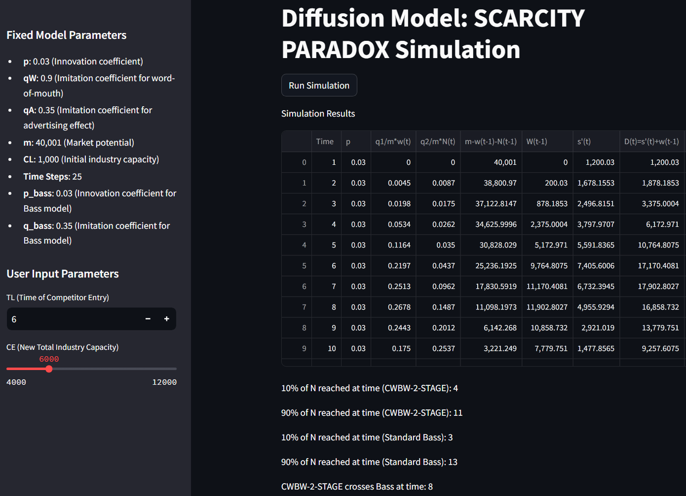
The data table can be downloaded by the readers for further analysis.
This simulation to assess impact of the dynamics of competitive entry can be run from: Streamlit (diffusion-2params.streamlit.app)
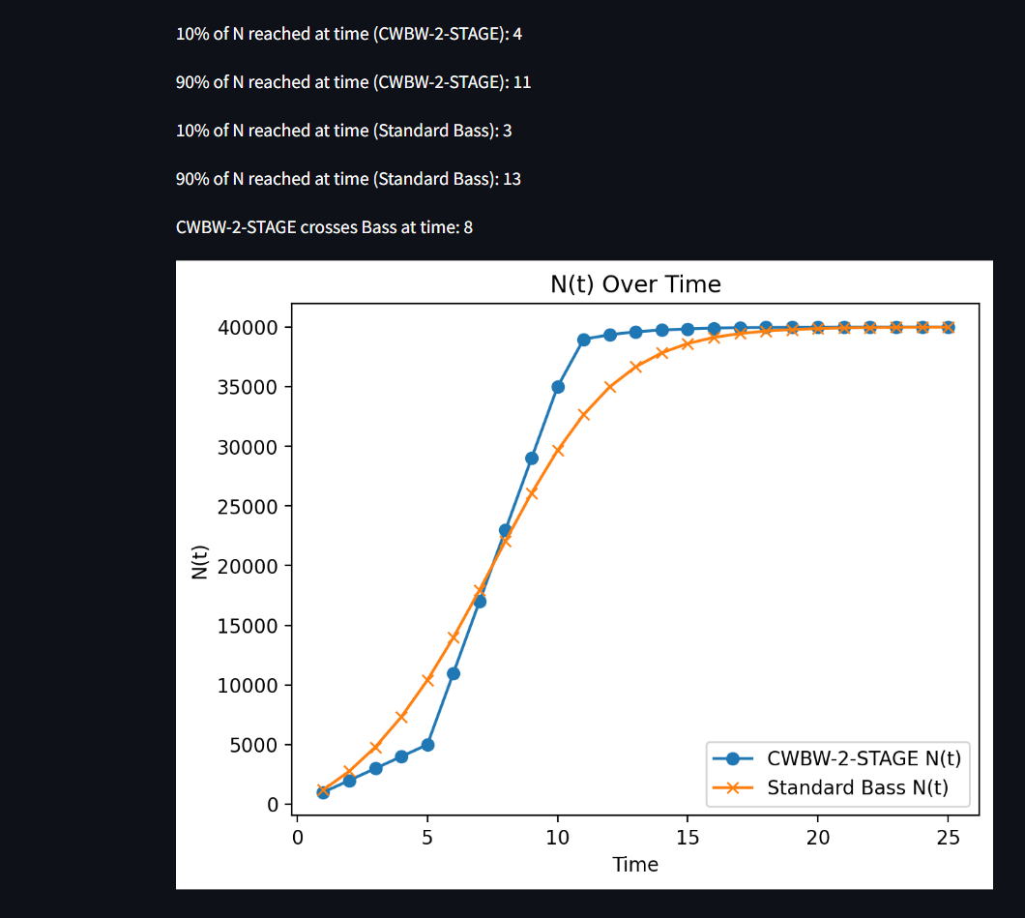

SAMPLE OF KEY RESULTS:
The time period when 10% of N is first reached or crossed in CWBM-2-STAGE is: 4
The time period when 90% of N is first reached or crossed in CWBM-2-STAGE is: 11
The time period when CWBM-2-STAGE crosses Bass for the first time is: 8

Results
Results are visualized through plots showing the number of adopters over time for both models, allowing for a direct comparison of diffusion patterns with and without the impact of scarcity and competitive dynamics.
This simulation helps provide insights into the strategic planning of product launches and market entry, particularly in scenarios where market capacity and competitive actions through market entry timing and capacity significantly influence adoption rates.

To demonstrate this easily for our reviewers we have now created an APP using Python that can be accessed at: Streamlit (diffusion-2params.streamlit.app). https://diffusion-2params.streamlit.app/
To preserve anonymity, the app has been uploaded to a cloud service that has no identifiers to the authors.

