Expressions of customer rumination in online posts and firm responses
Table of Contents
Web Appendix A 3
Table WA-1: Summary of select prior research (in alphabetical order) on reviews about negative marketplace experiences. 3
Table WA-2. Summary of select prior research on rumination 5
Web Appendix B 11
Table WB-1: Examples of online posts expressing strong versus weak rumination 11
Web Appendix C: Study 1R 14
Web Appendix D: Study 2: Methodological and data analytical details 16
1. Spell checking and text tokenization and lemmatization 16
Figure WD- 1. POS frequency across the whole sample. 17
2. Topic modeling using latent dirichlet allocation (LDA) 17
Figure WD-2. Intertopic distance map of the 6 topics. 18
Table WD-1. Top 20 words associated with each topic 21
Table WD-2. Operationalization, rationale, and sources of all variables 22
Table WD-3. Mean statistics and correlation coefficients 27
3. Control for endogeneity 28
4. Robustness checks for main effects 30
Table WD-4. Regression results for robustness checks using firm-level fixed effects with lagged DV. 30
5. Robustness checks for empathetic apology as a moderator 31
Table WD- 5 Regression results for empathetic expressions without apology and for apology without empathetic expressions 32
Web Appendix E: Study 3: Methodological and data analytical details 34
1. Topic modeling using latent dirichlet allocation (LDA) 34
Figure WE- 1: Coherence score 34
Table WE-1: Final word list used to measure rumination expression about service failure aspects 35
Table WE-2. Operationalization, rationale, and sources of all variables 36
Table WE-3. Mean statistics and correlation coefficients 38
2. The Appropriateness check of the use of Gaussian Copula following Becker, Proksch, and Ringle (2022) 39
Figure WE-2: Distribution of the Endogenous Variables and the Error Terms 40
Web Appendix F: Experimental stimuli for Study 4a and 4b 41
Web Appendix G: Scenario Realism and Manipulation Check of Rumination Expressions (Study 4a and 4b) 43
References 44

Web Appendix A

Table WA-1: Summary of select prior research (in alphabetical order) on reviews about negative marketplace experiences.

Citation | Method | Narrative | Review Focus | Findings
Ratings
Basuroy et al. (2003) | Field data | Movie reviews | Review rating | Low-rated (vs. high-rated) reviews reduce box office sales.
Berger et al. (2010) | Field data | Book reviews | Review rating | Low-rated reviews increase awareness and short-term sales.
Chevalier et al. (2018) | Field data | Hotel reviews | Review rating | Firm response stimulates low-rated reviews.
Chevalier & Mayzlin (2006) | Field data | Book reviews | Review rating | One-star reviews hurt book sales on Amazon.com.
Wang & Chaudhry (2018) | Field data | Hotel reviews | Review rating | Firm responses to low-rated reviews have a positive effect on subsequent ratings.
Emotional expressions
Herhausen et al. (2023) | Field data; experiments | Reviews on social media | High arousal negative emotions | Online complaints that express high arousal negative emotions reduce the likelihood of gratitude for the firm response.
Herhausen et al. (2019) | Field data | Reviews of U.S. S&P 500 firms | High arousal negative emotions | Strong (vs. weak) high arousal negative emotions lead to post virality; empathy and explanations minimize virality.
Ludwig et al. 2013 | Field data | Amazon reviews | Positive and Negative emotions | There is a quadratic relationship between changes in aggregate negative emotional expressions in product’s reviews and changes in the conversion rate.
McGraw & Kan (2015) | Experiments | Yelp reviews, Facebook | Humor | Humor creates entertainment, warnings, or impressions, but is detrimental for redress or sympathy goals.
Yin et al. (2014) | Field data; experiments | Seller reviews from Yahoo! | Anxiety and anger | Reviews expressing anxiety are perceived to be more helpful than those expressing anger.
Yin et al. (2019) | Experiments | Retailer reviews | Anger | Expression of anger in low-rated reviews increases review persuasiveness and exerts negative effects on review readers’ attitudes and decisions.
Cognitive expressions
Allard et al. (2020) | Experiments | Reviews of reusable products in restaurants | Perceptions of unfairness | Unfair negative reviews elicit greater firm support compared to fair negative reviews.
Moore (2015) | Field data; experiments | Book reviews | Explanation | Explained actions enhance attitude predictability for utilitarian products, whereas explained reactions increase attitude predictability for hedonic products.

Table WA-2. Summary of select prior research on rumination
Citations | Conceptualization (definition) | Operationalization  (measurement) | Type of study  (e.g., survey, experiment) | Effects on outcomes | Moderators of rumination effects on outcomes
Rumination in psychology and other disciplines (Select research in alphabetical order)
Rumination about stressful event aspects
Alloy et al. (2000) | Rumination is a negative thinking about the adverse inferences related to stressful events. | Self-reported scale | Experiment | Stress-reactive rumination moderated the effect of cognitive risk in relation to lifetime prevalence of major depressive disorder.
Conway et al. (2000) | Rumination is repetitive thinking about distress. | Self-reported scale | Cross-sectional survey | Rumination is correlated with sadness, Beck depression inventory (BDI), and neuroticism.
Watkins (2004) | Rumination is the mode of thinking that can be projected in self-focused attention including conceptual-evaluative self-focus (focusing on the causes and consequences of the outcomes) or experiential self-focus (focusing on the momentary experience of the feelings). | Self-reported scale | Experiment | Rumination is associated with a higher level of negative mood
Liu et al. (2018) | Rumination is defined as repetitive and passive thinking about one’s distress or concerns without making positive changes. | Self-reported scale | Cross-sectional survey | Rumination is positively associated with poor sleep quality. | Self-control: The effect of rumination on poor sleep quality is stronger for individuals with low self-control than those with high self-control.
Rumination about stressful event causes and consequences
Mor & Winquist (2002) | Rumination is a negative thought with a passive focus on causes of one’s symptom of distress that prolongs negative affect and depression. |  | Meta-analysis | Rumination prolongs negative affect and depression.
Nolen-Hoeksema (1991) | Rumination is a repetitive thought that focuses an individual’s attention on possible causes, consequences, and symptoms of distress. | Self-reported scale | Experiment | Rumination prolongs depression
Rusting & Nolen-Hoeksema (1998) | Rumination is negative thinking that focuses an individual’s attention on negative mood, causes and consequences of the mood, which exacerbates anger. | Self-reported scale | Experiments | Rumination increases anger. | Gender: Women are more likely to ruminate in a neutral mood. Men are equally likely to choose rumination or distraction regardless of their mood.
Rumination in Marketing Research
Kähr et al. (2016) | Consumer rumination is a repetitive thought about negative brand stimuli that can worsen customers’ negative internal states by directing them to more intense negative emotions. | Self-reported scale | Experiment | Consumers will be more likely to sabotage a brand if they repetitively think about the negative situation.
Lisjak et al. (2015) | Consumer rumination is a cognitive process of repeatedly thinking about something. | Self-reported scale and manipulated rumination | Experiment |  | Compensatory consumption strategies: When consumers engage in within-domain (vs. across-domain). compensatory consumption in response to a threat, they report stronger rumination about the threat.
Porath et al. (2010) | Rumination is a negative repetitive thought that is fostered by anger | Open-ended question that asked respondent to report thoughts. Rumination was measured by the total number of negative thoughts. | Lab experiment | Rumination reduces intentions to interact with the service firm.
Strizhakova et al. (2012) | Consumer rumination is recurrent thoughts about a stressful event, such as a negative service experience. | Self-reported scale | Scenario-based experiment | Rumination increases negative WOM and decreases future purchase intention.
Wang et al. (2013) | Rumination is a repetitive thought about a negative experience. | Self-reported scale | Longitudinal Survey | Daily customer mistreatment increases employees’ rumination at night. | Organization support: The within-person effect of customer mistreatment on rumination is stronger among those who had higher (vs. lower) level of service rule commitment. but weaker among those who had higher (vs. lower) levels of perceived organizational support.
Ruminative Expressions in Narratives
Afifi et al. (2013) | Verbal rumination focuses on repetitive talk - continually talking about a problem and its potential consequences, negative emotions surrounding the problem, and one’s role in it. | Self-reported scale | Experiment | Verbal rumination was directly associated with more brooding after the conversation, regardless of the type of support provided. | Social support: Individuals became more anxious and dissatisfied with their relationship when they verbally ruminated and received poor support. However, when there is satisfactory support, people who verbally ruminate are more satisfied with their friendship, but their anxiety is not significantly reduced.
Grisham et al. (2011) | Rumination is a repetitive thought about current depression symptoms, and their causes, meanings, and consequences (similar to Nolen-Hoeksema 1991). | Open-ended question | Experiment | Compared to rumination, reappraisal was associated with more positive affect and less negative affect.  Participants in the rumination condition include a greater proportion of causal words (reflecting thoughts about the causes, meanings, and consequences) than those in the reappraisal condition.
Marin & Rotondo (2017) | Narrative rumination is passive and negative reasoning about the experience and/or self, which focuses on the causes and consequences of undesired outcomes without efforts to move beyond the causes and/or consequences, or cope with them. | Coding scheme | Longitudinal study | Individuals who increased ruminative brooding across the 3 days of writing showed lower ego identity development (short-term and long-term) and self-esteem (short-term).

Web Appendix B

Table WB-1: Examples of online posts expressing strong versus weak rumination

 | Strong Rumination Expressions about Service Failure Aspects | Weak Rumination Expressions about Service Failure Aspects | Strong Rumination Expressions about Service Failure Causes | Weak Rumination Expressions about Service Failure Causes | No Rumination Expression about both Service Failure Aspects and Causes
Study 2 | Score: 6  Woke up first morning and watched a well-fed bed bug crawl across white comforter. Terminix confirmed it as bed bug about 5 hours later. The manager said it was an isolated bug. No signs of infestation. Implied that I had brought bug into hotel. Fresh blood smears on sheets and after inspection old brown spots too. This was the first time in my life I had seen such a bug. Series of 5 bites were in nearly a straight line down calf. Horrible experience. Hotel did not care - to them it was no different than being bitten by a mosquito while camping. | Score: 2  When I said extremely dirty means " EXTREMELY " if you can avoid this, do it. They don't even make the room for a couple. Besides carpet and sofa were wet you not even can take off your shoes if so your socks will be trash, this is the worst hotel for this firm. | Score: 4  After checking in and getting to my room, I found the door open since it wouldn't automatically latch closed. I went to the front desk and requested a new room because I didn't feel safe in that one - especially as a woman traveling alone. Even though the hotel said they had space available, the front desk insisted that I go back up and wait for maintenance to fix the door. Because they didn’t fix the door that day, I couldn’t sleep at night. I felt worried the whole trip due to their terrible service. A simple room change would have kept me happy. | Score: 1  Couldn't sleep well because the room was always warm. They didn't allow me to change rooms. Because of the heat, I had to shower in the middle of the night to cool off. I would not stay here the next time. | Score: 0  Terrible experience. Didn't get pre-requested room amenities, firm pillows. Took pets, paid extra, small with cage, didn't get room service for all 3 days . . . was charged extra for HOT breakfast . . . even after paying for breakfast as part of room rate. Pool area didn't have towels, hot tub disgusting all 3 days.
Study 3 | Score: 10  Very unhappy with your delivery service. Your customer service has been telling me for days one thing your tracking on the page says another. For days I was waiting on a package that was out for delivery that never was according to the shipping company. So for days I have been lied to and waiting for a package that was never put for delivery. You guys need to get your facts and tracking skills & program together. After calling the company they told me do not go by your tracking records for delivery. If you can’t deliver the product, do not sell it. | Score: 2  This mess is through the roof of disgusting! I'm here at the place to order my free pizza and they told me it was delivery only. I make the order for delivery, then it say the pizza does not cost enough money to delivery-$15 minimum order. You can take your coupon and bless it. That gives me more reason to blast to the public how awful you are. | Score: 8  This is the worst bank ever! Not only have they let fraudulent charge go through but also refusing to give our money back and their reason why? Please explain to me how could I have ever made the charge after you let an $8000 charge go through? I have called your fraud department 4 times and there was no help! Now this bank is holding us hostage because we cannot open another checking account, with another bank because of this craziness! At this point you, Bank of America, has stolen 2 paychecks from me and one from my husband because you let a fraudulent charge of $8000 go through on an account with only $90 in it! We have lost almost all creature comforts and depend on friends for food for the past 2 weeks while you hold us in financial hostage! All because of you. | Score: 2  We needed a place to sleep for two nights--nothing fancy. The last morning, we got breakfast and returned to the room to find that our key cards had been disabled hours ahead of schedule. We left for the airport late, first because we had to wait to get them reprogrammed so we could get our belongings, and then because when we tried to return the cards to check out there was no one but confused patrons standing at the front desk. Plenty of other hotels in that neighborhood!!! | Score: 0  Don't bother buying an extended warranty from Lowes. It does not appear to be worth the paper it is printed on. Also the customer ratings for the company really give me pause. Collin /Grayson Appliance you are not making customers for life.

Web Appendix C: Study 1R

The goal of Study 1R was to provide a robustness check to Study 1 on a sample of U.K. Prolific workers (vs. U.S. MTurk workers as in Study 1) and our proposition that repetitive use of topic and cause-related words in online posts expresses an internal cognitive process of rumination. We used the same approach as in Study 1 to first prescreen 1,600 U.K. Prolific workers to identify customers who had made a post about a service failure (either on review sites or firms’ social media sites) within the past three months. We then invited 251 participants who passed this criterion to retrieve their post from the review site or social media page and copy-and-paste it. This process yielded n = 198 usable posts (participants: M_{age} = 32.62; SD_{age} = 11.80; 54% male) after excluding participants who could not find their post (n = 26), copy random link with no content related to a service failure (n = 12), or wrote posts that were too short for text analysis (three or fewer words; n = 15).
We used a single-item measure of customer rumination from Study 1 (“I still find myself replaying the incident over and over in my mind,” 1 = strongly disagree/7 = strongly agree; Strizhakova et al. 2012; M = 4.68, SD = 1.87). Similar to Study 1, to measure expressions of rumination about service failure aspects, two independent coders (blind to participants’ rumination scale responses) manually coded the posts by counting the number of times the writer repeatedly used similar or exactly the same words to describe a certain service failure aspect. Intercoder reliability was high (r = .87); any disagreements were resolved through discussion. The service failure aspect score was calculated by subtracting 1 from the number of times each service failure aspect was mentioned (if greater than 0; M = 1.26, SD = 1.13) because a single use of an aspect word does not indicate repetition (i.e., rumination).
Similar to Study 1, to measure expressions of rumination about service failure causes, we relied on LIWC (Pennebaker et al. 2015). We used LIWC’s “cause” dimension to calculate the number of times “cause” words were mentioned in the post and subtracted 1 from the “cause” score (if greater than 0) to capture repetitions (M = .52, SD = .84). Correlation results indicate significant positive relationships between self-reported rumination and rumination expressions about service failure aspects (r(196) = .39, p < .001) and causes (r(196) = .28, p < .001).
Similar to Study 1, we divided self-reported rumination into low and high levels using a median split and compared rumination expressions between these two groups. Rumination expressions were significantly higher when the level of self-reported rumination was high, with this pattern holding both for service failure aspects (M_{high} = 1.58, SD_{high} = 1.16; M_{low}= .75, SD_{low} = .88, t(196) = 5.70, p < .001) and causes (M_{high} = .67, SD_{high}= .93; M_{low} = .28, SD_{low} = .58, t(196) = 3.53, p = .002).

Web Appendix D: Study 2: Methodological and data analytical details

Spell checking and text tokenization and lemmatization

To perform the spell check process, we employed the word2vec model in the genism package in Python 3.7, using part of the Google News dataset that contains 3 million words and phrases in the English language to estimate the word probabilities. Our spell check process then follows Norvig’s (2007) method in which the correction of each erroneous word is conducted based on the most likely spelling correction for that word based on the constructed word rank dictionary. Some examples of the correction are “Cl3an” being corrected as “Clean”, “qalty” being corrected as “quality”, and “rehersal” being corrected as “rehearsal.”
After having completed the spell check, we proceeded with the process of text tokenization and lemmatization. The process involves breaking down the sequence of strings of each review into parts of speech (POS) being tagged as NOUN, VERB, ADJ (adjectives), PROPN (proper noun), and so on using the universal POS tags of the spaCy library in Python. In our sample we have a total of 17 POSs and the frequency of each is shown in Figure A1.

Figure WD- 1. POS frequency across the whole sample.
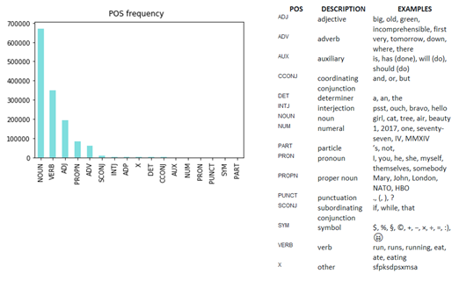
For our modeling, we only selected the POSs that have the most meaning, including NOUN, VERB, ADJ, and ADV. Even though PROPN (Proper Noun, such as private names) has higher frequency than ADV, we did not include it in modeling since it does not convey any meaningful information to the modeling results. With the selected POS, we lemmatized the words in each review. To improve the meaningfulness of topic modeling results, we only selected lemmas that are not stop-words (i.e., words that convey no meaning by themselves) and have at least 3 characters.
Altogether we have 16,725 unique lemmas across the whole sample of 19,139 negative reviews, with an average of 59 lemmas per review.

Topic modeling using latent dirichlet allocation (LDA)

After conducing the LDA model to find the optimal number of 6 topics, we employed the pyLDAvis package in Python, following the description by Sievert and Shirley (2014) to define the LDA model. Results of the LDA model from this interactive visualized package can help determine some basic principles of a fitted topic model, such as a topic’s meaning, each topic’s prevalence, and the relationship between topics. Each topic is represented as a bubble numbered 1 to 6 in a two-dimensional Intertopic Distance Map. The size of the bubble tells the prevalence of the topic across reviews, and the positions of the bubbles on the Map indicate how close each one is to the others, or how relevant they are in terms of topic words. The closer two topics are to each other, the more overlapping of words between the two topics occurs. Figure A2 shows the Intertopic Distance Map of the sex topics resulted from our modeling in the left panel.

Figure WD-2. Intertopic distance map of the 6 topics.

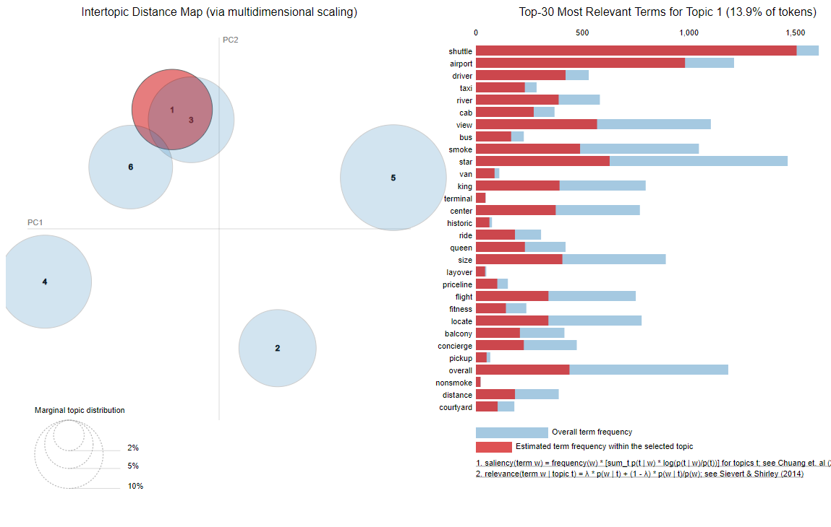
The right panel of the interactive pyLDAvis widget shows the list of the top 30 most relevant terms for each topic. In Figure A2, we also show the example of top 30 most relevant terms for Topic 1. The list’s ordering from top to bottom shows the descending order of term’s relevance to topic from the highest to the lowest. In terms of relevance, Sievert and Shirley (2014) proposed the relevance measure of a term $w$ to topic $k$ as
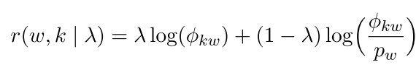
in which $λ (0≤λ≤1)$ is the weight parameter to balance between a term’s saliency and distinctiveness to the topic. If $λ=0$, the relevance of term $w$ to topic $k$ $r\left(w,k | λ\right)$ relies solely on the term’s distinctiveness, measured by the log of the term’s probability to topic over the topic’s marginal probability. If $λ=1$, the relevance of term $w$ to topic $k$ $r\left(w,k | λ\right)$ relies solely on the term’s saliency, which is the log of the term’s probability to topic, a measure of the term’s overall frequency within the topic.
Prioritizing saliency over distinctiveness might lead to a modeling result that contains a lot of overlapping between the lists of most relevant topic terms across topics, since distinctiveness has been overlooked. Conversely, prioritizing distinctiveness over saliency might result in words of the most relevant term list being less correlated with each other, since the probability of words to occur in the topic has been undermined. As a result, it might be more difficult to interpret and label the topics. The results of topic modeling, therefore, depend on adjusting the weight parameter $λ$ to minimize overlapping, while still maintaining a good interpretability of topics. After the trial process we chose to set $λ=.24$ to come up with a result that can best meet these two goals. Our final result contains 6 topics. The list of 20 most relevant terms for each one is presented in Table WC-1.
Figure WD-3. Topic coherence score over numbers of topics
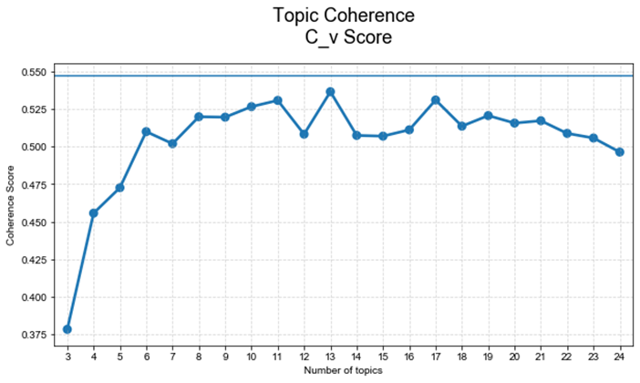

Table WD-1. Top 20 words associated with each topic

Transportation | Room Issues | Noise | Cleanliness | Payment | Food
Shuttle | Bug | Internet | Hair | Credit | Egg
Airport | Bite | Sound | Mold | Email | Menu
Driver | Suite | Music | Filthy | Steal | Smoking
Taxi | Kid | Nosy | Black | Contact | Fruit
River | Baby | Construction | Curtain | Account | Waffle
Cab | Roach | Neighbor | Sink | Bill | Cereal
View | Daughter | Insulation | Bathtub | Cancel | Sausage
Bus | Guest | Ear | Roach | Confirmation | Muffin
Smoke | Check | Constant | Gross | Receipt | Buffet
Star | Tile | Slam | Mildew | Company | Salad
Van | Problem | Access | Cricket | Bank | Cook
King | Crib | Connection | Flea | Vehicle | Cold
Terminal | Room | Concert | Urine | Camera | Juice
Center | Child | Horn | Dust | File | Cheese
Historic | Itch | Train | Drain | Inform | Bread
Ride | Service | Vibrate | Dirt | Security | Toast
Queen | Ready | Park | Vacuum | Information | Tea
Size | Cricket | Atrium | Paint | Refuse | Bacon
Layover | Furniture | Freeway | Peel | Situation | Cup
Priceline | Celling | Drunk | Blood | Hold | Yogurt

Table WD-2. Operationalization, rationale, and sources of all variables

Variable | Operationalization | Source | Related Studies
Dependent Variable
Sales | The average revenue per available room in a given quarter. | Consulting company | (Hollenbeck 2018)
Independent Variables (Rumination Expressions)
Rumination expressions about service failure aspects | LDA was used to model high-dimensional text data into distinct topics. We identify the frequency of words in the dictionary of each topic. Then, each review is categorized based on the topic it is most associated with. We then subtract 1 from the score of reviews that mention topic words at least one time. We divide it by the total word counts per review and multiply by 10. This score is then averaged out at the hotel-quarterly level and cumulated to the current period. | Text mining | Rumination involves repetitive thinking about a stressful experience (Conway et al. 2000; Watkins 2004). Consequently, people are likely to repeatedly mention a particular issue they encountered in their reviews. That is, customers should use more topic-related words to express their thoughts about different aspects of a service failure.
Rumination expressions about service failure causes | The average score of LIWC dictionary "cause" for all reviews in a quarter. For each review, we calculate the number of times the "cause" words are mentioned. We subtract 1 from the frequency score and divide it by total word counts and multiply it by 10. The score is then averaged out at the hotel-quarterly level and cumulated to the current period. | Text mining | Rumination induces thinking about the causes and consequences of a negative experience.  (Nolen-Hoeksema 1991). Therefore, narratives with rumination expressions should generate more cause-consequence words, reflecting more causality thoughts (similar to the finding of rumination manifested in individual written narratives: (Denson, Moulds, and Grisham 2012; Grisham et al. 2011).
Moderators
Empathetic apology | First, the average score of "affective" dictionary from LIWC for all responses to reviews is extracted. Then, the average score of apology dictionary adopted from Herhausen et al. (2019) to measure the apology language used in the response and is dummy-coded (1 = apology was mentioned; 0 = apology was not mentioned).  Next, empathetic apology variable takes value 0 if expressions of apology is null and takes the value of empathy if expressions of apology is equal to 1. Then the score is aggregated to the hotel-quarterly level and cumulated to the current period. | Text mining | Intensity of empathy may ease customer's anger (Herhausen et al. 2019).  Offering apology satisfies complaining customer and distracts ruminative thoughts (Afifi et al. 2013: Roschk & Kaiser 2013).
Compensation | The average score of compensation dictionary adopted from Herhausen et al. (2019) to measure the compensation language used in the response. The score is then categorized into a dummy, taking value 1 if the score is equal or greater than 1 and value 0 if the score is 0. Then the score is aggregated to the hotel-quarterly level and cumulated to the current period. | Text mining | Offering compensation satisfies complaining customer (Davidow 2003) and might distract ruminative thoughts.
Control Variables
Average Rating | The average rating of the studied hotels in a quarter. | TripAdvisor | Average rating impacts sales (Chevalier and Mayzlin 2006).
Standard deviation of average rating | The standard deviation of the average rating per quarter. | TripAdvisor | Average rating impacts sales (Chevalier and Mayzlin 2006).
Capacity | The number of rooms that were available for occupation in a hotel in a quarter. | Consulting company | Hotel’s capacity impacts sales (Hollenbeck 2018).
Average price | The average price offered by a hotel in a quarter. | Consulting company | Customers tend to be price-sensitive, higher prices might reduce demand and negatively influence sales.
Negative emotions | The average score of negative high arousal emotional dictionary adopted from (Herhausen et al. 2019) for all reviews at the hotel-quarter level. For each review, we calculate the percentage of matching words between the review and the dictionary. | Text mining | Negative emotional expressions in reviews influence persuasiveness of the review (Yin, Bond, and Zhang 2019) that could influence prospective customer’s purchasing behavior.
Positive emotions | The average score of posemo dictionary adopted from LWIC for all reviews at the hotel-quarter level. For each review, we calculate the percentage of matching words between the review and the dictionary. | Text mining | Positive emotional expressions in reviews influence prospective customers purchasing behavior (Ludwig et al. 2013).
Number of Reviews per quarter | The total number of reviews that each studied firm received in a quarter. | TripAdvisor | Review numbers influence sales (Chevalier and Mayzlin 2006).
Service failure severity | The average number of word counts in each review, at the hotel-quarter level. | TripAdvisor | Longer low-rated reviews project higher levels of general service experience negativity (Umashankar, Ward, and Dahl 2017) that can be a proxy for service failure severity and might influence prospective customers’ purchase intention.
Ratio of low-rated review | The proportion of 1* and 2* rated reviews to total reviews a hotel received in a quarter. | TripAdvisor | This indicates the frequency of service failures for a given hotel.
Review Helpfulness | The number of helpfulness votes for all reviews that a hotel receives in a quarter. | TripAdvisor | Review helpfulness vote impacts readers' perception of the usefulness of information and may impact sales (Ludwig et al. 2013).
Breadth of complaints | The variable is the quarterly averaged score of the sum of all service failure aspects minus the most frequently mentioned one. | TripAdvisor | Customers might discuss more than one aspect in their reviews that might influence prospective customers.
Other channels | The variable is quarterly averaged of the review-level dummies, which take value 1 if a review mentions about other channels and value 0 if a review does not do so. “Other channel” words are adopted from Herhausen et al.’s (2019) dictionaries. | TripAdvisor | Firms might direct customer to other communication channels when handling low- rated reviews and this might impact prospective customers’ perceptions and behaviors (Herhausen et al. 2019).
Empathetic apology of competitors | Sum of empathetic apology variable values of all hotels per quarter in the same zip code minus the value of the focal one. | TripAdvisor | Competitive intensity might have impacted firms’ recovery strategies to restore customer satisfaction and regain patronage after service failures (Golmohammadi et al. 2023).
Competitors’ compensation | Sum of compensation variable values of all hotels per quarter in the same zip code minus the value of the focal one. | TripAdvisor | Competitive intensity might have impacted firms’ recovery strategies to restore customer satisfaction and regain patronage after service failures (Golmohammadi et al. 2023).
Response ratio to reviews | The ratio of reviews that received hotel responses in a quarter to the total number of reviews. | TripAdvisor | Hotels may be selective in picking reviews that they want to respond; and this strategy may influence their sales.
Past focus | The average score of past focus dictionary adopted from LWIC for all low-rated reviews at the hotel-quarter level. For each review, we calculate the percentage of matching words between the review and the dictionary. | Text mining | Written expressions in the past tense reflect the triggered processes of re-calling the service failure in low-rated reviews, but they do not impact sales.
First-person language | The average score of first ppron dictionary adopted from LIWC for all reviews at the hotel-quarter level. For each review, we calculate the percentage of matching words between the review and the dictionary. | Text mining | The use of the first-person pronoun language is strongly associated with the tendency to ruminate (Watkins 2004), but not sales.
Focal hotel’s (vs. competitors’) response to rumination expressions about service failure aspects | A dummy variable that takes value 1 if a firm response ratio to reviews with rumination expressions about service failure aspects higher than the mean value of competitors; value 0 otherwise. | TripAdvisor | A firm might be selective in picking reviews with rumination expressions about service failure aspects to respond to, and this may lead to a selection bias.
Focal hotel’s (vs. competitors’) response to rumination expressions about service failure causes | A dummy variable that takes value 1 if a firm response ratio to reviews with rumination expressions about service failure causes higher than the mean value of competitors; value 0 otherwise. | TripAdvisor | A firm might be selective in picking reviews with rumination expressions about service failure causes to respond to, and this may lead to selection bias.
Responses to reviews with rumination expressions about service failure aspects of competitors | The logged sum of all responses to reviews with rumination expressions about service failure aspects of competitors (except for the focal hotel) in a quarter. | TripAdvisor | The response strategies of competitors could predict the focal response behavior (Golmohammadi et al. 2023).
Responses to reviews with rumination expressions about service failure causes of competitors | The logged sum of all responses to reviews with rumination expressions about service failure causes of competitors (except for the focal hotel) in a quarter. | TripAdvisor | The response strategies of competitors could predict the focal response behavior (Golmohammadi et al. 2023)

Table WD-3. Mean statistics and correlation coefficients

Variable | Mean | SD | (1) | (2) | (3) | (4) | (5) | (6) | (7) | (8) | (9) | (10) | (11) | (12) | (13) | (14) | (15) | (16) | (17) | (18) | (19) | (20)
Sales | 86.875 | 38.939
“Aspects” rumination | 1.033 | 1.259 | -0.099
“Causes” rumination | 1.008 | 1.491 | -0.042 | 0.438
Empathetic apology | .730 | .505 | 0.707 | -0.087 | -0.045
Compensation | 6.016 | 4.447 | 0.347 | -0.038 | -0.017 | 0.317
Average rating | 3.887 | 2.002 | 0.251 | -0.002 | 0.074 | 0.117 | 0.031
SD average rating | 1.172 | .282 | -0.145 | 0.007 | -0.027 | -0.029 | -0.027 | -0.430
Capacity (no. room) | 214.364 | 213.975 | 0.336 | 0.015 | 0.048 | 0.232 | 0.395 | 0.259 | -0.295
Average price | 171.945 | 76.610 | 0.452 | -0.007 | 0.063 | 0.146 | 0.230 | 0.527 | -0.408 | 0.570
Negative emotions | .540 | .760 | 0.080 | -0.040 | 0.013 | 0.198 | 0.061 | 0.055 | 0.018 | 0.060 | 0.074
Positive emotions | 2.494 | 1.363 | 0.113 | -0.029 | -0.033 | 0.069 | 0.057 | 0.102 | -0.093 | 0.110 | 0.135 | -0.011
No. reviews | 46.724 | 94.421 | 0.214 | -0.001 | 0.022 | 0.056 | 0.282 | 0.431 | -0.435 | 0.550 | 0.542 | 0.032 | 0.147
Severity | 15.550 | 1.425 | -0.081 | 0.502 | 0.635 | -0.097 | 0.025 | 0.076 | -0.031 | 0.172 | 0.172 | -0.009 | -0.023 | 0.146
Ratio of low-rated reviews | .187 | .168 | 0.257 | -0.068 | -0.092 | 0.370 | 0.150 | -0.569 | 0.421 | -0.189 | -0.428 | 0.021 | -0.070 | -0.365 | -0.182
Review helpfulness | 4.303 | 13.159 | -0.126 | 0.090 | 0.098 | -0.223 | 0.131 | 0.020 | -0.015 | 0.298 | 0.263 | -0.020 | 0.044 | 0.548 | 0.290 | -0.249
Breadth of complaints | 7.643 | 1.031 | -0.017 | 0.168 | 0.144 | -0.042 | -0.108 | 0.143 | -0.132 | -0.038 | 0.059 | -0.021 | 0.005 | -0.151 | 0.128 | -0.138 | -0.142
Other channels | 5.415 | 9.231 | 0.530 | -0.057 | -0.063 | 0.454 | 0.491 | -0.203 | 0.019 | 0.504 | 0.197 | 0.059 | 0.076 | 0.331 | -0.031 | 0.489 | 0.155 | -0.182
Competitors’ compensation | 23.325 | 34.724 | 0.413 | 0.013 | 0.031 | 0.299 | 0.160 | 0.168 | -0.195 | 0.361 | 0.408 | 0.086 | 0.080 | 0.257 | 0.087 | -0.013 | 0.077 | 0.011 | 0.329
Competitors’ empathetic apology | 4.640 | 5.128 | 0.235 | 0.045 | 0.037 | 0.175 | 0.115 | 0.126 | -0.168 | 0.296 | 0.284 | 0.067 | 0.054 | 0.232 | 0.099 | -0.057 | 0.114 | 0.011 | 0.256 | 0.435
Response ratio to reviews | 7.349 | 11.404 | 0.26 | -0.01 | 0.03 | 0.28 | 0.07 | 0.51 | -0.47 | 0.26 | 0.38 | 0.20 | 0.06 | 0.32 | 0.01 | -0.28 | -0.09 | 0.13 | 0.00 | 0.20 | 0.16

3. Control for endogeneity
We control for endogeneity using the following approaches:
First, we include the interaction terms for class x year ${(v}_{t}×v_{c})$ and location x year ${(v}_{t}×v_{g})$ to control for time-varying effects associated with hotel class and location by time. The class x year interaction term captured any systematic changes made by hotels belonging to a specific ranking class due to, for example, changes in regulations and industry standards. The location x year interaction term captured systematic changes made by hotels clustered in a particular region due to, for example, competition and specifics of the local business environment. Using the interaction terms of time dummies and location/industry dummies is widely considered a valid approach to control for unobservable variables at the meso level (Hollenbeck 2018).
Then, even though we controlled for unobservable variables at different levels, concerns with potential endogeneity remain for four reasons. First, selection bias in response strategies could be an issue. Specifically, the actual response strategies are only observable when hotels respond to low-rated reviews; hence, nonresponse may raise a selection bias concern. Second, there might be a missing-variable bias in our sample since we examine hotels only in Texas, while excluding 1-star hotels and non-standard lodgings. As a result, we might observe more reviews for the specific group of observations in the regions where the accommodation market is very active. Third, the threat of reverse causation is non-negligible. Specifically, one might expect that hotels with better performance (higher value of sales) will have more resources to improve after-sale service quality or run large-scale marketing campaigns that influence perceptions of review readers about the service failures that other customers experienced, leading to reduced effects of rumination expressions in reviews on sales. Fourth, measurement errors in the dependent variables could be an issue since these errors will become part of the residual term in regression equations and create an endogeneity bias.
To address a potential selection bias, we included the response ratio to reviews expressing rumination as a control variable in all equations. Moreover, we model hotel sales jointly with the decision to respond to such as review in the setting of the Heckman selection framework (Heckman, 1979). In the first stage, we utilized the response strategies of competitors (i.e., hotels in the same location in the same period) to explain the response strategy of focal hotels (Golmohammadi et al., 2023). A hotel was defined as being active in its response strategy when its response rate was higher than the mean value of competitors in the same location and same period. If a hotel was in an area where other hotels were very active in responding to reviews with rumination expressions, it would be under peer pressure to do the same. From the first stage regression, we went on to calculate the inverse Mills ratio and entered it as a control augmenting our equations. Because we have two dimensions of rumination expressions, we calculated two inverse Mills ratios.
Then, to address other endogeneity-related issues (i.e., reverse causation, measurement errors, and omitted variables), we employed a panel-data instrumental variable approach (Dost et al. 2019) with inverse Mills ratios included in all specifications (Estrin et al. 2022). This approach takes into account the longitudinal nature of the data by employing hotel-level fixed effects, at the same time addressing endogeneity using a set of instrumental variables. Instrumental variables must be strongly correlated with the endogenous variables (i.e., the two dimensions of rumination expressions), but not directly relevant to the dependent sales variable. We proposed two instrumental variables. First, we extracted reviewers’ focus on the past experiences using the “past focus” dictionary from LIWC. When customers express a stronger tendency to engage with past events, they are more likely to ruminate (Smith and Alloy 2009). Written expressions in the past tense reflect the triggered processes of recalling the service failure in low-rated reviews; hence, the “past focus” expressions are likely to be related to rumination expressions; however, there is no empirical evidence linking the “past focus” words to sales. Second, we extracted the score for the use of “first-person pronoun” using the “I” dictionary from LIWC. The use of the first-person pronoun language is strongly associated with the tendency to ruminate (Watkins 2004) because reviewers are keen on voicing their personal service failure experience when they express rumination. However, there is no empirical evidence supporting the effect of first-person pronouns on sales. We employed the two instrumental variables and their lagged values up to three periods as valid instrumental variables because this approach takes advantage of the sequential nature of the variables (Hollenbeck 2018; Wooldridge 2010).

4. Robustness checks for main effects

Apart from using instruments, we conduct an additional robustness check against potential endogeneity issues. Specifically, we use a fixed-effect approach with the inclusion of the lagged dependent variable (no instrumental variables) to estimate the main equation. The lagged value of the dependent variable can effectively capture unobservable that might influence hotel sales, leading to reduced concerns about endogeneity related to missing relevant variables (Dost et al. 2019). In conducting this test, we keep the interaction terms between year dummies and location dummies, as well as the interaction terms between year dummies and hotel classes. The results are consistent with the findings reported in the paper and are detailed in Table WD-4.

Table WD-4. Regression results for robustness checks using firm-level fixed effects with lagged DV.

 | (1) | (2)
 | Sales | Sales
Lagged Sales | .138*** | .137***
 | (.026) | (.026)
“Aspects” rumination | -.053*** | -.061***
 | (.018) | (.020)
“Causes” rumination | -.055*** | -.059***
 | (.014) | (.016)
Average rating | .026 | .029
 | (.018) | (.018)
SD of average rating | -.621 | -.608
 | (.734) | (.735)
Capacity | .007*** | .007***
 | (.002) | (.002)
Average price | -.005 | -.005
 | (.009) | (.009)
Negative emotions | -.004 | -.004
 | (.008) | (.008)
Positive emotions | .037*** | .037***
 | (.012) | (.012)
No. reviews per quarter | .011* | -.003
 | (.007) | (.008)
Severity | -.277*** | -.268***
 | (.049) | (.049)
Ratio of low-rated reviews | .016*** | .016***
 | (.005) | (.005)
Review helpfulness | -.009 | -.009
 | (.021) | (.021)
Breadth of complaints | -.014** | -.015**
 | (.007) | (.007)
Other channels | -.088*** | -.084***
 | (.027) | (.027)
Compensation of competitors | -.010 | -.008
 | (.012) | (.012)
Empathetic apology of competitors | .013* | .013*
 | (.007) | (.007)
Response ratio to reviews | 0.00 | 0.00
 | (0.01) | (0.01)
Gaussian Copula term of “aspects” rumination |  | .008*
 |  | (.005)
Gaussian Copula term of “causes” rumination |  | .010*
 |  | (.006)
Year dummies | Yes | Yes
Year dummies × Hotel class dummies | Yes | Yes
Year dummies × Zip-code dummies | Yes | Yes
Hotel fixed effects | Yes | Yes
Clustered SE | Hotel class | Hotel class
Observations | 4,328 | 4,328
Note: The estimator is a fixed-effect panel-data technique. The figures reported in parentheses are standard errors clustered to the hotel class level. * p < .10 ** p < .05 and *** p <.01%.

5. Robustness checks for empathetic apology as a moderator

We also examined the moderating effects of expressions of empathy and expressions of apology separately. We constructed the variable empathy without apology that took the value of the “empathy” score when “apology” value was zero (i.e., no apology) and took the value 0 when “apology” was positive. Similarly, the variable apology without empathy took value 1 if “apology” was positive and “empathy” was zero (i.e., no empathy) and took the value 0 when “empathy” was positive.
Neither variable had any significant interaction effects on sales (see Appendix C, Table WC-5). That is, expressions of apology without empathy or empathy without apology do not change the negative effect of rumination expressions on sales. Hence, expressions of empathetic apology in firm responses appear to be the best recovery strategy to minimize the negative effect of rumination expressions about service failure aspects on sales.

Table WD- 5 Regression results for empathetic expressions without apology and for apology without empathetic expressions
 | (1) | (2)
 | Sales | Sales
“Aspects” Rumination | -.664*** | -.618***
 | (.072) | (.131)
“Causes” Rumination | -.033 | -.097
 | (.094) | (.140)
“Aspects” rumination × Apology without empathetic expressions | .009
 | (.241)
“Cause” rumination × Apology without empathetic expressions | -.001
 | (.436)
“Aspects” rumination × Empathetic expressions without apology | .068
 | (.437)
“Causes” rumination × Empathetic expressions without apology |  | -.000
 |  | (.013)
Apology without empathetic expressions |  | .056
 |  | (.045)
Empathetic expressions without apology |  | -.053
 |  | (.048)
Average rating | .017 | .006
 | (.057) | (.048)
SD of average rating | -.047** | -.048***
 | (.022) | (.019)
Capacity | 2.831** | 2.384**
 | (1.190) | (1.033)
Average price | -.450 | -.376
 | (.603) | (.521)
Negative emotions | -.026 | -.032
 | (.031) | (.023)
Positive emotions | -.017 | -.022
 | (.015) | (.016)
No. reviews per quarter | .032*** | .041***
 | (.010) | (.014)
Severity | .026 | .033
 | (.038) | (.044)
Ratio of low-rated reviews | -.092 | -.068
 | (.162) | (.178)
Review helpfulness | .008 | .005
 | (.008) | (.006)
Breadth of complaints | -.008 | -.008
 | (.006) | (.006)
Other channels | -.040 | -.038
 | (.085) | (.087)
Compensation of competitors | .084*** | .084***
 | (.008) | (.002)
Empathetic apology of competitors | .008 | .014*
 | (.010) | (.007)
Response ratio to reviews | .006*** | .005***
 | (.002) | (.002)
Inverse Mills Ratio aspect rumination | .799 | .482
 | (2.626) | (1.787)
Inverse Mills Ratio cause rumination | -.373 | -.057
 | (2.828) | (2.017)
Year dummies | Yes | Yes
Year dummies × Hotel class dummies | Yes | Yes
Year dummies × Zip-code dummies | Yes | Yes
Hotel fixed effects | Yes | Yes
Observations | 4,328 | 4,328
Under-identification test p_value | .779 | .779
Note: The estimator is a fixed-effect panel-data instrumental variable technique. The figures reported in parentheses are standard errors clustered to the hotel class level. The under-identification test is an LM test of whether the equation is identified, i.e., that the excluded instruments are "relevant", i.e., correlated with the endogenous regressors. A rejection of the null indicates that the matrix is full column rank, i.e., the model is identified. * p < .10, ** p <.05, *** p < .001.

Web Appendix E: Study 3: Methodological and data analytical details

Topic modeling using latent dirichlet allocation (LDA)
We first used LDA to identify different service failure aspects. The topic coherence score indicated the best fit for 6 topics (“payment,” “employees,” “delivery,” “service experience,” “refund,” and “product and service”; Figure WD-1). However, since our 10 service providers were in different industries (e.g., hotel, airline, retailers), the words associated with each aspect may differ across providers, creating noise. To produce the final word lists for each aspect, we therefore identified the top 10 seed words for each aspect and conducted a seeded latent Dirichlet allocation (LDA) using the seededlda package in R, yielding the top 100 words for each aspect. Two independent coders indicated whether each of these words was clearly associated with the six previously identified aspects. Intercoder reliability was high (r = .87); disagreements were resolved through discussion. This approach provided conservative text-mining dictionaries (with limited but clearly representative word stems) for each service aspect (Table WD-1 for the final word list). Thus, we measured word occurrences across service failure aspects, identified latent aspects based on these words, calculated the probability that each word appeared in each aspect, and assigned all online posts to their most likely aspect.

Figure WE- 1: Coherence score

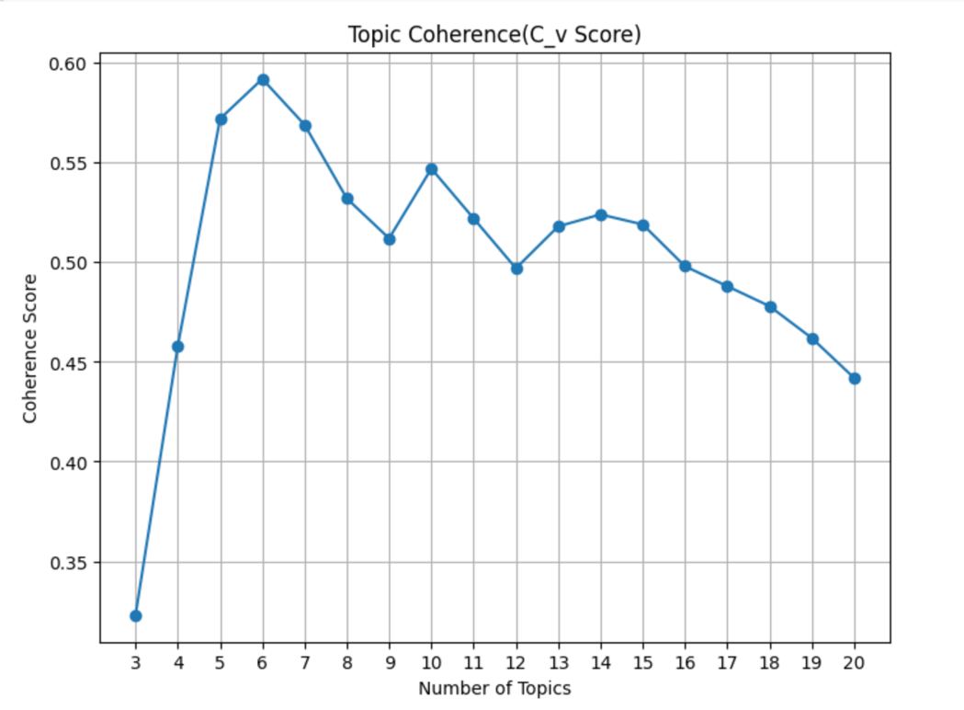

Table WE-1: Final word list used to measure rumination expression about service failure aspects

General service experience | Delivery | Price/Payment | Product/Service-related issues | Return | Employees
complaint | deliver | price | item | return | staff
service | delivery | cashier | purchase | scam | people
experience | delay | online | taste | exchange | center
terrible | pickup | website | guarantee | app | miss
horrible | way | issue | substitute | vendor | job
bad | check | phone | package | replace | hire
care | happen | update | look | refund | lady
get | vehicle | receive | clearance | confuse | worker
say | drive | technical | choice | nightmare | fire
tell | track | payment | review | change | seller
help | fedex | pay | feature | try | ruin
contact | ship | cost | design | cancel | nasty
check | wait | charge | photo |  | front
email | time |  | fix
speak | day |  | stuff
work
support
ignore
Excuse
excuse

Table WE-2. Operationalization, rationale, and sources of all variables

Variable | Operationalization | Source
Dependent Variable
“Likes” to posts | The number of “like” reactions a post receives. | Facebook data
“Likes” to firm’s responses to posts | The number of “like” reactions a firm’s response to a post receives. | Facebook data
Independent Variables
Rumination expressions about service failure aspects | LDA was used to model high-dimensional text data into distinct topics. We identified the frequency of words in the dictionary of each topic. Then, each post was categorized based on the topic it is most associated with. We then subtract 1 from the score of posts that mention topic words at least one time. We divide it by the total word counts per post and multiply by 1. | Facebook data
Rumination expressions about service failure causes | The average score of LIWC dictionary "cause" for all posts in a quarter. For each post, we calculate the number of times the "cause" words are mentioned. We subtract 1 from the frequency score and divide it by total word counts and multiply by 1. | Facebook data
The interaction between rumination expressions about service failure aspects and empathetic apology | The product of two variables: (1) rumination expressions about service failure aspects and (2) empathetic apology. The variable empathetic apology is created using the following procedure: first, the average score of "affective" dictionary from LIWC for all responses to posts is extracted. Then, the average score of apology dictionary adopted from Herhausen et al. (2019) to measure the apology language used in the response and is dummy-coded (1 = apology was mentioned; 0 = apology was not mentioned). Next, empathetic apology variable takes value 0 if expressions of apology is null and takes the value of empathy if expressions of apology is equal to 1. | Facebook data
The interaction between rumination expressions about service failure causes and empathetic apology | The product of two variables: (1) rumination expressions about service failure causes and (2) empathetic apology. | Facebook data
The interaction between rumination expressions about service failure aspects and compensation | The product of two variables: (1) rumination expressions about service failure aspects and (2) compensation. The variable compensation is the average score of compensation dictionary adopted from Herhausen et al. (2019) to measure the compensation language used in the firm’s response. The score is then categorized into a dummy, taking value 1 if the score is equal or greater than 1 and value 0 if the score is. | Facebook data
The interaction between rumination expressions about service failure causes and compensation | The product of two variables: (1) rumination expressions about service failure causes and (2) compensation. | Facebook data
Control Variables
Positive emotions | The average score of LIWC dictionary "posemo" for all posts in a quarter. For each post, we calculate the number of times the "posemo" words are mentioned. We divide it by total word counts and multiply it by 1. | Facebook data
Severity | The number of words in each post. | Facebook data
Negative emotions | The average score of LIWC dictionary "anger" for all posts in a quarter. For each post, we calculate the number of times the "anger" words are mentioned. We divide it by total word counts and multiply it by 1. | Facebook data
Personal pronoun | The average score of LIWC dictionary "pproun" for all posts in a quarter. For each post, we calculate the number of times the "pronounce" words are mentioned. We divide it by total word counts and multiply it by 1. | Facebook data
Breadth of complaints | The sum of all “aspects” words mentioned in a post minus the most frequently mentioned one. | Facebook data
Other channels | A dummy variable, which takes value 1 if a post mentions about other channels and value 0 if a post does not do so. “Other channel” words are adopted from Herhausen et al.’s (2019) dictionaries. | Facebook data
Ratio of low-rated reviews | The percentage of low-rated reviews (1* and 2* reviews) | Facebook data
No. total posts | Total number of posts of a firm in the study period. | Facebook data

Table WE-3. Mean statistics and correlation coefficients

 | Mean | SD | (1) | (2) | (3) | (4) | (5) | (6) | (7) | (8) | (9) | (10) | (11) | (12) | (13) | (14)
“Likes” to posts | 1.744 | 1.519
“Likes” to responses | .250 | 1.709 | .303
“Aspects” rumination | 1.895 | 2.841 | .017 | .043
“Causes” rumination | .320 | .879 | .005 | .013 | .434
Compensation | 1.705 | 3.329 | -.001 | .003 | .004 | .028
Empathetic apology | .027 | .162 | -.018 | -.017 | .042 | .010 | .008
Severity | 52.378 | 5.095 | -.024 | -.042 | .779 | .548 | .024 | .056
Negative emotions | .172 | 1.050 | .003 | -.001 | -.016 | -.013 | -.014 | .013 | -.021
Positive emotions | .361 | 1.398 | .010 | .017 | -.054 | -.019 | -.006 | -.005 | -.038 | .013
Pronoun words | 9.594 | 5.913 | -.014 | -.001 | .082 | .067 | .023 | .011 | .086 | .023 | -.006
Breadth of complaints | 2.220 | 2.797 | -.016 | -.029 | .730 | .444 | .029 | .033 | .794 | -.008 | -.038 | .059
Other channels | .353 | .478 | -.041 | -.032 | .029 | -.004 | -.038 | .035 | .052 | .007 | -.001 | .031 | .013
Ratio of low-rated reviews | .246 | .135 | -.049 | -.046 | .063 | -.033 | -.127 | .071 | .011 | .003 | .006 | -.001 | -.013 | .389
Total posts | 6,663 | 3,137 | -.043 | -.046 | .066 | -.038 | -.133 | .085 | .008 | .000 | .004 | -.007 | -.012 | .343 | .482

The Appropriateness check of the use of Gaussian Copula following Becker, Proksch, and Ringle (2022)

Following the flowchart to check the appropriateness of using Gaussian copula (Becker, Proksch, and Ringle 2022; pp.64), we first ensured that the intercepts were included in all estimations. Second, we needed to have the endogenous variables to be sufficiently non-normally distributed; otherwise, the standard errors would be very large, leading to a false conclusion of non-significance. We drew the distributions of the two endogenous variables (Figure WE-2) and conducted a Shapiro-Wilk test of normal distribution of the two endogenous variables (i.e., rumination expressions), and the results indicated that both variables were distributed non-normally (W_{Aspect rumination}=.800, Z_{Aspect rumination}=22.336, p< .001; W_{Cause rumination}=.848, Z_{Cause rumination}=21.582, p< .001). Hence, we satisfied the first two criteria. Third, we checked whether the regression residual in the estimation without copula was normally distributed. The error term, unfortunately, was not normally distributed (W_{Residual}=.613, Z_{Residual}=24.161, p< .001; Figure WD-4). However, as Eckert and Hohberger (2023) pointed out, “normally distributed residuals in the case of model misspecification do not necessarily reflect normally distributed error terms” (p. 8). They observe that prior exploration of the error structure using uniform distribution of the error term and nonnormal symmetric error distributions provides mixed results on the robustness of the Gaussian Copula approach to this assumption. Following Eckert and Hohberger’s (2023) arguments, we moved on to the next steps in Becker, Proksch, and Ringle's (2022) checklist of the sample size and skewness. Our sample size is larger than 2,000 and the skewness is larger than 2 (Skewness_{Aspect} = 3.149, Sknewness_{Cause} = 4.203) – the minimum numbers suggested by Becker, Proksch, and Ringle (2022). Hence, we satisfy these criteria as well and deem the use of the Gaussian copula in our estimations appropriate.

Figure WE-2: Distribution of the Endogenous Variables and the Error Terms
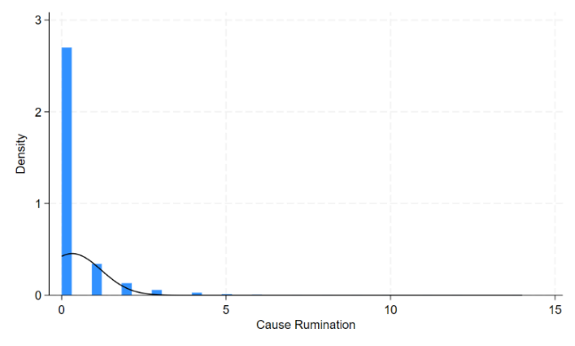
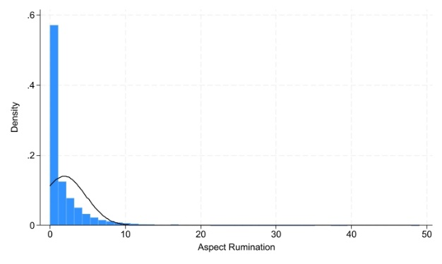
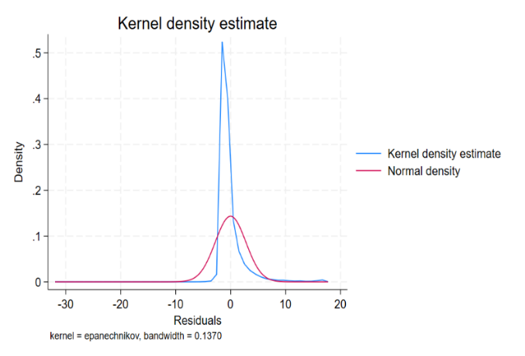

Web Appendix F: Experimental stimuli for Study 4a and 4b

Imagine that you are planning to go for a short relaxing trip for a summer getaway. After searching information online and reading some positive reviews, you are interested in Royal Hotel. Royal Hotel is recognized as a 3-star hotel on major hotel booking sites (e.g., Expedia, Hotels.com, Booking.com). The average rate at the hotel is £120/per night for a standard room.
Some information that you got from Royal Hotel’s website is:

Building/rooms
Clean and hygienic, and all mechanisms and equipment are functional and in a faultless condition.

Furniture/equipment
Toothbrush tumbler, soap and body wash, bath essential or shower gel, shampoo, cleansing tissue, and towels are available in the private bathroom. Double beds are a minimum of 1.80 m × 1.90 m. Large-screen HDTV with a remote control and telephone. Free Wi-Fi access.

Services
Daily room cleaning upon request. Free continental breakfast. 24-hour reception service. Free parking.

Five days prior to your trip, you double-check your reservation and read some more online reviews for Royal Hotel as you are not sure how to get there from the airport and you come across the following review on the hotel's Facebook page.
Study 4a
Strong Rumination Expressions about Service Failure Aspects
I booked this hotel after reading a number of positive reviews. However, their service was unacceptable. My room was close to the lounge bar and it was very noisy. The music was too loud. I could hear people singing and even screaming well till early morning. I talked to Royal receptionist about all this noise at night, but she didn’t look at me while talking and just ignored me saying that she couldn’t do anything to help with the noise. The noise and the whole unprofessional service destroyed my trip.
Weak Rumination Expressions about Service Failure Aspects
I booked this hotel after reading a number of positive reviews. However, their service was unacceptable. My room was close to the lounge bar, and it was very noisy well till early morning. I was not able to sleep at night during my trip. I talked to the Royal receptionist, but she didn’t look at me while talking and just ignored me saying that she couldn’t do anything to help. The whole unprofessional service destroyed my trip.

Study 4b
Strong Rumination Expressions about Service Failure Causes
On the first day, when I checked into my room, it had no hot water. I went to talk to the receptionist about the issue. She rudely told me that the boiler was not working, and nothing could be done soon! Hence, I was not able to take a shower after a tiring flight. I came to talk to the hotel manager next morning! But he didn't seem to care much, and they only fixed the boiler in the evening which caused me to stay dirty and filthy. My trip was destroyed due to their unacceptable service.
Weak Rumination Expressions about Service Failure Causes
On the first day, when I checked into my room, it had no hot water. I went to talk to the receptionist about the issue. She rudely told me that the boiler was not working, and nothing could be done soon! I came to talk to the hotel manager next morning! But he didn't seem to care much, and they only fixed the boiler in the evening. Their service was unacceptable.

Web Appendix G: Scenario Realism and Manipulation Check of Rumination Expressions (Study 4a and 4b)

Study 4a
Participants were also asked to rate scenario realism: “The description is realistic”, 1 = strongly disagree/ 7 = strongly agree (M_{strongc} = 5.47, SD_{strong} = 1.04; M_{weak} = 5.40, SD_{weak} = 1.15; F(1,192) = .21, p = .63 and above the midpoint of 4.0).
As a manipulation check of rumination expressions, we asked participants to indicate their perception of repetitive use of references to the issue with the hotel mentioned in the review (“The writer of the review mentions a specific issue with the hotel 1 = only one time/ 7 = several times”). Participants in the condition with strong expressions of rumination about the noise issue perceived more repetitions than participants who read the review with only one mentioning of the noise issue (M_{strong} = 4.25, SD_{strong} = 1.86 vs. M_{weak} = 3.14, SD_{weak} = 1.86; F(1,192) = 16.37, p < .001).

Study 4b
Scenarios with strong and weak expressions of rumination about service failure causes were similarly realistic (M_{strong} = 5.09, SD_{strong} = 1.27; M_{weak} = 5.11, SD_{weak} = 1.22; F(1, 198) = .02, p = .901 and above the midpoint of 4.0). The manipulation check (“The writer of the review mentions the causes and consequences of an issue with the hotel 1 = only one time/ 7 = several times”) was successful: M_{strong} = 4.39; SD_{strong} = 1.95 vs. M_{weak} = 3.17; SD_{weak} = 2.04; F(1,198) =18.38, p < .001.

References
Afifi, T., Afifi, W., Merrill, A. F., Denes, A., & Davis, S. (2013). “You need to stop talking about this!”: Verbal rumination and the costs of social support. Human Communication Research, 39(4), 395–421.
Allard, T., Dunn, L. H., & White, K. (2020). Negative reviews, positive impact: Consumer empathetic responding to unfair word of mouth. Journal of Marketing, 1–23.
Alloy, L. B., Abramson, L. Y., Hogan, M. E., Whitehouse, W. G., Rose, D. T., Robinson, M. S., Kim, R. S., & Lapkin, J. B. (2000). The temple-wisconsin cognitive vulnerability to depression project: Lifetime history of axis I psychopathology in individuals at high and low cognitive risk for depression. Journal of Abnormal Psychology, 109(3), 403–418.
Basuroy, S., Chatterjee, S., & Abraham Ravid, S. (2003). How critical are critical reviews? The box office effects of film critics, star power, and budgets. Journal of Marketing, 67(4), 103–117.
Becker, J. M., Proksch, D., & Ringle, C. M. (2022). Revisiting Gaussian copulas to handle endogenous regressors. Journal of the Academy of Marketing Science, 50, 46–66.
Berger, J., Sorensen, A. T., & Rasmussen, S. J. (2010). Positive effects of negative publicity: When negative reviews increase sales. Marketing Science, 29(5), 815–827.
Chevalier, J. A., Dover, Y., & Mayzlin, D. (2018). Channels of impact: User reviews when quality Is dynamic and managers respond. Marketing Science, 37(5), 1–22.
Chevalier, J. A., & Mayzlin, D. (2006). The effect of word of mouth on sales: Online book reviews. Journal of Marketing Research, 43(3), 345–354.
Conway, M., Csank, P. A. R., Holm, S. L., & Blake, C. K. (2000). On assessing individual differences in rumination on sadness. Journal of Personality Assessment, 75(3), 404–425.
Davidow, M. (2003). Organizational responses to customer complaints: What works and what doesn’t. Journal of Service Research, 5(3), 225–25.
Denson, T. F., Moulds, M. L., & Grisham, J. R. (2012). The effects of analytical rumination, reappraisal, and distraction on anger experience. Behavior Therapy, 43(2), 355–364.
Dost, F., Phieler, U., Haenlein, M., & Libai, B. (2019). Seeding as part of the marketing mix: Word-of-mouth program interactions for fast-moving consumer goods. Journal of Marketing, 83(2), 62–81.
Eckert, C., & Hohberger, J. (2023). Addressing endogeneity without instrumental variables: An evaluation of the gaussian copula approach for management research. Journal of Management, 49(4), 1460-1495.
Golmohammadi, A., Gauri, D. K., & Mirahmad, H. (2023). Social media communication and company value: The moderating role of industry competitiveness. Journal of Service Research, 26(1), 120-135.
Grisham, J. R., Flower, K. N., Williams, A. D., & Moulds, M. L. (2011). Reappraisal and rumination during recall of a sad memory. Cognitive Therapy and Research, 35, 276–283.
Herhausen, D., Grewal, L., Cummings, K. H., Roggeveen, A. L., Villarroel Ordenes, F., & Grewal, D. (2023). Complaint De-Escalation Strategies on Social Media. Journal of Marketing, 87(2), 210-231.
Herhausen, D., Ludwig, S., Grewal, D., Wulf, J., & Schoegel, M. (2019). Detecting, preventing, and mitigating online firestorms in brand communities. Journal of Marketing, 83(3), 1–21.
Hollenbeck, B. (2018). Online reputation mechanisms and the decreasing value of chain affiliation. Journal of Marketing Research, 55(5), 636–654.
Kähr, A., Nyffenegger, B., Krohmer, H., & Hoyer, W. D. (2016). When hostile consumers wreak havoc on your Brand: The phenomenon of consumer brand sabotage. Journal of Marketing, 80(3), 25–41.
Lisjak, M., Bonezzi, A., Kim, S., & Rucker, D. D. (2015). Perils of compensatory consumption: Within-domain compensation undermines subsequent self-regulation. Journal of Consumer Research, 41, 1186–1203.
Liu, Q. Q., Zhou, Z. K., Yang, X. J., Kong, F. C., Sun, X. J., & Fan, C. Y. (2018). Mindfulness and sleep quality in adolescents: analysis of rumination as a mediator and self-control as a aoderator. Personality and Individual Differences, 122(October 2017), 171–176. h
Ludwig, S., De Ruyter, K., Friedman, M., Brüggen, E. C., Wetzeis, I., & Pfann, G. (2013). More than words: The influence of affective content and linguistic style matches in online reviews on conversion rates. Journal of Marketing, 77, 87–103.
Marin, K. A., & Rotondo, E. K. (2017). Rumination and self-reflection in stress narratives and relations to psychological functioning. Memory, 25(1), 44–56.
McGraw, A. P., & Kan, C. (2015). Humorous complaining. Journal of Consumer Research, 41(February), 1153–1171.
Moore, S. G. (2015). Attitude predictability and helpfulness in online reviews: The role of explained actions and reactions. Journal of Consumer Research, 42, 30–44.
Mor, N., & Winquist, J. (2002). Self-focused attention and negative affect: A Meta-analysis. Psychological Bulletin, 128(4), 638–662.
Nolen-Hoeksema, S. (1991). Responses to depression and their effects on the duration of depressive episodes. Journal of Abnormal Psychology, 100(4), 569–582.
Norvig, P. (2007). How to write a spelling corrector. De: http://norvig. com/spell-correct. html.
Porath, C., Macinnis, D., & Folkes, V. (2010). Witnessing incivility among employees: Effects on consumer anger and negative inferences about companies. Journal of Consumer Research, 37, 292–303.
Roschk, H., & Kaiser, S. (2013). The Nature of an Apology: An experimental study on how to apologize after a service failure. Marketing Letters, 24, 293–309.
Rusting, C. L., & Nolen-Hoeksema, S. (1998). Regulating responses to anger: effects of rumination and distraction on angry mood. Journal of Personality and Social Psychology, 74(3), 790–803.
Sievert, C., & Shirley, K. (2014). LDAvis: A method for visualizing and interpreting topics. Proceedings Ofthe Workshop on Interactive Language Learning, Visualization, and Interfaces, 63–7.
Strizhakova, Y., Tsarenko, Y., & Ruth, J. A. (2012). “‘I’m mad and I can’t get that service failure off my mind’”: Coping and rumination as mediators of anger effects on customer intentions. Journal of Service Research, 15(4), 414–429.
Umashankar, N., Ward, M. K., & Dahl, D. W. (2017). The benefit of becoming friends: complaining after service failures leads customers with strong ties to increase loyalty. Journal of Marketing, 81(6), 79–98.
Wang, M., Liu, S., Liao, H., Gong, Y., Kammeyer-Mueller, J., & Shi, J. (2013). Can’t get it out of my mind: Employee rumination after customer mistreatment and negative mood in the next morning. The Journal of Applied Psychology, 98(6), 989–1004.
Wang, Y., & Chaudhry, A. (2018). When and how managers’ responses to online reviews affect subsequent reviews. Journal of Marketing Research, LV(April), 163–177.
Watkins, E. (2004). Adaptive and maladaptive ruminative self-focus during emotional processing. Behaviour Research and Therapy, 42, 1037–1052.
Yin, D., Bond, S. D., & Zhang, H. (2019). Anger in consumer reviews: Unhelpful but persuasive? MIS Quarterly. https://ssrn.com/abstract=3588859
Yin, D., Bond, S. D., & Zhang, H. (2014). Anxious or angry? Effects of discrete emotions on the perceived helpfulness of online reviews. MIS quarterly, 38(2), 539-560.

