Web Appendices

Dynamics of Pre-Release Consumer Buzz:
Driving Communication, Search, and Participation for Market Performance

Web Appendix A—PRCB versus WOM 2
Table A. Differences between PRCB and WOM 2
Web Appendix B—Movie Details 3
Table B. List of Movies 3
Web Appendix C—Details of VAR-X Models 10
Table C1. Unit Root Tests 10
Table C2. Lag Length Criteria (Focal Buzz Model) 11
Table C3. VAR-X Model Estimates (Focal Buzz Model) 12
Figure C1. IRFs of Digital and Traditional Mass Media Advertising 15
Figure C2. IRFs with Participation (Comments) and Participation (Tweets) 16
Figure C3. IRFs with Significant Dynamic Effects Involving Valence 17
Web Appendix D—Investigation of Different Lag Structures 18
Table D. Accumulated Effects on Buzz Behaviors over Two Weeks 18
Web Appendix E—Robustness Checks (Alternative Measures and Additional Predictors) 19
Table E. Impact of PRCB on Market Performance (Alternative Models) 20
Web Appendix F—Exploratory Interactions 21
Table F. Impact of PRCB on Market Performance with Exploratory Interactions (Star Power and Sequel/Adaptation) 21

Web Appendix A—PRCB versus WOM

Table A. Differences between PRCB and WOM
 | Pre-Release  Consumer Buzz | Post-Consumption Behaviors (e.g. word-of-mouth)
Phase | Pre-release phase | Post-release phase
Evaluations | Anticipation-based, speculative | Experience-based, concrete
Psychological States | Interest, hope, excitement, longing, desire for vicarious consumption, expected quality | Interest, satisfaction, dissatisfaction, perceived quality, perceived value
Construct Type | Aggregate-level/market level construct | Individual-level/message-level construct
Valence | Predominantly positive | Positive or negative
Sources: Houston et al. 2018; Karniouchina 2011; Xiong and Bharadwaj 2014.

References cited in Table A
Houston, Mark B., Ann-Kristin Kupfer, Thorsten Hennig-Thurau, and Martin Spann (2018), “Pre-Release Consumer Buzz,” Journal of the Academy of Marketing Science, 46 (2), 338-360.
Karniouchina, Ekaterina V. (2011), “Impact of Star and Movie Buzz on Motion Picture Distribution and Box Office Revenue,” International Journal of Research in Marketing, 28 (1), 62-74.
Xiong, Guiyang and Sundar Bharadwaj (2014), “Prerelease Buzz Evolution Patterns and New Product Performance,” Marketing Science, 33 (3), 401-421.

Web Appendix B—Movie Details

Table B. List of Movies
No. | Title | Genre | MPAA Rating | Release Date | Official Hashtag
1 | Rogue One: A Star Wars Story | Sci-Fi | PG-13 | 12/16/2016 | #RogueOne
2 | Finding Dory | Animation | PG | 6/17/2016 | #FindingDory
3 | Captain America: Civil War | Sci-Fi | PG-13 | 5/6/2016 | #CaptainAmericaCivilWar
4 | The Secret Life of Pets | Animation | PG | 7/8/2016 | #TheSecretLifeofPets
5 | The Jungle Book | Drama | PG | 4/15/2016 | #JungleBook
6 | Deadpool | Action | R | 2/12/2016 | #Deadpool
7 | Zootopia | Animation | PG | 3/4/2016 | #Zootopia
8 | Batman v Superman: Dawn of Justice | Fantasy | PG-13 | 3/25/2016 | #BatmanvSuperman
9 | Suicide Squad | Fantasy | PG-13 | 8/5/2016 | #SuicideSquad
10 | Sing | Animation | PG | 12/21/2016 | #SingMovie
11 | Moana | Animation | PG | 11/23/2016 | #Moana
12 | Fantastic Beasts and Where to Find Them | Fantasy | PG-13 | 11/18/2016 | #fantasticbeasts
13 | Doctor Strange | Fantasy | PG-13 | 11/4/2016 | #DoctorStrange
14 | Hidden Figures | History | PG | 12/25/2016 | #HiddenFigures
15 | Jason Bourne | Action | PG-13 | 7/29/2016 | #JasonBourne
16 | Star Trek Beyond | Sci-Fi | PG-13 | 7/22/2016 | #startrekbeyond
17 | X-Men: Apocalypse | Sci-Fi | PG-13 | 5/27/2016 | #XMenApocalypse
18 | Trolls | Animation | PG | 11/4/2016 | #DreamWorksTrolls
19 | La La Land | Music | PG-13 | 12/9/2016 | #LALALAND
20 | Kung Fu Panda 3 | Animation | PG | 1/29/2016 | #KungFuPanda
21 | Ghostbusters | Fantasy | PG-13 | 7/15/2016 | #Ghostbusters
22 | Central Intelligence | Comedy | PG-13 | 6/17/2016 | #CentralIntelligence
23 | The Legend of Tarzan | Adventure | PG-13 | 7/1/2016 | #LegendOfTarzan
24 | Sully | Drama | PG-13 | 9/9/2016 | #SULLY
25 | Bad Moms | Comedy | R | 7/29/2016 | #BadMoms
26 | The Angry Birds Movie | Animation | PG | 5/20/2016 | #AngryBirdsMovie
27 | Independence Day: Resurgence | Sci-Fi | PG-13 | 6/24/2016 | #IndependenceDay
28 | The Conjuring 2: The Enfield Poltergeist | Horror | R | 6/10/2016 | #theconjuring2
29 | Arrival | Sci-Fi | PG-13 | 11/11/2016 | #ArrivalMovie
30 | Passengers | Sci-Fi | PG-13 | 12/21/2016 | #PassengersMovie
31 | Sausage Party | Animation | R | 8/12/2016 | #SausagePartyMovie
32 | The Magnificent Seven | Western | PG-13 | 9/23/2016 | #TheMagnificentSeven
33 | Ride Along 2 | Comedy | PG-13 | 1/15/2016 | #RideAlong2
34 | Don’t Breathe | Horror | R | 8/26/2016 | #DontBreathe
35 | Miss Peregrine’s Home for Peculiar Children | Fantasy | PG-13 | 9/30/2016 | #StayPeculiar
36 | The Accountant | Thriller | R | 10/14/2016 | #TheAccountant
37 | Teenage Mutant Ninja Turtles: Out of the Shadows | Sci-Fi | PG-13 | 6/3/2016 | #TMNT2
38 | The Purge: Election Year | Horror | R | 7/1/2016 | #ThePurge
39 | Alice Through the Looking Glass | Fantasy | PG | 5/27/2016 | #ThroughTheLookingGlass
40 | Pete’s Dragon | Fantasy | PG | 8/12/2016 | #PetesDragon
41 | The Girl on the Train | Mystery | R | 10/7/2016 | #TheGirlOnTheTrain
42 | Boo! A Madea Halloween | Horror | PG-13 | 10/21/2016 | #madea
43 | Storks | Animation | PG | 9/23/2016 | #STORKS
44 | 10 Cloverfield Lane | Horror | PG-13 | 3/11/2016 | #Cloverfield
45 | Lights Out | Horror | PG-13 | 7/22/2016 | #LightsOut
46 | Hacksaw Ridge | History | R | 11/4/2016 | #HacksawRidge
47 | Now You See Me 2 | Adventure | PG-13 | 6/10/2016 | #NowYouSeeMe2
48 | Ice Age: Collision Course | Animation | PG | 7/22/2016 | #IceAge
49 | The Boss | Comedy | R | 4/8/2016 | #LikeABoss
50 | London Has Fallen | Action | R | 3/4/2016 | #LondonHasFallen
51 | Miracles from Heaven | Drama | PG | 3/16/2016 | #MiraclesFromHeaven
52 | Deepwater Horizon | Drama | PG-13 | 9/30/2016 | #DeepwaterHorizon
53 | Why Him? | Comedy | R | 12/23/2016 | #WhyHim
54 | My Big Fat Greek Wedding 2 | Romance | PG-13 | 3/25/2016 | #MyBigFatGreekWedding2
55 | Jack Reacher: Never Go Back | Action | PG-13 | 10/21/2016 | #JackReacherMovie
56 | Fences | Drama | PG-13 | 12/16/2016 | #FencesMovie
57 | Me Before You | Romance | PG-13 | 6/3/2016 | #MeBeforeYou
58 | The BFG | Fantasy | PG | 7/1/2016 | #TheBFG
59 | Neighbors 2: Sorority Rising | Comedy | R | 5/20/2016 | #Neighbors2
60 | The Shallows | Horror | PG-13 | 6/24/2016 | #TheShallows
61 | Office Christmas Party | Comedy | R | 12/9/2016 | #OfficeXmasParty
62 | Assassin’s Creed | Sci-Fi | PG-13 | 12/21/2016 | #AssassinsCreedMovie
63 | Barbershop: The Next Cut | Comedy | PG-13 | 4/15/2016 | #BarbershopMovie
64 | 13 Hours: The Secret Soldiers of Benghazi | History | R | 1/15/2016 | #13hours
65 | Lion | Drama | PG-13 | 11/25/2016 | #LionMovie
66 | Kubo and the Two Strings | Animation | PG | 8/19/2016 | #KuboMovie
67 | The Huntsman: Winter’s War | Adventure | PG-13 | 4/22/2016 | #TheHuntsman
68 | Manchester by the Sea | Drama | R | 11/18/2016 | #manchesterbythesea
69 | Warcraft | Fantasy | PG-13 | 6/10/2016 | #WarcraftMovie
70 | How to be Single | Romance | R | 2/12/2016 | #HowToBeSingle
71 | Mike and Dave Need Wedding Dates | Comedy | R | 7/8/2016 | #MikeAndDave
72 | War Dogs | Thriller | R | 8/19/2016 | #WarDogs
73 | Almost Christmas | Comedy | PG-13 | 11/11/2016 | #AlmostChristmas
74 | Money Monster | Thriller | R | 5/13/2016 | #MoneyMonster
75 | Allied | Romance | R | 11/23/2016 | #AlliedMovie
76 | Nerve | Thriller | PG-13 | 7/27/2016 | #Nerve
77 | Risen | Drama | PG-13 | 2/19/2016 | #RisenMovie
78 | The Nice Guys | Thriller | R | 6/3/2016 | #TheNiceGuys
79 | The Boy | Horror | PG-13 | 1/22/2016 | #TheBoyMovie
80 | Dirty Grandpa | Comedy | R | 1/22/2016 | #DirtyGrandpa
81 | Ouija: Origin of Evil | Horror | PG-13 | 10/21/2016 | #OuijaMovie
82 | The 5th Wave | Drama | PG-13 | 1/22/2016 | #5thWaveMovie
83 | Inferno | Thriller | PG-13 | 10/28/2016 | #InfernoMovie
84 | Mother’s Day | Romance | PG-13 | 4/29/2016 | #MothersDayMovie
85 | Patriots Day | Drama | R | 12/21/2016 | #PatriotsDayMovie
86 | Gods of Egypt | Fantasy | PG-13 | 2/26/2016 | #GodsOfEgypt
87 | Collateral Beauty | Drama | PG-13 | 12/16/2016 | #CollateralBeauty
88 | Hail, Caesar! | Comedy | PG-13 | 2/5/2016 | #HailCaesar
89 | When the Bough Breaks | Horror | PG-13 | 9/9/2016 | #WhenTheBoughBreaks
90 | Zoolander 2 | Comedy | PG-13 | 2/12/2016 | #Zoolander2
91 | Moonlight | Drama | R | 10/21/2016 | #MOONLIGHT
92 | The Finest Hours | History | PG | 1/29/2016 | #TheFinestHours
93 | Florence Foster Jenkins | Drama | PG-13 | 8/12/2016 | #FlorenceFosterJenkins
94 | Hell or High Water | Thriller | R | 8/12/2016 | #HOHWMovie
95 | The Forest | Horror | PG-13 | 1/8/2016 | #TheForestIsReal
96 | Ben-Hur | History | PG-13 | 8/19/2016 | #BENHUR
97 | The Witch | Horror | R | 2/19/2016 | #TheWitchMovie
98 | Bridget Jones’s Baby | Romance | R | 9/16/2016 | #BridgetJonesBaby
99 | Kevin Hart: What Now? | Comedy | R | 10/14/2016 | #KevinHartWhatNow
100 | Whiskey Tango Foxtrot | Drama | R | 3/4/2016 | #WhiskeyTangoFoxtrot
101 | Snowden | Thriller | R | 9/16/2016 | #Snowdenmovie
102 | Mechanic: Resurrection | Action | R | 8/26/2016 | #MechanicResurrection
103 | Free State of Jones | Drama | R | 6/24/2016 | #FreeStateOfJones
104 | Blair Witch | Horror | R | 9/16/2016 | #BlairWitch
105 | God’s Not Dead 2 | Drama | PG | 4/1/2016 | #GodsNotDead2
106 | Keanu | Comedy | R | 4/29/2016 | #Keanu
107 | Middle School: The Worst Years of My Life | Comedy | PG | 10/7/2016 | #MiddleSchoolMovie
108 | Nine Lives | Comedy | PG | 8/5/2016 | #NineLives
109 | Race | Sport | PG-13 | 2/19/2016 | #RACEmovie
110 | The Choice | Romance | PG-13 | 2/5/2016 | #TheChoice
111 | Eye in the Sky | Drama | R | 3/11/2016 | #EyeInTheSky
112 | Bad Santa 2 | Comedy | R | 11/23/2016 | #ThisIsBS
113 | Masterminds | Comedy | PG-13 | 9/30/2016 | #Masterminds
114 | Norm of the North | Animation | PG | 1/15/2016 | #NormOfTheNorth
115 | The Birth of a Nation | History | R | 10/7/2016 | #TheBirthOfANation
116 | Eddie the Eagle | Drama | PG-13 | 2/26/2016 | #EddieTheEagle
117 | The Infiltrator | Thriller | R | 7/13/2016 | #TheInfiltrator
118 | Keeping Up with the Joneses | Comedy | PG-13 | 10/21/2016 | #KeepingUpWithTheJoneses
119 | Criminal | Thriller | R | 4/15/2016 | #CriminalMovie
120 | Hello, My Name is Doris | Romance | R | 3/11/2016 | #HelloMyNameisDoris
121 | The Edge of Seventeen | Drama | R | 11/18/2016 | #EdgeOf17
122 | Love & Friendship | Comedy | PG | 5/13/2016 | #LoveAndFriendship
123 | Jackie | History | R | 12/2/2016 | #JackieFilm
124 | Hillary’s America | History | PG-13 | 7/15/2016 | #HillarysAmerica
125 | Triple 9 | Thriller | R | 2/26/2016 | #Triple9
126 | The Light Between Oceans | Romance | PG-13 | 9/2/2016 | #LightBetweenOceans
127 | Fifty Shades of Black | Comedy | R | 1/29/2016 | #FiftyShadesOfBlack
128 | Café Society | Romance | PG-13 | 7/15/2016 | #CafeSociety
129 | The Darkness | Horror | PG-13 | 5/13/2016 | #TheDarkness
130 | Nocturnal Animals | Thriller | R | 11/18/2016 | #NocturnalAnimals
131 | Live by Night | Thriller | R | 12/25/2016 | #LiveByNight
132 | The Lady in the Van | Drama | PG-13 | 1/15/2016 | #LadyInTheVan
133 | The Perfect Match | Romance | R | 3/11/2016 | #ThePerfectMatch
134 | Hardcore Henry | Action | R | 4/8/2016 | #HardcoreHenry
135 | The Lobster | Comedy | R | 5/13/2016 | #TheLobster
136 | Meet the Blacks | Horror | R | 4/1/2016 | #meettheblacks
137 | Queen of Katwe | Drama | PG | 9/23/2016 | #QueenOfKatwe
138 | Ratchet and Clank | Animation | PG | 4/29/2016 | #RatchetAndClank
139 | Robinson Crusoe | Animation | PG | 9/9/2016 | #TheWildLife
140 | A Beautiful Planet | Documentary | G | 4/29/2016 | #ABeautifulPlanet
141 | Loving | Drama | PG-13 | 11/4/2016 | #ThisisLoving
142 | Silence | Drama | R | 12/23/2016 | #SilenceMovie
143 | Shut In | Thriller | R | 11/11/2016 | #ShutIn
144 | The Brothers Grimsby | Comedy | R | 3/11/2016 | #TheBrothersGrimsby
145 | The Young Messiah | Drama | PG-13 | 3/11/2016 | #TheYoungMessiah
146 | Southside with You | Drama | PG-13 | 8/26/2016 | #SouthsideWithYou
147 | Captain Fantastic | Drama | R | 7/8/2016 | #CaptainFantastic
148 | 20th Century Women | Drama | R | 12/25/2016 | #20thCenturyWomen
149 | Hunt for the Wilderpeople | Adventure | PG-13 | 6/24/2016 | #Wilderpeople
150 | Bleed for This | Sport | R | 11/18/2016 | #BleedForThis
151 | Incarnate | Horror | PG-13 | 12/2/2016 | #Incarnate
152 | Absolutely Fabulous: The Movie | Comedy | R | 7/1/2016 | #AbFabMovie
153 | Hands of Stone | Sport | R | 8/26/2016 | #HandsOfStone
154 | Don’t Think Twice | Comedy | R | 7/22/2016 | #DontThinkTwice
155 | The Meddler | Comedy | PG-13 | 4/22/2016 | #TheMeddler
156 | A Hologram for the King | Drama | R | 4/22/2016 | #AHologramForTheKing
157 | Swiss Army Man | Adventure | R | 6/24/2016 | #SwissArmyMan
158 | Denial | Drama | PG-13 | 9/30/2016 | #DENIAL
159 | The Man Who Knew Infinity | Drama | PG-13 | 4/29/2016 | #TheManWhoKnewInfinity
160 | Where to Invade Next | Documentary | R | 2/12/2016 | #WhereToInvadeNext
161 | Midnight Special | Mystery | PG-13 | 3/18/2016 | #MidnightSpecial
162 | Rules Don’t Apply | Romance | PG-13 | 11/23/2016 | #RulesDontApply
163 | Miss Sloane | Thriller | R | 11/25/2016 | #MissSloane
164 | En man som heter Ove | Drama | PG-13 | 9/30/2016 | #OveFilm
165 | Indignation | Drama | R | 7/29/2016 | #Indignation
166 | Everybody Wants Some | Comedy | R | 3/30/2016 | #EverybodyWantsSome
167 | Maggie’s Plan | Romance | R | 5/20/2016 | #MaggiesPlan
168 | Green Room | Horror | R | 4/15/2016 | #GreenRoomMovie
169 | The Eagle Huntress | Documentary | G | 11/2/2016 | #EagleHuntress
170 | Our Kind of Traitor | Thriller | R | 7/1/2016 | #OurKindofTraitor
171 | Compadres | Comedy | R | 4/22/2016 | #Compadres
172 | Monster Trucks | Action | PG | 1/13/2017 | #MonsterTrucks
173 | The Great Wall | Fantasy | PG-13 | 2/17/2017 | #TheGreatWall
174 | Kong: Skull Island | Fantasy | PG-13 | 3/10/2017 | #KongSkullIsland
175 | The Belko Experiment | Horror | R | 3/17/2017 | #BelkoExperiment
176 | CHiPS | Comedy | R | 3/24/2017 | #CHIPSMovie
177 | Colossal | Sci-Fi | R | 4/14/2017 | #SheIsCOLOSSAL
178 | Sleight | Mystery | R | 4/28/2017 | #SleightMovie
179 | Snatched | Comedy | R | 5/12/2017 | #SnatchedMovie
180 | King Arthur: Legend of the Sword | Adventure | PG-13 | 5/12/2017 | #KingArthur
181 | Baywatch | Comedy | R | 5/25/2017 | #Baywatch
182 | Baby Driver | Action | R | 6/28/2017 | #BabyDriver
183 | Dunkirk | History | PG-13 | 7/21/2017 | #Dunkirk
184 | Kidnap | Thriller | R | 8/4/2017 | #KidnapMovie
185 | The Hitman’s Bodyguard | Comedy | PG-13 | 8/18/2017 | #HitmansBodyguard
186 | Birth of the Dragon | Action | PG-13 | 8/25/2017 | #BirthoftheDragon
187 | American Made | Action | R | 9/29/2017 | #AmericanMade
188 | Geostorm | Sci-Fi | PG-13 | 10/20/2017 | #Geostorm
189 | Hostiles | Western | R | 1/26/2018 | #Hostiles
190 | Gold | Adventure | R | 1/27/2017 | #GoldMovie
191 | The Space Between Us | Romance | PG-13 | 2/3/2017 | #TheSpaceBetweenUs
192 | Lowriders | Drama | PG-13 | 5/12/2017 | #Lowriders
193 | 47 Meters Down | Horror | PG-13 | 6/16/2017 | #47MetersDown
194 | Maudie | Drama | PG-13 | 6/16/2017 | #maudie
195 | The Shape of Water | Fantasy | R | 12/22/2017 | #TheShapeofWater
196 | The Lego Batman Movie | Animation | PG | 2/10/2017 | #LEGOBatmanMovie
197 | The Emoji Movie | Animation | PG | 7/28/2017 | #EmojiMovie
198 | The Lego Ninjago Movie | Animation | PG | 9/22/2017 | #LEGONINJAGOMovie
199 | Loving Vincent | Animation | PG-13 | 9/22/2017 | #LovingVincent
200 | My Little Pony: The Movie | Animation | PG | 10/6/2017 | #MyLittlePonyMovie
201 | Coco | Animation | PG | 11/22/2017 | #PixarCoco
202 | The Founder | Drama | PG-13 | 1/20/2017 | #TheFounder
203 | A United Kingdom | Drama | PG-13 | 2/10/2017 | #AUnitedKingdom
204 | Megan Leavey | Drama | PG-13 | 6/9/2017 | #MeganLeavey
205 | All Eyez on Me | Music | R | 6/16/2017 | #AllEyezOnMe
206 | Maudie | Drama | PG-13 | 6/16/2017 | #Maudie
207 | Battle of the Sexes | Sport | PG-13 | 9/29/2017 | #BattleOfTheSexes
208 | Stronger | Drama | R | 9/29/2017 | #StrongerMovie
209 | Marshall | Drama | R | 10/13/2017 | #MarshallMovie
210 | Only the Brave | Drama | PG-13 | 10/20/2017 | #OnlyTheBrave
211 | The Greatest Showman | Music | PG | 12/20/2017 | #GreatestShowman
212 | Darkest Hour | History | PG-13 | 12/22/2017 | #DarkestHour
213 | The Post | History | PG-13 | 1/12/2018 | #ThePost
214 | I, Tonya | Drama | R | 1/19/2018 | #ITonya
215 | Fist Fight | Comedy | R | 2/17/2017 | #FistFight
216 | Table 19 | Comedy | PG-13 | 3/3/2017 | #Table19
217 | How to Be a Latin Lover | Comedy | PG-13 | 4/28/2017 | #HowToBeALatinLover
218 | Paris Can Wait | Comedy | PG | 5/12/2017 | #ParisCanWait
219 | Beatriz at Dinner | Drama | R | 6/9/2017 | #BeatrizatDinner
220 | The Hero | Drama | R | 6/9/2017 | #TheHeroMovie
221 | Rough Night | Comedy | R | 6/16/2017 | #RoughNightMovie
222 | The House | Comedy | R | 6/30/2017 | #TheHouse
223 | The Big Sick | Romance | R | 7/14/2017 | #TheBigSick
224 | Girls Trip | Comedy | R | 7/21/2017 | #GirlsTrip
225 | Logan Lucky | Thriller | PG-13 | 8/18/2017 | #LoganLucky
226 | Ingrid Goes West | Drama | R | 8/25/2017 | #IngridGoesWest
227 | Home Again | Romance | PG-13 | 9/8/2017 | #HomeAgainMovie
228 | Three Billboards Outside Ebbing, Missouri | Drama | R | 12/1/2017 | #ThreeBillboards
229 | Lady Bird | Drama | R | 12/1/2017 | #LadyBird
230 | Father Figures | Comedy | R | 12/22/2017 | #FatherFigures
231 | The Book of Henry | Drama | PG-13 | 6/23/2017 | #TheBookofHenry
232 | Detroit | Thriller | R | 8/4/2017 | #DetroitMovie
233 | Wind River | Mystery | R | 8/18/2017 | #WindRiver
234 | Roman J. Israel, Esq. | Drama | PG-13 | 11/22/2017 | #RomanIsraelMovie
235 | I Am Not Your Negro | Documentary | PG-13 | 2/17/2017 | #IAmNotYourNegro
236 | Born in China | Documentary | G | 4/21/2017 | #BornInChina
237 | Gifted | Drama | PG-13 | 4/12/2017 | #GiftedMovie
238 | Norman | Drama | R | 4/14/2017 | #Norman
239 | Unforgettable | Thriller | R | 4/21/2017 | #UnforgettableMovie
240 | The Promise | History | PG-13 | 4/21/2017 | #KeepThePromise
241 | All Saints | Drama | R | 8/25/2017 | #AllSaintsMovie
242 | mother! | Horror | R | 9/15/2017 | #mothermovie
243 | The Florida Project | Drama | R | 10/6/2017 | #TheFloridaProject
244 | Let There Be Light | Drama | PG-13 | 11/3/2017 | #LTBLfilm
245 | Downsizing | Sci-Fi | R | 12/22/2017 | #Downsizing
246 | Phantom Thread | Romance | R | 1/19/2018 | #PhantomThread
247 | Wish Upon | Horror | PG-13 | 7/14/2017 | #WishUpon
248 | Get Out | Horror | R | 2/24/2017 | #GetOut
249 | Life | Horror | R | 3/24/2017 | #LifeMovie
250 | Phoenix Forgotten | Horror | PG-13 | 4/21/2017 | #PhoenixForgotten
251 | It Comes at Night | Horror | R | 6/9/2017 | #ItComesAtNight
252 | Friend Request | Horror | R | 9/22/2017 | #FriendRequest
253 | Happy Death Day | Horror | PG-13 | 10/13/2017 | #HappyDeathDay
254 | Underworld: Blood Wars | Fantasy | R | 1/6/2017 | #UnderworldMovie
255 | xXx: Return of Xander Cage | Action | PG-13 | 1/20/2017 | #xXxTheMovie
256 | Resident Evil: The Final Chapter | Horror | R | 1/27/2017 | #ResidentEvilMovie
257 | John Wick: Chapter Two | Action | R | 2/10/2017 | #JohnWick2
258 | The Fate of the Furious | Action | PG-13 | 4/14/2017 | #F8
259 | Guardians of the Galaxy Vol 2 | Sci-Fi | PG-13 | 5/5/2017 | #GuardiansoftheGalaxy
260 | Pirates of the Caribbean: Dead Men Tell No Tales | Fantasy | PG-13 | 5/26/2017 | #PiratesLife
261 | Transformers: The Last Knight | Sci-Fi | PG-13 | 6/21/2017 | #Transformers
262 | Star Wars Ep. VIII: The Last Jedi | Fantasy | PG-13 | 12/15/2017 | #TheLastJedi
263 | Jumanji: Welcome to the Jungle | Adventure | PG-13 | 12/20/2017 | #JUMANJI
264 | A Bad Moms Christmas | Comedy | R | 11/1/2017 | #BadMomsXmas
265 | Cars 3 | Animation | G | 6/16/2017 | #Cars3
266 | Despicable Me 3 | Animation | PG | 6/30/2017 | #DespicableMe3
267 | The Nut Job 2: Nutty by Nature | Animation | PG | 8/11/2017 | #TheNutJob2
268 | Tyler Perry’s Boo 2! A Madea Halloween | Comedy | PG-13 | 10/20/2017 | #Boo2
269 | Daddy’s Home 2 | Comedy | PG-13 | 11/10/2017 | #DaddysHome2
270 | Pitch Perfect 3 | Music | PG-13 | 12/22/2017 | #PitchPerfect3
271 | Jigsaw | Horror | R | 10/27/2017 | #JigsawMovie
272 | An Inconvenient Sequel | Documentary | PG-13 | 8/4/2017 | #BeInconvenient
273 | Rings | Horror | PG-13 | 2/3/2017 | #RINGS
274 | Blade Runner 2049 | Sci-Fi | R | 10/6/2017 | #BladeRunner2049
275 | Split | Thriller | PG-13 | 1/20/2017 | #Split
276 | Alien: Covenant | Sci-Fi | R | 5/19/2017 | #AlienCovenant
277 | Annabelle: Creation | Horror | R | 8/11/2017 | #AnnabelleCreation
278 | Sleepless | Thriller | R | 1/13/2017 | #SleeplessMovie
279 | Power Rangers | Sci-Fi | PG-13 | 3/24/2017 | #PowerRangersMovie
280 | The Mummy | Fantasy | PG-13 | 6/9/2017 | #TheMummy
281 | Going in Style | Comedy | PG-13 | 4/7/2017 | #GoingInStyle
282 | Flatliners | Sci-Fi | PG-13 | 9/29/2017 | #FlatlinersMovie
283 | Beauty and the Beast | Music | PG | 3/17/2017 | #BeautyAndTheBeast
284 | Ghost in the Shell | Sci-Fi | PG-13 | 3/31/2017 | #GhostInTheShell
285 | Valerian and the City of a Thousand Planets | Fantasy | PG-13 | 7/21/2017 | #Valerian
286 | Atomic Blonde | Thriller | R | 7/28/2017 | #AtomicBlonde
287 | The Dark Tower | Fantasy | PG-13 | 8/4/2017 | #DarkTowerMovie
288 | American Assassin | Thriller | R | 9/15/2017 | #AmericanAssassin
289 | The Mountain Between Us | Drama | PG-13 | 10/6/2017 | #MountainBetweenUs
290 | The Foreigner | Action | R | 10/13/2017 | #TheForeigner
291 | A Dog’s Purpose | Adventure | PG | 1/27/2017 | #ADogsJourney
292 | The Lost City of Z | Adventure | PG-13 | 4/21/2017 | #TheLostCityofZ
293 | A Monster Calls | Fantasy | PG-13 | 1/6/2017 | #AMonsterCalls
294 | Rock Dog | Animation | PG | 2/24/2017 | #RockDog
295 | The Boss Baby | Animation | PG | 3/31/2017 | #TheBossBaby
296 | Captain Underpants: The First Epic Movie | Animation | PG | 6/2/2017 | #CaptainUnderpants
297 | The Star | Animation | PG | 11/17/2017 | #TheStarMovie
298 | Ferdinand | Animation | PG | 12/15/2017 | #Ferdinand
299 | The Zookeeper’s Wife | Drama | PG-13 | 4/7/2017 | #TheZookeepersWife
300 | The Case for Christ | Drama | PG | 4/7/2017 | #CaseForChrist
301 | The Glass Castle | Drama | PG-13 | 8/11/2017 | #TheGlassCastle
302 | Victoria and Abdul | History | PG-13 | 10/6/2017 | #VictoriaAndAbdul
303 | Thank You for Your Service | Drama | R | 10/27/2017 | #ThankYouForYourService
304 | The Man Who Invented Christmas | Drama | PG | 11/22/2017 | #InventingChristmas
305 | The Disaster Artist | Comedy | R | 12/8/2017 | #TheDisasterArtist
306 | All the Money in the World | Thriller | R | 12/25/2017 | #AllTheMoney
307 | Molly’s Game | Thriller | R | 1/5/2018 | #MollysGame
308 | Their Finest | Drama | R | 4/7/2017 | #TheirFinest
309 | The Snowman | Thriller | R | 10/20/2017 | #TheSnowman
310 | The Shack | Drama | PG-13 | 3/3/2017 | #TheShack
311 | Before I Fall | Drama | PG-13 | 3/3/2017 | #BeforeIFall
312 | The Circle | Sci-Fi | PG-13 | 4/28/2017 | #TheCircle
313 | Everything, Everything | Romance | PG-13 | 5/19/2017 | #EverythingEverything
314 | Same Kind of Different as Me | Drama | PG-13 | 10/20/2017 | #SameKindMovie
315 | Wonder | Drama | PG | 11/17/2017 | #WonderMovie
316 | Call Me by Your Name | Romance | R | 1/19/2018 | #CMBYN
317 | The Bye Bye Man | Horror | PG-13 | 1/13/2017 | #TheByeByeMan
318 | Logan | Sci-Fi | R | 3/3/2017 | #Logan
319 | Wonder Woman | Fantasy | PG-13 | 6/2/2017 | #WonderWoman
320 | Spider-Man: Homecoming | Sci-Fi | PG-13 | 7/7/2017 | #SpiderManHomecoming
321 | War for the Planet of the Apes | Fantasy | PG-13 | 7/14/2017 | #WarForThePlanet
322 | Kingsman: The Golden Circle | Action | R | 9/22/2017 | #Kingsman
323 | Thor: Ragnarok | Fantasy | PG-13 | 11/3/2017 | #ThorRagnarok
324 | Justice League | Fantasy | PG-13 | 11/17/2017 | #JusticeLeague
325 | Diary of a Wimpy Kid: The Long Haul | Comedy | PG | 5/19/2017 | #WimpyKid
326 | Fifty Shades Darker | Romance | R | 2/10/2017 | #FiftyShadesDarker
327 | Smurfs: The Lost Village | Animation | PG | 4/7/2017 | #SmurfsMovie
328 | Murder on the Orient Express | Mystery | PG-13 | 11/10/2017 | #OrientExpressMovie
329 | The Beguiled | Thriller | R | 6/30/2017 | #TheBeguiled
330 | It | Horror | R | 9/8/2017 | #ITMovie

Web Appendix C—Details of VAR-X Models

Table C1. Unit Root Tests
Variable | Unit Root Test
Variable | Statistic | p
Pre-release marketing
Firm social media posts (movie-related) | -92.68 | <.001
Firm social media posts (trailer-related) | -92.78 | <.001
Trailers releases | -112.46 | <.001
Mass media advertising | 106.01 | 1.000
First difference of mass media advertising | -82.58 | <.001
Buzz behaviors
Communication | -50.67 | <.001
Search | -43.53 | <.001
Participation | -61.18 | <.001
Valence
Communication | -108.93 | <.001
Participation | -115.72 | <.001
Note. We included an individual intercept and trend in the tests.

Lag Structure of VAR-X Models
We decided on the number of lags used in each VAR-X model based on the Schwarz Information Criterion (SIC). The lowest SIC determines the number of lags. Moreover, we estimated a model with the number of lags based on the Akaike Information Criterion (AIC) as a robustness check. The following table displays the SIC and AIC for the focal model reported in the manuscript. The lowest SIC and the lowest AIC are highlighted in bold and bordered by a dashed frame.

Table C2. Lag Length Criteria (Focal Buzz Model)
Number of Lags | SIC | AIC
0 | 13.434 | 12.222
1 | 11.935 | 10.699
2 | 11.852 | 10.592
3 | 11.853 | 10.550
4 | 11.833 | 10.523
5 | 11.844 | 10.510
6 | 11.848 | 10.489
7 | 11.836 | 10.452
8 | 11.860 | 10.452
9 | 11.880 | 10.446
10 | 11.905 | 10.448

Table C3. VAR-X Model Estimates (Focal Buzz Model)
Variable | Firm Social  Media Posts  (Movie-Related) |  | Firm Social  Media Posts  (Trailer-Related) | Trailer Releases | Mass Media  Advertising |  | Communication | Search | Participation
Abbreviation | FSMP MR |  | FSMP TR | TR | MMAd |  | Com | Search | Part
FSMP MR (-1) | 0.273 |  | 0.015 | 0.007 | -0.019 |  | 0.098 | 0.034 | 0.006
SE | 0.008 |  | 0.005 | 0.004 | 0.011 |  | 0.009 | 0.010 | 0.009
t-statistic | 34.341 |  | 3.173 | 1.630 | -1.735 |  | 11.008 | 3.412 | 0.728
FSMP MR (-2) | 0.116 |  | 0.008 | 0.004 | 0.004 |  | -0.015 | 0.007 | -0.003
SE | 0.008 |  | 0.005 | 0.004 | 0.011 |  | 0.009 | 0.010 | 0.009
t-statistic | 14.106 |  | 1.565 | 0.905 | 0.396 |  | -1.676 | 0.652 | -0.346
FSMP MR (-3) | 0.083 |  | 0.008 | 0.000 | -0.013 |  | 0.021 | 0.009 | -0.003
SE | 0.008 |  | 0.005 | 0.004 | 0.011 |  | 0.009 | 0.011 | 0.009
t-statistic | 9.892 |  | 1.642 | -0.097 | -1.179 |  | 2.206 | 0.820 | -0.286
FSMP MR (-4) | 0.096 |  | 0.001 | 0.002 | -0.011 |  | 0.028 | 0.009 | 0.002
SE | 0.008 |  | 0.005 | 0.004 | 0.011 |  | 0.009 | 0.010 | 0.009
t-statistic | 11.746 |  | 0.271 | 0.451 | -1.024 |  | 3.059 | 0.898 | 0.250
FSMP TR (-1) | 0.013 |  | 0.389 | 0.012 | -0.009 |  | 0.051 | 0.010 | 0.076
SE | 0.013 |  | 0.008 | 0.007 | 0.018 |  | 0.015 | 0.017 | 0.015
t-statistic | 0.955 |  | 49.592 | 1.652 | -0.502 |  | 3.424 | 0.604 | 5.189
FSMP TR (-2) | 0.019 |  | 0.030 | -0.001 | 0.025 |  | -0.042 | 0.009 | 0.023
SE | 0.014 |  | 0.008 | 0.008 | 0.020 |  | 0.016 | 0.018 | 0.016
t-statistic | 1.283 |  | 3.550 | -0.109 | 1.248 |  | -2.611 | 0.467 | 1.452
FSMP TR (-3) | -0.036 |  | 0.053 | -0.016 | 0.001 |  | -0.027 | -0.029 | -0.032
SE | 0.015 |  | 0.009 | 0.008 | 0.020 |  | 0.016 | 0.019 | 0.016
t-statistic | -2.427 |  | 6.205 | -2.116 | 0.038 |  | -1.640 | -1.573 | -1.987
FSMP TR (-4) | -0.005 |  | 0.076 | 0.023 | 0.028 |  | -0.004 | 0.041 | 0.031
SE | 0.014 |  | 0.008 | 0.007 | 0.019 |  | 0.015 | 0.018 | 0.015
t-statistic | -0.379 |  | 9.458 | 3.169 | 1.475 |  | -0.264 | 2.326 | 2.063
TR (-1) | 0.005 |  | 0.010 | 0.084 | -0.005 |  | 0.057 | 0.032 | 0.153
SE | 0.016 |  | 0.009 | 0.008 | 0.022 |  | 0.018 | 0.020 | 0.018
t-statistic | 0.336 |  | 1.029 | 9.991 | -0.236 |  | 3.173 | 1.582 | 8.658
TR (-2) | 0.020 |  | -0.006 | -0.006 | -0.014 |  | -0.021 | 0.012 | -0.048
SE | 0.017 |  | 0.010 | 0.009 | 0.023 |  | 0.019 | 0.021 | 0.018
t-statistic | 1.222 |  | -0.663 | -0.680 | -0.623 |  | -1.139 | 0.577 | -2.627
TR (-3) | 0.025 |  | -0.019 | 0.016 | -0.001 |  | 0.022 | 0.034 | 0.004
SE | 0.017 |  | 0.010 | 0.009 | 0.023 |  | 0.019 | 0.022 | 0.019
t-statistic | 1.486 |  | -1.912 | 1.790 | -0.031 |  | 1.141 | 1.558 | 0.197
TR (-4) | 0.022 |  | -0.027 | 0.003 | -0.037 |  | 0.009 | 0.039 | -0.068
SE | 0.017 |  | 0.010 | 0.009 | 0.023 |  | 0.019 | 0.022 | 0.019
t-statistic | 1.271 |  | -2.677 | 0.337 | -1.607 |  | 0.473 | 1.827 | -3.641
MMAd (-1) | 0.001 |  | 0.002 | 0.002 | 0.200 |  | 0.000 | 0.001 | 0.002
SE | 0.006 |  | 0.003 | 0.003 | 0.008 |  | 0.006 | 0.007 | 0.006
t-statistic | 0.093 |  | 0.472 | 0.793 | 25.946 |  | 0.016 | 0.083 | 0.395
MMAd (-2) | -0.004 |  | -0.005 | 0.003 | 0.023 |  | -0.007 | -0.018 | 0.003
SE | 0.006 |  | 0.003 | 0.003 | 0.008 |  | 0.006 | 0.007 | 0.006
t-statistic | -0.719 |  | -1.437 | 1.069 | 2.956 |  | -1.154 | -2.491 | 0.545
MMAd (-3) | -0.008 |  | -0.002 | -0.005 | 0.015 |  | -0.008 | 0.004 | 0.001
SE | 0.006 |  | 0.003 | 0.003 | 0.008 |  | 0.006 | 0.007 | 0.006
t-statistic | -1.334 |  | -0.722 | -1.635 | 1.898 |  | -1.213 | 0.590 | 0.152
MMAd (-4) | 0.000 |  | 0.002 | -0.004 | 0.008 |  | 0.003 | 0.007 | -0.011
SE | 0.004 |  | 0.002 | 0.002 | 0.006 |  | 0.005 | 0.005 | 0.005
t-statistic | 0.074 |  | 0.993 | -1.703 | 1.327 |  | 0.636 | 1.293 | -2.412
Com (-1) | 0.070 |  | -0.002 | 0.020 | 0.017 |  | 0.490 | 0.098 | 0.067
SE | 0.007 |  | 0.004 | 0.004 | 0.010 |  | 0.008 | 0.009 | 0.008
t-statistic | 9.707 |  | -0.381 | 5.268 | 1.713 |  | 60.756 | 10.637 | 8.442
Com (-2) | -0.001 |  | -0.010 | -0.004 | 0.001 |  | 0.111 | 0.032 | -0.009
SE | 0.008 |  | 0.005 | 0.004 | 0.011 |  | 0.009 | 0.010 | 0.009
t-statistic | -0.127 |  | -2.103 | -1.079 | 0.115 |  | 12.571 | 3.147 | -0.997
Com (-3) | -0.005 |  | 0.005 | -0.001 | -0.030 |  | 0.045 | -0.030 | -0.005
SE | 0.008 |  | 0.005 | 0.004 | 0.011 |  | 0.009 | 0.010 | 0.009
t-statistic | -0.618 |  | 1.142 | -0.247 | -2.750 |  | 5.138 | -2.998 | -0.626
Com (-4) | 0.016 |  | 0.000 | 0.003 | 0.004 |  | 0.079 | 0.005 | -0.005
SE | 0.007 |  | 0.004 | 0.004 | 0.010 |  | 0.008 | 0.009 | 0.008
t-statistic | 2.158 |  | -0.096 | 0.887 | 0.444 |  | 9.895 | 0.504 | -0.690
Search (-1) | 0.014 |  | 0.003 | -0.001 | -0.004 |  | 0.040 | 0.385 | 0.034
SE | 0.006 |  | 0.004 | 0.003 | 0.008 |  | 0.007 | 0.008 | 0.007
t-statistic | 2.333 |  | 0.750 | -0.312 | -0.517 |  | 5.914 | 49.657 | 5.058
Search (-2) | -0.009 |  | 0.006 | 0.000 | -0.028 |  | 0.002 | 0.153 | -0.007
SE | 0.006 |  | 0.004 | 0.003 | 0.009 |  | 0.007 | 0.008 | 0.007
t-statistic | -1.463 |  | 1.478 | 0.081 | -3.202 |  | 0.316 | 18.603 | -0.943
Search (-3) | 0.005 |  | -0.004 | 0.001 | -0.001 |  | 0.005 | 0.105 | 0.002
SE | 0.006 |  | 0.004 | 0.003 | 0.009 |  | 0.007 | 0.008 | 0.007
t-statistic | 0.781 |  | -1.074 | 0.187 | -0.145 |  | 0.735 | 12.853 | 0.290
Search (-4) | 0.013 |  | -0.003 | 0.005 | -0.016 |  | 0.015 | 0.105 | -0.005
SE | 0.006 |  | 0.004 | 0.003 | 0.008 |  | 0.007 | 0.008 | 0.007
t-statistic | 2.169 |  | -0.827 | 1.685 | -1.913 |  | 2.243 | 13.751 | -0.700
Part (-1) | -0.002 |  | -0.015 | 0.008 | 0.000 |  | 0.030 | 0.052 | 0.453
SE | 0.008 |  | 0.004 | 0.004 | 0.010 |  | 0.008 | 0.010 | 0.008
t-statistic | -0.251 |  | -3.394 | 2.117 | -0.035 |  | 3.573 | 5.437 | 54.778
Part (-2) | -0.011 |  | 0.003 | -0.004 | 0.009 |  | -0.021 | -0.022 | 0.077
SE | 0.008 |  | 0.005 | 0.004 | 0.011 |  | 0.009 | 0.011 | 0.009
t-statistic | -1.382 |  | 0.579 | -0.852 | 0.761 |  | -2.256 | -2.124 | 8.437
Part (-3) | 0.000 |  | -0.005 | 0.003 | -0.002 |  | -0.021 | -0.023 | 0.053
SE | 0.008 |  | 0.005 | 0.004 | 0.011 |  | 0.009 | 0.011 | 0.009
t-statistic | 0.011 |  | -1.008 | 0.670 | -0.184 |  | -2.219 | -2.158 | 5.794
Part (-4) | 0.003 |  | 0.003 | -0.006 | -0.015 |  | -0.009 | -0.027 | 0.029
SE | 0.007 |  | 0.004 | 0.004 | 0.010 |  | 0.008 | 0.009 | 0.008
t-statistic | 0.398 |  | 0.708 | -1.626 | -1.466 |  | -1.061 | -2.904 | 3.601
log(time) | 0.165 |  | 0.021 | 0.049 | 0.005 |  | 0.272 | 0.209 | 0.101
SE | 0.011 |  | 0.006 | 0.006 | 0.015 |  | 0.012 | 0.014 | 0.012
t-statistic | 15.156 |  | 3.230 | 8.647 | 0.345 |  | 22.330 | 15.132 | 8.480
Tuesday | 0.046 |  | -0.008 | 0.011 | -0.016 |  | 0.059 | -0.006 | -0.004
SE | 0.017 |  | 0.010 | 0.009 | 0.023 |  | 0.019 | 0.021 | 0.018
t-statistic | 2.708 |  | -0.779 | 1.246 | -0.693 |  | 3.135 | -0.275 | -0.196
Wednesday | 0.046 |  | 0.002 | 0.023 | -0.020 |  | 0.056 | -0.048 | 0.007
SE | 0.017 |  | 0.010 | 0.009 | 0.023 |  | 0.019 | 0.022 | 0.019
t-statistic | 2.711 |  | 0.157 | 2.562 | -0.841 |  | 2.939 | -2.234 | 0.373
Thursday | 0.026 |  | 0.001 | 0.010 | -0.042 |  | 0.069 | 0.004 | -0.005
SE | 0.017 |  | 0.010 | 0.009 | 0.023 |  | 0.019 | 0.022 | 0.019
t-statistic | 1.552 |  | 0.111 | 1.164 | -1.803 |  | 3.627 | 0.166 | -0.268
Friday | 0.000 |  | -0.027 | 0.004 | 0.518 |  | -0.074 | -0.004 | -0.048
SE | 0.017 |  | 0.010 | 0.009 | 0.023 |  | 0.019 | 0.022 | 0.019
t-statistic | -0.017 |  | -2.704 | 0.456 | 22.351 |  | -3.938 | -0.169 | -2.586
Saturday | -0.273 |  | -0.059 | -0.086 | 0.083 |  | -0.314 | 0.090 | -0.083
SE | 0.017 |  | 0.010 | 0.009 | 0.023 |  | 0.019 | 0.022 | 0.019
t-statistic | -16.013 |  | -5.924 | -9.670 | 3.552 |  | -16.483 | 4.167 | -4.428
Sunday | -0.301 |  | -0.056 | -0.106 | 0.006 |  | -0.281 | 0.165 | -0.087
SE | 0.017 |  | 0.010 | 0.009 | 0.023 |  | 0.019 | 0.021 | 0.018
t-statistic | -18.040 |  | -5.727 | -12.155 | 0.250 |  | -15.078 | 7.799 | -4.769
R² | 0.647 |  | 0.397 | 0.162 | 0.119 |  | 0.893 | 0.881 | 0.843
Adjusted R² | 0.640 |  | 0.384 | 0.144 | 0.100 |  | 0.890 | 0.878 | 0.839
Sum sq. residuals | 5,139.886 |  | 1,750.297 | 1,394.686 | 9,611.823 |  | 6,401.488 | 8,272.181 | 6,138.703
SE equation | 0.551 |  | 0.322 | 0.287 | 0.754 |  | 0.615 | 0.699 | 0.602
F-statistic | 83.233 |  | 29.917 | 8.773 | 6.137 |  | 376.643 | 334.786 | 243.364
Log-likelihood | -14,045.908 |  | -4,733.658 | -2,770.355 | -19,457.045 |  | -15,943.372 | -18159.543 | -15,581.021
AIC | 1.668 |  | 0.591 | 0.364 | 2.294 |  | 1.888 | 2.144 | 1.846
SIC | 1.836 |  | 0.759 | 0.532 | 2.462 |  | 2.055 | 2.312 | 2.014
Mean dependent | 0.925 |  | 0.098 | 0.108 | 0.169 |  | 3.272 | 2.119 | 1.494
SD dependent | 0.918 |  | 0.410 | 0.310 | 0.794 |  | 1.856 | 2.003 | 1.504
Determinant resid. cov. (dof adj.) |  | 0.00007
Determinant resid. covariance |  | 0.00006
Log-likelihood |  | -88,220.27986
AIC |  | 10.52375
SIC |  | 11.83342
Number of coefficients |  | 2,618.00000

Figure C1. IRFs of Digital and Traditional Mass Media Advertising
 | Shock in digital mass media advertising  resulting in effect on… | Shock in traditional mass media advertising  resulting in effect on…
Communication | 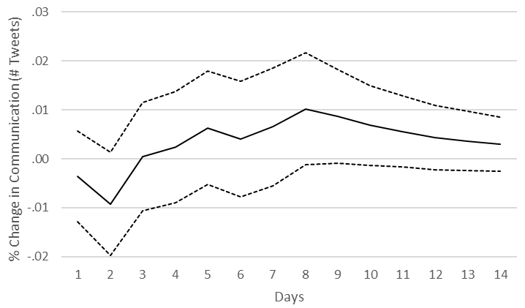 | 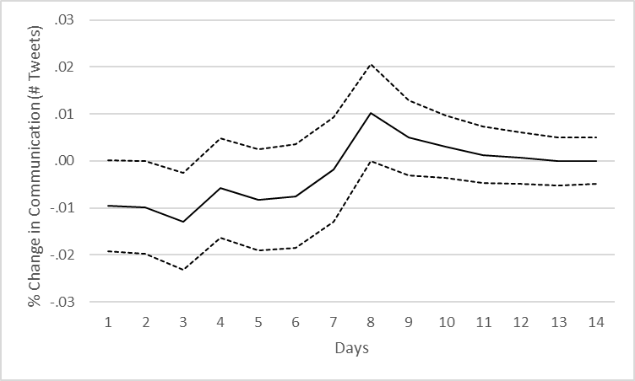
Search | 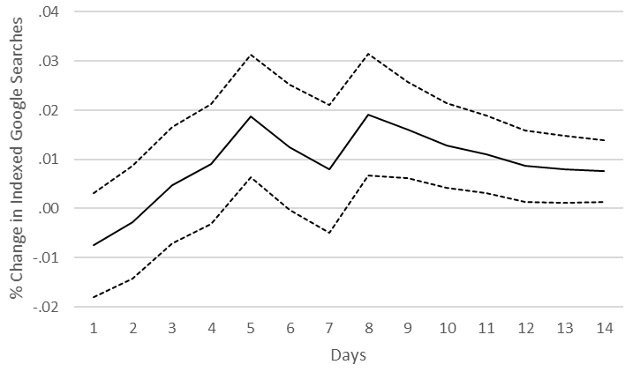 | 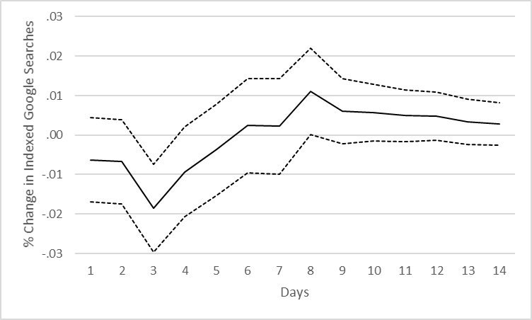
Participation | 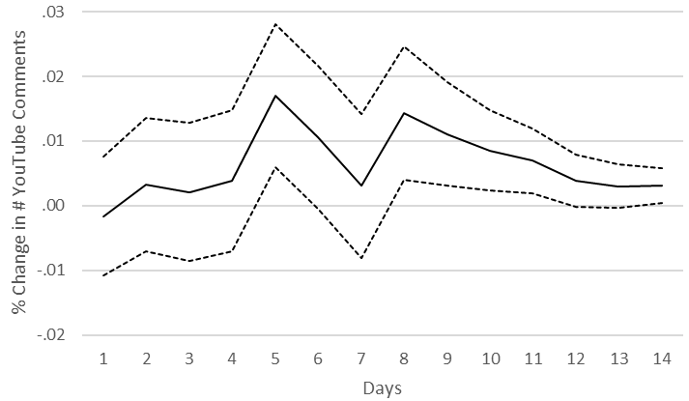 | 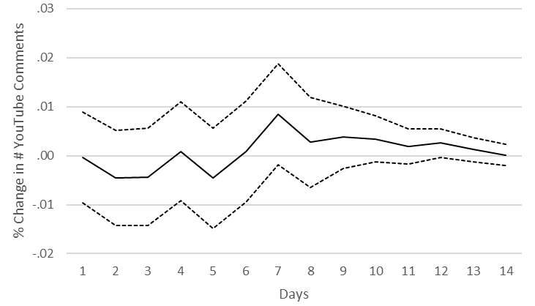
Note. IRFs of pre-release marketing on buzz behaviors and IRFs within buzz behaviors are very similar to those shown in the manuscript when mass media advertising is split into digital and traditional mass media advertising.

Figure C2. IRFs with Participation (Comments) and Participation (Tweets)
 |  | Step 2: … resulting in effect on buzz behavior …
 |  | Communication | Search | Participation (Comments) | Participation (Tweets)
Step 1: Shock in buzz behavior … | Communication | 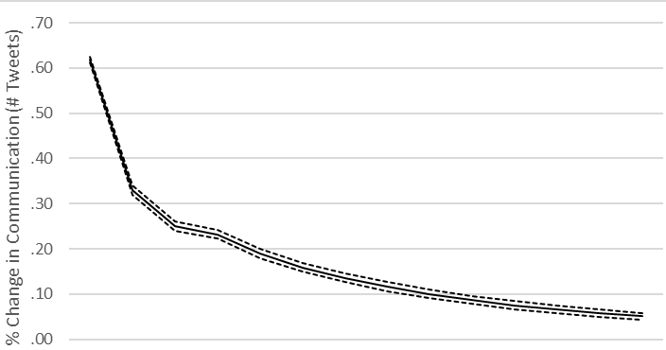 | 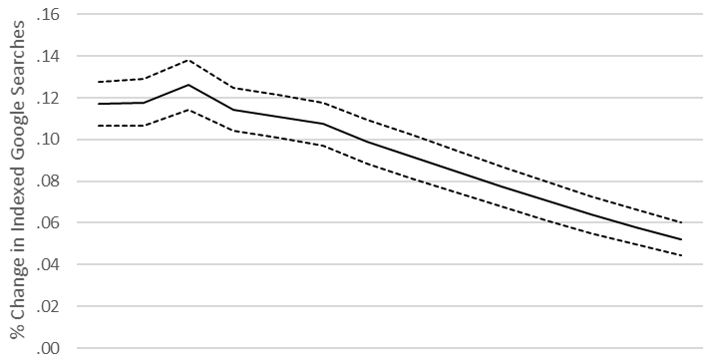 | 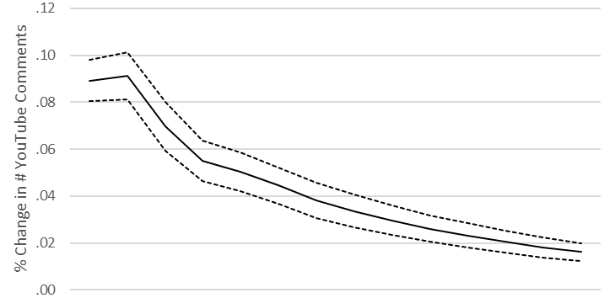 | 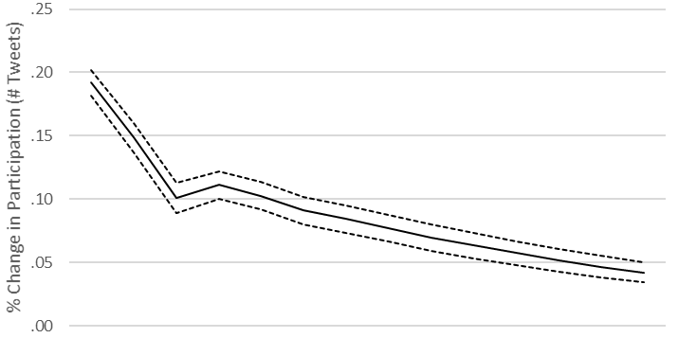
Step 1: Shock in buzz behavior … | Search | 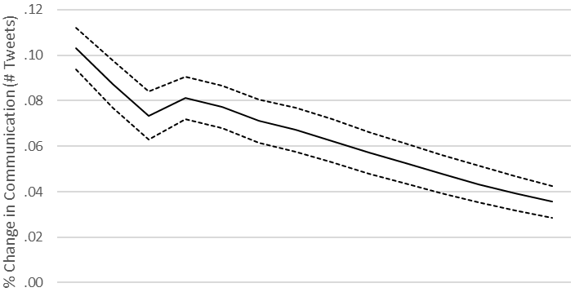 | 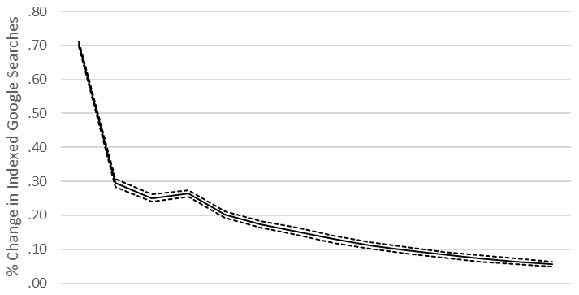 | 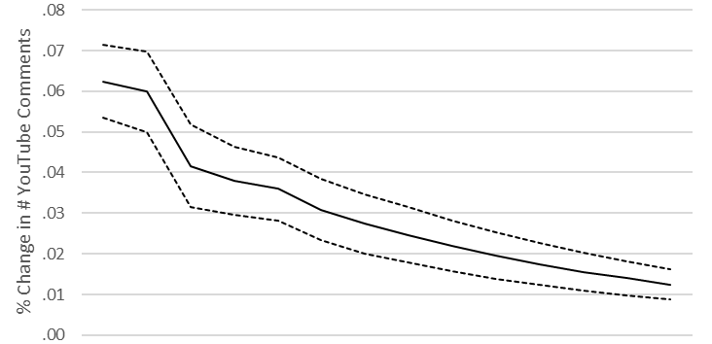 | 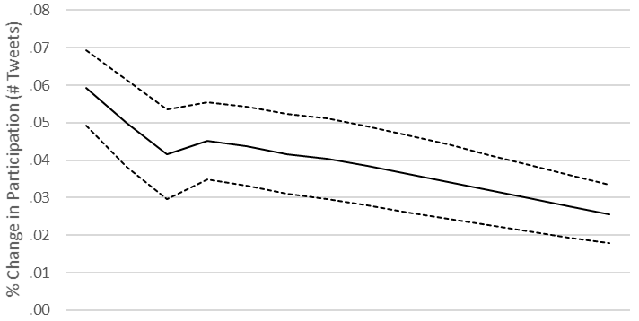
Step 1: Shock in buzz behavior … | Participation  (Comments) | 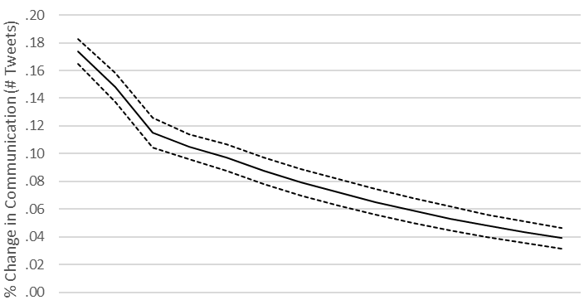 | 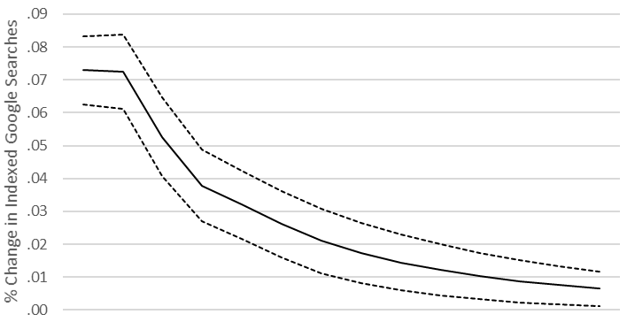 | 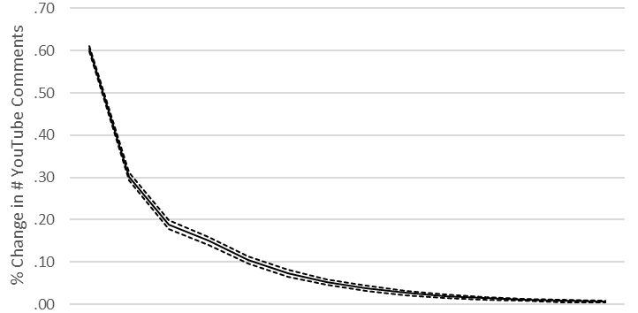 | 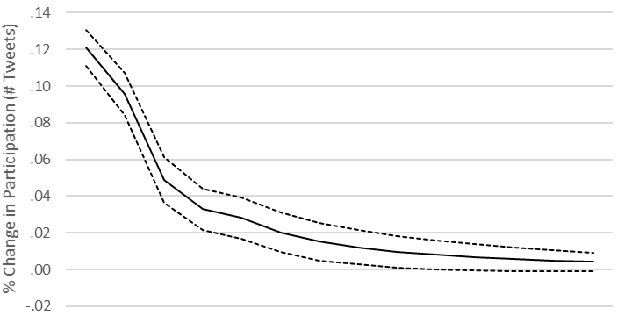
Step 1: Shock in buzz behavior … | Participation  (Tweets) | 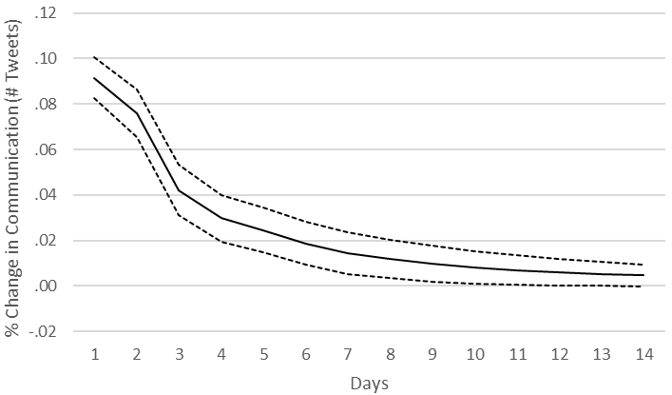 | 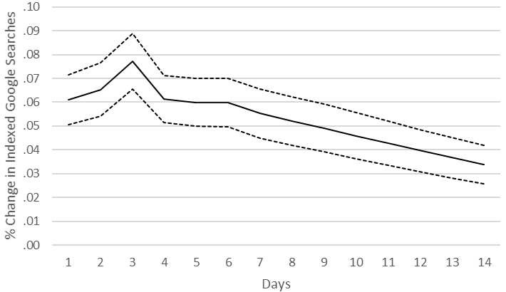 | 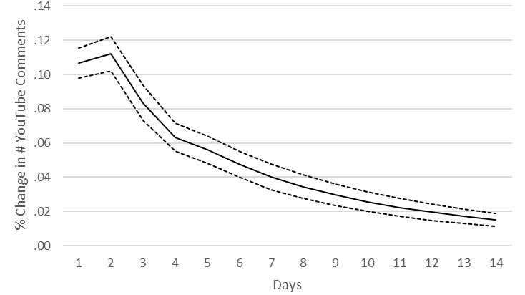 | 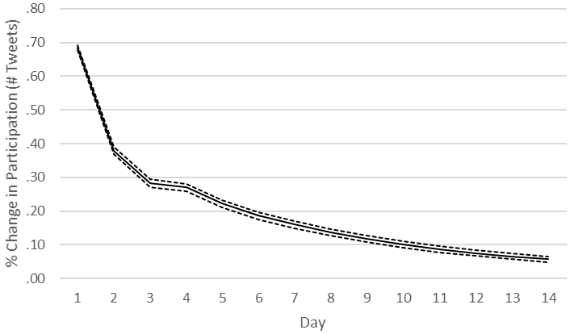

Figure C3. IRFs with Significant Dynamic Effects Involving Valence
- Shock in communication valence resulting in effect on communication
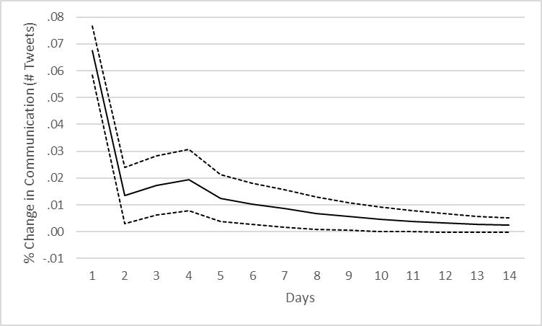
- Shock in participation valence resulting in effect on participation
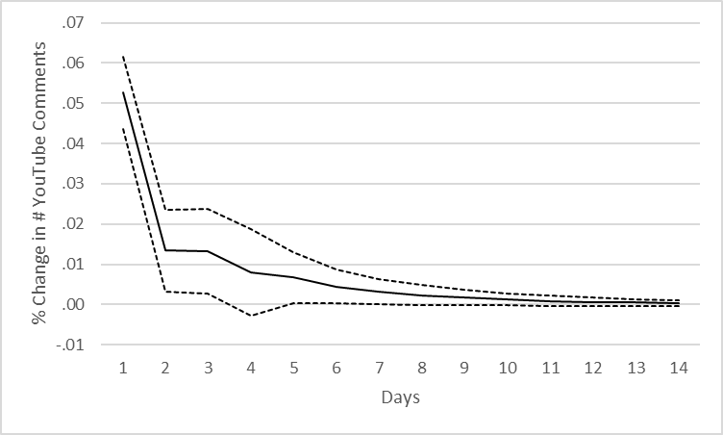
Notes. All other IRFs involving valence are non-significant. When considering valence, all IRFs of pre-release marketing on buzz behaviors and within buzz behaviors are very similar to those reported in the manuscript.

Web Appendix D—Investigation of Different Lag Structures

Table D. Accumulated Effects on Buzz Behaviors over Two Weeks
 | Lag Structure Based on SIC |  |  | Lag Structure Based on AIC
Shocked Variable (+1 SD) | Affected Buzz Behavior (Change in %) |  |  | Affected Buzz Behavior (Change in %)
Shocked Variable (+1 SD) | Communication | Search | Participation | Communication | Search | Participation
Buzz behaviors
Communication | 2.54*  (.06) | 1.29*  (.06) | .62*  (.04) | 2.27*  (.05) | .96*  (.06) | .54*  (.04)
Search | .89*  (.06) | 2.73*  (.06) | .42*  (.04) | .60*  (.05) | 2.46*  (.05) | .35*  (.04)
Participation | .38*  (.05) | .38*  (.06) | 1.62*  (.04) | .33*  (.05) | .24*  (.05) | 1.56*  (.04)
Pre-release marketing
Firm social media posts  (movie-related) | 1.17*  (.06) | .72*  (.06) | .30*  (.04) | 1.01*  (.05) | .51*  (.06) | .30*  (.04)
Firm social media posts  (trailer-related) | .21*  (.05) | .19*  (.06) | .37*  (.04) | .13*  (.06) | .07  (.06) | .31*  (.05)
Trailer releases | .39*  (.05) | .33*  (.05) | .65*  (.03) | .37*  (.06) | .23*  (.06) | .69*  (.04)
Mass media advertising | -.09  (.05) | -.06  (.05) | -.03  (.03) | -.03  (.04) | .07  (.05) | .07  (.04)
Notes. SD: Standard deviation. Standard errors in parentheses; SIC: Schwarz Information Criterion; AIC: Akaike Information Criterion. *p < .01.

Web Appendix E—Robustness Checks (Alternative Measures and Additional Predictors)
First, we utilized the movie Star Trek Beyond as a benchmark (instead of the letter “c”) for the measure of search volume (see Model R1). Second, we split mass media advertising into digital and traditional mass media advertising (see Model R2 and Figure C1 in Web Appendix C for corresponding IRFs). Third, we incorporated both movie-related and trailer-related firm social media posts into a single, unidimensional measure of firm social media posts (see Model R3). Fourth, we utilized the tweets with participatory elements that we removed from the communication measure (see section “Measures for Pre-Release Consumer Buzz” in the manuscript) as a second variable capturing participation (see Figure C2 in Web Appendix C for corresponding IRFs). The forecast of this variable has no significant effect on opening weekend box office sales (see Model R4). Fifth, we also considered the valence of communication and participation in the VAR-X (see Figure C3 in Web Appendix C for corresponding IRFs) and the corresponding box office model. Similar to the additional participation measure, valence (of communication or participation) has no significant effect on box office sales (see Model R5).

Table E. Impact of PRCB on Market Performance (Alternative Models)
DV:  Opening Weekend Box Office Sales | Model R1  Alternative Search Measure |  |  | Model R2  Digital and Traditional Advertising |  |  | Model R3  Alternative Firm Social Media Posts Measure |  |  | Model R4  Participatory Tweets as Additional Predictor |  |  | Model R5  Valence of Buzz as Additional Predictors
DV:  Opening Weekend Box Office Sales | β |  | p | β |  | p | β |  | p | β |  | p | β |  | p
Buzz behaviors
Communication | .235 | *** | <.001 | .222 | *** | <.001 | .235 | *** | <.001 | .255 | *** | <.001 | .226 | *** | <.001
Search | .095 | *** | .004 | .082 | *** | .003 | .087 | *** | <.001 | .083 | *** | .002 | .082 | *** | .002
Participation | .083 | ** | .014 | .090 | *** | .009 | .082 | ** | .018 | .099 | *** | .004 | .106 | *** | .003
Participation (Tweets) |  |  |  |  |  |  |  |  |  | -.043 |  | .301
Valence of…
…communication |  |  |  |  |  |  |  |  |  |  |  |  | -.621 |  | .184
…participation |  |  |  |  |  |  |  |  |  |  |  |  | -.103 |  | .845
Controls
Production budget | .004 |  | .978 | .002 |  | .851 | .004 |  | .743 | .001 |  | .916 | .007 |  | .563
Mass media advertising | .098 | * | .076 |  |  | .019 | .124 | ** | .024 | .127 | ** | .020 | .102 | * | .067
Digital advertising |  |  |  | .230 |  | .119
Traditional advertising |  |  |  | .125 | ** | .026
Critics’ ratings | .507 | *** | <.001 | .451 | *** | <.001 | .463 | *** | <.001 | .467 | *** | <.001 | .507 | *** | <.001
No. of screens | .618 | *** | <.001 | .611 | *** | <.001 | .611 |  | <.001 | .614 | *** | <.001 | .615 | *** | <.001
SStar power | -.029 |  | .637 | -.010 |  | .879 | -.008 |  | .899 | -.002 |  | .974 | -.010 |  | .873
Genre | Included (not shown for parsimony)
MPAA rating | Included (not shown for parsimony)
Sequel | Included (not shown for parsimony)
Remake | Included (not shown for parsimony)
Adaptation | Included (not shown for parsimony)
Season | Included (not shown for parsimony)
R² | .943 |  |  | .940 |  |  | .940 |  |  | .942 |  |  | .943
Notes. DV: Dependent Variable; *p < .10; **p < .05; ***p < .01 (two-tailed).

Web Appendix F—Exploratory Interactions

Table F. Impact of PRCB on Market Performance with Exploratory Interactions (Star Power and Sequel/Adaptation)
DV:  Opening Weekend  Box Office Sales | Focal Model  (same as Table 5) |  |  | Interactions within Buzz |  |  |  | Interactions with  Star Power |  |  |  |  | Interactions with Sequel/Adaptation |  |  |  | Full Model
DV:  Opening Weekend  Box Office Sales | β |  | p | β |  |  | p | β |  |  | p |  | β |  | p |  | β |  | p
Buzz behaviors
Communication | .230 | *** | <.001 | .224 |  | *** | <.001 | .225 |  | *** | <.001 |  | .269 | *** | <.001 |  | .217 | *** | <.001
Search | .082 | *** | .002 | .082 |  | *** | <.002 | .081 |  | *** | .002 |  | .072 | * | .056 |  | .081 | *** | .002
Participation | .092 | *** | .008 | .077 |  | ** | .031 | .085 |  | ** | .013 |  | .022 |  | .626 |  | .045 |  | .252
Interactions within buzz
Communication × search |  |  |  | .018 |  |  | .212
Communication × participation |  |  |  | . 022 |  |  | .238
Search × participation |  |  |  | -.003 |  |  | .868
Interactions with star power
Communication × star power |  |  |  |  |  |  |  | .144 |  | *** | .002 |  |  |  |  |  | .113 | *** | .002
Search × star power |  |  |  |  |  |  |  | -.033 |  |  | .342
Participation × star power |  |  |  |  |  |  |  | .001 |  |  | .980
Interactions with sequel/adaptation
Communication × sequel/adaptation |  |  |  |  |  |  |  |  |  |  |  |  | -.078 |  | .242
Search × sequel/adaptation |  |  |  |  |  |  |  |  |  |  |  |  | .018 |  | .715
Participation × sequel/adaptation |  |  |  |  |  |  |  |  |  |  |  |  | .146 | ** | .017 |  | .089 | ** | .053
Controls
Production budget | .002 |  | .852 | .006 |  |  | .622 | .004 |  |  | .716 |  | .001 |  | .962 |  | .003 |  | .809
Mass media advertising | .119 | ** | .032 | .148 |  | *** | .008 | .168 |  | *** | .003 |  | .114 | ** | .044 |  | .174 | *** | .002
Critics’ ratings | .459 | *** | <.001 | .417 |  | *** | <.001 | .448 |  | *** | <.001 |  | .445 | *** | <.001 |  | .450 | *** | <.001
No. of screens | .614 | *** | <.001 | .616 |  | *** | <.001 | .603 |  | *** | <.001 |  | .616 | *** | <.001 |  | .605 | *** | <.001
Star power | -.005 |  | .913 | -.013 |  |  | .840 | -.013 |  |  | .831 |  | -.021 |  | .732 |  | -.021 |  | .736
Included dummies | Genre, MPAA rating, sequel, remake, book adaptation, season
R² | .940 |  |  |  | .942 |  |  |  | .943 |  |  | .942 |  |  |  | .944
Notes. DV: Dependent Variable; *p < .10; **p < .05; ***p < .01 (two-tailed).

