Web Appendix
A Meta-Analysis of the Effectiveness of Social Media Influencers:
Mechanisms and Moderation

Contents
Web Appendix A: REVIEW OF PREVIOUS LITERATURE REVIEWS AND META-ANALYSES……………………………………………………………………...2
Web Appendix B: REVIEW OF PREVIOUS INFLUENCER MARKETING RESEARCH …..……4
Web Appendix C: MEASUREMENT ISSUES ……………………………………...…….……….10
Web Appendix D: ALTERNATIVE MODELS………………………………………..……...……14
Web Appendix E: MODERATOR VARIABLES DEFINITIONS AND OPERATIONALIZATIONS.…………………………………………...………19
Web Appendix F: LIST OF STUDIES AND VARIABLE CODING ……………………………...22
Web Appendix G: FUNNEL PLOTS……………………………………………...…………...…....38
Web Appendix H: RESULT OF OUTLIER ANALYSIS…………..…………………...….……….40 Web Appendix I: FREQUENCY DISTRIBUTION OF EFFECT SIZES …………………….…...41
Web Appendix J: HIERARCHICAL LINEAR MODELING EQUATION……...……..............….42
Web Appendix K: CORRELATION MATRIX BETWEEN MODERATORS..…….............…..…44 Web Appendix L: ROBUSTNESS CHECK ANALYSIS……………………………………...…...45
Web Appendix M: SOCIAL MEDIA INFLUENCER INTERACTION WITH CONSUMER RESPONSES……………………………………………………………...…….46

Web Appendix A: Review of Previous Literature Reviews And Meta-Analyses
Author(s) | Type of endorser | Research type (No. of studies) | Independent variables | Dependent variables | Mediation analysis | Moderator analysis
Knoll and Matthes (2017) | Celebrity endorsement | Meta analysis of 36 studies | Celebrity endorsement (vs. no endorsement, quality seals, awards, or endorser brands) | Attention, awareness, estimation, perception, attitude toward Ad and object, behavioral intention and behavior | _ | Endorser (gender, type, and match, familiarity of endorsed object); Message (explicitness and frequency); Comparative effect (actor celebrities, models, musicians, TV hosts)
Schimmelpfennig and Hunt (2020) | Celebrity endorsement | Literature review | Celebrity characteristics (credibility, attractiveness, match-up hypothesis, meaning transfer model) | Attitudes and behavioral intentions | Perceived fit or congruence, credibility, cultural meaning transfer
Elmi (2022) | Endorsers (e.g., celebrity, social media influencers) | Meta analysis of 103 studies | Celebrities or endorsement in traditional and social media, or Social media influencers, or opinion leaders | Brand attitude, trust, purchase, and loyalty | - | -
Packer et al. (2022) | Endorsers (e.g., celebrity, social media influencers) | Meta analysis of 7 studies | Celebrities’ endorsement in traditional or social media, or Social media influencers. | Children’s high in fat, sugar, and salt (HFSS) foods consumption | - | -
Ao et al. (2023) | Social media influencer | Meta analysis of 62 studies | Social media influencers characteristics (expertise, homophily, credibility, congruence, trustworthiness, attractiveness, entertainment, and informative value) | Purchase and engagement | - | -
Han and Balabanis (2024) | Social media influencer | Meta analysis of 53 studies | Social media influencer characteristics (credibility, trustworthiness, expertise, authenticity, attractiveness, homophily, opinion leadership, content informativeness, ad recognition) | Attitudes, purchase intention, and engagement | - | Social media influencers (size); Product (benefits); Platform (social media); Followers (Geographical distribution of sample)
Pan et al. (2024) | Endorsers (e.g., celebrities, social media influencers) | Meta analysis of 251 studies | Post content value, social identity, consumer knowledge, Influencer–brand fit, interaction strategies, influencer indegree | Attitude, purchase intention and engagement | Persuasion knowledge and Source credibility | Platform types (Nature of connection and usage) and Product types (Information availability and status-signaling capability)
Current study | Social media influencer | Meta analysis of 131 studies | Social media influencers (vs. celebrities, VIs, brand post in social media and others) | Credibility, attractiveness, ad and brand attitudes, purchase, and engagement | Developing and testing four different mediation mechanisms and an integrative model | Social media influencers (size, age, and gender); Message (appeal, abstractness, endorsement); Product (benefits and familiarity, classification, Social media influencers -product congruence); Platform (social media); Followers (age and gender); Interaction (Social media influencers size and other variables); Comparative effect: Social media influencers vs. other alternatives
Reference for Web Appendix A
Ao, L., Bansal, R., Pruthi, N., & Khaskheli, M. B. (2023). Impact of Social Media Influencers on Customer Engagement and Purchase Intention: A Meta-Analysis. Sustainability, 15(3), 2744.
Elmi, M. (2022). The role of influencer marketing in business: A meta-analysis İstanbul Gelişim Üniversitesi Lisansüstü Eğitim Enstitüsü].
Han, J., & Balabanis, G. (2024). Meta‐analysis of social media influencer impact: Key antecedents and theoretical foundations. Psychology & Marketing, 41(2), 394-426.
Knoll, J., & Matthes, J. (2017). The effectiveness of celebrity endorsements: a meta-analysis. Journal of the Academy of Marketing Science, 45, 55-75.
Packer, J., Russell, S. J., Siovolgyi, G., McLaren, K., Stansfield, C., Viner, R. M., & Croker, H. (2022). The impact on dietary outcomes of celebrities and influencers in marketing unhealthy foods to children: a systematic review and meta-analysis. Nutrients, 14(3), 434.
Schimmelpfennig, C., & Hunt, J. B. (2020). Fifty years of celebrity endorser research: Support for a comprehensive celebrity endorsement strategy framework. Psychology & Marketing, 37(3), 488-505.
Pan, M., Blut, M., Ghiassaleh, A., & Lee, Z. W. (2024). Influencer marketing effectiveness: A meta-analytic review. Journal of the Academy of Marketing Science, 1-27.

Web Appendix B: Review of Previous Influencer Marketing Research
Research area | Prior empirical research findings | Prior meta-analysis findings
Social media influencer effectiveness
Dependent variables
Engagement and purchase intention | Social media influencers are effective in engaging their followers with a product/brand (Cascio Rizzo et al., 2024; Wies et al., 2023) as well as triggering purchase intention among their followers of a product/brand (Gu et al., 2024) | Social media influencers characteristics (e.g., credibility, attractiveness) positively impact customer engagement and purchase intention (Ao et al., 2023; Han & Balabanis, 2024).  Endorsers including celebrity endorsements increase attitude toward the endorsed object (Knoll & Matthes, 2017) and purchase intention ((Elmi, 2022)
Comparative effect
Social media influencers vs. Celebrity | Social media influencers are more effective (Zhu et al., 2022) or indifferent (Kapitan et al., 2021; Shi et al., 2021) or less effective (Fan et al., 2024) than celebrity | Celebrities are more effective than no endorsement but less effective than quality seals, awards, or endorser brands (Knoll & Matthes, 2017)
Social media influencers vs. VI | Social media influencers are more effective (Zhou et al., 2023) or indifferent (Belanche et al., 2024) or less effective (Di Cioccio et al., 2024; Sands et al., 2022) than VI. | Not addressed in previous meta-analyses
Social media influencers vs. Brand post | Social media influencers are more effective (Singh et al., 2020) or indifferent (Beuckels & De Jans, 2022) or less effective (Kumar et al., 2024) than brand social media posts | Not addressed in previous meta-analyses
Social media influencers vs. No endorsement | Social media influencers are more effective (Buvár et al., 2024) or less effective (Kapoor et al., 2023) than no product or brand endorsement | Celebrities work better than no endorsement but are less effective than quality seals, awards, or endorser brands (Knoll & Matthes, 2017)
Mediation mechanism
Direct effect | Social media influencers directly influences consumer responses (Leung et al., 2022). | Not addressed in previous meta-analyses
Social influence theory | Social media influencers' credibility and attractiveness mediate the relationship between social media influencers and consumer responses (Schouten et al., 2020; J. Yang et al., 2023) | Not addressed in previous meta-analyses
Hierarchy of effects | Ad attitude influencing brand attitude serves as a mediator between social media influencers' credibility/attractiveness and consumer engagement/purchase intention (O. Ozdemir et al., 2023; Qu & Baek, 2023) | Not addressed in previous meta-analyses
Moderating effects
Social media influencer characteristics
Size (number of followers) | Social media influencers with a lower number of followers are more effective (Cascio Rizzo et al., 2024; Wies et al., 2023) or less effective than Social media influencers with a higher number of followers (Gu et al., 2024) | Findings of the moderating effect of social media influencer size on the influence of social media influencers characteristics (e.g., credibility, attractiveness) depend on consumer responses (engagement and purchase intention) (Han & Balabanis, 2024)
Age | No previous research | Not addressed in previous meta-analyses
Gender | No previous research | Male celebrities are more effective than female celebrities (Knoll & Matthes, 2017)
Message
Appeal (emotional vs. rational) | Social media influencers are more effective (Ozan Ozdemir et al., 2023) or less effective (Zhu et al., 2022) when using an emotional messages (vs. rational messages) | Not addressed in previous meta-analyses
Abstractness (high vs. low) | No previous research | Not addressed in previous meta-analyses
Endorsement (usage vs. recommendation based) | No previous research | Not addressed in previous meta-analyses
Product
Benefits (hedonic vs. utilitarian) | Social media influencers are more effective (Belanche et al., 2024; Hughes et al., 2019) or less effective (Cho et al., 2024) when endorsing hedonic products (vs. utilitarian) | Mixing finding in moderating effects of hedonic (vs. utilitarian) on the relationship between social media influencers characteristics (e.g., credibility, attractiveness) and consumer response (engagement and purchase intention) (Han & Balabanis, 2024)
Familiarity (new vs. established) | Social media influencers are more effective (Wies et al., 2023) or less effective (Zhu et al., 2022) when endorsing new (vs. familiar) products | Celebrities are more effective in endorsing unfamiliar products (vs. familiar ones) (Knoll & Matthes, 2017)
Classification (search vs. experience) | Social media influencers are more effective (Xie et al., 2022) or less effective (Hill et al., 2020) when endorsing search product (vs. experience) | Not addressed in previous meta-analyses
Social media influencer-product congruence (high vs. low) | Social media influencers fit with endorsed product enhance social media influencers effectiveness (Breves et al., 2019; Schouten et al., 2020) or does not have an effect | Congruent celebrities (vs. incongruent) enhance celebrity effectiveness (Knoll & Matthes, 2017)
Channel
Social media platform (e.g., Instagram, TikTok, YouTube) | No previous research | Finding of the moderating effect of social media platforms on the influence of social media influencers characteristics (e.g., credibility, attractiveness) depends on consumer response (engagement and purchase intention) (Han & Balabanis, 2024)
Followers
Age | No previous research | Not addressed in previous meta-analyses
Gender | Social media influencers effect on consumer responses are stronger among females (Kumar et al., 2024) than males | Not addressed in previous meta-analyses

Reference for Web Appendix B
Ao, L., Bansal, R., Pruthi, N., & Khaskheli, M. B. (2023). Impact of Social Media Influencers on Customer Engagement and Purchase Intention: A Meta-Analysis. Sustainability, 15(3), 2744.
Belanche, D., Casaló, L. V., & Flavián, M. (2024). Human versus virtual influences, a comparative study. Journal of Business Research, 173, Article 114493.
Beuckels, E., & De Jans, S. (2022). ‘My Mom Got Influenced by Yours’: The persuasiveness of mom influencers in relation to mothers' food assessments and decisions. Appetite, 106269.
Breves, P. L., Liebers, N., Abt, M., & Kunze, A. (2019). The perceived fit between instagram influencers and the endorsed brand: How influencer–brand fit affects source credibility and persuasive effectiveness. Journal of Advertising Research, 59(4), 440-454.
Buvár, Á., Balogh, E., Dobai, A. M., & Tessényi, J. (2024). Do You Care to Share? The Negative Effect of Sponsored Content on the Behavioral Engagement with a Social Media Post Containing a COVID-19 Message. Journal of Interactive Advertising, 24(2), 143-155.
Cascio Rizzo, G. L., Villarroel Ordenes, F., Pozharliev, R., De Angelis, M., & Costabile, M. (2024). How High-Arousal Language Shapes Micro- Versus Macro-Influencers’ Impact. Journal of Marketing, 88(4), 107-128.
Cho, Y. N., Kim, Y., & Ye, C. (2024). Influencers and donations: The impact of source and product benefits. International Journal of Consumer Studies, 48(2), Article e13039.
Di Cioccio, M., Pozharliev, R., & De Angelis, M. (2024). Pawsitively powerful: Why and when pet influencers boost social media effectiveness. Psychology and Marketing, 41(7), 1614-1628.
Elmi, M. (2022). The role of influencer marketing in business: A meta-analysis İstanbul Gelişim Üniversitesi Lisansüstü Eğitim Enstitüsü].
Fan, F., Fu, L., & Jiang, Q. (2024). Virtual idols vs online influencers vs traditional celebrities: how young consumers respond to their endorsement advertising. Young Consumers, 25(3), 329-348.
Gu, X., Zhang, X., & Kannan, P. K. (2024). Influencer Mix Strategies in Livestream Commerce: Impact on Product Sales. Journal of Marketing, 88(4), 64-83.
Han, J., & Balabanis, G. (2024). Meta‐analysis of social media influencer impact: Key antecedents and theoretical foundations. Psychology & Marketing, 41(2), 394-426.
Hill, S. R., Troshani, I., & Chandrasekar, D. (2020). Signalling effects of vlogger popularity on online consumers. Journal of Computer Information Systems.
Hughes, C., Swaminathan, V., & Brooks, G. (2019). Driving Brand Engagement Through Online Social Influencers: An Empirical Investigation of Sponsored Blogging Campaigns. Journal of Marketing, 83(5), 78-96.
Kapitan, S., van Esch, P., Soma, V., & Kietzmann, J. (2021). Influencer Marketing and Authenticity in Content Creation. Australasian Marketing Journal, 18393349211011171.
Kapoor, P. S., Tagore, A., & Dua, S. (2023). Social Media Influencer Promoted Sustainable Fashion: Effects of Sponsorship and Benefit Association. Journal of Promotion Management, 29(4), 461-490.
Knoll, J., & Matthes, J. (2017). The effectiveness of celebrity endorsements: a meta-analysis. Journal of the Academy of Marketing Science, 45, 55-75.
Kumar, A., Rayne, D., Salo, J., & Yiu, C. S. (2024). Battle of Influence: Analysing the Impact of Brand-Directed and Influencer-Directed Social Media Marketing on Customer Engagement and Purchase Behaviour. Australasian Marketing Journal.
Leung, F. F., Gu, F. F., Li, Y., Zhang, J. Z., & Palmatier, R. W. (2022). Influencer Marketing Effectiveness. Journal of Marketing, 00222429221102889.
Ozdemir, O., Kolfal, B., Messinger, P. R., & Rizvi, S. (2023). Human or virtual: How influencer type shapes brand attitudes [Article]. Computers in Human Behavior, 145, Article 107771.
Ozdemir, O., Kolfal, B., Messinger, P. R., & Rizvi, S. (2023). Human or virtual:: How influencer type shapes brand attitudes. Computers in Human Behavior
Qu, Y., & Baek, E. (2023). Let virtual creatures stay virtual: tactics to increase trust in virtual influencers [Article]. Journal of Research in Interactive Marketing.
Sands, S., Campbell, C. L., Plangger, K., & Ferraro, C. (2022). Unreal influence: leveraging AI in influencer marketing. European Journal of Marketing, 56(6), 1721-1747.
Schouten, A. P., Janssen, L., & Verspaget, M. (2020). Celebrity vs. Influencer endorsements in advertising: the role of identification, credibility, and Product-Endorser fit [Article]. International Journal of Advertising, 39(2), 258-281.
Shi, P., Lu, X., Zhou, Y., Sun, C., Wang, L., & Geng, B. (2021). Online Star vs. celebrity endorsements: The role of self-concept and advertising appeal in influencing purchase intention. Frontiers in psychology, 12, 736883.
Singh, J., Crisafulli, B., Quamina, L. T., & Xue, M. T. (2020). ‘To trust or not to trust’: The impact of social media influencers on the reputation of corporate brands in crisis. Journal of Business Research, 119, 464-480.
Wies, S., Bleier, A., & Edeling, A. (2023). Finding Goldilocks Influencers: How Follower Count Drives Social Media Engagement. Journal of Marketing, 87(3), 383-405.
Xie, Z., Yu, Y., Zhang, J., & Chen, M. (2022). The searching artificial intelligence: Consumers show less aversion to algorithm‐recommended search product. Psychology & Marketing, 39(10), 1902-1919.
Yang, J., Chuenterawong, P., Lee, H., Tian, Y., & Chock, T. M. (2023). Human versus Virtual Influencer: The Effect of Humanness and Interactivity on Persuasive CSR Messaging [Article]. Journal of Interactive Advertising, 23(3), 275-292.
Zhou, X., Yan, X., & Jiang, Y. (2023). Making sense? The sensory-specific nature of virtual influencer effectiveness. Journal of Marketing, 00222429231203699.
Zhu, H., Kim, M., & Choi, Y. K. (2022). Social media advertising endorsement: the role of endorser type, message appeal and brand familiarity [Article]. International Journal of Advertising, 41(5), 948-969.

Web Appendix C: Measurement Issues
Table 2 (in the manuscript) presents a detailed overview of how consumer responses to social media influencers have been operationalized in prior research, highlighting potential measurement differences next to the current research's definitions of these variables. Below, we discuss the different measures, and the definition of the aggregate concept used in the meta-analysis. Using different measures to assess the same (aggregate) concept is a common issue in meta-analysis research. Following previous meta-analyses (Knoll & Matthes, 2017; Liadeli et al., 2023; Rosengren et al., 2020), we aggregate these diverse measures under one focal concept (credibility, attractiveness, ad attitude, brand attitude, engagement and purchase intention) to ensure consistency and comparability across studies.
Cognitive responses, such as credibility and attractiveness, have been measured using various scales. For instance, credibility has been assessed through constructs such as credibility (Lee & Ham, 2023), expertise (Lee et al., 2021), authenticity (Kapitan et al., 2021), trust, and trustworthiness (Jin et al., 2019), leading to fragmented measurement. This paper unifies these measures under a single definition of social media influencer credibility, encompassing perceptions of the endorser's trustworthiness and expertise. Similarly, attractiveness has been measured in terms of attractiveness (Choi et al., 2023), physical (Mirowska & Arsenyan, 2023), and social (van Reijmersdal et al., 2024) attractiveness or likeability, which this study consolidates as social media influencer attractiveness, defined as the perceived pleasing and appealing qualities of the endorser.
Affective responses have also been measured in varying ways. Attitude toward advertisements has been measured at different levels, including message (Holiday et al., 2021), ad (Franke et al., 2022), and post likeability/attitude (Pöyry et al., 2019). This paper consolidates these measures by defining ad attitude as the evaluation of the ad and the message endorsed by the influencer. Similarly, brand attitude has been measured in terms of brand (Jin et al., 2019) and/or product (Schouten et al., 2020) likeability or attitude. In this meta-analysis, we aggregate these measures and define brand attitude as the evaluation of the product/brand as endorsed by the influencer.
For conative responses, both engagement and purchase intention have been measured using a wide range of scales. Engagement has been assessed through measures such as social media post likes (Chung et al., 2023), likes and comments (Cascio Rizzo et al., 2024), sharing (Lee et al., 2021), number of reposts (Leung, Gu, Li, et al., 2022), as well as WOM (Sands et al., 2022). We combine all these under the umbrella of engagement, defined as involvement activities associated with the endorsed product or brand. Lastly, previous research has primarily focused on purchase intention (Piehler et al., 2022) or willingness to buy (Zhang et al., 2023) rather than actual behavior. Therefore, the current research focuses solely on purchase intention, defined as the likelihood of acquiring the endorsed product or brand.

Reference for Web Appendix C
Choi, Y. K., Zhang, R., & Sung, C. (2023). Attractiveness or expertise? Which is more effective in beauty product endorsement? Moderating role of social distance. International Journal of Advertising, 42(7), 1201-1225.
Chung, J., Ding, Y., & Kalra, A. (2023). I really know you: how influencers can increase audience engagement by referencing their close social ties. Journal of Consumer Research, 50(4), 683-703.
Franke, C., Groeppel-Klein, A., & Müller, K. (2022). Consumers’ Responses to Virtual Influencers as Advertising Endorsers: Novel and Effective or Uncanny and Deceiving? Journal of Advertising, 1-17.
Holiday, S., Densley, R. L., & Norman, M. S. (2021). Influencer Marketing Between Mothers: The Impact of Disclosure and Visual Brand Promotion [Article]. Journal of Current Issues & Research in Advertising (Routledge), 42(3), 236-257.
Jin, S. V., Muqaddam, A., & Ryu, E. (2019). Instafamous and social media influencer marketing [Social media influencer marketing]. Marketing Intelligence & Planning, 37(5), 567-579.
Kapitan, S., van Esch, P., Soma, V., & Kietzmann, J. (2021). Influencer Marketing and Authenticity in Content Creation. Australasian Marketing Journal, 18393349211011171.
Knoll, J., & Matthes, J. (2017). The effectiveness of celebrity endorsements: a meta-analysis. Journal of the Academy of Marketing Science, 45, 55-75.
Lee, D., & Ham, C.-D. (2023). AI versus Human: Rethinking the Role of Agent Knowledge in Consumers’ Coping Mechanism Related to Influencer Marketing. Journal of Interactive Advertising, 23(3), 241-258.
Lee, J., Kim, K., Park, G., & Cha, N. (2021). The role of online news and social media in preventive action in times of infodemic from a social capital perspective: The case of the COVID-19 pandemic in South Korea. Telematics and Informatics, 64, 101691.
Leung, F. F., Gu, F. F., Li, Y., Zhang, J. Z., & Palmatier, R. W. (2022). Influencer Marketing Effectiveness. Journal of Marketing, 00222429221102889.
Liadeli, G., Sotgiu, F., & Verlegh, P. W. (2023). A meta-analysis of the effects of brands’ owned social media on social media engagement and sales. Journal of Marketing, 87(3), 406-427.
Matthess, M., & Kunkel, S. (2020). Structural change and digitalization in developing countries: Conceptually linking the two transformations. Technology in Society, 63, 101428.
Mirowska, A., & Arsenyan, J. (2023). Sweet escape: The role of empathy in social media engagement with human versus virtual influencers. International Journal of Human-Computer Studies, 174, 103008.
Piehler, R., Schade, M., Sinnig, J., & Burmann, C. (2022). Traditional or ‘instafamous’ celebrity? Role of origin of fame in social media influencer marketing. Journal of Strategic Marketing, 30(4), 408-420.
Pöyry, E., Pelkonen, M., Naumanen, E., & Laaksonen, S.-M. (2019). A Call for Authenticity: Audience Responses to Social Media Influencer Endorsements in Strategic Communication. International Journal of Strategic Communication, 13(4), 336-351.
Rosengren, S., Campbell, C., & Rapp Farrell, J. (2024). Tricks of the trade: Understanding and utilizing influencer tactics to improve retailer performance. Journal of Retailing and Consumer Services, 79, Article 103857.
Sands, S., Campbell, C. L., Plangger, K., & Ferraro, C. (2022). Unreal influence: leveraging AI in influencer marketing. European Journal of Marketing, 56(6), 1721-1747.
Schouten, A. P., Janssen, L., & Verspaget, M. (2020). Celebrity vs. Influencer endorsements in advertising: the role of identification, credibility, and Product-Endorser fit [Article]. International Journal of Advertising, 39(2), 258-281.
van Reijmersdal, E. A., Walet, M., & Gudmundsdóttir, A. (2024). Influencer marketing: explaining the effects of influencer self-presentation strategies on brand responses through source credibility. Marketing Intelligence and Planning.
Zhang, K., Xia, H., Chen, Z., & Chen, W. (2023). Research on the impact of influencers on audiences' intention to follow. ACM International Conference Proceeding Series.

Web Appendix D: Alternative Models
Explaining how social media influencers drive consumer behavior
Figures B1 to B4 show four alternative models that are based on different theoretical frameworks and propose different mechanisms regarding how social media influencers drive consumer responses. Model 1, as the baseline model, refers to the direct and independent effects of social media influencers on the six consumer responses. This aligns with some prior research in this domain, suggesting that social media influencers can directly elicit diverse consumer responses (Leung et al., 2022).

Figure B1: Model 1: Direct effect model

Credibility
Social media influencer
Attractiveness
Ad attitude
Brand attitude
Engagement
Purchase intention

Model 2 is based on social influence theory, which investigates the impact of social surroundings on people's attitudes and actions (Kelman, 1961). According to this theory, individuals are more likely to conform to the prevailing norms and opinions of important people around them, such as social media influencers, rather than adhere to their own beliefs (Cialdini & Goldstein, 2004). Important people are characterized by credibility, attractiveness, and power, of which credibility and attractiveness are factors that are prevalent in marketing communications and work as mediators of persuasion (Erdogan, 1999).

Figure B2: Model 2: Social influence theory model

Credibility
Social media influencer
Attractiveness
Ad attitude
Brand attitude
Engagement
Purchase intention

Model 3 is predicated on the hierarchy of effects whereby a consumer is believed to move through a series of stages. Each stage builds upon the previous one, with the ultimate outcome of driving the consumer to take a desired action, such as making a purchase (Smith et al., 2008). The sequence of stages is based on a hierarchy in which consumers at first evaluate social media influencers’ credibility and attractiveness in promoting a product or brand leading to ad and brand attitude formation, which in turn influence engagement and purchase intention (Barry, 2002). While there are various combinations of cognitive and affective responses that lead to behavioral outcomes, this model aligns with the affect transfer model (MacKenzie et al., 1986). According to this model, ad attitude influencing brand attitude serves as a mediator between social media influencers’ credibility/attractiveness and consumer engagement/purchase, ultimately determining the effectiveness of an advertisement.

Figure B3: Model 3: Hierarchy of effects model

Credibility
Social media influencer
Attractiveness
Ad attitude
Brand attitude
Engagement
Purchase intention

Model 4 represents an integration and nesting of the above three models and incorporates both the direct and indirect effects of social media influencers to obtain a more comprehensive account of how social media influencers work. Further, integration allows us to test whether and which of the partial models or the integrative model provides the best fit. We can also compare the strength of social media influencers’ effects along each path and identify the most persuasive path.
Figure B4: Model 4: Integrative model

Credibility
Social media influencer
Attractiveness
Ad attitude
Brand attitude
Engagement
Purchase intention

Testing alternative models
Table B1 presents the results of the MASEM, testing the alternative models. Except for model 1, all other models exhibited a good fit with the data.

Table B1: Result of meta-analysis structural equation modelling
Path |  |  | Model 1 (baseline) | Model 2 (Social influence) | Model 3 (Hierarchy of effects) | Model 4  Integrative model
Social media influencers | → | Credibility | .23** | .23** | .23** | .23**
Social media influencers | → | Attractiveness | .10** | .10** | .10** | .10**
Social media influencers | → | Ad attitude | .15** | — | — | .03
Social media influencers | → | Brand attitude | .13** | — | — | .01
Social media influencers | → | Engagement | .14** | — | — | .04
Social media influencers | → | Purchase intention | .11** | — | — | -.01
Credibility | → | Ad attitude | — | .31** | .31** | .31**
Attractiveness | → | Ad attitude | — | .43** | .43** | .43**
Credibility | → | Brand attitude | — | .44** | .44** | .44**
Attractiveness | → | Brand attitude | — | .16** | .16** | .16*
Credibility | → | Engagement | — | .27** | — | .02
Attractiveness | → | Engagement | — | .30** | — | .17**
Credibility | → | Purchase intention | — | .38** | — | .18**
Attractiveness | → | Purchase intention | — | 23** | — | .07**
Ad attitude | → | Engagement | — | — | .25** | .15**
Brand attitude | → | Engagement | — | — | .46** | .43**
Ad attitude | → | Purchase intention | — | — | .37** | .26**
Brand attitude | → | Purchase intention | — | — | .34** | .28**
Model Statistics | RMSEA <.08 |  | .087 | .068 | .065 | .041
Model Statistics | CFI >.90 |  | .878 | .904 | .9010 | .920
Model Statistics | AGFI >.90 |  | .845 | .898 | .904 | .912
**p<.01, *p < .05

Because all models are nested within the integrative model, a chi-square difference test was employed to compare the three parsimonious models with the integrative model. The model fit significantly deteriorated when restricted to model 1 (Δχ²/df = 2877.45/13, p < .001), model 2 (Δχ²/df = 838.36/9, p < .001), and model 3 (Δχ²/df = 311.34/8, p < .001). The results of the chi-square difference test suggest that the integrative model when compared to each of the three nested models provides a significantly better fit and thus a better explanation.

Reference for Web Appendix D
Barry, T. E. (2002). In defence of the hierarchy of effects: a rejoinder to Weilbacher. Journal of Advertising Research, 42(3), 44-47.
Cialdini, R. B., & Goldstein, N. J. (2004). Social influence: Compliance and conformity. Annu. Rev. Psychol., 55, 591-621.
Erdogan, B. Z. (1999). Celebrity endorsement: A literature review. Journal of Marketing Management, 15(4), 291-314.
Kelman, H. C. (1961). Processes of attitude change. Public Opinion Quarterly, 25(1), 57-78.
Leung, F. F., Gu, F. F., Li, Y., Zhang, J. Z., & Palmatier, R. W. (2022). Influencer Marketing Effectiveness. Journal of Marketing, 00222429221102889.
MacKenzie, S. B., Lutz, R. J., & Belch, G. E. (1986). The role of attitude toward the ad as a mediator of advertising effectiveness: A test of competing explanations. Journal of Marketing Research, 23(2), 130-143.
Smith, R. E., Chen, J., & Yang, X. (2008). The impact of advertising creativity on the hierarchy of effects. Journal of Advertising, 37(4), 47-62.

Web Appendix E: Moderator Variables Definitions and Operationalizations
Moderator | Definitions | Coding details | Operationalizations
Social media influencer | The data were provided by experiment descriptions. If the information was not provided, online influencer social media pages or InfluencerMarketingHub.com were used to find the demographic and follower data of the social media influencers in the year the study was conducted.
Size | Number of social media influencer’s followers on a specific social media platform | - Large: Social media influencer had one million or more followers in the study or was introduced as a large social media influencer based on Campbell and Farrell (2020)’s classification.  - Small and medium: Social media influencer had less than one million followers in the study or was introduced as Nano or Micro or Macro based on Campbell and Farrell (2020)’s classification.  Note: If there was more than one social media influencer in a study, the sizes were based on the average number of all social media influencer followers. | 1 = Large vs 0 = small and medium  (Large = 39 vs. Small and medium = 92 studies)
Age | Social media influencer age at the time of data collection | In cases where there was more than one social media influencer in the study, the age was determined based on the average age of all social media influencers. | Continuous variable (mean = 27.09 years)
Gender | Social media influencer gender | - Female: Gender of social media influencer is female.  - Others: Gender of social media influencer is male or a mixture of male and female social media influencers. | 1 = Female vs 0 = Othersª  (Female = 95 vs. Others = 36 studies)
Message | The information about the message was provided in the study or experiment materials, such as stimuli, including social media posts and its captions.
Appeal | The degree to which the brand is promoted through emotional vs promotional message strategies | - Emotional: The message in the study was based on an emotional or soft approach to promote a product (e.g., “Resurrection of inner freshness. Today, I am born again.” (Zhu et al., 2022))  - Rational: The message in the study used a rational or hard approach to promote a product (e.g., “These earbuds sound clear without noise. My ear feel comfortable even after wearing it for six hours” (Li et al., 2023)) | 1 = Emotional vs 0 = Rational (AR ^{b} = 93%)  (Emotional = 54 vs. Rational = 67 studies)
Abstractness | The degree to which the product is promoted through abstract or concrete message strategies | - Low abstract: The message in the study was presented in a specific, detailed, and tangible manner (e.g., “This shampoo contains biotin as well as provitamin B5, zinc, coconut oil, and several other nutrient-rich botanicals. This blend works to remove DHT buildup, and prevents dandruff flakes and scales in the hair and scalp.” (Agnihotri & Bhattacharya, 2021)).  - High abstract: The message in the study was presented in a general, broad, or conceptual manner (e.g., “Outfit of the day”(Piehler et al., 2022)). | 1 = Low vs 0 = High (AR = 95%)  (Low = 44 vs. High = 76 studies)
Endorsement | The degree to which the product was promoted is based on the social media influencer referencing their previous or current product usage. | - Usage-based: Message used in study was based on social media influencer experience with product (e.g., “Hello girls! Since I've been using Myskin's “Hydra” cream, I've found my skin to be increasingly radiant and beautiful!”(Claeys et al., 2024)) or was using promoted product in the post image or video.  - Recommendation-based: Message used in study was recommendation (e.g., “Be protected, Feel refreshed”(Agnihotri & Bhattacharya, 2021)) without mentioning previous or current product usage. | 1 = Usage-based vs 0 = Recommendation-based (AR = 96%)  (Usage-based = 44 vs. Recommendation-based = 77 studies)
Product | The information about the product was provided in the study or experiment materials, such as stimuli, including social media posts with product images and their captions (e.g., product name, brand name, product description).
Benefit | The benefits of using the product for consumers | - Hedonic: The endorsed product in the study was introduced as hedonic, meaning it is primarily associated with pleasure, enjoyment, and sensory experiences.  - Utilitarian: The endorsed product in the study was introduced as utilitarian, meaning it serves a practical, or functional. | 1 = Hedonic vs 0 = Utilitarian (AR = 94%)  (Hedonic = 43 vs. Utilitarian = 82 studies)
Familiarity | The level of consumer familiarity with the promoted product or brand. | - New: The endorsed product in the study was a new product or fictitious product.  - Familiar: The endorsed product in the study was a familiar product, or it was a well-established or well-known product. | 1 = New vs 0 = Familiar (AR = 97%)  (New = 75 vs. Familiar = 52 studies)
Classification | A categorization of products based on how easily consumers can evaluate them | - Search: The endorsed product in the study can be evaluated based on objective criteria or information available (e.g., electronics, clothing).  - Experience: The endorsed product in the study can only be evaluated after consumption or usage (e.g., food, cosmetics). | 1 = Search vs 0 = Experience (AR = 96%)  (Search = 43 vs. Experience = 75 studies)
Social media influencer-product congruence | The level of product congruence with social media influencer area of expertise | - High: The endorsed product in the study has high congruence with the social media influencer's area of expertise (e.g., a fitness influencer endorsing athletic wear).  - Low: The endorsed product in the study has low congruence with the social media influencer's area of expertise (e.g., a fitness influencer endorsing electronic gadgets). | 1 = High vs 0 = Low (AR = 94%)  (High = 51 vs. Low = 70 studies)
Channel | The information about the platform was provided in the study or experiment materials, either mentioning the platform used for the experiment stimuli or the platform could be inferred from the design of the post.
Platform | The social media platform used by social media influencers for product/brand promotion | - Instagram  - Others: This category also includes cases where the platform was not indicated, or a mixture of different platforms was used. | 1 = Instagram vs 0 = Others  (Instagram = 69 vs. Others = 63 studies)
Followers | The information was provided in sample description of study.
Gender | Respondent gender | Female: 100% of the sample used in the study was female.  Others: Less than 100% of the sample used in the study was female. | 1 = Female vs 0 = Others  (Female = 20 vs. Others = 69 studies)
Age | Respondents’ average age | The average age of respondents in a study sample | Social media influencer age as continuous variable (mean = 30.69 years)
Control group | The group that was compared with social media influencer in studies. | Dummy coded variables. “Others” refers to three control conditions, e.g., traditional ad, expert person, and customer review. | - Others (base)  - Social media influencer  - Celebrity  - Virtual influencer  - Brand post  - No endoresement
Consumer response | The dependent variables identified in this research are consumer responses towards social media influencer | Dummy coded variables. | - Credibility (base)  - Attractiveness  - Ad attitude  - Brand attitude  - Engagement  - Purchase intention
Note: ª Social media influencer gender category “other” category includes 30 males and 6 mixed gender.
^{b} AR: Agreement rate.

Web Appendix F: List of Studies and Variable Coding
Paper | Study | Author, Year | Outcome | Control | Social media influencer Size | Social media influencer gender | Social media influencer Age | Message Appeal | Abstractness | Endorsement | Benefit | Familiarity | Classification | Social media influencer-product congruence | Platform | Flowers gender | Flowers Age
1 | 1 | Agnihotri and Bhattacharya (2021) | Purchase intention Brand Attitude | Celebrity | Small and medium | Others | 29 | Rational | High | Recommendation | Hedonic | New | Search | High | Instagram | Female | 33
1 | 2 | Agnihotri and Bhattacharya (2021) | Purchase intention Brand  Attitude | Celebrity | Small and medium | Female | 29 | Rational | Low | Recommendation | Hedonic | New | Search | High | Instagram | Female | 32
1 | 3 | Agnihotri and Bhattacharya (2021) | Purchase intention Brand Attitude | Celebrity | Small and medium | Female | 29 | Rational | Low | Recommendation | Hedonic | New | Experience | Low | Instagram | Female | 32
2 | 4 | Ahmadi and Ieamsom (2022) | Engagement | Celebrity | Large | Female | 26 | Rational | High | Recommendation | Hedonic | Familiar | Search | High | Instagram | Female | 28
3 | 5 | Barbosa (2021) | Purchase intention Credibility Attractiveness | Brand post | Small and medium | Female | 29 | Rational | Low | Usage | Hedonic | Familiar | Search | High | Instagram | Others | 21
4 | 6 | Belanche et al. (2024) | Engagement | Virtual influencer | Small and medium | Female | 30 | Rational | Low | Usage | Hedonic | New | Experience | Low | Instagram | Female | 31
5 | 7 | Beuckels and De Jans (2022) | Purchase intention Engagement  Ad Attitude Credibility | Brand post | Large | Female | 31 | Emotional | High | Usage | Hedonic | Familiar | Search | Low | Instagram | Female | 31
5 | 8 | Beuckels and De Jans (2022) | Purchase intention Engagement  Ad Attitude Credibility | Brand post | Large | Female | 31 | Emotional | High | Usage | Hedonic | Familiar | Search | Low | Instagram | Female | 31
6 | 9 | Buvár et al. (2024) | Engagement  Ad Attitude Credibility | Control | Small and medium | Others | 29 | Rational | Low | Recommendation | Hedonic | New | Experience | Low | Instagram | Others | 25
7 | 10 | Chiu and Ho (2023) | Purchase intention Engagement Attractiveness | Virtual influencer | Large | Female | 25 | Emotional | High | Recommendation | Utilitarian | New | Search | High | Others | Others | 21
7 | 11 | Chiu and Ho (2023) | Purchase intention Engagement Credibility | Virtual influencer | Large | Female | 25 | Emotional | High | Recommendation | Utilitarian | New | Search | High | Others | Others | 21
7 | 12 | Chiu and Ho (2023) | Engagement Credibility | Virtual influencer | Large | Female | 25 | Emotional | High | Recommendation | Utilitarian | New | Search | High | Others | Others | 21
7 | 13 | Chiu and Ho (2023) | Purchase intention Engagement Credibility Attractiveness | Virtual influencer | Large | Female | 25 | Emotional | High | Recommendation | Utilitarian | New | Search | High | Others | Others | 21
7 | 14 | Chiu and Ho (2023) | Purchase intention Engagement Credibility | Virtual influencer | Large | Female | 25 | Emotional | High | Recommendation | Utilitarian | New | Search | High | Others | Others | 21
7 | 15 | Chiu and Ho (2023) | Purchase intention Engagement Credibility | Virtual influencer | Large | Female | 25 | Emotional | High | Recommendation | Utilitarian | New | Search | High | Others | Others | 21
8 | 16 | Chung et al. (2023) | Purchase intention Engagement  Brand Attitude  Credibility | Celebrity | Small and medium | Female | 23 |  |  |  | Hedonic | New | Experience | High | Instagram | Others | 34
9 | 17 | Cho et al. (2024) | Purchase intention Engagement  Ad Attitude | Brand post | Small and medium | Female | 27 | Rational | Low | Usage | Hedonic | New | Search | Low | Instagram | Others | 44
9 | 18 | Cho et al. (2024) | Purchase intention | Brand post | Small and medium | Female | 27 | Rational | Low | Usage | Hedonic | New | Search | Low | Instagram | Others | 43
10 | 19 | (Choi et al., 2023) | Purchase intention Engagement  Brand Attitude  Ad Attitude | Celebrity | Small and medium | Others | 25 | Emotional | High | Recommendation | Hedonic | Familiar | Search | High | Others | Others | 30
11 | 20 | Di Cioccio et al. (2024) | Purchase intention Engagement | Virtual influencer | Small and medium | Others | 25 | Rational | High | Usage | Hedonic | New | Search | Low | Others | Others | 37
11 | 21 | Di Cioccio et al. (2024) | Purchase intention Engagement Credibility | Virtual influencer | Small and medium | Female | 25 | Rational | High | Usage | Hedonic | Familiar | Search | Low | Others | Others | 36
11 | 22 | Di Cioccio et al. (2024) | Purchase intention Engagement Credibility | Virtual influencer | Small and medium | Others | 26 | Rational | High | Usage | Hedonic | Familiar | Search | Low | Others | Others | 36
11 | 23 | Di Cioccio et al. (2024) | Purchase intention Engagement Credibility | Virtual influencer | Small and medium | Others | 26 | Rational | High | Usage | Hedonic | Familiar | Search | Low | Others | Others | 38
11 | 24 | Di Cioccio et al. (2024) | Purchase intention Engagement Credibility | Virtual influencer | Small and medium | Others | 26 | Rational | High | Usage | Hedonic | Familiar | Search | Low | Others | Others | 36
12 | 25 | Claeys et al. (2024) | Purchase intention | Control | Large | Female | 25 | Emotional | Low | Usage | Hedonic | New | Experience | Low | Instagram | Others | 23
12 | 26 | Claeys et al. (2024) | Purchase intention | Control | Large | Others | 25 | Emotional | Low | Usage | Hedonic | Familiar | Search | Low | Instagram | Others | 24
13 | 27 | Deng et al. (2024) | Brand Attitude | Virtual influencer | Small and medium | Others | 25 | Emotional | High | Usage | Utilitarian | New | Experience | High | Others | Others | 29
14 | 28 | Dwidienawati et al. (2020) | Purchase intention Credibility | Customer review | Small and medium | Others | 28 | Emotional | Low | Usage | Hedonic | Familiar | Experience | Low | Instagram | Others | 22
15 | 29 | Fan et al. (2024) | Ad Attitude Credibility Attractiveness | Virtual influencer | Large | Female | 35 | Rational | High | Recommendation | Hedonic | Familiar | Experience | Low | Others | Others | 21
15 | 30 | Fan et al. (2024) | Ad Attitude Credibility Attractiveness | Celebrity | Large | Female | 35 | Rational | High | Recommendation | Hedonic | Familiar | Experience | Low | Others | Others | 21
16 | 31 | Franke et al. (2022) | Ad Attitude | Virtual influencer | Small and medium | Female | 24 | Rational | High | Recommendation | Utilitarian | Familiar | Search | High | Others | Female | 29
16 | 32 | Franke et al. (2022) | Purchase intention Ad Attitude | Virtual influencer | Small and medium | Female | 24 | Rational | High | Recommendation | Hedonic | Familiar |  | Low | Others | Female | 30
17 | 33 | Giuffredi-Kähr et al. (2022) | Purchase intention Brand Attitude Credibility Attractiveness | Celebrity | Small and medium | Female | 28 | Rational | High | Recommendation | Hedonic | New | Search | High | Instagram | Others | 36
17 | 34 | Giuffredi-Kähr et al. (2022) | Purchase intention Brand Attitude Credibility Attractiveness | Celebrity | Small and medium | Others | 29 | Rational | High | Recommendation | Hedonic | Familiar | Experience | High | Instagram | Others | 35
17 | 35 | Giuffredi-Kähr et al. (2022) | Purchase intention Brand Attitude Credibility Attractiveness | Celebrity | Small and medium | Others | 29 | Rational | High | Recommendation | Hedonic | Familiar | Experience | High | Instagram | Others | 35
17 | 36 | Giuffredi-Kähr et al. (2022) | Purchase intention Brand Attitude Credibility Attractiveness | Celebrity | Large | Others | 29 | Rational | High | Recommendation | Hedonic | New | Search | High | Instagram | Others | 34
18 | 37 | Gräve and Bartsch (2022) | Purchase intention | Celebrity | Small and medium | Others |  |  |  | Recommendation | Hedonic | Familiar |  |  | Instagram | Others | 20
18 | 38 | Gräve and Bartsch (2022) | Ad Attitude | Celebrity | Small and medium | Others |  |  |  | Recommendation | Hedonic | Familiar | Search | Low | Instagram | Others | 23
18 | 39 | Gräve and Bartsch (2022) | Ad Attitude | Celebrity | Small and medium | Others |  |  |  | Recommendation | Hedonic | Familiar | Experience | Low | Instagram | Others | 39
19 | 40 | Gutaj (2022) | Purchase intention  Ad Attitude | Virtual influencer | Small and medium | Female | 32 | Rational | Low | Usage | Utilitarian | Familiar | Search | High | Instagram | Others | 36
19 | 41 | Gutaj (2022) | Purchase intention  Ad Attitude | Virtual influencer | Small and medium | Female | 32 | Rational | Low | Usage | Utilitarian | Familiar | Search | High | Instagram | Others | 35
20 | 42 | Hermanda et al. (2019) | Purchase intention  Brand Attitude | Control | Small and medium | Female | 29 | Emotional | Low | Usage | Utilitarian | New | Search | High | Instagram | Others | 26
21 | 43 | Hofeditz et al. (2022) | Credibility | Virtual influencer | Small and medium | Female | 25 | Emotional | High | Recommendation |  |  |  |  | Instagram | Others | 35
22 | 44 | Holiday et al. (2021) | Engagement | Control | Small and medium |  |  |  |  |  | Hedonic | Familiar |  |  | Instagram | Female | 36
23 | 45 | Hung and Chen (2021) | Engagement | Celebrity | Small and medium | Others |  | Emotional | High | Recommendation | Hedonic | New |  |  | Instagram | Others | 24
24 | 46 | Igarashi et al. (2024) | Purchase intention Ad Attitude | Virtual influencer | Small and medium | Female | 24 | Emotional | Low | Recommendation | Hedonic | New | Search | Low | Instagram | Others | 39
24 | 47 | Igarashi et al. (2024) | Purchase intention Ad Attitude | Virtual influencer | Small and medium | Female | 24 | Emotional | Low | Recommendation | Hedonic | New | Search | Low | Instagram | Others | 35
24 | 48 | Igarashi et al. (2024) | Purchase intention Ad Attitude | Virtual influencer | Small and medium | Female | 24 | Emotional | Low | Recommendation | Hedonic | New | Search | Low | Instagram | Others | 41
25 | 49 | Janssen and Rudeloff (2024) | Purchase intention | Brand post | Small and medium | Female | 25 | Emotional | High | Recommendation | Hedonic | New | Experience | Low | Instagram | Female | 25
26 | 50 | Jin and Muqaddam (2019) | Brand Attitude Credibility Attractiveness | Brand post | Small and medium | Female | 33 | Emotional |  | Recommendation | Utilitarian | Familiar | Experience | High | Instagram | Female
27 | 51 | Jin et al. (2019) | Credibility | Celebrity | Large | Female | 30 | Emotional |  |  |  | New |  |  | Instagram | Female
28 | 52 | Kapitan et al. (2021) | Purchase intention Credibility | Celebrity | Large | Others | 24 | Rational | Low | Usage | Utilitarian | New |  | Low | Others | Others | 26
28 | 53 | (Kapitan et al., 2021) | Purchase intention Credibility | Celebrity | Large | Others | 24 | Rational | Low | Usage | Utilitarian | New |  | Low | Others | Others | 26
29 | 54 | Kapoor et al. (2023) | Purchase intention Attractiveness | Control | Large | Female | 28 | Emotional | High | Recommendation | Hedonic | Familiar | Experience | Low | Instagram | Others | 28
30 | 55 | Kim et al. (2021) | Purchase intention Engagement | Celebrity | Small and medium | Others | 42 | Rational | Low | Usage | Hedonic | New | Experience | Low | Others | Others | 26
31 | 56 | Kumar et al. (2024) | Purchase intention Engagement | Brand post |  |  |  |  |  |  |  |  |  |  |  | Others | 42
32 | 57 | Lee and Ham (2023) | Purchase intention Brand Attitude  Ad Attitude Credibility | Virtual influencer | Large | Female | 22 | Emotional | High | Recommendation | Hedonic | Familiar | Experience | High | Instagram | Others | 40
33 | 58 | Lee et al. (2021) | Engagement Brand Attitude  Ad Attitude Credibility | Celebrity | Small and medium | Female | 28 | Rational | Low | Usage | Utilitarian | Familiar | Search | Low | Instagram | Female | 20
34 | 59 | Li et al. (2023) | Purchase intention Brand Attitude Credibility | Virtual influencer | Small and medium | Female | 29 | Emotional | High | Usage | Utilitarian | New | Experience | High | Others | Others | 30
34 | 60 | Li et al. (2023) | Purchase intention Brand Attitude Credibility | Virtual influencer | Small and medium | Female | 29 | Emotional | High | Usage | Utilitarian | New | Experience | High | Instagram | Female | 29
34 | 61 | Li et al. (2023) | Purchase intention Brand Attitude | Virtual influencer | Small and medium | Others | 28 | Rational | High | Usage | Hedonic | New | Experience | Low | Instagram | Others | 41
35 | 62 | Liu and Lee (2022) | Purchase intention Engagement  Brand Attitude  Ad Attitude Credibility Attractiveness | Virtual influencer |  | Female |  |  |  |  |  |  |  |  | Instagram | Others | 34
36 | 63 | Liu and Lee (2024) | Purchase intention Engagement | Control | Large | Female | 19 | Emotional | High | Usage | Utilitarian | New | Experience | High | Instagram | Others | 42
36 | 64 | Liu and Lee (2024) | Engagement  Brand Attitude | Virtual influencer | Large | Female | 19 | Emotional | High | Usage | Utilitarian | New | Experience | High | Instagram | Others | 35
36 | 65 | Liu and Lee (2024) | Purchase intention Brand Attitude Credibility | Virtual influencer | Small and medium | Female | 22 | Rational | Low | Recommendation | Hedonic | New | Experience | High | Instagram | Others | 29
37 | 66 | Meng et al. (2024) | Brand Attitude Ad Attitude | Virtual influencer | Small and medium | Female | 24 | Emotional | High | Usage | Hedonic | New | Search | Low | Others | Others | 45
37 | 67 | Meng et al. (2024) | Brand Attitude | Virtual influencer | Small and medium | Female | 24 | Emotional | High | Usage | Hedonic | New | Search | High | Others | Others | 23
37 | 68 | Meng et al. (2024) | Brand Attitude | Virtual influencer | Small and medium | Others | 24 | Rational | High | Recommendation | Hedonic | Familiar | Search | Low | Others | Others | 25
37 | 69 | Meng et al. (2024) | Brand Attitude | Virtual influencer | Small and medium | Others | 25 | Rational | High | Recommendation | Hedonic | Familiar | Search | Low | Others | Others | 37
38 | 70 | Meng et al. (2025) | Purchase intention | Virtual influencer | Small and medium | Female | 26 | Emotional | High | Recommendation | Utilitarian | New | Search | Low | Others | Others | 24
38 | 71 | Meng et al. (2025) | Purchase intention | Virtual influencer | Small and medium | Female | 26 | Emotional | High | Recommendation | Utilitarian | New | Search | Low | Others | Others | 29
38 | 72 | Meng et al. (2025) | Purchase intention | Virtual influencer | Small and medium | Others | 26 | Emotional | High | Recommendation | Utilitarian | New | Search | Low | Instagram | Others | 42
38 | 73 | Meng et al. (2025) | Purchase intention | Virtual influencer | Small and medium | Female | 26 | Emotional | High | Recommendation | Utilitarian | New | Search | Low | Instagram | Others | 37
38 | 74 | Meng et al. (2025) | Purchase intention | Virtual influencer | Small and medium | Female | 26 | Emotional | High | Recommendation | Utilitarian | New | Search | Low | Instagram | Others | 40
39 | 75 | Mirowska and Arsenyan (2023) | Engagement Attractiveness | Virtual influencer | Large | Female | 20 | Emotional | High | Usage | Utilitarian | New | Search | High | Others | Others
40 | 76 | Myers (2017) | Purchase intention Brand Attitude | Celebrity | Small and medium | Female | 22 | Emotional | High | Usage | Hedonic | Familiar | Search | High | Instagram | Others | 20
41 | 77 | Naderer et al. (2021) | Purchase intention Engagement Credibility | Control | Small and medium | Female | 23 | Emotional | High | Usage | Utilitarian | Familiar | Experience | High | Instagram | Female | 24
42 | 78 | Ozan Ozdemir et al. (2023) | Brand Attitude Credibility | Virtual influencer | Small and medium | Female | 28 |  |  |  |  |  |  |  | Others | Others | 39
42 | 79 | Ozan Ozdemir et al. (2023) | Brand Attitude Credibility | Virtual influencer | Small and medium | Female | 28 |  | High | Recommendation | Hedonic | New | Experience | Low | Others | Others | 38
42 | 80 | Ozan Ozdemir et al. (2023) | Brand Attitude Credibility | Virtual influencer | Small and medium | Female | 28 | Emotional | Low | Usage | Hedonic | New | Experience | Low | Instagram | Others | 41
42 | 81 | Ozan Ozdemir et al. (2023) | Brand Attitude | Virtual influencer | Small and medium | Female | 28 | Rational | High | Recommendation | Hedonic | New | Experience | Low | Instagram | Others | 39
42 | 82 | Ozan Ozdemir et al. (2023) | Brand Attitude Credibility | Virtual influencer | Small and medium | Female | 28 | Rational | High | Recommendation | Hedonic | New | Experience | Low | Others | Others | 40
43 | 83 | Piehler et al. (2022) | Purchase intention | Celebrity | Small and medium | Female | 28 | Rational | High | Usage | Utilitarian | Familiar | Experience | High | Instagram | Female | 27
44 | 84 | Pöyry et al. (2019) | Ad Attitude Credibility | Celebrity | Small and medium | Others | 30 | Rational | High |  | Hedonic |  |  | Low | Instagram | Others | 25
45 | 85 | Qu and Baek (2024) | Brand Attitude Credibility | Virtual influencer | Small and medium | Female | 26 | Emotional | High | Recommendation | Utilitarian | New | Search | Low | Others | Others | 31
45 | 86 | Qu and Baek (2024) | Brand Attitude Credibility | Virtual influencer | Small and medium | Female | 26 | Emotional | High | Recommendation | Utilitarian | New | Search | Low | Others | Others | 31
45 | 87 | Qu and Baek (2024) | Credibility | Virtual influencer | Small and medium | Female | 26 | Emotional | High | Recommendation | Utilitarian | New | Search | Low | Others | Others | 30
45 | 88 | Qu and Baek (2024) | Credibility | Virtual influencer | Small and medium | Female | 26 | Emotional | High | Recommendation | Utilitarian | New | Search | Low | Others | Others | 29
46 | 89 | van Reijmersdal et al. (2024) | Credibility Attractiveness | Layperson | Small and medium | Female | 27 | Rational | Low | Usage | Hedonic | Familiar | Search | High | Others | Female | 21
46 | 90 | van Reijmersdal et al. (2024) | Credibility Attractiveness | Celebrity | Small and medium | Female | 27 | Rational | Low | Usage | Hedonic | Familiar | Search | High | Others | Female | 21
47 | 91 | Ren et al. (2023) | Purchase intention Credibility | Celebrity | Large | Female | 28 | Rational | Low | Recommendation | Hedonic | Familiar | Search | High | Others | Others | 28
47 | 92 | Ren et al. (2023) | Purchase intention Credibility | Celebrity | Small and medium | Female | 34 | Emotional | High | Recommendation | Utilitarian | New | Search | High | Others | Others | 26
47 | 93 | Ren et al. (2023) | Purchase intention Credibility | Celebrity | Large | Female | 36 | Rational | Low | Recommendation | Hedonic | New | Search | High | Others | Others | 34
48 | 94 | Rizzo et al. (2023) | Credibility | Virtual influencer
48 | 95 | Rizzo et al. (2023) | Credibility | Virtual influencer
49 | 96 | Sands et al. (2022) | Engagement Credibility | Virtual influencer | Small and medium | Female | 26 |  |  |  |  | Familiar |  |  | Instagram | Female | 33
49 | 97 | Sands et al. (2022) | Engagement Credibility | Virtual influencer | Small and medium | Female | 26 |  |  |  |  | Familiar |  |  | Instagram | Others | 36
50 | 98 | Schaffler (2021) | Purchase intention Credibility | Virtual influencer | Small and medium | Female | 21 | Emotional | High | Recommendation | Utilitarian | Familiar | Search | Low | Instagram | Others | 26
51 | 99 | Schouten et al. (2020) | Purchase intention Brand Attitude Ad Attitude Credibility | Celebrity | Large | Female | 31 | Rational | Low | Recommendation | Utilitarian | Familiar | Search | Low | Instagram | Female | 23
51 | 100 | Schouten et al. (2020) | Purchase intention Brand Attitude  Ad Attitude Credibility | Celebrity | Large | Female | 31 | Rational | Low | Recommendation | Utilitarian | Familiar | Search | Low | Instagram | Female | 23
51 | 101 | Schouten et al. (2020) | Purchase intention Brand Attitude  Ad Attitude Credibility | Celebrity | Large | Female | 31 | Rational | Low | Recommendation | Hedonic | Familiar | Search | Low | Instagram | Female | 31
51 | 102 | Schouten et al. (2020) | Purchase intention Brand Attitude  Ad Attitude Credibility | Celebrity | Large | Female | 31 | Rational | Low | Recommendation | Hedonic | Familiar | Search | Low | Instagram | Female | 31
52 | 103 | Shi et al. (2021) | Credibility Attractiveness | Celebrity | Large | Female | 33 | Rational | High | Recommendation | Hedonic | New | Search | Low | Others | Others | 22
52 | 104 | Shi et al. (2021) | Credibility Attractiveness | Celebrity | Large | Female | 33 | Rational | High | Recommendation | Hedonic | New | Search | Low | Others | Others | 23
52 | 105 | Shi et al. (2021) | Credibility Attractiveness | Celebrity | Large | Female | 33 | Rational | High | Recommendation | Hedonic | New | Search | Low | Others | Others | 23
52 | 106 | Shi et al. (2021) | Credibility Attractiveness | Celebrity | Large | Female | 33 | Rational | High | Recommendation | Hedonic | New | Search | Low | Others | Others | 23
53 | 107 | Singh et al. (2020) | Credibility | Brand post | Large | Female | 27 | Rational | Low | Recommendation | Hedonic | Familiar | Search | Low | Others | Others | 31
54 | 108 | Soma (2019) | Purchase intention Ad Attitude Credibility Attractiveness | Celebrity | Large | Others | 26 | Rational | Low | Usage | Utilitarian | New | Experience | High | Others | Others | 26
55 | 109 | Stein et al. (2022) | Purchase intention Engagement Credibility | Virtual influencer | Small and medium | Female | 31 | Rational | Low | Usage | Utilitarian | New | Search | High | Others | Others | 23
56 | 110 | Thomas and Fowler (2021) | Purchase intention Brand Attitude Credibility | Virtual influencer | Small and medium | Female | 29 | Rational | High | Recommendation | Hedonic | New | Experience |  | Instagram | Others | 36
57 | 111 | Jin et al. (2021) | Credibility | Brand post | Small and medium | Female | 27 | Rational | Low | Usage | Utilitarian | Familiar | Experience | Low | Instagram | Female | 32
58 | 112 | Verger (2020) | Purchase intention Ad Attitude Credibility | Celebrity | Small and medium | Female | 23 | Emotional | High | Recommendation | Utilitarian | New | Search | High | Instagram | Others | 31
58 | 113 | Verger (2020) | Purchase intention Ad Attitude Credibility | Celebrity | Large | Female | 23 | Emotional | High | Recommendation | Hedonic | New | Experience | High | Instagram | Others | 31
59 | 114 | Wang and Lee (2021) | Purchase intention | Celebrity | Large | Female | 18 | Emotional | High | Recommendation | Utilitarian | New | Search | High | Others | Female | 25
60 | 115 | Wang and Lee (2021) | Engagement Credibility | Control | Small and medium | Others | 35 | Rational | Low | Recommendation | Hedonic | New | Experience | Low | Others | Others | 36
60 | 116 | Wang and Lee (2021) | Engagement Credibility | Celebrity | Small and medium | Others | 35 | Rational | Low | Recommendation | Hedonic | New | Experience | Low | Others | Others | 36
60 | 117 | Wang and Lee (2021) | Engagement | Celebrity | Small and medium | Others | 35 | Rational | Low | Recommendation | Hedonic | New | Experience | Low | Others | Others | 36
61 | 118 | Wielen (2022) | Brand Attitude  Ad Attitude | Celebrity | Small and medium | Female | 29 | Emotional | High | Recommendation | Utilitarian | Familiar | Search | High | Instagram | Female | 23
62 | 119 | Wolff (2022) | Purchase intention Engagement  Brand Attitude Credibility Attractiveness | Virtual influencer | Small and medium | Others | 27 | Emotional | High | Recommendation | Hedonic | New | Search | Low | Instagram | Others | 23
62 | 120 | Wolff (2022) | Purchase intention Engagement  Brand Attitude  Credibility Attractiveness | Virtual influencer | Small and medium | Others | 27 | Emotional | High | Recommendation | Hedonic | New | Search | Low | Instagram | Others | 23
63 | 121 | Wu et al. (2021) | Purchase intention Brand Attitude  Ad Attitude | Brand post | Large | Others | 28 | Emotional | Low | Usage | Utilitarian | New | Search | High | Others | Female | 24
64 | 122 | Jeongwon Yang et al. (2023) | Engagement Credibility | Virtual influencer | Large | Female | 31 | Rational | Low | Recommendation | Hedonic | Familiar | Experience | High | Instagram | Others | 26
65 | 123 | Zhang et al. (2021) | Purchase intention | Brand post | Small and medium | Others | 30 | Rational | Low | Usage | Hedonic | New | Search | High | Others | Others | 46
66 | 124 | Zhang et al. (2023) | Purchase intention Brand Attitude | Virtual influencer | Small and medium | Female | 25 | Rational | Low | Usage | Hedonic | New | Search | High | Instagram | Others | 33
67 | 125 | Zhang et al. (2023) | Purchase intention Brand Attitude | Virtual influencer | Small and medium | Female | 25 | Rational | Low | Usage | Hedonic | New | Search | High | Instagram | Others | 32
68 | 126 | Zhao et al. (2024) | Purchase intention Credibility Attractiveness | Virtual influencer | Small and medium | Female | 25 | Rational | High | Usage | Hedonic | Familiar | Experience | Low | Others | Others | 31
68 | 127 | Zhao et al. (2024) | Purchase intention | Virtual influencer | Small and medium | Female | 32 | Rational | High | Recommendation | Hedonic | Familiar | Experience | High | Others | Others | 38
69 | 128 | Zhou et al. (2023) | Purchase intention | Virtual influencer | Small and medium | Female | 21 |  |  |  |  |  |  |  | Others | Others | 39
69 | 129 | Zhou et al. (2023) | Purchase intention | Virtual influencer | Small and medium | Female | 21 | Rational | High | Recommendation | Hedonic | New | Experience | Low | Others | Others | 42
69 | 130 | Zhou et al. (2023) | Purchase intention | Virtual influencer | Small and medium | Others | 21 | Rational | Low | Recommendation | Hedonic | Familiar | Experience | Low | Others | Others | 39
69 | 131 | Zhou et al. (2023) | Purchase intention | Virtual influencer | Small and medium | Others | 21 | Rational | Low | Recommendation | Hedonic | Familiar | Search | Low | Others | Others | 38
69 | 132 | Zhou et al. (2023) | Purchase intention | Virtual influencer | Small and medium | Others | 21 | Rational | High | Recommendation | Hedonic | Familiar | Experience | Low | Others | Others | 40
70 | 133 | Zhou et al. (2023) | Purchase intention Engagement | Virtual influencer | Small and medium | Female | 24 | Emotional | High | Recommendation | Hedonic | New | Search | Low | Others | Others | 31
70 | 134 | Zhou et al. (2023) | Purchase intention Engagement  Brand Attitude | Virtual influencer | Small and medium | Female | 24 | Emotional | High | Usage | Hedonic | New | Experience | Low | Others | Others | 31
71 | 135 | Zhu et al. (2022) | Purchase intention Brand Attitude | Celebrity | Large | Female | 27 | Rational | High | Usage | Utilitarian | Familiar | Search | High | Others | Others | 23

References for Web Appendix F
Agnihotri, A., & Bhattacharya, S. (2021). Endorsement Effectiveness of Celebrities versus Social Media Influencers in the Materialistic Cultural Environment of India [Article]. Journal of International Consumer Marketing, 33(3), 280-302.
Ahmadi, A., & Ieamsom, S. (2022). Influencer fit post vs celebrity fit post: which one engages Instagram users more? Spanish Journal of Marketing-ESIC, 26(1), 98-116.
Barbosa, C. (2021). Understanding how Generation z Perceives Social Media Influencers and its Impact on the Adoption of Covid Safe Behaviours (Publication Number 28992284) [Master's, Universidade Catolica Portugesa (Portugal)]. ProQuest Dissertations & Theses Global. Ann Arbor.
Belanche, D., Casaló, L. V., & Flavián, M. (2024). Human versus virtual influences, a comparative study. Journal of Business Research, 173, Article 114493.
Beuckels, E., & De Jans, S. (2022). ‘My Mom Got Influenced by Yours’: The persuasiveness of mom influencers in relation to mothers' food assessments and decisions. Appetite, 106269.
Buvár, Á., Balogh, E., Dobai, A. M., & Tessényi, J. (2024). Do You Care to Share? The Negative Effect of Sponsored Content on the Behavioral Engagement with a Social Media Post Containing a COVID-19 Message. Journal of Interactive Advertising, 24(2), 143-155.
Chiu, C. L., & Ho, H.-C. (2023). Impact of celebrity, Micro-Celebrity, and virtual influencers on Chinese gen Z’s purchase intention through social media. Sage Open, 13(1), 21582440231164034.
Cho, Y. N., Kim, Y., & Ye, C. (2024). Influencers and donations: The impact of source and product benefits. International Journal of Consumer Studies, 48(2), Article e13039.
Choi, Y. K., Zhang, R., & Sung, C. (2023). Attractiveness or expertise? Which is more effective in beauty product endorsement? Moderating role of social distance. International Journal of Advertising, 42(7), 1201-1225.
Chung, Y., Lee, S., & Kim, E. (2023). The effects of influencer types and sponsorship disclosure in instagram sponsored posts. Journal of Current Issues & Research in Advertising, 44(2), 193-211.
Claeys, P., Charry, K., & Tessitore, T. (2024). To be real or not to be real? The effect of genuine (vs. nongenuine) depictions of social media influencers on followers' well‐being and brand purchase intention. Psychology & Marketing, 41(1), 203-222.
Deng, F., Tuo, M., Chen, S., & Zhang, Z. (2024). Born for marketing? The effects of virtual versus human influencers on brand endorsement effectiveness: The role of advertising recognition. Journal of Retailing and Consumer Services, 80, Article 103904.
Di Cioccio, M., Pozharliev, R., & De Angelis, M. (2024). Pawsitively powerful: Why and when pet influencers boost social media effectiveness. Psychology and Marketing, 41(7), 1614-1628.
Dwidienawati, D., Tjahjana, D., Abdinagoro, S. B., Gandasari, D., & Munawaroh. (2020). Customer review or influencer endorsement: which one influences purchase intention more? Heliyon, 6(11), e05543.
Fan, F., Fu, L., & Jiang, Q. (2024). Virtual idols vs online influencers vs traditional celebrities: how young consumers respond to their endorsement advertising. Young Consumers, 25(3), 329-348.
Franke, C., Groeppel-Klein, A., & Müller, K. (2022). Consumers’ Responses to Virtual Influencers as Advertising Endorsers: Novel and Effective or Uncanny and Deceiving? Journal of Advertising, 1-17.
Giuffredi-Kähr, A., Petrova, A., & Malär, L. (2022). Sponsorship Disclosure of Influencers – A Curse or a Blessing? Journal of Interactive Marketing, 57(1), 18-34.
Gräve, J.-F., & Bartsch, F. (2022). #Instafame: exploring the endorsement effectiveness of influencers compared to celebrities [Article]. International Journal of Advertising, 41(4), 591-622.
Gutaj, W. (2022). The Effectiveness Of Virtual Influencers As Brand Endorsers.
Hermanda, A., Sumarwan, U., & Tinaprillia, N. (2019). The effect of social media influencer on brand image, self-concept, and purchase intention. Journal of Consumer Sciences, 4(2), 76-89.
Hofeditz, L., Nissen, A., Schütte, R., & Mirbabaie, M. (2022). Trust Me, I’m an Influencer!-A Comparison of Perceived Trust in Human and Virtual Influencers.
Holiday, S., Densley, R. L., & Norman, M. S. (2021). Influencer Marketing Between Mothers: The Impact of Disclosure and Visual Brand Promotion [Article]. Journal of Current Issues & Research in Advertising (Routledge), 42(3), 236-257.
Hung, K.-h., & Chen, K.-n. (2021). Traditional Celebrity versus Instafamous Endorsement: A Study of Skin Care Products on Advertising Effectiveness. International Journal of Humanities Social Sciences and Education, 2(2), 5.
Igarashi, R., Bhoumik, K., & Thompson, J. (2024). Investigating the effectiveness of virtual influencers in prosocial marketing. Psychology and Marketing.
Janssen, H., & Rudeloff, C. (2024). Exploring the Role of Influencers in Shaping Employer Brands: A Comparative Study of Corporate and Third-Party Influencers. Corporate Reputation Review.
Jin, S. V., & Muqaddam, A. (2019). Product placement 2.0: "Do Brands Need Influencers, or Do Influencers Need Brands?" [Article]. Journal of Brand Management, 26(5), 522-537.
Jin, S. V., Muqaddam, A., & Ryu, E. (2019). Instafamous and social media influencer marketing [Social media influencer marketing]. Marketing Intelligence & Planning, 37(5), 567-579.
Jin, S. V., Ryu, E., & Aziz, M. (2021). I trust what she's #endorsing on Instagram: moderating effects of parasocial interaction and social presence in fashion influencer marketing [Social media influencer marketing]. Journal of Fashion Marketing and Management, 25(4), 665-681.
Kapitan, S., van Esch, P., Soma, V., & Kietzmann, J. (2021). Influencer Marketing and Authenticity in Content Creation. Australasian Marketing Journal, 18393349211011171.
Kapoor, P. S., Tagore, A., & Dua, S. (2023). Social Media Influencer Promoted Sustainable Fashion: Effects of Sponsorship and Benefit Association. Journal of Promotion Management, 29(4), 461-490.
Kim, M., Song, D., & Jang, A. (2021). Consumer response toward native advertising on social media: the roles of source type and content type [Consumer response toward native advertising]. Internet Research, 31(5), 1656-1676.
Kumar, A., Rayne, D., Salo, J., & Yiu, C. S. (2024). Battle of Influence: Analysing the Impact of Brand-Directed and Influencer-Directed Social Media Marketing on Customer Engagement and Purchase Behaviour. Australasian Marketing Journal.
Lee, D., & Ham, C.-D. (2023). AI versus Human: Rethinking the Role of Agent Knowledge in Consumers’ Coping Mechanism Related to Influencer Marketing. Journal of Interactive Advertising, 23(3), 241-258.
Lee, S. S., Vollmer, B. T., Yue, C. A., & Johnson, B. K. (2021). Impartial endorsements: Influencer and celebrity declarations of non-sponsorship and honesty. Computers in Human Behavior, 122, 106858.
Li, H., Lei, Y., Zhou, Q., & Yuan, H. (2023). Can you sense without being human? Comparing virtual and human influencers endorsement effectiveness. Journal of Retailing and Consumer Services, 75, Article 103456.
Liu, F., & Lee, Y.-H. (2022). Unveiling behind-the-scenes human interventions and examining source orientation in virtual influencer endorsements. ACM International Conference on Interactive Media Experiences,
Liu, F., & Lee, Y. H. (2024). Virtually responsible? Attribution of responsibility toward human vs. virtual influencers and the mediating role of mind perception. Journal of Retailing and Consumer Services, 77, Article 103685.
Meng, L. M., Bie, Y., Yang, M., & Wang, Y. (2024). Watching it motivates me to become stronger: Virtual influencers' impact on consumer self-improvement product preferences. Journal of Business Research, 178, Article 114654.
Meng, L. M., Bie, Y., Yang, M., & Wang, Y. (2025). The effect of human versus virtual influencers: The roles of destination types and self-referencing processes. Tourism Management, 106, Article 104978.
Mirowska, A., & Arsenyan, J. (2023). Sweet escape: The role of empathy in social media engagement with human versus virtual influencers. International Journal of Human-Computer Studies, 174, 103008.
Myers, L. F. (2017). Disclosing the Truth About Instagram Endorsers: A Study of the Effects of the use of Material-Connection Disclosures on Instagram and Types of Endorsers on Advertising Identification and Consumer Response (Publication Number 29117897) [M.S., Louisiana State University and Agricultural & Mechanical College]. ProQuest Dissertations & Theses Global. Ann Arbor.
Naderer, B., Matthes, J., & Schäfer, S. (2021). Effects of disclosing ads on Instagram: the moderating impact of similarity to the influencer [Article]. International Journal of Advertising, 40(5), 686-707.
Ozdemir, O., Kolfal, B., Messinger, P. R., & Rizvi, S. (2023). Human or virtual:: How influencer type shapes brand attitudes. Computers in Human Behavior
Piehler, R., Schade, M., Sinnig, J., & Burmann, C. (2022). Traditional or ‘instafamous’ celebrity? Role of origin of fame in social media influencer marketing. Journal of Strategic Marketing, 30(4), 408-420.
Pöyry, E., Pelkonen, M., Naumanen, E., & Laaksonen, S.-M. (2019). A Call for Authenticity: Audience Responses to Social Media Influencer Endorsements in Strategic Communication. International Journal of Strategic Communication, 13(4), 336-351.
Qu, Y., & Baek, E. (2024). Let virtual creatures stay virtual: tactics to increase trust in virtual influencers. Journal of Research in Interactive Marketing, 18(1), 91-108.
Ren, L., Lee, S. K., & Chun, S. (2023). The effects of influencer type, regulatory focus, and perceived authenticity on consumers' purchase intention. International Journal of Consumer Studies, 47(4), 1241-1255.
Rizzo, G. L. C., Berger, J., & Villarroel, F. (2023). What Drives Virtual Influencer's Impact? arXiv preprint arXiv:2301.09874.
Sands, S., Campbell, C. L., Plangger, K., & Ferraro, C. (2022). Unreal influence: leveraging AI in influencer marketing. European Journal of Marketing, 56(6), 1721-1747.
Schaffler, L. (2021). The Role of Artificial Influencers in Tourism Marketing Modul University Vienna]. chrome-extension://efaidnbmnnnibpcajpcglclefindmkaj/https://www.modul.ac.at/uploads/files/Theses/Bachelor/Undergrad_2021/BBA_2021/11801176_SCHAFFLER_Lara_BBA_Thesis.pdf
Schouten, A. P., Janssen, L., & Verspaget, M. (2020). Celebrity vs. Influencer endorsements in advertising: the role of identification, credibility, and Product-Endorser fit [Article]. International Journal of Advertising, 39(2), 258-281.
Shi, P., Lu, X., Zhou, Y., Sun, C., Wang, L., & Geng, B. (2021). Online Star vs. celebrity endorsements: The role of self-concept and advertising appeal in influencing purchase intention. Frontiers in psychology, 12, 736883.
Singh, J., Crisafulli, B., Quamina, L. T., & Xue, M. T. (2020). ‘To trust or not to trust’: The impact of social media influencers on the reputation of corporate brands in crisis. Journal of Business Research, 119, 464-480.
Soma, V. (2019). Celebrity Endorsers vs. Social Influencers Auckland University of Technology].
Stein, J.-P., Linda Breves, P., & Anders, N. (2022). Parasocial interactions with real and virtual influencers: The role of perceived similarity and human-likeness. New Media & Society, 14614448221102900.
Thomas, V. L., & Fowler, K. (2021). Close encounters of the AI kind: Use of AI influencers as brand endorsers. Journal of Advertising, 50(1), 11-25.
van Reijmersdal, E. A., Walet, M., & Gudmundsdóttir, A. (2024). Influencer marketing: explaining the effects of influencer self-presentation strategies on brand responses through source credibility. Marketing Intelligence and Planning.
Verger, M. B. (2020). The effects of celebrities, macro-influencers and micro-influencers product endorsement on advertising effectiveness and credibility.
Wang, L., & Lee, J. H. (2021). The impact of K-beauty social media influencers, sponsorship, and product exposure on consumer acceptance of new products. Fashion and Textiles, 8(1), 1-29.
Wielen, R. (2022). Celebrity endorsement in the new era of influencer marketing: understanding the impact of advertisement type, endorser type, and level of congruency on consumers’ attitudes University of Twente].
Wolff, W. (2022). A trend or is the future of influencer marketing virtual? The effect of virtual influencers and sponsorship disclosure on purchase intention, brand trust, and consumer engagement University of Twente].
Wu, J., Ma, T., Lan, Z., Wu, Z., & Zang, J. (2021). A Contrastive Study of Influencer Marketing and Traditional Marketing in New Product Promotion Effectiveness: The Case of Chanel Lipstick. The Frontiers of Society, Science and Technology, 3(1), 74-78.
Yang, J., Chuenterawong, P., Lee, H., Tian, Y., & Chock, T. M. (2023). Human versus Virtual Influencer: The Effect of Humanness and Interactivity on Persuasive CSR Messaging. Journal of Interactive Advertising, 1-18.
Zhang, L., Wei, W., Rathjens, B., & Zheng, Y. (2023). Pet influencers on social media: The joint effect of message appeal and narrator. International Journal of Hospitality Management, 110, Article 103453.
Zhang, W., Chintagunta, P. K., & Kalwani, M. U. (2021). Social Media, Influencers, and Adoption of an Eco-Friendly Product: Field Experiment Evidence from Rural China [Article]. Journal of Marketing, 85(3), 10-27.
Zhao, T., Ran, Y., Wu, B., Lynette Wang, V., Zhou, L., & Lu Wang, C. (2024). Virtual versus human: Unraveling consumer reactions to service failures through influencer types. Journal of Business Research, 178, Article 114657.
Zhou, X., Yan, X., & Jiang, Y. (2023). Making sense? The sensory-specific nature of virtual influencer effectiveness. Journal of Marketing, 00222429231203699.
Zhu, H., Kim, M., & Choi, Y. K. (2022). Social media advertising endorsement: the role of endorser type, message appeal and brand familiarity [Article]. International Journal of Advertising, 41(5), 948-969.
Web Appendix G: Funnel Plots
The circles in the plot represent the individual effect sizes, with larger effect sizes represented on the right side of the line and smaller effect sizes represented on the left side. The precision of the effect sizes is represented by their proximity to the bottom of the plot, with larger standard errors corresponding to points closer to the bottom. The white funnel-shaped area represents the expected dispersion of individual effect sizes around the mean as their precision decreases. The absence of rightward asymmetry, meaning the lack of missing effect sizes in the bottom left corner of the funnel in comparison to their counterparts on the bottom right corner, suggests that publication bias is unlikely to be a factor in our sample. Except for ad attitude, for the rest of the plots, it can be concluded that there is an even distribution of effect sizes across the entire funnel. Therefore, the missing effect size on the left and bottom side of the ad attitude plot could be a signal of publication bias. However, the result of Egger's test (i.e., limit estimate in the figures below) indicates symmetry in all funnel plots.
Credibility | Attractiveness
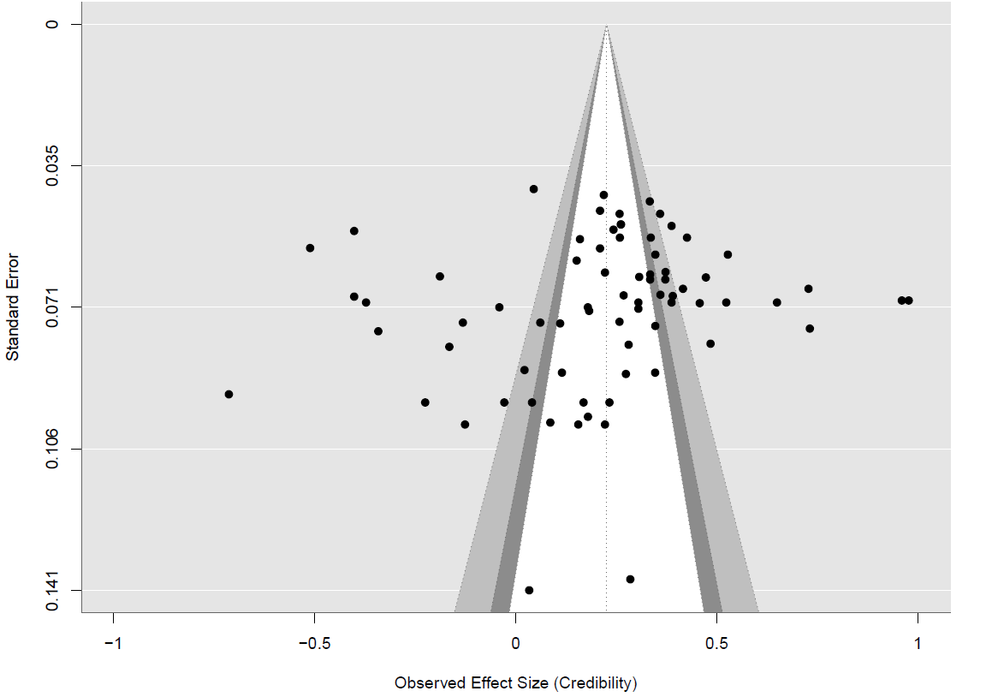 | 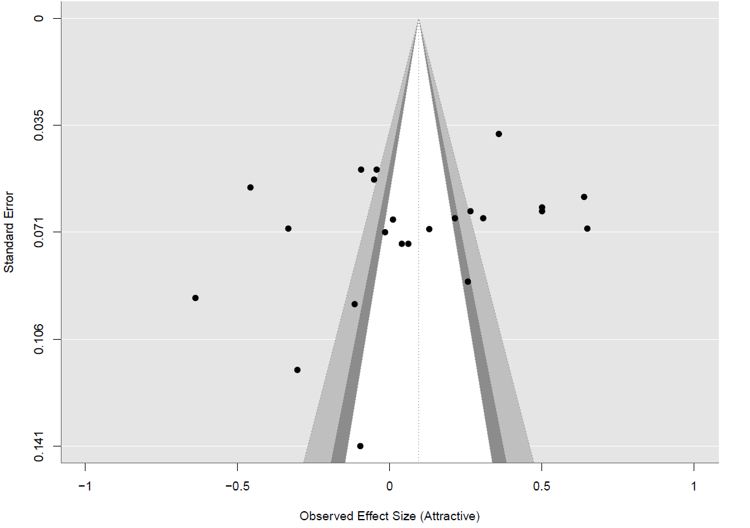
Test for Funnel Plot Asymmetry: z = 0.0927, p = 0.9261  Limit Estimate (as sei -> 0): b = 0.1882 (CI: -0.2921, 0.6684) | Test for Funnel Plot Asymmetry: z = -0.8049, p = 0.4209  Limit Estimate (as sei -> 0): b = 0.6897 (CI: -0.8938, 2.2732)
Brand attitude | Ad attitude
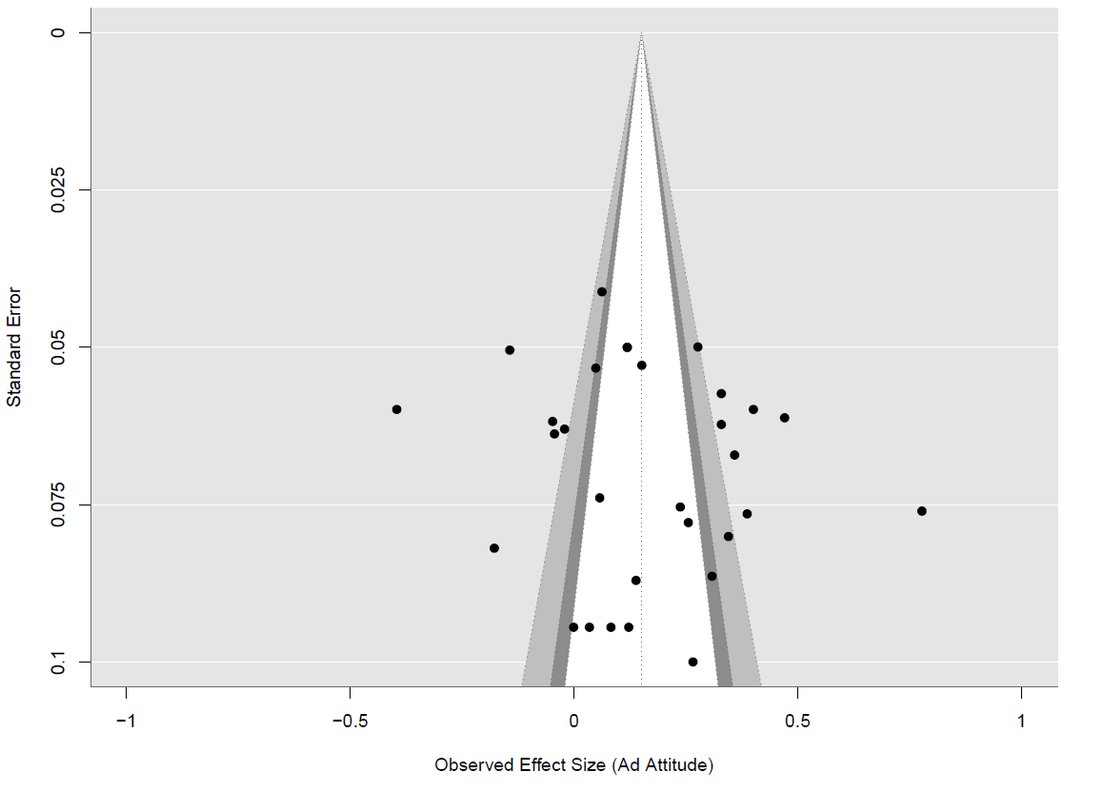 | 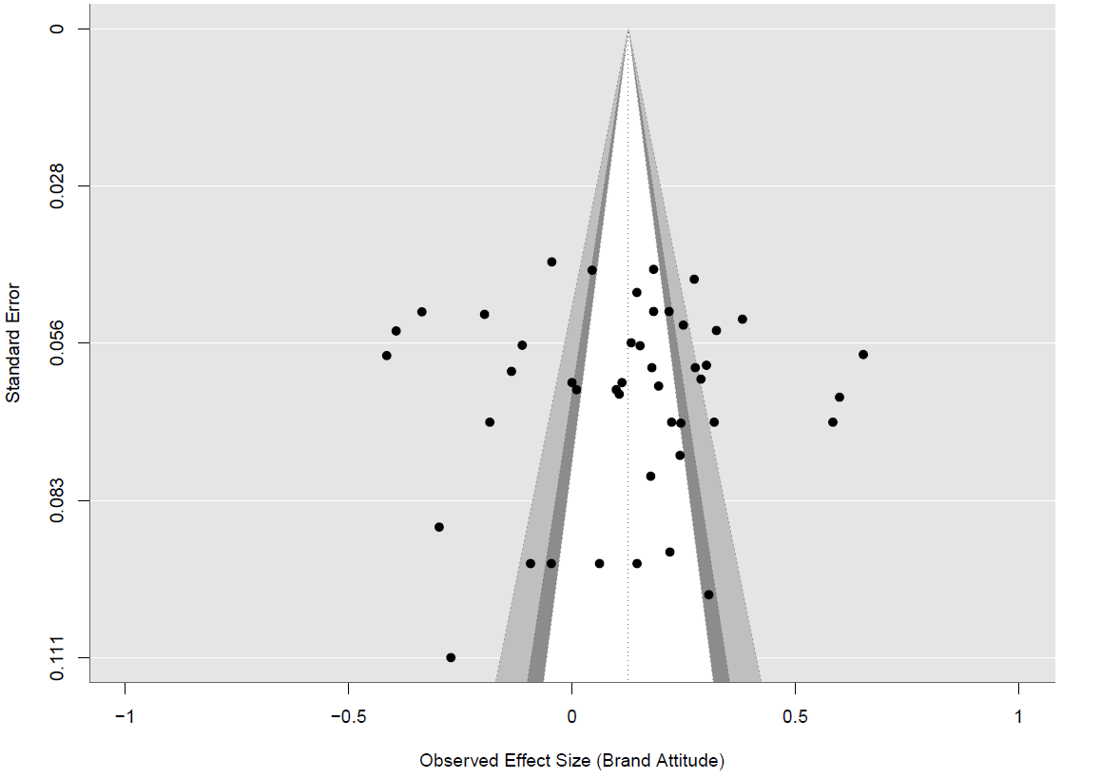
Test for Funnel Plot Asymmetry: z = -0.1187, p = 0.9055  Limit Estimate (as sei -> 0): b = 0.1497 (CI: -0.7701, 1.0696) | Test for Funnel Plot Asymmetry: z = 1.2807, p = 0.2003  Limit Estimate (as sei -> 0): b = -0.0823 (CI: -0.4981, 0.3336)
Purchase intention | Engagement
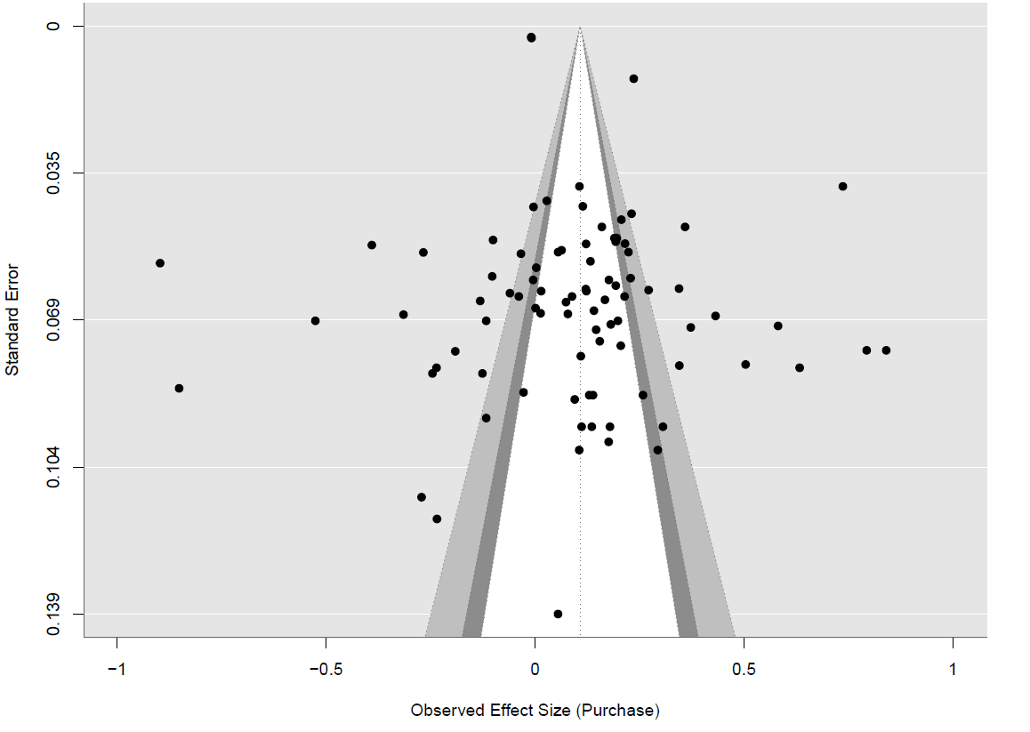 | 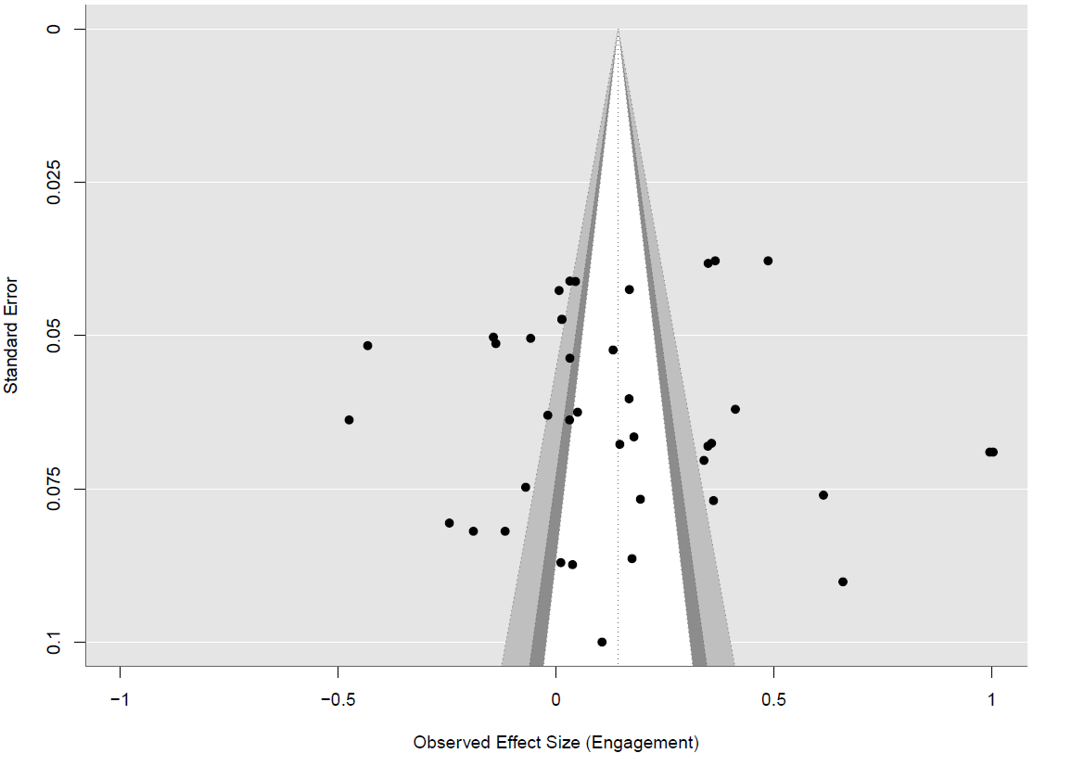
Test for Funnel Plot Asymmetry: z = -1.8051, p = 0.0711  Limit Estimate (as sei -> 0): b = 0.4796 (CI: 0.0330, 0.9263) | Test for Funnel Plot Asymmetry: z = 1.4286, p = 0.1531  Limit Estimate (as sei -> 0): b = -0.3586 (CI: -0.9781, 0.2610)

Web Appendix H: Results of Outlier Analysis
 | With outliers |  |  | Without outliers
Response to social media influencer | K | N | r_{rcvw} | K | N | r_{rcvw}
Credibility | 73 | 17,209 | .23** | 70 | 16,524 | 0.22*
Attractiveness | 23 | 5,541 | .10 | 22 | 5,358 | 0.10
Ad attitude | 30 | 7,250 | .15** | 30 | 7,250 | .15**
Brand attitude | 45 | 12,626 | .13** | 44 | 12,201 | .13**
Engagement | 40 | 12,318 | .14** | 38 | 11,906 | .13**
Purchase intention | 86 | 307,700 | .11** | 84 | 307,120 | .12**
Note: K: number of studies; N: combined sample size; r_{rcvw}: Reliability corrected, and variance weighted integrated correlation **p<.01, *p < .05
Web Appendix I: Frequency Distribution of Effect Sizes

Web Appendix J: Hierarchical Linear Modeling Equation
For the moderator analysis, we included all reliability-corrected correlations as effect sizes across the six dependent variables. We then included dummy variables that represent the various consumer response variables at level 1 of the model, and captured the nested structure of effect sizes within studies using the following equations:
Level 1 (within-study level):
Level 1: ES_{ij} = β_{0j} + β_{1j} * X_{ij} + v_{ij} + e_{ij} (1)
where:
  - ES_{ij} represents the i_{th} observed effect size from the j_{th} study
  - X_{ij} denotes the independent variable (different consumer response variables) at level 1
  - β_{0j} is the intercept for the j_{th} study
  - β_{1j} is the regression coefficient for X_{ij} in the j_{th} study
  - v_{ij} is known sampling error with mean of zero and a known variance
  - e_{ij} is the residual error at level 1 that captures the unexplained variation in ES_{ij} after accounting for X_{ij} and β_{0j} and the interaction term
This equation represents a multilevel regression model at level 1, where the outcome variable (ES_{ij}) is regressed on the level 1 predictors (X_{ij}) and the intercept (β_{0j}), which varies across studies.

Level 2 (between-study level):
At level 2, the model incorporates study-level moderators and interaction terms as follows:
Equation for the intercept (β_{0j}​):
β_{0j} = γ₀₀ + γ₀₁ * W_{1j} + u_{0j}, (2)
Where:
  - β_{0j} represents the intercept for the j_{th} study, as in equation (1)
  - W_{1j} represents other study-level moderators
  - γ₀₀ is the overall intercept across studies
  - γ₀₁ is the regression coefficient for W_{1j} in predicting β_{0j}
  - u_{0j} is the residual error at level 2, capturing the unexplained variation in β_{0j} after accounting for W_{1j} and Z_{j}

Equation for the slope (β_{1j}​):
The slope β_{1j}, which represents the relationship between the level 1 predictor (X_{ij} ​) and the effect size, is modelled as follows:
β_{1j} = γ₁₀ + γ₁₁ × W_{1j} + γ₁₂ × Z_{j} + γ₁₃ × (Z_{j} × X_{Engagement}) + γ₁₄ × (Z_{j} × X_{Purchase Intention}) + u_{1j}, (3)

Where:
  - β_{1j} is the slope of X_{ij} from level 1;
  - W_{1j} denotes the level 2 moderator;
  - Z_{j}​ is the dummy-coded variable for Endorser Type;
  - γ₁₀ is the overall slope across studies;
  - γ₁₁ is the regression coefficient for W_{1j}​ in predicting the slope;
  - γ12​ represents the main effect of Endorser Type on the slopes;
  - γ₁₃​ and γ₁₄​ capture the interaction effects between Endorser Type and the customer responses, Engagement and Purchase intention, respectively;
  - u_{1j} is the residual error at level 2, capturing the unexplained variation in the slope after accounting for W_{1j}, Z_{j} and their interactions.
Web Appendix K: Correlation Matrix Between Moderators
 | 01 | 02 | 03 | 04 | 05 | 06 | 07 | 08 | 09 | 10 | 11 | 12 | 13 | 14 | 15 | 16 | 17 | 18 | 19 | 20 | 21 | 22 | 23 | 24
Social media influencer | 1.00
Celebrity | -0.33 | 1.00
Virtual influencer | -0.30 | -0.26 | 1.00
Brand post | -0.22 | -0.10 | -0.12 | 1.00
Others | -0.21 | -0.09 | -0.12 | -0.04 | 1.00
Social media influencer size | 0.23 | 0.14 | -0.16 | 0.06 | 0.01 | 1.00
Social media influencer gender | 0.12 | -0.09 | 0.07 | 0.05 | -0.04 | 0.19 | 1.00
Social media influencer age | 0.32 | 0.20 | -0.25 | 0.11 | 0.03 | 0.11 | -0.06 | 1.00
Appeal | 0.24 | -0.23 | 0.15 | 0.07 | 0.05 | 0.05 | 0.18 | -0.39 | 1.00
Abstractness | 0.13 | 0.09 | -0.17 | 0.10 | 0.09 | 0.01 | 0.00 | 0.25 | -0.39 | 1.00
Social media influencer-product congruence | 0.32 | 0.08 | -0.04 | -0.03 | -0.03 | 0.09 | 0.14 | -0.19 | 0.15 | -0.07 | 1.00
Endorsement | 0.24 | -0.16 | 0.01 | 0.19 | 0.08 | -0.14 | -0.03 | -0.10 | -0.05 | 0.20 | 0.04 | 1.00
Benefit | 0.13 | -0.04 | 0.06 | -0.03 | -0.02 | 0.19 | 0.24 | -0.15 | 0.33 | 0.00 | 0.32 | 0.12 | 1.00
Classification | 0.32 | 0.03 | 0.03 | 0.07 | -0.19 | 0.13 | 0.08 | -0.03 | 0.08 | 0.03 | -0.05 | -0.02 | 0.15 | 1.00
Familiarity | 0.12 | -0.06 | 0.13 | -0.09 | -0.07 | -0.03 | -0.01 | -0.13 | 0.26 | -0.04 | 0.09 | -0.09 | 0.14 | -0.01 | 1.00
Platform | 0.10 | 0.06 | -0.13 | 0.10 | 0.06 | -0.12 | 0.08 | 0.00 | 0.07 | 0.18 | 0.04 | -0.06 | -0.14 | -0.12 | -0.15 | 1.00
Flowers gender | 0.19 | 0.18 | -0.23 | 0.17 | -0.03 | 0.14 | 0.20 | 0.10 | -0.02 | 0.20 | 0.01 | 0.14 | 0.20 | 0.22 | -0.17 | 0.22 | 1.00
Flowers age | 0.13 | 0.09 | -0.09 | -0.10 | 0.13 | 0.36 | 0.06 | 0.13 | 0.01 | 0.19 | 0.08 | -0.02 | 0.38 | 0.20 | -0.06 | -0.08 | 0.16 | 1.00
Purchase intention | 0.09 | -0.03 | 0.02 | 0.02 | 0.00 | -0.05 | -0.03 | -0.14 | 0.03 | 0.05 | 0.02 | 0.06 | 0.03 | 0.04 | 0.04 | 0.02 | -0.04 | -0.03 | 1.00
Engagement | 0.10 | -0.08 | 0.04 | 0.01 | 0.04 | -0.01 | -0.06 | -0.04 | 0.06 | -0.05 | -0.02 | 0.09 | -0.01 | 0.00 | 0.05 | -0.06 | 0.00 | -0.03 | 0.25 | 1.00
Brand | 0.06 | 0.02 | 0.04 | -0.05 | -0.06 | -0.13 | 0.00 | -0.04 | 0.02 | -0.04 | 0.07 | 0.00 | -0.01 | -0.06 | 0.07 | 0.09 | 0.02 | -0.09 | 0.27 | 0.17 | 1.00
Ad | 0.05 | 0.05 | -0.06 | 0.03 | -0.01 | 0.05 | 0.03 | 0.05 | 0.00 | 0.11 | -0.08 | -0.04 | 0.00 | 0.07 | -0.15 | 0.12 | 0.17 | 0.05 | 0.21 | 0.13 | 0.14 | 1.00
Credibility | 0.09 | 0.01 | -0.01 | -0.01 | 0.00 | 0.06 | 0.06 | 0.11 | -0.05 | 0.00 | -0.05 | -0.06 | 0.03 | -0.04 | -0.02 | -0.08 | -0.03 | 0.02 | 0.36 | 0.23 | 0.24 | 0.19 | 1.00
Attractive | 0.06 | 0.05 | -0.06 | 0.00 | 0.04 | 0.12 | 0.01 | 0.12 | -0.08 | -0.10 | 0.05 | -0.07 | -0.07 | 0.00 | -0.02 | -0.08 | -0.10 | 0.12 | 0.18 | 0.11 | 0.12 | 0.10 | 0.17 | 1.00

Web Appendix L: Robustness Check Analysis
Table: Average effect of social media influencers – excluding virtual influencer
Relationship | K | N | r_{rcvw} | S.E. | LCI | UCI | Q | FSN
Social Media Influencer → Credibility | 38 | 7,985 | .19** | .06 | .07 | .31 | 1384** | 1,956
Social Media Influencer → Attractiveness | 15 | 5,541 | -.02 | .10 | -.21 | .18 | 389** | 326
Social Media Influencer → Ad Attitude | 10 | 4,282 | .11* | .07 | .02 | .26 | 236** | 495
Social Media Influencer → Brand Attitude | 20 | 4,974 | .07 | .07 | -.07 | .21 | 309** | 321
Social Media Influencer → Engagement | 17 | 5,890 | .21* | .08 | .05 | .37 | 567** | 214
Social Media Influencer → Purchase Intention | 43 | 9,914 | .12* | .06 | .05 | .23 | 1141** | 2,165
Note: K: number of studies; N: cumulative sample size; r_{rcvw}: Reliability corrected, and variance weighted integrated correlation; S.E. = Standard error; LCI: 95%- lower confidence interval; UCI: 95%-upper confidence interval; Q=Q statistic; FSN=fail-safe N,
**p<.01, *p<.05

Web Appendix M: Social Media Influencer Interaction with Consumer Responses
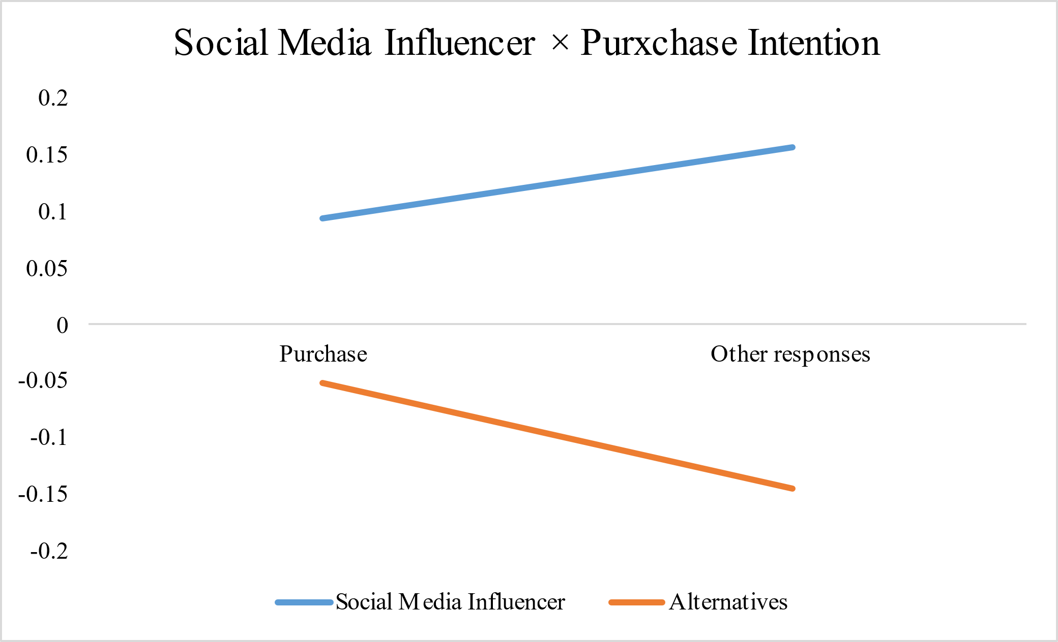 | 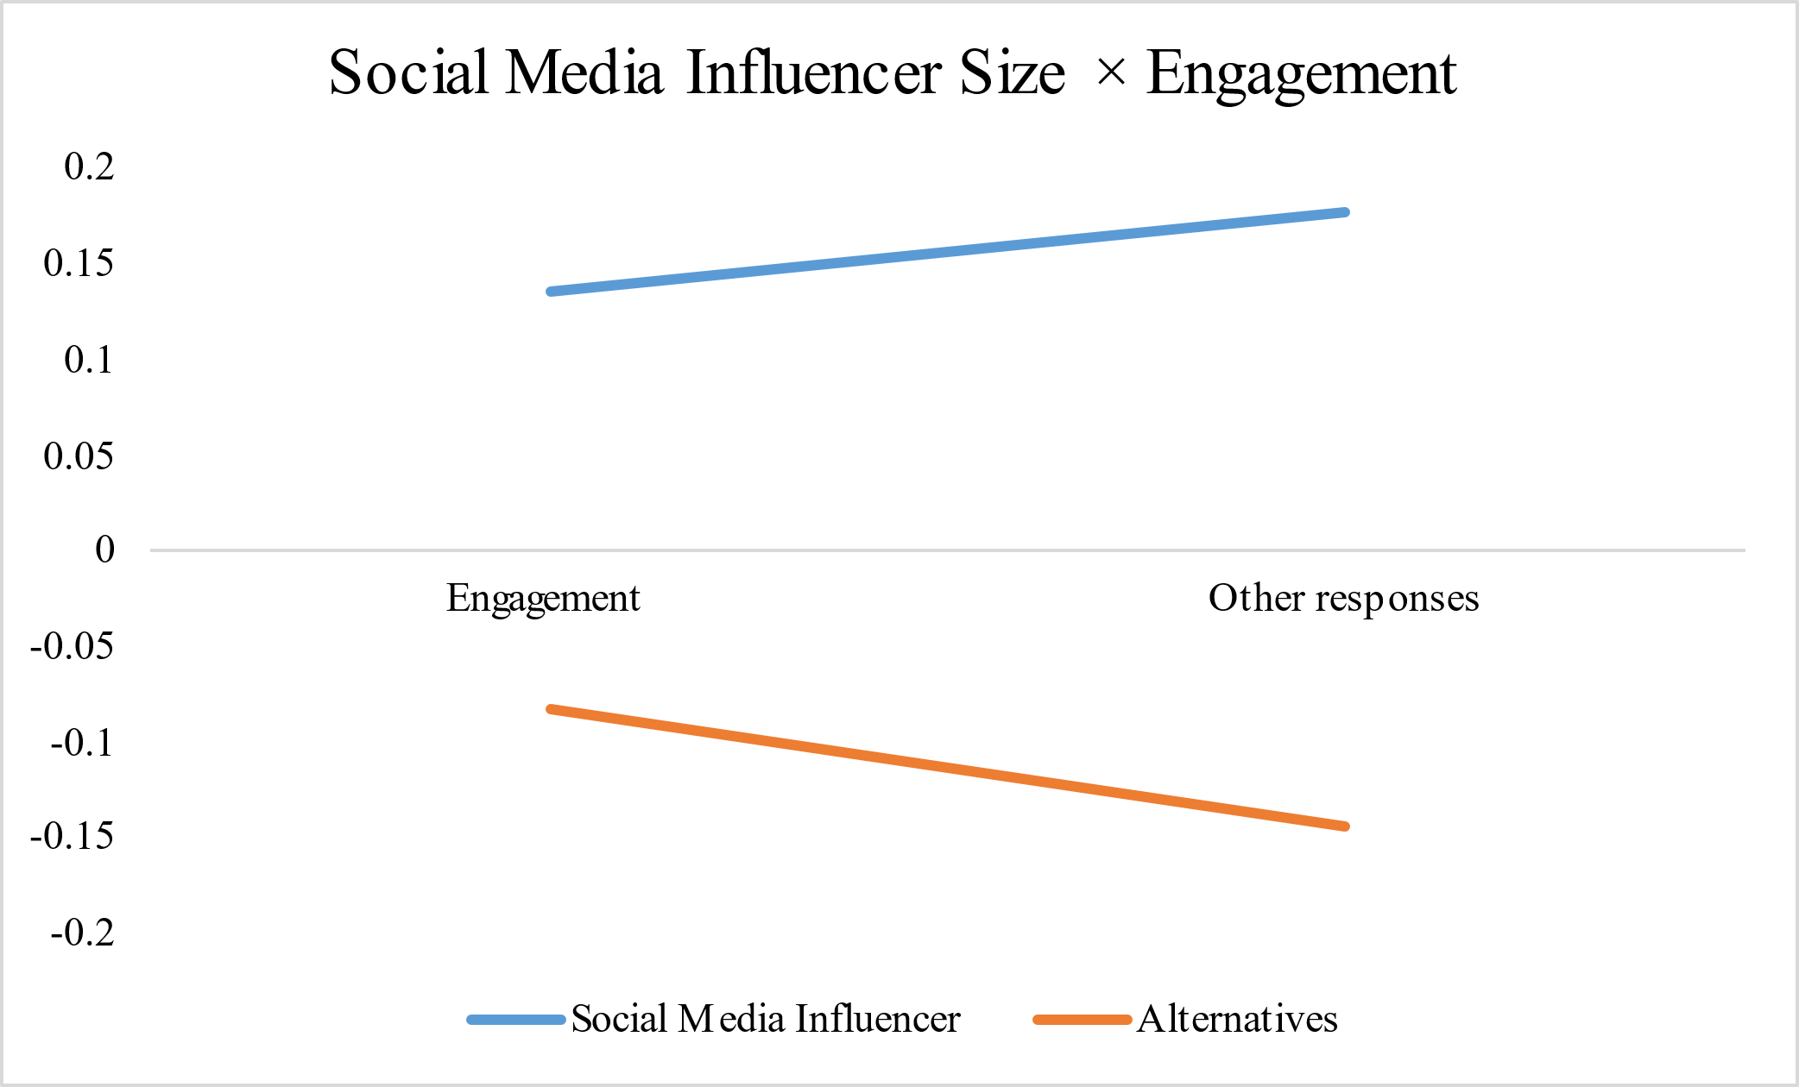
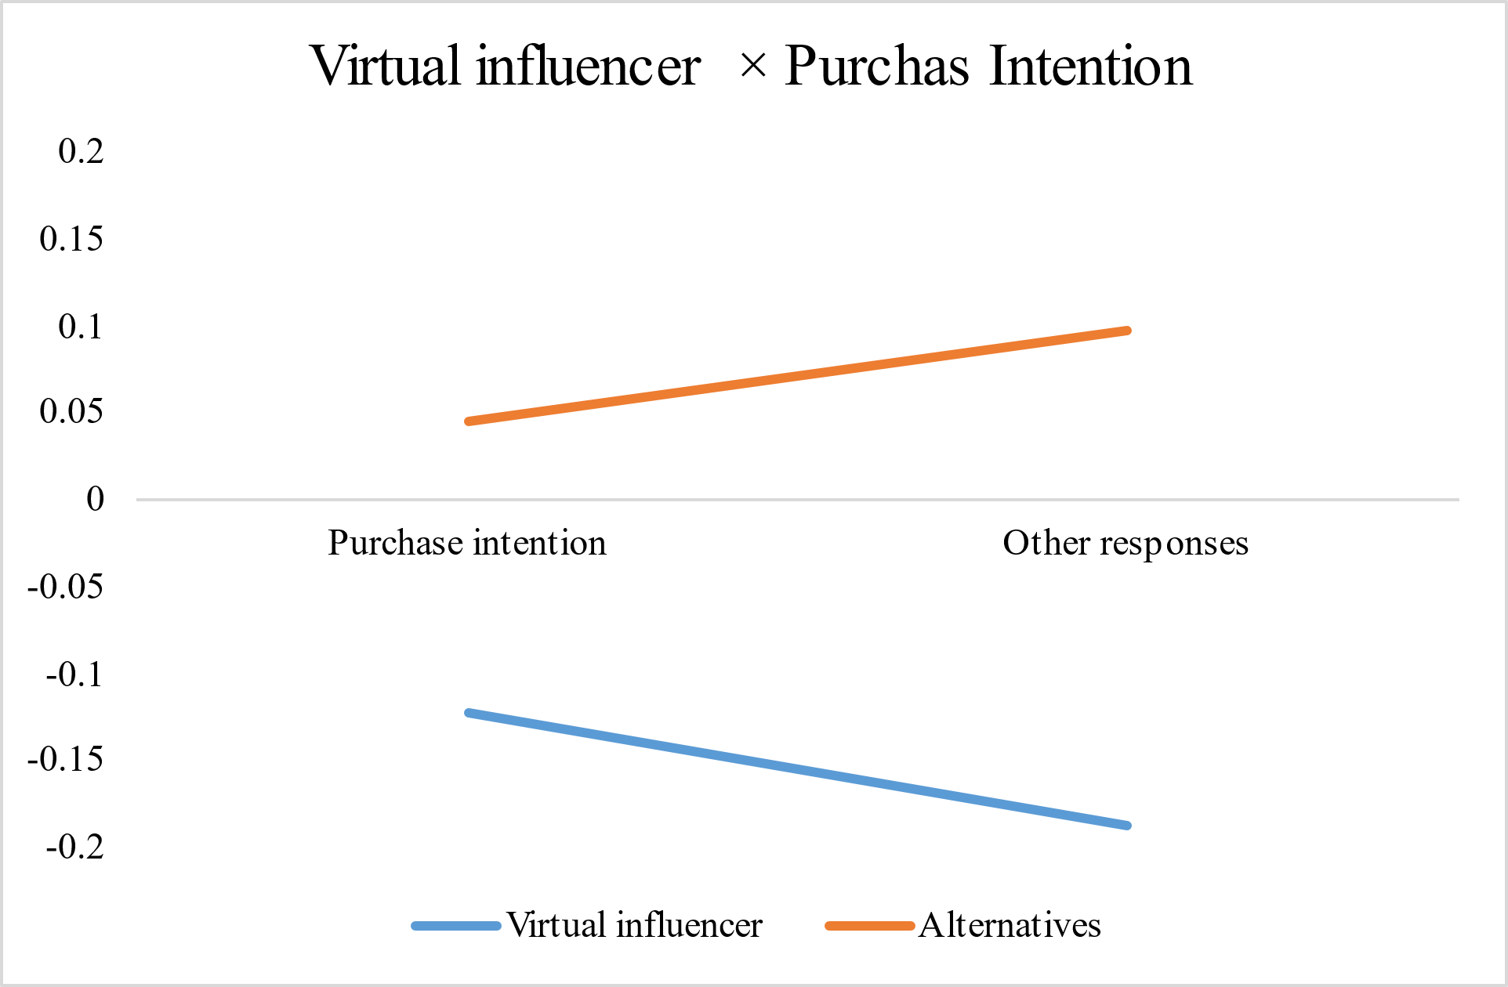 | 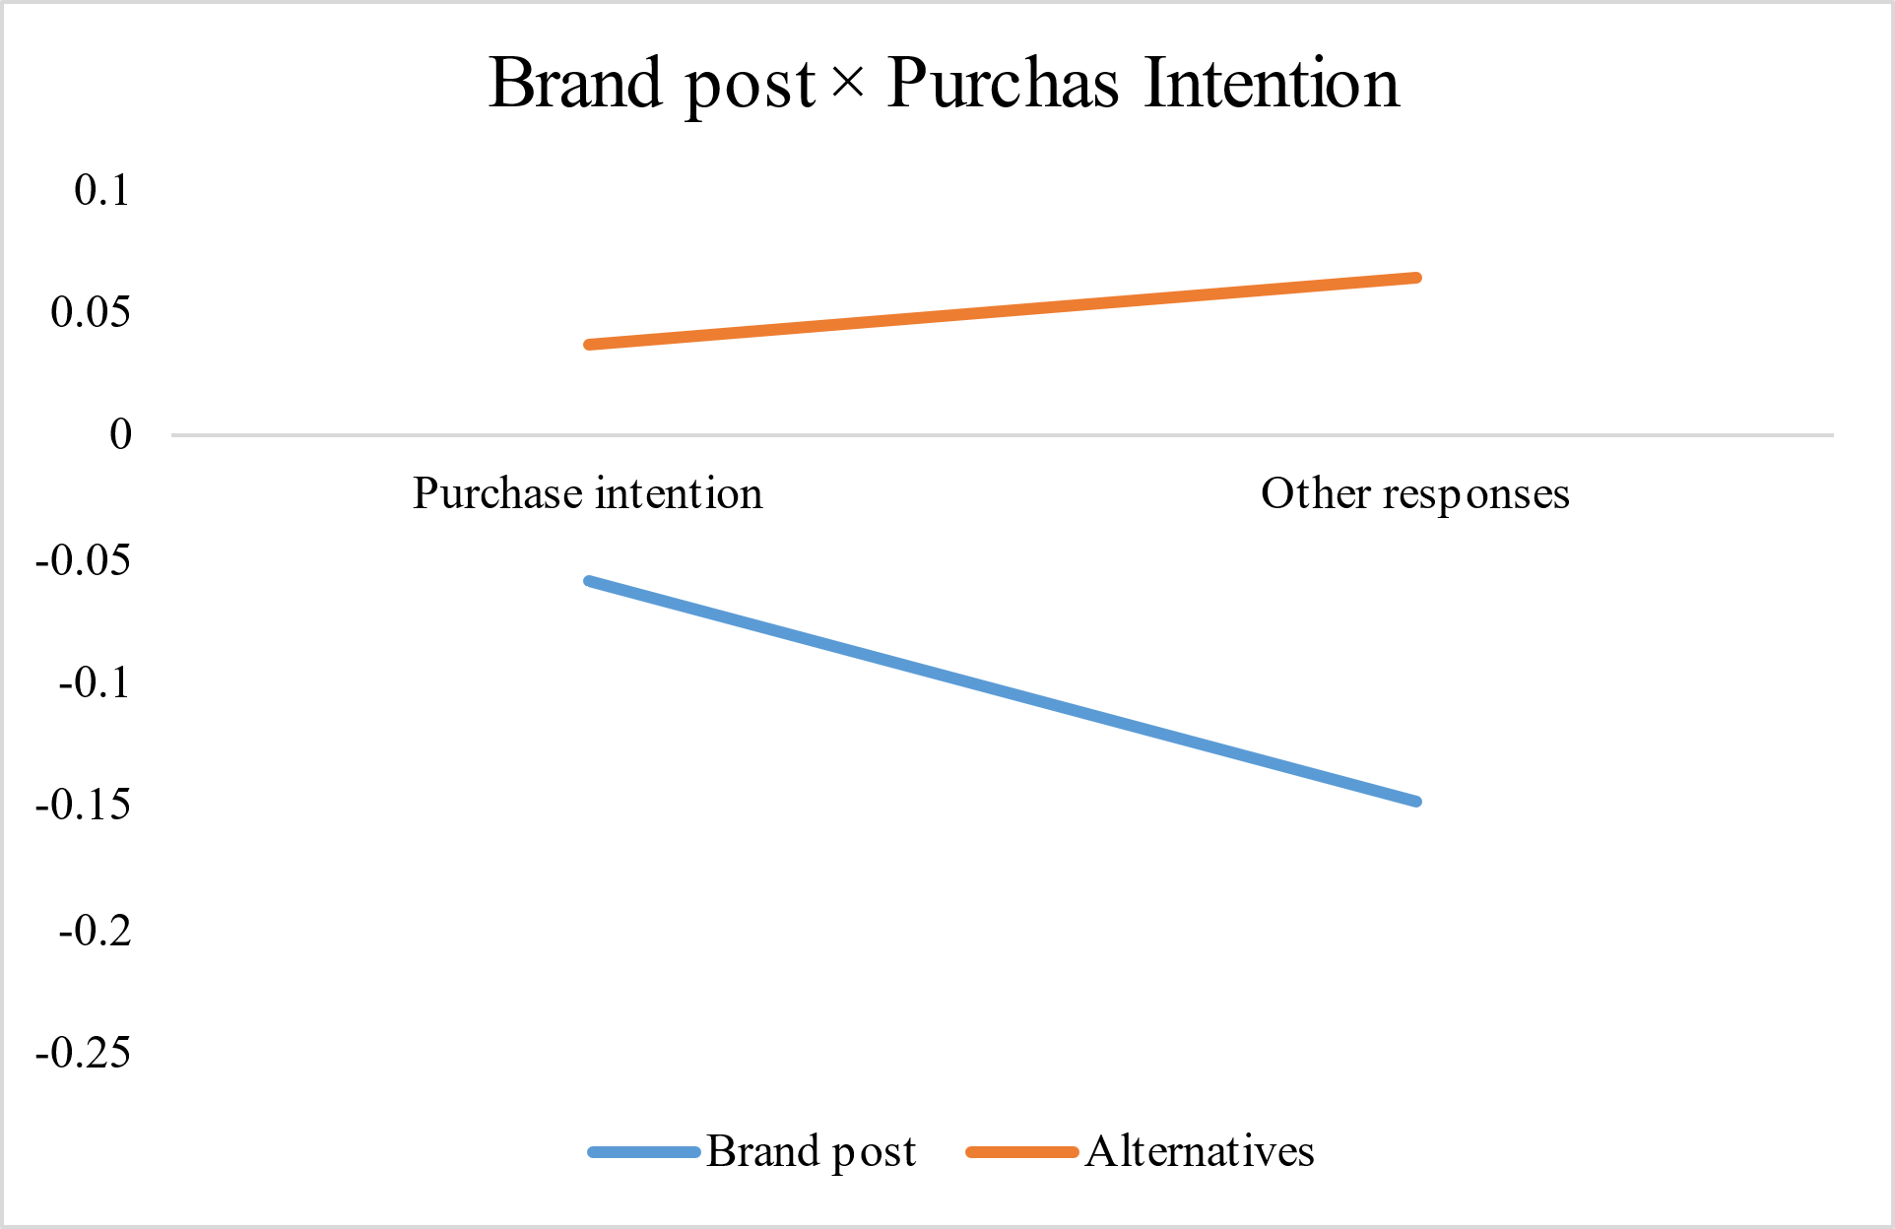
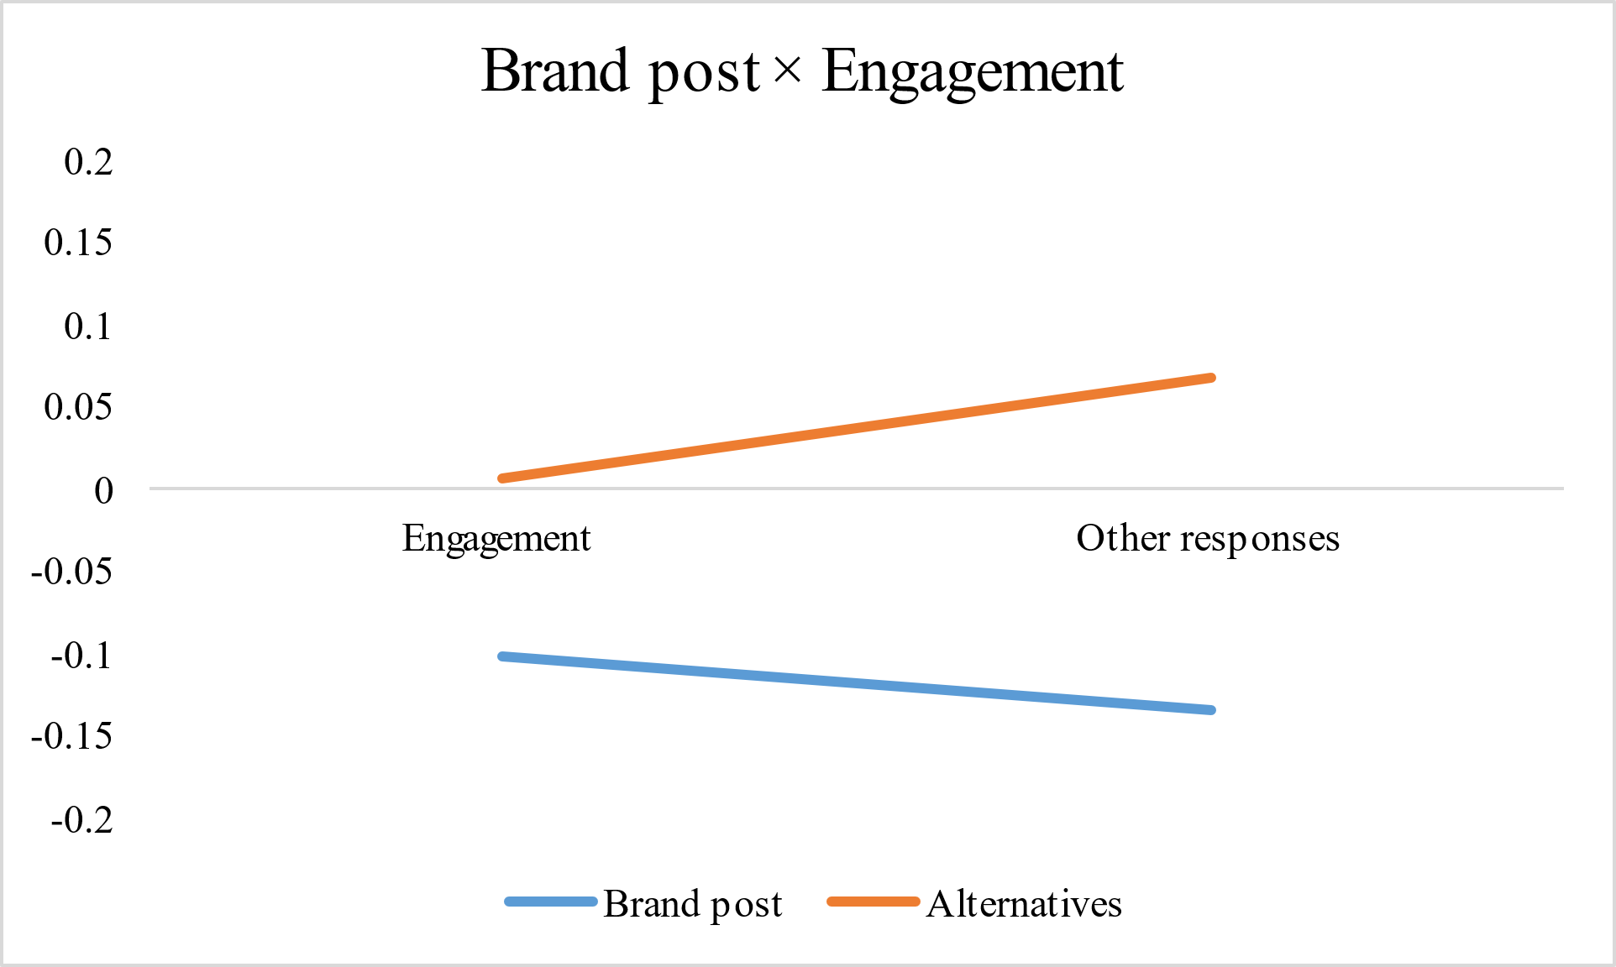 | 