Web Appendix

Beyond Youth: The Optimal Age for
Influencer Credibility and Marketing Success

Contents

Web Appendix 1: Interviews Influencer Agency 1
Web Appendix 2: Overview Studies 5
Web Appendix 3: Study 1 6
WA3-1: Design 6
WA3-2: ChatGPT age and attractiveness validation study 15
WA3-3: Instagram downtimes and outages 24
WA3-4: Variables and operationalization 25
WA3-5: Descriptives and correlations 26
WA3-6: Full Models Table 27
WA3-7: Interaction Table 28
Web Appendix 4: Study 2 31
WA4-1: Design 31
WA4-2: Variables and operationalization 34
WA4-3: Descriptives and correlations 35
WA4-4: Main Models Table 36
WA4-5: Poisson Table 37
WA4-6: Interaction Table 38
Web Appendix 5: Study 3 41
WA5-1: Design 41
WA5-2: Variables and operationalization 45
WA5-3: Descriptives and correlations 45
WA5-4: Manipulation check models 46
WA5-5: Main Models Robustness Table 47
WA5-6: H2 H3 Models Robustness Table 48
WA5-7: H4 Models Table 49
WA5-8: Cpath Table 49
WA5-9: Interaction Tables 50
WA5-10: Interaction Tables 55
WA5-11: Warmth & Competence 64
WA5-12: Mediation Warmth Competence 65
Web Appendix 6: Study 4 66
WA6-1: Design 66
WA6-2: Variables and operationalization 68
WA6-3: Descriptives and correlations 68
WA6-4: Manipulation check models 69
WA6-5: Main Models Robustness Table 70
WA6-6: H2 H3 Models Robustness Table 71
WA6-7: H4 Models Table 72
WA6-8: Interaction Tables 73
Web Appendix 7: Study 3b 84
WA7-1: Design 84
WA7-2: Variables and operationalization 91
WA7-3: Descriptives and correlations 91
WA7-4: Manipulation check models 92
WA7-5: Main Models Table 92
WA7-6: Figure Predicted Engagement, Credibility, Attractiveness 93
WA7-7: H2 H3 Models Table 93
WA7-8: H4 Models Table 94
WA7-9: Mediations Tests Table 94
WA7-10: Cpath Table 95
WA7-11: Interaction Table 96
Web Appendix 8: Study 3c 99
WA8-1: Design 99
WA8-2: Variables and operationalization 103
WA8-3: Descriptives and correlations 103
WA8-4: Manipulation check models 104
WA8-5: Main Models Table 104
WA8-6: Figure Predicted Engagement, Credibility, Attractiveness 105
WA8-7: H2 H3 Models Table 105
WA8-8: H4 Models Table 106
WA8-9: Cpath Table 106
WA8-10: Mediations Tests Table 107
WA8-11: Interaction Tables 108
Web Appendix 9: Study 4b 111
WA9-1: Design 111
WA9-2: Variables and operationalization 113
WA9-3: Descriptives and correlations 114
WA9-4: Manipulation check models 115
WA9-5: Main Models Table 115
WA9-6: H2 H3 Models Table 116
WA9-7: H4 Models Table 116
WA9-8: Interaction Tables 117
Web Appendix 10: Side-by-side comparison of field and lab context effects 121
Web Appendix 11: References 123

Web Appendix 1: Interviews Influencer Agency
Interview 1, 14.07.2025: Influencer marketing agency specializing in brand partnerships and creator collaborations. The agency develops tailored campaigns, matches brands with suitable influencers, and manages the execution and evaluation of collaborations. An agency executive with expertise in digital marketing and partnership development provided insights into strategic and operational aspects of influencer campaigns.

Example quotes:

Before revealing results, on optimal influencers, age, demographics, trends and platforms:

- ‘The faces that work best have a high match or a high fit with the product, the brand and, of course, the target group. In other words, if I use a face today that someone aged 26 doesn't know, but the product is made for people aged 26, I've made a classic miscast. So of course this is highly relevant.’

- ‘Age alone is not decisive. Age is only ever relevant in connection with the topic of authenticity, with the topic of fit. [...] The same age, sometimes a very high-quality product, sometimes a mass product - these are two different target groups and usually two very different influencers or talents.’

- ‘[...] the best, the best-performing influencers, in terms of sales, are all a bit older and not quite as perfect and tend to have between 150,000 and 300,000 followers. These are the ones who actually sell the best. Apart from the big cases, where it's always difficult to assign exactly where the individual sale comes from.’

- ‘Those with the best performance values are 35 to 45’

- ‘We also have a shoe manufacturer where the target group is over 60, but talent and even models are chosen who look around 30. Because nobody wants to be 60 anymore, or let's say 60 is the new 40 or the new 35. That's why I don't actually choose faces that are the same age. But in the end it always depends on how good the fit is that I manage to achieve here.’

- ‘Someone who is 60 today actually thinks they are 40 [...]. And even 70 [...] should look at most like 50. People used to say that you should use a face at that age. No, you shouldn't. Nobody wants to have their mirror held up to them, so to speak, but I actually want to see a particularly well-preserved specimen from my age cohort. It has become much younger.’

Virtual Influencer question reaction:

- ‘So it's not an issue for us. I'm also very skeptical about it, but it's more of a personal issue because it's just not real enough yet. So of course it helps enormously, let's say, to generate content without people or, let's say, to generate run-of-the-mill content [...]. I'm very skeptical, because the issue of authenticity is also important. [...] That's always been the case so far. So something that my target group can connect with, that they can relate to. And I haven't really seen any top cases yet.’

Reaction to the (interim) result & interest in results:

- ‘Yes, that's what I would have said now. That's what I meant before. So the ones with the best performance values are 35 to 45 I would say.’

- ‘When you have finished your study, I would of course be very interested to hear what you have found out and if you could send it to me. Very, very gladly.’

- ‘I'm very excited to see [...] what I get from you.’

Interview 2, 14.07.2025: Influencer marketing agency focusing on personal brand building and long-term creator–brand relationships. The agency designs and implements campaigns, supports content strategy, and fosters sustainable collaborations between influencers and brands. A marketing specialist with more than 7 years work experience provided insights into communication strategies, campaign design, and the agency’s approach to influencer partnerships.

Example quotes:

Before revealing results, on optimal influencers, age, looks, demographics, trends, and platforms:

- ‘I would therefore say that it depends entirely on what the customer wants and, above all, what the campaign is intended to achieve at the end of the day.’

- ‘So I think it probably depends more on the target group, because in the end [...] it's the target group that decides whether the recommendations or the recommendations are followed up, especially in terms of purchasing power. [...] If a campaign is really purely about sales, then it is probably more effective to work with older influencers because there is simply a community, a target group behind it that has more purchasing power. [...] I believe that people who have a bit more experience in life, in whatever respect, are simply a bit more trustworthy when it comes to recommendations. [...] If, for example, it's not about sales, but about awareness or branding, simply making sure that someone knows a brand, then of course I would say that younger influencers probably have an advantage because they generally [...] also have a greater reach.’

- ‘I wouldn't say across the board that there is the TikTok influencer or the Instagram influencer and I can categorize them because they bring A, B and C, but it's more about what the customer needs. But I think people are more open on TikTok and somehow also willing to show their perhaps more humorous side. And Instagram is still a [...] bit more serious.’

- ‘So basically you can still say, even though the platform has developed a lot, that TikTok is generally aimed at a younger target group and the creators on TikTok are generally younger. I would say that older creators tend to perform better on Instagram now [...] because the target group on Instagram is older.’

- ‘I actually don't think it's about looks anymore. I think that was a thing in influencer marketing [...] five, six, seven years ago, where it was really purely about aesthetics. And it was primarily photos that were posted. There wasn't anything like the reels and moving videos that exist today. It was mainly about what something looked like and, of course, what someone looked like. I think that today, and the word that's already getting on people's nerves in the industry, is the word authenticity. The greatest asset [...] in influencer marketing. And it doesn't really matter what someone looks like. So it's about how authentic the person is, how credible the person is, how do they take me as a consumer with them through their everyday life at the end of the day? Do I feel anything? Emotion is also always a big issue. Not in the sense that it makes me cry or moves me, but what does it do to me? Am I happy for the person? Do I empathize with the person? Do I just find what they do exciting? And I think that appearance has actually become, I would almost say, 99 percent completely irrelevant.’

Virtual Influencer question reaction:

- ‘'The topic of virtual influencers is difficult. [...] But what we really hardly ever see is virtual influencers being booked for campaigns. [...] It's simply not comparable with real people.’
Reaction to the (interim) result & interest in results:

- ‘So I would be interested to know what you found at the end of your study, what other [...] experts might think of it, because maybe I'm just really bad at my job and I'm just realizing it now because everyone else has a different perspective and I just haven't paid attention in the last six years. Of course, that would interest me in the end.’

- ‘Yes, exciting. I'm very excited.’

Interview 3, 18.07.2025: Influencer marketing agency offering full-service solutions for both B2C and B2B sectors. The agency connects brands with a wide range of influencers, including highly specialized niche audiences, and provides services from single campaign elements to comprehensive strategy and execution. An influencer marketing expert with extensive experience since 2010 shared insights into targeting specific audiences, managing diverse collaborations, and delivering tailored marketing solutions.

Example quotes:

Before revealing results, on optimal influencers, age, demographics, trends and platforms:

- ‘I don't believe [...] that there is a perfect age. Of course, there may be a perfect age in the target group. But I wouldn't say necessarily for influencers.’

- ‘People who are perhaps over 30, and above all over 40, and who have perhaps already had children [...] and have been working for a while, that they naturally come across differently, have a different way of thinking than young people now, who perhaps still have to find themselves, and where everything is still wild [...] and free [...].’

- ’We have also seen this with best-ager channels, which are really over 50 or sometimes over 60. Of course, the community has a much higher quality. This probably also has something to do with the fact that over-40 influencers are probably better [...]. The purchasing power is stronger, people follow them, not necessarily 20-year-olds and 20-year-olds, but people who are already earning money, who know how much I can spend [...], who have a different standing.’

- ‘TikTok has nothing to pretend about, is mainly a young target group, but is now catching up very strongly.’

- ‘For example, we also had a client who had the target group of men over 50 because he was comparing private health insurance policies. [...] And we also tested different things [...]. We came up with this typical cliché, older men, young attractive woman, because we tested the woman of the same age. a little younger woman, we tested men of course and the young woman. And in the end, he won the woman who brought the most.’

- ‘Because I think that being close to 40 can pick up younger people [as well as] older people who are 60 or so.’

Reaction to the (interim) result & interest in results:

- ‘I don't know what they can deliver, but of course, of course, results like that are always not bad. I always see it clearly, yes, from, as they say, two sides. I gave a lecture at my old university back then and I also said, yes, this whole thing started with YouTube and the internet in my day. Nowadays, I find it brutally difficult for people who teach at a university, university of applied sciences or something like that, because you actually say something and it's already outdated next week or sometimes a day later, because everything happens so quickly. So even books like that, I bought an AI book yesterday, yes, I'm reading it, but do you know what I mean? I always enjoy looking at it. I just always think that a lot of people in this influencer sector want to get something like this out, where this holy grail or a lot of software says, yes, we know exactly how it works, but if it were that easy, then suddenly there would be multimillionaires and you could grab influencers.’

Interview 4, 22.07.2025: Global creative agency with a dedicated focus on influencer and creator marketing. The agency develops integrated campaigns that combine brand storytelling with influencer collaborations, leveraging social platforms to drive engagement and reach. A director of influencer and creator solutions provided insights into strategic campaign planning, creator relationship management, and the integration of influencer marketing into broader brand strategies.

Example quotes:

Before revealing results, on optimal influencers, age, demographics, trends and platforms:

- ‘So it's actually not just about the age of the content creators.’

- ‘It doesn't help me if I put Caro Dauer there to tell me about wrinkle cream, but it makes more sense if a grandma or at least an older person tells you: I didn't believe in it, I used it and of course the wrinkles don't disappear, but they have become less or are not as pronounced. It's [...] very much about authenticity when we talk about target groups.’

- ‘But I don't think that has anything to do with age, but rather [...] with assets and [...] what money you have at what age and what liquidity is available to you. I think that is [...] more linked to age, that the older you get, the better financially [...] or more independent you are. [...] than the fact of age itself.’

- ‘The kids are out of the woods by the time you're 40 and you have a bit of time for yourself again and maybe you'll start to engage with topics again. [...] And you interact with things, not because you're algorithm-driven, but because you're interest-driven.’

- ‘Because people follow content creators because they're relatable, because at best you assume they're going through heartbreak like you, that they've experienced racism like you, that they're interested in the same shoes as you. If you have an AI influencer, where am I supposed to relate?’

Reaction to the (interim) result & interest in results:

- ‘I can confirm it.’

- ‘I would like to have a look at the study when you have finished it, because I find it super interesting.’

Web Appendix 2: Overview Studies
Overview of the age groups examined in the studies

Range | Intended | AI Check (Chat GPT)
Study 2
1 | 15-20 | Woman: 18-22 Man: 18-22
2 | 20-25 | Woman: 22-28 Man: 22-28
3 | 25-30 | Woman: 28-35 Man: 28-35
4 | 30-35 | Woman: 35-45 Man: 35-45
5 | 40-45 | Woman: 45-55 Man: 45-55
6 | 50-55 | Woman: 55-70 Man: 55-70
7 | 60-65 | Woman: 70-85 Man: 70-85
Study 3
1 | 20-25 | 20-25
2 | 30-35 | 30-35
3 | 40-45 | 40-45
4 | 50-55 | 50-55
5 | 60-65 | 60-65
Study 3b
1 | 20-30 | Woman 1: 20-25 Woman 2: 22-27 Woman 3: 20-25
2 | 40-50 | Woman 1: 35-45 Woman 2: 38-45 Woman 3: 35-42
3 | 60-70 | Woman 1: 55-65 Woman 2: 58-68 Woman 3: 55-65
Study 3c
1 | 20-25 | Woman: 20-25
2 | 25-30 | Woman: 25-30
3 | 30-40 | Woman:30-40
4 | 40-50 | Woman: 40-50
5 | 50-60 | Woman: 50-65
Study 4
1 | 20-25 | Woman: 20-25 Man: 20-25
2 | 25-30 | Woman: 25-30 Man: 22-28
3 | 30-40 | Woman: 30-40 Man: 28-32
4 | 40-50 | Woman: 40-50 Man: 35-40
5 | 50-60 | Woman: 50-65 Man: 45-55
6 | 60-70 | Woman: 70-80 Man: 65-75
7 | 70-80 | Woman: 80-90 Man: 80-90
Study 4b
1 | 20-25 | Woman: 20-25 Man: 20-25
2 | 25-30 | Woman: 25-30 Man: 22-28
3 | 30-40 | Woman 30-40 Man: 28-32
4 | 40-50 | Woman: 40-50 Man: 35-40
5 | 50-60 | Woman: 50-65 Man: 45-55

Web Appendix 3: Study 1

WA3-1: Design
Influencer types
 | Virtual Influencer | Youngest Influencer | Biggest Influencer | Oldest Influencer
Accounts | 47 | 54 | 51 | 52

The following biggest virtual (type a) influencers (mostly human-like) were extracted from the following sources.
https://www.storyclash.com/blog/de/virtuelle-influencer/
https://dreamfarmagency.com/blog/top-virtual-influencers/
https://influencermarketinghub.com/virtual-influencers/
https://influencers.feedspot.com/virtual_instagram_influencers/
https://www.insg.co/en/virtual-influencers-world/
https://www.influencerintelligence.com/blog/TZr/10-virtual-influencers-you-should-follow
(all retrieved 12/19/2024)

ID | Type | Username | Age | Female | Follower | Content Category | Number of Posts
1 | A | leyalovenature | 25 | ✓ | 541943 | Lifestyle, Sports, Health | 49
2 | A | lilmiquela | 21 | ✓ | 2490683 | Lifestyle, Fashion | 48
3 | A | anymalu_real | 21,5 | ✓ | 683496 | Lifestyle | 47
4 | A | casasbahia | 9 | Χ | 4068856 | Random | 40
5 | A | emily.yoo_ | 21,5 | ✓ | 728505 | Portrait | 49
6 | A | barbie | 25 | ✓ | 3549519 | Lifestyle | 38
7 | A | realvivisaur | 21,5 | ✓ | 594381 | Food, Travel* | 50
8 | A | kda_music | 21,5 | ✓ | 482731 | Musician | 50
9 | A | naina_avtr | 22,5 | ✓ | 422526 | Lifestyle | 49
10 | A | imma.gram | 18 | ✓ | 393819 | Lifestyle | 47
11 | A | noonoouri | 18 | ✓ | 496723 | Model, Artist* | 50
12 | A | iam_zlu | 25 | Χ | 464467 | Fashion, Art* | 46
13 | A | seradotwav | 21,5 | ✓ | 327231 | Songwriter, Producer* | 50
14 | A | arbie_seo | 18 | ✓ | 369314 | Lifestyle | 50
15 | A | iampolarmusic | 21,5 | ✓ | 361515 | Musician, Dancer* | 50
16 | A | shudu.gram | 27,5 | ✓ | 237231 | Supermodel* | 52
17 | A | realqaiqai | 4 | ✓ | 329789 | Lifestyle | 46
18 | A | realsophiarobot | 27,5 | ✓ | 265742 | Lifestyle | 25
19 | A | eusouluks | 24 | Χ | 149260 | Lifestyle | 42
20 | A | rozy.gram | 21 | ✓ | 177303 | Lifestyle | 47
21 | A | here.me.lucy | 22,5 | ✓ | 128880 | Lifestyle, Fashion | 50
22 | A | imapoki | 19 | ✓ | 135896 | Singer, Lifestyle | 50
23 | A | bodybyralph | 35 | X | 141811 | Personal Trainer, Life Coach* | 50
24 | A | lechat.vv | 18 | ✓ | 131823 | Musician | 50
25 | A | millasofiafin | 24 | ✓ | 208630 | Lifestyle, Portrait | 46
26 | A | blawko22 | 25 | X | 119683 | Lifestyle, Fashion | 50
27 | A | iongottlich | 32,5 | X | 72111 | Sports* | 46
28 | A | soymar.ia | 25 | ✓ | 75105 | Food*, Lifestyle | 49
29 | A | ai_angelica | 30 | ✓ | 48934 | Video-Creator* | 50
30 | A | astrolovesu | 21,5 | X | 89150 | Musician* | 50
31 | A | rina.8k | 21,5 | ✓ | 27928 | Lifestyle, Fashion | 50
32 | A | sua_to_z | 21,5 | ✓ | 72155 | Artist | 50
33 | A | aidreamergirl | 25 | ✓ | 34352 | Portrait | 25
34 | A | zoedvir | 25 | ✓ | 24597 | Beauty, Fashion* | 50
35 | A | ai_ailynn | 21,5 | ✓ | 29197 | Lifestyle | 49
36 | A | ruuui_li | 21 | ✓ | 16599 | Musician | 50
37 | A | here.is.rae | 21,5 | ✓ | 22017 | Skating, Fashion* | 50
38 | A | albarenai | 22,5 | ✓ | 18156 | Lifestyle | 48
39 | A | liam_nikuro | 19 | X | 11695 | Lifestyle, Sport | 50
40 | A | hollyy.kimm | 25 | ✓ | 21671 | Portrait | 49
41 | A | ivaany.h | 30 | ✓ | 11091 | Lifestyle | 47
42 | A | magazineluiza | 27,5 | ✓ | 7630930 | Lifestyle, Brand Ambassador Einzelhandels-unternehmen | 50
43 | A | aliona_pole | 23 | ✓ | 13214 | Lifestyle | 47
44 | A | vandadvlogs | 30 | X | 5373 | Video-Creator* | 48
45 | A | kyraonig | 25 | ✓ | 253195 | Lifestyle, Portrait | 44
46 |  | kaisa_dancer | 21 | ✓ | 13063 | Vocalist, Dancer, Choreographer* | 45
47 | A | winni.grounds | 21,5 | ✓ | 81312 | Digital Creator*, Lifestyle, Musician | 47

This study analysed a sample of 47 virtual influencers with an average age of 22.73 years (SD = 5.13). Most of the sample consisted of female virtual influencers, with 38 out of 47 (80.85%) identifying as female. The virtual influencers had an average follower count of 565,395.8, indicating a considerable reach within their respective audiences. Additionally, the average number of posts per influencer was 47.13.
As a second category (type B), we looked at the youngest and biggest Instagram influencers (not older than Gen Z, i.e. born after 1997). We took these from the following lists/sources.
https://collabstr.com/blog/gen-z-influencers
https://influencers.feedspot.com/teen_instagram_influencers/
https://www.stylight.com/Magazine/Fashion/Wildly-Successful-Influencers-21/
https://tagshop.ai/de/blog/gen-z-influencers/
https://www.mydoh.ca/learn/blog/lifestyle/most-interesting-kid-influencers-under-16/
https://influencermarketinghub.com/kid-influencers/
https://starngage.com/plus/en-us/influencer/ranking → influencers from this list who are 27 years old or younger
https://izea.com/resources/top-instagram-influencers-list/ → influencers from this list who are 27 years old or younger
(all retrieved 12/19/2024)

ID | Type | Username | Age | Female | Follower | Content Category | Number of Posts
1 | B | milliebobbybrown | 20 | ✓ | 63383019 | Actor* | 37
2 | B | k.mbappe | 25 | X | 123242853 | Sports* | 43
3 | B | billieeilish | 22 | ✓ | 121819940 | Musician | 47
4 | B | khaby00 | 24 | X | 81262666 | Gaming-Video-Creator* | 41
5 | B | mrbeast | 26 | X | 65554824 | Lifestyle | 44
6 | B | shawnmendes | 26 | X | 71457006 | Musician | 48
7 | B | larissamanoela | 23 | ✓ | 54285309 | Actress, Singer* | 47
8 | B | gretathunberg | 21 | ✓ | 14092674 | Climate Activist* | 19
9 | B | kyliejenner | 26 | ✓ | 394855003 | Lifestyle, Artist, Model | 44
10 | B | addisonraee | 24 | ✓ | 34255932 | Lifestyle, Artist, Music | 48
11 | B | carryminati | 25 | X | 22221058 | Artist | 46
12 | B | avani | 22 | ✓ | 16053754 | Lifestyle, Artist | 50
13 | B | maddieziegler | 22 | ✓ | 13420660 | Actor | 49
14 | B | emmachamberlain | 23 | ✓ | 14897370 | Lifestyle, Artist | 50
15 | B | nianaguerrero | 18 | ✓ | 15421443 | Dancer, Lifestyle Creator* | 42
16 | B | julesleblanc | 20 | ✓ | 9660828 | Actor | 49
17 | B | charlidamelio | 20 | ✓ | 42818082 | Artist, Lifestyle | 46
18 | B | fatehhalilintar | 18 | X | 5386043 | Business Owner*, Lifestyle | 43
19 | B | mollymae | 25 | ✓ | 8546951 | Lifestyle, Actress | 47
20 | B | wisdm | 23 | X | 6721358 | Director, model, stylist, photographer, videographer* | 43
21 | B | elle | 7 | ✓ | 3900722 | Lifestyle | 50
22 | B | hayley.leblanc | 16 | ✓ | 4095151 | Actress | 48
23 | B | everleighrose | 11 | ✓ | 4935130 | Dancer | 43
24 | B | laurenorlando88 | 20 | ✓ | 4684458 | Artist | 50
25 | B | lexibrookerivera | 23 | ✓ | 8003082 | Lifestyle, Artist, Actress | 50
26 | B | cookingwithkian | 14 | X | 5472617 | Cook* | 39
27 | B | salishmatter | 14 | ✓ | 3698536 | Gymnast*, Lifestyle | 50
28 | B | ariana_greenblatt | 17 | ✓ | 3661032 | Actress | 50
29 | B | naturally.jo | 18 | X | 1226682 | Food* | 50
30 | B | jaydenbartels | 20 | ✓ | 3354837 | Actress* | 49
31 | B | deja_clarkk | 13 | ✓ | 1590709 | Artist | 47
32 | B | mccluretwins | 11 | ✓ | 2478267 | Lifestyle | 41
33 | B | sawyersharbino | 18 | X | 1242278 | Musician, Lifestyle? | 37
34 | B | gavinmagnus | 17 | X | 2474707 | Artist*, Lifestyle, Musician | 47
35 | B | kylethomas | 20 | X | 1391307 | Artist | 42
36 | B | aliyahsinterlude | 21 | ✓ | 988283 | Musician, Artist | 46
37 | B | tianawilson | 16 | ✓ | 873209 | Video-Creator* | 50
38 | B | cocoquinn3 | 16 | ✓ | 2070980 | Artist* | 49
39 | B | benoftheweek | 25 | X | 863653 | Artist, Comedy | 12
40 | B | payton_delu | 16 | ✓ | 553403 | Gymnast* | 40
41 | B | kingferran | 14 | X | 1155990 | Artist | 48
42 | B | clairerocksmith | 16 | ✓ | 704007 | Creator*, Lifestyle | 42
43 | B | kurzawa_karina | 17 | ✓ | 760854 | Artist | 50
44 | B | trinity_morisette | 21 | ✓ | 628353 | Artist | 43
45 | B | tekkerzkid | 15 | X | 829272 | YouTuber, Footballer* | 45
46 | B | lileeannenelson | 18 | ✓ | 239156 | Artist | 22
47 | B | nicola.crisa | 17 | ✓ | 307772 | Lifestyle | 45
48 | B | fatherkels | 26 | ✓ | 2831646 | Lifestyle, Food | 50
49 | B | oliviajade | 25 | ✓ | 1263632 | Artist | 49
50 | B | andreaa_arru | 17 | X | 564831 | Actor* | 44
51 | B | coco_pinkprincess | 14 | ✓ | 519961 | Creator*, Lifestyle, Fashion | 50
52 | B | littlemissflint | 17 | ✓ | 192799 | Sports*, Lifestyle | 44
53 | B | flavialeone | 18 | ✓ | 280428 | Actress* | 48
54 | B | giaflip10 | 13 | ✓ | 340309 | Lifestyle, Artist, Musicician | 22

This study analyzed a sample of 54 of the youngest influencers with an average age of 19.15 years (SD = 4.45). Most of the sample consisted of female influencers, with 38 out of 54 (70.37%) identifying as female. These influencers had an average follower count of 23,102,496.78, showcasing a substantial reach and popularity among their target audiences. Additionally, the average number of posts per influencer was 43.98.
In the third category (type C), we are looking for the 50 most influential people who do not necessarily fall into the categories of the youngest or oldest influencers. We extracted them from the following website:
https://starngage.com/plus/en-us/influencer/ranking
(all retrieved 12/19/2024)

ID | Type | Username | Age | Female | Follower | Content Category | Number of Posts
1 | C | therock | 52 | X | 395352876 | Actor | 48
2 | C | selenagomez | 32 | ✓ | 422441691 | Artist* | 50
3 | C | beyonce | 43 | ✓ | 313140554 | Musician | 49
4 | C | justinbieber | 30 | X | 294959741 | Musician | 50
5 | C | jlo | 55 | ✓ | 249529214 | Musician | 47
6 | C | kimkardashian | 44 | ✓ | 358415120 | Lifestyle, Artist, Model | 50
7 | C | arianagrande | 31 | ✓ | 376533183 | Musician | 37
8 | C | nickiminaj | 42 | ✓ | 226681784 | Musician* | 49
9 | C | neymarjr | 32 | X | 227791813 | Sports* | 25
10 | C | mileycyrus | 32 | ✓ | 213507528 | Musician | 31
11 | C | virat.kohli | 36 | X | 270467440 | Sports | 42
12 | C | zendaya | 28 | ✓ | 180666643 | Actress | 50
13 | C | khloekardashian | 40 | ✓ | 304608631 | Lifestyle, Artist, Model | 47
14 | C | taylorswift | 34 | ✓ | 282667650 | Musician | 47
15 | C | katyperry | 40 | ✓ | 204942461 | Musician | 44
16 | C | iamcardib | 32 | ✓ | 164264894 | Artist* | 50
17 | C | badgalriri | 36 | ✓ | 150188845 | Musician | 49
18 | C | ddlovato | 32 | ✓ | 154041018 | Musician | 48
19 | C | lalalalisa_m | 27 | ✓ | 105458389 | Musician | 46
20 | C | gal_gadot | 39 | ✓ | 108686093 | Model, Actress | 49
21 | C | kingjames | 39 | X | 159628252 | Basketball | 30
22 | C | champagnepapi | 38 | X | 143497099 | Singer | 47
23 | C | kendalljenner | 29 | ✓ | 289716740 | Lifestyle, Model, Author | 48
24 | C | ellendegeneres | 66 | ✓ | 137101250 | Artist, Author, Actress, Comedian | 50
25 | C | chrisbrownofficial | 35 | X | 144632826 | Artist* | 48
26 | C | kevinhart4real | 45 | X | 177659990 | Actor | 43
27 | C | vindiesel | 57 | X | 103207229 | Actor | 50
28 | C | narendramodi | 74 | X | 92436032 | Politics* | 46
29 | C | jennierubyjane | 28 | ✓ | 86121637 | Musician | 50
30 | C | dualipa | 29 | ✓ | 87423220 | Musician | 49
31 | C | shakira | 47 | ✓ | 90861877 | Musician | 42
32 | C | priyankachopra | 42 | ✓ | 92615273 | Musician, Actress | 49
33 | C | deepikapadukone | 38 | ✓ | 80441569 | Model, Actress | 42
34 | C | sooyaaa__ | 29 | ✓ | 79739873 | Musician | 48
35 | C | snoopdogg | 53 | X | 88156475 | Musician | 42
36 | C | aliaabhatt | 31 | ✓ | 86244111 | Actress | 47
37 | C | roses_are_rosie | 27 | ✓ | 82780108 | Musician | 44
38 | C | shraddhakapoor | 37 | ✓ | 94249599 | Artist, Model, Actress | 35
39 | C | nehakakkar | 36 | ✓ | 78444836 | Musician* | 47
40 | C | karimbenzema | 36 | X | 76181803 | Athlete* | 36
41 | C | katrinakaif | 41 | ✓ | 80449516 | Actress* | 40
42 | C | theweeknd | 34 | X | 76009125 | Musician | 50
43 | C | emmawatson | 34 | ✓ | 73808457 | Actress | 50
44 | C | justintimberlake | 43 | X | 72227902 | Musician | 43
45 | C | gigihadid | 29 | ✓ | 77497979 | Model | 50
46 | C | karolg | 33 | ✓ | 70411058 | Musician | 49
47 | C | urvashirautela | 30 | ✓ | 72620000 | Artist | 46
48 | C | ronaldinho | 44 | X | 76887175 | Sports | 37
49 | C | beingsalmankhan | 59 | X | 69915492 | Artist* | 49
50 | C | marcelotwelve | 36 | X | 67849708 | Entrepreneur* | 39
51 | C | davidbeckham | 49 | X | 88226860 | Sports | 48
This study analysed a sample of 51 of the largest influencers on Instagram with an average age of 38.92 years (SD = 10.14). Most of the sample consisted of female influencers, with 33 out of 51 (64.71%) identifying as female. These influencers had an average follower count of 158,850,757.6, demonstrating an extraordinary level of reach and influence within their digital audiences. Additionally, the average number of posts per influencer was 45.14.
Lastly, we looked for “old” influencers (type D) who are explicitly listed as “granfluencers” or are at least 40 years old. We extracted them from the following sources:
https://influencers.feedspot.com/senior_instagram_influencers/
https://influencers.feedspot.com/over_50_instagram_influencers/
(all retrieved 12/19/2024)

ID | Type | Username | Age | Female | Follower | Content Category | Number of Posts
1 | D | melrobbins | 56 | ✓ | 7757453 | Author, Podcaster* | 44
2 | D | marthastewart | 83 | ✓ | 5430866 | Lifestyle, Food, Artist, Author, Actress | 49
3 | D | hillaryclinton | 77 | ✓ | 6307024 | Politics | 46
4 | D | stanleytucci | 64 | X | 5212736 | Actor | 48
5 | D | robertfkennedyjr | 70 | X | 4678835 | Politics | 46
6 | D | grandma_droniak | 94 | ✓ | 3490006 | Comedian | 50
7 | D | jordan.b.peterson | 62 | X | 8808228 | Author | 31
8 | D | deepakchopra | 78 | X | 3010475 | Sports, Author | 45
9 | D | baddiewinkle | 96 | ✓ | 3075541 | Lifestyle | 50
10 | D | iris.apfel | 102 | ✓ | 3065495 | Model | 43
11 | D | brunchwithbabs | 76 | ✓ | 3881131 | Cook*, Food | 47
12 | D | brenebrown | 59 | ✓ | 5067085 | Researcher, Storyteller* | 50
13 | D | elizabethwarren | 75 | ✓ | 2861868 | Politics | 40
14 | D | rosssmith | 80 | X | 3770242 | Lifestyle | 47
15 | D | jaadiee | 78 | X | 2561184 | Fashion | 49
16 | D | trainwithjoan | 70 | ✓ | 2012836 | Sports | 42
17 | D | greceghanem | 58 | ✓ | 1904246 | Fashion* | 50
18 | D | ageingdisgracefully | 75 | ✓ | 24091 | Sport, Health | 50
19 | D | williamaseedsmd | 63 | X | 1578027 | Orthopaedic surgeon*, Health | 34
20 | D | goldiehawn | 79 | ✓ | 3823538 | Artist, Actress | 43
21 | D | timwalz | 60 | X | 2115875 | Politics* | 41
22 | D | mayemusk | 76 | ✓ | 1517247 | Author* | 49
23 | D | piersmorgan | 59 | X | 2253863 | Artist | 48
24 | D | paulinaporizkov | 59 | ✓ | 1204468 | Author* | 47
25 | D | milindrunning | 59 | X | 1489859 | Sports, Health | 28
26 | D | robertgreeneofficial | 65 | X | 2171022 | Author* | 23
27 | D | agingwith_style_and_grays | 57 | ✓ | 1312045 | Health, Cosmetics* | 40
28 | D | susirejano | 61 | ✓ | 1140331 | Fashion | 50
29 | D | luenell | 65 | ✓ | 1194276 | Comedian* | 46
30 | D | embracingfifty | 65 | ✓ | 915039 | Digital Creator*, Fashion | 50
31 | D | tedcruz | 53 | X | 988540 | Politics* | 47
32 | D | drvondawright | 57 | ✓ | 1120680 | Orthopaedic surgeon* | 31
33 | D | chalenejohnson | 55 | ✓ | 838172 | Health, Fitness* | 46
34 | D | grannybibbins | 83 | ✓ | 854018 | Lifestyle | 31
35 | D | grandadjoe1933 | 91 | X | 1414034 | Digital Creator*, Lifestyle | 49
36 | D | lili_hayes | 77 | ✓ | 1257137 | Dancer* | 50
37 | D | maria_elena_miura | 79 | ✓ | 590592 | Lifestyle | 44
38 | D | iconaccidental | 70 | ✓ | 770729 | Author* | 42
39 | D | bignikbh | 85 | ✓ | 608975 | Lifestyle, Fashion, Artist | 49
40 | D | freshbeautystudio | 50 | ✓ | 485800 | Beauty, Style* | 50
41 | D | jimpressions | 65 | X | 425247 | Actor, Impressionist* | 43
42 | D | excusemygrandma | 70 | ✓ | 477913 | Lifestyle, Dating | 47
43 | D | stylealiveafter55 | 70 | ✓ | 408848 | Blogger*, Fashion | 50
44 | D | glennstearns | 61 | X | 432477 | Entrepreneur* | 44
45 | D | wormrani | 60 | ✓ | 352804 | Farming, Lifestyle | 15
46 | D | thesilverkat | 53 | ✓ | 607132 | Fashion, jewellery, Lifestyle, Hairdresser, Beauty* | 50
47 | D | elvieinthecity | 40 | ✓ | 394793 | Fashion* | 50
48 | D | mypilatestime | 45 | ✓ | 475099 | Pilates* | 49
49 | D | therealangrygrandma | 90 | ✓ | 389284 | Comedian* | 48
50 | D | styleatacertainage | 65 | ✓ | 343200 | Fashion | 50
51 | D | whitehairwisdom | 62,5 | ✓ | 1026817 | Fashion, Beauty, Yoga* | 44
52 | D | drmarkhyman | 65 | X | 3215131 | Doctor, Author* | 40

This study analysed a sample of 52 of the oldest influencers with an average age of 68.61 years (SD = 13.01). Most of the sample consisted of female influencers, with 36 out of 52 (69.23%) identifying as female. These influencers had an average follower count of 2,136,776.04, reflecting a moderate yet notable reach within their target audiences. Additionally, the average number of posts per influencer was 44.14.

WA3-2: ChatGPT age and attractiveness validation study
Age assessment study
To verify the age assessment by ChatGPT (for most virtual influencers and a few “older” real influencers), selected influencers (see Tables above) are evaluated by participants in terms of age/gender and popularity. The aim of this study is to examine differences in perceived age between real and AI-generated influencers, based on varying reference points: the influencer’s actual age, an AI-based estimate (e.g., ChatGPT), and participants’ age judgments. The order in which the seven stimuli (images) are displayed is randomized to rule out any sequence effects. As an attention check, we included a picture of a tractor and asked whether the person was known (the answer option here was “this is a tractor”) and whether they were real or AI-generated (the answer here was “this is still a tractor”). Participants who failed this check were excluded from the analysis.
Stimuli of this study | Number of images | Display per subject within the study
Virtual influencers | 47 | 3
Youngest influencers | 18 | 1
Biggest influencers | 17 | 1
Oldest influencers | 18 | 1
Stimuli from Study 3 | 10 | 1
∑ | 110 | 7

The following questions are included in this study. In addition, demographic information (age and gender) about the participants is also requested.
Variable | Question | Type of question/scale
Dependent variable:
Age | How old do you think this person is? | Open text field (answer in years)
Control variables:
Gender | What gender would you assign to this person? | choice between male and female
AI generation | Is this person real or AI-generated? | choice between real and AI-generated
Knowing | Do you know this person? | Choice between yes and no
Attractiveness (1) & Credibility (2) Perception | 1: I consider this person very attractive.  2: I feel this person was credible. | 5-point Likert Scale (strongly disagree to strongly agree)

Descriptives and correlations
 | Mean | SD | Min | Max | 1 | 2 | 3 | 4
perceived_age | 34.96 | 17.00 | 0.00 | 400.00 | 1 | . | . | .
ChatGPT_age | 33.13 | 17.19 | 4.00 | 85.00 | .83 | 1 | . | .
attractiveness | 3.16 | 1.16 | 1.00 | 5.00 | -.13 | -.11 | 1 | .
ChatGPT_attractiveness | 3.55 | 1.13 | 1.00 | 5.00 | -.23 | -.25 | .46 | 1

Validation Models Table
 | DV: Perceived Age | DV: Perceived Attractiveness
ChatGPT_age | 1.005 ***
 | (0.004)
ChatGPT_attractiveness |  | 0.852 ***
 |  | (0.005)
N | 3844 | 3850
R² | 0.932 | 0.889
AIC | 28708.851 | 11799.450
*** p < 0.001; ** p < 0.01; * p < 0.05.

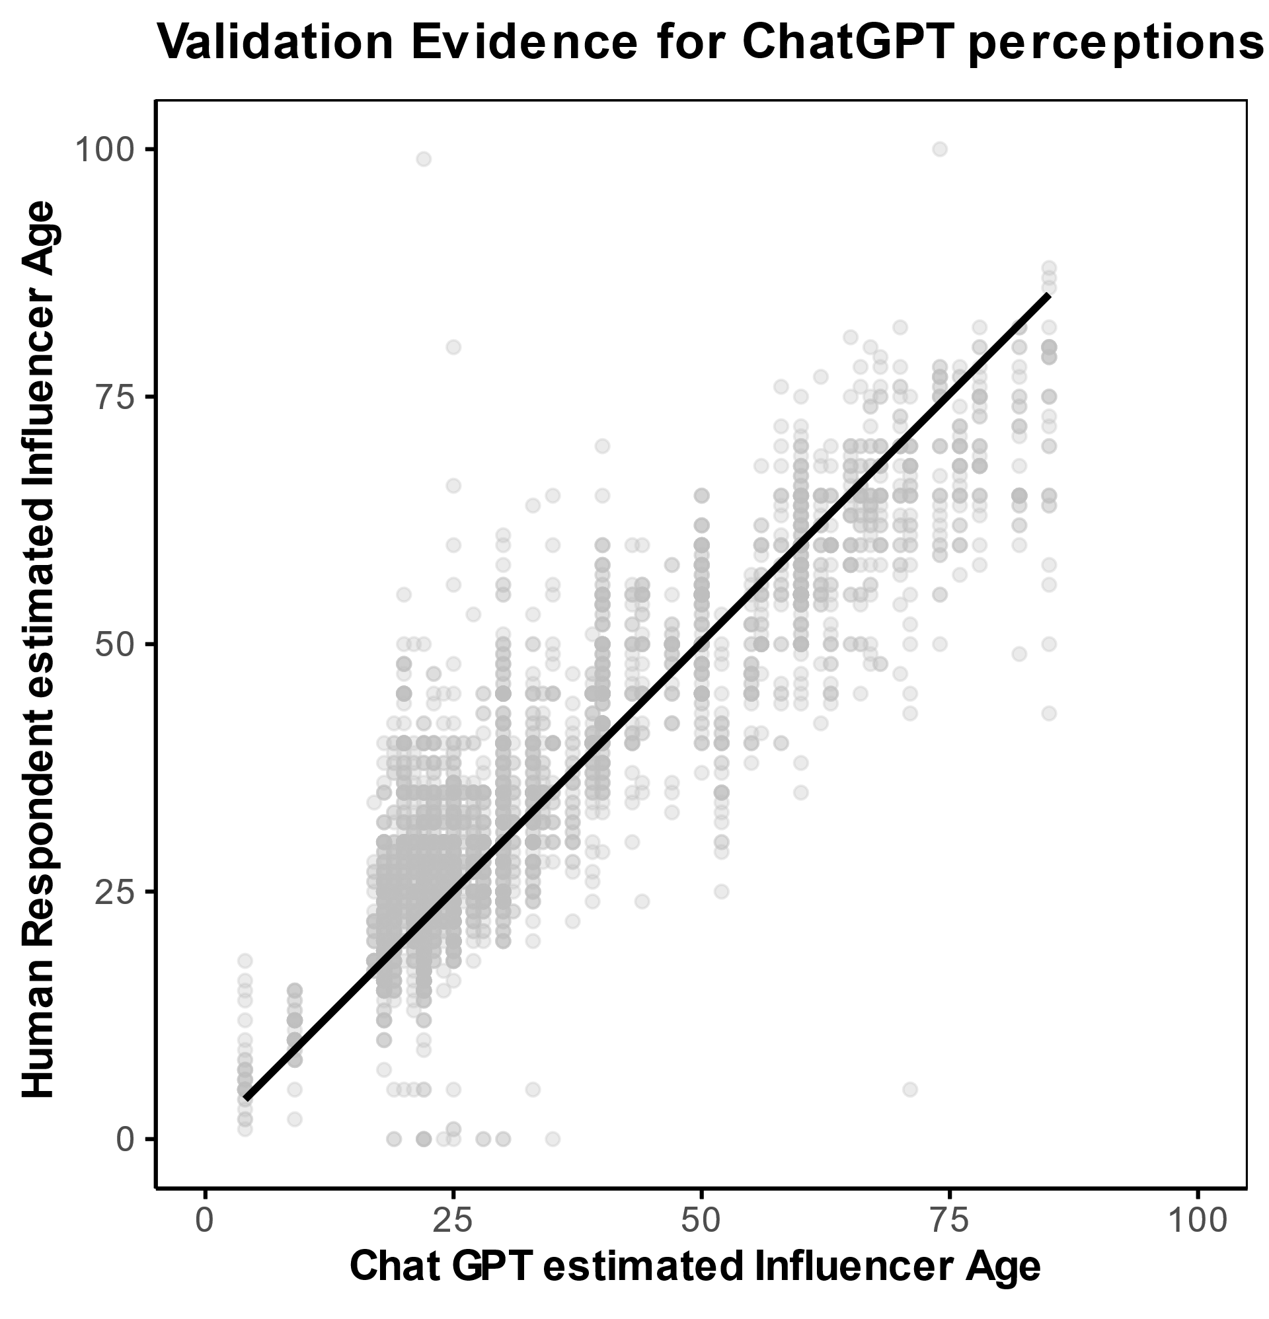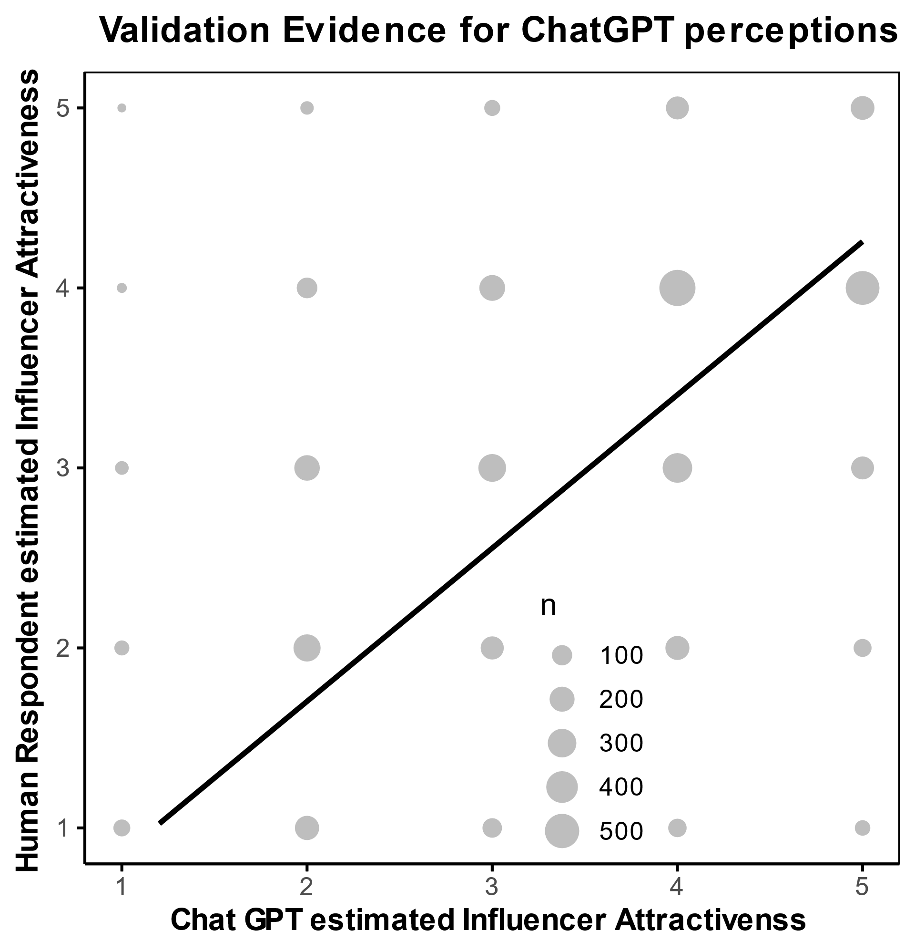

Assessment of attractiveness by Chat GPT
ChatGPT-Prompt: Rate the following people (1-6) using the Ohanian (1990) attractiveness scale. Give me your score from 1 (strongly disagree) to 5 (strongly agree) for the following statement: “I consider this person very attractive” for each person (including comments on why you rated them this way). Rate the people regardless of the person's age or compared to the average for age.
The first table contains all selected influencers that were tested in the age assessment study. The second table refers to all other influencers.
Name | Type | Scale rating | Justification/explanation
ai_ailynn | A | 4 | Soft features, even complexion, clear skin - classically attractive in kawaii style
ai_angelica | A | 3 | Striking face, interesting haircut - more edgy than classically beautiful
aidreamergirl | A | 5 | Symmetrical face, impressive eyes, elegant look - very high aesthetic appeal
albarenai | A | 4 | Naturally beautiful radiance, full hair, harmonious proportions
aliona_pole | A | 4 | Unconventionally attractive, strong facial contours, modern look
anymalu_real | A | 2 | Cartoon style with exaggerated features - eye-catching, but not realistically assessable
arbie_seo | A | 4 | Very symmetrical, soft face, classically "sweet" - high youthfulness, slightly doll-like
astrolovesu | A | 1 | Cartoon-like, ironically staged, no aesthetically appealing features in the classical sense
barbie | A | 4 | Barbie aesthetic: highly idealized, standardized beauty - smooth, artificial, but iconic
blawko22 | A | 3 | Interesting, modern style with urban influence - attractive, but partly overlaid by the style
bodybyralph | A | 1 | Humorously exaggerated caricature - deliberately drawn unaesthetically
casasbahia | A | 2 | Childlike, likeable - but aesthetically rather cute than "attractive" in the classic sense
emilyy.yoo_ | A | 5 | Highly idealized face with great eye-nose-mouth harmony, porcelain-like complexion - almost "perfect" in the conventional sense
eusouluks | A | 2 | Comic-like with a sympathetic expression, but rather clunky proportions and few aesthetic subtleties - seems somewhat artificial
here.is.rae | A | 4 | Unconventional but harmonious look - soft facial features, clear skin, interesting hair color and a subtle style
here.me.lucy | A | 5 | Classically beautiful: elegant styling, balanced proportions, very neat - high aesthetic impact
hollyy.kimm | A | 4 | Strongly sexualized portrayal, flawless skin and symmetry - objectively attractive, but somewhat obtrusively staged
iam_zlu | A | 2 | Creative, eye-catching design with artistic aspirations - friendly and unusual, but not conventionally attractive
iampolarmusic | A | 3 | Stylized presentation with a dynamic pose and eye-catching look - exotic and playful, but not classically attractive
imapoki | A | 2 | Childlike comic style with oversized eyes - cute and charming, but not designed for classic attractiveness
imma.gram | A | 4 | Doll-like symmetry, clear lines, modern hairstyle - a very "clean" style that is aesthetically appealing
iongottlich | A | 2 | Exaggerated masculinity with a comic-like face - humorous, but not very appealing in a classic beauty context
ivaany.h | A | 5 | Expressive face with striking make-up, intense eyes - powerful, elegant and visually very present
kaisa_dancer | A | 5 | Perfectly staged aesthetics: futuristic, sensual and strong - high symmetry and visual impact
kda_music | A | 4 | Strongly stylized group aesthetics with fantasy references - visually appealing overall, despite deliberately artificial staging
kyraonig | A | 5 | Symmetrical face, natural charisma, warm facial expressions - classically attractive and very harmonious
lechat.vv | A | 3 | Playful anime style with clear proportions - more cute than classically attractive
leyalovenature | A | 5 | Open smile, natural beauty, friendly eyes - very positive charisma with a strong connection to reality
liam_nikuro | A | 4 | Distinctive facial features, cool expression, fashionable styling - looks modern and attractive
lilmiquela | A | 3 | Playful look with unusual facial expressions - likeable, but less classically attractive due to exaggerated facial expressions
magazineluiza | A | 4 | Symmetrical face, classic aesthetics, positive expression - stylized but appealing
millasofiafin | A | 5 | Radiant smile, clear skin, natural beauty - very attractive in the classic sense
naina_avtr | A | 4 | Self-confident charisma, well-groomed look - less flashy, but charming.
noonoouri | A | 3 | Unusual animé style, big eyes - looks cute rather than classically attractive
realqaiqai | A | 2 | Cute and playful - clearly intended as a childlike stylized figure, therefore less attractive in the classic sense
realsophiarobot | A | 1 | Clearly recognizable robot with unnatural facial expressions - looks artificial and unattractive
realvivisaur | A | 2 | Cartoonish depiction, friendly and charming, but not classically attractive compared to more realistic depictions
rina.8k | A | 5 | Very harmonious face, smooth skin, elegant appearance - corresponds to highly idealized beauty standards
rozy.gram | A | 4 | Fresh, appealing appearance with positive charisma and harmonious facial harmony
ruuui_li | A | 3 | Cute and playful, but less convincing in terms of classic attractiveness due to the filter or avatar look
seradotwav | A | 3 | Stylized animation with soft features - appears friendly and endearing, but not explicitly attractive
shudu.gram | A | 5 | Distinctive facial features, strong natural beauty, very photogenic - highly attractive due to elegance and expressiveness
soymar.ia | A | 3 | Friendly, natural charisma - solid facial symmetry, but stylistically somewhat neutral
sua_to_z | A | 5 | Very smooth, flawless skin, harmonious features, calm and elegant overall impression - strongly idealized, but clearly attractive
vandadvlogs | A | 4 | Masculine, fit, well-groomed - a type with broad appeal, supported by a likeable dog scene, which positively reinforces the perception
winni.grounds | A | 4 | Playful, fashionable look with lots of personality; attractive thanks to style, skin texture and a friendly smile - eye-catching without being overdone
zoedvir | A | 4 | Expressive eyes, full hair, striking facial features - very present and photogenic, high visual impact, but less classically symmetrical
aliyahsinterlude | B | 4 | Very lively charisma, radiant smile, creative hairstyling - looks striking, self-confident and positive overall
andreaa_arru | B | 5 | Classically attractive face with clear, symmetrical features and intense blue eyes - corresponds strongly to common ideals of beauty
billieeilish | B | 3 | Distinctive facial features, interesting charisma - appears stylistically reduced and distanced, which seems less attractive in a mainstream sense
charliedamerlio | B | 4 | Cheerful, very likeable charisma with a natural look - warm and approachable, but somewhat less conspicuous than others
cocoquinn3 | B | 5 | Very well-groomed, glamorous look - harmonious facial features, perfect skin and hairstyle - corresponds strongly to typical social media attractiveness standards
fatehhalilntar | B | 3 | Unagitated, youthful look - friendly face, but less expressive and striking compared to others - rather neutrally attractive
gavinn | B | 4 | Modern, stylish look with clear facial features and a slightly rebellious vibe - looks fashionable and visually present
giaflip10 | B | 4 | Sympathetic face with natural beauty, lively smile and harmonious proportions - conveys openness and charm
k.mbappe | B | 3 | Friendly facial expression, but somewhat more reserved in appearance - appears approachable, but less conspicuously attractive
khaby00 | B | 4 | a striking, expressive face with strong contours - appears powerful, calm and aesthetically independent
littlemissflint | B | 5 | Very expressive eyes and lips, natural charisma, voluminous hair - high recognition and strong presence
maddieziegler | B | 5 | Classically elegant face, perfect skin, harmonious proportions - looks self-confident and very present in the media
mollymae | B | 5 | Classically beautiful facial features, symmetrical, clearly defined look with a professional expression - looks very well-groomed and presentable
mrbeast | B | 2 | Pleasant overall impression, but no particularly emphasized aesthetic features - appears more friendly than visually attractive
oliviajade | B | 5 | Very harmonious face, large eyes, clear skin and strong medial presence - looks elegant and photogenic
tekkerzkid | B | 3 | Likeable and self-confident charisma, but the look is less stylized - rather averagely attractive
tianawilson | B | 4 | Gentle radiance with natural, warm beauty - the hair and eyes in particular stand out
wisdm | B | 4 | Distinctive facial features, a confident look and modern charisma - visually appealing with a strong presence
beingsalmankhan | C | 3 | Distinctive facial features and charismatic charisma, but visually less stylized or model-like in the classic sense
beyonce | C | 5 | High media presence, flawless skin, clear symmetry and strong gaze - very professional and attractive appearance
davidbeckham | C | 4 | Masculine charisma, well-groomed look and charismatic smile - slightly aged, but very appealing overall
iamcardb | C | 5 | Striking styling, perfect skin, big eyes, fashionable look - overall visually very attractive and photogenic
jlo | C | 5 | Very glamorous appearance, perfect contouring and striking eye area - looks very professional and expressive
kendalljenner | C | 5 | Classically beautiful face with strong symmetry, perfect make-up, elegant style - very high aesthetic appeal
kingjames | C | 4 | Very charismatic charisma, striking facial features, masculine appearance with well-groomed beard - high presence, but less classic, model-like features
marcelotwelve | C | 3 | Pleasant and friendly appearance, but somewhat less balanced compared to classic standards of attractiveness
mileycyrus | C | 4 | Highly recognizable, interesting mix of naturalness and extravagance - expressive face with strong media presence
nehakakkar | C | 4 | Soft, warm smile, friendly look and harmonious facial features - looks very natural and approachable
nickiminaj | C | 5 | Very strong media staging, clear contours, large eyes, perfect make-up - looks very glamorous and stylized throughout
ronaldinho | C | 3 | Cool, individual style with recognition value, but visually less focused on classic appeal features
sooyaa_ | C | 5 | Very harmonious and balanced facial features, clear skin, large eyes - classically attractive appearance with elegant charisma
taylorswift | C | 4 | Striking look with eye-catching make-up and self-confident pose, slightly dramatic effect - looks attractive overall, but stylized
theweeknd | C | 3 | Very striking facial features with an intense gaze - individual charisma, but rather polarizing compared to the classic ideal of beauty
urvashirautela | C | 4 | Very glamorous staging, eye-catching styling and clear facial features - high visual impact, but appears somewhat artificial
zendaya | C | 5 | Strong presence, expressive face, special hairstyle as a stylistic device - high media appeal and modern aesthetics
agingwith_style_and_grace | D | 4 | Friendly, fresh appearance with natural charisma and well-groomed look - very appealing overall
bignikbh | D | 2 | Heavy make-up, eye-catching style - visually present, but less naturally attractive due to over-staging
deepakchopra | D | 2 | Expressive facial features, but charm outweighs classic attractiveness here - intellectual rather than visual presence
drmarkhyman | D | 3 | Sympathetic facial expression with relaxed charisma, but visually rather inconspicuous
elizabethwarren | D | 2 | Friendly and open, but less emphasized styling and rather functional appearance - low visual attractiveness features
elvieinthecity | D | 4 | Well-groomed appearance with youthful charisma, clear styling and harmonious face - strikingly attractive
embracingfifty | D | 4 | Smooth, well-groomed skin, natural appearance, pleasant smile - overall positively striking and attractive
excusemygrandma | D | 3 | Friendly appearance and well-groomed style, but less emphasized facial features - solid, but rather inconspicuous
greceghanem | D | 2 | Strongly accentuated lips and an unusual facial expression detract somewhat from the overall effect - rather polarizing
hillaryclinton | D | 3 | Likeable and radiant, looks confident and well-groomed, but visually more classic and conservative than strikingly attractive
jaadiee | D | 2 | Very friendly, but rather "charmingly old-fashioned" in look - the focus is clearly on likeability, less on physical attractiveness
jordon.b.peterson | D | 3 | Distinctive facial features, serious charisma - visually present, but not necessarily classically attractive; appears rather stern
melrobbins | D | 4 | Fresh, vital look, modern styling, friendly expression - looks very well-groomed and appealing overall
millindrunning | D | 3 | Sympathetic smile and alert eyes, but visually rather inconspicuous - more natural than model-like attractive
susiejerano | D | 4 | Stylish and elegant, with a harmonious facial expression - timeless appeal and clean lines
trainwithjoan | D | 3 | Very friendly and warm, natural charisma - less focused on external attractiveness
williamseedsmd | D | 3 | Eye-catching glasses and well-groomed beard give him character - more "distinguished" than classically attractive
wormrani | D | 2 | Warm-hearted charisma, but focus is less on classic beauty - appears more cultivated and competent

Name | Scale Rating | Justification/explanation
shawnmendes | 5 | Very symmetrical face, radiant smile, striking jawline, natural charisma; the relaxed posture with the guitar lends additional attractiveness through charm and approachability
milliebobbybrown | 4 | Strong presence thanks to a focused gaze and made-up face; harmonious proportions, beautiful skin, but slightly staged expression, which somewhat diminishes the naturalness.
larissamanoela | 4 | Very well-groomed, feminine appearance with clear facial features and expressive eyes. The styling emphasizes the attractiveness, but at the same time appears authentic.
addisonraee | 3 | Natural look, soft facial features and interesting charisma, but somewhat unfavorable light and slightly tired facial expression, which somewhat weakens the visual effect.
carryminati | 2 | Likeable, but not very expressive face. The glasses and the discreet facial expression convey intellect and friendliness, but without strong visual stimuli in the classic ideal of beauty.
avani | 4 | Warm, open smile, friendly eyes and positive charisma; harmonious colors highlight the face. Very photogenic, natural attractiveness.
nianaguerrero | 4 | Clear facial symmetry, strong bone structure, and a confident gaze. The minimalist styling and natural look enhance her visual appeal in a modern, editorial way
emmachamberlain | 4 | High-fashion look with striking facial features and a unique hairstyle that adds individuality. Her expression and posture suggest confidence and elegance, contributing to her attractiveness.
gretathunberg | 2 | While she radiates authenticity and has recognizable features, the casual, unstyled appearance and flat lighting reduce the perceived visual impact. Her attractiveness is understated and context-dependent.
julesleblanc | 5 | Very photogenic with flawless skin, defined bone structure, and a captivating gaze. She exudes a strong combination of elegance and youth, consistent with beauty standards in fashion media.
lexibrookerivera | 5 | Striking, model-like appearance with vibrant eyes, symmetrical features, and a confident, slightly sultry expression. Styling and setting support a highly appealing aesthetic.
cookingwithkian | 3 | Youthful charm and friendly expression. While not conventionally “model-attractive,” he presents a clean, natural look and genuine smile that suggest above-average attractiveness for his peer group.
everleighrose | 4 | Natural appearance, friendly face, clear skin. Fresh look with a friendly charisma
laurenorlando88 | 4 | Classically attractive with harmonious facial features and a calm gaze. Well proportioned face.
hayley.leblanc | 4 | Expressive eyes, smooth skin, very symmetrical face. Visually very present despite reserved facial expressions.
elle |  | Child, may not be evaluated by ChatGPT
ariana_greenblatt | 5 | Very elegant appearance, heavily made up but stylish. High symmetry, striking eyes and glamorous aura
jaydenbartels | 5 | Strikingly attractive presence - striking lips, clear skin, fashionable look. Particularly aesthetically staged in the picture.
salishmatter | 3 | Friendly and youthful appearance, but less stylized or striking than others; natural look, but not strongly accentuated facial features.
fatherkels | 5 | Strong facial symmetry, defined jawline, glowing skin, and confident gaze – very traditionally attractive in a glamorized way.
mccluretwins |  | Child, may not be evaluated by ChatGPT
kylethomas | 4 | Clean-cut, expressive smile, good symmetry – charming rather than traditionally "model-like", but still clearly attractive.
deja_clarkk | 5 | Bright, glowing complexion, expressive eyes, natural curls – vibrant and aesthetically strong presence, very striking.
kingferran | 4 | Sharp features, intense gaze, styled look – visually compelling with high photogenic value, though slightly performative.
benoftheweek | 4 | Well-defined facial structure, strong jawline, expressive eyes – overall balanced and stylish appearance with broad appeal.
kurzawa_karina | 5 | Striking symmetry, classic beauty, and a confident, direct gaze – very polished and photogenic, especially in the posed setting.
clairerocksmith | 3 | Cute and expressive, but slightly less defined features; charm over glamour, which makes her look more relatable than model-like
trinity_morisette | 4 | Bright, warm look with well-styled hair and makeup – approachable beauty, clearly above-average attractiveness for her peer group.
payton_delu | 4 | Sun-kissed, fresh aesthetic and open smile give her a natural, lively appearance – not overly stylized, but quite photogenic.
coco_pinkprincess | 3 | Unique and niche aesthetic, likely appealing to specific fashion-forward audiences – not conventionally attractive, but distinctive and memorable.
nicola.crisa | 4 | Strong facial features, elegant pose, and artistic lighting – the overall presentation is refined and appealing.
flavialeone | 3 | Natural charm and a candid expression – not overly styled but warm and expressive, making her relatable and moderately attractive.
lileeannenelson | 3 | Friendly and open appearance with a genuine smile – the look leans more toward approachability than conventional beauty standards, but still attractive within her peer group.
selenagomez | 4,5 | Very expressive look, styled hair and makeup enhance her natural features. The overall aesthetic is trendy and captivating
therock | 3 | Strong and symmetrical facial features, but the serious expression and direct lighting create a less warm impression. Still attractive, but more striking than conventionally beautiful.
arianagrande | 4 | Soft features and glamorous styling give a polished, elegant impression. The makeup is intentionally flattering and highlights her symmetry and skin texture.
kimkardashian | 5 | Highly stylized appearance with symmetrical features, clear skin, and confident expression. This is a textbook example of beauty ideals in Western media.
khloekardashian | 4 | Balanced facial features, strong brows, and a distinctive style (cowboy hat, contouring) that adds personality. Very attractive in a fashionable, composed way.
justinbieber | 3,5 | Natural charm and softness in expression. The candid black-and-white setting and facial hair give a creative, relaxed appeal. Not conventionally styled, but appealing.
virat.kohli | 4 | Friendly expression, well-groomed appearance, and symmetrical facial features. The overall look is clean and naturally appealing.
neymarjr | 3,5 | Charismatic smile and casual charm. Slight asymmetry and informal styling reduce conventional attractiveness slightly but still above average.
kourtneykardash | 4,5 | Classic glamor look: styled hair, defined makeup, and strong symmetrical features. She fits the traditional beauty standard very well.
katyperry | 3 | Unusual styling and strong theatrical makeup dominate the impression. Unique look, but less conventionally attractive due to the exaggerated aesthetic.
kevinhart4real | 3,5 | Natural and expressive facial structure, warm energy. Attractive in a relatable and authentic way. Styling is casual but enhances the facial harmony.
ddlovato | 4 | Strong features and striking makeup, paired with a serious expression. While slightly intimidating, the symmetry and clarity of facial traits contribute to high attractiveness.
badgalriri | 5 | Striking features, confident pose, flawless skin and symmetry—classic high-attractiveness markers. Radiates presence and appeal.
champagnepapi | 4 | Well-groomed, charismatic expression, strong facial structure. Slightly lowered due to less traditionally symmetrical features
chrisbrownofficial | 3,5 | Edgy and distinctive style, clear bone structure. Aesthetic appeal is high, though personal styling is more niche
ellendegeneres | 3 | Warm, open expression and neat appearance. While not conforming to conventional beauty norms, she exudes an inviting charm
gal_gadot | 5 | Highly symmetrical, refined features, and a poised, elegant expression. Fits beauty standards exceptionally well
lalalalisa_m | 5 | Very photogenic, stylish, and youthful. Her symmetrical features and confident styling contribute to top-tier attractiveness
vindiesel | 3,5 | Distinctive and masculine look, strong features. His expression is more casual here, which softens the overall impression
narendramodi | 2,5 | Presents himself well with a dignified appearance, but based purely on attractiveness (not charisma or authority), rated below average
priyankachopra | 4,5 | Striking symmetry, strong bone structure, and a poised, confident aura. Very photogenic and classically attractive
shakira | 4 | Charismatic smile, warm expression, and clear skin. Her vitality and charm elevate her perceived attractiveness
dualipa | 5 | High-fashion facial symmetry, intense gaze, and glowing skin. Her aesthetic strongly aligns with current beauty ideals
aliaabhatt | 5 | Radiates softness and elegance. Symmetrical features, flawless makeup, and a confident pose—high attractiveness
jennierubyjane | 4,5 | Very clear skin, delicate features, elegant styling. She has a refined and soft look that aligns with many contemporary beauty standards.
snoopdogg | 3 | While iconic in presence, his attractiveness is more charismatic than visual in this image. Smile adds warmth, but the visual impression is moderate.
shraddhakapoor | 4,5 | Very harmonious facial structure, expressive eyes, and a well-lit, composed presentation. Confident and elegant.
roses_are_rosie | 3,5 | Trendy and cool appearance, strong eye contact and expressive makeup. Slightly edgy style may polarize, but she’s visually appealing.
katrinakaif | 4,5 | Radiates warmth and grace, well-balanced facial features, excellent lighting and styling contribute to high attractiveness.
deepikapadukone | 5 | Striking facial symmetry, captivating gaze, sculpted features. Her confidence and calm elegance elevate perceived attractiveness to the highest level.
gigihadid | 5 | Highly symmetrical face, glowing skin, soft expression, and excellent styling. Represents modern fashion aesthetics very well.
karimbenzema | 3,5 | Strong physical features and a charismatic smile, but the image (sports context, lighting) reduces emphasis on facial appeal.
raffinagita1717 | 3 | Clean and composed, formal presentation. Attractive in a conventional, professional way, but lacks striking visual distinctiveness.
emmawatson | 4,5 | Naturally beautiful, warm smile, and expressive eyes. Classic appeal that feels relatable and genuine.
justintimberlake | 3,5 | Rugged appeal with stylish elements (glasses, beard). Overall cool presence, but attractiveness is more understated.
karolg | 5 | Striking facial features, voluminous hair, confident and sensual expression. Strong visual impact consistent with fashion modeling standards.
brenebrown | 4 | Friendly and energetic smile, symmetrical facial features, and an overall approachable and vibrant appearance. Very age-consistent attractiveness.
stanleytucci | 3 | Refined and well-groomed, but facial attractiveness is more subtle. Glasses and styling contribute to a smart, respectable aura rather than striking physical appeal.
marthastewart | 4 | Classic beauty, elegant hair and makeup, well-preserved appearance. Appears polished and graceful with a pleasant expression.
robertfkennedyjr | 2,5 | Athletic and expressive, but facial features are relatively coarse in this image. The smile is confident but less focused on visual attractiveness.
brunchwithbabs | 2 | Warm presence and natural demeanor, but relatively limited emphasis on traditionally attractive facial traits. Lighting and angle also reduce visual impact.
goldiehawn | 4,5 | Youthful styling, pronounced facial features, and vibrant presentation. Stands out strongly compared to same-age peers.
rosssmith | 3,5 | Energetic and joyful expression, bright eyes, and authentic charisma. While not classically styled, there's a natural warmth and vitality that enhances attractiveness.
grandma_droniak | 3 | Cheerful and expressive, with a friendly demeanor. A wholesome and positive presence, though less emphasis on conventional physical features.
baddiewinkle | 3,5 | Vivid personality and expressive style (accessories, hairstyle), which stand out. Her facial liveliness and creative flair contribute positively to perceived attractiveness.
iris.apfel | 2,5 | Iconic fashion sense and dignified presence, but facial features are relatively subdued. The oversized glasses dominate the look, giving it more eccentricity than conventional appeal.
piersmorgan | 2,5 | Friendly and professional appearance, but overall impression is more formal than visually striking. His charm leans more toward approachability than attractiveness.
timwalz | 2 | Serious and stern expression limits the emotional warmth of the portrait. Well-groomed, but overall facial attractiveness is not particularly emphasized here.
robertgreeneofficial | 2,5 | Intellectual vibe with confidence and kindness in expression, but overall appearance is understated and leans more toward approachable than traditionally attractive.
mayemusk | 4 | Striking elegance, radiant smile, and very well-groomed. Her styling enhances her sophisticated and classic beauty, making her highly appealing.
ageingdisgracefully | 3 | Cheerful and friendly look with bright eyes and a positive aura. Her big glasses add a quirky charm but slightly overshadow facial harmony.
lili_hayes | 2 | Strong individuality and bold style, but heavy accessories and oversized shades dominate the face, reducing conventional attractiveness cues.
paulinaporizkov | 4,5 | High-fashion look with vibrant energy, stunning facial symmetry, and expressive eyes. This image radiates confidence and timeless beauty.
luenell | 2,5 | Very strong personality expressed in her pose and styling, which adds uniqueness. However, facial features are not emphasized in a conventionally attractive way due to heavy makeup and lighting.
grandadjoe1933 | 3,5 | Warm and approachable look with a genuine smile; neat appearance and kind eyes suggest charm, though not overtly striking.
drvondawright | 2,5 | Strong presence, articulate expression, but the photo angle and lighting do not flatter facial features optimally; the red glasses dominate the face.
whitehairwisdom | 4,5 | Striking look for her age group: luminous skin, bright eyes, long silver hair that adds elegance and distinction; very photogenic and graceful.
tedcruz | 2 | Relaxed and friendly demeanor, but the posture, lighting, and casual outfit detract from a conventionally attractive impression.
grannybibbins | 2,5 | Stylish short hair and hoop earrings are expressive; the closed-eye squint into the sun reduces facial readability, so visual attractiveness is hard to gauge.
chalenejohnson | 4 | Confident and poised, with a glamorous hairstyle and expressive eyes; the black-and-white filter flatters facial features and adds sophistication.
iconaccidental | 3 | Elegant and composed, with a classic appearance and strong posture. The expression is quite reserved, which slightly mutes the charisma.
thesilverkat | 4 | Bright, cheerful aura with soft curls and warm smile. Natural beauty and vibrant energy contribute strongly to her attractiveness.
maria_elena_miura | 2,5 | Friendly and expressive, but the strong lighting and contrast blur facial features. The styling is playful, though not conventionally glamorous.
freshbeautystudio | 4,5 | Extremely polished look with radiant skin and strong facial symmetry. The closed eyes and genuine smile exude confidence and glow.
mypilatestime | 4 | Open expression and healthy, vibrant appearance. Blonde waves and glasses give her a confident and relatable look. Very photogenic.
glennstearns | 3 | Lean and defined face, with a direct gaze that signals confidence. Slight asymmetry and lighting reduce visual harmony, but overall pleasant.
jimpressions | 2,5 | Friendly demeanor, but the facial expression is slightly distracted or unsure. Natural aging visible, but without striking or polished features.
stylealiveafter55 | 4 | Radiant, confident, and joyful expression. Well-groomed with elegant styling. Charisma enhances her attractiveness noticeably.
styleatacertainage | 4,5 | Very graceful and stylish appearance. Her posture and grooming suggest elegance and presence that make her stand out.
therealangrygrandma | 2 | Warm and likeable aura, but not traditionally aligned with conventional attractiveness markers (e.g., symmetry, grooming). Charm lies more in personality than appearance.

WA3-3: Instagram downtimes and outages
Date | Duration | Details | Source
6-30-2012 |  | Outage due to storm | https://www.thejournal.ie/instagram-down-why-pinterest-netflixamazon-servers-505239-Jun2012/
1-27-2015 | approx. 30 min | Facebook and Instagram Go Down (no official reason) | https://time.com/3683673/facebook-and-instagram-go-down-while-twitter-reacts/
3-14-2019 | a few hours |  | https://www.wired.com/story/wired-awake-140319/
10-4-2021 | ~6–7 hours | Global Meta Outage | https://www.axios.com/2021/10/04/facebook-instagram-whatsapp-outage
5-21-2023 | ~2 hours | Instagram Outage | https://www.pingdom.com/outages/instagram-outage-may-2023-recap/
3-5-2024 | ~2 hours | Meta Outage | https://www.thousandeyes.com/blog/meta-outage-analysis-march-5-2024#:~:text=Summary,outage%20detection%20service%2C%20Internet%20Insights
4-1-2024 | ~1–2 hours | Instagram Outage | https://www.thescottishsun.co.uk/tech/12396711/instagram-down-meta-website-in-global-outage/
12-11-2024 | ~4 hours | Meta Outage | https://www.theguardian.com/technology/2024/dec/11/instagram-facebook-and-whatsapp-affected-by-global-meta-outage

WA3-4: Variables and operationalization
Variable | Units | Type | Operationalization | Reference
Engagement | factor | DV | (scaled(ln(likes) + scaled(ln(comments))/2 | (Wies et al., 2023)
logLikes | log(number of likes) | DV | ln(likes)
InfluencerAge | decades | IV | (age in years)/10
InfluencerVirtual | binary | Moderator | 0: real, 1: virtual
InfluencerFemale | binary | Moderator | 0: male, 1: female
InfluencerAttractive | binary | Moderator | 0: less.attractive, 1: more.attractive
InfluencerFollowers | log(number of followers) | Control
PostingFrequency | log(avg. number of posts per day) | Control
PlatformDown | binary | IV/Moderator | 0: normal, 1: reported downtime within 7 days
PaidSponsorship | binary | Moderator | 0: not flagged, 1: flagged as paid
Video | binary | Control | 0: image, 1: video
Sidecar | binary | Control | 0: image, 1: sidecar
CaptionLenght | log(number of characters) | Control
Hashtags | number of hashtags | Control
PhysicalContent | relative dictionary wordcounts | Control | LIWC-22: Physical | (Boyd et al., 2022)
LifestyleContent | relative dictionary wordcounts | Control | LIWC-22: Lifestyle | Boyd et al., 2022)
CultureContent | relative dictionary wordcounts | Control | LIWC-22: Culture | Boyd et al., 2022)
CognitionContent | relative dictionary wordcounts | Control | LIWC-22: Cognition | Boyd et al., 2022)
SocialContent | relative dictionary wordcounts | Control | LIWC-22: Social | Boyd et al., 2022)
AffectContent | relative dictionary wordcounts | Control | LIWC-22: Affect | Boyd et al., 2022)
PositiveContent | relative dictionary wordcounts | Control | LIWC-22: tone_pos | Boyd et al., 2022)
NegativeContent | relative dictionary wordcounts | Control | LIWC-22: tone_neg | Boyd et al., 2022)

WA3-5: Descriptives and correlations
 | Mean | SD | Min | Max | 1 | 2 | 3 | 4 | 5 | 6 | 7 | 8 | 9 | 10 | 11 | 12 | 13 | 14 | 15 | 16 | 17 | 18 | 19 | 20 | 21 | 22
Engagement | 8.21 | 2.61 | 0.69 | 15.26 | 1 | . | . | . | . | . | . | . | . | . | . | . | . | . | . | . | . | . | . | . | . | .
logLikes | 10.54 | 3.07 | 1.39 | 17.08 | .96 | 1 | . | . | . | . | . | . | . | . | . | . | . | . | . | . | . | . | . | . | . | .
InfluencerAge | 3.81 | 2.18 | 0.40 | 10.20 | -.00 | -.05 | 1 | . | . | . | . | . | . | . | . | . | . | . | . | . | . | . | . | . | . | .
InfluencerVirtual | 0.24 | 0.43 | 0.00 | 1.00 | -.56 | -.55 | -.39 | 1 | . | . | . | . | . | . | . | . | . | . | . | . | . | . | . | . | . | .
InfluencerFemale | 0.72 | 0.45 | 0.00 | 1.00 | -.10 | -.09 | -.11 | .12 | 1 | . | . | . | . | . | . | . | . | . | . | . | . | . | . | . | . | .
InfluencerAttractive | 0.26 | 0.44 | 0.00 | 1.00 | .23 | .26 | -.17 | -.12 | .29 | 1 | . | . | . | . | . | . | . | . | . | . | . | . | . | . | . | .
InfluencerFollowers | 15.06 | 2.85 | 8.59 | 19.86 | .83 | .84 | .08 | -.64 | -.11 | .21 | 1 | . | . | . | . | . | . | . | . | . | . | . | . | . | . | .
PostingFrequency | -1.44 | 1.07 | -5.96 | 1.92 | -.10 | -.16 | .34 | -.06 | -.02 | -.18 | .11 | 1 | . | . | . | . | . | . | . | . | . | . | . | . | . | .
PlatformDown | 0.05 | 0.21 | 0.00 | 1.00 | -.00 | -.00 | .02 | -.04 | .02 | -.00 | .03 | .05 | 1 | . | . | . | . | . | . | . | . | . | . | . | . | .
PaidSponsorship | 0.03 | 0.16 | 0.00 | 1.00 | .02 | .02 | .01 | -.04 | -.02 | .02 | .05 | -.01 | .03 | 1 | . | . | . | . | . | . | . | . | . | . | . | .
Video | 0.42 | 0.49 | 0.00 | 1.00 | -.15 | -.20 | .24 | -.02 | -.05 | -.19 | -.09 | .22 | .02 | .09 | 1 | . | . | . | . | . | . | . | . | . | . | .
Sidecar | 0.36 | 0.48 | 0.00 | 1.00 | .28 | .33 | -.21 | -.18 | .11 | .24 | .22 | -.20 | .00 | -.05 | -.64 | 1 | . | . | . | . | . | . | . | . | . | .
CaptionLenght | 4.29 | 1.50 | 0.00 | 7.69 | -.18 | -.19 | .20 | .03 | .02 | -.07 | -.10 | .19 | .02 | .09 | .10 | -.11 | 1 | . | . | . | . | . | . | . | . | .
Hashtags | 2.43 | 5.27 | 0.00 | 35.00 | -.31 | -.33 | .07 | .18 | .11 | .00 | -.28 | .13 | .02 | .03 | .21 | -.19 | .25 | 1 | . | . | . | . | . | . | . | .
PhysicalContent | 2.30 | 7.02 | 0.00 | 100.00 | -.01 | -.02 | .05 | -.04 | -.02 | -.00 | -.01 | .03 | -.00 | .00 | .07 | -.04 | .00 | -.01 | 1 | . | . | . | . | . | . | .
LifestyleContent | 3.75 | 7.70 | 0.00 | 100.00 | -.00 | .00 | -.01 | -.03 | -.01 | -.01 | -.00 | -.01 | .03 | .00 | .04 | -.02 | -.02 | .05 | .01 | 1 | . | . | . | . | . | .
CultureContent | 0.81 | 3.43 | 0.00 | 100.00 | -.09 | -.10 | .03 | .08 | -.01 | -.03 | -.09 | .06 | -.02 | .00 | .02 | -.09 | .02 | .06 | -.00 | .00 | 1 | . | . | . | . | .
CognitionContent | 15.50 | 14.77 | 0.00 | 100.00 | .03 | .03 | .08 | -.10 | -.03 | .00 | .02 | .01 | .00 | -.03 | -.00 | -.02 | .06 | -.08 | -.04 | .03 | -.02 | 1 | . | . | . | .
SocialContent | 10.36 | 12.93 | 0.00 | 100.00 | .03 | .03 | .10 | -.11 | -.01 | -.04 | .03 | -.01 | -.01 | -.05 | .01 | -.02 | -.01 | -.06 | -.04 | .02 | .01 | .06 | 1 | . | . | .
AffectContent | 7.38 | 11.53 | 0.00 | 100.00 | .06 | .06 | .03 | -.09 | -.02 | .02 | .05 | -.05 | .00 | -.01 | -.04 | .04 | -.10 | -.05 | .03 | .13 | -.03 | .04 | .31 | 1 | . | .
PositiveContent | 6.35 | 10.74 | 0.00 | 100.00 | .07 | .07 | .01 | -.09 | -.02 | .03 | .06 | -.06 | .01 | -.00 | -.05 | .05 | -.08 | -.04 | .00 | .15 | -.04 | .04 | .31 | .91 | 1 | .
NegativeContent | 0.81 | 3.95 | 0.00 | 100.00 | -.01 | -.02 | .04 | -.00 | -.00 | -.01 | -.03 | -.00 | -.00 | -.02 | .01 | -.02 | -.05 | -.02 | .08 | -.01 | .00 | .01 | .08 | .31 | -.04 | 1

WA3-6: Full Models Table
 | Quadratic Model | Cubic Model | GAM | GAM (PlatformDown as Moderator)
Constant | -3.704 *** | -3.900 *** | -3.864*** | -3.866***
 | (0.069) | (0.072) | (0.073) | (0.073)
InfluencerAge | -0.099 *** | 0.215 *** | edf=8.672*** | edf=8.309***
 | (0.015) | (0.040) | (F=45.590) | (F=41.895)
InfluencerAge² | 0.010 *** | -0.062 ***
 | (0.001) | (0.009)
InfluencerAge³ |  | 0.005 ***
 |  | (0.001)
InfluencerVirtual | -0.202 *** | -0.262 *** | -0.303*** | -0.310***
 | (0.023) | (0.024) | (0.025) | (0.025)
InfluencerFemale | -0.101 *** | -0.107 *** | -0.101*** | -0.105***
 | (0.015) | (0.015) | (0.015) | (0.015)
InfluencerAttractive | 0.075 *** | 0.074 *** | 0.063*** | 0.057***
 | (0.016) | (0.016) | (0.016) | (0.016)
InfluencerFollowers | 0.263 *** | 0.253 *** | 0.263*** | 0.262***
 | (0.003) | (0.004) | (0.004) | (0.004)
PostingFrequency | -0.129 *** | -0.116 *** | -0.123*** | -0.123***
 | (0.007) | (0.007) | (0.007) | (0.007)
PaidSponsored | -0.084 * | -0.092 ** | -0.119*** | -0.112**
 | (0.034) | (0.034) | (0.034) | (0.034)
PlatformDown | -0.068 ** | -0.065 * | -0.063* | -0.061*
 | (0.026) | (0.026) | (0.026) | (0.026)
InfluencerAge × PlatformDown |  |  |  | edf=4.260***
 |  |  |  | (F=5.244)
Theme_Artist | -0.022 | -0.021 | -0.036** | -0.032*
 | (0.014) | (0.014) | (0.014) | (0.014)
Theme_Lifestyle | -0.094 *** | -0.095 *** | -0.141*** | -0.126***
 | (0.015) | (0.015) | (0.015) | (0.015)
Theme_Music | 0.055 ** | 0.032 | 0.017 | 0.026
 | (0.018) | (0.018) | (0.018) | (0.018)
Theme_Acting | -0.212 *** | -0.202 *** | -0.225*** | -0.216***
 | (0.018) | (0.018) | (0.017) | (0.018)
Theme_SportsHealth | -0.194 *** | -0.201 *** | -0.171*** | -0.165***
 | (0.020) | (0.020) | (0.020) | (0.020)
Theme_Fashion | -0.071 *** | -0.077 *** | -0.061** | -0.045*
 | (0.020) | (0.020) | (0.020) | (0.020)
Theme_Model | 0.089 *** | 0.043 | 0.101*** | 0.114***
 | (0.025) | (0.026) | (0.026) | (0.026)
Theme_Author | -0.248 *** | -0.213 *** | -0.266*** | -0.249***
 | (0.030) | (0.030) | (0.030) | (0.030)
Theme_Comedy | 0.000 | -0.018 | -0.067* | -0.116***
 | (0.028) | (0.028) | (0.029) | (0.031)
Theme_Food | -0.254 *** | -0.259 *** | -0.303*** | -0.295***
 | (0.032) | (0.032) | (0.032) | (0.032)
Theme_Politics | 0.046 | 0.080 * | 0.052 | 0.050
 | (0.032) | (0.032) | (0.033) | (0.033)
Theme_Portrait | 0.127 ** | 0.089 * | 0.053 | 0.065
 | (0.044) | (0.044) | (0.043) | (0.043)
type_Video | -0.011 | 0.006 | 0.011 | 0.009
 | (0.016) | (0.016) | (0.016) | (0.016)
type_Sidecar | 0.056 *** | 0.057 *** | 0.043** | 0.043*
 | (0.017) | (0.017) | (0.016) | (0.017)
LIWC_Physical | 0.001 | 0.001 | 0.001 | 0.001
 | (0.001) | (0.001) | (0.001) | (0.001)
LIWC_Lifestyle | -0.000 | -0.000 | -0.000 | 0.000
 | (0.001) | (0.001) | (0.001) | (0.001)
LIWC_Culture | -0.005 ** | -0.004 * | -0.004* | -0.004*
 | (0.002) | (0.002) | (0.002) | (0.002)
LIWC_Cognition | 0.001 ** | 0.001 ** | 0.001** | 0.001**
 | (0.000) | (0.000) | (0.000) | (0.000)
LIWC_Social | -0.001 | -0.001 | -0.001* | -0.001**
 | (0.000) | (0.000) | (0.000) | (0.000)
LIWC_Affect | -0.004 | -0.004 | -0.005* | -0.004
 | (0.002) | (0.002) | (0.002) | (0.002)
LIWC_positive | 0.004 | 0.004 | 0.005* | 0.005*
 | (0.002) | (0.002) | (0.002) | (0.002)
LIWC_negative | 0.004 | 0.004 | 0.004 | 0.004
 | (0.003) | (0.003) | (0.003) | (0.003)
N | 7337 | 7337 | 7337 | 7197
R² | 0.749 | 0.752 | 0.760 | 0.762
AIC | 10182.296 | 10113.372 | 9827.379 | 9673.216
*** p < 0.001; ** p < 0.01; * p < 0.05; GAM smooth terms represent estimated df (linear: edf=1), with F-test for explained variance.

WA3-7: Interaction Table
 | DV: Engagement
 | GAM (Age × Virtual) | GAM (Age × PaidPost) | GAM (Age × Female) | GAM (Age × Attractive)
Constant | -3.834*** | -3.910*** | -3.999*** | -3.718***
 | (0.101) | (0.074) | (0.074) | (0.076)
InfluencerAge | edf=8.852*** | edf=8.510*** | edf=8.743*** | edf=8.869***
 | (F=74.457) | (F=37.178) | (F=57.594) | (F=53.567)
Moderator: | Influencer Virtual | Paid Sponsored | Influencer Female | Influencer Attractive
InfluencerAge × Moderator | edf=5.418*** | edf=6.718*** | edf=8.654*** | edf=8.697***
 | (F=22.918) | (F=3.832) | (F=29.520) | (F=19.666)
InfluencerVirtual | -0.150 | -0.265*** | -0.249*** | -0.324***
 | (0.159) | (0.026) | (0.026) | (0.027)
InfluencerFemale | -0.082*** | -0.109*** | -0.113*** | -0.161***
 | (0.019) | (0.015) | (0.015) | (0.016)
InfluencerAttractive | 0.099*** | 0.068*** | 0.060*** | -0.006
 | (0.018) | (0.017) | (0.016) | (0.024)
InfluencerFollowers | 0.263*** | 0.267*** | 0.274*** | 0.258***
 | (0.005) | (0.004) | (0.004) | (0.004)
PostingFrequency | -0.073*** | -0.116*** | -0.116*** | -0.108***
 | (0.009) | (0.007) | (0.007) | (0.007)
PaidSponsored | -0.154*** | -0.106** | -0.080* | -0.094**
 | (0.037) | (0.035) | (0.034) | (0.034)
PlatformDown | -0.067* | -0.062* | -0.051* | -0.054*
 | (0.030) | (0.026) | (0.025) | (0.026)
Controls:
Theme_Artist | 0.066*** | -0.038** | -0.052*** | -0.068***
 | (0.019) | (0.014) | (0.014) | (0.016)
Theme_Lifestyle | -0.182*** | -0.132*** | -0.162*** | -0.126***
 | (0.020) | (0.015) | (0.016) | (0.017)
Theme_Music | 0.002 | 0.015 | 0.012 | 0.057**
 | (0.020) | (0.018) | (0.018) | (0.019)
Theme_Acting | -0.093*** | -0.226*** | -0.236*** | -0.241***
 | (0.022) | (0.018) | (0.018) | (0.020)
Theme_SportsHealth | -0.170*** | -0.177*** | -0.147*** | -0.169***
 | (0.025) | (0.020) | (0.020) | (0.021)
Theme_Fashion | -0.049 | -0.067** | 0.013 | -0.021
 | (0.028) | (0.021) | (0.022) | (0.022)
Theme_Model | 0.097*** | 0.103*** | 0.061* | 0.057*
 | (0.028) | (0.026) | (0.026) | (0.027)
Theme_Author | -0.019 | -0.277*** | -0.235*** | -0.257***
 | (0.081) | (0.030) | (0.031) | (0.033)
Theme_Comedy | -0.065 | -0.063* | 0.041 | -0.091**
 | (0.045) | (0.030) | (0.035) | (0.033)
Theme_Food | -0.423*** | -0.310*** | -0.321*** | -0.367***
 | (0.039) | (0.032) | (0.032) | (0.034)
Theme_Politics | -0.408*** | 0.038 | 0.017 | -0.033
 | (0.063) | (0.033) | (0.034) | (0.034)
Theme_Portrait | 0.055 | 0.047 | 0.063 | 0.045
 | (0.047) | (0.044) | (0.043) | (0.045)
type_Video | -0.025 | 0.005 | 0.007 | 0.015
 | (0.018) | (0.016) | (0.016) | (0.016)
type_Sidecar | 0.043* | 0.042* | 0.047** | 0.054**
 | (0.018) | (0.017) | (0.016) | (0.017)
LIWC_Physical | -0.000 | 0.001 | 0.001 | 0.001
 | (0.001) | (0.001) | (0.001) | (0.001)
LIWC_Lifestyle | 0.000 | -0.000 | -0.001 | -0.000
 | (0.001) | (0.001) | (0.001) | (0.001)
LIWC_Culture | -0.000 | -0.004* | -0.004* | -0.004*
 | (0.002) | (0.002) | (0.002) | (0.002)
LIWC_Cognition | 0.000 | 0.001** | 0.001** | 0.001**
 | (0.000) | (0.000) | (0.000) | (0.000)
LIWC_Social | -0.002** | -0.001* | -0.001* | -0.002***
 | (0.001) | (0.000) | (0.000) | (0.000)
LIWC_Affect | -0.006 | -0.005* | -0.004 | -0.005*
 | (0.003) | (0.002) | (0.002) | (0.002)
LIWC_positive | 0.006 | 0.005* | 0.004 | 0.005*
 | (0.003) | (0.002) | (0.002) | (0.002)
LIWC_negative | 0.007 | 0.004 | 0.004 | 0.005
 | (0.003) | (0.003) | (0.003) | (0.003)
N | 5166 | 7216 | 7151 | 6833
R² | 0.812 | 0.760 | 0.772 | 0.777
AIC | 6418.391 | 9699.519 | 9283.412 | 8904.306
Optimal InfluencerAge (decades) | 2.190  (CI=[1.000, 3.680])  vs. 3.350  (CI=[2.190, 4.810]) | 2.400  (CI=[2.320, 2.510])  vs. 4.500  (CI=[2.270, 6.010]) | 2.380  (CI=[2.020, 2.730])  vs. 7.400  (CI=[2.410, 8.460]) | 4.780  (CI=[2.510, 7.340])  vs. 2.350  (CI=[2.040, 3.890])
Ranges of  significant contrasts: | neg.(-) in:  [0.900 to 1.850],  neg.(-) in:  [2.230 to 2.930],  pos.(+) in:  [3.050 to 3.510] | neg.(-) in:  [1.390 to 2.200],  neg.(-) in:  [4.000 to 4.900],  neg.(-) in:  [8.400 to 9.750] | pos.(+) in:  [0.900 to 1.150],  neg.(-) in:  [1.400 to 3.550],  pos.(+) in:  [3.800 to 5.040],  neg.(-) in:  [5.460 to 7.360],  pos.(+) in:  [7.610 to 8.690],  neg.(-) in:  [8.850 to 9.100] | pos.(+) in:  [1.630 to 2.170],  neg.(-) in:  [2.430 to 2.770],  pos.(+) in:  [3.030 to 4.570],  neg.(-) in:  [4.900 to 5.700],  pos.(+) in:  [5.970 to 6.300],  neg.(-) in:  [6.570 to 7.630],  pos.(+) in:  [7.830 to 7.900]
*** p < 0.001; ** p < 0.01; * p < 0.05; GAM smooth terms represent estimated df (linear: edf=1), with F-test for explained variance.

Figure Interaction A) Virtual Influencer, B) Paid Post, C) Influencer Female, D) Influencer Attractive
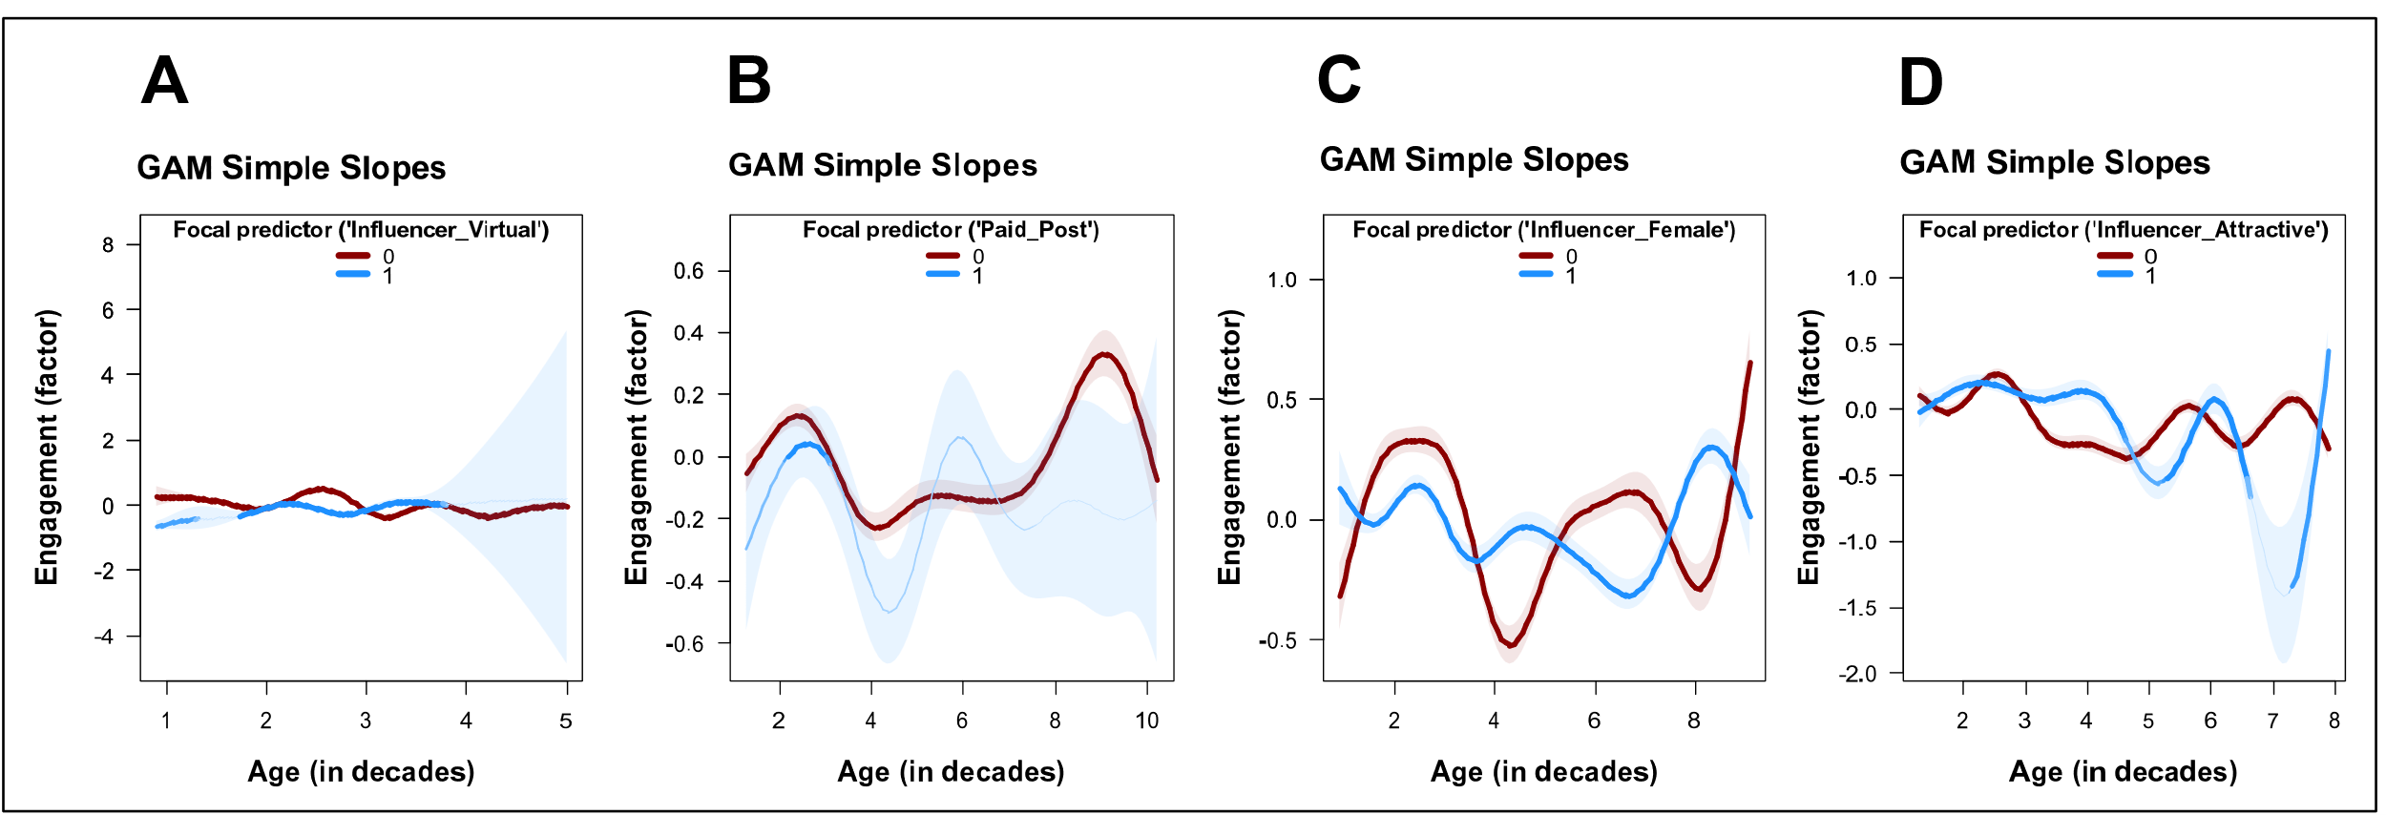

Web Appendix 4: Study 2

WA4-1: Design
Overview of the TikTok Accounts
ID | Male (0) /female (1) | Account | Randomized list of videos
1 | 0 | noah.lane.music.100 | 3 1 9 6 5 4 2 8 10 7
2 | 0 | noah.lane.music.200 | 2 7 3 5 8 9 1 6 4 10
3 | 0 | noah.lane.music.300 | 2 3 7 10 1 4 9 6 5 8
4 | 0 | noah.lane.music.4 | 7 1 8 4 10 2 6 3 5 9
5 | 0 | noah.lane.music.5 | 9 4 7 3 2 5 1 10 6 8
6 | 0 | noah.lane.music.6 | 2 5 4 1 7 3 9 10 8 6
7 | 0 | noah.lane.music.7 | 7 9 8 2 6 4 1 10 3 5
8 | 0 | noah.lane.music.8 | 2 4 3 7 10 8 5 9 6 1
9 | 0 | noah.lane.music.9 | 8 3 10 7 2 5 4 9 6 1
10 | 0 | noah.lane.music.10 | 2 9 10 5 6 4 8 7 3 1
11 | 0 | noah.lane.music.11 | 10 5 3 1 4 6 2 7 8 9
12 | 0 | noah.lane.music.12 | 3 6 1 5 10 8 7 4 2 9
13 | 0 | noah.lane.music.13 | 5 1 10 6 7 2 4 9 3 8
14 | 0 | noah.lane.music.14 | 3 1 7 6 9 8 2 5 4 10
15 | 0 | noah.lane.music.15 | 4 2 6 7 9 5 10 1 8 3
16 | 0 | noah.lane.music.16 | 10 1 6 9 3 5 8 7 2 4
17 | 0 | noah.lane.music.17 | 4 5 1 2 10 9 6 8 3 7
18 | 0 | noah.lane.music.18 | 5 9 2 4 3 1 7 6 8 10
19 | 0 | noah.lane.music.19 | 8 4 3 10 6 9 7 2 1 5
20 | 0 | noah.lane.music.20 | 2 10 5 1 8 3 7 6 4 9
21 | 0 | noah.lane.music.21 | 9 8 3 4 1 2 7 10 6 5
22 | 1 | luna.bale.music.1000 | 6 5 1 7 4 9 10 3 8 2
23 | 1 | luna.bale.music.2 | 10 4 8 3 6 9 2 5 7 1
24 | 1 | luna.bale.music.3 | 1 7 3 8 5 10 6 4 9 2
25 | 1 | luna.bale.music.4 | 5 9 10 4 7 6 8 2 1 3
26 | 1 | luna.bale.music.5 | 7 6 8 5 9 4 3 10 2 1
27 | 1 | luna.bale.music.6 | 6 3 1 8 4 7 2 10 9 5
28 | 1 | luna.bale.music.7 | 9 10 7 5 8 1 4 2 3 6
29 | 1 | luna.bale.music.8 | 2 3 6 9 10 5 4 7 1 8
30 | 1 | luna.bale.music.9 | 10 8 9 7 3 4 6 5 1 2
31 | 1 | luna.bale.music.10 | 5 6 9 2 3 10 4 1 8 7
32 | 1 | luna.bale.music.11 | 3 2 8 7 10 6 1 9 5 4
33 | 1 | luna.bale.music.12 | 7 4 9 1 10 6 5 8 2 3
34 | 1 | luna.bale.music.13 | 10 6 2 8 7 5 4 1 3 9
35 | 1 | luna.bale.music.14 | 2 9 6 10 4 3 8 5 7 1
36 | 1 | luna.bale.music.15 | 5 4 1 6 7 3 9 2 10 8
37 | 1 | luna.bale.music.16 | 6 1 3 5 8 9 7 4 10 2
38 | 1 | luna.bale.music.17 | 9 10 5 8 6 4 1 7 2 3
39 | 1 | luna.bale.music.18 | 8 4 7 10 3 1 2 6 9 5
40 | 1 | luna.bale.music.19 | 1 9 6 5 3 10 8 4 7 2
41 | 1 | luna.bale.music.20 | 4 5 9 2 6 8 1 10 7 3
42 | 1 | luna.bale.music.21 | 7 8 10 4 3 9 5 2 6 1

AI-generated songs
ID | Genre | Song 1 | Song 2
1 | Pop | GLARE | CRAVE
3 | Rock | BLARE | AFIRE
5 | Country | THRIVE | BRAVE
7 | Hip Hop | GRAVE | SHINE
9 | Classical/Cinematic | SPIRE | FLARE

Stimuli
woman | blond | brunette | black
15-20 years | 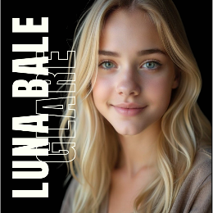 | 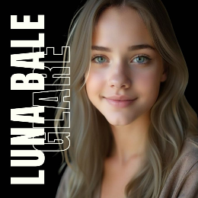 | 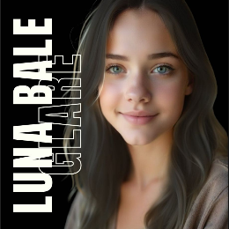
20-25 years | 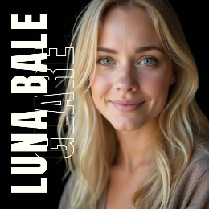 | 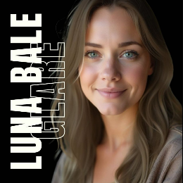 | 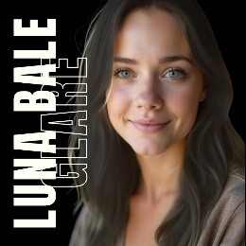
25-30 years | 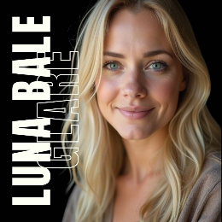 | 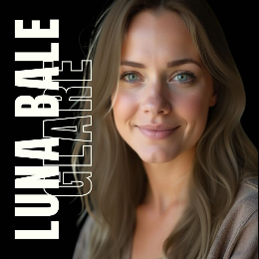 | 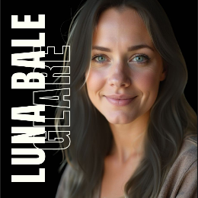
30-35 years | 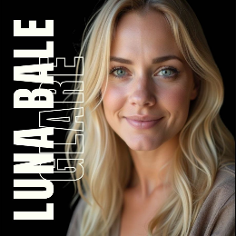 | 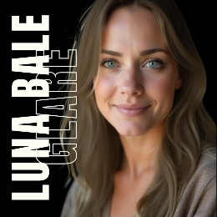 | 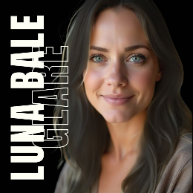
40-45 years | 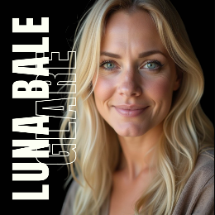 | 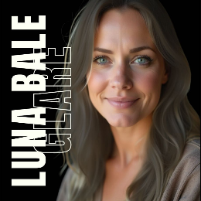 | 
50-55 years | 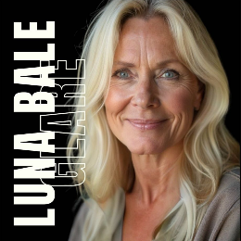 | 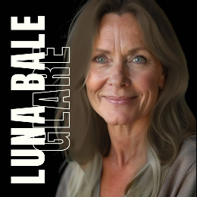 | 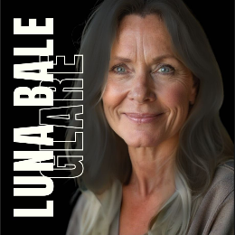
60-65 years | 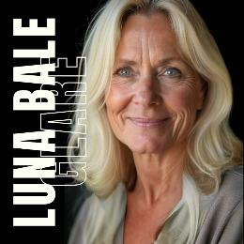 | 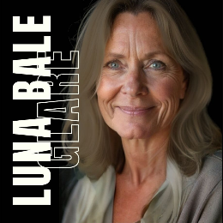 | 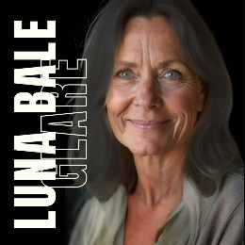

man | blond | brunette | black
15-20 years | 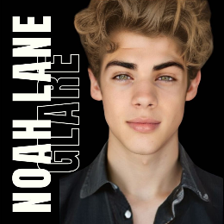 | 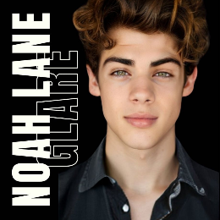 | 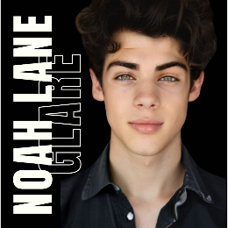
20-25 years | 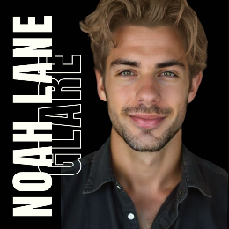 | 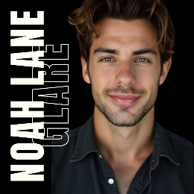 | 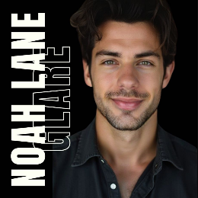
25-30 years | 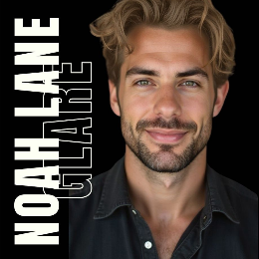 | 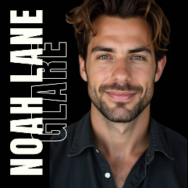 | 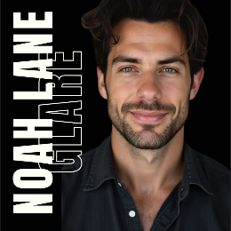
30-35 years | 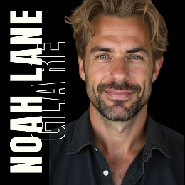 | 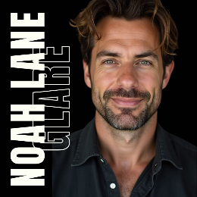 | 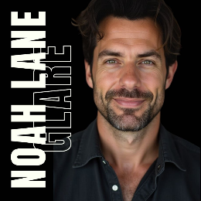
40-45 years | 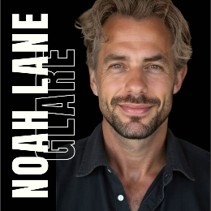 |  | 
50-55 years | 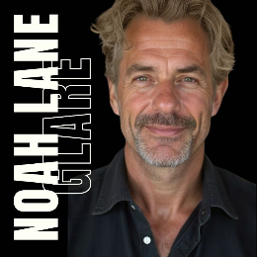 | 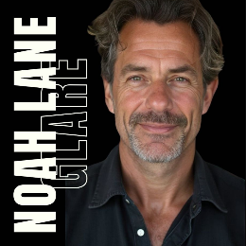 | 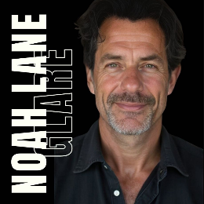
60-65 years |  |  | 

WA4-2: Variables and operationalization
Variable | Units | Type | Operationalization | Reference
Views | count | DV |  | ref
Likes | count | DV |  | ref
Viewtime | seconds | DV |  | ref
InfluencerAge | decades | IV |  | ref
InfluencerFemale | binary | IV |  | ref
ConsumerFemaleShare | % | Control |  | ref
ConsumerFemale | binary | Group | 1: female (ConsumerFemaleShare > .5), 0: male | ref
ConsumerAge18to24Share | % | Control |  | ref
ConsumerAge25to34Share | % | Control |  | ref
ConsumerAge35to44Share | % | Control |  | ref
ConsumerAge45to54Share | % | Control |  | ref
ConsumerAge55plusShare | % | Control |  | ref
ConsumerOlder | binary | Group | 1: older (share of 35y and older > .5), 0: younger | ref
MatchingAgesShare | % | Control |  | ref
AgeMatch | binary | Group | 1: matching (Share of similar age group > 0.5), 0: different | ref
Haircolor | factor | Fixed effect |  | ref
Song | factor | Fixed effect |  | ref
Weekday | factor | Fixed effect |  | ref

WA4-3: Descriptives and correlations
 | Mean | SD | Min | Max | 1 | 2 | 3 | 4 | 5 | 6 | 7 | 8 | 9 | 10 | 11 | 12 | 13 | 14 | 15
Views | 136.06 | 117.07 | 1.00 | 334.00 | 1 | . | . | . | . | . | . | . | . | . | . | . | . | . | .
Likes | 0.36 | 0.68 | 0.00 | 6.00 | .26 | 1 | . | . | . | . | . | . | . | . | . | . | . | . | .
Viewtime | 1.77 | 0.71 | 0.80 | 8.20 | -.13 | -.02 | 1 | . | . | . | . | . | . | . | . | . | . | . | .
InfluencerAge | 4.22 | 1.90 | 2.00 | 7.75 | .30 | -.01 | -.09 | 1 | . | . | . | . | . | . | . | . | . | . | .
InfluencerFemale | 0.61 | 0.49 | 0.00 | 1.00 | -.20 | -.19 | .12 | .15 | 1 | . | . | . | . | . | . | . | . | . | .
ConsumerFemaleShare | 0.58 | 0.08 | 0.33 | 0.79 | -.15 | .08 | -.16 | -.51 | -.08 | 1 | . | . | . | . | . | . | . | . | .
ConsumerFemale | 0.86 | 0.35 | 0.00 | 1.00 | -.07 | .04 | -.11 | -.39 | -.13 | .71 | 1 | . | . | . | . | . | . | . | .
ConsumerAge18to24Share | 0.39 | 0.11 | 0.12 | 0.64 | -.01 | .08 | -.15 | -.58 | -.65 | .44 | .36 | 1 | . | . | . | . | . | . | .
ConsumerAge25to34Share | 0.27 | 0.05 | 0.17 | 0.43 | -.10 | -.01 | .04 | -.28 | .10 | .14 | .07 | -.11 | 1 | . | . | . | . | . | .
ConsumerAge35to44Share | 0.15 | 0.05 | 0.03 | 0.27 | -.05 | -.13 | .14 | .44 | .57 | -.31 | -.26 | -.77 | -.09 | 1 | . | . | . | . | .
ConsumerAge45to54Share | 0.11 | 0.05 | 0.00 | 0.40 | .01 | -.06 | .08 | .42 | .42 | -.39 | -.27 | -.64 | -.18 | .47 | 1 | . | . | . | .
ConsumerAge55plusShare | 0.10 | 0.10 | 0.01 | 0.70 | -.04 | -.11 | .17 | .31 | .35 | -.42 | -.28 | -.54 | .00 | .42 | .50 | 1 | . | . | .
ConsumerOlder | 0.12 | 0.33 | 0.00 | 1.00 | -.17 | -.13 | .10 | .27 | .36 | -.40 | -.34 | -.56 | -.14 | .49 | .54 | .65 | 1 | . | .
MatchingAgesShare | 0.19 | 0.12 | 0.05 | 0.57 | -.33 | .00 | .05 | -.64 | -.14 | .24 | .11 | .34 | .07 | -.35 | -.25 | -.12 | .01 | 1 | .
AgeMatch | 0.46 | 0.50 | 0.00 | 1.00 | -.22 | -.02 | -.04 | -.52 | -.05 | .23 | .06 | .19 | -.05 | -.17 | -.08 | .01 | .15 | .72 | 1

WA4-4: Main Models Table
 | DV: Views
 | Quadratic Model | Cubic Model | GAM
Constant | 176.829 | -213.939 | 416.296**
 | (176.125) | (209.743) | (126.554)
InfluencerAge | 115.773 *** | 352.470 *** | edf=4.039***
 | (29.538) | (80.669) | (F=6.693)
InfluencerAge² | -10.840 *** | -61.514 ***
 | (2.542) | (16.356)
InfluencerAge³ |  | 3.360 **
 |  | (1.072)
InfluencerFemale | -25.815 | -33.401 * | -31.427*
 | (15.034) | (14.597) | (14.511)
ConsumerFemaleShare | -53.918 | -32.381 | -34.545
 | (87.839) | (84.381) | (84.075)
ConsumerAge18to24Share | -130.128 | -147.990 | -156.765
 | (132.272) | (126.770) | (127.794)
ConsumerAge25to34Share | -314.804 * | -209.805 | -231.375
 | (142.638) | (140.619) | (140.049)
ConsumerAge35to44Share | -241.665 | -208.991 | -224.276
 | (218.885) | (209.828) | (211.439)
ConsumerAge45to54Share | 39.659 | 19.051 | 18.271
 | (150.205) | (143.963) | (143.757)
ConsumerAge55plusShare | -27.031 | -20.430 | -20.159
 | (69.617) | (66.687) | (67.148)
MatchingAgesShare | 91.917 | 144.807 | 113.800
 | (91.441) | (89.162) | (87.980)
Haircolor: blond | 7.755 | 11.120 | 10.908
 | (16.516) | (15.850) | (15.940)
Haircolor: brown | -5.545 | -10.250 | -9.027
 | (12.213) | (11.789) | (11.758)
Song: 2 | -18.136 | -21.145 | -19.203
 | (22.539) | (21.601) | (21.514)
Song: 3 | -13.886 | -14.593 | -14.934
 | (22.144) | (21.203) | (21.105)
Song: 4 | -32.086 | -31.769 | -30.989
 | (24.577) | (23.532) | (23.555)
Song: 5 | 13.842 | 11.331 | 10.252
 | (22.316) | (21.381) | (21.498)
Song: 6 | -21.703 | -27.063 | -25.957
 | (23.017) | (22.103) | (22.001)
Song: 7 | 19.884 | 6.257 | 8.139
 | (21.989) | (21.498) | (21.335)
Song: 8 | -9.158 | -10.026 | -9.002
 | (23.324) | (22.333) | (22.292)
Song: 9 | -16.671 | -15.831 | -15.014
 | (22.130) | (21.190) | (21.157)
Song: 10 | 31.066 | 26.530 | 28.055
 | (26.427) | (25.343) | (25.337)
Weekday: Monday | 24.348 | 38.119 | 29.009
 | (61.676) | (59.214) | (59.414)
Weekday: Tuesday | 15.887 | 32.720 | 35.045
 | (59.326) | (57.055) | (78.192)
Weekday: Wednesday | 19.603 | 31.604 | 29.181
 | (58.355) | (56.002) | (61.417)
Weekday: Thursday | 3.499 | 21.591 | 11.668
 | (58.878) | (56.667) | (56.923)
Weekday: Saturday | 35.859 | 50.404 | 23.980
 | (81.095) | (77.782) | (57.281)
Weekday: Sunday | 22.115 | 38.714 | 23.641
 | (63.711) | (61.229) | (56.215)
N | 125 | 125 | 125
R² | 0.379 | 0.437 | 0.280
AIC | 1372.327 | 1362.158 | 1362.726
*** p < 0.001; ** p < 0.01; * p < 0.05; GAM smooth terms represent estimated df (linear: edf=1), with F-test for explained variance.

WA4-5: Poisson Table
 | DV: Views
 | Quadratic Model | Cubic Model | GAM
Constant | 5.081 *** | 3.109 *** | 6.160***
 | (0.222) | (0.286) | (0.171)
InfluencerAge | 0.499 *** | 1.636 *** | edf=5.639***
 | (0.038) | (0.107) | (F=422.686)
InfluencerAge² | -0.046 *** | -0.284 ***
 | (0.003) | (0.021)
InfluencerAge³ |  | 0.016 ***
 |  | (0.001)
InfluencerFemale | -0.100 *** | -0.137 *** | -0.137***
 | (0.018) | (0.018) | (0.018)
ConsumerFemaleShare | -0.206 * | -0.103 | -0.029
 | (0.104) | (0.104) | (0.106)
ConsumerAge18to24Share | -0.460 ** | -0.478 ** | -0.700***
 | (0.168) | (0.170) | (0.178)
ConsumerAge25to34Share | -1.258 *** | -0.743 *** | -0.906***
 | (0.175) | (0.182) | (0.183)
ConsumerAge35to44Share | -0.866 *** | -0.647 * | -0.883**
 | (0.263) | (0.264) | (0.274)
ConsumerAge45to54Share | 0.090 | 0.025 | -0.070
 | (0.200) | (0.202) | (0.203)
ConsumerAge55plusShare | -0.132 | -0.112 | -0.129
 | (0.085) | (0.084) | (0.086)
MatchingAgesShare | 0.454 *** | 0.764 *** | 0.708***
 | (0.117) | (0.123) | (0.134)
Haircolor: blond | 0.027 | 0.040 * | 0.058**
 | (0.020) | (0.020) | (0.021)
Haircolor: brown | -0.024 | -0.047 ** | -0.035*
 | (0.014) | (0.014) | (0.015)
Song: 2 | -0.074 ** | -0.091 *** | -0.081**
 | (0.027) | (0.027) | (0.027)
Song: 3 | -0.054 * | -0.059 * | -0.064*
 | (0.026) | (0.026) | (0.026)
Song: 4 | -0.126 *** | -0.125 *** | -0.113***
 | (0.029) | (0.029) | (0.029)
Song: 5 | 0.054 * | 0.043 | 0.042
 | (0.026) | (0.026) | (0.026)
Song: 6 | -0.082 ** | -0.107 *** | -0.115***
 | (0.027) | (0.028) | (0.028)
Song: 7 | 0.080 ** | 0.018 | 0.019
 | (0.026) | (0.026) | (0.026)
Song: 8 | -0.036 | -0.048 | -0.018
 | (0.028) | (0.028) | (0.028)
Song: 9 | -0.065 * | -0.063 * | -0.049
 | (0.026) | (0.026) | (0.027)
Song: 10 | 0.130 *** | 0.110 *** | 0.121***
 | (0.030) | (0.031) | (0.031)
Weekday: Monday | 0.084 | 0.148 * | 0.059
 | (0.071) | (0.071) | (0.073)
Weekday: Tuesday | 0.048 | 0.123 | 0.089
 | (0.069) | (0.069) | (0.096)
Weekday: Wednesday | 0.064 | 0.118 | 0.060
 | (0.067) | (0.067) | (0.076)
Weekday: Thursday | -0.005 | 0.073 | -0.014
 | (0.068) | (0.068) | (0.070)
Weekday: Saturday | 0.141 | 0.212 * | 0.041
 | (0.094) | (0.094) | (0.070)
Weekday: Sunday | 0.076 | 0.148 * | 0.037
 | (0.074) | (0.074) | (0.069)
N | 125 | 125 | 125
AIC | 2359.332 | 2229.970 | 2182.743
*** p < 0.001; ** p < 0.01; * p < 0.05; GAM smooth terms represent estimated df (linear: edf=1), with F-test for explained variance.

WA4-6: Interaction Table
 | DV: Views
 | GAM (Age × Influencer Female) | GAM (Age × Consumer Female) | GAM (Age × Consumer Older) | GAM (Age × Age Match)
Constant | 503.721*** | 448.563*** | 497.457*** | 465.769**
 | (131.948) | (125.114) | (134.543) | (137.627)
InfluencerAge | edf=2.908 | edf=1.001 | edf=4.090*** | edf=2.152
 | (F=1.726) | (F=0.015) | (F=5.365) | (F=1.881)
Moderator: | Influencer Female | Consumer Female | Consumer Older | Age Match
InfluencerAge × Moderator | edf=3.965*** | edf=4.083*** | edf=2.880*** | edf=3.309***
 | (F=6.480) | (F=6.490) | (F=5.786) | (F=5.864)
InfluencerFemale | -30.411* | -32.130* | -32.013* | -31.316*
 | (14.372) | (14.647) | (14.227) | (14.729)
ConsumerFemaleShare | -39.776 | -47.654 | -48.769 | -48.706
 | (86.604) | (94.124) | (83.187) | (86.118)
ConsumerAge18to24Share | -206.326 | -168.767 | -238.407 | -177.785
 | (128.077) | (127.377) | (138.858) | (138.545)
ConsumerAge25to34Share | -315.468* | -231.499 | -334.329* | -263.844
 | (144.145) | (140.972) | (147.172) | (156.290)
ConsumerAge35to44Share | -388.535 | -209.391 | -325.830 | -273.323
 | (218.538) | (212.264) | (210.882) | (226.571)
ConsumerAge45to54 Share | 27.120 | 12.297 | 139.252 | 6.970
 | (148.525) | (144.152) | (160.972) | (146.213)
ConsumerAge55plus Share | -13.604 | -4.980 | -82.418 | -15.298
 | (67.769) | (67.952) | (72.058) | (68.756)
MatchingAgesShare | 17.341 | 121.722 | 105.248 | 70.951
 | (91.935) | (89.697) | (93.149) | (85.224)
Haircolor: blond | 13.882 | 10.512 | 16.695 | 11.830
 | (15.940) | (16.149) | (15.735) | (16.097)
Haircolor: brown | -7.373 | -9.162 | -8.018 | -7.572
 | (12.219) | (11.745) | (11.450) | (11.890)
Song: 2 | -9.970 | -17.855 | -16.946 | -17.498
 | (21.746) | (21.902) | (20.904) | (21.888)
Song: 3 | -11.555 | -13.582 | -17.383 | -16.223
 | (20.898) | (21.366) | (20.696) | (21.617)
Song: 4 | -28.924 | -28.273 | -34.958 | -33.993
 | (23.957) | (23.734) | (22.996) | (24.141)
Song: 5 | 13.994 | 15.056 | 4.339 | 6.889
 | (21.309) | (22.041) | (21.249) | (22.064)
Song: 6 | -28.341 | -24.725 | -23.841 | -24.964
 | (21.873) | (22.391) | (21.345) | (22.226)
Song: 7 | 13.149 | 10.105 | 7.924 | 8.982
 | (21.174) | (21.657) | (20.921) | (21.767)
Song: 8 | -3.592 | -2.878 | -12.684 | -8.579
 | (22.282) | (23.151) | (21.843) | (22.600)
Song: 9 | -17.271 | -12.932 | -14.441 | -16.198
 | (21.073) | (21.326) | (20.617) | (21.824)
Song: 10 | 26.902 | 31.080 | 27.992 | 27.116
 | (25.092) | (25.483) | (24.618) | (25.665)
Weekday: Monday | 18.517 | 4.529 | 24.455 | 22.586
 | (58.932) | (61.813) | (57.773) | (60.059)
Weekday: Tuesday | 28.577 | 11.415 | 23.160 | 20.214
 | (77.840) | (80.079) | (76.279) | (79.308)
Weekday: Wednesday | 24.315 | 6.561 | 27.414 | 24.463
 | (60.874) | (63.521) | (59.666) | (61.995)
Weekday: Thursday | 9.192 | -15.790 | 9.787 | 4.746
 | (56.315) | (58.780) | (55.348) | (57.387)
Weekday: Saturday | 13.212 | -1.320 | 25.060 | 19.253
 | (56.826) | (59.055) | (55.803) | (57.694)
Weekday: Sunday | 16.746 | -3.568 | 19.828 | 18.624
 | (55.685) | (58.404) | (54.634) | (56.788)
N | 125 | 125 | 125 | 125
R² | 0.294 | 0.275 | 0.325 | 0.264
AIC | 1363.321 | 1364.281 | 1357.613 | 1367.475
Optimal InfluencerAge (decades) | 4.050  (CI=[2.000, 8.000]) | 5.650  (CI=[2.000, 8.000]) | 4.880  (CI=[2.430, 8.000]) | 4.650  (CI=[2.000, 8.000])
Ranges of significant contrasts: | neg.(-) in:  [2.000 to 2.500] | neg.(-) in:  [2.000 to 2.500],  pos.(+) in:  [4.000 to 5.000] | pos.(+) in:  [5.000 to 5.000] | Ranges of sig. contrasts: none
*** p < 0.001; ** p < 0.01; * p < 0.05; GAM smooth terms represent estimated df (linear: edf=1), with F-test for explained variance.

Figure Interaction A) Influencer Female, B) Consumer Female, C) Consumer Older, D) Age Match
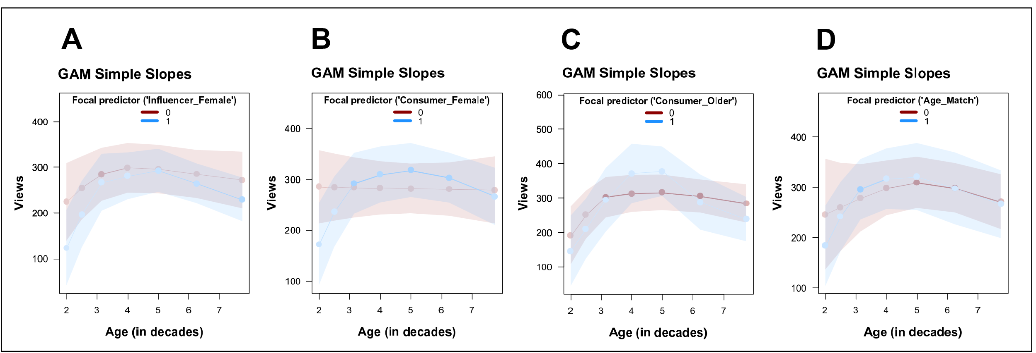

Web Appendix 5: Study 3

WA5-1: Design
Stimuli
Alex Stein | attractive | unattractive
20-25 years |  | 
30-35 years |  | 
40-45 years |  | 
50-55 years |  | 
60-65 years |  | 

 | Low | High
Experience | Research Assistant at Local Consumer Studies | Research Consultant at Global Insights Group
Experience | - BA in Business Communication (Central Institute of Management)  - Recently transitioned into market research  - Assists with surveys, data preparation and reporting tasks  - Currently building skills in SPSS and online research platforms  - Interested in behavioral trends and digital consumer insights | - MSc in Strategic Market Analytics (North European Business School)  - Over 10 years of experience in international market research  - Led projects for global clients in tech, retail and finance  - Specialized in survey design, segmentation and strategic reporting  - Speaker at professional conferences and co-author of industry reports
Experience | 46 connections | 500+ connections
Experience | No endorsements | Endorsed by 30+ colleagues
Attractiveness | Overweight:  with the prompts “overweight”, “unattractive”, and “with skin blemishes” via ChatGPT (based on the highly attractive man) | Normal weight:  no statements during creation with ChatGPT regarding weight (ChatGPT assumes that normal weight is desired)

LinkedIn Profil Experience high | LinkedIn Profil Experience low
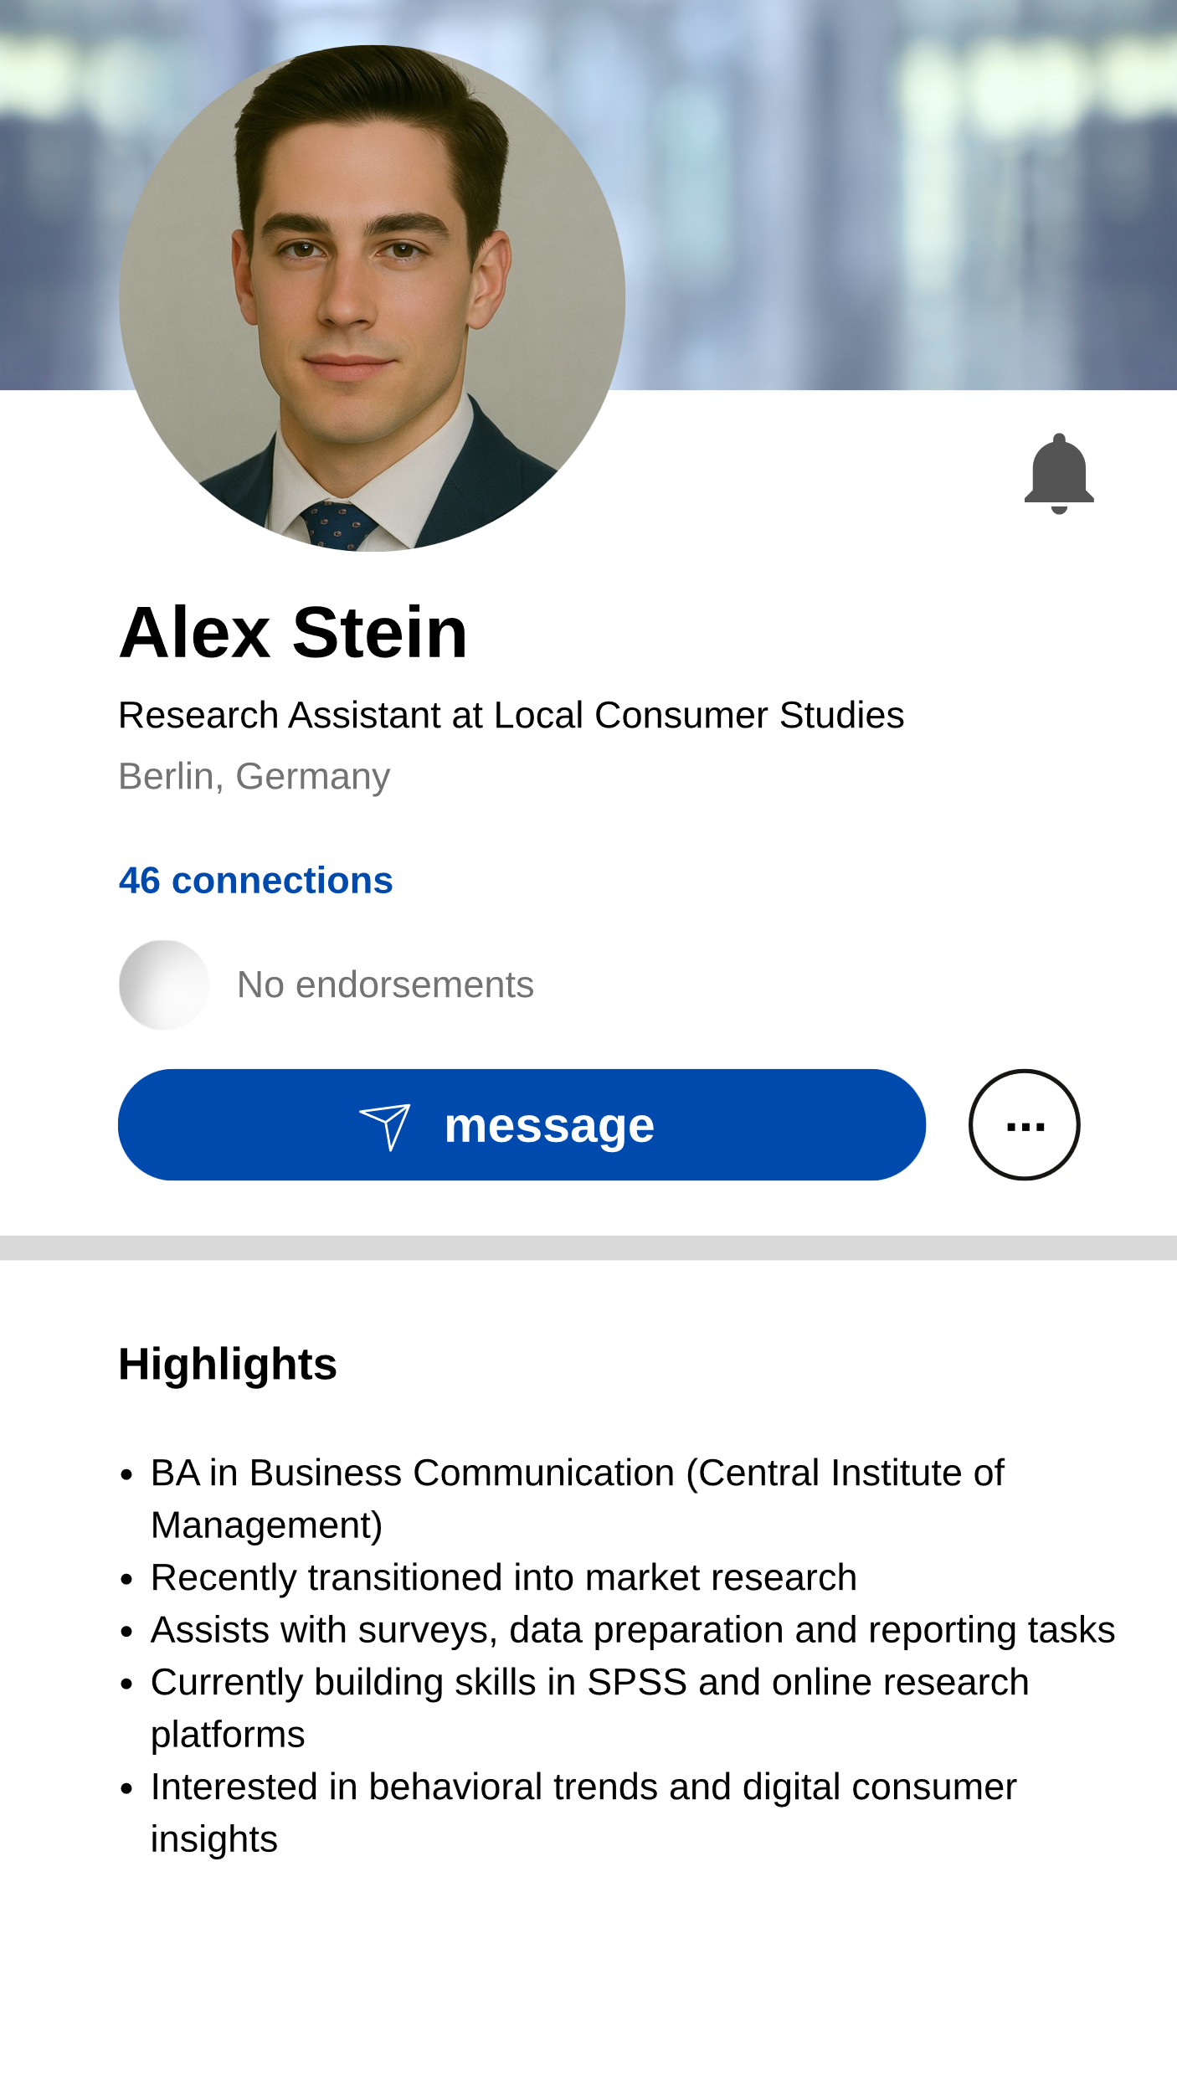 | 

LinkedIn Post | Job Advertisement
 | 

Measures
Factor | Items | Source
Job Suitability | (1) Based on the LinkedIn profile and considering the job advertisement, I believe the applicant is suitable for the position.  (2) Considering the job requirements, I would consider inviting this applicant for an interview based on their LinkedIn profile.  (3) The applicant’s LinkedIn profile gives a positive overall impression regarding their suitability for the advertised position. | based on (Derous et al., 2009)
Engagement | (1) I would like this post.  (2) I would comment on this post.  (3) I would share this post with my network.  (4) I would follow the author of this post. | based on (Swani & Labrecque, 2020)
Attractiveness | (1) I consider this person very attractive.  (2) I consider this person very stylish.  (3) I think this person is good-looking.  (4) I think this person is sexy. | based on (Ohanian, 1990)
Expertise | (1) I feel this person knows a lot about the product.  (2) I feel this person is competent to make assertions about the product.  (3) I consider this person an expert on the product.  (4) I consider this person sufficiently experienced to make assertions about the product. | based on (Ohanian, 1990)
Trustworthiness | (1) I feel this person was honest.  (2) I consider this person trustworthy.  (3) I feel this person was truthful.  (4) I consider this person earnest. | based on (Ohanian, 1990)
Warmth  Competence | (1) I consider this person tolerant.  (2) I consider this person friendly.  (3) I consider this person warm.  (4) I consider this person well-intentioned.  (5) I consider this person good-natured.  (6) I consider this person agreeable.  (7) I consider this person sincere.  (1) I consider this person competent.  (2) I consider this person independent.  (3) I consider this person capable.  (4) I consider this person confident.  (5) I consider this person efficient.  (6) I consider this person competitive.  (7) I consider this person skillful.  (8) I consider this person intelligent. | based on (Fiske, 2012; Fiske et al., 2007)
Manipulation Check | Age: How old do you think this influencer is?  Gender: What gender would you assign to the influencer?  AI: Is this a real person?  Attractiveness: Would you describe this person as overweight?  Expertise: Was the applicant’s highest degree a bachelor's or a master's?
all items were measured with a 5-point Likert scale (except manipulation checks)

WA5-2: Variables and operationalization
Variable | Units | Type | Operationalization | Reference | Alpha | AVE | CR
Engagement | factor | DV |  | ref | 0.92 | 0.75 | 0.922
Job Suitability | factor | DV |  |  | 0.93 | 0.809 | 0.927
Attractiveness | factor | Mediator |  |  | 0.92 | 0.751 | 0.923
Expertise | factor | Mediator component |  |  | 0.9 | 0.703 | 0.904
Trustworthiness | factor | Mediator component |  |  | 0.92 | 0.74 | 0.919
Credibility | factor | Mediator |  |  | 0.9 | 0.474 | 0.789
Competence | factor | alternative Mediator |  |  | 0.88 | 0.722 | 0.886
Warmth | factor | alternative Mediator |  |  | 0.88 | 0.723 | 0.886
Influencer Age | decades | IV (measured) |  |  | 0 | 0 | 0
Consumer Age | decades | Control |  |  | 0 | 0 | 0
Consumer is Female | dummy | Control |  |  | 0 | 0 | 0
Absolute age difference | decades | Control |  |  | 0 | 0 | 0

WA5-3: Descriptives and correlations
 | Mean | SD | Min | Max | 1 | 2 | 3 | 4 | 5 | 6 | 7 | 8 | 9 | 10 | 11 | 12
Engagement | 3.17 | 1.09 | 1.00 | 5.00 | 1 | . | . | . | . | . | . | . | . | . | . | .
JobSuitability | 4.06 | 0.84 | 1.00 | 5.00 | .32 | 1 | . | . | . | . | . | . | . | . | . | .
Attractiveness | 3.16 | 1.02 | 1.00 | 5.00 | .45 | .26 | 1 | . | . | . | . | . | . | . | . | .
Expertise | 3.98 | 0.74 | 1.00 | 5.00 | .41 | .68 | .31 | 1 | . | . | . | . | . | . | . | .
Trustworthiness | 3.82 | 0.63 | 1.00 | 5.00 | .48 | .29 | .36 | .50 | 1 | . | . | . | . | . | . | .
Credibility | 3.90 | 0.60 | 1.50 | 5.00 | .51 | .58 | .39 | .89 | .84 | 1 | . | . | . | . | . | .
Competence | 4.21 | 0.58 | 1.33 | 5.00 | .37 | .49 | .32 | .71 | .58 | .75 | 1 | . | . | . | . | .
Warmth | 3.72 | 0.70 | 1.00 | 5.00 | .47 | .27 | .41 | .45 | .64 | .62 | .53 | 1 | . | . | . | .
Influencer_age | 4.33 | 0.94 | 2.00 | 7.10 | -.06 | .00 | -.32 | .04 | -.01 | .02 | .03 | -.05 | 1 | . | . | .
Consumer_age | 4.09 | 1.34 | 1.80 | 8.00 | -.13 | -.11 | -.08 | -.11 | -.08 | -.11 | -.06 | -.08 | .12 | 1 | . | .
Consumer_is_ female | 0.51 | 0.50 | 0.00 | 1.00 | .05 | .01 | .06 | .01 | -.02 | .00 | .01 | .00 | .04 | .01 | 1 | .
Age_difference | 0.24 | 1.55 | -5.10 | 4.20 | .08 | .10 | -.12 | .12 | .06 | .11 | .07 | .04 | .50 | -.80 | .02 | 1

WA5-4: Manipulation check models
 | Check 1 | Check 2 | Check 3 | Check 4
Dependent variable: | Influencer Age | Credibility Factor | Attractiveness Factor | Consumer Age
Manipulated variable: | Age  (5 levels) | Age Manipulation +  More Experienced + Less Attractive | Age Manipulation +  More Experienced + Less Attractive | Age bracket  (4 levels)
Age = 20 | 3.139 ***
 | (0.043)
Age = 30 | 3.509 *** | -0.024 | -0.014 | 2.498 ***
 | (0.044) | (0.034) | (0.075) | (0.024)
Age = 40 | 3.951 *** | 0.005 | -0.134 | 3.430 ***
 | (0.043) | (0.034) | (0.074) | (0.024)
Age = 50 | 4.471 *** | 0.055 | -0.144 | 4.379 ***
 | (0.044) | (0.034) | (0.075) | (0.024)
Age = 60 | 4.878 *** | 0.010 | -0.507 *** | 5.888 ***
 | (0.043) | (0.034) | (0.073) | (0.023)
Constant |  | -0.047 | 0.638 ***
 |  | (0.028) | (0.061)
More Experienced | 0.134 *** | 0.079 *** | 0.049
 | (0.033) | (0.022) | (0.047)
Less Attractive | 0.550 *** | -0.002 | -1.014 ***
 | (0.033) | (0.022) | (0.047)
N | 1487 | 1487 | 1487 | 1487
R² | 0.980 | 0.012 | 0.263 | 0.989
AIC | 2869.857 | 1610.036 | 3940.680 | 1886.147
F | 10174.798 | 3.112 | 87.909 | 32810.735
p | 0.000 | 0.005 | 0.000 | 0.000
*** p < 0.001; ** p < 0.01; * p < 0.05.

WA5-5: Main Models Robustness Table
 | DV: Engagement |  |  | DV: Job Suitability
 | Cubic Model | Quadratic Model | GAM | Cubic Model | Quadratic Model | GAM
Constant | -5.862 *** | -0.623 | -0.000 | -3.283 * | -0.420 | 0.000
 | (1.549) | (0.442) | (0.022) | (1.401) | (0.399) | (0.020)
InfluencerAge | 4.016 *** | 0.444 * | edf=3.291*** | 2.216 * | 0.356 * | edf=2.597
 | (1.101) | (0.201) | (F=4.884) | (0.996) | (0.181) | (F=2.247)
InfluencerAge² | -0.884 *** | -0.050 * |  | -0.476 * | -0.042 *
 | (0.255) | (0.023) |  | (0.230) | (0.021)
InfluencerAge³ | 0.063 ** |  |  | 0.033
 | (0.019) |  |  | (0.017)
ConsumerAge |  | -0.073 *** | edf=2.003*** |  | -0.070 *** | edf=1.740***
 |  | (0.017) | (F=7.958) |  | (0.015) | (F=9.680)
AbsoluteAgeDelta |  | -0.010 | edf=1.579 |  | -0.004 | edf=1.000
 |  | (0.025) | (F=0.957) |  | (0.022) | (F=0.445)
ControlFunction | -0.171 *** | -0.114 * | edf=3.130*** | 0.023 | 0.065 | edf=2.632
 | (0.049) | (0.049) | (F=6.293) | (0.044) | (0.044) | (F=2.195)
N | 1487 | 1487 | 1487 | 1487 | 1487 | 1487
R² | 0.022 | 0.027 | 0.050 | 0.006 | 0.017 | 0.021
AIC | 3797.634 | 3791.665 | 3756.736 | 3500.047 | 3484.504 | 3476.520
Optimal InfluencerAge (decades) | 3.910  (CI=[3.620, 4.220]) | 4.480  (CI=[3.660, 6.170]) | 3.930  (CI=[3.620, 4.300]) | 3.880  (CI=[3.440, 4.320]) | 4.170  (CI=[2.000, 5.080]) | 4.020  (CI=[2.000, 6.490])
*** p < 0.001; ** p < 0.01; * p < 0.05; GAM smooth terms represent estimated df (linear: edf=1), with F-test for explained variance.

WA5-6: H2 H3 Models Robustness Table
 | DV: Credibility |  |  | DV: Attractiveness
 | Linear Model | Quadratic Model | GAM | Linear Model | Quadratic Model | GAM
Constant | 0.009 | -0.393 | 0.000 | 2.384 *** | 2.455 *** | 0.000
 | (0.076) | (0.212) | (0.011) | (0.182) | (0.506) | (0.025)
InfluencerAge | 0.024 | 0.217 * | edf=2.709* | -0.502 *** | -0.536 * | edf=2.102***
 | (0.016) | (0.096) | (F=3.600) | (0.037) | (0.230) | (F=74.607)
InfluencerAge² |  | -0.022 * |  |  | 0.004
 |  | (0.011) |  |  | (0.026)
ConsumerAge | -0.027 ** | -0.026 ** | edf=1.892** | -0.050 * | -0.050 * | edf=1.935
 | (0.008) | (0.008) | (F=5.181) | (0.019) | (0.019) | (F=2.586)
AbsoluteAge Delta | -0.003 | 0.001 | edf=3.386 | -0.008 | -0.008 | edf=2.930
 | (0.012) | (0.012) | (F=1.514) | (0.028) | (0.028) | (F=0.837)
ControlFunction | -0.040 | -0.035 | edf=2.929* | 0.329 *** | 0.328 *** | edf=3.514***
 | (0.023) | (0.023) | (F=2.738) | (0.055) | (0.056) | (F=12.300)
N | 1487 | 1487 | 1487 | 1487 | 1487 | 1487
R² | 0.010 | 0.013 | 0.024 | 0.126 | 0.126 | 0.140
AIC | 1609.022 | 1606.880 | 1591.493 | 4189.442 | 4191.420 | 4168.688
*** p < 0.001; ** p < 0.01; * p < 0.05; GAM smooth terms represent estimated df (linear: edf=1), with F-test for explained variance.

WA5-7: H4 Models Table
 | DV: Engagement |  | DV: Purchase Intention
 | Linear Interaction | GAM Interaction | Linear Interaction | GAM Interaction
Constant | -0.303 | 0.000 | 0.173 | -0.000
 | (0.160) | (0.020) | (0.177) | (0.022)
Credibility | 0.558 *** | edf=4.889*** | 0.663 *** | edf=7.029***
 | (0.027) | (F=35.691) | (0.030) | (F=26.716)
Attractiveness | 0.083 ** | edf=1.000** | 0.121 *** | edf=1.304*
 | (0.026) | (F=9.301) | (0.029) | (F=5.051)
Credibility × Attractiveness | 0.139 *** | edf=2.958* | 0.100 *** | edf=2.110
 | (0.023) | (F=2.875) | (0.025) | (F=0.752)
InfluencerAge | 0.052 | edf=2.208 | 0.076 | edf=4.184
 | (0.063) | (F=0.907) | (0.070) | (F=1.195)
InfluencerAge² | -0.006 |  | -0.009
 | (0.007) |  | (0.008)
ControlFunction | -0.030 | edf=1.000 | -0.036 | edf=3.460
 | (0.027) | (F=1.403) | (0.030) | (F=1.670)
ConsumerAge | 0.043 ** | edf=1.000** | -0.075 *** | edf=3.960***
 | (0.015) | (F=10.255) | (0.016) | (F=7.102)
AbsoluteAgeDifference | -0.006 | edf=1.000 | -0.006 | edf=1.000
 | (0.017) | (F=0.111) | (0.019) | (F=0.303)
N | 1235 | 1235 | 1235 | 1235
R² | 0.355 | 0.380 | 0.375 | 0.404
AIC | 2651.985 | 2601.560 | 2897.605 | 2845.725
*** p < 0.001; ** p < 0.01; * p < 0.05; GAM smooth terms represent estimated df (linear: edf=1), with F-test for explained variance.

WA5-8: Cpath Table
 | DV: Engagement |  | DV: Job Suitability
 | Quadratic Model | GAM | Quadratic Model | GAM
Constant | -0.586 *** | 0.000 | -0.111 | -0.000
 | (0.125) | (0.018) | (0.126) | (0.018)
Credibility | 0.765 *** | edf=1.000*** | 0.648 *** | edf=8.878***
 | (0.048) | (F=130.922) | (0.049) | (F=12.971)
Attractiveness | 0.281 *** | edf=1.000*** | 0.103 *** | edf=5.333
 | (0.020) | (F=170.971) | (0.021) | (F=1.170)
Credibility × Attractiveness | 0.133 *** | edf=1.000** | -0.049 | edf=11.530
 | (0.038) | (F=10.694) | (0.039) | (F=1.205)
InfluencerAge | 0.130 *** | edf=3.057*** | 0.027 | edf=2.718
 | (0.028) | (F=7.441) | (0.029) | (F=1.072)
ControlFunction | -0.204 *** | edf=2.498*** | 0.029 | edf=1.696
 | (0.040) | (F=9.874) | (0.040) | (F=0.794)
N | 1487 | 1487 | 1487 | 1487
R² | 0.350 | 0.355 | 0.170 | 0.246
AIC | 3193.110 | 3183.378 | 3234.145 | 3111.140
*** p < 0.001; ** p < 0.01; * p < 0.05; GAM smooth terms represent estimated df (linear: edf=1), with F-test for explained variance.

WA5-9: Interaction Tables
GAM
 |  | Test Changes in Curve |  |  |  | Explore Mechanism
Moderator | DV | Significant Contrasts | Optimal Age Change | Optimal DV Change |  | Credibility Shift (H5a) | Credibility Slope (H6a) | Attractiveness Shift (H5b) | Attractiveness Slope (H6b)
More Experienced | Engagement Factor | pos.(+) in:  [3.13 to 3.85] | -0.779  CI=[-2.879, -0.402] | 0.109  CI=[-0.076, 0.314] |  | 0.08***  (0.022) | edf=1.05  (F=0.01) | 0.067  (0.046) | edf=3.67***  (F=10.93)
More Experienced | JS Factor | pos.(+) in:  [2 to 7.1] | -1.106  CI=[-2.626, 0.659] | 0.493  CI=[0.294, 0.649] |  | 0.08***  (0.022) | edf=1.05  (F=0.01) | 0.067  (0.046) | edf=3.67***  (F=10.93)
Less Attractive | Engagement Factor | neg.(-) in:  [3.49 to 4.22] | 0.205  CI=[-1.869, 1.419] | -0.139  CI=[-0.274, 0.005] |  | 0.006  (0.024) | edf=1.17  (F=1.67) | -0.948***  (0.053) | edf=3.98***  (F=10.08)
Less Attractive | JS Factor | neg.(-) in:  [3.8 to 5.19] | -0.952  CI=[-2.424, 1.581] | -0.057  CI=[-0.21, 0.139] |  | 0.006  (0.024) | edf=1.17  (F=1.67) | -0.948***  (0.053) | edf=3.98***  (F=10.08)

Figure Interaction GAM A-D) More Experienced, E-H) Less Attractive
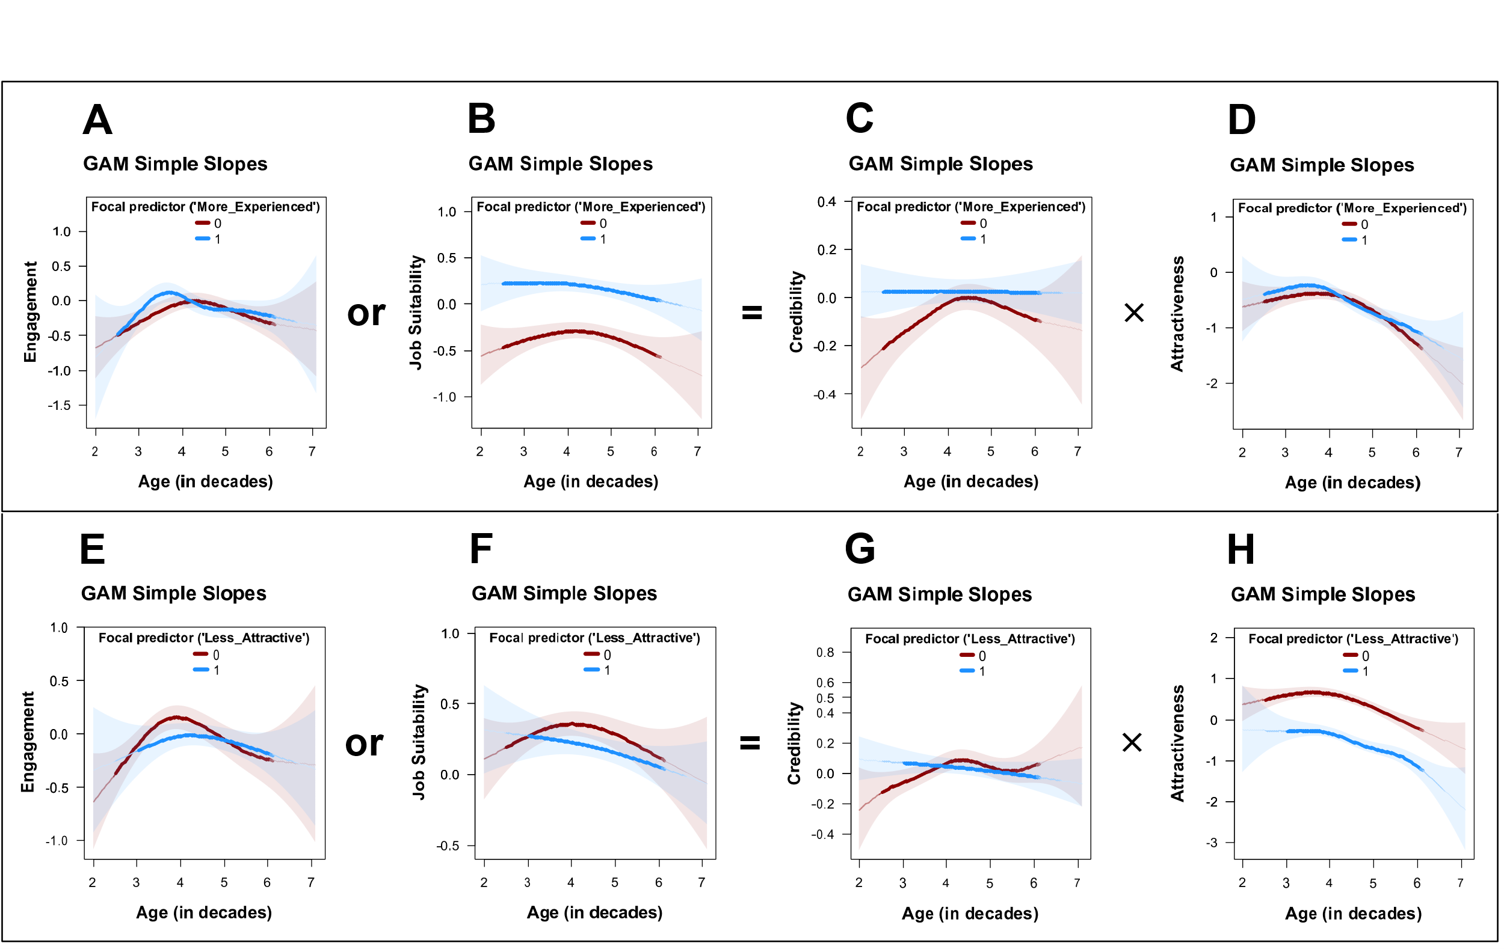

Credibility
 | DV: Engagement |  | DV: Job Suitability |  | DV: Credibility |  | DV: Attractiveness
 | Quadratic Model | GAM | Quadratic Model | GAM | Linear Model | GAM | Linear Model | GAM
Constant | -1.476 * | 0.003 | -1.183 * | -0.218*** | -0.201 * | -0.037 | 1.458 *** | 0.439***
 | (0.574) | (0.040) | (0.486) | (0.034) | (0.090) | (0.019) | (0.195) | (0.042)
InfluencerAge | 0.657 * | edf=3.033*** | 0.481 * | edf=2.369* | 0.036 | edf=2.867* | -0.242 *** | edf=2.783***
 | (0.272) | (F=5.013) | (0.230) | (F=2.786) | (0.020) | (F=3.460) | (0.044) | (F=14.307)
InfluencerAge² | -0.070 * |  | -0.057 *
 | (0.031) |  | (0.026)
More Experienced | 1.074 | 0.070 | 1.226 | 0.545*** | 0.201 * | 0.080*** | 0.239 | 0.067
 | (0.878) | (0.045) | (0.743) | (0.038) | (0.102) | (0.022) | (0.222) | (0.046)
InfluencerAge × More Experienced | -0.407 | edf=4.323* | -0.306 | edf=1.692 | -0.028 | edf=1.051 | -0.038 | edf=3.672***
 | (0.409) | (F=2.868) | (0.346) | (F=1.791) | (0.023) | (F=0.010) | (0.050) | (F=10.930)
InfluencerAge² × More Experienced | 0.039 |  | 0.033
 | (0.046) |  | (0.039)
Less Attractive | -0.066 | -0.075 | -0.110 ** | -0.104* | 0.013 | -0.003 | -0.909 *** | -0.956***
 | (0.050) | (0.049) | (0.042) | (0.042) | (0.023) | (0.024) | (0.051) | (0.052)
ControlFunction | -0.159 ** | edf=3.306*** | 0.044 | edf=3.455* | -0.050 * | edf=5.183* | 0.066 | edf=3.834***
 | (0.050) | (F=8.759) | (0.043) | (F=2.834) | (0.024) | (F=2.409) | (0.052) | (F=6.519)
N | 1487 | 1487 | 1487 | 1487 | 1487 | 1487 | 1487 | 1487
R² | 0.020 | 0.045 | 0.127 | 0.132 | 0.013 | 0.020 | 0.270 | 0.291
AIC | 3807.092 | 3767.484 | 3312.685 | 3300.365 | 1607.803 | 1597.044 | 3924.490 | 3882.946
Ranges of significant contrasts: | pos.(+) in:  [2.670 to 3.550] | pos.(+) in:  [3.130 to 3.850] | pos.(+) in:  [2.000 to 7.100] | pos.(+) in:  [2.000 to 7.100] | pos.(+) in:  [2.000 to 5.190] | pos.(+) in:  [2.000 to 3.910],  pos.(+) in:  [5.350 to 6.070] | Ranges of sig. contrasts: none | pos.(+) in:  [3.390 to 3.550]
*** p < 0.001; ** p < 0.01; * p < 0.05; GAM smooth terms represent estimated df (linear: edf=1), with F-test for explained variance.

Attractiveness
 | DV: Engagement |  | DV: Job Suitability |  | DV: Credibility |  | DV: Attractiveness
 | Quadratic Model | GAM | Quadratic Model | GAM | Linear Model | GAM | Linear Model | GAM
Constant | -1.428 ** | -0.002 | -1.088 * | -0.216*** | -0.237 ** | -0.031 | 1.489 *** | 0.442***
 | (0.543) | (0.040) | (0.459) | (0.035) | (0.085) | (0.020) | (0.186) | (0.042)
InfluencerAge | 0.670 * | edf=3.334*** | 0.433 | edf=2.309 | 0.045 * | edf=4.105* | -0.249 *** | edf=2.821***
 | (0.261) | (F=5.836) | (0.221) | (F=2.658) | (0.019) | (F=2.714) | (0.042) | (F=13.177)
InfluencerAge² | -0.075 * |  | -0.051 *
 | (0.030) |  | (0.026)
Less Attractive | 0.940 | -0.067 | 0.739 | -0.094* | 0.270 * | 0.006 | -0.781 ** | -0.948***
 | (1.025) | (0.050) | (0.867) | (0.042) | (0.110) | (0.024) | (0.240) | (0.053)
InfluencerAge × Less Attractive | -0.461 | edf=2.252 | -0.354 | edf=1.379 | -0.059 * | edf=1.172 | -0.029 | edf=3.980***
 | (0.462) | (F=1.521) | (0.391) | (F=2.895) | (0.024) | (F=1.674) | (0.053) | (F=10.080)
InfluencerAge² × More Experienced | 0.051 |  | 0.035
 | (0.051) |  | (0.043)
More Experienced | 0.072 | 0.068 | 0.541 *** | 0.544*** | 0.083 *** | 0.080*** | 0.077 | 0.066
 | (0.045) | (0.045) | (0.038) | (0.038) | (0.022) | (0.022) | (0.047) | (0.047)
ControlFunction | -0.155 ** | edf=3.290*** | 0.047 | edf=3.374* | -0.049 * | edf=5.170* | 0.067 | edf=3.711***
 | (0.050) | (F=8.592) | (0.043) | (F=2.578) | (0.024) | (F=2.558) | (0.052) | (F=6.411)
N | 1487 | 1487 | 1487 | 1487 | 1487 | 1487 | 1487 | 1487
R² | 0.019 | 0.041 | 0.127 | 0.131 | 0.016 | 0.023 | 0.270 | 0.289
AIC | 3808.660 | 3771.159 | 3312.287 | 3300.876 | 1603.449 | 1594.701 | 3924.754 | 3886.327
Ranges of significant contrasts: | Ranges of sig. contrasts: none | neg.(-) in:  [3.490 to 4.220] | neg.(-) in:  [3.910 to 5.550] | neg.(-) in:  [3.800 to 5.190] | pos.(+) in:  [2.000 to 3.550],  neg.(-) in:  [6.430 to 7.100] | pos.(+) in:  [2.000 to 3.390] | neg.(-) in:  [2.000 to 7.100] | neg.(-) in:  [2.360 to 7.100]
*** p < 0.001; ** p < 0.01; * p < 0.05; GAM smooth terms represent estimated df (linear: edf=1), with F-test for explained variance.

WA5-10: Interaction Tables
 |  | Test Changes in Curve |  |  |  | Explore Mechanism
Moderator | DV | Significant Contrasts | Optimal Age Change | Optimal DV Change |  | Credibility Shift (H5a) | Credibility Slope (H6a) | Attractiveness Shift (H5b) | Attractiveness Slope (H6b)
Consumer Female | Engagement Factor | pos.(+) in:  [3.75 to 5.4] | 0.381  CI=[-1.621, 2.465] | 0.168  CI=[0.045, 0.282] |  | 0.003  (SE= 0.102) | -0.002  (SE= 0.023) | 0.201  (SE= 0.221) | -0.015  (SE= 0.050)
Consumer Female | JS Factor | Ranges of sig. contrasts: none | 0.193  CI=[-1.869, 2.222] | 0.049  CI=[-0.061, 0.157] |  | 0.003  (SE= 0.102) | -0.002  (SE= 0.023) | 0.201  (SE= 0.221) | -0.015  (SE= 0.050)
Consumer Older | Engagement Factor | neg.(-) in:  [2.67 to 5.25] | 1.086  CI=[-0.255, 2.879] | -0.229  CI=[-0.351, -0.083] |  | -0.180  (SE= 0.102) | 0.021  (SE= 0.023) | -0.183  (SE= 0.223) | 0.008  (SE= 0.050)
Consumer Older | JS Factor | neg.(-) in:  [2.62 to 5.5] | 0.5  CI=[-1.718, 2.374] | -0.234  CI=[-0.331, -0.138] |  | -0.180  (SE= 0.102) | 0.021  (SE= 0.023) | -0.183  (SE= 0.223) | 0.008  (SE= 0.050)
Age Match | Engagement Factor | pos.(+) in:  [3.18 to 3.65] | -0.797  CI=[-2.528, 0.255] | 0.087  CI=[-0.038, 0.204] |  | 0.081  (SE= 0.117) | -0.012  (SE= 0.027) | -0.007  (SE= 0.266) | 0.020  (SE= 0.062)
Age Match | JS Factor | pos.(+) in: [  2 to 3.8] | -1.446  CI=[-2.677, 1.215] | 0.155  CI=[-0.074, 0.371] |  | 0.081  (SE= 0.117) | -0.012  (SE= 0.027) | -0.007  (SE= 0.266) | 0.020  (SE= 0.062)
Notes: *** p < 0.001; ** p < 0.01; * p < 0.05; CI are 95% confidence intervals; GAM smooth terms represent estimated df (linear: edf=1), with F-test for explained variance.

GAM
 |  | Test Changes in Curve |  |  |  | Explore Mechanism
Moderator | DV | Significant Contrasts | Optimal Age Change | Optimal DV Change |  | Credibility Shift (H5a) | Credibility Slope (H6a) | Attractiveness Shift (H5b) | Attractiveness Slope (H6b)
Consumer Female | Engagement Factor | pos.(+) in:  [3.7 to 5.04] | 0.145  CI=[-0.455, 0.862] | 0.149  CI=[0.015, 0.262] |  | -0.008  (0.021) | edf=2.92***  (F=5.31) | 0.133**  (0.046) | edf=3.12***  (F=15.73)
Consumer Female | JS Factor | Ranges of sig.  contrasts: none | 0.421  CI=[-2.629, 2.323] | 0.022  CI=[-0.178, 0.149] |  | -0.008  (0.021) | edf=2.92***  (F=5.31) | 0.133**  (0.046) | edf=3.12***  (F=15.73)
Consumer Older | Engagement Factor | neg.(-) in:  [2.98 to 4.83] | 0.539  CI=[-0.051, 1.667] | -0.3  CI=[-0.433, -0.157] |  | -0.084***  (0.022) | edf=2.21  (F=0.84) | -0.122**  (0.047) | edf=2.63***  (F=18.4)
Consumer Older | JS Factor | neg.(-) in:  [2.41 to 5.61] | 0.261  CI=[-1.818, 2.376] | -0.189  CI=[-0.346, -0.02] |  | -0.084***  (0.022) | edf=2.21  (F=0.84) | -0.122**  (0.047) | edf=2.63***  (F=18.4)
Age Match | Engagement Factor | pos.(+) in:  [3.34 to 3.8] | -0.398  CI=[-0.96, 0.051] | 0.159  CI=[-0.002, 0.338] |  | 0.024  (0.026) | edf=2.63  (F=1.04) | 0.05  (0.056) | edf=2.52***  (F=11.82)
Age Match | JS Factor | pos.(+) in:  [2 to 3.7] | -1.377  CI=[-2.475, 0.101] | 0.182  CI=[0.031, 0.349] |  | 0.024  (0.026) | edf=2.63  (F=1.04) | 0.05  (0.056) | edf=2.52***  (F=11.82)
Notes: *** p < 0.001; ** p < 0.01; * p < 0.05; CI are 95% confidence intervals; GAM smooth terms represent estimated df (linear: edf=1), with F-test for explained variance.

3
Figure Interaction Linear Model A-D) Consumer Female, E-H) Consumer Older, I-L) Age Match
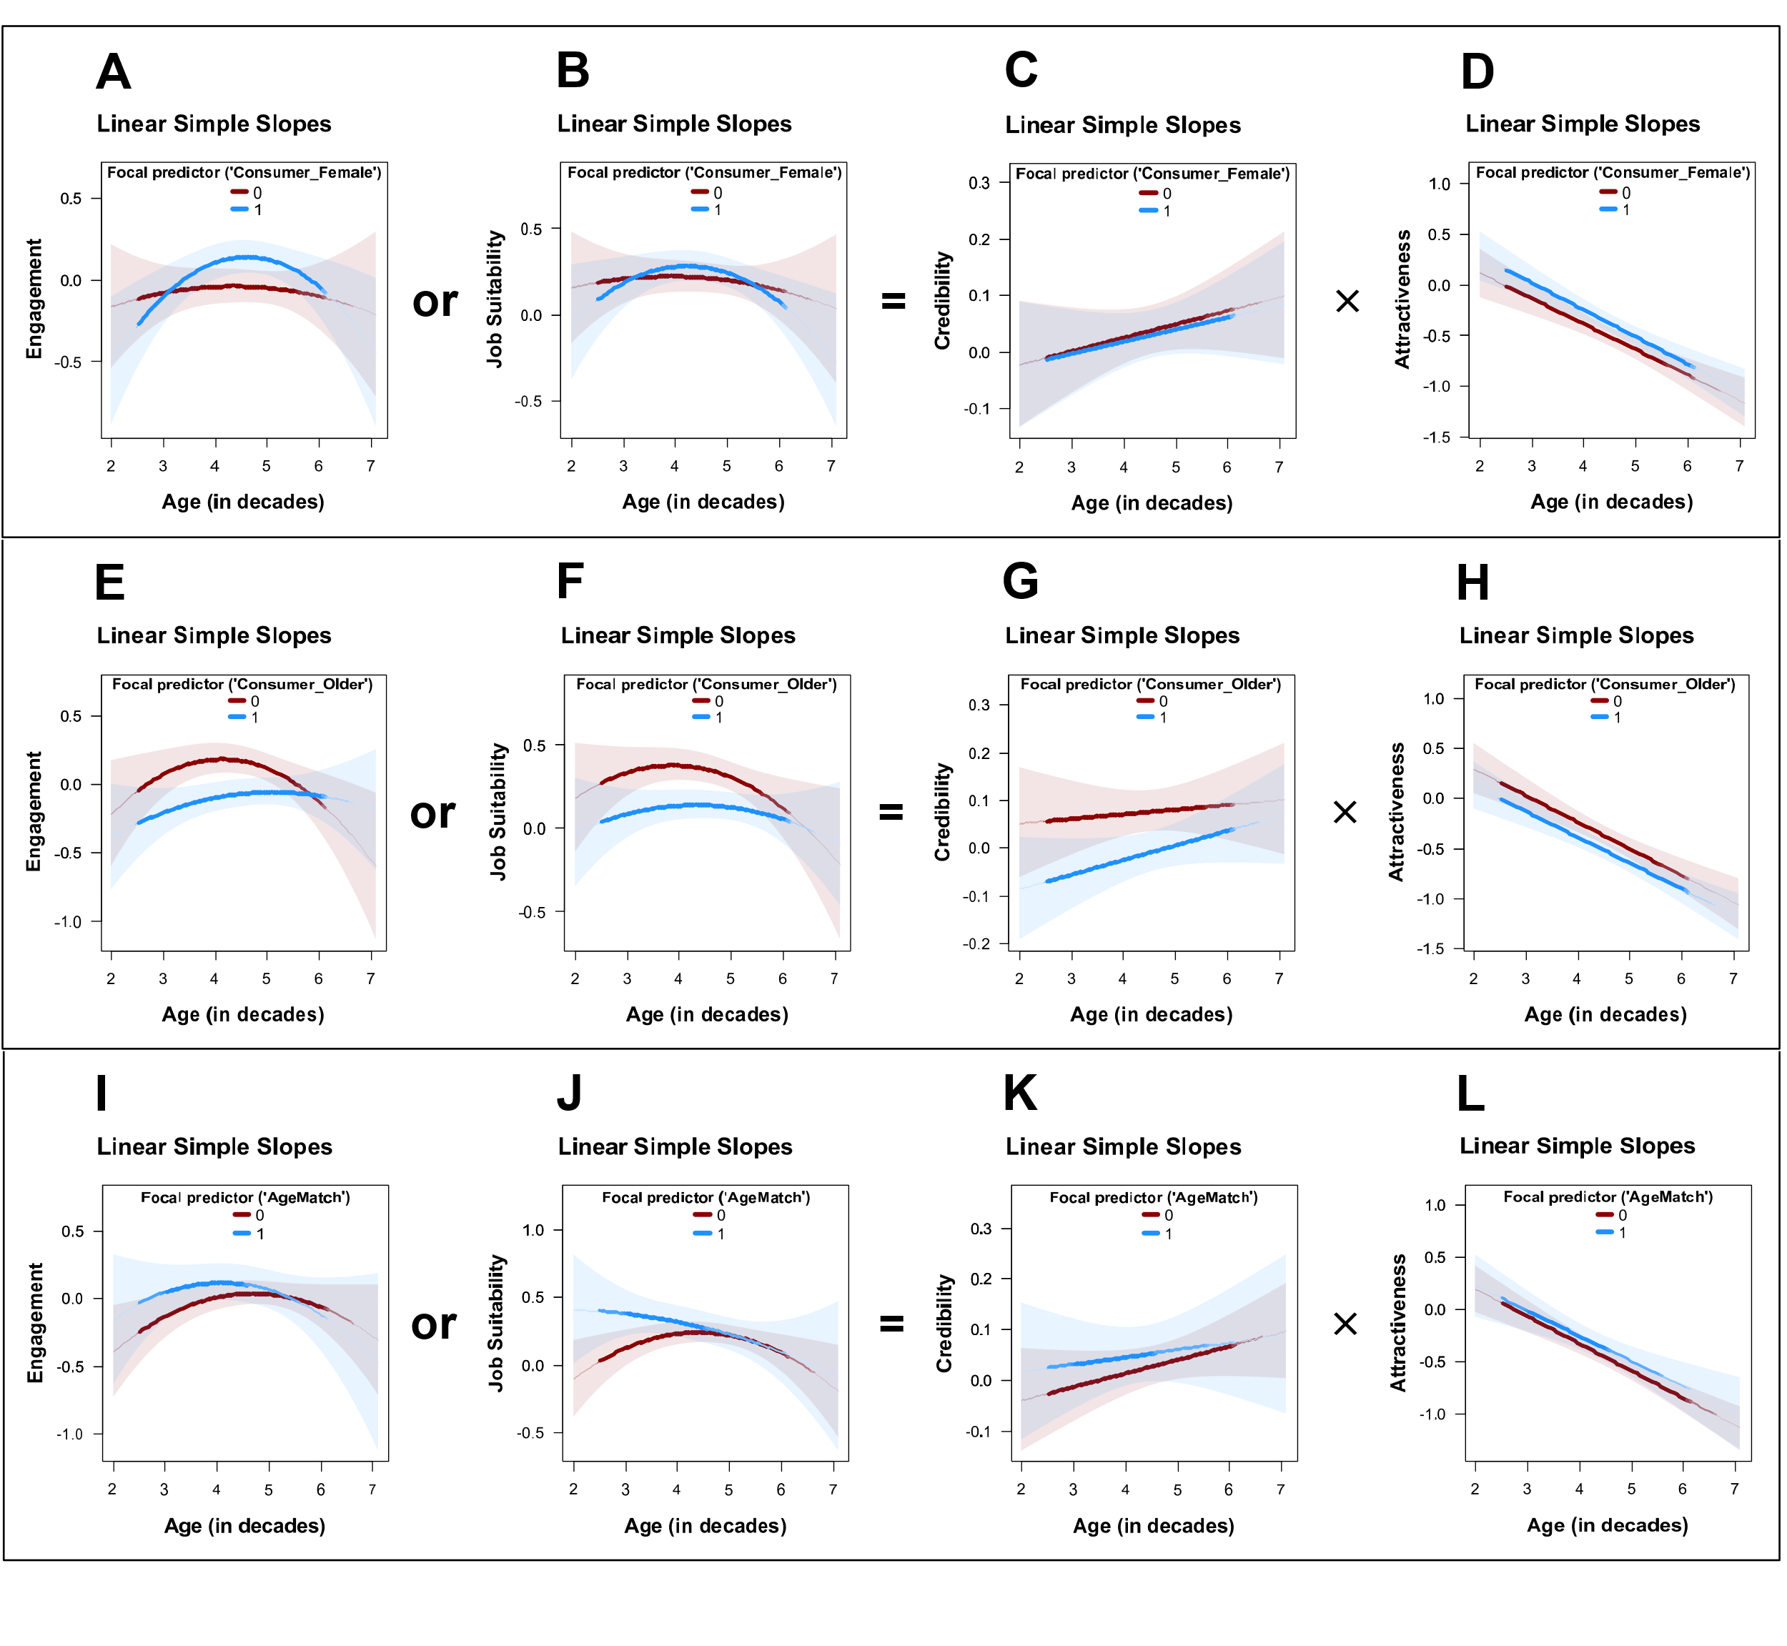

Figure Interaction GAM A-D) Consumer Female, E-H) Consumer Old, I-L) Age Match
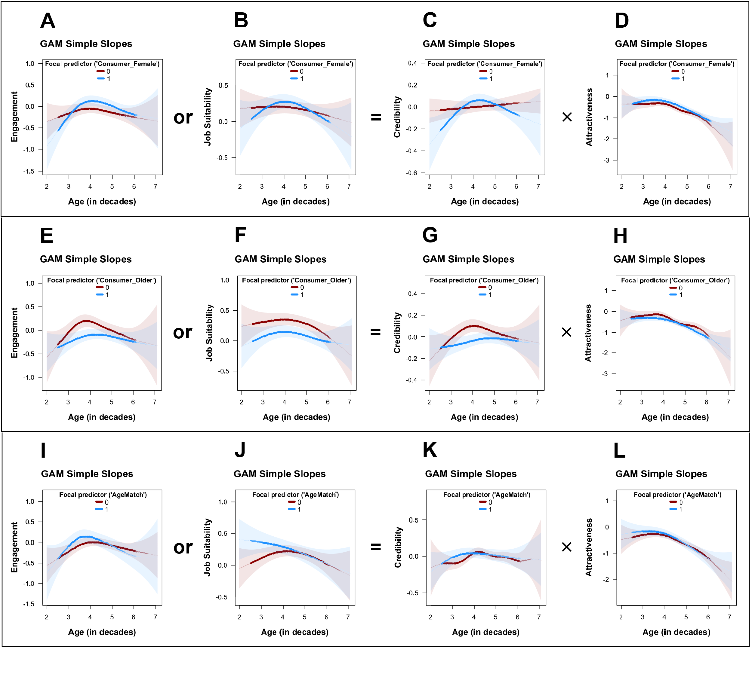

Female
term | Engagement | JobSuitability | Credibility | Attractiveness
Parametric coefficients:
(Intercept) | -0.05  (0.046) | -0.225***  (0.04) | -0.02  (0.022) | 0.337***  (0.048)
Consumer Female | 0.102*  (0.045) | 0.014  (0.038) | -0.008  (0.021) | 0.133**  (0.046)
More Experienced | 0.071  (0.045) | 0.542***  (0.038) | 0.073***  (0.021) | 0.082  (0.046)
Less Attractive | -0.076  (0.049) | -0.105*  (0.042) | -0.023  (0.023) | -0.904***  (0.051)
Moderator variable: | Consumer Female | Consumer Female | Consumer Female | Consumer Female
Smooth terms:
s(InfluencerAge):  Consumer_Female | edf=2.47  (F=1.68) | edf=1.62  (F=0.94) | edf=1  (F=0.7) | edf=4.49***  (F=9.52)
s(InfluencerAge):  Consumer_Female | edf=3.42***  (F=5.71) | edf=2.6*  (F=3.35) | edf=2.92***  (F=5.31) | edf=3.12***  (F=15.73)
s(InfluencerAgeCF) | edf=3.3***  (F=9.06) | edf=3.14*  (F=2.81) | edf=2.85**  (F=4.22) | edf=3.84***  (F=7.08)
N | 1487 | 1487 | 1487 | 1487
Adj R^2 | 0.044 | 0.131 | 0.026 | 0.294
AIC | 3767.45 | 3301.68 | 1587.94 | 3877.87
Ranges of significant contrasts: | pos.(+) in:  [3.7 to 5.04] | Ranges of sig. contrasts: none | neg.(-) in:  [2 to 2.98],  pos.(+) in:  [4.06 to 4.37],  neg.(-) in:  [5.97 to 6.28] | pos.(+) in:  [3.34 to 3.44],  pos.(+) in:  [4.32 to 4.78]

Consumer Older
term | Engagement | Job Suitability | Credibility | Attractiveness
Parametric coefficients:
(Intercept) | -0.05  (0.046) | -0.225***  (0.04) | -0.02  (0.022) | 0.337***  (0.048)
Consumer Female | 0.102*  (0.045) | 0.014  (0.038) | -0.008  (0.021) | 0.133**  (0.046)
More Experienced | 0.071  (0.045) | 0.542***  (0.038) | 0.073***  (0.021) | 0.082  (0.046)
Less Attractive | -0.076  (0.049) | -0.105*  (0.042) | -0.023  (0.023) | -0.904***  (0.051)
Moderator variable: | Consumer Female | Consumer Female | Consumer Female | Consumer Female
Smooth terms:
s(InfluencerAge):  Consumer_Female | edf=2.47  (F=1.68) | edf=1.62  (F=0.94) | edf=1  (F=0.7) | edf=4.49***  (F=9.52)
s(InfluencerAge):  Consumer_Female | edf=3.42***  (F=5.71) | edf=2.6*  (F=3.35) | edf=2.92***  (F=5.31) | edf=3.12***  (F=15.73)
s(InfluencerAgeCF) | edf=3.3***  (F=9.06) | edf=3.14*  (F=2.81) | edf=2.85**  (F=4.22) | edf=3.84***  (F=7.08)
N | 1487 | 1487 | 1487 | 1487
Adj R^2 | 0.044 | 0.131 | 0.026 | 0.294
AIC | 3767.45 | 3301.68 | 1587.94 | 3877.87
Ranges of significant contrasts: | pos.(+) in:  [3.7 to 5.04] | Ranges of sig. contrasts: none | neg.(-) in:  [2 to 2.98],  pos.(+) in:  [4.06 to 4.37],  neg.(-) in:  [5.97 to 6.28] | pos.(+) in:  [3.34 to 3.44],  pos.(+) in:  [4.32 to 4.78]

Age Match
term | Engagement | Job Suitability | Credibility | Attractiveness
Parametric coefficients:
(Intercept) | -0.012  (0.042) | -0.241***  (0.036) | -0.03  (0.02) | 0.393***  (0.044)
Age Match | 0.055  (0.054) | 0.079  (0.046) | 0.024  (0.026) | 0.05  (0.056)
More Experienced | 0.07  (0.045) | 0.544***  (0.038) | 0.075***  (0.022) | 0.079  (0.047)
Less Attractive | -0.077  (0.049) | -0.106*  (0.042) | -0.027  (0.024) | -0.905***  (0.051)
Moderator variable: | AgeMatch | AgeMatch | AgeMatch | AgeMatch
Smooth terms:
s(InfluencerAge):AgeMatch | edf=2.9**  (F=3.91) | edf=2.37*  (F=3.09) | edf=5.51*  (F=2.47) | edf=3.69***  (F=14.74)
s(InfluencerAge):AgeMatch | edf=3.4**  (F=3.3) | edf=1.48  (F=3.54) | edf=2.63  (F=1.04) | edf=2.52***  (F=11.82)
s(InfluencerAgeCF) | edf=3.31***  (F=8.43) | edf=4.19*  (F=2.35) | edf=2.96**  (F=3.83) | edf=4.05***  (F=6.58)
N | 1487 | 1487 | 1487 | 1487
Adj R^2 | 0.041 | 0.135 | 0.024 | 0.29
AIC | 3772.79 | 3295.26 | 1594.86 | 3885.03
Ranges of significant contrasts: | pos.(+) in:  [3.34 to 3.8] | pos.(+) in:  [2 to 3.7] | pos.(+) in:  [3.18 to 3.55] | Ranges of sig. contrasts: none

WA5-11: Warmth & Competence
Parametric Models
 | Engagement | Job Suitability | Competence | Warmth
(Intercept) | -0.558 *** | -0.111 | -0.754 ** | -0.213
 | (0.124) | (0.119) | (0.265) | (0.316)
AttractivenessFactor | 0.256 *** | 0.082 ***
 | (0.021) | (0.020)
CredibilityFactor | 0.601 *** | 0.232 ***
 | (0.066) | (0.064)
WarmthFactor | 0.192 *** | -0.081 *
 | (0.039) | (0.037)
CompetenceFactor | 0.010 | 0.620 ***
 | (0.047) | (0.045)
InfluencerAge | 0.122 *** | 0.024 | 0.359 ** | 0.103
 | (0.028) | (0.027) | (0.123) | (0.147)
InfluencerAgeCF | -0.191 *** | -0.006 | 0.031 | -0.073 *
 | (0.040) | (0.038) | (0.030) | (0.035)
AttractivenessFactor:CredibilityFactor | 0.107 ** | -0.039
 | (0.041) | (0.039)
WarmthFactor:CompetenceFactor | 0.063 | 0.078
 | (0.047) | (0.045)
I(InfluencerAge^2) |  |  | -0.041 ** | -0.012
 |  |  | (0.014) | (0.017)
N | 1487 | 1487 | 1487 | 1487
R² | 0.361 | 0.265 | 0.007 | 0.006
AIC | 3172.245 | 3059.106 | 2357.990 | 2878.185
Warmth Competence GAM
term | Engagement | Job Suitability | Competence | Warmth
Parametric coefficients:
(Intercept) | 0  (0.018) | 0  (0.017) | 0  (0.014) | 0  (0.016)
Moderator variable:
Smooth terms:
s(AttractivenessFactor) | edf=1***  (F=61.95) | edf=5.46  (F=0.88)
s(CredibilityFactor) | edf=7.12***  (F=4.06) | edf=8.75***  (F=7.46)
te(AttractivenessFactor,CredibilityFactor) | edf=3.36  (F=1.22) | edf=12.45  (F=1.25)
s(WarmthFactor) | edf=1***  (F=26.02) | edf=1  (F=0.8)
s(CompetenceFactor) | edf=1.23  (F=0.05) | edf=1.33**  (F=5.9)
te(WarmthFactor,CompetenceFactor) | edf=1  (F=0.38) | edf=6.2*  (F=2.44)
s(InfluencerAge) | edf=3.57***  (F=5.79) | edf=2.45  (F=0.71) | edf=2.61*  (F=2.54) | edf=2.64  (F=1.39)
s(InfluencerAgeCF) | edf=2.54***  (F=8.12) | edf=1.73  (F=0.63) | edf=2  (F=0.89) | edf=2.71**  (F=3.87)
N | 1487 | 1487 | 1487 | 1487
Adj R^2 | 0.372 | 0.315 | 0.006 | 0.013
AIC | 3150.79 | 2975.99 | 2357.55 | 2867.53

WA5-12: Mediation Warmth Competence
 | DV: Engagement |  | DV: Job Suitability
Mediator | Competence | Warmth | Competence | Warmth | Method
Bootstrapped a×b - Linear | 0.003  [-0.03, 0.039] | 0.017  [-0.035, 0.074] | 0.197  [0.057, 0.348] | -0.007  [-0.037, 0.016] | Bootstrapped mediation test
Bootstrapped a×b - GAM | -0.002  [-0.381, 0.548] | 0.027  [-0.049, 1.133] | 0.08  [-6.056, 3.474] | -0.007  [-0.952, 0.529] | (MacKinnon et al., 2002; Preacher & Hayes, 2008)
Conclusion | none significant | none significant | linear significant, GAM not. | none significant

Web Appendix 6: Study 4

WA6-1: Design
Stimuli
 | woman | man
20-25 years | 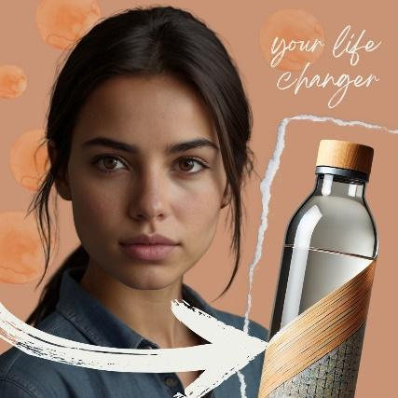 | 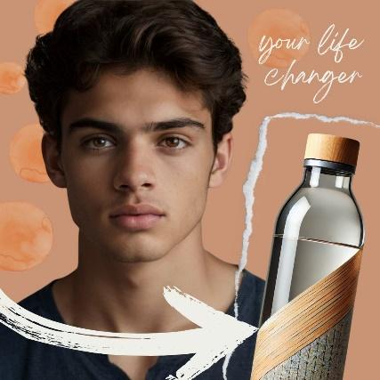 | 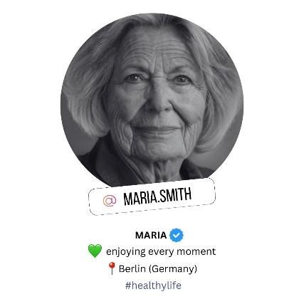  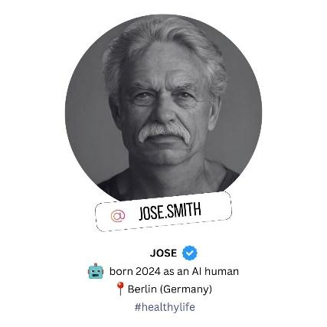
25-30 years | 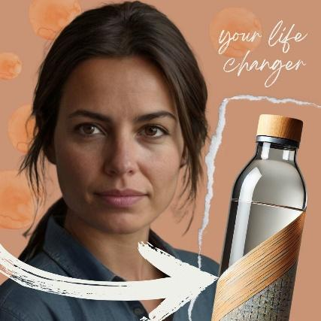 | 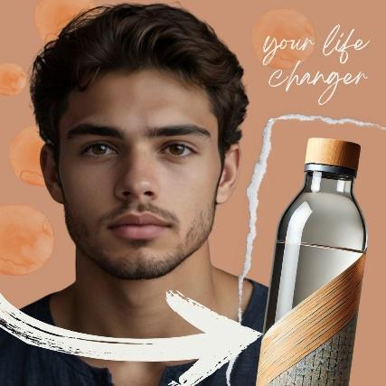
30-40 years | 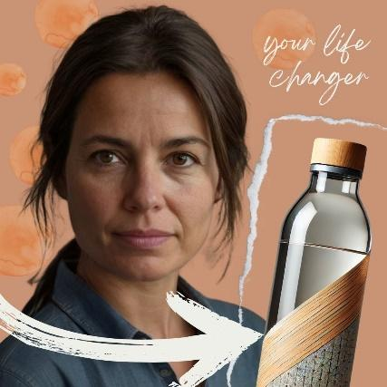 | 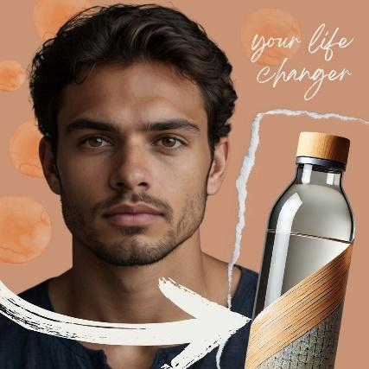
40-50 years | 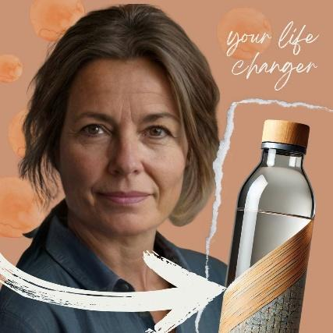 | 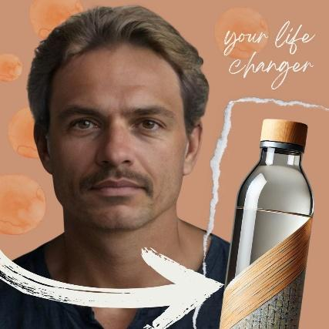
50-60 years | 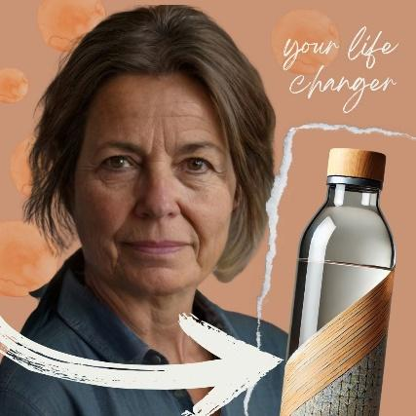 | 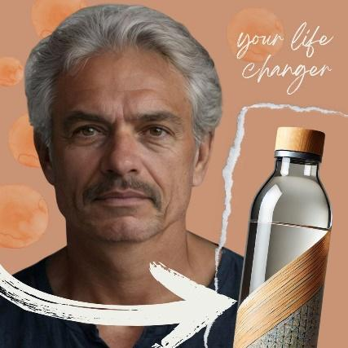 | Design:  7 ages (20-25 years, 25-30 years, 30-40 years, 40-50 years, 50-60 years, 60-70 years, 70-80 years) x gender (male/female) x AI disclosure Instagram account information (‘born as an AI human’)  Product:  Neutral water bottle  Post Caption:  💧 Stay Hydrated, Stay Healthy! 💧  Make a positive impact on the planet while boosting your hydration game 🌍💚 This reusable glass water bottle is made from sustainable materials, designed to help you drink more water throughout the day 🚰 Say goodbye to single-use plastics and hello to eco-friendly hydration🥤Drinking more water is key to a healthier lifestyle — feel the difference with every sip! 🌿✨ #hydrationgoals #sustainableliving #ecofriendly #reusable #drinkmorewater #healthy #plasticfree #stayhydrated
60-70 years | 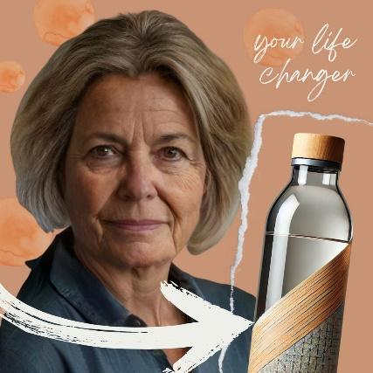 | 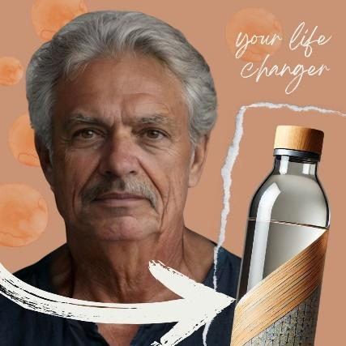
70-80 years | 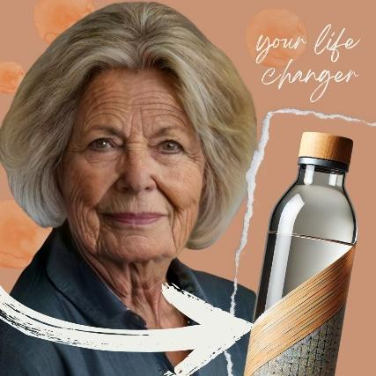 | 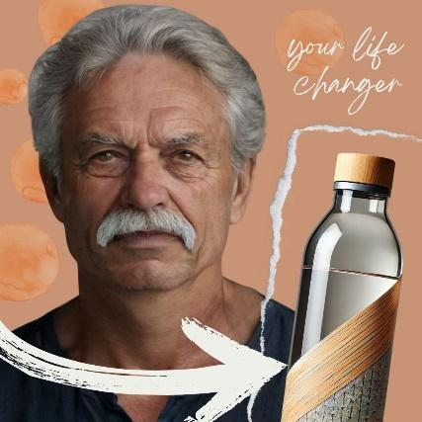

Measures
Factor | Items | Source
Purchase Intention | (1) It is very likely that I will buy this product.  (2) I will purchase this product the next time I need this.  (3) I will definitely try this product.  (4) Suppose a friend called you last night to seek your advice on this product. Would you recommend that they buy this product? | based on (Putrevu & Lord, 1994)
Engagement | (1) I would like the post.  (2) I would comment on the post.  (3) I would share the post. | based on (Swani & Labrecque, 2020)
Attractiveness | (1) I consider the influencer very attractive.  (2) I consider the influencer very stylish.  (3) I think the influencer is good-looking.  (4) I think the influencer is sexy. | based on (Ohanian, 1990)
Expertise | (1) I feel the influencer knows a lot about the product.  (2) I feel the influencer is competent to make assertions about the product.  (3) I consider the influencer an expert on the product.  (4) I consider the influencer sufficiently experienced to make assertions about the product. | based on (Ohanian, 1990)
Trustworthiness | (1) I feel the influencer was honest.  (2) I consider the influencer trustworthy.  (3) I feel the influencer was truthful.  (4) I consider the influencer earnest. | based on (Ohanian, 1990)
Manipulation Check | Age: How old do you think this influencer is?  Gender: What gender would you assign to the influencer?  AI: Is this a real person?
all items were measured with a 5-point Likert scale

WA6-2: Variables and operationalization
Variable | Units | Type | Alpha | AVE | CR
Engagement | factor | DV | 0.87 | 0.6949 | 0.872
Purchase Intention | factor | DV | 0.93 | 0.7813 | 0.933
Attractiveness | factor | Mediator | 0.91 | 0.7349 | 0.918
Expertise | factor | Mediator component | 0.94 | 0.7934 | 0.938
Trustworthiness | factor | Mediator component | 0.97 | 0.8747 | 0.965
Credibility | factor | Mediator | 0.96 | 0.7083 | 0.917
Influencer Age | decades | IV (measured) | 0 | 0 | 0
Perceived as Virtual | dummy | Manip. check | 0 | 0 | 0
Perceived as Female | dummy | Manip. check | 0 | 0 | 0
Consumer Age | decades | Manip. check | 0 | 0 | 0
Absolute age difference | decades | Control | 0 | 0 | 0
Consumer is Female | dummy | Control | 0 | 0 | 0

WA6-3: Descriptives and correlations
 | Mean | SD | Min | Max | 1 | 2 | 3 | 4 | 5 | 6 | 7 | 8 | 9 | 10 | 11 | 12
Engagement | 1.94 | 0.94 | 1.00 | 5.00 | 1 | . | . | . | . | . | . | . | . | . | . | .
Purchase_intention | 2.21 | 1.02 | 1.00 | 5.00 | .71 | 1 | . | . | . | . | . | . | . | . | . | .
Attractiveness | 2.91 | 0.95 | 1.00 | 5.00 | .29 | .31 | 1 | . | . | . | . | . | . | . | . | .
Expertise | 2.44 | 1.01 | 1.00 | 5.00 | .59 | .58 | .29 | 1 | . | . | . | . | . | . | . | .
Trustworthiness | 2.72 | 1.00 | 1.00 | 5.00 | .58 | .58 | .34 | .76 | 1 | . | . | . | . | . | . | .
Credibility | 2.58 | 0.94 | 1.00 | 5.00 | .63 | .62 | .33 | .94 | .94 | 1 | . | . | . | . | . | .
Influencer_age | 4.27 | 1.92 | 0.00 | 8.50 | .05 | .04 | -.29 | .14 | .17 | .16 | 1 | . | . | . | . | .
Perceived_as_virtual | 0.65 | 0.48 | 0.00 | 1.00 | -.25 | -.20 | -.11 | -.33 | -.36 | -.37 | -.13 | 1 | . | . | . | .
Perceived_as_female | 0.49 | 0.50 | 0.00 | 1.00 | .07 | .05 | .00 | .08 | .11 | .10 | .15 | -.07 | 1 | . | . | .
Consumer_age | 4.20 | 1.37 | 1.80 | 8.20 | .16 | .01 | .11 | .11 | .17 | .15 | .02 | -.03 | -.00 | 1 | . | .
AbsoluteAgeDifference | 1.89 | 1.37 | 0.00 | 6.60 | -.07 | -.09 | -.17 | -.08 | -.10 | -.10 | -.03 | .07 | -.02 | .05 | 1 | .
Consumer_is_female | 0.53 | 0.50 | 0.00 | 1.00 | .09 | .07 | .12 | .09 | .11 | .10 | .04 | -.01 | .05 | .02 | -.02 | 1

WA6-4: Manipulation check models
 | Check 1 |  |  | Check 2 | Check 3 | Check 4 | Heckman 1st Stage Probit
Dependent variable: | Influencer Age |  |  | Perceived Virtual | Perceived Female | Consumer Age | Age Match
Manipulated variable: | Age  (7 levels) |  |  | Influencer Virtual | Influencer Female | Older Consumer | Older Consumer + Age Manipulation
Age = 20-25 | 2.347 *** |  | Constant: | 0.452 *** | 0.005 | 3.045 *** | -0.612 ***
 | (0.094) |  |  | (0.017) | (0.003) | (0.031) | (0.110)
Age = 25-30 | 2.780 *** |  |  |  |  |  | 0.086
 | (0.096) |  |  |  |  |  | (0.145)
Age = 30-40 | 3.219 *** |  |  |  |  |  | -0.043
 | (0.095) |  |  |  |  |  | (0.147)
Age = 40-50 | 4.108 *** |  |  |  |  |  | -0.157
 | (0.094) |  |  |  |  |  | (0.149)
Age = 50-60 | 5.215 *** |  |  |  |  |  | -0.226
 | (0.094) |  |  |  |  |  | (0.151)
Age = 60-70 | 5.919 *** |  |  |  |  |  | -0.407 **
 | (0.095) |  |  |  |  |  | (0.157)
Age = 70-80 | 6.281 *** |  |  |  |  |  | -0.869 ***
 | (0.096) |  |  |  |  |  | (0.184)
Manipulation |  |  |  | 0.407 *** | 0.985 *** | 2.283 *** | -0.181 *
 |  |  |  | (0.024) | (0.005) | (0.044) | (0.084)
N | 1235 |  |  | 1235 | 1235 | 1235 | 1235
R² | 0.928 |  |  | 0.183 | 0.971 | 0.690
AIC | 4087.639 |  |  | 1426.721 | -2577.475 | 2848.154 | 1156.532
F | 2249.098 |  |  | 276.443 | 41407.516 | 2746.055
p | 0.000 |  |  | 0.000 | 0.000 | 0.000
*** p < 0.001; ** p < 0.01; * p < 0.05.

WA6-5: Main Models Robustness Table
 | DV: Engagement |  |  | DV: Purchase Intention
 | Quadratic Model | Cubic Model | GAM | Quadratic Model | Cubic Model | GAM
Constant | -1.019 *** | -1.295 *** | 0.000 | -0.731 *** | -1.071 *** | 0.000
 | (0.183) | (0.224) | (0.024) | (0.208) | (0.254) | (0.027)
InfluencerAge | 0.318 *** | 0.599 *** | edf=3.593*** | 0.412 *** | 0.757 *** | edf=4.055***
 | (0.074) | (0.151) | (F=4.836) | (0.084) | (0.171) | (F=7.209)
InfluencerAge² | -0.036 *** | -0.114 ** |  | -0.047 *** | -0.144 ***
 | (0.008) | (0.038) |  | (0.009) | (0.043)
InfluencerAge³ |  | 0.007 * |  |  | 0.008 *
 |  | (0.003) |  |  | (0.003)
ConsumerAge | 0.103 *** | 0.103 *** | edf=1.086*** | -0.001 | -0.000 | edf=3.475**
 | (0.018) | (0.018) | (F=28.165) | (0.020) | (0.020) | (F=3.388)
AbsoluteAgeDelta | 0.004 | 0.002 | edf=1.000 | 0.004 | 0.001 | edf=1.000
 | (0.021) | (0.021) | (F=0.000) | (0.024) | (0.024) | (F=0.628)
ControlFunction | -0.030 | -0.075 * | edf=1.001 | -0.035 | -0.090 * | edf=1.001
 | (0.031) | (0.038) | (F=2.304) | (0.036) | (0.043) | (F=3.736)
N | 1235 | 1235 | 1235 | 1235 | 1235 | 1235
R² | 0.049 | 0.053 | 0.048 | 0.033 | 0.037 | 0.044
AIC | 3124.718 | 3122.146 | 3125.006 | 3431.141 | 3427.766 | 3418.102
Optimal InfluencerAge (decades) | 4.450  (CI=[3.840, 4.930]) | 3.990  (CI=[3.350, 4.850]) | 4.060  (CI=[3.290, 5.510]) | 4.360  (CI=[3.840, 4.850]) | 3.920  (CI=[3.470, 4.490]) | 3.780  (CI=[2.910, 5.730])
*** p < 0.001; ** p < 0.01; * p < 0.05; GAM smooth terms represent estimated df (linear: edf=1), with F-test for explained variance.

WA6-6: H2 H3 Models Robustness Table
 | DV: Credibility |  |  | DV: Attractiveness
 | Linear Model | Quadratic Model | GAM | Linear Model | Quadratic Model | GAM
Constant | -0.528 *** | -1.562 *** | 0.000 | 0.987 *** | 0.328 | 0.000
 | (0.102) | (0.171) | (0.023) | (0.107) | (0.182) | (0.024)
InfluencerAge | 0.045 ** | 0.546 *** | edf=4.136*** | -0.282 *** | 0.038 | edf=5.779***
 | (0.016) | (0.069) | (F=12.435) | (0.017) | (0.074) | (F=39.469)
InfluencerAge² |  | -0.056 *** |  |  | -0.036 ***
 |  | (0.007) |  |  | (0.008)
ConsumerAge | 0.101 *** | 0.100 *** | edf=1.001*** | 0.082 *** | 0.081 *** | edf=1.769***
 | (0.017) | (0.017) | (F=36.651) | (0.018) | (0.018) | (F=10.346)
AbsoluteAgeDelta | -0.048 ** | 0.017 | edf=1.000 | -0.070 *** | -0.028 | edf=2.562*
 | (0.018) | (0.020) | (F=0.449) | (0.019) | (0.021) | (F=2.851)
ControlFunction | 0.062 * | -0.048 | edf=1.000 | 0.303 *** | 0.233 *** | edf=2.325***
 | (0.026) | (0.029) | (F=3.674) | (0.027) | (0.031) | (F=5.585)
N | 1235 | 1235 | 1235 | 1235 | 1235 | 1235
R² | 0.069 | 0.110 | 0.107 | 0.218 | 0.230 | 0.256
AIC | 3005.311 | 2952.715 | 2954.158 | 3130.479 | 3112.699 | 3078.203
*** p < 0.001; ** p < 0.01; * p < 0.05; GAM smooth terms represent estimated df (linear: edf=1), with F-test for explained variance.

WA6-7: H4 Models Table
 | DV: Engagement |  | DV: Purchase Intention
 | Linear Interaction | GAM Interaction | Linear Interaction | GAM Interaction
Constant | -0.303 | 0.000 | 0.173 | -0.000
 | (0.160) | (0.020) | (0.177) | (0.022)
Credibility | 0.558 *** | edf=4.889*** | 0.663 *** | edf=7.029***
 | (0.027) | (F=35.691) | (0.030) | (F=26.716)
Attractiveness | 0.083 ** | edf=1.000** | 0.121 *** | edf=1.304*
 | (0.026) | (F=9.301) | (0.029) | (F=5.051)
Credibility × Attractiveness | 0.139 *** | edf=2.958* | 0.100 *** | edf=2.110
 | (0.023) | (F=2.875) | (0.025) | (F=0.752)
InfluencerAge | 0.052 | edf=2.208 | 0.076 | edf=4.184
 | (0.063) | (F=0.907) | (0.070) | (F=1.195)
InfluencerAge² | -0.006 |  | -0.009
 | (0.007) |  | (0.008)
ControlFunction | -0.030 | edf=1.000 | -0.036 | edf=3.460
 | (0.027) | (F=1.403) | (0.030) | (F=1.670)
ConsumerAge | 0.043 ** | edf=1.000** | -0.075 *** | edf=3.960***
 | (0.015) | (F=10.255) | (0.016) | (F=7.102)
AbsoluteAgeDifference | -0.006 | edf=1.000 | -0.006 | edf=1.000
 | (0.017) | (F=0.111) | (0.019) | (F=0.303)
N | 1235 | 1235 | 1235 | 1235
R² | 0.355 | 0.380 | 0.375 | 0.404
AIC | 2651.985 | 2601.560 | 2897.605 | 2845.725
*** p < 0.001; ** p < 0.01; * p < 0.05; GAM smooth terms represent estimated df (linear: edf=1), with F-test for explained variance.

WA6-8: Interaction Tables
GAM
 |  | Test Changes in Curve |  |  |  | Explore Mechanism
Moderator | DV | Significant Contrasts | Optimal Age Change | Optimal DV Change |  | Credibility Shift (H5a) | Credibility Slope (H6a) | Attractiveness Shift (H5b) | Attractiveness Slope (H6b)
Influencer Virtual | Engagement  Factor | Ranges of sig. contrasts: none | 0.51  CI=[-2.428, 3.96] | -0.078  CI=[-0.343, 0.245] |  | -0.311***  (0.05) | edf=4.21***  (F=9.59) | -0.149**  (0.05) | edf=6.42***  (F=23.66)
Influencer Virtual | PI Factor | neg.(-) in:  [0 to 0.52],  neg.(-) in:  [3.86 to 5.32] | -1.192  CI=[-2.921, 1.863] | -0.037  CI=[-0.283, 0.24] |  | -0.311***  (0.05) | edf=4.21***  (F=9.59) | -0.149**  (0.05) | edf=6.42***  (F=23.66)
Influencer Female | Engagement  Factor | pos.(+) in:  [2.32 to 3.95] | -0.874  CI=[-4.368, 1.701] | 0.217  CI=[0.046, 0.393] |  | -0.285***  (0.047) | edf=3.7***  (F=7.08) | -0.09  (0.049) | edf=4.65***  (F=23.51)
Influencer Female | PI Factor | pos.(+) in:  [2.4 to 3.61] | -1.342  CI=[-4.614, 1.212] | 0.267  CI=[0.103, 0.442] |  | -0.285***  (0.047) | edf=3.7***  (F=7.08) | -0.09  (0.049) | edf=4.65***  (F=23.51)
Consumer Female | Engagement  Factor | pos.(+) in:  [4.21 to 5.84] | 0.598  CI=[-3.083, 2.505] | 0.119  CI=[-0.029, 0.277] |  | 0.146**  (0.045) | edf=3.64***  (F=7.7) | 0.216***  (0.048) | edf=5.43***  (F=25.31)
Consumer Female | PI Factor | Ranges of sig. contrasts: none | -0.101  CI=[-3.56, 2.428] | 0.102  CI=[-0.065, 0.258] |  | 0.146**  (0.045) | edf=3.64***  (F=7.7) | 0.216***  (0.048) | edf=5.43***  (F=25.31)
Consumer Older | Engagement  Factor | pos.(+) in:  [1.72 to 6.95] | 0.326  CI=[-1.62, 2.772] | 0.237  CI=[0.061, 0.404] |  | -0.286***  (0.046) | edf=4.09***  (F=9.73) | -0.095  (0.049) | edf=3.52***  (F=31.39)
Consumer Older | PI Factor | Ranges of sig. contrasts: none | -0.209  CI=[-2.505, 2.101] | 0.017  CI=[-0.143, 0.18] |  | -0.286***  (0.046) | edf=4.09***  (F=9.73) | -0.095  (0.049) | edf=3.52***  (F=31.39)
Age Match | Engagement  Factor | pos.(+) in: [4.89 to 6.27] | 1.983  CI=[-0.016, 4.606] | 0.243  CI=[0.023, 0.507] |  | 0.023  (0.071) | edf=2.17**  (F=5.59) | 0.265***  (0.064) | edf=1***  (F=40.59)
Age Match | PI Factor | pos.(+) in: [3.35 to 4.29] | -0.933  CI=[-3.236, 1.616] | 0.265  CI=[0.046, 0.487] |  | 0.023  (0.071) | edf=2.17**  (F=5.59) | 0.265***  (0.064) | edf=1***  (F=40.59)
Notes: *** p < 0.001; ** p < 0.01; * p < 0.05; CI are 95% confidence intervals; GAM smooth terms represent estimated df (linear: edf=1), with F-test for explained variance.

Figure Interaction GAM A-D) Virtual Influencer, E-H) Influencer Female, I-L) Consumer Female, M-P) Consumer Old, Q-T) Age Match
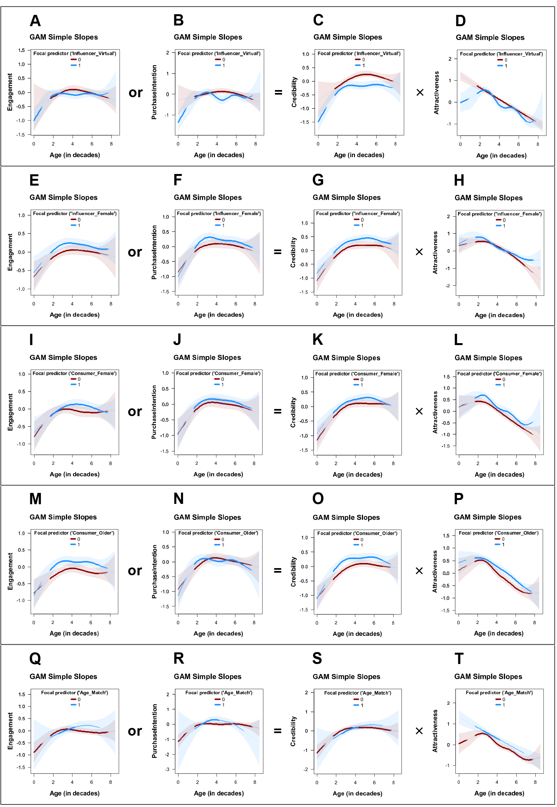
Virtual Influencer Linear Model
 | Engagement | Purchase Intention | Credibility | Attractiveness
(Intercept) | -0.683 * | -0.844 * | 0.000 | 1.402 ***
 | (0.301) | (0.336) | (0.098) | (0.104)
InfluencerAge | 0.359 * | 0.470 ** | 0.023 | -0.314 ***
 | (0.143) | (0.159) | (0.020) | (0.022)
Influencer Virtual | 0.004 | 0.036 | -0.466 *** | -0.322 *
 | (0.346) | (0.387) | (0.129) | (0.138)
I(InfluencerAge^2) | -0.041 ** | -0.054 **
 | (0.015) | (0.017)
Influencer Female | 0.138 ** | 0.113 | 0.146 ** | 0.026
 | (0.052) | (0.059) | (0.048) | (0.051)
InfluencerAgeCF | -0.047 | -0.052 | 0.035 | 0.310 ***
 | (0.035) | (0.040) | (0.027) | (0.029)
InfluencerAge:Influencer_Virtual | -0.053 | -0.077 | 0.031 | 0.043
 | (0.165) | (0.185) | (0.027) | (0.029)
Influencer_Virtual1:I(InfluencerAge^2) | 0.008 | 0.009
 | (0.018) | (0.020)
N | 1235 | 1235 | 1235 | 1235
R² | 0.030 | 0.039 | 0.080 | 0.203
AIC | 3153.727 | 3427.729 | 2992.804 | 3155.970
Ranges of significant contrasts: | Ranges of sig. contrasts: none | Ranges of sig. contrasts: none | neg.(-) in: [0.000 to 8.070] | neg.(-) in: [0.000 to 5.070]
*** p < 0.001; ** p < 0.01; * p < 0.05.

Virtual Influencer GAM
term | Engagement | Purchase Intention | Credibility | Attractiveness
Parametric coefficients:
(Intercept) | -0.042  (0.048) | 0.009  (0.051) | 0.06  (0.043) | 0.022  (0.044)
Influencer Virtual | -0.064  (0.056) | -0.142*  (0.06) | -0.311***  (0.05) | -0.149**  (0.05)
Influencer Female | 0.167**  (0.054) | 0.174**  (0.06) | 0.213***  (0.049) | 0.169**  (0.054)
Moderator variable: | Influencer_Virtual | Influencer_Virtual | Influencer_Virtual | Influencer_Virtual
Smooth terms:
s(InfluencerAge): Influencer_Virtual0 | edf=2.61  (F=2.02) | edf=2.2  (F=2.2) | edf=2.44***  (F=6.24) | edf=1***  (F=149.3)
s(InfluencerAge): Influencer_Virtual1 | edf=4.51***  (F=4.31) | edf=5.87***  (F=6.28) | edf=4.21***  (F=9.59) | edf=6.42***  (F=23.66)
s(InfluencerAgeCF) | edf=1*  (F=6.09) | edf=1**  (F=8.86) | edf=1.13**  (F=7.46) | edf=2.25**  (F=5.03)
N | 1235 | 1235 | 1235 | 1235
Adj R^2 | 0.033 | 0.05 | 0.122 | 0.244
AIC | 3146.65 | 3410.4 | 2935.28 | 3091.57
Ranges of significant contrasts: | Ranges of sig. contrasts: none | neg.(-) in:  [0 to 0.52],  neg.(-) in:  [3.86 to 5.32] | neg.(-) in:  [0 to 0.43],  neg.(-) in:  [2.49 to 7.3] | neg.(-) in:  [0 to 1.63],  neg.(-) in:  [3.78 to 4.64],  neg.(-) in:  [6.44 to 7.04]

Influencer Female Linear Model
 | Engagement | Purchase Intention | Credibility | Attractiveness
(Intercept) | -0.671 *** | -0.695 *** | -0.117 | 1.373 ***
 | (0.179) | (0.200) | (0.091) | (0.097)
InfluencerAge | 0.346 *** | 0.394 *** | 0.050 * | -0.310 ***
 | (0.088) | (0.099) | (0.020) | (0.021)
Influencer Female | 0.188 | -0.009 | 0.257 * | -0.127
 | (0.196) | (0.219) | (0.114) | (0.122)
I(InfluencerAge^2) | -0.039 *** | -0.045 ***
 | (0.010) | (0.011)
Influencer Virtual | -0.045 | -0.100 | -0.329 *** | -0.131 **
 | (0.051) | (0.057) | (0.047) | (0.051)
InfluencerAgeCF | -0.048 | -0.060 | 0.047 | 0.325 ***
 | (0.033) | (0.037) | (0.025) | (0.027)
InfluencerAge:Influencer_Female | -0.035 | 0.053 | -0.028 | 0.033
 | (0.101) | (0.113) | (0.024) | (0.026)
Influencer_Female1:I(InfluencerAge^2) | 0.005 | -0.005
 | (0.012) | (0.014)
N | 1235 | 1235 | 1235 | 1235
R² | 0.030 | 0.039 | 0.080 | 0.202
AIC | 3154.257 | 3427.530 | 2992.818 | 3156.510
Ranges of significant contrasts: | pos.(+) in: [5.070 to 6.180] | pos.(+) in: [4.980 to 5.750] | pos.(+) in: [0.000 to 5.320] | Ranges of sig. contrasts: none
*** p < 0.001; ** p < 0.01; * p < 0.05.

Influencer Female GAM
term | Engagement | Purchase Intention | Credibility | Attractiveness
Parametric coefficients:
(Intercept) | -0.058  (0.044) | -0.024  (0.049) | 0.033  (0.041) | -0.031  (0.044)
Influencer Virtual | -0.047  (0.051) | -0.101  (0.057) | -0.285***  (0.047) | -0.09  (0.049)
Influencer Female | 0.167**  (0.054) | 0.155**  (0.06) | 0.217***  (0.05) | 0.156**  (0.054)
Moderator variable: | Influencer_Female | Influencer_Female | Influencer_Female | Influencer_Female
Smooth terms:
s(InfluencerAge):Influencer_Female0 | edf=2.79*  (F=3.29) | edf=3.14**  (F=4.23) | edf=3.46***  (F=9.46) | edf=3.48***  (F=43.13)
s(InfluencerAge):Influencer_Female1 | edf=3.27*  (F=3.18) | edf=3.96***  (F=5.77) | edf=3.7***  (F=7.08) | edf=4.65***  (F=23.51)
s(InfluencerAgeCF) | edf=1.83  (F=2.33) | edf=1.38*  (F=2.92) | edf=1.78**  (F=4.86) | edf=2.56***  (F=7.58)
N | 1235 | 1235 | 1235 | 1235
Adj R^2 | 0.028 | 0.04 | 0.118 | 0.245
AIC | 3155.71 | 3426.49 | 2945.89 | 3094.25
Ranges of significant contrasts: | pos.(+) in: [2.32 to 3.95] | pos.(+) in:  [2.4 to 3.61] | pos.(+) in: [2.15 to 6.44] | pos.(+) in: [2.15 to 2.4],  pos.(+) in: [5.92 to 8.5]

Consumer Female Linear Model
 | Engagement | Purchase Intention | Credibility | Attractiveness
(Intercept) | -0.635 *** | -0.753 *** | -0.194 * | 1.209 ***
 | (0.183) | (0.204) | (0.099) | (0.105)
InfluencerAge | 0.296 *** | 0.390 *** | 0.049 * | -0.296 ***
 | (0.084) | (0.094) | (0.020) | (0.022)
Consumer_Female1 | -0.022 | 0.022 | 0.235 * | 0.180
 | (0.196) | (0.219) | (0.113) | (0.120)
I(InfluencerAge^2) | -0.033 *** | -0.044 ***
 | (0.009) | (0.010)
Influencer Virtual | -0.045 | -0.101 | -0.327 *** | -0.130 **
 | (0.051) | (0.057) | (0.047) | (0.050)
Influencer_Female | 0.134 ** | 0.114 * | 0.138 ** | 0.011
 | (0.051) | (0.057) | (0.047) | (0.050)
InfluencerAgeCF | -0.050 | -0.059 | 0.038 | 0.318 ***
 | (0.033) | (0.037) | (0.025) | (0.027)
InfluencerAge:Consumer_Female | 0.059 | 0.045 | -0.019 | 0.008
 | (0.101) | (0.113) | (0.024) | (0.026)
Consumer_Female: I(InfluencerAge^2) | -0.006 | -0.006
 | (0.012) | (0.013)
N | 1235 | 1235 | 1235 | 1235
R² | 0.033 | 0.041 | 0.088 | 0.214
AIC | 3152.414 | 3426.960 | 2984.612 | 3141.056
Ranges of significant contrasts: | Ranges of sig. contrasts: none | Ranges of sig. contrasts: none | pos.(+) in: [0.000 to 5.920] | pos.(+) in: [1.120 to 8.500]
*** p < 0.001; ** p < 0.01; * p < 0.05.

Consumer Female GAM
term | Engagement | Purchase Intention | Credibility | Attractiveness
Parametric coefficients:
(Intercept) | -0.111*  (0.051) | -0.076  (0.057) | -0.043  (0.047) | -0.154**  (0.05)
Consumer Female | 0.099*  (0.049) | 0.097  (0.055) | 0.146**  (0.045) | 0.216***  (0.048)
Influencer Virtual | -0.042  (0.051) | -0.099  (0.057) | -0.285***  (0.046) | -0.09  (0.049)
Influencer Female | 0.159**  (0.054) | 0.145*  (0.06) | 0.214***  (0.05) | 0.167**  (0.054)
Moderator variable: | Consumer Female | Consumer Female | Consumer Female | Consumer Female
Smooth terms:
s(InfluencerAge): Consumer_Female0 | edf=3.38*  (F=3.2) | edf=3.35***  (F=4.68) | edf=3.51***  (F=8.57) | edf=3.53***  (F=33.56)
s(InfluencerAge): Consumer_Female1 | edf=2.98**  (F=3.83) | edf=3.66***  (F=4.92) | edf=3.64***  (F=7.7) | edf=5.43***  (F=25.31)
s(InfluencerAgeCF) | edf=1.73  (F=2.65) | edf=1.31*  (F=2.85) | edf=1.85**  (F=5.36) | edf=2.83***  (F=6.2)
N | 1235 | 1235 | 1235 | 1235
Adj R^2 | 0.032 | 0.039 | 0.125 | 0.255
AIC | 3151.76 | 3428.09 | 2937.31 | 3081.16
Ranges of significant contrasts: | pos.(+) in:  [4.21 to 5.84] | Ranges of sig. contrasts: none | pos.(+) in:  [4.55 to 6.1] | pos.(+) in:  [2.15 to 3.35],  pos.(+) in:  [4.81 to 6.27],  pos.(+) in:  [6.95 to 8.5]

Consumer Older Linear Model
 | Engagement | Purchase Intention | Credibility | Attractiveness
(Intercept) | -0.664 *** | -0.711 *** | -0.189 | 1.237 ***
 | (0.184) | (0.207) | (0.097) | (0.104)
InfluencerAge | 0.267 ** | 0.383 *** | 0.037 | -0.301 ***
 | (0.084) | (0.095) | (0.020) | (0.021)
Consumer Older | 0.003 | -0.072 | 0.239 * | 0.143
 | (0.191) | (0.215) | (0.111) | (0.119)
I(InfluencerAge^2) | -0.029 ** | -0.043 ***
 | (0.009) | (0.010)
Influencer Virtual | -0.047 | -0.101 | -0.329 *** | -0.134 **
 | (0.050) | (0.057) | (0.047) | (0.050)
Influencer Female | 0.143 ** | 0.118 * | 0.141 ** | 0.018
 | (0.051) | (0.057) | (0.047) | (0.050)
InfluencerAgeCF | -0.053 | -0.058 | 0.044 | 0.324 ***
 | (0.032) | (0.037) | (0.025) | (0.027)
InfluencerAge:Consumer_Older | 0.135 | 0.068 | 0.000 | 0.015
 | (0.099) | (0.111) | (0.024) | (0.026)
Consumer_Older: I(InfluencerAge^2) | -0.015 | -0.010
 | (0.012) | (0.013)
N | 1235 | 1235 | 1235 | 1235
R² | 0.050 | 0.039 | 0.100 | 0.213
AIC | 3129.808 | 3429.157 | 2968.636 | 3142.252
Ranges of significant contrasts: | pos.(+) in: [1.630 to 6.950] | Ranges of sig. contrasts: none | pos.(+) in: [0.000 to 8.500] | pos.(+) in: [1.630 to 8.500]
*** p < 0.001; ** p < 0.01; * p < 0.05.

Consumer Older GAM
term | Engagement | Purchase Intention | Credibility | Attractiveness
Parametric coefficients:
(Intercept) | -0.187***  (0.05) | -0.031  (0.056) | -0.094*  (0.046) | -0.143**  (0.049)
Consumer Older | 0.245***  (0.049) | -0.001  (0.055) | -0.286***  (0.046) | -0.095  (0.049)
Influencer Virtual | -0.045  (0.05) | -0.097  (0.057) | 0.221***  (0.049) | 0.165**  (0.054)
Influencer Female | 0.169**  (0.053) | 0.155**  (0.059) | 0.246***  (0.045) | 0.212***  (0.048)
Moderator variable: | Consumer  Older | Consumer  Older | Consumer  Older | Consumer  Older
Smooth terms:
s(InfluencerAge):Consumer_Older | edf=3.2*  (F=3.17) | edf=3.31***  (F=4.95) | edf=3.33***  (F=8.7) | edf=4.49***  (F=32.09)
s(InfluencerAge):Consumer_Older | edf=3.77***  (F=4.96) | edf=4.34***  (F=6.08) | edf=4.09***  (F=9.73) | edf=3.52***  (F=31.39)
s(InfluencerAgeCF) | edf=1.46  (F=2.47) | edf=1.01*  (F=5.73) | edf=1.63**  (F=5.87) | edf=2.87***  (F=6.71)
N | 1235 | 1235 | 1235 | 1235
Adj R^2 | 0.051 | 0.041 | 0.141 | 0.252
AIC | 3128.05 | 3424.46 | 2914.45 | 3084.44
Ranges of significant contrasts: | pos.(+) in: [1.72 to 6.95] | Ranges of sig. contrasts: none | pos.(+) in: [1.55 to 6.87] | pos.(+) in: [3.52 to 6.87]

Age Match Linear Model
 | Engagement | Purchase Intention | Credibility | Attractiveness
(Intercept) | -0.585 *** | -0.729 *** | -0.034 | 1.214 ***
 | (0.164) | (0.183) | (0.086) | (0.092)
InfluencerAge | 0.302 *** | 0.387 *** | 0.029 | -0.280 ***
 | (0.072) | (0.080) | (0.017) | (0.018)
Age_Match | -0.631 | -0.941 | -0.235 | 0.338
 | (0.582) | (0.649) | (0.177) | (0.189)
I(InfluencerAge^2) | -0.035 *** | -0.043 ***
 | (0.008) | (0.009)
Influencer Virtual | -0.044 | -0.098 | -0.327 *** | -0.132 **
 | (0.051) | (0.057) | (0.047) | (0.050)
Influencer Female | 0.129 * | 0.106 | 0.134 ** | 0.012
 | (0.052) | (0.057) | (0.048) | (0.051)
InfluencerAgeCF | -0.041 | -0.058 | 0.051 | 0.306 ***
 | (0.033) | (0.037) | (0.026) | (0.028)
InfluencerAge:Age_Match | 0.269 | 0.596 | 0.064 | -0.030
 | (0.288) | (0.321) | (0.040) | (0.043)
Age_Match:I(InfluencerAge^2) | -0.022 | -0.077 *
 | (0.033) | (0.036)
N | 1235 | 1235 | 1235 | 1235
R² | 0.033 | 0.044 | 0.081 | 0.209
AIC | 3152.391 | 3422.435 | 2993.335 | 3148.548
Ranges of significant contrasts: | Ranges of sig. contrasts: none | pos.(+) in:  [3.260 to 4.040],  neg.(-) in:  [6.440 to 8.500] | Ranges of sig. contrasts: none | pos.(+) in:  [0.690 to 5.490]
*** p < 0.001; ** p < 0.01; * p < 0.05.

Age Match GAM
term | Engagement | Purchase Intention | Credibility | Attractiveness
Parametric coefficients:
(Intercept) | -0.074  (0.045) | -0.045  (0.05) | 0.033  (0.042) | -0.077  (0.045)
Age Match | 0.094  (0.075) | -0.019  (0.096) | 0.023  (0.071) | 0.265***  (0.064)
Influencer Virtual | -0.039  (0.051) | -0.089  (0.056) | -0.281***  (0.047) | -0.089  (0.049)
Influencer Female | 0.168**  (0.054) | 0.157**  (0.059) | 0.22***  (0.05) | 0.168**  (0.054)
Moderator variable: | Age Match | Age Match | Age Match | Age Match
Smooth terms:
s(InfluencerAge):Age_Match | edf=3.87***  (F=4.78) | edf=4.42***  (F=6.47) | edf=4.07***  (F=9.63) | edf=5.33***  (F=35.79)
s(InfluencerAge):Age_Match | edf=1.97  (F=3) | edf=2.83*  (F=2.94) | edf=2.17**  (F=5.59) | edf=1***  (F=40.59)
s(InfluencerAgeCF) | edf=1.52*  (F=2.93) | edf=1.01**  (F=7.26) | edf=1.6**  (F=5.09) | edf=2.72**  (F=4.84)
N | 1235 | 1235 | 1235 | 1235
Adj R^2 | 0.035 | 0.047 | 0.121 | 0.249
AIC | 3147.48 | 3417.13 | 2941.73 | 3087.35
Ranges of significant contrasts: | pos.(+) in: [4.89 to 6.27] | pos.(+) in:  [3.35 to 4.29] | Ranges of sig. contrasts: none | pos.(+) in:  [0 to 2.15],  pos.(+) in:  [3.52 to 6.78]

Web Appendix 7: Study 3b

WA7-1: Design
Pretest
Study 3b was conducted to replicate study 3 on a different platform (Instagram). We pre-registered the study prior to data collection (AsPredicted #213,412, 02/18/2025). To ensure a solid foundation for the study, a pretest was conducted, evaluating three different AI-generated images of young women in three distinct contexts: (1) travel in Thai nature, (2) cooking, and (3) lifestyle & fitness. These images were transformed into social media posts using Zeoob.com, while high-engagement captions were generated with ChatGPT.

Pretest Stimuli
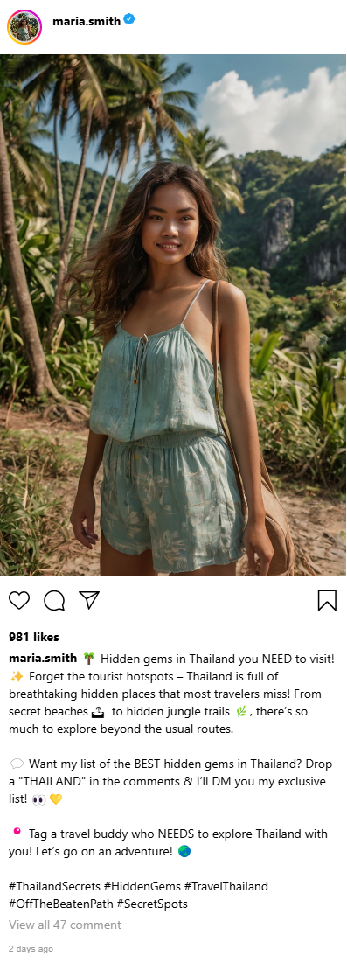 |  | 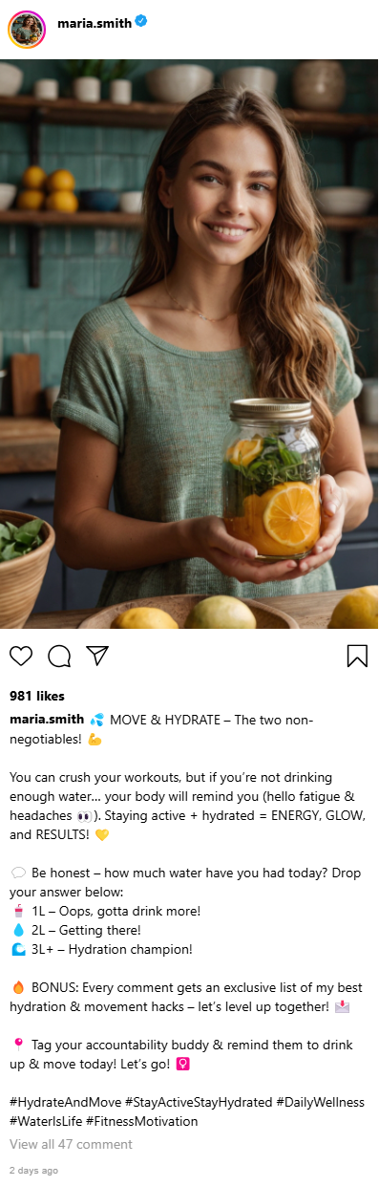

Pretest Measures
Factor | Items | Source
Engagement | (1) I would like the post.  (2) I would comment on the post.  (3) I would share the post. | adapted from (Swani & Labrecque, 2020)
all items were measured with a 5-point Likert scale
The three sample posts were tested for the likelihood of engagement (see Table Measures) using a 5-Likert scale. A total of 150 participants took part in the pretest (Mean Age = 39.793, SD = 13.796, 87/150 = 58% female), with almost the same number of participants per context (see the following Table). The results affirmed that the pretest participants regarded found the latter topic of lifestyle & fitness the most interesting (highest values in engagement—individually and combined). Even though the three context groups did not differ within the ANOVA with respect to likes (F = 1.340, p = .265), comments (F = .554, p = .576), shares (F = .062, p = .940), and engagement (F = .262, p = .770), we nevertheless decided on topic 3 for the following study due to the higher engagement values.
 | Travel M (SD) | Cooking M (SD) | Lifestyle/Fitness M (SD)
Engagement (likes) | 2.816 (1.364) | 2.500 (1.266) | 2.922 (1.398)
Engagement (comments) | 1.878 (.971) | 2.100 (1.147) | 2.078 (1.324)
Engagement (shares) | 1.898 (1.104) | 1.940 (1.058) | 1.980 (1.319)
Engagement (mean) | 2.197 (1.032) | 2.180 (1.061) | 2.327 (1.236)
n | 49 | 50 | 51

Stimuli
Stimuli attempt to manipulate age, perceived attractiveness, expertise, and trustworthiness. We chose not to use a full factorial design to increase statistical power. We created 12 different stimuli with the following characteristics, which varied as follows: 1) three different ages (young: 20-25 years, middle-aged: 40-45 years, older: 60-65 years). 2) manipulation of attractiveness (0: symmetrical face, 1: asymmetrical face = “LessAttractive”) using YouCamMakeup. 3) manipulation of expertise (0: casual clothing, 1: professional attire such as sports coaching gear = “MoreExperienced”) using Canva’s AI tools. The high expertise condition also included a bio descriptor such as "licensed fitness coach." 4) Manipulation of trustworthiness (0: presence of verification with a blue checkmark and no negative comment, 1: absence of verification and presence of a negative comment questioning credibility = “LowTrustworthiness”). To ensure consistency of presentation, captions were generated using ChatGPT, and all images were formatted as Instagram posts using Zeoob.com.

 | Control | Expertise high | Attractiveness low
20-30 years | 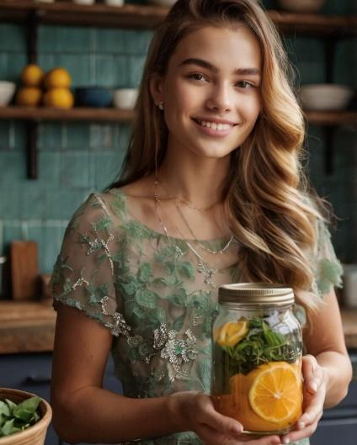 | 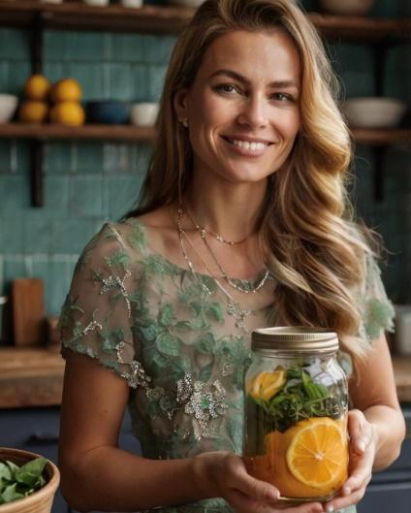 | 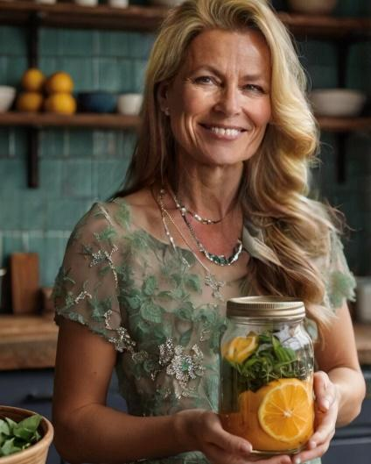
40-50 years | 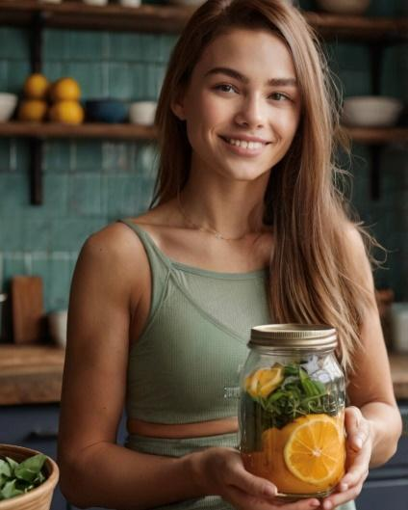 | 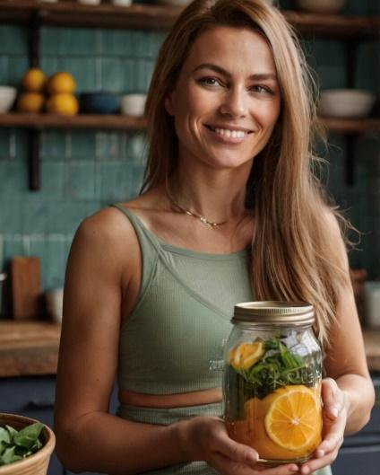 | 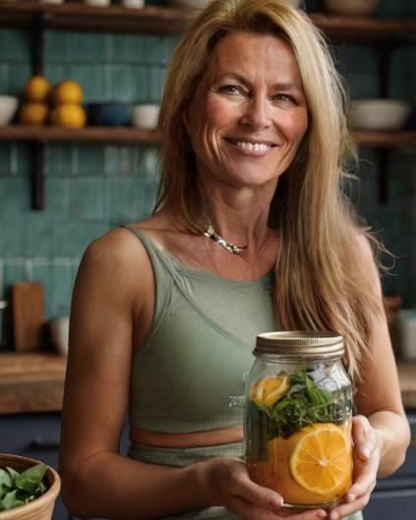
60-70 years | 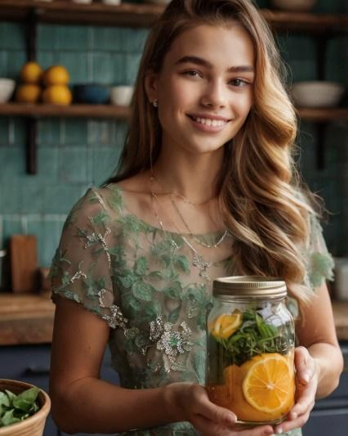 | 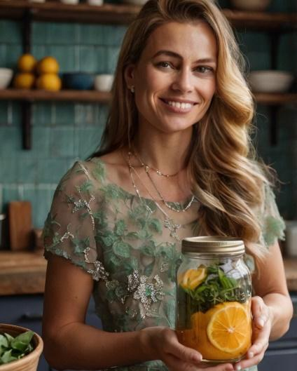 | 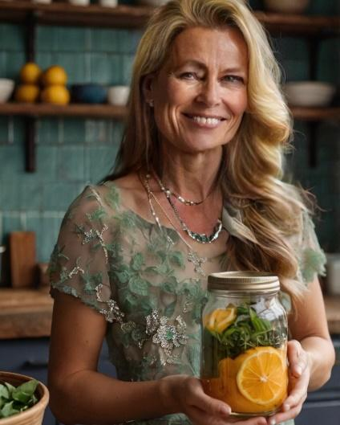

Caption (revised from pretest)
Control group, attractiveness low and trustworthiness low condition | Expertise high
💦 MOVE & HYDRATE – The two non-negotiables!  You can crush your workouts, but if you’re not drinking enough water… your body will remind you (hello fatigue & headaches 👀). Staying active + hydrated = ENERGY, GLOW, and RESULTS! 💛  💬 Be honest – how much water have you had today? Drop your answer below:  1L – Oops, gotta drink more!  2L – Getting there!  3L+ – Hydration champion!  🔥 BONUS: Every comment gets an exclusive list of my best hydration & movement hacks FOR FREE – let’s level up together! 📩  📍 Tag your accountability buddy & remind them to drink up & move today! Let’s go! 🚶‍♀️  #HydrateAndMove #StayActiveStayHydrated #DailyWellness #WaterIsLife #FitnessMotivation  low trustworthiness (additional negative comment):  ‘Funny how you’re promoting water intake now, but last week you were pushing energy drinks and detox teas. Feels like whatever pays the bills, right?’ | As a licensed FITNESS COACH, I advise you to💦 MOVE & HYDRATE  You can crush your workouts, but if you’re not drinking enough water… your body will remind you (hello fatigue & headaches 👀). Staying active + hydrated = ENERGY, GLOW, and RESULTS! 💛  💬 Be honest – how much water have you had today? Drop your answer below:  1L – Oops, gotta drink more!  2L – Getting there!  3L+ – Hydration champion!  🔥 BONUS: Every comment gets an exclusive list of my best hydration & movement hacks FOR FREE – let’s level up together! 📩  📍 Tag your accountability buddy & remind them to drink up & move today! Let’s go! 🚶‍♀️  #HydrateAndMove #StayActiveStayHydrated #DailyWellness #WaterIsLife #FitnessMotivation

Measures
Factor | Items | Source
Engagement | (1) I would like the post.  (2) I would comment on the post.  (3) I would share the post. | based on (Swani & Labrecque, 2020)
Attractiveness | (1) I consider the influencer very attractive.  (2) I consider the influencer very stylish.  (3) I think the influencer is good-looking.  (4) I think the influencer is sexy. | based on (Ohanian, 1990)
Expertise | (1) I feel the influencer knows a lot about the topic.  (2) I feel the influencer is competent to make assertions about the topic.  (3) I consider the influencer an expert on the topic.  (4) I consider the influencer sufficiently experienced to make assertions about the topic. | based on (Ohanian, 1990)
Trustworthiness | (1) I feel the influencer was honest.  (2) I consider the influencer trustworthy.  (3) I feel the influencer was truthful.  (4) I consider the influencer earnest. | based on (Ohanian, 1990)
Manipulation Check | Age: How old do you think this influencer is?  AI: Based on image and content, would you consider this influencer a real person?
all items were measured with a 5-point Likert scale

Participants, design, and procedure
Participants were recruited again on Prolific (initially total of 1376), after removing incomplete datasets (23), failed attention checks (47), and respondents below the benchmark response time (49), leaving 1265 valid datasets (Mean Age = 41.315, SD = 11.440, female: 55.18%). Participants were randomly assigned to one of the twelve conditions. After viewing the assigned stimulus, they were asked to rate their purchase intention for a reusable water bottle using four items, as well as their likelihood of engaging with the post (like, comment, share) using three items, all measured on 5-point Likert scales. To assess influencer characteristics, participants rated attractiveness, trustworthiness, and expertise using four items each. Additionally, the survey included an attention check and post-exposure questions about the perceived age and gender of the influencer, along with an open-ended field for respondents to explain why they found the influencer trustworthy or untrustworthy.

WA7-2: Variables and operationalization
Variable | Units | Type | Alpha | AVE | CR
Engagement | factor | DV | 0.84 | 0.6361 | 0.839
Attractiveness | factor | Mediator | 0.87 | 0.6366 | 0.874
Expertise | factor | Mediator component | 0.93 | 0.7811 | 0.934
Trustworthiness | factor | Mediator component | 0.95 | 0.8351 | 0.953
Credibility | factor | Mediator | 0.95 | 0.699 | 0.932
Influencer Age | decades | IV (measured) | 0 | 0 | 0
Consumer Age | decades | Control | 0 | 0 | 0
Consumer is Female | dummy | Control | 0 | 0 | 0
Absolute age difference | decades | Control | 0 | 0 | 0

WA7-3: Descriptives and correlations
 | Mean | SD | Min | Max | 1 | 2 | 3 | 4 | 5 | 6 | 7 | 8 | 9
Engagement | 2.07 | 0.96 | 1.00 | 5.00 | 1 | . | . | . | . | . | . | . | .
Attractiveness | 3.55 | 0.79 | 1.00 | 5.00 | .30 | 1 | . | . | . | . | . | . | .
Expertise | 2.92 | 0.96 | 1.00 | 5.00 | .56 | .38 | 1 | . | . | . | . | . | .
Trustworthiness | 3.12 | 0.95 | 1.00 | 5.00 | .57 | .42 | .75 | 1 | . | . | . | . | .
Credibility | 3.02 | 0.89 | 1.00 | 5.00 | .60 | .43 | .94 | .93 | 1 | . | . | . | .
Influencer_age | 3.74 | 1.31 | 1.50 | 7.00 | .01 | -.23 | .10 | .05 | .08 | 1 | . | . | .
Consumer_age | 4.13 | 1.15 | 1.80 | 7.70 | .09 | .14 | .09 | .17 | .14 | .06 | 1 | . | .
Consumer_is_female | 0.56 | 0.50 | 0.00 | 1.00 | .06 | .03 | .08 | .10 | .10 | -.00 | -.01 | 1 | .
Age_difference | 1.38 | 1.04 | 0.00 | 5.20 | -.03 | -.06 | -.05 | -.01 | -.03 | -.02 | .43 | .04 | 1

WA7-4: Manipulation check models
 | Check 1 | Check 2 | Check 3 | Check 4
Dependent variable: | Influencer Age | Credibility Factor | Attractiveness Factor | Consumer Age
Manipulated variable: | Age (3 levels) | More Experienced + Less Trustworthy | Less Attractive | Age bracket (2 levels)
Age = 20 | 2.467 ***
 | (0.038)
Age = 40 | 3.364 ***
 | (0.038)
Age = 60 | 5.304 ***
 | (0.038)
More Experienced | -0.147 *** | 0.191 ***
 | (0.044) | (0.055)
Less Trustworthy | 0.081 | -0.294 ***
 | (0.043) | (0.055)
Less Attractive | 0.109 * |  | -0.329 ***
 | (0.043) |  | (0.054)
Constant |  | 0.028 | 0.083 ** | 4.103 ***
 |  | (0.032) | (0.027) | (0.047)
Older Group |  |  |  | 0.049
 |  |  |  | (0.066)
N | 1204 | 1204 | 1204 | 1204
R² | 0.982 | 0.047 | 0.030 | 0.000
AIC | 1909.582 | 2824.654 | 2919.235 | 3760.322
F | 10908.632 | 29.828 | 37.237 | 0.547
p | 0.000 | 0.000 | 0.000 | 0.460
*** p < 0.001; ** p < 0.01; * p < 0.05.

WA7-5: Main Models Table
 | DV: Engagement
 | Quadratic Model | GAM
Constant | -0.713 ** | 0.000
 | (0.270) | (0.025)
InfluencerAge | 0.396 ** | edf=2.500
 | (0.145) | (F=2.463)
InfluencerAge² | -0.049 **
 | (0.018)
ControlFunction | 0.038 | edf=4.091**
 | (0.051) | (F=3.508)
N | 1204 | 1204
R² | 0.006 | 0.019
AIC | 3055.904 | 3043.208
Optimal InfluencerAge (decades) | 4.050  (CI=[3.670, 4.420]) | 3.870  (CI=[3.080, 4.640])
*** p < 0.001; ** p < 0.01; * p < 0.05; GAM smooth terms represent estimated df (linear: edf=1), with F-test for explained variance.

WA7-6: Figure Predicted Engagement, Credibility, Attractiveness
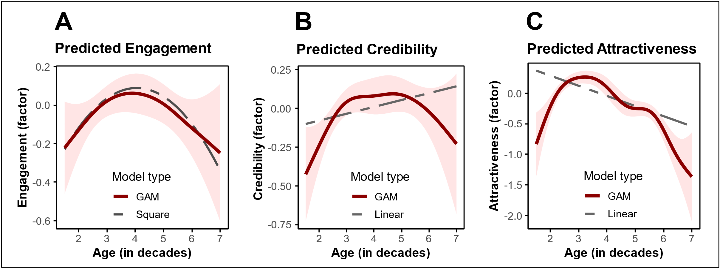

WA7-7: H2 H3 Models Table
 | DV: Credibility |  | DV: Attractiveness
 | Linear Model | GAM | Linear Model | GAM
Constant | -0.165 * | 0.000 | 0.618 *** | 0.000
 | (0.076) | (0.023) | (0.076) | (0.022)
InfluencerAge | 0.044 * | edf=3.155** | -0.165 *** | edf=5.290***
 | (0.019) | (F=4.377) | (0.019) | (F=23.357)
ControlFunction | -0.041 | edf=3.709 | 0.081 | edf=3.486*
 | (0.047) | (F=1.695) | (0.047) | (F=2.901)
N | 1204 | 1204 | 1204 | 1204
R² | 0.004 | 0.022 | 0.060 | 0.118
AIC | 2877.735 | 2862.566 | 2883.068 | 2814.073
*** p < 0.001; ** p < 0.01; * p < 0.05; GAM smooth terms represent estimated df (linear: edf=1), with F-test for explained variance.

WA7-8: H4 Models Table
 | DV: Engagement
 | Linear Interaction | GAM Interaction
Constant | -0.032 | -0.000
 | (0.022) | (0.020)
Credibility | 0.380 ** | edf=2.383
 | (0.120) | (F=1.883)
Attractiveness | 0.077 | edf=1.000
 | (0.146) | (F=0.019)
Credibility × Attractiveness | 0.120 *** | edf=2.867
 | (0.026) | (F=2.338)
CF: Credibility | 0.206 | edf=4.318
 | (0.123) | (F=2.163)
CF: Attractiveness | -0.007 | edf=1.001
 | (0.147) | (F=0.003)
N | 1204 | 1204
R² | 0.311 | 0.327
AIC | 2619.414 | 2598.585
*** p < 0.001; ** p < 0.01; * p < 0.05; GAM smooth terms represent estimated df (linear: edf=1), with F-test for explained variance.

WA7-9: Mediations Tests Table
 | DV: Engagement
Mediator | Credibility | Attractiveness | Method
Bootstrapped a×b - Linear | 0.026  [0.004, 0.047] | -0.011  [-0.023, 0] | Bootstrapped mediation test
Bootstrapped a×b - GAM | 0.143  [0.052, 0.359] | 0.111  [-0.985, 0.993] | (MacKinnon et al., 2002; Preacher & Hayes, 2008)
MMM: - Linear | MoreExp:Ranges of sig. contrasts: none  LessTru:neg.(-) in: [2.33 to 3.94] | LessAtt:Ranges of sig. contrasts: none | Manipulation of mediation as a moderator
MMM - GAM | MoreExp:pos.(+) in: [2.17 to 2.33]  LessTru:neg.(-) in: [2.28 to 4.56] | LessAtt:Ranges of sig. contrasts: none | (Ge, 2023) with nonlinear test from (Simonsohn, 2024)
Conclusion | expected directions, most confirm. | Only mediation confirms.

WA7-10: Cpath Table
 | DV: Engagement
 | Linear Model | GAM
Constant | 0.021 | 0.000
 | (0.072) | (0.020)
Credibility | 0.579 *** | edf=6.468***
 | (0.029) | (F=4.578)
Attractiveness | 0.067 * | edf=6.622
 | (0.030) | (F=1.797)
Credibility × Attractiveness | 0.116 *** | edf=3.254
 | (0.026) | (F=0.550)
InfluencerAge | -0.014 | edf=1.575
 | (0.018) | (F=1.006)
ControlFunction | 0.037 | edf=7.131**
 | (0.043) | (F=2.969)
N | 1204 | 1204
R² | 0.310 | 0.344
AIC | 2621.333 | 2575.604
*** p < 0.001; ** p < 0.01; * p < 0.05; GAM smooth terms represent estimated df (linear: edf=1), with F-test for explained variance.

WA7-11: Interaction Table
 |  | Test Changes in Curve |  |  |  | Explore Mechanism
Moderator | DV | Significant Contrasts | Optimal Age Change | Optimal DV Change |  | Credibility Shift (H5a) | Credibility Slope (H6a) | Attractiveness Shift (H5b) | Attractiveness Slope (H6b)
More Experienced | Engagement  Factor | Ranges of sig. contrasts: none | -1.215  CI=[-2.708, -0.303] | 0.078  CI=[-0.097, 0.251] |  | 0.418 *  (SE= 0.175) | -0.088  (SE= 0.046) | 0.111  (SE= 0.178) | -0.046  (SE= 0.046)
Less Trustworthy | Engagement  Factor | neg.(-) in:  [2.33 to 3.94] | 1.11  CI=[-0.96, 3.131] | -0.157  CI=[-0.366, 0.055] |  | -0.453 **  (SE= 0.159) | 0.014  (SE= 0.038) | -0.042  (SE= 0.161) | -0.022  (SE= 0.039)
Less Attractive | Engagement  Factor | Ranges of sig. contrasts: none | 0.146  CI=[-1.268, 1.768] | -0.02  CI=[-0.217, 0.181] |  | -0.544 ***  (SE= 0.157) | 0.089 *  (SE= 0.038) | -0.686 ***  (SE= 0.160) | 0.084 *  (SE= 0.038)
Notes: *** p < 0.001; ** p < 0.01; * p < 0.05; CI are 95% confidence intervals; GAM smooth terms represent estimated df (linear: edf=1), with F-test for explained variance.

GAM
 |  | Test Changes in Curve |  |  |  | Explore Mechanism
Moderator | DV | Significant Contrasts | Optimal Age Change | Optimal DV Change |  | Credibility Shift (H5a) | Credibility Slope (H6a) | Attractiveness Shift (H5b) | Attractiveness Slope (H6b)
More Experienced | Engagement Factor | pos.(+) in:  [2.17 to 2.33] | -1.231  CI=[-3.386, 0.859] | 0.056  CI=[-0.155, 0.267] |  | 0.059  (0.065) | edf=2.08  (F=1.15) | -0.134  (0.069) | edf=7.38***  (F=5.48)
Less Trustworthy | Engagement Factor | neg.(-) in:  [2.28 to 4.56] | 0.605  CI=[-1.422, 3.333] | -0.132  CI=[-0.322, 0.084] |  | -0.399***  (0.063) | edf=1  (F=3.37) | -0.116  (0.063) | edf=5.58***  (F=7.31)
Less Attractive | Engagement Factor | Ranges of sig. contrasts: none | -0.286  CI=[-3.131, 2.172] | -0.016  CI=[-0.316, 0.333] |  | -0.202**  (0.063) | edf=2.44**  (F=5.05) | -0.357***  (0.063) | edf=3.88***  (F=6.66)
Notes: *** p < 0.001; ** p < 0.01; * p < 0.05; CI are 95% confidence intervals; GAM smooth terms represent estimated df (linear: edf=1), with F-test for explained variance.

Figure Interaction Linear Model A-D) More Experienced, D-F) Less Trustworthy, G-I) Less Attractive
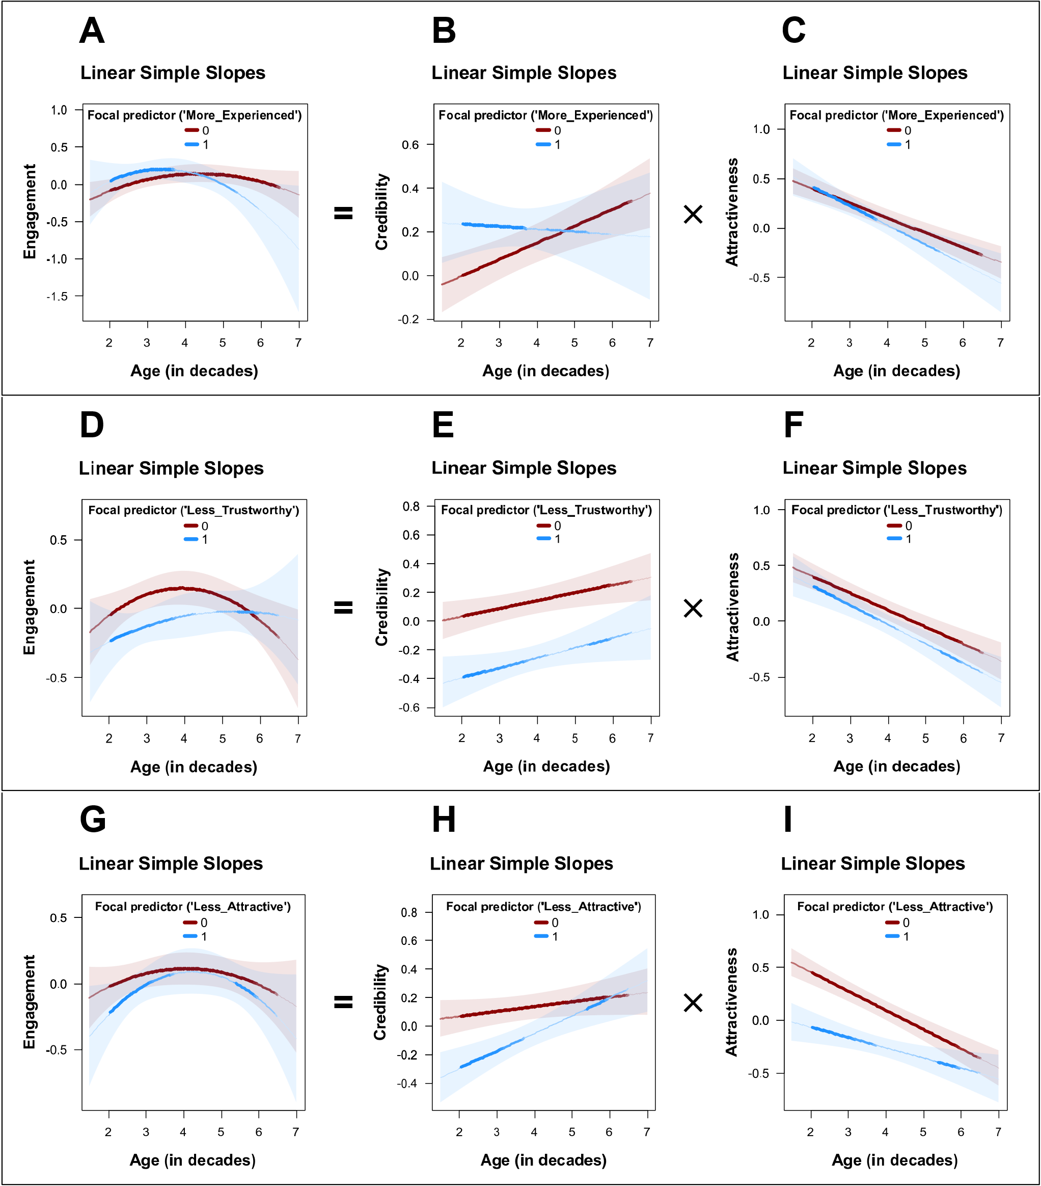

Figure Interaction GAM A-C) More Experienced, D-F) Less Trustworthy, G-I) Less Attractive
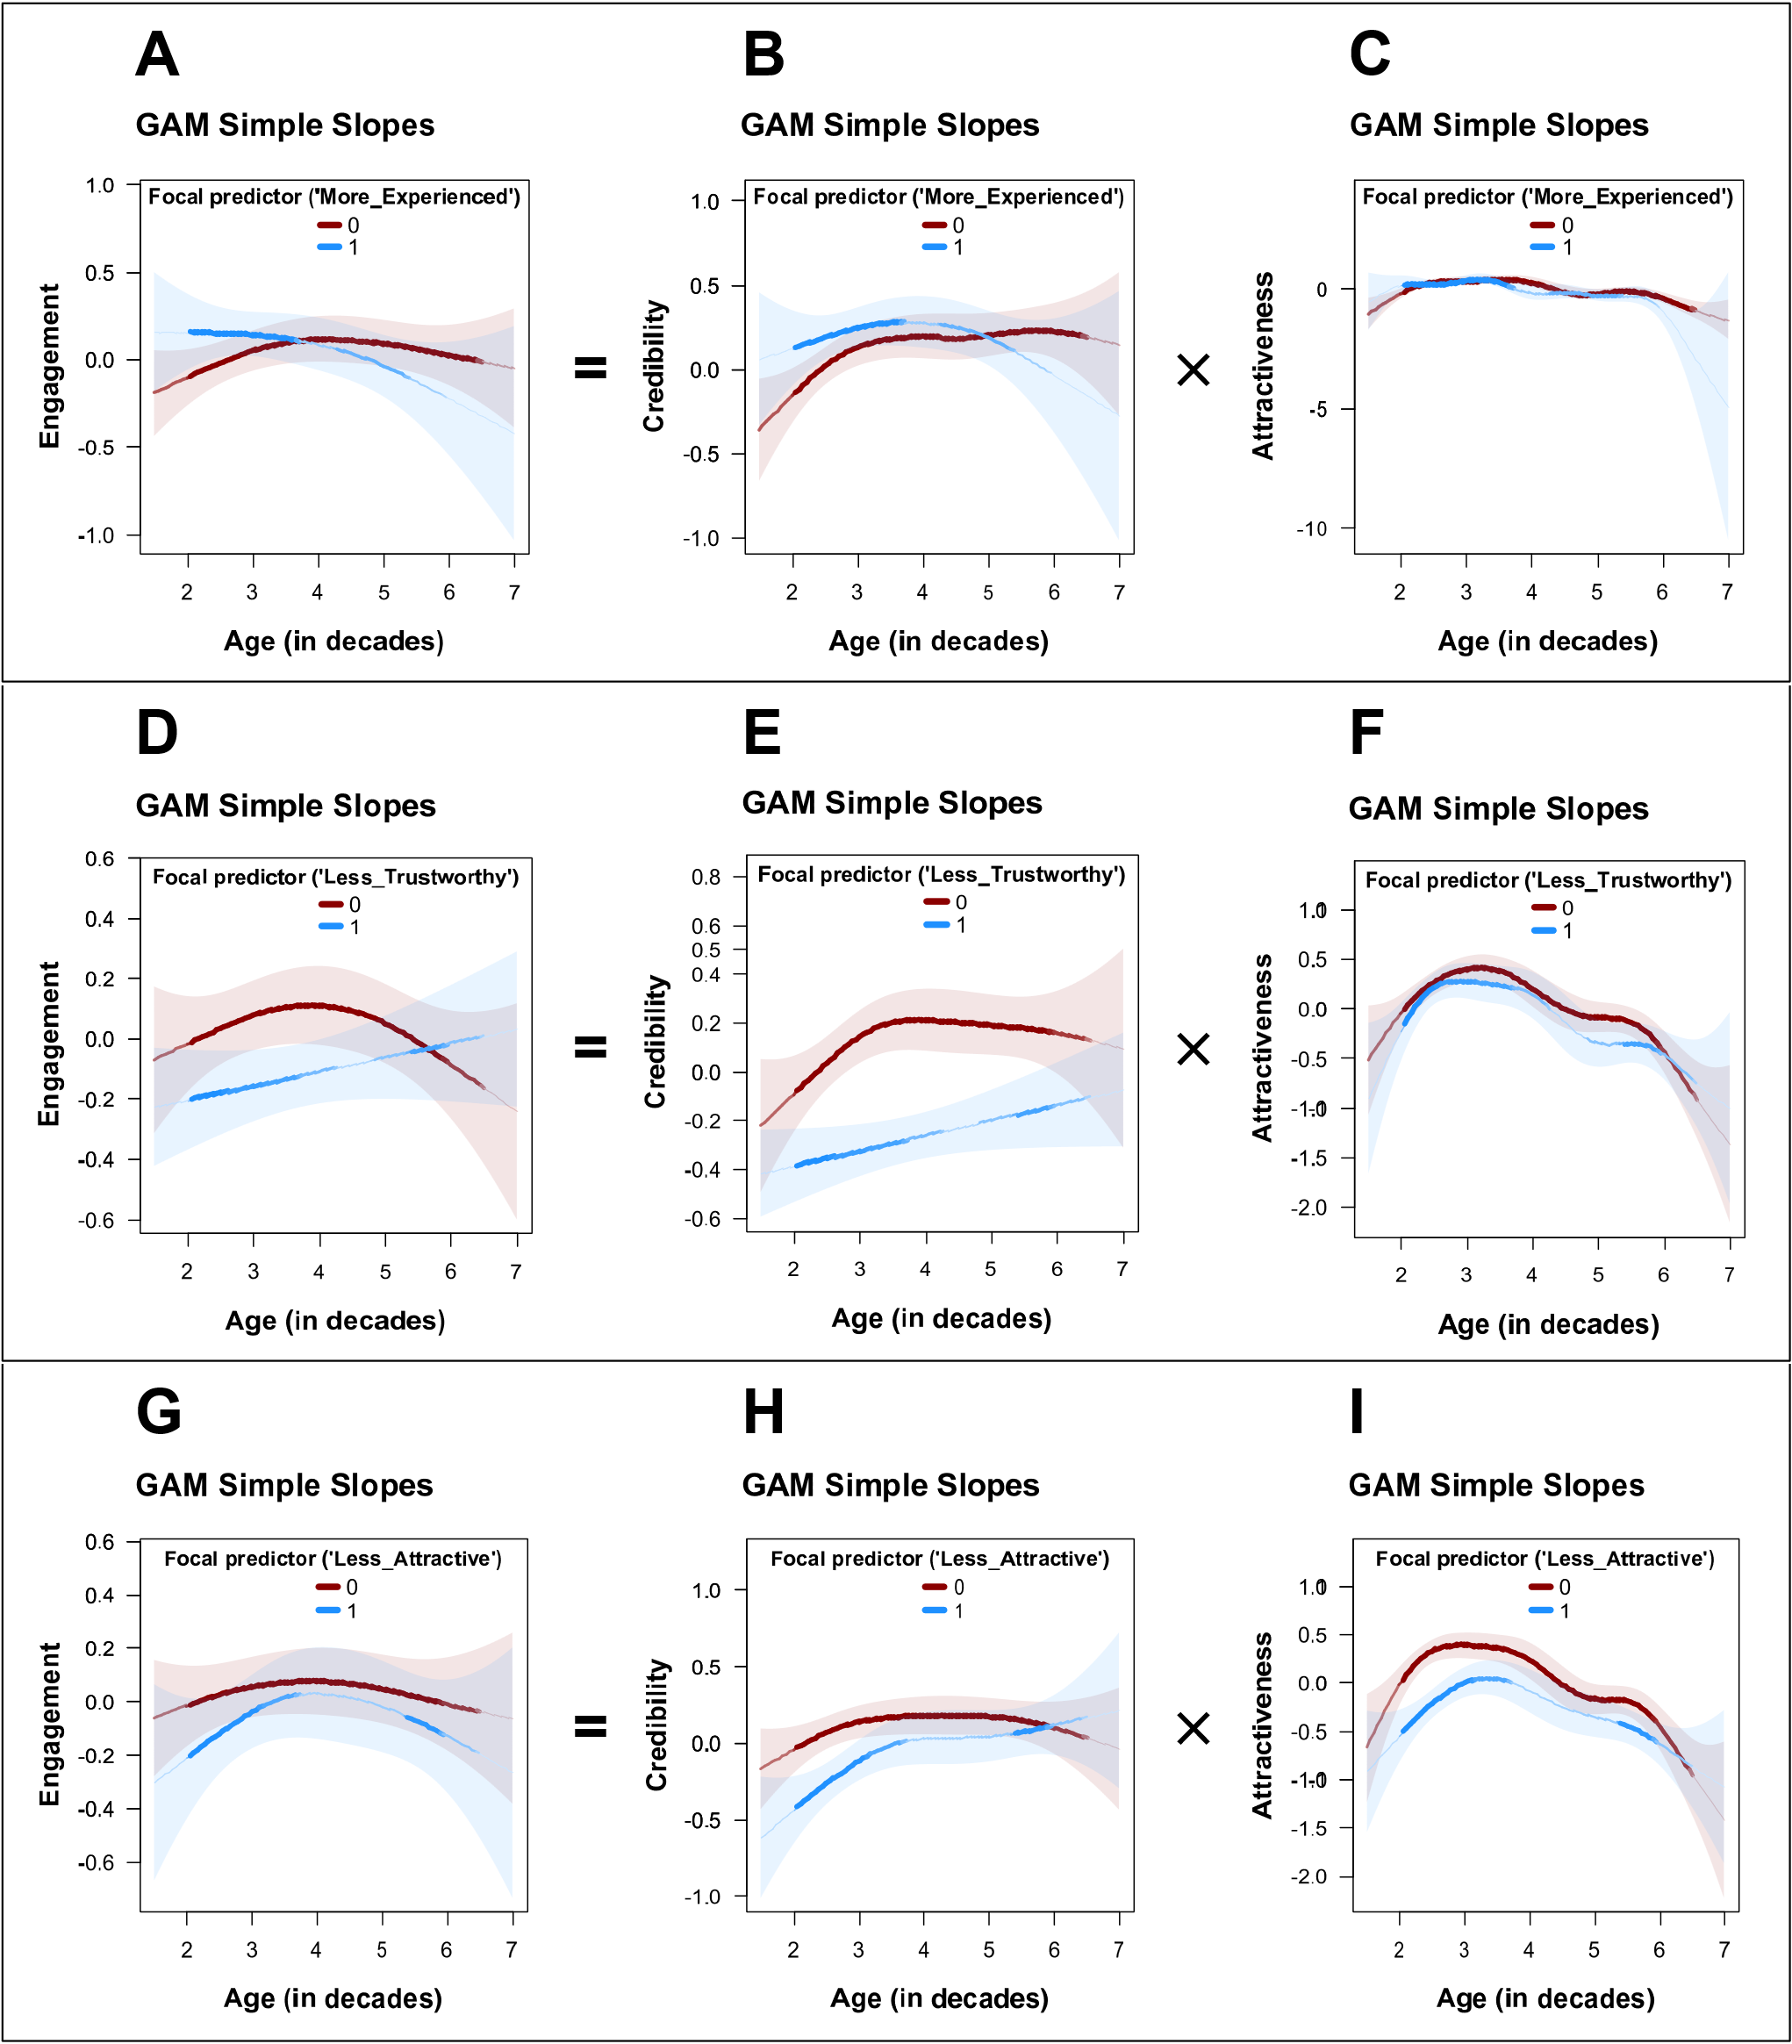

Web Appendix 8: Study 3c

WA8-1: Design
Stimuli
For this study, we created 40 different stimuli with the following characteristics, which differed as follows: 1) five different ages (20-25 years, 25-30 years, 30-40 years, 40-50 years, 50-60 years), 2) manipulation of attractiveness (0: asymmetrical face, 1: symmetrical face), 3) manipulation of expertise (0: no glasses, 1: glasses), 4) manipulation of trustworthiness (0: no smiling, 1: smiling with eyes - Duchenne smile (Olszanowski et al., 2019)). Here, too, we used the same fictitious influencer persona, Maria Smith. We randomly assigned each participant to one profile.
In contrast to the previous two experimental studies, we have only included the influencer's post here (without the profile description), as the focus here should not be on AI generation. Various tools were used to create the stimuli. These include Leonardo.ai for creating the influencers, FaceApp for rejuvenation and aging of them, ChatGPT for generating the caption, Zeoob.com for creating the posts and Canva for putting the two parts of the stimuli together.

Caption
💧 I never knew water could make such a difference! 💧
I used to just grab any bottled water, but let’s be real – most of them do nothing for you. Then I found Neutral Water and WOW... 🚀 It’s packed with essential nutrients & minerals that actually help me stay energized, balanced & refreshed all day long. 🌿✨
Most waters just quench thirst. This one fuels your body. 💙
⚡ Why I’m obsessed with Neutral Water:
✅ Naturally enriched with vital minerals 🌍
✅ No artificial flavors, no nonsense 🚫
✅ Ultra-pure & scientifically optimized for hydration 🔬
💬 Who else is upgrading their hydration? Drop a 💧 in the comments & tag a friend who NEEDS to try this!
#HydrationHack #NextLevelWater #StayBalanced #DrinkBetter #PurePerformance #HydrateLikeAPro

 | 20-25 years | 25-30 years | 30-40 years | 40-50 years | 50-60 years
A: high  E: low  T: low | 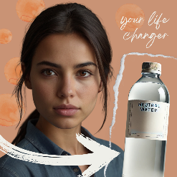 | 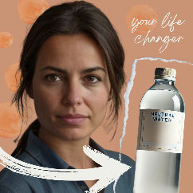 | 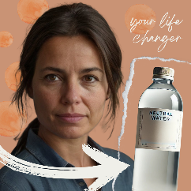 | 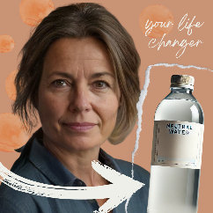 | 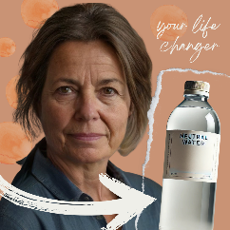
A: high  E: high  T: low | 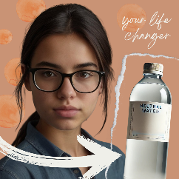 | 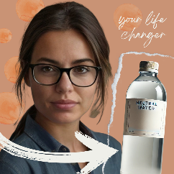 | 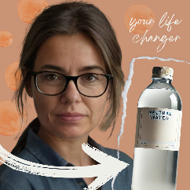 | 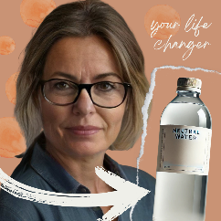 | 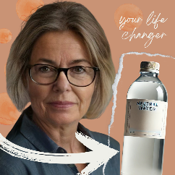
A: high  E: high  T: high | 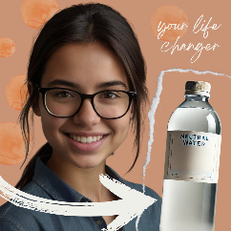 | 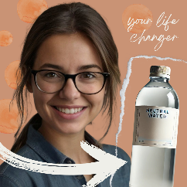 | 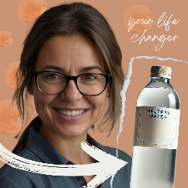 | 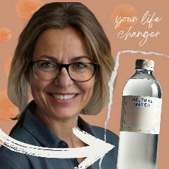 | 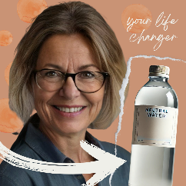
A: high  E: low  T: high | 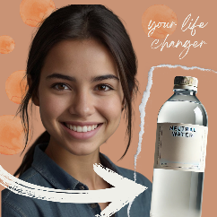 | 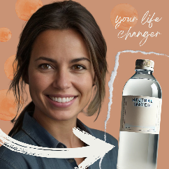 | 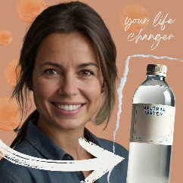 | 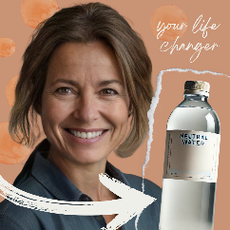 | 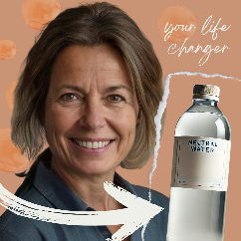
A: low  E: high  T: low | 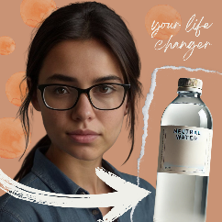 | 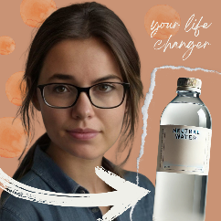 | 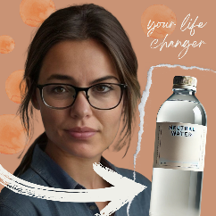 | 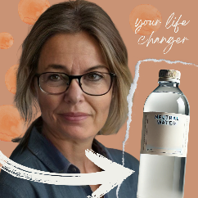 | 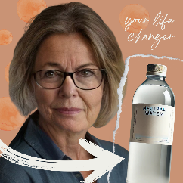
A: low  E: high  T: high | 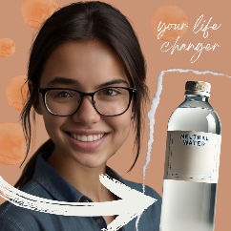 | 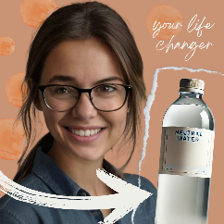 | 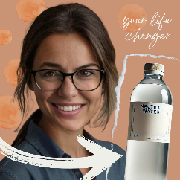 | 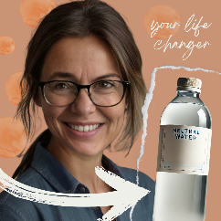 | 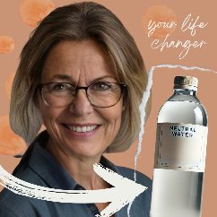
A: low  E: low  T: low | 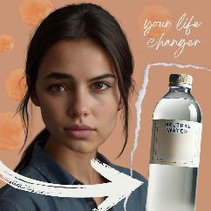 | 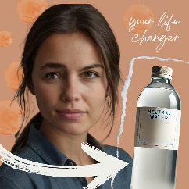 | 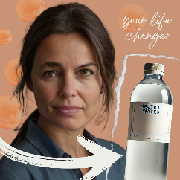 | 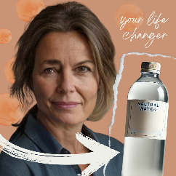 | 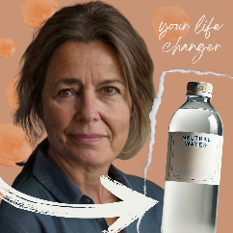
A: low  E: low  T: high | 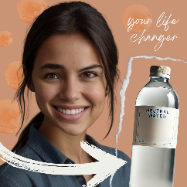 | 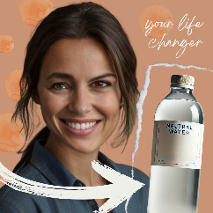 | 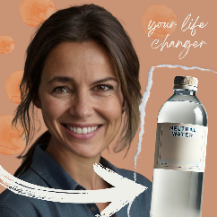 | 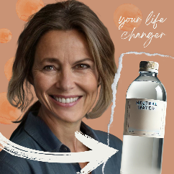 | 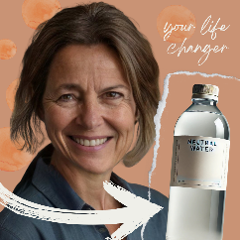
A = Attractiveness, E = Expertise, T = Trustworthiness

Measures
Factor | Items | Source
Purchase Intention | (1) It is very likely that I will buy this product  (2) I will purchase this product the next time I need this  (3) I will definitely try this product  (4) Suppose a friend called you last night to seek your advice on this product. Would you recommend that they buy this product? | based on (Putrevu & Lord, 1994)
Engagement | (1) I would like the post.  (2) I would comment on the post.  (3) I would share the post. | based on (Swani & Labrecque, 2020)
Attractiveness | (1) I consider the influencer very attractive.  (2) I consider the influencer very stylish.  (3) I think the influencer is good-looking.  (4) I think the influencer is sexy. | based on (Ohanian, 1990)
Expertise | (1) I feel the influencer knows a lot about the product.  (2) I feel the influencer is competent to make assertions about the product.  (3) I consider the influencer an expert on the product.  (4) I consider the influencer sufficiently experienced to make assertions about the product. | based on (Ohanian, 1990)
Trustworthiness | (1) I feel the influencer was honest.  (2) I consider the influencer trustworthy.  (3) I feel the influencer was truthful.  (4) I consider the influencer earnest. | based on (Ohanian, 1990)
Manipulation Check | Age: How old do you think this influencer is?  Gender: What gender would you assign to the influencer?  Attractiveness: Would you say that this influencer has a symmetrical face?  Expertise: Did you notice the glasses on the influencer?  Trustworthiness: Did you find the influencer's smile honest and authentic?
all items were measured with a 5-point Likert scale

Participants, design, and procedure
In our preregistration (AsPredicted #205,257; 12/19/2024) we planned with 1,200 original participants to get at least 25 data sets per condition after data cleaning (because of incomplete data sets, data sets below benchmark time). After data cleaning, which involved the removal of incomplete responses and cases failing the pre-registered attention check, 1,127 participants were included in the final analysis. The sample consisted of 57.2% female respondents, with an age range of 18 to 84 years (M = 38.0, SD = 13.2). Participants were recruited via Prolific in February 2025 and were prescreened to ensure a balanced age distribution (approximately half below 35 years and half 35 years or older). The study employed a 5 (influencer age: 20–25, 25–30, 30–40, 40–50, 50–60 years) × 2 (attractiveness: high vs. low) × 2 (expertise: high vs. low) between-subjects design, using the fixed fictitious influencer identity “Maria Smith” in all conditions. Each participant was randomly assigned to one condition and shown a single Instagram post in which the influencer endorsed a bottled water product (Neutral Water) with a standardized caption. Following stimulus exposure, participants reported their purchase intention and engagement intention, as well as ratings of the influencer’s perceived attractiveness, expertise, and trustworthiness, all measured on 5-point Likert scales.

WA8-2: Variables and operationalization
Variable | Units | Type | Alpha | AVE | CR
Engagement | factor | DV | 0.85 | 0.6569 | 0.851
Purchase Intention | factor | DV | 0.93 | 0.7803 | 0.932
Intention | factor | DV | 0.93 | 0.6816 | 0.918
Attractiveness | factor | Mediator | 0.89 | 0.6714 | 0.886
Expertise | factor | Mediator component | 0.92 | 0.7574 | 0.926
Trustworthiness | factor | Mediator component | 0.96 | 0.8434 | 0.956
Credibility | factor | Mediator | 0.95 | 0.6788 | 0.913
Influencer Age | decades | IV (measured) | 0 | 0 | 0
Consumer Age | decades | Control | 0 | 0 | 0
Consumer is Female | dummy | Control | 0 | 0 | 0

WA8-3: Descriptives and correlations
 | Mean | SD | Min | Max | 1 | 2 | 3 | 4 | 5 | 6 | 7 | 8 | 9 | 10
Engagement | 1.71 | 0.83 | 1.00 | 5.00 | 1 | . | . | . | . | . | . | . | . | .
Purchase_intention | 2.02 | 1.00 | 1.00 | 5.00 | .75 | 1 | . | . | . | . | . | . | . | .
Intention | 1.88 | 0.87 | 1.00 | 5.00 | .90 | .96 | 1 | . | . | . | . | . | . | .
Attractiveness | 3.06 | 0.86 | 1.00 | 5.00 | .25 | .27 | .28 | 1 | . | . | . | . | . | .
Expertise | 2.29 | 0.97 | 1.00 | 5.00 | .62 | .66 | .69 | .25 | 1 | . | . | . | . | .
Trustworthiness | 2.48 | 0.96 | 1.00 | 5.00 | .62 | .67 | .69 | .33 | .74 | 1 | . | . | . | .
Credibility | 2.39 | 0.90 | 1.00 | 5.00 | .67 | .72 | .74 | .31 | .93 | .93 | 1 | . | . | .
Influencer_age | 3.93 | 1.34 | 1.40 | 7.40 | .04 | .05 | .05 | -.32 | .06 | .05 | .06 | 1 | . | .
Consumer_age | 3.82 | 1.34 | 1.80 | 8.40 | .12 | .01 | .05 | .16 | .04 | .16 | .11 | -.05 | 1 | .
Consumer_is_female | 0.57 | 0.49 | 0.00 | 1.00 | .04 | .02 | .03 | .01 | .06 | .10 | .09 | .03 | .04 | 1

WA8-4: Manipulation check models
 | Check 1 | Check 2 | Check 3
Dependent variable: | Influencer Age | Credibility Factor | Attractiveness Factor
Manipulated variable: | Age (5 levels) | More Experienced + More Trustworthy | Less Attractive
Age = 20 | 2.630 ***
 | (0.051)
Age = 30 | 3.147 ***
 | (0.052)
Age = 35 | 3.807 ***
 | (0.051)
Age = 45 | 5.090 ***
 | (0.051)
Age = 55 | 5.796 ***
 | (0.052)
More Experienced | -0.050 | 0.084
 | (0.036) | (0.047)
More Trustworthy | -0.219 *** | -0.051
 | (0.036) | (0.047)
Less Attractive | -0.070 |  | -0.191 ***
 | (0.036) |  | (0.052)
Constant |  | -0.016 | 0.094 **
 |  | (0.041) | (0.036)
N | 1127 | 1127 | 1127
R² | 0.978 | 0.004 | 0.012
AIC | 2101.417 | 2659.587 | 2882.676
F | 6356.426 | 2.181 | 13.641
p | 0.000 | 0.113 | 0.000
*** p < 0.001; ** p < 0.01; * p < 0.05.

WA8-5: Main Models Table
 | DV: Engagement
 | Quadratic Model | GAM
Constant | -0.347 | -0.000
 | (0.249) | (0.024)
InfluencerAge | 0.158 | edf=3.396
 | (0.129) | (F=2.212)
InfluencerAge² | -0.016
 | (0.015)
ControlFunction | 0.013 | edf=3.374
 | (0.046) | (F=1.800)
N | 1127 | 1127
R² | 0.003 | 0.015
AIC | 2738.013 | 2728.263
Optimal InfluencerAge (decades) | 4.900  (CI=[3.240, 7.000]) | 4.010  (CI=[3.190, 7.000])
*** p < 0.001; ** p < 0.01; * p < 0.05; GAM smooth terms represent estimated df (linear: edf=1), with F-test for explained variance.

WA8-6: Figure Predicted Engagement, Credibility, Attractiveness
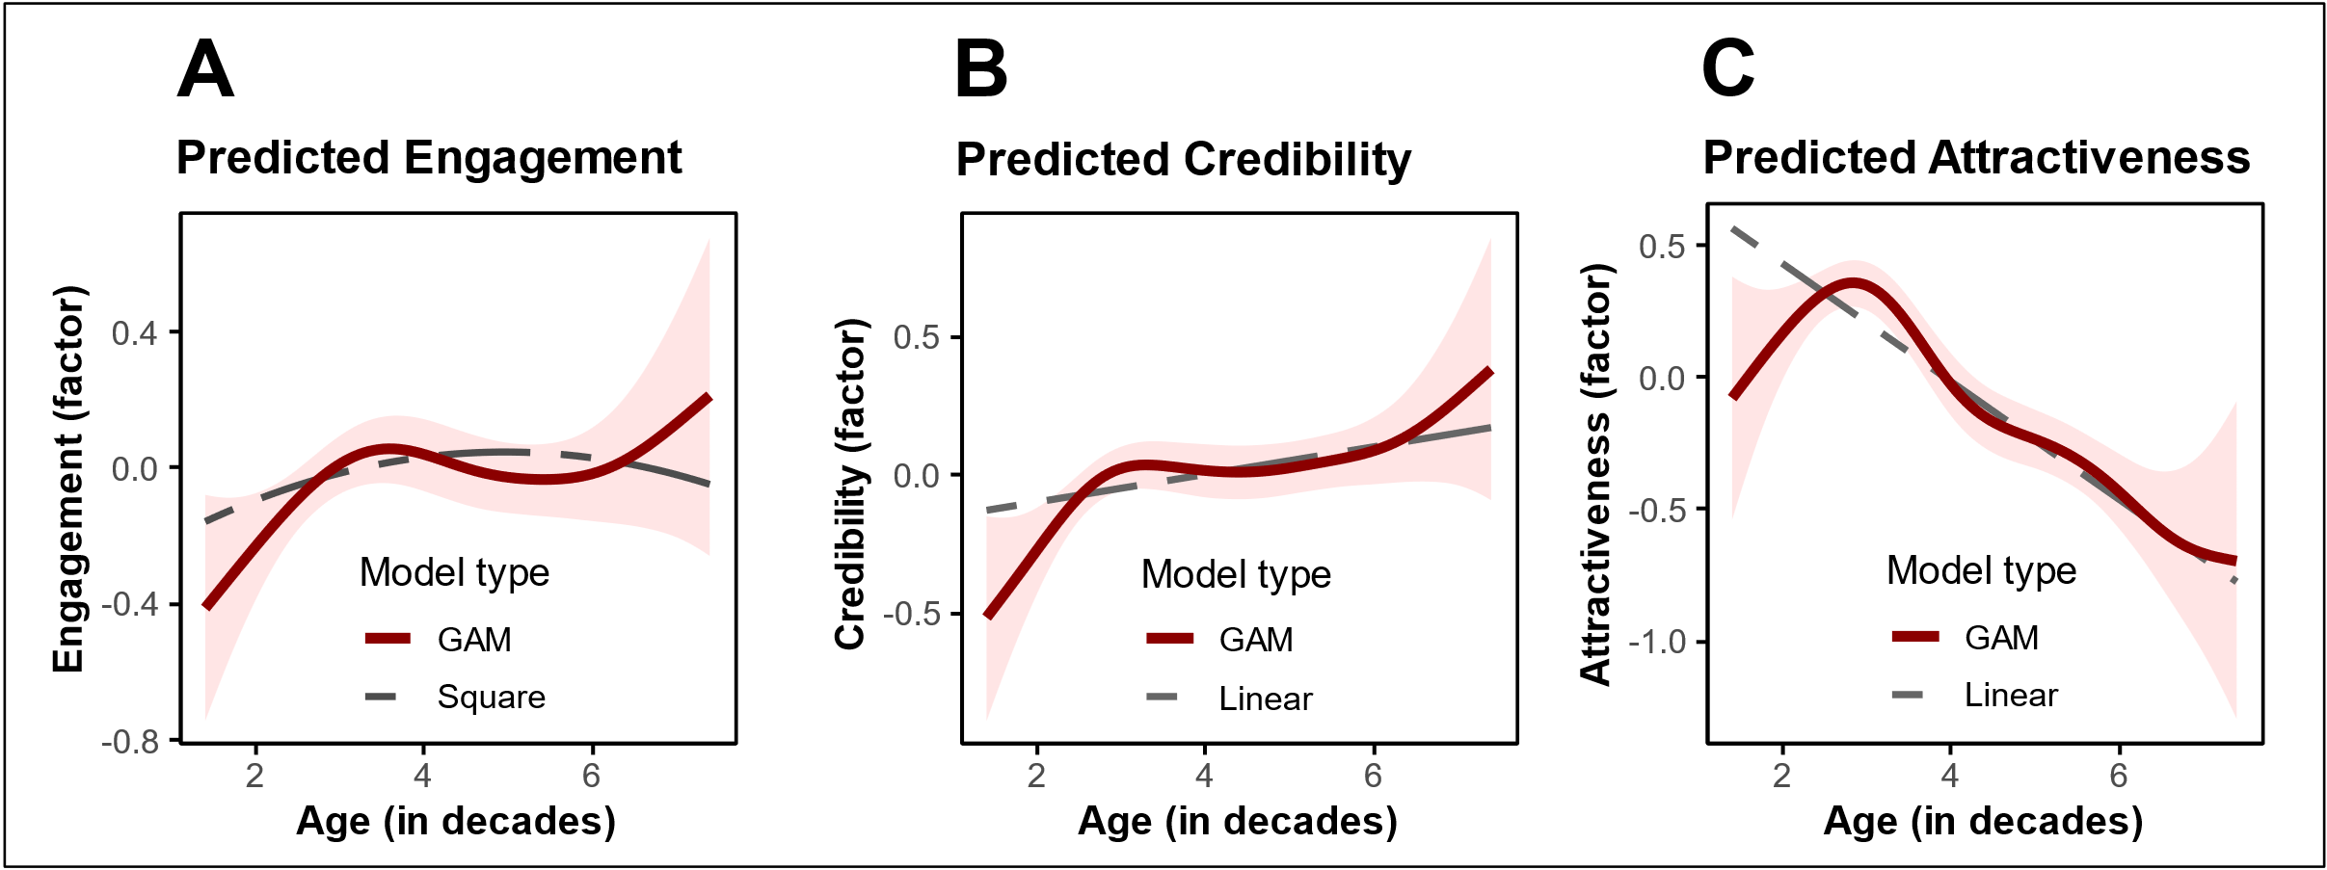

WA8-7: H2 H3 Models Table
 | DV: Credibility |  | DV: Attractiveness
 | Linear Model | GAM | Linear Model | GAM
Constant | -0.195 * | 0.000 | 0.879 *** | -0.000
 | (0.081) | (0.023) | (0.085) | (0.024)
InfluencerAge | 0.050 * | edf=4.099* | -0.223 *** | edf=4.922***
 | (0.020) | (F=2.870) | (0.021) | (F=20.803)
ControlFunction | -0.079 | edf=1.000* | 0.012 | edf=2.059
 | (0.043) | (F=4.513) | (0.045) | (F=1.059)
N | 1127 | 1127 | 1127 | 1127
R² | 0.006 | 0.011 | 0.115 | 0.130
AIC | 2656.989 | 2652.225 | 2760.884 | 2744.363
*** p < 0.001; ** p < 0.01; * p < 0.05; GAM smooth terms represent estimated df (linear: edf=1), with F-test for explained variance.

WA8-8: H4 Models Table
 | DV: Engagement
 | Linear Interaction | GAM Interaction
Constant | -0.035 | 0.000
 | (0.019) | (0.018)
Credibility | 1.800 *** | edf=6.502***
 | (0.166) | (F=18.741)
Attractiveness | -0.039 | edf=1.465
 | (0.192) | (F=0.403)
Credibility × Attractiveness | 0.161 *** | edf=1.623
 | (0.024) | (F=1.265)
CF: Credibility | -1.032 *** | edf=3.881***
 | (0.141) | (F=10.698)
CF: Attractiveness | 0.102 | edf=1.000
 | (0.193) | (F=1.181)
N | 1127 | 1127
R² | 0.432 | 0.472
AIC | 2108.545 | 2029.892
*** p < 0.001; ** p < 0.01; * p < 0.05; GAM smooth terms represent estimated df (linear: edf=1), with F-test for explained variance.

WA8-9: Cpath Table
 | DV: Engagement
 | Linear Model | GAM
Constant | -0.079 | 0.000
 | (0.069) | (0.018)
Credibility | 0.598 *** | edf=6.058***
 | (0.026) | (F=74.036)
Attractiveness | 0.067 ** | edf=1.801*
 | (0.025) | (F=3.122)
Credibility × Attractiveness | 0.169 *** | edf=1.000*
 | (0.025) | (F=4.897)
InfluencerAge | 0.011 | edf=3.062
 | (0.017) | (F=1.338)
ControlFunction | 0.048 | edf=3.578**
 | (0.035) | (F=3.315)
N | 1127 | 1127
R² | 0.406 | 0.455
AIC | 2157.758 | 2066.130
*** p < 0.001; ** p < 0.01; * p < 0.05; GAM smooth terms represent estimated df (linear: edf=1), with F-test for explained variance.

WA8-10: Mediations Tests Table
 | DV: Engagement
Mediator | Credibility | Attractiveness |  | Method
Bootstrapped a×b - Linear | 0.03 [0.006, 0.054] | -0.015 [-0.026, -0.004] |  | Bootstrapped mediation test
Bootstrapped a×b - GAM | 0.125 [-0.531, 0.317] | 0.024 [-0.002, 0.714] |  | (MacKinnon et al., 2002; Preacher & Hayes, 2008)
MMM: - Linear | MoreExp: Ranges of sig. contrasts: none  MoreTru: neg.(-) in:  [5.7 to 7.4] | LessAtt: Ranges of sig. contrasts: none |  | Manipulation of mediation as a moderator
MMM - GAM | MoreExp: Ranges of sig. contrasts: none  MoreTru: neg.(-) in:  [5.28 to 6.37] | LessAtt: Ranges of sig. contrasts: none |  | (Ge, 2023) with nonlinear test from (Simonsohn, 2024)
Conclusion | expected directions, most confirm. | Only mediation confirms.

WA8-11: Interaction Tables
 |  | Test Changes in Curve |  |  |  | Explore Mechanism
Moderator | DV | Significant Contrasts | Optimal Age Change | Optimal DV Change |  | Credibility Shift (H5a) | Credibility Slope (H6a) | Attractiveness Shift (H5b) | Attractiveness Slope (H6b)
More Experienced | Engagement  Factor | Ranges of sig. contrasts: none | 0.796  CI=[-1.717, 3.183] | 0.019  CI=[-0.161, 0.198] |  | 0.006  (SE= 0.148) | 0.020  (SE= 0.036) | -0.653 ***  (SE= 0.153) | 0.141 ***  (SE= 0.037)
More Trustworthy | Engagement  Factor | neg.(-) in:  [5.7 to 7.4] | -0.485  CI=[-3.03, 1.761] | 0  CI=[-0.193, 0.165] |  | 0.270  (SE= 0.146) | -0.079 *  (SE= 0.035) | -0.381 *  (SE= 0.151) | 0.098 **  (SE= 0.036)
Less Attractive | Engagement  Factor | Ranges of sig. contrasts: none | 0.173  CI=[-2.485, 2.879] | 0.011  CI=[-0.146, 0.187] |  | 0.027  (SE= 0.146) | 0.001  (SE= 0.035) | -0.323 *  (SE= 0.152) | 0.032  (SE= 0.036)
Notes: *** p < 0.001; ** p < 0.01; * p < 0.05; CI are 95% confidence intervals; GAM smooth terms represent estimated df (linear: edf=1), with F-test for explained variance.

GAM
 |  | Test Changes in Curve |  |  |  | Explore Mechanism
Moderator | DV | Significant Contrasts | Optimal Age Change | Optimal DV Change |  | Credibility Shift (H5a) | Credibility Slope (H6a) | Attractiveness Shift (H5b) | Attractiveness Slope (H6b)
More Experienced | Engagement  Factor | Ranges of sig. contrasts: none | 0.938  CI=[-2.376, 3.697] | 0.041  CI=[-0.15, 0.247] |  | 0.092  (0.047) | edf=2.78  (F=2.33) | -0.087  (0.049) | edf=8.03***  (F=5.03)
More Trustworthy | Engagement  Factor | neg.(-) in:  [5.28 to 6.37] | -1.714  CI=[-3.699, 0.947] | 0.001  CI=[-0.225, 0.216] |  | -0.039  (0.047) | edf=3.43**  (F=3.42) | 0.024  (0.049) | edf=3.72***  (F=9.83)
Less Attractive | Engagement  Factor | Ranges of sig. contrasts: none | -0.077  CI=[-3.336, 3.515] | 0.01  CI=[-0.298, 0.237] |  | 0.027  (0.047) | edf=1  (F=3.58) | -0.208***  (0.048) | edf=3.38***  (F=13.78)
Notes: *** p < 0.001; ** p < 0.01; * p < 0.05; CI are 95% confidence intervals; GAM smooth terms represent estimated df (linear: edf=1), with F-test for explained variance.

Figure Interaction Linear Model A-C) More Experienced, D-F) More Trustworthy, G-I) Less Attractive
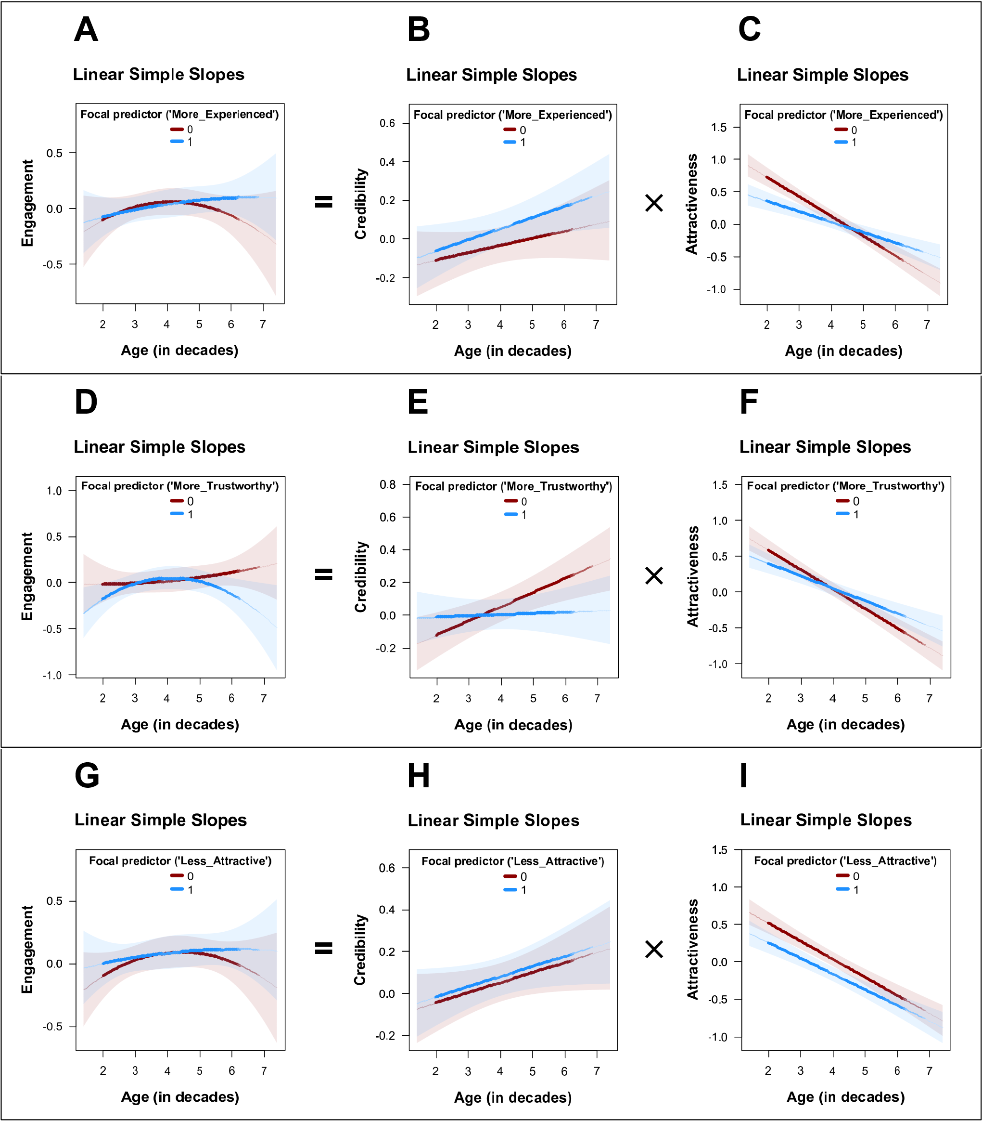

Figure Interaction GAM A-C) More Experienced, D-F) More Trustworthy, G-I) Less Attractive
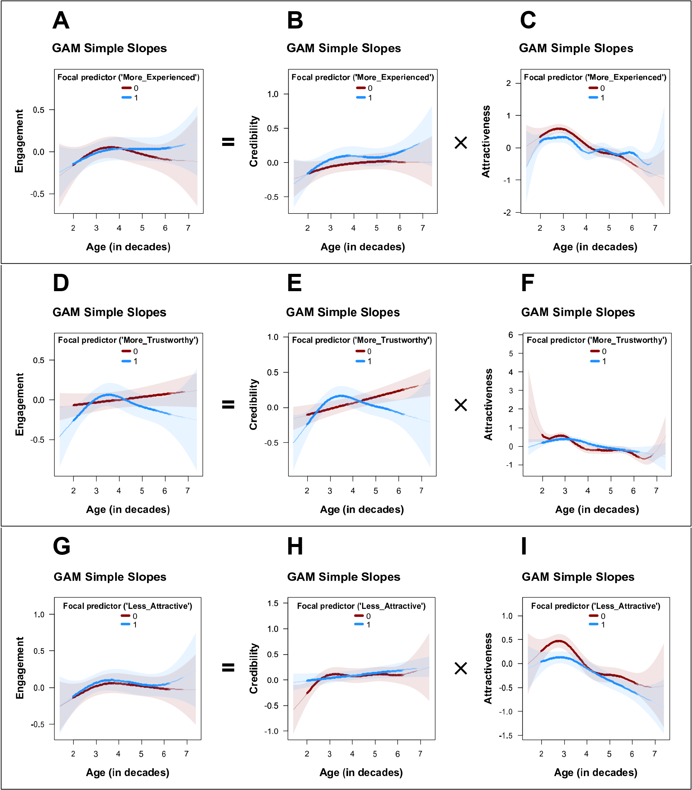

Web Appendix 9: Study 4b

WA9-1: Design
Stimuli
 | woman | man
20-35 years | 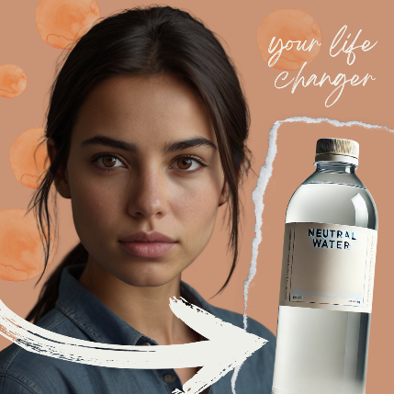 | 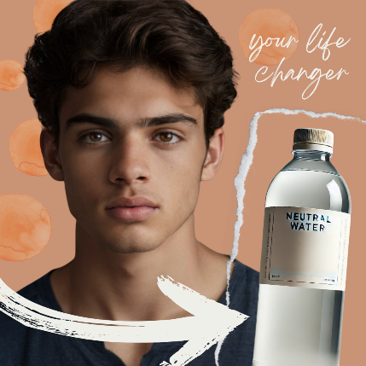 | 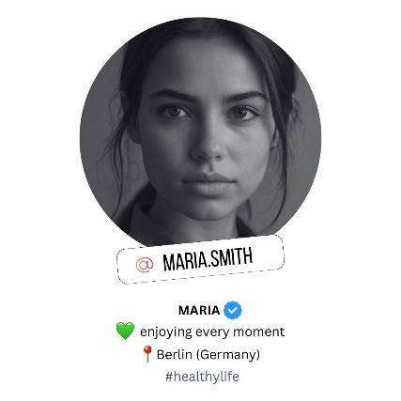
25-30 years | 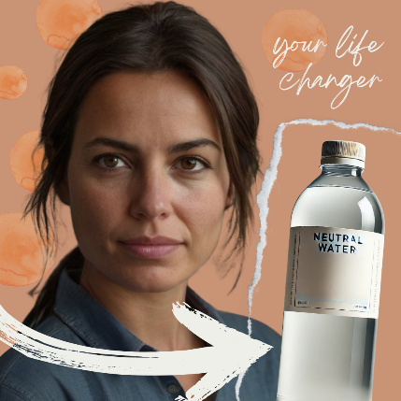 | 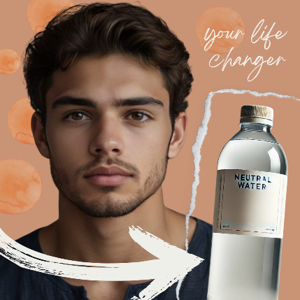 | 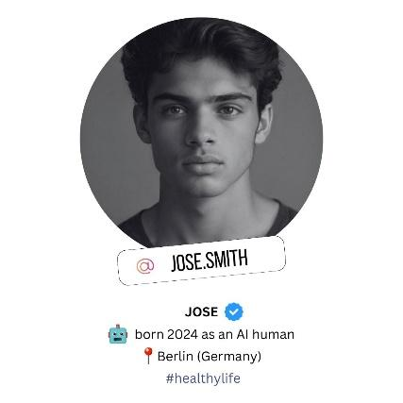
30-40 years | 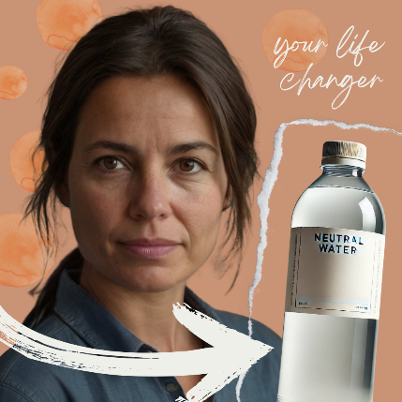 | 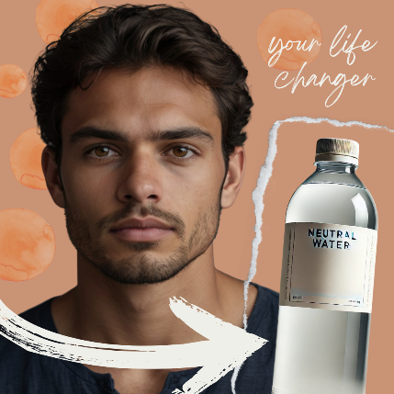 | Design:  5 ages (20-25 years, 25-30 years, 30-40 years, 40-50 years, 50-60 years) x gender (male/female) x AI disclosure Instagram account information (‘born as an AI human’)  Product:  Neutral water bottle  Post Caption:  💧Refresh your body, mind, and soul with the purest form of hydration. This Neutral Water is crafted for those who appreciate balance, simplicity, and clean taste 🌿 No added flavors, no artificial ingredients — just natural hydration at its finest.  Stay refreshed, stay balanced. 🌍✨  #NeutralWater #PureHydration #StayBalanced #RefreshYourself #HydrateClean #DrinkPure
40-50 years | 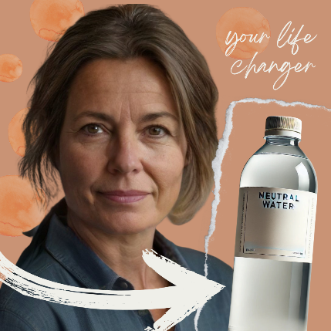 | 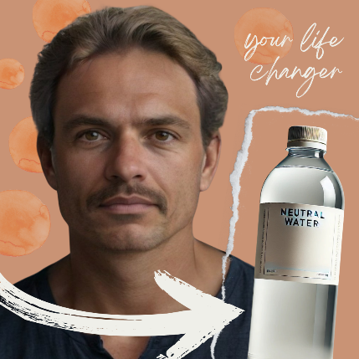
50-60 years | 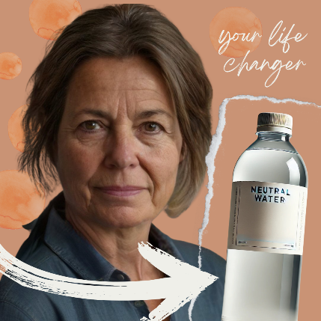 | 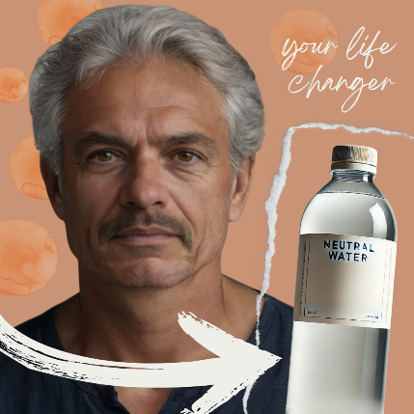
Measures
Factor | Items | Source
Purchase Intention | (1) It is very likely that I will buy this product.  (2) I will purchase this product the next time I need this.  (3) I will definitely try this product.  (4) Suppose a friend called you last night to seek your advice on this product. Would you recommend that they buy this product? | (Putrevu & Lord, 1994)
Engagement | (1) I would like the post.  (2) I would comment on the post.  (3) I would share the post. | based on (Swani & Labrecque, 2020)
Attractiveness | (1) I consider the influencer very attractive.  (2) I consider the influencer very stylish.  (3) I think the influencer is good-looking.  (4) I think the influencer is sexy. | based on (Ohanian, 1990)
Expertise | (1) I feel the influencer knows a lot about the product.  (2) I feel the influencer is competent to make assertions about the product.  (3) I consider the influencer an expert on the product.  (4) I consider the influencer sufficiently experienced to make assertions about the product. | based on (Ohanian, 1990)
Trustworthiness | (1) I feel the influencer was honest.  (2) I consider the influencer trustworthy.  (3) I feel the influencer was truthful.  (4) I consider the influencer earnest. | based on (Ohanian, 1990)
Manipulation Check | Age: How old do you think this influencer is?  Gender: What gender would you assign to the influencer?  AI: Is this a real person?
all items were measured with a 5-point Likert scale

Participants, design, and procedure
We pre-registered the study prior to data collection (AsPredicted #205,132, 12/18/2024). Participants (N = 910; 57% female) were recruited via Prolific, an online participant recruitment platform. Ages ranged from 18 to 78 years (M = 38.0, SD = 13.0). Following pre-registered exclusion criteria, respondents who failed attention checks or provided incomplete responses were removed prior to analysis. The study employed a 5 (influencer age: 20–25, 25–30, 30–40, 40–50, 50–60 years) × 2 (influencer gender: male vs. female) × 2 (AI disclosure) between-subjects design, resulting in 20 experimental conditions. Participants were randomly assigned to one condition and viewed a single influencer profile post corresponding to their assignment. The stimuli were presented within an online survey, after which participants completed the dependent measures and manipulation checks.

WA9-2: Variables and operationalization
Variable | Units | Type | Alpha | AVE | CR
Engagement | factor | DV | 0.9 | 0.7583 | 0.904
Purchase Intention | factor | DV | 0.95 | 0.8313 | 0.951
Attractiveness | factor | Mediator | 0.91 | 0.718 | 0.908
Expertise | factor | Mediator component | 0.95 | 0.8274 | 0.95
Trustworthiness | factor | Mediator component | 0.97 | 0.8748 | 0.965
Credibility | factor | Mediator | 0.96 | 0.7352 | 0.933
Influencer Age | decades | IV (measured) | 0 | 0 | 0
Perceived as Virtual | dummy | Manip. check | 0 | 0 | 0
Perceived as Female | dummy | Manip. check | 0 | 0 | 0
Consumer Age | decades | Manip. check | 0 | 0 | 0
Perceived Age Difference | decades | Control | 0 | 0 | 0
Consumer is Female | dummy | Control | 0 | 0 | 0

WA9-3: Descriptives and correlations
 | Mean | SD | Min | Max | 1 | 2 | 3 | 4 | 5 | 6 | 7 | 8 | 9 | 10 | 11 | 12
Engagement | 2.12 | 1.15 | 1.00 | 5.00 | 1 | . | . | . | . | . | . | . | . | . | . | .
Purchase_intention | 2.31 | 1.17 | 1.00 | 5.00 | .81 | 1 | . | . | . | . | . | . | . | . | . | .
Attractiveness | 3.23 | 0.98 | 1.00 | 5.00 | .41 | .41 | 1 | . | . | . | . | . | . | . | . | .
Expertise | 2.48 | 1.15 | 1.00 | 5.00 | .70 | .72 | .38 | 1 | . | . | . | . | . | . | . | .
Trustworthiness | 2.77 | 1.06 | 1.00 | 5.00 | .66 | .70 | .42 | .78 | 1 | . | . | . | . | . | . | .
Credibility | 2.62 | 1.04 | 1.00 | 5.00 | .72 | .75 | .43 | .95 | .94 | 1 | . | . | . | . | . | .
Influencer_age | 3.59 | 1.52 | 0.00 | 7.90 | .04 | .04 | -.24 | .12 | .13 | .13 | 1 | . | . | . | . | .
Perceived_as_virtual | 0.61 | 0.49 | 0.00 | 1.00 | -.37 | -.38 | -.25 | -.40 | -.40 | -.43 | -.13 | 1 | . | . | . | .
Perceived_as_female | 0.51 | 0.50 | 0.00 | 1.00 | -.00 | .01 | -.09 | .06 | .04 | .05 | .25 | -.01 | 1 | . | . | .
Consumer_age | 3.80 | 1.30 | 1.80 | 7.80 | -.10 | -.19 | -.00 | -.10 | -.03 | -.07 | .02 | .07 | -.01 | 1 | . | .
AbsAgeDifference | 1.58 | 1.22 | 0.00 | 6.40 | -.11 | -.16 | -.18 | -.12 | -.12 | -.13 | -.08 | .11 | .02 | .33 | 1 | .
Consumer_is_female | 0.57 | 0.50 | 0.00 | 1.00 | -.09 | -.09 | -.02 | -.05 | -.01 | -.03 | .04 | .03 | -.00 | .07 | .05 | 1

WA9-4: Manipulation check models
 | Check 1 |  |  | Check 2 | Check 3 | Check 4 | Heckman 1st Stage Probit
Dependent variable: | Influencer Age |  |  | Perceived Virtual | Perceived Female | Consumer Age | Age Match
Manipulated variable: | Age  (7 levels) |  |  | Influencer Virtual | Influencer Female | Older Consumer | Older Consumer + Age Manipulation
Age = 20-25 | 2.269 *** |  | Constant: | 0.401 *** | 0.022 *** | 2.744 *** | -0.329 **
 | (0.081) |  |  | (0.021) | (0.006) | (0.037) | (0.112)
Age = 25-30 | 2.799 *** |  |  |  |  |  | 0.129
 | (0.078) |  |  |  |  |  | (0.141)
Age = 30-40 | 3.315 *** |  |  |  |  |  | 0.001
 | (0.081) |  |  |  |  |  | (0.144)
Age = 40-50 | 4.125 *** |  |  |  |  |  | -0.222
 | (0.078) |  |  |  |  |  | (0.146)
Age = 50-60 | 5.366 *** |  |  |  |  |  | -0.520 ***
 | (0.079) |  |  |  |  |  | (0.155)
Manipulation |  |  |  | 0.427 *** | 0.967 *** | 2.073 *** | -0.524 ***
 |  |  |  | (0.029) | (0.008) | (0.052) | (0.094)
N | 910 |  |  | 910 | 910 | 910 | 910
R² | 0.925 |  |  | 0.192 | 0.935 | 0.634
AIC | 2710.929 |  |  | 1083.802 | -1164.284 | 2153.242 | 971.716
F | 2240.361 |  |  | 216.137 | 13118.168 | 1573.217
p | 0.000 |  |  | 0.000 | 0.000 | 0.000
*** p < 0.001; ** p < 0.01; * p < 0.05.

WA9-5: Main Models Table
 | DV: Engagement |  | DV: Purchase Intention
 | Quadratic Model | GAM | Quadratic Model | GAM
Constant | -0.268 | 0.000 | -0.447 | 0.000
 | (0.213) | (0.035) | (0.232) | (0.038)
InfluencerAge | 0.183 | edf=3.041 | 0.293 * | edf=3.174*
 | (0.108) | (F=1.881) | (0.118) | (F=2.788)
InfluencerAge² | -0.026 * |  | -0.040 **
 | (0.013) |  | (0.014)
ControlFunction | 0.043 | edf=1.987 | 0.038 | edf=2.410
 | (0.052) | (F=0.934) | (0.057) | (F=0.976)
N | 910 | 910 | 910 | 910
R² | 0.010 | 0.012 | 0.016 | 0.018
AIC | 2674.137 | 2674.166 | 2834.103 | 2834.661
Optimal InfluencerAge (decades) | 3.550  (CI=[2.100,4.930]) | 2.900  (CI=[0.720,3.680]) | 3.510  (CI=[2.420,4.440]) | 3.040  (CI=[2.700,3.680])
*** p < 0.001; ** p < 0.01; * p < 0.05; GAM smooth terms represent estimated df (linear: edf=1), with F-test for explained variance.

WA9-6: H2 H3 Models Table
 | DV: Credibility |  | DV: Attractiveness
 | Linear Model | GAM | Linear Model | GAM
Constant | -0.090 | 0.000 | 1.292 *** | 0.000
 | (0.110) | (0.032) | (0.103) | (0.029)
InfluencerAge | 0.025 | edf=3.174*** | -0.360 *** | edf=6.585***
 | (0.029) | (F=5.240) | (0.028) | (F=25.881)
ControlFunction | 0.118 ** | edf=1.001 | 0.411 *** | edf=4.364***
 | (0.042) | (F=0.050) | (0.039) | (F=5.079)
N | 910 | 910 | 910 | 910
R² | 0.026 | 0.045 | 0.161 | 0.230
AIC | 2514.973 | 2497.578 | 2401.100 | 2334.288
*** p < 0.001; ** p < 0.01; * p < 0.05; GAM smooth terms represent estimated df (linear: edf=1), with F-test for explained variance.

WA9-7: H4 Models Table
 | DV: Engagement |  | DV: Purchase Intention
 | Linear Interaction | GAM Interaction | Linear Interaction | GAM Interaction
Constant | 0.210 | 0.000 | 0.539 ** | 0.000
 | (0.180) | (0.023) | (0.185) | (0.024)
Credibility | 0.647 *** | edf=8.644*** | 0.770 *** | edf=3.315***
 | (0.029) | (F=11.163) | (0.030) | (F=11.117)
Attractiveness | 0.183 *** | edf=3.429*** | 0.173 *** | edf=2.435**
 | (0.031) | (F=9.750) | (0.032) | (F=4.468)
Credibility × Attractiveness | 0.235 *** | edf=1.000*** | 0.186 *** | edf=2.561**
 | (0.024) | (F=12.242) | (0.024) | (F=3.855)
InfluencerAge | -0.108 | edf=1.000 | -0.091 | edf=1.000
 | (0.083) | (F=0.193) | (0.085) | (F=0.004)
InfluencerAge² | 0.016 |  | 0.013
 | (0.010) |  | (0.010)
ControlFunction | 0.020 | edf=1.000 | 0.015 | edf=1.000
 | (0.037) | (F=0.082) | (0.038) | (F=0.090)
ConsumerAge | -0.040 * | edf=1.000 | -0.118 *** | edf=1.000***
 | (0.020) | (F=2.242) | (0.021) | (F=31.411)
AbsoluteAgeDifference | 0.001 | edf=2.094 | -0.017 | edf=1.488
 | (0.025) | (F=1.150) | (0.025) | (F=0.332)
N | 910 | 910 | 910 | 910
R² | 0.527 | 0.564 | 0.584 | 0.595
AIC | 2011.507 | 1939.447 | 2060.920 | 2032.317
*** p < 0.001; ** p < 0.01; * p < 0.05; GAM smooth terms represent estimated df (linear: edf=1), with F-test for explained variance.

WA9-8: Interaction Tables
 |  | Test Changes in Curve |  |  |  | Explore Mechanism
Moderator | DV | Significant Contrasts | Optimal Age Change | Optimal DV Change |  | Credibility Shift (H5a) | Credibility Slope (H6a) | Attractiveness Shift (H5b) | Attractiveness Slope (H6b)
Influencer Virtual | Engagement Factor | neg.(-) in:  [5.67 to 7.82] | -0.837  CI=[-4.044, 2.124] | 0.017  CI=[-0.21, 0.216] |  | -0.209  (SE= 0.183) | -0.044  (SE= 0.046) | -0.382 *  (SE= 0.172) | 0.031  (SE= 0.043)
Influencer Virtual | PI Factor | neg.(-) in:  [0 to 2.07],  neg.(-) in:  [5.59 to 7.9] | -0.401  CI=[-2.913, 1.859] | 0.02  CI=[-0.203, 0.208] |  | -0.209  (SE= 0.183) | -0.044  (SE= 0.046) | -0.382 *  (SE= 0.172) | 0.031  (SE= 0.043)
Influencer Female | Engagement Factor | Ranges of sig. contrasts: none | 1.301  CI=[-2.428, 4.691] | -0.064  CI=[-0.296, 0.159] |  | -0.090  (SE= 0.165) | 0.026  (SE= 0.043) | 0.002  (SE= 0.156) | -0.046  (SE= 0.041)
Influencer Female | PIFactor | pos.(+) in: [4.95 to 7.9] | 2.22  CI=[0.352, 5.01] | 0.003  CI=[-0.244, 0.29] |  | -0.090  (SE= 0.165) | 0.026  (SE= 0.043) | 0.002  (SE= 0.156) | -0.046  (SE= 0.041)
Consumer Female | Engagement Factor | neg.(-) in:  [1.36 to 4.31] | 1.547  CI=[-1.772, 5.095] | -0.245  CI=[-0.48, -0.046] |  | -0.245  (SE= 0.165) | 0.056  (SE= 0.043) | 0.057  (SE= 0.155) | -0.010  (SE= 0.040)
Consumer Female | PI Factor | neg.(-) in:  [1.2 to 4.23] | 1.419  CI=[-0.889, 4.668] | -0.245  CI=[-0.443, -0.07] |  | -0.245  (SE= 0.165) | 0.056  (SE= 0.043) | 0.057  (SE= 0.155) | -0.010  (SE= 0.040)
Consumer Older | Engagement Factor | neg.(-) in:  [1.04 to 4.87] | 1.296  CI=[-2.428, 4.853] | -0.289  CI=[-0.52, -0.083] |  | -0.246  (SE= 0.160) | 0.025  (SE= 0.041) | -0.419 **  (SE= 0.151) | 0.106 **  (SE= 0.039)
Consumer Older | PI Factor | neg.(-) in:  [0.4 to 5.67] | 1.214  CI=[-1.297, 4.525] | -0.502  CI=[-0.691, -0.321] |  | -0.246  (SE= 0.160) | 0.025  (SE= 0.041) | -0.419 **  (SE= 0.151) | 0.106 **  (SE= 0.039)
Age Match | Engagement Factor | pos.(+) in:  [1.6 to 2.87] | -0.84  CI=[-5.095, 2.747] | 0.034  CI=[-0.38, 0.78] |  | 0.363  (SE= 0.236) | -0.071  (SE= 0.065) | 0.289  (SE= 0.222) | -0.042  (SE= 0.061)
Age Match | PI Factor | pos.(+) in: [0.48 to 3.27] | -1.402  CI=[-5.091, 2.409] | 0.207  CI=[-0.35, 1.172] |  | 0.363  (SE= 0.236) | -0.071  (SE= 0.065) | 0.289  (SE= 0.222) | -0.042  (SE= 0.061)
Notes: *** p < 0.001; ** p < 0.01; * p < 0.05; CI are 95% confidence intervals; GAM smooth terms represent estimated df (linear: edf=1), with F-test for explained variance.

GAM
 |  | Test Changes in Curve |  |  |  | Explore Mechanism
Moderator | DV | Significant Contrasts | Optimal Age Change | Optimal DV Change |  | Credibility Shift (H5a) | Credibility Slope (H6a) | Attractiveness Shift (H5b) | Attractiveness Slope (H6b)
Influencer Virtual | Engagement Factor | neg.(-) in: [0 to 1.84],  neg.(-) in: [5.67 to 6.62] | -0.169  CI=[-4.848, 3.232] | -0.034  CI=[-0.381, 0.33] |  | -0.396***  (0.066) | edf=3.52**  (F=3.75) | -0.159  (0.106) | edf=6.78***  (F=17.21)
Influencer Virtual | PI Factor | neg.(-) in: [0 to 2.31],  neg.(-) in: [5.59 to 7.26] | 0.015  CI=[-3.818, 3.475] | -0.039  CI=[-0.618, 0.392] |  | -0.396***  (0.066) | edf=3.52**  (F=3.75) | -0.159  (0.106) | edf=6.78***  (F=17.21)
Influencer Female | Engagement Factor | Ranges of sig. contrasts: none | 1.026  CI=[-2.756, 5.253] | -0.105  CI=[-0.362, 0.172] |  | -0.341***  (0.064) | edf=2.8**  (F=3.72) | -0.204***  (0.059) | edf=4.16***  (F=20.26)
Influencer Female | PI Factor | neg.(-) in: [2.47 to 2.71],  pos.(+) in: [4.95 to 6.86] | 2.266  CI=[0.238, 5.414] | -0.075  CI=[-0.404, 0.278] |  | -0.341***  (0.064) | edf=2.8**  (F=3.72) | -0.204***  (0.059) | edf=4.16***  (F=20.26)
Consumer Female | Engagement Factor | neg.(-) in: [1.6 to 4.39] | 0.604  CI=[-2.12, 4.848] | -0.271  CI=[-0.512, -0.039] |  | -0.026  (0.063) | edf=3.05**  (F=3.75) | 0.07  (0.058) | edf=6.87***  (F=19.35)
Consumer Female | PI Factor | neg.(-) in: [1.84 to 4.31] | 0.764  CI=[-1.297, 4.772] | -0.315  CI=[-0.568, -0.118] |  | -0.026  (0.063) | edf=3.05**  (F=3.75) | 0.07  (0.058) | edf=6.87***  (F=19.35)
Consumer Older | Engagement Factor | neg.(-) in: [1.2 to 4.55] | 1.622  CI=[-2.748, 5.58] | -0.335  CI=[-0.538, -0.108] |  | -0.343***  (0.064) | edf=2.13  (F=2.11) | -0.205***  (0.059) | edf=4.29***  (F=16.51)
Consumer Older | PI Factor | neg.(-) in: [0.64 to 5.51] | 1.643  CI=[-2.347, 5.499] | -0.524  CI=[-0.783, -0.3] |  | -0.343***  (0.064) | edf=2.13  (F=2.11) | -0.205***  (0.059) | edf=4.29***  (F=16.51)
Age Match | Engagement Factor | pos.(+) in: [0 to 2.87] | -1.707  CI=[-4.054, 2.113] | 0.413  CI=[-0.185, 1.095] |  | 0.114  (0.074) | edf=1  (F=0.02) | 0.162*  (0.07) | edf=1***  (F=37.46)
Age Match | PI Factor | pos.(+) in: [0 to 3.43] | -2.663  CI=[-5.321, 1.616] | 0.634  CI=[-0.294, 1.443] |  | 0.114  (0.074) | edf=1  (F=0.02) | 0.162*  (0.07) | edf=1***  (F=37.46)
Notes: *** p < 0.001; ** p < 0.01; * p < 0.05; CI are 95% confidence intervals; GAM smooth terms represent estimated df (linear: edf=1), with F-test for explained variance.

Figure Interaction Linear Model A-D) Virtual Influencer, E-H) Influencer Female, I-L) Consumer Female, M-P) Consumer Older, Q-T) Age Match
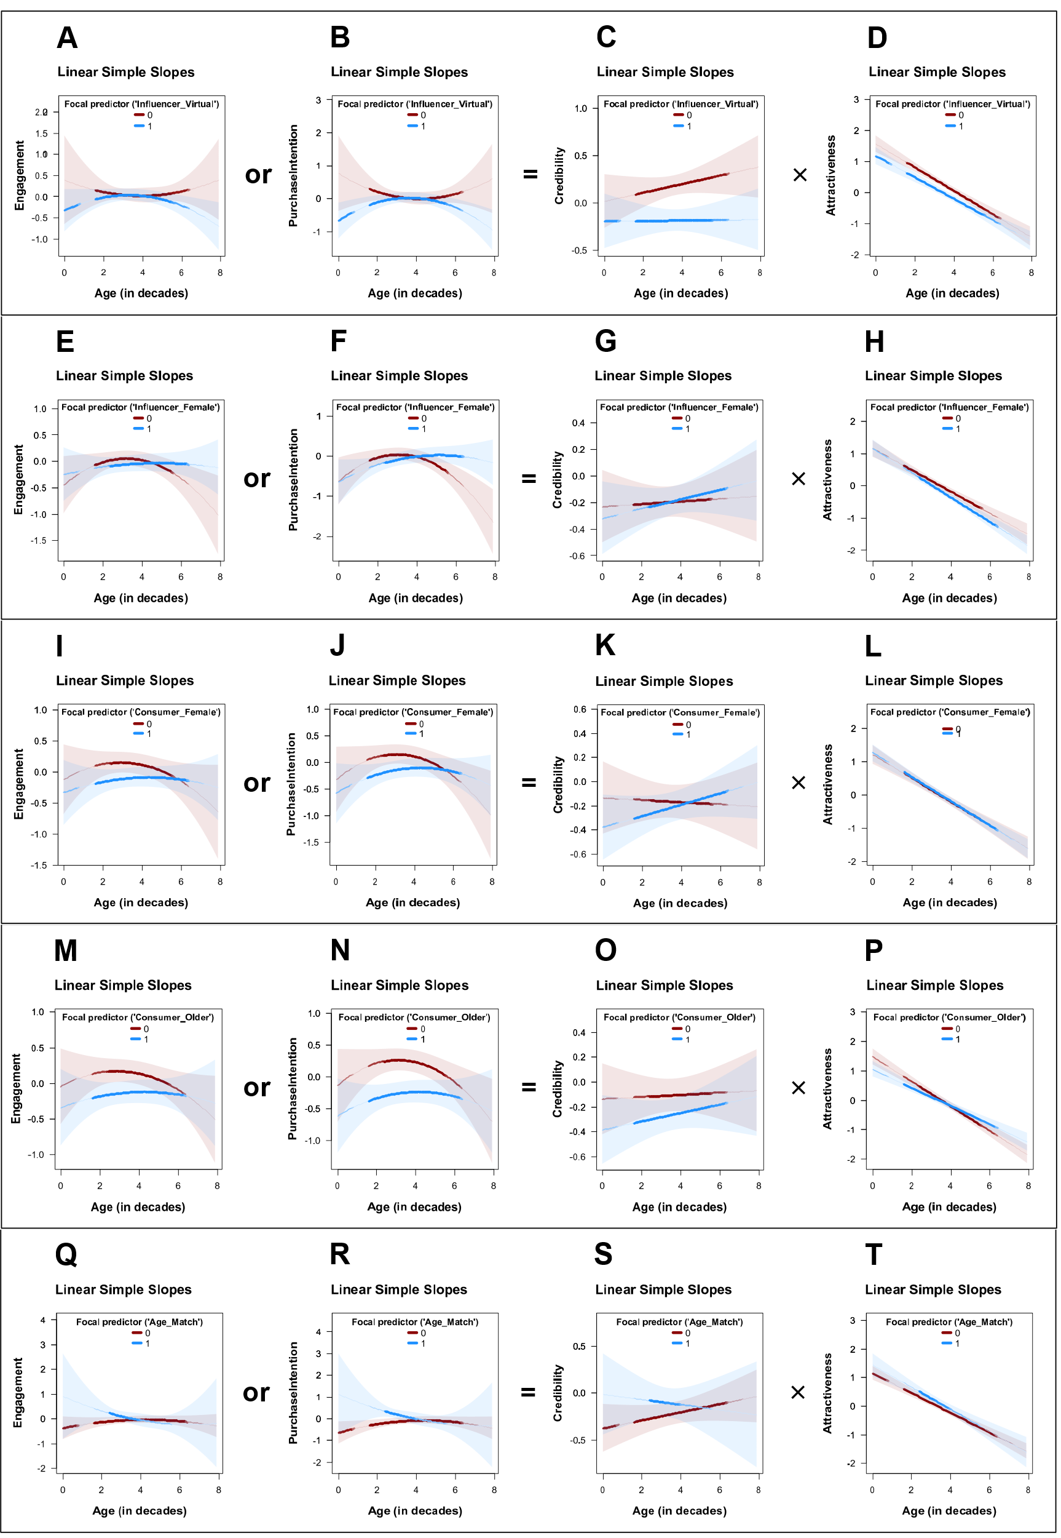
Figure Interaction GAM A-D) Virtual Influencer, E-H) Influencer Female, I-L) Consumer Female, M-P) Consumer Older, Q-T) Age Match
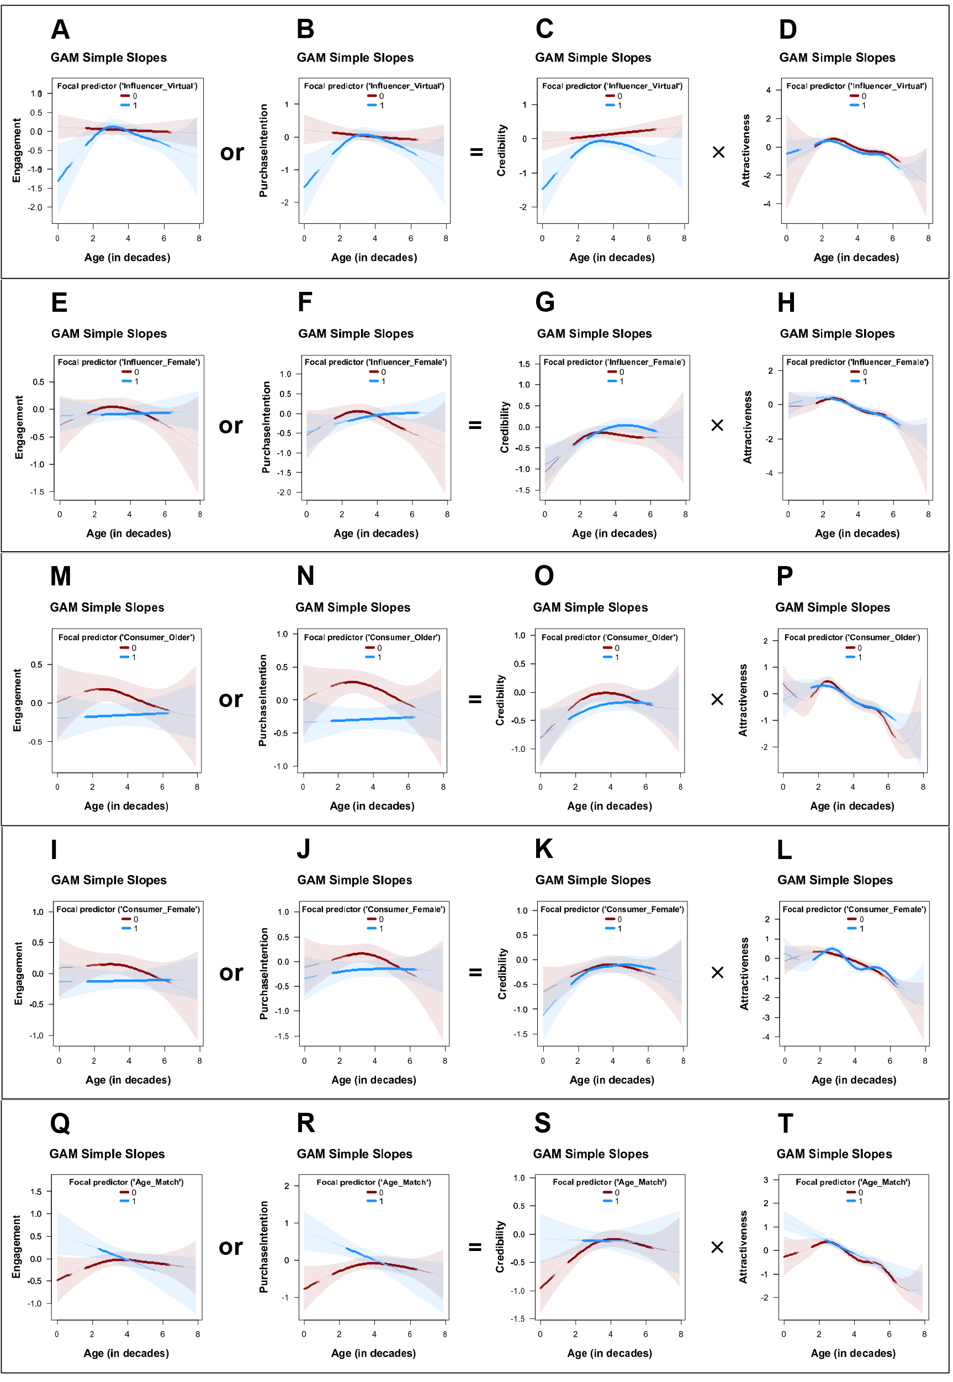

Web Appendix 10: Side-by-side comparison of field and lab context effects

 | Experiment/Lab | Field Study | Hypothesis
Influencer Virtual | Study 4  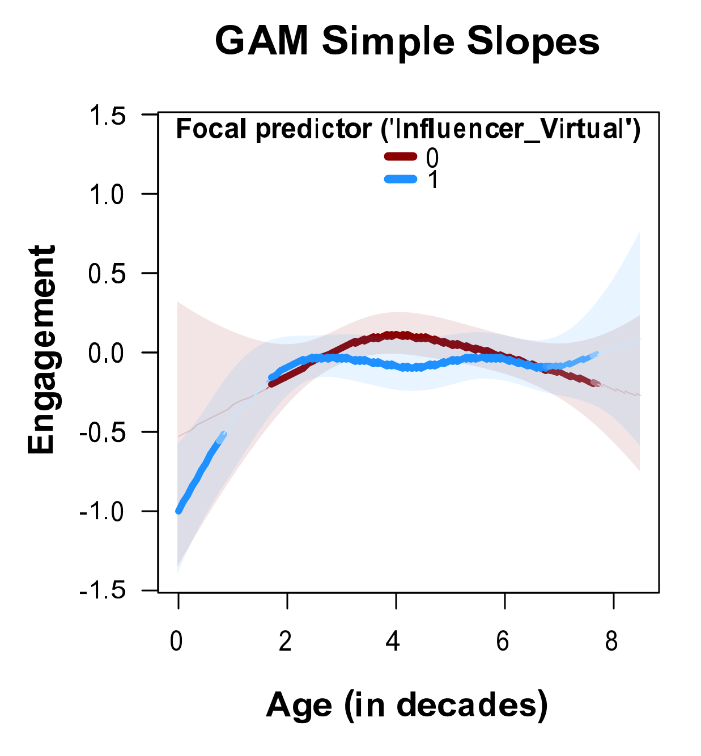 | Study 1  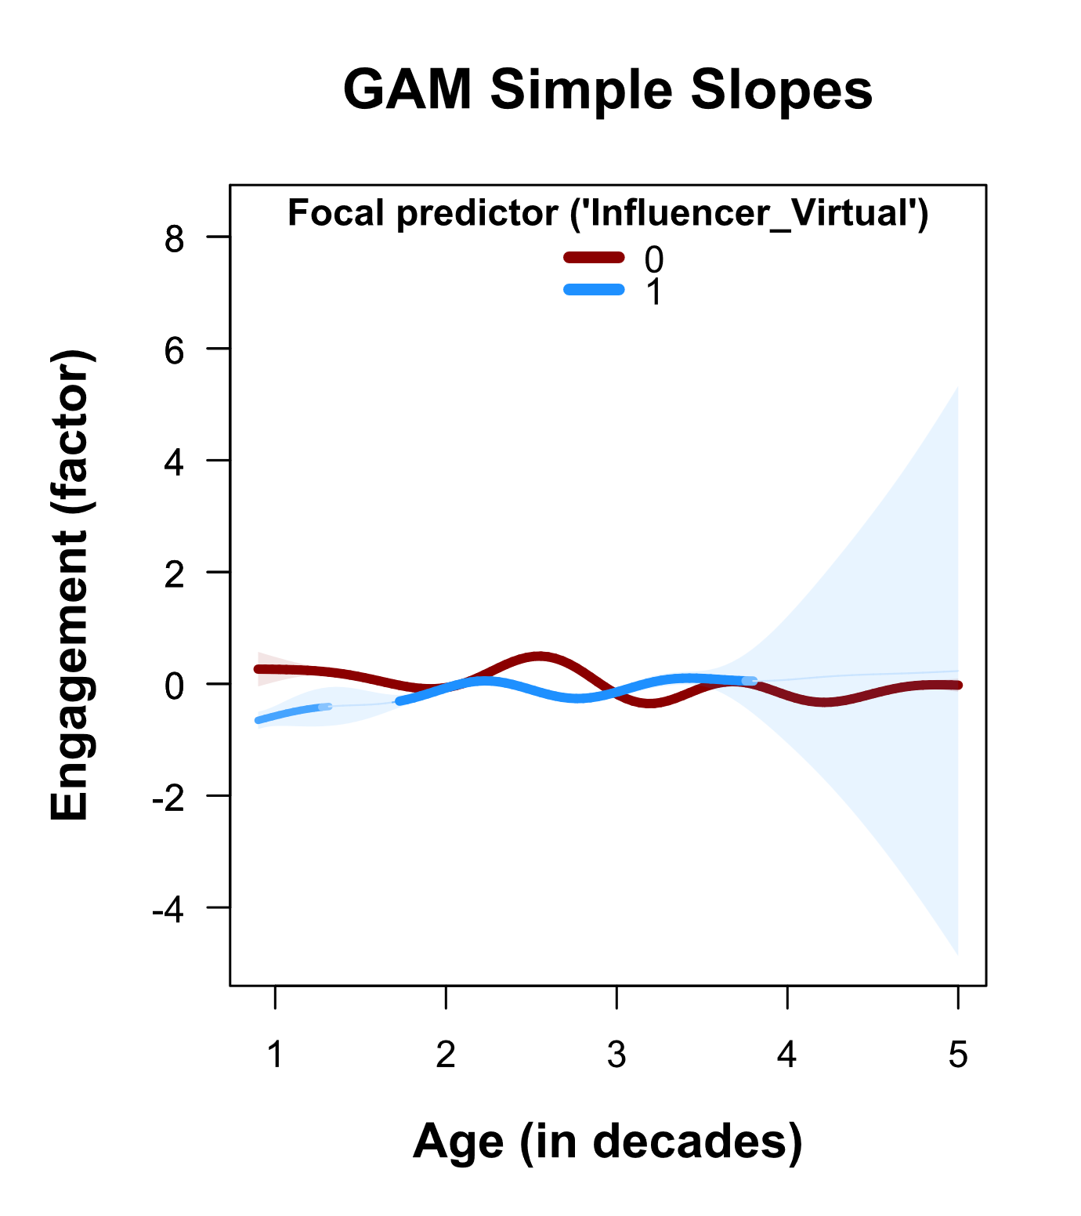 | H5a
Influencer Attractiveness | Study 3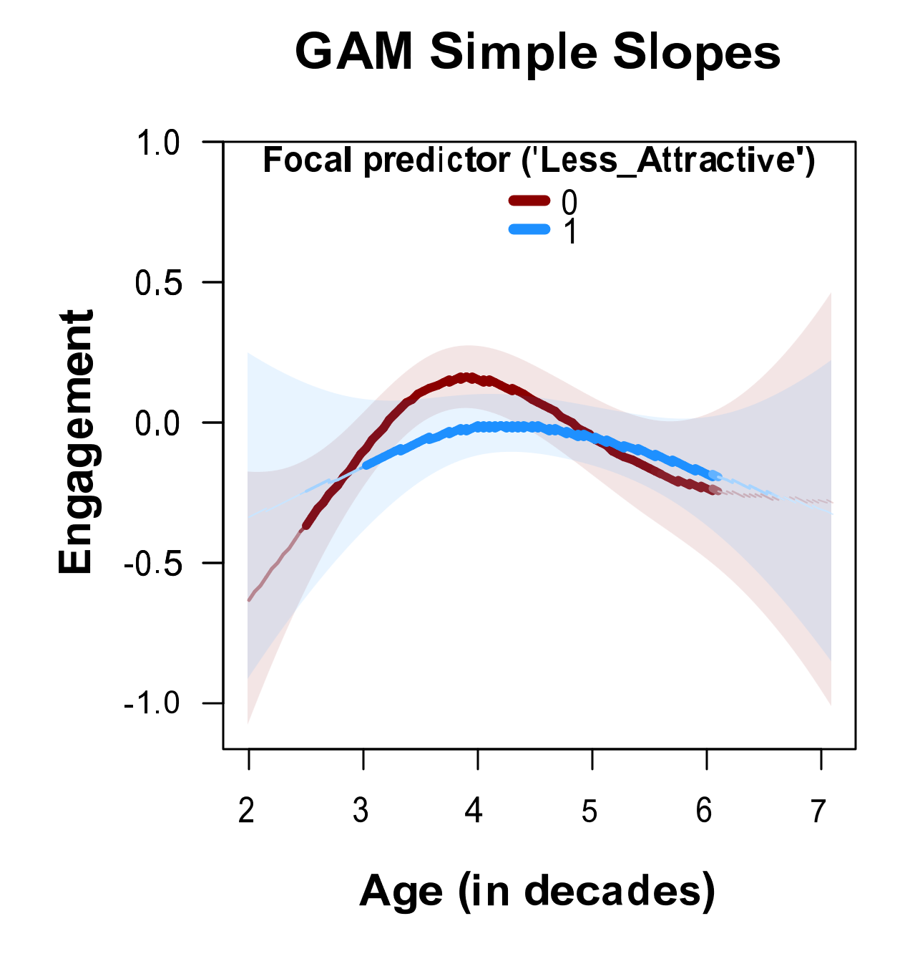 | Study 1  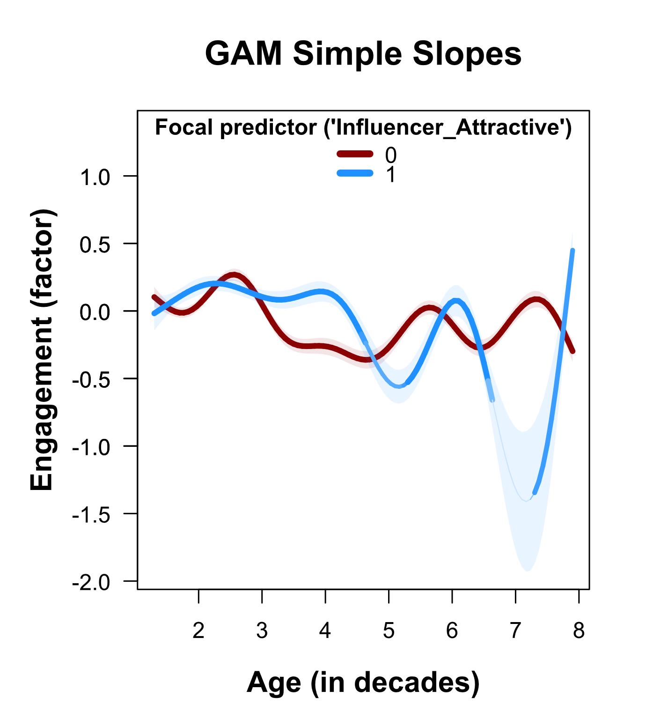 | H5b
Influencer Female | Study 4  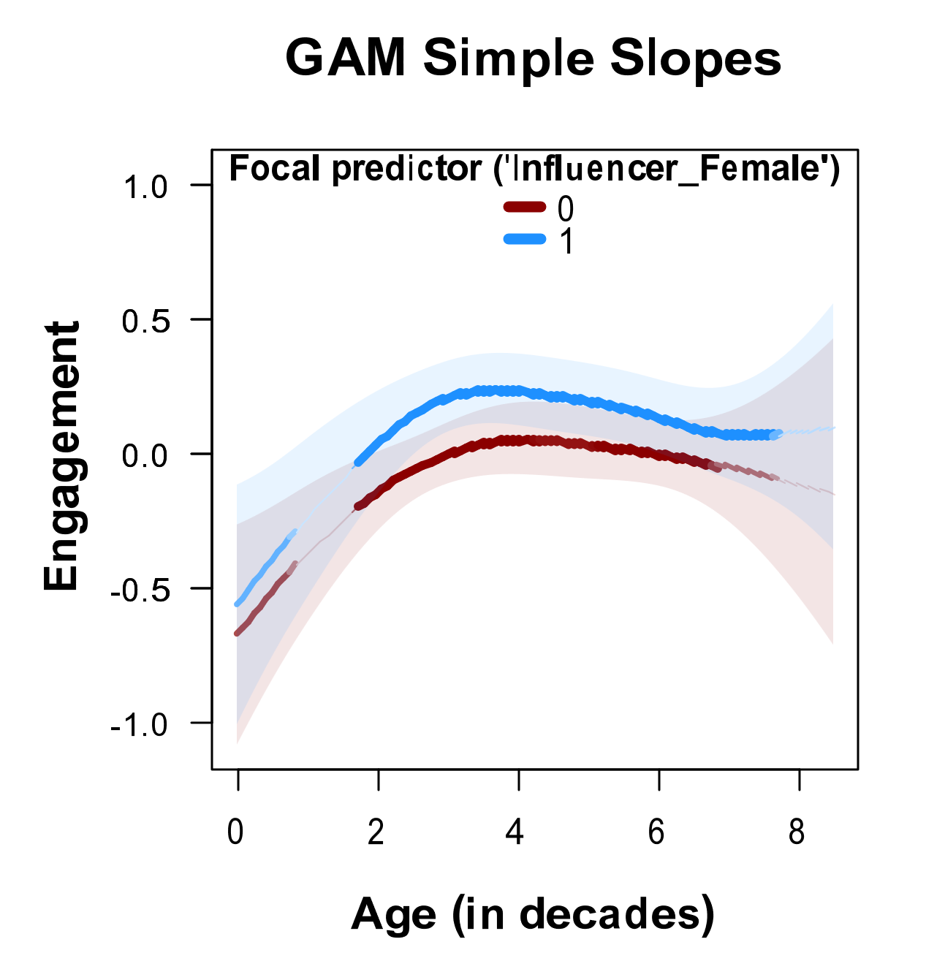 | Study 2 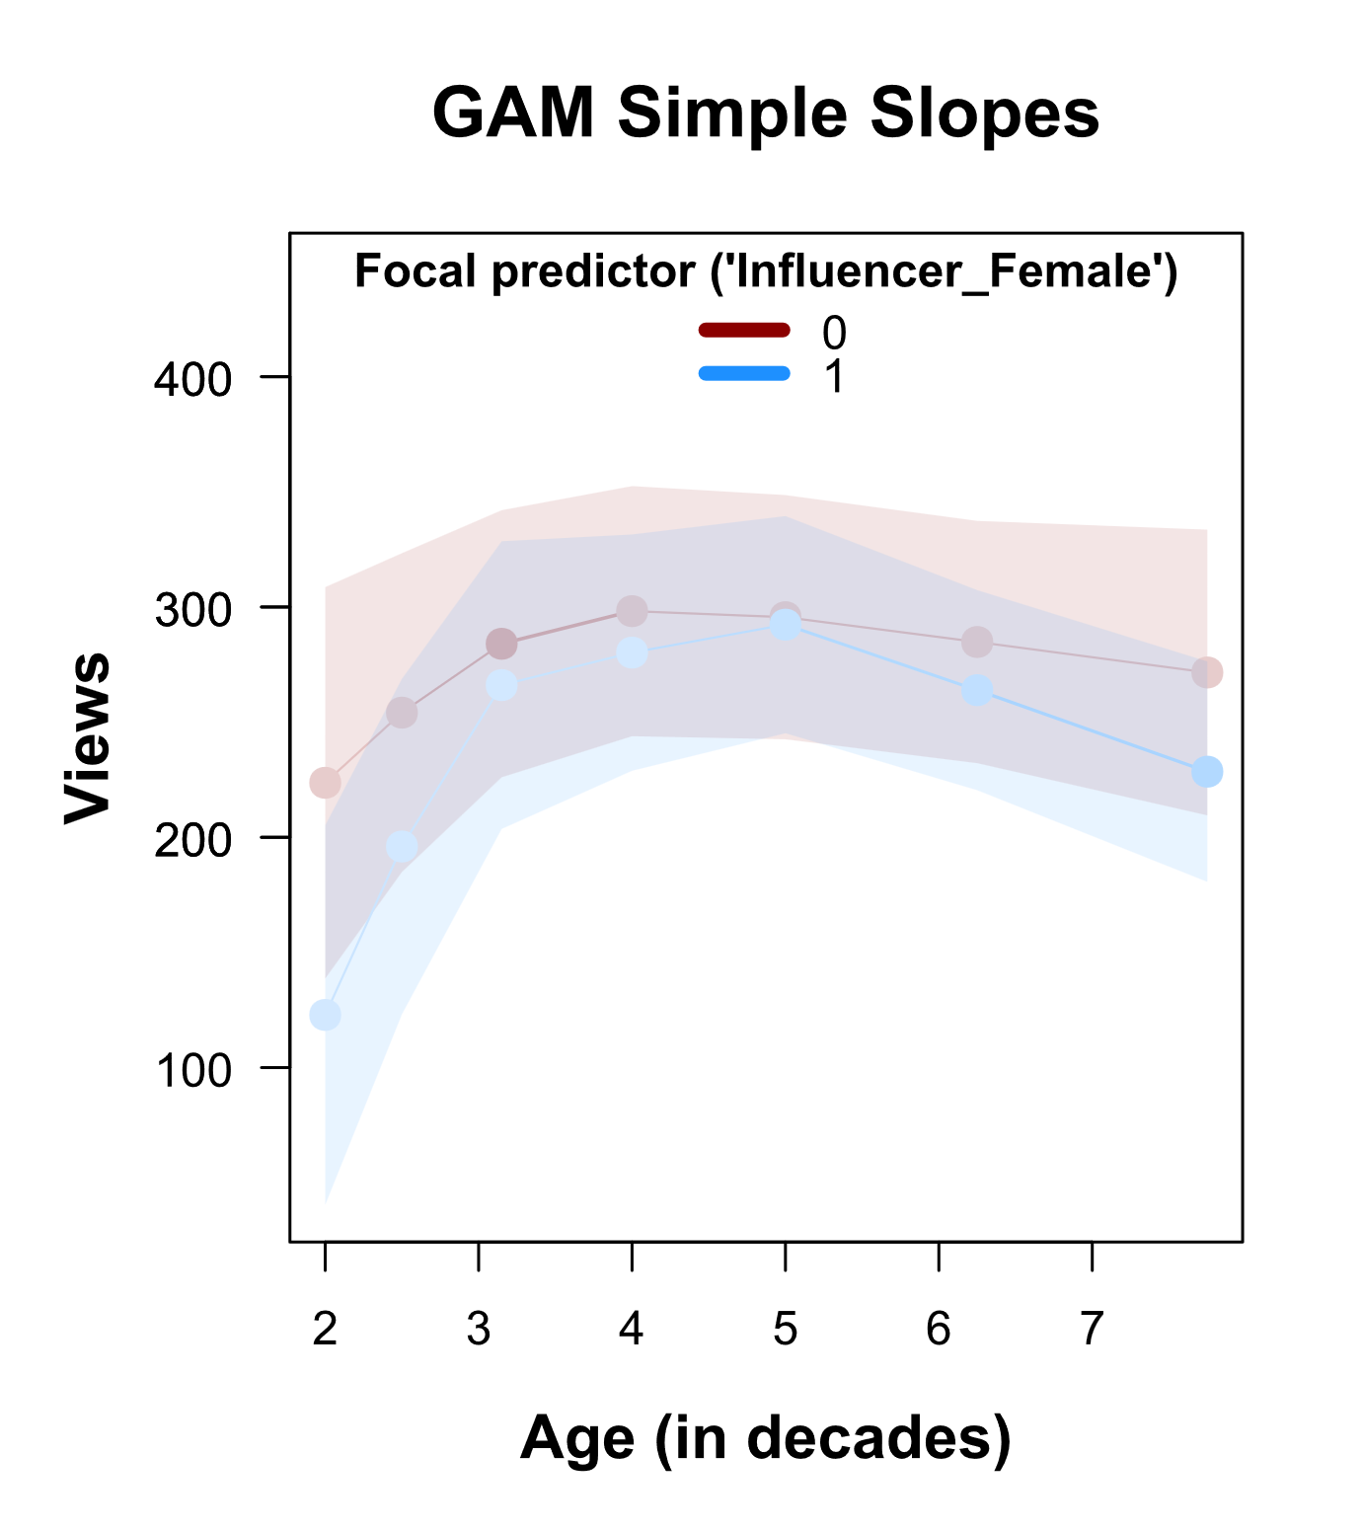 | H5a

 | Experiment/Lab | Field Study | Hypothesis
Consumer Female | Study 4  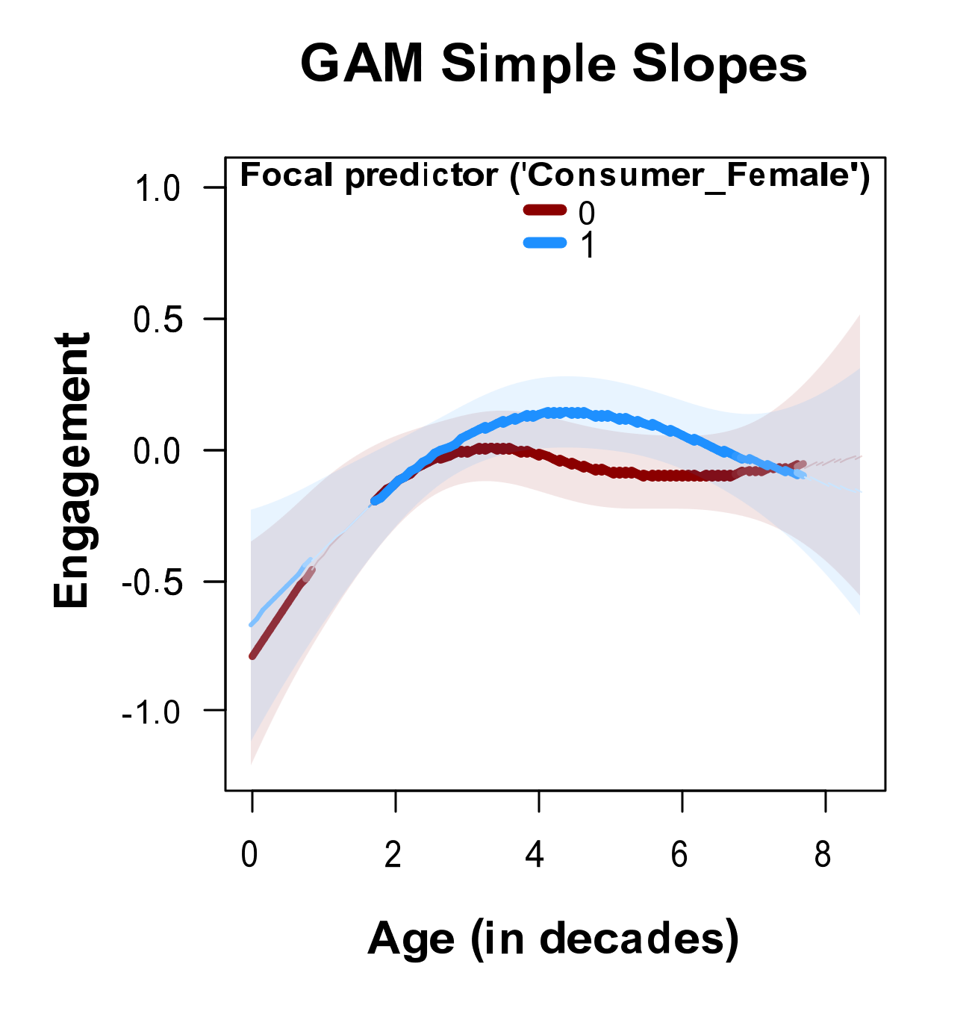 | Study 2  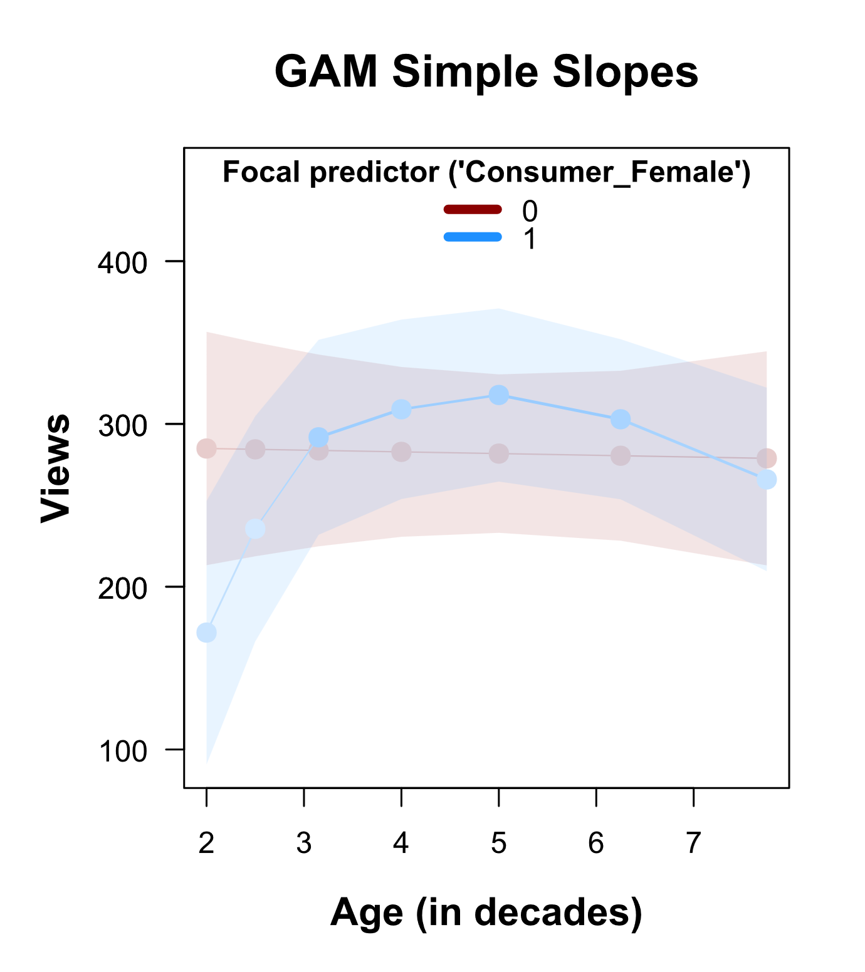 | H5a, H5b
Consumer Older | Study 4  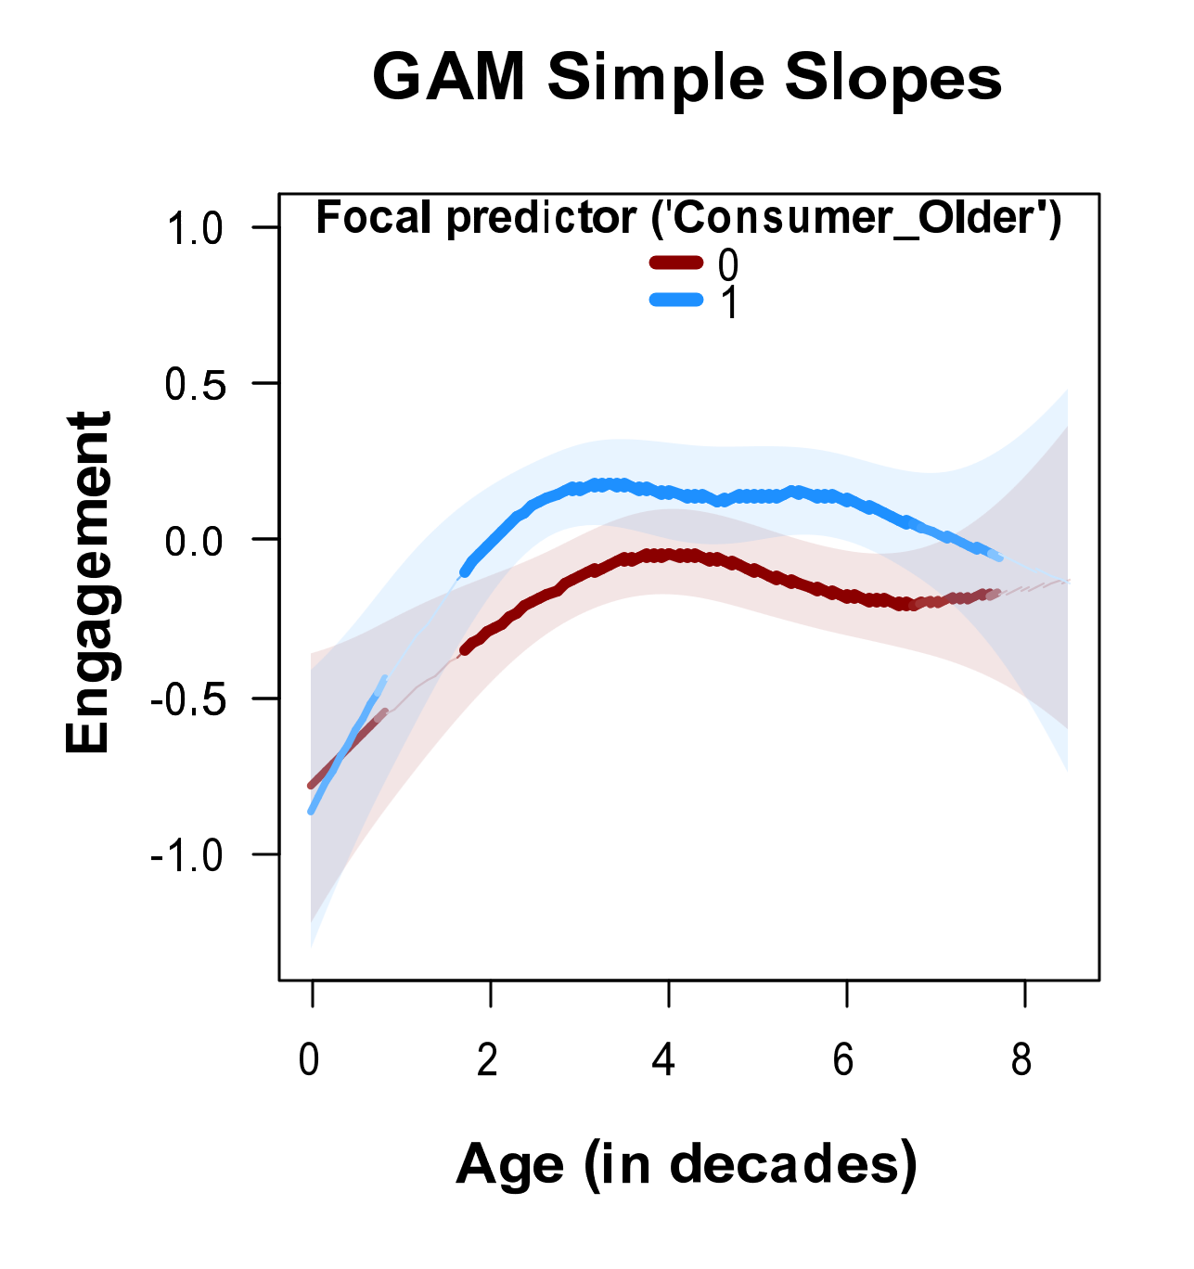 | Study 2  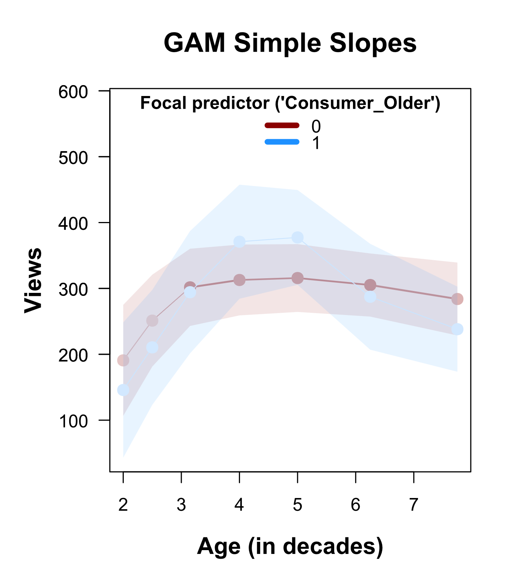 | H5a
Age Match | Study 4  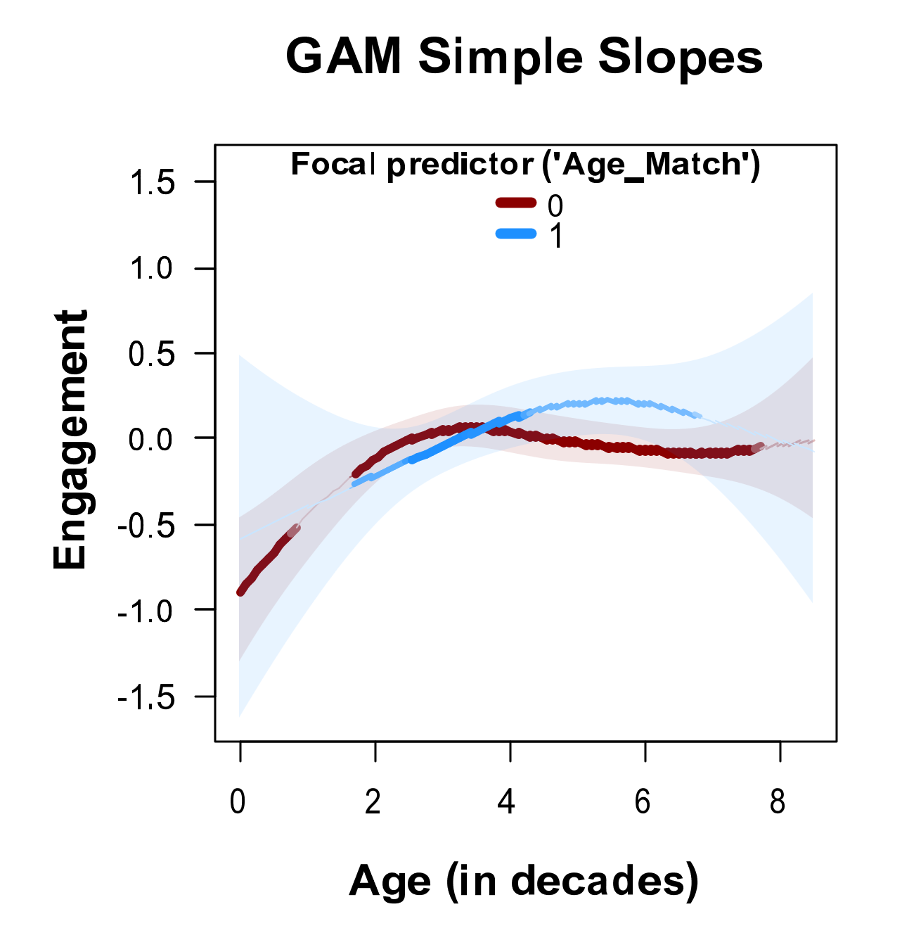 | Study 2  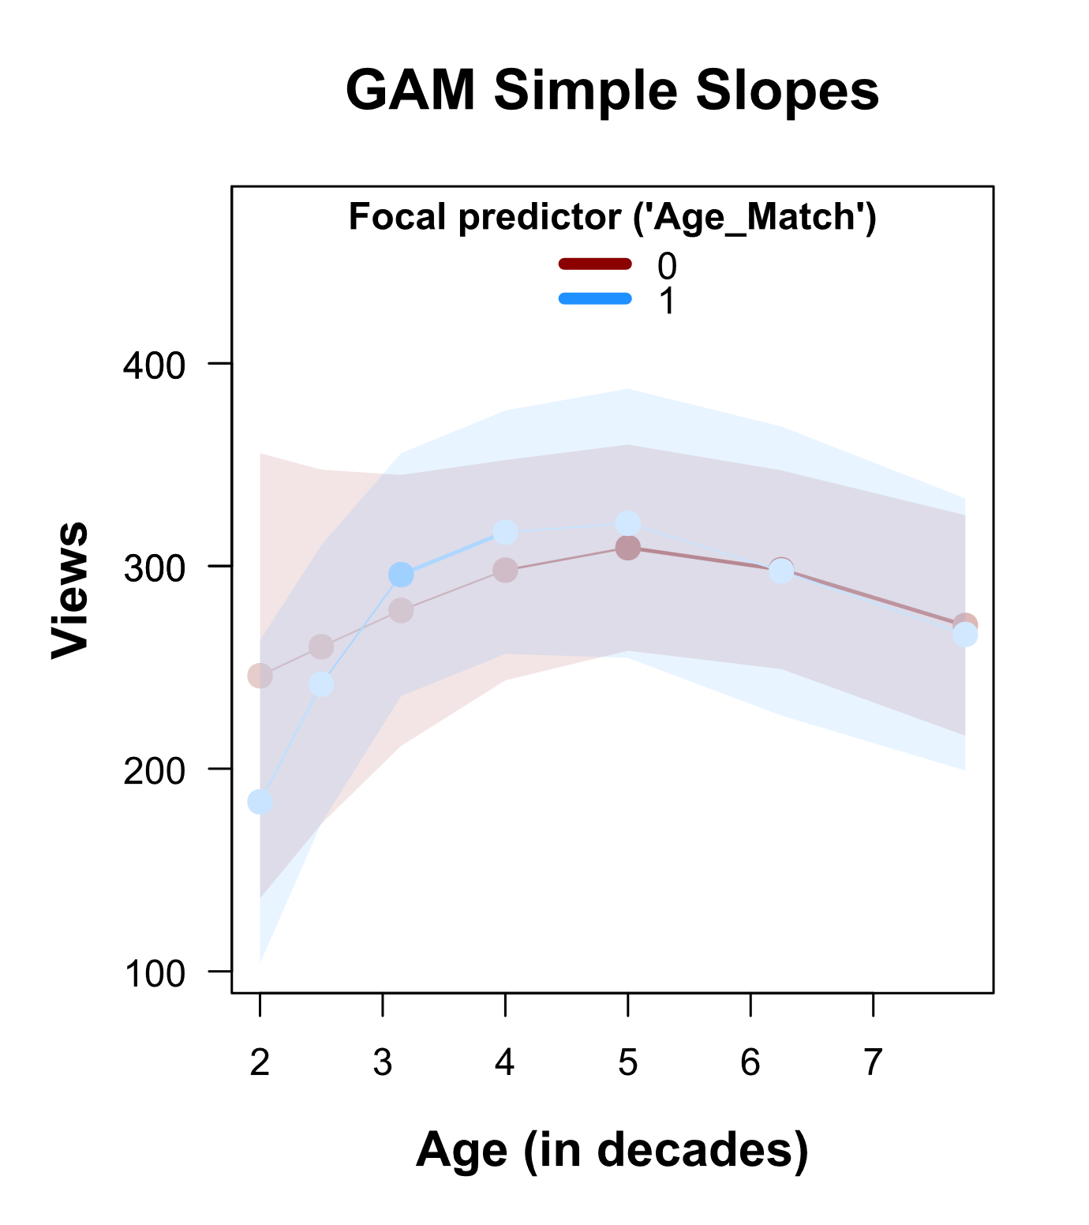 | H6a, H5b

Web Appendix 11: References
Boyd, R. L., Ashokkumar, A., Seraj, S., & Pennebaker, J. W. (2022). The Development and Psychometric Properties of LIWC-22.
Derous, E., Nguyen, H.-H., & Ryan, A. M. (2009). Hiring Discrimination Against Arab Minorities:Interactions Between Prejudice and Job Characteristics. Human Performance, 22(4), 297–320. https://doi.org/10.1080/08959280903120261
Fiske, S. T. (2012). Warmth and competence: Stereotype content issues for clinicians and researchers. Canadian Psychology/Psychologie Canadienne, 53(1).
Fiske, S. T., Cuddy, A. J. C., & Glick, P. (2007). Universal dimensions of social cognition: Warmth and competence. Trends in Cognitive Sciences, 11(2), 77–83. https://doi.org/10.1016/j.tics.2006.11.005
Ge, X. (2023). Experimentally manipulating mediating processes: Why and how to examine mediation using statistical moderation analyses. Journal of Experimental Social Psychology, 109, 104507. https://doi.org/10.1016/j.jesp.2023.104507
MacKinnon, D. P., Lockwood, C. M., Hoffman, J. M., West, S., & Sheets, V. (2002). A comparison of methods to test mediation and other intervening variable effects. Psychological Methods, 7(1), 83–104.
Ohanian, R. (1990). Construction and Validation of a Scale to Measure Celebrity Endorsers’ Perceived Expertise, Trustworthiness, and Attractiveness. Journal of Advertising, 19(3), 39–52. https://doi.org/10.1080/00913367.1990.10673191
Olszanowski, M., Parzuchowski, M., & Szymkow, A. (2019). When the smile is not enough: The interactive role of smiling and facial characteristics in forming judgments about trustworthiness and dominance. Roczniki Psychologiczne, 22(1), 35–52.
Preacher, K. J., & Hayes, A. F. (2008). Asymptotic and resampling strategies for assessing and comparing indirect effects in multiple mediator models. Behavior Research Methods, 40(3), 879–891. https://doi.org/10.3758/BRM.40.3.879
Putrevu, S., & Lord, K. R. (1994). Comparative and Noncomparative Advertising: Attitudinal Effects under Cognitive and Affective Involvement Conditions. Journal of Advertising, 23(2), 77–91. https://doi.org/10.1080/00913367.1994.10673443
Simonsohn, U. (2024). Interacting With Curves: How to Validly Test and Probe Interactions in the Real (Nonlinear) World. Advances in Methods and Practices in Psychological Science, 7(1), 25152459231207787. https://doi.org/10.1177/25152459231207787
Swani, K., & Labrecque, L. I. (2020). Like, Comment, or Share? Self-presentation vs. brand relationships as drivers of social media engagement choices. Marketing Letters, 31(2–3), 279–298. https://doi.org/10.1007/s11002-020-09518-8
Wies, S., Bleier, A., & Edeling, A. (2023). Finding Goldilocks Influencers: How Follower Count Drives Social Media Engagement. Journal of Marketing, 87(3), 383–405. https://doi.org/10.1177/00222429221125131

