WEB APPENDIX

TITLE
Short and Simple:
The Dynamic Effects of Visual Complexity and Scene Cuts on Viewer Attention

AUTHORS
Purposefully left blank for peer review

Web Appendix A: Video Feature Extraction 3
Web Appendix B: Descriptive Statistics of Scenes per Video 13
Web Appendix C: Augmented Dickey-Fuller (ADF) Tests 15
Web Appendix D: Durbin Watson Tests 16
Web Appendix E:ARDL Model with Additional Lagged Controls 18
Web Appendix F: Alternative Operationalization of Attentional Synchrony 21
Web Appendix G: Delay Multipliers per Frame 24
Web Appendix H: Demographic Subgroups Analysis 25

Web Appendix A: Video Feature Extraction
Visual Complexity To compute saliency maps using the pixels of image frames, we applied the pretrained deep learning model “Deep Gaze II” (Kümmerer et al., 2016). It provides a continuous heat map of visual saliency for every video frame, according to the pixels of the frame as shown in Figure A1 in Panel A2 and B2. This model has achieved strong performance in measuring visual saliency, compared with other machine learning models or traditional approaches based on lower-level features like contrast or colors (Yan et al., 2021).
To compute these saliency maps, we used TensorFlow and the pretrained Deep Gaze II model. In terms of parameter settings, we included a center bias, which is in line with standard practice for saliency predictions (Yan et al., 2021). The Deep Gaze II model uses a convolutional neural network to predict visual saliency based on image features from the VGG-19 deep neural network trained to identify objects in images, which are calculated from the pixels of the images (Kümmerer et al., 2016). In order to obtain a saliency map for every image frame, we used a for loop to go through every frame of the video and apply the model one-by-one. We provide the python code to compute these saliency maps in appendix A1 below, depending on the hardware (i.e., CPU/GPU) this can take a long time to process.
To quantify visual complexity based on these saliency maps, we applied a logic like that we used for the eye-tracking data (Python Code in Appendix A2). That is, we computed the standard distance of the predicted top 5% most visually salient areas to the mean center in the two-dimensional space, using the Python library Point Patterns (Kang et al., 2023). This distance offers a measure of the visual complexity of the video frame (i.e., spread out vs. concentrated visually salient areas). Finally, we normalized this distance measure, originally defined in pixels, to a 1920 × 1080 resolution so that it can be standardized across all videos.
Scene Cuts: To identify scene cuts for each video, we used Microsoft Azure Video Indexer (Microsoft, 2023), an algorithm that can detect abrupt changes in the video (e.g., shifts in luminance) and thereby identify edits that separate different scenes. It lists the location of the cuts and timing of scenes.
We used default parameters for obtaining these insights, specifying the language to Dutch. More specifically, the Azure video indexer provides the start and end times for scenes, where the video changes from one scene to the next. We used this timing to separate the different scenes. Microsoft’s documentation provides more detailed information about how to upload media (Microsoft, 2024) and further details about the output (Microsoft, 2024). The output was downloaded as a JSON file, with a nested structure providing start and end times for every scene. We provided an example of JSON output below for one scene. With Python, we matched these keyframes to the Full python code is provided on the next page for transparency and reproducibility (Appendix A3). To further illustrate the video indexer, we provide an example of the output for video #22 on the next page in Figure A2.
We use this information to quantify the length of the average scene, in seconds, for each video, and we calculated the time since the last cut for each point of each video to define a dynamic within-video measure. This measure simply counts the duration of the current scene, from the start of a new scene in seconds, starting from 0 seconds at the start of the new scene. For the time-series model, we created a scene cut dummy variable, which indicates an event that starts from 0 seconds at the moment of the cut to .66 seconds after the cut.

References
Microsoft (2023). Azure Video Indexer. Retrieved from: https://azure.microsoft.com/en- us/products/video-indexer
Microsoft (10 Sept, 2024). Upload and Index Media. Retrieved from: https://learn.microsoft.com/en-us/azure/azure-video-indexer/upload-index-media
Microsoft (10 Sept, 2024). Scene, shot, keyframe detection insight overview. Retrieved from: https://learn.microsoft.com/en-us/azure/azure-video-indexer/scene-shot-keyframe- detection-insight
Kümmerer, M., Wallis, T. S., & Bethge, M. (2016). DeepGaze II: Reading fixations from deep features trained on object recognition. arXiv preprint arXiv:1610.01563.
Yan, F., Chen, C., Xiao, P., Qi, S., Wang, Z., & Xiao, R. (2021). Review of Visual Saliency Prediction: Development Process from Neurobiological Basis to Deep Models. Applied Sciences, 12(1), 309.

Figure A1: Comparison of Relatively More Simple (top) and More Complex (bottom) Frames from Video #22
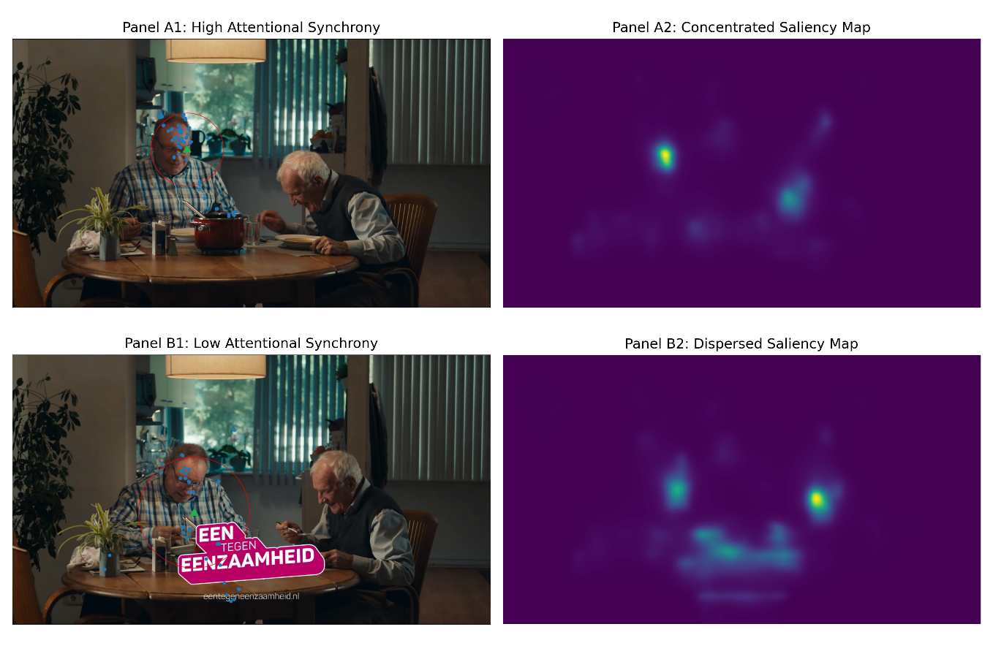
Notes: In the panel A1 (B1), representing higher (lower) attentional synchrony, the gaze points in blue are more (less) concentrated around the mean center, indicated by the green triangle, so the standard distance circle in red is smaller (larger), indicating more concentrated (dispersed) gaze points. Additionally, the saliency maps in Panel A2 (B2), based on the image pixels, shows less (more) areas competing for attention reflecting image complexity.

Figure A2: Example output from Microsoft Video Indexer for Video #22
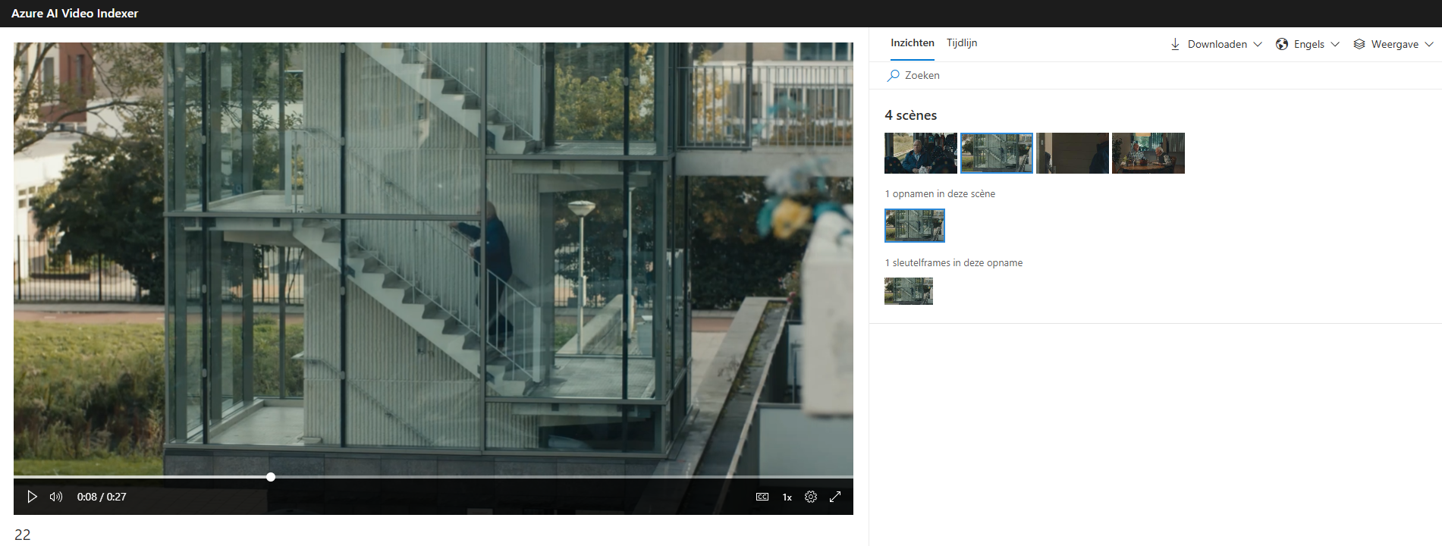
Example outtake of JSON output from Azure Video Indexer for video #22:
Data describing Scene #2 begins at 8.2 seconds and lasts until 11.8 seconds, the keyframe is shown for 0.033 seconds (i.e., 1 frame at 30FPS).
Scene #2 of this video: {"id": 2, "keyFrames": [{ "id": 2, "instances": [ { "thumbnailId": "23584ea4-7e5c-411e-808c-d88e34dbb1e7", "start": "0:00:08.2","end": "0:00:08.2333333"} ] } ], "instances": [{"start": "0:00:08", "end": "0:00:11.8"}

Appendix A1: Python code for computing saliency maps with Deep Gaze 2
#import tensorflow as tf
import tensorflow.compat.v1 as tf
tf.disable_v2_behavior()
import numpy as np
from scipy.ndimage import zoom
from scipy.special import logsumexp
import os
import matplotlib.pyplot as plt
import cv2
import progressbar
#get videos
os.chdir('.\deep_gaze')
''' Overall goal:
##calculate saliency maps per frame (per video)
## save these saliency maps to a folder
'''
# load centerbias template
centerbias_template = np.load('centerbias.npy')
#use pre-trained deep gaze model
tf.reset_default_graph()
check_point = 'DeepGazeII.ckpt' # DeepGaze II
#check_point = 'ICF.ckpt' # ICF
new_saver = tf.train.import_meta_graph('{}.meta'.format(check_point))
input_tensor = tf.get_collection('input_tensor')[0]
centerbias_tensor = tf.get_collection('centerbias_tensor')[0]
log_density = tf.get_collection('log_density')[0]
log_density_wo_centerbias = tf.get_collection('log_density_wo_centerbias')[0]
videos = os.listdir('.\Stimuli_Extension')
with tf.Session() as sess:
new_saver.restore(sess, check_point)
#iterate over all 42 videos
for vid in videos:
#read video start looping through frames
cap = cv2.VideoCapture(f'.\Stimuli_Extension\{vid}')
#cap.set(2,546);
print(f'processing: {vid}')
i = 1
amount_of_frames = int(cap.get(cv2.CAP_PROP_FRAME_COUNT))
#show progressbar
bar = progressbar.ProgressBar(maxval=amount_of_frames, \
widgets=[progressbar.Bar('=', '[', ']'), ' ', progressbar.Percentage()])
bar.start()
#writing numpy array of saliency maps per frame to this folder
while(True):
ret, frame = cap.read()
if ret == False:
break
frame = cv2.cvtColor(frame, cv2.COLOR_BGR2RGB)
centerbias = zoom(centerbias_template, (frame.shape[0]/1024, frame.shape[1]/1024), order=0, mode='nearest')
# renormalize log density
centerbias -= logsumexp(centerbias)
image_data = frame[np.newaxis, :, :, :]
centerbias_data = centerbias[np.newaxis, :, :, np.newaxis]

log_density_prediction = sess.run(log_density, {
input_tensor: image_data,
centerbias_tensor: centerbias_data,
})
#save saliency map to an outputfile (2d array) on the external hard drive (D:\),
os.chdir('.\density_maps_extension')
#os.chdir('D:\Deep_Gaze_II\output')
np.savez_compressed("{}\{}".format(vid.split('.')[0],i),np.exp(log _density_prediction[0, :, :, 0]))
os.chdir("..")
#update progress bar
try:
bar.update(i+1)
except:
pass
i += 1

Appendix A2: Computing Visual Complexity from Saliency Maps:
import os
import numpy as np
os.getcwd()
os.chdir('F:\Deep_Gaze_II\output')
import matplotlib.pyplot as plt
from scipy.spatial import distance
import progressbar
import pandas as pd
import cv2 as cv2
import pointpats
'''
Script goes through all the saliency maps per frame created by deep gaze II for all 42 videos.
It computes the dispersion in the density maps per frame, to compute a measure of visual complexity (i.e., more areas competing for attention).
More specifically, it computes the standard distance between the most salient areas per frame.
The output is saved on the external hard-drive.
'''
#dispersion measures using pointpats
mc = pointpats.mean_center(pp.points)
mc #mean centre
stdd = pointpats.std_distance(pp.points)
stdd #standard distance, this the main measure
final_data = pd.DataFrame()
#run script for all 42 video's
for vid in range(1,43):
#go to folder with deep gaze 2 output
os.chdir(f'F:\Deep_Gaze_II\output\{vid}')
amount_of_frames = len(os.listdir())
complexity_array = [] #empty array to contain complexity scores per frame
#update user feedback
print(2*'\n')
print(f'Processing video number: {vid}')
print(2*'\n')
#show progressbar per video
bar = progressbar.ProgressBar(maxval=amount_of_frames, \
widgets=[progressbar.Bar('=', '[', ']'), ' ', progressbar.Percentage()])
bar.start()
#iterate through all frames per video
for j in range(1,amount_of_frames+1):
test = np.load(f'./{j}.npz') #saliency maps per frame
heatmap = test['arr_0']
# Threshold the heatmap to create a binary array of X,Y points (top 5% of points)
threshold = np.quantile(test['arr_0'],0.95)
points = np.argwhere(heatmap >= threshold)
#create a window to plot in the shape of the original heatmap
shape = np.shape(heatmap)
win = pointpats.Window([(0, 0), (0, shape[1]), (shape[0],shape[1]), (shape[0], 0), (0, 0)])
#create point pattern data structure
pp = pointpats.PointPattern(points,window=win)
#compute dispersion measures
mc = pointpats.mean_center(pp.points) #mean centre
stdd = pointpats.std_distance(pp.points) #standard distance, this the main measure of complexity
#append to list
complexity_array.append(stdd)
#update progressbar
try:
bar.update(j)
except:
pass
#create dataframe with frame numbers and complexity measure (observation per frame), also a column with video number
frames = np.linspace(1,amount_of_frames,amount_of_frames,int)
vid_number = np.repeat(vid,amount_of_frames)
column_values = ["Frame","Complexity","Vid_Number"]
matrix = np.vstack([frames,complexity_array,vid_number])
matrix = np.transpose(matrix)
data = pd.DataFrame(matrix,columns=column_values)
#append data for current video to final_data
final_data = final_data.append(data)

Appendix A3: Python code to match keyframes to output from Microsoft Video Indexer
#create time since last cut variable from scene durations
cut_output = []
for vid in range(1,43):
scenes_vid = drive_search(vid,scenes)
vid_duration = len(scenes_vid['scene_durations'])/scenes_vid['fps']
output = np.linspace(0,vid_duration, len(scenes_vid['scene_durations']),np.int64)
for scene in scenes_vid['scenes']:
#find index of first cut and set timedelta to zero at this location in output vector
cut_start = pd.to_timedelta(scene[0]).total_seconds()
cut_end = pd.to_timedelta(scene[1]).total_seconds()
scene_duration = cut_end - cut_start
index_start = np.where(np.isclose(output,cut_start,rtol = 0.05))[0][-1]
index_end = np.where(np.isclose(output,cut_end,rtol = 0.05))[0][-1]
#replace value for first timepoint since last cut with 0 and start counting again to end cut, repeat for next scene
replacement = np.linspace(0,scene_duration,index_end- index_start,np.int64)
output[index_start:index_end] = replacement
#remove outlier at the end
newarr = []
for i in range(0,len(output)):
newarr.append(output[i] if output[i]-output[i-1] < 1 else output[i-1])
cut_output.append(newarr)

Web Appendix B: Descriptive Statistics of Scenes per Video
Table B1: Descriptive Statistics of Scenes per Video
Video  # | Total  Scenes | Average  Duration | Median  Duration | Max Scene  Duration | Min Scene  Duration | Total Video  Duration
1 | 3 | 9.00 | 4.50 | 20.57 | 1.93 | 27.00
2 | 6 | 4.49 | 2.92 | 12.80 | 2.16 | 26.96
3 | 12 | 2.25 | 2.06 | 5.56 | 1.24 | 27.00
4 | 8 | 3.38 | 2.60 | 6.27 | 1.60 | 27.00
5 | 8 | 3.38 | 3.30 | 7.20 | 1.10 | 27.00
6 | 14 | 1.93 | 1.55 | 4.70 | 1.07 | 27.00
7 | 17 | 1.59 | 1.60 | 2.43 | 1.03 | 26.97
8 | 10 | 2.69 | 2.15 | 6.00 | 1.23 | 26.90
9 | 15 | 1.80 | 1.70 | 3.57 | 1.07 | 27.00
10 | 11 | 2.45 | 1.96 | 6.36 | 1.32 | 26.96
11 | 8 | 3.38 | 2.10 | 11.12 | 1.52 | 27.00
12 | 13 | 2.08 | 2.13 | 3.27 | 1.07 | 27.00
13 | 13 | 2.08 | 1.96 | 3.72 | 1.32 | 27.00
14 | 13 | 2.08 | 1.72 | 4.12 | 1.36 | 27.00
15 | 11 | 2.73 | 2.56 | 4.64 | 1.36 | 30.00
16 | 11 | 2.73 | 2.60 | 4.88 | 1.24 | 30.00
17 | 9 | 3.00 | 2.57 | 7.27 | 1.43 | 27.00
18 | 5 | 5.40 | 5.43 | 8.33 | 2.37 | 27.00
19 | 4 | 6.75 | 6.75 | 7.80 | 5.70 | 27.00
20 | 6 | 4.50 | 3.75 | 9.20 | 2.00 | 27.00
21 | 18 | 1.50 | 1.40 | 2.63 | 1.03 | 27.03
22 | 4 | 6.75 | 7.60 | 8.00 | 3.80 | 27.00
23 | 4 | 6.75 | 7.18 | 9.53 | 3.10 | 27.00
24 | 5 | 5.40 | 5.92 | 7.08 | 2.56 | 27.00
25 | 10 | 2.70 | 2.36 | 4.92 | 1.48 | 27.00
26 | 7 | 3.99 | 4.12 | 9.44 | 0.44 | 27.96
27 | 10 | 2.80 | 2.60 | 5.12 | 0.44 | 27.96
28 | 12 | 2.25 | 1.97 | 6.13 | 1.10 | 27.00
29 | 11 | 2.45 | 2.17 | 6.13 | 1.03 | 27.00
30 | 11 | 2.45 | 1.50 | 6.33 | 1.07 | 27.00
31 | 17 | 1.59 | 1.50 | 2.77 | 1.17 | 27.00
32 | 12 | 2.25 | 2.20 | 4.13 | 1.10 | 27.00
33 | 12 | 2.25 | 2.20 | 4.13 | 1.10 | 27.00
34 | 14 | 1.93 | 1.95 | 3.23 | 1.07 | 27.00
35 | 10 | 2.70 | 2.53 | 4.47 | 1.23 | 27.00
36 | 9 | 3.00 | 2.16 | 9.12 | 1.36 | 27.00
37 | 14 | 1.91 | 1.92 | 3.53 | 1.03 | 26.80
38 | 12 | 2.25 | 1.63 | 5.40 | 1.17 | 27.00
39 | 9 | 3.00 | 2.67 | 5.33 | 1.43 | 27.00
40 | 6 | 4.50 | 3.95 | 7.97 | 2.60 | 27.00
41 | 10 | 2.70 | 2.62 | 4.83 | 1.37 | 27.00
42 | 17 | 1.76 | 1.68 | 2.56 | 1.24 | 30.00

Web appendix C: Augmented Dickey-Fuller (ADF) Tests
Web appendix D: Durbin-Watson Tests
Table D1: Durbin-Watson Tests per Video
Video | Model Lags |  |  | DW-test
# | P | Q | R | p-value
1 | 2 | 2 | 2 | 0.629
2 | 4 | 2 | 2 | 0.291
3 | 2 | 2 | 2 | 0.505
4 | 2 | 2 | 2 | 0.710
5 | 4 | 2 | 3 | 0.343
6 | 2 | 2 | 2 | 0.715
7 | 4 | 2 | 3 | 0.653
8 | 2 | 2 | 2 | 0.161
9 | 3 | 2 | 3 | 0.602
10 | 4 | 2 | 2 | 0.366
11 | 4 | 2 | 3 | 0.312
12 | 2 | 2 | 2 | 0.740
13 | 2 | 2 | 2 | 0.577
14 | 2 | 2 | 2 | 0.523
15 | 4 | 2 | 3 | 0.161
16 | 4 | 2 | 4 | 0.553
17 | 2 | 2 | 2 | 0.540
18 | 3 | 2 | 2 | 0.196
19 | 2 | 2 | 2 | 0.433
20 | 2 | 2 | 2 | 0.580
21 | 2 | 2 | 2 | 0.356
22 | 3 | 3 | 2 | 0.359
23 | 2 | 2 | 2 | 0.443
24 | 2 | 2 | 2 | 0.457
25 | 2 | 2 | 2 | 0.463
26 | 2 | 2 | 2 | 0.408
27 | 2 | 2 | 2 | 0.499
28 | 3 | 2 | 3 | 0.465
29 | 2 | 2 | 2 | 0.654
30 | 2 | 2 | 2 | 0.493
31 | 3 | 2 | 2 | 0.585
32 | 2 | 2 | 2 | 0.581
33 | 2 | 2 | 2 | 0.596
34 | 3 | 2 | 3 | 0.611
35 | 2 | 2 | 2 | 0.597
36 | 2 | 2 | 2 | 0.425
37 | 2 | 2 | 2 | 0.321
38 | 2 | 2 | 2 | 0.557
39 | 2 | 2 | 2 | 0.615
40 | 2 | 2 | 2 | 0.366
41 | 2 | 2 | 2 | 0.515
42 | 4 | 2 | 2 | 0.491

Web appendix E: ADRL Model with Additional Lagged Controls
In response to Reviewer #2, we added lagged controls to our model to address potential endogeneity concerns. In particular, we added a measure of audio complexity, called the acoustic complexity index (ACI; Pieretti et al., 2011). The ACI measures the variability of the sound spectrum intensities at different frequencies. These sound spectra were obtained by applying the Fast Fourier Transform (FFT) to the audio files. More complex sounds have higher variability in their intensities across the different frequencies (i.e., higher ACI values).
Thus far, we have considered visual complexity and scene cuts, but not the audio, because the viewing task is mostly visual in nature. However, audio plays a supporting role in multisensory attention (Knoeferle et al., 2016), and there might be benefits to synchronizing audio- and visual information (Simmonds, 2020). That being said, sounds create weaker effects on visual attention compared to visual cues in terms of eye movements (Simmonds, 2020). Moreover, research has shown that visual information takes precedence over audio information in terms of processing and memory (e.g., Cohen, Horowitz, & Wolfe, 2009).
By adding the ACI to our model (Pieretti et al., 2011), we control for audio effects. Using the same methodology, we repeated our analysis including this control variable. We show that our results are robust when adding this measure of audio complexity to our model. The meta-analysis reveals that, across all 42 videos, the long-run effects of visual complexity (random effect estimate = -1.22×10⁻³, 95% CI [-1.38×10⁻³, -1.05×10⁻³], p < 0.001) and scene cuts (random effect estimate = 1.82×10⁻³, 95% CI [1.39×10⁻³, 2.26×10⁻³], p < 0.001) on attentional synchrony remain statistically significant, in the same direction as our hypotheses.
To clarify how such long-term effects unfold, we again consider the interim multipliers and investigate how a change in video features affects the attentional synchrony time-series in the 20 video frames that follow this change, equivalent to two-thirds of a second at 30FPS (Figure E1). To facilitate interpretability, we convert the interim multipliers into percentage changes from the median baseline, then aggregate the values over all 42 videos; we report the findings separately for visual complexity and scene cuts.
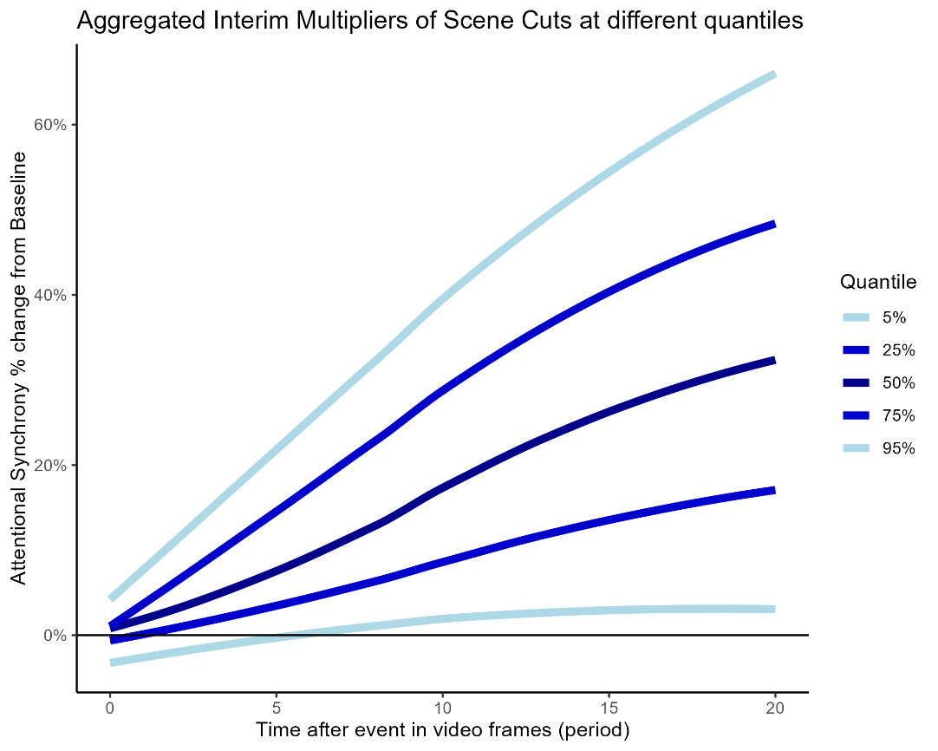
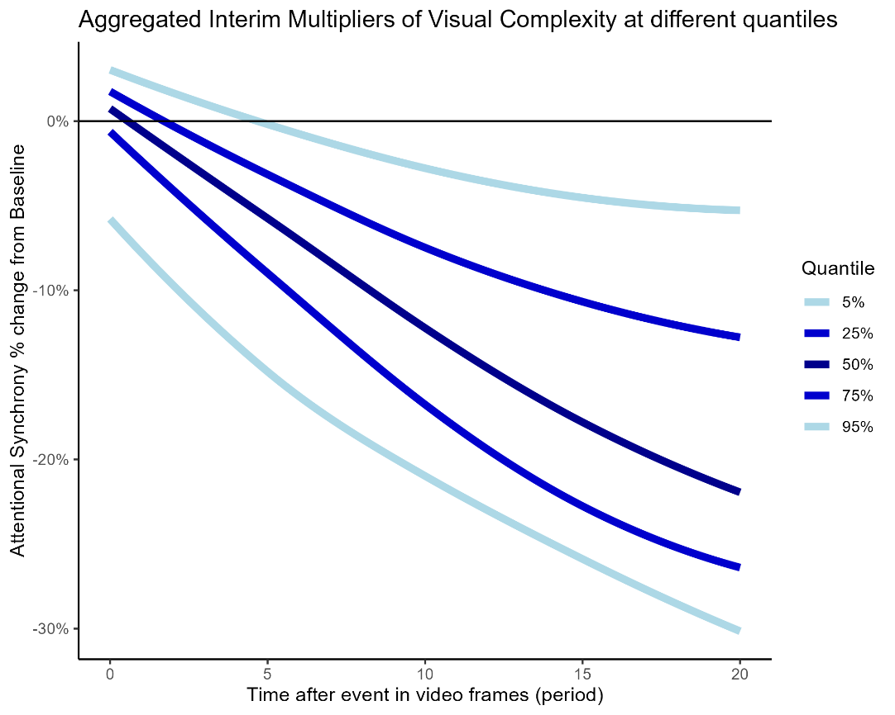
Figure E1: Aggregated Interim Multipliers, including ACI lagged control variable
References
Cohen, M. A., Horowitz, T. S., & Wolfe, J. M. (2009). Auditory recognition memory is inferior to visual recognition memory. Proceedings of the National Academy of Sciences, 106(14), 6008-6010.
Knoeferle, K. M., Knoeferle, P., Velasco, C., & Spence, C. (2016). Multisensory brand search: How the meaning of sounds guides consumers’ visual attention. Journal of Experimental Psychology: Applied, 22(2), 196.
Pieretti, N., Farina, A., & Morri, D. (2011). A new methodology to infer the singing activity of an avian community: The Acoustic Complexity Index (ACI). Ecological indicators, 11(3), 868-873.
Simmonds, L., Bogomolova, S., Kennedy, R., Nenycz‐Thiel, M., & Bellman, S. (2020). A dual‐process model of how incorporating audio‐visual sensory cues in video advertising promotes active attention. Psychology & Marketing, 37(8), 1057-1067.

Web appendix F: Alternative Operationalization of Attentional Synchrony
In response to reviewer #3, we have repeated our analysis using a different operationalization of attentional synchrony. We show that both operationalizations are strongly correlated and that they lead to similar results as shown below. We report correlations between these operationalizations, and the main results under this operationalization versus our main results.
Alternative operationalization: This calculation uses the pairwise Euclidian distances between each possible pair of gaze points (X, Y coordinates) per point in time, using the function “pdist” from the Scipy distances module in Python. It then takes the average of those values, and the inverse of this average distance is then our measure of attentional synchrony per point in time. Our original operationalization is very similar, but uses the mean center of the group and computes the standard distance from the gaze points to this mean center per point in time. We have chosen for the latter option in our analysis because this is more computationally efficient, versus computing this metric across all possible combinations.
Correlations: We find that the two alternative measures are strongly correlated (r = 0.85, p < 0.001). Both operationalizations of attentional synchrony led to similar values in terms of magnitude, and are strongly correlated over time. This shows that the metric is robust across different operationalizations, such that they are measuring the same underlying phenomenon.
Results from ARDL models: We repeated our main analysis with this alternative operationalization. As in our main analysis, we defined the model search space from a minimum number of two up to five lags per variable and selected the best model via AIC.
Using the same ARDL methodology, we repeated our main analysis. We show that our results are robust with this alternative operationalization. The meta-analysis reveals that, across all 42 videos, the long-run effects of visual complexity (random effect estimate = -1.01×10⁻³, 95% CI [-1.15×10⁻³, -0.87×10⁻³], p < 0.001) and scene cuts (random effect estimate = 1.70×10⁻³, 95% CI [1.34×10⁻³, 2.06×10⁻³], p < 0.001) on attentional synchrony remain statistically significant, in the same direction as our hypotheses. We show a positive effect on attentional focus after scene cuts, and a negative effect on attention with increasing visual complexity.
Regarding short-run effects, in line with the main model with additional lags, the short-run effect of visual complexity on attentional synchrony is no longer statistically significant (random effect estimate = -0.39×10⁻⁵, 95% CI [-1.60×10⁻⁵, 0.81×10⁻⁵], p = 0.260), but the short-run effect of scene cuts (random effect estimate = 3.70×10⁻⁵, 95% CI [1.33×10⁻⁵, 6.07×10⁻⁵], p = 0.002) remains statistically significant. That being said, the short-run effects happening on the same frame (i.e., within 0.03 seconds at 30 FPS), are much smaller than the long-run effects (i.e., two orders of magnitude), because the brain needs time to respond to visual changes. These effects on viewer responses happen over the course of a second.
In line with our predictions, these effects translate into a median 26% decrease in attentional synchrony, relative to the median baseline levels, following a one-standard-unit increase in visual complexity, as well as a median 43% increase after a scene cut. These effects are statistically significant with large effect sizes. Furthermore, the long-run effects are two orders of magnitude larger than the short-run effects, reflecting our prediction that visual features have a mostly delayed effect on attentional synchrony.
To clarify how such long-term effects unfold, we consider the interim multipliers and investigate how a change in video features affects the attentional synchrony time-series in the 20 video frames that follow this change, equivalent to two-thirds of a second at 30FPS (Figure F1). To facilitate interpretability, we convert the interim multipliers into percentage changes from the median baseline, then aggregate the values over all 42 videos; we report the findings separately for visual complexity and scene cuts.

Figure F1: Aggregated Interim Multipliers, using alternative operationalization of attentional synchrony via pairwise Euclidian distances.
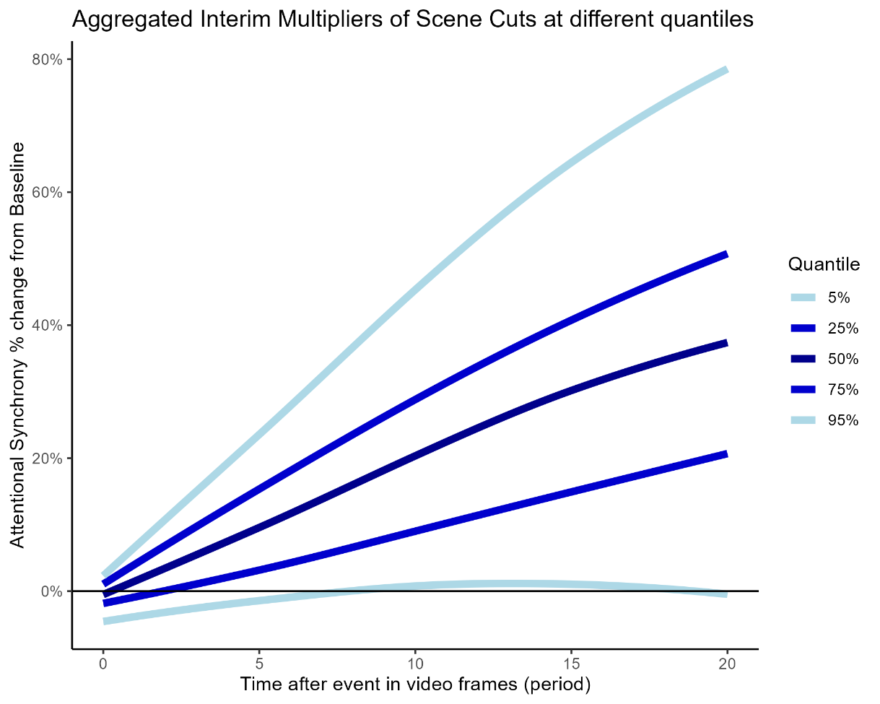
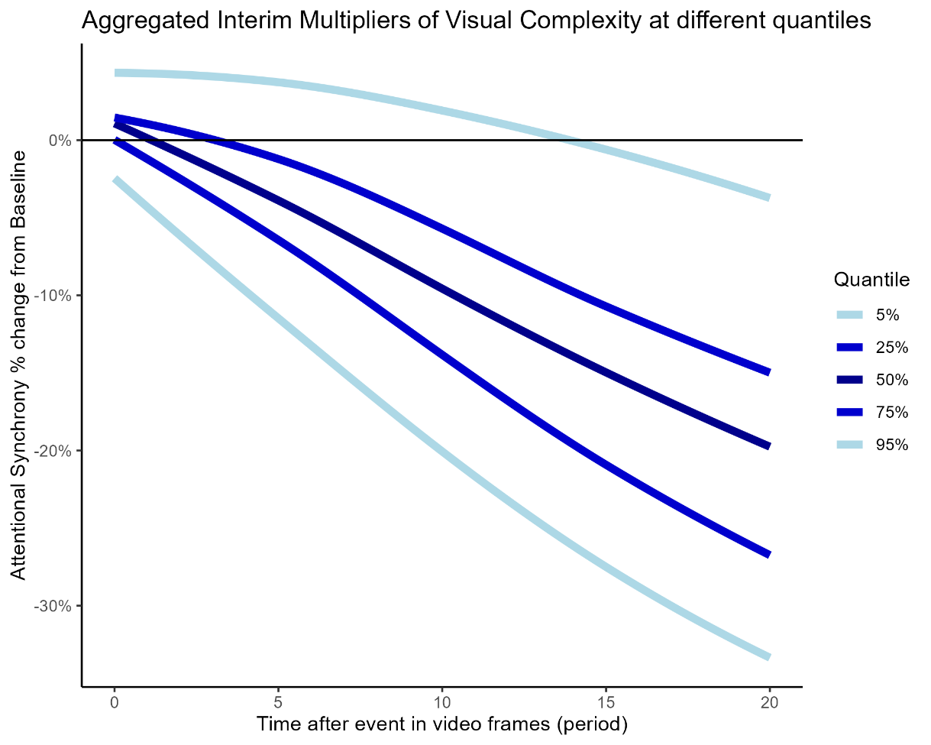

Web Appendix G: Delay Multipliers per Frame
Figure G1: Detailed Overview of Multipliers per Frame

Notes: These heat maps reveal, for each video (row), whether its short-run, delayed, and long-run effects are significant at a 90% confidence level.

Web appendix H: Demographics Subgroup Analysis
In response to the comments from reviewer #1 and #3, we ran an additional analysis to compare attentional synchrony across age groups. We used a median split to divide the sample into younger (n = 15, mean age = 20 years) and older participants (n = 15, mean age = 41 years). We re-calculated the attentional synchrony measure for each of these groups per frame, by using the same eye-tracking methodology as we did for the entire group. Figure H1 below shows that the measures are robust across groups. We observe similar patterns in attentional synchrony over time across groups, shown by a large positive correlation (r = 0.52, p < 0.001) between young and older subgroups across all 42 videos, which makes sense given that both groups of viewers are synchronized to the same stimulus.
On average, the younger group had higher levels of attentional synchrony than the older group (average median level difference = 0.0005, t(41) = 4.63, p < 0.001), as well as higher levels of volatility in the signal (average MAD difference = 0.0003, t(41) = 2.08, p = 0.04). These results translate to a 10% difference in attentional synchrony on average. This suggests that the younger group is more attentive and sensitive to changes than the older group, which is supported by literature on attention and age (e.g., Otaki, & Shibata, 2019).
Across videos, we examined how differences between the younger and older sub-groups were associated with characteristics of the videos. Using simple linear regression, we found that the difference in attentional synchrony between younger and older participants becomes larger for more arousing videos as judged by the average SAM scale arousal ratings (R = 0.42, t(40) = 2.89, p = 0.006; Figure H2). This makes sense as younger audiences are generally more attracted to arousing media content than older audiences (Mares, Oliver, & Cantor, 2008). We also examined differences between groups per individual video. The largest difference in attentional synchrony between age groups occurred for video #13 scoring higher with younger audiences (Figure H5), which is a story about partying while addressing drinking and driving as part of the BOB campaign. Video #8 scored highest relatively with older audiences, which is a story about doing your taxes as part of a campaign from the Dutch tax authority. Campaigns scoring relatively higher with young adults are BOB (videos #12 to #16) and HEY about mental health (Figure H6; videos #30 and #31), are targeted 16- to 25-year-olds (Ministerie van VWS, 2025).
Overall, these findings show our measure of attentional synchrony is robust across different samples, and sensitive to relevant differences in target audiences. This indicates that attentional synchrony is useful to assess audience responses in pre-testing of communication.
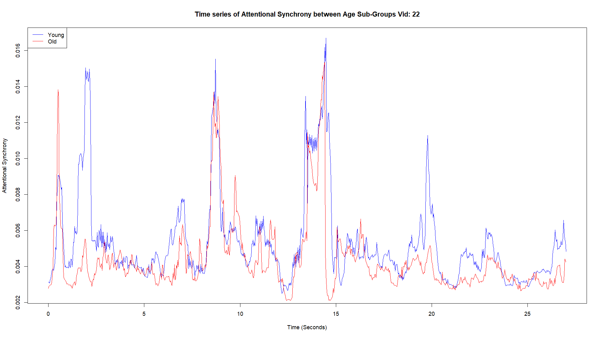
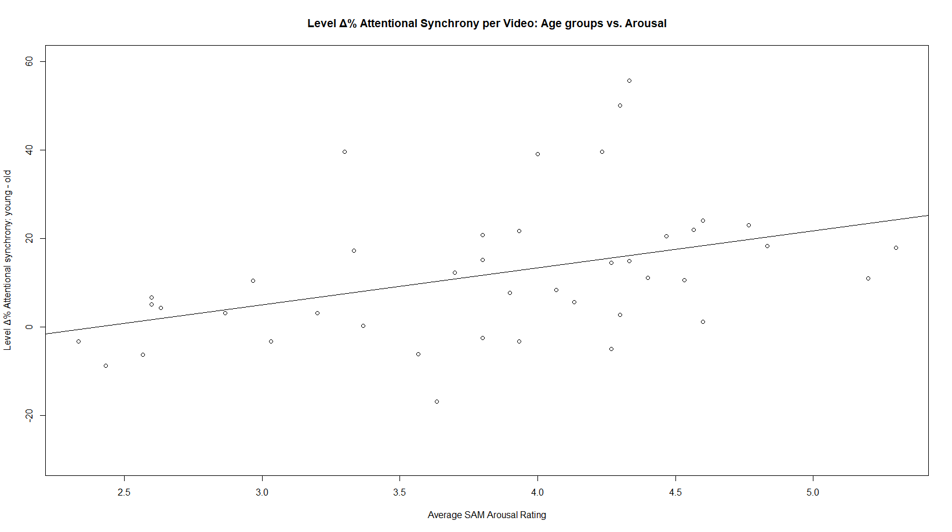
Figure H1: Attentional Synchrony time series for Video #22, shown for both younger (blue) and older (red) participants. Both groups are synchronized to the same stimulus.
Figure H2: Difference between Young and Old sub-groups over average arousal level per video. Younger audiences are more responsive to arousing content, than older audiences.
Replication of main ARDL results: Within subgroups, using the same ARDL methodology for time series modelling, we replicated our main effects and show that the dynamic effects of the video features remained significant and in the same direction for both age groups. More specifically, we show the negative effect of visual complexity and the positive effect of scene cuts on attentional synchrony levels for both groups.
For the young sub-group (Figure H3), the meta-analysis across all 42 videos reveals that the long-run effects are statistically significant both for the negative effect of visual complexity (random effect estimate = -1.30×10⁻³, 95% CI [-1.53×10⁻³, -1.06×10⁻³], p <0.001) and the positive effect of scene cuts (random effect estimate = 1.85×10⁻³, 95% CI [1.30×10⁻³, 2.40×10⁻³], p < 0.001). Similarly for the older group (Figure H4), the meta-analysis across all 42 videos reveals that the long-run effects are statistically significant both for the negative effect of visual complexity (random effect estimate = -1.12×10⁻³, 95% CI [-1.38×10⁻³, -0.87×10⁻³], p <0.001) and the positive effect of scene cuts (random effect estimate = 1.58×10⁻³, 95% CI [1.21×10⁻³, 1.96×10⁻³], p < 0.001). These effects translate to roughly 30% increases after scene cuts for young adults and 20% increases for older adults, compared to median baseline levels attentional synchrony. As well as roughly 20% decreases after a one standard deviation increase in visual complexity for young adults and 15% decreases in older adults, compared to median baseline levels attentional synchrony. These effects are similar, in the same directions, and their sizes are comparable with our main effects across both age groups.
Conclusions: We replicated our main results across both groups, but there are some differences between the age groups. An interesting detail to note is that the response of the younger group is both bigger and quicker than that of the older group. We observe that the response starts slightly sooner, and the long-run effect is bigger. Young audiences might be better able to respond to quick editing sequences than older audiences. These results might contradict popular beliefs that young people have worse attentional performance than older adults. However, in line with previous literature (e.g., Otaki, & Shibata, 2019), we find that young adults are generally quicker to respond to visual changes on the screen and show higher levels of attentional synchrony. Our findings suggest that young adults are more responsive to arousing videos, and relevant content that is targeted to young adults. These findings are in line with previous literature on age differences in engagement with arousing media content (Mares et al., 2008), and viewer responses may become more idiosyncratic with older age (Petroni et al., 2018).
Figure H3: Dynamic effects of scene cuts (top) visual complexity (bottom) in the younger age sub-group
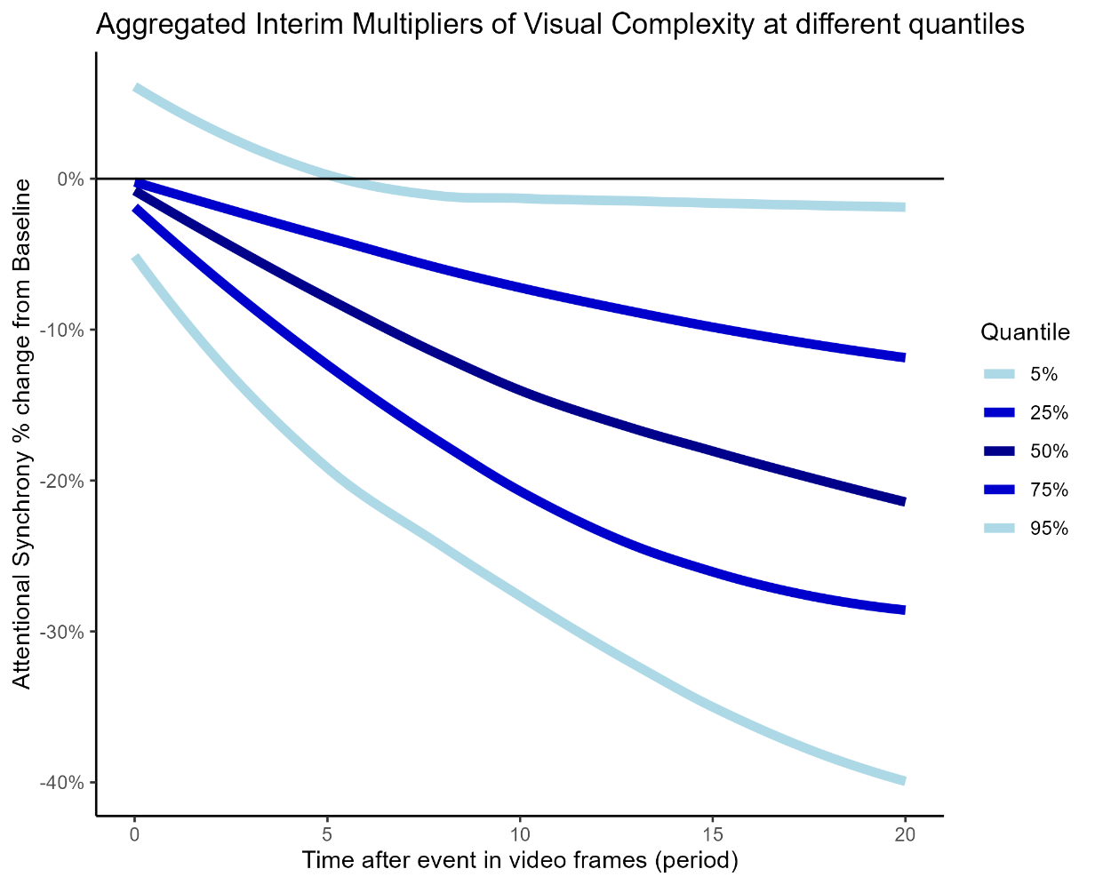
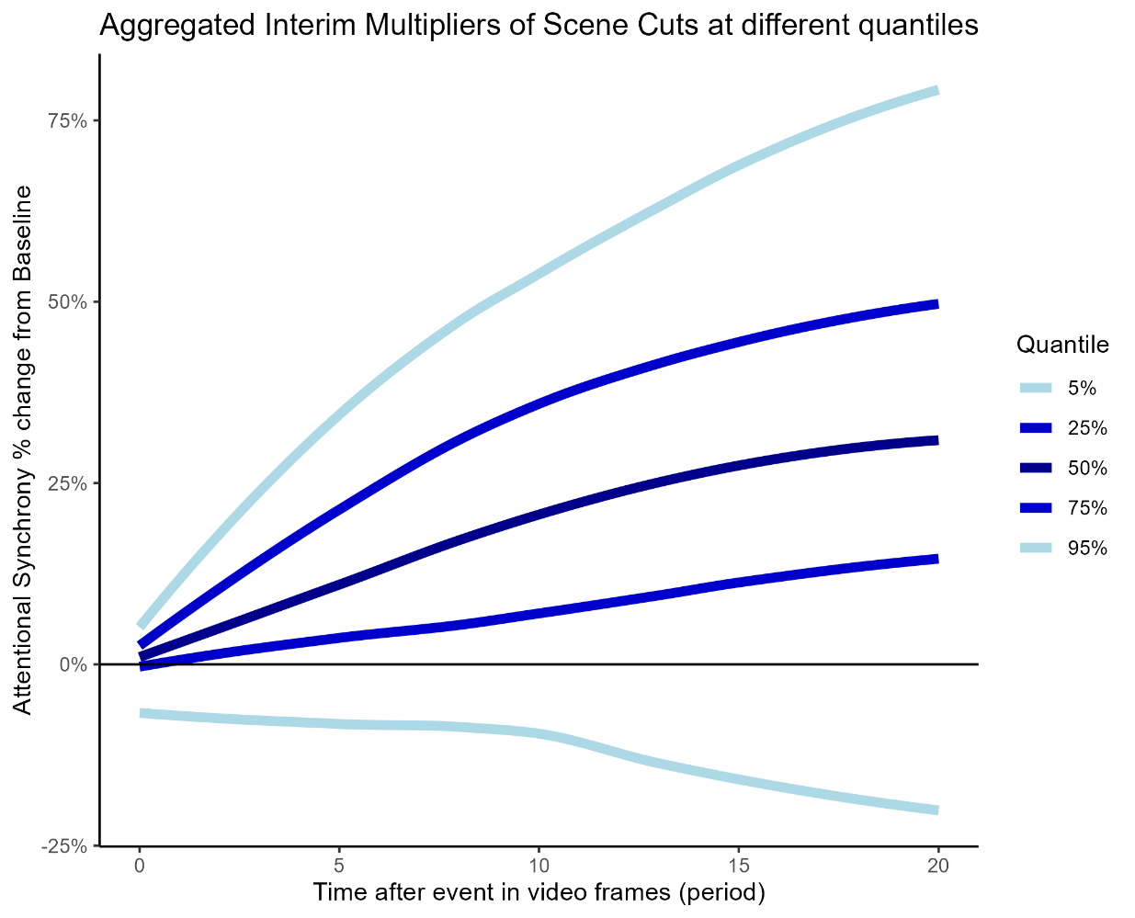
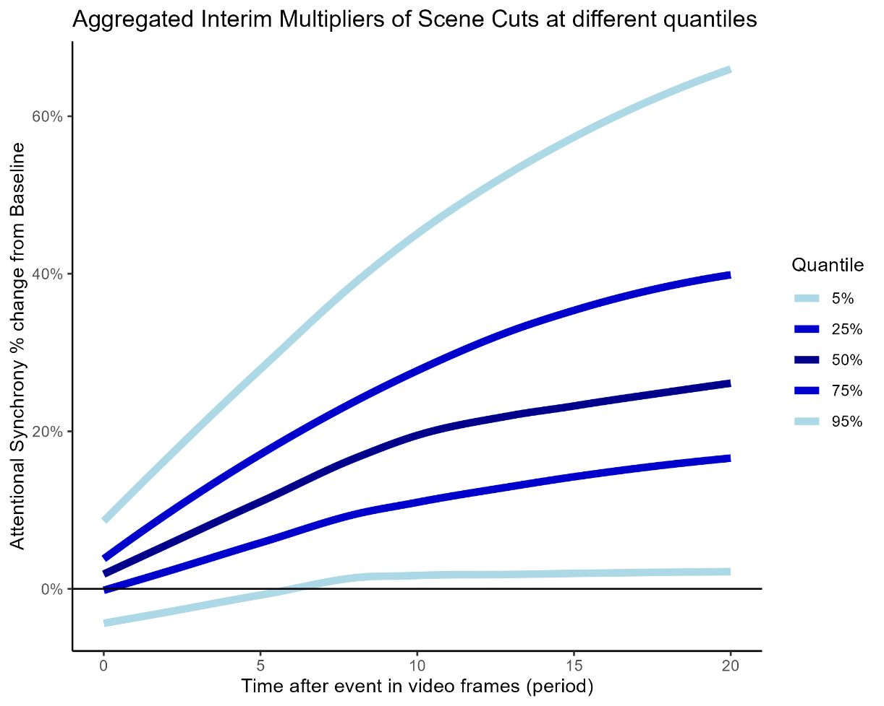
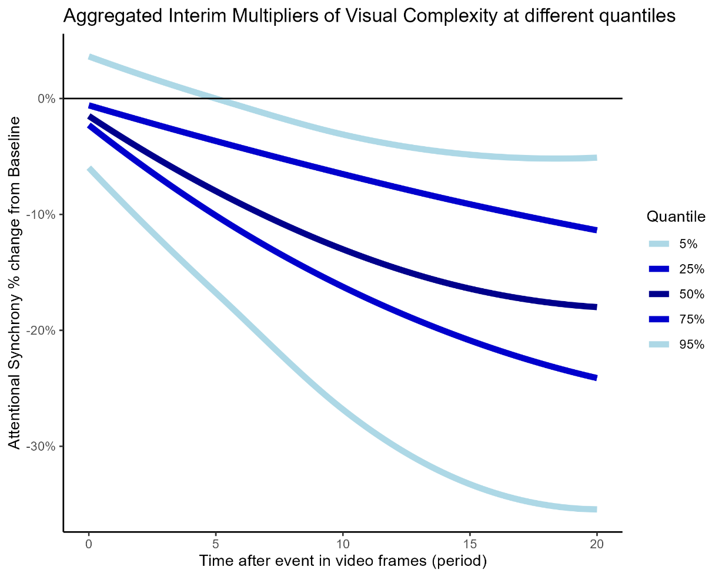
Figure H4 Dynamic effects of scene cuts (top) visual complexity (bottom) in the older age sub-group
Examples of Targeted Campaigns: BOB and HEY

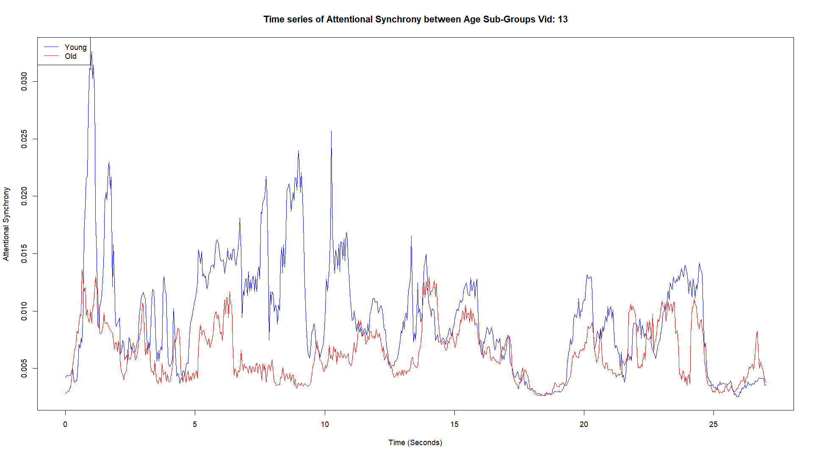
Figure H5: Video #13 of the BOB campaign about drinking and driving, scoring higher levels of attentional synchrony with young adults versus older audiences

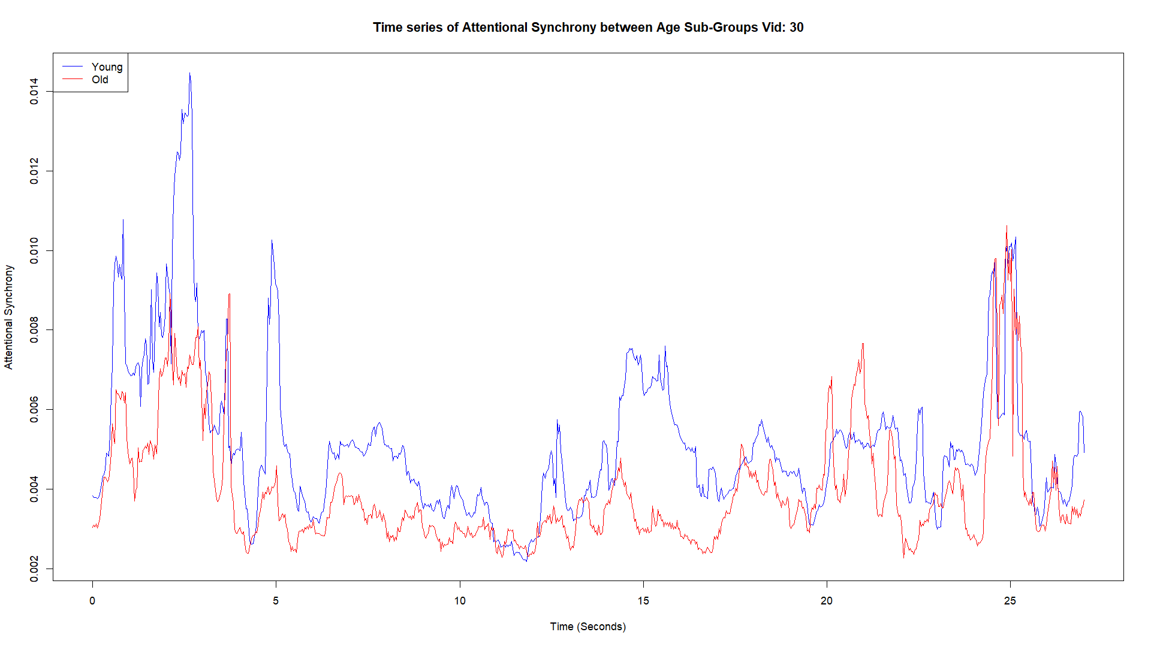
Figure H6: Video #30 of the HEY campaign about mental health in youths, scoring higher levels of attentional synchrony with young adults versus older audiences

References:
Mares, M. L., Oliver, M. B., & Cantor, J. (2008). Age differences in adults' emotional motivations for exposure to films. Media Psychology, 11(4), 488-511.
Otaki, M., & Shibata, K. (2019). The effect of different visual stimuli on reaction times: a performance comparison of young and middle-aged people. Journal of physical therapy science, 31(3), 250-254.
Ministerie van Volksgezondheid, Welzijn en Sport (VWS). (2025, N.D.,) Hey, het is oké'. Retrieved from: https://www.heyhetisoke.nl/over-de-campagne
Petroni, A., Cohen, S. S., Ai, L., Langer, N., Henin, S., Vanderwal, T., ... & Parra, L. C. (2018). The variability of neural responses to naturalistic videos change with age and sex. ENeuro, 5(1), ENEURO.0244-17.2017.

