Web Appendix A. DeepFace‐Derived Valence Recognition
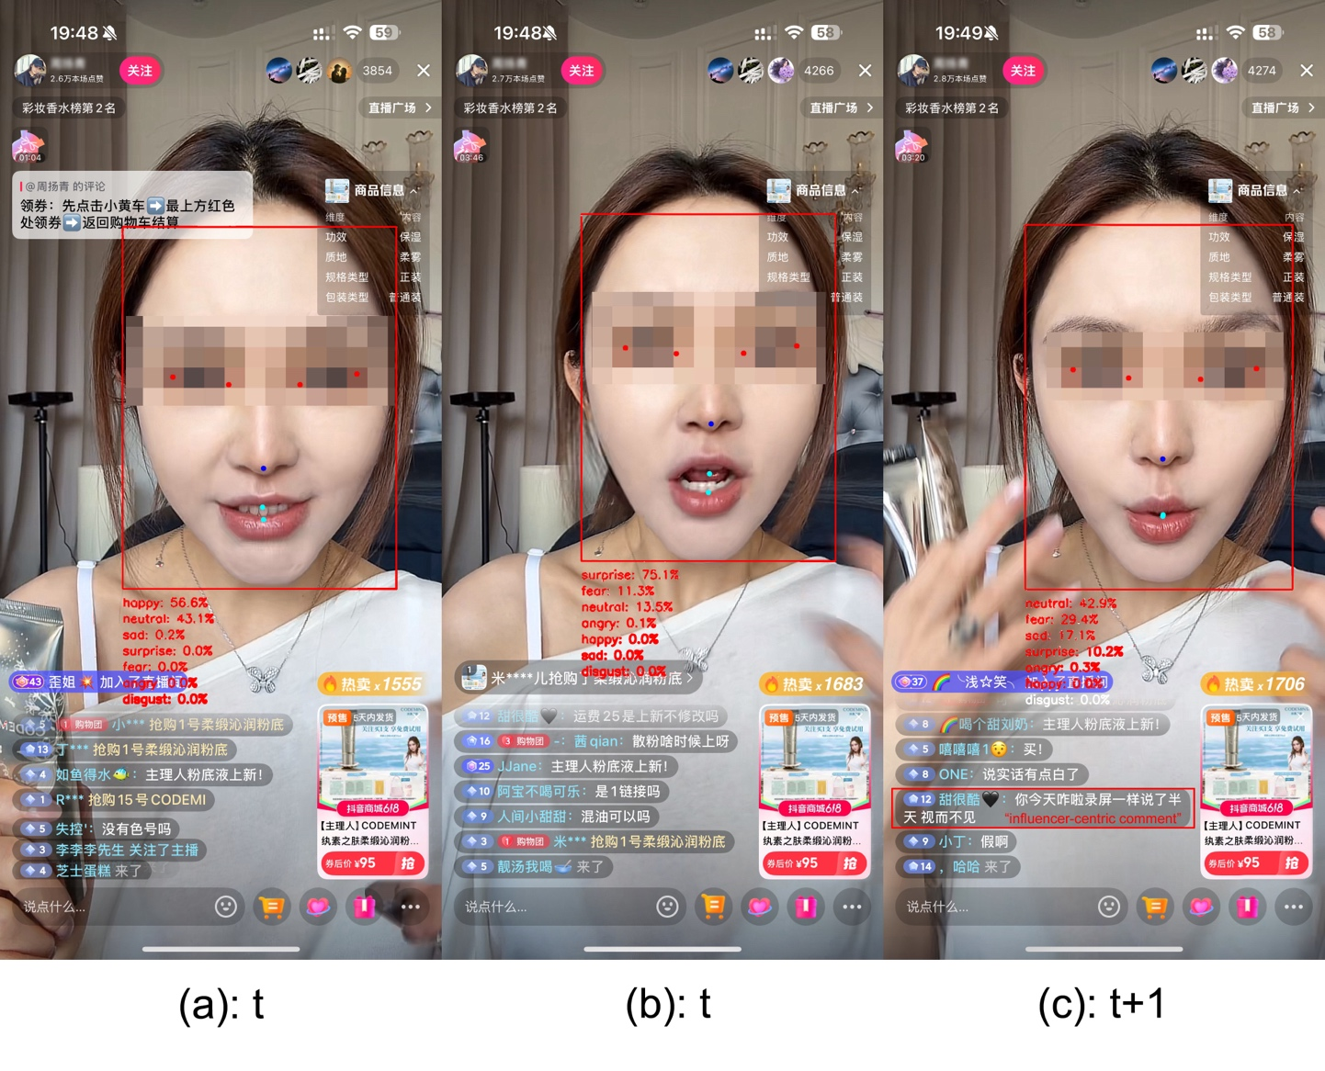
Figure 1. Three livestream frames depicting the DeepFace recognition results
Panels a-c show livestream frames at times t and t+1, each overlaid with DeepFace’s emotion probability outputs for the seven basic expressions. We aggregate them into a single valence label per frame by mapping “happy”→positive, “neutral”→neutral, and {“sad,” “fear,” “anger,” “disgust”}→negative, then assigning each frame the valence category with the highest summed probability. Accordingly, Panel a at t is classified as positive, Panel b at t is negative, and Panel c at t+1 is neutral, signaling a positive-to-negative transition at t.
In the comment feed in Panel c, we also observe the first viewer comments directed at the influencer, whereas in Panels a and b, all comments focus on the product or other topics. This shift suggests that the abrupt valence reversal redirected viewers’ attention toward the influencer. The minute‐level unit sales also dropped, from a range of 158-192 units in the five minutes preceding the transition (t-5 through t-1) to just 126 units at t+1. This concrete single-case example thus illustrates how sudden emotional transitions may coincide with reduced purchasing behaviour.

Web Appendix B
Table B1. Product-centric words list
No. | Words | English Translation | No. | Words | English Translation
1 | 价格 / 便宜 / 贵 / 优惠 / 实惠 | price / cheap / expensive / discount / affordable | 20 | 七号 / 7号 | number seven
2 | 保修 / 售后 / 维修 | warranty / after-sales service / repair | 21 | 八号 / 8号 | number eight
3 | 现货 / 库存 / 缺货 | in stock / inventory / out of stock | 22 | 九号 / 9号 | number nine
4 | 实拍 / 细节 / 真机展示 | real photos / details / live product demo | 23 | 十号 / 0号 | number ten / number zero
5 | 快递 / 发货 / 物流 | courier / shipping / logistics | 24 | 保真 / 正品 | guaranteed authentic / genuine product
6 | 几天到 | how many days to arrive | 25 | 产品 / 商品 | product / merchandise
7 | 功效 / 效果 | efficacy / effect | 26 | 品牌 | brand
8 | 客服 | customer service | 27 | 型号 | model number
9 | 讲一下 | describe / talk about | 28 | 功能 / 特性 | function / features
10 | 介绍 | introduce / introduction | 29 | 材质 / 材质怎么样 | material / what material is it
11 | 保质期 | shelf life | 30 | 口味 / 味道 | taste / flavor
12 | 拍不了 | cannot purchase | 31 | 成分 / 配方 | ingredients / formula
13 | 质保 / 安全认证 / 质量保证 | quality assurance / safety certification / quality guarantee | 32 | 产地 | place of origin
14 | 一号 / 1号 | number one | 33 | 包装 | packaging
15 | 二号 / 2号 | number two | 34 | 型号选择 / 规格 / 尺寸 / 大小 / 重量 | model selection / specifications / dimensions / size / weight
16 | 三号 / 3号 | number three | 35 | 颜色 / 款式 / 图案 | color / style / pattern
17 | 四号 / 4号 | number four | 36 | 配件 / 附赠 / 赠品 | accessories / freebies / gifts
18 | 五号 / 5号 | number five | 37 | 使用方法 / 怎么用 / 注意事项 | usage instructions / how to use / precautions
19 | 六号 / 6号 | number six

Table B2. Influencer-centric words list
No. | Words | English | No. | Words | English
1 | 你 / 哥 / 姐 | you | 21 | 惊喜 | delighted
2 | 主播 / 美女 | host | 22 | 冷静 | calm
3 | 伤心 | sad | 23 | 悲伤 | sorrowful
4 | 高兴 | happy | 24 | 喜悦 | joyful
5 | 开心 | cheerful | 25 | 烦恼 | annoyance
6 | 难过 | upset | 26 | 感动 | moving
7 | 生气 | angry | 27 | 无聊 | boring
8 | 快乐 | joyful | 28 | 疲倦 | tiring
9 | 沮丧 | depressed | 29 | 期待 | eager
10 | 兴奋 | excited | 30 | 害怕 | scary
11 | 激动 | agitated | 31 | 困惑 | confusing
12 | 焦虑 | anxious | 32 | 激昂 | exuberant
13 | 紧张 | nervous | 33 | 忧伤 | morose
14 | 满意 | satisfied | 34 | 沉默 | silent
15 | 失望 | disappointing | 35 | 安心 | relieving
16 | 恐惧 | fearful | 36 | 自豪 | proud
17 | 惊讶 | surprised | 37 | 羞愧 | ashamed
18 | 厌烦 | annoyed | 38 | 焦躁 | restless
19 | 愤怒 | furious | 39 | 满足 | content
20 | 忧郁 | melancholic | 40 | 郁闷 | gloomy

Web Appendix C. Multicollinearity Diagnostics
Table C1. Correlation Matrix of Focal Variables
 | 1 | 2 | 3 | 4 | 5 | 6 | 7 | 8 | 9 | 10 | 11 | 12
1. Total transition rate | -
2. Total transition rate² | .03 | -
3. PCR | -.08 | -.03 | -
4. Price | .07 | -.05 | -.07 | -
5. Discount | .04 | -.10 | -.03 | .06 | -
6. Promotion | .05 | -.07 | -.09 | .07 | .33 | -
7. Pitch duration | -.05 | -.01 | -.14 | -.11 | .07 | .07 | -
8. Total viewers | -.02 | -.02 | .19 | -.10 | .07 | .03 | .01 | -
9. Speech rate | -.06 | -.07 | -.01 | .05 | .10 | .08 | .05 | .00 | -
10. Speech volume | -.04 | .01 | .08 | -.09 | .01 | -.04 | -.07 | -.09 | -.11 | -
11. Time of day | .03 | -.02 | -.06 | -.02 | .03 | .01 | .02 | .22 | -.01 | -.16 | -
12. Weekend | .00 | .02 | .02 | -.04 | .05 | -.01 | .00 | .06 | .07 | .04 | .04 | -
Notes: PCR = Product Comment Ratio.

Table C2. Variance Inflation Factor (VIF) Diagnostics
Variable | VIF (without quadratics) | VIF (with quadratics)
Total transition rate | 1.022 | 1.023
Total transition rate² | — | 1.019
Product Comment Ratio | 1.095 | 1.096
Price | 1.053 | 1.055
Discount | 1.148 | 1.154
Promotion | 1.145 | 1.146
Pitch duration | 1.055 | 1.055
Total viewers | 1.123 | 1.123
Speech rate | 1.041 | 1.045
Speech volume | 1.072 | 1.072
Time of day | 1.088 | 1.088
Weekend | 1.016 | 1.017

Web Appendix D. Heatmaps
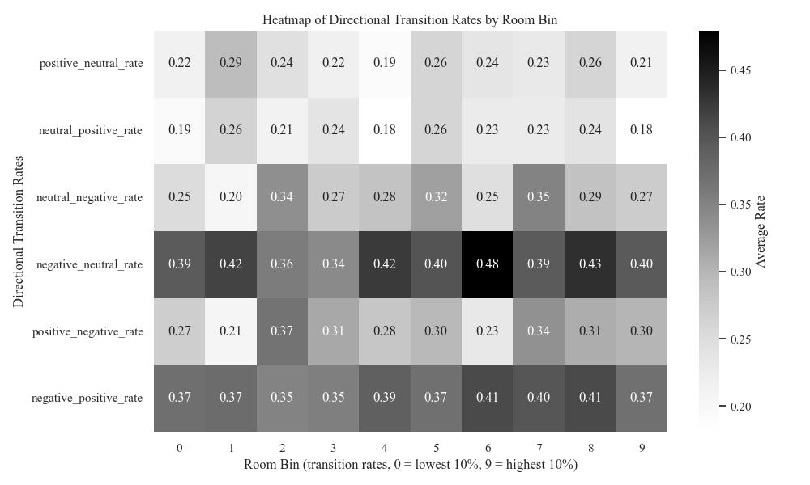
Figure D1. Heatmap of directional transition rates by room decile
Notes: Darker colors indicate more transitions per minute.

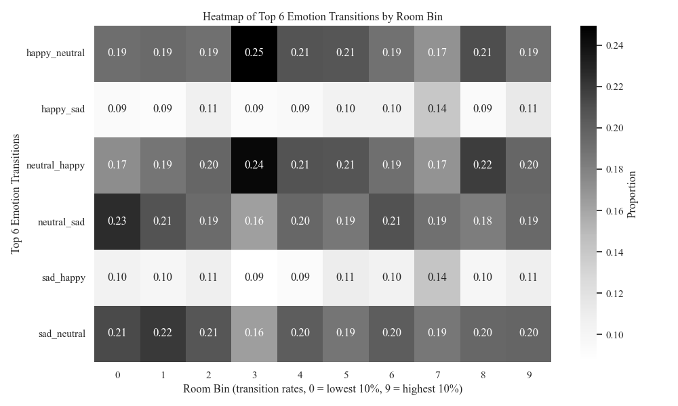
Figure D2. Heatmap of top six facial emotion paths by room decile
Notes: Cells show the proportion of each transition type, among all transitions, within that room.

Web Appendix E. Dual-Level Analytical Framework
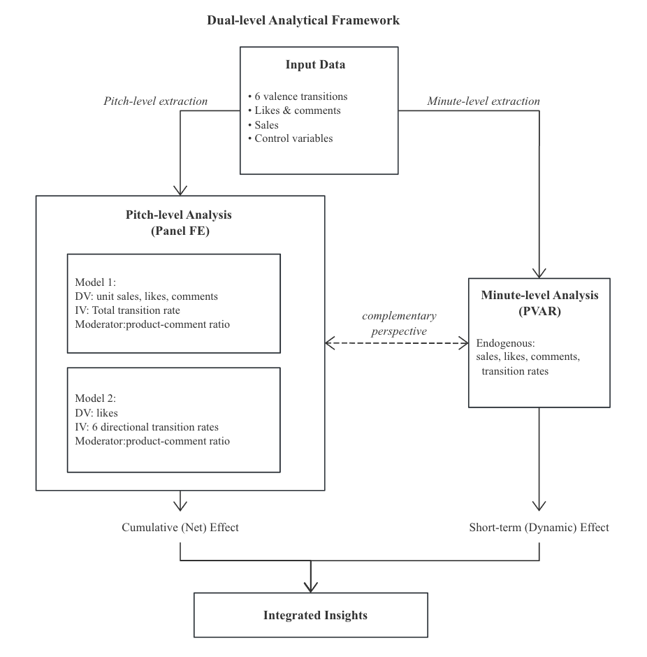

Web Appendix F. Effects of Seven-Emotion Transition Rates
 | Unit Sales |  | Likes |  | Comments
 | Estimate | SE | Estimate | SE | Estimate | SE
Emotion transition rates
Total transition rate | -1.034*** | (.165) | 1.338*** | (.104) | .753*** | (.096)
Total transition rate² | -.916** | (.452) | -.880*** | (.088) | -.500*** | (.119)
Control variables
Product price | -.142 | (.204) | -.209*** | (.054) | -.008 | (.031)
Discount | .253 | (.274) | .157** | (.075) | -.002 | (.072)
Promotion | .939*** | (.274) | .142** | (.059) | .003 | (.099)
Pitch duration | -1.046*** | (.113) | .602*** | (.013) | .115*** | (.033)
Total viewers | -.918*** | (.227) | -.206 | (.219) | -.014 | (.113)
Speech rate | -.330*** | (.110) | .036 | (.073) | .074* | (.040)
Speech volume | .364*** | (.116) | .147 | (.164) | -.049 | (.033)
Afternoon (morning) | -.572 | (.492) | .361 | (.279) | .268** | (.105)
Evening (morning) | -.861 | (.695) | 1.195*** | (.301) | .286 | (.183)
Weekend (weekday) | -.182 | (.421) | .436 | (.288) | .142 | (.210)
Product category | Yes |  | Yes |  | Yes
Fixed effects
Room | Yes |  | Yes |  | Yes
Observations | 12,949 |  | 12,946 |  | 12,949
*p < .1. **p < .05. ***p < .01.
Notes: SE = standard errors, in parentheses. Estimates are based on the Model 1 specification from the main analysis, but with the total transition rate calculated using the seven emotion categories (happiness, sadness, surprise, anger, fear, disgust, and neutral).

Web Appendix G. Robustness Checks
Table G1. Testing 1% outlier effects in Model 1
 | Outlier Treatment (winsorized at 1%)
 | Unit Sales |  | Likes |  | Comments
 | Estimate | SE | Estimate | SE | Estimate | SE
Main effects
Total transition rate | -.573** | (.279) | .214*** | (.047) | .214*** | (.051)
Quadratic effects
Total transition rate² | .453*** | (.167) | -1.566*** | (.138) | -.791*** | (.118)
Control variables
Product price | -.128 | (.222) | -.171*** | (.054) | .004 | (.029)
Discount | .201 | (.280) | .130** | (.060) | .002 | (.069)
Promotion | .949*** | (.281) | .147** | (.065) | .001 | (.105)
Pitch duration | -.845*** | (.070) | .583*** | (.020) | .071** | (.035)
Total viewers | -1.011*** | (.244) | -.153 | (.176) | .058 | (.107)
Speech rate | -.380*** | (.115) | .017 | (.042) | .079** | (.039)
Speech volume | .232*** | (.081) | .178 | (.130) | -.035 | (.034)
Afternoon (morning) | -.489 | (.486) | .279 | (.278) | .252** | (.104)
Evening (morning) | -.789 | (.871) | 1.221*** | (.291) | .271 | (.179)
Weekend (weekday) | -.566 | (.360) | .454* | (.254) | .184 | (.212)
Product category | Yes |  | Yes |  | Yes
Fixed effects
Room | Yes |  | Yes |  | Yes
Observations | 12,817 |  | 12,814 |  | 12,817
*p < .1. **p < .05. ***p < .01.
Notes: SE = standard errors clustered at the account level, in parentheses. Five PCA components of product categories are included.

Table G2. Testing 5% outlier effects in Model 1
 | Outlier Treatment (winsorized at 5%)
 | Unit Sales |  | Likes |  | Comments
 | Estimate | SE | Estimate | SE | Estimate | SE
Main effects
Total transition rate | -.570** | (.263) | .234*** | (.054) | .185*** | (.062)
Quadratic effects
Total transition rate² | .503* | (.298) | -1.513*** | (.137) | -.873*** | (.136)
Control variables
Product price | -.134 | (.228) | -.171*** | (.053) | .003 | (.030)
Discount | .159 | (.289) | .131** | (.057) | -.002 | (.071)
Promotion | .974*** | (.283) | .141** | (.063) | .002 | (.106)
Pitch duration | -.864*** | (.079) | .586*** | (.019) | .071** | (.036)
Total viewers | -1.021*** | (.241) | -.149 | (.175) | .054 | (.108)
Speech rate | -.377*** | (.114) | .031 | (.042) | .080* | (.041)
Speech volume | .221*** | (.073) | .185 | (.131) | -.036 | (.035)
Afternoon (morning) | -.499 | (.487) | .295 | (.282) | .257** | (.109)
Evening (morning) | -.814 | (.881) | 1.231*** | (.299) | .280 | (.183)
Weekend (weekday) | -.534 | (.354) | .463* | (.254) | .187 | (.218)
Product category | Yes |  | Yes |  | Yes
Fixed effects
Room | Yes |  | Yes |  | Yes
Observations | 12,411 |  | 12,408 |  | 12,411
*p < .1. **p < .05. ***p < .01.
Notes: SE = standard errors clustered at the account level, in parentheses. Five PCA components of product categories are included.

Table G3. Testing OLS fixed-effects estimation in Model 1
 | Unit Sales |  | Likes |  | Comments
 | Estimate | SE | Estimate | SE | Estimate | SE
Main effects
Total transition rate | -.276*** | (.029) | .506*** | (.023) | .103*** | (.015)
Quadratic effects
Total transition rate² | .273*** | (.059) | -1.617*** | (.047) | -.239*** | (.030)
Control variables
Product price | .033 | (.053) | -.116*** | (.026) | .042*** | (.015)
Discount | .033 | (.055) | .117*** | (.040) | .009 | (.025)
Promotion | -.041 | (.092) | -.124* | (.069) | .003 | (.039)
Pitch duration | -.430*** | (.037) | .268*** | (.027) | .100*** | (.013)
Total viewers | -.807*** | (.072) | -.078 | (.076) | .135*** | (.029)
Speech rate | -.010 | (.026) | .155*** | (.028) | .022* | (.013)
Speech volume | -.087** | (.034) | -.079** | (.036) | .002 | (.015)
Afternoon (morning) | -.083 | (.110) | -.131 | (.088) | .046 | (.048)
Evening (morning) | .215 | (.155) | .072 | (.150) | -.040 | (.064)
Weekend (weekday) | -.321 | (.204) | -.022 | (.295) | .044 | (.092)
Product category | Yes |  | Yes |  | Yes
Fixed effects
Room | Yes |  | Yes |  | Yes
Observations | 12,949 |  | 12,946 |  | 12,949
*p < .1. **p < .05. ***p < .01.
Notes: SE = standard errors clustered at the account level, in parentheses. Five PCA components of product categories are included.

Table G4. Transition probability effects, Model 1
 | Positive-to-Negative |  | Negative-to-Positive
 | Estimate | SE | Estimate | SE
Main effects
Total transition rate | -.713** | (.286) | -.567** | (.232)
Quadratic effects
Total transition rate² | .842*** | (.234) | .559*** | (.201)
Moderator
ProdCommRatio | 2.301*** | (.455) | 2.191*** | (.489)
× Total transition probability | 1.209** | (.506) | .964*** | (.366)
× Total transition probability² | -2.647*** | (.901) | -2.741*** | (.961)
Probabilities
Positive-to-negative transition probability | -1.641*** | (.543) | — | —
Positive-to-negative transition probability² | 2.904 | (.730) | — | —
Negative-to-positive transition probability | — | — | -2.581*** | (.527)
Negative-to-positive transition probability² | — | — | 6.327*** | (1.547)
Control variables
Product Price | -.149 | (.195) | -.151 | (.193)
Discount | .206 | (.336) | .253 | (.319)
Promotion | .900** | (.389) | .935*** | (.361)
Pitch duration | -.796*** | (.095) | -.728*** | (.075)
Total viewers | -.839*** | (.197) | -.826*** | (.197)
Speech rate | -.428*** | (.097) | -.417*** | (.088)
Speech volume | .176** | (.088) | .210*** | (.077)
Afternoon (morning) | -.439 | (.414) | -.426 | (.441)
Evening (morning) | -.972 | (.858) | -.919 | (.924)
Weekend (weekday) | -.005 | (.475) | -.123 | (.481)
Price category | Yes |  | Yes
Fixed effects | Yes |  | Yes
Room | Yes |  | Yes
Observations | 12,949 |  | 12,949
*p < .1. **p < .05. ***p < .01.
Notes: SE = standard errors clustered at the account level, in parentheses. Five PCA components of product categories are included. The transition probability, P(A→B) = count(A→B)/∑jcount(A→j), reflects the probability that an emotion in state A shifts to state B (excluding A→A).

Table G5. Testing 1% outlier effects in Model 2
 | Outlier Treatment (winsorized at 1%)
 | Unit Sales |  |  | Likes |  | Comments
 | Estimate | SE |  | Estimate | SE | Estimate |  | SE
Main effects
Positive-to-negative transition rate | -2.306*** | (.648) |  | .525*** | (.127) | .459** |  | (.216)
Negative-to-positive transition rate | -2.272*** | (.644) |  | .812*** | (.158) | .855*** |  | (.174)
Positive-to-neutral transition rate | -1.003** | (.437) |  | .265** | (.117) | .361 |  | (.252)
Neutral-to-positive transition rate | -.287 | (.605) |  | .404*** | (.140) | -.010 |  | (.228)
Neutral-to-negative transition rate | -.179 | (.479) |  | .443*** | (.120) | .425* |  | (.249)
Negative-to-neutral transition rate | -.408 | (.311) |  | 1.033*** | (.227) | .261 |  | (.219)
Quadratic effects
Positive-to-negative transition rate² | 1.458*** | (.403) |  | -.707*** | (.145) | -.442*** |  | (.150)
Negative-to-positive transition rate² | 1.845*** | (.508) |  | -1.234*** | (.122) | -.983*** |  | (.144)
Positive-to-neutral transition rate² | .728 | (.621) |  | -.691*** | (.087) | -.545** |  | (.231)
Neutral-to-positive transition rate² | .086 | (.736) |  | -.457 | (.286) | -.038 |  | (.314)
Neutral-to-negative transition rate² | .069 | (.359) |  | -.796*** | (.113) | -.508** |  | (.200)
Negative-to-neutral transition rate² | .171 | (.340) |  | -1.451*** | (.192) | -.276 |  | (.218)
Control variables
Product price | -.104 | (.206) |  | -.203*** | (.052) | -.019 |  | (.031)
Discount | .277 | (.249) |  | .155*** | (.058) | .001 |  | (.073)
Promotion | .876*** | (.263) |  | .053 | (.043) | -.029 |  | (.097)
Pitch duration | -.803*** | (.071) |  | .571*** | (.025) | .050 |  | (.036)
Total viewers | -.859*** | (.208) |  | -.134 | (.186) | .039 |  | (.112)
Speech rate | -.328*** | (.103) |  | .046 | (.042) | .070* |  | (.041)
Speech volume | .251*** | (.069) |  | .194 | (.151) | -.042 |  | (.032)
Afternoon (morning) | -.526 | (.476) |  | .274 | (.293) | .269*** |  | (.103)
Evening (morning) | -.827 | (.805) |  | 1.135*** | (.342) | .269 |  | (.184)
Weekend (weekday) | -.365 | (.472) |  | .484* | (.289) | .131 |  | (.181)
Product category | Yes |  | Yes |  |  |  | Yes
Fixed effects
Room | Yes |  | Yes |  |  |  | Yes
Observations | 12,817 |  |  | 12,814 |  | 12,817
*p < .1. **p < .05. ***p < .01.
Notes: SE = standard errors clustered at the account level, in parentheses. Five PCA components of product categories are included.

Table G6. Testing 5% outlier effects in Model 2
 | Outlier Treatment (winsorized at 5%)
 | Unit Sales |  |  | Likes |  |  |  |  | Comments
 | Estimate | SE |  | Estimate |  | SE |  |  | Estimate |  | SE
Main effects
Positive-to-negative transition rate | -.946 | (.707) |  | .807*** |  | (.112) |  |  | .420 |  | (.280)
Negative-to-positive transition rate | -2.394*** | (.716) |  | .902*** |  | (.234) |  |  | .851*** |  | (.170)
Positive-to-neutral transition rate | -.988* | (.582) |  | .030 |  | (.200) |  |  | .865** |  | (.342)
Neutral-to-positive transition rate | 1.488** | (.691) |  | .221 |  | (.206) |  |  | -.023 |  | (.318)
Neutral-to-negative transition rate | -1.459 | (.957) |  | .357 |  | (.268) |  |  | .654* |  | (.377)
Negative-to-neutral transition rate | -.778* | (.470) |  | 1.103*** |  | (.293) |  |  | .254 |  | (.334)
Quadratic effects
Positive-to-negative transition rate² | -1.764 | (2.199) |  | -2.114*** |  | (.548) |  |  | -.504 |  | (.816)
Negative-to-positive transition rate² | 2.886*** | (.938) |  | -1.690*** |  | (.370) |  |  | -1.352*** |  | (.342)
Positive-to-neutral transition rate² | 1.177 | (1.994) |  | -.229 |  | (.561) |  |  | -2.813*** |  | (.941)
Neutral-to-positive transition rate² | -5.466*** | (2.029) |  | .754 |  | (.879) |  |  | .002 |  | (.986)
Neutral-to-negative transition rate² | 3.200 | (2.286) |  | -.094 |  | (1.231) |  |  | -1.445* |  | (.858)
Negative-to-neutral transition rate² | .629 | (.990) |  | -1.560*** |  | (.453) |  |  | -.258 |  | (.837)
Control variables
Product price | -.126 | (.214) |  | -.205*** |  | (.055) |  |  | -.022 |  | (.031)
Discount | .257 | (.249) |  | .165*** |  | (.064) |  |  | -.004 |  | (.073)
Promotion | .923*** | (.261) |  | .066 |  | (.050) |  |  | -.033 |  | (.095)
Pitch duration | -.811*** | (.081) |  | .577*** |  | (.035) |  |  | .007 |  | (.042)
Total viewers | -.834*** | (.183) |  | -.128 |  | (.186) |  |  | .022 |  | (.108)
Speech rate | -.329*** | (.094) |  | .073* |  | (.040) |  |  | .078* |  | (.043)
Speech volume | .206*** | (.062) |  | .192 |  | (.145) |  |  | -.045 |  | (.034)
Afternoon (morning) | -.538 | (.488) |  | .297 |  | (.290) |  |  | .267** |  | (.107)
Evening (morning) | -.967 | (.770) |  | 1.151*** |  | (.328) |  |  | .273 |  | (.179)
Weekend (weekday) | -.271 | (.393) |  | .470* |  | (.269) |  |  | .133 |  | (.181)
Product category | Yes |  | Yes |  |  |  |  | Yes
Fixed effects
Room | Yes |  | Yes |  |  |  |  | Yes
Observations | 12,411 |  |  |  | 12,408 |  | 12,411
*p < .1. **p < .05. ***p < .01.
Notes: SE = standard errors clustered at the account level, in parentheses. Five PCA components of product categories are included.

Table G7. Moderation effects on sales, Models 1 and 2
 | Model 1 |  | Model 2
 | Divided By Influencer Comments | With Zero Comments | Divided By Influencer Comments | With Zero Comments
Main effects
Total transition rate | -.443*** | -.390* | — | —
Total transition rate | (.155) | (.216)
Positive-to-negative transition rate | — | — | -2.551*** | -2.785***
Positive-to-negative transition rate |  |  | (0.805) | (1.016)
Negative-to-positive transition rate | — | — | -2.123*** | -2.004***
Negative-to-positive transition rate |  |  | (0.504) | (0.585)
Positive-to-neutral transition rate | — | — | -0.664 | -0.695*
Positive-to-neutral transition rate |  |  | (0.413) | (0.414)
Neutral-to-positive transition rate | — | — | -1.058** | -1.109***
Neutral-to-positive transition rate |  |  | (0.498) | (0.422)
Neutral-to-negative transition rate | — | — | -0.349 | -0.325
Neutral-to-negative transition rate |  |  | (0.420) | (0.651)
Negative-to-neutral transition rate | — | — | 0.810 | 0.608
Negative-to-neutral transition rate |  |  | (0.746) | (0.748)
Quadratic effects
Total transition rate² | .567** | .594*** | — | —
Total transition rate² | (.251) | (.223)
Positive-to-negative transition rate² | — | — | 1.501*** | 1.670***
Positive-to-negative transition rate² |  |  | (0.468) | (0.567)
Negative-to-positive transition rate² | — | — | 1.766*** | 1.691***
Negative-to-positive transition rate² |  |  | (0.439) | (0.519)
Positive-to-neutral transition rate² | — | — | 0.314 | 0.847
Positive-to-neutral transition rate² |  |  | (0.548) | (0.595)
Neutral-to-positive transition rate² | — | — | 0.709 | 0.581
Neutral-to-positive transition rate² |  |  | (0.720) | (0.512)
Neutral-to-negative transition rate² | — | — | 0.215 | 0.328
Neutral-to-negative transition rate² |  |  | (0.277) | (0.405)
Negative-to-neutral transition rate² | — | — | -0.585 | -0.333
Negative-to-neutral transition rate² |  |  | (0.461) | (0.404)
Moderator
ProdCommRatio | 3.290*** | 2.945*** | 3.793*** | 3.820***
ProdCommRatio | (.585) | (.511) | (0.541) | (0.573)
× Total transition rate | .702 | .387 | — | —
× Total transition rate | (.443) | (.565)
× Total transition rate² | -1.333** | -1.266*** | — | —
× Total transition rate² | (.562) | (.458)
× Positive-to-negative transition rate | — | — | 4.622** | 4.653**
× Positive-to-negative transition rate |  |  | (1.882) | (2.159)
× Negative-to-positive transition rate | — | — | 2.742* | 2.732*
× Negative-to-positive transition rate |  |  | (1.444) | (1.426)
× Positive-to-neutral transition rate | — | — | -1.005 | -0.074
× Positive-to-neutral transition rate |  |  | (2.115) | (1.461)
× Neutral-to-positive transition rate | — | — | 4.967*** | 4.920***
× Neutral-to-positive transition rate |  |  | (1.580) | (1.475)
× Neutral-to-negative transition rate | — | — | 1.355* | 0.640
× Neutral-to-negative transition rate |  |  | (0.783) | (1.157)
× Negative-to-neutral transition rate | — | — | -2.554 | -2.036
× Negative-to-neutral transition rate |  |  | (1.697) | (1.511)
× Positive-to-negative transition rate² | — | — | -2.735** | -2.789**
× Positive-to-negative transition rate² |  |  | (1.149) | (1.246)
× Negative-to-positive transition rate² | — | — | -2.334* | -2.712**
× Negative-to-positive transition rate² |  |  | (1.330) | (1.312)
× Positive-to-neutral transition rate² | — | — | 1.909 | -1.038
× Positive-to-neutral transition rate² |  |  | (1.985) | (1.416)
× Neutral-to-positive transition rate² | — | — | -3.245 | -3.245*
× Neutral-to-positive transition rate² |  |  | (2.050) | (1.774)
× Neutral-to-negative transition rate² | — | — | -1.036** | -0.687
× Neutral-to-negative transition rate² |  |  | (0.463) | (0.637)
× Negative-to-neutral transition rate² | — | — | 0.841 | 0.550
× Negative-to-neutral transition rate² |  |  | (0.709) | (0.723)
Controls
Product price | -.185 | -.157 | -0.193 | -0.197
 | (.163) | (.181) | (0.140) | (0.145)
Discount | .216 | .173 | 0.271 | 0.270
 | (.250) | (.296) | (0.208) | (0.222)
Promotion | 1.090*** | 1.027*** | 0.955*** | 0.826**
 | (.294) | (.394) | (0.279) | (0.356)
Pitch duration | -.745*** | -.763*** | -0.676*** | -0.705***
 | (.079) | (.081) | (0.066) | (0.069)
Total viewers | -.832*** | -.855*** | -0.791*** | -0.781***
 | (.204) | (.212) | (0.180) | (0.163)
Speech rate | -.308*** | -.379*** | -0.278*** | -0.349***
 | (.110) | (.091) | (0.102) | (0.083)
Speech volume | .211** | .145 | 0.224*** | 0.153*
 | (.085) | (.092) | (0.074) | (0.088)
Afternoon (morning) | -.433 | -.382 | -0.417 | -0.409
 | (.357) | (.339) | (0.267) | (0.260)
Evening (morning) | -.704 | -.594 | -0.834 | -0.819
 | (.713) | (.828) | (0.678) | (0.715)
Weekend (weekday) | -.323 | -.259 | -0.244 | -0.157
 | (.240) | (.288) | (0.309) | (0.340)
Product category | Yes | Yes | Yes | Yes
Fixed effects
Room | Yes | Yes | Yes | Yes
Observations | 12,167 | 11,827 | 12,167 | 11,827
*p < .1. **p < .05. ***p < .01.
Notes: SE = standard errors clustered at the account level, in parentheses. Five PCA components of product categories are included. Divided By Influencer Comments is the moderator, defined as the number of product comments divided by the sum of product comments and influencer-centric comments. With Zero Comments uses the same ratio but is computed before dropping pitches with no product- or influencer-related comments. Each variable serves as a moderator in both Models 1 and 2.

Table G8. Effects of lagged transition rates, Models 1 and 2
 | Unit Sales |  | Likes |  | Comments
 | Estimate | SE | Estimate | SE | Estimate | SE
Model 1
Main effects
Total transition rate | -.454* | (.265) | .239*** | (.050) | .200*** | (.050)
Quadratic effects
Total transition rate² | .579*** | (.113) | -1.486*** | (.072) | -.735*** | (.114)
Control variables
Lagged transition rate | -.262 | (.218) | -.179*** | (.046) | -.037 | (.039)
Product price | -.383*** | (.065) | -.169*** | (.054) | .006 | (.029)
Discount | .276 | (.286) | .165*** | (.044) | .022 | (.067)
Promotion | .995*** | (.272) | .149** | (.058) | .024 | (.111)
Pitch duration | -.824*** | (.076) | .586*** | (.014) | .075** | (.035)
Total viewers | -.460** | (.214) | -.163 | (.196) | -.046 | (.120)
Speech rate | -.273*** | (.098) | -.002 | (.048) | .070* | (.039)
Speech volume | .099 | (.096) | .174 | (.134) | -.031 | (.034)
Afternoon (morning) | -.193 | (.253) | .282 | (.288) | .274** | (.110)
Evening (morning) | -1.024 | (.629) | 1.211*** | (.290) | .344* | (.186)
Weekend (weekday) | -.374** | (.152) | .421 | (.259) | .187 | (.205)
Price category | Yes |  | Yes |  | Yes
Fixed effects
Room | Yes |  | Yes |  | Yes
Observations | 12,308 |  | 12,346 |  | 12,348
Model 2
Main effects
Positive-to-negative transition rate | -1.129*** | (.408) | .416*** | (.105) | .450** |  | (.208)
Negative-to-positive transition rate | -2.170*** | (.818) | .722*** | (.107) | .900*** |  | (.170)
Positive-to-neutral transition rate | -.752** | (.331) | .298** | (.116) | .329 |  | (.261)
Neutral-to-positive transition rate | -1.014 | (.830) | .444*** | (.140) | -.002 |  | (.210)
Neutral-to-negative transition rate | -.406 | (.317) | .388*** | (.111) | .364 |  | (.245)
Negative-to-neutral transition rate | -.490 | (.309) | 1.131*** | (.221) | .202 |  | (.183)
Quadratic effects
Positive-to-negative transition rate² | .626*** | (.224) | -.506*** | (.167) | -.417*** |  | (.136)
Negative-to-positive transition rate² | 1.776*** | (.644) | -1.181*** | (.095) | -1.057*** |  | (.148)
Positive-to-neutral transition rate² | .543 | (.520) | -.767*** | (.099) | -.542** |  | (.242)
Neutral-to-positive transition rate² | .764 | (.868) | -.613*** | (.211) | -.119 |  | (.239)
Neutral-to-negative transition rate² | .247 | (.212) | -.552*** | (.074) | -.413** |  | (.168)
Negative-to-neutral transition rate² | .165 | (.134) | -1.511*** | (.146) | -.183 |  | (.134)
Control variables
Lagged transition rate | -.190 | (.162) | -.173*** | (.038) | -.039 |  | (.039)
Product price | -.339*** | (.058) | -.201*** | (.050) | -.019 |  | (.029)
Discount | .334 | (.242) | .182*** | (.045) | .018 |  | (.070)
Promotion | .886*** | (.238) | .055 | (.044) | -.007 |  | (.100)
Pitch duration | -.832*** | (.076) | .577*** | (.019) | .055 |  | (.037)
Total viewers | -.330 | (.206) | -.191 | (.223) | -.088 |  | (.126)
Speech rate | -.240** | (.098) | .025 | (.046) | .064 |  | (.042)
Speech volume | .114 | (.075) | .188 | (.158) | -.038 |  | (.034)
Afternoon (vs. morning) | -.204 | (.235) | .284 | (.297) | .303*** |  | (.110)
Evening (vs. morning) | -.910* | (.541) | 1.153*** | (.321) | .365* |  | (.193)
Weekend (weekday) | -.387** | (.185) | .451 | (.292) | .138 |  | (.177)
Price category | Yes |  | Yes |  | Yes
Fixed effects
Room | Yes |  | Yes |  | Yes
Observations | 12,308 |  | 12,346 |  | 12,348
*p < .1. **p < .05. ***p < .01.
Notes: SE = standard errors clustered at the account level, in parentheses. Five PCA components of product categories are included.

Table G9. Poorly performance pitches, Models 1 and 2
 | Unit Sales |  | Likes |  | Comments
 | Estimate | SE | Estimate | SE | Estimate | SE
Model 1
Main effects
Total transition rate | -.461* | (.269) | .103 | (.067) | -.018 | (.017)
Quadratic effects
Total transition rate² | -.261 | (.440) | -.528*** | (.104) | -.040 | (.057)
Control variables
Product price | -.308*** | (.066) | .042 | (.127) | -.033 | (.023)
Discount | .195 | (.350) | .247** | (.107) | -.046 | (.033)
Promotion | .914** | (.387) | -.205*** | (.069) | .074 | (.063)
Pitch duration | -.865*** | (.140) | .029 | (.134) | -.095*** | (.034)
Total viewers | -.626*** | (.190) | -.383*** | (.122) | -.004 | (.061)
Speech rate | -.458*** | (.102) | .022 | (.017) | -.031 | (.025)
Speech volume | .322*** | (.074) | -.115*** | (.044) | .010 | (.030)
Afternoon (morning) | -.495* | (.293) | .114 | (.142) | .018 | (.070)
Evening (morning) | -2.588*** | (.724) | .525* | (.276) | -.096 | (.104)
Weekend (weekday) | -.059 | (.365) | .011 | (.111) | -.206* | (.110)
Price category | Yes |  | Yes |  | Yes
Fixed effects
Room | Yes |  | Yes |  | Yes
Observations | 3,138 |  | 3,134 |  | 3,134
Model 2
Main effects
Positive-to-negative transition rate | -1.940** | (.842) | .764*** | (.121) | .055 |  | (.098)
Negative-to-positive transition rate | -1.339*** | (.458) | .252 | (.257) | .176* |  | (.101)
Positive-to-neutral transition rate | -.673 | (1.075) | .548** | (.234) | .163 |  | (.283)
Neutral-to-positive transition rate | -.950 | (.620) | 1.102*** | (.347) | -.187 |  | (.133)
Neutral-to-negative transition rate | -.205 | (.390) | .663*** | (.165) | -.155** |  | (.072)
Negative-to-neutral transition rate | .282 | (.347) | .632*** | (.201) | -.106 |  | (.080)
Quadratic effects
Positive-to-negative transition rate² | 1.018** | (.451) | -.481*** | (.068) | -.050 |  | (.058)
Negative-to-positive transition rate² | 1.051** | (.411) | -.226 | (.240) | -.246** |  | (.121)
Positive-to-neutral transition rate² | .476 | (.978) | -.592*** | (.187) | -.134 |  | (.233)
Neutral-to-positive transition rate² | .232 | (.794) | -1.226*** | (.435) | .118 |  | (.117)
Neutral-to-negative transition rate² | .008 | (.262) | -.478*** | (.104) | .061 |  | (.044)
Negative-to-neutral transition rate² | -.802* | (.467) | -.657*** | (.175) | .132** |  | (.057)
Control variables
Product price | -.247** | (.098) | -.004 | (.119) | -.030 |  | (.024)
Discount | .247 | (.285) | .256*** | (.096) | -.045 |  | (.034)
Promotion | .827*** | (.251) | -.197** | (.082) | .064 |  | (.063)
Pitch duration | -1.036*** | (.136) | .039 | (.117) | -.099*** |  | (.036)
Total viewers | -.585*** | (.196) | -.434*** | (.119) | -.012 |  | (.054)
Speech rate | -.418*** | (.094) | .002 | (.030) | -.030 |  | (.027)
Speech volume | .318*** | (.065) | -.100*** | (.038) | .007 |  | (.031)
Afternoon (vs. morning) | -.449* | (.245) | .088 | (.114) | .026 |  | (.066)
Evening (vs. morning) | -2.915*** | (1.096) | .487** | (.235) | -.076 |  | (.094)
Weekend (weekday) | -.054 | (.446) | .009 | (.104) | -.207* |  | (.113)
Price category | Yes |  | Yes |  | Yes
Fixed effects
Room | Yes |  | Yes |  | Yes
Observations | 3,138 |  | 3,134 |  | 3,34
*p < .1. **p < .05. ***p < .01.
Notes: SE = standard errors clustered at the account level, in parentheses. Five PCA components of product categories are included.

Table G10. First Appearance of Each Product Within a Room, Models 1 and 2
 | Unit Sales |  | Likes |  | Comments
 | Estimate | SE | Estimate | SE | Estimate | SE
Model 1
Main effects
Total transition rate | -.448* | (.257) | .282*** | (.061) | .227*** | (.039)
Quadratic effects
Total transition rate² | -.006 | (.131) | -1.537*** | (.196) | -.713*** | (.141)
Control variables
Product price | -.404*** | (.064) | -.011 | (.128) | .001 | (.072)
Discount | .295 | (.291) | .056 | (.161) | .033 | (.084)
Promotion | .885*** | (.231) | .335*** | (.122) | .031 | (.086)
Pitch duration | -.790*** | (.124) | .440*** | (.028) | .057 | (.054)
Total viewers | -.471*** | (.179) | -.255 | (.265) | -.018 | (.125)
Speech rate | -.316*** | (.098) | -.016 | (.042) | .064 | (.053)
Speech volume | .274*** | (.104) | -.040* | (.021) | -.014 | (.032)
Afternoon (morning) | -.188 | (.300) | .069 | (.149) | .317* | (.172)
Evening (morning) | -.541 | (.573) | .590** | (.286) | .402* | (.227)
Weekend (weekday) | -.635*** | (.204) | .016 | (.263) | .209 | (.210)
Price category | Yes |  | Yes |  | Yes
Fixed effects
Room | Yes |  | Yes |  | Yes
Observations | 7,107 |  | 7,094 |  | 7,107
Model 2
Main effects
Positive-to-negative transition rate | -1.018** | (.450) | .583*** | (.151) | .764** |  | (.345)
Negative-to-positive transition rate | -1.797*** | (.673) | 1.136*** | (.318) | 1.163*** |  | (.308)
Positive-to-neutral transition rate | -1.021 | (.666) | 1.170*** | (.200) | .689 |  | (.495)
Neutral-to-positive transition rate | -.179 | (.858) | .933*** | (.294) | .045 |  | (.348)
Neutral-to-negative transition rate | -.313 | (.222) | .418* | (.230) | .278 |  | (.347)
Negative-to-neutral transition rate | .093 | (.415) | 1.193*** | (.250) | .367 |  | (.261)
Quadratic effects
Positive-to-negative transition rate² | .516** | (.222) | -.439** | (.203) | -.501** |  | (.216)
Negative-to-positive transition rate² | 1.343** | (.534) | -1.431*** | (.283) | -1.239*** |  | (.270)
Positive-to-neutral transition rate² | .648 | (.737) | -1.368*** | (.201) | -.680* |  | (.405)
Neutral-to-positive transition rate² | -.204 | (1.004) | -.793** | (.327) | .042 |  | (.327)
Neutral-to-negative transition rate² | .078 | (.135) | -.418** | (.169) | -.259 |  | (.206)
Negative-to-neutral transition rate² | -.545* | (.313) | -1.373*** | (.143) | -.215 |  | (.171)
Control variables
Product price | -.375*** | (.052) | -.076 | (.132) | -.036 |  | (.074)
Discount | .353 | (.247) | .125 | (.159) | .045 |  | (.085)
Promotion | .819*** | (.229) | .259 | (.187) | .038 |  | (.057)
Pitch duration | -.841*** | (.146) | .421*** | (.027) | .073 |  | (.049)
Total viewers | -.417*** | (.157) | -.193 | (.275) | .003 |  | (.126)
Speech rate | -.298*** | (.090) | .028 | (.063) | .057 |  | (.056)
Speech volume | .269*** | (.088) | -.064** | (.032) | -.018 |  | (.027)
Afternoon (vs. morning) | -.218 | (.295) | .127 | (.176) | .367** |  | (.172)
Evening (vs. morning) | -.547 | (.507) | .483 | (.307) | .486** |  | (.229)
Weekend (weekday) | -.702*** | (.225) | .099 | (.213) | .286 |  | (.251)
Price category | Yes |  | Yes |  | Yes
Fixed effects
Room | Yes |  | Yes |  | Yes
Observations | 7,107 |  | 7,094 |  | 7,107
*p < .1. **p < .05. ***p < .01.
Notes: SE = standard errors clustered at the account level, in parentheses. Five PCA components of product categories are included.

Table G11. Moderating effects of product comment ratio, Model 2
 | Unit Sales |  | Likes |  | Comments
 | Estimate | SE | Estimate | SE | Estimate | SE
Main effects
Positive-to-negative transition rate | -2.588*** | (0.963) | 0.344*** | (0.132) | 0.547** | (0.214)
Negative-to-positive transition rate | -2.797*** | (0.821) | 0.917*** | (0.089) | 0.855*** | (0.148)
Positive-to-neutral transition rate | -0.812** | (0.414) | 0.161 | (0.123) | 0.411* | (0.244)
Neutral-to-positive transition rate | -1.192*** | (0.330) | 0.447*** | (0.169) | 0.083 | (0.200)
Neutral-to-negative transition rate | -0.812 | (0.653) | 0.467*** | (0.116) | 0.362 | (0.227)
Negative-to-neutral transition rate | -0.269 | (0.680) | 1.064*** | (0.219) | 0.224 | (0.174)
Quadratic effects
Positive-to-negative transition rate² | 1.546*** | (0.529) | -0.520*** | (0.166) | -0.577*** | (0.155)
Negative-to-positive transition rate² | 2.159*** | (0.614) | -1.407*** | (0.074) | -1.041*** | (0.153)
Positive-to-neutral transition rate² | 0.656 | (0.556) | -0.665*** | (0.125) | -0.629*** | (0.230)
Neutral-to-positive transition rate² | 0.531* | (0.315) | -0.540 | (0.336) | -0.261 | (0.247)
Neutral-to-negative transition rate² | 0.417 | (0.421) | -0.673*** | (0.090) | -0.429*** | (0.160)
Negative-to-neutral transition rate² | -0.028 | (0.373) | -1.358*** | (0.185) | -0.316** | (0.141)
Moderator
ProdCommRatio | 2.637*** | (0.710) | -0.283 | (0.187) | -1.708*** | (0.437)
× Positive-to-negative transition rate | 2.376 | (2.423) | 0.509 | (0.365) | 0.810 | (0.665)
× Negative-to-positive transition rate | 3.699** | (1.502) | -0.999 | (1.155) | 0.087 | (0.647)
× Positive-to-neutral transition rate | -1.518 | (1.361) | 1.035** | (0.431) | -0.017 | (1.116)
× Neutral-to-positive transition rate | 4.848*** | (1.211) | -0.719 | (0.816) | 0.002 | (0.725)
× Neutral-to-negative transition rate | 3.343*** | (1.234) | -0.710 | (0.734) | 0.784 | (0.538)
× Negative-to-neutral transition rate | 0.201 | (1.486) | -1.186*** | (0.285) | -0.881* | (0.524)
× Positive-to-negative transition rate² | -1.816 | (1.493) | 0.590* | (0.318) | -0.977* | (0.523)
× Negative-to-positive transition rate² | -3.128** | (1.261) | 1.645 | (1.473) | -0.282 | (0.804)
× Positive-to-neutral transition rate² | 0.777 | (1.234) | -0.134 | (0.493) | 0.082 | (1.124)
× Neutral-to-positive transition rate² | -3.895** | (1.648) | 1.387 | (1.237) | -0.582 | (0.901)
× Neutral-to-negative transition rate² | -1.668*** | (0.543) | 0.627 | (0.580) | -0.735** | (0.368)
× Negative-to-neutral transition rate² | -0.238 | (0.862) | 1.641*** | (0.347) | 0.164 | (0.305)
Control variables
Product price | -0.142 | (0.187) | -0.185*** | (0.058) | -0.018 | (0.033)
Discount | 0.284 | (0.285) | 0.161*** | (0.062) | -0.002 | (0.067)
Promotion | 0.829** | (0.373) | 0.026 | (0.046) | -0.062 | (0.086)
Pitch duration | -0.744*** | (0.074) | 0.589*** | (0.023) | 0.046 | (0.039)
Total viewers | -0.753*** | (0.163) | -0.148 | (0.194) | -0.079 | (0.083)
Speech rate | -0.408*** | (0.088) | 0.038 | (0.043) | 0.087** | (0.038)
Speech volume | 0.213*** | (0.072) | 0.181 | (0.155) | -0.048 | (0.031)
Afternoon (morning) | -0.504 | (0.390) | 0.246 | (0.249) | 0.303*** | (0.101)
Evening (morning) | -1.043 | (0.756) | 1.095*** | (0.295) | 0.350** | (0.147)
Weekend(weekday) | -0.006 | (0.481) | 0.485* | (0.284) | 0.137 | (0.179)
Price category | Yes |  | Yes |  | Yes
Fixed effects | Yes |  | Yes |  | Yes
Observations | 12,565 |  | 12,562 |  | 12,565
*p < .1. **p < .05. ***p < .01.
Notes: SE = standard errors clustered at the account level, in parentheses. Five PCA components of product categories are included.

Web Appendix H. PVAR Tables
Table H1. Fisher-Type Panel Unit Root Tests
 | Inverse Chi-squared (P) | Inverse  Normal (Z) | Inverse  Logit (L*) | Modified Inverse Chi-squared (Pm) | Conclusion
Unit Sales | 29200*** | -70.42*** | -90.37*** | 88.71*** | Stationary
Likes | 31600*** | -42.53*** | -72.46*** | 103.21*** | Stationary
Comments | 52900*** | -101.21*** | -165.02*** | 229.33*** | Stationary
Transition Rate | 22200*** | -32.94*** | -43.88*** | 47.19*** | Stationary
Notes: This table presents Fisher-type panel unit root test results. The null hypothesis is that all panels contain unit roots. The alternative hypothesis is that at least one panel is stationary. All tests include panel-specific means (fixed effects). The p-values are reported in parentheses. The consistently significant p-values (p < .001) across all four test statistics for each variable allow us to strongly reject the null hypothesis of a unit root for all variables, confirming that they are stationary.

Table H2. PVAR Lag and Moment Selection Criteria
Instruments (lags) | Lag | CD | Hansen's J | J P-Value | MBIC | MAIC | MQIC
1-2 | 1 | 1.000 | 1227.72 | .000 | 1044.44 | 1195.72 | 1149.69
2-3 | 1 | 1.000 | 1029.84 | .000 | 847.81 | 997.83 | 952.02
3-4 | 1 | 1.000 | 14.86 | .535 | –165.89 | –17.14 | –62.72
4-5 | 1 | 1.000 | 163.32 | .000 | –16.13 | 131.32 | 85.97
5-6 | 1 | 1.000 | 123.12 | .000 | –55.02 | 91.12 | 46.00
1-3 | 1 | 1.000 | 1692.13 | .000 | 1328.07 | 1628.13 | 1536.51
1-3 | 2 | 1.000 | 694.64 | .000 | 512.61 | 662.64 | 616.83
2-4 | 1 | 1.000 | 979.76 | .000 | 618.25 | 915.76 | 824.56
2-4 | 2 | 1.000 | 337.73 | .000 | 156.97 | 305.73 | 260.14
3-5 | 1 | .1.000 | 253.54 | .000 | –105.37 | 189.54 | 90.83
3-5 | 2 | 1.000 | 171.90 | .000 | –7.76 | 139.90 | 94.54
4-6 | 1 | 1.000 | 189.73 | .000 | –166.54 | 125.73 | 35.50
4-6 | 2 | 1.000 | 168.00 | .000 | –10.14 | 136.00 | 90.88
Notes: This table presents the model selection statistics for the PVAR model. CD is the coefficient of determination. Hansen's J is the test statistic for overidentifying restrictions, with its p-value reported. MBIC, MAIC, and MQIC are the moment model selection criteria of Andrews and Lu (2001), analogous to the Bayesian, Akaike, and Hannan-Quinn information criteria, respectively; lower values indicate a preferred model. The preferred specification (PVAR(1) with instruments from t–3 to t–4) is selected as it satisfies the overidentification test (p > .10) and minimizes all MMSC values.

Table H3. PVAR Granger Causality Wald Tests
Equation | Excluded Variable | χ² | Degrees of Freedom | P Value
Unit Sales | Likes | .028 | 1 | .866
 | Comments | .652 | 1 | .419
 | Valence Transitions | 4.962 | 1 | .026
 | All | 8.261 | 3 | .041
Likes | Unit Sales | .062 | 1 | .803
 | Comments | 2.508 | 1 | .113
 | Valence Transitions | .052 | 1 | .819
 | All | 2.823 | 3 | .420
Comments | Unit Sales | .267 | 1 | .605
 | Likes | .845 | 1 | .358
 | Valence Transitions | 53.314 | 1 | .000
 | All | 54.829 | 3 | .000
Transition Rate | Unit Sales | 1.329 | 1 | .249
 | Likes | 15.057 | 1 | .000
 | Comments | 3.428 | 1 | .064
 | All | 20.547 | 3 | .000
Notes: This table reports the results of Granger causality Wald tests from the PVAR model. For each test, Equation specifies the dependent variable, and Excluded Variable is the potential causal factor being tested. The test statistic (χ²) and its degrees of freedom (corresponding to the number of lag restrictions) are reported, with the null hypothesis stating that the excluded variable does not Granger-cause the equation variable. The row labeled ALL tests the joint significance of all other endogenous variables in the equation.

Table H4. Variance-Covariance Matrix of PVAR Residuals
 | 1 | 2 | 3 | 4
1: Unit sales | 2.915× 10⁵
2: Likes | 30,965.600 | 2.300 × 10⁸
3: Comments | -5.907 | 3,459.164 | 63.856
4: Transition Rate | 7.611 | -1,047.290 | 1.308 | 2.161
Notes: This matrix reports the residual variances on the diagonal and the residual covariances on the off-diagonal entries. Residual variation is largest for likes and sales, reflecting the wide minute-level dispersion of these outcomes, whereas comments and the transition rate exhibit substantially smaller residual variability. The off-diagonal covariances are modest relative to the corresponding diagonal elements, indicating that cross-equation residual dependence is limited in magnitude.

Web Appendix I. PVAR Figures
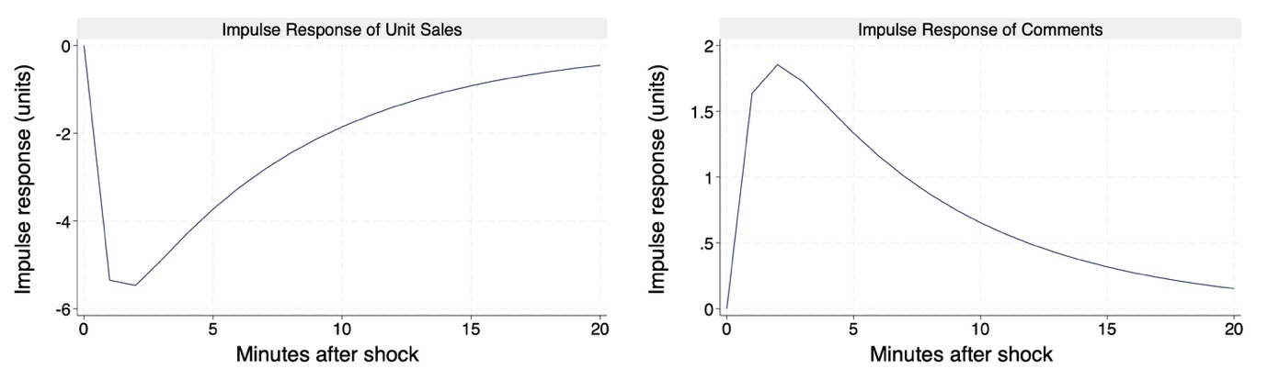
Figure I1. Simple Impulse Response to a Valence Transition Rate Shock

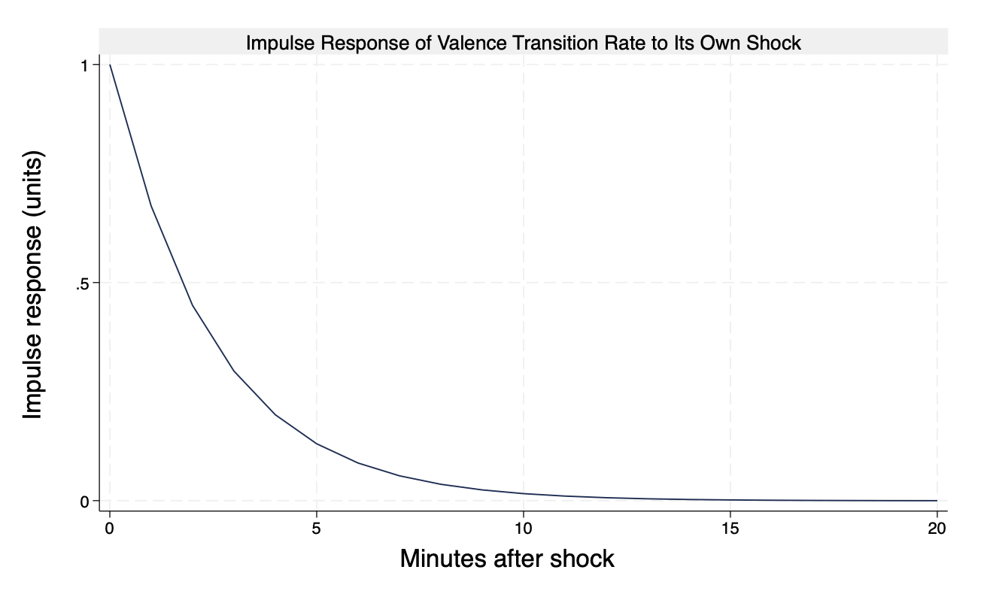
Figure I2. Impulse Response of Valence Transition Rate to Its Own Shock

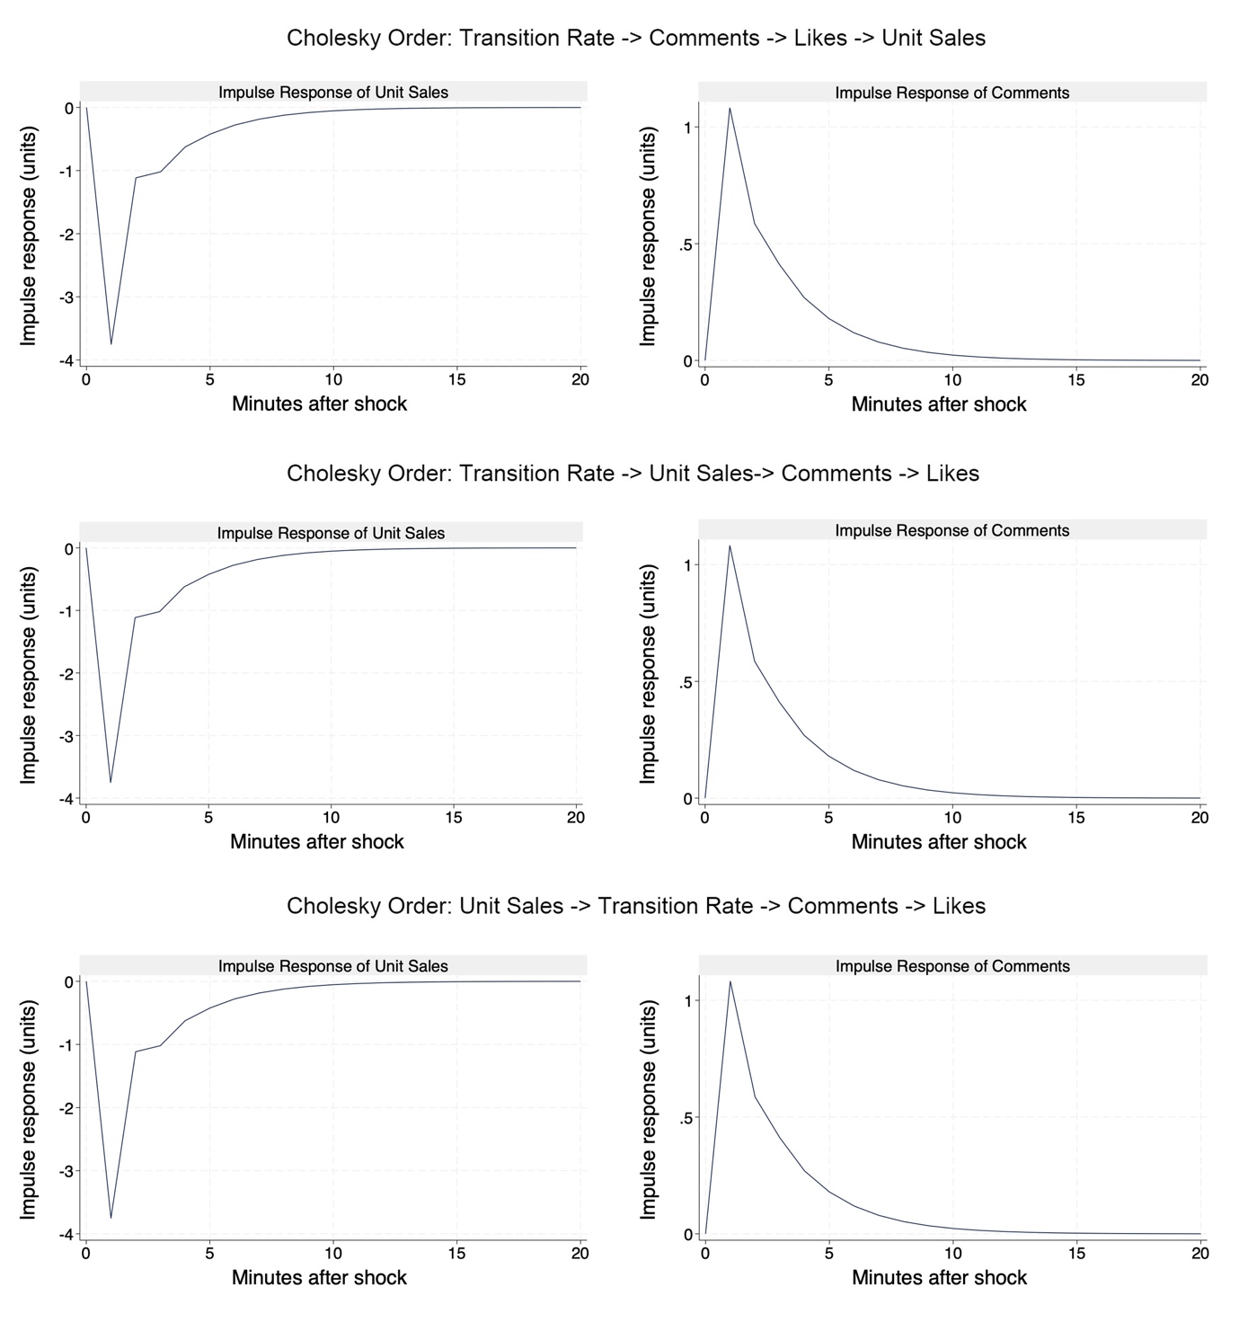
Figure I3. Robustness of Impulse Response Functions (IRF) to Alternative Cholesky Orderings
Notes: This figure displays the orthogonalized impulse response functions (OIRFs) of Unit Sales (left column) and Comments (right column) to a one-standard-deviation shock in the Transition Rate, estimated via a four-variable PVAR model. The three rows represent alternative Cholesky orderings of the endogenous variables (listed in the subheadings) to verify robustness to causal ordering assumptions.

Web Appendix J. Web Application
The web app emotionlivetream.com is designed to provide influencers with real-time feedback on their emotional displays. During a session, the app continuously monitors the influencer’s facial expressions and offers on-screen prompts to encourage them to maintain stable emotional displays. If the system detects a high-risk transition—such as a positive-to-negative or negative-to-positive shift, which our research identifies as particularly detrimental to sales—it immediately issues a “red warning” and begins a two-minute countdown. The alert signals the need for immediate emotional regulation and also visually communicates the expected duration of the negative sales impact, in accordance with our results.
Rather than requiring influencers to shift from neutral to happy in each case, the app also leverages context-sensitive visual cues. If the context suggests that a stable positive or neutral expression would be optimal, the app displays a prominent smile emoji or sticker on-screen as a gentle reminder. When the influencer’s detected expression is sad, surprised, or angry, the visual prompts serve as a nudge to transition back toward a more positive display. Therefore, with these features, the app translates our theoretical findings into practical recommendations that can be adopted in real-time and thereby enhance influencers’ efforts to achieve both sales optimization and effective audience engagement.

