AI and Human Designers: How Consumers See the Genuine Care in Product Design as More Sustainable

WEB APPENDIX

Table of Contents

Web Appendix A. In-depth Interviews 2
Section WA1: Interview Guide 2
Table WA1: Interview Participant Details 4
Table WA2: Detailed Interview Findings 5
Web Appendix B1. 8
Study 4 Details & Additional Analysis 8
Web Appendix B2. 9
Study 5 Details & Additional Analysis 9
Web Appendix C. Main effect of AI versus Human Designed Products 10
Web Appendix D. Consequential Choice Study 12
Web Appendix E. Ruling Out Alternative Mediators 16
Web Appendix F. Trust Cues Increase Perceived Sustainability 21
Web Appendix G. Ruling Out The Role of Transparency 27
Web Appendix H. Ruling Out Role of AI Literacy 31
Web Appendix I. References 33

Web Appendix A. In-depth Interviews

Section WA1: Interview Guide
1. Introduction / Warm-Up
- Can you tell me a bit about your background and design experience?
- How often do you use AI in your design work, and in what ways?
2. General Associations with AI vs. human Design
- When you hear the term “human-designed product,” what comes to mind?
- When you hear “AI-designed product,” what comes to mind?
- What qualities or attributes do you associate with AI vs. human design?
  - Probe: creativity, originality, effort, authenticity, efficiency, precision.
3. Perceived Differences in Design Process
- In your view, what is distinctive about the process of human design compared to AI-assisted design?
- Do you think the process itself influences how consumers (or other designers) value the end product? How?
- To what extent do you think craftsmanship or the “human touch” matters in design outcomes?
4. Perceptions of Sustainability
- How do you personally define “sustainable design”?
- When you think of human design, what sustainability-related associations come up?
- When you think of AI design, what associations with sustainability come up?
- Do you think consumers perceive one as more sustainable than the other? Why?
5. Trade-offs and Tensions
- Do you think AI can make design more sustainable (e.g., through efficiency, waste reduction) products than humans can?
- Or do you think AI may make design less sustainable (e.g., due to energy use, loss of durability, overproduction)?
- How do you personally balance these potential tensions in your own work?
6. Consumer Perceptions and Market Implications
- In your experience, how do consumers talk about or respond to products made with AI vs. human design?
- Do you think sustainability cues are relevant or related to these perceptions?
  - Probe: Does “handcrafted” feel greener than “AI-generated”? Why or why not?
- How do you think brands should (or should not) communicate design origins in marketing?
7. Future Outlook
- Looking ahead, how do you see the relationship between human creativity and AI evolving in creating sustainable design?
- What would an ideal balance between human and AI design look like from a sustainability perspective?
8. Wrap-Up
- Is there anything we didn’t cover that you think is important about AI vs. human design and sustainability?
- If you were advising a company marketing an AI-designed product, what should they keep in mind?

Respondent | Profile | Occupation/ Industry | Experience with product design | Industry
Participant 1 | 55-64 years, Male | Consultant | Involved with product design, managerial and consulting experience | FMCG
Participant 2 | 55-64 years, Female | Business Owner | Involved with product ideation and design, kitchen | Home appliance
Participant 3 | 25-34 years, Male | Head of Product | Involved with product design and innovation | Software and hardware
Participant 4 | 35-44 years, Female | Product Manager | Involved with product design and communications | FMCG
Participant 5 | 35-44 years, Female | Product Manager | Involved with product design and communications | FMCG
Participant 6 | 45-55 years, Female | Business Owner | Product packaging design and development | Telecommunications and technology
Participant 7 | 45-55 years, Male | Product Designer | Involved with product design | Service, experience and industrial design
Participant 8 | 45-55 years, Female | Product Designer | Product marketing | B2B technology and infrastructure

Table WA1: Interview Participant Details

Sustainability Design Feature (Xie, Zhang and Zhu 2025) | Dimension | Human Design  Table WA2: Detailed Interview Findings | AI Design | Representative Participants / Quotes
1. Comprehensiveness | Craftsmanship and Aesthetic Judgment | Involves artistry, material awareness, and sensory feel (hand-feel, color balance). | Often produces designs that look “off” or unrealistic; lacks tacit design sense. | P2“The visuals are not there yet… AI might be able to figure out what type of plastic you’d use… but the finer points, make sure that the overall experience is aesthetically nice, I think that’s still a huge piece that’s missing.” P7: “There’s a lot of amateurs creating slop [with AI]—it still takes human touch to take that input and manage the tools properly.”
1. Comprehensiveness | Perceived Sustainability / Environmental Care | Signals conscious effort, durability, and long-term value; aligned with moral care. | Technically efficient but perceived as detached from environmental care. | P5: “Sustainability feels very human, like there is a human touch, a caring touch.” P3: “Using AI everywhere in an uncontrollable way is not creating sustainable business for us —there are servers, cost structure.” P7: “AI can help a lot.. you can research in seconds….” P8: “People don’t associate AI with emotion, and sustainability is very emotional.”
1. Comprehensiveness | Moral and Ethical Responsibility | Designers seen as accountable, ethical agents who care about social and environmental impact. | Viewed as amoral; lacks capacity for moral reasoning or ethical motivation. | P5: “Why would AI care if my product’s sustainable like a human would, right?” P8: “People aren’t associating AI with emotion… sustainability is very emotional.” P4: “People might feel AI is cutting corners or being a little lazy.”
2. Dynamism | Efficiency and Speed | Slower, iterative, more deliberative, but signals effort and authenticity. | Highly efficient, accelerates timelines, allows more prototyping. | P6: “AI has made our timelines easier.” P2: “If you say this was designed by AI and we cut our development timeline in half, or we only had to order so many prototypes saving so much plastic or fuel, then that’s how it can go more hand-in-hand with sustainability.” P3: “AI enables quicker prototyping and you can get feedback faster.”
2. Dynamism | Human–AI Collaboration (Future Outlook) | Humans define intent, aesthetics, and moral boundaries. | AI supports ideation, validation, and optimization. | P4: “AI as a validation tool.” P6“I sat with a bunch of humans, and were coming up with prompts… then we all need to review it, to make sure that the output is not crazy or outlandish.” P3: “Senior designers using AI are powerful; junior designer that didn’t have much experience with AI is not a good output.”
3. Propensity | Authenticity and Consumer Perception | Seen as authentic, intentional, and trustworthy. | Risk of being perceived as artificial or “cutting corners.” | P5: “Transparency [in using AI]… can be seen as cutting corners… people may think big corporations are just saving money.” P6: “If they knew AI was behind it, it wouldn’t come through as authentic anymore.” P4: “People may see AI as taking a shortcut to design.”
3. Propensity | Moral and Ethical Responsibility | Designers seen as accountable, ethical agents who care about social and environmental impact. | Viewed as amoral; lacks capacity for moral reasoning or ethical motivation. | P5: “Why would AI care if my product’s sustainable like a human would, right?” P8: “People aren’t associating AI with emotion… sustainability is very emotional.” P4: “People might feel AI is cutting corners or being a little lazy.”
3. Propensity | Transparency and Disclosure | Human authorship rarely questioned; authenticity presumed. | Disclosure creates tension: seen as honest but may harm brand trust. | P6: “To say ‘designed by AI’—May end up being a necessary legal disclaimer.” P1: “I don’t think there should be a requirement to publish how much AI you use… it’s a tool.”
4. Inclusiveness | Emotional Intentionality / Human Touch | Emotionally resonant; conveys care, empathy, and user understanding. | Lacks warmth; too technical or cold; cannot replicate human emotion. | P4: “There’s some emotional component to it… small features in the product design that would drive emotional output would feel less easy for AI to get to.” P5: “Sustainability feels very human… AI doesn’t have kids that are going to walk the earth.” P2: “AI might know the right plastic… but not the hand feel… can the cup fit in a human hand nicely?”
4. Inclusiveness | Creativity and Ideation | Draws from intuition, life experience, and aesthetic sensitivity. | Generates fast iterations and novel combinations but misses nuance. | P8: “Before AI it was ideating collaboratively—AI expands the art of the possible [but still needs humans].” P7: “AI unleashes capabilities—you can prompt it and get directions you’d never imagine.” P3: “AI helps summarize feedback… but its missing this sort of understanding of human nature.”
4. Inclusiveness | Symbolic Meaning of “Design” | Embodies human creativity, story, and craftsmanship; linked to legacy and meaning. | Symbolizes innovation, data, and futuristic rationality, but lacks “soul.” | P1: “AI doesn’t express initial intent, like the process itself.” P7: “Consumers… have no idea how design happens, they just think that someone sat down and the did the Coca Cola bottle, that’s it… but they feel like AI is a threat.” P8: “AI means intelligence and automated; humans mean caring and empathetic.”

Web Appendix B1.

Study 4 Details & Additional Analysis

Mediation was tested by using Hayes’ Process Model 4, with a bootstrapping sample of 5,000, with perceived sustainability as dependent variable, design agent as the independent variable, genuine care as mediator. The sample size is 199. The results are shown in Table B.1-2.

Table B.1 Regression results
Predictor | b | SE | t | p | 95% CI [LL, UL]
DV: Genuine care
Constant | 4.74 | .14 | 34.39 | < .001 | [4.47; 5.01]
Design agent | -1.73 | .20 | -8.84 | <.001 | [-2.11; -1.34]
R² = .28, F(1, 197) = 78.05, p <.001
DV: Perceived sustainability
Constant | 2.11 | .28 | 7.63 | <.001 | [1.57; 2.66]
Design agent | .12 | .18 | .70 | .49 | [-.22 .47]
Genuine care | .51 | .05 | 9.48 | < .001 | [.41; .62]
R² = .37, F(2, 196) = 58.18, p < .001
Notes: N = 199

Table B.2 Direct and indirect effects of design agent on perceived sustainability
Effect | b | SE | 95% CI [LL, UL]
Direct Effect (X → Y) | .12 | .18 | [-.22; .47]
Total Indirect Effect | -.88 | .15 | [-1.19; -.61]

Web Appendix B2.

Study 5 Details & Additional Analysis

Table B.3 Analysis of variance results
DV: Perceived sustainability
Source | Type III Sum of Squares | df | Mean Square | F | Sig.
Corrected Model | 127.980ª | 3 | 42.660 | 27.991 | <.001
Intercept | 9238.212 | 1 | 9238.212 | 6061.527 | <.001
Design Agent (AI vs. Human) | 71.039 | 1 | 71.039 | 46.612 | <.001
Genuine Care Cue (Present vs. Absent) | 44.873 | 1 | 44.873 | 29.442 | <.001
Design Agent x Genuine Care Cue | 9.567 | 1 | 9.567 | 6.277 | .013
Error | 588.292 | 386 | 1.524
Total | 9899.750 | 390
Corrected Total | 716.272 | 389
a. R Squared = .179 (Adjusted R Squared = .172)
Table B.4 Cell means estimates
DV: Perceived sustainability
AI | Genuine Care Cue | Mean | SE | 95% CI
 |  |  |  | LL | UL
Human | Absent | 5.113 | .125 | 4.867 | 5.360
Human | Present | 5.479 | .127 | 5.228 | 5.729
AI | Absent | 3.946 | .122 | 3.706 | 4.186
AI | Present | 4.938 | .125 | 4.692 | 5.185
Table B.5 Cell means comparisons
DV: Perceived sustainability
Design Agent | (I) Genuine Care Cue | (J) Genuine Care Cue | Mean Difference (I-J) | SE | p | 95% CI
 |  |  |  |  |  | LL | UL
Human | Absent | Present | -.365* | .179 | .042 | -.717 | -.014
AI | Absent | Present | -.992* | .175 | <.001 | -1.336 | -.648
Genuine Care Cue | (I) Design Agent | (J) Design Agent | Mean Difference (I-J) | Std. Error | p | 95% CI ^{b}
 |  |  |  |  |  | LL | UL
Absent | Human | AI | 1.167* | .175 | <.001 | .823 | 1.512
Present | Human | AI | .541* | .179 | .003 | .189 | .892
Notes: Based on estimated marginal means; *. The mean difference is significant at the .05 level

Table B.6 Univariate test results
DV: Perceived sustainability
 |  | Sum of Squares | df | Mean Square | F | Sig.
Human | Contrast | 6.37§ | 1 | 6.371 | 4.180 | .042
Human | Error | 588.292 | 386 | 1.524
AI | Contrast | 48.933 | 1 | 48.933 | 32.107 | <.001
AI | Error | 588.292 | 386 | 1.524
Genuine Care Cue Absent | Contrast | 67.749 | 1 | 67.749 | 44.452 | <.001
Genuine Care Cue Absent | Error | 588.292 | 386 | 1.524
Genuine Care Cue Present | Contrast | 13.950 | 1 | 13.950 | 9.153 | .003
Genuine Care Cue Present | Error | 588.292 | 386 | 1.524

Web Appendix C. Main effect of AI versus Human Designed Products

This preregistered experiment (https://aspredicted.org/ey88t8.pdf) had two between-subjects conditions (product designed by AI-enabled technology vs. humans). The stimuli involved a naturalistic, social-media type ad context; see Table C1 for the stimuli details. Students from a major US university (N = 263; M_{age}:19.97; females: 54.0%, males: 45.6%, other/prefer not to say: .4%) participated for course extra credit. The dependent variable of perceived sustainability was measured using two items (r = .73, p < .001): This backpack seems to be [very environmentally friendly] [good for sustainable practices] (1 = strongly disagree, 7 = strongly agree).

Results and Discussion
Consistent with H₁, the product designed by AI (vs. by humans) had a lower level of perceived sustainability (M_{AI} = 4.24, SD = 1.28 vs. M_{human} = 4.61, SD = 1.07; F(1, 261) = 6.36, p = .012, η² = .024). The results of this study provide evidence in support of our hypothesis (H₁) that a product linked to being designed by AI technologies is perceived as less sustainable than when linked to being designed by humans.

Table C1: Study Web Appendix C Stimuli
“Human” Condition | “AI” Condition
Please go through the image (below) of an Instagram post.  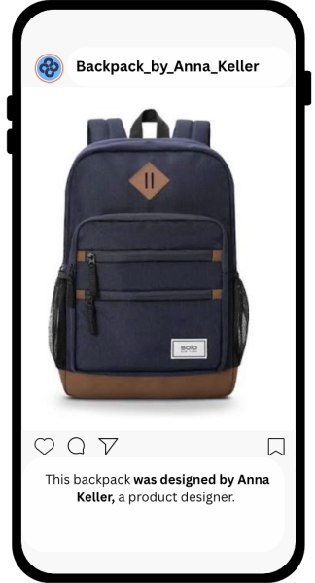 | Please go through the image (below) of an Instagram post.  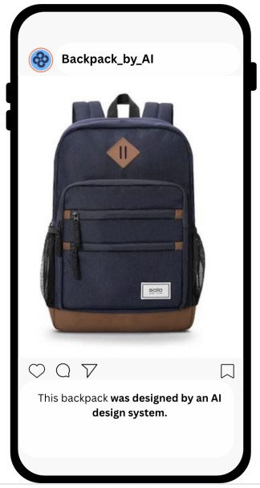

Web Appendix D. Consequential Choice Study

Building on the findings from Studies 1 and 2, which demonstrated that consumers perceive products designed by AI (vs. humans) as being less sustainable, this study aims to examine whether this perceptual bias also translates into downstream consequential behavior. Specifically, we test whether the AI-versus-human design attribution affects not only perceived sustainability but also participants’ actual product choice. By incorporating a real behavioral outcome (a consequential selection between the featured granola bar and an alternative) we assess whether AI vs. human design influences consumer preferences in decisions with tangible implications. This approach allows us to determine whether the perceptual disadvantage of AI-designed products extends beyond attitudes into action.
In this preregistered experiment (https://aspredicted.org/57j8-dcqs.pdf), 300 Prolific participants were randomly assigned to one of two between-subjects experimental conditions (AI vs. human designed granola bar). In line with our pre-registered exclusion criterion, we excluded participants who failed the bot check and/or did not finish the survey. Thus, the final sample size comprised 288 participants (61.5% female, 38.2% male, .3% prefer not to say; M_{age}: 34.89).
Method
Participants were randomly assigned to read a short product description for a granola bar, accompanied by an image (Table D1). The description framed the design and production process as conducted entirely by either humans or AI. Perceived sustainability served as the primary dependent variable and was measured using the same two items as in Study 1 (r = .86, p < .001): “This granola bar seems to be very environmentally friendly” and “This granola bar seems to be good for sustainable practices” (1 = strongly disagree, 7 = strongly agree).
In addition to these self-reported items, we included a downstream behavioral outcome: a consequential choice measure. Participants were told that a small number of randomly selected participants would receive a gift card for granola bars and were asked whether they would prefer to receive the granola bar they just saw (coded as 1) or a different one (coded as 2). This consequential choice allowed us to test whether AI-vs-human framing influences not only perceptions but also preferences tied to real outcomes. Five Prolific participants were randomly picked using Miniwebtool.com’s random picker, and a $10 Amazon gift voucher was emailed to them as a reward.
Results
Consistent with H₁, our results indicate that a product presented as being designed/manufactured by AI was perceived as being less sustainable than a product designed/manufactured by a human (M_{human} = 5.33 (SD = 1.22) vs. M_{AI} = 4.81 (SD = 1.58); F(1, 287) = 10.13, p = .002, η_{p}² = .034). Furthermore, participants were less likely to select the promoted granola bar (vs. a different one) when it was presented as being designed/manufactured by AI (vs. human) (M_{Human} = 1.13 (SD = .33) vs. M_{AI} = 1.23 (SD = .42); F(1, 287) = 5.04, p = .025, η_{p}² = .017).
To see whether perceived sustainability mediated the effect of design agent on the consequential dependent variable, we conducted a mediation analysis using PROCESS Model 4 with 5,000 bootstrap samples (Hayes 2017). The independent variable was the design agent condition (0 = human, 1 = AI), the mediator was perceived sustainability, and the dependent variable was the granola bar selection.
Mediation analyses revealed that perceived sustainability significantly predicted the consequential dependent variable of granola choice (b = –0.93, SE = 0.14, z = –6.48, p < .001). The indirect effect of the design agent condition on the consequential outcome via perceived sustainability was statistically significant (indirect effect = 0.48, BootSE = 0.18, 95% CI [0.17, 0.88]), indicating a significant mediation pathway.

Discussion
This study extends our earlier findings by demonstrating that AI involvement in product design not only diminishes perceived sustainability but also leads to downstream behavioral outcomes in the form of consumers’ reduced likelihood of choosing the product in a consequential decision-making context. Participants who were told that a granola bar was designed and manufactured by AI rated it as significantly less sustainable than when it was framed as human-designed, replicating the main effect observed in Study 1 and 2. Importantly, this study again demonstrated a behavioral downstream outcome. The findings of this study reinforce the idea that human involvement signals sustainability, and that the absence of such signals in AI-driven creation can meaningfully shape both judgments and choices.
“Human” Condition | “AI” Condition
This granola bar has been designed and manufactured by humans only.  That is, only humans were involved in the entire process of making this granola bar.  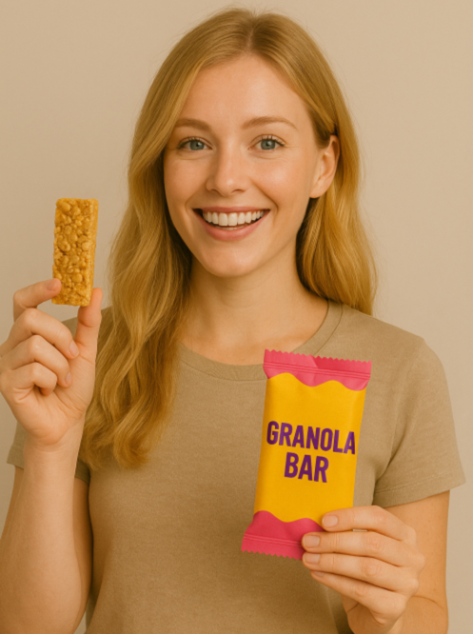 | This granola bar has been designed and manufactured by AI-enabled technology.  That is, AI (artificial intelligence) was involved in the entire process of making this granola bar.
Table D1: Study Stimuli

Web Appendix E. Ruling Out Alternative Mediators

Study 4 demonstrate the mediating role of genuine care. The purpose of this preregistered study (https://aspredicted.org/6ck6zi.pdf) is to verify the proposed genuine care underlying the core effect and rule out alternative accounts, including perceived effort and cognitive intentionality.
Cognitive intentionality reflects the rational dimension: the perception that the product was thoughtfully and deliberately designed with awareness of its impact (e.g., “The design of this backpack seems carefully thought through”). Perceived effort assessed the extent to which participants believed time, energy, and attention to detail were invested in the design (e.g., “It looks like the designer worked hard on every aspect of this backpack”). Together, these three mediators capture complementary emotional, cognitive, and effort-based aspects of product design.
Method
We recruited 200 participants via Prolific and randomly assigned them to one of two conditions (design agent: AI vs. human) in a between-subjects design experiment (see Table 7 of the Manuscript). The study tests whether the source of product design influences sustainability perceptions, and through which psychological pathway. In line with the pre-registered exclusion criteria, participants who did not finish the survey were excluded; thus, the final sample size comprised of 199 participants (62.8% female, 36.2% male, 1.0% prefer not to say; M_{age}= 41.25).
Participants were randomly assigned to view a backpack described as either “designed by AI-enabled technology” or “designed by humans only.” After exposure to the assigned condition, participants rated the backpack on several perceptual dimensions. Perceived sustainability (r = .86, p < .001) and genuine care (α = .96) were measured with the same items as in our previous studies.
Cognitive intentionality (α = .95) was measured using a four-item, seven-point Likert scale adapted from Silva, Crilly and Hekkert (2015) capturing the extent to which the design appeared reasoned and deliberate: “The design of this backpack seems carefully thought through,” “It feels as if the designer made intentional and reasoned decisions throughout the process,” “The backpack’s design reflects conscious decision-making,” and “It seems that the design resulted from logical consideration.” Perceived effort was measured using a five-item, seven-point Likert scale (α = .98) adapted from Mohr and Bitner (1995) and Langan and Kumar (2019): “A lot of effort went into designing this backpack,” “It seems like the designer put a lot of energy into this design,” “It seems that the designer put in a lot of work to create this backpack,” “It looks like the designer worked hard on every aspect of this backpack,” and “It seems that the designer paid close attention to every detail.”

Results
A one-way ANOVA revealed a significant main effect of design agent on perceived sustainability (F(1, 197) = 42.21, p < .001, η² = .18), such that AI-designed products (M = 3.60, SD = 1.47) were perceived as significantly less sustainable than human-designed products (M = 4.73, SD = 0.94)
Furthermore, a series of one-way ANOVAs revealed significant effects of design agent on all three mediators. Participants perceived AI-designed products as exhibiting lower genuine care than human-designed ones (M_{AI} = 3.04, SD = 1.52 vs. M_{human} = 5.05, SD = 1.00; F(1, 197) = 122.98, p < .001, η² = .38). Similarly, AI designs were rated lower on cognitive intentionality (M = 4.04, SD = 1.63 vs. M = 5.56, SD = 0.88; F(1,197) = 68.74, p < .001, η² = .26) and perceived effort (M = 3.06, SD = 1.60 vs. M = 5.14, SD = 1.17; F(1, 197) = 109.26, p < .001, η² = .36).
Parallel mediation

We conducted a parallel mediation analysis (PROCESS Model 4; Hayes, 2022) to examine whether genuine care, cognitive intentionality, and perceived effort independently mediated the effect of design agent (0 = human, 1 = AI) on perceived sustainability.
Results showed that the design agent significantly predicted all three mediators: genuine care (b = –2.00, SE = .18, t = –11.09, p < .001), cognitive intentionality (b = –1.52, SE = .18, t = –8.29, p < .001), and perceived effort (b = –2.07, SE = .20, t = –10.45, p < .001). In the full model, only genuine care significantly predicted perceived sustainability (b = 0.58, SE = .10, t = 6.06, p < .001), whereas cognitive intentionality (b = 0.11, SE = .08, t = 1.38, p = .171) and perceived effort (b = 0.00, SE = .09, t = 0.03, p = .979) were not significant.
The indirect effect of design agent on perceived sustainability through genuine care was significant (indirect effect = –1.16, BootSE = .28, 95% CI [–1.73, –0.64]), while indirect effects through cognitive intentionality (indirect effect = –0.16, 95% CI [–0.44, 0.12]) and perceived effort (indirect effect = –0.00, 95% CI [–0.45, 0.38]) were not. The direct effect of design agent on perceived sustainability was nonsignificant (b = 0.19, SE = .16, t = 1.19, p = .234), indicating full mediation via genuine care.
Together, these results suggest that perceptions of genuine care (feelings of care and love) explain why human-designed products are viewed as more sustainable, whereas cognitive intentionality and perceived effort do not significantly contribute once genuine care is accounted for.

Discussion
The results of this study provide support for our main hypothesis (H₁) that the identity of the design agent influences sustainability perceptions. Specifically, products described as AI-designed were perceived as significantly less sustainable than those described as human-designed, supporting the notion that consumers associate human involvement with greater environmental care and accountability.
We also found support for our second hypothesis (H₂), which proposed that this effect is mediated by genuine care. Participants rated human-designed products as being made with more love and care, and these perceptions in turn significantly increased sustainability judgments. Mediation analyses revealed that genuine care was a robust predictor of sustainability perceptions, accounting for a substantial portion of the design agent effect.
The mediation was tested by using Hayes’ Process Model 4, with a bootstrapping sample of 5,000, with perceived sustainability as dependent variable, design agent as the independent variable, genuine care, cognitive intentionality and perceived effort as mediators. The results are shown in Table E.1-2.

Table E.1 Regression Results

Predictor | b | SE | t | p | 95% CI [LL, UL]
DV: Genuine care
Constant | 5.05 | .13 | 30.19 | <.001 | [4.79; 5.29]
Design agent | -2.00 | .18 | -11.09 | < .001 | [-2.36; -1.65]
R² = 0.38, F(1, 197) = 122.98, p < .001
DV: Cognitive intentionality
Constant | 5.56 | .13 | 43.57 | < .001 | [5.31; 5.81]
Design agent | -1.52 | .18 | -8.29 | < .001 | [-1.88; -1.16]
R² = 0.26, F(1, 197) = 68.74, p < .001
DV: Perceived effort
Constant | 5.14 | .14 | 37.32 | < .001 | [4.86; 5.41]
Design agent | -2.07 | .20 | -10.45 | <.001 | [-2.46; -1.68]
R² = .36, F(1, 197) = 109.26, p <.001
DV: Perceived sustainability
Constant | 1.21 | .30 | 4.08 | .0001 | [.63; 1.78]
Design agent | .19 | .16 | 1.19 | .23 | [-.13; .52]
Genuine care | .58 | .20 | 6.06 | <.001 | [.39; .77]
Cognitive intentionality | .11 | .08 | 1.38 | .17 | [-.05; .26]
Perceived effort | .00 | .09 | .03 | .98 | [-.17; .17]
R² = .57, F(3, 194) = 63.81, p < .001
Notes: N = 200

Table E.2 Direct and indirect effects of design agent on perceived sustainability
Effect | b | SE | 95% CI [LL, UL]
Direct Effect | .19 | .16 | [-.13; .52]
Total Indirect Effect | -1.33 | .18 | [-1.70; -.98]
Genuine care | -.1.6 | .28 | [-1.73; -.64]
Cognitive intentionality | -.17 | .131 | [-.44; .12]
Perceived effort | -.01 | .21 | [-.45; .38]

Web Appendix F. Trust Cues Increase Perceived Sustainability
Studies 1 – 4 demonstrated that products designed by AI elicit lower perceptions of sustainability than products designed by humans, with genuine care being the underlying process. Web Appendix F examines a managerially relevant moderator, related to trust cues. We expect the main effects observed in Studies 1 and 2 to hold in the absence of any trust cue information but to attenuate when trust cue information is provided.

Method
This preregistered experiment (https://aspredicted.org/88fi8p.pdf) had a 2 (design agent: AI vs. human) X 2 (trust cue: absent vs. present) between-subjects design. See Table F1 for the stimuli details. Prolific workers (N = 394 [400 requested but received 394 completed surveys]; 51.8% female, 47.5% male, .8% prefer not to say; M_{age}= 41.72) participated in this study.
For the first factor, participants were randomly assigned to view a tote bag that was described as either designed by an AI system or by humans. For the second factor, participants were randomly assigned to one of two trust cue conditions (present vs. absent). In the “trust cue present” condition, participants were informed that: “Recent research shows that [AI systems] [human teams] are increasingly trusted by experts to make responsible, sustainable decisions—on par with or even exceeding [human] [AI] judgment in certain domains.” In the “trust cue absent” condition, participants did not receive any additional information beyond the product description. Perceived sustainability was assessed using the same two-item scale employed in our prior studies (r = .93, p < .001).

Results
A 2 (design agent: AI vs. human) × 2 (trust cue: absent vs. present) between-subjects ANOVA was conducted on perceived sustainability. There were significant main effects of design agent (F(1, 390) = 42.83, p < .001, ηp² = .099) and trust cue (F(1, 390) = 6.05, p = .014, ηp² = .015). The interaction between design agent and trust cue was not significant (F(1, 390) = 0.47, p = .492, ηp² = .001), which makes sense since the cell means moved in the same direction. We conducted planned contrasts to test our theoretically derived predictions, consistent with the approach of Monga and John (2007). That is, when specific directional hypotheses are grounded in theory, planned contrasts provide a more precise test of focal effects than omnibus interactions. In line with our theorizing, the contrasts reveal that the trust cue amplifies the perceived sustainability of AI-designed products, but not of human-designed ones, indicating that trust selectively mitigates the sustainability penalty associated with AI involvement rather than exerting a uniform effect across both agents.
More specifically, and in line with H₁, participants rated AI-designed products as less sustainable than human-designed ones (M_{human} = 5.30, SD = .98 vs. M_{AI} = 4.41, SD = 1.64; F(1, 390) = 42.83, p < .001, ηp² = .099). Similarly, participants in the trust cue “present” condition rated the product to be more sustainable than those in the trust “absent” (i.e., control) condition (M_{trust} = 5.02, SD = 1.38 vs. M_{no_trust} = 4.68, SD = 1.49; F(1, 390) = 6.05, p = .014, ηp² = .015).
In the control condition, the perceived sustainability of AI-designed product was significantly lower than the human designed product (M_{human} = 5.18, SE = .14 vs. M_{AI} = 4.20, SE = .13; F(1, 390) = 26.14, p < .001, ηp² = .063). When the trust cue was present, the effect was still significant but with lower effect size (M_{human} = 5.42, SE = .14 vs. M_{AI} = 4.63, SE = .14; F(1, 390) = 17.16, p < .001, ηp² = .042). Interestingly, for the AI-designer conditions, presence of the trust cue led to enhanced perceived sustainability (M_{trust_AI} = 4.63, SE = .14 vs. M_{no_trust_AI} = 4.20, SE = .13; F(1, 390) = 5.03, p = .026, ηp² = .013) with no such effects for the human-designer conditions (M_{trust_human} = 5.42, SE = .14 vs. M_{no_trust_human} = 5.18, SE = .14; F(1, 390) = 1.55, p = .214, ηp² = .004). See Figure F1 for the graphical representation of these results.
Discussion
The results of this study show that both the type of design agent (AI vs. human) and trust in the designer independently influenced perceived sustainability. Products designed by AI were rated as less sustainable than those designed by humans, replicating our main effect. Also, overall, higher trust in the designer was associated with higher sustainability perceptions across the board. Trust significantly increased perceived sustainability only for AI-designed products. This shows that trust is relevant primarily when the design agent lacks genuine care, as is the case with AI. In contrast, trust did not influence perceptions of human-designed products, suggesting that human designers are already perceived as inherently trustworthy in this context. Although we manipulate trust directly in this study, future research could also prime trust as a cognitive mindset (e.g., via recall) to examine whether similar effects emerge.

Table F1: Web Appendix F Stimuli
Trust Cue | “Human” Condition | “AI” Condition
Trust Cue Absent | This tote bag has been designed by humans only. That is, only humans were involved in the entire process of designing this tote bag.  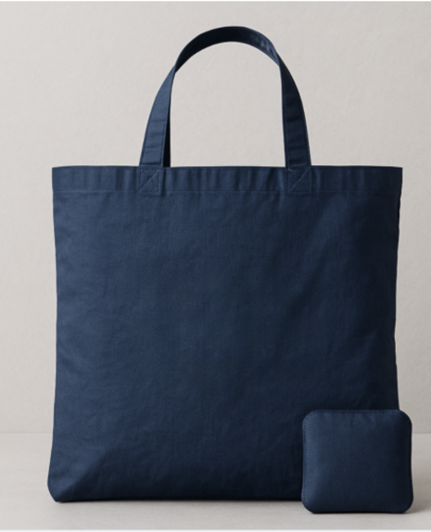 | This tote bag has been designed by AI-enabled technology. That is, AI (artificial intelligence) was involved in the entire process of designing this tote bag.
Trust Cue Present | This tote bag has been designed by humans only. That is, only humans were involved in the entire process of designing this tote bag.  Recent research shows that human teams are increasingly trusted by experts to make responsible, sustainable decisions—on par with or even exceeding artificial intelligence judgment in certain domains. | This tote bag has been designed by AI-enabled technology. That is, AI (artificial intelligence) was involved in the entire process of designing this tote bag.  Recent research shows that AI systems are increasingly trusted by experts to make responsible, sustainable decisions—on par with or even exceeding human judgment in certain domains.  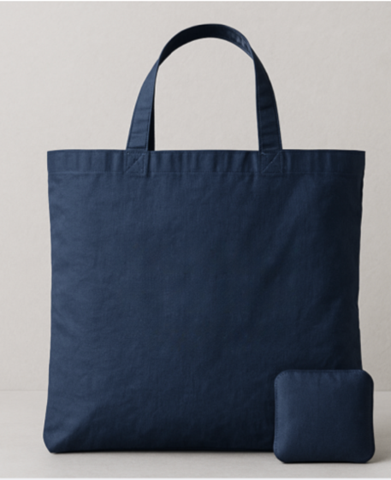

Table F.2 Analysis of variance results
DV: Perceived sustainability
Source | Type III Sum of Squares | df | Mean Square | F | Sig.
Corrected Model | 90.718ª | 3 | 30.239 | 16.577 | <.001
Intercept | 9293.477 | 1 | 9293.477 | 5094.47 | <.001
Design Agent (AI vs. Human) | 78.125 | 1 | 78.125 | 42.827 | <.001
Trust Cue (Present vs. Absent) | 11.031 | 1 | 11.031 | 6.047 | .014
Design Agent x Trust Cue | .861 | 1 | .861 | .472 | .492
Error | 711.447 | 390 | 1.824
Total | 10071.000 | 394
Corrected Total | 802.165 | 393
a. R Squared = .113 (Adjusted R Squared = .106)
Table F.3 Cell means estimates
DV: Perceived sustainability
AI | Trust Cue | Mean | SE | 95% CI
 |  |  |  | LL | UL
Human | Absent | 5.182 | .138 | 4.911 | 5.453
Human | Present | 5.423 | .136 | 5.155 | 5.692
AI | Absent | 4.198 | .134 | 3.934 | 4.462
AI | Present | 4.626 | .136 | 4.359 | 4.893
Table F.4 Cell means comparisons
DV: Perceived sustainability
Design Agent | (I) Trust Cue | (J) Trust Cue | Mean Difference (I-J) | SE | p | 95% CI
 |  |  |  |  |  | LL | UL
Human | Absent | Present | -.241 | .194 | .214 | -.622 | .140
AI | Absent | Present | -.428* | .191 | .026 | -.804 | -.053
Trust Cue | (I) Design Agent | (J) Design Agent | Mean Difference (I-J) | Std. Error | p | 95% CI ^{b}
 |  |  |  |  |  | LL | UL
Absent | Human | AI | .984* | .193 | <.001 | .606 | 1.363
Present | Human | AI | .797* | .192 | <.001 | .419 | 1.176
Notes: Based on estimated marginal means; *. The mean difference is significant at the .05 level

Table F.5 Univariate test results
DV: Perceived sustainability
 |  | Sum of Squares | df | Mean Square | F | Sig.
Human | Contrast | 2.821 | 1 | 2.821 | 1.546 | .214
Human | Error | 711.447 | 390 | 1.824
AI | Contrast | 9.169 | 1 | 9.169 | 5.026 | .026
AI | Error | 711.447 | 390 | 1.824
Trust Cue Absent | Contrast | 47.682 | 1 | 47.682 | 26.138 | <.001
Trust Cue Absent | Error | 711.447 | 390 | 1.824
Trust Cue Present | Contrast | 31.299 | 1 | 31.299 | 17.158 | <.001
Trust Cue Present | Error | 711.447 | 390 | 1.824

Figure F1: Web Appendix F Results

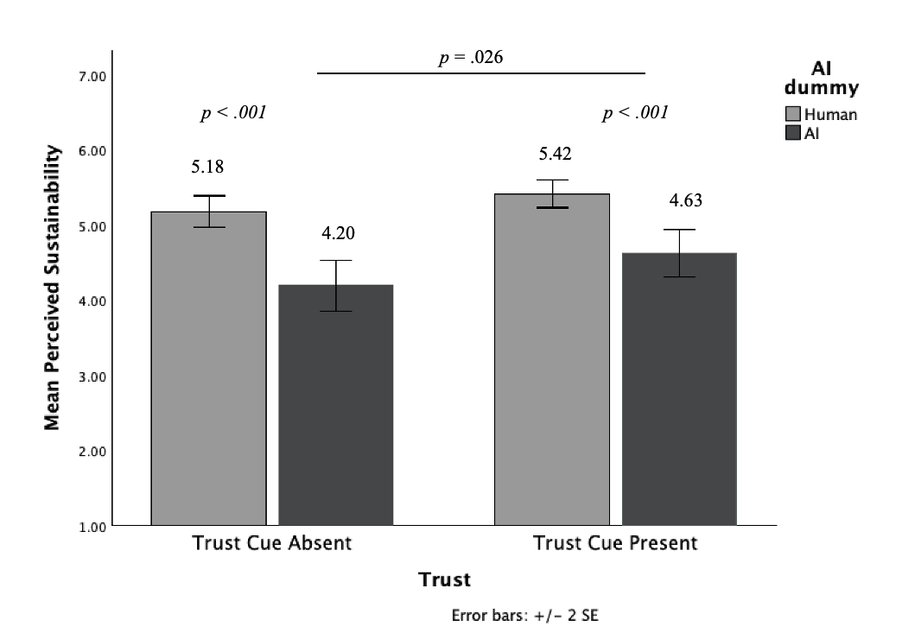

Web Appendix G. Ruling Out The Role of Transparency
The purpose of the next preregistered study (https://aspredicted.org/vdzb-qmvd.pdf) is to test whether increasing the transparency of AI or human design moderates the impact of design agent on perceived sustainability.
We recruited 400 participants via Prolific and randomly assigned them to one of four conditions in a 2 (design agent: AI vs. human) X 2 (transparency cue: present vs. absent) between-subjects design experiment (see Table G1). The study tested whether the source of product design and the presence of transparency cues influence sustainability perceptions. Specifically, we examine whether products designed by AI are perceived as less sustainable than those designed by humans, and whether providing information that highlights AI’s (vs. human’s) capacity for responsible and sustainable decision-making (i.e., transparency cue) can mitigate the perceived sustainability gap between AI- and human-designed products. In line with our pre-registered exclusion criteria, we excluded participants who did not complete the survey and/or failed the bot check test. The final sample size comprised of 396 participants (60.1 % female, 37.6% male, 2.3% prefer not to say, M_{age}= 41.29).

Method
Participants were randomly assigned to view a tote bag described as designed either by AI-enabled technology or by humans. In addition to the design agent manipulation (AI vs. human), participants were randomly allocated to one of two transparency cue conditions (present vs. absent). In the transparency cue present condition, participants were informed that “The design process of this product was guided by transparent and responsible decision-making principles, ensuring that each design choice was made with sustainability in mind.” In the transparency cue absent condition, participants did not receive any additional information beyond the basic product description. Perceived sustainability served as the primary dependent variable and was measured using the same two-item scale as in prior studies (r = .85, p < .001).

Results
A 2 (design agent: AI vs. human) × 2 (transparency cue: absent vs. present) between-subjects ANOVA was conducted on perceived sustainability. There was a significant main effect of design agent (F(1, 392) = 52.79, p < .001, η² = .119), indicating that products designed by humans (M = 5.12, SD = 0.97) were perceived as more sustainable than those designed by AI (M = 4.22, SD = 1.44).
The main effect of transparency cue was not significant (F(1, 392) = 0.32, p = .571, η² = .001), suggesting that adding information about transparent and responsible design practices did not increase perceived sustainability overall. The interaction between design agent and transparency cue was also nonsignificant (F(1, 392) = 0.03, p = .872, η² < .001).
Pairwise comparisons showed that for both transparency conditions, AI-designed products were consistently perceived as less sustainable than human-designed ones (no transparency: M_{human} = 5.09 vs. M_{AI} = 4.17, F (1, 392) = 28.02, p < .001; transparency: M_{human} = 5.14 vs. M_{AI} = 4.26, F (1, 392) = 24.85, p < .001). Within each design agent condition, the transparency cue did not significantly change perceptions (for humans: F(1, 392) = .08, p = .77; for AI: F (1, 392) = .26, p = .61). These results indicate that while human design continues to serve as a strong sustainability signal, simply highlighting AI’s transparency or responsible decision-making does not meaningfully alter perceptions of sustainability.

Discussion
The results of this study show that transparency cues do not enhance perceived sustainability. While products designed by AI were again viewed as less sustainable than those designed by humans, providing information about transparent and responsible design processes failed to improve sustainability perceptions for either design agent. This suggests that transparency alone is insufficient to offset the perceived lack of genuine care in AI-driven creation. Consumers may interpret sustainability as rooted in moral intention and human care: qualities that transparency about process cannot fully convey. Thus, even when AI systems are described as acting responsibly, they remain perceived as less capable of producing genuinely sustainable outcomes compared to human designers.

Transparency | “Human” Condition  Table G1: Study Stimuli | “AI” Condition
Transparency Cue Absent | This tote bag has been designed by humans only. That is, only humans were involved in the entire process of designing this tote bag.  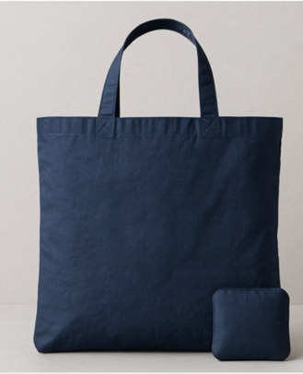 | This tote bag has been designed by AI-enabled technology. That is, AI (artificial intelligence) was involved in the entire process of designing this tote bag.
Transparency Cue Present | 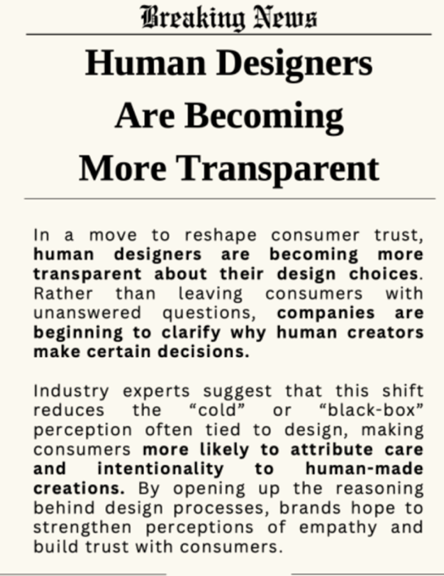  This tote bag has been designed by humans only. That is, only humans were involved in the entire process of designing this tote bag. | 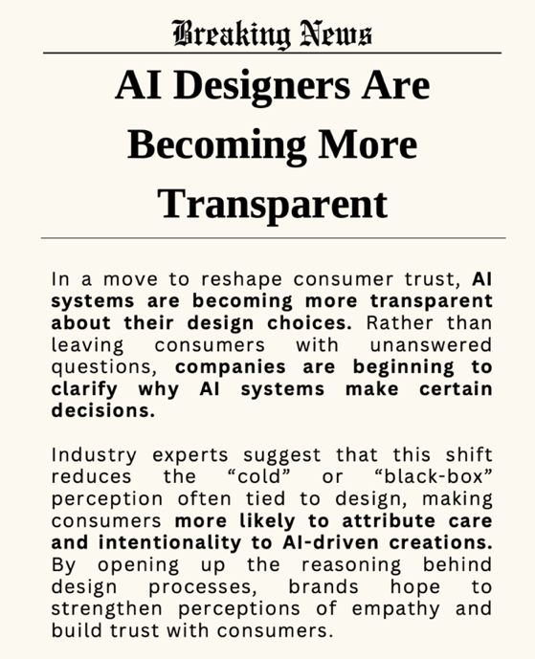  This tote bag has been designed by AI-enabled technology. That is, AI (artificial intelligence) was involved in the entire process of designing this tote bag.

Web Appendix H. Ruling Out Role of AI Literacy
The purpose of this preregistered study ( https://aspredicted.org/wn6eq7.pdf) was to test whether AI literacy moderates the effect of design agent on perceived sustainability. We recruited 200 participants 58.0 % female, 40.5% male, 1.5% prefer not to say, M_{age}= 41.21) via Prolific and randomly assigned them to one of two conditions in a 2 (design agent: AI vs. human) in a between-subjects design experiment (see Table 6 of the Manuscript). The study tests whether AI literacy moderates the effect of the source of product design on sustainability perceptions. Specifically, we examine whether products designed by AI are perceived as less sustainable than those designed by humans, and whether higher or lower AI literacy moderates this effect.
Method
Participants were randomly assigned to view a backpack described as designed either by AI-enabled technology or by humans. We measured AI transparency using the 10-item AI Literacy Scale developed by Tully, Longoni, and Appel (2025). Each item assesses respondents’ technical understanding of artificial intelligence. Responses were scored dichotomously, with each correct answer coded as 1, yielding a total score ranging from 0 to 10, where higher values indicate greater AI literacy. Perceived sustainability served as the primary dependent variable and was measured using the same two-item scale as in prior studies (r = .84, p < .001).
Results
A moderation analysis (PROCESS Model 1; Hayes, 2022) was conducted to test whether the effect of the design agent on perceived sustainability was moderated by AI literacy. The overall model was significant, F(3, 196) = 14.93, p < .001, R² = .186. There was a significant main effect of the design agent, b = –1.49, SE = 0.82, t = –1.83, p = .069, 95% CI [–3.10, 0.11], such that participants in the human condition (M = 4.86, SD = 0.92) evaluated the product more positively than those in the AI condition (M = 3.72, SD = 1.49). The main effect of AI literacy was nonsignificant, b = –0.11, SE = 0.08, t = –1.38, p = .17, 95% CI [–0.26, 0.05]. Importantly, the interaction between the IV and moderator was not significant (b = 0.06, SE = 0.12, t = 0.50, p = .62, 95% CI [–0.18, 0.29]), and the change in explained variance was negligible (ΔR² = .001, F(1, 196) = 0.25, p = .62).

Discussion

Together, these results indicate that while the design source significantly shaped sustainability evaluations, AI literacy neither influenced perceptions directly nor interacted with the design source to significantly influence the main effect.

Web Appendix I. References

Langan, R., & Kumar, A. (2019). Time versus money: the role of perceived effort in consumers’ evaluation of corporate giving. Journal of Business Research, 99, 295–305.
Mohr, L.A., & Bitner, M.J. (1995). The role of employee effort in satisfaction with service transactions. Journal of Business Research, 32, 239–252.
Monga, A.B., & John, D.R. (2007). Cultural Differences in Brand Extension Evaluation: The Influence of Analytic versus Holistic Thinking, Journal of Consumer Research, 33(4), 529–536.
Silva, O., Crilly, N., & Hekkert, P. (2015). How people’s appreciation of products is affected by their knowledge of the designers’ intentions. International Journal of Design, 9(2), 21–33
Tully, S.M., Longoni, Ch., & Appel, G. (2025). Lower Artificial Intelligence
Literacy Predicts Greater AI Receptivity. Journal of Marketing, 89(5), 1–20.
Xie, Y., Zhang, S., & Zhu, D. (2025). How to define sustainable design? An exploration through bibliometric analysis and literature review based on Web of Science. The Design Journal, 28(5), 885–907.

The pre-registration labels the focal mechanism as perceived human touch. To improve conceptual precision, we adopt the term genuine care in the manuscript. This change is terminological only; the measures, theoretical meaning, manipulation, and hypotheses remain unchanged.

