Process and outcome frames in firms’ environmental posts and
consumer engagement
Contents
Web Appendix A: Research on Environmental Message Frames 3
Table WA1: Summary of Prior Research on Environmental Message Frames 3
Web Appendix B: Research on Mental Simulation 6
Table WB1: Summary of Prior Research on Mental Simulation 6
Web Appendix C: Research on Warmth and Competence 9
Table WC1: Summary of Prior Research on Warmth and Competence 9
Web Appendix D: Methodological Details of Experimental Studies 13
Table WD1: Stimuli for Experimental Studies 13
Web Appendix E: Study 2: Methodological Details 18
Table WE1: List of 110 Brands Used in Study 2 18
Fine-Tuned BERT Model for Process and Outcome Frames 20
Table WE2: Intercoder Reliability 21
Table WE3: BERT Models Performance of Process and Outcome Measurements 22
Fine-Tuned BERT Model for Warmth and Competence Expressions 23
Table WE4: BERT Models Performance of Warmth and Competence Measurements 25
Table WE5: Definitions, Operationalizations and Rationale of Variables Used in Study 2 26
Table WE6: Descriptive Statistics and Correlations 27
Figure WE1: Study 2: Distribution of Process and Outcome Frames 28
Figure WE2: Interaction Effect of Warmth Expressions and Process Frame on Consumer Engagement with Posts 29
Figure WE3: Interaction Effect of Competence Expressions and Outcome Frame on Consumer Engagement with Posts 30
Figure WE4: Interaction Effect of Competence Expressions and Process Frame on Consumer Engagement with Posts 30
Table WE7: Binomial Regression Analyses Results Table 31
Web Appendix F: Study 3: Methodological Details 32
Table WF1: Definitions, Operationalizations and Rationale of Variables in Study 3 35
Table WF2: Study 3: Descriptive Statistics and Correlations 37
Figure WF1: Study 3: Distribution of Process and Outcome Frames 38
Figure WF2: Study 3: Interaction Effect of Warmth Expressions and Process Frame on Firm Engagement 39
Figure WF3: Study 3: Interaction Effect of Competence Expressions and Outcome Frame on Firm Engagement 39
Web Appendix G: Implications for Firms 40
References 42

Web Appendix A: Research on Environmental Message Frames

Table WA1: Summary of Prior Research on Environmental Message Frames
Authors | Message characteristic | Method | Moderator | Dependent variable | Findings
Amel et al. (2017) | The negative impact of educational efforts and fear (or guilt) based messages in sustainability communication | Review |  |  | Sustainable action is constrained by uncertainty, as people perceive ecological threats as distant, outcomes as unclear, and fear-based messages as ineffective without solutions. Social norms can reduce doubt and encourage collective action.
Carrete et al. (2012) | Consumer confusion, credibility, and compatibility of green product claims and eco-labels | Survey | Perceived personal benefits, cultural adaptation | Green consumer behaviors | Uncertainty in green behavior adoption could be caused by consumer confusion, low trust/credibility, and poor compatibility with daily practices. Green behaviors are often driven more by perceived personal benefits (e.g., financial benefits) than environmental values. Therefore, green behavior should be communicated on reduced perceived risk and uncertainty, clear personal benefits, cost control, and cultural adaptation.
Mancuso et al. (2021) | Clarity and the relevance of sustainability communication | Survey | Sustainable interest and sensitivity to marketing practices | Brand loyalty | Uncertainty from inadequate or confusing sustainability information undermines brand loyalty. Clear sustainability communication, when aligned with consumer interest, reduces uncertainty and strengthens brand loyalty.
Reczek et al. (2018) | Abstract vs. concrete frames | Experiment | Consumer segments, the emphasis of broad (societal or global) impact | Attitudes and choice of eco-friendly products | Compared to concrete construal, abstract construal enhances positive reactions (e.g., more favorable evaluations and stronger choice intentions) to eco-friendly products because these products align well with broad, long-term goals (e.g., “protect the planet”). Compared to abstract construal, concrete construal reduces uncertainty when messages highlight specific, present-focused attributes such as cost savings, convenience, and performance.
Reppmann et al. (2025) | Psychological ownership | Experiment | Embedded vs. peripheral corporate sustainable programs | Sustainable consumption | Psychological ownership via customer involvement may reduce uncertainty as it enhances the perception of personal impact and motivates green behavior. Furthermore, the link between customer involvement and psychological ownership depends on whether corporate sustainability is embedded in or peripheral to the core business.
Salnikova et al. (2022) | Promotion focus, spatially distant and temporally proximal frames | Experiment |  | Consumer engagement with environmental sustainability initiatives | Consumers with a global identity engage more with sustainability initiatives when promotion-framed messages reduce uncertainty by linking distant spatial outcomes to more immediate temporal benefits. In contrast, messaging strategies do not appear to impact consumers with a local identity.
van der Wal et al. (2018) | Benefit frames | Experiment | Benefit frames | Sustainable behavior | Uncertainty generally results in lower levels of sustainable behavior compared to certainty. However, highlighting the immediate benefits of sustainability during uncertain times can mitigate this negative effect and encourage consumers to engage in more sustainable actions.
van der Weiden et al. (2013) | Psychological mechanisms of self-agency | Review |  | Perceived self-agency | Perceptions of agency depend on accessible goals and situational cues. When people experience stronger self-agency, they feel more certain that their actions matter.
White and Simpson (2013) | Normative appeals including descriptive norms vs. injunctive norms vs. self-benefit appeals | Experiment | Congruent goals | Sustainable consumer behaviors | The effectiveness of normative and self-benefit appeals depends on whether the collective self or the individual self is activated. When the collective self is salient, normative appeals (including descriptive and injunctive norms) are most effective, whereas benefit appeals are less persuasive. In contrast, when the individual self is activated, self-benefit and descriptive appeals are particularly effective. These effects are explained by a goal-compatibility mechanism, in which the appeals that align with the activated self-goals produce the most sustainable consumer behaviors, such as composting.
White et al. (2019) | SHIFT (Social influence, Habits, Individual self, Feelings & cognition, Tangibility) framework | Conceptual review paper |  | Sustainable consumer behaviors | Sustainable behaviors often hinger on uncertainty about outcomes, timing, and personal impact. The SHIFT framework proposes multiple approaches to deal with uncertainty by enhancing tangibility, using credible social norms, and delivering clear, actionable information in sustainable communication.
Our research | Process versus outcome frames used separately and jointly in firm’s communication | Text mining using field data; online and field experiments | Warmth and competence expressions; congruency of process and outcome frames in messages that use joint frames | Engagement with the post (like, share, comment); engagement with the firm (purchase intentions, investment decision) | Both process and outcome frames increase engagement via distinct mechanisms. Combining incongruent process and outcome frames in one post can minimize their effectiveness. Furthermore, warmth expressions amplify the effects of process, but not outcome, frames, whereas competence expressions strengthen the effects of both process and outcome frames on engagement with the post, but only the effect of outcome frames on engagement with the firm.

Web Appendix B: Research on Mental Simulation

Table WB1: Summary of Prior Research on Mental Simulation
Authors | Method | Independent variable | Simulation focus | Mediator | Moderator |  | Dependent variable | Findings
Castaño et al. (2008) | Experiment | Mental simulation (process vs. outcome) | Consumers simulate their own behaviors and outcomes (self as agent) |  | Temporal frames (near future vs. distant future) |  | Uncertainty (switching-cost uncertainty, affective uncertainty, performance-benefit uncertainty, symbolic-benefit uncertainty), emotion (feelings of anxiety and feelings of optimism), and  behavioral intentions | Process simulation is more effective in the near future for reducing switching-cost and affective uncertainty, lessening anxiety and increasing behavioral intentions. Outcome simulation is more effective in the distant future for reducing performance uncertainty, bolstering positive feelings and increasing behavioral intentions.
Escalas and Luce (2003) | Experiment | Mental simulation (process vs. outcome) | Consumers simulate their own behaviors and outcomes (self as agent) |  | Argument strength (strong vs. weak) |  | Behavioral intentions | Process simulation enhances behavioral intentions more than does outcome simulation in the presence of strong advertisement arguments. Process simulation lowers behavioral intentions in the presence of weak advertisement arguments compared to outcome simulation.
Lu and Jen (2016) | Experiment | Option frames (additive vs. subtractive) and temporal distance (near future vs. distant future) | Consumers simulate their own behaviors (self as agent) |  | Type of mental simulation (process vs. outcome) |  | Decision difficulty | Additive option frames increase decision difficulty in the near future more than in the distant future, whereas subtractive option framing increases decision difficulty in the distant future more than in the near future. Process simulations reduce decision difficulty for distant-future choices, whereas outcome simulations reduce decision difficulty for near-future choices.
Petit et al. (2022) | Experiment | Product format (served vs. packaged) and visualization mode (3D vs. augmented reality) | Consumers simulate their own behaviors (self as agent) | Mental simulation of eating (process vs. outcome) |  |  | Purchase intention | Augmented reality visualization improves simulation of the eating process for served food more than does 3D, increasing purchase intention.
Ringler et al. (2024) | Experiment | Process versus outcome product demonstration | Consumers simulate other behaviors and other outcomes (other as agent) | Cognitive flow, narrative transportation | Social presence |  | Purchase intention | A process (vs. outcome) demonstration increases customers’ experience of cognitive flow and narrative transportation.  A process (vs. outcome) demonstration increases purchase intentions for the demonstrated product(s), which can include the focal product and any supporting products featured in the demonstration.
Thompson et al. (2009) | Experiment | Type of mental simulation (process-oriented vs. outcome-oriented thinking) | Consumers simulate their own behaviors and outcomes (self as agent) |  | Type of trade-off (means vs. end benefits, desirability vs. feasibility) |  | Decision difficulty | Process-oriented simulation leads to a dual focus on both means and end benefits; it increases decision difficulty when consumers face substantive trade-offs between desirability and feasibility.
Ülkümen and Thomas (2013) | Experiment | Duration framing | Consumers simulate their own behaviors (self as agent) |  | Process simulation and personal relevance |  | Perceived duration | When a plan seems personally relevant to participants, it triggers process-focused simulation, which in turn amplifies the effect of duration frames and increases the perceived duration of the plan.
Zhao et al. (2007) | Experiment | Time (near future vs. distant future) and type of simulation (outcome simulation vs. process simulation) | Consumers simulate their own outcomes (self as agent) | - | Outcome timing |  | Preference (change vs. consistency) | Outcome simulation for near-future events and process simulation for distant-future events lead to preference consistency over time. Outcome timing moderates the effectiveness of process versus outcome simulation.
Zhang et al. (2021) | Experiment | Mental simulation (process vs. outcome of recycling) | Consumers simulate their own vs. other behaviors and outcomes (self vs. other as agent) | - | Imagery perspective (actor vs. observer perspective) | Intention to recycle |  | Mental simulation significantly increases recycling intentions. An observer’s perspective enhances outcome-focused simulations, whereas an actor’s perspective enhances process-focused simulations.
Our research | Text mining and experiments | Consumer engagement with environmental posts and the firm | Consumers simulate firm actions and outcomes (firm as agent) | Consumers’ outcome and process simulations | Warmth versus competence expressions | Engagement with the post (like, share, comment); engagement with the firm (purchase intentions, investment decision) |  | Both process and outcome frames increase engagement via distinct mechanisms. Combining incongruent process and outcome frames in one post can minimize their effectiveness. Furthermore, firm’s warmth expressions amplify the effects of process, but not outcome, frames, whereas competence expressions strengthen the effects of both process and outcome frames on engagement with the post, but only the effect of outcome frames on engagement with the firm.

Web Appendix C: Research on Warmth and Competence

Table WC1: Summary of Prior Research on Warmth and Competence
Study | Context | Role of warmth/competence | Focal target | Dependent variables | Main findings
Warmth/Competence Perceptions in the Context of Brands
Aaker et al. (2010) | General branding | Antecedent: perception of warmth and competence are consumer stereotypes of firms | For-profit and nonprofit firms | Brand evaluations and purchase intentions | Nonprofits are generally seen as warmer but less competent; for-profits are generally seen as more competent but less warm.
Aaker et al. (2012) | General branding | Antecedent: perceived brand warmth and competence predict consumer responses | Brands | Brand admiration, brand evaluations, and purchases | Brands perceived as both warm and competent receive the strongest admiration and favorable responses.
Zhou et al. (2022) | Brand communication | Mediator: competitive brand-to-brand praise influences perceived warmth and competence, which then explain consumer responses. | Brands praising competitors | Click-through rate, brand attitude, brand interest, and perceived costliness/authenticity/novelty | Public praise of competitors leads to positive brand outcomes; this effect of brand-to-brand praise is explained by the increased perceptions of brand warmth.
Warmth/Competence Perceptions in the Context of Services
Chi et al. (2024) | Service robots | Antecedent: anthropomorphic warmth and competence congruence influences attachment and recommendation | Service robots | Consumer attachment to service robots and recommendation intention | Consumer attachment and recommendation intention increase when anthropomorphic warmth and competence are congruent.
Güntürkün et al. (2020) | Service delivery | Antecedent: perceived provider warmth and competence shape different relationship outcomes through relational and capability concerns. | Customer-service provider relationships | Relational outcomes and performance outcomes | Warmth is more important for relational outcomes, whereas competence is more important for transactional and performance outcomes. Relational and capability concerns mediate the effects of these perceptions. For consumers with strong process goal orientation respond, the diagnosticity of warmth perceptions is important; for consumers with outcome orientation, the diagnosticity of competence perceptions is important.
Huang et al. (2020) | Service recovery | Moderator: the effectiveness of perceptions of service employee warmth and competence depends on service failure type. | Process vs. outcome service failures | Customer service recovery cooperation intention | Competence perceptions of the employee are more effective in outcome-failure recovery, whereas warmth perceptions are more effective in process-failure recovery.
Su et al. (2025) | Service delivery | Moderator: provider warmth or competence perceptions work better when matched with activity type | Service providers in relaxing vs. challenging activities | Electronic word-of-mouth | Warmth perceptions of providers work better for relaxing activities; competence perceptions work better for challenging activities; pleasure mediates the effects of warmth and competence perceptions on positive eWOM
Warmth/Competence Perceptions in the Context of Influencer Marketing
Chen et al. (2025) | Online streaming | Mediator: language certainty affects purchase behavior through perceived competence and warmth. | Streamers | Product sales and purchase intention | Moderate certainty increases professionalism/competence perceptions, increasing purchase intention. High certainty expression decreases warmth perceptions, lowering purchase intention.
Gu et al. (2025) | Influencer marketing | Mediator: warmth and competence perceptions are shaped by emotional expressions. | Social media influencers | Engagement, eWOM, perceived authenticity, and perceived appropriateness | Influencer popularity depends more on authenticity and appropriateness of emotional expressions than on emotional valence alone. The warmth and competence perceptions mediate the effect of the expressive style on outcomes.
El Hedhli et al. (2023) | Virtual influencers | Mediator: anthropomorphism affects consumer responses through perceived warmth and competence. | Human-like virtual influencers | Willingness to follow recommendations and purchase intention | Anthropomorphism increases perceived warmth and competence perceptions; warmth perception is more strongly linked to willingness to follow recommendations.
Kim & Read (2021) | Influencer marketing | Mediator: visual cues affect warmth and competence perceptions, which then affect persuasion outcomes | Social media influencers | Influencer evaluation and behavioral responses to persuasive messages | Broad smiles increase warmth and competence perceptions of the influencer, which increase admiration and positive responses.
Ren et al. (2023) | Influencer marketing | Moderator: brand warmth and competence perceptions change the effectiveness of influencer type | Brands endorsed by informers vs. entertainers | Endorsement engagement, post engagement (i.e., views, likes, comments), and online sales | Entertainers (vs. informers) attract more engagement overall; however, informers (vs. entertainers) generate more sales when endorsing brands that are perceived as competent; there is no significant difference in the effects of the influencer for the brands that are perceived warm.
Warmth/Competence in the Context of Environmental Communication
Sun et al. (2024) | Green advertising | Mediator: perceived warmth and competence of the advertising message partially explain sentence-pattern effects. | Green advertisements | Green purchase intention | Affirmative (negative) sentence patterns work with promotion (prevention) regulatory focus. The indirect effect of perceived competence is significant only in affirmative sentences with promotion focus groups. The indirect effect of perceived warmth is significant only in negative sentences with prevention focus groups.
Yu et al. (2025) | Green advertising | Moderator: warmth and competence appeals are more effective when matched with information framing | Green advertising messages | Green purchase intention, advertising attitude, and product involvement | Concrete-competence and abstract-warmth pairings are more effective in increasing positive consumer response than mismatched pairings.
Warmth/Competence as Message Expressions
Packard et al. (2024) | Service language | Antecedent: linguistic markers communicate warmth and competence. | Service providers and customer-facing language | Consumer evaluations and service behavior outcomes | Specific language markers can convey warmth and competence and change consumer responses
Peasley et al. (2026) | Service agent | Moderators: the service agent warmth and competence in communication | Customer-service agent relationship | Customer frustration, customer satisfaction, cost per call | Competence-focused communication helps reduce customer frustration and, in turn, improves customer satisfaction while lowering service costs, especially when customers face highly severe issues. Conversely, warmth-focused communication is beneficial primarily in low-severity situations.
Roccapriore & Pollock (2023) | Influencer marketing | Antecedent: word- and image-based warmth/competence cues (both image and text) predict different engagement levels. | Fitness influencers | Number of followers and positive interactions in comments | Competence cues are more strongly tied to the number of followers, whereas warmth cues are more strongly tied to positive interactions in comments.
Key Gaps:
- The majority of studies examined consumer perceptions of warmth and competence rather than how firms can express warmth and competence in their communication.
- Few studies examined warmth and competence in relation to environmental communication, but most findings indicate the importance of message/perception contexts to the effectiveness of these signals.
- Most studies examined warmth/competence perceptions as antecedents or mediators but only a few focused on their moderating role.
- Although some studies demonstrate effectiveness of warmth perceptions when paired with process/concrete goals and competence perceptions when paired with outcome/abstract goals, these results are not consistent and context dependent.

Our research | Firm’s environmental communication | Moderator: warmth and competence are expressions that moderate the effects of process and outcome frames. | Firm’s environmental posts | Post engagement (i.e., likes, shares, comments) and engagement with the firm | Warmth expressions strengthen the effect of process (but not outcome) frames on engagement. Competence expressions increase post engagement when paired with either process or outcome frames, but they only amplify firm engagement when paired with outcome frames.

Web Appendix D: Methodological Details of Experimental Studies

Table WD1: Stimuli for Experimental Studies
 | Process Frame | Outcome Frame | Control | Joint Incongruent Frame | Joint Congruent Frame
Study 1a | Our manufacturing plants have focused on major steps for energy efficiency: upgraded to energy-efficient equipment, improved insulation, and optimized production flow. | Our manufacturing plants have achieved a major 40% reduction in energy usage, significantly lowering our environmental footprint and advancing energy efficiency. | Our manufacturing plants have demonstrated a major commitment to environmental sustainability by their continuous focus on energy efficiency.
Study 1b | At BWS & Co., we take three steps with our packaging to protect the environment. First, we start with 100% recycled cardboard. Next, each package is hand-folded and sealed using biodegradable tape. Finally, to cushion the items, we shred old office paper instead of using plastic fillers. These steps are how we do sustainability. | At BWS & Co., we are committed to a greener future and have achieved tangible outcomes. Our recycled cardboard packaging helps cut down on waste. This year, our packaging has kept over 10,000 pounds of plastic out of landfills. That decreases CO2 emissions by 20% and leaves a smaller environmental footprint. | At BWS & Co., we use packaging that consists of recycled cardboard, minimizing environmental impact. It represents a strategic focus on protecting natural resources. 100% of our product parts are chosen for their environmental benefits, not just looks. This approach supports our 3 sustainability values and ongoing dedication to responsible practices.
Study 4a | At BWS & Co., we have taken three steps to protect the environment. First, we use eco-friendly materials like recycled rubber and organic cotton. Second, we implement energy-efficient processes, such as lighting and heating controls. Finally, we developed a circular model for recycling old shoes into new products. | At BWS & Co., we are committed to a greener future and have achieved tangible outcomes. Over the past five years, we’ve reduced carbon emissions in manufacturing by 30% and cut plastic use by 90%. Our mission is clear: to reach Net-Zero emissions by 2030. |  | At BWS & Co., over the past five years, we have achieved a tangible outcome of cutting carbon emissions in manufacturing by 30%. We also take additional steps to protect the environment. First, we utilize eco-friendly materials, such as recycled rubber and organic cotton, and second, we minimize energy consumption.
Study 4b | At Orinell, we have taken three steps to protect the environment. First, we use eco-friendly materials like organic cotton. Second, we implement energy-efficient systems such as lighting and heating controls. Finally, we develop a circular model for recycling old shoes into new products. | At Orinell, we are committed to greener future and have achieved tangible outcomes. We have reduced carbon emissions in manufacturing by 30% and our efforts have led to a 90% reduction in plastic use. We aim to reach Net-Zero emissions by 2030. |  |  | At Orinell, we have achieved tangible environmental outcomes by cutting emissions by 30% and reducing plastic use by 90%. We were able to get those results by taking specific steps. First, we use recycled materials such as organic cotton and second, we minimize energy consumption
Study 4c | At Orinell, we have taken three steps to protect the environment. First, we use eco-friendly materials like organic cotton. Second, we implement energy-efficient systems such as lighting and heating controls. Finally, we develop a circular model for recycling old shoes into new products. | At Orinell, we are committed to greener future and have achieved tangible outcomes. We have reduced carbon emissions in manufacturing by 30% and our efforts have led to a 90% reduction in plastic use. We aim to reach Net-Zero emissions by 2030. |  | At Orinell, we have achieved tangible environmental outcomes by cutting emissions by 30% and reducing plastic use by 90%. We also take additional steps to protect the environment. First, we use recycled materials such as organic cotton and second, we minimize energy consumption. | At Orinell, we have achieved tangible environmental outcomes by cutting emissions by 30% and reducing plastic use by 90%. We were able to get those results by taking specific steps. First, we use recycled materials such as organic cotton and second, we minimize energy consumption

Manipulation Check Analyses across Experiment Studies
Study 1a
Our manipulations were successful for both process and outcome simulations. Multivariate ANOVA results (Wilk’s Lambda = .73, F (4,295) = 25.71, p < .001) indicate that participants in the process condition (M = 5.46, F(2,296) = 19.64, p < .001) reported that the post emphasized steps that BWS & Co is taking to achieve sustainability more than those in the outcome (M = 4.84, t(198) = 2.95, p = .004) and control (M = 4.07, t(199) = 6.33, p < .001) conditions. Participants in the outcome condition (M = 5.26, F(2,296) = 28.82, p < .001) reported that the post emphasized tangible results of BWS & Co’s environmental actions more than those in the process (M = 4.07, t(198) = 4.95, p = .002) and control (M = 3.44, t(195) = 7.74, p < .001) conditions. There was no significant difference in participants’ perceptions of the post length (F(2,296) = .14, p = .87), but participants in the process (M = 4.42) and outcome (M = 3.99) conditions perceived the posts as having more concrete information than those in the control condition (M = 3.08, F(2,296) = 16.38, p < .001).
Study 1b
Results of multivariate ANOVA (Wilk’s Lambda = .83, F (4, 376) = 19.04, p < .001) indicate that our manipulation check was successful. Participants in the process condition (M = 6.15, F(2, 377) = 5.03, p =.007) reported that the post emphasized steps that BWS & Co is taking to achieve sustainability more than those in the outcome (M = 5.91, t(251) = 1.63, p = .052) and control (M = 5.67, t(251) = 3.30, p < .001) conditions. Participants in the outcome condition (M = 5.91, F(2, 377) = 29.79, p < .001) reported that the post emphasized tangible results of BWS & Co’s environmental actions more than those in the process (M = 4.33, t(251) = 7.41, p < .001) and control (M = 4.83, t(252) = 5.80, p < .001) conditions. The posts did not significantly differ based on their length (F (2,377) = 1.91, p = .14) or on perceptions of concrete details about environmental sustainability that BWS & Co presented in the post (F (2,377) = 2.01, p = .14) across conditions.
Study 4a
Results of multivariate ANOVA (Wilk’s Lambda = .63, F(3, 436) = 56.62, p < .001) indicate that our manipulation was successful. Participants in the process condition (M = 6.19; F(2, 436) = 35.41, p < .001) reported that the post emphasized steps that BWS & Co is taking to achieve sustainability more than those in the outcome condition (M = 4.70, t(290) = 8.49, p < .001) and the joint incongruent condition (M = 5.08, t(289) = 6.80, p < .001). Participants in the joint incongruent condition were significantly more likely to report that the post emphasized steps that BWS & Co is taking than those in the outcome condition (t(293) = 1.82, p = .07). Similarly, participants in the outcome condition (M = 5.99, F(2,436) = 75.76, p < .001) reported that the post emphasized tangible results of BWS & Co’s environmental actions more than those in the process (M = 3.84, t(290) = 12.38, p < .001) and joint incongruent (M = 5.10, t(293) = 5.61, p < .001) conditions. Participants in the joint incongruent condition were more likely to report that the post emphasized tangible outcomes than those in the process condition (t(289) = 6.57, p < .001).
Study 4b
Results of multivariate ANOVA (Wilk’s Lambda = .69, F(3, 296) = 28.07, p < .001) indicate that our manipulation check was successful. Participants in the process condition (M = 5.69; t(199) = 5.29, p < .001) and the joint congruent condition (M = 5.30, t(196) = 3.17, p = .002) reported that the post emphasized steps that Orinell is taking to achieve sustainability more than those in the outcome condition (M = 4.55; F(2, 296) = 14.92, p < .001). Participants in the outcome condition (M = 5.48, t(199) = 7.46, p < .001) and the joint congruent condition (M = 5.53, t(197) = 7.80, p < .001) reported that the post emphasized tangible results of Orinell’s environmental actions more than those in the process (M = 3.90; F(2, 296) = 42.31, p < .001) condition. The posts did not significantly differ based on their length (F (2, 296) = 2.00, p = .14) or on perceptions of the use of concrete language (F (2, 296) = 1.25, p = .29) across conditions.

Web Appendix E: Study 2: Methodological Details

Table WE1: List of 110 Brands Used in Study 2
Brand | Env Post | Brand | Env Post | Brand | Env Post | Brand | Env Post | Brand | Env Post
Discovery | 1256 | Royal Caribbean Group | 123 | Comcast | 51 | Dollar Tree | 20 | Luby’s | 8
Pepsi Co | 909 | Kroger | 122 | Chipotle | 50 | Gannett | 20 | Red Robin Burgers | 8
SeaWorld | 795 | Coca Cola | 117 | AEO | 49 | Footlocker | 20 | Papa John’s | 7
United Natural Foods (UNFI) | 649 | Fastenal Company | 116 | Coke CCBCC | 47 | Express | 19 | Boot Barn | 6
Kellogg Company | 500 | McDonald’s | 111 | Travel Zoo | 46 | Albertson’s Co. | 18 | BJ restaurants | 6
Home Depot | 473 | Tiffany and Co. | 109 | Caesar’s Ent. | 45 | Ultra Beauty | 18 | Hibbett sports | 5
Grainger | 439 | Wayfair | 99 | GUESS | 40 | Dove | 17 | Planet Fitness | 5
General Mills | 373 | NY Times | 95 | Bed, Bath & Beyond | 38 | DICK’S | 17 | Cracker Barrel | 4
ORBCOMM_Inc | 302 | Overstock | 92 | Williams Sonoma | 37 | Yelp | 16 | Shoe Carnival | 4
CP News | 296 | Starbucks | 87 | Target | 37 | Potbelly | 16 | HIG Capital LLC | 4
Extra Space | 282 | Hyatt | 87 | Tilly’s | 36 | Estee Lauder | 15
CDW Corp | 262 | Chegg | 85 | Nordstrom | 35 | Denny’s Diner | 14
Berry Global Inc. | 260 | Hilton Hotels | 84 | ZAGG Daily | 33 | Sally Beauty | 14
Forrester | 232 | UTI | 83 | Hasbro | 33 | Crocs | 13
Hershey Company | 212 | 1-800-flowers | 75 | Ralph Lauren | 32 | Meredith Corp | 13
XPO Logistics | 209 | Amazon | 75 | Hilton Grand | 32 | JJ Snack Foods | 12
Marriott Intl. | 200 | DFIN Solutions | 69 | Kraft Heinz Co | 31 | Macy’s | 12
Tupperware | 196 | HMH Co | 65 | EW Scripps Co | 31 | Choice Hotels | 11
Sprout’s | 182 | HR Block | 62 | Dollar General | 25 | Domino’s | 11
Scholastic | 162 | CarParts.com | 61 | Reebok | 25 | Zumiez | 11
MGM Resorts Intl | 158 | Walmart | 60 | Franklin Covey | 24 | Chuy’s Restaurant | 10
Darden | 157 | Oreilly auto | 57 | Alsbridge Inc. | 24 | Five Below | 9
Paychex | 154 | Container Store | 56 | Revlon | 23 | WWE | 8
Columbia | 145 | Urban Outfitters | 55 | Extended Stay | 21 | Disney | 8
Gartner | 136 | TEGNA | 54 | Fossil | 21 | Nike | 8

Fine-Tuned BERT Model for Process and Outcome Frames
Initially, we created a reliable and scalable classifier to identify the process and outcome frames in an environmental post. Leveraging this trained classifier, we predicted the process and outcome frames in our entire set of environmental posts. To train this classifier, we utilized the pre-trained transformer-based language BERT model, “bert-base-uncased” from Hugging Face (https://huggingface.co/bert-base-uncased).
The pre-trained BERT model processes text input by converting words into text representation vectors. These vectors are then input to a dense layer to identify patterns and generate the output. We employed PyTorch as our development framework due to its widespread adoption in the deep learning community (Paszke et al., 2019). The procedure of fine-tuning the BERT model is as follows:
Step 1: Manual coding for the training data
To fine-tune the BERT model for identifying process and outcome frames, a dataset containing 2,000 environmental posts are randomly selected from all the environmental posts in our dataset of the 110 firms. Then, three human coders participated in rigorous training to guarantee the reliability and accuracy of their annotations of process and outcome frames. The subsequent page includes a detailed codebook that outlines the questions used for coding process and outcome frames in an environmental post.
Coding Instruction
You will be asked to read and code 2,000 posts. Please classify each post as exhibiting either process, outcome, or other.
To help you with this process, we have provided a codebook that defines these constructs and includes examples.
What type of frame is used in the environmental posts?
1. Process | A process frame is a type of communication manner that emphasizes the steps or procedures that a firm has taken in its environmental activities that are described in environmental posts.  Examples of posts using process frames:  - We are cutting waste by using recycled materials. We have also switched to renewable energy.  - To protect the environment, we have optimized packaging using recycle materials and invest in renewable energy.
2. Outcome | An outcome frame is a type of communication manner that emphasizes the results, benefits, or desired/achieved outcomes of a firm's environmental activities that are described in environmental posts.  Examples of posts using outcome frames:  - Our #GreenRenovations have kept 25 million cubic feet of material out of landfills.  - An important step in our journey to making 100% of our packaging recyclable, reusable or compostable by 2025.
3. Other | Both of communications above are not used

Table WE2: Intercoder Reliability
 | Agreement
Process  Outcome | 82%  86%
Other | 80%

Following the coding procedure, intercoder reliability was high (Table WE2), with agreement rates of 82% for process frames, 86% for outcome frames, and 80% for other frames. Based on this coding, we identified 620 environmental posts using process frames, 498 using outcome frames, and 882 using other frames.
Step 2: Fine-tuning the BERT model
We developed our deep learning model using the PyTorch framework and Python 3 with an NVIDIA A100 GPU on Google Cloud. We selected the “bert-base-uncased” as the pre-trained BERT model, which contains 12 layers, 768 hidden units, 12 attention heads, and a total of 110 million parameters. The output from the pre-trained BERT model was then input into a dense layer to get the final output. To achieve stable and consistent performance in the initial stages of training, we implemented warmup steps. Table WE3 illustrates that BERT demonstrated great performance in classifying process and outcome frames, achieving an average accuracy of 81.9% and an AUROC of .822. Following this, we applied the trained model to classify the remaining environmental posts to extract process and outcome.

Table WE3: BERT Models Performance of Process and Outcome Measurements

Label | Accuracy | AUROC
Process | .805 | .818
Outcome | .832 | .836
Other | .821 | .813
Average | .819 | .822

The model for measuring process and outcome frames is available at the following link (https://huggingface.co/ProcessOutcomePaper/ProcessOutcome). A code demonstration is provided below:
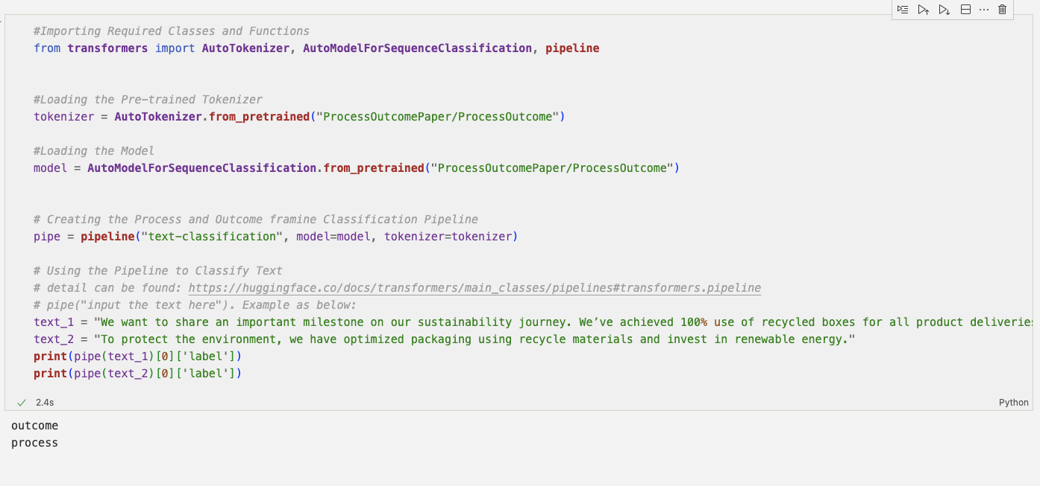

Fine-Tuned BERT Model for Warmth and Competence Expressions
The procedure of fine-tuning the BERT model is the same as for process and outcome frames. The coding instructions are listed below.
Coding Instruction
You will be asked to read and code 2,000 posts. Please classify each post as exhibiting either warmth expression, competence expression, or none.
To help you with this process, we have provided a codebook that defines these constructs and includes examples.
What expression is used in environmental posts?
1. Warmth | Warmth expressions are communicative cues that convey affective concern, friendliness, care, and sincerity, expressed through emotional and affective language that signals attention to the customer’s emotional state.  Examples of posts using warmth expressions:  - The devastation from #HurricaneLaura and the California wildfires has been heartbreaking — and we want to help those affected by these disasters. (This post is coded as warmth because it expresses concern for people affected by disasters and communicates the firm’s willingness to provide support)  - Our mini cans may be small, but our care for the environment runs deep. We collect and recycle every bottle we sell. Small steps, shared care. (This post is coded as warmth because it emphasizes environment support. These elements present the firm as caring, sincere, and relationship-oriented)
2. Competence | Competence expressions are communicative cues that convey capability, expertise, effectiveness, and reliability, expressed through cognitive and instrumental language that signals rational thinking, problem-solving, and agency in addressing customer needs.  Examples of posts using competence expressions:  - Innovative PlantBottle begins global rollout! Up to 30% plant-based, 100% recyclable bottle! (This post is coded as competence because it presents the firm as capable of developing and implementing an environmental product innovation at scale. The phrases “innovative,” “global rollout,” “plant-based,” and “100% recyclable” do not merely provide factual information; they signal product development capability, technical execution, and scalable implementation.)  - An innovative sugar-based bathing suit can clean the ocean as you swim. (This post is coded as competence because it highlights functional problem-solving ability. The bathing suit is presented as an innovative product that can generate concrete environmental benefit by cleaning the ocean during use. Thus, the post signals capability, effectiveness, and product-based environmental solution delivery)
3. None | Neither of the communication cues listed above is used

The intercoder reliability among the three independent coders was 82%, 80%, and 78% for warmth, competence, and the “other” category, respectively. We then fine-tuned a BERT model using the same parameter settings and procedure as process and outcome’s BERT model. The resulting classification accuracy for warmth, competence, and others were 85%, 78%, and 79%, respectively, with corresponding AUC values of .83, .80, and .79 (Table WE4).

Table WE4: BERT Models Performance of Warmth and Competence Measurements

Label | Accuracy | AUROC
Warmth | .851 | .830
Competence | .782 | .801
Other | .793 | .792
Average | .808 | .807

These results indicate that the model achieves satisfactory predictive performance for identifying warmth and competence expressions. We subsequently applied the trained model to the full dataset to extract warmth and competence expressions.

Table WE5: Definitions, Operationalizations and Rationale of Variables Used in Study 2
Variable | Definitions/Operationalization | Source of measurements | Rationale
Consumer engagement with the post | The sum of the number of likes, shares and comments that an environmental post receives. | X platform | Prior research has measured consumer social media engagement based on this measurement (Pezzuti & Leonhardt, 2023)
Process frame | The propensity score of process frame, obtained using a BERT model, for an environmental post. | Text Mining | We utilized machine learning (a fine-tuned BERT model) to identify the propensity of an environmental post to use process frame. This is one of our independent variables.
Outcome frame | The propensity score of outcome frame, obtained using a BERT model, for an environmental post. | Text Mining | We utilized machine learning (a fine-tuned BERT model) to identify the propensity of an environmental post to use outcome frame. This is one of our independent variables.
Warmth expressions | The propensity score of warmth expressions, obtained using a BERT model, for an environmental post. | Text Mining | We utilized machine learning (a fine-tuned BERT model) to identify the propensity of an environmental post to use warmth expressions. This is one of our moderating variables.
Competence expressions | The propensity score of competence expressions, obtained using a BERT model, for an environmental post. | Text Mining | We utilized machine learning (a fine-tuned BERT model) to identify the propensity of an environmental post to use competence expressions. This is one of our moderating variables.
Post length | The number of words in an environmental post. | Text Mining | Longer posts can provide more information (Huang et al., 2025), influencing consumer social media engagement.
Photos | The total number of photos used in an environmental post. | X platform | Consumer social media engagement can be influenced by the vividness of a message (Xu et al., 2023). And the level of vividness of a message can be captured by its visual content (e.g., video and image).
Videos | The total number of videos used in an environmental post. | X platform | Consumer social media engagement can be influenced by the vividness of a message (Xu et al., 2023). And the level of vividness of a message can be captured by its visual content (e.g., video and image).
Links | The total number of links used in an environmental post. | X platform | Links could provide additional information that influence consumer social media engagement (Huang et al., 2025).
Question marks | The number of question marks used in an environmental post. | X platform | Question marks are indicators of a post’s interactivity, which may affect consumer social media engagement (Huang et al., 2025).
Negation language | The percentage of affective language based on the “negate” dictionary from LIWC in an environmental post. | Text Mining | Negation language signals the power of a brand and perceived brand power can influence their social media engagement (Pezzuti & Leonhardt, 2023).
Personal pronouns | The percentage of affective language based on the “ppron” dictionary from LIWC in an environmental post. | Text Mining | The use of personal pronoun in firm social media post has been found to influence consumer engagement with the post (Huang et al., 2025).
Certainty language | The percentage of certainty language based on the “certitude” dictionary from LIWC in an environmental post. | Text Mining | Certainty language also enhances consumers’ perception of brand power that, in turn, influences social media engagement (Pezzuti et al., 2021).
Past-focused language | The percentage of past-focused language based on the “focuspast” dictionary from LIWC in an environmental post. | Text Mining | Environmental communication often tends to be abstract. The use of past-focused language can signal actual environmental practices undertaken by the firm. Also, the use of past tense has been found to influence the persuasion of a message (Packard et al., 2023) that might influence consumer engagement with the message.
Future-focused language | The percentage of future-focused language based on the “focusfuture” dictionary from LIWC in an environmental post. | Text Mining | The use of future-focused language can shape consumers’ perceptions by activating a more abstract construal, which may, in turn, influence consumer engagement with environmental messages (Trope & Liberman, 2010).
Concrete language | The number of concrete words adopted from (Brysbaert et al., 2014) in an environmental post. | Text Mining | Concrete environmental message reduces consumer uncertainty toward environmental practices and enhances trust which can drive their social media engagement (Reczek et al., 2018).
Engagement carryover | The sum of the number of likes, shares and comments that the three posts prior to a current environmental post receives. | X platform | Consumers often read about three posts when interacting with brands on social media, so the level of engagement that other posts receive may influence their engagement with the current post (Ordenes et al., 2019).

Table WE6: Descriptive Statistics and Correlations
Variables | Mean | SD | 1 | 2 | 3 | 4 | 5 | 6 | 7 | 8 | 9 | 10 | 11 | 12 | 13 | 14 | 15 | 16 | 17
1 Engagement with post | 59.234 | 387.479 | 1.000
2 Process frame | .23 | .131 | -.010 | 1.000
3 Outcome frame | .187 | .193 | .051*** | -.158*** | 1.000
4 Competence expressions | .296 | .426 | -.028*** | .025*** | .033*** | 1.000
5 Warmth expressions | .388 | .392 | -.007 | -.035*** | -.235*** | -.613*** | 1.000
6 Post Length | 2.55 | 8.851 | .007 | .471*** | .139*** | .062*** | -.180*** | 1.000
7 Photos | .398 | .603 | .021** | .181*** | -.054*** | -.004 | .121*** | .257*** | 1.000
8 Videos | .053 | .225 | .062*** | .133*** | .025*** | -.016* | .009 | .245*** | -.157*** | 1.000
9 Links | 1.223 | .608 | -.013 | .158*** | -.128*** | -.031*** | .210*** | .233*** | .545*** | .134*** | 1.000
10 Question marks | .114 | .334 | -.021** | -.101*** | -.087*** | .007 | -.069*** | .014 | -.041*** | -.016* | -.044*** | 1.000
11 Negation language | .054 | .239 | .019** | -.009 | .009 | .002 | -.055*** | .073*** | .008 | .016* | .006 | .038*** | 1.000
12 Personal pronouns | 3.835 | 4.246 | .017* | .146*** | -.101*** | .015* | .012 | .174*** | .021** | .064*** | -.092*** | .126*** | .018** | 1.000
13 Certainty language | .104 | .735 | .002 | -.004 | .004 | .004 | -.029*** | .016* | -.010 | .008 | -.029*** | .012 | .022** | -.004 | 1.000
14 Past-focused language | .953 | 2.248 | .016* | .085*** | .132*** | -.001 | -.064*** | .087*** | -.015* | .015* | -.075*** | .027*** | .014* | .083*** | .024*** | 1.000
15 Future-focused language | .672 | 1.87 | .009 | -.041*** | .031*** | .020** | -.058*** | .028*** | -.048*** | -.018** | -.053*** | .067*** | .028*** | .027*** | .000 | -.057*** | 1.000
16 Concrete language | 2.671 | .38 | .037*** | -.045*** | .079*** | -.015* | -.078*** | -.078*** | .004 | -.018** | -.038*** | .048*** | .016* | -.004 | -.022** | .003 | -.046*** | 1.000
17 Engagement carryover | 275.153 | 4686.58 | .183*** | .009 | .021** | -.012 | -.004 | .014 | -.004 | .011 | -.019** | .003 | .011 | .011 | -.003 | .020** | -.002 | .014 | 1.000
*** p<.01, ** p<.05, * p<.1

Figure WE1: Study 2: Distribution of Process and Outcome Frames

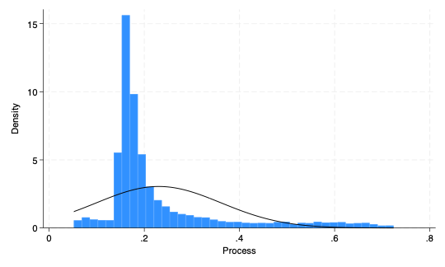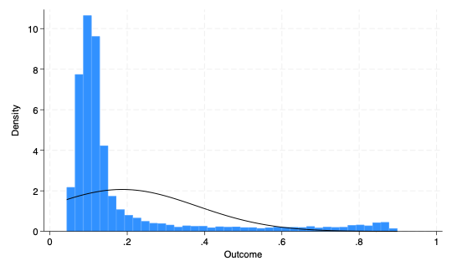

Figure WE2: Interaction Effect of Warmth Expressions and Process Frame on Consumer Engagement with Posts
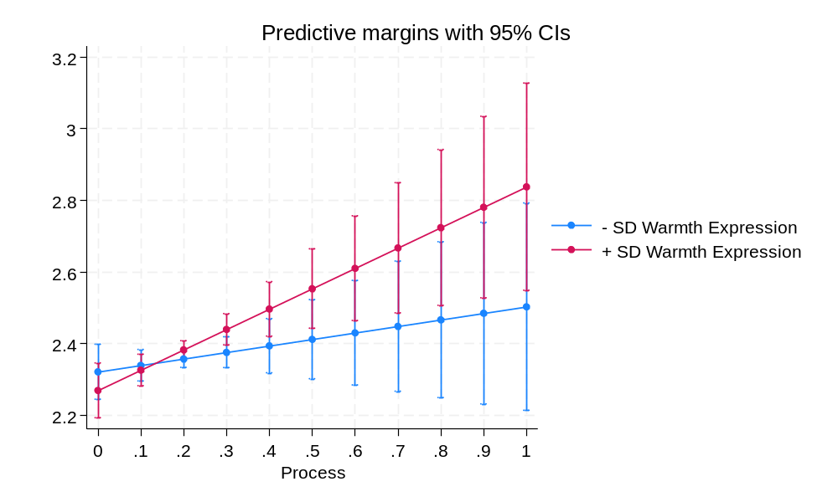

Figure WE3: Interaction Effect of Competence Expressions and Outcome Frame on Consumer Engagement with Posts
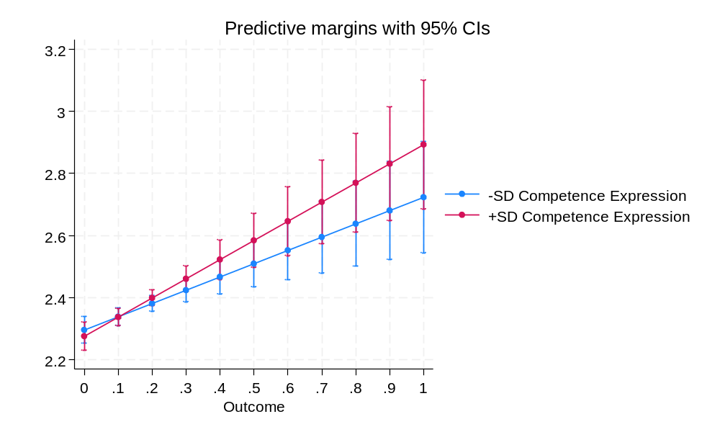

Figure WE4: Interaction Effect of Competence Expressions and Process Frame on Consumer Engagement with Posts

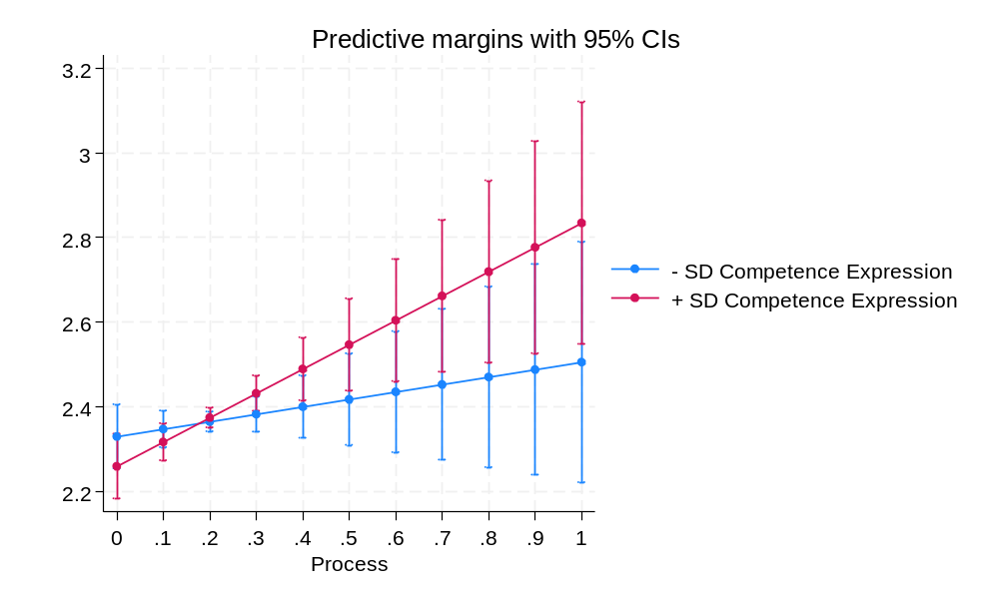

Table WE7: Binomial Regression Analyses Results Table
DV: Engagement with post | Model 1 |  |  | Model 2 |  |  | Model 3 |  |  | Model 4
 | B | SE | p | B | SE | p | B | SE | p | B | SE | p
Process frame | .724 | .192 | .000 | .696 | .193 | .000 | .768 | .204 | .000 | .055 | .280 | .846
Outcome frame | .353 | .117 | .003 | .375 | .117 | .001 | .508 | .168 | .002 | .228 | .151 | .131
Competence expressions |  |  |  | .075 | .043 | .077 | .077 | .043 | .069 | -.432 | .115 | .000
Warmth expressions |  |  |  | .154 | .048 | .001 | .157 | .048 | .001 | .004 | .126 | .974
Process * outcome expressions |  |  |  |  |  |  | -1.022 | .922 | .267
Process * competence expressions |  |  |  |  |  |  |  |  |  | 1.694 | .395 | .000
Process * warmth expressions |  |  |  |  |  |  |  |  |  | .741 | .456 | .104
Outcome * competence expressions |  |  |  |  |  |  |  |  |  | .781 | .248 | .002
Outcome * warmth expressions |  |  |  |  |  |  |  |  |  | -.308 | .346 | .374
Post Length | .069 | .034 | .044 | .088 | .035 | .011 | .083 | .035 | .018 | .080 | .035 | .022
Photos | .572 | .033 | .000 | .563 | .033 | .000 | .562 | .033 | .000 | .569 | .033 | .000
Videos | .945 | .060 | .000 | .931 | .060 | .000 | .928 | .060 | .000 | .936 | .060 | .000
Links | -.067 | .041 | .099 | -.091 | .041 | .027 | -.090 | .041 | .029 | -.089 | .041 | .031
Question marks | -.235 | .042 | .000 | -.224 | .043 | .000 | -.220 | .043 | .000 | -.227 | .043 | .000
Negation language | .206 | .054 | .000 | .214 | .054 | .000 | .212 | .054 | .000 | .218 | .054 | .000
Personal pronouns | .032 | .010 | .001 | .031 | .010 | .002 | .031 | .010 | .002 | .031 | .010 | .002
Certainty language | .041 | .035 | .232 | .043 | .035 | .211 | .042 | .035 | .225 | .045 | .035 | .194
Past-focused language | .003 | .013 | .798 | .003 | .013 | .831 | .002 | .013 | .865 | .003 | .013 | .839
Future-focused language | .043 | .015 | .003 | .045 | .015 | .003 | .044 | .015 | .003 | .045 | .015 | .002
Concrete language | -.014 | .089 | .877 | .013 | .090 | .881 | .013 | .090 | .884 | .011 | .090 | .905
Engagement carryover | .407 | .010 | .000 | .406 | .010 | .000 | .406 | .010 | .000 | .404 | .010 | .000
Gaussian copula- Process frame | -.031 | .020 | .129 | -.027 | .020 | .181 | -.015 | .023 | .501 | -.020 | .020 | .340
Gaussian copula- Outcome frame | .049 | .016 | .002 | .054 | .016 | .001 | .060 | .017 | .000 | .055 | .016 | .001
Constant | -3.858 | .441 | .000 | -3.987 | .441 | .000 | -3.971 | .442 | .000 | -3.801 | .447 | .000
Firm fixed effects |  | Yes |  |  | Yes |  |  | Yes |  |  | Yes
Year fixed effects |  | Yes |  |  | Yes |  |  | Yes |  |  | Yes
Month fixed effects |  | Yes |  |  | Yes |  |  | Yes |  |  | Yes
Observations | 12,311 |  |  | 12,311 |  |  | 12,311 |  |  | 12,311

Web Appendix F: Study 3: Methodological Details
Coding Instructions for Warmth and Competence Expressions
You are asked to code the Environment sections of Kickstarter project descriptions at the sentence level. Each sentence should be treated as an independent unit and evaluated separately.
Warmth
Warmth expressions are communicative cues that convey affective concern, friendliness, care, sincerity, and moral or ethical commitment. They are expressed through emotional or value-laden language that signals attention to customers’ emotional, social, or collective wellbeing.
Warmth expressions in this dataset typically emphasize:
- Emotional or social intent
- Sustainability and environmental responsibility
- Wellbeing and care for people or society
- Ethical, moral, or prosocial commitment
Examples of warmth expressions:
- “We love the Earth and need to make sure we do what we can as business people to lessen our impact in a negative way.”
- “The environment is important to us, so we’ve designed the packaging with 100% recycled materials, and completely recyclable again!”
Competence
Competence expressions are communicative cues that convey capability, expertise, effectiveness, reliability, and technical or operational quality. They are expressed through cognitive, technical, or instrumental language that signals problem-solving ability and control over production, design, or performance outcomes.
Competence expressions in this dataset typically emphasize:
- Engineering skill and technical design
- Certifications and compliance with standards
- Manufacturing quality and production systems
- Durability, reliability, and performance efficiency
Examples of competence expressions:
- “It has first-class automated production equipment, standard clean production plants and complete anti-static system devices.”
- “We use a special PolyCarbonate/ABS blend to make the product as strong as possible.”
Coding Procedure
For each sentence, assign a binary code (0/1) for each construct:
- Warmth = 1 if the sentence contains at least one clear indicator of warmth; otherwise 0.
- Competence = 1 if the sentence contains at least one clear indicator of competence; otherwise 0.

Table WF1: Definitions, Operationalizations and Rationale of Variables in Study 3
Variable name | Definition/Operationalization | Source of measurements | Rationale
Engagement with the firm (investment decisions) | The total number of investors that fund a project during the crowdfunding project duration on Kickstarter | Kickstarter | Given that our research focuses on consumer engagement with the firms based on their environmental communication, we focus on number of investors supporting a project on Kickstarter crowdfunding platform as the dependent variable.
Process frame | The total number of sentences in the environment section using process expressions was calculated as follows: three independent coders coded each sentence, assigning a score of 1 for process frame and 0 otherwise. Finally, we summed the scores for all sentences in the environment section of a project. | Manual Coding | We didn’t use BERT model in Study 3 because fine-tuning on a small dataset can lead to instability and overfitting (Mosbach et al., 2020). Therefore, we manually coded the sentences using process frame in the environment section of a project.
Outcome frame | The total number of sentences in the environment section using outcome expressions was calculated as follows: three independent coders coded each sentence, assigning a score of 1 for outcome frame and 0 otherwise. Finally, we summed the scores for all sentences in the environment section of a project. | Manual Coding | We didn’t use BERT model in Study 3 because fine-tuning on a small dataset can lead to instability and overfitting (Mosbach et al., 2020). Therefore, we manually coded the sentences using outcome frame in the environment section of a project.
Warmth expressions | The total number of sentences in the environment section using warmth expressions was calculated as follows: three independent coders coded each sentence, assigning a score of 1 for warmth expressions and 0 otherwise. Finally, we summed the scores for all sentences in the environment section of a project. | Manual Coding | We didn’t use BERT model in Study 3 because fine-tuning on a small dataset can lead to instability and overfitting (Mosbach et al., 2020). Therefore, we manually coded the sentences using warmth expressions in the environment section of a project.
Competence expressions | The total number of sentences in the environment section using competence expressions was calculated as follows: three independent coders coded each sentence, assigning a score of 1 for competence expressions and 0 otherwise. Finally, we summed the scores for all sentences in the environment section of a project. | Manual Coding | We didn’t use BERT model in Study 3 because fine-tuning on a small dataset can lead to instability and overfitting (Mosbach et al., 2020). Therefore, we manually coded the sentences using competence expressions in the environment section of a project.
Innovativeness | The ratio of the total number of innovativeness words in a project description to the total number of words in that description. Innovativeness words were identified using the “innovativeness” dictionary from Short et al. (2010) | Text mining | The level of innovativeness of a project influences investors decision on crowdfunding platform (Oo et al., 2019).
Personal pronoun | The ratio of the total number of personal pronoun words in a project description to the total number of words in that description. Personal pronoun words were identified using the “ppron” dictionary from LIWC. | Text mining | The use of personal pronouns signals a conversational tone (e.g., making the message personal and engaging), which influences consumer purchase intention (Barcelos et al., 2018) and may also affect consumers’ decisions to support the business through investment.
Negation language | The ratio of the total number of negation words in a project description to the total number of words in that description. Negation words were identified using the “negate” dictionary from LIWC. | Text mining | Negation language signals the power of a business (Pezzuti & Leonhardt, 2023), and that perceived power could enhance consumers’ confidence in investing in the project.
Certainty language | The ratio of the total number of certainty words in a project description to the total number of words in that description. Certainty words were identified using the “certitude” dictionary from LIWC. | Text mining | Certainty language also enhances consumers’ perception of business power (Pezzuti et al., 2021) that might enhance their confidence in investing in the project.
Photos | The total number of images posted on the project page during the crowdfunding period. | Kickstarter | Visual content enhances vividness of the project that impact consumers’ investment decisions in the crowdfunding platform (Moradi et al., 2024).
Videos | The total number of videos posted on the project page during the crowdfunding period. | Kickstarter | Visual content enhances vividness of the project that impact consumers’ investment decisions in the crowdfunding platform (Moradi et al., 2024).
Length of project description | The total numbers of words used to describe the project. | Text mining | The length of the project demonstrates the level of information that backers can access to understand the project (Zhou et al., 2018). It may, therefore, influence their investment decisions.
Update | The total number of posted updates on a project’s page during the crowdfunding period. | Kickstarter | Updating the project shows that entrepreneurs take consumers’ feedback into account to further improve the project, which might influence consumers’ investment decisions in the project (Block et al., 2018).
Project duration | The number of days that the project call for funding on Kickstarter. | Kickstarter | The number of days a project remains open on Kickstarter could influence the number of backers it attracts, as longer durations may potentially draw more investors (Gafni et al., 2021).
Number of projects launched | The total number of projects launched by the entrepreneurs prior to the current project. | Kickstarter | The number of projects launched by the firm might signal its competence and capability, which could influence investment decisions (Courtney et al., 2017)
Funding goal | The value of the funding goals set by entrepreneurs for their projects in US dollars. | Kickstarter | A higher upfront goal is likely to signal higher aspirations and may impact investments (Sewaid et al., 2022).
Feedback | The total of feedback that investors provided for the project during the crowdfunding period. | Kickstarter | The number of feedback signals the popularity of the project on the Kickstarter platform that might influence consumers’ investment decisions (Ryoba et al., 2020)
Concrete language | The ratio of the total number of concrete words in an environment section to the total number of words in that section. Concrete words were identified based on the concrete word list of Brysbaert et al. (2014). | Text mining | Concrete environmental message reduces consumer uncertainty toward environmental practices (Reczek et al., 2018). Consumers supporting crowdfunding projects also focus on their social aspects. Therefore, concrete environmental messages might influence their investment decisions (von Selasinsky & Lutz, 2021).
Future-focused language | The ratio of the total number of future-focused words in an environment section to the total number of words in that section. Future-focused words were identified using the “focusfuture” dictionary from LIWC. | Text mining | The use of future-focused language can shape consumers’ perceptions by activating a more abstract construal (Trope & Liberman, 2010). This abstract construal in environmental communication might influence consumers’ decisions in supporting the project.
Past-focused language | The ratio of the total number of past-focused words in an environment section to the total number of words in that section. Past-focused words were identified using the “focuspast” dictionary from LIWC. | Text mining | Using past-focused language can indicate the concrete environmental actions a firm has undertaken. Moreover, employing the past tense has been shown to enhance message persuasiveness (Packard et al., 2023), which may, in turn, affect investors’ decisions to support a project.

Table WF2: Study 3: Descriptive Statistics and Correlations
Variables | Mean | SD | 1 | 2 | 3 | 4 | 5 | 6 | 7 | 8 | 9 | 10 | 11 | 12 | 13 | 14 | 15 | 16 | 17 | 18 | 19 | 20
1 Investment decisions | 462.484 | 985.327 | 1.000
2 Process frame | 2.595 | 2.411 | .027 | 1.000
3 Outcome frame | 1.287 | 1.674 | .023 | .389*** | 1.000
4 Warmth expressions | .833 | 1.461 | .003 | .154*** | .096** | 1.000
5 Competence expressions | 3.326 | 2.11 | -.039 | .030 | .137*** | .062 | 1.000
6 Innovativeness | .537 | .553 | -.053 | -.063 | -.030 | .035 | .034 | 1.000
7 Personal pronoun | 5.236 | 2.782 | -.030 | .004 | .094** | .169*** | .597*** | .051 | 1.000
8 Negation language | .588 | .491 | -.058 | .026 | .001 | .029 | .138*** | -.112*** | .317*** | 1.000
9 Certainty language | .399 | .417 | .025 | .025 | .042 | .079* | .060 | .070* | .110** | .200*** | 1.000
10 Photos | 1.814 | 1.306 | .100** | .102** | .114*** | -.065 | .024 | -.074* | .011 | .058 | .084* | 1.000
11 Videos | 6.822 | 1.346 | .126*** | .029 | .070* | .038 | -.081* | -.118*** | -.050 | -.069* | .017 | -.094** | 1.000
12 Length of project description | 724.205 | 497.845 | .004 | .137*** | .133*** | .050 | .006 | .038 | .058 | .117*** | .068 | .337*** | -.142*** | 1.000
13 Update | 11.417 | 1.632 | .411*** | .075* | .024 | -.044 | -.048 | -.094** | -.039 | .001 | .017 | .069 | .083* | .130*** | 1.000
14 Project duration | 34.182 | 11.878 | .090** | .052 | .020 | -.089** | -.075* | -.152*** | -.087** | -.063 | -.025 | -.029 | .056 | -.098** | .064 | 1.000
15 Number of projects launched | 2.165 | 3.782 | -.049 | -.100** | -.138*** | -.033 | -.034 | .183*** | -.081* | -.110** | -.033 | -.010 | -.056 | .097** | .194*** | -.085* | 1.000
16 Funding goal | 14531.28 | 37138.472 | .400*** | .012 | .087** | -.034 | -.086** | -.011 | -.025 | -.060 | -.007 | .071* | .017 | .093** | .238*** | .041 | -.081* | 1.000
17 Feedback | 156.595 | 44.745 | .723*** | .002 | .042 | -.043 | -.063 | -.038 | -.029 | -.043 | .012 | .110** | .112*** | .011 | .363*** | .069 | -.039 | .528*** | 1.000
18 Concrete language | 2.664 | .217 | .014 | -.128*** | -.155*** | -.073* | -.009 | .003 | -.054 | -.002 | -.040 | .058 | -.004 | .016 | .002 | -.026 | .038 | -.052 | -.004 | 1.000
19 Future-focused language | 1.663 | 1.295 | .007 | .016 | -.005 | .060 | .212*** | .049 | .410*** | .204*** | .071* | -.114*** | -.094** | -.020 | .002 | -.033 | .010 | -.032 | -.042 | -.018 | 1.000
20 Past-focused language | 1.022 | .819 | -.066 | -.091** | -.029 | .017 | .199*** | .119*** | .274*** | .100** | -.022 | -.089** | -.114*** | .043 | .034 | -.052 | .032 | -.043 | -.083* | -.054 | .119*** | 1.000
*** p<.01, ** p<.05, * p<.1
Figure WF1: Study 3: Distribution of Process and Outcome Frames
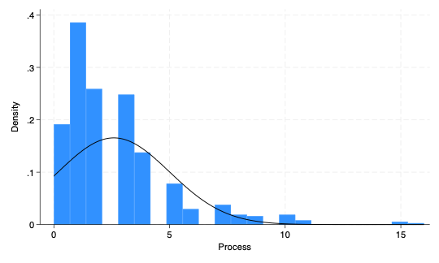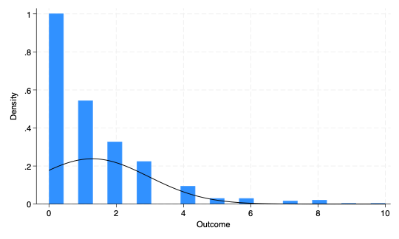

Figure WF2: Study 3: Interaction Effect of Warmth Expressions and Process Frame on Firm Engagement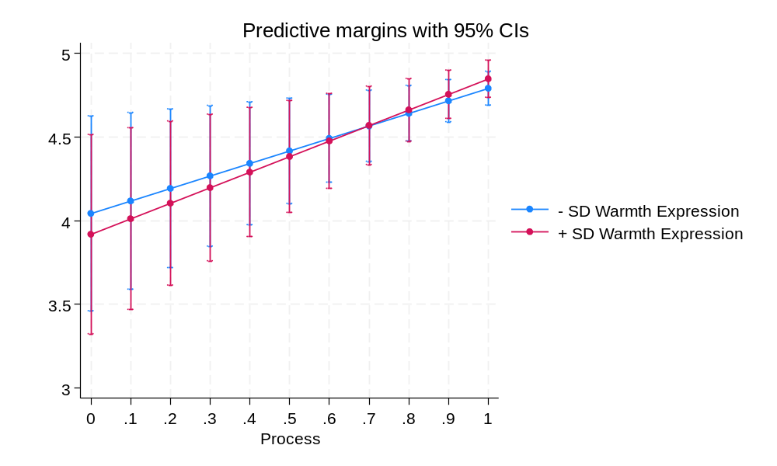

Figure WF3: Study 3: Interaction Effect of Competence Expressions and Outcome Frame on Firm Engagement

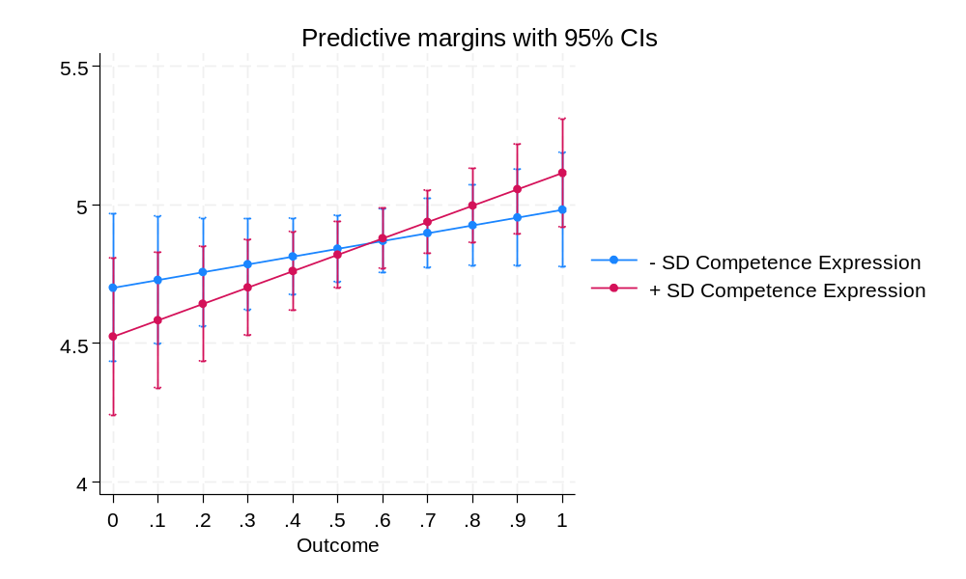

Web Appendix G: Implications for Firms
Managerial insight | Examples
Promote firm’s environmental practices using process frames in digital communication to increase engagement with the post and the firm. | “[…] We are reducing emissions by deploying electric delivery vehicles, investing in renewable energy projects, and optimizing packaging to minimize waste. Taking big steps for a sustainable supply chain. […]”  “[…] We are cutting waste by using recycled materials, reducing water usage in manufacturing, and switching to renewable energy across all our facilities. A triple effort for a greener future […]”
Promote firm’s environmental practices using outcome frames in digital communication to increase engagement with the post and the firm. | “[…] Our company champions sustainable farming by supporting regenerative agriculture and cutting plastic packaging by 50%. We achieve zero waste to landfill across all factories […]”  “[…] Our commitment to sustainability has led to a 30% reduction in energy consumption and a 25% decrease in water usage, all while maintaining the experience you expect. […]”
Use joint congruent process and outcome frames to boost consumer engagement with the environmental post. | “[…] We have achieved tangible environmental outcomes by cutting emissions by 30% and reducing plastic use by 90%. We were able to get those results by taking specific steps. First, we use recycled materials such as organic cotton and second, we minimize energy consumption […]”
Avoid joint incongruent process and outcome frames that may decrease consumer engagement with the environmental post. | “[…] We have achieved tangible environmental outcomes by cutting emissions by 30% and reducing plastic use by 90%. We all take different steps to protect environment. First, we use recycled materials such as organic cotton and second, we minimize energy consumption […]”
Use more warmth expressions when posting content about firm’s environmental practices with a process frame to increase consumer engagement with the post and the firm. | “[…] We are trying our best to cutting waste by using recycled materials and switching to renewable energy across all our facilities. It’s a bold, exciting triple effort driving us toward a brighter, greener future! […]”  “[…] Our love for the environment inspires everything we do. We are proud to deploy electric delivery vehicles, invest in renewable energy projects, and optimize packaging to minimize waste! […]”
Use more competence expressions when posting content about firm’s environmental practices with a process frame to increase consumer engagement with the post. | […] We have reduced waste by implementing recycled materials and transitioning to renewable energy across our facilities. This integrated approach reflects our operational capability in executing efficiency-driven sustainability initiatives. […]  […] We have deployed electric delivery vehicles, invested in renewable energy projects, and optimized packaging systems to reduce waste, demonstrating our ability to implement scalable and effective environmental solutions. […]
Use more competence expressions when posting content about firm’s environmental practices with a outcome frame to increase consumer engagement with the post and the firm | […] The company has implemented regenerative agriculture practices and reduced plastic packaging by 50% through process optimization and supply-chain coordination. All factories now operate at zero waste to landfill, reflecting effective environmental management. […]  […] Sustainability initiatives have resulted in a 30% reduction in energy consumption and a 25% decrease in water usage, achieved through systematic efficiency improvements while maintaining consistent product performance. […]

References
Aaker, J., Vohs, K. D., & Mogilner, C. (2010). Nonprofits are seen as warm and for-profits as competent: Firm stereotypes matter. Journal of consumer research, 37(2), 224-237.
Aaker, J. L., Garbinsky, E. N., & Vohs, K. D. (2012). Cultivating admiration in brands: Warmth, competence, and landing in the “golden quadrant”. Journal of consumer psychology, 22(2), 191-194.
Amel, E., Manning, C., Scott, B., & Koger, S. (2017). Beyond the roots of human inaction: Fostering collective effort toward ecosystem conservation. Science, 356(6335), 275-279.
Barcelos, R. H., Dantas, D. C., & Sénécal, S. (2018). Watch your tone: How a brand’s tone of voice on social media influences consumer responses. Journal of Interactive Marketing, 41, 60–80.
Block, J., Hornuf, L., & Moritz, A. (2018). Which updates during an equity crowdfunding campaign increase crowd participation?. Small Business Economics, 50(1), 3-27.
Brysbaert, M., Warriner, A. M., & Kuperman, V. (2014). Concreteness ratings for 40 thousand generally known English word lemmas. Behavior Research Methods, 46(3), 904–911.
Carrete, L., Castaño, R., Felix, R., Centeno, E., & González, E. (2012). Green consumer behavior in an emerging economy: confusion, credibility, and compatibility. Journal of Consumer Marketing, 29(7), 470-481.
Castaño, R., Sujan, M., Kacker, M., & Sujan, H. (2008). Managing consumer uncertainty in the adoption of new products: Temporal distance and mental simulation. Journal of Marketing Research, 45(3), 320–336.
Chen, Y., Han, Q., Lian, Z., Zhu, W., & Jiang, Y. (2025). From Certainty to Doubt: The Impact of Streamer Expression Certainty on Consumer Purchase Behavior in Live-Stream E-Commerce. Journal of Theoretical and Applied Electronic Commerce Research, 20(2), 138.
Chi, R., Zhang, J., & Pan, M. (2024). The effect of anthropomorphic competence-warmth congruence of service robots on recommendation intention. Current Psychology, 43(7), 6570-6583.
Courtney, C., Dutta, S., & Li, Y. (2017). Resolving information asymmetry: Signaling, endorsement, and crowdfunding success. Entrepreneurship Theory and Practice, 41(2), 265-290.
El Hedhli, K., Zourrig, H., Al Khateeb, A., & Alnawas, I. (2023). Stereotyping human-like virtual influencers in retailing: does warmth prevail over competence?. Journal of Retailing and Consumer Services, 75, 103459.
Escalas, J. E., & Luce, M. F. (2003). Process versus outcome thought focus and advertising. Journal of Consumer Psychology, 13(3), 246–254.
Gafni, H., Marom, D., Robb, A., & Sade, O. (2021). Gender dynamics in crowdfunding (Kickstarter): Evidence on entrepreneurs, backers, and taste-based discrimination. Review of Finance, 25(2), 235-274.
Gu, S., Heerdink, M. W., & van Kleef, G. A. (2025). How social media influencers’ emotional expressions shape their popularity: the role of authenticity and appropriateness. Cognition and Emotion, 1-23.
Güntürkün, P., Haumann, T., & Mikolon, S. (2020). Disentangling the differential roles of warmth and competence judgments in customer-service provider relationships. Journal of Service Research, 23(4), 476-503.
Huang, Y., Zhang, M., Gursoy, D., & Shi, S. (2020). An examination of interactive effects of employees’ warmth and competence and service failure types on customer’s service recovery cooperation intention. International Journal of Contemporary Hospitality Management, 32(7), 2429-2451.
Huang, G., Evanschitzky, H., & Tran, H. A. (2025). The impact of influence tactics on brand message sharing. Journal of Business Research, 199, 115497.
Kim, T., & Read, G. L. (2021). Free smiles are worth a lot for social media influencers: The mediating roles of warmth, competence, and admiration. Cyberpsychology, Behavior, and Social Networking, 24(2), 135-140.
Lu, M., & Jen, W. (2016). Effects of product option framing and temporal distance on consumer choice: The moderating role of process versus outcome mental simulations. Psychology & Marketing, 33(10), 856–863.
Mancuso, I., Natalicchio, A., Panniello, U., & Roma, P. (2021). Understanding the Purchasing Behavior of Consumers in Response to Sustainable Marketing Practices: An Empirical Analysis in the Food Domain. Sustainability, 13(11), 6169.
Moradi, M., Dass, M., Arnett, D., & Badrinarayanan, V. (2024). The time-varying effects of rhetorical signals in crowdfunding campaigns. Journal of the Academy of Marketing Science, 52(2), 370-398.
Mosbach, M., Andriushchenko, M., & Klakow, D. (2020). On the stability of fine-tuning BERT: Misconceptions, explanations, and strong baselines. arXiv preprint arXiv:2006.04884.
Oo, P. P., Allison, T. H., Sahaym, A., & Juasrikul, S. (2019). User entrepreneurs' multiple identities and crowdfunding performance: Effects through product innovativeness, perceived passion, and need similarity. Journal of Business Venturing, 34(5), 105895.
Ordenes, F. V., Grewal, D., Ludwig, S., De Ruyter, K., Mahr, D., & Wetzels, M. (2019). Cutting through content clutter: How speech and image acts drive consumer sharing of social media brand messages. Journal of Consumer Research, 45(5), 988–1012.
Packard, G., Berger, J., & Boghrati, R. (2023). How verb tense shapes persuasion. Journal of Consumer Research, 50(3), 645-660.
Packard, G., Li, Y., & Berger, J. (2024). When language matters. Journal of Consumer Research, 51(3), 634–653.
Paszke, A., Gross, S., Massa, F., Lerer, A., Bradbury, J., Chanan, G., & Chintala, S. (2019). Pytorch: An imperative style, high-performance deep learning library. Advances in Neural Information Processing Systems, 32.
Peasley, M. C., Bauer, C., Hochstein, B., Bachrach, D. G., & Patil, A. (2026). Inside the call: How customer service agent warmth and competence shape customer reactions. Journal of the Academy of Marketing Science, 1-21.
Petit, O., Javornik, A., & Velasco, C. (2022). We eat first with our (digital) eyes: Enhancing mental simulation of eating experiences via visual-enabling technologies. Journal of Retailing, 98(2), 277–293.
Pezzuti, T., Leonhardt, J. M., & Warren, C. (2021). Certainty in language increases consumer engagement on social media. Journal of Interactive Marketing, 53, 32–46.
Pezzuti, T., & Leonhardt, J. M. (2023). What’s not to like? Negations in brand messages increase consumer engagement. Journal of the Academy of Marketing Science, 51(3), 675–694.
Reczek, R. W., Trudel, R., & White, K. (2018). Focusing on the forest or the trees: How abstract versus concrete construal level predicts responses to eco-friendly products. Journal of Environmental Psychology, 57, 87–98.
Ren, S., Karimi, S., Velázquez, A. B., & Cai, J. (2023). Endorsement effectiveness of different social media influencers: The moderating effect of brand competence and warmth. Journal of Business Research, 156, 113476.
Reppmann, M., Harms, S., Edinger-Schons, L. M., & et al. (2025). Activating the sustainable consumer: The role of customer involvement in corporate sustainability. Journal of the Academy of Marketing Science, 53(2), 310–340.
Ringler, C., Sirianni, N. J., Peck, J., & Gustafsson, A. (2024). Does your demonstration tell the whole story? How a process mindset and social presence impact the effectiveness of product demonstrations. Journal of the Academy of Marketing Science, 52(2), 512–530.
Roccapriore, A. Y., & Pollock, T. G. (2023). I don’t need a degree, I’ve got abs: Influencer warmth and competence, communication mode, and stakeholder engagement on social media. Academy of Management Journal, 66(3), 979-1006.
Ryoba, M. J., Qu, S., Ji, Y., & Qu, D. (2020). The right time for crowd communication during campaigns for sustainable success of crowdfunding: Evidence from Kickstarter platform. Sustainability, 12(18), 7642.
Salnikova, E., Strizhakova, Y., & Coulter, R. A. (2022). Engaging consumers with environmental sustainability initiatives: Consumer global–local identity and global brand messaging. Journal of Marketing Research, 59(5), 983–1001.
Su, L., Wang, X., Lin, Z., & Xiao, S. (2025). From impression to expression: How warmth and competence in relaxing and challenging activities shape pleasure and eWOM. Psychology & Marketing, 42(1), 64-79.
Sun, C. W., Obrenovic, B., & Zhang, Y. F. (2024). Affirmative or negative: A study of the effectiveness of advertising sentence patterns on green advertisements. Current Psychology, 43(44), 34199-34214.
von Selasinsky, C., & Lutz, E. (2021). The effects of pro-social and pro-environmental orientation on crowdfunding performance. Sustainability, 13(11), 6064.
Sewaid, A., Garcia‐Cestona, M., & Silaghi, F. (2022). Do learning benefits accrue equally over successive fundraising attempts? Strategic change and the moderating role of experience. British Journal of Management, 33(4), 1710-1734.
Short, J. C., Broberg, J. C., Cogliser, C. C., & Brigham, K. H. (2010). Construct validation using computer-aided text analysis (CATA) an illustration using entrepreneurial orientation. Organizational Research Methods, 13(2), 320-347.
Thompson, D. V., Hamilton, R. W., & Petrova, P. K. (2009). When mental simulation hinders behavior: The effects of process-oriented thinking on decision difficulty and performance. Journal of Consumer Research, 36(4), 562–574.
Trope, Y., & Liberman, N. (2010). Construal-level theory of psychological distance. Psychological Review, 117(2), 440.
Ülkümen, G., & Thomas, M. (2013). Personal relevance and mental simulation amplify the duration framing effect. Journal of Marketing Research, 50(2), 194–206.
van der Wal, A. J., van Horen, F., & Grinstein, A. (2018). Temporal myopia in sustainable behavior under uncertainty. International Journal of Research in Marketing, 35(3), 378–393.
van der Weiden, A., Ruys, K. I., & Aarts, H. (2013). A matter of matching: How goals and primes affect self-agency experiences. Journal of Experimental Psychology: General, 142(3), 954.
White, K., Habib, R., & Hardisty, D. J. (2019). How to SHIFT consumer behaviors to be more sustainable: A literature review and guiding framework. Journal of Marketing, 83(3), 22–49.
White, K., & Simpson, B. (2013). When do (and don't) normative appeals influence sustainable consumer behaviors?. Journal of Marketing, 77(2), 78-95.
Xu, Y., Chen, W., & Ow, T. T. (2023). The effects of social media posts’ characteristics on customer engagement: Evidence from WeChat. Information & Management, 60(7), 103854.
Yu, J., Sun, X., Huang, Y., & Jia, Y. (2025). Concrete or abstract? The impact of green advertising appeals and information framing on consumer responses. Journal of Theoretical and Applied Electronic Commerce Research, 20(2), 130.
Zhang, J., Zhao, L., & Hu, S. (2021). Visualizing recycling: Promoting recycling through mental simulation. Resources, Conservation and Recycling, 174, 105783.
Zhao, M., Hoeffler, S., & Zauberman, G. (2007). Mental simulation and preference consistency over time: The role of process- versus outcome-focused thoughts. Journal of Marketing Research, 44(3), 379–388.
Zhou, M., Lu, B., Fan, W., & Wang, G. A. (2018). Project description and crowdfunding success: an exploratory study. Information Systems Frontiers, 20(2), 259-274.
Zhou, L., Du, K. M., & Cutright, K. M. (2022). Befriending the enemy: The effects of observing brand-to-brand praise on consumer evaluations and choices. Journal of Marketing, 86(4), 57-72.

