Web Appendix
Virtual Influencer Marketing: A Meta-Analytic Review

Web Appendix A: PRISMA Flow Diagram 2
Web Appendix B: List Studies Included in The Meta Analysis 3
Web Appendix C: Funnel Plots 11
Web Appendix D: Result of Outlier Analysis 13
Web Appendix E: Frequency Distribution of Effect Sizes Plot 14
Web Appendix F: The HLM Full Model 15
Web Appendix G: VIF And Correlation Between Moderator Variables 17
Web Appendix H: Multivariate Meta-Regression Base Model 18
Web Appendix I: Multivariate Meta-Regression of Subgroups of dependent variables 19
Web Appendix J: Multivariate Meta-Regression of Alternative Operationalization of Journal Quality 22
Web Appendix K: Marketing Professionals’ Perception Survey Desing and Questionnaire 24
Web Appendix L: Descriptive Statistics of Marketing Professional Survey 30

Web Appendix A: PRISMA Flow Diagram

Business Source Complete, Scopus, SpringerLink, Emerald, Sage, ProQuest Digital Dissertations, SSRN, and Google Scholar (N = 1,165)
Unique papers
(N = 953)
Relevant papers
(N = 322)
Empirical papers
(N = 1158)
Direct effect of virtual influencer
(N = 129)
Duplicate paper removed
(N = 212)
Irrelevant paper removed
(N = 631)
Non-empirical paper removed (N = 164)

Lack of information for effect size calculation removed (N = 7)
Final papers retained
(N = 110) including 210 experimental studies examining virtual influencers (vs. control)
Did not study direct effect of virtual influencer removed
(N = 29)

Experimental studies
(N = 117)
Did not study virtual influencer (vs. control) removed (N = 12)

Web Appendix B: List Studies Included in The Meta Analysis
Arsenyan, J., & Mirowska, A. (2021). Almost human? A comparative case study on the social media presence of virtual influencers. International Journal of Human-Computer Studies, 155, 102694.
Belanche, D., Casaló, L. V., & Flavián, M. (2024). Human versus virtual influences, a comparative study [Article]. Journal of Business Research, 173, Article 114493.
Bie, Y., Tang, J., Miao, M., Sun, W., & Jiang, Y. (2025). Beyond the Shores of Reality: The Effect of Virtual Influencers on Luxury Perception and Its Downstream Consequence. Psychology and Marketing. https://www.scopus.com/inward/record.uri?eid=2-s2.0-105005542251&doi=10.1002%2fmar.22234&partnerID=40&md5=65568425146c7ca50e2fafdcbb3afb53
Cascio Rizzo, G. L., Berger, J. A., & Villarroel Ordenes, F. (2023). What Drives Virtual Influencer's Impact? Available at SSRN 4329150.
Cheng, J., & Wang, J. (2025). Influencer-product attractiveness transference in interactive fashion marketing: the moderated moderating effect of speciesism against AI. Journal of Research in Interactive Marketing, 19(4), 712-729.
Cheng, J., & Wang, J. (2025). Influencer-product attractiveness transference in interactive fashion marketing: the moderated moderating effect of speciesism against AI: An International Journal. Journal of Research in Interactive Marketing, 19(4), 712.
Choi, M., Choi, Y., & Lee, H. (2023). Gen Z Travelers in the Instagram Marketplace: Trust, Influencer Type, Post Type, and Purchase Intention [Article]. Journal of Hospitality and Tourism Research. https://doi.org/10.1177/10963480231180938
Chuhan, L. (2023). An Analysis of the Impact of a Human-like Virtual Influencer Marketing 한양대학교].
De Cicco, R., Iacobucci, S., Cannito, L., Onesti, G., Ceccato, I., & Palumbo, R. (2024). Virtual vs. human influencer: Effects on users’ perceptions and brand outcomes. Technology in Society, 77, Article 102488.
Deng, F., Tuo, M., Chen, S., & Zhang, Z. (2024). Born for marketing? The effects of virtual versus human influencers on brand endorsement effectiveness: The role of advertising recognition. Journal of Retailing and Consumer Services, 80, Article 103904.
Di Cioccio, M., Pozharliev, R., & De Angelis, M. (2024). Pawsitively powerful: Why and when pet influencers boost social media effectiveness [Article]. Psychology and Marketing, 41(7), 1614-1628.
Dondapati, A., & Dehury, R. K. (2024). Virtual vs. Human influencers: The battle for consumer hearts and minds. Computers in Human Behavior: Artificial Humans, 2(1), 100059.
Dong, X., Zhou, R., & Liao, J. (2024). Mega-influencer follower effect: the mediating role of sense of control in brand attitudes, purchase intentions and engagement. European Journal of Marketing. https://www.scopus.com/inward/record.uri?eid=2-s2.0-85210443682&doi=10.1108%2fEJM-04-2023-0278&partnerID=40&md5=c600f7d215338be202eadbf3ca760a08
Drossaert, D. (2023). The Replacement of Human Influencers With Virtual Influencers: Perceptions of Candidness, Trustworthiness and Purchase intention In Social Media Advertisements [Master Thesis]. Tilburg University.
Edwards, C., Edwards, A., Rijhwani, V., Mostafa, H. K., Ebo, D., & Doku, D. (2025). Beauty and the Bot: Perceptions of Human and AI Fitness Influencers on Instagram. International Journal of Human-Computer Interaction. https://www.scopus.com/inward/record.uri?eid=2-s2.0-105016806531&partnerID=40&md5=fbc31b019094f7f86d6198705d41de55
Ekinci, Y., Can, A. S., Javed, A., & Viglia, G. (2025). Human vs metahuman brand endorsements: assessing the effectiveness of social media influencers in online brand engagement. Internet Research, 1-24.
Franke, C., Groeppel-Klein, A., & Müller, K. (2023). Consumers’ Responses to Virtual Influencers as Advertising Endorsers: Novel and Effective or Uncanny and Deceiving? Journal of Advertising, 52(4), 523-539.
Guan, B., Li, X., Zeng, S., Liu, P., & Sun, H. (2026). The power of influencers: How moral image drives suboptimal food consumption. Journal of Retailing and Consumer Services, 88, Article 104462.
Gutaj, E. (2021). The Effectiveness of Virtual Influencers As Brand Endorsers
Hofeditz, L., Nissen, A., Schütte, R., & Mirbabaie, M. (2022). Trust Me, I’m an Influencer!-A Comparison of Perceived Trust in Human and Virtual Influencers.
Huang, H., Yu, J., Jiang, D., & Wang, T. (2026). Virtual influencers as endorsers in hospitality green marketing. International Journal of Hospitality Management, 133, Article 104455.
Igarashi, R., Bhoumik, K., & Thompson, J. (2024). Investigating the effectiveness of virtual influencers in prosocial marketing. Psychology and Marketing.
Joel-Edgar, S., Chowdhury, S., Nagy, P., & Ren, S. (2025). Virtual influencers in social media versus the metaverse: Mind Perception, blame judgements and brand trust. Journal of Business Research, 189, Article 115139.
Kästner, E., & Baczynski, M. (2025). Believe me, even though I’m fake: how the credibility of real and virtual influencers affects purchase intention. Journal of Media Business Studies. https://www.scopus.com/inward/record.uri?eid=2-s2.0-86000605946&doi=10.1080%2f16522354.2025.2475424&partnerID=40&md5=88290b017e34470bf65366f3729fbc6b
Kataria, S., Saxena, S., & Shankar, A. (2025). Virtual Meets Real: The Effect of Influencer Type and Message Framing on Sustainable Fashion Intentions. Journal of Consumer Behaviour. https://www.scopus.com/inward/record.uri?eid=2-s2.0-105025367627&partnerID=40&md5=374f50ae0467b071e4f92d55b78eebd4
Kholkina, V., Chesnokova, E., & Zelenskaya, E. (2024). Virtual or human? The impact of the influencer type on Gen Z consumer outcomes. Journal of Product and Brand Management. https://www.scopus.com/inward/record.uri?eid=2-s2.0-85208279485&doi=10.1108%2fJPBM-12-2023-4885&partnerID=40&md5=256064fe518bab53dd8c23e7c09c40d3
Kim, S., & Huang, L. (2025). The Effectiveness of Virtual Influencers in Luxury Brand Promotion: The Roles of Tactile Presentation Style and Autonomy. Journal of Global Marketing. https://www.scopus.com/inward/record.uri?eid=2-s2.0-105022726354&partnerID=40&md5=821cea0531d15cba077a52af9c398cb5
Kim, T., Lee, S. J., & Park, S. (2025). Social Support from Virtual vs. Human Influencers: Effects on Support Efficacy, Interactivity, and Social Attractiveness. International Journal of Human-Computer Interaction. https://www.scopus.com/inward/record.uri?eid=2-s2.0-105002983878&doi=10.1080%2f10447318.2025.2489029&partnerID=40&md5=693cf6a70d4c14ed1cbaf708f1978935
Ko, C., & Baek, H. (2026). Effects of emotional expression on user engagement in virtual influencers’ Instagram posts: A comparative analysis with human influencers. Journal of Retailing and Consumer Services, 88, Article 104484. https://www.scopus.com/inward/record.uri?eid=2-s2.0-105013983108&partnerID=40&md5=c821ada8b27ce10b0867ef5501ad6cb6
Laghari, A. H., Ping, H., Memon, S., & Makhdoom, Z. H. (2025). Human vs. virtual influencers in Crisis: How attribution and crisis response shape brand trust. Journal of Retailing and Consumer Services, 87, Article 104410. https://www.scopus.com/inward/record.uri?eid=2-s2.0-105010322239&doi=10.1016%2fj.jretconser.2025.104410&partnerID=40&md5=59035582e54d727d3c6635a591bc1319
Lamping, S. (2024). Are virtual influencers the new standard in digital marketing? The difference between virtual and human influencers and the role of identification and credibility Uinversity of Twente].
Lee, D., & Ham, C. D. (2023). AI versus Human: Rethinking the Role of Agent Knowledge in Consumers’ Coping Mechanism Related to Influencer Marketing [Article]. Journal of Interactive Advertising, 23(3), 241-258.
Lee, H., Shin, M., Yang, J., & Chock, T. M. (2024). Virtual Influencers vs. Human Influencers in the Context of Influencer Marketing: The Moderating Role of Machine Heuristic on Perceived Authenticity of Influencers [Article]. International Journal of Human-Computer Interaction, 1-18. https://doi.org/10.1080/10447318.2024.2374100
Lee, J. Y. (2022). Whose Message Is More Powerful? Comparing the Effect of Virtual Influencers and Human Celebrities on Social Media Persuasion Depending on Perceived Source Characteristics and Nutrition of Instagram Food Messages (Publication Number 29998935) [Ph.D., Michigan State University]. ProQuest Dissertations & Theses Global. United States -- Michigan.
Li, H., Lei, Y., Zhou, Q., & Yuan, H. (2023). Can you sense without being human? Comparing virtual and human influencers endorsement effectiveness. Journal of Retailing and Consumer Services, 75, 103456.
Lim, H. S., Lee, N., Pittet Gonzalez, L., & Moon, W. K. (2025). Human vs. Virtual Influencers: Unveiling the Expectancy Violation Effect of Sponsorship Disclosure on Environmental CSR Communication and Skepticism. Journal of Promotion Management, 31(7), 1072-1094.
Liu, F. (2026). Who and how to pair with a virtual influencer? The impact of co-endorser type, perceived distance, and gender congruence on consumer responses in virtual influencer collaborations. Journal of Retailing and Consumer Services, 89, Article 104593.
Liu, F., & Lee, Y. H. (2022). Unveiling Behind-the-Scenes Human Interventions and Examining Source Orientation in Virtual Influencer Endorsements. IMX 2022 - Proceedings of the 2022 ACM International Conference on Interactive Media Experiences,
Liu, F., & Lee, Y. H. (2024a). Virtually authentic: examining the match-up hypothesis between human vs virtual influencers and product types [Article]. Journal of Product and Brand Management, 33(2), 287-299.
Liu, F., & Lee, Y. H. (2024b). Virtually responsible? Attribution of responsibility toward human vs. virtual influencers and the mediating role of mind perception [Article]. Journal of Retailing and Consumer Services, 77, Article 103685.
Liu, R., Zhang, Y., & Lin, L. (2024). The effectiveness of virtual vs. human influencers in digital marketing: Based on perceived psychological distance and credibility. Proceedings of the Annual Meeting of the Cognitive Science Society,
Liu, T., Xue, S., Zhang, K., & Wu, C. (2026). Virtual or human, male or female? exploring the gender effect of virtual influencers on consumers’ purchase intentions for emerging brands. Journal of Retailing and Consumer Services, 91, 104765.
Liu, X., Wan, L. C., & Mattila, A. S. (2025). Virtual influencers going head-to-head with human influencers: the impact of influencer type on trust perceptions of endorsement. International Journal of Contemporary Hospitality Management, 37(5), 1574-1602.
Ma, Y., & Li, J. (2024). How humanlike is enough?: Uncover the underlying mechanism of virtual influencer endorsement. Computers in Human Behavior: Artificial Humans, 2(1), 100037.
Märlegård, H., & Raflund, J. (2024). Conveyed by Artificial Authenticity? The Impact of Virtual Influencers on Brand Trust-A Quantitative Study on Consumer Perceptions.
Meng, L., Wu, Q., Wang, Y., & Duan, S. (2025). Health-Related Advertising: Leveraging Virtual and Human Influencers to Encourage Health Behaviors. Journal of Advertising, 54(4), 548-565.
Meng, L. M., Bie, Y., Yang, M., & Wang, Y. (2024). Watching it motivates me to become stronger: Virtual influencers' impact on consumer self-improvement product preferences. Journal of Business Research, 178, Article 114654.
Meng, L. M., Bie, Y., Yang, M., & Wang, Y. (2025). The effect of human versus virtual influencers: The roles of destination types and self-referencing processes. Tourism Management, 106, Article 104978.
Mesquita, E., Herrero, E., Luiz Lopes, E. L., Ribeiro, T. d. L. S., & Scrivano, P. (2025). Artificial influence: how AI and influencers shape choices in tourism and hospitality. International Journal of Contemporary Hospitality Management, 1-18.
Mirowska, A., & Arsenyan, J. (2023). Sweet escape: The role of empathy in social media engagement with human versus virtual influencers. International Journal of Human-Computer Studies, 174, 103008.
Mo, T., & Wang, W. (2024). The virtual new or the real old? The effect of temporal alignment between influencer virtuality and brand heritage narration on consumers' luxury consumption. Psychology and Marketing. https://www.scopus.com/inward/record.uri?eid=2-s2.0-85205576278&doi=10.1002%2fmar.22132&partnerID=40&md5=14e91da0b478e8d6bc54836b30f33a68
Mo, Z., & Zhou, M. (2024). Don’t Like Them but Take What They Said_ The Effectiveness of Virtual Influencers in Public Service Announcements. Journal of Theoretical and Applied Electronic Commerce Research, 19(3), 2269-2288.
Nazir, M., & Wani, T. A. (2025). Human vs virtual influencers and message framing: enhancing environmental awareness, activism and sustainable purchase intentions through effective messaging. Management Research Review, 48(5), 685-708.
Nissen, A., Conrad, C., & Newman, A. (2023). Are You Human? Investigating the Perceptions and Evaluations of Virtual Versus Human Instagram Influencers. Conference on Human Factors in Computing Systems - Proceedings,
Ozdemir, O., Kolfal, B., Messinger, P. R., & Rizvi, S. (2023). Human or virtual: How influencer type shapes brand attitudes. Computers in Human Behavior, 145, 107771.
Park, J., Oh, C., & Kim, H. Y. (2024). AI vs. human-generated content and accounts on Instagram: User preferences, evaluations, and ethical considerations. Technology in Society, 79, Article 102705.
Pichierri, M., & Belk, R. W. (2026). Virtual characters, virtual influence? Assessing the efficacy of virtual and human influencers and the influence of need for interaction and consumer envy. Journal of Retailing and Consumer Services, 88, Article 104486.
Pittman, M., & Kim, I. (2025). Should travel influencers be human or virtual? Comparing effectiveness for material and experiential products. International Journal of Advertising. https://www.scopus.com/inward/record.uri?eid=2-s2.0-105014935046&partnerID=40&md5=c46388190f9cdbda20800e36084d8c15
Qu, Y., & Baek, E. (2023). Let virtual creatures stay virtual: tactics to increase trust in virtual influencers. Journal of Research in Interactive Marketing, ahead-of-print(ahead-of-print). https://doi.org/10.1108/JRIM-09-2022-0280
Sakuma, H., Hori, A., Murashita, M., Kondo, C., & Hijikata, Y. (2023). YouTubers vs. VTubers: Persuasiveness of human and virtual presenters in promotional videos [Article]. Frontiers in Computer Science, 5, Article 1043342. https://doi.org/10.3389/fcomp.2023.1043342
Sands, Campbell, C. L., Plangger, K., & Ferraro, C. (2022). Unreal influence: leveraging AI in influencer marketing [Article]. European Journal of Marketing, 56(6), 1721-1747.
Schaffler, L. (2021). The Role of Artificial Influencers in Tourism Marketing
Shi, Y., Zhang, X., Kim, J.-H., & Ouyang, H. (2026). Virtual influencer or human influencer in destination endorsement? The role of travel inspiration and forestalgic appeals. Journal of Business Research, 206, 115964.
Skaltsa, D., & Vanwesenbeeck, I. (2023). Virtual versus Human Influencers: A Comparative Study on Their Impact on Perceived Source Credibility, Machine Heuristics, and Purchase Intention.
Song, X., Lu, Y., & Yang, Q. (2024). The negative effect of virtual endorsers on brand authenticity and potential remedies. Journal of Business Research, 185, 114898.
Song, Y., Wang, L., Zhang, Z., & Hikkerova, L. (2024). AI or human: How endorser shapes online purchase intention? Computers in Human Behavior, 158,108300.
Stein, J. P., Linda Breves, P., & Anders, N. (2022). Parasocial interactions with real and virtual influencers: The role of perceived similarity and human-likeness [Article]. New Media and Society.
Su, Z., Kuang, Z., Wang, W., & Chen, M. H. (2025). Virtual vs. human streamers: Unlocking effective recovery strategies in livestreaming e-commerce. Journal of Hospitality and Tourism Management, 65, Article 101352.
Sun, Y., Zheng, C., & Ma, K. (2026). Speaking of facts or experiences? The interaction effect between description types of virtual influencers and product types on endorsement effectiveness. Journal of Retailing and Consumer Services, 90, 104704.
Tao, Y., Zhang, T. C., Lin, D., Guo, Z., Zeng, X., & Wedge, L. (2026). Eco-persuasion 2.0: The green messaging power of virtual vs. human influencers in hospitality. International Journal of Hospitality Management, 133,104516.
Thomas, V. L., & Fowler, K. (2021). Close Encounters of the AI Kind: Use of AI Influencers As Brand Endorsers [Article]. Journal of Advertising, 50(1), 11-25.
Tibaldi, M. (2024). The Impact of Virtual Influencers as Innovation Strategy on Consumer Behavior: An Experimental Research in the Healthcare and Fitness Industries LUISS].
Volles, B. K., Park, J., Van Kerckhove, A., & Geuens, M. (2024). How and when do virtual influencers positively affect consumer responses to endorsed brands? Journal of Business Research, 183, 114863.
Wan, A., & Jiang, M. (2023). Can Virtual Influencers Replace Human Influencers in Live-Streaming E-Commerce? An Exploratory Study from Practitioners’ and Consumers’ Perspectives [Article]. Journal of Current Issues and Research in Advertising, 44(3), 332-372.
Wang, B., Han, Y., Kandampully, J., & Lu, X. (2025). How language arousal affects purchase intentions in online retailing? The role of virtual versus human influencers, language typicality, and trust. Journal of Retailing and Consumer Services, 82, Article 104106.
Wang, J., Ye, G., & Yang, J. (2025). Not a human, not for green? The effectiveness of virtual influencers endorsing green products. Journal of Product and Brand Management, 34(4), 468-485.
Wang, L., Li, Y. Q., Ruan, W. Q., & Zhang, S. N. (2024). The congruence effect in tourism activity marketing: the difference between virtual influencers and human influencers. Current Issues in Tourism. https://www.scopus.com/inward/record.uri?eid=2-s2.0-85203265835&doi=10.1080%2f13683500.2024.2400180&partnerID=40&md5=b0da8f5011f9ef7483aaa8e9a7f3b747
Wang, X., & Qiu, X. (2023). The Influence of Image Realism of Digital Endorsers on the Purchase Intention of Gift Products for the Elderly. Behavioral Sciences, 13(1), 74.
Wilke, B. (2023). Are you being influenced?: The effect of human, virtual and AI influencers on purchase intention through Instagram University of Twente].
Willemsen, L. M., Withuis, I., Brom, M., & Boerman, S. C. (2025). How does persuasion knowledge differ between humanlike virtual influencers and human influencers? International Journal of Advertising, 44(1), 109-130.
Wolff, W. (2022). A trend or is the future of influencer marketing virtual? The effect of virtual influencers and sponsorship disclosure on purchase intention, brand trust, and consumer engagement University of Twente].
Wu, H., & Li, W. (2026). Environmental guardians: How virtual influencers and human influencers can more effectively promote green products. Journal of Retailing and Consumer Services, 88, Article 104553.
Wu, H., & Li, W. (2026). Environmental guardians: How virtual influencers and human influencers can more effectively promote green products. Journal of Retailing and Consumer Services, 88, 104553.
Wu, J., Zhang, Y., & Bock, G. W. (2024). The Impact of AI Influencer vs. Human Influencer on a Social Media User's Attitude toward a Product. 45th International Conference on Information Systems, ICIS 2024,
Xie-Carson, L., Magor, T., Benckendorff, P., & Hughes, K. (2023). All hype or the real deal? Investigating user engagement with virtual influencers in tourism. Tourism Management, 99, 104779.
Yan, X., Huam, H. T., & Sade, A. B. (2024). Is AI Better than Humans? Unveiling the Boundary Conditions Under Which Virtual Influencers Outperform Human Influencers in Endorsing Sustainable Products. Sustainability (Switzerland), 16(22), Article 9896.
Yang, J., Chuenterawong, P., Lee, H., Tian, Y., & Chock, T. M. (2023). Human versus Virtual Influencer: The Effect of Humanness and Interactivity on Persuasive CSR Messaging [Article]. Journal of Interactive Advertising, 23(3), 275-292. https://doi.org/10.1080/15252019.2023.2189036
Yao, Q., Liu, Y., Hu, B., & Jin, J. (2025). Virtual or human influencers as endorsers? Behavioral and EEG evidence of how influencer type affects purchase intention of new products. Computers in Human Behavior, 172, Article 108754.
Yao, Y., Liu, Q., & Guo, M. (2025). Virtual influencers in brand image recovery: A comparative study of younger and older brands after celebrity endorsement crises. Journal of Retailing and Consumer Services, 86, Article 104316.
Yi, M. R., & Lee, H. S. (2023). A Study on the Regulatory Fit Effects of Influencer Types and Message Types [Article]. International Journal of Human-Computer Interaction. https://doi.org/10.1080/10447318.2023.2232213
You, L., & Liu, F. (2024). From virtual voices to real impact: Authenticity, altruism, and egoism in social advocacy by human and virtual influencers. Technological Forecasting and Social Change, 207, 123650.
Yuan, Y., Nguyen, M., Shao, W., & Zhang, Y. (2025). Digital congruence in influencer marketing: how NFTs shift the balance between human and AI-driven virtual endorsers through parasocial relationships. Marketing Intelligence and Planning, 1-39.
Zeng, W., Ma, Z., & Chen, T. (2024). When and why do consumers resist virtual influencer endorsement? The role of product depth and advertising claim types. Electronic Commerce Research, 1-34.
Zeng, Y., Pu, G., Liu, J., & Feng, W. (2024). The Influence Mechanism of Narrative Strategies Used by Virtual Influencers on Consumer Product Preferences. Journal of Theoretical and Applied Electronic Commerce Research, 19(4), 2828-2850.
Zhang, J., Shao, Z., & Wang, K. (2025). Does your company have the right influencer? Influencer type and tourism brand personality. Tourism Management, 107, Article 105079.
Zhang, K., Sun, X., & Li, G. (2025). Virtual influencer and cultural heritage destination: Endorsement effectiveness of virtual versus human influencers. Annals of Tourism Research, 110, Article 103873.
Zhang, L., Wei, W., Rathjens, B., & Zheng, Y. (2023). Pet influencers on social media: The joint effect of message appeal and narrator. International Journal of Hospitality Management, 110, 103453.
Zhang, W., Jiang, M., & Kim, H. (2024). Human vs. AI Influencer Activism: Exploring Self-Branding and Issue Advocacy Effectiveness Through Social Influence Processes. Journal of Interactive Advertising, 24(4), 382-400.
Zhang, Y., & He, A. Z. (2025). The impact of AI influencer endorsements on consumers’ purchase intentions: the serial mediating roles of mind perception and brand trustworthiness. Journal of Product and Brand Management, 34(5), 754-765.
Zhang, Y., Zhu, J., Chen, H., & Jiang, Y. (2025). Enhancing Trust and Empathy in Marketing: Strategic AI and Human Influencer Selection for Optimized Content Persuasion. Journal of Consumer Behaviour, 24(2), 866-885.
Zhao, T., Ran, Y., Wu, B., Lynette Wang, V., Zhou, L., & Lu Wang, C. (2024). Virtual versus human: Unraveling consumer reactions to service failures through influencer types. Journal of Business Research, 178, Article 114657.
Zheng, C., & Ma, K. (2026). Speaking of facts or experiences? The interaction effect between description types of virtual influencers and product types on endorsement effectiveness. Journal of Retailing and Consumer Services, 90, Article 104704.
Zheng, X., Cui, C., Zhang, C., & Li, D. (2025). Who says what? How message appeals shape virtual- versus human-influencers’ impact on consumer engagement. Journal of Research in Interactive Marketing. https://www.scopus.com/inward/record.uri?eid=2-s2.0-105008925940&doi=10.1108%2fJRIM-10-2024-0482&partnerID=40&md5=41c9270fe54183994c0b6fc638dd6ab0
Zheng, X., Miao, M., Zhang, L., & Huang, L. (2024). Standing out or fitting in? How perceived autonomy affects virtual influencer marketing outcomes. Journal of Business Research, 185, 114917.
Zhou, A., Liu, Y., & Dai, Y. (2026). Artificial yet credible: How virtual influencers overcome authenticity challenges. Journal of Business Research, 206, 115940.
Zhou, Q., Li, B., Li, H., & Lei, Y. (2024). Mere copycat? The effects of human versus human-like virtual influencers on brand endorsement effectiveness: A moderated serial-mediation model [Article]. Journal of Retailing and Consumer Services, 76, Article 103610.
Zhou, X., Yan, X., & Jiang, Y. (2023). Making Sense? The Sensory-Specific Nature of Virtual Influencer Effectiveness. Journal of Marketing, 00222429231203699.

Web Appendix C: Funnel Plots

Behavioral intention | Engagement
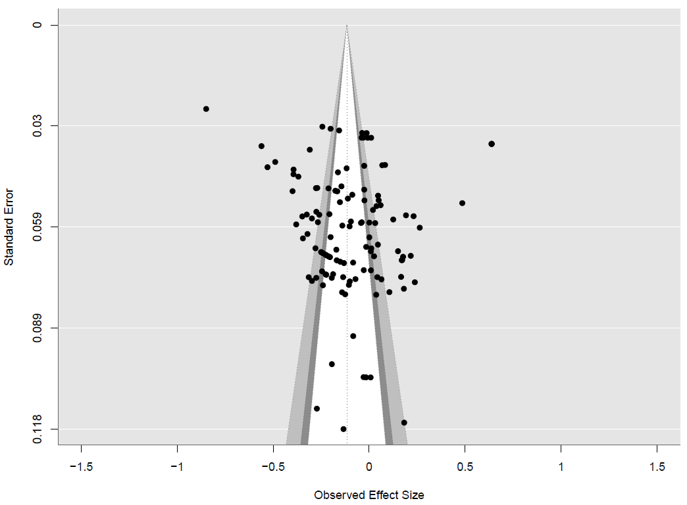 | 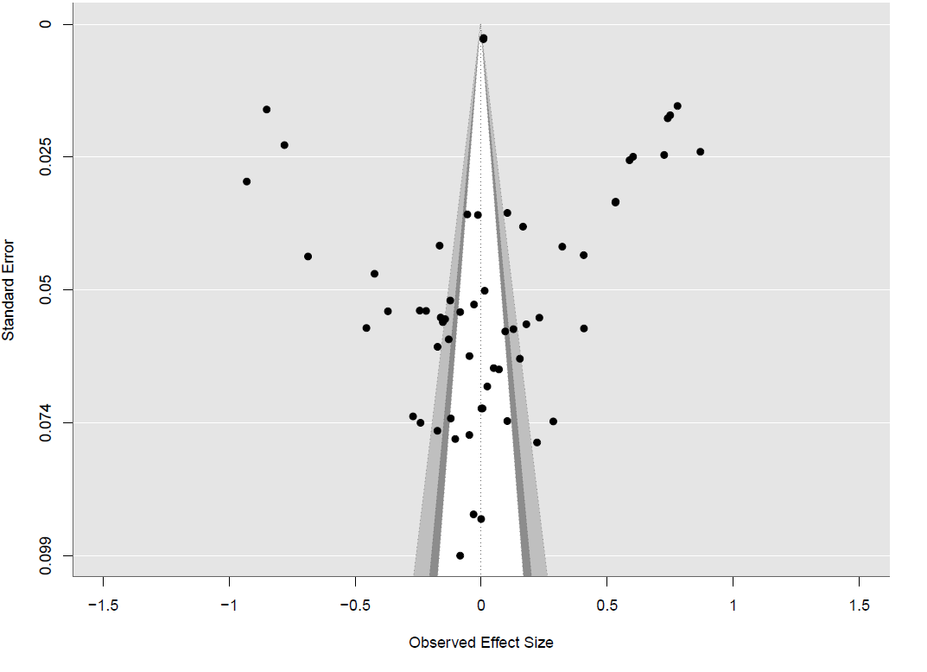
Brand attitude |  | Ad attitude
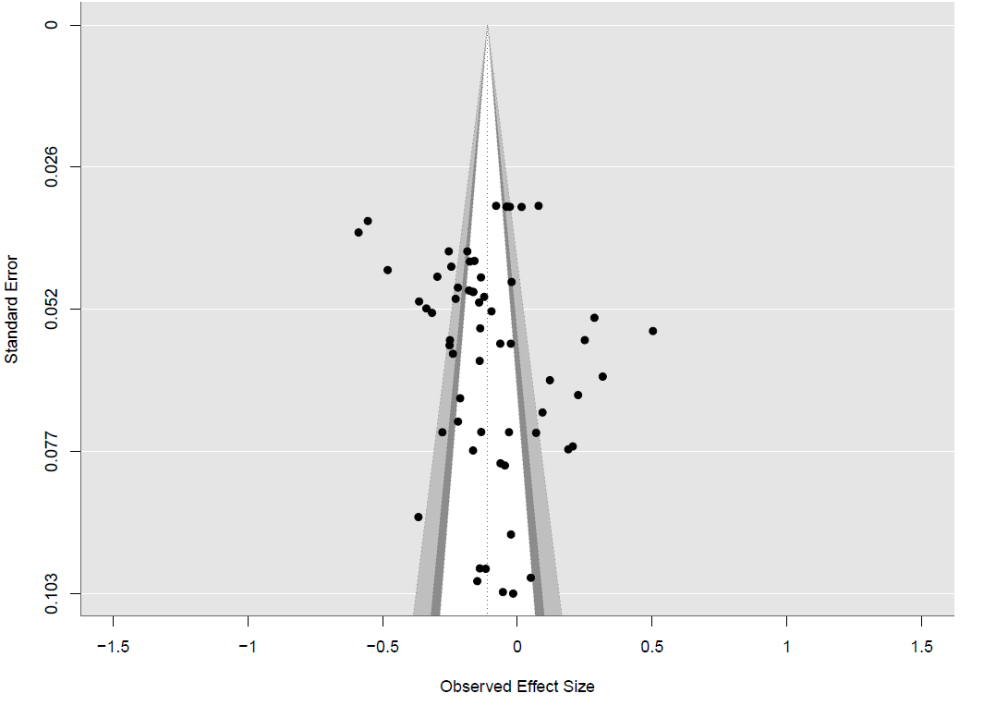 |  | 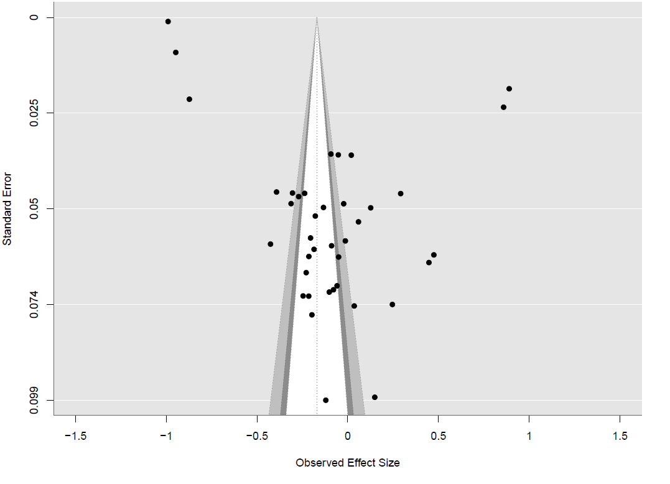

Credibility | Attractiveness
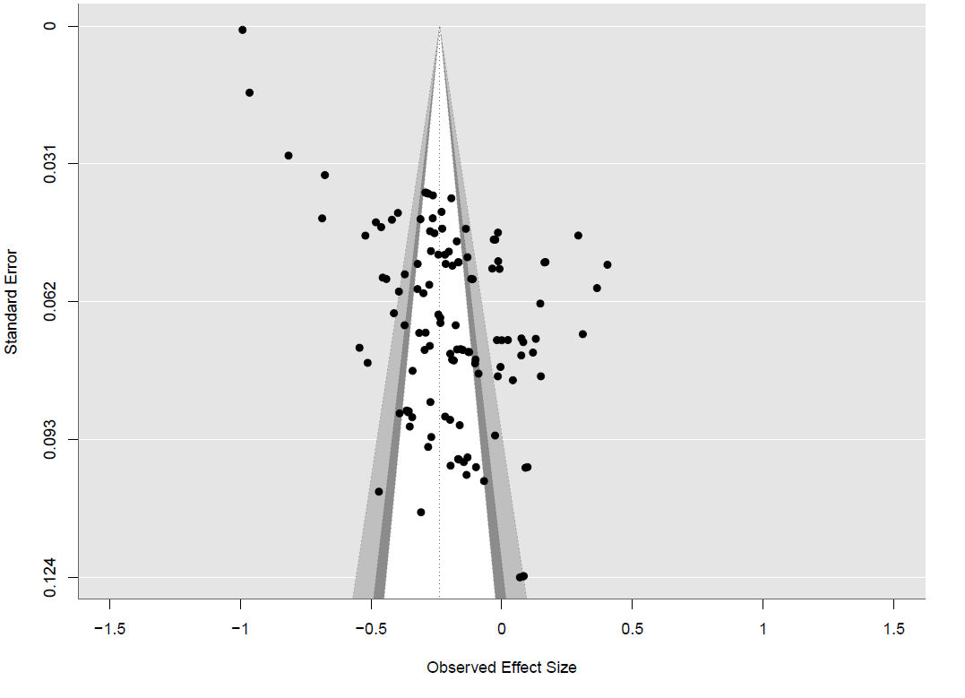 | 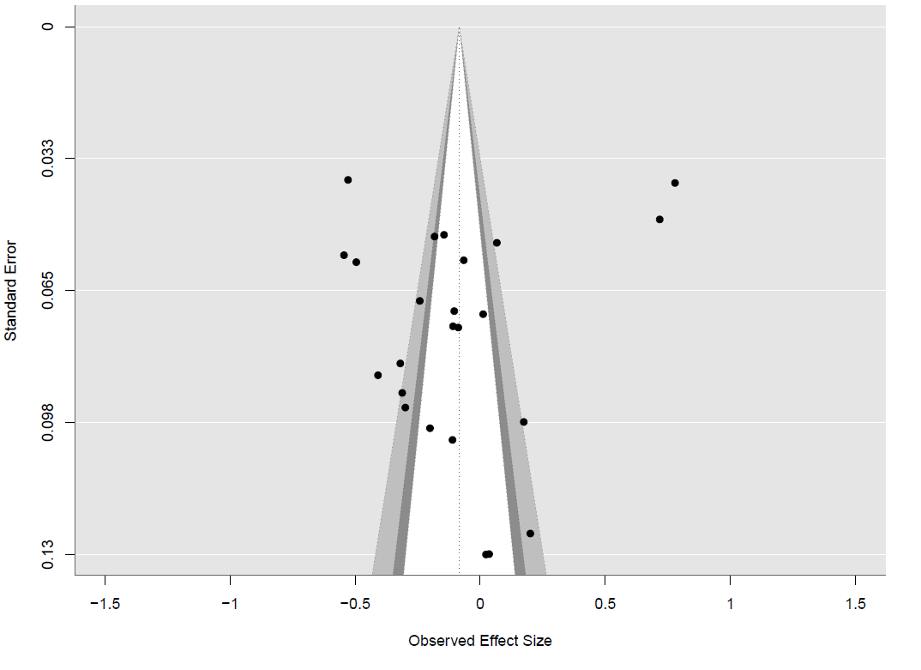
Novelty
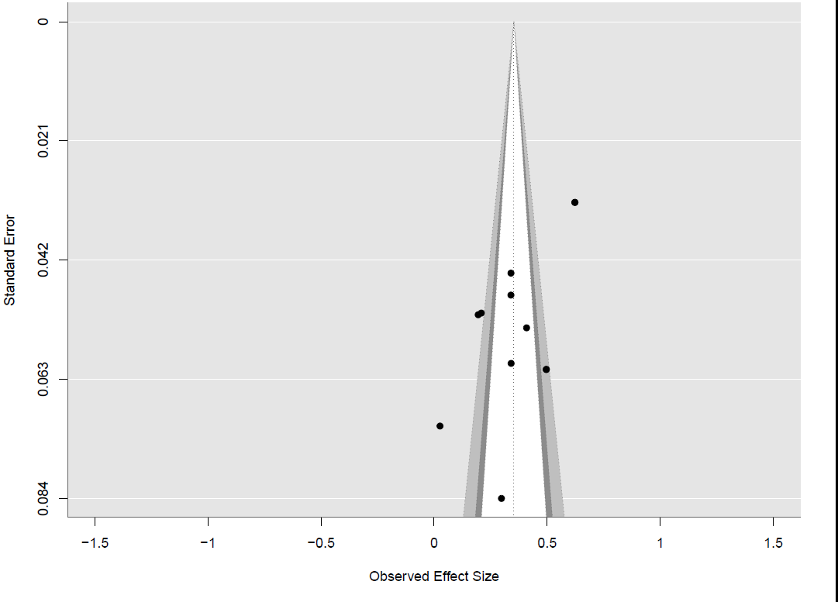

Web Appendix D: Result of Outlier Analysis

 | With outliers |  |  |  | Without outliers
DV | #Paper | #Study | #Effect size | r_{rcvw} | #Paper | #Study | #Effect size | r_{rcvw}
Behavioral intention | 52 | 144 | 200 | -.125** | 52 | 114 | 199 | -.130**
Brand attitude | 26 | 46 | 85 | -.123** | 26 | 46 | 82 | -.120**
Ad attitude | 23 | 34 | 52 | -.147* | 23 | 34 | 51 | -.192**
Credibility | 50 | 87 | 179 | -.210** | 50 | 87 | 175 | -.234**
Attractiveness | 15 | 20 | 32 | -.097 | 14 | 19 | 30 | -.160**
**p<.01, *p < .05

Web Appendix E: Frequency Distribution of Effect Sizes Plot

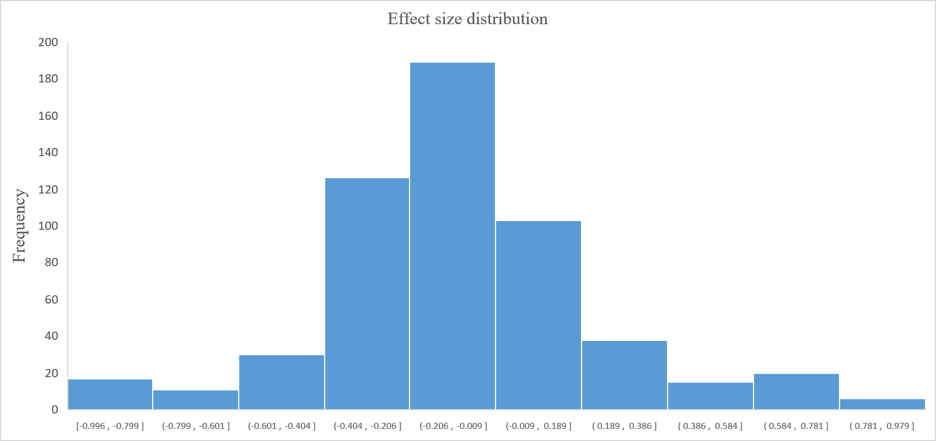

Web Appendix F: The HLM Full Model

A three-level hierarchical linear model (HLM) was used to evaluate the role of moderators in explaining the variability of effect sizes in virtual influencer marketing. The nested data structure was modelled as effect sizes (Level 1) nested within studies (Level 2), which were in turn nested within papers (Level 3).

Level 1 Equation: Effect Sizes within Studies
Level 1: ES_{ij} = β_{0jk} + β_{1jk} × X_{ijk} + u_{ijk} + e_{ijk}, (1)
where:
ES_{ijk} represents the i_{th} observed effect size from the j_{th} study in k_{th} paper.
X_{ijk} denotes Level 1 predictors, consumer response variables (i.e., behavioral intention (baseline), engagement, brand attitude, Ad attitudes, credibility, attractiveness).
β_{0jk} is the intercept for study j in paper k, indicating the average effect size within that study.
β_{1jk} is the slope coefficient capturing the relationship between the Level 1 predictor and effect size within study j.
u_{ijk} is the known sampling error (mean = 0, known variance).
e_{ijk} is the residual error representing unexplained variation in ES_{ijk}​ beyond the predictor and intercept.
This level models how consumer response variables influence effect sizes within studies, accounting for sampling and residual error.

Level 2 Equation: Between Studies
Level 2: β_{0jk} = γ_{00k} + γ_{01k} × W_{jk} + u_{0jk}, (2)
where:
β_{0jk} is the study-specific intercept defined in Level 1.
W_{1jk} refers to Level 2 predictors, such as study-level moderators (at brand, product, message levels, and consumer response (base behavioral intention)).
γ_{00k} represents the mean effect size for paper k.
γ_{01k} is the regression coefficient for W_{jk} ​, capturing the influence of study-level moderators.
u_{0jk} is the Level 2 residual error, representing unexplained variation in the study intercepts after accounting for moderators​.
This level models how study-level moderators explain between-study differences in average effect sizes.

Level 3 Equation: Between Papers
Level 3: γ_{00k} = δ₀₀₀ + r_{00k}, (3)
- γ_{00k}​ is the mean intercept for paper k from Level 2.
- δ₀₀₀ represents the grand mean effect size across all papers.
- r_{00k} is the Level 3 residual error, capturing unexplained variance in paper-level intercepts.
This level accounts for random variation between papers, recognizing that multiple studies within the same paper may share methodological or contextual similarities that contribute to correlated effect sizes.

Web Appendix G: VIF and Correlations Between Moderator Variables

Variable | VIF | 01 | 02 | 03 | 04 | 05 | 06 | 07 | 08 | 09 | 10 | 11 | 12 | 13 | 14 | 15 | 16 | 17 | 18 | 19
01. Anthropomorphism | 1.53 | 1.00
02. Autonomy | 1.52 | 0.13 | 1.00
03. Brand type | 1.36 | 0.12 | 0.23 | 1.00
04. Brand positioning | 1.50 | 0.25 | 0.02 | 0.13 | 1.00
05. Communication style | 1.22 | 0.08 | 0.12 | -0.02 | -0.06 | 1.00
06. Product familiarity | 1.95 | 0.08 | -0.19 | -0.11 | -0.25 | 0.23 | 1.00
07. Self-improvement | 1.38 | 0.12 | -0.17 | -0.10 | -0.15 | -0.19 | 0.24 | 1.00
08. Product involvement | 1.65 | -0.24 | -0.37 | -0.31 | -0.18 | 0.21 | 0.28 | 0.13 | 1.00
09. Message appeal | 1.47 | 0.10 | -0.05 | 0.15 | 0.02 | -0.13 | 0.03 | -0.16 | -0.18 | 1.00
10. Point of view | 1.21 | -0.14 | 0.01 | -0.10 | 0.09 | 0.26 | -0.05 | -0.26 | 0.13 | 0.02 | 1.00
11. Sensory capacity | 1.55 | -0.40 | 0.04 | 0.05 | -0.24 | -0.14 | -0.28 | -0.08 | -0.08 | -0.01 | -0.12 | 1.00
12. Behavioral intention | 1.45 | -0.09 | 0.01 | 0.06 | 0.11 | 0.09 | 0.10 | -0.06 | 0.08 | 0.12 | -0.07 | 0.11 | 1.00
13. Engagement | 1.60 | -0.01 | 0.01 | -0.16 | 0.10 | 0.01 | -0.09 | -0.03 | 0.08 | 0.09 | 0.01 | -0.13 | -.06 | 1.00
14. Brand attitude | 1.15 | 0.14 | -0.10 | 0.19 | -0.04 | -0.09 | 0.11 | 0.12 | -0.07 | 0.01 | -0.13 | 0.01 | -0.16 | 0.12 | 1.00
15. Ad attitude | 1.39 | -0.03 | 0.14 | 0.04 | 0.06 | -0.01 | -0.04 | 0.18 | -0.06 | -0.05 | -0.03 | 0.06 | -0.12 | -.06 | -0.13 | 1.00
16. Credibility | 1.36 | 0.16 | 0.13 | 0.10 | 0.12 | 0.13 | 0.10 | 0.09 | -0.08 | 0.06 | 0.11 | 0.12 | 0.16 | 0.12 | 0.02 | 0.08 | 1.00
17. Attractiveness | 1.49 | 0.02 | -0.11 | -0.03 | 0.06 | 0.10 | 0.09 | -0.07 | 0.07 | 0.05 | 0.06 | -0.05 | -0.10 | -0.12 | -0.10 | -0.08 | 0.06 | 1.00
18. Publication status | 1.98 | 0.02 | 0.11 | 0.06 | 0.09 | 0.12 | 0.06 | -0.02 | 0.10 | 0.09 | 0.09 | -0.21 | 0.08 | 0.09 | 0.06 | 0.05 | 0.03 | 0.14 | 1.00
19. Journal quality | 2.00 | 0.06 | 0.09 | 0.11 | 0.09 | 0.11 | 0.10 | -0.06 | 0.16 | 0.10 | 0.14 | 0.11 | 0.09 | 0.11 | 0.12 | 0.06 | 0.11 | 0.10 | 0.16 | 1.00

Web Appendix H: Multivariate Meta-Regression Base Model

Moderators | Estimate | SE | P-value
Intercept | 0.217 | 0.280 | 0.439
Virtual influencer
High anthropomorphism (vs. low) | -0.186 | 0.278 | 0.505
High Autonomy (vs. Low Autonomy) | -0.306 | 0.143 | 0.035
Brand
Functional (vs. experiential) | -0.216 | 0.158 | 0.174
Futuristic (vs. traditional) | -0.330 | 0.198 | 0.098
Entertaining (vs. informative) | 0.538 | 0.377 | 0.156
Product
New product (vs. familiar) | 0.212 | 0.087 | 0.017
Self-improvement (vs. non-self-improvement) | 0.223 | 0.143 | 0.122
High involvement (vs. low involvement) | -0.045 | 0.145 | 0.757
Message
Emotional (vs. rational) | 0.388 | 0.198 | 0.051
First-person (vs. third-person) | -0.027 | 0.182 | 0.884
Proximal (vs. distal) | -0.243 | 0.137 | 0.078
Consumer responses
Engagement (base)
Behavioral intention | -0.194 | 0.054 | 0.000
Brand Attitude | -0.136 | 0.065 | 0.037
Ad attitude | -0.116 | 0.073 | 0.114
Credibility | -0.217 | 0.056 | 0.000
Attractiveness | -0.278 | 0.088 | 0.002
Control variables
Published (vs. unpublished) | 0.025 | 0.074 | 0.733
Journal quality | 0.010 | 0.058 | 0.863

Web Appendix I: Multivariate Meta-Regression of Subgroups of Dependent Variables

Table 1. Multivariate meta-regression analysis results – Behavioral outcomes
Moderators | Estimate | SE | P-value
Intercept | -0.508 | 0.561 | 0.369
Virtual influencer
High anthropomorphism (vs. low) | 0.335 | 0.561 | 0.553
High Autonomy (vs. Low Autonomy) | -0.290 | 0.370 | 0.435
Brand
Futuristic (vs. conventional) | -0.269 | 0.196 | 0.072
Functional (vs. experiential) | -0.027 | 0.117 | 0.819
Entertaining (vs. informative) | 0.051 | 0.404 | 0.899
Product
New product (vs. familiar) | 0.002 | 0.233 | 0.993
Self-improvement (vs. non-self-improvement) | 0.506 | 0.293 | 0.089
High involvement (vs. low) | 0.199 | 0.261 | 0.449
Message
Emotional (vs. rational) | 0.416 | 0.201 | 0.038
First person (vs. third person) | 0.176 | 0.214 | 0.413
Proximal (vs. distal) | -0.226 | 0.112 | 0.049
Consumer responses
Engagement (base)
Behavioral intention | -0.181 | 0.064 | 0.006
Control variables
Published (vs. unpublished) | -0.084 | 0.106 | 0.428
High quality (vs. low quality) | -.036 | 0.216 | 0.868
Interaction effects
High anthropomorphism (vs. low) × With AI capacity (vs. no AI capacity) | 0.319 | 0.136 | 0.018
High anthropomorphism (vs. low) × Functional (vs. experiential) | 0.098 | 0.241 | 0.682
High anthropomorphism (vs. low) × Futuristic brand (vs. traditional) | 0.245 | 0.103 | 0.017
High anthropomorphism (vs. low) × Playfulness (vs. serious) | -0.099 | 0.220 | 0.655
High anthropomorphism (vs. low) × New product (vs. familiar) | -0.482 | 0.302 | 0.110
High anthropomorphism (vs. low) × Self-improvement (vs. non-self-improvement) | -0.030 | 0.240 | 0.900
High anthropomorphism (vs. low) × High involvement (vs. low) | 0.081 | 0.132 | 0.542
High anthropomorphism (vs. low) × Emotional (vs. rational) | -0.355 | 0.168 | 0.035
High anthropomorphism (vs. low) × First-person (vs. third person) | 0.145 | 0.128 | 0.258
High anthropomorphism (vs. low) × Proximal post (vs. distal) | 0.343 | 0.115 | 0.002
Table 2. Multivariate meta-regression analysis results – Attitude
Moderators | Estimate | SE | P-value
Intercept | -0.179 | 0.461 | 0.700
Virtual influencer
High anthropomorphism (vs. low) | -0.223 | 0.290 | 0.447
High Autonomy (vs. Low Autonomy) | -0.139 | 0.289 | 0.632
Brand
Futuristic (vs. conventional) | -0.292 | 0.127 | 0.031
Functional (vs. experiential) | -0.703 | 0.430 | 0.115
Entertaining (vs. informative) | 0.364 | 0.118 | 0.006
Product
New product (vs. familiar) | -0.346 | 0.588 | 0.561
Self-improvement (vs. non-self-improvement) | 0.407 | 0.398 | 0.313
High involvement (vs. low) | -0.073 | 0.117 | 0.541
Message
Emotional (vs. rational) | 0.065 | 0.122 | 0.597
First person (vs. third person) | 0.005 | 0.505 | 0.992
Proximal (vs. distal) | -0.071 | 0.110 | 0.523
Consumer responses
Ad attitude (base)
Brand attitude | 0.153 | 0.117 | 0.203
Control variables
Published (vs. unpublished) | -0.037 | 0.355 | 0.918
High quality (vs. low quality) | -0.099 | 0.198 | 0.618
Interaction effects
High anthropomorphism (vs. low) × With AI capacity (vs. no AI capacity) | 0.600 | 0.304 | 0.055
High anthropomorphism (vs. low) × Functional (vs. experiential) | 0.475 | 0.440 | 0.290
High anthropomorphism (vs. low) × Futuristic brand (vs. traditional) | 0.345 | 0.198 | 0.081
High anthropomorphism (vs. low) × Playfulness (vs. serious) | -0.162 | 0.269 | 0.548
High anthropomorphism (vs. low) × New product (vs. familiar) | 0.695 | 0.581 | 0.243
High anthropomorphism (vs. low) × Self-improvement (vs. non-self-improvement) | -0.041 | 0.410 | 0.921
High anthropomorphism (vs. low) × High involvement (vs. low) | -0.011 | 0.296 | 0.970
High anthropomorphism (vs. low) × Emotional (vs. rational) | -0.365 | 0.228 | 0.110
High anthropomorphism (vs. low) × First-person (vs. third person) | -0.189 | 0.513 | 0.716
High anthropomorphism (vs. low) × Proximal post (vs. distal) | 0.236 | 0.129 | 0.067

Table 3. Multivariate meta-regression analysis results – Evaluation
Moderators | Estimate | SE | P-value
Intercept | -0.739 | 0.573 | 0.203
Virtual influencer
High anthropomorphism (vs. low) | -0.770 | 0.545 | 0.163
With AI capacity (vs. no AI capacity) | 0.017 | 0.109 | 0.878
Brand
Futuristic (vs. conventional) | -1.123 | 0.386 | 0.005
Functional (vs. experiential) | -0.020 | 0.321 | 0.951
Playfulness (vs. serious) | 0.402 | 0.319 | 0.208
Product
New product (vs. familiar) | 0.355 | 0.329 | 0.280
Self-improvement (vs. non-self-improvement) | 0.157 | 0.083 | 0.061
High involvement (vs. low) | -0.149 | 0.104 | 0.159
Message
Emotional (vs. rational) | 0.854 | 0.687 | 0.219
First person (vs. third person) | -0.536 | 0.416 | 0.203
Proximal (vs. distal) | -0.423 | 0.209 | 0.052.
Consumer responses
Credibility (base)
Attractiveness | -0.013 | 0.095 | 0.888
Control variables
Published (vs. unpublished) | -0.101 | 0.119 | 0.402
High quality (vs. low quality) | -0.169 | 0.123 | 0.170
Interaction effects
High anthropomorphism (vs. low) × With AI capacity (vs. no AI capacity) | 0.600 | 0.304 | 0.055
High anthropomorphism (vs. low) × Functional (vs. experiential) | -0.038 | 0.328 | 0.909
High anthropomorphism (vs. low) × Futuristic brand (vs. traditional) | 0.298 | 0.157 | 0.058
High anthropomorphism (vs. low) × Playfulness (vs. serious) | 0.012 | 0.123 | 0.922
High anthropomorphism (vs. low) × New product (vs. familiar) | 0.884 | 0.442 | 0.051
High anthropomorphism (vs. low) × Self-improvement (vs. non-self-improvement) | -0.041 | 0.410 | 0.921
High anthropomorphism (vs. low) × High involvement (vs. low) | 0.089 | 0.213 | 0.676
High anthropomorphism (vs. low) × Emotional (vs. rational) | -0.259 | 0.105 | 0.013
High anthropomorphism (vs. low) × First-person (vs. third person) | 0.808 | 0.429 | 0.065
High anthropomorphism (vs. low) × Proximal post (vs. distal) | 0.437 | 0.226 | 0.060

Web Appendix J: Multivariate Meta-Regression of Alternative Operationalization of Journal Quality

Table 1. Multivariate Meta-Regression Results (Alternative 1: Continuous Journal Impact Factor)
Moderators | Estimate | SE | P-value
Intercept | 0.224 | 0.278 | 0.421
Virtual influencer
High anthropomorphism (vs. low) | -0.184 | 0.276 | 0.507
High Autonomy (vs. Low Autonomy) | -0.304 | 0.142 | 0.034
Brand
Functional (vs. experiential) | -0.214 | 0.157 | 0.175
Futuristic (vs. traditional) | -0.327 | 0.197 | 0.099
Entertaining (vs. informative) | 0.533 | 0.375 | 0.157
Product
New product (vs. familiar) | 0.211 | 0.086 | 0.017
Self-improvement (vs. non-self-improvement) | 0.221 | 0.142 | 0.123
High involvement (vs. low involvement) | -0.047 | 0.144 | 0.744
Message
Emotional (vs. rational) | 0.385 | 0.197 | 0.052
First-person (vs. third-person) | -0.028 | 0.181 | 0.88
Proximal (vs. distal) | -0.241 | 0.136 | 0.079
Consumer responses
Engagement (base)
Behavioral intention | -0.193 | 0.054 | 0.000
Brand Attitude | -0.135 | 0.065 | 0.038
Ad attitude | -0.115 | 0.073 | 0.116
Credibility | -0.215 | 0.056 | 0.000
Attractiveness | -0.275 | 0.087 | 0.002
Control variables
Published (vs. unpublished) | 0.024 | 0.073 | 0.739
Journal quality (Continuous) | 0.012 | 0.057 | 0.832
Interaction effects
High anthropomorphism (vs. low) × High Autonomy (vs. Low Autonomy) | 0.318 | 0.149 | 0.036
High anthropomorphism (vs. low) × Functional (vs. experiential) | 0.139 | 0.163 | 0.391
High anthropomorphism (vs. low) × Futuristic (vs. traditional) | 0.341 | 0.100 | 0.001
High anthropomorphism (vs. low) × Entertaining (vs. informative) | -0.292 | 0.325 | 0.366
High anthropomorphism (vs. low) × New product (vs. familiar) | 0.214 | 0.095 | 0.025
High anthropomorphism (vs. low) × Self-improvement (vs. non-self-improvement) | -0.217 | 0.151 | 0.153
High anthropomorphism (vs. low) × High involvement (vs. low) | 0.017 | 0.149 | 0.910
High anthropomorphism (vs. low) × Emotional (vs. rational) | -0.423 | 0.203 | 0.039
High anthropomorphism (vs. low) × First-person (vs. third-person) | 0.096 | 0.187 | 0.607
High anthropomorphism (vs. low) × Proximal (vs. distal) | 0.360 | 0.143 | 0.012
Table 2. Multivariate Meta-Regression Results (Alternative 2: Journal Quality – Q1 vs. Others)
Moderators | Estimate | SE | P-value
Intercept | 0.212 | 0.281 | 0.452
Virtual influencer
High anthropomorphism (vs. low) | -0.187 | 0.278 | 0.504
High Autonomy (vs. Low Autonomy) | -0.307 | 0.143 | 0.034
Brand
Functional (vs. experiential) | -0.217 | 0.158 | 0.173
Futuristic (vs. traditional) | -0.332 | 0.198 | 0.097
Entertaining (vs. informative) | 0.539 | 0.377 | 0.155
Product
New product (vs. familiar) | 0.213 | 0.087 | 0.017
Self-improvement (vs. non-self-improvement) | 0.224 | 0.143 | 0.121
High involvement (vs. low involvement) | -0.044 | 0.145 | 0.760
Message
Emotional (vs. rational) | 0.389 | 0.198 | 0.05
First-person (vs. third-person) | -0.027 | 0.182 | 0.885
Proximal (vs. distal) | -0.244 | 0.137 | 0.077
Consumer responses
Engagement (base)
Behavioral intention | -0.194 | 0.054 | 0.000
Brand Attitude | -0.136 | 0.065 | 0.037
Ad attitude | -0.116 | 0.073 | 0.114
Credibility | -0.217 | 0.056 | 0.000
Attractiveness | -0.278 | 0.088 | 0.002
Control variables
Published (vs. unpublished) | 0.026 | 0.074 | 0.729
Q1 journal (vs. others) | 0.018 | 0.059 | 0.76
Interaction effects
High anthropomorphism (vs. low) × High Autonomy (vs. Low Autonomy) | 0.321 | 0.150 | 0.035
High anthropomorphism (vs. low) × Functional (vs. experiential) | 0.142 | 0.164 | 0.387
High anthropomorphism (vs. low) × Futuristic (vs. traditional) | 0.345 | 0.101 | 0.001
High anthropomorphism (vs. low) × Entertaining (vs. informative) | -0.297 | 0.326 | 0.363
High anthropomorphism (vs. low) × New product (vs. familiar) | 0.216 | 0.095 | 0.025
High anthropomorphism (vs. low) × Self-improvement (vs. non-self-improvement) | -0.220 | 0.152 | 0.150
High anthropomorphism (vs. low) × High involvement (vs. low) | 0.014 | 0.150 | 0.926
High anthropomorphism (vs. low) × Emotional (vs. rational) | -0.427 | 0.204 | 0.039
High anthropomorphism (vs. low) × First-person (vs. third-person) | 0.099 | 0.188 | 0.603
High anthropomorphism (vs. low) × Proximal (vs. distal) | 0.364 | 0.144 | 0.012

Web Appendix K: Marketing and Communication Professionals Survey
A total of 204 marketing and communication professionals were recruited through the Prolific online research platform. Full descriptive statistics are provided in Appendix L. We report the survey questions and findings below.

Q1. Please rate how virtual influencers compare with human influencers in shaping customer perceptions, attitudes, and behaviors across the following dimensions.
 | Human much more effective | Human more effective | Human slightly more effective | About the same | Virtual slightly more effective | Virtual more effective | Virtual much more effective
Effectiveness in influencing purchase intentions | ❏ | ❏ | ❏ | ❏ | ❏ | ❏ | ❏
Effectiveness in driving engagement | ❏ | ❏ | ❏ | ❏ | ❏ | ❏ | ❏
Effectiveness in shaping brand attitudes (positive evaluation of the brand) | ❏ | ❏ | ❏ | ❏ | ❏ | ❏ | ❏
Effectiveness in shaping ad attitudes (positive evaluation of the advertisement) | ❏ | ❏ | ❏ | ❏ | ❏ | ❏ | ❏
Effectiveness in conveying credibility | ❏ | ❏ | ❏ | ❏ | ❏ | ❏ | ❏
Effectiveness in demonstrating attractiveness | ❏ | ❏ | ❏ | ❏ | ❏ | ❏ | ❏
Effectiveness in providing novelty | ❏ | ❏ | ❏ | ❏ | ❏ | ❏ | ❏

Q1 Results
The summary of the results is provided in Table 1, which reports the means and standard deviations of industry professionals’ perceptions regarding the effectiveness of virtual versus human influencers across different outcomes. The results indicate that novelty has the highest mean score (M = 3.980, SD = 1.943), followed by attractiveness (M = 3.278, SD = 1.817) and engagement (M = 2.946, SD = 1.687). Perceptions are slightly lower for ad attitude (M = 2.922, SD = 1.643) and brand attitude (M = 2.668, SD = 1.596). The lowest mean scores are observed for behavioral intention (M = 2.395, SD = 1.532) and credibility (M = 2.156, SD = 1.595). The table also reports pairwise comparisons between variables, showing that most differences are statistically significant (p < .01), except for the difference between engagement and ad attitude (p = .796). Overall, the results suggest that industry professionals perceive the main advantage of virtual influencers relative to human influencers in terms of novelty, while perceptions related to credibility and behavioral outcomes are comparatively weaker.
Table 1. Means (SDs) of Industry Professionals’ Perceptions of the Effectiveness of Virtual vs. Human Influencers
Variable | Mean (SD) | 01 | 02 | 03 | 04 | 05 | 06 | 07
01. Novelty | 3.980 (1.943) | – | 6.132 (.000) | 7.364 (.000) | 8.443 (.000) | 10.000 (.000) | 10.906 (.000) | 12.249 (.000)
02. Attractiveness | 3.278 (1.817) |  | – | 3.060 (.003) | 4.039 (.000) | 6.357 (.000) | 7.879 (.000) | 9.838 (.000)
03. Engagement | 2.946 (1.687) |  |  | – | 0.259 (.796) | 3.134 (.002) | 5.732 (.000) | 8.247 (.000)
04. Ad Attitude | 2.922 (1.643) |  |  |  | – | 3.460 (.001) | 5.994 (.000) | 8.246 (.000)
05. Brand Attitude | 2.668 (1.596) |  |  |  |  | – | 3.616 (.000) | 7.207 (.000)
06. Behavioral Intention | 2.395 (1.532) |  |  |  |  |  | – | 3.242 (.001)
07. Credibility | 2.156 (1.595) |  |  |  |  |  |  | –

Q2. Next, you will see some research findings. For each one, please rate how much you agree or disagree with the statements and add a brief comment to explain your answer.
Finding 1
Compared to human influencers, virtual influencer endorsements are less effective in shaping customers’ purchase intentions, brand and ad evaluations, and credibility; equally effective in driving engagement and attractiveness; and more effective in generating perceptions of novelty.

Please indicate how much you agree or disagree with the following statements:
 | Strongly disagree | Disagree | Somewhat disagree | Neither agree nor disagree | Somewhat agree | Agree | Strongly agree
These findings challenge my existing assumptions. | ❏ | ❏ | ❏ | ❏ | ❏ | ❏ | ❏
These findings provide me with a new perspective. | ❏ | ❏ | ❏ | ❏ | ❏ | ❏ | ❏
These findings are useful for informing a brand’s influencer marketing strategy. | ❏ | ❏ | ❏ | ❏ | ❏ | ❏ | ❏

Finding 2
Compared to less human-like virtual influencers (for example, cartoon-like ones), highly human-like virtual influencers with artificial intelligence capabilities are more effective, whereas adding artificial intelligence to less human-like virtual influencers makes them less effective.

Please indicate how much you agree or disagree with the following statements:
 | Strongly disagree | Disagree | Somewhat disagree | Neither agree nor disagree | Somewhat agree | Agree | Strongly agree
These findings challenge my existing assumptions. | ❏ | ❏ | ❏ | ❏ | ❏ | ❏ | ❏
These findings provide me with a new perspective. | ❏ | ❏ | ❏ | ❏ | ❏ | ❏ | ❏
These findings are useful for informing a brand’s influencer marketing strategy. | ❏ | ❏ | ❏ | ❏ | ❏ | ❏ | ❏
Finding 3
Compared to conventional brands (for example, Coca-Cola), futuristic brands (for example, Apple) are more effective when working with highly human-like virtual influencers, whereas conventional brands are more effective when working with less human-like virtual influencers.
Please indicate how much you agree or disagree with the following statements:
 | Strongly disagree | Disagree | Somewhat disagree | Neither agree nor disagree | Somewhat agree | Agree | Strongly agree
These findings challenge my existing assumptions. | ❏ | ❏ | ❏ | ❏ | ❏ | ❏ | ❏
These findings provide me with a new perspective. | ❏ | ❏ | ❏ | ❏ | ❏ | ❏ | ❏
These findings are useful for informing a brand’s influencer marketing strategy. | ❏ | ❏ | ❏ | ❏ | ❏ | ❏ | ❏

Finding 4
Compared to familiar and well-known products, novel products (for example, innovations) are more effectively endorsed by highly human-like virtual influencers, whereas familiar products are more effectively endorsed by less human-like virtual influencers.
Please indicate how much you agree or disagree with the following statements:
 | Strongly disagree | Disagree | Somewhat disagree | Neither agree nor disagree | Somewhat agree | Agree | Strongly agree
These findings challenge my existing assumptions. | ❏ | ❏ | ❏ | ❏ | ❏ | ❏ | ❏
These findings provide me with a new perspective. | ❏ | ❏ | ❏ | ❏ | ❏ | ❏ | ❏
These findings are useful for informing a brand’s influencer marketing strategy. | ❏ | ❏ | ❏ | ❏ | ❏ | ❏ | ❏

Finding 5
Compared to emotional messages (for example, appeals that evoke joy or excitement), rational messages (for example, highlighting product features or performance) are more effective when delivered by highly human-like virtual influencers, whereas emotional messages are more effective when delivered by less human-like virtual influencers.
Please indicate how much you agree or disagree with the following statements:
 | Strongly disagree | Disagree | Somewhat disagree | Neither agree nor disagree | Somewhat agree | Agree | Strongly agree
These findings challenge my existing assumptions. | ❏ | ❏ | ❏ | ❏ | ❏ | ❏ | ❏
These findings provide me with a new perspective. | ❏ | ❏ | ❏ | ❏ | ❏ | ❏ | ❏
These findings are useful for informing a brand’s influencer marketing strategy. | ❏ | ❏ | ❏ | ❏ | ❏ | ❏ | ❏

Finding 6
Compared to endorsements focused on sight and sound, endorsements that emphasize touch, taste, or smell are more effective when delivered by highly human-like virtual influencers, whereas endorsements focused on sight and sound are more effective when delivered by less human-like virtual influencers.
Please indicate how much you agree or disagree with the following statements:
 | Strongly disagree | Disagree | Somewhat disagree | Neither agree nor disagree | Somewhat agree | Agree | Strongly agree
These findings challenge my existing assumptions. | ❏ | ❏ | ❏ | ❏ | ❏ | ❏ | ❏
These findings provide me with a new perspective. | ❏ | ❏ | ❏ | ❏ | ❏ | ❏ | ❏
These findings are useful for informing a brand’s influencer marketing strategy. | ❏ | ❏ | ❏ | ❏ | ❏ | ❏ | ❏

Q2 Results
The summary of the results is provided in Table 12, which reports the means and standard deviations of industry professionals’ evaluations of the six findings across three criteria: challenging assumptions, providing a new perspective, and usefulness. Overall, the findings receive moderate to high evaluations across all three criteria. The highest scores for challenging assumptions are observed for F6 (Anthropomorphism × Sensory capacity) (M = 4.34, SD = 1.65), followed by F5 (Anthropomorphism × Message appeal) (M = 4.10, SD = 1.73) and F4 (Anthropomorphism × Product familiarity) (M = 4.05, SD = 1.59). The lowest score on this dimension is for F1 (Virtual influencer comparative effectiveness) (M = 3.28, SD = 1.83). A similar pattern appears for new perspective, where F6 (M = 4.53, SD = 1.62) and F5 (M = 4.48, SD = 1.75) receive the highest evaluations, followed closely by F3 (Anthropomorphism × Brand positioning) (M = 4.46, SD = 1.61) and F4 (M = 4.42, SD = 1.53). F1 again receives the lowest score on this criterion (M = 3.65, SD = 1.78). For usefulness, all findings receive relatively high scores. The highest evaluation is for F2 (Anthropomorphism × Autonomy) (M = 5.52, SD = 1.17), followed by F1 (Virtual influencer comparative effectiveness) (M = 5.45, SD = 1.26). The remaining findings also show strong perceived usefulness, ranging from M = 4.88 to 5.17.

Table 2: Means (SDs) for industry professionals’ evaluations of six findings across three evaluation criteria
Finding | Challenging assumptions  Mean (SD) | New perspective  Mean (SD) | Usefulness  Mean (SD)
F1: Virtual influencer comparative effectiveness. | 3.28 (1.83) | 3.65 (1.78) | 5.45 (1.26)
F2: Anthropomorphism × Autonomy | 3.55 (1.70) | 3.91 (1.74) | 5.52 (1.17)
F3. Anthropomorphism × Brand positioning | 3.95 (1.71) | 4.46 (1.61) | 5.17 (1.37)
F4. Anthropomorphism × Product familiarity | 4.05 (1.59) | 4.42 (1.53) | 4.88 (1.47)
F5. Anthropomorphism × Message appeal | 4.10 (1.73) | 4.48 (1.75) | 4.94 (1.46)
F6. Anthropomorphism × Sensory capacity | 4.34 (1.65) | 4.53 (1.62) | 5.01 (1.45)

Q3. Future Research Needs
As a marketing professional, your perspective is important in guiding future research. We would like to know what unanswered questions about virtual influencers matter most to you, and how future studies could better support your work.

What do you see as the most important areas where future research on virtual influencers should focus?

Q4. About You
The following questions ask about you and your professional background. Your responses will only be reported in aggregate and are used solely to help us understand the sample on which our findings are based.

What is your age?

How do you identify?
- Female
- Male
- Non-binary
- Prefer to self-describe
- Prefer not to say

Years of work experience

Area of expertise (select all that apply)
- Digital marketing
- Social media marketing
- Brand management
- Consumer insights / market research
- Advertising and communications
- Retail and e-commerce
- Public relations / Corporate communications
- Other

Current role level
- Entry-level / Junior professional
- Mid-level professional
- Senior manager / Director
- Executive / C-suite
- Other

Industry sector
- Advertising / Marketing services
- Consumer goods / Retail
- Technology / Digital platforms
- Media / Entertainment
- Professional services
- Education / Research
- Government / Non-profit
- Other
Web Appendix L: Descriptive Statistics of Marketing Professional Survey

Table 1. Expert Survey Respondent Profile (N = 204)
Category | Subcategory | % of Respondents
Gender | Female | 49.75%
 | Male | 48.76%
 | Non-binary / Prefer not to say | 1.49%
Age Group (years) | 18–30 | 28.5%
 | 31–40 | 36.5%
 | 41–50 | 17.0%
 | 51–60 | 14.5%
 | 61+ | 3.5%
Work Experience (years) | 3–10 | 35.08%
 | 11–20 | 32.46%
 | 21–30 | 22.51%
 | 31–40 | 7.33%
 | 41+ | 2.62%
Professional Role Level | Entry-level / Junior professional | 8.96%
 | Mid-level professional | 55.22%
 | Senior manager / Director | 25.37%
 | Executive / C-suite | 7.96%
 | Other | 2.49%
Area of Expertise | Digital marketing | 23.27%
 | Social media marketing | 20.65%
 | Brand management | 12.79%
 | Advertising and communications | 15.41%
 | Consumer insights / Market research | 8.94%
 | Retail and e-commerce | 8.94%
 | Public relations / Corporate communications | 8.47%
 | Other | 1.54%
Industry Sector | Advertising / Marketing services | 28.85%
 | Consumer goods / Retail | 18.97%
 | Technology / Digital platforms | 10.28%
 | Media / Entertainment | 10.67%
 | Professional services | 13.04%
 | Education / Research | 5.14%
 | Government / Non-profit | 6.72%
 | Other | 6.32%

