Table of Contents
Web Appendix A: Selected Recent Field Studies on Influencer Marketing
Web Appendix B: Conceptual Framework and Mechanism-Based Feature Classes
Web Appendix C: Feature Description
Appendix C1: Detailed Feature Description and Operationalization
Appendix C2: Visual Display Saliency Detection
Web Appendix D: Example of Instagram Post and Story
Web Appendix E: Data Schematics on Sample Composition
Web Appendix F: Examples of Visual Displays with High/Low Feature Values
Web Appendix G: Consistency Operationalization
Appendix G1: Consistency Operationalization for Numeric and Text Features
Appendix G2: Examples of Consistency Operationalization per Feature
Web Appendix H: Descriptive Statistics
Web Appendix I: Grid Search Results for Determining the Optimal λ Coefficients
Web Appendix J: Contingency Factors Results
Appendix J1: Influencer Follower Size
Appendix J2: Product vs. Service Campaigns
Web Appendix K: Summary of Consistency-variation Patterns Across Subgroups
Web Appendix L: Robustness Estimations
Appendix L1: Using Mode Instead of Median
Appendix L2: Using Linear Time Trend
Appendix L3: Unpenalized Mixed-Effects Models
Appendix L4: Major Algorithmic Changes Control
Appendix L5: Influencer-Campaign Level Cross-Format Consistency Dummy
Appendix L6: Influencer-Campaign Level Cross-Format Consistency Index
Appendix L7: Campaign-Level Cross-Format Consistency Dummy Control
Appendix L8: Campaign-Level Cross-Format Consistency Index Control
Appendix L9: COVID-19 Controls
Appendix L10: Campaign Content Intensity
Appendix L11: Campaign Day-Level Concentration (HHI)
Appendix L12: Consistency with Same-Day and Prior Campaign Content

Web Appendix M: Illustrative Campaigns with Post Consistency and Story Variation

Appendix A: Selected recent field studies on influencer marketing
Study | Platform | Key Dependent Variable | Key Independent Variable | Campaign  Data | Visual Display Features | Consistency of Visual Display | Key Findings
  Color | Complexity | Composition | Content | Other
Lanz et al. (2019) | SoundCloud | Follow backs | Indegree difference |  |  |  | For unknown musicians, starting with low-status users and increasing their status is beneficial
Hughes et al. (2019) | Facebook and blogs | Engagement | Campaign scope, blogger expertise, hedonic value, campaign incentives | ✓ |  |  | Average indegree boosts Facebook likes and blog comments
Valsesia et al. (2020) | Twitter and Instagram | Engagement | Influencer outdegree |  |  |  | Influencers with a substantial follower base who follow fewer others are perceived as more autonomous, increasing engagement
Leung, Gu, Li, et al. (2022) | Sina Weibo | Engagement | Influencer marketing spend | ✓ |  |  | Engagement elasticity grows with higher indegree
Bharadwaj et al. (2022) | Anonymous livestream retailer | Sales | Emotional displays on the salesperson’s face |  |  |  | Negative U-shaped effect of livestream retail emotional displays
  Face presence, emotional display
Karagür et al. (2022) | Instagram | Engagement Rate | Sponsorship disclosure type |  |  |  | Negative effect of platform disclosure; positive effect of influencer disclosure
Wies et al. (2023) | Instagram | Engagement | Influencer indegree | ✓ |  |  | Inverted U-shaped effect of influencer indegree
Chen et al. (2023) | BiliBili | Engagement | Sponsorship disclosure, brand appearance timing, video customization, subjective endorsement |  |  |  | Brand sponsorship disclosure, early brand presence, significant video personalization, and sharing personal experiences impact engagement
  Timing of the brand’s first appearance, video customization, subjective endorsement, disclosure clarity
Cascio Rizzo et al. (2023) | Instagram, TikTok | Engagement and purchase likelihood | Sensory language |  |  |  | Sensory language conveys that influencers have personally used the product, enhancing purchase likelihood and engagement
  Color dominance and saturation |  |  | Face presence and emotional state of the face
Tian et al. (2024) | TikTok | Impressions | Influencer indegree | ✓ |  |  | Positive, non-linear follower elasticity of impressions averaging 0.10
  Controlled content using variational autoencoder representation learning model
Gu et al. (2024) | Douyin | Sales | Influencer mix (influencer indegree) | ✓ |  |  | Negative effect of mixing big and small influencers in livestream
  Number of shown products in the video
Beichert et al. (2024) | Instagram | Performance metrics (revenue per follower and reach, return on spend) | Influencer indegree | ✓ |  |  | Low indegree influencers outperform high indegree influencers across three performance metrics
   | Visual complexity (kilobytes) | Visual balance, image clarity, and sharpness | Face presence
Cascio Rizzo et al. (2024) | Instagram,  TikTok | Engagement | Language arousal |  |  |  | High-arousal language enhances micro-influencer engagement but reduces macro-influencer engagement
  Color dominance and saturation |  |  | Face presence, emotional facial expression
This paper | Instagram | Engagement | Visual display features | ✓ |  | ✓  25 Measures evaluating campaign-level consistency of influencers’ visual display | Features along all dimensions are associated with engagement. Consistency is positively associated with engagement for posts. For stories, associations are feature-specific: consistency is positively linked for color complexity, diagonal dominance, whole human coverage, and text allocation, whereas variation is positively linked for warmth, luminance complexity, size difference, locations, and activities and items
  Warmth,  saturation,  brightness, brightness contrast | Color complexity, edge density, luminance complexity,  Number of objects, number of tags, and number of faces | Diagonal dominance, rule of thirds, color balance, color difference,  texture difference, size difference, depth of field, and quality | Face, text, whole human and face coverage, item similarity and co-occurrence, location, contextual sentiment, activities and items

Appendix B: Conceptual framework and mechanism-based feature classes
Figure B1. Conceptual framework
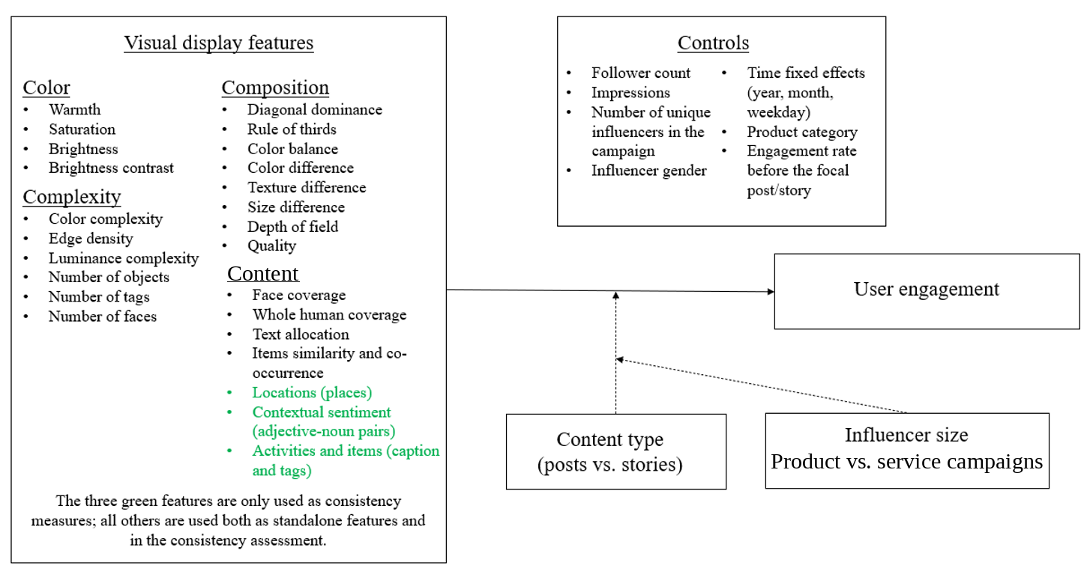

Mechanism-based feature classes
We map the 4C features to mechanism-based classes for interpretation purposes of the feature-level empirical estimates (Table B1). Specifically, we organize visual features into four mechanism-based classes. First, affective tone cues, such as warmth, saturation, brightness, brightness contrast, and contextual sentiment, shape the mood and arousal conveyed by the visual display. Second, structural clarity cues, such as color complexity, luminance complexity, diagonal dominance, rule of thirds, color balance, figure-ground differences, depth of field, and quality, guide visual processing and scanning. Third, social and interpretive continuity cues, such as number of faces, face coverage, whole human coverage, and text allocation, help viewers interpret who or what is central in the content. Fourth, contextual novelty cues, such as locations, activities and items, number of objects, number of tags, and items similarity and co-occurrence, signal the setting and semantic variety of the campaign. We expect consistency to be positively linked to engagement when repeated cues support campaign recognition, lower processing effort, and create clarity or continuity, whereas variation should be positively linked to engagement when changing cues create novelty, signal new information, or fit expectations for spontaneous, in-the-moment content. Because posts are persistent, repeated cues can build a coherent campaign schema over time; in contrast, stories’ ephemeral and sequential nature makes controlled novelty useful for sustaining attention, while some continuity remains necessary for rapid comprehension.

Table B1. Mechanism-based feature classes
Feature class | Features | Expected consistency/variation logic
Affective tone | Warmth, saturation, brightness, brightness contrast, contextual sentiment | Consistency can support a stable campaign mood; variation can refresh affective stimulation and reduce repetition.
Structural clarity | Color complexity, luminance complexity, diagonal dominance, rule of thirds, color balance, color difference, texture difference, size difference, depth of field, quality | Consistency can support recognition, fluency, and fast processing; selected variation can create visual salience when repetition becomes monotonous.
Social and interpretive continuity | Number of faces, face coverage, whole human coverage, text allocation | Consistency can help viewers interpret who or what is central across campaign content and maintain continuity across exposures.
Contextual novelty | Locations, activities and items, number of objects, number of tags, items similarity and co-occurrence | Variation can signal new information and contextual variety, which is particularly relevant for ephemeral and sequential formats such as stories.

Appendix C: Feature Description
Appendix C1: Definition and operationalization of visual features along the 4C dimensions
Dimension | Feature | Definition and Operationalization | Reference
Color | Warmth | The prevalence of warm tones in an image; Operationalized by computing the proportion of pixels with hues that fall outside the cool range (30-110, Wang et al., 2013) on the hue spectrum. | Zhang and Luo (2023); Zhang et al. (2022)
Color | Saturation | We define saturation as the intensity or purity of a color in an image, which indicates the degree to which it has been diluted with white. Saturation is operationalized as the mean value of all pixels within an image. | Zhang and Luo (2023); Zhang et al. (2022)
Color | Brightness | We define brightness as the overall level of illumination in an image. We operationalize brightness by determining the intensity of each pixel and averaging the intensity values across the entire image. | Zhang and Luo (2023); Zhang et al. (2022)
Color | Brightness contrast | We define brightness contrast as the extent of variation in brightness across an image. We operationalize brightness contrast by calculating the standard deviation of pixel intensity across an image. | Zhang and Luo (2023); Zhang et al. (2022)
Complexity | Color complexity | We define color complexity as the richness and variability of colors that reflect the distribution of colors throughout the image (Corchs et al., 2016; Hasler & Suesstrunk, 2003). We operationalize color complexity by the mean chroma, which indicates the intensity of color, and the variability in color, denoted by the standard deviations along the a and b axes in the CIELab color space. | Overgoor et al. (2022)
Complexity | Edge density | We define edge density as the proportion of pixels in an image that form edges. We operationalize edge density via the Canny edge detection algorithm (Canny, 1987) and adaptive thresholding to identify and count edge pixels relative to the total number of pixels. | Overgoor et al. (2022)
Complexity | Luminance complexity | We define luminance complexity as the variability in brightness levels in an image. We operationalize luminance complexity by computing the weighted sum of the red, green, and blue channels. We identify the unique luminance levels and calculate the pixel distribution across them. The entropy of this distribution measures luminance complexity. | Overgoor et al. (2022)
Complexity | Number of objects | We define the number of objects as the total count of objects detected in an image. We operationalize the number via the Detection Transformer (Carion et al., 2020) model. We use the total number of identified objects to measure image complexity. | Overgoor et al. (2022)
Complexity | Number of tags | We define the number of tags as the total count of distinct labels assigned to an image. We operationalize the number of tags by employing the Recognize Anything Model to auto-label entities within an image. | Zhang et al. (2023)
Complexity | Number of faces | We define the number of faces as the total count of human faces detected in an image. We operationalize the number of faces by using the RetinaFace (Deng et al., 2019; Serengil & Ozpinar, 2020). | Deng et al. (2019)
Composition | Diagonal dominance | We define diagonal dominance as the degree to which the salient region aligns with an image’s diagonal lines. We operationalize diagonal dominance by identifying the salient area and measuring the distance between its center and the diagonals. | Zhang and Luo (2023); Zhang et al. (2022)
Composition | Rule of thirds | We define the rule of thirds as the alignment of the salient region in an image with the intersections of an imaginary 2×2 grid. We operationalize the rule of thirds by locating the center of the salient region and calculating its proximity to each of the four grid intersections (Datta et al., 2006). | Zhang and Luo (2023); Zhang et al. (2022)
Composition | Color balance | We define color balance as the symmetry in color distribution across an image. We operationalize color balance by dividing the image into mirrored halves (both vertically and horizontally) and measuring color similarity between these halves. | Zhang and Luo (2023); Zhang et al. (2022)
Composition | Color difference | We define color difference as the degree of color distinction between the foreground and the background of an image. We operationalize color difference by segmenting the image into figure and ground, then measuring the disparity in their respective color distributions. | Zhang and Luo (2023); Zhang et al. (2022)
Composition | Texture difference | We define texture difference as the disparity in textural patterns between the figure (foreground) and ground (background) of an image. We operationalize texture difference by measuring the difference in edge densities of these regions, indicating how distinct the figure is from the background. | Zhang and Luo (2023); Zhang et al. (2022)
Composition | Size difference | We define size difference as the proportion of an image occupied by the figure (foreground) relative to the total image area. We operationalize size difference by segmenting the figure from the ground and calculating the area of the figure compared to the overall image size. | Zhang and Luo (2023); Zhang et al. (2022)
Composition | Depth of field | We define depth of field as the range within an image that remains in sharp focus. We operationalize depth of field by comparing the focus in the center of the image to the periphery, yielding a score where higher values indicate a stronger central focus (i.e., a shallower depth of field). | Zhang and Luo (2023)
Composition | Quality | We define image quality as the perceived aesthetic value of an image. We operationalize image quality through the Neural Image Assessment CNN model. | Talebi and Milanfar (2018)
Content | Face coverage | We define face coverage as the proportion of an image occupied by detected human faces. We operationalize face coverage by running the RetinaFace (Deng et al., 2019; Serengil & Ozpinar, 2020) model to locate faces and measure their total area relative to the total image area. | Deng et al. (2019)
Content | Whole human coverage | We define whole human coverage as the proportion of an image depicting human figures. We operationalize whole human coverage by applying a Mask R-CNN with a ResNet-50-FPN backbone (He et al., 2017; Li et al., 2021) to detect human figures, then calculate the ratio of human-covered to the total pixels. | He et al. (2017); Li et al. (2021)
Content | Text allocation | We define text allocation as the portion of the image containing textual elements. We operationalize text allocation using the Google Cloud Vision API and measure the text area relative to the entire image. | Google Cloud Vision API
Content | Items similarity and co-occurrence (similarity of caption and tags within an image) | We define items similarity and co-occurrence between items within the image as how commonly certain items and concepts are seen together and how semantically similar they are. We operationalize this by using GloVe (Pennington et al., 2014) word embeddings, which are used to measure pairwise cosine similarity. We compute pairwise similarities of the words found in each image’s captions and tags. We then average these to get an overall similarity score that describes item similarity and co-occurrence within an image. | Pennington et al. (2014)
Content | Contextual sentiment (adjective-noun pairs) | We define contextual sentiment (adjective-noun pairs) as the affective tone shown in an image (e.g., “smiling woman,” “cute baby”). We operationalize contextual sentiment by using a pre-trained convolutional neural network model developed using the SentiBank dataset (Borth et al., 2013) to extract the top 10 adjective-noun pairs in each image. | Borth et al. (2013); Chen et al. (2014)
Content | Locations (places) | We define locations as the place-related concepts detected in an image. We operationalize locations by extracting the top 5 predictions from the Places365 pre-trained model. | Zhou et al. (2018)
Content | Activities and items (caption and tags) | We define activities and items as an image's main actions and concepts. We operationalize this feature by generating a caption via an image captioning model (BLIP) (Li et al., 2022), tagging the image using the Recognize Anything Model (Zhang et al., 2023), and creating embeddings through SBERT. | Zhang et al. (2023); Li et al. (2022)

Appendix C2: Visual Display Saliency Detection
Detecting the center of saliency in an image is designed to identify the most visually prominent region, offering insights into where the user’s attention is naturally drawn. This is achieved through saliency map generation, contour analysis, and image processing.
Operational steps
Saliency map generation A pre-trained saliency detection model generates a saliency map for each image. We utilize a custom saliency detector class (Liu et al., 2019) initialized with pre-trained weights from a ResNet-50 and saliency models. This method uses a pre-trained deep neural network model on large datasets to generate a detailed and precise saliency map, effectively capturing areas of high visual interest. This approach is superior to models that base saliency purely on local contrast or simpler handcrafted features. Additionally, the neural network model employed can understand complex visual patterns, making it adaptable to diverse image types.
Normalization of saliency map The raw saliency map output from the detector is normalized to a grayscale intensity range of [0, 255] to ensure that the saliency values are appropriately scaled for further processing.
Thresholding to segment salient regions Otsu’s thresholding is applied to the normalized saliency map to segment the image into salient and non-salient regions. This step ensures a clear distinction between visually prominent (foreground) and less significant (background) areas, allowing for a straightforward contour detection process.
Contour detection and identification Contours are detected using the thresholded binary map to outline the salient regions. The largest contour is identified as representing the main area of visual interest in the image. This step allows for isolating the most dominant region from the saliency map.
Calculating the center of saliency The center of the salient region is calculated using image moments—a method that computes the weighted average of pixel intensities. The centroid of the largest contour is derived from the moments to determine the exact (x, y) coordinates representing the center of the visual focus.
Visual display figure-ground detection
Figure-ground detection aims to separate the main subject (figure) from the background (ground) in the entire image. This process segments the whole image into these two regions, allowing a comprehensive understanding of how the figure stands out against the ground.
Operationalization
Similar to the center of saliency detection, a map is generated using a pre-trained deep learning model (Liu et al., 2019). After thresholding the saliency map, contours are identified to segment the figure from the background. After detecting the largest contour, we create a binary mask by filling the contour, thus labeling all pixels inside the contour as part of the foreground (figure) and all outside as background (ground). This generates a complete segmentation of the figure from the background.
This approach captures a broad range of visual patterns and attention cues, not limited to color or texture, and can perform well even when the figure is non-uniform, textured, or overlapping with the background. Additionally, our method does not require manual initialization or a bounding box to define the figure and is computationally efficient.
Web Appendix D: Example of Instagram Post and Story

Content Placement | Post | Story
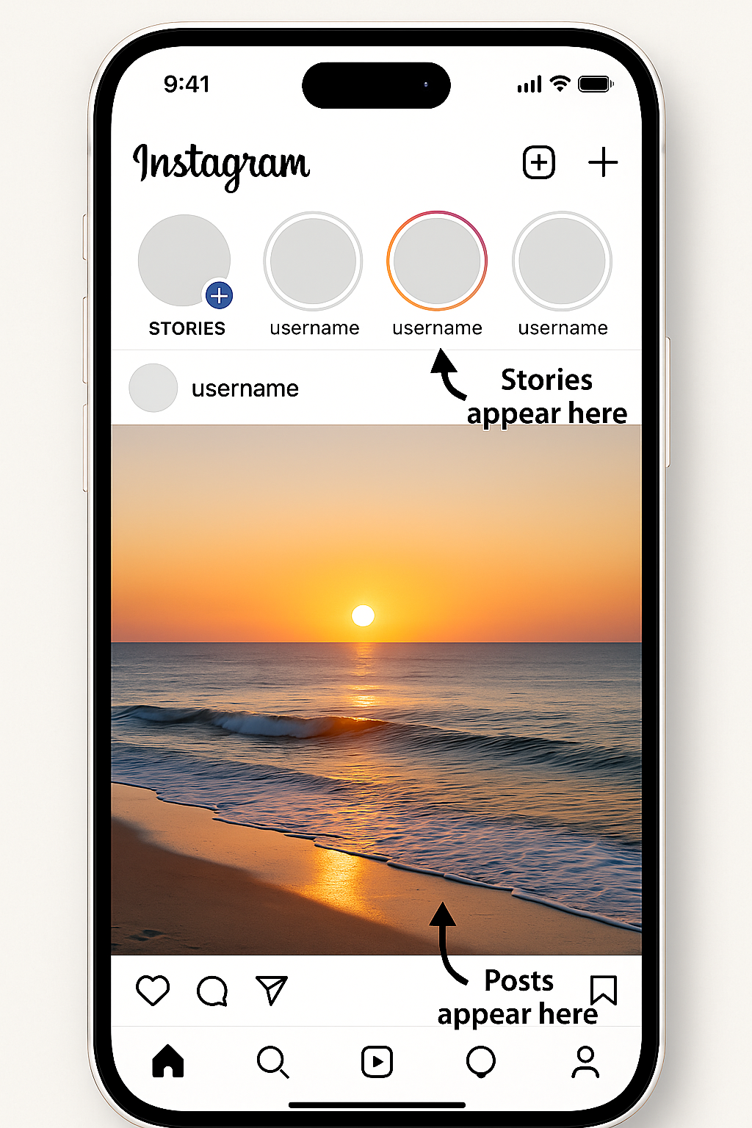 | 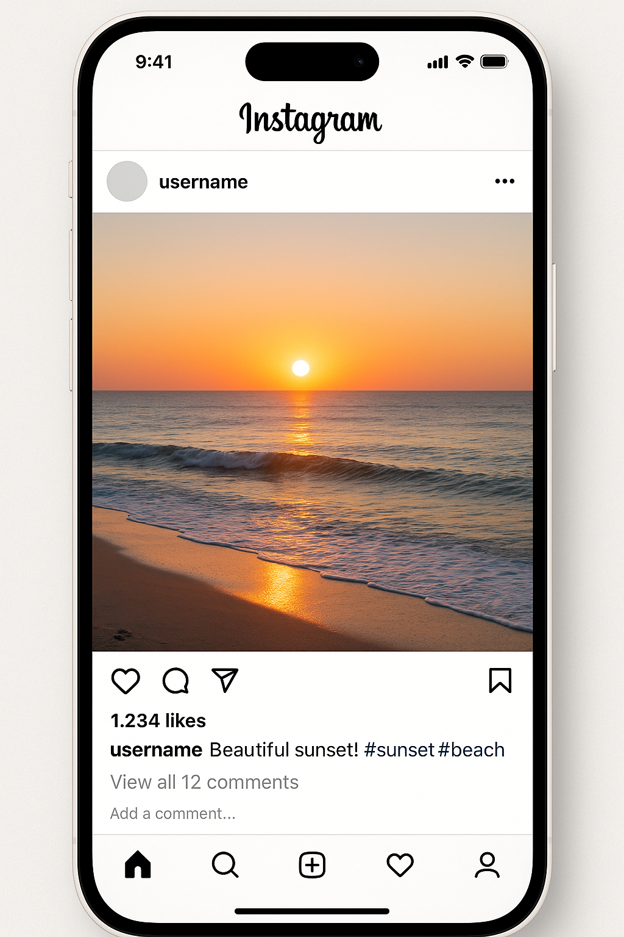 | 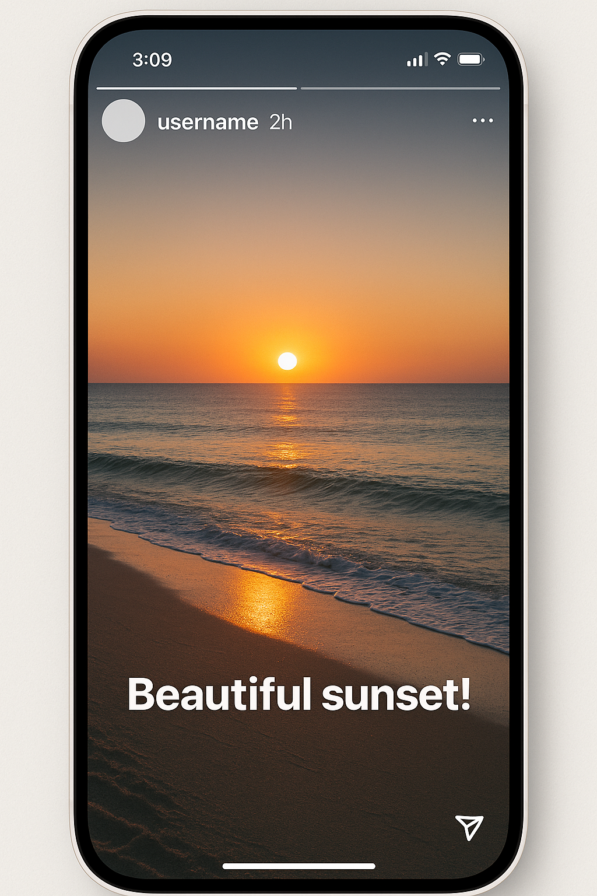
Created by Sora and GPT-4o

Web Appendix E: Data Schematic
Figure E1. Sample Composition and Content Formats
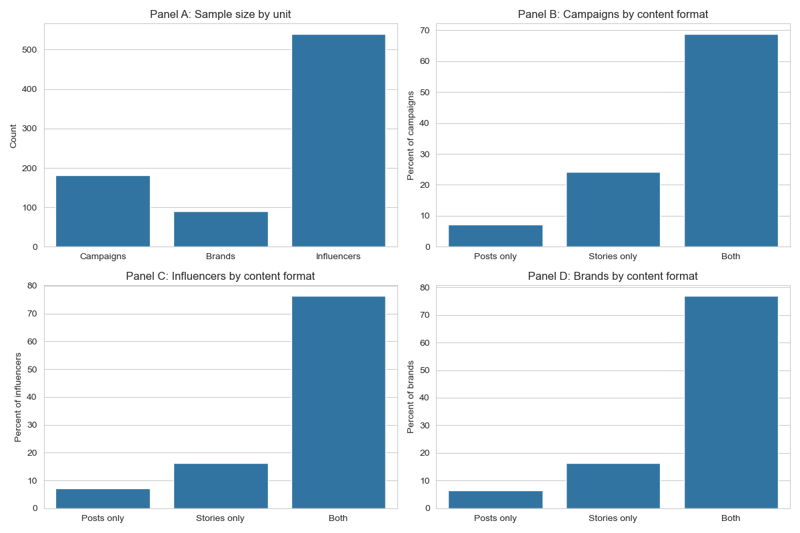
Panel A shows that our data consists of 182 campaigns, promoted by 91 brands and executed by 539 influencers. Panels B–D describe the co-appearance of stories and posts across campaigns, influencers, and brands. At the campaign level (Panel B), 68.68% (n = 125) of campaigns use both posts and stories, whereas 7.14% (n = 13) and 24.18% (n = 44) rely only on posts and stories, respectively. At the influencer level (Panel C), 76.44% (n = 412) of influencers create both posts and stories, while 7.24% (n = 39) and 16.33% (n = 88) create only posts and stories, respectively. At the brand level (Panel D), 76.92% (n = 70) of brands deploy both posts and stories across their campaigns, while 6.59% (n = 6) and 16.48% (n = 15) rely solely on posts or stories. Taken together, these descriptives indicate that brands and influencers overwhelmingly pursue multi-format campaign strategies.

Figure E2. Distribution of Content Volume Across Campaigns
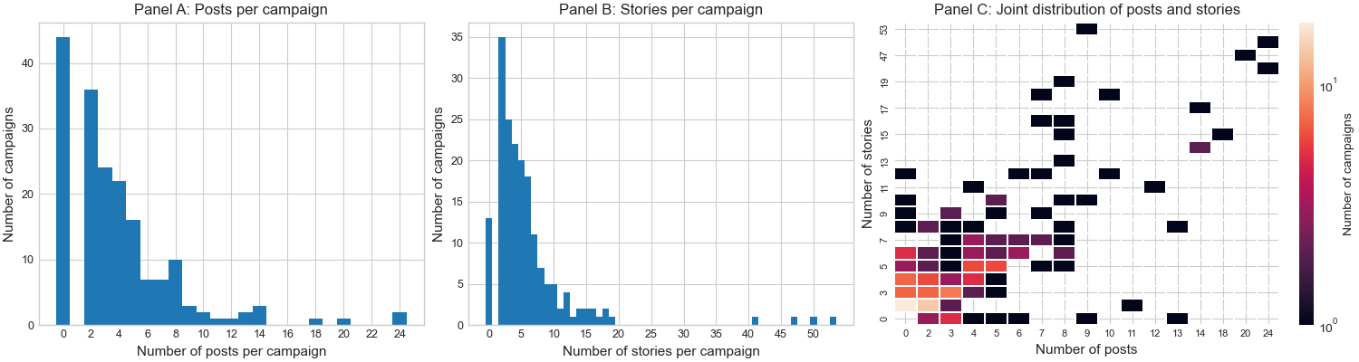
Panel A shows that most campaigns include only a small number of posts, with a right-skewed distribution and a long tail of campaigns with many posts. Panel B shows a similar pattern for stories, with slightly more stories than posts per campaign on average, and again a strong right skew. Panel C plots the joint distribution of posts and stories per campaign; the lighter/warmer cells (yellow–orange) indicate that most campaigns cluster in the region of roughly 0–6 posts and 0–8 stories, while only a few campaigns combine large numbers of both formats.

Figure E3: Campaigns Timeline Density
Panel A | Panel B
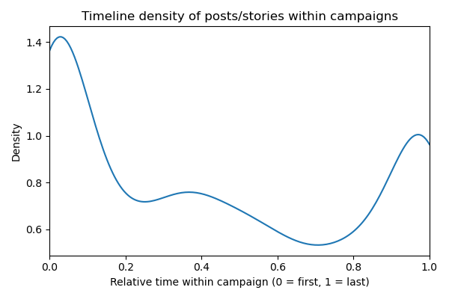 | 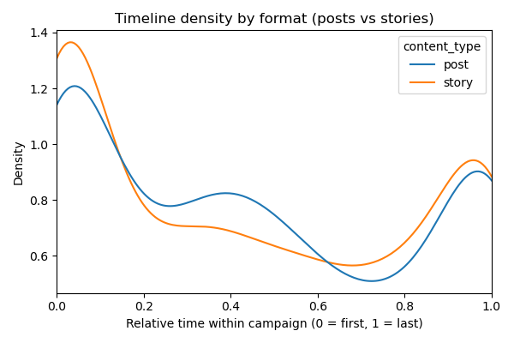
To illustrate the temporal deployment of posts and stories within campaigns, we normalize each content unit's timing relative to its campaign lifecycle. For each campaign, we set the first observed post or story to 0 and the last observed post or story to 1, and express all intermediate content as a fraction of the elapsed campaign duration. The figures above plot kernel density estimates of this relative-time variable, first pooling posts and stories (Panel A) and then separating them by format (Panel B). The distribution of within-campaign timing is bimodal. Content is concentrated at the beginning and end of campaigns. The densities for Instagram posts and Instagram stories are very similar, suggesting that both formats are used in parallel throughout the campaign lifecycle. Stories appear slightly more front-loaded than posts, with a somewhat higher density at the beginning of campaigns, whereas posts are marginally more evenly distributed across the campaign window.

Appendix F: Examples of Visual Displays with High/Low Feature Values
Table F1: Instagram Post Examples
Dimension | Feature | High | Low |  | Feature | High |  | Low
Color | Warmth |  | 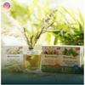 |  | Saturation |  |  | 
Color | Brightness |  |  |  | Brightness contrast |  |  | 
Complexity | Color complexity |  |  |  | Edge density |   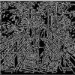 |  |   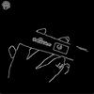
 | Luminance complexity |  |  |  | Number of objects |  |  | 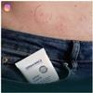
 | Number of tags |   alcohol, apron, bartender, beverage, bottle, cocktail, cocktail shaker, liquor, cup, drink, gin, liquid, make, martini, martini glass, pitcher, pour, shaker, shot glass, vodka, woman |   building, pillar, hotel, pool, swimming pool |  | Number of faces | 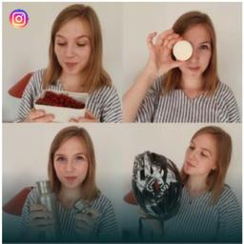 |  | 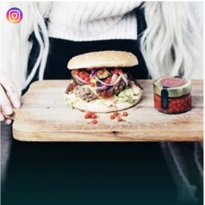
Composition | Diagonal dominance |  |  |  | Rule of thirds | 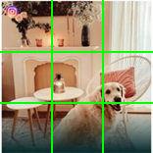 |  | 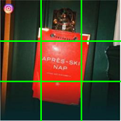
Composition | Color balance |    |    |  | Color difference |    |  |   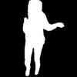
Composition | Texture difference |     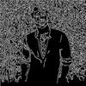 |      |  | Size difference |    |  | 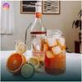  
Composition | Depth of field |  |  |  | Quality |  |  | 
Content | Face coverage | 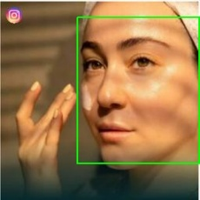 |  |  | Whole human coverage
Content | Text allocation |  |  |  | Items similarity and co-occurrence (similarity of caption and tags within an image) |   there is a bowl of soup with corn and potatoes in it, bowl, food, oatmeal, oats, porridge, soup |  |   two girls holding up a set of Rubik’s cubes in front of a body of water, catch, smartphone, cube, electronic, girl, iPad, laptop, sea, tablet, tablet computer, toy, woman
Content | Examples of features that focus solely on consistency | Locations (places)    Beer garden, porch, patio, restaurant, coffee shop |  | Contextual sentiment (adjective-noun pairs)    Hot girls, sexy body, charming smile, smiling beauty, sexy dress, pretty girls, beautiful girl, pretty lady, attractive girls, gorgeous hair |  |  | Activities and items (caption and tags)  there is a bowl of soup with corn and potatoes in it, bowl, food, oatmeal, oats, porridge, soup

Table F2: Instagram Story Examples
Dimension | Feature | High | Low |  | Feature | High |  | Low
Color | Warmth |  |  |  | Saturation |  |  | 
Color | Brightness |  |  |  | Brightness contrast |  |  | 
Complexity | Color complexity |  |  |  | Edge density | 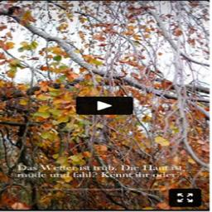  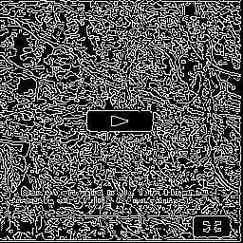 |  |   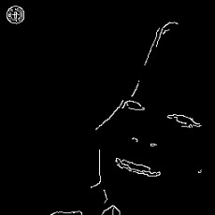
 | Luminance complexity | 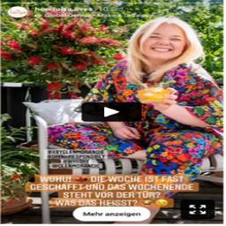 |  |  | Number of objects |  |  | 
 | Number of tags |   alcohol, basil, beverage, bottle, container, countertop, table, drink, food, fruit, green, juice, kitchen counter, lemonade, lettuce, liquid, orange, orange juice, plant, shaker, soda, squeeze, straw |   folder |  | Number of faces |  |  | 
Composition | Diagonal dominance | 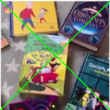 | 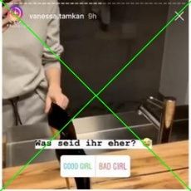 |  | Rule of thirds | 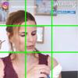 |  | 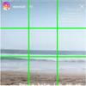
Composition | Color balance | 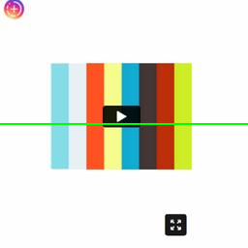  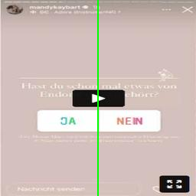 | 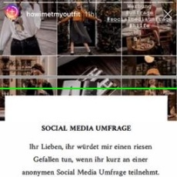   |  | Color difference | 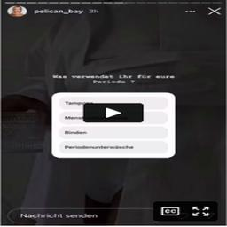   |  | 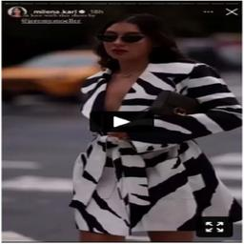  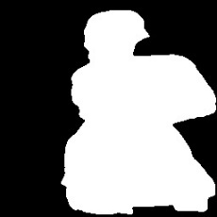
Composition | Texture difference |     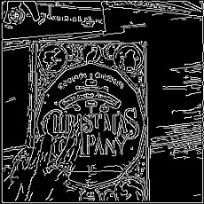 | 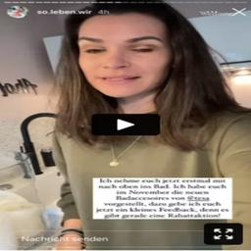  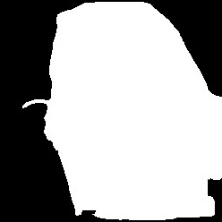  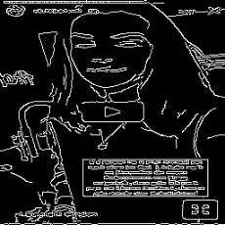 |  | Size difference |    |  |   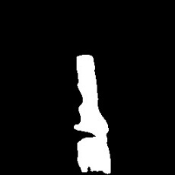
Composition | Depth of field |  | 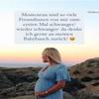 |  | Quality |  |  | 
Content | Face coverage |  |  |  | Whole human coverage |   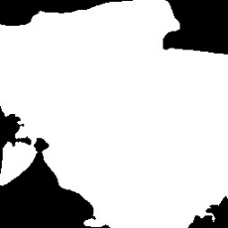 |  | 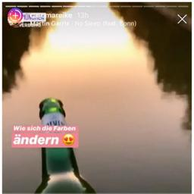
Content | Text allocation |  | 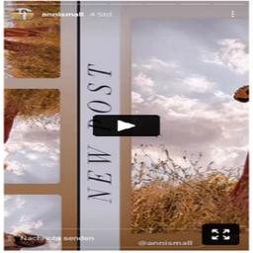 |  | Items similarity and co-occurrence (similarity of caption and tags within an image) |   there is a bathroom with a sink and a mirror in it, bathroom, bathroom accessory, bathroom mirror, bathroom sink, counter top, faucet, mirror, restroom, sink |  | a close up of a person holding a cake in front of a black background, album, album cover, cake, CD, cocktail dress, DVD, kilt, magician, man, poster, pyramid
Content | Examples of features that focus solely on consistency | Locations (places)    Beach, ocean, coast, wave, lagoon |  | Contextual sentiment (adjective-noun pairs)  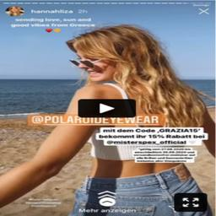  Hot blonde, hot body, hot girls, sexy blonde, beautiful girl, attractive girls, sexy girls, great hair, hot model, sexy body |  |  | Activities and items (caption and tags)    A close-up of a woman in a red bikini holding a cell phone, belly, girl, phone, photo, selfie, take, underclothes, woman

Appendix G: Consistency Operationalization
Appendix G1: Consistency Operationalization for Numeric and Text Features
Figure G1. Distance Metrics: How Euclidean, Cosine, and Jaccard Quantify Consistency vs. Variation

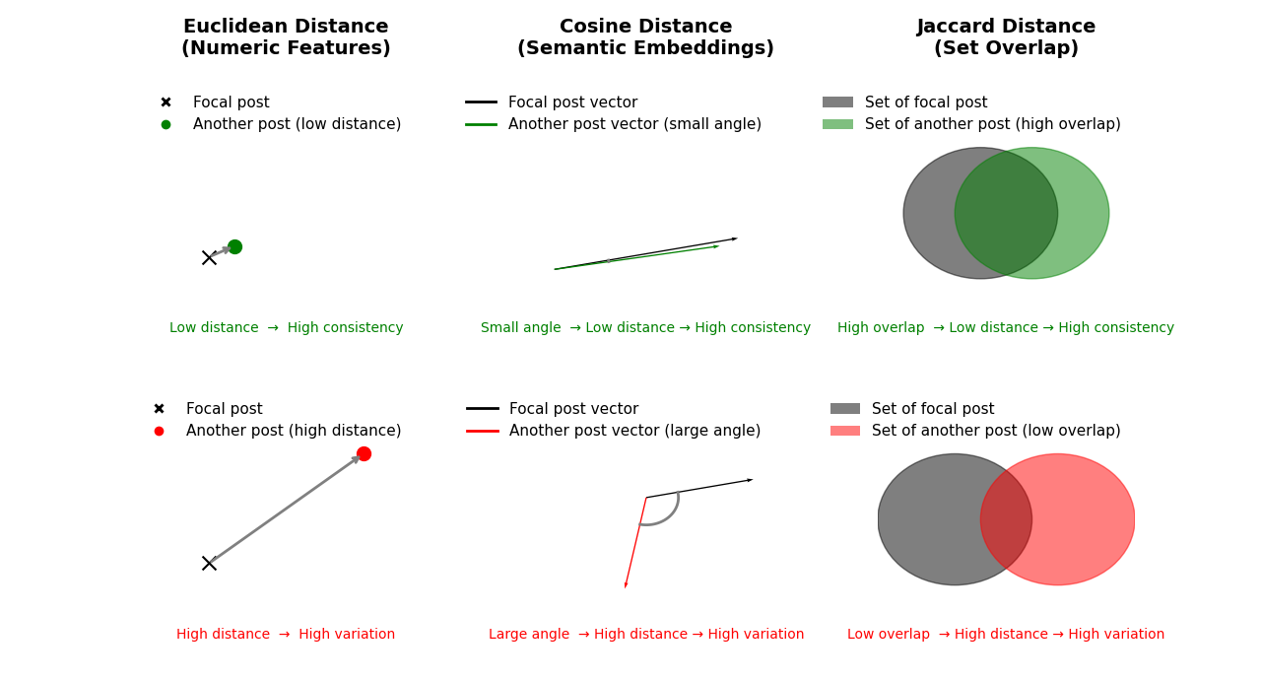

In the following, we describe the calculation of the consistency measures for numeric and textual features. Noted, our consistency measure reflects the deviation of one specific visual display with respect to the campaign baseline. Let the uploaded content $i$ belong to the campaign $c$ and content type $t$ $∈$ {post, story}$.$ Let $S_{c,t}$be the set of uploaded contents in the cell $(c,t)$. For $i∈S_{c,t}$, denote the set of all other assets in the same cell by $S_{c,t}∖\{i\}$, whose size is $∣S_{c,t}∣-1$.
Numeric visual features
We use the Euclidean distance as a consistency measure for our 22 numeric visual features (e.g., brightness, saturation). The consistency calculation is performed in two steps: (1) First, for every post/story within each campaign, we calculate pairwise Euclidean distance to any other post/story within that campaign. The pairwise Euclidean distance between two posts/stories $i$ and $j$ is calculated as $d_{ij}^{(r)}$ = $\sqrt{{{(x}_{i}^{(r)}- x_{j}^{\left(r\right)})}^{2}}$, where $x_{i}^{(r)}$ denotes the value of visual feature r for post i. (2) We calculate the mean distance for each post/story with respect to the other posts/stories within a campaign c, i.e., the post/story-level within campaign consistency for feature $r$ is calculated via ${\overline{d}}_{i,c,t}^{(r)}= \frac{1}{\left|S_{c,t}\right|-1} \sum_{j∈S_{c,t\backslash \{i\}}}{d_{i,j}^{(r)}}$, where c denotes a specific campaign, and t the format type (post/story).
Textual features
We have two sets of textual features. First, we transform the image into text on activities and items via Bootstrapping Language-Image Pre-training (Blip) and the Recognize Anything model. Then we extract embeddings from these activities and items from the images with the sentence-transformers/all-mpnet-base-v2 algorithm. For this feature, we measure the consistency via the cosine distance between the embeddings. The consistency measurement comprises two steps: (1) First, we calculate pairwise distances of activities and items between two posts/stories i and j via the cosine distance between their embeddings: $d_{ij}^{COS}=1- \frac{u_{i}. u_{j}}{ \left\|u_{i}\right\| \left\|u_{j}\right\| }$, where $u_{i}, u_{j}$ are embeddings for posts i and j. (2) We calculate the mean distance for each post/story with respect to all posts/stories within a campaign c: ${\overline{d}}_{i,c,t}^{COS}= \frac{1}{\left|S_{c,t}\right|-1} \sum_{j∈S_{c,t\backslash \{i\}}}{d_{i,j}^{COS}}$, where c denotes a specific campaign and t the format type.
For the textual features that represent category sets, such as places and adjective noun pairs, we use the Jaccard distance. In analogy to the calculations above, we first calculate pairwise distances between posts/stories within a campaign c. For any two posts/stories i and j with feature sets $A_{i},A_{j}$the Jaccard distance measures the degree in which these features overlap $d_{ij}^{JAC}= \frac{|A_{i} ∩ A_{j}|}{|A_{i} ∪ A_{j}|}$. Then, we calculate the mean across all pairwise distances within one campaign: ${\overline{d}}_{i,c,t}^{JAC}= \frac{1}{\left|S_{c,t}\right|-1} \sum_{j∈S_{c,t\backslash \{i\}}}{d_{i,j}^{JAC}}$.

Appendix G2: Examples of Consistency Operationalization per Feature
Figure G2: Example for Numeric Variables
Warmth
(1)
(3)
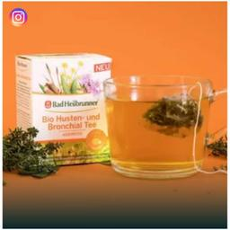
Warmth: 0.68
Distance
(2)
Warmth: 0.89

Warmth: 0.86
Distance
Distance

The analysis of the warmth feature illustrates that image (3) has the highest average distance at 0.20, indicating it is the most inconsistent compared to the other two posts in the same campaign. In contrast, image (1) has an average distance of 0.12, while image (2) has the lowest average distance at 0.11, making it the most consistent with the other two images in terms of warmth.
Saturation
(1)
(3)
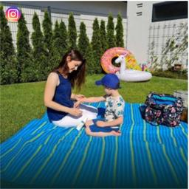
Saturation: 0.54
Distance
(2)
Saturation: 0.24

Saturation: 0.23
Distance
Distance

The analysis of the saturation feature illustrates that image (3) has the highest average distance at 0.31, indicating it is the most inconsistent compared to the other two posts in the same campaign. In contrast, image (2) has an average distance of 0.16, while image (1) has the lowest average distance at 0.155, making it the most consistent with the other two images in terms of saturation.
Brightness
(1)
(3)

Brightness: 0.29
Distance
(2)
Brightness: 0.56

Brightness: 0.57
Distance
Distance

The analysis of the brightness feature illustrates that image (3) has the highest average distance at 0.28, indicating it is the most inconsistent compared to the other two posts in the same campaign. In contrast, image (2) has an average distance of 0.145, while image (1) has the lowest average distance at 0.14, making it the most consistent with the other two images in terms of brightness.
Brightness contrast
(1)
(3)

Brightness contrast: 0.11
Distance
(2)
Brightness contrast: 0.33

Brightness contrast: 0.26
Distance
Distance

The analysis of the brightness contrast feature illustrates that image (3) has the highest average distance at 0.19, indicating it is the most inconsistent compared to the other two posts in the same campaign. In contrast, image (1) has an average distance of 0.15, while image (2) has the lowest average distance at 0.11, making it the most consistent with the other two images in terms of brightness contrast.
Color complexity
(1)
(3)

Color complexity: 10.53
Color complexity: 27.26
Distance
(2)

Color complexity: 21.71
Distance
Distance

The analysis of the color complexity feature illustrates that image (3) has the highest average distance at 13.96, indicating it is the most inconsistent compared to the other two posts in the same campaign. In contrast, image (1) has an average distance of 11.14, while image (2) has the lowest average distance at 8.37, making it the most consistent with the other two images in terms of color complexity.
Edge density
(1)
(3)
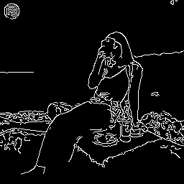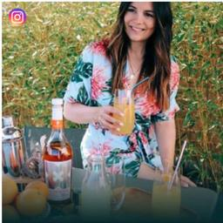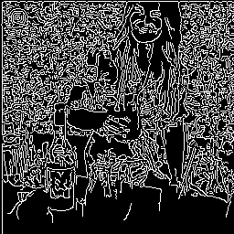
Distance
Edge density: 0.25
Edge density: 0.06
Distance
Distance
(2)
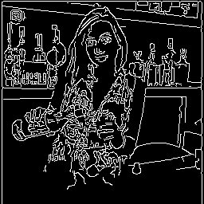
Edge density: 0.13
The analysis of the edge density feature illustrates that image (3) has the highest average distance at 0.16, indicating it is the most inconsistent compared to the other two posts in the same campaign. In contrast, image (1) has an average distance of 0.13, while image (2) has the lowest average distance at 0.10, making it the most consistent with the other two images in terms of edge density.
Luminance complexity
(1)
(3)
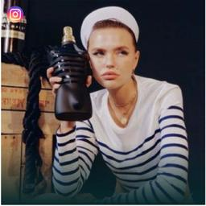
Distance
(2)
Luminance complexity: 6.43
Luminance complexity: 9.27

Luminance complexity: 6.38
Distance
Distance

The analysis of the luminance complexity feature illustrates that image (3) has the highest average distance at 2.87, indicating it is the most inconsistent compared to the other two posts in the same campaign. In contrast, image (2) has an average distance of 1.47, while image (1) has the lowest average distance at 1.45, making it the most consistent with the other two images in terms of luminance complexity.
Number of objects
(1)
(3)

Distance
(2)
Number of objects: 2
Number of objects: 19

Number of objects: 4
Distance
Distance

The analysis of the number of objects feature illustrates that image (3) has the highest average distance at 16, indicating it is the most inconsistent compared to the other two posts in the same campaign. In contrast, image (1) has an average distance of 9.5, while image (2) has the lowest average distance at 8.5, making it the most consistent with the other two images in terms of number of objects.
Number of tags
(1)
(3)
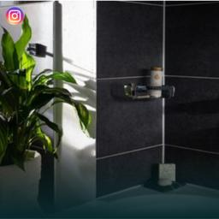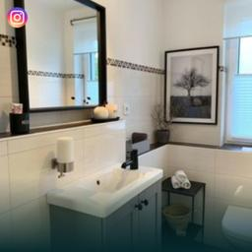
Number of tags: 8 (bathroom, bathroom accessory, glassdoor, house plant, plant, room, screen door, shower)
Number of tags: 21 (bath, bathroom, bathroom accessory, bathroom cabinet, bathroom mirror, bathroom sink, faucet, fixture, footstall, mirror, picture frame, wall lamp, shower, sink, stool, tile wall, toilet bowl, tub, vanity, white, window)
Distance
(2)
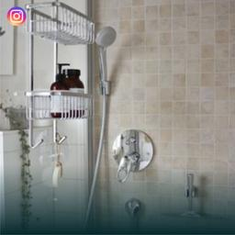
Number of tags: 12 (bath, bathroom, bathroom accessory, screen door, shelf, shower, shower curtain, shower head, sink, tile wall, towel bar, white)
Distance
Distance

The analysis of the number of tags feature illustrates that image (3) has the highest average distance at 11, indicating it is the most inconsistent compared to the other two posts in the same campaign. In contrast, image (1) has an average distance of 8.5, while image (2) has the lowest average distance at 6.5, making it the most consistent with the other two images in terms of number of tags.
Number of faces
(1)
(3)

Distance
(2)
Number of faces: 0
Number of faces: 2
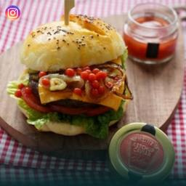
Number of faces: 0
Distance
Distance

The analysis of the number of faces feature illustrates that image (3) has the highest average distance at 2, indicating it is the most inconsistent compared to the other two posts in the same campaign. In contrast, images (1) and (2) have an average distance of 1.33, making each more consistent with the other two images in terms of the number of faces.
Diagonal dominance
(1)
(3)
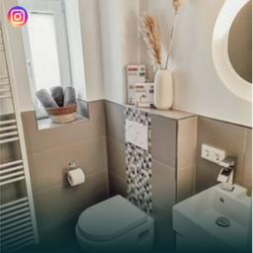
Distance
(2)
Diagonal dominance: 0.95
Diagonal dominance: 0.36

Diagonal dominance: 0.73
Distance
Distance

The analysis of the diagonal dominance feature illustrates that image (3) has the highest average distance at 0.48, indicating it is the most inconsistent compared to the other two posts in the same campaign. In contrast, image (1) has an average distance of 0.41, while image (2) has the lowest average distance at 0.30, making it the most consistent with the other two images in terms of diagonal dominance.
Rule of thirds
(1)
(3)

Distance
(2)
Rule of thirds: 0.51
Rule of thirds: 0.97

Rule of thrids: 0.54
Distance
Distance

The analysis of the rule of thirds feature illustrates that image (3) has the highest average distance at 0.45, indicating it is the most inconsistent compared to the other two posts in the same campaign. In contrast, image (1) has an average distance of 0.25, while image (2) has the lowest average distance at 0.23, making it the most consistent with the other two images in terms of the rule of thirds.
Color balance
(1)
(3)

Distance
(2)
Color balance: 0.66
Color balance: 0.78

Color balance: 0.68
Distance
Distance

The analysis of the color balance feature illustrates that image (3) has the highest average distance at 0.11, indicating it is the most inconsistent compared to the other two posts in the same campaign. In contrast, image (1) has an average distance of 0.07, while image (2) has the lowest average distance at 0.06, making it the most consistent with the other two images in terms of color balance.
Color difference
(1)
(3)
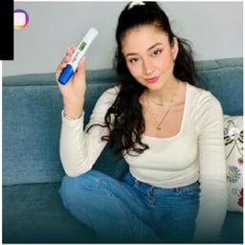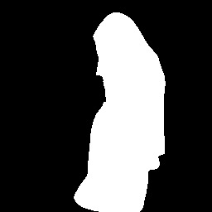
Distance
Color difference: 0.45
Color difference: 0.05
Distance
Distance
(2)
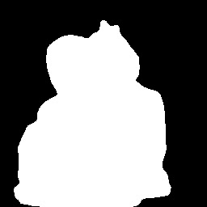
Color difference: 0.07
The analysis of the color difference feature illustrates that image (3) has the highest average distance at 0.39, indicating it is the most inconsistent compared to the other two posts in the same campaign. In contrast, image (1) has an average distance of 0.21, while image (2) has the lowest average distance at 0.20, making it the most consistent with the other two images in terms of color difference.
Texture difference
(1)
(3)
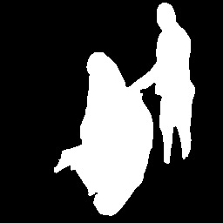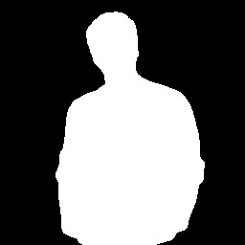
Texture difference: 3.66
Texture difference: 119.06
Distance
Distance
Distance
(2)
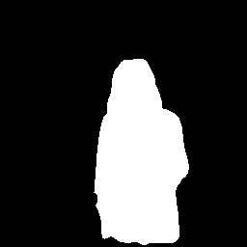
Texture difference: 6.16
The analysis of the texture difference feature illustrates that image (3) has the highest average distance at 114.15, indicating it is the most inconsistent compared to the other two posts in the same campaign. In contrast, image (1) has an average distance of 58.95, while image (2) has the lowest average distance at 57.70, making it the most consistent with the other two images in terms of texture difference.
Size difference
(1)
(3)
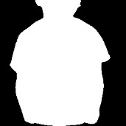
Distance
Size difference: 0.26
Size difference: 0.60
Distance
Distance
(2)

Size difference: 0.44
The analysis of the size difference feature illustrates that image (3) has the highest average distance at 0.26, indicating it is the most inconsistent compared to the other two posts in the same campaign. In contrast, image (1) has an average distance of 0.25, while image (2) has the lowest average distance at 0.17, making it the most consistent with the other two images in terms of size difference.
Depth of field
(1)
(3)

Distance
(2)
Depth of field: 0.07
Depth of field: 1.09

Depth of field: 0.09
Distance
Distance

The analysis of the depth of field feature illustrates that image (3) has the highest average distance at 1.01, indicating it is the most inconsistent compared to the other two posts in the same campaign. In contrast, image (1) has an average distance of 0.52, while image (2) has the lowest average distance at 0.51, making it the most consistent with the other two images in terms of depth of field.
Quality
(1)
(3)

Distance
(2)
Quality: 1.22
Quality: 5.38

Quality: 2.94
Distance
Distance

The analysis of the quality feature illustrates that image (3) has the highest average distance at 3.30, indicating it is the most inconsistent compared to the other two posts in the same campaign. In contrast, image (1) has an average distance of 2.94, while image (2) has the lowest average distance at 2.08, making it the most consistent with the other two images in terms of quality.
Items similarity and co-occurrence (similarity of caption and tags within an image)
(1)
(3)

Items similarity and co-occurrence : 0.31
Items similarity and co-occurrence : 0.39
Distance
(2)
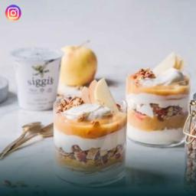
Items similarity and co-occurrence: 0.39
Distance
Distance

The analysis of the items similarity and co-occurrence feature illustrates that image (3) has the highest average distance at 0.08, indicating it is the most inconsistent compared to the other two posts in the same campaign. In contrast, images (1) and (2) have an average distance of 0.05 each, making them more consistent with the other two images in terms of items similarity and co-occurrence.
Face coverage
(1)
(3)

Face coverage: 0.06
Face coverage: 0.25
Distance
(2)
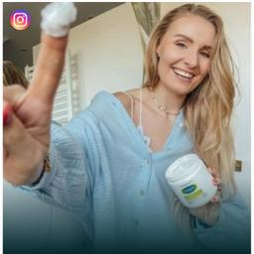
Face coverage: 0.07
Distance
Distance

The analysis of the face coverage feature illustrates that image (3) has the highest average distance at 0.19, indicating it is the most inconsistent compared to the other two posts in the same campaign. In contrast, image (1) has an average distance of 0.10, while image (2) has the lowest average distance at 0.095, making it the most consistent with the other two images in terms of face coverage.
Whole human coverage
(3)
(1)
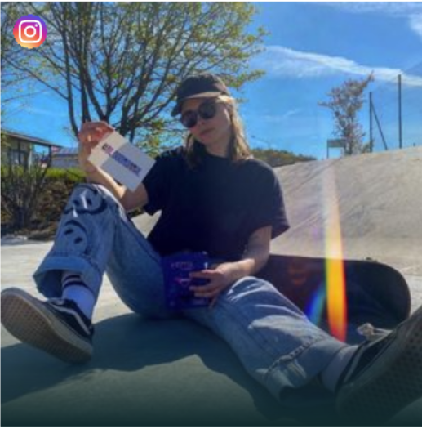
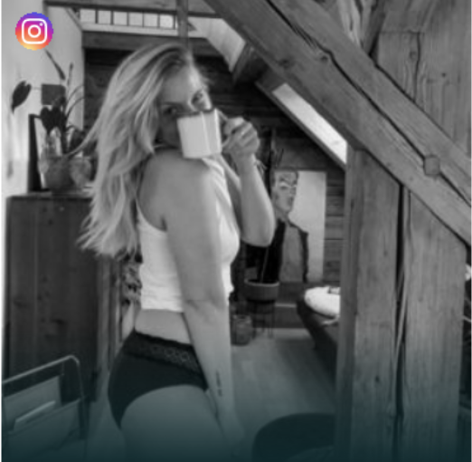
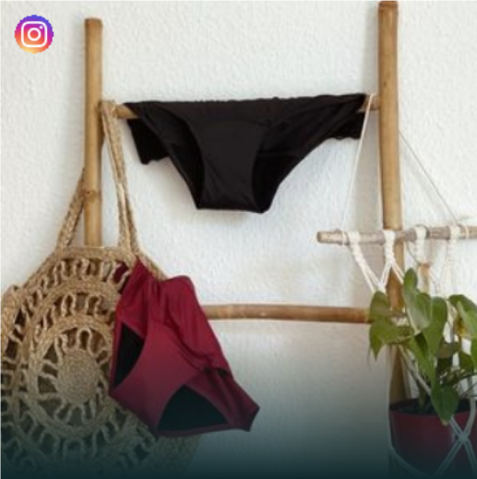
Whole human coverage: 0.25
Distance0.25
Whole human coverage: 0.39
Distance 0.14
Distance0.39
(2)
Whole human coverage: 0

The analysis of the whole human coverage feature illustrates that image (3) has the highest average distance at 0.32, indicating it is the most inconsistent compared to the other two posts in the same campaign. In contrast, image (1) has an average distance of 0.27, while image (2) has the lowest average distance at 0.20, making it the most consistent with the other two images in terms of whole human coverage.

Text allocation
(1)
(3)
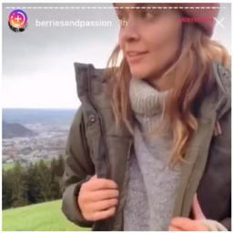
Text allocation: 0.07
Text allocation: 0.01
Distance
(2)
Text allocation: 0.05
Distance
Distance

The analysis of the text allocation feature illustrates that image (3) has the highest average distance at 0.05, indicating it is the most inconsistent compared to the other two stories in the same campaign. In contrast, image (1) has an average distance of 0.04, while image (2) has the lowest average distance at 0.03, making it the most consistent with the other two images in terms of text allocation.
Figure G3: Example of text variables
Contextual sentiment (category set)
(1)
(3)

quiet_bay, calm_river, tranquil_water, tiny_boat, warm_creek, calm_water, natural_mirror, peaceful_lake, snowy_mountain, beautiful_beach
(2)
Distance
sexy_girls, hot_girls, sparkling_smile, sexy_body, hot_model, sexy_smile, beautiful_girl, sexy_dress, sweet_girls, sexy_model
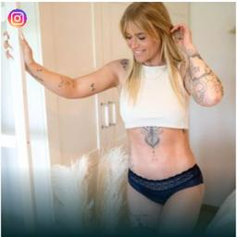
sexy_girls, sparkling_smile, sexy_body, hot_girls, hot_model, hot_body, sexy_model, cute_girls, favorite_dress, lovely_dress
Distance
Distance

The analysis of the contextual sentiment (adjective-noun pairs) illustrates that image (3) has the highest average distance at 1, indicating it is the most inconsistent compared to the other two posts in the same campaign. In contrast, images (1) and (2) have a lower average distance at 0.79, making them more consistent with the other two images in terms of contextual sentiment (adjective-noun pairs).
Locations (category set)
(1)
(3)
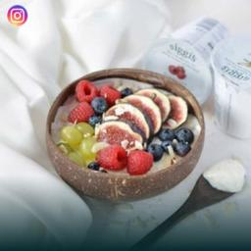
(2)
Distance
bakery/shop, candy_store, pizzeria, ice_cream_parlo, delicatessen
harbor, lake/natural, lagoon, ocean, pier
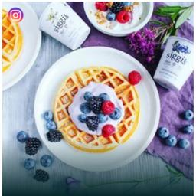
bakery/shop, candy_store, pizzeria, delicatessen, coffee_shop
Distance
Distance

The analysis of the location (places) illustrates that image (3) has the highest average distance at 1, indicating it is the most inconsistent compared to the other two posts in the same campaign. In contrast, images (1) and (2) have a lower average distance at 0.67, making them more consistent with the other two images in terms of location (places).

Activities and items (sentence captions)
(1)   | (2)   | (3)   | (4)  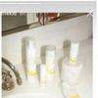 | (5)  
a close-up of a woman holding a toothbrush in her hand, brush, cosmetic, eyebrow, face, selfie, tube, woman | a close-up of a bottle of sunscreen and a straw bag, bottle, carpet, cosmetic, grain, product, skin, tube | a close-up of a woman in a white dress talking on a cell phone, advertisement, blanket, brush, cosmetic, face, selfie, stand, woman | there are several bottles of lotion sitting on a sink, bathroom, bathroom accessory, bathroom mirror, bathroom sink, bottle, countertop, faucet, mirror, product, shampoo, sink, soap, soap dispenser, toiletry, toothpaste, tube | a woman holding a tube of sunscreen cream in her hand, bottle, catch, cosmetic, muscle, product, skin, tube, woman
Average distance: 0.4 | Average distance: 0.39 | Average distance: 0.5 | Average distance: 0.45 | Average distance: 0.34
(6)   | (7)   | (8)   | (9)  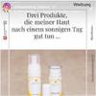 | (10)  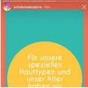
a woman holding a tube of sunscreen cream in her hand, bottle, catch, cosmetic, muscle, product, skin, tube, woman | someone is holding a bottle of sunscreen and a bottle of sunscreen, bottle, catch, cosmetic, hand, person, liquid, product, skin, spray, tube, woman | woman with a towel on her head and a smile, head, photo, selfie, smile, towel, wear, white, woman, wrap | there are two bottles of lotion sitting on a table, bottle, cosmetic, product, skin, tube | a close-up of a cell phone with a text message on it, text, yellow
Average distance: 0.37 | Average distance: 0.39 | Average distance: 0.41 | Average distance: 0.46 | Average distance: 0.65
The analysis of the activities and items (caption and tags) feature shows that image (10) exhibits significant inconsistency in this feature. In contrast, image (5) demonstrates the highest level of consistency, as it includes both the product and the influencer.

Appendix H: Descriptive Statistics
 |  | Posts |  |  |  | Stories
 | Numerical variables | Minimum | Maximum | Mean | SD | Minimum | Maximum | Mean | SD
Dependent variable | Post likes/ Story clicks (standardized) | -0.52 | 10.08 | 0 | 1 | -0.33 | 21.85 | 0 | 1
Numerical controls | Impressions (standardized) | -0.64 | 9.89 | 0 | 1 | -0.47 | 19.23 | 0 | 1
 | Follower count (standardized) | -0.58 | 11.20 | 0 | 1 | -0.47 | 7.97 | 0 | 1
 | Number of influencers in the campaign (standardized) | -1.22 | 2.95 | 0 | 1 | -1.20 | 2.89 | 0 | 1
 | Engagement rate (standardized) | -0.38 | 15.54 | 0 | 1 | -0.44 | 18.68 | 0 | 1
Color | Warmth | 0.19 | 1.00 | 0.81 | 0.14 | 0.04 | 1 | 0.90 | 0.12
 | Warmth consistency | 0 | 0.63 | 0.14 | 0.08 | 0 | 0.73 | 0.10 | 0.09
 | Saturation | 0.09 | 0.73 | 0.30 | 0.11 | 0 | 0.80 | 0.28 | 0.12
 | Saturation consistency | 0.01 | 0.36 | 0.10 | 0.06 | 0 | 0.52 | 0.12 | 0.07
 | Brightness | 0.09 | 0.83 | 0.53 | 0.12 | 0.05 | 0.94 | 0.55 | 0.15
 | Brightness consistency | 0 | 0.41 | 0.12 | 0.06 | 0.01 | 0.52 | 0.14 | 0.08
 | Brightness contrast | 0.09 | 0.41 | 0.25 | 0.03 | 0.07 | 0.39 | 0.25 | 0.05
 | Brightness contrast consistency | 0 | 0.18 | 0.04 | 0.02 | 0 | 0.17 | 0.05 | 0.02
Complexity | Color complexity | 6.85 | 48.33 | 21.13 | 6.25 | 0.68 | 53.17 | 20.24 | 7.43
 | Color complexity consistency | 0.02 | 26.09 | 5.97 | 3.55 | 0.31 | 35.06 | 7.09 | 4.02
 | Edge density | 0.01 | 0.30 | 0.12 | 0.05 | 0.01 | 0.33 | 0.13 | 0.05
 | Edge density consistency | 0 | 0.19 | 0.05 | 0.03 | 0 | 0.22 | 0.04 | 0.03
 | Luminance complexity | 5.29 | 10.72 | 9.31 | 0.80 | 2.54 | 10.73 | 8.86 | 1.39
 | Luminance complexity consistency | 0 | 4.45 | 0.74 | 0.49 | 0.05 | 7.07 | 1.17 | 0.97
 | Number of objects | 0 | 26 | 5.46 | 4.26 | 0 | 46 | 4.22 | 3.49
 | Number of objects consistency | 0 | 23.35 | 3.80 | 2.91 | 0 | 42.09 | 2.83 | 2.86
 | Number of tags | 4 | 26 | 12.06 | 3.48 | 1 | 23 | 8.68 | 3.18
 | Number of tags consistency | 0 | 10.69 | 3.49 | 1.83 | 0 | 14.5 | 3.13 | 1.76
 | Number of faces | 0 | 4 | 0.88 | 0.62 | 0 | 5 | 0.65 | 0.60
 | Number of faces consistency | 0 | 3.14 | 0.43 | 0.47 | 0 | 5 | 0.49 | 0.45
Composition | Diagonal dominance | 0.3125 | 1 | 0.87 | 0.12 | 0.16 | 1 | 0.83 | 0.15
 | Diagonal dominance consistency | 0 | 0.48 | 0.12 | 0.08 | 0 | 0.69 | 0.15 | 0.09
 | Rule of thirds | 0.39 | 0.98 | 0.68 | 0.10 | 0.21 | 0.98 | 0.68 | 0.10
 | Rule of thirds consistency | 0 | 0.45 | 0.10 | 0.05 | 0.01 | 0.42 | 0.11 | 0.06
 | Color balance | 0.55 | 0.95 | 0.76 | 0.06 | 0.49 | 0.98 | 0.78 | 0.07
 | Color balance consistency | 0.01 | 0.23 | 0.06 | 0.03 | 0 | 0.33 | 0.07 | 0.04
 | Color difference | 0 | 0.61 | 0.16 | 0.10 | 0.01 | 0.70 | 0.19 | 0.12
 | Color difference consistency | 0 | 0.48 | 0.11 | 0.07 | 0.13 | 0.55 | 0.13 | 0.13
 | Texture difference | 0.10 | 241.34 | 10.77 | 17.25 | 0.03 | 252.91 | 7.30 | 11.68
 | Texture difference consistency | 0.15 | 228.62 | 10.21 | 17.10 | 0.14 | 247.68 | 7.18 | 10.80
 | Size difference | 0 | 0.91 | 0.33 | 0.18 | 0 | 0.85 | 0.33 | 0.22
 | Size difference consistency | 0.01 | 0.66 | 0.18 | 0.10 | 0 | 0.70 | 0.23 | 0.10
 | Depth of field | -40.50 | 70.79 | 0.12 | 4.42 | -251.47 | 218.22 | 0.25 | 12.40
 | Depth of field consistency | 0.01 | 86.13 | 1.58 | 4.53 | 0.02 | 372.97 | 2.57 | 13.83
 | Quality | 1.16 | 7.32 | 4.26 | 0.95 | 1.35 | 7.64 | 4.65 | 0.99
 | Quality consistency | 0.05 | 3.86 | 0.98 | 0.57 | 0.07 | 5.41 | 1.07 | 0.52
Content | Face coverage | 0 | 0.44 | 0.05 | 0.07 | 0 | 0.48 | 0.08 | 0.10
 | Face coverage consistency | 0 | 0.33 | 0.05 | 0.05 | 0 | 0.45 | 0.09 | 0.06
 | Whole human coverage | 0 | 0.98 | 0.37 | 0.23 | 0 | 0.99 | 0.33 | 0.25
 | Whole human coverage consistency | 0 | 0.73 | 0.20 | 0.12 | 0 | 0.80 | 0.26 | 0.12
 | Text allocation | 0 | 0.17 | 0 | 0.01 | 0 | 0.50 | 0.05 | 0.05
 | Text allocation consistency | 0 | 0.17 | 0.01 | 0.01 | 0 | 0.41 | 0.05 | 0.04
 | Items similarity and co-occurrence within an image | 0.21 | 0.54 | 0.33 | 0.05 | 0.14 | 0.51 | 0.31 | 0.05
 | Items similarity and co-occurrence within an image consistency | 0 | 0.16 | 0.04 | 0.02 | 0.01 | 0.19 | 0.05 | 0.03
 | Contextual sentiment (adjective-noun pairs) consistency | 0.67 | 1 | 0.94 | 0.06 | 0.69 | 1 | 0.95 | 0.05
 | Locations consistency | 0.33 | 1 | 0.88 | 0.12 | 0.33 | 1 | 0.88 | 0.10
 | Activities and items (caption and tags) consistency | 0.09 | 0.85 | 0.44 | 0.12 | 0.03 | 0.86 | 0.53 | 0.11
 | Categorical Variables | Count |  |  |  | Count
Categorical controls | Female influencers' total uploads | 587 |  |  |  | 911
 | Male influencers' total uploads | 120 |  |  |  | 194
 | Product category: health | 242 |  |  |  | 383
 | Product category: energy | 37 |  |  |  | 56
 | Product category: entertainment | 71 |  |  |  | 95
 | Product category: fashion | 74 |  |  |  | 150
 | Product category: food | 193 |  |  |  | 231
 | Product category: home | 65 |  |  |  | 106
 | Product category: other | 25 |  |  |  | 84
 | Month of the year: January | 7 |  |  |  | 33
 | Month of the year: February | 21 |  |  |  | 45
 | Month of the year: March | 60 |  |  |  | 91
 | Month of the year: April | 31 |  |  |  | 56
 | Month of the year: May | 37 |  |  |  | 70
 | Month of the year: June | 99 |  |  |  | 157
 | Month of the year: July | 44 |  |  |  | 51
 | Month of the year: August | 58 |  |  |  | 93
 | Month of the year: September | 87 |  |  |  | 111
 | Month of the year: October | 97 |  |  |  | 125
 | Month of the year: November | 77 |  |  |  | 129
 | Month of the year: December | 89 |  |  |  | 144
 | Day of week: Saturday | 59 |  |  |  | 82
 | Day of week: Sunday | 74 |  |  |  | 89
 | Day of week: Monday | 88 |  |  |  | 144
 | Day of week: Tuesday | 112 |  |  |  | 161
 | Day of week: Wednesday | 115 |  |  |  | 174
 | Day of week: Thursday | 123 |  |  |  | 226
 | Day of week: Friday | 136 |  |  |  | 229
 | Year: 2018 | 19 |  |  |  | 8
 | Year: 2019 | 136 |  |  |  | 152
 | Year: 2020 | 156 |  |  |  | 222
 | Year: 2021 | 287 |  |  |  | 413
 | Year: 2022 | 104 |  |  |  | 265
 | Year: 2023 | 5 |  |  |  | 45
Other statistics | Number of brands | 76 |  |  |  | 85
 | Number of influencers | 451 |  |  |  | 500
 | Female influencers | 363 |  |  |  | 398
 | Male influencers | 88 |  |  |  | 102
 | Number of influencers with fewer than 100,000 followers | 230 |  |  |  | 237
 | Number of influencers with more than 100,000 followers | 221 |  |  |  | 263
 | Number of campaigns | 138 |  |  |  | 169
 | Number of campaigns per product category
 | Product category: health | 52 |  |  |  | 64
 | Product category: energy | 4 |  |  |  | 4
 | Product category: entertainment | 15 |  |  |  | 18
 | Product category: fashion | 10 |  |  |  | 13
 | Product category: food | 34 |  |  |  | 34
 | Product category: home | 14 |  |  |  | 15
 | Product category: other | 9 |  |  |  | 21
 | Number of influencers per product category
 | Product category: health | 164 |  |  |  | 196
 | Product category: energy | 31 |  |  |  | 34
 | Product category: entertainment | 59 |  |  |  | 68
 | Product category: fashion | 38 |  |  |  | 44
 | Product category: food | 154 |  |  |  | 156
 | Product category: home | 51 |  |  |  | 58
 | Product category: other | 24 |  |  |  | 49
For the consistency measures, smaller values indicate less distance between stories or posts of the same campaign for that feature, suggesting greater consistency. In contrast, larger values suggest a greater distance and indicate more inconsistency. The full sample contains 182 campaigns, 91 brands, and 539 influencers. The counts in this table are format-specific and therefore not additive, because the same campaign, brand, or influencer can appear in both the post and story subsamples.
Appendix I: Grid Search Results for Determining the Optimal λ Coefficients
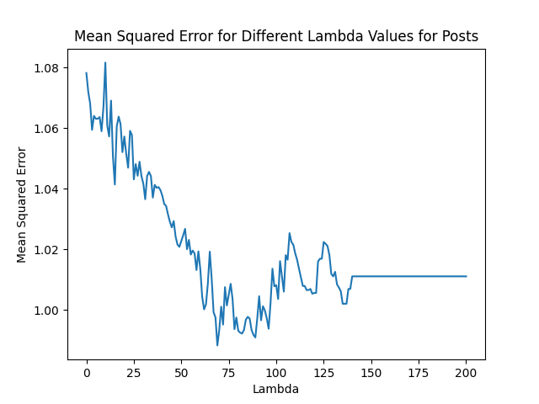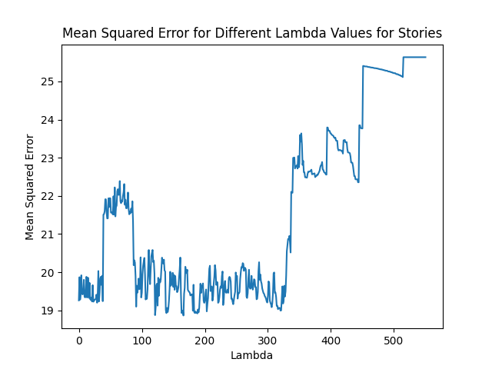

Appendix J: Contingency Factors Results
Appendix J1: Influencer Follower Size
Table J1.1: Posts
 |  | Below 100,000 followers |  |  |  | Above 100,000 followers
 |  | Feature |  | Consistency |  | Feature |  | Consistency
Dimension | Feature | Median Association | |Marginal Association| | Median Association | |Marginal Association| | Median Association | |Marginal Association| | Median Association | |Marginal Association|
Color | Saturation |  |  | -0.01 | 0.10 |  |  | 0.10 | 1.01
 | Brightness | -0.04 | 0.40 | -0.06 | 0.60 | -0.05 | 0.50 | -0.11 | 1.09
Complexity | Color complexity |  |  | 0.01 | 0.10 |  |  | -0.18 | 1.78
 | Edge density |  |  | 0.08 | 0.80 |  |  | -0.05 | 0.50
 | Number of objects | -0.02 | 0.20 | 0.06 | 0.60 | 0.07 | 0.70 | -0.11 | 1.09
 | Number of tags | -0.04 | 0.40 | -0.02 | 0.20 | 0.03 | 0.30 | 0.06 | 0.60
 | Number of faces | 0.10 | 1.01 | 0.03 | 0.30 | 0.05 | 0.50 | -0.09 | 0.90
Composition | Diagonal dominance | 0.10 | 1.01 | -0.03 | 0.30 | 0.06 | 0.60 | -0.04 | 0.40
 | Color balance | 0.06 | 0.60 | 0.04 | 0.40 | 0.04 | 0.40 | -0.05 | 0.50
 | Size difference | 0.06 | 0.60 |  |  | 0.04 | 0.40
Content | Face coverage | -0.13 | 1.29 | 0.03 | 0.30 | -0.08 | 0.80 | -0.18 | 1.78
 | Whole human coverage | 0.04 | 0.40 |  |  | 0.04 | 0.40
 | Text allocation | -0.01 | 0.10 |  |  | -0.03 | 0.30
 | Contextual sentiment (adjective-noun pairs) |  |  | -0.05 | 0.50 |  |  | 0.06 | 0.60
 | Intercept | 6.53 |  |  |  | 8.16
Controls
Follower count |  | ✓
Impressions |  | ✓
Number of unique influencers in the campaign |  | ✓
Influencer gender |  | ✓
Time fixed effects (year, month, weekday) |  | ✓
Product category fixed effects |  | ✓
Engagement rate before the focal post |  | ✓
Random intercepts (campaigns, influencers) |  | ✓
Note: Following variables were excluded: Color: warmth, brightness contrast; Complexity: luminance complexity; Composition: rule of thirds, color and texture difference, depth of field, quality; Content: items similarity, locations, activities and items. Bold indicates prop-value<0.05. Marginal associations show the percent change in outcome for a 10% predictor change. For consistency features, negative values show lower distance (higher consistency), positive values show higher distance (lower consistency).

Table J1.2: Stories
 |  | Below 100,000 followers |  |  |  | Above 100,000 followers
 |  | Feature |  | Consistency |  | Feature |  | Consistency
Dimension | Feature | Median Association | |Marginal Association| | Median Association | |Marginal Association| | Median Association | |Marginal Association| | Median Association | |Marginal Association|
Color | Warmth | -0.29 | 2.86 | -0.25 | 2.47 |  |  | 0.40 | 4.08
 | Saturation | 0.49 | 5.02 |  |  | 0.52 | 5.34
 | Brightness | 0.06 | 0.60 |  |  | 0.28 | 2.84
Complexity | Color complexity |  |  | 0.55 | 5.65 |  |  | -0.20 | 1.98
 | Luminance complexity |  |  | 0.47 | 4.81 |  |  | 1.10 | 11.63
 | Number of objects | -0.13 | 1.29 |  |  | 0.33 | 3.36
 | Number of tags |  |  | -0.31 | 3.05 |  |  | -0.02 | 0.20
Composition | Diagonal dominance |  |  | 0.26 | 2.63 |  |  | -0.37 | 3.63
 | Color balance |  |  | -0.10 | 1.00 |  |  | -0.37 | 3.63
 | Color difference | 0.22 | 2.22
 | Texture difference | 0.43 | 4.39 | -0.14 | 1.39 | 0.90 | 9.42 | -0.96 | 9.15
 | Size difference | -0.05 | 0.50 | 0.22 | 2.22 | -0.12 | 1.19 | 0.52 | 5.34
Content | Whole human coverage | 0.49 | 5.02 | -0.07 | 0.70 | 0.43 | 4.39 | -0.65 | 6.29
 | Text allocation | -0.95 | 9.06 | 0.36 | 3.67 | 0.24 | 2.43 | -0.56 | 5.45
 | Contextual sentiment |  |  | -0.23 | 2.27 |  |  | 0.10 | 1.01
 | Locations (places) |  |  | -0.20 | 1.98 |  |  | 0.39 | 3.98
 | Activities and items |  |  | 0.84 | 8.76 |  |  | 0.14 | 1.41
 | Intercept | 2.82 |  |  |  | 4.41
Controls
Follower count |  | ✓
Impressions |  | ✓
Number of unique influencers in the campaign |  | ✓
Influencer gender |  | ✓
Time fixed effects (year, month, weekday) |  | ✓
Product category |  | ✓
Engagement rate before the focal story |  | ✓
Random intercepts (campaigns, influencers) |  | ✓
Note: Following variables were excluded: Color: brightness contrast; Complexity: edge density, number of faces; Composition: rule of thirds, depth of field, quality; Content: face coverage, items similarity. Bold indicates prop-value<0.05. Marginal associations show the percent change in outcome for a 10% predictor change. For consistency features, negative values show lower distance (higher consistency), positive values show higher distance (lower consistency).

Appendix J2: Product vs. Service Campaigns
Table J2.1: Posts
 |  | Products |  |  |  | Services
 |  | Feature |  | Consistency |  | Feature |  | Consistency
Dimension | Feature | Median Association | |Marginal Association| | Median  Associations | |Marginal  Association| | Median  Association | |Marginal Association| | Median  Association | |Marginal Association|
Color | Saturation |  |  | 0.03 | 0.30 |  |  | 0.08 | 0.80
 | Brightness | -0.08 | 0.80 | -0.16 | 1.59 | -0.18 | 1.78 | -0.10 | 1.00
Complexity | Color complexity |  |  | -0.13 | 1.29 |  |  | -0.22 | 2.18
 | Edge density |  |  | -0.04 | 0.40 |  |  | -0.03 | 0.30
 | Number of objects | 0.01 | 0.10 | -0.07 | 0.70 | -0.19 | 1.88 | 0.19 | 1.92
 | Number of tags | 0.03 | 0.30 | 0.03 | 0.30 | 0.01 | 0.10 | 0.13 | 1.31
 | Number of faces | 0.10 | 1.01 | -0.07 | 0.70 | 0.04 | 0.40 | 0.08 | 0.80
Composition | Diagonal dominance | 0.07 | 0.70 | -0.07 | 0.70 | -0.13 | 1.29 | -0.05 | 0.50
 | Color balance | 0.07 | 0.70 | -0.03 | 0.30 | 0.03 | 0.30 | -0.20 | 1.98
 | Size difference | -0.01 | 0.10 |  |  | -0.05 | 0.50
Content | Face coverage | -0.09 | 0.90 | -0.08 | 0.80 | -0.04 | 0.40 | 0.06 | 0.60
 | Whole human coverage | 0.07 | 0.70 |  |  | -0.11 | 1.09
 | Text allocation | -0.04 | 0.40 |  |  | -0.21 | 2.08
 | Contextual sentiment (adjective-noun pairs) |  |  | -0.01 | 0.10 |  |  | 0.14 | 1.41
 | Intercept | 7.51 |  |  |  | 7.17
Controls
Follower count |  | ✓
Impressions |  | ✓
Number of unique influencers in the campaign |  | ✓
Influencer gender |  | ✓
Time fixed effects (year, month, weekday) |  | ✓
Engagement rate before the focal post |  | ✓
Random intercepts (campaigns, influencers) |  | ✓
Note: Following variables were excluded: Color: warmth, brightness contrast; Complexity: luminance complexity; Composition: rule of thirds, color and texture difference, depth of field, quality; Content: items similarity, locations, activities and items. Bold indicates prop-value<0.05. Marginal associations show the percent change in outcome for a 10% predictor change. For consistency features, negative values show lower distance (higher consistency), positive values show higher distance (lower consistency).

Table J2.2: Stories
 |  | Products |  |  |  | Services
 |  | Feature |  | Consistency |  | Feature |  | Consistency
Dimension | Feature | Median Association | |Marginal Association| | Median Association | |Marginal Association| | Median Association | |Marginal Association| | Median Association | |Marginal Association|
Color | Warmth | 0.22 | 2.22 | 0.71 | 7.36 | -0.73 | 7.04 | -1.46 | 13.58
 | Saturation | 0.61 | 6.29 |  |  | 0.50 | 5.13
 | Brightness | 0.30 | 3.05 |  |  | 0.05 | 0.50
Complexity | Color complexity |  |  | -0.06 | 0.60 |  |  | 0.46 | 4.71
 | Luminance complexity |  |  | 1.02 | 10.74 |  |  | 0.36 | 3.67
 | Number of objects | 0.29 | 2.94 |  |  | -0.17 | 1.69
 | Number of tags |  |  | -0.20 | 1.98 |  |  | 0.15 | 1.51
Composition | Diagonal dominance |  |  | -0.57 | 5.54 |  |  | 0.52 | 5.34
 | Color balance |  |  | -0.48 | 4.69 |  |  | 0.09 | 0.90
 | Color difference | 0.22 | 2.22 |  |  | 0.07 | 0.70
 | Texture difference | 0.76 | 7.90 | -0.78 | 7.50 | 0.07 | 0.70 | -0.17 | 1.69
 | Size difference | -0.29 | 2.86 | 0.30 | 3.05 | -0.46 | 4.50 | 0.47 | 4.81
Content | Whole human coverage | 0.45 | 4.60 | -0.52 | 5.07 | 0.60 | 6.18 | -0.49 | 4.78
 | Text allocation | -0.15 | 1.49 | 0.12 | 1.21 | 0.33 | 3.36 | -1.10 | 10.42
 | Contextual sentiment (adjective-noun pairs) |  |  | -0.03 | 0.30 |  |  | 0.60 | 6.18
 | Locations (places) |  |  | 0.14 | 1.41 |  |  | -0.17 | 1.69
 | Activities and items (caption and tags) |  |  | 0.30 | 3.05 |  |  | 0.47 | 4.81
 | Intercept | 3.50 |  |  |  | 4.03
Controls
Follower count |  | ✓
Impressions |  | ✓
Number of unique influencers in the campaign |  | ✓
Influencer gender |  | ✓
Time fixed effects (year, month, and weekday) |  | ✓
Engagement rate before the focal story |  | ✓
Random intercepts (campaigns, influencers) |  | ✓
Note: Following variables were excluded: Color: brightness contrast; Complexity: edge density, number of faces; Composition: rule of thirds, depth of field, quality; Content: items similarity, face coverage. Bold indicates prop-value<0.05. Marginal associations show the percent change in outcome for a 10% predictor change. For consistency features, negative values show lower distance (higher consistency), positive values show higher distance (lower consistency).

Appendix K: Summary of Consistency-variation Patterns Across Subgroups
Moderator | Subgroup | Format | # Consistency* | # Variation** | Pattern
Influencer size | Micro (< 100k followers) | Posts | 2 | 3 | Mixed
Influencer size | Micro (< 100k followers) | Stories | 3 | 6 | Mixed, tilt toward variation
Influencer size | Macro (≥ 100k followers) | Posts | 5 | 0 | Consistency-dominated
Influencer size | Macro (≥ 100k followers) | Stories | 4 | 5 | Mixed
Campaign type | Products | Posts | 5 | 0 | Consistency-dominated
Campaign type | Products | Stories | 3 | 6 | Mixed, tilt toward variation
Campaign type | Services | Posts | 3 | 2 | Mixed
Campaign type | Services | Stories | 4 | 5 | Mixed
* Number of consistency features positively associated with engagement (prop-value < .05).
** Number of consistency features negatively associated with engagement (prop-value < .05).

Appendix L: Robustness Estimations
Appendix L1: Results using Mode Instead of Median
Table L1.1: Posts
 |  | Feature |  |  | Consistency
Dimension | Feature | Mode Association | Prop-Val | |Marginal Association| | Mode Association | Prop-Val | |Marginal Association|
Color | Warmth | 0.07 | 0.84 | 0.70 | 0.07 | 0.99 | 0.70
 | Saturation |  |  |  | 0.01 | 0.08 | 0.10
 | Brightness | -0.09 | 0.00 | 0.90 | -0.15 | 0.00 | 1.49
Complexity | Color complexity | -0.02 | 0.64 | 0.20 | -0.11 | 0.00 | 1.09
 | Luminance complexity |  |  |  | -0.09 | 0.92 | 0.90
 | Edge density |  |  |  | -0.02 | 0.05 | 0.20
 | Number of objects | -0.02 | 0.13 | 0.20 | 0.02 | 0.08 | 0.20
 | Number of tags | 0.06 | 0.30 | 0.60 | 0.03 | 0.36 | 0.30
 | Number of faces | 0.09 | 0.00 | 0.90 | -0.06 | 0.00 | 0.60
Composition | Diagonal dominance | 0.05 | 0.00 | 0.50 | -0.04 | 0.00 | 0.40
 | Color balance | 0.08 | 0.44 | 0.80 | -0.06 | 0.48 | 0.60
 | Size difference | 0.03 | 0.46 | 0.30 | 0.05 | 0.71 | 0.50
 | Depth of field | -0.04 | 0.98 | 0.40
Content | Face coverage | -0.08 | 0.03 | 0.80 | -0.04 | 0.02 | 0.40
 | Whole human coverage | 0.03 | 0.03 | 0.30
 | Text allocation | -0.06 | 0.01 | 0.60 | -0.03 | 0.79 | 0.30
 | Contextual sentiment (adjective-noun pairs) |  |  |  | -0.01 | 0.17 | 0.10
 | Activities and items (caption and tags) |  |  |  | 0.06 | 0.97 | 0.60
 | Intercept | 7.45 | 0.00
Controls
Follower count |  | ✓
Impressions |  | ✓
Number of unique influencers in the campaign |  | ✓
Influencer gender |  | ✓
Time fixed effects (year, month, weekday) |  | ✓
Product category |  | ✓
Engagement rate before the focal post |  | ✓
Random intercepts (campaigns, influencers) |  | ✓
BIC 2496.39
Note: Following variables were excluded: Color: brightness contrast; Composition: rule of thirds, color difference, texture difference, quality; Content: locations (places), items similarity. BIC = Bayesian information criterion. Bold indicates prop-value<0.05. Marginal associations show the percent change in outcome for a 10% predictor change. For consistency features, negative values show lower distance (higher consistency), positive values show higher distance (lower consistency).

Table L1.2: Robustness estimation results for stories
 |  | Feature |  |  | Consistency
Dimension | Feature | Mode Association | Prop-Val | |Marginal Association| | Mode Association | Prop-Val | |Marginal Association|
Color | Warmth | -0.05 | 0.10 | 0.50 | 0.18 | 0.00 | 1.82
 | Saturation | 0.22 | 0.04 | 2.22 | 0.04 | 0.50 | 0.40
 | Brightness | 0.32 | 0.00 | 3.25 | -0.32 | 0.76 | 3.15
Complexity | Color complexity | 0.37 | 0.98 | 3.77 | -0.11 | 0.03 | 1.09
 | Luminance complexity | -0.06 | 0.93 | 0.60 | 0.67 | 0.00 | 6.93
 | Edge density | 0.19 | 0.80 | 1.92
 | Number of objects | 0.21 | 0.00 | 2.12 | -0.02 | 0.56 | 0.20
 | Number of tags | -0.06 | 0.99 | 0.60 | -0.13 | 0.06 | 1.29
 | Number of faces | 0.23 | 0.97 | 2.33
Composition | Diagonal dominance |  |  |  | -0.23 | 0.01 | 2.27
 | Rule of thirds |  |  |  | 0.17 | 0.83 | 1.71
 | Color balance | 0.25 | 0.98 | 2.53 | -0.06 | 0.06 | 0.60
 | Color difference | 0.14 | 0.02 | 1.41
 | Texture difference | 0.22 | 0.25 | 2.22 | 0.10 | 0.29 | 1.01
 | Size difference |  |  |  | 0.37 | 0.00 | 3.77
 | Quality | 0.23 | 0.78 | 2.33
Content | Face coverage | -0.01 | 0.47 | 0.10 | -0.01 | 0.53 | 0.10
 | Whole human coverage | 0.23 | 0.04 | 2.33 | -0.53 | 0.00 | 5.16
 | Text allocation | 0.07 | 0.15 | 0.70 | -0.45 | 0.00 | 4.40
 | Items similarity and co-occurrence within an image |  |  |  | 0.02 | 0.95 | 0.20
 | Contextual sentiment (adjective-noun pairs) |  |  |  | 0.01 | 0.39 | 0.10
 | Locations (places) |  |  |  | 0.09 | 0.04 | 0.90
 | Activities and items (caption and tags) |  |  |  | 0.27 | 0.03 | 2.74
 | Intercept | 3.78 | 0.00
Controls
Follower count |  | ✓
Impressions |  | ✓
Number of unique influencers in the campaign |  | ✓
Influencer gender |  | ✓
Time fixed effects (year, month, weekday) |  | ✓
Product category |  | ✓
Engagement rate before the focal story |  | ✓
Random intercepts (campaigns, influencers) |  | ✓
BIC 10480.11
Note: Following main and consistency associations were excluded due to penalization: Color: brightness contrast; Composition: depth of field. BIC = Bayesian information criterion. Bold indicates prop-value<0.05. Marginal associations show the percent change in outcome for a 10% predictor change. For consistency features, negative values show lower distance (higher consistency), positive values show higher distance (lower consistency).

Appendix L2: Robustness Estimation Using Year-Week Linear Time Trend Instead of Fixed Effects
Table L2.1: Posts
 |  | Feature |  |  | Consistency
Dimension | Feature | Median Association | Prop-Val | |Marginal  Association| | Median Association | Prop-Val | |Marginal Association|
Color | Saturation |  |  |  | 0.02 | 0.07 | 0.20
 | Brightness | -0.08 | 0.00 | 0.80 | -0.14 | 0.00 | 1.39
Complexity | Color complexity |  |  |  | -0.10 | 0.00 | 1.00
 | Luminance complexity |  |  |  | -0.08 | 0.32 | 0.90
 | Number of objects | -0.02 | 0.11 | 0.20 | 0.01 | 0.10 | 0.10
 | Number of tags | 0.06 | 0.01 | 0.60 | 0.02 | 0.35 | 0.20
 | Number of faces | 0.09 | 0.00 | 0.90 | -0.07 | 0.01 | 0.70
Composition | Diagonal dominance | 0.06 | 0.00 | 0.60 | -0.03 | 0.00 | 0.30
 | Color balance | 0.08 | 0.45 | 0.80 | -0.04 | 0.42 | 0.40
Content | Face coverage | -0.07 | 0.00 | 0.70 | -0.06 | 0.02 | 0.60
 | Whole human coverage | 0.02 | 0.05 | 0.20
 | Text allocation | -0.05 | 0.00 | 0.50
 | Intercept | 7.46 | 0.00
Controls
Follower count |  | ✓
Impressions |  | ✓
Number of unique influencers in the campaign |  | ✓
Influencer gender |  | ✓
Time fixed effects (month and weekday) |  | ✓
Year-week linear trend |  | ✓
Product category |  | ✓
Engagement rate before the focal post |  | ✓
Random intercepts (campaigns, influencers) |  | ✓
Note: Following variables were excluded: Color: warmth, brightness contrast; Complexity: edge density; Composition: rule of thirds, color, texture and size difference, depth of field, quality; Content: items similarity, locations, activities and items, contextual sentiment. Bold indicates prop-value<0.05. Marginal associations show the percent change in outcome for a 10% predictor change. For consistency features, negative values show lower distance (higher consistency), positive values show higher distance (lower consistency).

Table L2.2: Stories
 |  | Feature |  |  | Consistency
Dimension | Feature | Median Association | Prop-Val | |Marginal Association| | Median Association | Prop-Val | |Marginal Association|
Color | Warmth | -0.05 | 0.10 | 0.50 | 0.20 | 0.00 | 2.02
 | Saturation | 0.25 | 0.01 | 2.53 | 0.01 | 0.48 | 0.10
 | Brightness | 0.33 | 0.00 | 3.36
Complexity | Color complexity |  |  |  | -0.13 | 0.03 | 1.29
 | Luminance complexity | 0.05 | 0.33 | 0.50 | 0.65 | 0.00 | 6.72
 | Number of objects | 0.21 | 0.01 | 2.12
 | Number of tags |  |  |  | -0.08 | 0.08 | 0.80
Composition | Diagonal dominance |  |  |  | -0.24 | 0.01 | 2.37
 | Color balance | 0.16 | 0.02 | 1.61 | -0.04 | 0.25 | 0.40
 | Color difference | 0.12 | 0.49 | 1.21
 | Texture difference | 0.23 | 0.33 | 2.33 | -0.14 | 0.34 | 1.39
 | Size difference | -0.04 | 0.21 | 0.40 | 0.37 | 0.00 | 3.77
Content | Face coverage | 0.01 | 0.38 | 0.10
 | Whole human coverage | 0.28 | 0.04 | 2.84 | -0.50 | 0.00 | 4.88
 | Text allocation | 0.05 | 0.20 | 0.50 | -0.45 | 0.00 | 4.4
 | Locations (places) |  |  |  | 0.05 | 0.12 | 0.50
 | Activities and items (caption and tags) |  |  |  | 0.29 | 0.01 | 2.94
 | Intercept | 3.76 | 0.00
Controls
Follower count |  | ✓
Impressions |  | ✓
Number of unique influencers in the campaign |  | ✓
Influencer gender |  | ✓
Time fixed effects (month and weekday) |  | ✓
Year-week linear trend |  | ✓
Product category |  | ✓
Engagement rate before the focal story |  | ✓
Random intercepts (campaigns, influencers) |  | ✓
Note: Following variables were excluded: Color: brightness contrast; Complexity: edge density, number of faces; Composition: rule of thirds, depth of field, quality; Content: items similarity, contextual sentiment. Bold indicates prop-value<0.05. Marginal associations show the percent change in outcome for a 10% predictor change. For consistency features, negative values show lower distance (higher consistency), positive values show higher distance (lower consistency).

Appendix L3: Unpenalized Mixed-effects Models
Table L3.1: Posts
 |  | Feature |  |  | Consistency
Dimension | Feature | Estimate | Std. Error | p_value | Estimate | Std. Error | p_value
Color | Warmth | 0.09 | 0.04 | 0.04 | 0.05 | 0.05 | 0.33
 | Saturation | 0.07 | 0.09 | 0.44 | -0.01 | 0.05 | 0.89
 | Brightness | -0.03 | 0.07 | 0.66 | -0.11 | 0.05 | 0.01
 | Brightness contrast | -0.07 | 0.06 | 0.20 | -0.03 | 0.05 | 0.55
Complexity | Color complexity | -0.05 | 0.09 | 0.61 | -0.06 | 0.05 | 0.28
 | Luminance complexity | -0.12 | 0.07 | 0.08 | -0.14 | 0.05 | 0.01
 | Edge density | 0.01 | 0.06 | 0.90 | 0.02 | 0.05 | 0.74
 | Number of objects | -0.03 | 0.05 | 0.54 | 0.04 | 0.05 | 0.43
 | Number of tags | 0.07 | 0.04 | 0.10 | 0.02 | 0.04 | 0.70
 | Number of faces | 0.12 | 0.04 | 0.01 | -0.11 | 0.05 | 0.03
Composition | Diagonal dominance | 0.06 | 0.05 | 0.22 | -0.01 | 0.05 | 0.83
 | Rule of thirds | 0.01 | 0.04 | 0.78 | 0.00 | 0.04 | 1.00
 | Color balance | 0.02 | 0.06 | 0.77 | -0.05 | 0.05 | 0.31
 | Color difference | -0.06 | 0.04 | 0.17 | 0.04 | 0.05 | 0.34
 | Texture difference | 0.05 | 0.08 | 0.51 | -0.02 | 0.08 | 0.80
 | Size difference | 0.04 | 0.06 | 0.48 | 0.04 | 0.05 | 0.39
 | Depth of field | -0.01 | 0.03 | 0.86 | 0.01 | 0.04 | 0.81
 | Quality | 0.02 | 0.04 | 0.71 | 0.07 | 0.04 | 0.09
Content | Face coverage | -0.09 | 0.07 | 0.22 | -0.04 | 0.08 | 0.56
 | Whole human coverage | 0.02 | 0.06 | 0.70 | 0.00 | 0.05 | 0.95
 | Text allocation | -0.03 | 0.06 | 0.69 | -0.03 | 0.08 | 0.73
 | Items similarity and co-occurrence within an image | 0.03 | 0.04 | 0.48 | -0.05 | 0.04 | 0.20
 | Contextual sentiment (adjective-noun pairs) |  |  |  | -0.01 | 0.05 | 0.88
 | Locations (places) |  |  |  | 0.00 | 0.05 | 0.97
 | Activities and items (caption and tags) |  |  |  | 0.08 | 0.06 | 0.13
 | Intercept | 7.46 | 0.05 | 0.00
Controls
Follower count |  | ✓
Impressions |  | ✓
Number of unique influencers in the campaign |  | ✓
Influencer gender |  | ✓
Time fixed effects (year, month, and weekday) |  | ✓
Product category |  | ✓
Engagement rate before the focal story |  | ✓
Random intercepts (campaigns, influencers) |  | ✓
BIC 2368.47
BIC = Bayesian information criterion. Bold indicates prop-value<0.05. For consistency features, negative values show lower distance (higher consistency), positive values show higher distance (lower consistency).

Table L3.2: Stories
 |  | Feature |  |  | Consistency
Dimension | Feature | Estimate | Std. Error | p_value | Estimate | Std. Error | p_value
Color | Warmth | -0.07 | 0.21 | 0.76 | 0.16 | 0.25 | 0.51
 | Saturation | -0.06 | 0.21 | 0.83 | 0.15 | 0.20 | 0.46
 | Brightness | 0.39 | 0.22 | 0.08 | -0.30 | 0.20 | 0.14
 | Brightness contrast | 0.16 | 0.18 | 0.39 | -0.19 | 0.17 | 0.27
Complexity | Color complexity | 0.21 | 0.26 | 0.41 | -0.28 | 0.20 | 0.15
 | Luminance complexity | 0.09 | 0.30 | 0.76 | 0.68 | 0.26 | 0.01
 | Edge density | 0.11 | 0.20 | 0.59 | -0.03 | 0.17 | 0.88
 | Number of objects | 0.38 | 0.19 | 0.05 | -0.14 | 0.22 | 0.52
 | Number of tags | 0.01 | 0.15 | 0.94 | -0.07 | 0.16 | 0.67
 | Number of faces | -0.27 | 0.18 | 0.14 | 0.16 | 0.18 | 0.36
Composition | Diagonal dominance | -0.02 | 0.17 | 0.92 | -0.29 | 0.19 | 0.14
 | Rule of thirds | -0.08 | 0.14 | 0.58 | 0.13 | 0.16 | 0.41
 | Color balance | 0.38 | 0.23 | 0.10 | 0.22 | 0.20 | 0.26
 | Color difference | 0.23 | 0.16 | 0.15 | -0.26 | 0.17 | 0.14
 | Texture difference | 0.08 | 0.33 | 0.80 | 0.14 | 0.38 | 0.72
 | Size difference | 0.01 | 0.20 | 0.97 | 0.42 | 0.18 | 0.02
 | Depth of field | 0.08 | 0.13 | 0.54 | -0.15 | 0.16 | 0.33
 | Quality | 0.15 | 0.14 | 0.31 | 0.03 | 0.15 | 0.83
Content | Face coverage | 0.09 | 0.28 | 0.75 | -0.12 | 0.25 | 0.63
 | Whole human coverage | 0.35 | 0.24 | 0.14 | -0.59 | 0.21 | 0.00
 | Text allocation | 0.04 | 0.20 | 0.86 | -0.54 | 0.23 | 0.02
 | Items similarity and co-occurrence within an image | -0.07 | 0.14 | 0.59 | -0.02 | 0.15 | 0.89
 | Contextual sentiment (adjective-noun pairs) |  |  |  | 0.03 | 0.17 | 0.86
 | Locations (places) |  |  |  | 0.04 | 0.19 | 0.86
 | Activities and items (caption and tags) |  |  |  | 0.26 | 0.18 | 0.15
 | Intercept | 3.85 | 0.27 | 0.00
Controls
Follower count |  | ✓
Impressions |  | ✓
Number of unique influencers in the campaign |  | ✓
Influencer gender |  | ✓
Time fixed effects (year, month, and weekday) |  | ✓
Product category |  | ✓
Engagement rate before the focal story |  | ✓
Random intercepts (campaigns, influencers) |  | ✓
BIC 6805.39
BIC = Bayesian information criterion. Bold indicates prop-value<0.05. Marginal associations show the percent change in outcome for a 10% predictor change. For consistency features, negative values show lower distance (higher consistency), positive values show higher distance (lower consistency).

Appendix L4: Major Algorithmic Changes Control
Table L4.1: Posts
 |  | Feature |  |  | Consistency
Dimension | Feature | Median Association | Prop-Val | |Marginal Association| | Median Association | Prop-Val | |Marginal Association|
Color | Saturation |  |  |  | 0.01 | 0.12 | 0.10
 | Brightness | -0.09 | 0.00 | 0.90 | -0.15 | 0.00 | 1.49
Complexity | Color complexity |  |  |  | -0.11 | 0.03 | 1.09
 | Edge density |  |  |  | -0.03 | 0.01 | 0.30
 | Number of objects | -0.03 | 0.07 | 0.30 | 0.02 | 0.03 | 0.20
 | Number of tags | 0.06 | 0.04 | 0.60 | 0.02 | 0.40 | 0.20
 | Number of faces | 0.09 | 0.00 | 0.90 | -0.07 | 0.00 | 0.70
Composition | Diagonal dominance | 0.05 | 0.00 | 0.50 | -0.03 | 0.00 | 0.30
 | Color balance | 0.08 | 0.38 | 0.80 | -0.04 | 0.49 | 0.40
 | Size difference | 0.03 | 0.46 | 0.30 | 0.01 | 0.69 | 0.10
Content | Face coverage | -0.09 | 0.05 | 0.90 | -0.04 | 0.03 | 0.40
 | Whole human coverage | 0.03 | 0.07 | 0.30
 | Text allocation | -0.06 | 0.01 | 0.60
 | Contextual sentiment (adjective-noun pairs) |  |  |  | -0.01 | 0.19 | 0.10
 | Intercept | 7.45 | 0.00
Controls
Follower count |  | ✓
Impressions |  | ✓
Number of unique influencers in the campaign |  | ✓
Influencer gender |  | ✓
Time fixed effects (year, month, and weekday) |  | ✓
Product category |  | ✓
Engagement rate before the focal post |  | ✓
Major changes in the Instagram algorithm |  | ✓
Random intercepts (campaigns, influencers) |  | ✓
Note: Following variables were excluded: Color: warmth, brightness contrast; Complexity: luminance complexity; Composition: rule of thirds, color difference, texture difference, depth of field, quality; Content: locations (places), activities and items (caption and tags), items similarity. Bold indicates prop-value<0.05. Marginal associations show the percent change in outcome for a 10% predictor change. For consistency features, negative values show lower distance (higher consistency), positive values show higher distance (lower consistency).
Table L4.2: Stories
 |  | Feature |  |  | Consistency
Dimension | Feature | Median Association | Prop-Val | |Marginal Association| | Median Association | Prop-Val | |Marginal Association|
Color | Warmth | -0.03 | 0.25 | 0.30 | 0.17 | 0.00 | 1.71
 | Saturation | 0.02 | 0.45 | 0.20 | 0.05 | 0.28 | 0.50
 | Brightness | 0.25 | 0.00 | 2.53
Complexity | Color complexity | 0.29 | 0.44 | 2.94 | -0.18 | 0.01 | 1.78
 | Luminance complexity |  |  |  | 0.65 | 0.00 | 6.72
 | Number of objects | 0.21 | 0.00 | 2.12
 | Number of tags |  |  |  | -0.13 | 0.05 | 1.29
Composition | Diagonal dominance |  |  |  | -0.23 | 0.00 | 2.27
 | Color balance | 0.14 | 0.42 | 1.41 | -0.02 | 0.34 | 0.20
 | Color difference | 0.14 | 0.01 | 1.41
 | Texture difference | 0.14 | 0.36 | 1.41 | -0.03 | 0.44 | 0.30
 | Size difference | -0.03 | 0.24 |  | 0.40 | 0.00 | 4.08
Content | Face coverage |  |  |  | -0.01 | 0.38 | 0.10
 | Whole human coverage | 0.26 | 0.03 | 2.63 | -0.52 | 0.00 | 5.07
 | Text allocation | 0.07 | 0.11 | 0.70 | -0.49 | 0.00 | 4.78
 | Contextual sentiment (adjective-noun pairs) |  |  |  | 0.01 | 0.37 | 0.10
 | Locations (places) |  |  |  | 0.08 | 0.04 | 0.80
 | Activities and items (caption and tags) |  |  |  | 0.26 | 0.00 | 2.63
 | Intercept | 3.79 | 0.00
Controls
Follower count |  | ✓
Impressions |  | ✓
Number of unique influencers in the campaign |  | ✓
Influencer gender |  | ✓
Time fixed effects (year, month, and weekday) |  | ✓
Product category |  | ✓
Engagement rate before the focal story |  | ✓
Major changes in the Instagram algorithm |  | ✓
Random intercepts (campaigns, influencers) |  | ✓
Note: Following variables were excluded: Color: brightness contrast; Complexity: edge density, number of faces; Composition: rule of thirds, depth of field, quality; Content: items similarity. Bold indicates prop-value<0.05. Marginal associations show the percent change in outcome for a 10% predictor change. For consistency features, negative values show lower distance (higher consistency), positive values show higher distance (lower consistency).

Appendix L5: Influencer-Campaign Level Cross-Format Consistency Control (Dummy for Cross- vs. Single-Format)
Table L5.1: Posts
 |  | Feature |  |  | Consistency
Dimension | Feature | Median Association | Prop-Val | |Marginal Association| | Median Association | Prop-Val | |Marginal Association|
Color | Saturation |  |  |  | 0.02 | 0.06 | 0.20
 | Brightness | -0.09 | 0.00 | 0.90 | -0.15 | 0.00 | 1.49
Complexity | Color complexity |  |  |  | -0.11 | 0.01 | 1.09
 | Edge density |  |  |  | -0.02 | 0.08 | 0.20
 | Number of objects | -0.01 | 0.17 | 0.10 | 0.01 | 0.12 | 0.10
 | Number of tags | 0.06 | 0.30 | 0.60 | 0.02 | 0.36 | 0.20
 | Number of faces | 0.08 | 0.00 | 0.80 | -0.06 | 0.00 | 0.60
Composition | Diagonal dominance | 0.06 | 0.00 | 0.60 | -0.04 | 0.00 | 0.40
 | Color balance | 0.08 | 0.44 | 0.80 | -0.04 | 0.49 | 0.40
 | Size difference | 0.02 | 0.46 | 0.20
Content | Face coverage | -0.07 | 0.03 | 0.70 | -0.05 | 0.02 | 0.50
 | Whole human coverage | 0.03 | 0.03 | 0.30
 | Text allocation | -0.05 | 0.00 | 0.50
 | Contextual sentiment (adjective-noun pairs) |  |  |  | -0.01 | 0.25 | 0.10
 | Intercept | 7.34 | 0.00
Controls
Follower count |  | ✓
Impressions |  | ✓
Number of unique influencers in the campaign |  | ✓
Influencer gender |  | ✓
Time fixed effects (year, month, and weekday) |  | ✓
Product category |  | ✓
Engagement rate before the focal post |  | ✓
Influencer cross-format indicator |  | ✓
Random intercepts (campaigns, influencers) |  | ✓
Note: Following variables were excluded: Color: warmth, brightness contrast; Complexity: luminance complexity; Composition: rule of thirds, color difference, texture difference, depth of field, quality; Content: locations (places), activities and items (caption and tags), items similarity. Bold indicates prop-value<0.05. Marginal associations show the percent change in outcome for a 10% predictor change. For consistency features, negative values show lower distance (higher consistency), positive values show higher distance (lower consistency).
Table L5.2: Stories
 |  | Feature |  |  | Consistency
Dimension | Feature | Median Association | Prop-Val | |Marginal Association| | Median Association | Prop-Val | |Marginal Association|
Color | Warmth | -0.04 | 0.12 | 0.40 | 0.18 | 0.00 | 1.82
 | Saturation | 0.27 | 0.02 | 2.74 | 0.01 | 0.45 | 0.10
 | Brightness | 0.33 | 0.00 | 3.36
Complexity | Color complexity |  |  |  | -0.13 | 0.02 | 1.29
 | Luminance complexity |  |  |  | 0.69 | 0.00 | 7.14
 | Number of objects | 0.21 | 0.00 | 2.12
 | Number of tags |  |  |  | -0.13 | 0.06 | 1.29
Composition | Diagonal dominance |  |  |  | -0.24 | 0.01 | 2.37
 | Rule of thirds | 0.15 | 0.28 | 1.51
 | Color balance |  |  |  | -0.07 | 0.08 | 0.70
 | Color difference | 0.13 | 0.03 | 1.31
 | Texture difference | 0.23 | 0.20 | 2.33 | -0.12 | 0.26 | 1.19
 | Size difference | -0.01 | 0.42 | 0.10 | 0.37 | 0.00 | 3.77
Content | Whole human coverage | 0.25 | 0.05 | 2.53 | -0.53 | 0.00 | 5.16
 | Text allocation | 0.04 | 0.24 | 0.40 | -0.46 | 0.00 | 4.50
 | Contextual sentiment (adjective-noun pairs) |  |  |  | 0.01 | 0.43 | 0.10
 | Locations (places) |  |  |  | 0.08 | 0.04 | 0.80
 | Activities and items (caption and tags) |  |  |  | 0.26 | 0.04 | 2.63
 | Intercept | 4.13 | 0.00
Controls
Follower count |  | ✓
Impressions |  | ✓
Number of unique influencers in the campaign |  | ✓
Influencer gender |  | ✓
Time fixed effects (year, month, and weekday) |  | ✓
Product category |  | ✓
Engagement rate before the focal story |  | ✓
Influencer cross-format indicator |  | ✓
Random intercepts (campaigns, influencers) |  | ✓
Note: Following variables were excluded: Color: brightness contrast; Complexity: edge density, number of faces; Composition: depth of field, quality; Content: items similarity, face coverage. Bold indicates prop-value<0.05. Marginal associations show the percent change in outcome for a 10% predictor change. For consistency features, negative values show lower distance (higher consistency), positive values show higher distance (lower consistency).

Appendix L6: Influencer-Campaign Level Cross-Format Consistency Index Control
Table L6.1: Posts
 |  | Influencer-campaign level cross-format consistency index
 |  | Feature |  | Consistency
Dimension | Feature | Median Association | |Marginal Association| | Median Associations | |Marginal Association|
Color | Saturation |  |  | 0.02 | 0.20
 | Brightness | -0.07 | 0.70 | -0.16 | 1.59
Complexity | Color complexity |  |  | -0.11 | 1.09
 | Edge density |  |  | -0.04 | 0.40
 | Number of objects | -0.02 | 0.20
 | Number of tags | 0.06 | 0.60 | 0.04 | 0.40
 | Number of faces | 0.08 | 0.80 | -0.07 | 0.70
Composition | Diagonal dominance | 0.06 | 0.60 | -0.06 | 0.60
 | Color balance | 0.10 | 1.01 | -0.06 | 0.60
 | Size difference | 0.04 | 0.40
Content | Face coverage | -0.12 | 1.19 | -0.05 | 0.50
 | Whole human coverage | 0.04 | 0.40
 | Text allocation | -0.04 | 0.40
 | Locations (places) | 0.07 | 0.70
 | Intercept | 7.41
Controls
Follower count |  | ✓
Impressions |  | ✓
Number of unique influencers in the campaign |  | ✓
Influencer gender |  | ✓
Time fixed effects (year, month, and weekday) |  | ✓
Product category |  | ✓
Engagement rate before the focal post |  | ✓
Influencer cross-format consistency index |  | ✓
Random intercepts (campaigns, influencers) |  | ✓
Note: Following variables were excluded: Color: warmth, brightness contrast; Complexity: luminance complexity; Composition: rule of thirds, color and texture difference, depth of field, quality; Content: items similarity, contextual sentiment, activities and items. Bold indicates prop-value<0.05. Marginal associations show the percent change in outcome for a 10% predictor change. For consistency features, negative values show lower distance (higher consistency), positive values show higher distance (lower consistency).

Table L6.2: Stories
 |  | Influencer-campaign level cross-format consistency index
 |  | Feature |  | Consistency
Dimension | Feature | Median Association | |Marginal Association| | Median Association | |Marginal Association|
Color | Warmth | 0.03 | 0.30 | 0.33 | 3.36
 | Saturation | 0.17 | 1.71 | -0.05 | 0.50
 | Brightness | 0.35 | 3.56 | -0.35 | 3.44
Complexity | Color complexity |  |  | 0.05 | 0.50
 | Luminance complexity |  |  | 0.80 | 8.33
 | Number of objects | 0.35 | 3.56
 | Number of tags |  |  | -0.28 | 2.76
Composition | Diagonal dominance |  |  | -0.29 | 2.86
 | Color balance |  |  | -0.05 | 0.50
 | Color difference | 0.12 | 1.21
 | Texture difference | 0.67 | 6.93 | -0.56 | 5.45
 | Size difference | -0.08 | 0.80 | 0.45 | 4.60
Content | Whole human coverage | 0.30 | 3.05 | -0.56 | 5.45
 | Text allocation | -0.04 | 0.40 | -0.39 | 3.82
 | Contextual sentiment (adjective-noun pairs) |  |  | 0.06 | 0.60
 | Locations (places) |  |  | -0.07 | 0.70
 | Activities and items (caption and tags) |  |  | 0.25 | 2.53
 | Intercept | 3.73
Controls
Follower count |  | ✓
Impressions |  | ✓
Number of unique influencers in the campaign |  | ✓
Influencer gender |  | ✓
Time fixed effects (year, month, and weekday) |  | ✓
Product category |  | ✓
Engagement rate before the focal story |  | ✓
Influencer cross-format consistency index |  | ✓
Random intercepts (campaigns, influencers) |  | ✓
Note: Following variables were excluded: Color: brightness contrast; Complexity: edge density, number of faces; Composition: rule of thirds, depth of field, quality; Content: items similarity, face coverage. Bold indicates prop-value<0.05. Marginal associations show the percent change in outcome for a 10% predictor change. For consistency features, negative values show lower distance (higher consistency), positive values show higher distance (lower consistency).
Figure L6.1: Examples of Campaigns with High/Low Cross-Format Index at Influencer–Campaign Level
Influencer with High Consistency
Post Story Post Story
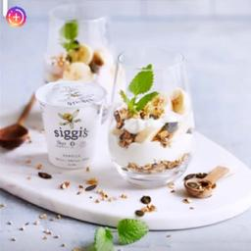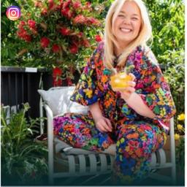
Influencer with Low Consistency
Post Story Post Story
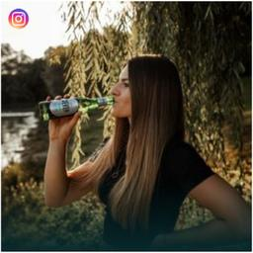

Appendix L7: Campaign-Level Cross-Format Consistency Control (Cross-Format vs. Single-Format Dummy)
Table L7.1: Posts
 |  | Feature |  |  | Consistency
Dimension | Feature | Median Association | Prop-Val | |Marginal Association| | Median Association | Prop-Val | |Marginal Association|
Color | Saturation |  |  |  | 0.02 | 0.06 | 0.20
 | Brightness | -0.09 | 0.00 | 0.90 | -0.15 | 0.00 | 1.49
Complexity | Color complexity |  |  |  | -0.11 | 0.01 | 1.09
 | Edge density |  |  |  | -0.02 | 0.05 | 0.20
 | Number of objects | -0.02 | 0.14 | 0.20 | 0.01 | 0.17 | 0.10
 | Number of tags | 0.06 | 0.23 | 0.60 | 0.02 | 0.36 | 0.20
 | Number of faces | 0.09 | 0.00 | 0.90 | -0.06 | 0.00 | 0.60
Composition | Diagonal dominance | 0.06 | 0.00 | 0.60 | -0.04 | 0.00 | 0.40
 | Color balance | 0.07 | 0.44 | 0.70 | -0.04 | 0.49 | 0.40
 | Size difference | 0.02 | 0.46 | 0.20
Content | Face coverage | -0.08 | 0.03 | 0.80 | -0.05 | 0.02 | 0.50
 | Whole human coverage | 0.03 | 0.03 | 0.30
 | Text allocation | -0.05 | 0.00 | 0.50
 | Contextual sentiment (adjective-noun pairs) |  |  |  | -0.01 | 0.23 | 0.10
 | Intercept | 7.29 | 0.00
Controls
Follower count |  | ✓
Impressions |  | ✓
Number of unique influencers in the campaign |  | ✓
Influencer gender |  | ✓
Time fixed effects (year, month, and weekday) |  | ✓
Product category |  | ✓
Engagement rate before the focal post |  | ✓
Campaign cross-format indicator |  | ✓
Random intercepts (campaigns, influencers) |  | ✓
Note: Following variables were excluded: Color: warmth, brightness contrast; Complexity: luminance complexity; Composition: rule of thirds, color difference, texture difference, depth of field, quality; Content: locations (places), activities and items (caption and tags), items similarity. Bold indicates prop-values below 0.05. Marginal associations represent the percentage change in the outcome for a 10% change in the predictor. For consistency features, negative values denote lower distance (i.e., higher consistency), and positive values denote higher distance (i.e., lower consistency).

Table L7.2: Stories
 |  | Feature |  |  | Consistency
Dimension | Feature | Median Association | Prop-Val | |Marginal Association| | Median Association | Prop-Val | |Marginal Association|
Color | Warmth | -0.04 | 0.11 | 0.40 | 0.19 | 0.00 | 1.92
 | Saturation | 0.26 | 0.01 | 2.63 | 0.01 | 0.46 | 0.10
 | Brightness | 0.33 | 0.00 | 3.36
Complexity | Color complexity |  |  |  | -0.12 | 0.02 | 1.19
 | Luminance complexity |  |  |  | 0.70 | 0.00 | 7.25
 | Number of objects | 0.21 | 0.00 | 2.12
 | Number of tags |  |  |  | -0.13 | 0.06 | 1.29
Composition | Diagonal dominance |  |  |  | -0.23 | 0.01 | 2.27
 | Rule of thirds |  |  |  | 0.04 | 0.50 | 0.40
 | Color balance |  |  |  | -0.09 | 0.06 | 0.90
 | Color difference | 0.13 | 0.03 | 1.31
 | Texture difference | 0.23 | 0.23 | 2.33 | -0.12 | 0.27 | 1.19
 | Size difference | -0.02 | 0.37 | 0.20 | 0.37 | 0.00 | 3.77
Content | Face coverage | -0.01 | 0.43 | 0.10
 | Whole human coverage | 0.25 | 0.05 | 2.53 | -0.53 | 0.00 | 5.16
 | Text allocation | 0.05 | 0.20 | 0.50 | -0.46 | 0.00 | 4.50
 | Contextual sentiment (adjective-noun pairs) |  |  |  | 0.02 | 0.31 | 0.20
 | Locations (places) |  |  |  | 0.08 | 0.04 | 0.80
 | Activities and items (caption and tags) |  |  |  | 0.25 | 0.04 | 2.53
 | Intercept | 4.44 | 0.00
Controls
Follower count |  | ✓
Impressions |  | ✓
Number of unique influencers in the campaign |  | ✓
Influencer gender |  | ✓
Time fixed effects (year, month, and weekday) |  | ✓
Product category |  | ✓
Engagement rate before the focal story |  | ✓
Campaign cross-format indicator |  | ✓
Random intercepts (campaigns, influencers) |  | ✓
Note: Following variables were excluded: Color: brightness contrast; Complexity: edge density, number of faces; Composition: depth of field, quality; Content: items similarity. Bold indicates prop-values below 0.05. Marginal associations represent the percentage change in the outcome for a 10% change in the predictor. For consistency features, negative values denote lower distance (i.e., higher consistency), and positive values denote higher distance (i.e., lower consistency).
Appendix L8: Campaign-Level Cross-Format Consistency Index Control
Table L8.1: Posts
 |  | Campaign-level cross-format consistency index
 |  | Feature |  | Consistency
Dimension | Feature | Median Association | |Marginal Association| | Median Associations | |Marginal Association|
Color | Saturation |  |  | 0.03 | 0.30
 | Brightness | -0.06 | 0.60 | -0.15 | 1.49
Complexity | Color complexity |  |  | -0.09 | 0.90
 | Luminance complexity |  |  | -0.08 | 0.80
 | Edge density |  |  | -0.03 | 0.30
 | Number of objects | -0.01 | 0.10
 | Number of tags | 0.06 | 0.60 | 0.05 | 0.50
 | Number of faces | 0.08 | 0.80 | -0.08 | 0.80
Composition | Diagonal dominance | 0.06 | 0.60 | -0.05 | 0.50
 | Color balance | 0.09 | 0.90 | -0.06 | 0.60
 | Size difference | 0.04 | 0.40
Content | Face coverage | -0.11 | 1.09 | -0.03 | 0.30
 | Whole human coverage | 0.03 | 0.30
 | Text allocation | -0.04 | 0.40
 | Contextual sentiment (adjective-noun pairs) |  |  | 0.02 | 0.20
 | Intercept | 7.40
Controls
Follower count |  | ✓
Impressions |  | ✓
Number of unique influencers in the campaign |  | ✓
Influencer gender |  | ✓
Time fixed effects (year, month, and weekday) |  | ✓
Product category |  | ✓
Engagement rate before the focal post |  | ✓
Campaign-level cross-format consistency index |  | ✓
Random intercepts (campaigns, influencers) |  | ✓
Note: Following variables were excluded: Color: warmth, brightness contrast; Composition: rule of thirds, color and texture difference, depth of field, quality; Content: items similarity, locations (places), activities and items. Bold indicates prop-value<0.05. Marginal associations show the percent change in outcome for a 10% predictor change. For consistency features, negative values show lower distance (higher consistency), positive values show higher distance (lower consistency).

Table L8.2: Stories
 |  | Campaign-level cross-format consistency index
 |  | Feature |  | Consistency
Dimension | Feature | Median Association | |Marginal Association| | Median Association | |Marginal Association|
Color | Warmth | 0.04 | 0.40 | 0.31 | 3.15
 | Saturation | 0.15 | 1.51
 | Brightness | 0.37 | 3.77 | -0.41 | 4.02
Complexity | Color complexity |  |  | -0.03 | 0.30
 | Luminance complexity |  |  | 0.78 | 8.11
 | Number of objects | 0.29 | 2.94
 | Number of tags |  |  | -0.17 | 1.69
Composition | Diagonal dominance |  |  | -0.21 | 2.08
 | Color balance | 0.28 | 2.84 | 0.01 | 0.10
 | Color difference | 0.08 | 0.80
 | Texture difference | 0.37 | 3.77 | -0.25 | 2.47
 | Size difference | -0.18 | 1.78 | 0.46 | 4.71
Content | Whole human coverage | 0.40 | 4.08 | -0.63 | 6.11
 | Text allocation | 0.04 | 0.40 | -0.44 | 4.30
 | Contextual sentiment (adjective-noun pairs) |  |  | -0.05 | 0.50
 | Locations (places) |  |  | 0.05 | 0.50
 | Activities and items (caption and tags) |  |  | 0.26 | 2.63
 | Intercept | 3.70
Controls
Follower count |  | ✓
Impressions |  | ✓
Number of unique influencers in the campaign |  | ✓
Influencer gender |  | ✓
Time fixed effects (year, month, and weekday) |  | ✓
Product category |  | ✓
Engagement rate before the focal story |  | ✓
Campaign-level cross-format consistency index |  | ✓
Random intercepts (campaigns, influencers) |  | ✓
Note: Following variables were excluded: Color: brightness contrast; Complexity: edge density, number of faces; Composition: rule of thirds, depth of field, quality; Content: items similarity, face coverage. Bold indicates prop-value<0.05. Marginal associations show the percent change in outcome for a 10% predictor change. For consistency features, negative values show lower distance (higher consistency), positive values show higher distance (lower consistency).

Figure L8.1: Examples of Campaigns with High/Low Cross-Format Consistency at Campaign Level
Campaigns with High consistency
Posts Stories

Posts Stories


Campaigns with Low Consistency
Posts Stories

Posts Stories


Appendix L9: COVID-19 Control
Table L9.1: Posts
 |  | Feature |  |  | Consistency
Dimension | Feature | Median Association | Prop-Val | |Marginal Association| | Median Association | Prop-Val | |Marginal Association|
Color | Saturation |  |  |  | 0.01 | 0.08 | 0.10
 | Brightness | -0.09 | 0.00 | 0.90 | -0.14 | 0.00 | 1.39
Complexity | Color complexity |  |  |  | -0.11 | 0.01 | 1.09
 | Edge density |  |  |  | -0.02 | 0.05 | 0.20
 | Number of objects | -0.02 | 0.12 | 0.20 | 0.02 | 0.08 | 0.20
 | Number of tags | 0.06 | 0.22 | 0.60 | 0.02 | 0.36 | 0.20
 | Number of faces | 0.09 | 0.00 | 0.90 | -0.07 | 0.00 | 0.70
Composition | Diagonal dominance | 0.05 | 0.00 | 0.50 | -0.04 | 0.00 | 0.40
 | Color balance | 0.07 | 0.43 | 0.70 | -0.04 | 0.48 | 0.40
 | Size difference | 0.01 | 0.48 | 0.10
Content | Face coverage | -0.08 | 0.02 | 0.80 | -0.04 | 0.02 | 0.40
 | Whole human coverage | 0.03 | 0.03 | 0.30
 | Text allocation | -0.06 | 0.00 | 0.60
 | Contextual sentiment (adjective-noun pairs) |  |  |  | -0.01 | 0.18 | 0.10
 | Intercept | 7.37 | 0.00
Controls
Follower count |  | ✓
Impressions |  | ✓
Number of unique influencers in the campaign |  | ✓
Influencer gender |  | ✓
Time fixed effects (year, month, and weekday) |  | ✓
Product category |  | ✓
Engagement rate before the focal post |  | ✓
COVID-19 period |  | ✓
Random intercepts (campaigns, influencers) |  | ✓
Note: Following variables were excluded: Color: warmth, brightness contrast; Complexity: luminance complexity; Composition: rule of thirds, color difference, texture difference, depth of field, quality; Content: locations (places), activities and items (caption and tags), items similarity. Bold indicates prop-value<0.05. Marginal associations show the percent change in outcome for a 10% predictor change. For consistency features, negative values show lower distance (higher consistency), positive values show higher distance (lower consistency).

Table L9.2: Stories
 |  | Feature |  |  | Consistency
Dimension | Feature | Median Association | Prop-Val | |Marginal Association| | Median Association | Prop-Val | |Marginal Association|
Color | Warmth | -0.05 | 0.09 | 0.50 | 0.18 | 0.00 | 1.82
 | Saturation | 0.26 | 0.02 | 2.63
 | Brightness | 0.32 | 0.00 | 3.25
Complexity | Color complexity |  |  |  | -0.12 | 0.03 | 1.19
 | Luminance complexity |  |  |  | 0.70 | 0.00 | 7.25
 | Number of objects | 0.21 | 0.00 | 2.12
 | Number of tags |  |  |  | -0.13 | 0.06 | 1.29
Composition | Diagonal dominance |  |  |  | -0.22 | 0.01 | 2.18
 | Color balance |  |  |  | -0.10 | 0.04 | 1.00
 | Color difference | 0.13 | 0.02 | 1.31
 | Texture difference | 0.22 | 0.25 | 2.22 | -0.11 | 0.29 | 1.09
 | Size difference | -0.02 | 0.32 | 0.20 | 0.39 | 0.00 | 3.98
Content | Face coverage | 0.02 | 0.37 | 0.20 | -0.02 | 0.38 | 0.20
 | Whole human coverage | 0.23 | 0.04 | 2.33 | -0.53 | 0.00 | 5.16
 | Text allocation | 0.05 | 0.19 | 0.50 | -0.46 | 0.00 | 4.50
 | Contextual sentiment |  |  |  | 0.01 | 0.44 | 0.10
 | Locations (places) |  |  |  | 0.09 | 0.04 | 0.90
 | Activities and items |  |  |  | 0.27 | 0.05 | 2.74
 | Intercept | 2.80 | 0.00
Controls
Follower count |  | ✓
Impressions |  | ✓
Number of unique influencers in the campaign |  | ✓
Influencer gender |  | ✓
Time fixed effects (year, month, and weekday) |  | ✓
Product category |  | ✓
Engagement rate before the focal story |  | ✓
COVID-19 period |  | ✓
Random intercepts (campaigns, influencers) |  | ✓
Note: Following variables were excluded: Color: brightness contrast; Complexity: edge density, number of faces; Composition: rule of thirds, depth of field, quality; Content: items similarity. Bold indicates prop-values below 0.05. Marginal associations represent the percentage change in the outcome for a 10% change in the predictor. For consistency features, negative values denote lower distance (i.e., higher consistency), and positive values denote higher distance (i.e., lower consistency).

Appendix L10: Campaign Content Intensity
Table L10.1: Posts
 |  | Feature |  |  | Consistency
Dimension | Feature | Median Association | Prop-Val | |Marginal Association| | Median Association | Prop-Val | |Marginal Association|
Color | Saturation |  |  |  | 0.02 | 0.06 | 0.20
 | Brightness | -0.09 | 0.00 | 0.90 | -0.15 | 0.00 | 1.49
Complexity | Color complexity |  |  |  | -0.11 | 0.01 | 1.09
 | Edge density |  |  |  | -0.02 | 0.04 | 0.20
 | Number of objects | -0.02 | 0.11 | 0.20 | 0.02 | 0.04 | 0.20
 | Number of tags | 0.06 | 0.11 | 0.60 | 0.02 | 0.36 | 0.20
 | Number of faces | 0.09 | 0.00 | 0.90 | -0.06 | 0.00 | 0.60
Composition | Diagonal dominance | 0.05 | 0.00 | 0.50 | -0.04 | 0.00 | 0.40
 | Color balance | 0.07 | 0.44 | 0.70 | -0.05 | 0.46 | 0.50
 | Size difference | 0.01 | 0.48 | 0.10
Content | Face coverage | -0.08 | 0.03 | 0.80 | -0.04 | 0.02 | 0.40
 | Whole human coverage | 0.03 | 0.02 | 0.30
 | Text allocation | -0.04 | 0.01 | 0.40 | -0.03 | 0.42 | 0.30
 | Contextual sentiment (adjective-noun pairs) |  |  |  | -0.01 | 0.17 | 0.10
 | Intercept | 7.45 | 0.00
Controls
Follower count |  | ✓
Impressions |  | ✓
Number of unique influencers in the campaign |  | ✓
Influencer gender |  | ✓
Time fixed effects (year, month, and weekday) |  | ✓
Product category |  | ✓
Engagement rate before the focal post |  | ✓
Campaign content intensity |  | ✓
Random intercepts (campaigns, influencers) |  | ✓
Note: Following variables were excluded: Color: warmth, brightness contrast; Complexity: luminance complexity; Composition: rule of thirds, color difference, texture difference, depth of field, quality; Content: locations (places), activities and items (caption and tags), items similarity. Bold indicates prop-value<0.05. Marginal associations show the percent change in outcome for a 10% predictor change. For consistency features, negative values show lower distance (higher consistency), positive values show higher distance (lower consistency).

Table L10.2: Stories
 |  | Feature |  |  | Consistency
Dimension | Feature | Median Association | Prop-Val | |Marginal Association| | Median Association | Prop-Val | |Marginal Association|
Color | Warmth | -0.05 | 0.10 | 0.50 | 0.17 | 0.00 | 1.71
 | Saturation | 0.25 | 0.01 | 2.53
 | Brightness | 0.32 | 0.00 | 3.25
Complexity | Color complexity |  |  |  | -0.11 | 0.03 | 1.09
 | Luminance complexity |  |  |  | 0.68 | 0.00 | 7.04
 | Number of objects | 0.20 | 0.00 | 2.02
 | Number of tags |  |  |  | -0.13 | 0.06 | 1.29
Composition | Diagonal dominance |  |  |  | -0.24 | 0.01 | 2.37
 | Color balance |  |  |  | -0.07 | 0.11 | 0.70
 | Color difference | 0.14 | 0.06 | 1.41
 | Texture difference | 0.23 | 0.25 | 2.33 | -0.12 | 0.30 | 1.19
 | Size difference |  |  |  | 0.38 | 0.00 | 3.87
Content | Face coverage | -0.02 | 0.38 | 0.20 | -0.02 | 0.38 | 0.20
 | Whole human coverage | 0.23 | 0.04 | 2.33 | -0.53 | 0.00 | 5.16
 | Text allocation | 0.07 | 0.13 | 0.70 | -0.49 | 0.00 | 4.78
 | Contextual sentiment |  |  |  | 0.01 | 0.40 | 0.10
 | Locations (places) |  |  |  | 0.08 | 0.04 | 0.80
 | Activities and items |  |  |  | 0.25 | 0.12 | 2.53
 | Intercept | 3.79 | 0.00
Controls
Follower count |  | ✓
Impressions |  | ✓
Number of unique influencers in the campaign |  | ✓
Influencer gender |  | ✓
Time fixed effects (year, month, and weekday) |  | ✓
Product category |  | ✓
Engagement rate before the focal story |  | ✓
Campaign content intensity |  | ✓
Random intercepts (campaigns, influencers) |  | ✓
Note: Following variables were excluded: Color: brightness contrast; Complexity: edge density, number of faces; Composition: rule of thirds, depth of field, quality; Content: items similarity. Bold indicates prop-values below 0.05. Marginal associations represent the percentage change in the outcome for a 10% change in the predictor. For consistency features, negative values denote lower distance (i.e., higher consistency), and positive values denote higher distance (i.e., lower consistency).

Appendix L11: Campaign Day-Level Concentration (HHI)
Table L11.1: Posts
 |  | Feature |  |  | Consistency
Dimension | Feature | Median Association | Prop-Val | |Marginal Association| | Median Association | Prop-Val | |Marginal Association|
Color | Saturation |  |  |  | 0.02 | 0.06 | 0.20
 | Brightness | -0.09 | 0.00 | 0.90 | -0.14 | 0.00 | 1.39
Complexity | Color complexity |  |  |  | -0.11 | 0.00 | 1.09
 | Edge density |  |  |  | -0.02 | 0.03 | 0.20
 | Number of objects | -0.02 | 0.11 | 0.20 | 0.02 | 0.06 | 0.20
 | Number of tags | 0.06 | 0.19 | 0.60 | 0.02 | 0.36 | 0.20
 | Number of faces | 0.09 | 0.00 | 0.90 | -0.06 | 0.00 | 0.60
Composition | Diagonal dominance | 0.05 | 0.00 | 0.50 | -0.05 | 0.00 | 0.50
 | Color balance | 0.07 | 0.43 | 0.70 | -0.04 | 0.45 | 0.40
Content | Face coverage | -0.08 | 0.03 | 0.80 | -0.05 | 0.02 | 0.50
 | Whole human coverage | 0.03 | 0.03 | 0.30
 | Text allocation | -0.05 | 0.00 | 0.50
 | Contextual sentiment (adjective-noun pairs) |  |  |  | -0.01 | 0.18 | 0.10
 | Intercept | 7.45 | 0.00
Controls
Follower count |  | ✓
Impressions |  | ✓
Number of unique influencers in the campaign |  | ✓
Influencer gender |  | ✓
Time fixed effects (year, month, and weekday) |  | ✓
Product category |  | ✓
Engagement rate before the focal post |  | ✓
Campaign day-level concentration (HHI) |  | ✓
Random intercepts (campaigns, influencers) |  | ✓
Note: Following variables were excluded: Color: warmth, brightness contrast; Complexity: luminance complexity; Composition: rule of thirds, color difference, texture difference, size difference, depth of field, quality; Content: locations (places), activities and items (caption and tags), items similarity. Bold indicates prop-value<0.05. Marginal associations show the percent change in outcome for a 10% predictor change. For consistency features, negative values show lower distance (higher consistency), positive values show higher distance (lower consistency).

Table L11.2: Stories
 |  | Feature |  |  | Consistency
Dimension | Feature | Median Association | Prop-Val | |Marginal Association| | Median Association | Prop-Val | |Marginal Association|
Color | Warmth | -0.04 | 0.13 | 0.40 | 0.17 | 0.00 | 1.71
 | Saturation | 0.24 | 0.01 | 2.43 | 0.02 | 0.40 | 0.20
 | Brightness | 0.32 | 0.00 | 3.25
Complexity | Color complexity |  |  |  | -0.11 | 0.04 | 1.09
 | Luminance complexity |  |  |  | 0.67 | 0.00 | 6.93
 | Number of objects | 0.21 | 0.00 | 2.12 | -0.01 | 0.43 | 0.10
 | Number of tags |  |  |  | -0.12 | 0.05 | 1.19
Composition | Diagonal dominance |  |  |  | -0.25 | 0.00 | 2.47
 | Color balance |  |  |  | -0.07 | 0.09 | 0.70
 | Color difference | 0.14 | 0.04 | 1.41
 | Texture difference | 0.19 | 0.28 | 1.92 | -0.07 | 0.35 | 0.70
 | Size difference | -0.01 | 0.37 | 0.10 | 0.38 | 0.00 | 3.87
Content | Face coverage | 0.01 | 0.45 | 0.10 | -0.02 | 0.38 | 0.20
 | Whole human coverage | 0.22 | 0.05 | 2.22 | -0.53 | 0.00 | 5.16
 | Text allocation | 0.07 | 0.11 | 0.70 | -0.49 | 0.00 | 4.78
 | Contextual sentiment |  |  |  | 0.03 | 0.24 | 0.30
 | Locations (places) |  |  |  | 0.10 | 0.02 | 1.01
 | Activities and items |  |  |  | 0.24 | 0.26 | 2.43
 | Intercept | 3.83 | 0.00
Controls
Follower count |  | ✓
Impressions |  | ✓
Number of unique influencers in the campaign |  | ✓
Influencer gender |  | ✓
Time fixed effects (year, month, and weekday) |  | ✓
Product category |  | ✓
Engagement rate before the focal story |  | ✓
Campaign day-level concentration (HHI) |  | ✓
Random intercepts (campaigns, influencers) |  | ✓
Note: Following variables were excluded: Color: brightness contrast; Complexity: edge density, number of faces; Composition: rule of thirds, depth of field, quality; Content: items similarity. Bold indicates prop-values below 0.05. Marginal associations represent the percentage change in the outcome for a 10% change in the predictor. For consistency features, negative values denote lower distance (i.e., higher consistency), and positive values denote higher distance (i.e., lower consistency).

Appendix L12: Consistency with Same-Day and Prior Campaign Content
Table L12.1: Posts
 |  | Feature |  | Consistency
Dimension | Feature | Median Association | |Marginal Association| | Median Associations | |Marginal Association|
Color | Saturation |  |  | -0.02 | 0.20
 | Brightness | -0.08 | 0.80 | -0.12 | 1.19
Complexity | Color complexity |  |  | -0.11 | 1.09
 | Edge density |  |  | 0.02 | 0.20
 | Number of objects | -0.03 | 0.30 | 0.03 | 0.30
 | Number of tags | 0.06 | 0.60 | 0.02 | 0.20
 | Number of faces | 0.10 | 1.01 | -0.08 | 0.80
Composition | Diagonal dominance | 0.08 | 0.80 | 0.01 | 0.10
 | Color balance |  |  | -0.01 | 0.10
 | Size difference | 0.05 | 0.50
Content | Face coverage | -0.10 | 1.00 | -0.03 | 0.30
 | Whole human coverage | 0.02 | 0.20
 | Text allocation | -0.05 | 0.50
 | Intercept | 7.45
Controls
Follower count |  | ✓
Impressions |  | ✓
Number of unique influencers in the campaign |  | ✓
Influencer gender |  | ✓
Time fixed effects (year, month, and weekday) |  | ✓
Product category |  | ✓
Engagement rate before the focal post |  | ✓
Consistency with same-day and prior campaign content |  | ✓
Random intercepts (campaigns, influencers) |  | ✓
Note: Following variables were excluded: Color: warmth, brightness contrast; Complexity: luminance complexity; Composition: rule of thirds, color and texture difference, depth of field, quality; Content: items similarity, contextual sentiment, locations (places), activities and items. Bold indicates prop-value<0.05. Marginal associations show the percent change in outcome for a 10% predictor change. For consistency features, negative values show lower distance (higher consistency), positive values show higher distance (lower consistency).

Table L12.2: Stories
 |  | Feature |  | Consistency
Dimension | Feature | Median Association | |Marginal Association| | Median Association | |Marginal Association|
Color | Warmth | -0.08 | 0.80 | 0.13 | 1.31
 | Saturation | 0.15 | 1.51 | 0.06 | 0.60
 | Brightness | 0.29 | 2.94
Complexity | Color complexity |  |  | -0.05 | 0.50
 | Luminance complexity |  |  | 0.47 | 4.81
 | Number of objects | 0.24 | 2.43
 | Number of tags |  |  | -0.04 | 0.40
Composition | Diagonal dominance |  |  | -0.18 | 1.78
 | Color balance |  |  | -0.11 | 1.09
 | Color difference | 0.18 | 1.82
 | Texture difference | 0.20 | 2.02 | -0.09 | 0.90
 | Size difference | 0.01 | 0.10 | 0.14 | 1.41
Content | Whole human coverage | 0.35 | 3.56 | -0.23 | 2.27
 | Text allocation | -0.22 | 2.18 | -0.12 | 1.19
 | Locations (places) |  |  | 0.06 | 0.60
 | Activities and items (caption and tags) |  |  | 0.26 | 2.63
 | Intercept | 3.77
Controls
Follower count |  | ✓
Impressions |  | ✓
Number of unique influencers in the campaign |  | ✓
Influencer gender |  | ✓
Time fixed effects (year, month, and weekday) |  | ✓
Product category |  | ✓
Engagement rate before the focal story |  | ✓
Consistency with same-day and prior campaign content |  | ✓
Random intercepts (campaigns, influencers) |  | ✓
Note: Following variables were excluded: Color: brightness contrast; Complexity: edge density, number of faces; Composition: rule of thirds, depth of field, quality; Content: items similarity, face coverage, contextual sentiment. Bold indicates prop-value<0.05. Marginal associations show the percent change in outcome for a 10% predictor change. For consistency features, negative values show lower distance (higher consistency), positive values show higher distance (lower consistency).

Web Appendix M: Illustrative Campaigns with Post Consistency and Story Variation
Industry Cases
Dior’s “67 Shades of Dior” campaign, which featured 67 makeup influencers promoting the brand’s inclusive Forever Foundation line, exemplifies how visual consistency in posts can reinforce brand identity and support strategic messaging (Influencity, 2024). By maintaining uniform visual aesthetics across influencer posts, Dior created a cohesive and recognizable campaign that benefited from processing fluency and associative memory reinforcement. Similarly, Sephora’s Squad Ambassador Program offers a compelling case of large-scale visual consistency achieved through carefully curated ambassador cohorts (Vendrell, 2021). Influencers in the program are provided with branded templates, stylized shoot guidelines, and shared messaging frameworks, resulting in highly consistent visuals. This alignment not only enhances recall and brand linkage but also facilitates trust and credibility among diverse consumer segments, particularly when paired with long-term ambassador relationships.
In contrast, the story examples illustrate how variation can be useful for selected feature classes, especially contextual novelty and affective or salience cues. Brands such as Nintendo use diverse, fast-paced story content, including product reveals, tips, interactive games, and live unboxings (Curator.io, 2025). Such variation is consistent with our feature-level finding that story engagement is positively associated with variation in locations, activities/items, warmth, luminance complexity, and size difference. Similarly, Disney’s use of interactive quizzes and hashtag challenges, such as #DisneyMagicMoments in stories, illustrates how spontaneous and novel story elements can support contextual variety in ephemeral formats (Curator.io, 2025). At the same time, our results do not imply that all story features should vary; stories are also positively linked to consistency in color complexity, diagonal dominance, whole human coverage, and text allocation. Together, these examples illustrate feature-specific adaptation to format affordances rather than a general rule that stories should always vary. The examples that follow showcase these real-world campaigns.

Table M1: Examples of real-world campaigns featuring visual variation in stories and visual consistency in posts
Campaign name | Consistency in posts | Campaign name | Variation in stories
67 Shades of Dior | Mahon Point Shopping Centre (2018)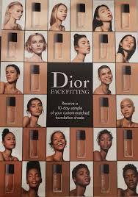 | Nintendo Holiday Gift Guide | Curator.io (2025)  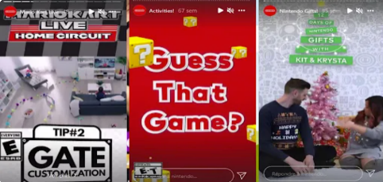
Sephora Squad | Segran (2019)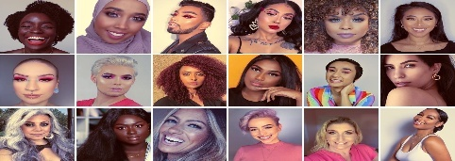 | Disney Magic Moments | Curator.io (2025)  

Additionally, the table below showcases sample campaigns from our dataset that exhibit the highest average consistency in those visual features most strongly linked—statistically—to engagement, for posts, namely, brightness, color complexity, number of faces, diagonal dominance, and face coverage. For stories, we present example campaigns characterized by high average consistency in color complexity, diagonal dominance, whole human coverage, and text allocation. We also include campaigns featuring stories with the highest average variation in visual features that showed significant associations with engagement when presented inconsistently, including warmth, luminance complexity, size difference, locations (places), and activities and items (caption and tags). Finally, for stories, we include examples that combine the two strategies—maintaining high consistency on features where consistency pays off and introducing variation on features where inconsistency is beneficial.

Table M2: Campaign examples that align with the model-derived consistency strategies
Content type | Feature pattern | Key consistency-related visual features | Campaign
Post | High consistency | Brightness, color complexity, number of faces, diagonal dominance, and face coverage | 1  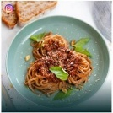  2  
Story | High consistency | Color complexity, diagonal dominance, whole human coverage, and text allocation | 1    2  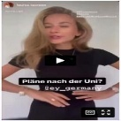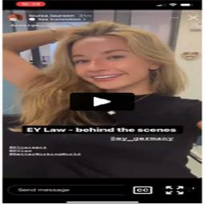
Story | Low consistency (high variation) | Warmth, luminance complexity, size difference, locations (places), and activities and items (caption and tags) | 1  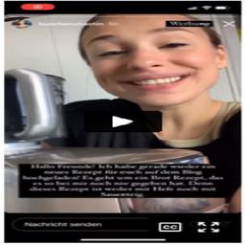  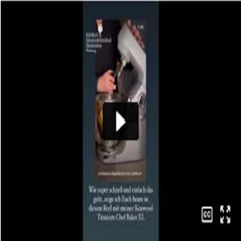  2  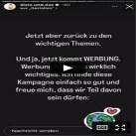
Story | Balanced:  High consistency and low consistency (high variation) combined | High consistency:  Color complexity, diagonal dominance, whole human coverage, and text allocation  High variation:  Warmth, luminance complexity, size difference, locations (places), and activities and items (caption and tags) | 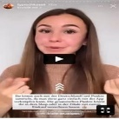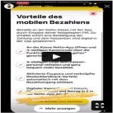

References
Beichert, M., Bayerl, A., Goldenberg, J., & Lanz, A. (2024). Revenue generation through influencer marketing. Journal of Marketing, 88(4), 40–63.
Bharadwaj, N., Ballings, M., Naik, P. A., Moore, M., & Arat, M. M. (2022). A new livestream retail analytics framework to assess the sales impact of emotional displays. Journal of Marketing, 86(1), 27–47.
Borth, D., Ji, R., Chen, T., Breuel, T., & Chang, S.-F. (2013). Large-scale visual sentiment ontology and detectors using adjective noun pairs. Proceedings of the 21st ACM International Conference on Multimedia, 223–232.
Canny, J. (1987). A computational approach to edge detection. In Readings in Computer Vision (pp. 184–203). Elsevier.
Carion, N., Massa, F., Synnaeve, G., Usunier, N., Kirillov, A., & Zagoruyko, S. (2020). End-to-end object detection with transformers (Version 3). arXiv.
Cascio Rizzo, G. L., Berger, J., De Angelis, M., & Pozharliev, R. (2023). How sensory language shapes influencer’s impact. Journal of Consumer Research, 50(4), 810–825.
Cascio Rizzo, G. L., Villarroel Ordenes, F., Pozharliev, R., De Angelis, M., & Costabile, M. (2024). How high-arousal language shapes micro- versus macro-influencers’ impact. Journal of Marketing, 88(4), 107–128.
Chen, T., Borth, D., Darrell, T., & Chang, S.-F. (2014). DeepSentiBank: Visual sentiment concept classification with deep convolutional neural networks (Version 1). arXiv.
Chen, L., Yan, Y., & Smith, A. N. (2023). What drives digital engagement with sponsored videos? An investigation of video influencers’ authenticity management strategies. Journal of the Academy of Marketing Science, 51(1), 198–221.
Corchs, S. E., Ciocca, G., Bricolo, E., & Gasparini, F. (2016). Predicting complexity perception of real world images. PLOS ONE, 11(6), e0157986.
Curator.io. (2025). Boost your marketing campaigns with these 10 Instagram Stories examples. Curator Group Blog. Retrieved June 24, 2025 from https://curator.io/blog/instagram-stories-examples
Datta, R., Joshi, D., Li, J., & Wang, J. Z. (2006). Studying aesthetics in photographic images using a computational approach. In A. Leonardis, H. Bischof, & A. Pinz (Eds.), Computer Vision – ECCV 2006 (Vol. 3953, pp. 288–301). Springer Berlin Heidelberg.
Deng, J., Guo, J., Zhou, Y., Yu, J., Kotsia, I., & Zafeiriou, S. (2019). RetinaFace: Single-stage dense face localisation in the wild (Version 2). arXiv.
Gu, X., Zhang, X., & Kannan, P. (2024). Influencer mix strategies in livestream commerce: Impact on product sales. Journal of Marketing, 88(4), 64–83.
Hasler, D., & Suesstrunk, S. E. (2003). Measuring colorfulness in natural images. Proceedings of SPIE, the International Society for Optical Engineering/Proceedings of SPIE.
He, K., Gkioxari, G., Dollár, P., & Girshick, R. (2017). Mask R-CNN (Version 3). arXiv.
Influencity. (2024). 9 examples of successful influencer marketing campaigns. Retrieved November 1, 2024 from https://influencity.com/blog/en/9-examples-of-successful-influencer-marketing-campaigns
Hughes, C., Swaminathan, V., & Brooks, G. (2019). Driving brand engagement through online social influencers: An empirical investigation of sponsored blogging campaigns. Journal of Marketing, 83(5), 78–96.
Karagür, Z., Becker, J.-M., Klein, K., & Edeling, A. (2022). How, why, and when disclosure type matters for influencer marketing. International Journal of Research in Marketing, 39(2), 313–335.
Lanz, A., Goldenberg, J., Shapira, D., & Stahl, F. (2019). Climb or jump: Status-based seeding in user-generated content networks. Journal of Marketing Research, 56(3), 361–378.
Li, J., Li, D., Xiong, C., & Hoi, S. (2022). Blip: Bootstrapping language-image pre-training for unified vision-language understanding and generation. International Conference on Machine Learning, 12888–12900.
Li, Y., Xie, S., Chen, X., Dollar, P., He, K., & Girshick, R. (2021). Benchmarking detection transfer learning with vision transformers (Version 1). arXiv.
Liu, J.-J., Hou, Q., Cheng, M.-M., Feng, J., & Jiang, J. (2019). A simple pooling-based design for real-time salient object detection (Version 1). arXiv.
Leung, F. F., Gu, F. F., Li, Y., Zhang, J. Z., & Palmatier, R. W. (2022). Influencer marketing effectiveness. Journal of Marketing, 86(6), 93–115.
Mahon Point Shopping Centre. (2018). A new amazing Dior foundation launched today at Debenhams Ireland at Mahon Point!. Facebook. Retrieved June 26, 2025 from https://www.facebook.com/mahonpoint/posts/a-new-amazing-dior-foundation-launched-today-at-debenhams-ireland-at-mahon-point/10156224264531925/
Overgoor, G., Rand, W., van Dolen, W., & Mazloom, M. (2022). Simplicity is not key: Understanding firm-generated social media images and consumer liking. International Journal of Research in Marketing, 39(3), 639–655.
Pennington, J., Socher, R., & Manning, C. (2014). Glove: Global vectors for word representation. Proceedings of the 2014 Conference on Empirical Methods in Natural Language Processing (EMNLP), 1532–1543.
Segran, E. (2019). Sephora picks 24 influencers for its coveted #SephoraSquad program. Fast Company. Retrieved June 28, 2025 from https://www.fastcompany.com/90326765/sephora-brings-25-influencers-into-its-coveted-sephorasquad-program
Serengil, S. I., & Ozpinar, A. (2020). LightFace: A hybrid deep face recognition framework. 2020 Innovations in Intelligent Systems and Applications Conference (ASYU), 1–5.
Talebi, H., & Milanfar, P. (2018). NIMA: Neural image assessment. IEEE Transactions on Image Processing, 27(8), 3998–4011.
Tian, Z., Dew, R., & Iyengar, R. (2024). Mega or micro? Influencer selection using follower elasticity. Journal of Marketing Research, 61(3), 472-495.
Valsesia, F., Proserpio, D., & Nunes, J. C. (2020). The positive effect of not following others on social media. Journal of Marketing Research, 57(6), 1152–1168.
Vendrell, D. (2021). Sephora shines a light on influencer strategy. The Future Party. Retrieved June 27, 2025 from https://futureparty.com/sephora-squad-influencer-program/
Wang, X., Jia, J., Yin, J., & Cai, L. (2013). Interpretable aesthetic features for affective image classification. 2013 IEEE International Conference on Image Processing, 3230–3234.
Wies, S., Bleier, A., & Edeling, A. (2023). Finding goldilocks influencers: How follower count drives social media engagement. Journal of Marketing, 87(3), 383–405.
Zhang, M., & Luo, L. (2023). Can consumer-posted photos serve as a leading indicator of restaurant survival? Evidence from Yelp. Management Science, 69(1), 25–50.
Zhang, S., Lee, D., Singh, P. V., & Srinivasan, K. (2022). What makes a good image? Airbnb demand analytics leveraging interpretable image features. Management Science, 68(8), 5644–5666.
Zhang, Y., Huang, X., Ma, J., Li, Z., Luo, Z., Xie, Y., Qin, Y., Luo, T., Li, Y., Liu, S., Guo, Y., & Zhang, L. (2023). Recognize Anything: A strong image tagging model (Version 3). arXiv.
Zhou, B., Lapedriza, A., Khosla, A., Oliva, A., & Torralba, A. (2018). Places: A 10 million image database for scene recognition. IEEE Transactions on Pattern Analysis and Machine Intelligence, 40(6), 1452–1464.

