THE SUSTAINABLE EDGE EFFECT:
NUANCED CONSUMER RESPONSE TO SEMANTIC MEANINGS OF DIFFERENT SEMANTICALLY SIMILAR ECO-LABELS INFLUENCE CONSUMER JUDGMENTS

Web Appendix

Appendix A: Usage of Eco-Labels 2
A1: Stimuli Database Consumer Research 2
A2: Marketplace Examples 8

Appendix B: Additional Analyses 10
Pilot A 10
Pilot B 11
Pilot C 12

Appendix C: Experimental Stimuli and Measures in Each Study 14
Pilot A 14
Pilot B 16
Pilot C 19
Study 1A 20
Study 1B 23
Study 2 25
Study 3 27
Study 4 29
Study 5A 31
Study 5B 32

Appendix D: Supplemental Studies 34
D1 Exploring Green vs. Sustainable Label Choice 34
D2 Replication with Amazon Storefront 40
D3 Replication with Consumable 46

References 49
Appendix A1: Planet-Friendly Stimuli Used in Academic Research in Consumer Behavior

Paper | Study Stimuli | Independent Variable by Study | Dependent Variable by Study | Valence of Phenomenon
Chernev, A., Blair, S., Böckenholt, U., & Mishra, H. (2025). Is sustainability a liability? Green marketing and consumer beliefs about eco-friendly products. Journal of Public Policy & Marketing, 44(2), 261-275. | 1: "eco-friendly", "sustainable", "green", "natural", "environmentally friendly", "organic" | 1: Different conditions in a 2 (product description: control vs. sustainable benefit) × 13 (product scenario) design | 1: Perceived product performance (sustainable vs. control product) | Negative: The data from thirteen scenarios using product categories and decision criteria suggest that the overall effect of the presence of sustainability benefits on perceived product performance is too small to be managerially relevant
Burkert, M., Gil Roig, J. M., Rahmani, D., & Hüttl-Maack, V. (2023). The influence of green consumption values on how consumers form overall sustainability perceptions of food products and brands. Journal of Sustainable Marketing, 1-19. | 1: "zero waste", "nutrient recycling", "organic certified", "officially certified" (oyster mushroom) vs. "energy efficient", "locally grown", "without GM or other additives", "vegan", "soy-free" (plant-based meat burger) vs. "organic farming", "regenerative agriculture", "use probiotics", "quality"(fruit)  2: "do not harm the environment", "environmental impact", "concern for our environment", "wasting the resources", "environmentally responsible", "environmentally friendly" vs. "reduction of greenhouse gas emissions", "environmentally friendly land use", "reduction of water pollution" vs. "fair wages", good working conditions", "human rights" vs. "labeled sustainable", sustainable choice" | 1: brief description (oyster mushroom, bean-based meat substitute, or fruit)  2: socio-demographic profile of respondents (age, gender, education), green consumption values | 1: personal values and attitudes towards green consumption  2: perceived sustainability benefits of the product (mushroom, burger, fruit) | Positive: both product environmental and social sustainability benefits are more strongly perceived if consumers hold higher green consumption values  Negative: While environmental sustainability benefits mediate the effect in other categories, it was deemed insignificant with social sustainability benefits.
Schultz, A. E., Newman, K. P., & Wright, S. A. (2023). The negative effect of low belonging on consumer responses to sustainable products. Journal of Business Ethics, 187(3), 473-492. | 1a: "socially responsible" vs. "effective", "bad" vs. "good", "unfavorable" vs. "favorable", "negative" vs. "positive" 1b: "sustainably sourced", "socially responsible", "essential", "effective"  2:"100% bamboo", "recycled", "proenvironmental", "better for the environment"  3: "sustainable choices", "collective"  4a: "sustainable", "similar hopes and dreams", "similar values", "whole community"  4b: "shared human experience" | 1a: Product type (sustainable vs. conventional)  1b: Product type (sustainable or conventional water bottles)  2: Product type (sustainable vs. conventional toilet paper)  3: Product type (sustainable or conventional coffee) and belonging (high or low)  4a: Product type (sustainable or conventional coffee)  4b: Advertisement appeal type (shared human experience or non-shared human experience) and belonging (high or low) | 1a: Consumers' sense of belonging (low vs. high)  1b: Consumers' sense of belonging (low vs. high)  2: Money consumers were willing to give up for sustainable toilet paper ($0-$3.00)  3: Willingness to pay (sustainable coffee vs. conventional coffee)  4a: belonging (low vs. high), Perceptions of a shared human experience  4b: Willingness to pay (Green Mountain Coffee) | Positive: A high sense of belonging is associated with sustainable preference  Negative: A low sense of belonging is associated with conventional preference
Cakanlar, A., Nikolova, H., & Nenkov, G. Y. (2023). I will be green for us: When consumers compensate for their partners’ unsustainable behavior. Journal of Marketing Research, 60(1), 110-129. | 1: "recycle", "green", "high efficiency"  2a: "responsibility", "environmentally conscious", "sustainable consumption"  2b: "recycling", "food waste", "environmentally friendly"  3: "fair-trade"  4. "sustainable", "carbon footprint", "environment" | 1: relationship behavior (unsustainable vs. control/no behavior)  2a: marriage relationship power (high vs. low)  2b: marriage relationship power (high vs. low)  3: relationship power (high vs. low)  4: advertisement type: (partner’s unsustainable behavior vs. control/no partner behavior) | 1: Perceived Responsibility (reconstruction of couple sustainable identity)  2a: Partner’s choice: sustainable vs. unsustainable)  2b: Partner's choice (sustainable vs. unsustainable food waste)  3: Product preference (sustainable tea bags)  4. relationship power: high (women) vs. low (men) | Positive: high relationship power individuals compensate for their partners' unsustainable behavior by being more sustainable
Lee, S., & Winterich, K. P. (2022). The price entitlement effect: When and why high price entitles consumers to purchase socially costly products. Journal of Marketing Research, 59(6), 1141-1160. | 1: "green" or "nongreen"  2: "synthetic", "durable"  3: visual manipulation only, articles including social costs that range from a scale of not severe to very severe  4: "hidden sources of plastic pollution"  5: "hiddern sources of plastic pollution"  6. "potential environmental damage" vs "extensive environmental damage" | 1: price, green vs nongreen  2: backpack price  3: higher price to keep a book vs same price  4: backpack price  5: article about salient cost, article without salient cost  6: article with less severe/ more severe social costs | 1: actual purchase of a nongreen hand sanitizer.  2: purchase intention for a backpack  3: Entitlement to keep a library book beyond a due date  4: Purchase intention for a backpack  5: Purchase intention for a backpack  6: willingness to pay for a vacation tour program | Positive: if social costs of a product are highlighted beforehand, the upperclass is less likely to experience the entitlement effect and purchase that product  Negative: Upper class members tend to purchase products with higher prices regardless of their sustainability due to a feeling of entitlement.
Gong, S., Wang, L., Peverelli, P., & Suo, D. (2022). When is sustainability an asset? The interaction effects between the green attributes and product category. Journal of Product & Brand Management, 31(6), 971-983. | 1: "100% natural ingredients" vs. "100% recycled packaging material”  2: "environmentally friendly factors", "energy efficiency", "sensitivity to pollution", "recycled materials", "limited resource usage" | 1: shampoo/body lotion green attributes (core vs peripheral vs none), shampoo/body lotion product  category (utilitarian vs hedonic)  2: green attributes (core vs peripheral), product category (utilitarian vs hedonic) | 1: consumer purchase intention (shampoo/body lotion)  2: consumer purchase intention (smartwatch) | Positive: Benefits-based mechanisms explain how green attributes in utilitarian and hedonic product categories trigger consumer benefits analysis in a green decision context, which in turn leads to positive purchase intention
Chernev, A., & Blair, S. (2021). When sustainability is not a liability: The halo effect of marketplace morality. Journal of Consumer Psychology, 31(3), 551-569. | 1: "environmentally friendly", "better for society", "premium clean", "safe and effective", "advanced", "non-chemical", "clean", "vitamins and antioxidants", "removes harmful bacteria", "antimicrobial", "biodegradable", "plant-derived", "plant-based", "sustainable", "natural ingredients", "energy-efﬁcient"  2: "most environmentally friendly", "made from soy rather than petroleum", "green credentials"  3: "impact they have on society", "sustainable products", "better for the environment", "good for society"  4: "96% naturally derived", "formulated for use in high-efﬁciency washers", "eco-friendly ingredients", "moral responsibility", "sustainable future", "environmentally friendly", "not as effective as regular products" | 1: sustainability information (absent vs. present)  2: sustainability information (control vs. product focus vs. company focus), product category (pen ink vs. marker ink vs. printer ink)  3: beneﬁt type (control vs. sustainable beneﬁt vs. societal beneﬁt), product category: (laundry detergent vs. insect spray vs. sunscreen vs. air conditioner)  4: company's motivation for engaging in sustainable behavior | 1: perceived product perormance (laundry detergent vs. insect spray vs. sunscreen vs. air conditioner)  2: perceived product performance (pen ink vs. marker ink vs. printer ink)  3: perceived product performance (laundry detergent vs. insect spray vs. sunscreen vs. air conditioner)  4: consumer's compensatory beliefs (moral vs. neutral) | Positive: The higher the consumers' perception of the company's moral intentions to benefit society and the more prominently they think about the societal benefits of sustainability, the higher the strength is of the halo effect.
Reczek, R. W., Trudel, R., & White, K. (2018). Focusing on the forest or the trees: How abstract versus concrete construal level predicts responses to eco-friendly products. Journal of Environmental Psychology, 57, 87-98. | 1a: visual ad, no linguistics  1b: "sustainable methods", "recycled", "plant-derived", "environmentally friendly"  2: "natural", "non-toxic", "biodegradable", "good for the environment", "all-purpose cleaning"  3: "do not harm the environment", "environmental impact", "concern for our environment", "resources of our planet", "environmentally responsible", "environmentally friendly", "world in the future", "world today"  4: "good for the environment", "reduced carbon footprint", "impact global warming" | 1a: advertisement (eco-friendly vs. traditional granola bar)  1b: product type condition (eco-friendly vs. traditional car tire)  2: product type (eco-friendly vs. traditional household cleaner)  3: Brita Water filter advertisement (future-focused vs. present-focused)  4: eco-friendly product described in detailed vs. general terms, concrete vs. abstract construal | 1a: real product choice (eco-friendly vs. performance-related attributes)  1b: purchase intentions (eco-friendly vs. traditional car tire)  2: purchase intentions (eco-friendly vs. traditional household cleaner)  3: measured construal level (chronic abstract mindset vs. chronic concrete mindset)  4: likelihood to purchase tire | Positive: chronically construing information more abstractly (vs. concretely) predicts higher choice likelihood and purchase intentions for eco- friendly (but not traditional) products.

Luchs, M. G., Naylor, R. W., Irwin, J. R., & Raghunathan, R. (2010). The sustainability liability: Potential negative effects of ethicality on product preference. Journal of Marketing, 74(5), 18-31. | 1. "ethical", “fair labor practices,” “cares about the environment,” “sustainable,” “green” “socially responsible”, “profit at all costs,” “exploitative,” “selfish,” “self-centered,” “short-term goals”, “safe,” “mild,” “healthy,” “good for children,” “soft ”, “powerful,” “tough” “gets the job done,” “harsh,” “effective”  2. "proenvironmental", "ethical", "prosocial", "pollution", "resource usage", "fair treatment"  3. gentle on environment  4. "recycled" , "plant-derived"  5. "eco-friendly" | 1,2,3: Product condition (gentleness-related attributes vs. strength-related attributes)  4. Sustainable information provided vs. no sustainable information provided  5. Packaging (green vs. clear bottle) | 1: Preference (gentleness-related vs. strenght-related IAT)  2: Preference (sustainable vs. less sustainable shampoo)  3. Preference (gentle vs. strong shampoo, opinion of self vs. average american consumer)  4. Preference (sustainable vs. less-sustainable car tire)  5. Hand-sanitizer product choice (eco-friendly sign visible vs. not visible) | Positive: evaluation of gentleness-related attributes enhance positive preference;  Negative: strength-related attributes reduce preference

Appendix A2: Product Examples Either Labeled as “Sustainable” or “Green”

Product | Green |  |  | Sustainable
 | Title | Picture | Link | Title | Picture | Link
pillow | Avocado Green Pillow | 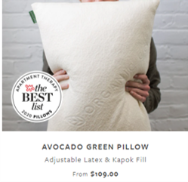 | LINK | Sustainable Bamboo Pillow | 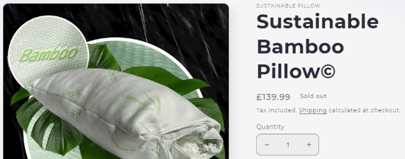 | LINK
cleaning products | Simple Green 2710001213012 24 oz. Spray Bottle Concentrated Industrial Cleaner and Degreaser | 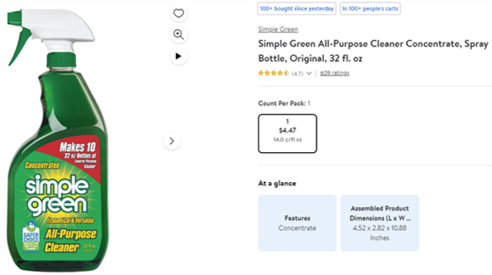 | LINK | Sustainable Earth All-Purpose Cleaner 32 oz. (SEB641032-A-CC) 807727 | 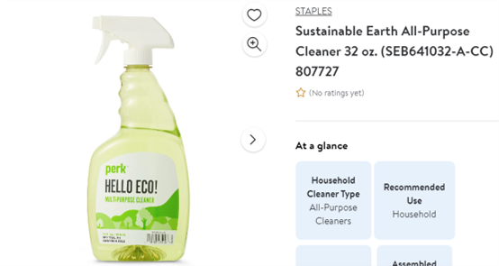
Tote Bag | Custom Eco-Green Medium Jute Tote Bag | 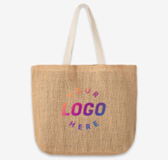 | LINK | The Go Tote Bag | Sustainable Reusable Canvas | 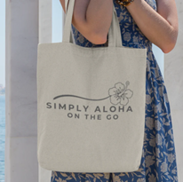 | LINK
Pet food | Healthy Dogma PetMix Super Green Grain-Free Supplemental Dog Food, 2-lb bag | 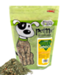 | LINK | Wilder Harrier Hypoallergenic & Sustainable Dog Food (4.4lbs, Fish Recipe, Puppy) | 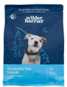 | LINK
Paper Towels | Eco Green Recycled Multifold Paper Towels, 1-ply, 250 Sheets/Pack, 16 Packs/Carton (EN416) | 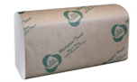 | LINK | Sustainable Earth by Staples Recycled Hardwound Paper Towels | 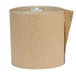 | LINK

Appendix B: Additional Analyses

Pilot Study A

A total of 490 undergraduate students (M_{age} = 19.67, 42% females) completed this study. Participants viewed two similar-looking windshield wiper options: a conventional “CT Windshield Wiper” and an “LS [term] Windshield Wiper.” Participants were randomly assigned to one of ten between-subjects conditions in which the LS Windshield Wiper was labeled with one of the following planet-friendly terms: green, eco-friendly, sustainable, environmentally-friendly, earth-friendly, environmentally conscious, carbon-neutral, eco-conscious, planet-friendly, and climate-friendly. They then rated the durability of the LS product using a three-item scale (α = .97, “Compared to the conventional CT Windshield Wipers, I expect that the LS [term] Windshield Wipers are made to last longer,” “Compared to the conventional CT Windshield Wipers, I expect that the LS [term] Windshield Wipers will remain functional for a longer period,” “Compared to the conventional CT Windshield Wipers, I expect that the LS [term] Windshield Wipers are made to be more durable;” 1 = Not at all, 7 = Very much). A one-way ANOVA revealed a significant effect of term condition on perceived durability, F(9, 480) = 16.60, p < .001, η² = .19, indicating that the wording used to describe the product influenced durability perceptions. Post hoc Tukey HSD comparisons showed that the sustainable label led to the highest perceived durability (M = 5.22, SD = 1.52), significantly higher than other labels, including green (M = 4.19, SD = 1.35), p = .018, eco-friendly (M = 3.06, SD = 1.28), p < .001, and environmentally friendly (M = 3.11, SD = 1.22), p < .001, but not carbon-neutral (M = 5.03, SD = 1.40, p = 1.000). The latter may be an artefact of the prevalence of a sturdy material – carbon – in the term, allowing for durability inferences.
These findings are consistent with our expectations. Compared with other semantically similar terms, the label sustainable is uniquely associated with durability perceptions. These results highlight how nuanced differences in the semantic meanings of similar eco-labels can alter consumer inferences about the same product.

Pilot Study B

Four hundred and eighty-three undergraduate students were randomly assigned to a 2 label (sustainable vs green) x 4 product attributes (performance, durability, environmental-friendliness, aesthetics) between-subject design (M_{age} = 19.59, 46% females). We informed participants that they needed new windshield wipers for their car and that the store had two similar-looking options to offer: conventional “CT Windshield Wipers” or “LS Green [Sustainable] Windshield Wipers.” After that, participants indicated their perceptions of one of four different product attribute constructs with three items each: product performance (α=.96), environmental friendliness (α=.98), product durability (α=.96), or product aesthetics (α=.97) (see web appendix for complete list of measures). Participants were also explicitly informed that after these measures they would have space to express any additional comments (Gal & Rucker, 2011). A 2 x 4 ANOVA elicited a significant interaction of label and product attribute measured (F(3, 475) = 3.41, p = .018, partial η² = .02). For durability, participants rated the product as significantly more durable when labeled sustainable (M = 4.96, SD = .96) compared to green (M = 4.27, SD = 1.01), F(1, 475) = 5.73, p = .017, partial η² = .01. Critically, the product label did not influence participants’ ratings of performance, environmental friendliness, or aesthetic appeal (see figure 2 in the manuscript). For performance, the label sustainable (M = 4.25, SD = 1.01) led to marginally higher ratings than green (M = 3.69, SD = .98, F(1, 475) = 3.69, p = .055, partial η² = .01. For environmental friendliness, no significant difference emerged between green (M = 5.40, SD = .99) and sustainable (M = 5.21, SD = 1.04), F(1, 475) < 1, p = .508, partial η² < .001. Lastly, aesthetic appeal did not differ significantly between the green (M = 3.66, SD = 1.00) and sustainable (M = 3.28, SD = 1.00) labels, F(1, 475) = 1.74, p = .189, partial η² = .004.)

Pilot Study C

In total, 604 Connect workers completed this pre-registered study (https://aspredicted.org/iv3dh4.pdf). 10 participants completed the study multiple times and were excluded, yielding a remaining sample of 594 participants (M_{age} = 39.26, 54% females, 58% White) who completed this single factor between-participants study (label: conventional vs. green vs. sustainable). We informed participants that they needed new windshield wipers for their car and that the store offered one option: “LS Conventional [Green, Sustainable] Windshield Wipers.” After that, participants indicated their perceptions of the wiper’s durability (α=.97; I expect that the LS Conventional [Green, Sustainable] Windshield Wipers are made to last long; I expect that the LS Conventional [Green, Sustainable] Windshield Wipers will remain functional for a long period; I expect that the LS Conventional [Green, Sustainable] Windshield Wipers are made to be durable; 1 = Strongly Disagree, 7 = Strongly Agree). Finally, participants rated what word was used to describe the LS Windshield Wipers (1 = Definitely green, 4 = Conventional, 7 = Definitely sustainable).
As expected, participants in the conventional (green, sustainable) condition were more likely to agree that the word used to describe the windshield wipers was conventional (green, sustainable), thus confirming the success of the between-subjects manipulation $\left( M_{conventional}=4.18, SD=.63 vs. M_{green}=1.92, SD=1.76 vs. M_{sustainable}=6.46, SD=1.20; F\left(2, 593\right)=625.29, p<.001, η^{2}= .679\right).$A one-way ANOVA revealed a significant effect of label condition on perceived durability, F(2, 593) = 5.09, p = .006, η² = .017, indicating that the wording used to describe the product influenced durability perceptions. Planned contrasts showed that the sustainable label led to the highest perceived durability (M = 4.90, SD = 1.37), significantly higher than both green (M = 4.55, SD = 1.19), t(591) = -2.84, p = .005, and conventional (M = 4.57, SD = 1.12), t(591) = -2.68, p =.008. More importantly, conventional and green did not differ from each other, t(591) = .14, p = .891.

Appendix C: Experimental Stimuli and Measures for Each Study in the Paper

Pilot Study A

Cover Story

Imagine you take your car to the shop as you are experiencing visibility issues in rain. You know your wipers are problematic and you decide to get new windshield wipers.

The store offers two types of windshield wipers for your car.

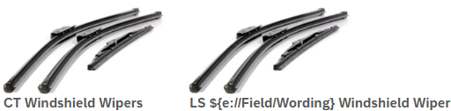
order counterbalanced

Wording = Green [Eco-friendly, Sustainable, Environmentally friendly, Earth-friendly, Environmentally conscious, Carbon-neutral, Eco-conscious, Planet-friendly, Climate-friendly]

Measures

Perceived Product Durability

We are now interested in your evaluation of the durability of the LS Green [Eco-friendly, Sustainable, Environmentally friendly, Earth-friendly, Environmentally conscious, Carbon-neutral, Eco-conscious, Planet-friendly, Climate-friendly] Windshield Wipers compared to the conventional pair the store offered.

Compared to the conventional CT Windshield Wipers, I expect that the LS Green [Eco-friendly, Sustainable, Environmentally friendly, Earth-friendly, Environmentally conscious, Carbon-neutral, Eco-conscious, Planet-friendly, Climate-friendly] Windshield Wipers are made to last longer.
Compared to the conventional CT Windshield Wipers, I expect that the LS Green [Eco-friendly, Sustainable, Environmentally friendly, Earth-friendly, Environmentally conscious, Carbon-neutral, Eco-conscious, Planet-friendly, Climate-friendly] Windshield Wipers will remain functional for a longer period.

Compared to the conventional CT Windshield Wipers, I expect that the LS Green [Eco-friendly, Sustainable, Environmentally friendly, Earth-friendly, Environmentally conscious, Carbon-neutral, Eco-conscious, Planet-friendly, Climate-friendly] Windshield Wipers are made to be more durable.
(1 = Not at all, 7 = Very much)

Comprehension Check

According to the scenario, to what extent were the windshield wipers in this study described as green [eco-friendly, sustainable, environmentally friendly, earth-friendly, environmentally conscious, carbon-neutral, eco-conscious, planet-friendly, climate-friendly]?
(1 = Not at all, 7 = Very much)

Pilot Study B

Cover Story

Imagine you take your car to the shop as you are experiencing visibility issues in rain. You know your wipers are problematic and you decide to get new windshield wipers.

The store offers two types of windshield wipers for your car.

order counterbalanced

Wording = Green [Sustainable]

Measures

We are now interested in your evaluation of the product performance [environmental-friendliness, durability, aesthetics] of the LS Green [Sustainable] Windshield Wipers compared to the conventional pair the store offered.

There will also be space to express any additional comments you might have afterward.

Condition: Perceived Product Performance

Compared to the conventional CT Windshield Wipers, I expect that the LS Green [Sustainable] Windshield Wipers will clear the windshield more completely.

Compared to the conventional CT Windshield Wipers, I expect that the LS Green [Sustainable] Windshield Wipers will leave fewer streaks or water spots.

Compared to the conventional CT Windshield Wipers, I expect that the LS Green [Sustainable] Windshield Wipers will move more smoothly across the glass without making squeaking or chattering sounds.
(1 = Not at all, 7 = Very much)

Condition: Perceived Environmental-Friendliness

Compared to the conventional CT Windshield Wipers, I expect that the LS Green [Sustainable] Windshield Wipers will be more environmentally friendly.
Compared to the conventional CT Windshield Wipers, I expect that the LS Green [Sustainable] Windshield Wipers will be less harmful to the environment.

Compared to the conventional CT Windshield Wipers, I expect that the LS Green [Sustainable] Windshield Wipers will be better for the environment.
(1 = Not at all, 7 = Very much)

Condition: Perceived Product Durability

Compared to the conventional CT Windshield Wipers, I expect that the LS Green [Sustainable] Windshield Wipers will clear the windshield more completely.

Compared to the conventional CT Windshield Wipers, I expect that the LS Green [Sustainable] Windshield Wipers will leave fewer streaks or water spots.

Compared to the conventional CT Windshield Wipers, I expect that the LS Green [Sustainable] Windshield Wipers will move more smoothly across the glass without making squeaking or chattering sounds.
(1 = Not at all, 7 = Very much)

Condition: Perceived Product Aesthetics

Compared to the conventional CT Windshield Wipers, I expect that the LS Green [Sustainable] Windshield Wipers will be more visually-appealing.

Compared to the conventional CT Windshield Wipers, I expect that the LS Green [Sustainable] Windshield Wipers will have a more beautiful design.

Compared to the conventional CT Windshield Wipers, I expect that the LS Green [Sustainable] Windshield Wipers will be better looking.
(1 = Not at all, 7 = Very much)

All conditions

Open Thought Protocol

What additional comments do you have about the LS Green [Sustainable] Windshield Wipers?

Comprehension Check

According to the scenario, to what extent were the windshield wipers in this study described as green [sustainable]?
(1 = Not at all, 7 = Very much)

What did you evaluate of the product?
(product performance, product environmental friendliness, product durability, product aesthetics, neither)

Pilot Study C
Pre-registered at https://aspredicted.org/iv3dh4.pdf

Cover Story

Imagine you take your car to the shop as you are experiencing visibility issues in rain. You know your wipers are problematic and you decide to get new windshield wipers.

The car shop offers a conventional [green, sustainable] pair of windshield wipers.
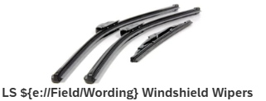

Wording = conventional [green, sustainable]

Measures

Perceived Product Durability

We are now interested in your evaluation of the durability of the LS Conventional [Green, Sustainable] Windshield Wipers.
Please think of them in comparison to the windshield wipers you normally buy.

I expect that the LS Conventional [Green, Sustainable] Windshield Wipers are made to last long.
I expect that the LS Conventional [Green, Sustainable] Windshield Wipers will remain functional for a long period.

I expect that the LS Conventional [Green, Sustainable] Windshield Wipers are made to be durable.
(1 = Strongly Disagree, 7 = Strongly Agree)

Comprehension Check

In the scenario you read, what WORD was used to describe the LS Windshield Wipers?
(1 = Definitely “GREEN”, 4 = “Conventional”, 7 = Definitely “SUSTAINABLE”)

Study 1A
Preregistered at https://aspredicted.org/n5fm-s3hh.pdf

Attention Check

It is very important that you take this survey on a laptop or a PC, NOT a cellphone.

We will ask you one question about Marshalls. Note that a lot of different facts can affect decisions consumers make. A key factor influencing decision is whether you, the decision maker, read and understand the decision making context carefully prior to making a decision. In order to demonstrate that you are reading the instructions carefully, please respond only to the item: “Ability to offer more discounted products than its competition” below, and respond by clicking the button for option “3” (Ignore the other two questions, by default responses are set to 1).

How would you rate the performance of the retailer Marshalls on the following aspects?

- Assortment variety
- Ability to offer more discounted products than its competition
- Ability to always have items in stock
(1 = Very bad, 2, 3, 4 = Neither bad nor good, 5, 6, 7 = Very good)

Cover Story

Imagine you take your bicycle [watch, tent] to Cycling [Watch, Camping] World as you are experiencing issues with your tire [strap, zipper]. You know your bicycle [watch, tent] tire [strap, zipper] is problematic and you decide to get a new one.

The store offers two types of bicycle [watch, tent] tire [strap, zipper]s for your bicycle [watch, tent]. They are presented below.

Measures

Product Choice

Which tire [strap, zipper] will you choose?

Product Condition: Bike Tire

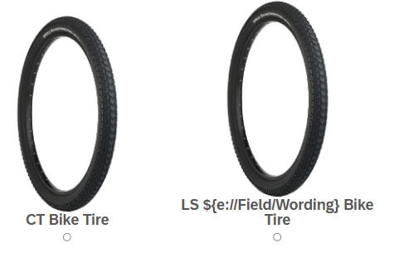
Wording = Green [Sustainable]

Product Condition: Watch Strap
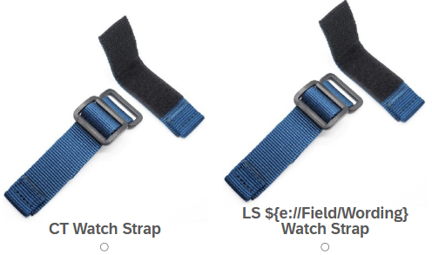
Wording = Green [Sustainable]

Product Condition: Tent Zipper

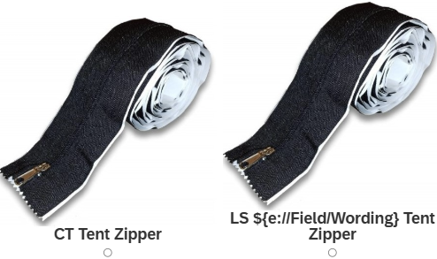
Wording = Green [Sustainable]

Comprehension Check

According to the scenario, to what extent was the LS product described as green [sustainable]? (1 = Not at all, 7 = Very much)

Study 1B
Pre-registered at https://aspredicted.org/6wt8zs.pdf.

Cover Story

In this research, we are studying how consumers evaluate and make decisions about a real umbrella brand.

Please read this information carefully, as you will be making a decision related to this umbrella brand later in the study, with real consequences for you. At the end of the study, 10 participants will be randomly selected to receive the umbrella they choose.

Please click the arrow below when you are ready to proceed.

[next screen]
This study is about consumers' interest in umbrellas. Imagine that you are looking for an umbrella.
Please click the arrow to proceed.

[next screen]
While looking for an umbrella, you see these two options: conventional or green [sustainable].

Measures

Product Choice

Which umbrella would you choose?
Take a moment to think about your choice!
This is a reminder that 10 participants will be randomly selected to receive the umbrella they choose.

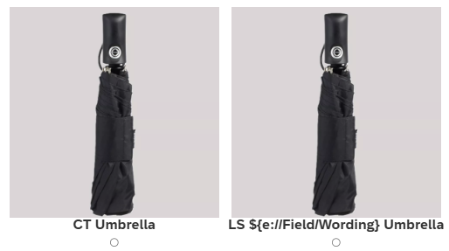
wording = green [sustainable]

Comprehension Check

In the scenario you read, what WORD was used to describe the LS Umbrella that was compared to the conventional CT Umbrella?
(1 = Definitely "GREEN", 7 = Definitely "SUSTAINABLE")

Study 2

Cover Story

Imagine you take your car to the shop as you are experiencing visibility issues in rain. You know your wipers are problematic and you decide to get new windshield wipers.

The car shop offers two types of windshield wipers: conventional or green [sustainable]. They are presented below.

Measures

Product Choice

Which pair of windshield wipers will you choose?

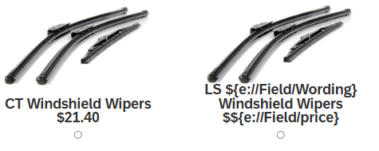

Wording = Green [Sustainable]
Price = 21.40 [24.60]

Process: Perceived Product Durability

We are now interested in your evaluation of the durability of the LS Green [Sustainable] Windshield Wipers compared to the conventional pair the store offered.

The following questions are about the LS Green [Sustainable] Windshield Wipers

Compared to the conventional CT Windshield Wipers, I expect that the LS Green [Sustainable] Windshield Wipers are made to last longer.
Compared to the conventional CT Windshield Wipers, I expect that the LS Green [Sustainable] Windshield Wipers will remain functional for a longer period.

Compared to the conventional CT Windshield Wipers, I expect that the LS Green [Sustainable] Windshield Wipers are made to be more durable.
(1 = Strongly Disagree, 7 = Strongly Agree)

Trait: Environmental Self-Identity

Please provide some information about yourself. To ensure the accuracy of our study, please answer genuinely and openly. Your honest responses are greatly appreciated, and there are no right or wrong answers.

Acting environmentally-friendly is an important part of who I am.
I am the type of person who acts environmentally-friendly.
I see myself as an environmentally-friendly person.
(1 = Strongly Disagree, 7 = Strongly Agree)

Comprehension Check

Compared to the CT Windshield Wipers, how much more expensive are the LS Green [Sustainable] Windshield Wipers?
(1 = Not much at all, 7 = Very much)

In the scenario you read, what WORD was used to describe the LS Windshield Wipers that were compared to the conventional CT Windshield Wipers?
(1 = Definitely "GREEN", 7 = Definitely "SUSTAINABLE")

Study 3
Preregistered at https://aspredicted.org/mt2jk4.pdf

Cover Story

Imagine you take your car to the shop as you are experiencing visibility issues in rain. You know your wipers are problematic and you decide to get new windshield wipers.

The car shop offers two types of windshield wipers: conventional or green [sustainable]. They are presented below.

Measures

Product Choice

Which pair of windshield wipers will you choose?

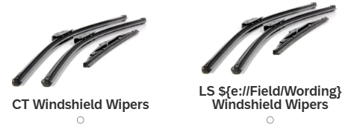

Wording = Green [Sustainable]

Process: Perceived Product Durability

We are now interested in your evaluation of the durability of the LS Green [Sustainable] Windshield Wipers compared to the conventional pair the store offered.

The following questions are about the LS Green [Sustainable] Windshield Wipers

Compared to the conventional CT Windshield Wipers, I expect that the LS Green [Sustainable] Windshield Wipers are made to last longer.
Compared to the conventional CT Windshield Wipers, I expect that the LS Green [Sustainable] Windshield Wipers will remain functional for a longer period.

Compared to the conventional CT Windshield Wipers, I expect that the LS Green [Sustainable] Windshield Wipers are made to be more durable.
(1 = Strongly Disagree, 7 = Strongly Agree)

Process: Long-Term Design Orientation

We are now interested in your evaluation in your evaluation of the product development process of the LS Green [Sustainable] Windshield Wipers compared to the conventional pair the store offered.

The following statements are about the LS Green [Sustainable] Windshield Wipers

Compared to the product development of the conventional CT Windshield Wipers, the development of the LS Green [Sustainable] Windshield Wipers focused on long-term outcomes rather than short-term payoffs.
Compared to the product development of the conventional CT Windshield Wipers, the conceptualization of the LS Green [Sustainable] Windshield Wipers was carried out to achieve results over a longer time horizon rather than quick gains.

Compared to the product development of the conventional CT Windshield Wipers, the LS Green [Sustainable] Windshield Wipers were designed with a long-term orientation in mind rather than focusing on immediate results.
(1 = Strongly Disagree, 7 = Strongly Agree)

Comprehension Check

In the scenario you read, what WORD was used to describe the LS Windshield Wipers that were compared to the conventional CT Windshield Wipers?
(1 = Definitely "GREEN", 7 = Definitely "SUSTAINABLE")

Study 4
Preregistered at https://aspredicted.org/h7g8pn.pdf

Cover Story

Imagine you take your watch to Watch World as you are experiencing issues with your strap. You know your watch strap is problematic and you decide to get a new one.

You see these two watch strap options: conventional or green [sustainable].

Measures

Product Choice

Which watch strap will you choose?

Wording = Green [Sustainable]
[Design Orientation Information = none]

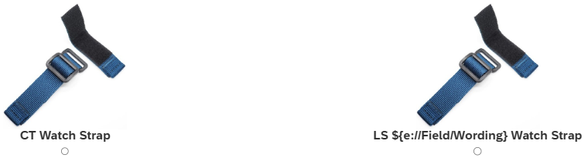

[Design Orientation Information = present]

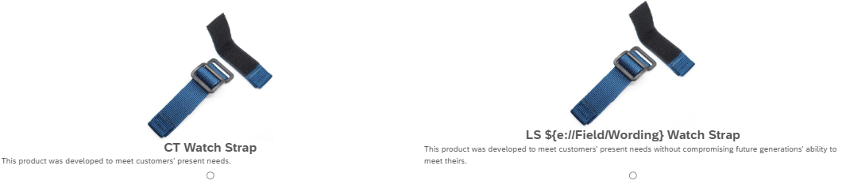
CT Watch Strap: “This product was developed to meet customers’ present needs.”
LS Green [Sustainable] Watch Strap: “This product was developed to meet customers’ present needs without compromising future generations’ ability to meet theirs.”

Process: Perceived Product Durability

We are now interested in your evaluation of the durability of the LS Green [Sustainable] Watch Strap compared to the conventional one the store offered.

The following questions are about the LS Green [Sustainable] Watch Strap

Compared to the conventional CT Watch Strap, I expect that the LS Green [Sustainable] Watch Strap is made to last longer.

Compared to the conventional CT Watch Strap, I expect that the LS Green [Sustainable] Watch Strap will remain functional for a longer period.

Compared to the conventional CT Watch Strap, I expect that the LS Green [Sustainable] Watch Strap is made to be more durable.
(1 = Strongly Disagree, 7 = Strongly Agree)

Comprehension Check

In the scenario you read, to what extent was the LS Watch Strap described as focusing on benefits for future generations compared to the conventional CT Watch Strap?
(1 = Not at all, 7 = Very much)

In the scenario you read, what WORD was used to describe the LS Watch Strap that was compared to the conventional CT Watch Strap?
(1 = Definitely "GREEN", 7 = Definitely "SUSTAINABLE")

Study 5A
Preregistered at https://aspredicted.org/f649-h5jr.pdf

Cover Story

Imagine you need an aluminum pan. You plan to use the pan only once [the same pan multiple times].

You see these two aluminum pan options: conventional or green [sustainable].

Measures

Product Choice

Which aluminum pan will you choose?

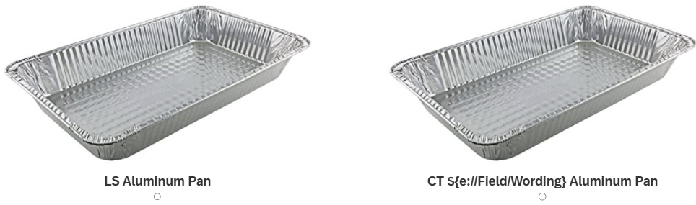

Wording = Green [Sustainable]

Comprehension Check

According to the scenario, how many times did you plan to use the aluminum pan?
(1 = Only once, 7 = Multiple times)

In the scenario you read, what WORD was used to describe the CT Aluminum Pan that was compared to the conventional LS Aluminum Pan?
(1 = Definitely "GREEN", 7 = Definitely "SUSTAINABLE")

Study 5B
Preregistered at https://aspredicted.org/rcr7-db6z.pdf

Cover Story

Imagine you take your phone to Phone World as you are experiencing issues with your screen. You know your screen protector is problematic and you decide to get a new one.

Condition: No guarantee provided

You see these two screen protector options: conventional or green [sustainable].

Condition: 5-year guarantee

You see these two screen protector options: conventional or green [sustainable].
The green [sustainable] option comes with 5-Year Durability Guarantee: Engineered to last longer than standard screen protectors.

Measures

Product Choice

Which screen protector will you choose?

Condition: No guarantee provided

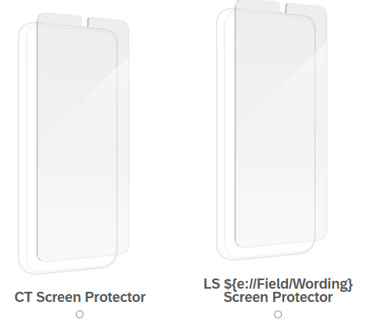
Condition: 5-year guarantee
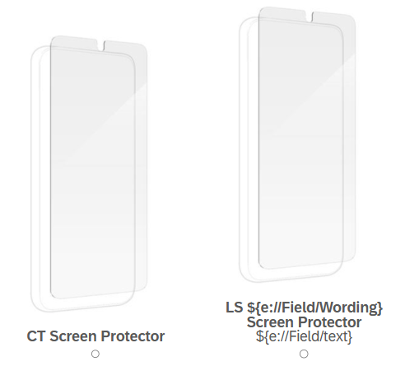
Wording = Green [Sustainable]

Text = 5-Year Durability Guarantee: Engineered to last longer than standard screen protectors

Comprehension Check

How long would you expect the LS Screen Protector is guaranteed to last?
(1 = Not long at all, 7 = Very long)

In the scenario you read, what WORD was used to describe the LS Screen Protector that was compared to the conventional CT Screen Protector?
(1 = Definitely "GREEN", 7 = Definitely "SUSTAINABLE")

Appendix D:

Supplementary Study – Exploring Green vs. Sustainable Label Choice

The goal of this supplemental study is twofold. Although consumers in typical retail settings are more likely to be presented with a choice between a conventional product and one featuring a planet-friendly label there may also be instances when they may have to compare between two planet-friendly alternatives. In this study we include a condition where we ask participants to directly compare between the sustainable and the green alternative. Second, we also provide additional evidence of our durability-based process. Based on our theorizing, the positive effect of a sustainable (vs. green) label occurs because the word sustainable inherently implies continuity and longevity, which are attributes that consumers typically value in durable products. If this is indeed the case, perceptions of product durability of sustainable-labeled products should exceed those of green-labeled products and influence participants’ choice.
Design and procedure
In this study, 496 undergraduate students (M_{age} = 19.58, 62% females) were randomly assigned to 3-cell (label: conventional relative to green vs. conventional relative to sustainable, vs. green relative to sustainable) between-subject design. Participants imagined taking their car to the shop because they had experienced issues with their windshield wipers and decided to get a new pair. The store offers two types of windshield wipers, both of which were presented with two identical-looking pictorial representations. However, the labels differed depending on the condition. While the conventional option was always labeled “CT Windshield Wipers,” the planet friendly options were “LS Green [Sustainable] Windshield Wipers” in the first two conditions. In the direct label comparison condition, we used the following labels “CT Green Windshield Wipers” and “LS Sustainable Windshield Wipers.” We counterbalanced the presentation order in all three conditions.
After choosing a windshield wiper of their choice, participants in the first two conditions responded to three questions designed to capture product durability perceptions of the eco-friendly product. We averaged these to create a durability scale (α = .91): “To what extent do you think the LS Green [Sustainable] Windshield Wipers are made to last?” (1 = Not made to last at all, 7 = Very much made to last), “How long will the LS Green [Sustainable] Windshield Wipers remain functional?” (1 = Not long at all, 7 = Very long), “How confident are you that the LS Green [Sustainable] Windshield Wipers are made to be durable?” (1 = Not confident at all, 7 = Very confident). In the third condition too, we measured durability perceptions. However, because in this condition two eco-friendly products were pitted against each other, we randomized the product durability questions such roughly half of the participants answered questions referencing the green product while or sustainable product such that participants only answered the durability question for one of the two planet-friendly alternatives. Finally, participants in the first two conditions rated the extent to which the focal product of the study was described as green [sustainable] (1 = Not at all, 7 = Very much) while those in the third condition (green vs. sustainable) indicated whether the focal product of the durability measures was green or sustainable on bipolar scale ends (1 = Green, 7 = Sustainable).
Results and discussion
Comprehension Check. We confirmed the success of our manipulation as participants recognized the labels correctly in the conventional choice scenario conditions $(M_{green}=4.31, SD=1.71, t\left(123\right)=5.318, p<.001, d= 0.474; M_{sustainable}=5.26, SD=1.39, t\left(123\right)=14.081, p<.001, d= 1.265$). In the green-sustainable choice condition, participants also successfully matched the label with the focal product they were questioned about $\left(M_{green}=3.82, SD=1.85 vs. M_{sustainable}=5.56, SD=1.42; F\left(1, 249\right)=69.623, p<.001, η^{2}= .219\right)$.
Product Choice. A binary logistic regression (1 = chose labeled product (green/ sustainable for conditions 1 and 2, sustainable for condition 3), 0 = chose conventional alternative for conditions 1 and 2, green for condition 3) revealed a significant effect of label condition (0 = green vs conventional, 1 = sustainable vs. conventional, 2 = green vs. sustainable) on choice ($χ^{2}\left(2\right)=74.070, p<.001, φ=.386).$ Consistent with prior findings, participants were more likely to choose the sustainable wipers relative to the conventional ones (68.5%) than they were to choose the green wipers relative to the conventional ones (44.4%). In line with our prediction, results indicated a main effect of label condition (B = 1.00, SE = .26, Wald $χ^{2}=14.44, p<.001;OddsRatio=2.72)$ such that the odds of picking the labeled wipers were doubled under the sustainable label than under the green label.
When the sustainable option was directly pitted against the green option, the odds of choosing sustainable (86.8%) were over eight times higher than the odds of choosing green (13.2%. see Figure 1) (B = 2.11, SE = .26, Wald $χ^{2}=66.18, p<.001;OddsRatio=$8.22). Choice did not underlie any display order effect of choice presentation (Wald χ²(2) = 0.15, p = .93).

Figure 1: Choice Share of Planet-Friendly Products
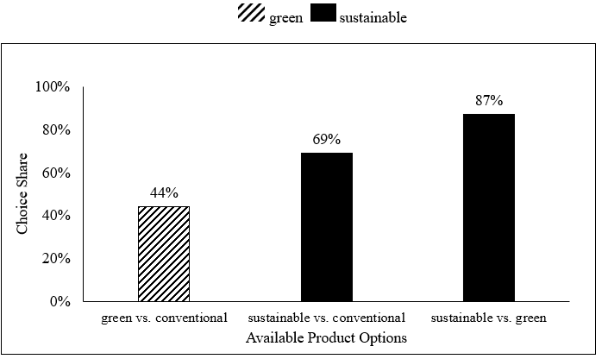
Perceived Product Durability. As expected, in the relative conditions, the sustainable windshield wipers were perceived as more durable than the green wipers $\left(M_{green}=4.36, SD=1.22 vs. M_{sustainable}=4.75, SD=1.25; F\left(1, 248\right)=5.957, p=.015, η^{2}= .023\right).$ A similar result emerged in the direct choice conditions: participants also rated the sustainable windshield wiper pair as more durable than the green one $\left(M_{green}=3.97, SD=1.12 vs. M_{sustainable}=5.12, SD=1.19; F\left(1, 249\right)=62.518, p<.001, η^{2}= .201\right)$.
Mediation Analysis. We treated label as a four-level independent variable with the conventional vs. green choice as baseline and report relative indirect effects of label on product choice mediated by durability. As predicted, perceived product durability mediated the effect of sustainable labels on the labeled product choice $(Compared to conventional vs. sustainable: b= .33, SE=.15, {CI}_{95}=\left[.057;.640\right]; Compared to green vs. sustainable: b= -.34, SE=.15, {CI}_{95}=\left[-.67;-.088\right]; Compared to sustainable vs. green: b= .65, SE=.17, {CI}_{95}=[.364;1.024])$ using Process (v 4.2) Model 4 (Hayes, 2022).
Discussion. Replicating previous results, this study demonstrates the strong preference a sustainable over green choice alternative offers. Moreover, we show that the effect is even stronger when consumers directly compare green and sustainable product alternatives and that perceived product durability drives the effect.

Experimental Stimuli

Cover Story

Imagine you take your car to the shop as you are experiencing visibility issues in rain. You know your wipers are problematic and you decide to get new windshield wipers.

The car shop offers two types of windshield wipers for your car. They are presented below.

Measures

Product Choice

Which pair of windshield wipers will you choose?

Conditions Label = Green or Sustainable

Wording = Green [Sustainable]

Conditions Label = Green vs. Sustainable

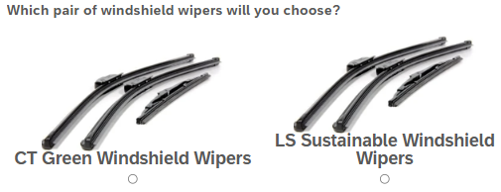
Order counterbalanced

Process: Perceived Product Durability

The following questions are about the LS Green [Sustainable] Windshield Wipers

Compared to the conventional CT Windshield Wipers, I expect that the LS Green [Sustainable] Windshield Wipers are made to last longer.
(1 = Not made to last at all, 7 = Very much made to last)

Compared to the conventional CT Windshield Wipers, I expect that the LS Green [Sustainable] Windshield Wipers will remain functional for a longer period.
(1 = Not long at all, 7 = Very long)

Compared to the conventional CT Windshield Wipers, I expect that the LS Green [Sustainable] Windshield Wipers are made to be more durable.
(1 = Not confident at all, 7 = Very confident)

Comprehension Check

Conditions Label = Green or Sustainable
According to the scenario, to what extent was the focal product in this study described as green [sustainable]?
(1 = Not at all, 7 = Very much)

Conditions Label = Green vs. Sustainable

According to the scenario, to what extent was the focal product in this study described as …
(1 = Green, 7 = Sustainable)

Supplementary Study – Exploring Green vs. Sustainable Label Choice, resembling a realistic Amazon Offer

Whereas most of our studies present consumers with a choice between a conventional product and a planet-friendly alternative, real-world retail environments often involve richer decision contexts where brand, price, and attribute cues vie for attention. To test the robustness of our effect under such conditions, we embed the sustainable versus green manipulation in realistic Amazon-style product listings containing product information, brand names, and imagery. Because the planet-friendly label appears only once within a dense attribute list, this setting provides a more conservative test of whether a sustainable label continues to impact consumer choice when competing with other diagnostic attributes.
Design and procedure
In this study, 401 undergraduate students (M_{age} = 19.93, 63% females, 84% White) were randomly assigned to a 2-cell (label: sustainable vs. green) between-subject design. Participants imagined taking their car to the shop because they had experienced issues with their windshield wipers and decided to get a new pair that they could directly order from Amazon. They were then presented with two Amazon storefront offers for windshield wipers: (1) AUTOVUU and (2) AUTEGAE. Both storefronts resembled an existing windshield wiper offer on Amazon with product attributes such as price, return policies, size, brand, fit type, item length, and mounting type. The only way they differed was that the AUTOVUU brand storefront listed the wipers as “26” and 18” Windshield Wipers Blades (Pack of 2),OEM Quality Premium All-Seasons Wiper blades,Stable and Quiet Armor wiper blades,Classic” while we replaced the “Classic” for the AUTEGAE offer with “Sustainable” [“Green”]. Upon inspection, participants then indicated whether they would choose the AUTOVUU or AUTEGAE pair of windshield wipers, suggesting a conservative test of the sustainable edge effect. The store offers two types of windshield wipers, both of which were presented with two identical-looking pictorial representations. However, the labels differed depending on the condition. While the conventional option was always labeled “CT Windshield Wipers,” the planet friendly options were “LS Green [Sustainable] Windshield Wipers” in the first two conditions. In the direct label comparison condition, we used the following labels “CT Green Windshield Wipers” and “LS Sustainable Windshield Wipers.” We counterbalanced the presentation order in all three conditions.
Finally, participants rated the extent to which the AUTEGAE windshield wipers were described as green [sustainable] (1 = Definitely “GREEN”, 7 = Definitely “SUSTAINABLE”).

Results and discussion
Comprehension Check. We confirmed the success of our manipulation as participants recognized the labels correctly $(M_{green}=3.13, SD=2.16 vs. M_{sustainable}=5.86, SD=1.40, F\left(1,400\right)=226.44, p<.001, η^{2}=.36$).
Product Choice. A binary logistic regression (1 = conventional product, 2 = sustainable/ green product) revealed a significant effect of label condition (1 = green, 2 = sustainable) on choice (B = 1.38, SE = .21, Wald $χ^{2}=41.58, p<.001;OddsRatio=3.96)$. Consistent with prior findings, participants were 3.96 times more likely to choose the sustainable wipers relative to the conventional ones (72%) than they were to choose the green wipers relative to the conventional ones (39%).
Discussion. The results of this high-realism study reaffirm the robustness of the sustainable edge effect. Even when the sustainable label was embedded within a set of product attributes, participants were four times more likely to choose the sustainable labeled option than the green-labeled one. This pattern mirrors the results from our other studies, demonstrating that the semantic meaning of sustainable exerts influence on consumer choice even when competing with numerous realistic marketplace cues. These findings strengthen the external validity of our account and show that the sustainable label advantage persists in a setting that closely resembles an actual online shopping environment.

Experimental Stimuli

Cover Story

Imagine you take your car to the shop as you are experiencing visibility issues in rain. You know your wipers are problematic and you decide to get new windshield wipers.

The car shop offers two types of windshield wipers, directly available through amazon: conventional or green [sustainable].

Measures

Product Choice

Which pair of windshield wipers will you choose?

Label Condition = Green

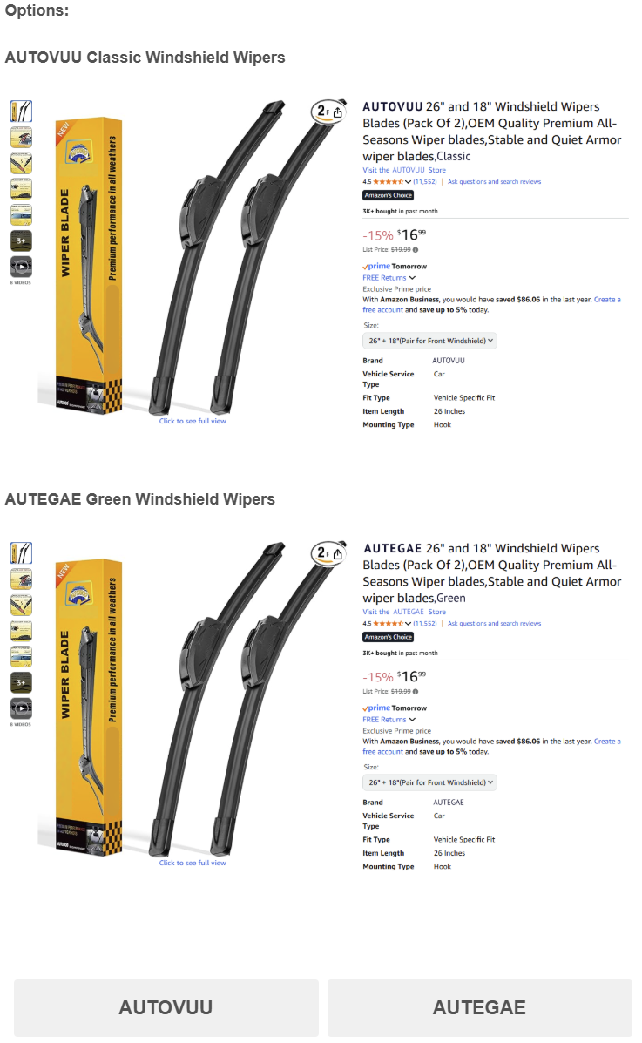
Label Condition = Sustainable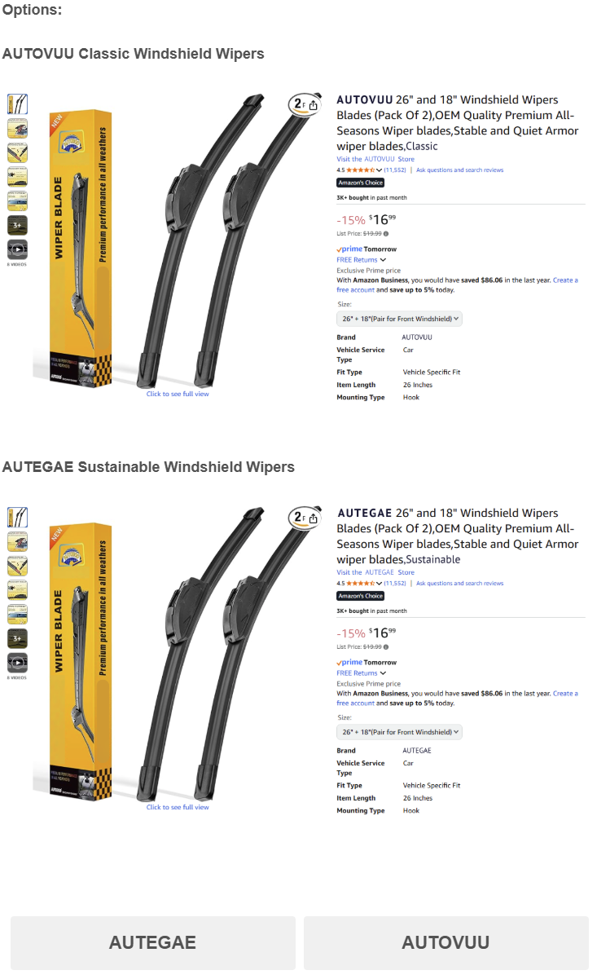

Comprehension Check

In the scenario you read, what WORD was used to describe the AUTEGAE Windshield Wipers that were compared to the conventional AUTOVUU Windshield Wipers?
(1 = Definitely “GREEN”, 7 = Definitely “SUSTAINABLE”)

Supplementary Study – Exploring Green vs. Sustainable Label Choice for a Consumable

The purpose of this study is twofold. First, we extend the sustainable edge effect from consumer durables to a consumable product for which longevity may be an important factor—in this case, an anti-itch cream. Second, we want to test whether the effect occurs even with a more subtle label manipulation in which the sustainable versus green label is embedded in the product description rather than in the more visible product title.
Design and procedure
In total, 406 CloudResearch Connect workers completed this study. Seven observations from three participants who completed the study multiple times were excluded, yielding a remaining sample of 399 participants (M_{age} = 35.82, 55% females, 68% white) who completed this single factor between-participants study (label: sustainable vs. green). We informed participants that they needed to purchase an anti-itch cream and presented them with two options, the “LS Anti-Itchy Cream” and the “CT Anti-Itchy Cream.” Both options were presented with an identical picture of a cream. The “LS” cream served as the conventional product alternative and was described identically in both conditions: “This cream isn't just about providing relief from itching caused by dryness, allergies, and bug bites; it's a statement of our dedication to delivering high-quality skincare.” We manipulated the “CT” cream’s description as follows: “This sustainable [green] cream isn't just about providing relief from itching caused by dryness, allergies, and bug bites; it's a statement of our dedication to delivering high-quality skincare.”
We then asked participants which anti-itchy cream they would choose. Finally, participants rated what word was used to describe the CT Anti-Itchy Cream that was compared to the conventional LS Anti-Itchy Cream (1 = Definitely green, 7 = Definitely sustainable).
Results and discussion
Comprehension check As expected, participants in the sustainable (green) condition were more likely to agree that the word used to describe the anti-itch cream was sustainable (green), thus confirming the success of the manipulation (M_{sustainable} = 6.62, SD = 1.00 vs. M_{green} = 1.51, SD = 1.33; F(1, 398) = 1872.26, p < .001, η² = .83).
Product choice We ran a logistic regression on choice (0 = chose conventional product, 1 = chose planet-friendly product) with label as the independent variable. As predicted, a main effect of label emerged (B = 1.11, SE = .21, Wald χ² = 27.60, p < .001), such that sustainable (vs. green) labels of products significantly increased the likelihood of choosing the planet-friendly product (Sustainable = 71%; Green = 44%; χ² = 28.38, p < .001, φ = .27).
Experimental Stimuli

Cover Story

Imagine needing anti-itch cream.

You see these two anti-itch cream options: conventional or green [sustainable].

Measures

Product Choice

Imagine needing anti-itch cream.

Which anti-itchy cream will you choose?
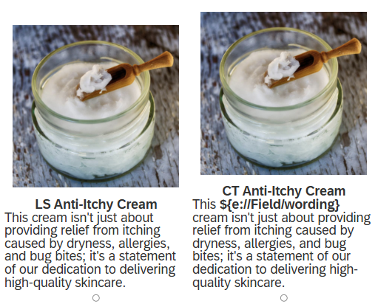
wording = green [sustainable]

Comprehension Check

In the scenario you read, what WORD was used to describe the CT Anti-Itchy Cream that was compared to the conventional LS Anti-Itchy Cream? (1 = Definitely "GREEN", 7 = Definitely "SUSTAINABLE")

References

Gal, D., & Rucker, D. D. (2011). Answering the Unasked Question: Response Substitution in Consumer Surveys. Journal of Marketing Research, 48(1), 185–195. https://doi.org/10.1509/jmkr.48.1.185
Hayes, A. F. (2022). Introduction to Mediation, Moderation, and Conditional Process Analysis: A Regression-Based Approach (Vol. 3). Guilford Publications. https://www.guilford.com/books/Introduction-to-Mediation-Moderation-and-Conditional-Process-Analysis/Andrew-Hayes/9781462549030

