Responses of selected beetle families (Carabidae, Chrysomelidae, Curculionidae) to non-crop habitats in an agricultural landscape

Biologia

Tamara Rischen* • Kim Ehringhausen • Maya Heyer • Klaus Fischer

Institute of Integrated Natural Sciences, Department Biology, Koblenz-Landau University, D-56070 Koblenz, Germany
E-Mail: tamararischen@uni-koblenz.de
Online resource (S)
Table S1 Coordinates of study sites for the four land use types.
Field margin (n = 9) | Grassland fallow (n = 9)
50°16'31.9"N 7°21'11.0"E | 50°17'10.5"N 7°22'09.8"E
50°16'53.6"N 7°21'24.8"E | 50°17'10.7"N 7°22'01.7"E
50°17'07.5"N 7°21'37.9"E | 50°17'08.3"N 7°22'19.6"E
50°17'17.0"N 7°21'38.4"E | 50°16'59.2"N 7°21'27.9"E
50°17'52.7"N 7°22'10.7"E | 50°17'07.8"N 7°21'43.5"E
50°17'57.2"N 7°22'19.4"E | 50°16'35.1"N 7°17'55.7"E
50°18'04.2"N 7°22'31.9"E | 50°16'37.3"N 7°17'55.4"E
50°18'10.0"N 7°22'43.1"E | 50°16'54.1"N 7°17'30.0"E
50°18'49.9"N 7°23'56.3"E | 50°16'44.6"N 7°18'09.2"E
Power pole island (n = 9) | Wheat field (n = 9)
50°16'32.3"N 7°21'10.0"E | 50°17'11.3"N 7°22'08.5"E
50°16'53.1"N 7°21'23.9"E | 50°17'12.7"N 7°22'00.7"E
50°17'05.5"N 7°21'32.7"E | 50°17'09.0"N 7°22'20.9"E
50°17'16.3"N 7°21'39.8"E | 50°16'58.9"N 7°21'25.6"E
50°17'52.9"N 7°22'11.2"E | 50°17'08.9"N 7°21'42.5"E
50°17'57.0"N 7°22'20.9"E | 50°16'36.6"N 7°17'51.4"E
50°18'03.4"N 7°22'30.9"E | 50°16'38.6"N 7°18'01.4"E
50°18'10.2"N 7°22'44.2"E | 50°16'52.6"N 7°17'32.5"E
50°18'50.4"N 7°23'58.7"E | 50°16'47.2"N 7°18'06.9"E

Table S2 Results of ANCOVAs for the effects of habitat type and plot shape on species number and effective species number (ENS) as well as plot size on community weighted mean (CWM) body size of beetles captured by suction sampling (Chrysomelidae and Curculionidae).

Suction sampling | Factor | DF | MS | F | p
Species number | Habitat type | 3,32 | 0.83 | 0.23 | 0.88
 | Plot shape | 1,32 | 1.23 | 0.15 | 0.67
ENS | Habitat type | 3,32 | 0.18 | 0.09 | 0.76
 | Plot shape | 1,32 | 0.48 | 0.26 | 0.86
CWM body size | Habitat type | 3,32 | 5.14 | 2.99 | 0.09
 | Plot size | 1,32 | 0.31 | 0.18 | 0.91

Table S3 Results of spatial autocorrelation using Moran’s I tests (ape-package; Dormann et al. 2007; Paradis and Schliep 2019) for various variables for beetles captured by pitfall trapping (Carabidae) or suction sampling (Chrysomelidae and Curculionidae). ENS: effective number of species; CWM: community weighted mean; SD: standard deviation.

Pitfall trapping | Observed value | Expected value | SD | p-value
Species number | -0.02 | -0.03 | 0.03 | 0.66
Number of individuals | -0.02 | -0.03 | 0.03 | 0.72
ENS | -0.05 | -0.03 | 0.03 | 0.47
Rarefied species | -0.02 | -0.03 | 0.03 | 0.84
CWM body size | -0.05 | -0.03 | 0.03 | 0.40
Suction sampling | Observed value | Expected value | SD | p-value
Species number | -0.06 | -0.03 | 0.03 | 0.29
Number of individuals | -0.03 | -0.03 | 0.02 | 0.84
ENS | -0.06 | -0.03 | 0.03 | 0.23
CWM body size | -0.02 | -0.03 | 0.03 | 0.81

Table S4 List of beetle species sampled by pitfall trapping (a; Carabidae) and suction sampling (b; Chrysomelidae; c; Curculionidae) including numbers of individuals across different habitat types, total number of individuals, and percentage of all individuals.

Table A4a

Carabidae
Species | Wheat field | Field margin | Power pole island | Grassland fallow | Sum | Percentage %
Acupalpus flavicollis | 0 | 0 | 0 | 2 | 2 | 0.04
Acupalpus meridianus | 0 | 0 | 1 | 0 | 1 | 0.02
Agonum viduum | 28 | 0 | 0 | 266 | 294 | 5.35
Amara aenea | 1 | 6 | 1 | 1 | 9 | 0.16
Amara apricaria | 1 | 2 | 4 | 0 | 7 | 0.13
Amara aulica | 1 | 0 | 2 | 0 | 3 | 0.05
Amara consularis | 7 | 1 | 0 | 0 | 8 | 0.15
Amara convexior | 0 | 24 | 2 | 1 | 27 | 0.49
Amara familiaris | 2 | 11 | 0 | 2 | 15 | 0.27
Amara lunicollis | 4 | 0 | 0 | 2 | 6 | 0.11
Amara ovata | 0 | 4 | 2 | 1 | 7 | 0.13
Amara plebeja | 2 | 4 | 4 | 1 | 11 | 0.20
Amara similata | 1 | 1 | 0 | 0 | 2 | 0.04
Anchomenus dorsalis | 238 | 147 | 231 | 4 | 620 | 11.29
Anisodactylus binotatus | 0 | 0 | 1 | 3 | 4 | 0.07
Asaphidion flavipes | 1 | 3 | 0 | 0 | 4 | 0.07
Badister bullatus | 0 | 0 | 0 | 8 | 8 | 0.15
Bembidion assimile | 3 | 0 | 0 | 3 | 6 | 0.11
Bembidion lampros | 54 | 152 | 26 | 22 | 254 | 4.63
Bembidion obtusum | 16 | 3 | 1 | 2 | 22 | 0.40
Bembidion tetracolum | 1 | 1 | 0 | 0 | 2 | 0.04
Brachinus explodens | 0 | 123 | 483 | 10 | 616 | 11.22
Calathus cinctus | 0 | 1 | 1 | 0 | 2 | 0.04
Calathus fuscipes | 41 | 115 | 21 | 3 | 180 | 3.28
Carabus auratus | 14 | 8 | 0 | 67 | 89 | 1.62
Carabus convexus | 3 | 0 | 0 | 0 | 3 | 0.05
Carabus coriaceus | 2 | 0 | 0 | 2 | 4 | 0.07
Carabus granulatus | 4 | 0 | 0 | 87 | 91 | 1.66
Carabus nemoralis | 2 | 0 | 0 | 10 | 12 | 0.22
Chlaenius nigricornis | 3 | 0 | 0 | 12 | 15 | 0.27
Clivina fossor | 1 | 0 | 0 | 2 | 3 | 0.05
Demetrias atricapillus | 6 | 2 | 0 | 1 | 9 | 0.16
Europhilus micans | 0 | 0 | 0 | 4 | 4 | 0.07
Harpalus affinis | 14 | 114 | 25 | 0 | 153 | 2.79
Harpalus dimidiatus | 4 | 10 | 2 | 1 | 17 | 0.31
Harpalus distinguendus | 0 | 1 | 1 | 1 | 3 | 0.05
Harpalus froelichii | 3 | 1 | 1 | 4 | 9 | 0.16
Harpalus hirtipes | 2 | 4 | 0 | 5 | 11 | 0.20
Harpalus latus | 6 | 5 | 2 | 1 | 14 | 0.25
Harpalus melancholicus | 6 | 1 | 0 | 1 | 8 | 0.15
Harpalus rubripes | 1 | 0 | 0 | 0 | 1 | 0.02
Harpalus rufipes | 8 | 57 | 95 | 1 | 161 | 2.93
Harpalus serripes | 0 | 2 | 0 | 0 | 2 | 0.04
Harpalus smaragdinus | 1 | 1 | 0 | 0 | 2 | 0.04
Harpalus tardus | 3 | 6 | 2 | 5 | 16 | 0.29
Loricera pilicornis | 3 | 0 | 0 | 0 | 3 | 0.05
Microlestes minutulus | 0 | 11 | 3 | 23 | 37 | 0.67
Nebria brevicollis | 21 | 5 | 35 | 0 | 61 | 1.11
Nebria salina | 403 | 104 | 522 | 5 | 1034 | 18.83
Notiophilus aestuans | 1 | 2 | 1 | 0 | 4 | 0.07
Notiophilus biguttatus | 7 | 4 | 6 | 0 | 17 | 0.31
Oodes helopioides | 0 | 0 | 0 | 18 | 18 | 0.33
Ophonus ardosiacus | 0 | 0 | 11 | 0 | 11 | 0.20
Ophonus azureus | 3 | 0 | 0 | 0 | 3 | 0.05
Ophonus rufibarbis | 8 | 0 | 1 | 0 | 9 | 0.16
Oxypselaphus obscurus | 1 | 0 | 0 | 0 | 1 | 0.02
Panagaeus bipustulatus | 0 | 0 | 0 | 1 | 1 | 0.02
Paratachys bistriatus | 3 | 0 | 2 | 2 | 7 | 0.13
Philochthus biguttatum | 1 | 0 | 0 | 32 | 33 | 0.60
Poecilus cupreus | 140 | 167 | 114 | 4 | 425 | 7.74
Poecilus versicolor | 16 | 10 | 4 | 9 | 39 | 0.71
Pseudoophonus griseus | 0 | 0 | 1 | 0 | 1 | 0.02
Pterostichus anthracinus | 0 | 0 | 0 | 16 | 16 | 0.29
Pterostichus madidus | 1 | 1 | 0 | 50 | 52 | 0.95
Pterostichus melanarius | 198 | 229 | 309 | 40 | 776 | 14.13
Pterostichus pumilio | 12 | 2 | 8 | 7 | 29 | 0.53
Pterostichus strenuus | 57 | 0 | 2 | 8 | 67 | 1.22
Semiophonus signaticornis | 4 | 0 | 0 | 0 | 4 | 0.07
Stomis pumicatus | 1 | 1 | 9 | 2 | 13 | 0.24
Trechus quadristriatus | 88 | 4 | 1 | 0 | 93 | 1.69

Table S4b
Chrysomelidae
Species | Wheat field | Field margin | Power pole island | Grassland fallow | Sum | Percentage %
Cassida rubiginosa | 0 | 0 | 1 | 0 | 1 | 0.46
Chaetocnema concinna | 0 | 0 | 1 | 0 | 1 | 0.46
Chaetocnema hortensis | 1 | 1 | 0 | 0 | 2 | 0.91
Cryptocephalus moraei | 0 | 1 | 0 | 0 | 1 | 0.46
Hippuriphila modeeri | 0 | 0 | 0 | 3 | 3 | 1.37
Hispa atra | 2 | 0 | 1 | 1 | 4 | 1.83
Longitarsus anchusae | 0 | 0 | 0 | 1 | 1 | 0.46
Longitarsus brunneus | 0 | 0 | 0 | 1 | 1 | 0.46
Longitarsus exoletus | 0 | 1 | 2 | 0 | 3 | 1.37
Longitarsus jacobaeae | 1 | 0 | 0 | 4 | 5 | 2.28
Longitarsus melanocephalus | 1 | 0 | 0 | 0 | 1 | 0.46
Longitarsus succineus | 0 | 0 | 0 | 14 | 14 | 6.39
Neocrepidodera ferruginea | 0 | 2 | 2 | 0 | 4 | 1.83
Neocrepidodera transversa | 0 | 1 | 3 | 0 | 4 | 1.83
Oulema gallaeciana | 5 | 0 | 0 | 0 | 5 | 2.28
Oulema melanopus | 6 | 2 | 3 | 0 | 11 | 5.02
Phyllotreta atra | 0 | 4 | 1 | 0 | 5 | 2.28
Phyllotreta nigripes | 0 | 8 | 0 | 0 | 8 | 3.65
Phyllotreta ochripes | 0 | 0 | 0 | 1 | 1 | 0.46
Phyllotreta vittula | 0 | 2 | 1 | 0 | 3 | 1.37
Podagrica fuscicornis | 0 | 2 | 7 | 0 | 9 | 4.11
Psylliodes chrysocephala | 0 | 1 | 0 | 0 | 1 | 0.46
Sphaeroderma rubidium | 0 | 3 | 3 | 0 | 6 | 2.74

Table S4c
Curculionidae
Species | Wheat field | Field margin | Power pole island | Grassland fallow | Sum | Percentage %
Aspidapion aeneum | 0 | 0 | 2 | 0 | 2 | 0.91
Aspidapion radiolus | 0 | 0 | 3 | 0 | 3 | 1.37
Aulacobaris coerulescens | 0 | 1 | 0 | 1 | 2 | 0.91
Ceratapion gibbirostre | 0 | 0 | 3 | 0 | 3 | 1.37
Ceutorhynchus alliariae | 0 | 3 | 0 | 2 | 5 | 2.28
Ceutorhynchus pallidactylus | 0 | 2 | 0 | 0 | 2 | 0.91
Ceutorhynchus picitarsis | 0 | 2 | 0 | 0 | 2 | 0.91
Coeliodes ruber | 0 | 2 | 0 | 0 | 2 | 0.91
Eusomus ovulum | 0 | 7 | 0 | 2 | 9 | 4.11
Exomias pellucidus | 0 | 1 | 0 | 1 | 2 | 0.91
Hypera rumicis | 0 | 0 | 1 | 0 | 1 | 0.46
Kalcapion semivittatum | 0 | 1 | 0 | 0 | 1 | 0.46
Malvapion malvae | 0 | 0 | 20 | 0 | 20 | 9.13
Nedyus quadrimaculatus | 0 | 0 | 1 | 8 | 9 | 4.11
Parethelcus pollinarius | 0 | 0 | 10 | 1 | 11 | 5.02
Phyllobius argentatus | 1 | 0 | 0 | 1 | 2 | 0.91
Phyllobius pomaceus | 0 | 0 | 0 | 3 | 3 | 1.37
Phyllobius roboretanus | 0 | 0 | 0 | 2 | 2 | 0.91
Pseudoperapion brevirostre | 0 | 0 | 0 | 2 | 2 | 0.91
Pseudostyphlus pillumus | 0 | 1 | 1 | 0 | 2 | 0.91
Rhinoncus pericarpius | 0 | 1 | 2 | 0 | 3 | 1.37
Sitona lineatus | 0 | 1 | 1 | 0 | 2 | 0.91
Stenocarus ruficornis | 0 | 1 | 0 | 0 | 1 | 0.46
Taeniapion urticarium | 0 | 0 | 1 | 2 | 3 | 1.37
Trachyphloeus bifoveolatus | 0 | 0 | 0 | 7 | 7 | 3.20
Tychius breviusculus | 0 | 21 | 3 | 0 | 24 | 10.96

Figure S1 Numbers of species and individuals and effective number of species (ENS) of Chrysomelidae and Curculionidae captured by suction sampling across four habitat types. Boxplots display the interquartile range (25-75%; box) and the median (line in the box). Whiskers represent 1.5 times the lower or upper interquartile range. No significant differences among habitat types were found (multiple comparisons after Kruskal-Wallis ANOVAs; n = 9 plots each).

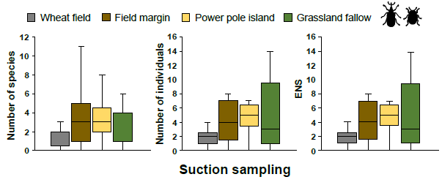

Figure S2 CWM body sizes of Carabidae captured by pitfall trapping (a) and Chrysomelidae and Curculionidae captured by suction sampling (b) across four habitat types. Boxplots display the interquartile range (25-75%; box) and the median (line in the box). Whiskers represent 1.5 times the lower or upper interquartile range. No significant differences among habitat types were found (multiple comparisons after Kruskal-Wallis ANOVAs; n = 9 plots each).

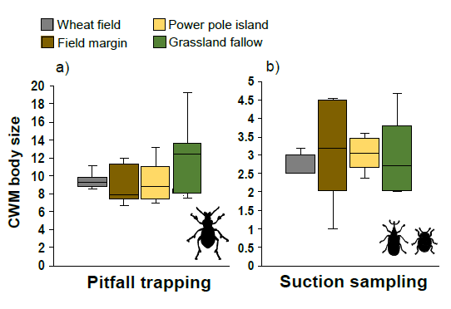
Figure S3 Plot size (a) and shape (b) for wheat fields (W), field margins (M), power pole islands (I), and grassland fallows (F). Boxplots display the interquartile range (25-75%; box) and the median (line in the box). Whiskers represent 1.5 times the lower or upper interquartile range. Different letters above bars indicate significant differences among habitat types (multiple comparisons after Kruskal-Wallis ANOVAs; n = 9 plots each).

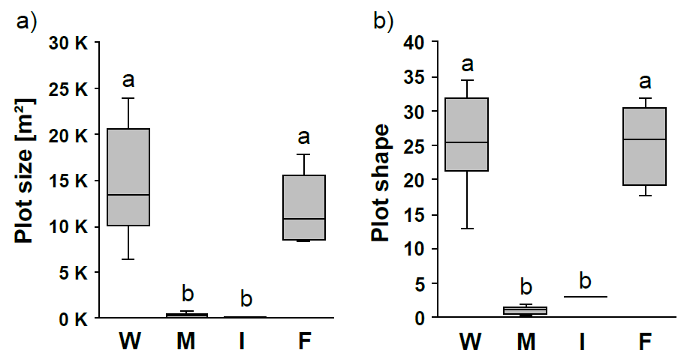

References
Dormann CF, McPherson JM, B. Araújo M, et al (2007) Methods to account for spatial autocorrelation in the analysis of species distributional data: a review. Ecography (Cop) 30:609–628. https://doi.org/10.1111/j.2007.0906-7590.05171.x
Paradis E, Schliep K (2019) ape 5.0: an environment for modern phylogenetics and evolutionary analyses in R. Bioinformatics 35:526–528. https://doi.org/10.1093/bioinformatics/bty633

