Heavy rainfall induced colony fission and nest relocation in nocturnal bull ants (Myrmecia midas)

Sudhakar Deeti¹, Isaac Tjung¹, Cody Freas¹, Trevor Murray¹, Ken Cheng¹

¹ School of Natural Sciences, Macquarie University, Sydney, NSW 2109, Australia
Email: sudhadeeti@gmail.com

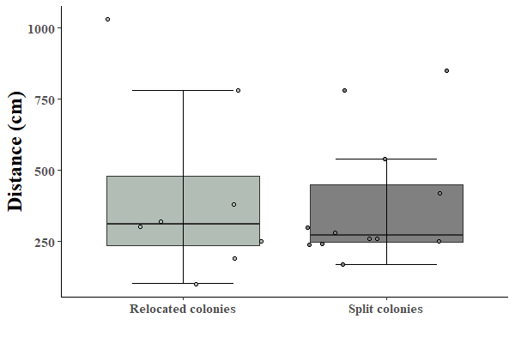
250
500
750
1000
Relocated colonies
Split colonies
Distance (cm)

Online resource 1: Fig. S1. The distance between the old colony entrances and new colony entrances of relocated and split colonies. The boxes indicate the lower and upper quartiles, the black horizontal lines within the boxes indicate medians, and whiskers extend to 1.5 times the interquartile range.

