Supplementary Information

Morphology and habitat of Euglesa casertana populations in Yakushima Island, Japan, with implications for its taxonomic status (Mollusca: Sphaeriidae)

Naoto Sawada¹, Sukenobu Konishi², Aya Ueno³, Shun Ito⁴, Yasuto Ishii^{5,6}, Takumi Saito⁷, Osamu Kagawa^{8,9}
¹ Department of Biological Sciences, School of Science, the University of Tokyo, Hongo, Bunkyo-ku, Tokyo 113-0033, Japan
² Koseda, Yakushima, Kumage, Kagoshima 891-4207, Japan
³ Nagata, Yakushima, Kumage, Kagoshima 891-4201, Japan
⁴ College of Science, Academic Institute, Shizuoka University, Shizuoka, Shizuoka 422-8529, Japan
⁵ Graduate School of Life Sciences, Tohoku University, Katahira, Aoba-ku, Sendai, Miyagi 980-8577, Japan
⁶ Genetics Program, Graduate Institute for Advanced Studies, SOKENDAI, Shizuoka 411-0801, Japan
⁷ Department of Ecological Science, Vrije Universiteit Amsterdam, De Boelelaan, Amsterdam, 1081 HV, The Netherlands
⁸ Shimoda Marine Research Center, Graduate School of Life and Environmental Sciences, University of Tsukuba, Shimoda, Shizuoka 415-0025, Japan
⁹ Department of Marine Biology, School of Marine Science and Technology, Tokai University, Shimizu, Shizuoka 424-8610 Japan

Corresponding: Naoto Sawada (sawada@zoo.zool.kyoto-u.ac.jp)

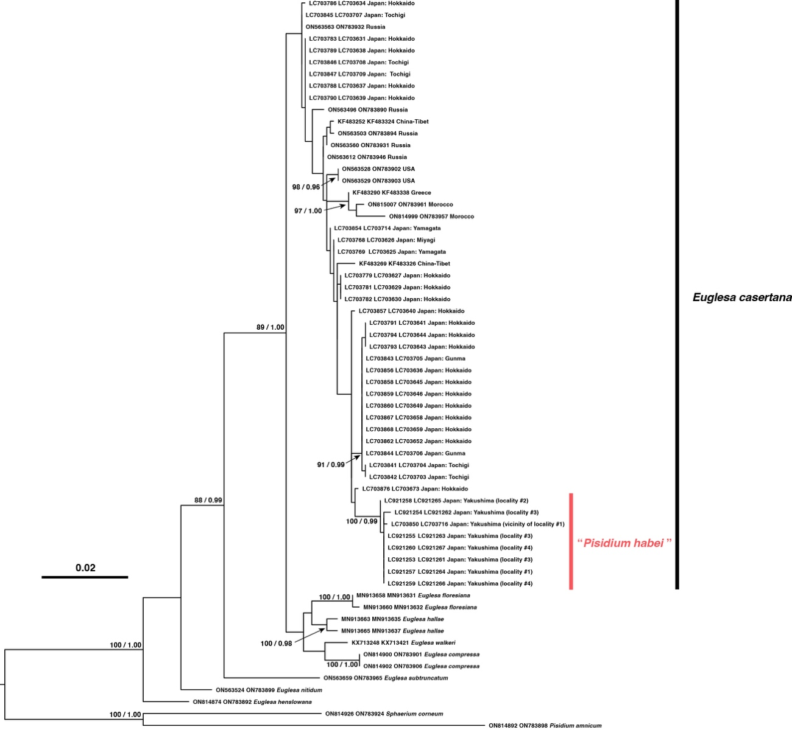
Fig. S1 Maximum likelihood tree for 1,246 bp concatenated sequences of the 16S and 28S rRNA genes. The numbers associated with the nodes represent the nonparametric bootstrap (BS) values for ML and Bayesian posterior probabilities (BPP). BS values higher than 80% and BPP values higher than 0.95 are indicated. The numbers in parentheses indicate the locality numbers listed in Table S1

Table S1 List of specimens used for genetic analyses with collection localities, accession numbers of International Nucleotide Sequence Database (INSD), references, and specimen vouchers
Species | Locality | INSD Accession # |  | Reference / Voucher
 |  | 16S | 28S
Euglesa casertana (Poli, 1791) | Japan: Kagoshima Prefecture, Kumage-gun, Yakushima-cho, Kohananoego at an altitude of 1,630 m (locality 1) | LC921256 |  | This study / KUZ Z6435
 | Japan: Kagoshima Prefecture, Kumage-gun, Yakushima-cho, Kohananoego at an altitude of 1,630 m (locality 1) | LC921257 | LC921264 | This study / KUZ Z6436
 | Kagoshima Prefecture, Kumage-gun, Yakushima-cho, Hirauchi at an altitude of 1,400 m (locality 2) | LC921258 | LC921265 | This study / KUZ Z6438
 | Kagoshima Prefecture, Kumage-gun, Yakushima-cho, Koseda at an altitude of 8 m (locality 3) | LC921253 | LC921261 | This study / KUZ Z6428
 | Kagoshima Prefecture, Kumage-gun, Yakushima-cho, Koseda at an altitude of 8 m (locality 3) | LC921254 | LC921262 | This study/ KUZ Z6429
 | Kagoshima Prefecture, Kumage-gun, Yakushima-cho, Koseda at an altitude of 8 m (locality 3) | LC921255 | LC921263 | This study/ KUZ Z6430
 | Kagoshima Prefecture, Kumage-gun, Yakushima-cho, Koseda at an altitude of 21 m (locality 4) | LC921259 | LC921266 | This study / KUZ Z6432
 | Kagoshima Prefecture, Kumage-gun, Yakushima-cho, Koseda at an altitude of 21 m (locality 4) | LC921260 | LC921267 | This study / KUZ Z6433
 | Japan: Kagoshima Pref., Yakushima Town, Yakushima Island, loc 1 (vicinity of locality 1 in this study) | LC703850 | LC703716 | Saito et al. (2022)
 | Japan: Hokkaido Pref., Abashiri City | LC703876 | LC703673 | Saito et al. (2022)
 | Japan: Hokkaido Pref., Appi Town | LC703868 | LC703659 | Saito et al. (2022)
 | Japan: Hokkaido Pref., Chitose City | LC703867 | LC703658 | Saito et al. (2022)
 | Japan: Hokkaido Pref., Kushiro City, Akan Town, loc. 1 | LC703859 | LC703646 | Saito et al. (2022)
 | Japan: Hokkaido Pref., Kushiro City, Akan Town, loc. 2 | LC703860 | LC703649 | Saito et al. (2022)
 | Japan: Hokkaido Pref., Kushiro Town | LC703857, LC703788–LC703790 | LC703637–LC703640 | Saito et al. (2022)
 | Japan: Hokkaido Pref., Shibecha Town, loc. 1 | LC703779, LC703781–LC703783, LC703786 | LC703627, LC703629, LC703630, LC703631, LC703634 | Saito et al. (2022)
 | Japan: Hokkaido Pref., Shibecha Town, loc. 2 | LC703856 | LC703636 | Saito et al. (2022)
 | Japan: Hokkaido Pref., Shibecha Town, loc. 3 | LC703862 | LC703652 | Saito et al. (2022)
 | Japan: Hokkaido Pref., Teshikaga Town | LC703858, LC703791, LC703793, LC703794 | LC703641, LC703643–LC703645 | Saito et al. (2022)
 | Japan: Miyagi Pref., Shikama Town, Mt. Funagata, loc. 1 (Honshu) | LC703768 | LC703626 | Saito et al. (2022)
 | Japan: Tochigi Pref., Kanuma City, loc. 1 (Honshu) | LC703846, LC703847 | LC703708, LC703709 | Saito et al. (2022)
 | Japan: Tochigi Pref., Nikko City (Honshu) | LC703845 | LC703707 | Saito et al. (2022)
 | Japan: Tochigi Pref., Nikko City, Kotoku pond (Honshu) | LC703841, LC703842 | LC703703, LC703704 | Saito et al. (2022)
 | Japan: Gunma Pref., Numata City (Honshu) | LC703843, LC703844 | LC703705, LC703706 | Saito et al. (2022)
 | Japan: Yamagata Pref., Iide Town, Mt. Iide (Honshu) | LC703769 | LC703625 | Saito et al. (2022)
 | Japan: Yamagata Pref., Yamagata City (Honshu) | LC703854 | LC703714 | Saito et al. (2022)
 | China: Tibet | KF483252, KF483269 | KF483324, KF483326 | Clewing et al. (2013)
 | Russia: Yakutia, Ust-Yansky District, Ust-Kuyga village, Kuyga river | ON563612 | ON783946 | Bespalaya et al. (2022)
 | Russia: Yakutia, Ust-Yansky District, Ust-Kuyga village | ON563607 |  | Bespalaya et al. (2022)
 | Russia: Irkutsk region, Vitim Nature Reserve, Okunevo lake | ON563625, ON563626 |  | Bespalaya et al. (2022)
 | Russia: Yakutia, Chokurdakh, Semi Obrivov lake | ON563662 |  | Bespalaya et al. (2022)
 | Russia: Kamchatka, Bystrinsky District, Esso village | ON563563, ON563564 | ON783932 | Bespalaya et al. (2022)
 | Russia: Chukotka Autonomous Area, Iultinsky District, Amguema village, Tishina lake | ON563568, ON563569 |  | Bespalaya et al. (2022)
 | Russia: Commander Islands | PQ032448, PQ032450 |  | Besparaya et al. (2025)
 | Russia: Yamalo-Nenets Autonomous Area, Yamal Peninsula, Seyaha village, Seyaha River | ON563496 | ON783890 | Bespalaya et al. (2022)
 | Nepal: Karnali | KF483307 |  | Clewing et al. (2013)
 | Russia: Kabardino-Balkaria, Elbrus region, Dolina Narzanov | ON815016, ON815017 |  | Bespalaya et al. (2024)
 | Iceland: Hverfjall | KY126460 |  | Bespalaya et al. (2017)
 | Iceland: Small lake near to Blondulon | ON563536 |  | Bespalaya et al. (2022)
 | Iceland: Hverfjall | ON563697 |  | Bespalaya et al. (2022)
 | Russia: Nenets Autonomous Area, Vaygach Island | ON563503 | ON783894 | Bespalaya et al. (2022)
 | Russia: Nenets Autonomous Area, Shoyna | ON563560 | ON783931 | Bespalaya et al. (2022)
 | Albania: Tušemišta, wetland | EU559093 |  | Schultheiß et al. (2008)
 | Greece: West Macedonia | KF483290 | KF483338 | Clewing et al. (2013)
 | Macedonia: north of Misleschwbo, creek | EU559091 |  | Schultheiß et al. (2008)
 | Macedonia: Pretor, Lake Prespa shore | EU559095 |  | Schultheiß et al. (2008)
 | Spain: Picos de Europa | EU559096, EU559097 |  | Schultheiß et al. (2008)
 | France | KY202850, KY202851 |  | Mouthon & Forcellini (2017)
 | Germany: Ammerbuch | AY093557 |  | Lee & Foighil (2003)
 | Germany: Müllrose | EU559092 |  | Schultheiß et al. (2008)
 | Canada: Quebec, Dufault Lake near Rouyn-Noranda | ON563630 |  | Bespalaya et al. (2022)
 | USA: Montana, Yellowstone National Park, Madison River | ON563528 | ON783902 | Bespalaya et al. (2022)
 | USA: Montana, Yellowstone National Park, Gibbon River | ON563529 | ON783903 | Bespalaya et al. (2022)
 | USA: Michigan | AF152031, AY093556 |  | Lee & Foighil (2003)
 | USA: 1 mile past Mitchell Lake on trail towards Blue Lake (Colorado) | AY957772 |  | Guralnick (2005)
 | USA: swale next to Red Rock Lake, Boulder CO. (Colorado) | AY957773 |  | Guralnick (2005)
 | USA: Lower Crater Lake - south side (Oregon) | AY957778 |  | Guralnick (2005)
 | USA: ice-melt pond (Oregon) | AY957779 |  | Guralnick (2005)
 | USA: Utah: Junction Creek north of Lynn | AY957793 |  | Guralnick (2005)
 | USA: Long Lake (New York state) | AY957794 |  | Guralnick (2005)
 | USA: behind red rock lake, in small glacial melt swale | AY957809 |  | Guralnick (2005)
 | USA: Woodland Pond | AY957830 |  | Guralnick (2005)
 | Morocco: Bekrit, stream from the Middle Atlas of Morocco | ON814999 | ON783957 | Bespalaya et al. (2024)
 | Morocco: Ain Chkef, spring and river from Fès-Meknès region, Morocco | ON815007 | ON783961 | Bespalaya et al. (2024)
Euglesa floresiana  (B. Rensch, 1934) | Indonesia, Western New Guinea | MN913658 , MN913660 | MN913631, MN913632 | Clewing et al. (2020)
Euglesa hallae (Kuiper, 1983) | Australia: Sydney | MN913663, MN913665 | MN913635, MN913637 | Clewing et al. (2020)
Euglesa compressa (Prime, 1852) | USA: Montana, Yellowstone National Park, Madison River | ON814900, ON814902 | ON783901, ON783906 | Bespalaya et al. (2024)
Euglesa walkeri (Sterki, 1895) | USA: Illinois | KX713248 | KX713421 | Combosch et al. (2017)
Euglesa subtruncata (Malm, 1855) | Russia: Yakutia, Srednekolymsk, lake next to the oil depot | ON563659 | ON783965 | Bespalaya et al. (2022)
Euglesa nitida  (Jenyns, 1832) | USA: Montana, Yellowstone National Park, Swan Lake | ON563524 | ON783899 | Bespalaya et al. (2022)
Euglesa henslowana (Sheppard, 1825) | Russia: Perm region, Romanovo village, Yayva river | ON814874 | ON783892 | Bespalaya et al. (2024)
Pisidium amnicum  (O. F. Müller, 1774) | Russia: Nenets Autonomous Area, Bolshezemelskaya tundra, Vashutkiny Lakes, Makty lake | ON814892 | ON783898 | Bespalaya et al. (2024)
Sphaerium corneum  (Linnaeus, 1758) | Russia: Krasnoyarsk Region, Taymyr Peninsula, Dudinka | ON814926 | ON783924 | Bespalaya et al. (2024)

References
Bespalaya Y, Bolotov I, Aksenova O, Kondakov A, Spitsyn V, Kogut Y, Sokolova S (2017) Two Pisidium species inhabit freshwater lakes of Novaya Zemlya Archipelago: the first molecular evidence. Polar Biol 40: 2119–2126. https://doi.org/10.1007/s00300-017-2119-y
Bespalaya YV, Aksenova OV, Aksenov AS, Sokolova SE, Kropotin AV, Travina OV, Khrebtova IS, Kondakov AV, Eliseeva TA, Zubrii NA, Butorina EV (2025) Taxonomic and genetic diversity of freshwater mollusks of Bering Island (the Commander Islands, Kamchatka Krai, Russia). Inland Water Biol 18: 837–848. https://doi.org/10.1134/S1995082925600620
Bespalaya YV, Travina OV, Tomilova AA, Khrebtova IS, Aksenova OV, Aksenov AS, Vinarskii MV, Kondakov AV, Nekhaev IO, Palatov DM, Spitsyn VM, Shevchenko AR, Bolotov IN (2022) Species diversity, settlement routes, and ecology of freshwater mollusks of Kolguev Island (Barents Sea, Russia). Inland Water Biol 15: 836–849. https://doi.org/10.1134/S1995082922060025
Bespalaya YV, Vinarski MV, Aksenova OV, Babushkin ES, Gofarov MY, Kondakov AV, Konopleva ES, Kropotin AV, Mabrouki Y, Ovchankova NB, Palatov DM, Sokolova SE, Shevchenko AR, Travina OV, Taybi AF, Soboleva AA, Zubrii NA, Bolotov IN (2024) Phylogeny, taxonomy, and biogeography of the Sphaeriinae (Bivalvia: Sphaeriidae). Zool J Linn Soc 201: 305–338. https://doi.org/10.1093/zoolinnean/zlad139
Clewing C, Bössneck U, Oheimb PV von, Albrecht C (2013) Molecular phylogeny and biogeography of a high mountain bivalve fauna: the Sphaeriidae of the Tibetan Plateau. Malacologia 56: 231–252. https://doi.org/10.4002/040.056.0213
Clewing C, Stelbrink B, Bößneck U, Neubauer TA, von Rintelen T, Köhler F, Marwoto RM, Albrecht C (2020) Freshwater biogeography in Wallacea: The case of sphaeriid bivalves in the Malili lake system (Sulawesi, Indonesia). J Great Lakes Res 46: 1176–1186. https://doi.org/10.1016/j.jglr.2020.02.003
Combosch DJ, Collins TM, Glover EA, Graf DL, Harper EM, Healy JM, Kawauchi GY, Lemer S, McIntyre E, Strong EE, Taylor JD, Zardus JD, Mikkelsen PM, Giribet G, Bieler R (2017) A family-level Tree of Life for bivalves based on a Sanger-sequencing approach. Mol Phylogenet Evol 107: 191–208. https://doi.org/10.1016/j.ympev.2016.11.003
Guralnick RP 2005. Combined molecular and morphological approaches to documenting regional biodiversity and ecological patterns in problematic taxa: a case study in the bivalve group Cyclocalyx (Sphaeriidae, Bivalvia) from western North America. Zool Scr 34: 469–482. https://doi.org/10.1111/j.1463-6409.2005.00205.x
Lee T, Foighil DO (2003) Phylogenetic structure of the Sphaeriinae, a global clade of freshwater bivalve molluscs, inferred from nuclear (ITS-1) and mitochondrial (16S) ribosomal gene sequences. Zool J Linn Soc 137: 245–260. https://doi.org/10.1046/j.1096-3642.2003.00047.x
Mouthon J, Maxence F (2017) Genetic evidence of the presence in France of the North American species Euglesa compressa Prime, 1852 (Bivalvia, Sphaeriidae). Bioinvasions Rec 6: 225–231. https://doi.org/10.3391/bir.2017.6.3.07
Saito T, Fujimoto K, Uchida S, Yamazaki D, Hirano T, Sano I, Ye B, Kagawa O, Shariar MS, Do VT, Morii Y, Prozorova L, Chiba S (2022) Uncovering overlooked diversity using molecular phylogenetic approach: A case of Japanese sphaeriid clams (Bivalvia: Sphaeriidae). Mol Phylogenet Evol 173: 107508. https://doi.org/10.1016/j.ympev.2022.107508
Schultheiß R, Albrecht C, Bößneck U, Wilke T (2008) The neglected side of speciation in ancient lakes: phylogeography of an inconspicuous mollusc taxon in lakes Ohrid and Prespa. Hydrobiologia 615: 141–156. https://doi.org/10.1007/s10750-008-9553-3

Table S2 Primers used for polymerase chain reaction (PCR) amplification and sequencing, and PCR conditions in this study. For 16S rRNA gene, either of the two primer combinations was used
Primer | Direction | Sequence 5'–3' | Reference for primer | DNA Polymerase / PCR condition
16S rRNA
16Sar-sph | Forward | CGCGCCTGTTTATCAAAAACATCG | Sawada et al. (2026) | Ex Premier DNA Polymerase (Takara Bio Inc., Japan)
16Sbr-sph | Reverse | TCACGCCGGTCTGAACTCAGATC | Sawada et al. (2026) | 98 °C 2 min, (98 °C 10 s, 52 °C 15 s, 68 °C 35 s) x 35, 68 °C 5 min
16Sph-longF | Forward | CCTGAAGATTCTAGGGTTAC | This study | Ex Premier DNA Polymerase (Takara Bio Inc., Japan)
16Sph-longR | Reverse | TACGCGATCCTCTCGTACAAAG | This study | 98 °C 2 min, (98 °C 10 s, 52 °C 15 s, 68 °C 35 s) x 35, 68 °C 5 min
28S rRNA
28S-sph2F | Forward | CCAATGTGGGTGGTAAACTC | This study | Ex Premier DNA Polymerase (Takara Bio Inc., Japan)
D6R | Reverse | CCAGCTATCCTGAGGGAAACTTCG | Park and Foighil (2000) | 98 °C 2 min, (98 °C 10 s, 62 °C 15 s, 68 °C 35 s) x 35, 68 °C 5 min

References
Park JK, Foighil DÓ (2000) Sphaeriid and corbiculid clams represent separate heterodont bivalve radiations into freshwater environments. Mol Phylogenet Evol 14: 75–88. https://doi.org/10.1006/mpev.1999.0691
Sawada N, Kameda Y, Fukuda H (2026) Cavernacmella dentata n. sp. (Caenogastropoda: Truncatelloidea: Assimineidae) endemic to the Sekigahara Limestone Cave, central Honshū, Japan. Molluscan Res 46: 49–67. https://doi.org/10.1080/13235818.2025.2592643

