Supplementary material - Figure II: Overview of bWell

A. 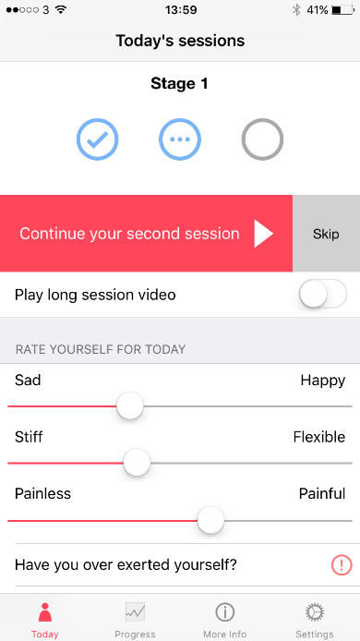 B. 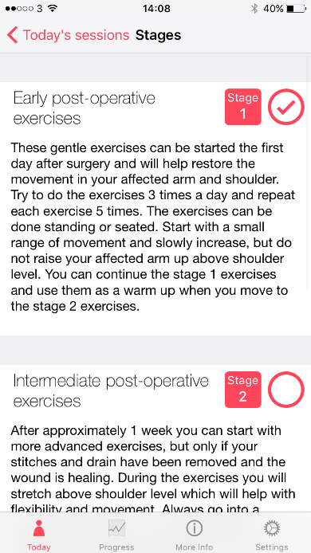

C. 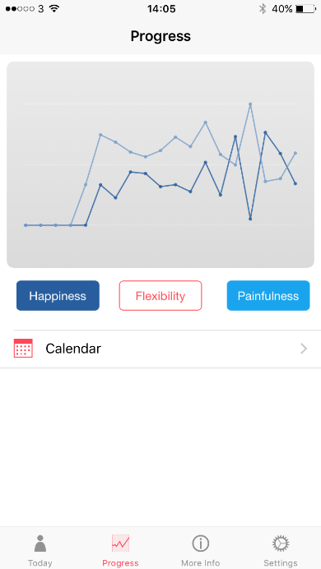 D. 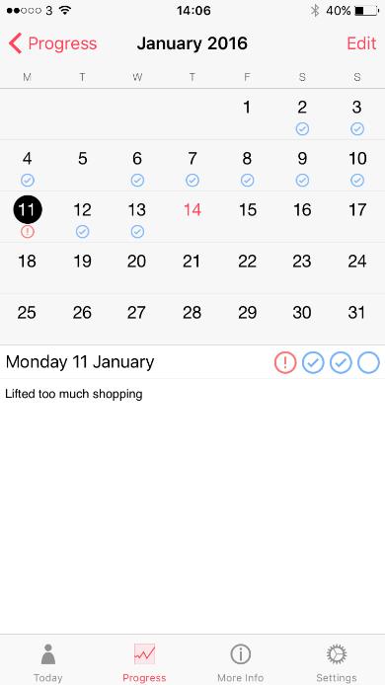 E.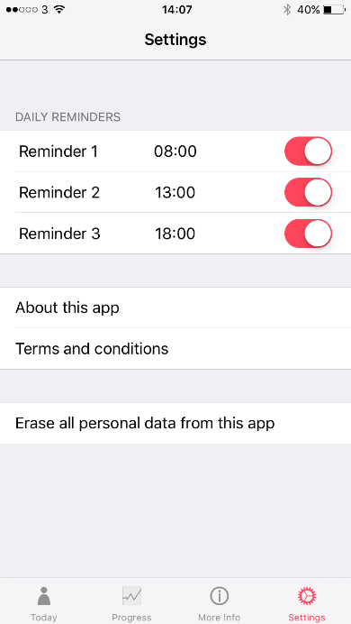

Supplementary material - Figure II: Overview of bWell - continued

F. 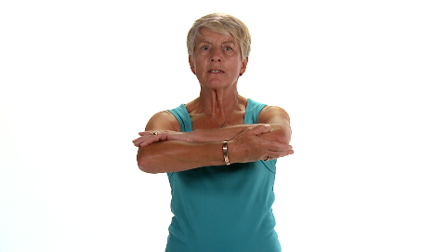 F. 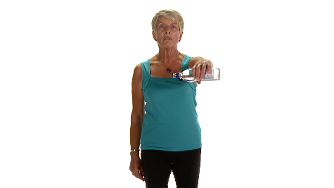

F. 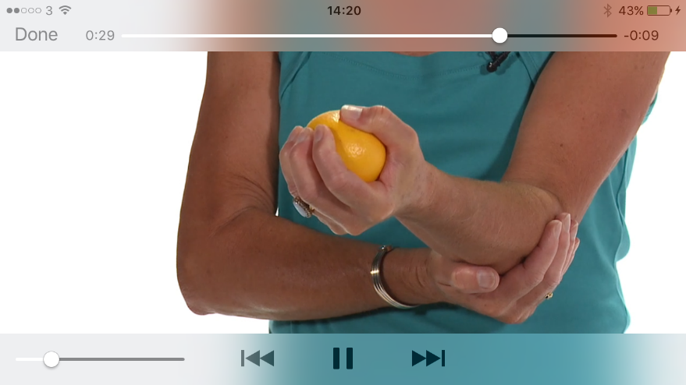

A: start page bWell
B: exercise stage selection page
C: progress tracking
D: calendar and note function
E: reminder settings
F: exercise images/videos

