Supplementary materials

Title:
Brain-Derived Neurotrophic Factor rs6265 polymorphism is associated with severe cancer-related fatigue and neuropathic pain in female cancer survivors.
Journal:
Journal of Cancer Survivorship
Authors:
Taichi Goto¹, Diane Von Ah², Xiaobai Li³, Lichen Xiang¹, Catherine Kwiat¹, Christopher Nguyen¹, Chao-Pin Hsiao⁴, Leorey N. Saligan^{1*}
- Symptoms Biology Unit, Division of Intramural Research, National Institute of Nursing Research, National Institutes of Health, Bethesda, MD, USA
- The Ohio State University College of Nursing, Columbus, OH, USA
- Department of Biostatistics, National Institutes of Health Clinical Center, Bethesda, MD, USA
- Case Western Reserve University School of Nursing, Cleveland, OH, USA
* Corresponding Author:
Leorey N. Saligan, PhD
3 Center Drive, Building 3, Room 5E14, Bethesda, MD 20892, USA
301-451-1685
saliganl@mail.nih.gov

Supplementary materials
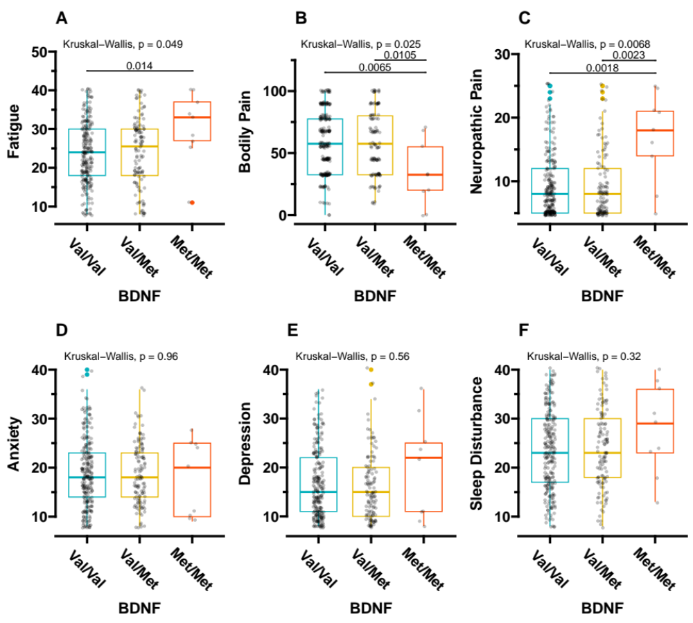
Figure S1. Differences in each PN symptom per BDNF genotype among White study participants.
The Kruskal-Wallis test and post-hoc multiple comparisons using Wilcoxon’s rank-sum test were applied to all statistical comparisons.
BDNF, brain-derived neurotrophic factor

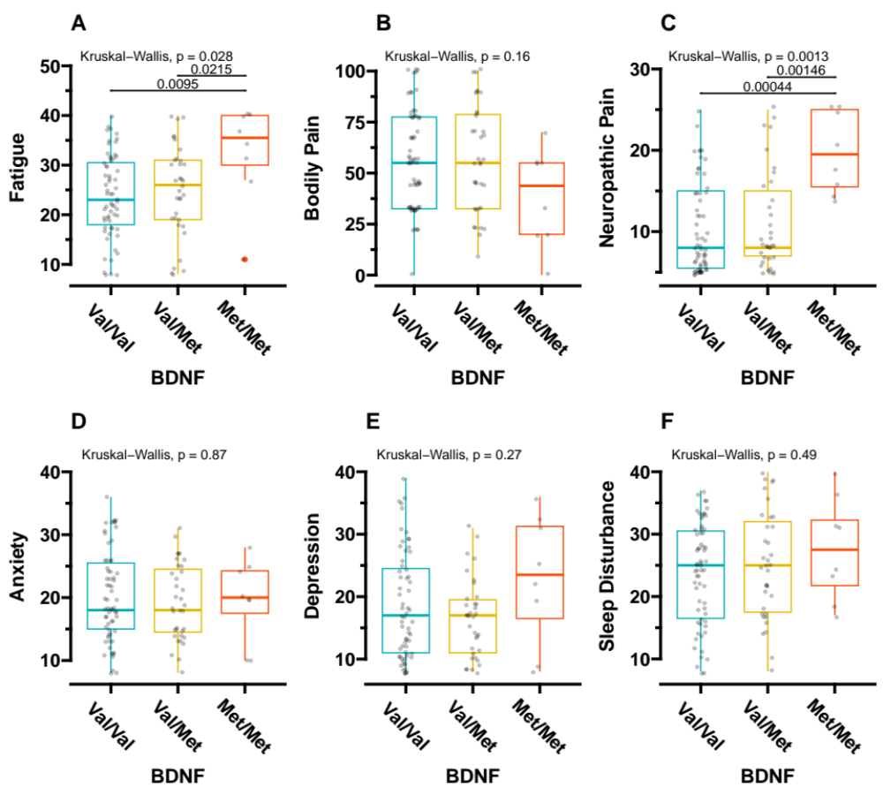

Figure S2. Differences in each PN symptom per BDNF genotype in the study participants with clinical cancer stage III of both breast and colon/rectal cancer types.
The Kruskal-Wallis test and post-hoc multiple comparisons using Wilcoxon’s rank-sum test were applied to all statistical comparisons.
BDNF, brain-derived neurotrophic factor

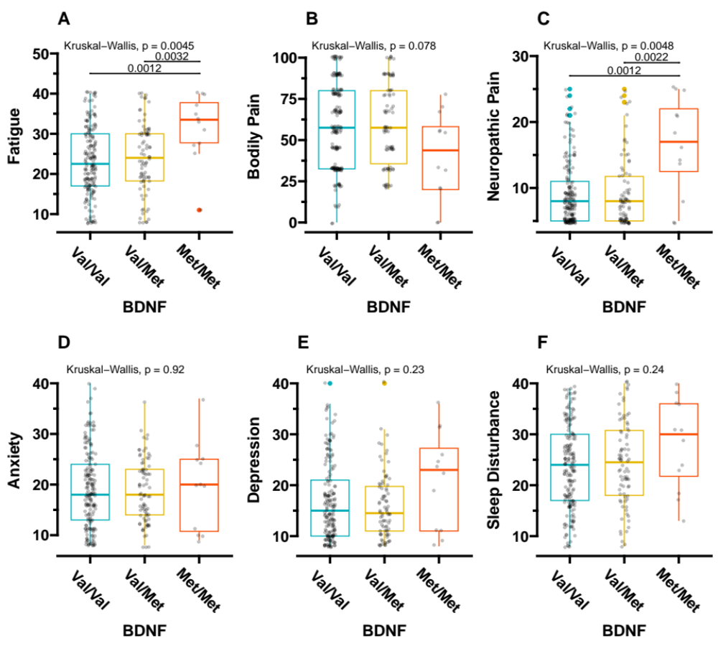
Figure S3. Differences in each PN symptom per BDNF genotype in post-radiation therapy study participants.
The Kruskal-Wallis test and post-hoc multiple comparisons using Wilcoxon’s rank-sum test were applied to all statistical comparisons.
BDNF, brain-derived neurotrophic factor

Table S1. Genotype and allele frequencies of the BDNF Val66Met polymorphism
Genotype | Absolute frequency (#) | Relative frequency %
C/C (Val/Val) | 258 | 65.6
C/T (Val/Met) | 123 | 31.3
T/T(Met/Met) | 12 | 3.1
C (Val) allele | 639 | 81.3
T (Met) allele | 147 | 18.7

Table S2. Multivariate rank-based regression models for all study participants
 |  | Coefficients | SE | p-value
Fatigue
 | BDNF Val/Met | 1.11 | 1.01 | .22
 | BDNF Met/Met | 6.00 | 3.03 | .048
 | Years Since Cancer Diagnosis | -0.19 | 0.08 | .03
 | Education History - Master's/PhD | -2.73 | 0.98 | .01
 | Employment - Retired | -1.67 | 1.12 | .14
 | Employment - Unemployment | 4.84 | 1.81 | .01
Neuropathic Pain
 | BDNF Val/Met | -0.17 | 0.42 | .70
 | BDNF Met/Met | 9.30 | 1.27 | < .001
 | Years Since Cancer Diagnosis | -0.08 | 0.03 | .02
 | Education History - Master's/PhD | -1.00 | 0.41 | .01
Rank-based regression was employed. The reference groups for BDNF, education history, and employment were “Val/Val,” “Highschool/Undergraduate/Associate,” and “Working,” respectively.

Table S3 Correlation matrix
 |  | Bodily Pain | Neuropathic Pain | Anxiety Score | Depression | Sleep Disturbance
Val/Val | Fatigue | -0.42 | 0.34 | 0.38 | 0.45 | 0.38
Val/Val | Bodily Pain |  | -0.43 | -0.17 | -0.24 | -0.21
Val/Val | Neuropathic Pain |  |  | 0.24 | 0.26 | 0.22
Val/Val | Anxiety Score |  |  |  | 0.64 | 0.37
Val/Val | Depression |  |  |  |  | 0.40
Val/Met | Fatigue | -0.56 | 0.41 | 0.55 | 0.70 | 0.55
Val/Met | Bodily Pain |  | -0.55 | -0.39 | -0.40 | -0.37
Val/Met | Neuropathic Pain |  |  | 0.29 | 0.32 | 0.22
Val/Met | Anxiety Score |  |  |  | 0.74 | 0.36
Val/Met | Depression |  |  |  |  | 0.39
Met/Met | Fatigue | -0.26 | 0.57 | 0.67 | 0.71 | 0.22
Met/Met | Bodily Pain |  | -0.54 | 0.01 | -0.19 | -0.41
Met/Met | Neuropathic Pain |  |  | -0.02 | 0.18 | 0.03
Met/Met | Anxiety Score |  |  |  | 0.65 | 0.65
Met/Met | Depression |  |  |  |  | 0.34
Spearman's correlation was applied.

