Supplementary Material
Supplementary Material 1
Table S1. Additional prostate cancer details 2
Table S2. Medical comorbidities details 2
Table S3. Covariate Analysis with p-values 3
S5: SPSS output of logistic regression analysis using PCI20 as a predictor of occupational outcomes 5
(1) Changes to your ability to work? 5
(2) Ability to perform work duties at the same level? 6
(3) Decreased work hours? 6
Table S6. PCI20 Means and Standard Deviations for Occupational Outcomes 8
S7: SPSS output of logistic regression analysis using EORTC-QLQ CF as a predictor of occupational outcomes 9
(1) Changes to your ability to work? 9
(2) Ability to perform work duties at the same level? 9
(3) Decreased work hours? 10
Table S8. EORTC-CF Means and Standard Deviations for Occupational Outcomes 11

Table S1. Additional prostate cancer details
 | M (SD), N (%), range
Surgery type
- Radical prostatectomy | 15 (31%)
- Other | 2 (4%)
Hormonal treatment
- Goserelin | 17 (33%)
- Leuprolide | 8 (16%)
- Bicalutamide | 6 (12%)
- Enzalutamide | 3 (6%)
- Leuprorelin | 4 (8%)
- Abiraterone | 6 (12%)
- Other | 3 (6%)
Discontinuation of HT due to side-effects previously | 5 (10%)
HT administration route
- Monthly injections | 3 (6%)
- Four-monthly injections | 24 (47%)
- Six-monthly injections | 3 (6%)
- Intermittent | 3 (6%)
- Tablets | 3 (6%)
Radiation types
- External beam | 22 (43%)
- Brachytherapy | 2 (4%)

Table S2. Medical comorbidities details
Condition | Number endorsing ‘Yes’ | Number endorsing ‘No’
Heart condition | 8 | 42
Diabetes | 8 | 43
High blood pressure | 23 | 27
Condition affects the brain (e.g., encephalitis, meningitis, epilepsy, dementia, Parkinson's,etc.?) | 0 | 51
Head trauma* | 4 | 47
Seizures or fits (where you have blacked out) | 0 | 51
*The question asked was “Have you ever been knocked unconscious for more than 5 minutes?”

Table S3. Covariate Analysis with p-values
 | Occupational outcomes (p-values)*
Demographic | (1) Changes to your ability to work? | (2) Ability to perform work duties at the same level? | (3) Decreased work hours?
Age (n = 51) | .401 | .095 | .661
Relationship | .245 | .056 | .437
- Partnered
- Not partnered
Education level | .598 | .494 | .098
- Did not complete Year 12
- Year 12/ Vocational training
- Undergraduate/postgraduate
Current employment status | .769 | .776 | 1.00
- Full-time/part-time/looking for employment/self-employed/carer
- Retired
Employment type | .283 | .785 | .471
- Clerical and sales/service/agricultural/ machines trade/ structural work e.g., construction
- Professional, technical and managerial occupations
- Other
No. of children (n=44) | .806 | .484 | .721
Children living at home | .374 | .547 | .512
- Yes
- No
Country of birth | .539 | .570 | .545
- Aus/NZ
- Other: US/UK/Europe/Asia/South America/ Africa
Location of residence | .206 | 1.00 | .746
- Metropolitan
- Regional
Languages spoken other than English | .251 | .06 | .114
- No
- Yes
Prostate cancer details
Stage | .574 | .775 | .565
- Early/Regional
- Metastatic
Time since diagnosis in months (n=50) | .548 | .789 | .603
Cancer treatments
- Watchful waiting/active surveillance | .136 | .238 | .237
- Surgery | .768 | .557 | .769
- Hormone therapy (e.g., ADT) | .007** | .110 | .049**
- Radiation therapy | .085 | .775 | .153
- Chemotherapy | .035 | .223 | 1.00
- Immunotherapy | - | - | -
Medical details
Number of noncancer medications (n=42) | .721 | .571 | .719
No of comorbidities* (n=50) | .009** | .375 | .515
Mental health diagnosis (n=51) | 1.00 | .741 | .297
*Categorical and continuous variables analysed using two-tailed Fisher’s exact tests and one-way Analysis of Variance respectively.
** p<.05

S5: SPSS output of logistic regression analysis using PCI20 as a predictor of occupational outcomes

(1) Changes to your ability to work?

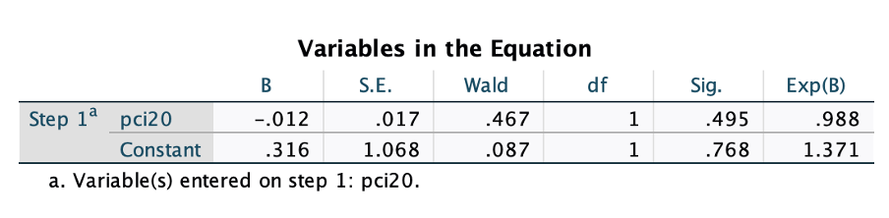
With covariates:

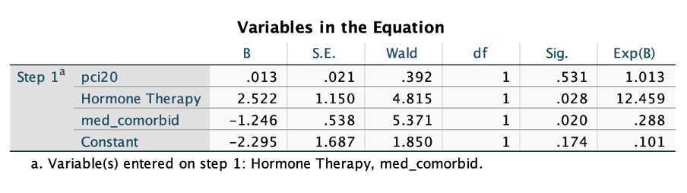

PCI20 using Fardell et al. (2022) cut off for low cognitive functions:
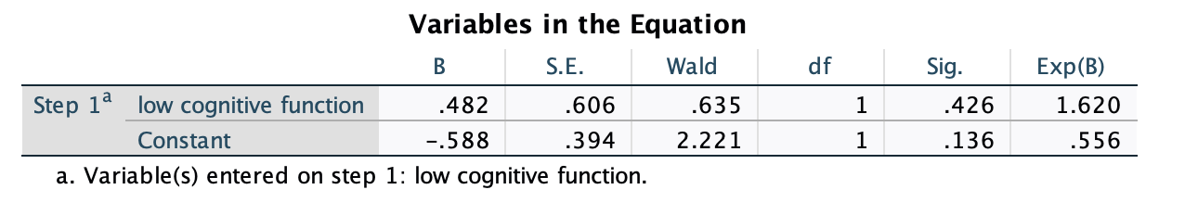
With covariates:

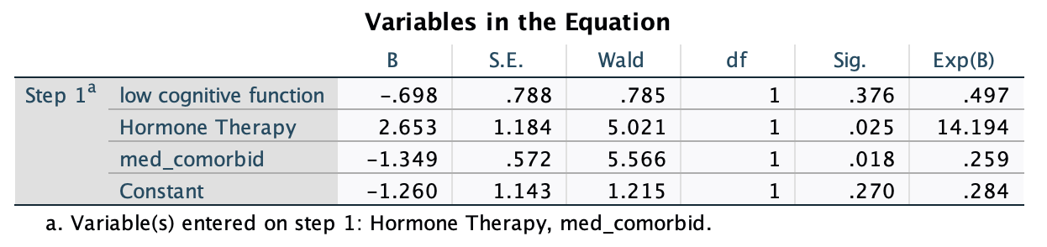

(2) Ability to perform work duties at the same level?

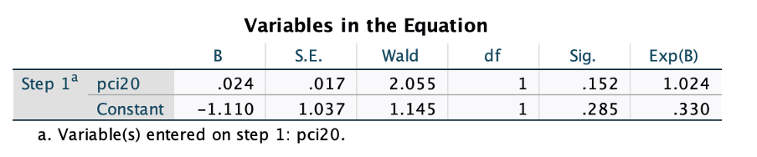

PCI20 using Fardell et al. (2022) cut off for low cognitive functions:

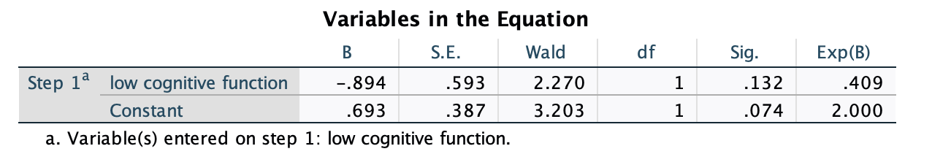

(3) Decreased work hours?

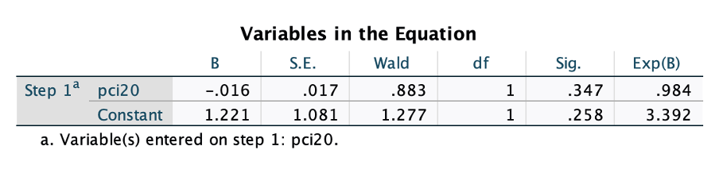
With covariates:

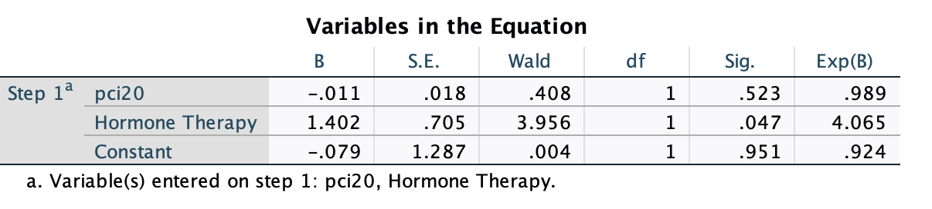

PCI20 using Fardell et al. (2022) cut off for low cognitive functions:
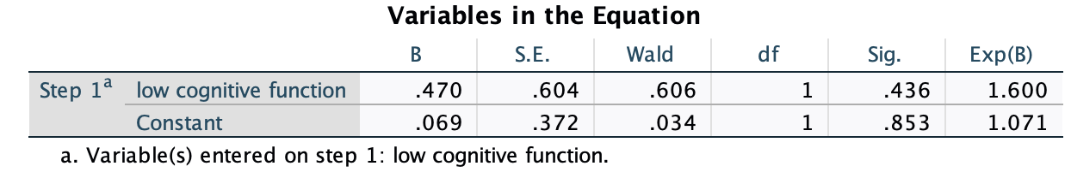

With covariates:
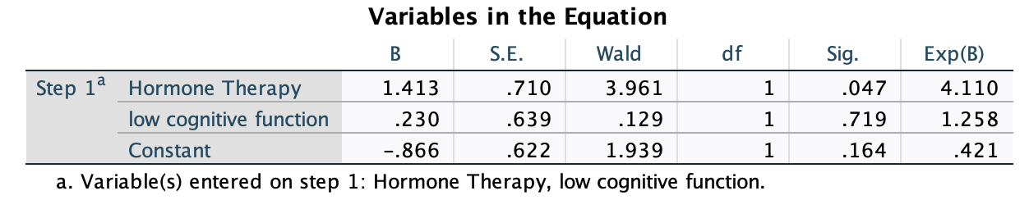

Table S6. PCI20 Means and Standard Deviations for Occupational Outcomes

 | (1) Changes to your ability to work? |  | (2) Ability to perform work duties at the same level? |  | (3) Decreased work hours?
 | No | Yes | No | Yes | No | Yes
Mean | 61.7 | 58.4 | 55.4 | 62.7 | 62.4 | 57.6
SD | 18.3 | 15.6 | 18.1 | 17 | 17.3 | 18.1

S7: SPSS output of logistic regression analysis using EORTC-QLQ CF as a predictor of occupational outcomes

(1) Changes to your ability to work?
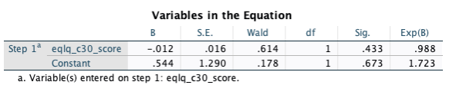
With covariates:
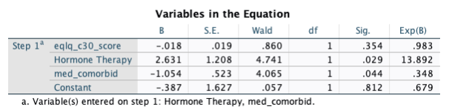
PCI20 using Fardell et al. (2022) cut off for low cognitive functions:
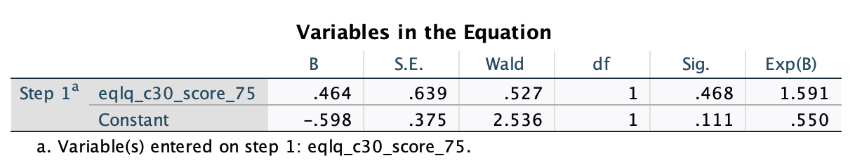
With covariates:
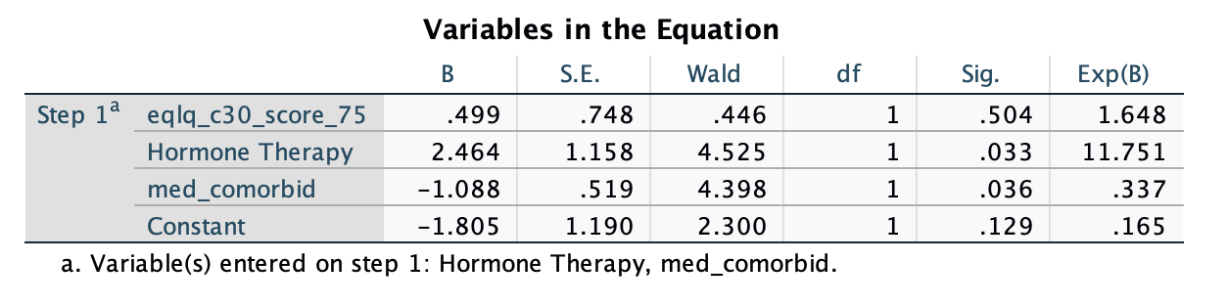

(2) Ability to perform work duties at the same level?
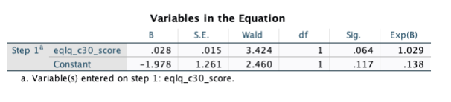
PCI20 using Fardell et al. (2022) cut off for low cognitive functions:

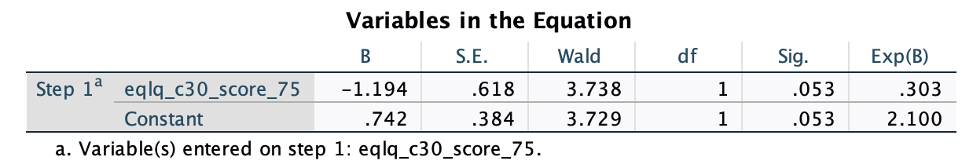

(3) Decreased work hours?
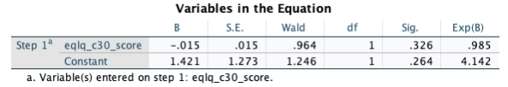
With covariates:

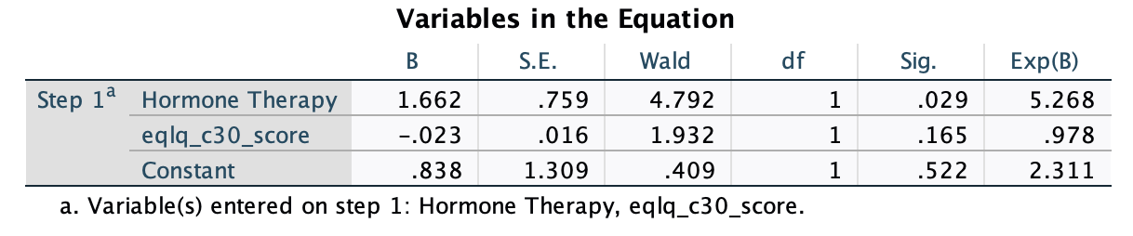

PCI20 using Fardell et al. (2022) cut off for low cognitive functions:

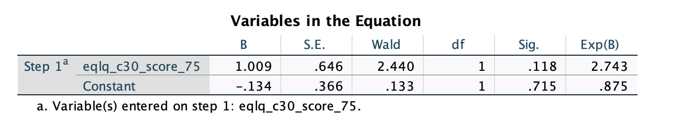
With covariates:

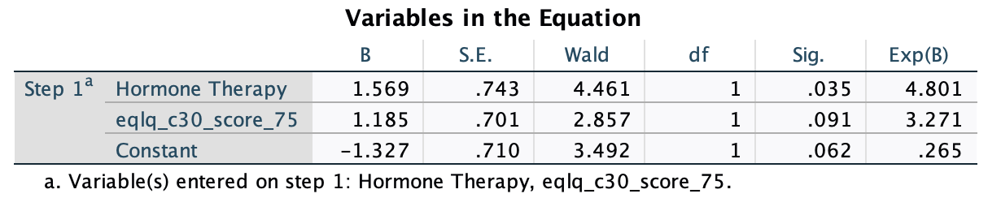

Table S8. EORTC-CF Means and Standard Deviations for Occupational Outcomes

 | (1) Changes to your ability to work? |  | (2) Ability to perform work duties at the same level? |  | (3) Decreased work hours?
 | No | Yes | No | Yes | No | Yes
Mean | 83.9 | 78.1 | 73.8 | 85.1 | 84.1 | 78.2
SD | 20.2 | 18.5 | 22.7 | 17.8 | 18.6 | 22

