Appendix Figure 1. Mean QoL scores per scale of AYA cancer survivors compared to matched normative population
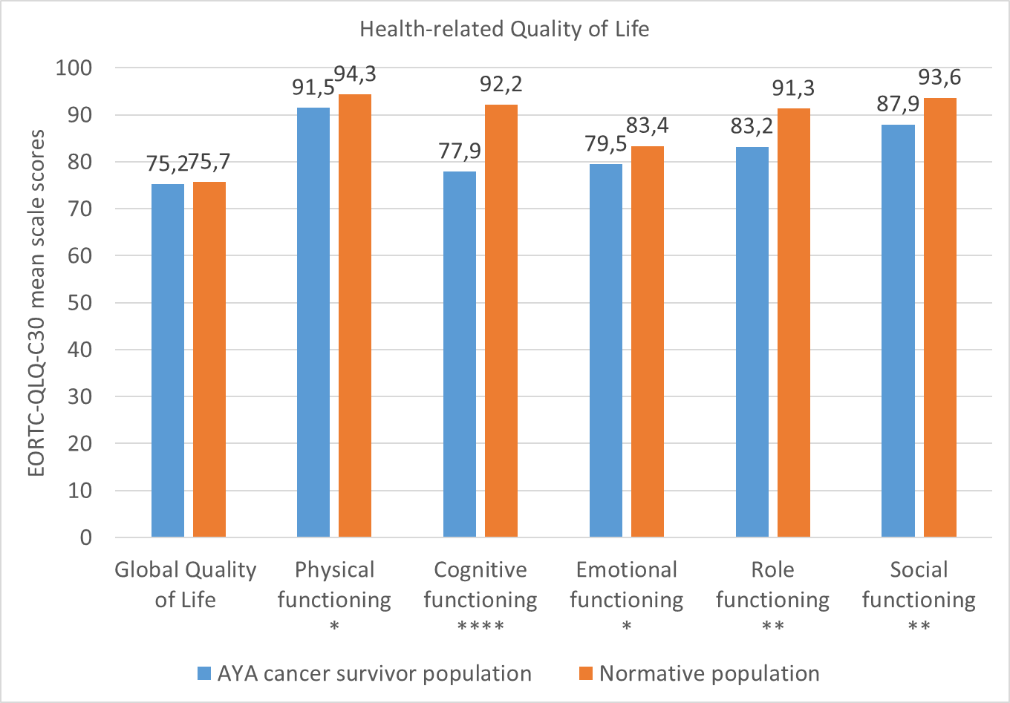
Note: Scores can range from 0 to 100: a higher score implies better global QoL or functioning; * p<0.05 and trivial clinical difference; ** p<0.05 and small clinical difference; *** p<0.05 and medium clinical difference; **** p<0.05 and large clinical difference.

