Supplementary material for: Effects of the right to be forgotten for childhood or breast cancer survivors: Results of a quasi-experimentalstudy in France, by Nicolas Bougas, Tienhan Sandrine Dabakuyo Yonli, Emerline Assogba, Nadia Haddy, Florent De Vathaire, Asmaa Janah, Morgane Miche, Aurelie Bourmaud, Hugo Jeanningros, Moreno Ursino, Renaud Debailly, Agnes Dumas
Corresponding author: Agnes Dumas, INSERM, Aix Marseille Univ, IRD, ISSPAM, SESSTIM, (Economic and Social Sciences of Health and Medical Information Processing), CALIPSO Team, Marseille, France; agnes.dumas@inserm.fr

Tables

Table A. Characteristics of subjects according to group allocation before matching (N=1 649)

 |  | Before the "Right to be forgotten"  (2010-2016) |  |  |  |  |  |  |  |  | After the "Right to be forgotten"  (2017-2022) |  |  |  |  |  |  |  |  | p-value
 |  | Cancer group pre-RTBF N=123 |  |  | Control group pre-RTBF  N=784 |  |  |  |  |  | Cancer group post-RTBF N=141 |  |  | Control group post-RTBF  N=601
Female, n (%) |  | 101 (79.5) |  |  | 610 (77.0) |  |  |  |  |  | 91 (64.1) |  |  | 439 (72.6) |  |  |  |  |  | 0.0034
Age at loan application n (%) |  | 40.2 ± 9.4 |  |  | 37.0 ± 9.3 |  |  |  |  |  | 41.8 ± 9.8 |  |  | 39.4 ± 9.6 |  |  |  |  |  | <0.0001
<35 years old |  | 33 (26.83) |  |  | 364 (46.43) |  |  |  |  |  | 32 (22.70) |  |  | 212 (35.27) |  |  |  |  |  | <.0001
>=35 years old |  | 90 (73.17) |  |  | 420 (53.57) |  |  |  |  |  | 109 (77.30) |  |  | 389 (64.73)
Education level n (%)
Less than high school or high school graduate |  | 27 (22.31) |  |  | 63 (10.52) |  |  |  |  |  | 24 (17.27) |  |  | 30 (6.82) |  |  |  |  |  | <.0001
Higher than high school graduate |  | 94 (77.69) |  |  | 536 (89.48) |  |  |  |  |  | 115 (82.73) |  |  | 410 (93.18)
Overweight, n (%) |  | 32 (26.02) |  |  | 191 (24.36) |  |  |  |  |  | 54 (38.30) |  |  | 196 (32.61) |  |  |  |  |  | 0.0003
Smoker, n (%) |  | 21 (17.07) |  |  | 156 (19.90) |  |  |  |  |  | 27 (19.15) |  |  | 82 (13.64) |  |  |  |  |  | 0.0220
Comorbidity, n (%) |  | 30 (24.39) |  |  | 146 (18.62) |  |  |  |  |  | 53 (37.59) |  |  | 90 (14.98) |  |  |  |  |  | <.0001
Long-term sick leave or disability pension, n (%) |  | 22 (23.66) |  |  | 172 (21.94) |  |  |  |  |  | 39 (29.55) |  |  | 111 (18.50) |  |  |  |  |  | 0.0347
Amount of the loan, n (%)
<150,000€ |  | 57 (46.34) |  | 286 (36.48) |  |  |  |  |  | 51 (36.17) |  |  | 193 (32.11) |  |  |  |  |  | 0.0217
≥150,000€ |  | 66 (53.66) |  | 498 (63.52) |  |  |  |  |  | 90 (63.83) |  |  | 408 (67.89)
Household income n (%) |  |  |  |  |  |  |  |  |  |  |  |  |  |  |  |  |  |  | 0.0013
<2,000€ |  | 8 (6.56) |  | 67 (8.74) |  |  |  |  |  | 16 (11.51) |  |  | 35 (6.74)
≥2,000 and <3,000€ |  | 29 (23.77) |  | 165 (21.51) |  |  |  |  |  | 28 (20.14) |  |  | 93 (17.92)
≥3,000 and <4,000€ |  | 25 (20.49) |  | 240 (31.29) |  |  |  |  |  | 32 (23.02) |  |  | 127 (24.47)
≥4,000€ |  | 61 (48.4) |  |  | 297 (38.6) |  |  |  |  |  | 63 (45.3) |  |  | 265 (50.9)
Cancer type, n (%) |  |  |  |  |  |  |  |  |  |  |  |  |  |  |  |  |  |  |  | <0.0001
Non-invasive breast cancer |  | 7 (5.69) |  |  |  |  |  |  |  |  | 11 (7.80)
Invasive breast cancer |  | 66 (53.66) |  |  |  |  |  |  |  |  | 22 (15.60)
Childhood cancer |  | 50 (40.65) |  |  |  |  |  |  |  |  | 108 (76.60)
Type of childhood cancer, n (%) |  |  |  |  |  |  |  |  |  |  |  |  |  |  |  |  |  |  |  | 0.5827
Lymphoma |  | 11 (22.00) |  |  |  |  |  | 23 (21.30)
Nephroblastoma |  | 14 (28.00) |  |  |  |  |  | 18 (16.67)
Neuroblastoma |  | 7 (14.00) |  |  |  |  |  | 15 (13.89)
Soft tissue sarcoma |  | 3 (6.00) |  |  |  |  |  | 11 (10.19)
Bone sarcoma |  | 6 (12.00) |  |  |  |  |  | 15 (13.89)
CNS tumour |  | 3 (6.00) |  |  |  |  |  | 4 (3.70)
Other |  | 6 (12.00) |  |  |  |  |  | 22 (20.37)
Cancer treatment, n (%) |  |  |  |  |  |  |  |  |  |  |  |  |  |  |  |  |  |  |  | 0.0073
No radiotherapy, no chemotherapy |  | 9 (7.32) |  |  |  |  |  |  |  |  | 8 (5.67)
Radiotherapy only |  | 11 (8.94) |  |  |  |  |  |  |  |  | 18 (12.77)
Chemotherapy only |  | 27 (21.95) |  |  |  |  |  |  |  |  | 55 (39.01)
Both radio- and chemotherapy |  | 76 (61.79) |  |  |  |  |  |  |  |  | 60 (42.55)
Difficulty in obtaining home loan-related insurance, n (%) |  | 91 (73.98) |  |  | 100 (12.76) |  |  |  |  |  | 42 (29.79) |  |  | 82 (13.64) |  |  |  |  |  | <.0001

Figure A. Questions on mortgage applications and difficulties experienced in accessing loan insurance, ELOCAN Study

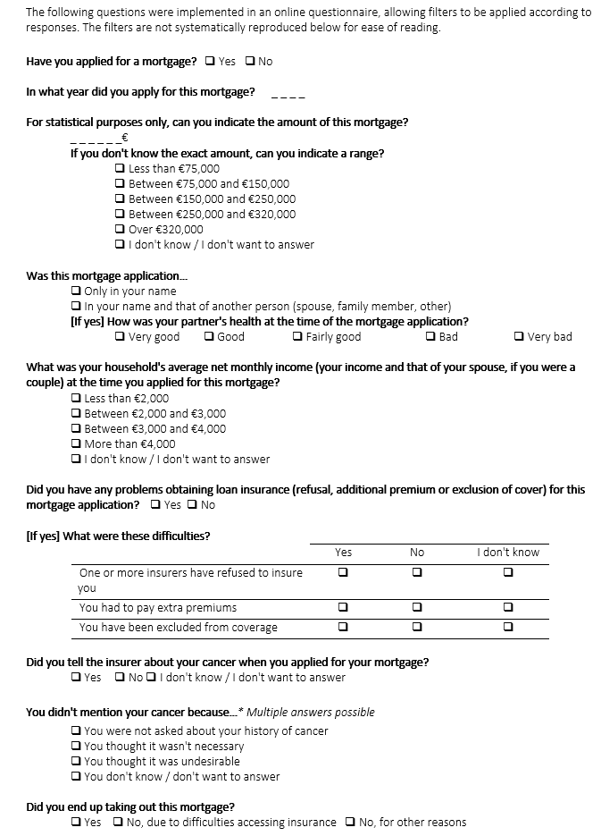

Figure B. Description of the matching procedure of the ELOCAN study

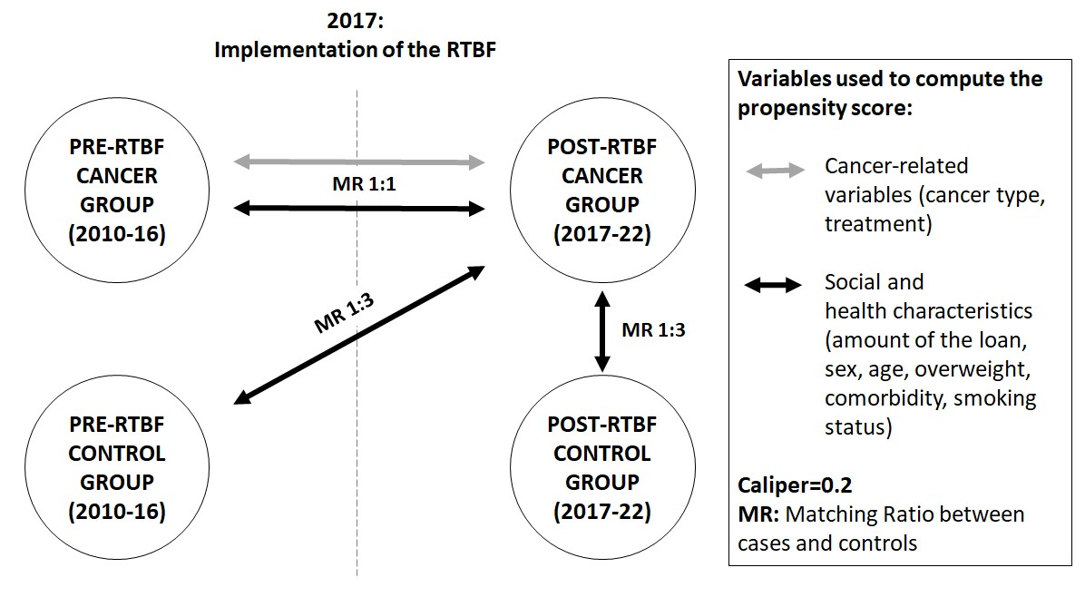

Figure C. Graphical test of the the parallel trends assumption

Figure D. Flow chart of the ELOCAN study
