Appendix 1: Geographical distribution of participants by region of France (n = 2306)
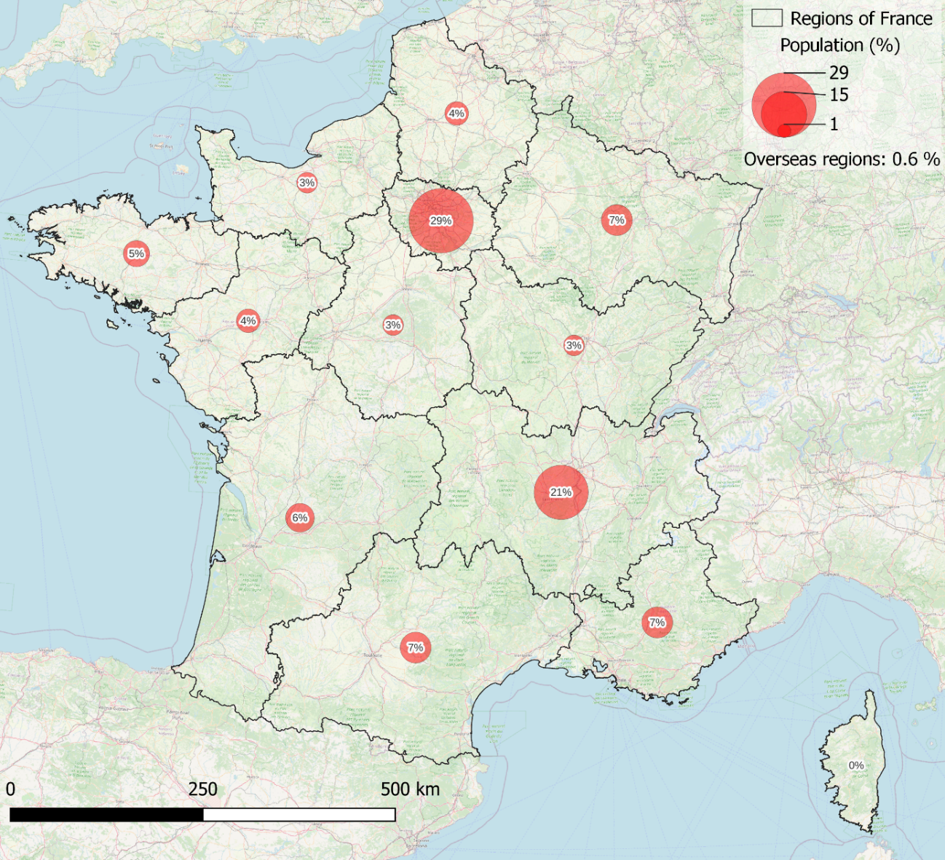

Appendix 2: List of barrier and facilitator items
Barriers
Intro: “I am not as physically active as I would like because…”
- I am too tired
- Bad weather prevents me from being physically active
- I have too much pain
- I do not have a partner to exercise with
- The schedules do not fit into my timetable
- I do not feel pleasure when being physically active
- There are no facilities near my home
- I am afraid of others’ judgment
- I am not interested
- My family obligations prevent me from being physically active
- I do not know what to do
- Engaging in physical activity is too expensive
- I am afraid of getting injured
- My social commitments prevent me from being physically active
- I cannot motivate myself
- I experience too many side effects from medical treatments
- There is no accessible transport to the practice facilities
- I cannot organize myself
- My work obligations prevent me from being physically active
- I do not feel capable of being physically active
- I am afraid because of safety concerns
- This is not my priority

Facilitators
Intro: “My practice of physical activity is facilitated by the fact that…”
- It helps me to have better control over my health
- It is a recommendation from my physician
- It improves my physical capacities
- I have time to dedicate to my practice
- It improves the symptoms of my disease
- I set myself a goal and an objective
- It improves my quality of life
- It allows me to reconnect with a group, a friend, or a relative
- It improves my sleep
- I practice in a facility that adapts physical activity to my capacities
- It reduces my fatigue
- I am encouraged by a group, a friend, or a relative
- It helps me maintain or lose weight
- I practice in an environment where I feel safe
- It helps me feel better in my body
- I am supervised by a physical activity professional
- It makes me feel proud of myself
- It stimulates my immune system and helps prevent disease
- I feel pleasure when exercising
- I feel competent in the activity I practice
- I manage to organize my schedule so that physical activity becomes a habit
- It gives me more energy

