Prevention of breast cancer-related lymphedema by progressive resistance training – a long-term follow-up of the LYCA Randomized Controlled Trial.

Journal of Cancer Survivorship

Gunn Ammitzbøll, Marie Lillegaard, Christoffer Johansen, Charlotte Lanng, Kathrine Grell, Niels Kroman, Bo Zerahn, Ole Hyldegaard, Merete Celano Wittenkamp, Susanne Oksbjerg Dalton.

Corresponding author:
Gunn Ammitzbøll
Danish Cancer Institute, Strandboulevarden 49, 2100 Copenhagen, Denmark. Email: gunnam@cancer.dk

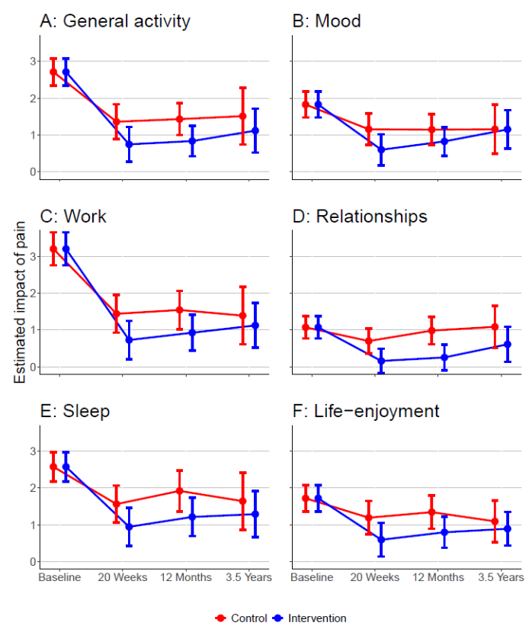
Supplementary Figure 2. Estimated mean levels for the impact of pain on the aspects of daily life (0–10) for participants in the LYCA study, 2015–2022, East Denmark.
The vertical lines show 95% confidence intervals.

