Supporting Information (SI)

Effect of Si/Al₂ ratio over BEA zeolite in steam and direct catalytic cracking of n-dodecane
Arumugam Ramesh¹, Jun-Hyuk Ahn¹, Su-Un Leeª, Su-Ah Kang¹, Temur Khujamuratov^{1,2}, Kwang-Eun Jeong¹, Tae-Wan Kim^{1,2,} *, Chul-Ung Kim^{1,}*

¹Chemical & Process Technology Division, Korea Research Institute of Chemical Technology, 141, Gajeong-ro, Yuseong-gu, Daejeon 34114, South Korea

²Advanced Materials and Chemical Engineering Technology, University of Science & Technology, 217 Gajeong-ro, Yuseong-gu, Daejeon 34113, Republic of Korea

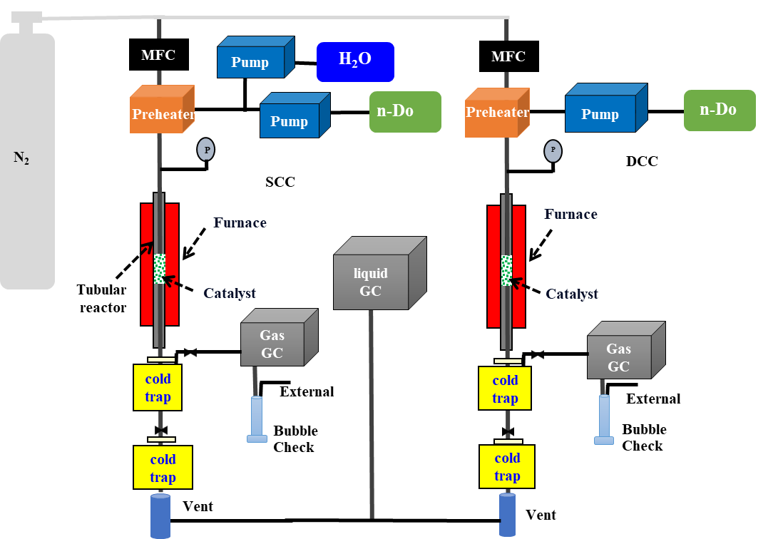

Fig. S1 Schematic diagram of the catalytc cracking reaction system in SCC and
DCC of n-Do.

Table S1 Experimental conditions for catalytic cracking (DCC, SCC) of n-Do over BEA zeolite catalysts
Parameters | Values
Rxn. temperature (ºC)  Rxn. pressure (MPa)  Time-on-stream (h)  LHSV (h⁻¹) of n-Do  Catalyst loading (g)  Catalysts (SAR) | 500 to 650  0.1  1 to 6  4.2, 5.7, 12.8, 17.0  0.675  ZSM-5(280), BEA(25) to BEA(360)

Table S2 Comparison between BEA and ZSM-5 zeolite catalyst in similar SAR on the n-Do conversion and, light olefin selectivity and yield in DCC and SCC of n-Do (500, 650℃, LHSV = 4.2 h⁻¹, TOS = 1, 6 h)
Catalyst  materials |  |  |  | Cracking  method | n-Do  conv.  (wt%) |  |  | Selectivity (wt%) |  |  |  |  |  |  |  | Yield (wt%)
Catalyst  materials | Temp.  (ºC) |  | TOS  (h) | Cracking  method | n-Do  conv.  (wt%) | H₂ | Ethylene  (E) |  | Propylene  (P) | Butenes  (B) | Paraffins | BTX | E/P  ratio | Light olefin/  paraffin | E+P |  | E+P+B
BEA(300)-C | 550 |  | 1 | DCC | 97.5 | 0.3 | 3.3 |  | 24.4 | 25.3 | 45.0 | 0.6 | 0.14 | 1.18 | 27.0 |  | 51.6
BEA(300)-C |  |  | 6 |  | 59.3 | 1.9 | 2.6 |  | 20.5 | 22.1 | 47.5 | 3.1 | 0.13 | 0.95 | 13.7 |  | 26.8
ZSM-5(280)-C |  |  | 1 |  | 92.2 | 0.8 | 13.4 |  | 24.5 | 13.3 | 45.6 | 0.2 | 0.55 | 1.12 | 35.0 |  | 47.2
ZSM-5(280)-C |  |  | 6 |  | 85.3 | 0.7 | 11.5 |  | 22.3 | 12.4 | 48.0 | 3.4 | 0.51 | 0.96 | 28.7 |  | 39.3
BEA(300)-C | 650 |  | 1 |  | 94.6 | 1.2 | 23.3 |  | 24.8 | 13.5 | 21.1 | 0.1 | 0.94 | 2.92 | 45.5 |  | 58.3
BEA(300)-C |  |  | 6 |  | 77.3 | 0.5 | 30.3 |  | 27.8 | 11.7 | 16.8 | 0.3 | 1.09 | 4.15 | 44.9 |  | 54.0
ZSM-5(280)-C |  |  | 1 |  | 98.6 | 1.7 | 27.9 |  | 26.2 | 8.5 | 20.7 | 0.1 | 1.06 | 3.02 | 53.2 |  | 61.6
ZSM-5(280)-C |  |  | 6 |  | 82.8 | 1.2 | 26.9 |  | 27.2 | 9.4 | 21.8 | 0.6 | 0.99 | 2.91 | 44.7 |  | 52.5
BEA(300)-C | 550 |  | 1 | SCC | 91.1 | 0.3 | 4.1 |  | 33.1 | 27.8 | 32.2 | 2.0 | 0.12 | 2.02 | 33.9 |  | 59.2
BEA(300)-C |  |  | 6 |  | 95.1 | 0.2 | 2.9 |  | 28.6 | 26.1 | 36.6 | 5.0 | 0.10 | 1.57 | 30.0 |  | 54.8
ZSM-5(280)-C |  |  | 1 |  | 75.6 | 0.4 | 9.2 |  | 39.4 | 25.1 | 22.8 | 2.5 | 0.23 | 3.23 | 36.7 |  | 55.7
ZSM-5(280)-C |  |  | 6 |  | 46.8 | 0.3 | 7.1 |  | 33.9 | 22.0 | 29.7 | 6.6 | 0.21 | 2.12 | 19.1 |  | 29.4
BEA(300)-C | 650 |  | 1 |  | 97.5 | 0.8 | 12.3 |  | 36.0 | 28.0 | 16.9 | 1.7 | 0.34 | 4.51 | 47.1 |  | 74.3
BEA(300)-C |  |  | 6 |  | 78.5 | 0.7 | 12.5 |  | 30.8 | 27.6 | 20.4 | 3.8 | 0.41 | 3.48 | 34.0 |  | 55.6
ZSM-5(280)-C |  |  | 1 |  | 81.0 | 0.6 | 18.0 |  | 38.1 | 24.2 | 13.6 | 2.1 | 0.47 | 5.90 | 45.5 |  | 65.1
ZSM-5(280)-C |  |  | 6 |  | 58.7 | 0.6 | 18.0 |  | 34.7 | 22.6 | 16.9 | 3.4 | 0.52 | 4.46 | 30.9 |  | 44.2

Table S3 Effect of SAR of BEA catalyst with different SAR = 25 - 360 in DCC and SCC of n-Do over BEA zeolite catalysts (550 ℃, LHSV = 17.0 h⁻¹, TOS = 6 h)
Catalyst  materials | SAR of BEA | Cracking  method | n-Do  conv.  (wt%) | Selectivity (wt%) |  |  |  |  |  |  |  | Yield (wt%)
 |  |  |  | H₂ | Ethylene  (E) | Propylene  (P) | Butenes  (B) | Paraffin | BTX | E/P  ratio | Light olefin/  paraffin | E+P | E+P+B
BEA(25)-S | 25 | DCC | 13.5 | 0.7 | 7.2 | 20.7 | 13.8 | 50.7 | 4.2 | 0.35 | 0.82 | 3.8 | 5.6
BEA(38)-C | 38 | DCC | 17.4 | 0.4 | 5.6 | 26.6 | 14.9 | 46.3 | 5.0 | 0.21 | 1.02 | 5.6 | 8.2
BEA(100)-S | 100 | DCC | 27.3 | 0.3 | 3.5 | 20.7 | 15.2 | 54.6 | 4.0 | 0.17 | 0.72 | 6.6 | 10.7
BEA(300)-C | 300 | DCC | 36.6 | 0.2 | 3.1 | 21.8 | 16.9 | 53.0 | 3.6 | 0.14 | 0.79 | 9.1 | 15.3
BEA(360)-C | 360 | DCC | 44.3 | 0.1 | 1.9 | 20.6 | 19.2 | 49.4 | 8.3 | 0.09 | 0.84 | 9.9 | 18.4
BEA(25)-S | 25 | SCC | 54.4 | 0.2 | 1.4 | 26.7 | 22.7 | 46.0 | 2.7 | 0.05 | 1.10 | 15.3 | 27.7
BEA(38)-C | 38 | SCC | 58.2 | 0.2 | 1.8 | 26.0 | 22.4 | 45.3 | 4.0 | 0.07 | 1.11 | 16.1 | 29.2
BEA(100)-S | 100 | SCC | 74.7 | 0.2 | 1.3 | 23.8 | 23.2 | 45.1 | 6.2 | 0.05 | 1.07 | 18.7 | 36.1
BEA(300)-C | 300 | SCC | 75.3 | 0.2 | 1.7 | 24.5 | 22.7 | 43.9 | 6.7 | 0.07 | 1.11 | 19.7 | 36.8
BEA(360)-C | 360 | SCC | 80.3 | 0.2 | 1.8 | 25.2 | 23.4 | 42.4 | 6.7 | 0.07 | 1.19 | 27.0 | 50.3

Table S4 Effect of reaction temperature on the n-Do conversion and light olefin selectivity in SCC of n-Do over a typical BEA(300)-C zeolite catalyst (LHSV = 4.2 h⁻¹, TOS = 1, 6 h)
Rxn.  temp.  (ºC) |  | TOS  (h) | n-Do  conv.  (wt%) | Selectivity (wt%) |  |  |  |  |  |  |  | Yield (wt%)
 |  | TOS  (h) | n-Do  conv.  (wt%) | H₂ | Ethylene  (E) | Propylene  (P) | Butenes  (B) | Paraffin | BTX | E/P  ratio | Light olefin/  paraffin | E+P | E+P+B
500 |  | 1 | 94.0 | 0.1 | 2.3 | 28.2 | 25.9 | 42.2 | 1.0 | 0.08 | 1.34 | 28.7 | 53.0
 |  | 6 | 85.3 | 0.1 | 1.5 | 24.9 | 26.0 | 42.2 | 3.1 | 0.06 | 1.24 | 22.5 | 44.7
550 |  | 1 | 90.3 | 0.3 | 4.1 | 33.1 | 28.8 | 32.2 | 2.0 | 0.12 | 2.02 | 33.9 | 60.1
 |  | 6 | 95.1 | 0.2 | 2.9 | 28.6 | 27.1 | 36.6 | 5.0 | 0.10 | 1.79 | 30.0 | 55.7
600 |  | 1 | 96.9 | 0.4 | 7.6 | 36.9 | 25.2 | 27.4 | 1.5 | 0.21 | 2.54 | 43.1 | 67.6
600 |  | 6 | 99.6 | 0.4 | 5.3 | 32.6 | 26.7 | 29.6 | 4.5 | 0.16 | 2.18 | 37.7 | 64.3
650 |  | 1 | 98.6 | 0.8 | 11.1 | 36.3 | 28.6 | 17.9 | 1.6 | 0.31 | 4.25 | 46.7 | 74.9
 |  | 6 | 77.8 | 0.7 | 11.0 | 30.4 | 27.7 | 21.9 | 4.2 | 0.36 | 3.16 | 32.2 | 53.8

Table S5 Effect of LHSV on the n-Do conversion and light olefin selectivity in SCC of n-Do over a typical BEA(300)-C zeolite catalyst (550 ℃, TOS = 1, 6 h)
LHSV  (h⁻¹) | TOS  (h) | n-Do  conv.  (wt%) | Selectivity (wt%) |  |  |  |  |  |  |  | Yield (wt%)
LHSV  (h⁻¹) | TOS  (h) | n-Do  conv.  (wt%) | H₂ | Ethylene  (E) | Propylene  (P) | Butenes  (B) | Paraffin | BTX | E/P  ratio | Light olefin/  paraffin | E+P | E+P+B
4.2 | 1 | 91.1 | 0.3 | 4.1 | 33.1 | 27.8 | 32.2 | 2.0 | 0.12 | 2.02 | 33.9 | 60.1
4.2 | 6 | 95.1 | 0.2 | 2.9 | 28.6 | 26.1 | 36.6 | 5.0 | 0.10 | 1.57 | 30.0 | 55.7
5.7 | 1 | 90.3 | 0.2 | 3.5 | 32.8 | 29.5 | 32.3 | 1.2 | 0.10 | 2.04 | 32.8 | 59.4
5.7 | 6 | 86.9 | 0.2 | 2.9 | 30.1 | 29.2 | 34.4 | 1.9 | 0.10 | 1.81 | 28.7 | 54.1
12.8 | 1 | 91.2 | 0.2 | 2.0 | 29.2 | 29.1 | 35.9 | 3.3 | 1.68 | 1.68 | 28.5 | 55.0
12.8 | 6 | 85.3 | 0.2 | 1.5 | 22.5 | 22.3 | 46.4 | 7.0 | 1.00 | 1.00 | 20.5 | 39.5
17.0 | 1 | 81.5 | 0.2 | 2.3 | 28.3 | 25.9 | 38.0 | 5.0 | 0.08 | 1.49 | 24.9 | 46.0
17.0 | 6 | 75.6 | 0.2 | 1.7 | 23.0 | 21.3 | 45.8 | 7.7 | 0.07 | 1.00 | 18.7 | 34.8

Table S6 Comparison with previous results on the catalytic cracking activity of n-Do over BEA and ZSM-5 catalysts in SCC and DCC
Cracking  method | Catalysts | Rxn. temp.  (ºC) | LHSV  (h⁻¹ ) | n-Do con.  (wt%) | Light olefins yield (wt%) | References
SCC  SCC  SCC  SCC  SCC  SCC | BEA(300)  BEA(300)  0.2Ni-Dsi-BEA(48)  BEA (B-25(48))  BEA, DT4-DeAl(151)  BEA(40) | 550  650  400  350  350  550 | 4.2  4.2  4.0  4.0  4.0  1.0 | 91.1  97.5  72.6  45.0  76.0  99.0 | 59.2  74.3  21.8  -  18.9  47.8 | This work  This work  1  2  3  4
DCC  DCC  DCC | BEA(300)  Nano-BEA(38) (BEA-Co)  BEA(40) | 550  550  550 | 4.2  10.0  1.0 | 97.5  97.7  98.0 | 51.6  51.4  48.0 | This work  5  4
SCC  SCC | ZSM-5(280)  ZSM-5(50) | 550  550 | 4.2  1.0 | 75.6  98.0 | 55.7  40.0 | This work  4
DCC  DCC  SCC  DCC | ZSM-5(280)  0.2P-ZSM-5(132), washed coated  ZSM-5(100)  ZSM-5(50) | 550  500  450  550 | 4.2  8.0  4.0  1.0 | 92.2  52.5  75.0  95.0 | 47.2  37.7  45.1  48.0 | This work  6  7  4

References

1. M.H. Ahmed, O. Muraza, A.K. Jamil, E.N. Shafei, Z.H. Yamani, K.H. Choi, Energy & Fuels 31, 5482 (2017)
2. M.H. Ahmed, O. Muraza, A. Galadima, A.K. Jamil, E.N. Shafei, Z.H. Yamani, K.H. Choi, Energy & Fuels 32, 5501 (2018)
3. M.A. Sanhoo, U. Khalil, E.N. Shafei, K.H. Choi, T. Yokoi, O. Muraza, Fuel 263, 116624 (2020)
4. E.N. Al-Shafei, M. Z. Albahar, M.F. Aljishi, A.N. Aljishi, G.A. Nasser, M.A. Sanhoo,
A. AlAsseel, Fuel 321, 124089 (2022)
5. G.A. Nasser, M.H.M. Ahmed, M.A. Firdaus, M.A. Sanhoo, I.A. Bakare, E.N. Al-
Shafei, O. Muraza, RSC Advances 11, 7904 (2021)
6. H. Liu, Z. Diao, G. Liu, L. Wang, X. Zhang, Journal of Porous Materials 24, 1679 (2017)
7. X. Xian, G. Liu, X. Zhang, L. Wang, Z. Mi, Chemical Engineering Science 65, 5588 (2010)

