Electronic Supporting Information
for
Development of Surfactant-Templated Mesoporous CeO₂ with Enhanced CO Oxidation Activity: Comparative Optimization by Response Surface Methodology Using Different Surfactants

Text S1. Materials characterization
The textural properties of the synthesized CeO₂ samples were characterized by N₂ adsorption–desorption measurements. The specific surface area was calculated using the Brunauer–Emmett–Teller (BET) method, while the pore size distribution and pore volume were derived from the adsorption isotherms.
Temperature-programmed reduction (TPR) measurements were conducted to evaluate the reducibility of the catalysts. The samples were heated at a controlled rate under a reducing atmosphere, and the consumption of the reducing gas was monitored as a function of temperature.
The surface chemical states and elemental composition of the samples were analyzed by X-ray photoelectron spectroscopy (XPS). The binding energies were determined to identify the oxidation states and surface species.
The morphology and surface structure of the samples were examined using scanning electron microscopy (SEM).
The crystalline structure and phase composition were analyzed by X-ray diffraction (XRD). Diffraction patterns were recorded and compared with standard reference data to identify the crystalline phases.

Text S2. The Fit Summary results of CTAB-templated system
Response 1: BET surface area
Source | Sequential p-value | Lack of Fit p-value | Adjusted R² | Predicted R²
Linear | 0.1487 | 0.1850 | 0.1719 | -0.3060
2FI | 0.0048 | 0.6919 | 0.6880 | 0.4241 | Suggested
Quadratic | 0.8595 | 0.4584 | 0.5973 | -0.4029
Cubic | 0.4584 |  | 0.6077 |  | Aliased
Response 2: Pore volume
Source | Sequential p-value | Lack of Fit p-value | Adjusted R² | Predicted R²
Linear | 0.0038 | 0.0468 | 0.5461 | 0.3599
2FI | 0.6497 | 0.0327 | 0.4956 | -0.0711
Quadratic | 0.0048 | 0.3127 | 0.8744 | 0.4752 | Suggested
Cubic | 0.3127 |  | 0.9018 |  | Aliased
Response 3: CO conversion (T500)
Source | Sequential p-value | Lack of Fit p-value | Adjusted R² | Predicted R²
Linear | 0.0172 | 0.0221 | 0.4221 | 0.0522
2FI | 0.0003 | 0.3145 | 0.8809 | 0.7635 | Suggested
Quadratic | 0.2656 | 0.3522 | 0.9000 | 0.6019
Cubic | 0.3522 |  | 0.9164 |  | Aliased

Text S3. Detailed analysis of variance (ANOVA) results for RSM models of CTAB-templated mesoporous CeO₂

Response 1: BET surface area
ANOVA for Reduced 2FI model
Source | Sum of Squares | df | Mean Square | F-value | p-value
Model | 5923.39 | 3 | 1974.46 | 10.21 | 0.0010 | significant
A-pH | 1822.09 | 1 | 1822.09 | 9.42 | 0.0090
B-Ratio | 920.40 | 1 | 920.40 | 4.76 | 0.0481
AB | 3180.90 | 1 | 3180.90 | 16.45 | 0.0014
Residual | 2514.11 | 13 | 193.39
Lack of Fit | 1686.53 | 9 | 187.39 | 0.9057 | 0.5884 | not significant
Pure Error | 827.58 | 4 | 206.89
Cor Total | 8437.50 | 16

Fit Statistics
Std. Dev. | 13.91 |  | R² | 0.7020
Mean | 102.79 |  | Adjusted R² | 0.6333
C.V. % | 13.53 |  | Predicted R² | 0.4944
 |  |  | Adeq Precision | 12.8353

Response 2: Pore volume
ANOVA for Reduced Quadratic model
Source | Sum of Squares | df | Mean Square | F-value | p-value
Model | 0.2236 | 3 | 0.0745 | 26.20 | < 0.0001 | significant
A-pH | 0.1223 | 1 | 0.1223 | 42.99 | < 0.0001
B-Ratio | 0.0415 | 1 | 0.0415 | 14.58 | 0.0021
A² | 0.0598 | 1 | 0.0598 | 21.03 | 0.0005
Residual | 0.0370 | 13 | 0.0028
Lack of Fit | 0.0306 | 9 | 0.0034 | 2.13 | 0.2434 | not significant
Pure Error | 0.0064 | 4 | 0.0016
Cor Total | 0.2605 | 16

Fit Statistics
Std. Dev. | 0.0533 |  | R² | 0.8581
Mean | 0.2897 |  | Adjusted R² | 0.8253
C.V. % | 18.41 |  | Predicted R² | 0.7260
 |  |  | Adeq Precision | 15.1241

Response 3: CO conversion (T500)

ANOVA for Reduced 2FI model
Source | Sum of Squares | df | Mean Square | F-value | p-value
Model | 2294.95 | 5 | 458.99 | 21.78 | < 0.0001 | significant
A-pH* | 43.93 | 1 | 43.93 | 2.08 | 0.1767
B-Ratio | 1012.05 | 1 | 1012.05 | 48.03 | < 0.0001
C-T | 284.29 | 1 | 284.29 | 13.49 | 0.0037
AC | 806.87 | 1 | 806.87 | 38.29 | < 0.0001
BC | 147.80 | 1 | 147.80 | 7.01 | 0.0227
Residual | 231.81 | 11 | 21.07
Lack of Fit | 179.00 | 7 | 25.57 | 1.94 | 0.2727 | not significant
Pure Error | 52.80 | 4 | 13.20
Cor Total | 2526.75 | 16

*To ensure the hierarchy of the model, factor A-pH was retained in the reduced model even though it was not statistically significant on its own.

Fit Statistics
Std. Dev. | 4.59 |  | R² | 0.9083
Mean | 77.24 |  | Adjusted R² | 0.8666
C.V. % | 5.94 |  | Predicted R² | 0.7383
 |  |  | Adeq Precision | 15.0734

Text S4. The Fit Summary results of F127-templated system
Response 1: BET surface area
Source | Sequential p-value | Lack of Fit p-value | Adjusted R² | Predicted R²
Linear | 0.0169 | 0.0029 | 0.4238 | 0.1618
2FI | 0.4322 | 0.0024 | 0.4238 | -0.2607
Quadratic | 0.0011 | 0.0545 | 0.9053 | 0.4421 | Suggested
Cubic | 0.0545 |  | 0.9708 |  | Aliased

Response 2: Pore volume
Source | Sequential p-value | Lack of Fit p-value | Adjusted R² | Predicted R²
Linear | 0.0035 | < 0.0001 | 0.5523 | 0.3328
2FI | 0.3876 | < 0.0001 | 0.5641 | -0.0078
Quadratic | < 0.0001 | 0.0502 | 0.9977 | 0.9864 | Suggested
Cubic | 0.0502 |  | 0.9993 |  | Aliased

Response 3: CO conversion (T500)
Source | Sequential p-value | Lack of Fit p-value | Adjusted R² | Predicted R²
Linear | 0.0639 | 0.2305 | 0.2826 | -0.1132
2FI | 0.0062 | 0.7546 | 0.7152 | 0.5302 | Suggested
Quadratic | 0.7725 | 0.5702 | 0.6497 | -0.0458
Cubic | 0.5702 |  | 0.6104 |  | Aliased

Text S5. Detailed analysis of variance (ANOVA) results for RSM models of F127-templated mesoporous CeO₂
Response 1: BET surface area
ANOVA for Reduced Quadratic model
Source | Sum of Squares | df | Mean Square | F-value | p-value
Model | 7474.67 | 6 | 1245.78 | 31.22 | < 0.0001 | significant
A-pH* | 175.70 | 1 | 175.70 | 4.40 | 0.0623
B-Ratio | 3326.51 | 1 | 3326.51 | 83.36 | < 0.0001
C-T | 685.18 | 1 | 685.18 | 17.17 | 0.0020
BC | 786.72 | 1 | 786.72 | 19.71 | 0.0013
A² | 242.56 | 1 | 242.56 | 6.08 | 0.0334
B² | 2169.68 | 1 | 2169.68 | 54.37 | < 0.0001
Residual | 399.05 | 10 | 39.91
Lack of Fit | 341.65 | 6 | 56.94 | 3.97 | 0.1016 | not significant
Pure Error | 57.40 | 4 | 14.35
Cor Total | 7873.73 | 16
*To ensure the hierarchy of the model, factor A-pH was retained in the reduced model even though it was not statistically significant on its own.

Fit Statistics
Std. Dev. | 6.32 |  | R² | 0.9493
Mean | 97.19 |  | Adjusted R² | 0.9189
C.V. % | 6.50 |  | Predicted R² | 0.7698
 |  |  | Adeq Precision | 17.9349

Response 2: Pore volume
ANOVA for Reduced Quadratic model
Source | Sum of Squares | df | Mean Square | F-value | p-value
Model | 0.0639 | 8 | 0.0080 | 993.50 | < 0.0001 | significant
A-pH | 0.0155 | 1 | 0.0155 | 1926.97 | < 0.0001
B-Ratio | 0.0239 | 1 | 0.0239 | 2969.97 | < 0.0001
C-T | 0.0013 | 1 | 0.0013 | 164.99 | < 0.0001
AB | 0.0058 | 1 | 0.0058 | 718.63 | < 0.0001
AC | 0.0001 | 1 | 0.0001 | 7.96 | 0.0224
A² | 0.0099 | 1 | 0.0099 | 1233.52 | < 0.0001
B² | 0.0063 | 1 | 0.0063 | 787.62 | < 0.0001
C² | 0.0006 | 1 | 0.0006 | 78.29 | < 0.0001
Residual | 0.0001 | 8 | 8.037E-06
Lack of Fit | 0.0001 | 4 | 0.0000 | 4.95 | 0.0752 | not significant
Pure Error | 0.0000 | 4 | 2.700E-06
Cor Total | 0.0639 | 16

Fit Statistics
Std. Dev. | 0.0028 |  | R² | 0.9990
Mean | 0.2135 |  | Adjusted R² | 0.9980
C.V. % | 1.33 |  | Predicted R² | 0.9912
 |  |  | Adeq Precision | 128.4055

Response 3: CO conversion (T500)
ANOVA for Reduced 2FI model
Source | Sum of Squares | df | Mean Square | F-value | p-value
Model | 392.29 | 5 | 78.46 | 10.01 | 0.0008 | significant
A-pH* | 16.30 | 1 | 16.30 | 2.08 | 0.1773
B-Ratio | 166.38 | 1 | 166.38 | 21.22 | 0.0008
C-T* | 16.92 | 1 | 16.92 | 2.16 | 0.1698
AB | 82.01 | 1 | 82.01 | 10.46 | 0.0080
BC | 110.68 | 1 | 110.68 | 14.12 | 0.0032
Residual | 86.25 | 11 | 7.84
Lack of Fit | 39.64 | 7 | 5.66 | 0.4860 | 0.8097 | not significant
Pure Error | 46.61 | 4 | 11.65
Cor Total | 478.54 | 16
*To ensure the hierarchy of the model, A-pH and C-T factors were retained in the reduced model even though they were not statistically significant on their own.

Fit Statistics
Std. Dev. | 2.80 |  | R² | 0.8198
Mean | 88.92 |  | Adjusted R² | 0.7378
C.V. % | 3.15 |  | Predicted R² | 0.5968
 |  |  | Adeq Precision | 11.8069

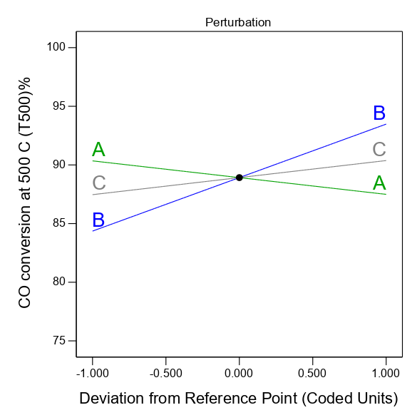
Fig. S1. The perturbation plot of CO oxidation (T500) % by F127-templated CeO₂

Table S1. Detailed fitting parameters used for O 1s XPS deconvolution
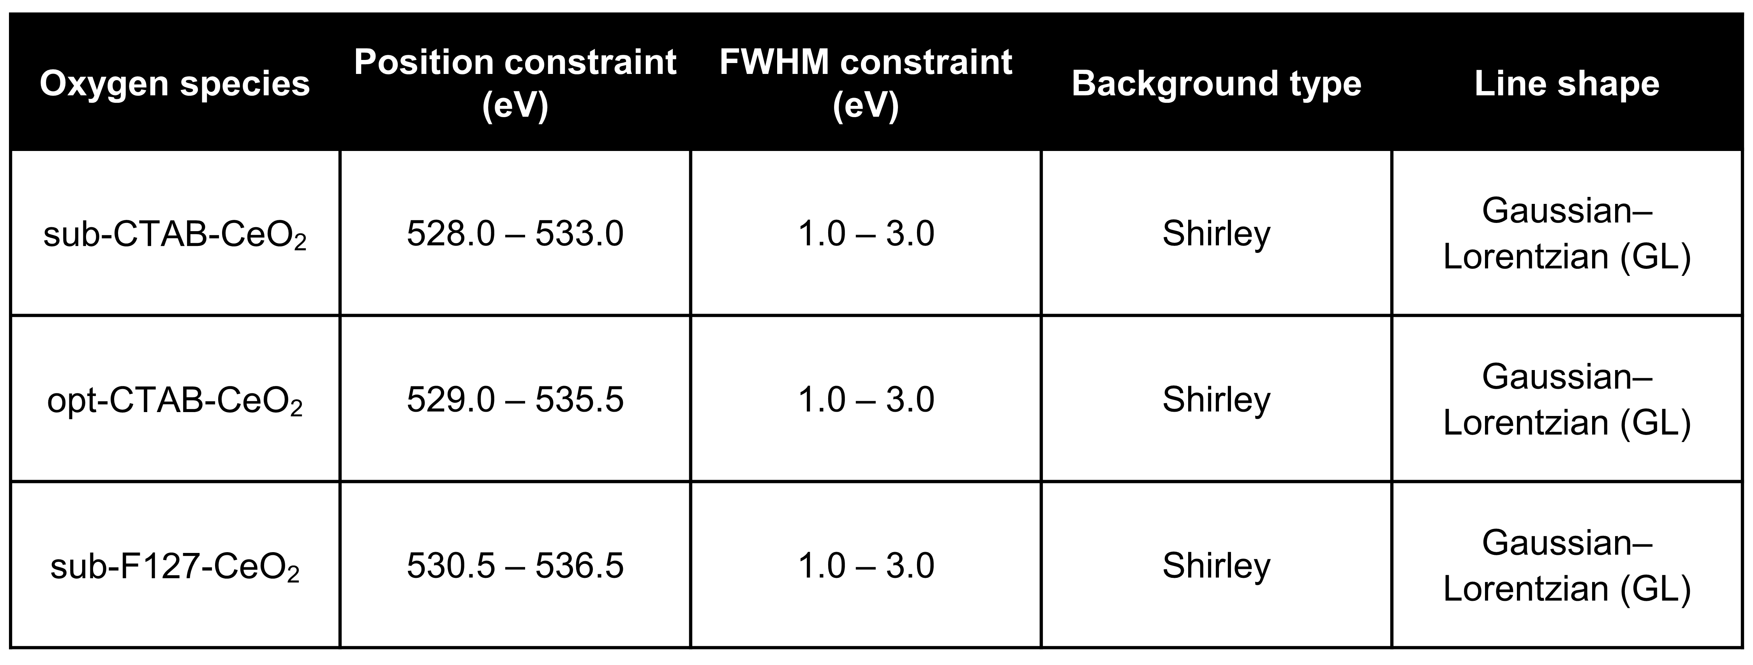

Table S2. T10, T50, and T90 temperatures of various CeO₂ for CO oxidation
