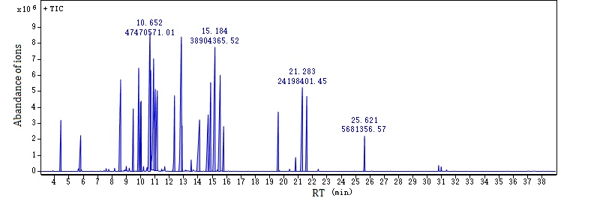
Figure S1. Total ion current of standard compounds in GC-MS analysis. The retention time, peak area, and some information were showed in Table S6

