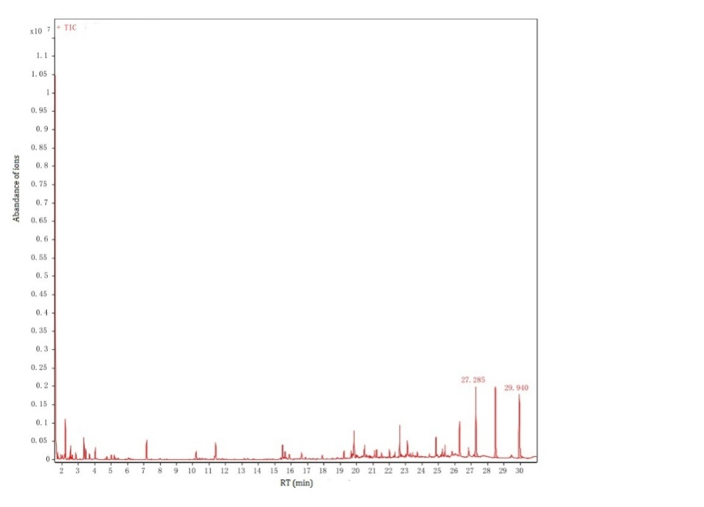
Figure S2. Total ion current of the volatiles of N. rustica “Han” in vegetative growth stage. The retention time, relative peak area and identified compounds were showed in Table 1.

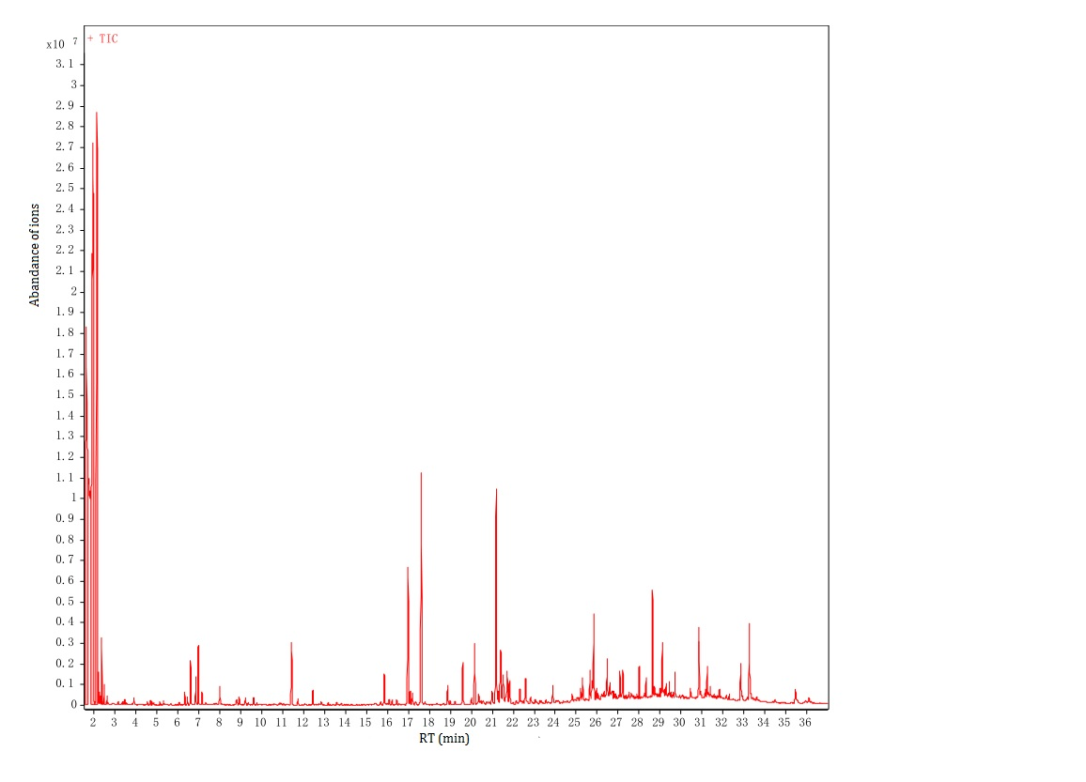
Figure S3. Total ion current of the volatiles of N. rustica “Han” in flowering stage. The retention time, relative peak area and identified compounds were showed in Table 1.

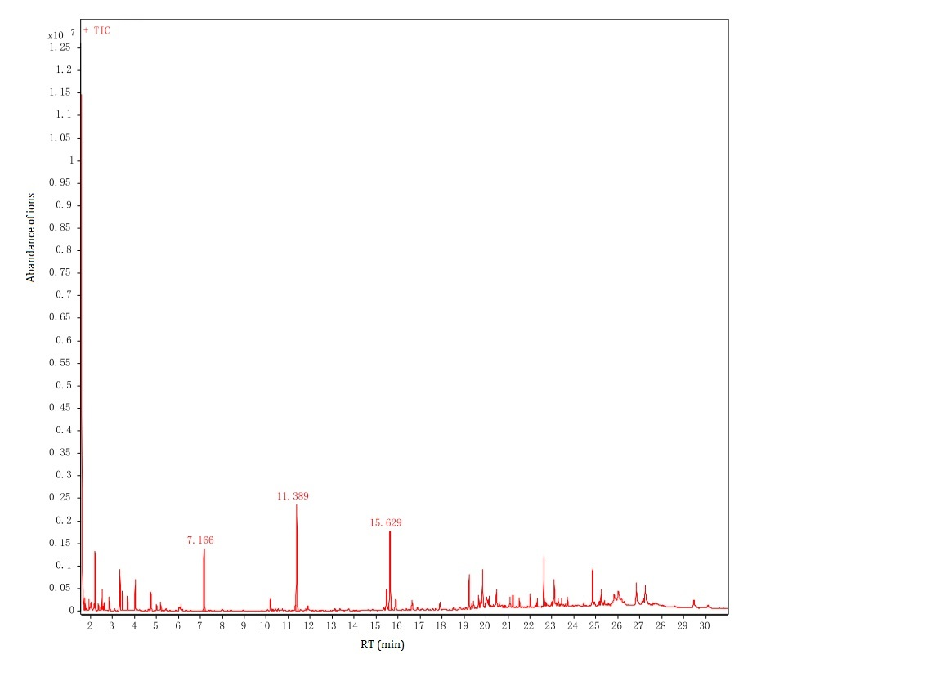
Figure S4. Total ion current of the volatiles of N. rustica “XF” in vegetative growth stage. The retention time, relative peak area and identified compounds were showed in Table 1.

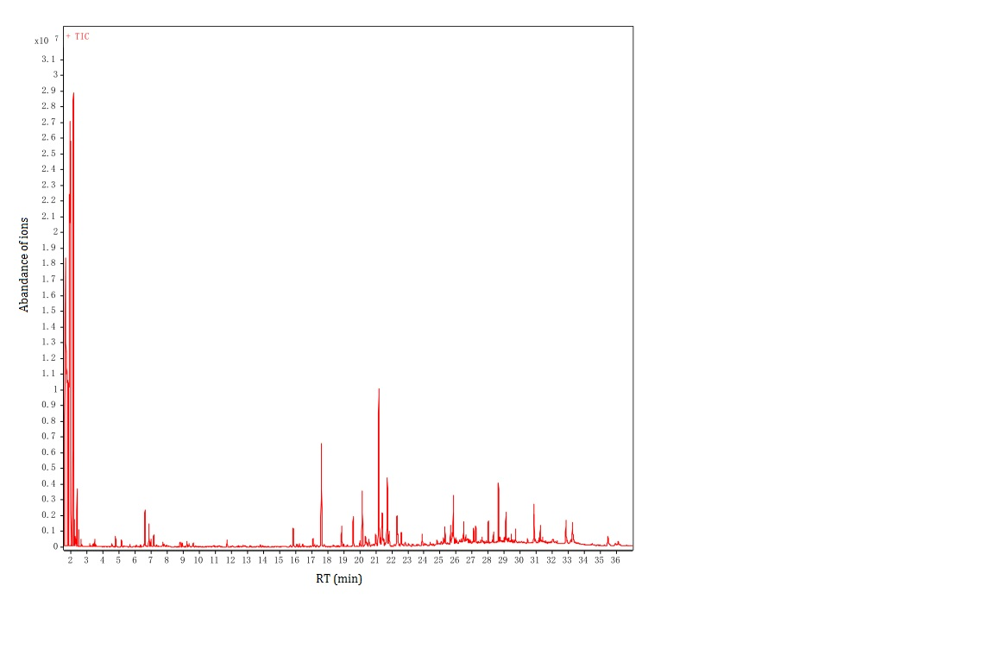
Figure S5. Total ion current of the volatiles of N. rustica “XF” in flowering stage. The retention time, relative peak area and identified compounds were showed in Table 1.

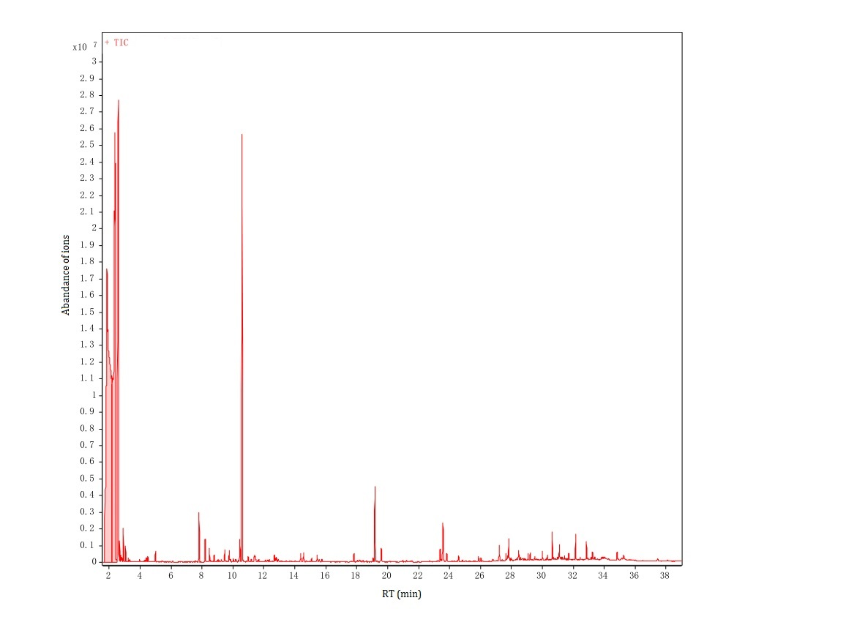
Figure S6. Total ion current of the volatiles of N. tabacum “K326” in vegetative growth stage. The retention time, relative peak area and identified compounds were showed in Table 1.
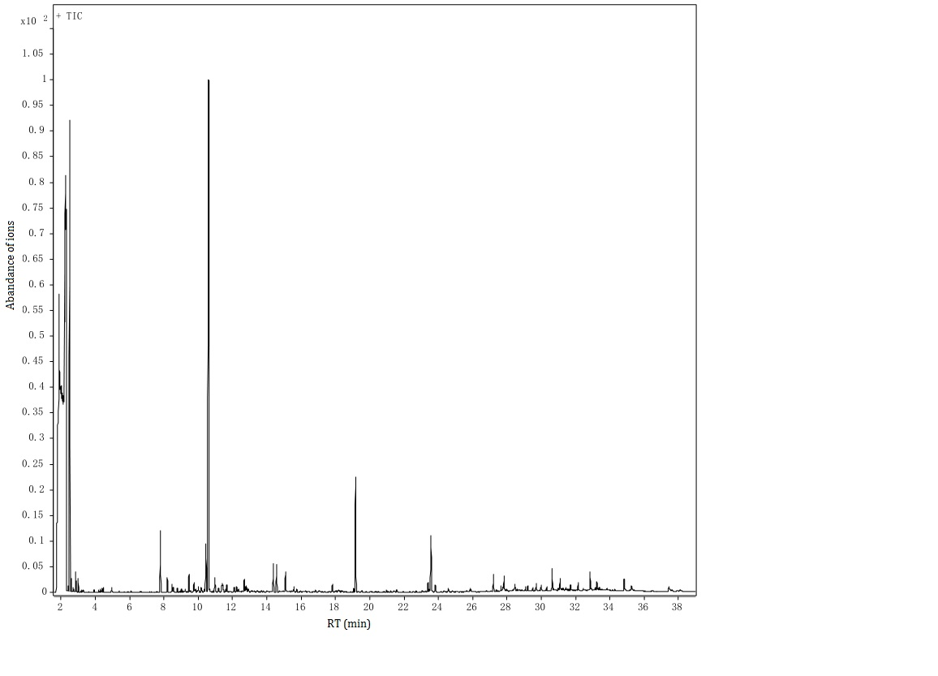
Figure S7. Total ion current of the volatiles of N. tabacum “K326” in flowering stage. The retention time, relative peak area and identified compounds were showed in Table 1.
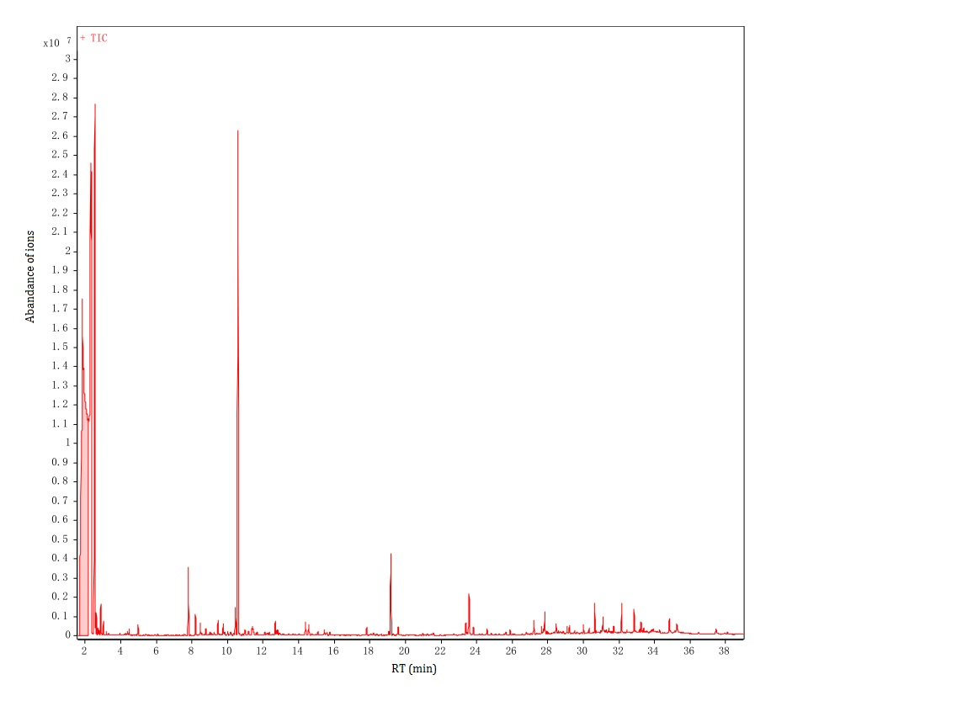
Figure S8. Total ion current of the volatiles of N. tabacum “ZY” in vegetative growth stage. The retention time, relative peak area and identified compounds were showed in Table 1.
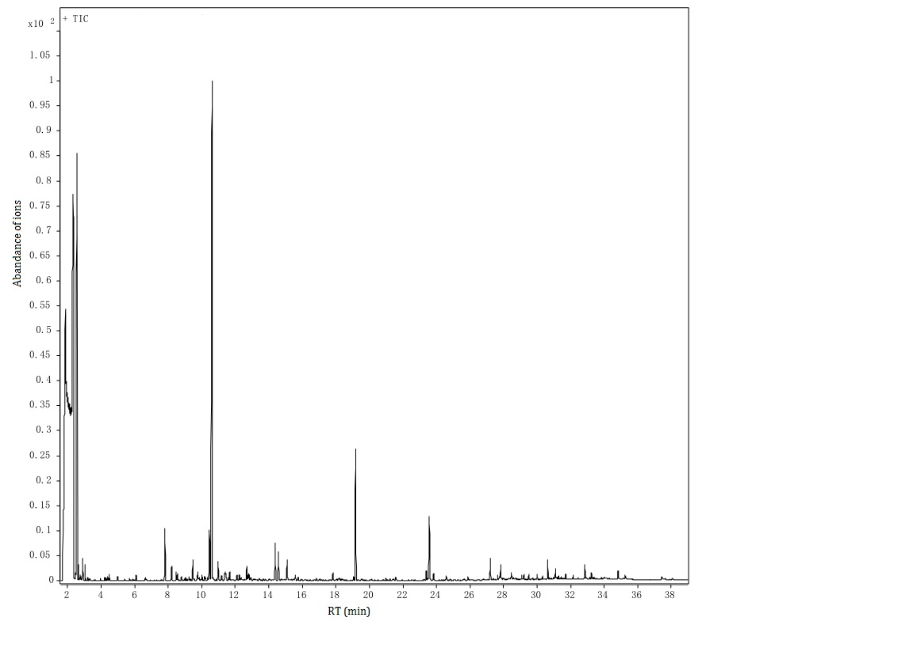
Figure S9. Total ion current of the volatiles of N. tabacum “ZY” in flowering stage. The retention time, relative peak area and identified compounds were showed inTable 1.

