Johnson et al.
Predation of spotted lanternfly (Lycorma delicatula) by generalist arthropod predators in North America

Supplementary Figures
Fig S1 Proportion of L. delicatula consumed in no-choice tests by S. carolina. There were no significant differences in consumption of prey reared with and without access to A. altissima.
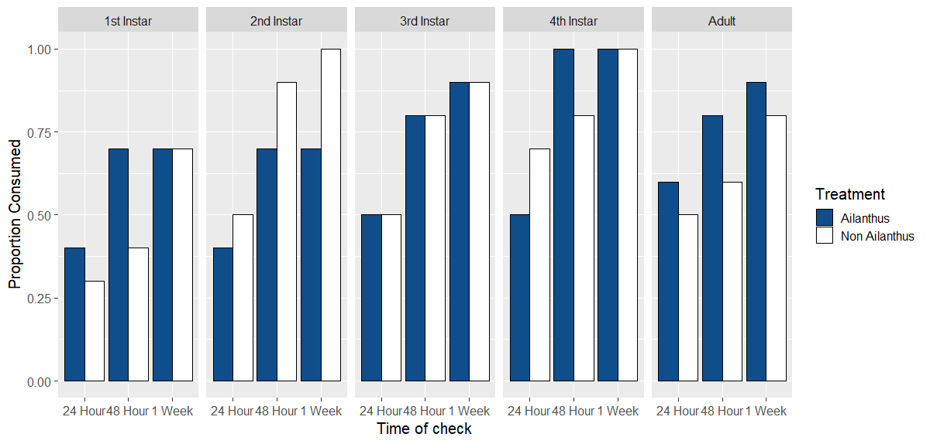

Fig S2 Proportion of L. delicatula consumed in no-choice tests by T. sinensis. There were no significant differences in consumption of prey based on access to A. altissima.
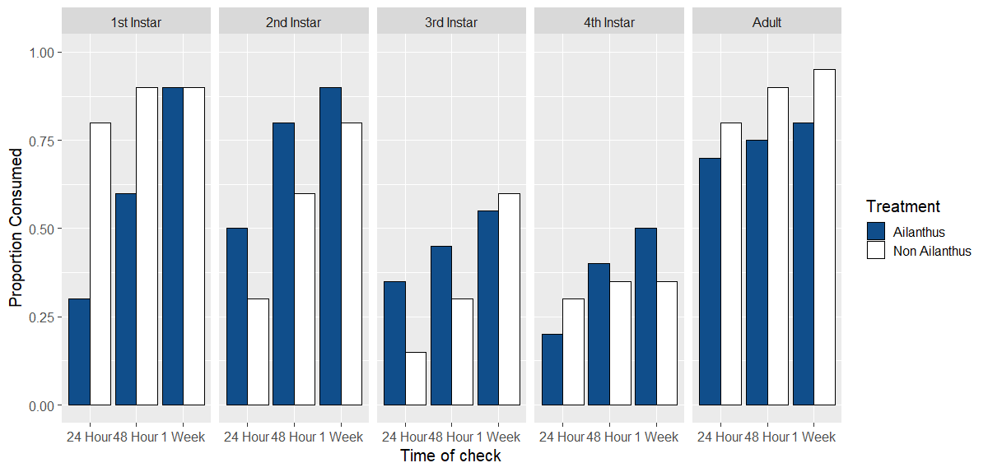

Fig S3 Proportion of L. delicatula consumed in no-choice tests by P. maculiventris. There were no significant differences in consumption of prey reared based on access to A. altissima.
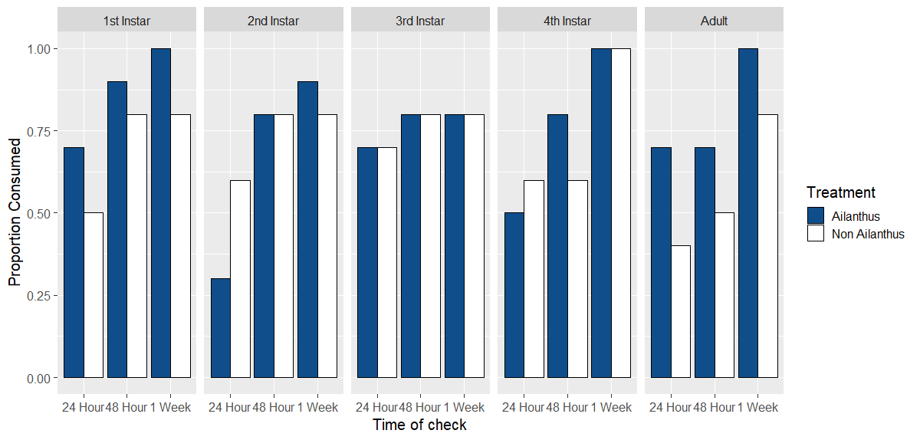

Fig S4 Proportion of L. delicatula consumed in no-choice tests by A. cristatus. There were no significant differences in consumption of prey reared based on access to A. altissima.
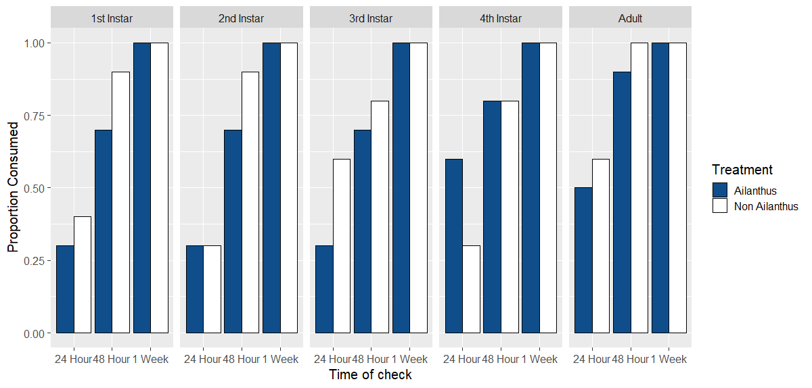

Fig S5 Proportion of L. delicatula consumed in no-choice tests by R. rabida. There were no significant differences in consumption of prey based on access to A. altissima.
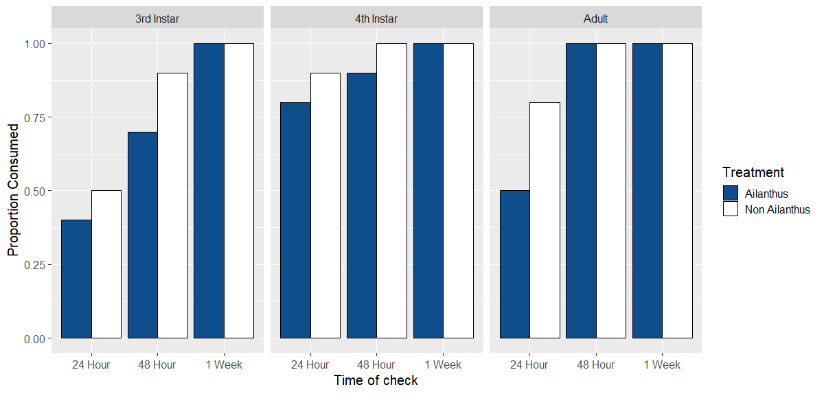
Fig S6 Proportion of L. delicatula eaten in choice tests by S. carolina. There were no significant differences in consumption of prey reared with and without access to A. altissima.
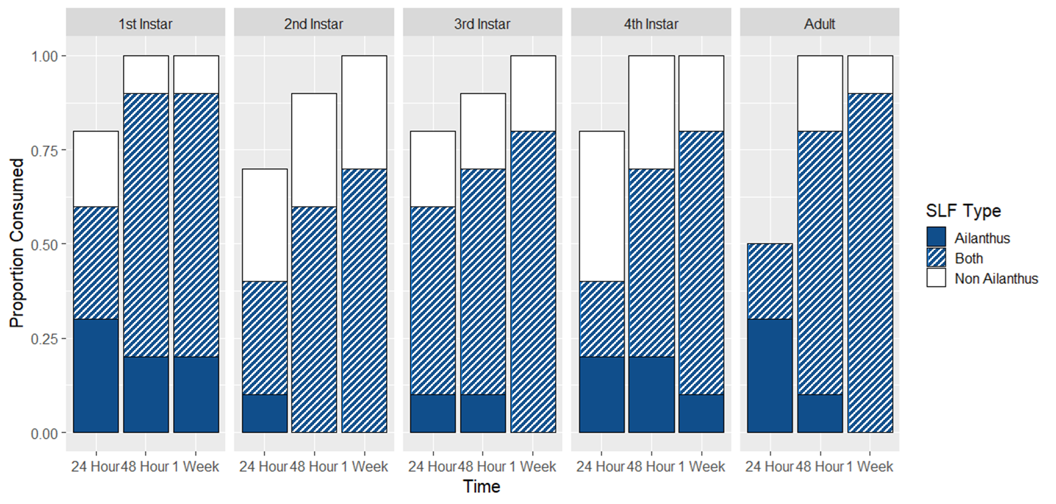
Fig S7 Proportion of L. delicatula eaten in choice tests by T. sinensis. There were no significant differences in consumption of prey reared with and without access to A. altissima.
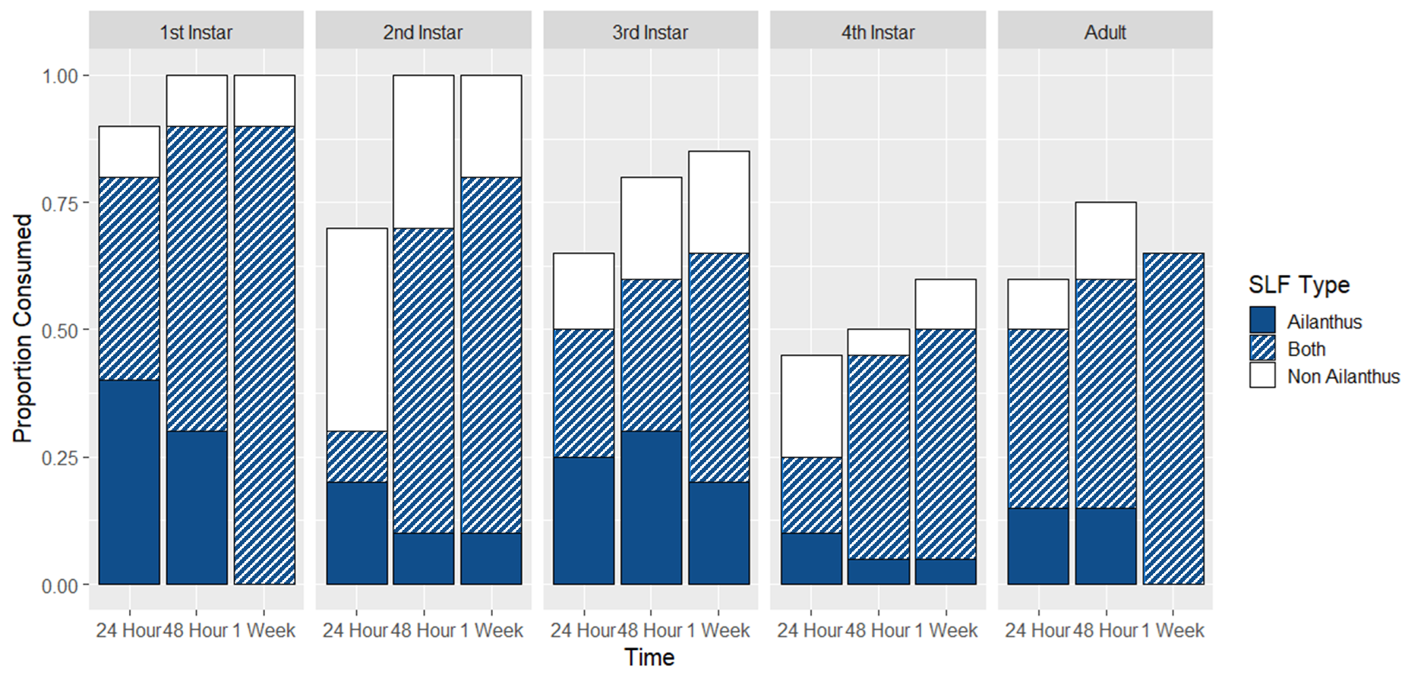

Fig S8 Proportion of L. delicatula eaten in choice tests by P. maculiventris. There were no significant differences in consumption of prey reared with and without access to A. altissima.
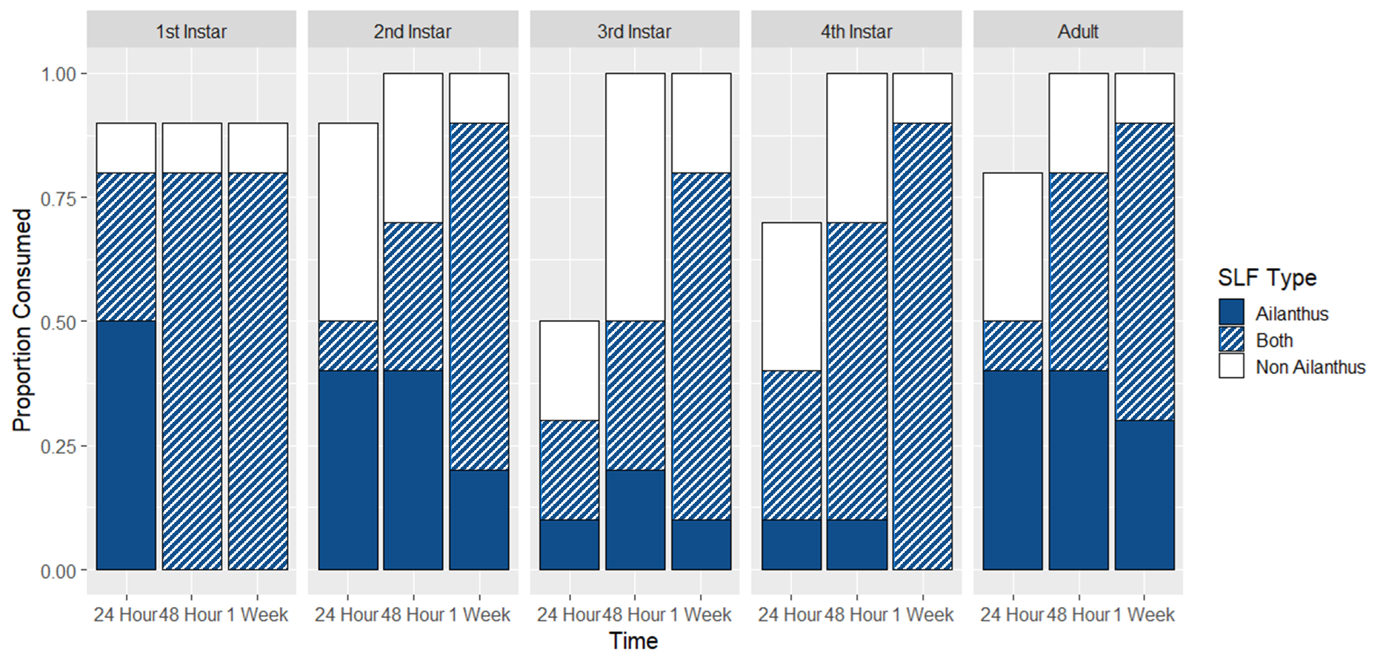

Fig S9 Proportion of L. delicatula eaten in choice tests by A. cristatus. There were no significant differences in consumption of prey reared with and without access to A. altissima.
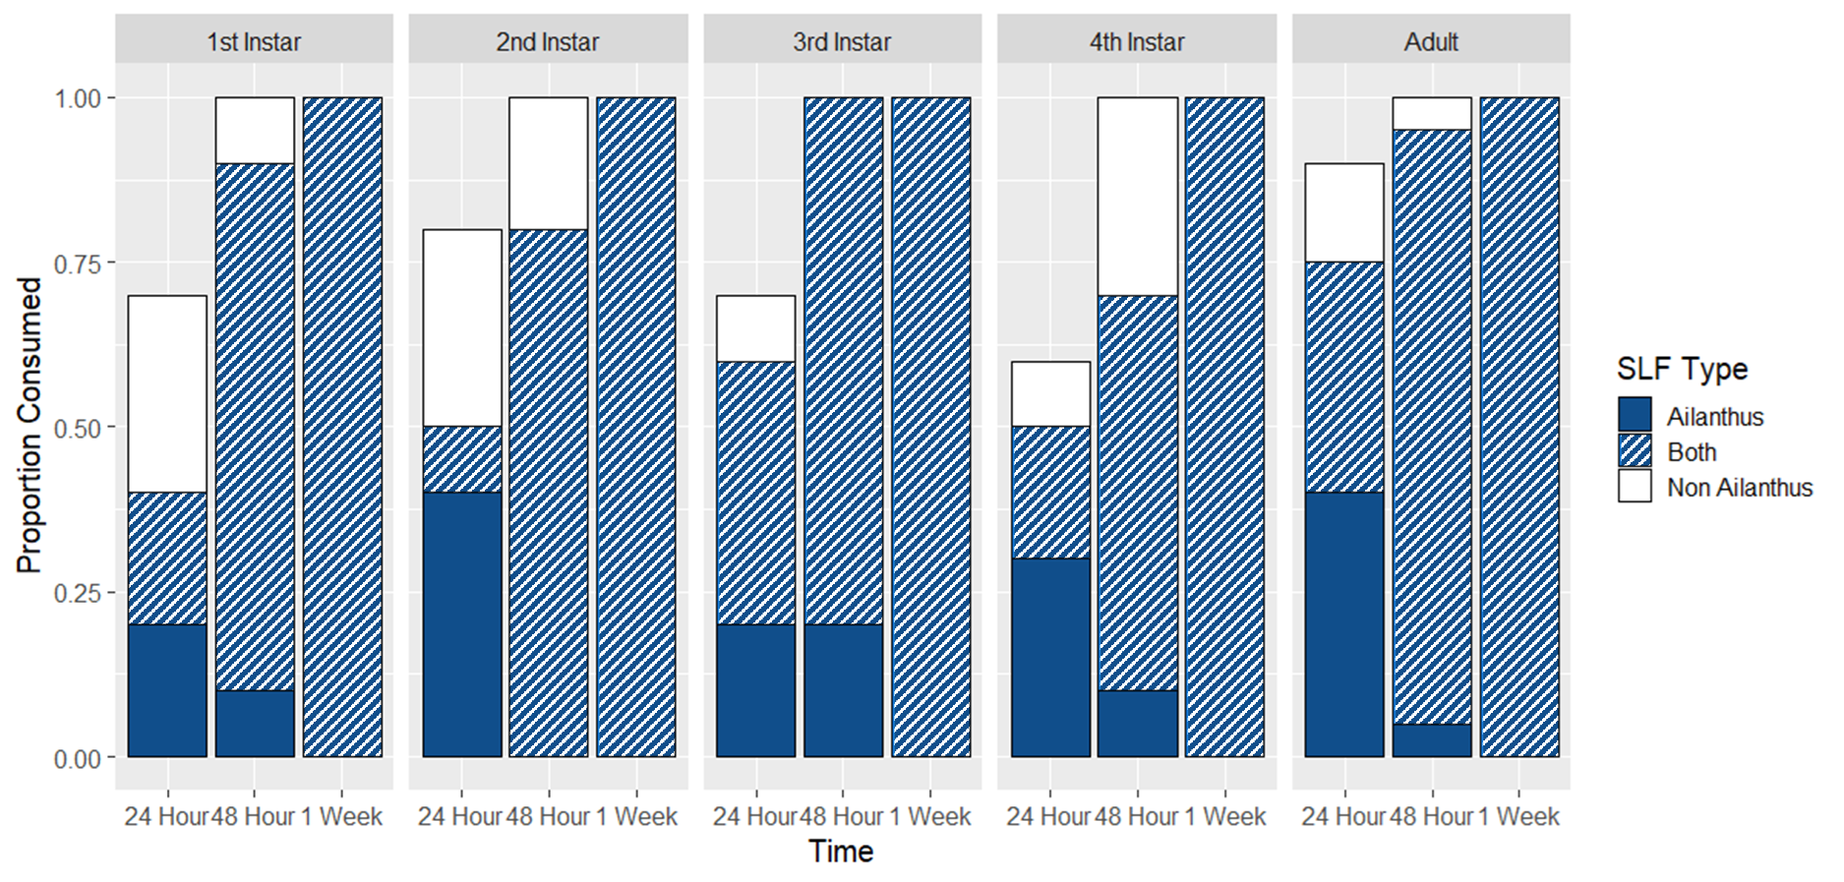

Fig S10 Proportion of L. delicatula eaten in choice tests by R. rabida. There were no significant differences in consumption of prey reared with and without access to A. altissima.
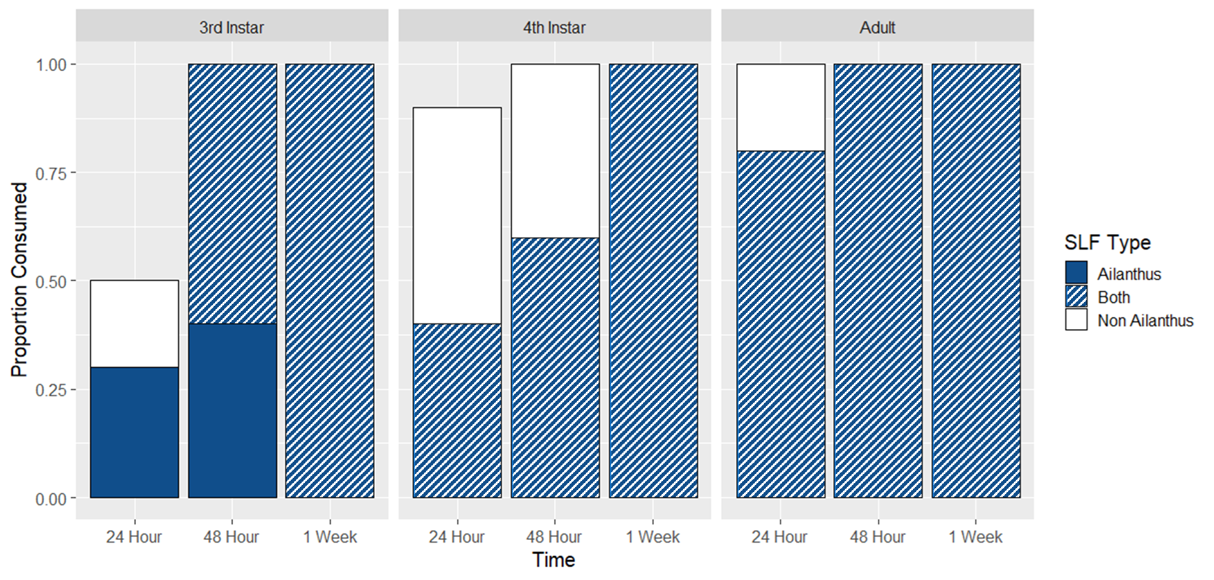

Fig S11 Proportion of L. delicatula removed in choice tests by C. pennsylvanicus. There were no significant differences in removal of prey reared with and without access to A. altissima. Because the ants took prey items to their nest, only presence/absence of prey could be recorded.
