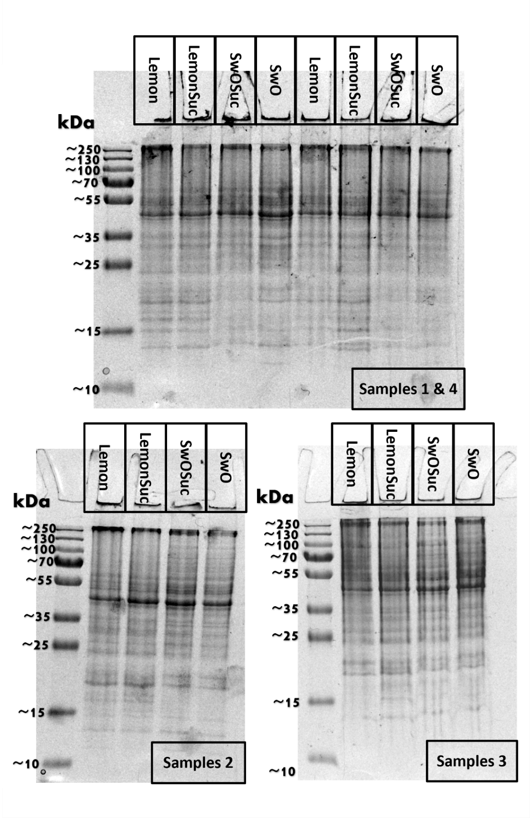
Figure A Sodium dodecyl sulfate–polyacrylamide gel electrophoresis (SDS-Page) results of the Trioza erytreae nymphs protein extraction from the Lemon, LemonSuc, SwO and SwOSuc samples. Stacking gel at 5% and separating gel at 12% acrylamide, 30 μg of protein of each sample was used. PageRuler Plus Prestained Protein Ladder 10 to 250 kDa (Thermo Scientific, Bremen, Germany) was used as the protein ladder. “Lemon”: nymphs that developed exclusively on lemon plants. “LemonSuc”: nymphs that developed on lemon plants and were then fed sucrose for24-h before sampling. “SwO”: nymphs exclusively developed on SwO. “SwOSuc”: nymphs that developed on SwO plants and were then fed sucrose for 24-h before sampling

