Supplementary Material

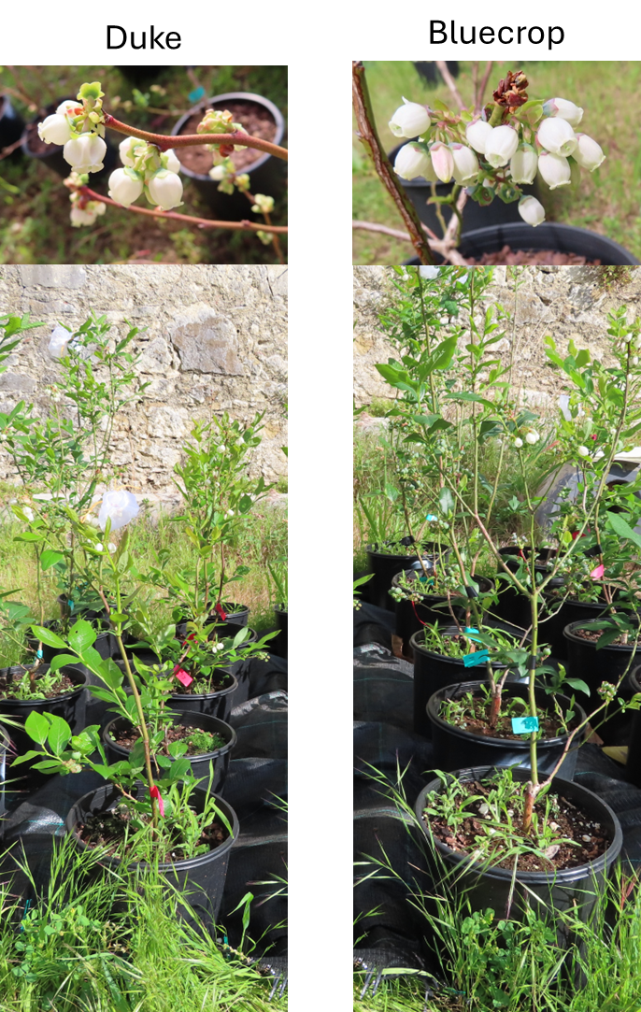
Figure 1. Plants and flowers of the cultivars Duke (left) and Bluecrop (right)

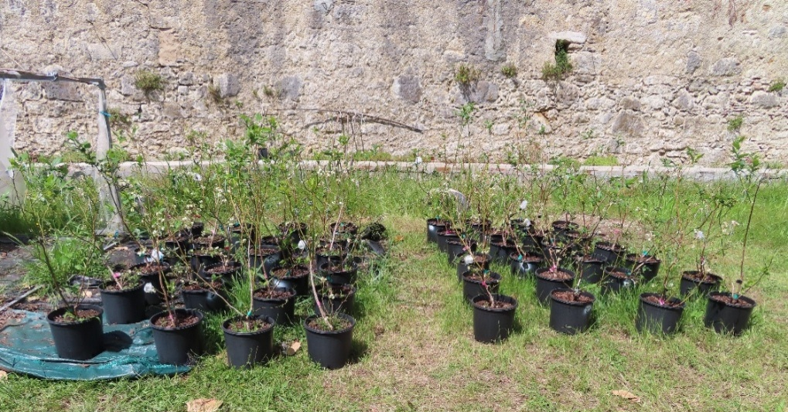
Figure 2. Experimental pots.

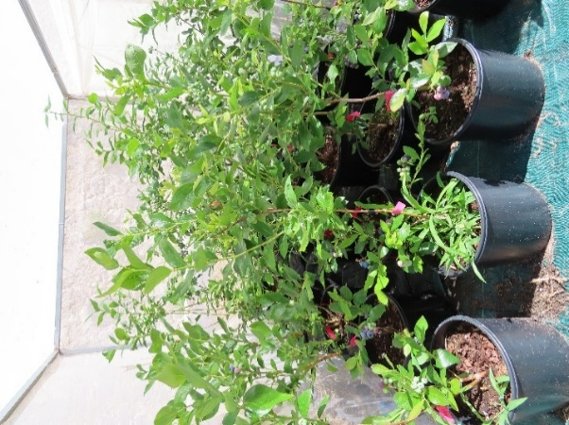
Figure 3. Overview of the structure used to protect plants under stress treatment from rainfall. This structure was covered with colorless plastic.

Methodology and experimental details
Determination of field capacity and pot maintenance
From bud break through the flowering period (23 February to 5 May 2022), half of the plants of each cultivar were subjected to moderate water deficit (33% of field capacity), while the remaining plants were kept well-watered (≥80% of field capacity). To determine field capacity, i.e., the maximum water holding capacity of the type of soil used, first we filled a total of 10 replicate pots (same type of pots used in the experiment) with soil (same soil we used in the experiment). Second, we added water until the soil was saturated with water (the soil could not absorb more water and water drops start to leak from the small holes at the base of the pot) and we recorded the amount of water needed to saturate each of the 10 replicates. At this stage we also recorded the weight of the pot filled with the saturated soil. Third, the soil was allowed to dry, and the weight of the pot filled with the dry soil recorded. The difference will give the amount of water stored in the soil.
The control pots were watered with 80 % of the water required to saturate the soil to avoid damage to the plants due to waterlogging. Plants under water deficit were kept at 33% of field capacity, which corresponds to one third of the amount of water needed to saturate the soil. The 33% value was decided based on expert opinion and experience from previous works on other plant species and crops (Castro et al 2023a; Castro et al 2023b; Dias et al 2014).
Soil water content was monitored by weighing the pots twice a week and rewetting them to maintain the target levels. Briefly, prior to starting the experiment all pots, which had been kept outdoors and watered regularly, including soil and plants were weighed. Those values, together with those obtained from calculating field capacity were used to determine the weight that each pot was expected to have at 33% field capacity. During the experiment a scale was used to control for the amount of water added, and water was added until the corresponding weight was attained.
To prevent rainfall from confounding the drought treatment, stressed plants were sheltered under a hollow iron structure covered with transparent plastic whenever precipitation was forecast (Supplementary Fig. 3). On rainy days, which were scattered during the month of April (1 to 2 days per week) and march (3 days, scattered), the cage was closed during the night, when rainfall was forecast, and during rain events. Whenever possible during these rainy days, care was taken to open the cage on the sides to allow air circulation and avoid subjecting the plants to increases in temperature. Outside of rainy days, the plants under water deficit conditions were kept out of the cage.

References
Castro H, Dias MC, Castro M, Loureiro J and Castro S (2023a) Impact of genome duplications in drought tolerance and distribution of the diploid-tetraploid Jasione maritima. Front. Plant Sci. 14:1144678. doi: 10.3389/fpls.2023.1144678
Castro, H.; Dias, M.C.; Sousa, J.P.; Freitas, H.(2023b) Functional Groups Response to Water Deficit in Mediterranean Ecosystems. Plants, 12, 1471. https://doi.org/ 10.3390/plants12071471
Maria Celeste Dias, Helena Oliveira, Armando Costa, Conceição Santos (2014) Improving elms performance under drought stress: The pretreatment with abscisic acid, Environmental and Experimental Botany, Volume 100, 2014, Pages 64-73, https://doi.org/10.1016/j.envexpbot.2013.12.013.

