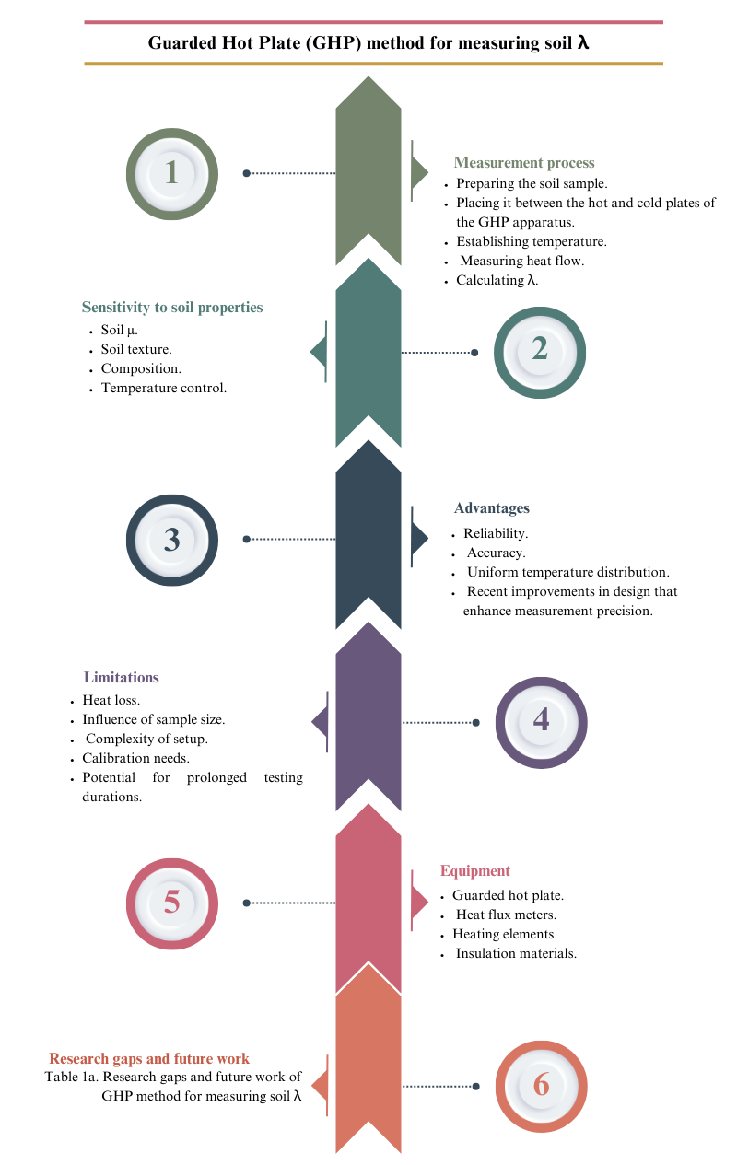
Figure 1. Guarded Hot Plate (GHP) methodology employed for the quantification of soil λ. The diagram elucidates the sensitivity to various soil characteristics, the benefits, constraints, and apparatus involved in the process.

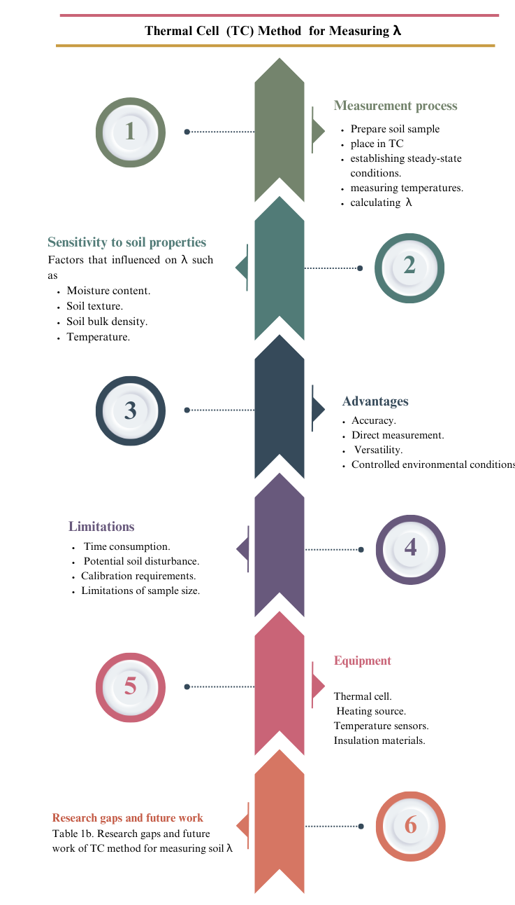
Figure 2. Thermal Cell (TC) methodology utilized for the assessment of soil λ. The illustration delineates the procedural aspects of measurement, the sensitivity to various soil characteristics, the advantages, constraints, and apparatus involved in the process.
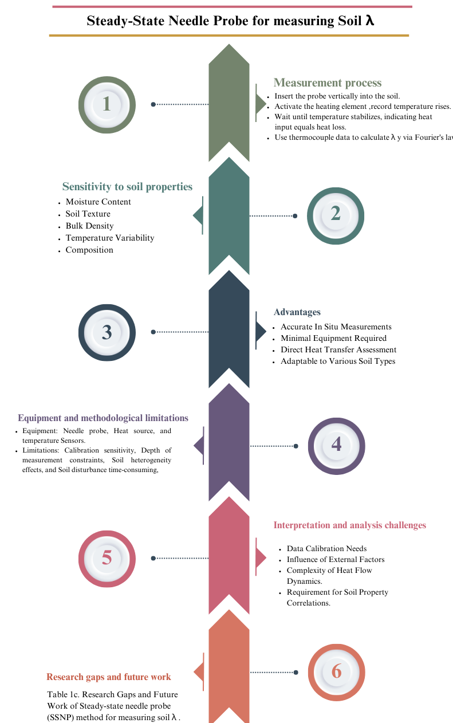

Figure 3. Steady-State Needle Probe for measuring soil λ, the figure illustrates the sensitivity to soil properties, advantages, equipment, and limitations.

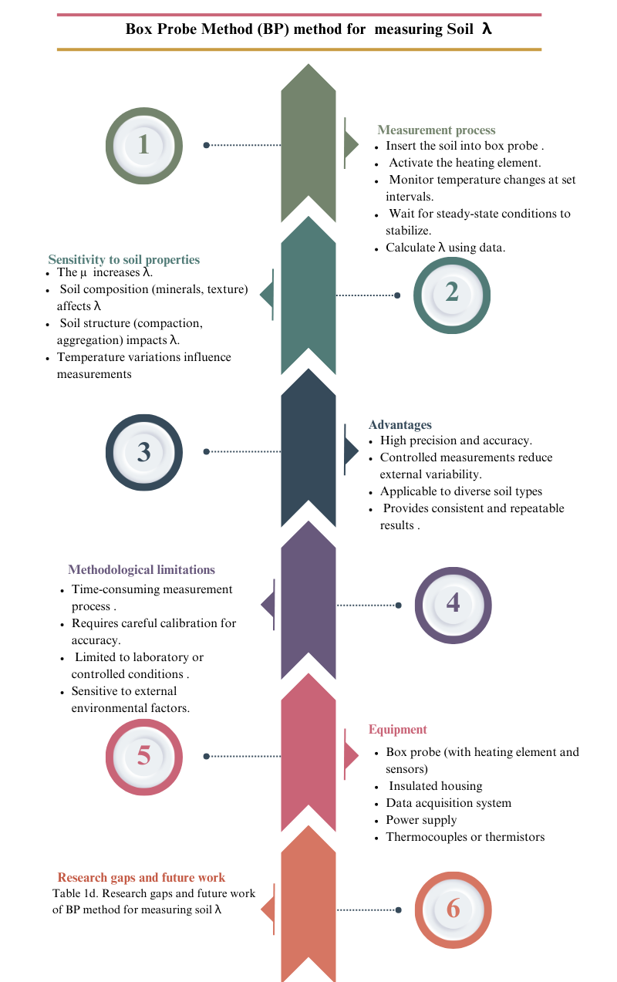
Figure 4. Box Probe (BP) methodology utilized for the assessment of soil λ. The illustration explicates the measurement methodology, the sensitivity to different soil characteristics, the methodological constraints, and the apparatus employed.
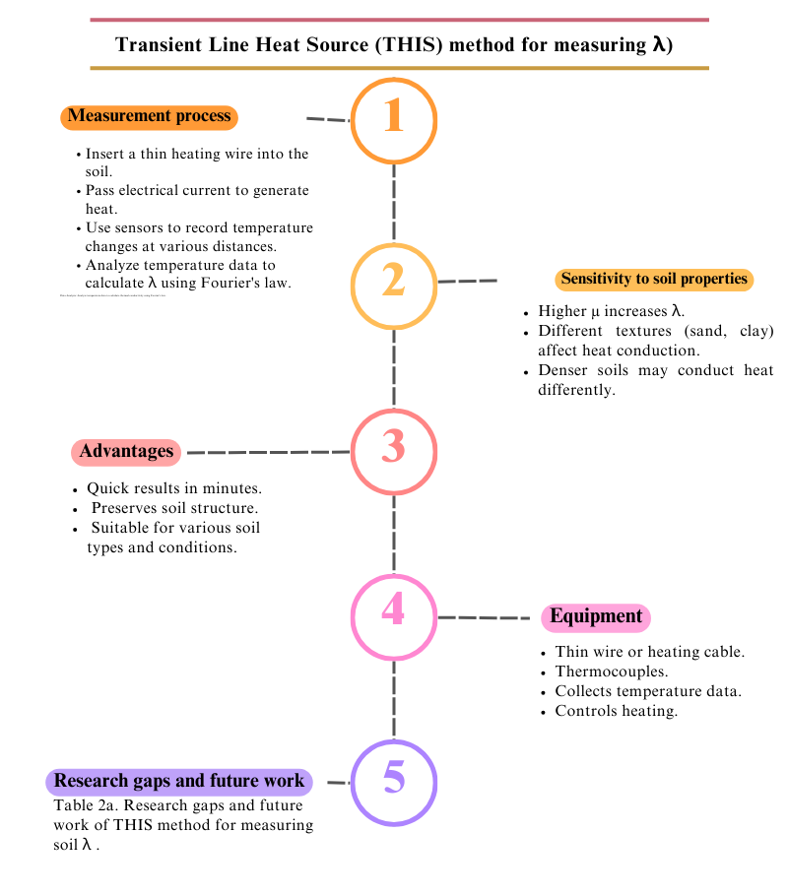
Figure 5. Transient Line Heat Source (THIS) method for measuring soil λ. The figure describes the measurement process, sensitivity to soil properties, advantages, and equipment.

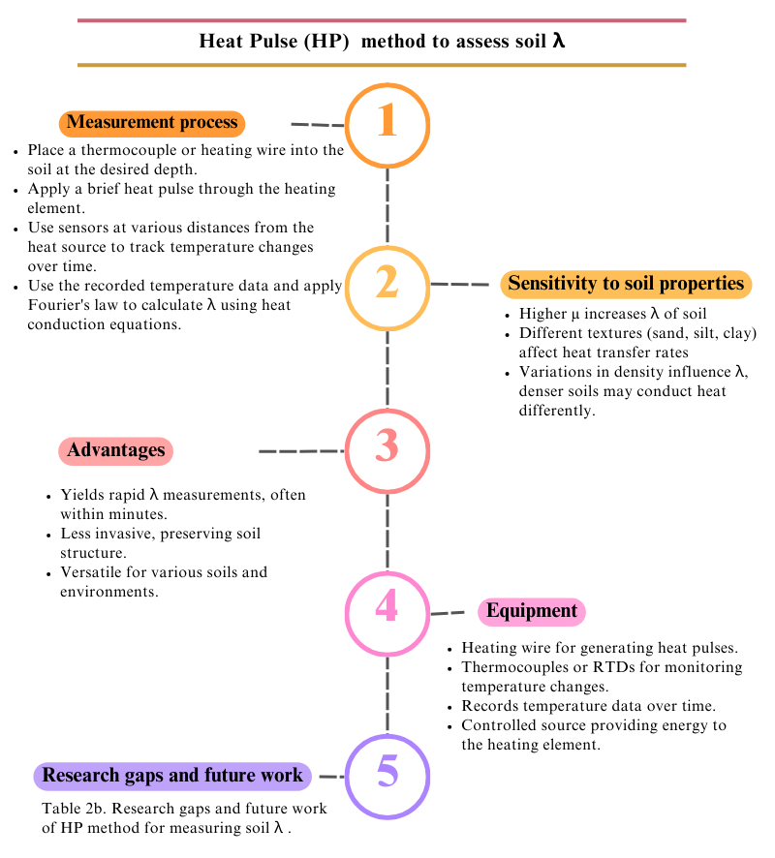
Figure 6. Heat Pulse (HP) technique utilized for the assessment of soil λ. The illustration elucidates the measurement procedure, the sensitivity to various soil characteristics, the benefits associated with the method, and the requisite apparatus.

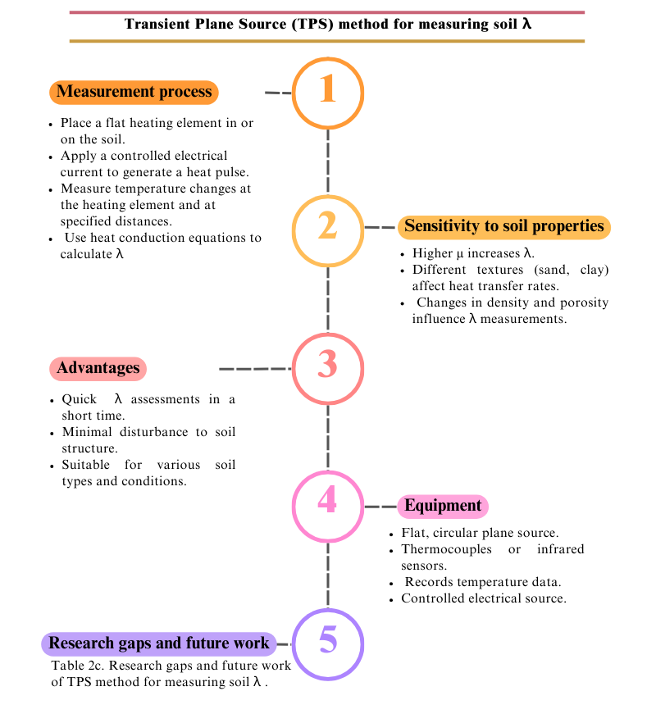
Figure 7. Transient Plane Source (TPS) method for measuring soil λ. The figure outlines the measurement process, sensitivity to soil properties, advantages, and equipment.

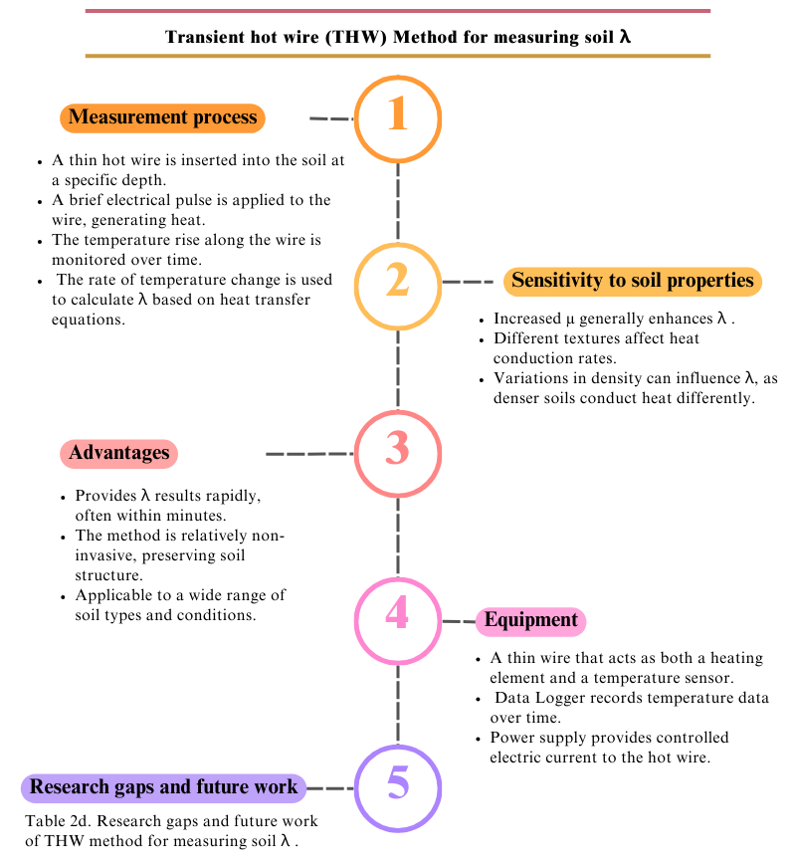
Figure 8. Transient Hot Wire (THW) method for measuring soil λ, the figure details the measurement process, sensitivity to soil properties, advantages, equipment, and research gaps.

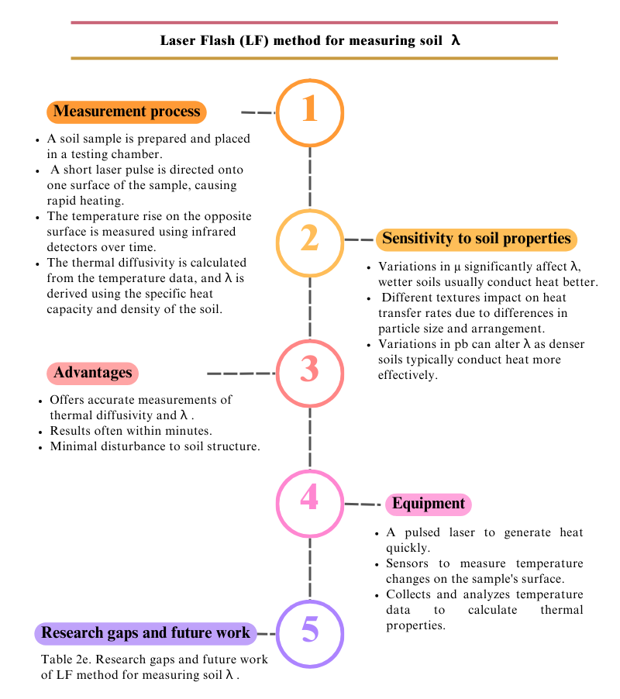
Figure 9. Laser Flash (LF) methodology employed for the quantification of soil λ, this illustration delineates the procedural aspects of measurement, the sensitivity to various soil characteristics, the benefits inherent to the method, and the requisite apparatus.

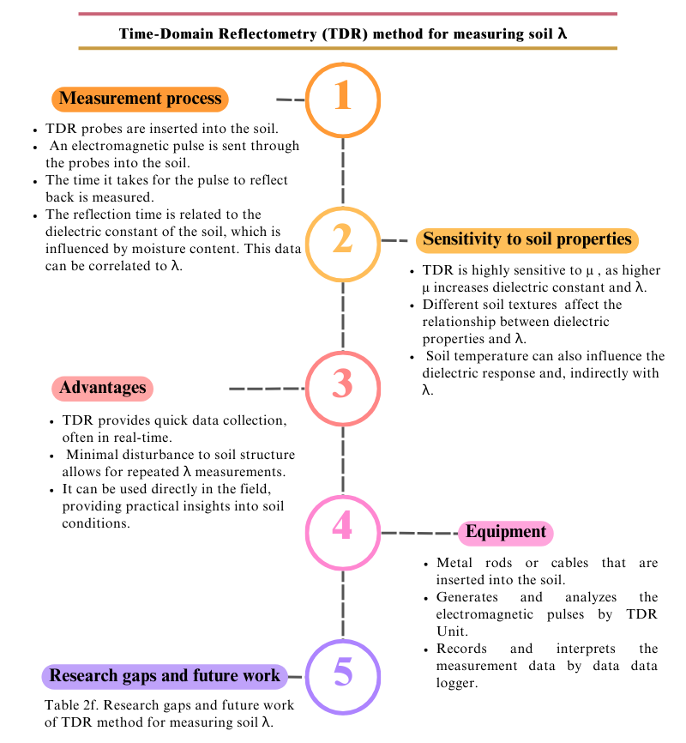
Figure 10. Time-Domain Reflectometry (TDR) methodology employed for the quantification of soil λ. The illustration elucidates the measurement protocol, responsiveness to soil characteristics, benefits, and instrumentation utilized.

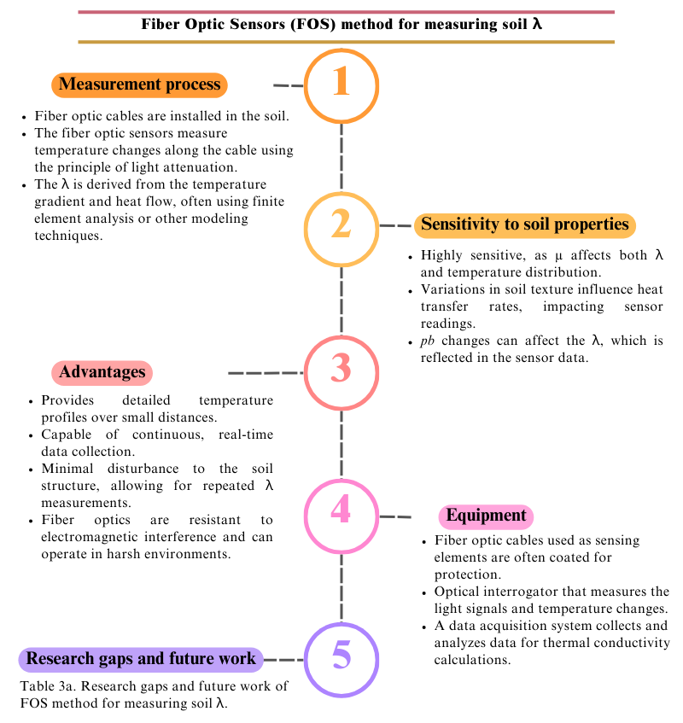
Figure 11. Fiber Optic Sensors (FOS) methodology for assessing soil thermal conductivity λ. The diagram elucidates the measurement protocol, sensitivity to soil attributes, advantages, and necessary equipment. The illustration delineates the measurement procedure, sensitivity to soil characteristics, benefits, and requisite apparatus.

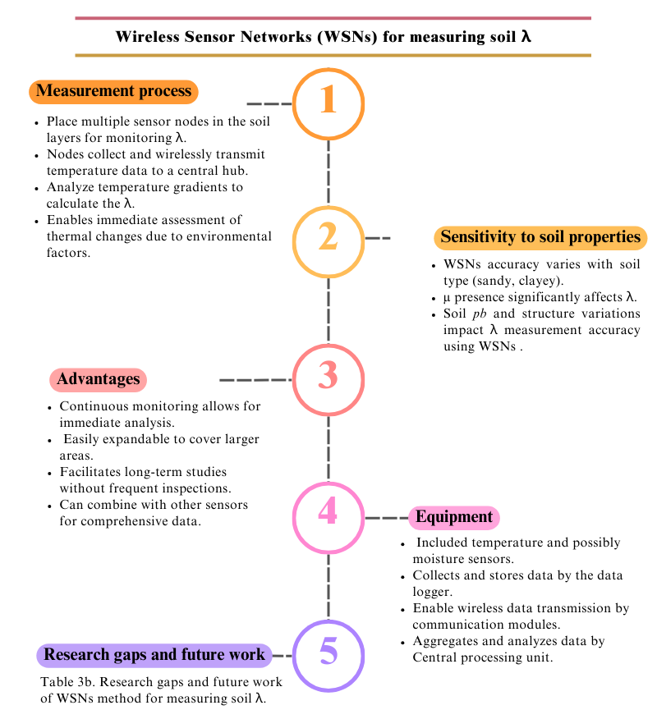
Figure 12. Wireless Sensor Networks (WSNs) of soil λ, measurement technique, the sensitivity to soil attributes, the advantages, and the instruments involved. The illustration elucidates the measurement procedure, the responsiveness to soil characteristics, the benefits, and t

