Supplementary Methods 1
Search String:
(("mediterranean"[All Fields] OR "mediterraneans"[All Fields]) AND "diet*"[All Fields] AND (("Flow-mediated"[All Fields] AND ("dilatable"[All Fields] OR "dilatated"[All Fields] OR "dilatating"[All Fields] OR "dilatation"[MeSH Terms] OR "dilatation"[All Fields] OR "dilatations"[All Fields] OR "dilate"[All Fields] OR "dilation"[All Fields] OR "dilations"[All Fields] OR "dilatative"[All Fields] OR "dilatator"[All Fields] OR "dilatators"[All Fields] OR "dilated"[All Fields] OR "dilates"[All Fields] OR "dilating"[All Fields] OR "dilator"[All Fields] OR "dilators"[All Fields])) OR ("Flow-mediated"[All Fields] AND ("dilatable"[All Fields] OR "dilatated"[All Fields] OR "dilatating"[All Fields] OR "dilatation"[MeSH Terms] OR "dilatation"[All Fields] OR "dilatations"[All Fields] OR "dilate"[All Fields] OR "dilation"[All Fields] OR "dilations"[All Fields] OR "dilatative"[All Fields] OR "dilatator"[All Fields] OR "dilatators"[All Fields] OR "dilated"[All Fields] OR "dilates"[All Fields] OR "dilating"[All Fields] OR "dilator"[All Fields] OR "dilators"[All Fields])) OR "FMD"[All Fields] OR (("veins"[MeSH Terms] OR "veins"[All Fields] OR "venous"[All Fields]) AND ("dental occlusion"[MeSH Terms] OR ("dental"[All Fields] AND "occlusion"[All Fields]) OR "dental occlusion"[All Fields] OR "occlusion"[All Fields] OR "occlused"[All Fields] OR "occlusions"[All Fields] OR "occlusive"[All Fields] OR "occlusives"[All Fields]) AND ("plethysmography"[MeSH Terms] OR "plethysmography"[All Fields] OR "plethysmographies"[All Fields])) OR (("peripheral"[All Fields] OR "peripherally"[All Fields] OR "peripherals"[All Fields] OR "periphereal"[All Fields] OR "peripheric"[All Fields] OR "peripherically"[All Fields]) AND ("arterialization"[All Fields] OR "arterializations"[All Fields] OR "arterialize"[All Fields] OR "arterialized"[All Fields] OR "arterializing"[All Fields] OR "arterially"[All Fields] OR "arterials"[All Fields] OR "arterie"[All Fields] OR "arteries"[MeSH Terms] OR "arteries"[All Fields] OR "arterial"[All Fields] OR "arteris"[All Fields] OR "artery"[All Fields] OR "arterious"[All Fields] OR "artery s"[All Fields] OR "arterys"[All Fields]) AND ("manometry"[MeSH Terms] OR "manometry"[All Fields] OR "tonometry"[All Fields] OR "tonometries"[All Fields])) OR ("nitric oxide"[MeSH Terms] OR ("nitric"[All Fields] AND "oxide"[All Fields]) OR "nitric oxide"[All Fields]) OR (("endothelialization"[All Fields] OR "endothelialize"[All Fields] OR "endothelialized"[All Fields] OR "endothelializing"[All Fields] OR "endothelials"[All Fields] OR "endothelium"[MeSH Terms] OR "endothelium"[All Fields] OR "endothelial"[All Fields]) AND ("functional"[All Fields] OR "functional s"[All Fields] OR "functionalities"[All Fields] OR "functionality"[All Fields] OR "functionalization"[All Fields] OR "functionalizations"[All Fields] OR "functionalize"[All Fields] OR "functionalized"[All Fields] OR "functionalizes"[All Fields] OR "functionalizing"[All Fields] OR "functionally"[All Fields] OR "functionals"[All Fields] OR "functioned"[All Fields] OR "functioning"[All Fields] OR "functionings"[All Fields] OR "functions"[All Fields] OR "physiology"[MeSH Subheading] OR "physiology"[All Fields] OR "function"[All Fields] OR "physiology"[MeSH Terms])) OR (("endothelialization"[All Fields] OR "endothelialize"[All Fields] OR "endothelialized"[All Fields] OR "endothelializing"[All Fields] OR "endothelials"[All Fields] OR "endothelium"[MeSH Terms] OR "endothelium"[All Fields] OR "endothelial"[All Fields]) AND ("dysfunctional"[All Fields] OR "dysfunctionals"[All Fields] OR "dysfunctioning"[All Fields] OR "dysfunctions"[All Fields] OR "physiopathology"[MeSH Subheading] OR "physiopathology"[All Fields] OR "dysfunction"[All Fields])) OR ("carotid intima media thickness"[MeSH Terms] OR ("carotid"[All Fields] AND "intima media"[All Fields] AND "thickness"[All Fields]) OR "carotid intima media thickness"[All Fields] OR ("carotid"[All Fields] AND "intima"[All Fields] AND "media"[All Fields] AND "thickness"[All Fields]) OR "carotid intima media thickness"[All Fields]) OR ("pulse wave analysis"[MeSH Terms] OR ("pulse"[All Fields] AND "wave"[All Fields] AND "analysis"[All Fields]) OR "pulse wave analysis"[All Fields] OR ("pulse"[All Fields] AND "wave"[All Fields] AND "velocity"[All Fields]) OR "pulse wave velocity"[All Fields]) OR (("augment"[All Fields] OR "augmentation"[All Fields] OR "augmentations"[All Fields] OR "augmented"[All Fields] OR "augmenting"[All Fields] OR "augments"[All Fields]) AND ("abstracting and indexing"[MeSH Terms] OR ("abstracting"[All Fields] AND "indexing"[All Fields]) OR "abstracting and indexing"[All Fields] OR "index"[All Fields] OR "indexed"[All Fields] OR "indexes"[All Fields] OR "indexing"[All Fields] OR "indexation"[All Fields] OR "indexations"[All Fields] OR "indexe"[All Fields] OR "indexer"[All Fields] OR "indexers"[All Fields] OR "indexs"[All Fields]))))

Supplementary Figure 1: Risk of Bias Assessment
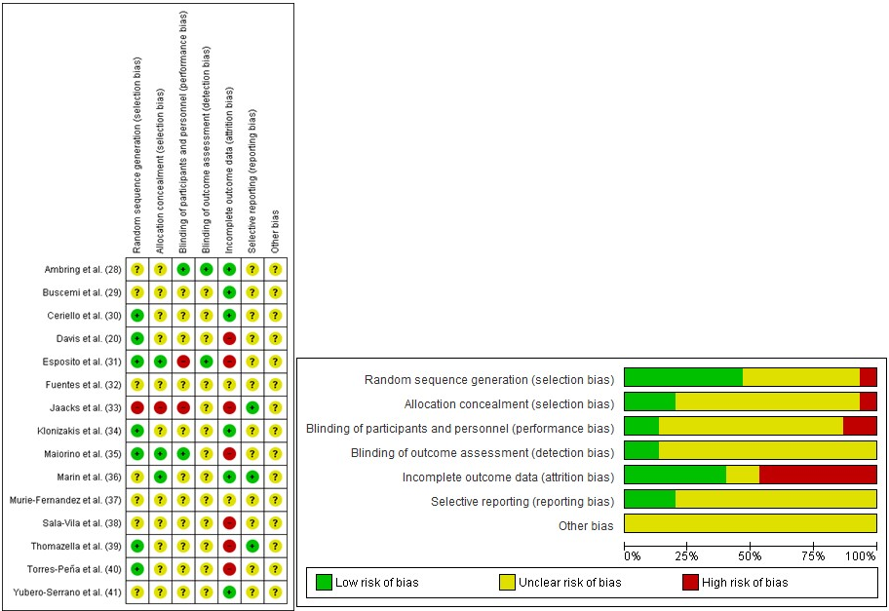
eTable 1: Meta-regression analysis to evaluate effect of age, BMI and study duration
 | Slope | SE | p-value
Age, y | -0.004 | 0.009 | 0.618
Study duration, week | 0.001 | 0.002 | 0.527
BMI, kg/m | -0.032 | 0.047 | 0.497

Supplemental Table 1: Raw data used in meta-analysis
Reference | Subgroup within study | Comparison | Outcome | Data format | Age  (yrs) | BMI  (kg/m²) | Duration  (weeks) | Design | Type  Of  MD | Difference in means | N | Paired groups  p-value | Tails
Ambring et al. (28) | Healthy | Functional | FBF | Paired groups (difference, p) | 43 | 26 | 12 | Cross-over | MD | 0.41 | 22 | 0.5 | 2
Fuentes et al. (32) | Increased CVD risk | Functional | FMD | Paired groups (difference, p) | 40 | 28 | 8 | Cross-over | MDPlus | 2.4 | 22 | 0.05 | 2
Fuentes et al. (32) | Increased CVD risk | Structural | BVS | Paired groups (difference, p) | 40 | 28 | 8 | Cross-over | MDPlus | 0.02 | 22 | 0.18 | 2
Yubero-Serrano et al. (41) | Increased CVD risk | Functional | FMD | Paired groups (difference, p) | 60.4 | 30.9 | 52 | Parallel | MD | 2.63 | 805 | 0.011 | 2

Supplemental Table 2: Raw data used in meta-analysis
Reference | Subgroup within study | Comparison | Outcome | Data Format | Age  (yrs) | BMI  (kg/m²) | Duration  (weeks) | Design | Type  Of  MD | Difference in means | Lower Limit | Upper Limit | MD  n | Control  n | Confidence Level
Davis et al. (20) | Healthy | Functional | FMD | Raw Difference (independent groups, CI) | 71 | 26.9 | 24 | Parallel | MD | 1.3 | 0.2 | 2.4 | 85 | 81 | 0.95

Supplemental Table 3
Reference | Subgroup within  study | Comparison | Outcome | Data format | Age | BMI | Duration | Design | Typeof  MD | MD  Pre Mean | MD  Pre SD | MD  Post Mean | MD  Post SD | MD  N | Control Pre Mean | Control Pre SD | Control Post Mean | Control  Post SD | Control  N | Pre Post  correlation
Buscemi, et  al. (29) | Healthy | Functional | FMD | Means,  SD in each | 38 | 34.2 | 8 | Parallel | MD | 10.3 | 7 | 10.6 | 6 | 10 | 12.2 | 9 | 11 | 4 | 10 | 0.5
Ceriello, et  al. (30) | Increased  CVD Risk | Functional | FMD | Means,  SD in each | 71 | 29.5 | 12 | Parallel | MDPlus | 5.6 | 2 | 7.9 | 1.4 | 1 2 | 5.5 | 1 | 5.6 | 2.1 | 12 | 0.5
Esposito, et  al. (31) | Increased  CVD Risk | Functional | EFS | Means,  SD in each group | 44 | 25 | 96 | Parallel | MD | 6 | 1.2 | 7.9 | 1.3 | 90 | 5.9 | 1.1 | 6.1 | 1.1 | 90 | 0.5
Jaacks  et al. (33) | Healthy | Functional | FMD | Means,  SD in each  group | 51 | 31.5 | 8 | Parallel | MD | 5.6 | 3.3 | 6.7 | 3.6 | 11 | 6.1 | 5.3 | 5.2 | 4.9 | 9 | 0.5
Klonizakis  et al. (34) | Healthy | Functional | CM | Means,  SD in each group | 55 | 30.4 | 8 | Parallel | MDPlu  s | 0.74 | 0.2  6 | 2.04 | 1.1 | 11 | 0.86 | 0.44 | 2.27 | 1 .67 | 11 | 0.5
Thomazella  et al. (39) | Increased  CVD Risk | Functional | FMD | Means,  SD in each | 55 | 26.4 | 12 | Parallel | MD | 4.4 | 3.6 | 4.9 | 4.3 | 21 | 4.4 | 5.5 | 49 | 3.7 | 19 | 0.5
Thomazella  et al. (39) | Increased  CVD Risk | Structural | BVS | Means,  SD in each group | 55 | 26.4 | 12 | Parallel | MD | 4.38 | 0.3  9 | 4.44 | 0.5  2 | 21 | 4.44 | 0.51 | 4.34 | 0.49 | 19 | 0.5
Torres-Pena  et al. (DM2) (40) | Increased  CVD Risk | Functional | FMD | Means,  SD in each group | 61 | 32 | 72 | Parallel | MDPlus | 3.8 | 5.9 | 5.2 | 5.9 | 220 | 3.98 | 5.9 | 3.7 | 5.9 | 218 | 0.5
Torres-Pena  et al. (pDM2) (40) | Increased  CVD Risk | Functional | FMD | Means,  SD in each group | 58 | 30.3 | 72 | Parallel | MDPlus | 3.8 | 4.9  6 | 4.9 | 4.9  6 | 154 | 5.1 | 5.8 | 4.6 | 46 | 135 | 0.5
Torres-Pena  et at. (Healthy) (40) | Healthy | Functional | PMD | Means,  SD in each group | 56 | 29.5 | 72 | Parallel | MDPlu  s | 4.8 | 3.2 | 4.2 | 2.6  5 | 44 | 6.1 | 3.5 | 3.6 | 1.75 | 34 | 0.5

Supplemental Table 4: Raw data used in meta-analysis
Reference | Subgroup within  study | Comparison | Outcome | Data format | Age | BMI | Duration | Design | Type of  MD | MD  Mean Difference | MD  Different e SD | MD  n | Control  Mean Difference | Control  Difference SD | Control  n | Pre Post  correlation
Maiorino et al. (35) | Increase  d CVD  Risk | Structural | CIMT | Mean  change, SD  difference in each group | 52 | 29.6 | 121 | Parallel | MD | 0.026 | 0.727 | 108 | 0.001 | 0.62 | 107 | 0.5
Murie-Fernandez et al. a  (37) | Increase  d CVD  Risk | Structural | CIMT | Mean  change, SD  difference in each | 67 | 29.4 | 48 | Parallel | MDPlus | -0.016 | 0.11 | 66 | -0.007 | 0.09 | 62 | 0.5
Murie-Fernandez et al. b  (37) | Increase  d CVD  Risk | Structural | CIMT | Mean  change, SD  difference in each | 67 | 29.4 | 48 | Parallel | MDPlus | -0.03 | 0.09 | 59 | -0.007 | 0.09 | 62 | 0.5
Sala-Vila et al. a (38) | Increase  d CVD  Risk | Structural | ICA-  IMT | Mean  change, SD  difference in each group | 6fi | 29.6 | 115 | Parallel | MDPlus | -0.028 | 0.1 | 57 | -0.004 | 0.1 | 61 | 0.5
Sala-Vila et at. B (38) | Increase  d CVD  Risk | Structural | IDA-  IMT | Mean  change, SD  difference in each | 66 | 29.6 | 115 | Parallel | MDPlus | -0.021 | 0.1 | 46 | -0.004 | 0.1 | 61 | 0.5

Supplemental Table 5: Raw data used in meta-analysis
Reference | Subgroup  within  study | Comparison | Outcome | Data  format | Age | BMI | Duration | Design | Type of  MD | MD  Mean | MD  SD | MD  n | Control  Mean | Control  SD | Control  n
Marin et al. (36) | Healthy | Functional | CM | Independent groups  (means, SD's) | 70 | 25 | 4 | Cross-Over | MD | 88 | 61.3 | 20 | 59.6 | 36.2 | 20

