Supplementary Material
Table 1: VTE risk assessment and prophylaxis strategies used in VTE (+) group
VTE (+) group (n = 73)
 | N | %
Evidence of completed risk assessment on admission | 41 | 55
Mechanical prophylaxis used
- Thromboembolic deterrent stockings (TEDS) | 20 | 27
- Intermittent pneumatic compression (IPC) | 2 | 3
Chemical prophylaxis used
- Enoxaparin | 15 | 20
- Clexane | 6 | 8
- Direct oral anticoagulant (DOAC) | 5 | 7
Inferior vena cava filter (IVCF) inserted | 5 | 8
No prophylaxis used | 3 | 4
Documented contraindication for cases with no chemical prophylaxis:
Active bleeding | 2 | 3
High risk intracranial haemorrhage | 2 | 3
Dropping haemoglobin (Hb) levels | 2 | 3
Blood transfusion requirements | 1 | 1.5
Intra-operative cerebrovascular accident (CVA) | 1 | 1.5
Spontaneous thrombocytopenia | 1 | 1.5
Active cancer for palliation | 1 | 1.5

Table 2: Associated Fit Criteria for 3 and 4 class solution
2 | 3 | 4 | 5 | 6
Log-likelihood: 251.45  AIC: 140.53  BIC: 175.09  CAIC: 190.09  Adjusted BIC: 127.82  Entropy: 0.92 | Log-likelihood: 227.21  AIC: 108.05  BIC: 161.04  CAIC: 184.04  Adjusted BIC: 88.56  Entropy: 0.95 | Log-likelihood: -216.21  AIC: 102.04  BIC: 173.46  CAIC: 204.46  Adjusted BIC: 75.77  Entropy: 0.96 | Log-likelihood: -212.29  AIC: 110.21  BIC: 200.07  CAIC: 239.07  Adjusted BIC: 77.16  Entropy: 0.96 | Log-likelihood: -208.80  AIC: 119.22  BIC: 227.51  CAIC: 274.51  Adjusted BIC:79.40  Entropy: 0.96

Class: 1 2 3 4
0.1442 0.5043 0.1226 0.2289
(0.0575) (0.0700) (0.0391) (0.0491)
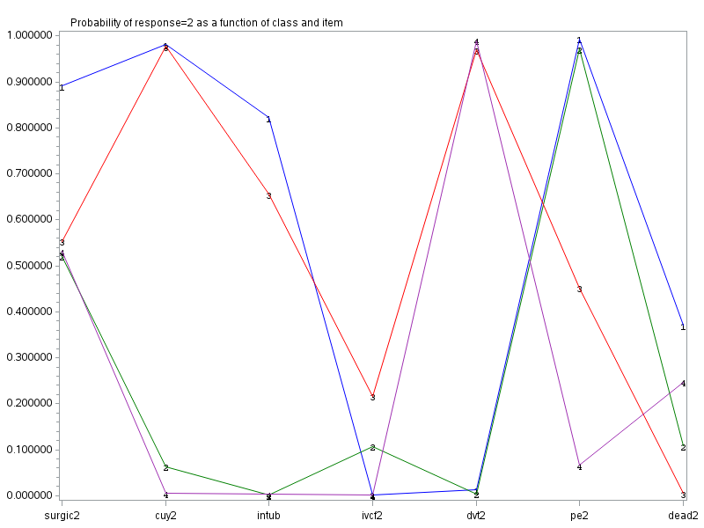
Figure 1: Item probability plot - K= 4 solution
In the interest of transparency, the k=3 solution, which was also a good fit to the data (CAIC and BIC), is presented below. Notice that in the transition from 3 to 4 solutions, class 2 (k=3 solution) was separated into two classes (1 & 3 in the k=4 solution), both yielding clinically relevant and well-discriminated sub-groups. This change had the potential to enhance interpretability was further supported by the fit criteria (AIC and Adjusted BIC).

Class: 1 2 3
0.4972 0.2739 0.2289
(0.0649) (0.0591) (0.0492)
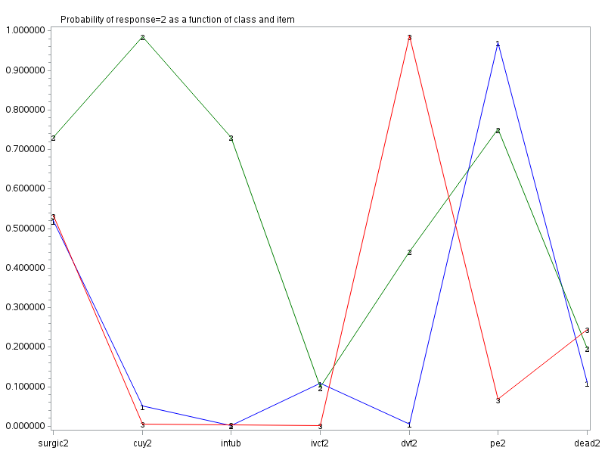
Figure 2: Item probability plot - K= 3 solution

