SUPPLEMENTARY MATERIAL
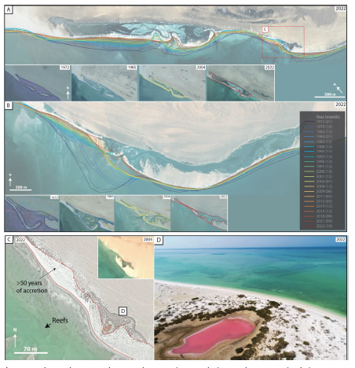
Figure S1: Detail of the Figure 4. Evolution of shoreline changes (e.g., accretion/progradation and retreat/erosion) over the past 50 years—1972 to 2022. (A) Ras Al Mishayu. (B) Ras Braiy: note the progressive closure of the elongated lagoon between 1972 and 2022 leeward the sandy spit. (C) Enlarged image of Ras Al Mishayu showing the development, westward extension, and stacking pattern of a sandy spit that isolates a small section of the shore, creating an isolated salt pond by 2009-– (D).

