Supplementary material A.1: Examples of tasks
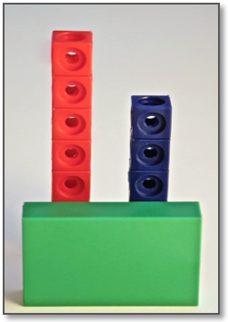
Basics: Difference sets
To introduce the characteristics of difference sets, the tutor showed a picture of two towers with a covered base (Figure 1), asked, which tower was higher (qualitative comparison), and how many blocks the left tower was higher (quantitative comparison). The students tried to find arguments, why they could answer these questions without seeing the entire towers. Additionally, they were asked to build various towers with the same difference as in the picture. This task emphasized the independence of the difference set from the two concrete sets.
Fig. 1 Two towers with covered base
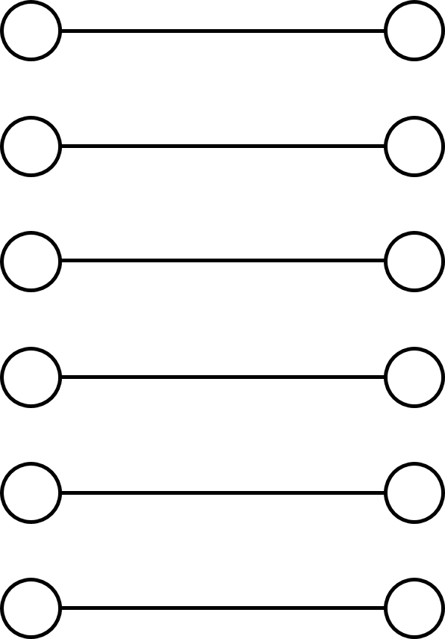
Basics: Equalizing
Two students rolled a dice simultaneously and put their achieved number in the form of chips on the template (Figure 2). By matching the single units of the two sets one by one (lines in Figure 2), the template facilitated the recognition of the difference set. The player with the greater amount of chips was allowed to collect the difference. To emphasize the connection between comparison and equalization, the tutor asked questions such as ‘Who has more/less?’ and ‘How many chips are you allowed to hoard?’ The first player who collected 12 chips won the round.
Fig. 2 Template for the game Hamstern adapted from Verboom (2010)
Verifying
After the students became familiar with the format of Verifying tasks in a joint discussion in Session 2, they worked individually on Verifying worksheets during Sessions 3, 6, and 8. The first line showed the given situation (in this example a picture with unknown difference set) and the next six lines contained statements that needed to be verified (see snippet in Figure 3). ‘Thumbs up’ meant that the statement fits to the given situation, ‘thumbs down’ the opposite. After circling the respective thumbs, the students corrected false statements and discussed their answers.
Is it true, what Flip tells us about the photo? Circle the correct thumb. | 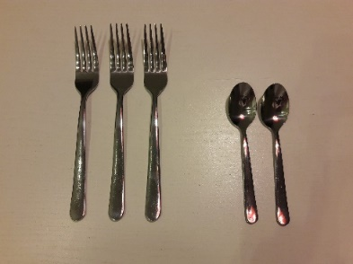
„There are two spoons less than forks.“ | . .
Matching
Fig. 3 Example for Verifying tasks
When matching statements to two inverse situations (Figure 4), contrasting features of these was possible. The tutor gave impulses like the following: ‘Why does this sentence fit to this picture, but not the other?’ ‘What is the difference between the two pictures?’ ‘There are pairs of sentences that look quite similar, but mean the exact opposite of each other. Can you find them?’

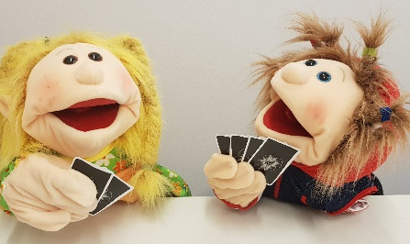
Susi has two cards more than Max.
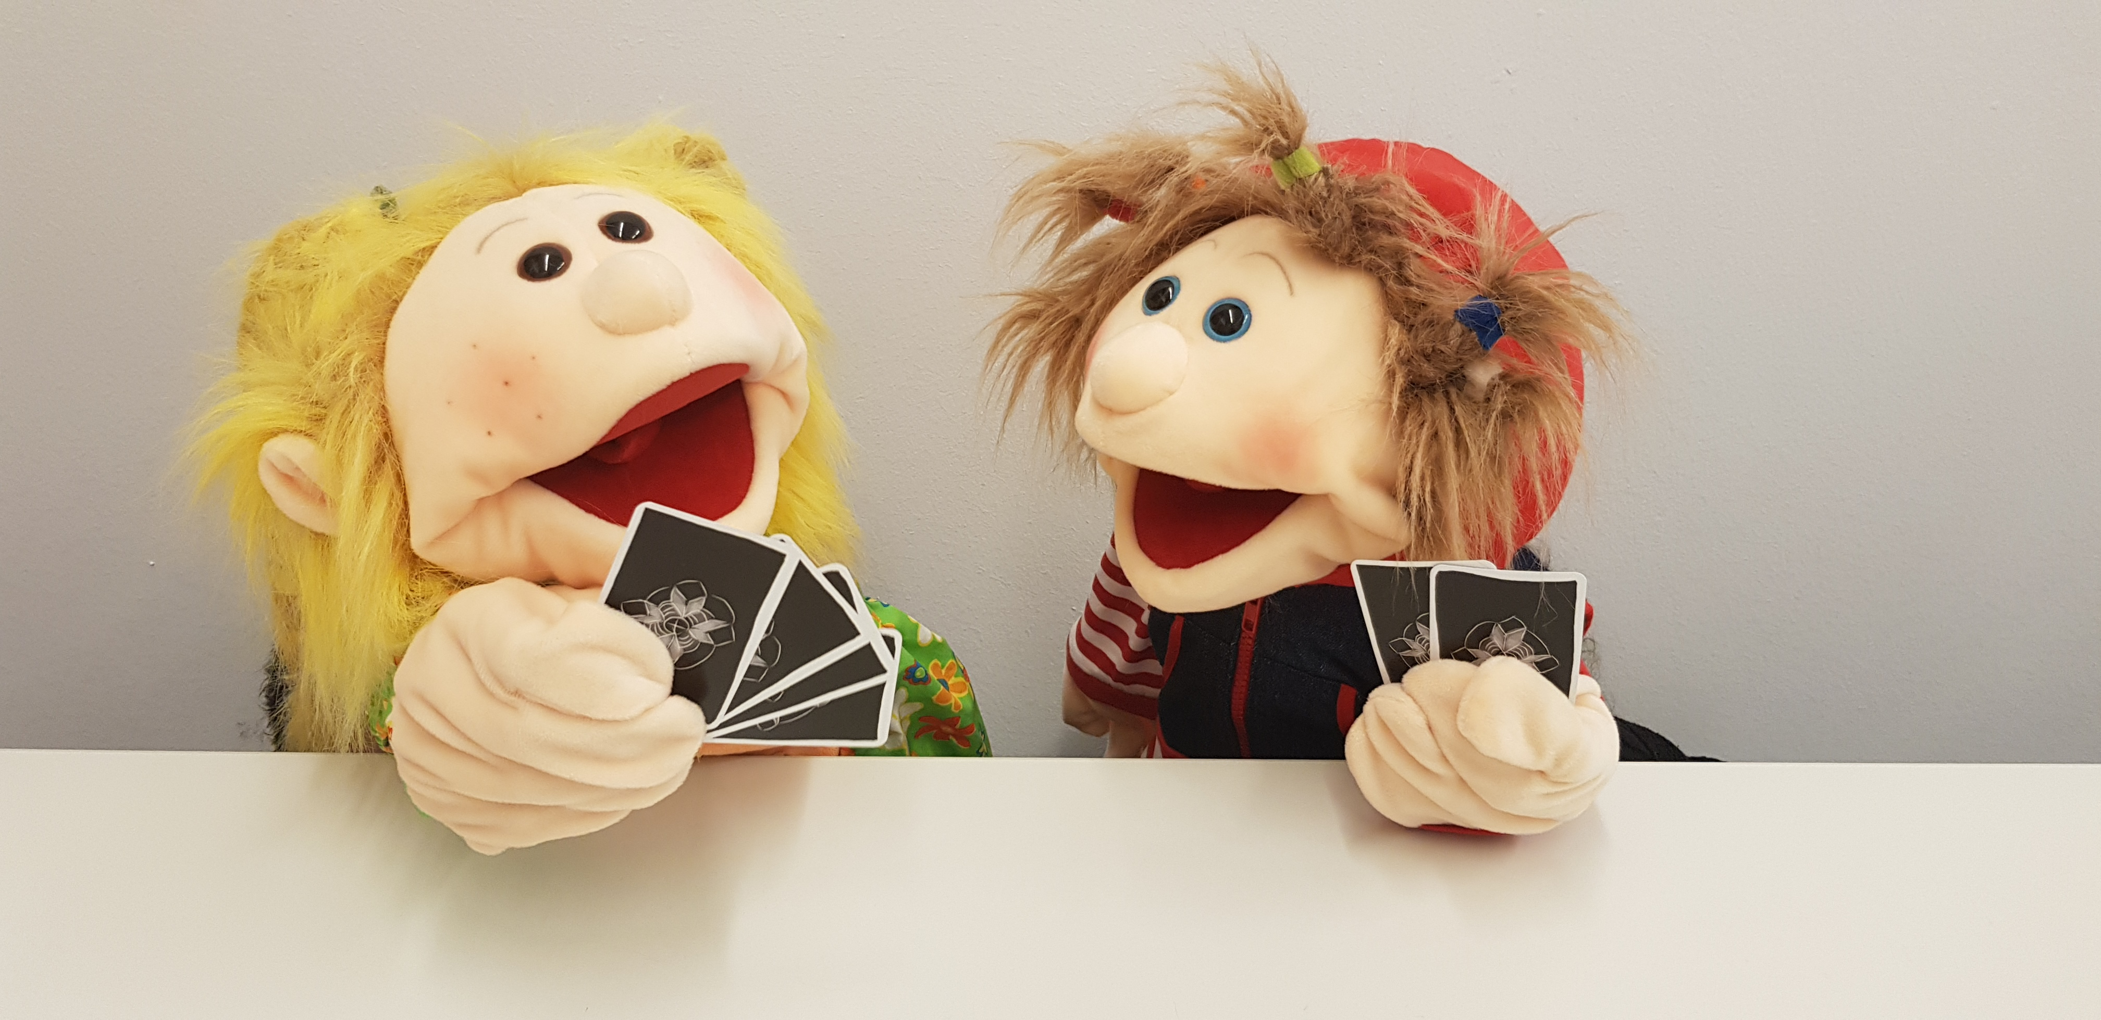Susi has two cards less than Max.
Max has two cards more than Susi.
Max has two cards less than Susi.
If Susi gets two more cards, she has as many as Max.
If Susi gives two cards away, she has as many as Max.
If Max gets two more cards, he has as many as Susi.
If Max gives two cards away, he has as many as Susi.
Symmetry of relations: Introduction
Fig. 4 Two inverse situations with swapped concrete sets
- The students read aloud a statement on qualitative comparison: ‘Laura has more cookies than Klara’
- The tutor puts two bags, one fuller than the other one (symbolical for the cookies), on the table and asks the students to decide, which bag belongs to which person and to explain why.
- Finally, the tutor encourages the students to find another formulation for the same situation, aiming at the symmetrical relational statement ‘Klara has less cookies than Laura’: ‘Can you find a different way to express the sentence?’
- If needed, the tutor was prepared to support the students in a certain order (from strong to light support). If neither of the word cards ‘Klara’ or ‘less’ helped, the tutor presented the solution and encouraged the students to compare both symmetrical relational statements (Measure 3).
- In case the students formulated the sentence ‘Klara has more cookies than Laura’ during Measure 1, the tutor asked, if it still described the same situation and gave the following impulse: ‘Can you replace ‘more’ with another word, so that the sentence fits the situation?’
Symmetry of relations: Application
To practice the inversion of relational statements, students were asked, for example, to create statements referring to a given situation while using predetermined relational terms (Figure 5). These always included pairs of antonymous relational terms (less, more) to encourage students to create symmetrical statements. Furthermore, relationships between relational terms were emphasized.
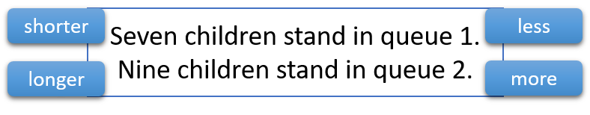
Fig. 5 Example for practicing the inversion of relational statements
Describing
Besides open-ended tasks, which should stimulate free and flexible language, the tutors also provided sentence frames to draw attention to crucial parts of describing equalization and comparison. Students should build towers like in Figure 1 and compare their height with the help of such sentence frames. For this, they either needed to fill in the blanks with one or more words or choose between two options. The left column shows examples for provided sentence frames, the right column shows the specific feature, on which the sentence frames focused (see Section 5.3 for the coding manual).
My tower is ___ bricks high. | [CON]
My tower is bigger/smaller than yours. | [COM-QUAL]
My tower is ___ bricks bigger/smaller than yours. | [DIF]
If I …, then my tower is as high as yours is. | [EQ]
Fig. 6 Examples for sentence frames

Supplementary material A.2
Table 1 Mean values and standard deviations of the Rasch scores for the whole intervention sample (N = 60) and each of the three measurements (repeated measures ANOVA in Section 5.2)
Session | M | SD
3 | -0.67 | 1.18
6 | -0.34 | 1.39
8 | -0.63 | 1.36

